Available online at [www.sciencedirect.com](http://www.sciencedirect.com/)



AASRI Procedia 2 (2012) 268 – 274

AASRI

Procedia

[www.elsevier.com/locate/procedia](http://www.elsevier.com/locate/procedia)

2012 AASRI Conference on Power and Energy Systems

# Comparison of the Performance of Vector Control and Direct Power Control of Induction Generator in Wind Energy Conversion System

Yerra Sreenivasa Raoa, Dr. A. Jaya Laxmib

a *Associate Professor*, *MIC College of Technology, Vijayawada, INDIA*

*b Associate Professor*, *JNTUCEH, Hyderabad, INDIA*

Abstract

The conventional approach for independent control of active and reactive powers handled by the machine is stator flux oriented vector control with rotor position sensors. The performance of the system in this case depends on the accuracy of computation of the stator flux and the accuracy of the rotor position information derived from the position encoder. In vector control, power is controlled by rotor current injection. Direct power control is a rotor side control of a doubly fed induction generator by which decoupled control of stator active and reactive power can be obtained. It is based on the measurement of active and reactive power on the grid side where voltages and currents are alternating at fixed frequency. The active and reactive powers are made to track references using hysteresis controllers. The measurements are taken on stator side and the control is made on rotor side. This control system eliminates the need for rotor position sensing and gives an excellent dynamic performance with simulation results for a variable speed constant frequency induction generator system. The system can be operated below, at and above synchronous speed. The controlling schemes are explained and the modelling of the complete system is done in MATLAB-SIMULINK.

© 2012 Published by Elsevier B.V. Selection and/or peer review under responsibility of American Applied Science Research Institute

© 2012 Published by Elsevier B.V. Selection and/or peer review under responsibility of American Applied Science Research Institute

© 2012 Published by Elsevier B.V.

Selection and/or peer review under responsibility of American Applied Science Research Institute

Open access under [CC BY-NC-ND license.](http://creativecommons.org/licenses/by-nc-nd/3.0/)

Keywords: DFIG; VSCF; CSCF; WECS

1. Introduction to Vector Control

Variable speed operation is attractive for large scale wind turbines and variable speed generating systems. It can capture more energy from the wind compared to constant speed generating systems. Due to the lower converter rating, Doubly Fed Induction Generators (DFIG) are preferred to other variable speed generators. The DFIG can be analyzed in two ways

* DFIG connected to a grid

2212-6716 © 2012 Published by Elsevier B.V. Selection and/or peer review under responsibility of American Applied Science Research Institute

Open access under [CC BY-NC-ND license.](http://creativecommons.org/licenses/by-nc-nd/3.0/) doi:10.1016/j.aasri.2012.09.045

* DFIG operating as a stand-alone generator

When a DFIG is connected to a grid, the grid imposes the voltage and frequency, and the generator control takes care of tasks such as active and reactive power control. On the other hand, when the DFIG operates as a stand-alone generator, the controller has to provide additional tasks such as regulating the generated voltage and frequency. The output voltage of the DFIG can be controlled indirectly by controlling the stator flux or by directly controlling the stator voltage. Indirect control of the stator voltage is achieved by regulating the stator flux through the d-axis rotor current where as the q-axis rotor current is controlled to ensure that the d-axis of the reference frame is aligned with the stator flux vector. In the direct control technique, the same orientation of the d-q frame is used. However, the stator voltage magnitude is directly controlled. In both techniques the torque cannot be controlled using the q-axis rotor current as this is already used to force the alignment of the reference frame. Therefore torque is controlled by controlling the load power.

1. Direct Power Control of DFIG

An algorithm is developed for independent control of active and reactive powers with high dynamic response. The schematic diagram of direct power control of DFIG is shown in Fig. 1.The instantaneous switching state of the rotor side converter is determined based on the active and reactive powers measured in the stator circuit. Measurements are carried out at one terminal of the machine whereas the switching action is carried out at another terminal. Here, the directly-controlled quantities are the stator active and reactive powers. Hence the algorithm is referred as direct power control. It can be applied to VSCF applications like wind power generation.[6]

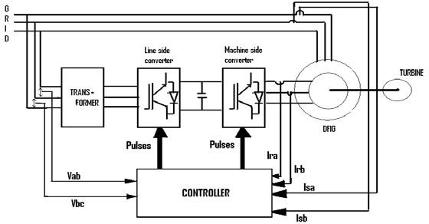

Fig. 1. Direct power control of DFIG

* 1. *Concept of Direct Power Control*

The two basic notions used to determine the instantaneous switching state of the rotor side converter to control the active and reactive power are

* + 1. The stator active power can be controlled by controlling the angular position of the rotor flux vector.
    2. The stator reactive power can be controlled by controlling the magnitude of the rotor flux vector.

*2.2 Voltage Vectors and Their Effects*

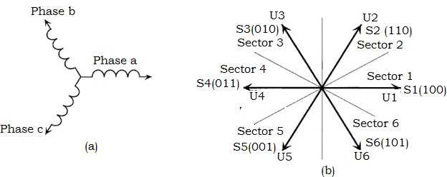

Fig. 2(a) Orientation of the rotor winding in space with respect to which the voltage space phasors (b) voltage space phasors.

Assuming that the orientation of the three phase rotor winding in space at any instant of time is as given in Fig. 2(a), the six active switching states S1, S2… S6 would result in the voltage space vectors U1, U2…U6 at that instant shown in Fig. 2(b). In order to make an appropriate selection of the voltage vector the space phasor plane is first subdivided into six 600 sectors 1, 2…6. The instantaneous magnitude and angular velocity of the rotor flux can now be controlled by selecting a particular voltage vector depending on its present location. The effect of the different vectors as reflected on the stator side active and reactive powers, when the rotor flux is positioned in Sector 1 is illustrated in the following subsections.

Considering anti-clockwise direction of rotation of the flux vectors in the rotor reference frame to be positive, it may be noted that Ts is behind Tr in generating mode. In the rotor reference frame, the flux vectors rotate in the positive direction at sub-synchronous speeds, remain stationary at synchronous speed and start rotating in the negative direction at super-synchronous speeds. [6]

* 1. *Implementation of Direct Power Control (DPC) Algorithm in Simulink*

The reference for the stator active power can be calculated as Ps* = T ref * ωs and Q * is selected depending on the requirement of power factor. The active and reactive powers on the stator side can be directly computed from the stator currents and voltages.

s

* 1. *DPC Algorithm*

The simulink model of direct power control scheme is shown in Fig. 3.

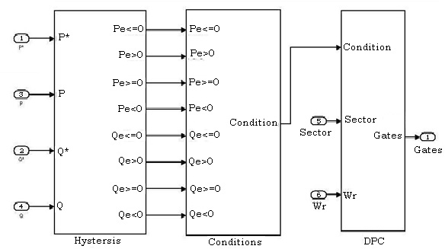

Fig. 3. Simulink model of direct power control scheme

* + 1. *Hysteresis Controllers*

P * is the reference for stator active power. The actual active power Ps to be controlled is to be within a

s

band of width Pband which is about P *. Similarly Q * is the reference for stator reactive power. The actual

s

s

reactive power Qs is to be controlled to stay within a band of width Qband about Q *.

s

* + 1. *Conditions According To Power Requirements*

In order to determine the appropriate switching vector at any instant of time, the errors in Ps and Qs, and the sector in which the rotor flux vector is presently residing are taken into consideration. The two switching tables for active vector selection are shown in Table 1 and Table 2 which correspond to negative and positive, active power errors respectively. If the rotor side converter is switched in accordance with these tables, it is possible to control the active and reactive powers on the stator side within the desired error bands.

Table 1 Selection of Active switching states when (Perr <= 0)

|  |  |  |  |  |  |  |  |
| --- | --- | --- | --- | --- | --- | --- | --- |
| Sector | | 1 | Sector 2 | Sector 3 | Sector 4 | Sector 5 | Sector 6 |
| Qerr>0 | S3 | S4 | | S5 | S6 | S1 | S2 |
| Qerr<=0 | S2 | S3 | | S4 | S5 | S6 | S1 |

Table 2 Selection of Active switching states when (Perr > 0)

|  |  |  |  |  |  |  |
| --- | --- | --- | --- | --- | --- | --- |
| Sector 1 | | Sector 2 | Sector 3 | Sector 4 | Sector 5 | Sector 6 |
| Qerr>0 | S5 | S6 | S1 | S2 | S3 | S4 |
| Qerr<=0 | S6 | S1 | S2 | S3 | S4 | S5 |

By considering the effect of the zero vector on active and reactive powers, the logic for selecting the zero vector can be summarized in Table 3. Whenever a zero vector has to be applied, the one nearest to the present active vector is selected to minimize the number of switchings.

Table 3 Condition for selection of zero vectors

|  |
| --- |
| Speed |
| Sub-Synchronous speed Qerr<0 And Perr>=0 |
| Super-Synchronous speed Perr<0 And Qerr<=0 |

*2.5 Pulse Generation*

From the inferences drawn in the previous section it is possible to switch an appropriate voltage vector on the rotor side at any given instant of time to increase or decrease the active or reactive powers on the stator side. Therefore, any given references for stator active and reactive powers can be tracked within a narrow band by selecting proper switching vectors for the rotor side converter.

*2.6. Sector Identification*

Sector identification method uses integration of the PWM rotor voltage to compute the rotor flux. Then the flux angle is calculated, hence the sector in which the rotor flux resides can be identified.



Tdr = (Vdr - Rr Idr ) dt (1)

Tqr = ( Vqr - Rr Iqr ) dt (2)

Ф r = tan -1 ( Tdr / Tqr ) (3)

1. Simulation Results

By varying the active and reactive powers with the help of step change, the three-phase stator voltages are kept constant which is equal to the grid voltage. So one can conclude that the stator reactive power can be controlled in accordance with our requirement, thus controlling the power factor of the system. Hence the overall system power factor can be kept at unity under varying conditions of load. The Optimal (Reference) stator active power and actual stator active power in vector control and direct power control are shown in Fig. 4 and Fig. 5 respectively. Actual active and reactive powers are tracked more faster to the reference values in DPC Control than Vector control.

By controlling the stator d-axis current, the active power of the stator is controlled. In the same way, by controlling the stator q-axis current, the reactive power of the stator is controlled. This system has excellent dynamic response and decoupled control of active and reactive powers shown by the simulation results. Independent control of Active and Reactive power is achieved in accordance with our requirement. This is achieved by the stator d- axis current (Isd) control which is based on the Active power demand and q- axis current (Isq) control which is based on the Reactive power demand.

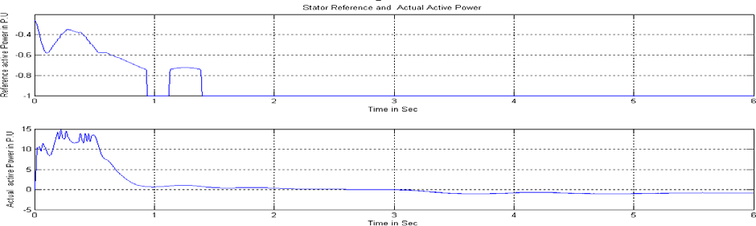

Fig. 4 Stator Reference and Actual Active Power in Vector control

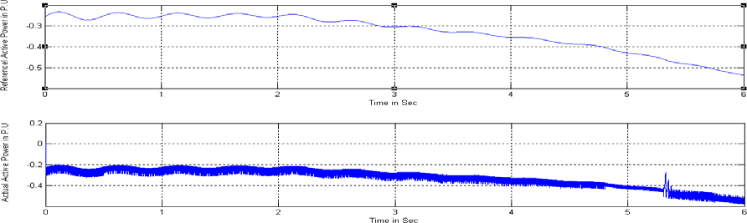

Fig. 5 Stator Reference and Actual Active Power in DPC control

The torques produced by wind turbine and electro-magnetic torque in vector control and direct power control are shown in Fig. 6 and Fig. 7 respectively. It is observed that the torques produced by wind turbine and generator are negative. Torque variations are less in DPC Control than Vector control.

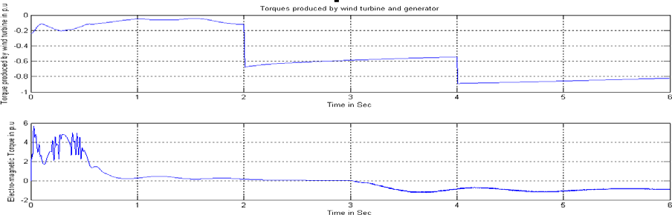

Fig. 6 Torques produced by wind turbine and generator in Vector control

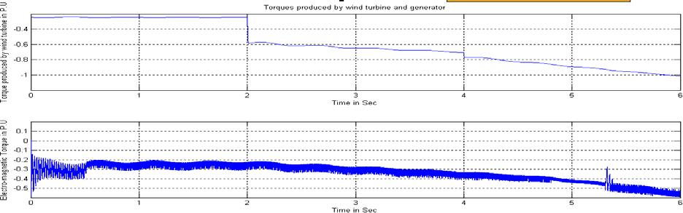

Fig. 7 Torques produced by wind turbine and generator in DPC control

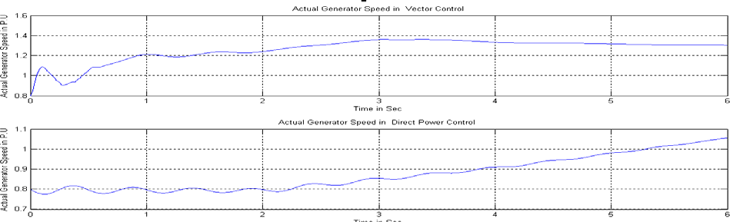The actual generator speeds in vector control and direct power control are shown in Fig. 8. Speed variations are less in direct power control than vector control.

Fig. 8 Actual Generator Speeds in Vector Control and Direct Power Control

1. Conclusions

The conventional approach for independent control of active and reactive powers handled by the machine is stator flux oriented vector control with rotor position sensors. The performance of the system in this case depends on the accuracy of computation of the stator flux and the accuracy of the rotor position information derived from the position encoder. Alignment of the position sensor is moreover, difficult in a doubly-fed wound rotor machine.

The direct power control of the doubly fed induction generator is capable of controlling the active and reactive powers of a wound rotor induction generator without rotor position sensors. Decoupled control of stator active and reactive power can be obtained and the system has good dynamic response as shown in the simulation results. Since it depends only on voltage and current measurements on the stator side, it is insensitive to the parameters of the machine. Direct power control is more advantageous than vector control since the settling time and peak overshoot in case of vector control scheme are higher than that of direct

power control scheme. The direct power control of the generator has been embedded in an optimal power controller for maximum energy capture in a wind energy application. Pitch angle control of wind turbine is also implemented to limit the generator speed to maximum speed at higher wind speeds so that the system can work satisfactorily for higher wind speeds also.

References

[1] L. Xu and W. Cheng, “Torque and reactive power control of a doubly fed Induction Machine by position sensorless scheme,” IEEE Trans.Ind.Applicat.vol.31, May/June 1995, pp.636–642.

B, vol.143, May 1996, pp. 231–241.

[2]B.Shanker ,S.P.Gupta and P.Agarwal, “Investigation on static slip energy recovery system operated in generating mode,” Journal of Institution of Engineers,july 1996, pp. 98-102.

1. Yi Guo, John N. Jiang, and Choon Yik Tang, “Nonlinear Control of Wind Power Generation Systems,”2009 IEEE explore.
2. R. Datta and V.T.Ranganathan, 1999 “Decoupled control of active and reactive power for a grid - connected doubly - fed wound rotor induction machine without position sensors,” in Proc. Conf. Rec. 1999 IEEE/IAS Anu.Meeting, pp. 2623–2630.
3. R. Datta and V. T. Ranganathan, “Method for direct control of active and reactive power from the rotor side for a grid connected doubly-fed slip-ring induction machine without position encoder,” Indian Patent 797/MAS/99, June 8, 1999.
4. Rajib Datta and V. T. Ranganathan, “Direct Power Control of Grid-Connected Wound Rotor Induction Machine Without Rotor Position Sensors”, IEEE Transactions on Power Electronics, Vol. 16, No. 3, MAY 2001,p.p.390-399.