[Artificial Intelligence in Agriculture 1 (2019) 48–55](https://doi.org/10.1016/j.aiia.2019.05.002)

Contents lists available at [ScienceDirect](http://www.sciencedirect.com/science/journal/25897217)

Artificial Intelligence in Agriculture

journal homepage: [http://www.keaipublishing.com/en/j ournals/artificial- intelligence-in-agriculture/](http://www.keaipublishing.com/en/journals/artificial-intelligence-in-agriculture/)

[](http://crossmark.crossref.org/dialog/?doi=10.1016/j.aiia.2019.05.002&domain=pdf)Comparison of two data fusion methods for localization of wheeled mobile robot in farm conditions

S. Erfani ⁎, A. Jafari, A. Hajiahmad

*Department of Agricultural Machinery Engineering, College of Agriculture and Natural Resources, University of Tehran, Karaj, Iran*

# a r t i c l e i n f o

*Article history:*

Received 29 January 2019

Received in revised form 10 May 2019

Accepted 11 May 2019

Available online 15 May 2019

*Keywords:*

Sensory data fusion Mobile robot Localization

Dempster - Shafer method Kalman filter

# a b s t r a c t

Localization of a mobile robot with any structure, work space and task is one of the most fundamental issues in the field of robotics and the prerequisite for moving any mobile robot that has always been a challenge for re- searchers. In this paper, the Dempster-Shafer (D.S.) and Kalman filter (K.F.) methods are used as the two main tools for the integration and processing of sensor data in robot localization to achieve the best estimate of posi- tioning according to the unsteady environmental conditions in agricultural applications. Also, by providing a new method, the initial weighing on each of these GPS sensors and wheel encoders is done based on the reliability of each one. Also, using the two MAD and MSE criteria, the localization error was compared in both K.F. and D.S. methods. In normal Gaussian noise, the K.F. with a mean error of 2.59% performed better than the D.S. method with a 3.12% error. However, in terms of non-Gaussian noise exposure, the K.F. information was associated with a moderate error of 1.4, while the D.S. behavior in the face of these conditions was not significantly changed. The experimental tests confirmed the statement.

© 2019 The Authors. Publishing services by Elsevier B.V. on behalf of KeAi Communications Co. Ltd. This is an open access article under the CC BY-NC-ND license (<http://creativecommons.org/licenses/by-nc-nd/4.0/>).

1. Introduction

Today, agricultural automation is inevitable in order to save on costs and produce more per unit area. Robotics can also meet the goals of au- tomation in agriculture, by minimizing the tough, risky, deadly and long working conditions, along with precise monitoring and control. With the development of research in this field and the development of tools used to guide robots, including optical, ultrasound and radio sensors, the problem of increasing the accuracy and speed of the robots was con- sidered (Murakami et al., 2006). Data fusion is a method for combining the data from several sources of information used to obtain a brighter picture of the problem being investigated and measured. Data fusion systems are currently being used in a variety of fields, including sensor networks, robotics, photo and video processing, and smart system de- sign. A lot of research, especially in recent years, has been done in the field of data fusion, but there is still a long gap between intelligent sys- tems in this area with the ability of organisms, especially the ability of the human brain (Hall and Llinas, 1997). Klein (1993) provided a defini- tion of the integration of sensor data, which combines sensor data, from one type or from different sources of data. Both definitions provide a general form in the use of sensors and can be used in a variety of appli- cations, including remote sensing. The authors have reviewed many of the methods of data fusion and discussed each one. Based on the

* Corresponding author.

*E-mail addresses:* [saeederfani@ut.ac.ir](mailto:saeederfani@ut.ac.ir) (S. Erfani), [Jafarya@ut.ac.ir](mailto:Jafarya@ut.ac.ir) (A. Jafari), [Hajiahmad@ut.ac.ir](mailto:Hajiahmad@ut.ac.ir) (A. Hajiahmad).

strengths and weaknesses of previous work, a basic definition of infor- mation integration is presented as follows: Information integration is an effective way to automatically or semi-automatic conversion of infor- mation from different sources or at different time points into an effec- tive output that in the decision-making process, acts automatically or supports human decision-making. In studies for localization, the combi- nation of the global positioning system and other sensors such as iner- tial measurement sensors, position detection sensors (digital compass), camera, radar and laser sensors, have shown more accurate results than the use of only the GPS (Keicher and Seufert, 2000; Subramanian et al., 2006; Li et al., 2010). The combination of GPS speed with the INS sensor was used to measure the slip angle of the ve- hicle and the tire when it was turned (Bevly et al., 2001). In other re- search, Zhang et al. (2002) equipped an agricultural tractor with an intelligent navigation system with machine vision sensors and optical fiber gyroscope. In a research conducted by Mizushima et al. (2011) po- sitioning sensors were combined with three vibrational gyroscopes and two inclinometers. Park (2016) for safe and comfortable mobile robot navigation in dynamic and uncertain environments, extended the state of the art in analytic control of mobile robots, sampling based op- timal path planning, and stochastic model predictive control.

Shafer et al. (2003) introduced the theory of evidence, later known as the Dempster-Shefer theory. The basis of this approach is to integrate data into evidence or beliefs that can manage information deficiencies. This was a reinterpretation of Arthur Dempster's research in the 1960s, which, according to Dempster, has been largely modified by Shafer (Shafer et al., 2003). Denoeux et al. (2017) provided two new

<https://doi.org/10.1016/j.aiia.2019.05.002>

2589-7217/© 2019 The Authors. Publishing services by Elsevier B.V. on behalf of KeAi Communications Co. Ltd. This is an open access article under the CC BY-NC-ND license ([http://](http://creativecommons.org/licenses/by-nc-nd/4.0/) [creativecommons.org/licenses/by-nc-nd/4.0/](http://creativecommons.org/licenses/by-nc-nd/4.0/)).

division methods, along with simulation of some applications in the D.S method. Liu et al. (2017), in their research, proposed a new weighting method in Dempster-Shafer theory by a fuzzy algorithm that can use the evidence obtained from different methods to classify the target.

Despite extensive research in the field of robotics and control, the implementation of plans and methods of localization in the agricultural industry has been less studied due to the fundamental difference in the laboratory environment with real conditions. Because highly accurate sensors such as DGPS, in addition to the high cost, have access restric- tions, In this paper, various methods of integrating global positioning unit and inertia measurement unit are utilized by Dempster-Shafer the- ory as well as Kalman filtering, and the results were compared to select

axis, because the robot cannot slip sideways. And because of the low speed, longitudinal slip and centrifugal force can be ignored.

*vx* = *v*, *vy* = 0 (1)

The wheels cannot move in the direction of the dashes, and these two dashes cut off at one point, which is called the instantaneous center of rotation. This point is the center of the circle the robot tracks and the angular velocity of the robot is obtained from the following equation.

*vθ* = (2)

_

*R*1

an accurate method for localization at an appropriate cost. Also, by in-

troducing a new method, initial weighting has been made on the infor-

In which *R*1 = *L*,

tan*γ*

and *L* is equal to the length of the robot.

mation of each of the GPS sensors and wheel encoders, based on the reliability of each one. In addition to obtaining the geometric equations governing the robot, a PD controller was implemented for kinematic control and evaluation of the robot localization algorithms.

The rest of the paper is organized as follows: The kinematic model- ing of the agricultural robot, the simulation of the robot in the MATLAB SimMechanic, localization by Dempster- Shafer and Kalman filter are given in Materials and Method section. Comparing of these two methods and the results is presented in Result and Discussions. The experimental tests were designed to investigate the validity of sim- ulation results. And finally, last section, where some conclusions are highlighted.

1. Materials and method
   1. *Modeling*

In this section, a model will be created for a robot that is a car-like robot. The typical model for the four-wheel robots is the bicycle model shown in Fig. 1. The two-wheel drive model has a rear wheel mounted on its body, and the front wheel plate rotates around a vertical axis for steering. The position of the robot is represented by a moving coordinate system whose x-axis is in the direction of moving forward of the robot and its center corresponds to the center of the rear axle of the robot. The configuration of the robot is also defined by general coor- dinates *q* = (*x*, *y*, *θ*) ∈ *C* in which, *C*, is an Euclidean two-dimensional space. In this coordinate system, the speed of the robot is along the *x*-

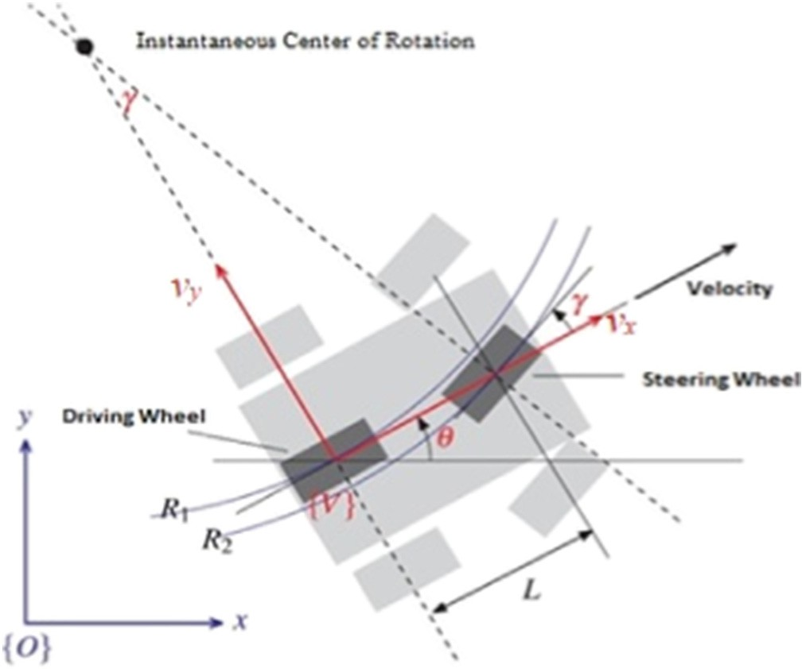

Fig. 1. Bicycle model of four wheeled robot.

As can be imagined, the radius of the robot's circular path increases with increasing length of the robot. On the other hand, the steering angle has a mechanical limit and its maximum value specifies the min- imum *R*1 value. So if the steering angle is constant, the robot runs a cir- cular arc.

According to Fig. 1, *R*2 N *R*1, which means that the front wheel must travel longer and therefore have a higher speed than the rear wheel. Also, in a four-wheel robot, the outer wheels are rotational with differ- ent radials from the inner wheels. Therefore, there is very little differ- ence between the steering angle of the steering wheels, and this difference can be made using the Ackerman steering mechanism on the steering wheels. Similarly, in moving wheels, the speed of rotation varies. The speed of the robot is equal to (*v* cos *θ*, *v* sin *θ*) in the reference coordinate system. By combining it with Eq. (2), the equations of mo- tion are obtained as follows.

*x*_ = *v* cos*θ* (3)

*y*_ = *v* sin*θ* (4)

*θ*_ = *v* tan*γ* (5)

*L*

This model is a kinematic model of the robot, because it is described by the speed of the robot, not the force and torque that speeds up. In the global or reference coordinate system:

*y*_ cos*θ*−*x*_ sin*θ* = 0 (6)

This is a non-holonomic motion control. Another important feature of this model is that when the robot speed is zero, then θ_ = 0. This means that the robot direction cannot be changed without moving. It comes from Eq. (5). Because, θ_ is the instantaneous velocity of rotation. Also the robot command is always less than π/2.

* 1. *Simulation*

In this section, according to the kinematic model of the robot, a sim- ulation of the robot in the MATLAB software has been addressed. Fig. 2 shows the implementation of Eqs. (3) to (5) in the Simulink environ- ment. Linear speed and steering angle as input, and position and angle of the robot are considered as output of this model.

In order to have a dynamic environment and visual representation of the robot's motion, the robot model is interconnected individually in the SimMechanics of Matlab software to allow the robot's behavior in deal- ing with various control algorithms be observed by combining it with Simulink environment. By placing a sensor on a robot, in order to report its position and angles (such as the gyroscope sensor), these robot fea- tures are available throughout the path. The robot moves with constant velocity and the steering angle is the only control variable.

The control commands to the simulated model have been imple- mented from controllers written in the Simulink. In addition, by reporting the amount of rotation of each joint, in fact, will be an encoder

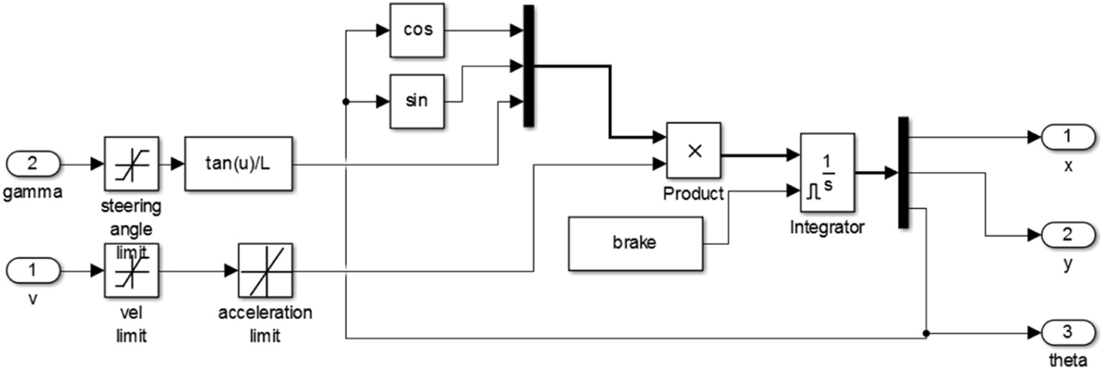

Fig. 2. Simulation of the kinematics model of robot.

on the each wheel which produces output in radians per second. In Fig. 3, simulation of the robot and the transfer of various parts of SolidWorks to the SimMechanics, along with an explanation of each part, are presented.

* 1. *Localization*

Now, the robot positioning in the simulation environment is per- formed using two methods, Kalman filter and Dempster-Shafer. Also, the initial weighing to the sensors' results will be explained and applied.

* + 1. *Dempster - Shafer's theory*

Dempster-Shafer's Theory of Evidence according to many credible references, is the most powerful method in data fusion. In fact, this method merges data at the decision level. This method has the ability

Consequently, conflicting results may be obtained. But D.S. theory is not limited by model defects or previous information defects. So, the ev- idence is determined solely on the basis of the obtained data, and not by the assumed data. So it can be concluded that this method is a quick and an accurate tool for combining incomplete data. For sensory data fusion using the D.S. method, a given weight must be assigned to each data source at any given time. For this purpose, firstly, by the standard devi- ation of data, for the N last produced data, the amount of data validation for each sensor is determined. If the standard deviation of the N last data is smaller than the specified value *α*, there are fewer jumps and more confidence in that sensor, and if the standard deviation is greater than that value, reliability will be less. *α* and N values are empirically deter- mined based on the behavior of sensor data or expert opinion. Initially, the variance of each sensor's data is calculated:

to integrate any numerical, signal, and multi-dimensional data. One of the areas that this tool and its features are underused is the localization. In this paper, firstly will be shown how D.S. Theory of Evidence can be used in precise positioning of moving objects, and then the performance

*σ* 2 = 1 X

*N i*=1

*N*

(*xi*−*μ*)2

(16)

of this method in localization will be compared with K.F. method. D.S theory is a generalization of the Bayesian method that can handle sensor information defects. In the event that all necessary information is avail- able, all data fusion methods provide a comprehensive and acceptable approach but in the face of lack of sensitivity and sensitivity data, they are not reliable. In such cases, data fusion methods should make as- sumptions about sensor data which may not match on real data.

*Hihgly reliable level* (*c*1 = 1) *σ* 2 ≤*α* (17)

*Poorly reliable level* (*c*2 = 2) *σ* 2 N *α*

With each new data, the variance of the N last data is updated and the upper and lower levels of confidence are specified. These levels

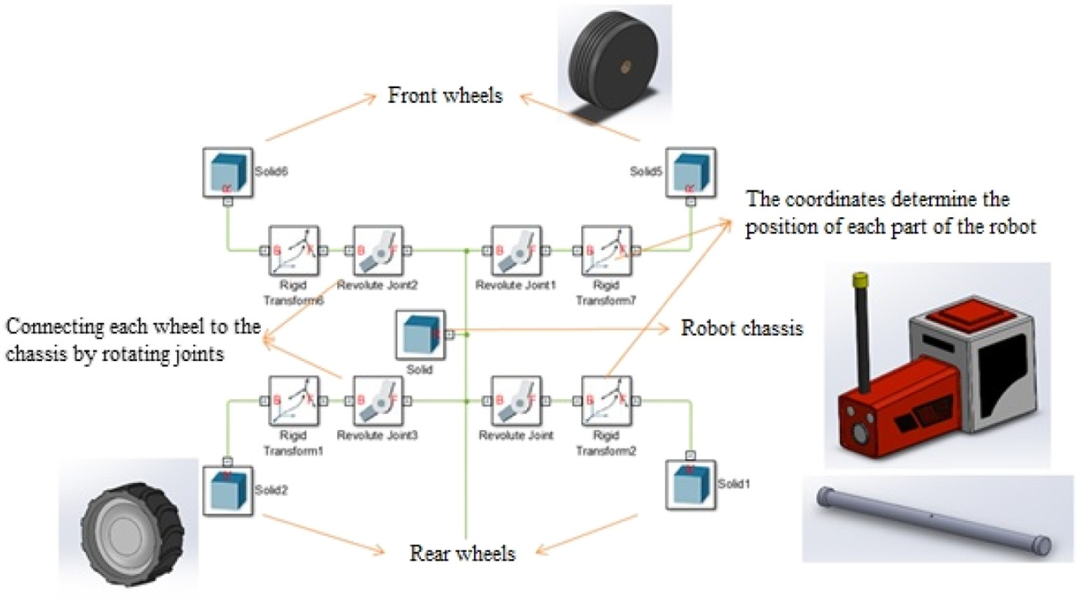

Fig. 3. Simulate a robot and transfer parts to the simulator SimMechanics.

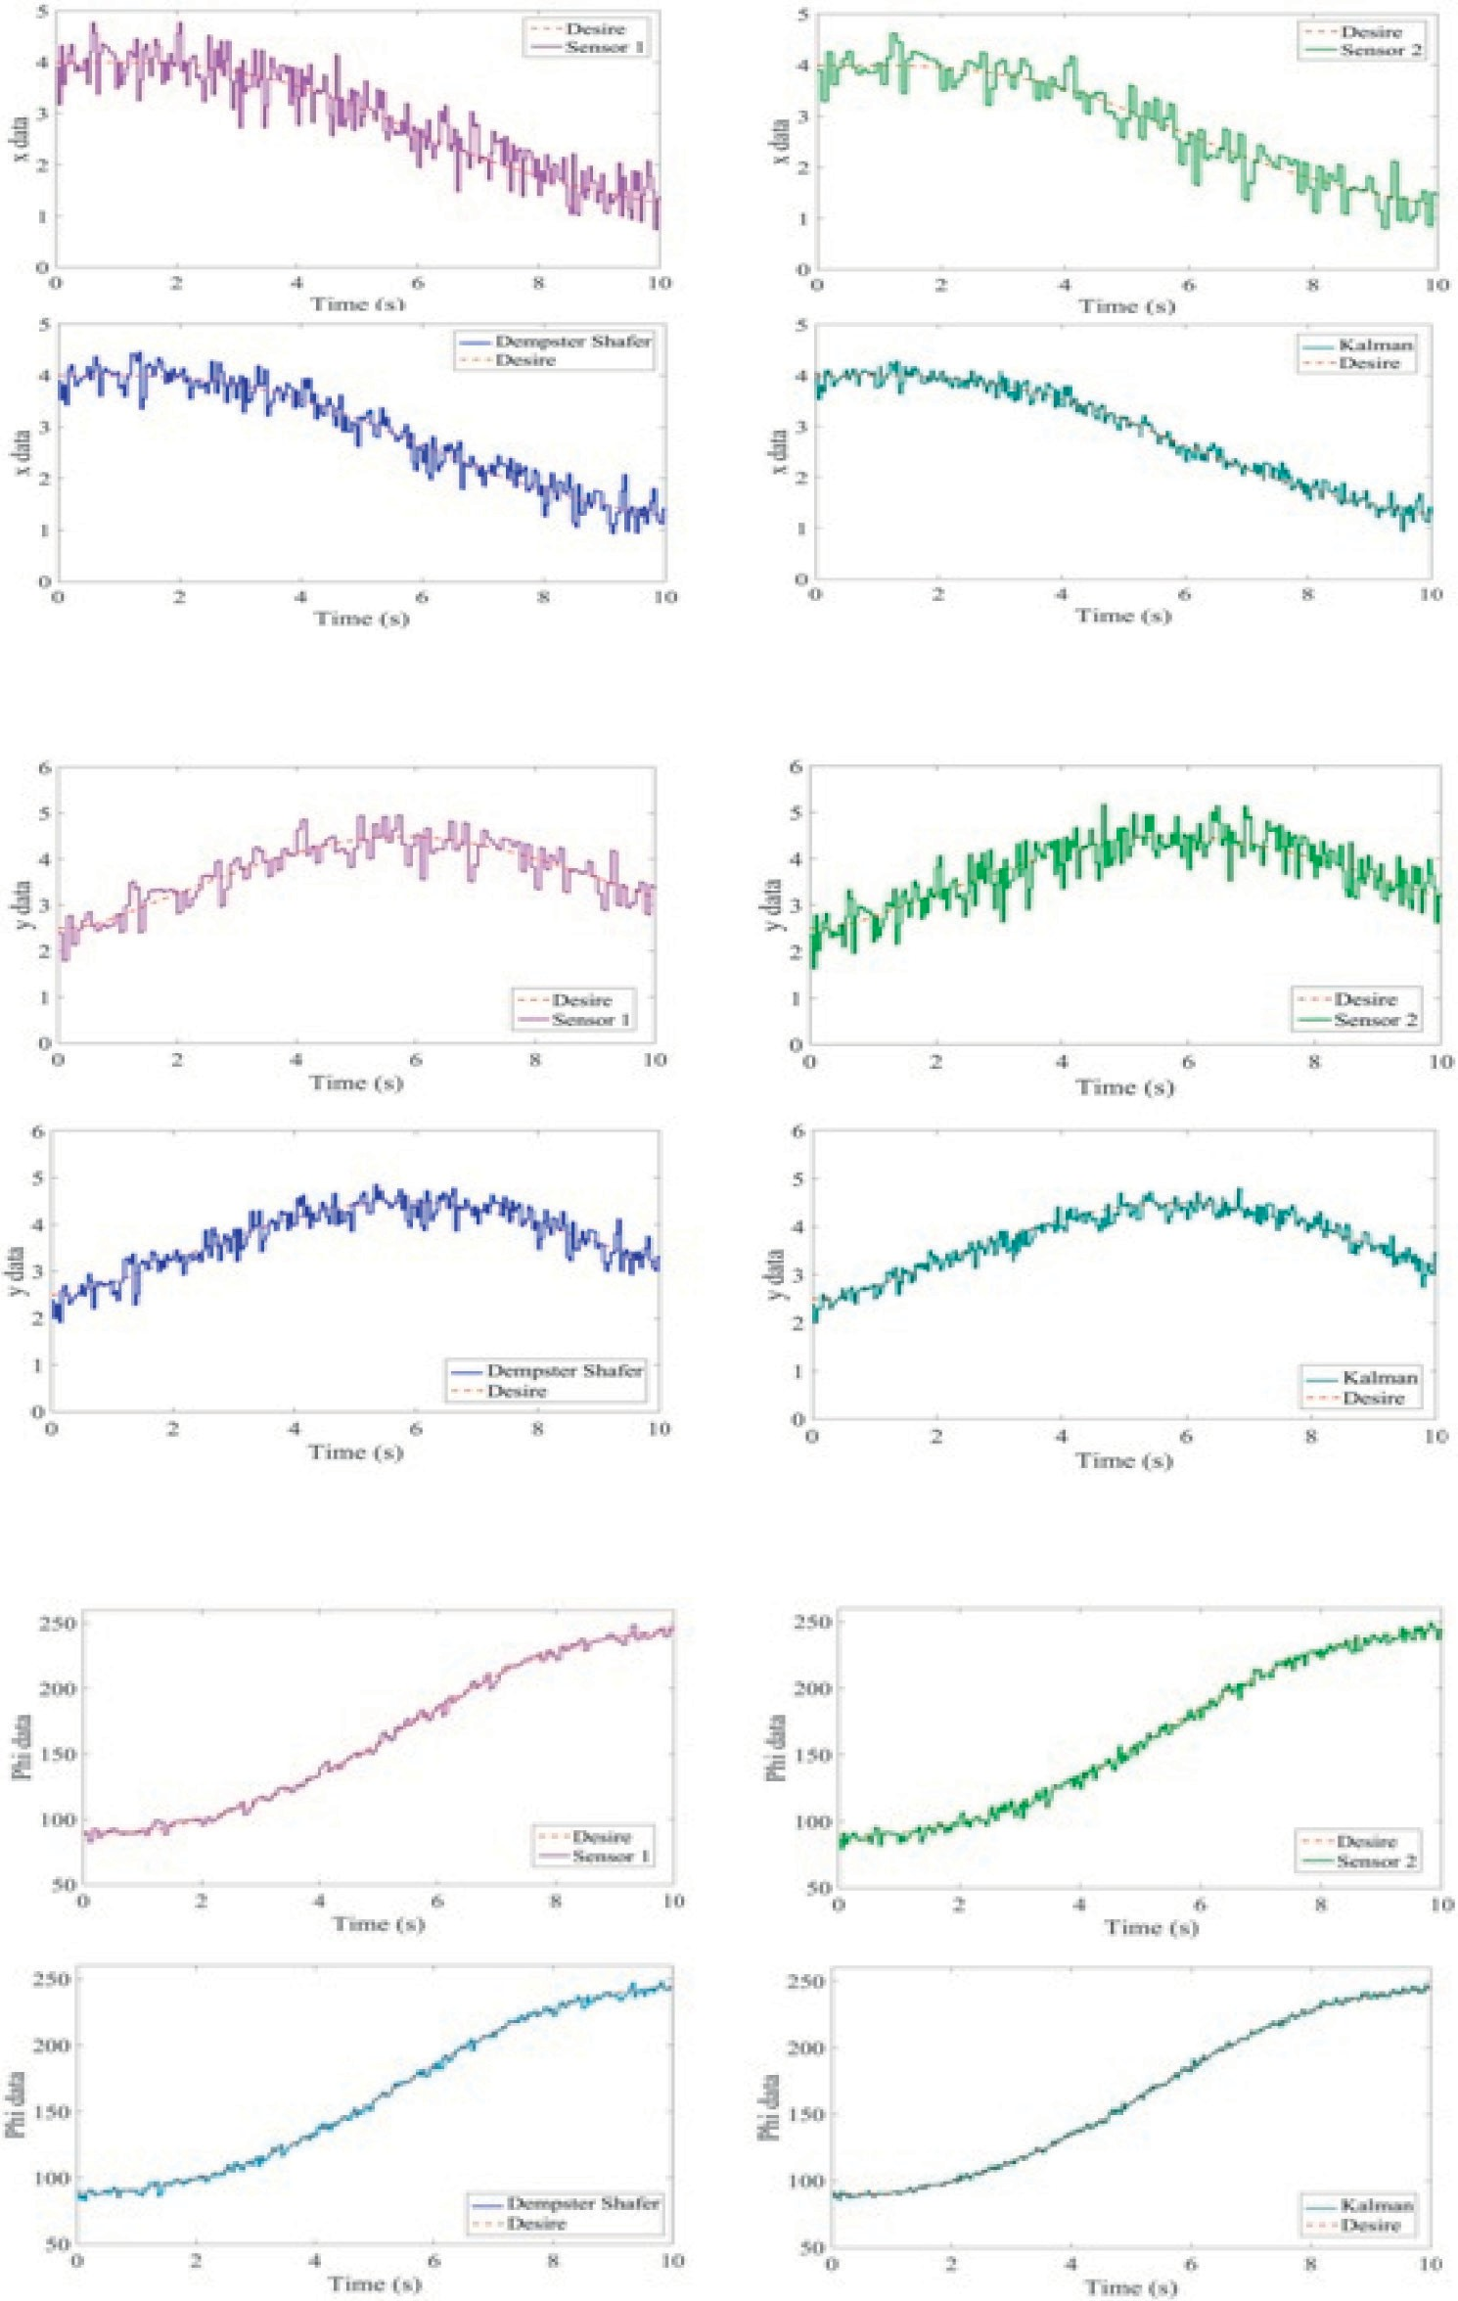(a)

(b)

(c)

Fig. 4. Noise simulation diagrams and the results of applying the fusion tool to the robot position parameters.

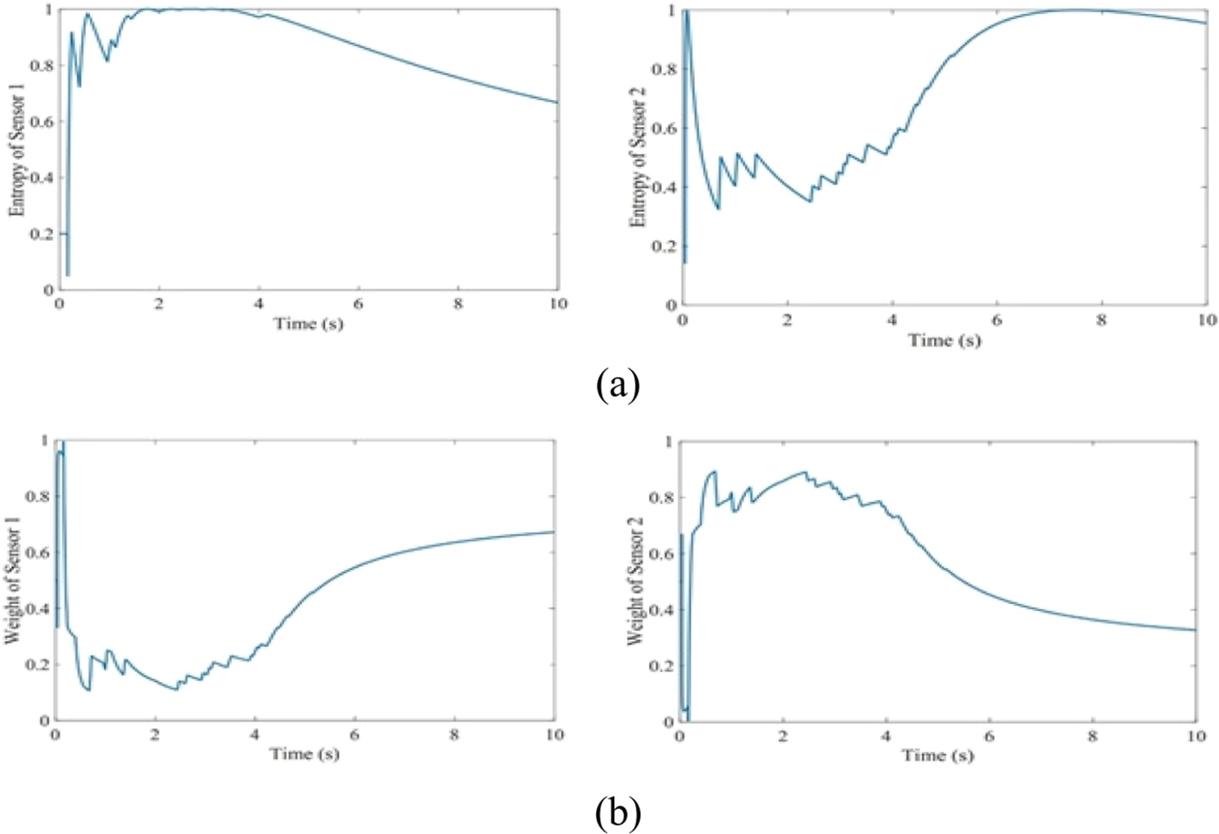

Fig. 5. Entropy graph of sensor data and weight assigned to sensor sources.

are used in Shannon entropy relations as follows: (Lu et al., 2016)

Finally, by the entropy obtained for each Sensor, and using the for- mula below, its weight will be determined (Lu et al., 2016):

*P* = R

*c*

R *c*1R*t*

, *Pc* = R

R *c*2R*t*

(18) 1

1*t c*1*t* +

*c*2*t* 2*t*

*c*1*t* +

*c*2*t*

*Wit* =

2 P*I*

−2 (20)

And the entropy criterion for each of the Sensors is obtained as fol- lows:

(*Hit*)

*i*=1 (*Hit* )

2

X *c c*

*Hit* = *Pit* log2*Pit* (19)

*c*=1

The greater the entropy of a sensor's data, the lower the confidence level, and consequently the lower the weight assigned.

* + 1. *Sensor noise simulation and performance analysis of fusion tools*

Firstly, the positioning data of two sensor data sources- Sensor 1: the GPS data and Sensor 2: the total of IMU data and the rear wheel encoders- is received from sensor blocks in the Simulink toolbox, and re-simulated after adding noise and bias up to 10% of the turmoil to

Table 1

Comparison of the performance of two data fusion tools in simulation.

|  |  |  |  |
| --- | --- | --- | --- |
| Test number | Benchmarking | D.S (% error) | K.F (% error) |
| 1 | MAD | 1.99 | 1.45 |
|  | MSE | 4.76 | 2.59 |
| 2 | MAD | 2.23 | 1.59 |
|  | MSE | 6.02 | 3.22 |
| 3 | MAD | 1.94 | 1.42 |
|  | MSE | 4.76 | 2.62 |
| 4 | MAD | 1.77 | 1.49 |
|  | MSE | 4.01 | 2.85 |
| 5 | MAD | 1.78 | 2.03 |
|  | MSE | 3.45 | 5.23 |
| 6 | MAD | 1.43 | 1.59 |
|  | MSE | 2.77 | 3.22 |

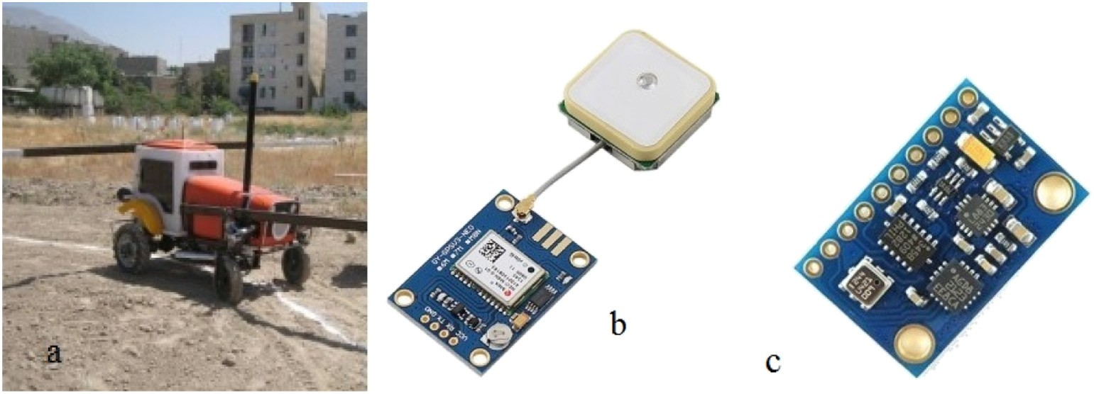

Fig. 6. a) Mobile robot implemented for tests. b) GPS module. c) IMU/AHRS module.

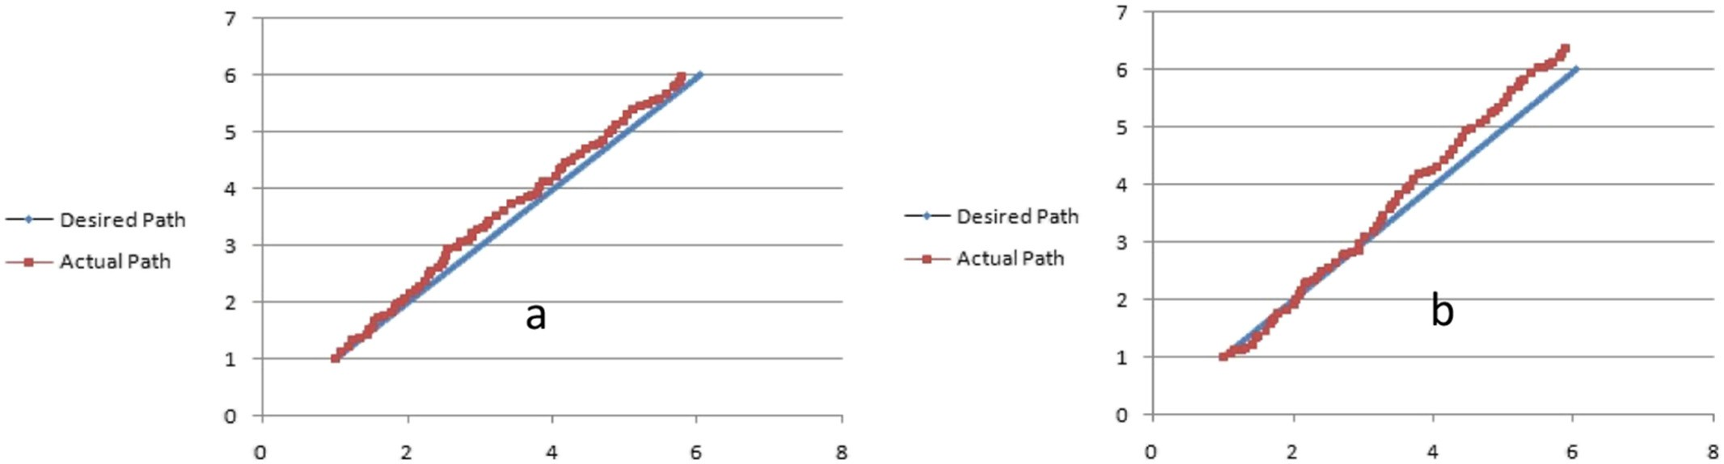

Fig. 7. a) Dempster-Shafer method. b) Kalman Filter method.

those. Then, in the first step, for a specific semicircular path, the sensor values are combined by Kalman filter and Dempster-Shafer separately. In the following, there are three series of diagrams, each showing one of the robot position parameters. In each series of charts, the output of the simulated blocks of two sensor sources that are coupled with noise, and the results of applying two data fusion tools are shown. In Fig. 4a, the parameter x, in the Fig. 4b, the parameter y and in the Fig. 4c, the parameter *θ* are analyzed and in MATLAB simulation toolbox, the performance of these two data fusion tools is shown in a given time period and path. As indicated in these diagrams, the red-dashed paths

are the real robot motions in the simulation environment, which is ex- pected to show by the ideal sensors. Purple and pale green colors are shown simulated sensor data after the noise respectively for the first and second sensor sources. Also the blue color shows the fusion of two noisy sensor data by D.S. method and the dark green color shows the fusion by the K.F. method. It is clear that the Kalman method shows better performance in Gaussian noise.

Fig. 5a is the entropy graph of the two sensor sources, and Fig. 5b is the obtained weight graph based on sensor data. As shown in these charts, the entropy of the Sensor 1 is greater than the Sensor 2, which

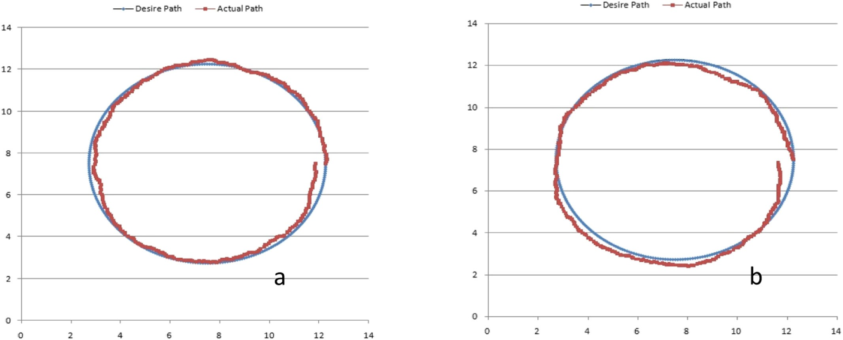

Fig. 8. a) Dempster-Shafer method. b) Kalman Filter method.

Table 2

Comparison of the performance of two data fusion tools in experimental test.

Path RMSE

Linear path 0.156

the fifth and sixth tests, the noise level applied to the Sensors is non- Gaussian noise. Typical IMU/GPS integration approaches usually adopt the Gaussian error assumption. However, in practice, especially during off-road navigation and when several sources of GPS interference are

D.S

K.F.

Circular path 0.172

Orientation error 0.31

Linear path 0.203

Circular path 0.224

Orientation error 0.40

present, this assumption does not hold. To this end, the best non- Gaussian noise model is the Huber estimator using a robust estimator algorithm, which is able to handle multipath GPS signals as well as in- tentional and unintentional interferences. Gaussian mixture models are based on the representation of any non-Gaussian distribution as the sum of multiple Gaussian densities with different weights

indicates more disorder in GPS data than the encoder plus IMU data and so, the reliability of the data is less and the weight allocated to that Sen- sor will be less.

1. Results and discussions

Looking at the diagrams of Fig. 4, K.F. seems to have a better perfor- mance than D.S., but according to Fig. 5, the need to provide a bench- mark for comparing the performance of these two data fusion tools seems to be necessary. For this reason, the Mean Absolute Deviation (MAD) and Mean square Error (MSE) criteria have been used. MAD, also referred to as the “mean deviation” or sometimes “average absolute deviation”, is the mean of the data's absolute deviations around the data's mean: the average (absolute) distance from the mean. “Average absolute deviation” can refer to either this usage, or to the general form with respect to a specified central point. The mean absolute devi- ation of a set {x1,x2,x3, … ,xn} is

(Karlgaard and Schaubt, 2007). For the IMU/GPS algorithm discussed here, the noise is assumed to be composed of two Gaussian components.

The results presented in Table 1 show that the performance of the Dempster-Shafer method in sensor data fusion associated with non- Gaussian noise is better than the Kalman filter. Since in real life the noise behavior is more non-Gaussian, it seems that the Dempster method will perform better in dealing with real issues.

1. Experimental results

In this section, an unmanned ground vehicle is implemented practi- cally to perform real-time navigation. This vehicle has been constructed in Biosystem Mechanical Engineering Department of Tehran University. The vehicle used as mobile robot has a servo mechanism as its steering mechanism. Then the aforementioned controller have been imple- mented and the platform is examined in two case study to verify the re-

MAD

1 Xn

x −m x

21 sults of simulation. The GPS module applied in the experiment is NEO-

= | i

n

i=1

( )| ( )

M8N and the IMU/AHRS module is GY-801. The vehicle and modules can be seen in Fig. 6.

Which n is the number of values and m(x) is the mean. MAD has been proposed to be used in place of standard deviation since it corre- sponds better to real life. Because the MAD is a simpler measure of var- iability than the standard deviation. This method's forecast accuracy is very closely related to the MSE method which is just the average squared error of the forecasts. Although these methods are very closely related, MAD is more commonly used because it is both easier to com- pute (avoiding the need for squaring) and easier to understand.

In the platform test a linear and a circular smooth path are generated as desired paths. These paths are fed into the system as inputs sepa- rately. So, the actual paths are obtained. The relation between the de- sired and actual path is shown in Figs. 7 and 8. The root mean square error (RMSE) criterion is used for comparing the performance of these two methods. According to Table 2, the Dempster-Shafer method had better performance in path tracking. Also the error between actual and desire orientation angles during the circle path is shown in Fig. 9 and Table 2.

MSE 1 Xn

= n

i=1

xi−xbi 2

(22)

Axis units x and y are in Figs. 7 and 8 in meter, and in Fig. 9, the x-axis is in terms of time (second) and the y axis in radians.

As seen from the Figures and Table above, the Dempster-Shafer method provides better performance with less error than Kalman Filter

which xi is predicted value.

b

The numbers in the table below belong to the x variable in each sim- ulation test and for each evaluation criterion.

The simulation reported in the previous section has been carried out six times for two different paths (a linear path and a circular path). In

in vehicle localization. Mean deviation from desire path in path tracking by Dempster-Shafer method is about 15.5 cm in linear path and about 17 cm in circular path. This method shows an error about 17.7 degree in orientation during circular path tracking. Localization using Kalman Filter makes up a higher error about 4.7% in linear path and about 5%

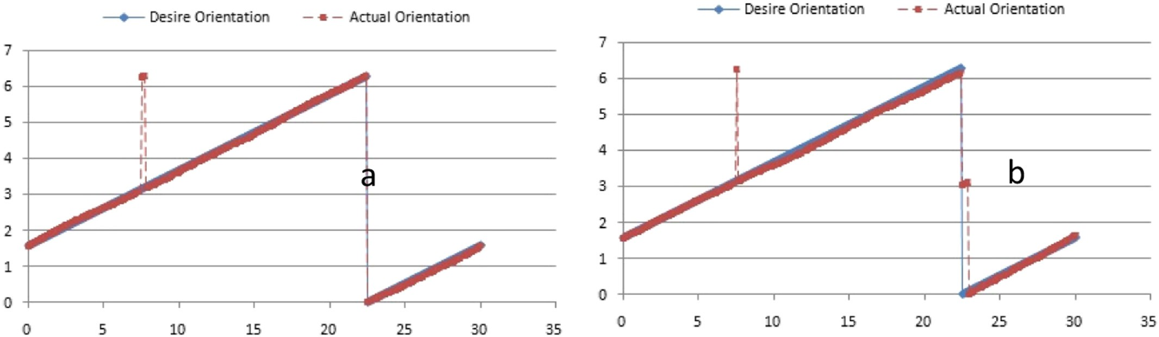

Fig. 9. The error between actual and desire orientation angles. a) Dempster-Shafer method. b) Kalman Filter method.

in circular path. Orientation error in circular path is about 23 degree by Kalman filter method.

1. Conclusion

In this paper, tried to simulate controlling of an agricultural tractor robot and it's localization in real condition using Dempster-Shafer and Kalman filter algorithms, as data fusion tools. The results showed a bet- ter performance of the Dempster-Shafer method when applying non- Gaussian noise which is the reliability validation of the Dempster- Shafer method in conditions close to real conditions. To verify the valid- ity of this statement and also to compare these two methods of data fu- sion for localization in real-world conditions, two paths were designed on the crop soil. The mobile robot prepared for autonomous navigation tracked the aforementioned paths by the controller described in the paper. Results show the better performance of Dempster-Shafer method in comparison with Kalman Filter.

References

Bevly, D.M., Sheridan, R., Gerdes, J.C., 2001. Integrating INS sensors with GPS velocity measurements for continuous estimation of vehicle sideslip and tire cornering stiff- ness. Proceedings of the 2001 American Control Conference. IEEE, Arlington, VA, USA <https://doi.org/10.1109/ACC.2001.945508>.

Denoeux, T., Li, S., Sriboonchitta, S., 2017. Evaluating and comparing soft partitions: an ap- proach based on Dempster-Shafer Theory. Journal of IEEE Transactions on Fuzzy Sys- tems. 26 (3), 1231–1244. <https://doi.org/10.1109/TFUZZ.2017.2718484>.

Hall, D.L., Llinas, J., 1997. An introduction to multisensor data fusion. Journal of Proceed- ings of the IEEE. 85 (1), 6–23. <https://doi.org/10.1109/5.554205>.

Karlgaard, C.D., Schaubt, H., 2007. Huber-based divided difference filtering. AIAA Journal of Guidance, Control and Dynamics 30 (3), 885–891. [https://doi.org/10.2514/](https://doi.org/10.2514/1.27968)

[1.27968](https://doi.org/10.2514/1.27968).

Keicher, R., Seufert, H., 2000. Automatic guidance for agricultural vehicles in Europe. Jour- nal of Computers and electronics in agriculture. 25 (1), 169–194. [https://doi.org/](https://doi.org/10.1016/S0168-1699(99)00062-9) [10.1016/S0168-1699(99)00062-9](https://doi.org/10.1016/S0168-1699(99)00062-9).

Klein, L.A. 1993. Sensor and data fusion concepts and applications. Society of Photo- Optical Instrumentation Engineers (SPIE) Bellingham, WA, USA. ISBN: 0819432318.

Li, W., Huang, Y., Cui, Y., Dong, S., Wang, J., 2010. Trafficability analysis of lunar mare ter- rain by means of the discrete element method for wheeled rover locomotion.

J. Terrramech. 47 (3), 161–172. <https://doi.org/10.1016/j.jterra.2009.09.002>.

Liu, Y.T., Pal, N.R., Marathe, A.R., Lin, C.T., 2017. Weighted fuzzy Dempster-Shafer frame- work for multi-modal information integration. Journal of IEEE Transactions on Fuzzy Systems. 26 (1), 338–352. <https://doi.org/10.1109/TFUZZ.2017.2659764>.

Lu, C.-C., Ying, K.-C., Chen, H.-J., 2016. Real-time relief distribution in the aftermath of disasters–a rolling horizon approach. Journal of Transportation research part E: logis- tics and transportation review. 93, 1–20. <https://doi.org/10.1016/j.tre.2016.05.002>.

Mizushima, A., Ishii, K., Noguchi, N., Matsuo, Y., Lu, R., 2011. Development of a low-cost attitude sensor for agricultural vehicles. Journal of Computers and electronics in agri- culture. 76 (2), 198–204. <https://doi.org/10.1016/j.compag.2011.01.017>.

Murakami, N., Dale Will, J., Ito, A., Steffen, M., Inoue, K., Kita, K., Miyaura, S., 2006. [Environ-](http://refhub.elsevier.com/S2589-7217(19)30006-6/rf0070) [ment identification technique using hyper omni-vision and image map. Proceedings](http://refhub.elsevier.com/S2589-7217(19)30006-6/rf0070) [of the 3rd IFAC Intl. Workshop Bio-Robotics, pp. 317–320 (DOI:10.1.1.472.918)](http://refhub.elsevier.com/S2589-7217(19)30006-6/rf0070).

Park, J.J., 2016. [Graceful Navigation for Mobile Robots in Dynamic and Uncertain Environ-](http://refhub.elsevier.com/S2589-7217(19)30006-6/rf0075) [ments. (Ph.D. diss.). Mechanical Engineering Dept., University of Michigan](http://refhub.elsevier.com/S2589-7217(19)30006-6/rf0075).

Shafer, G., Gillett, P.R., Scherl, R.B., 2003. A new understanding of subjective probability and its generalization to lower and upper prevision. Int. J. Approx. Reason. 33 (1), 1–49. <https://doi.org/10.1016/S0888-613X(02)00134-2>.

Subramanian, V., Burks, T.F., Arroyo, A., 2006. Development of machine vision and laser radar based autonomous vehicle guidance systems for citrus grove navigation. Jour- nal of Computers and electronics in agriculture. 53 (2), 130–143. [https://doi.org/](https://doi.org/10.1016/j.compag.2006.06.001) [10.1016/j.compag.2006.06.001](https://doi.org/10.1016/j.compag.2006.06.001).

Zhang, Q., Wu, D., Reid, J.F., Benson, E.R., 2002. Model recognition and validation for an off-road vehicle electrohydraulic steering controller. J. Mech. 12 (6), 845–858. <https://doi.org/10.1016/S0957-4158(01)00030-7>.