[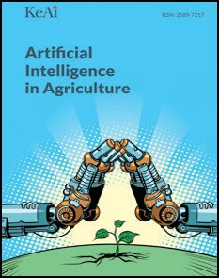](Journal%20logo)[Artificial Intelligence in Agriculture 10 (2023) 1–12](https://doi.org/10.1016/j.aiia.2023.09.001)

Contents lists available at [ScienceDirect](http://www.sciencedirect.com/science/journal/)

Artificial Intelligence in Agriculture

journal homepage: [http://www.keaipublishing.com/en/journa ls/artificial- intelligence- in-agriculture/](http://www.keaipublishing.com/en/journals/artificial-intelligence-in-agriculture/)

[](http://crossmark.crossref.org/dialog/?doi=10.1016/j.aiia.2023.09.001&domain=pdf)Crop diagnostic system: A robust disease detection and management system for leafy green crops grown in an aquaponics facility

R. Abbasi a, P. Martinez b, R. Ahmad a,⁎

a *Aquaponics 4.0 Learning Factory (AllFactory), Department of Mechanical Engineering, University of Alberta, 9211 116 St., Edmonton, AB T6G 2G8, Canada*

b *Mechanical and Construction Engineering Department, Northumbria University, Newcastle Upon Tyne NE7 7YT, UK*

a r t i c l e i n f o

*Article history:*

Received 4 August 2022

Received in revised form 7 July 2023 Accepted 6 September 2023

Available online 09 September 2023

*Keywords:* Computer vision Deep learning Disease detection Leafy crops Aquaponics Digital farming

a b s t r a c t

Crops grown on aquaponics farms are susceptible to various diseases or biotic stresses during their growth cycle, just like traditional agriculture. The early detection of diseases is crucial to witnessing the efficiency and progress of the aquaponics system. Aquaponics combines recirculating aquaculture and soilless hydroponics methods and promises to ensure food security, reduce water scarcity, and eliminate carbon footprint. For the large-scale imple- mentation of this farming technique, a unified system is needed that can detect crop diseases and support re- searchers and farmers in identifying potential causes and treatments at early stages. This study proposes an automatic crop diagnostic system for detecting biotic stresses and managing diseases in four leafy green crops, lettuce, basil, spinach, and parsley, grown in an aquaponics facility. First, a dataset comprising 2640 images is con- structed. Then, a disease detection system is developed that works in three phases. The first phase is a crop clas- sification system that identifies the type of crop. The second phase is a disease identification system that determines the crop's health status. The final phase is a disease detection system that localizes and detects the diseased and healthy spots in leaves and categorizes the disease. The proposed approach has shown promising results with accuracy in each of the three phases, reaching 95.83%, 94.13%, and 82.13%, respectively. The final dis- ease detection system is then integrated with an ontology model through a cloud-based application. This ontol- ogy model contains domain knowledge related to crop pathology, particularly causes and treatments of different diseases of the studied leafy green crops, which can be automatically extracted upon disease detection allowing agricultural practitioners to take precautionary measures. The proposed application finds its significance as a de- cision support system that can automate aquaponics facility health monitoring and assist agricultural practi- tioners in decision-making processes regarding crop and disease management.

© 2023 The Authors. Publishing services by Elsevier B.V. on behalf of KeAi Communications Co., Ltd. This is an open

access article under the CC BY-NC-ND license (<http://creativecommons.org/licenses/by-nc-nd/4.0/>).

1. Introduction

An aquaponic system is the combination of two well-known tech- nologies, namely recirculating aquaculture system (RAS) and a hydro- ponics system (soilless growing of plants) that work together in an integrated environment (Abbasi et al., 2021a). The rationale of this soil- less growing system involves sharing the mutual benefit of the available resources, such as water and nutrients, between aquaculture and plant production. Fish eats food and excretes waste consisting of ammonia (NH+) and other constituents, which are then converted by certain microbes to nitrates (NO−). This enriched effluent is then pumped into the hydroponic component of the system, where the nutrients are readily available for uptake. Under this general idea, it can be implied

3

3

* Corresponding author.

*E-mail address:* [rafiq.ahmad@ualberta.ca](mailto:rafiq.ahmad@ualberta.ca) (R. Ahmad).

that aquaponic is a green and sustainable food production system (Yanes et al., 2020).

Despite all the advantages offered by this emerging and growing technology, a few challenges need special attention, particularly consid- ering its large-scale implementation. Being a greenhouse and a symbi- otic environment, the parameters and factors (light, temperature, pH, moisture, etc.) that need to be controlled are diverse (Abbasi et al., 2021b). For the system to be functional and efficient, a delicate equilib- rium among these parameters must be established (Gillani et al., 2022). Optimal conditions must be met for the growth and development of all three varieties of organisms that are present in the system (fish, bacte- ria, and plants). Another significant challenge is related to crop diseases resulting from either nutrient deficiency or inadequate management of the system, impacting crop quality and causing crop wastage (Dhal et al., 2022; Stouvenakers et al., 2019). As Khirade and Patil pointed out, identifying crop diseases and applying disease management prac- tices are key to preventing losses in the yield and quantity of agricultural

<https://doi.org/10.1016/j.aiia.2023.09.001>

2589-7217/© 2023 The Authors. Publishing services by Elsevier B.V. on behalf of KeAi Communications Co., Ltd. This is an open access article under the CC BY-NC-ND license ([http://](http://creativecommons.org/licenses/by-nc-nd/4.0/) [creativecommons.org/licenses/by-nc-nd/4.0/](http://creativecommons.org/licenses/by-nc-nd/4.0/)).

products (Khirade and Patil, 2015). For this reason, early detection of disease outbreaks is crucial for the progress of aquaponics farms. Tradi- tionally, crop diagnostic is performed by agricultural specialists who vi- sually examine the plant leaves. This practice, however, is subjective, destructive, time-consuming, and labor-intensive (Dutot et al., 2013). Moreover, it also requires the experts to be proficient with extensive knowledge of various diseases, their symptoms, and treatments (Khan et al., 2022). Other methods include chemical analyses, leaf color chart (LCC) matching, soil plant analysis development (SPAD), hyperspectral imaging, and spectral remote sensing, which again are either time- consuming or costly or destructive techniques (Weaver et al., 2020). To address these problems, different automatic crop disease detection systems based on artificial intelligence (AI) techniques such as machine learning and deep learning are developed as they offer contactless, rapid, environmental-friendly, and accurate methods for performing a non-invasive evaluation of crops' health and quality (Bedi and Gole, 2021; Singh et al., 2020). Deep learning techniques offer two significant advantages over machine learning techniques. First, the feature extrac- tion process is automatic, and second, the time to process large datasets of high dimensions is significantly reduced (Bedi and Gole, 2021).

In addition to disease detection, it is also paramount that farm prac- titioners and researchers have access to relevant information about crop management strategies that allow them to pick up methods and treat- ments appropriately to prevent diseases, thereby gaining both eco- nomic and environmental benefits (Barosa et al., 2019). In most cases, such information is dispersed throughout multiple heterogeneous data sources — posing a need for a unified model that contains knowl- edge about the causes and treatments of different crop diseases. Seman- tic technologies such as ontologies have proven effective for data integration in multiple domains (Rodríguez-García et al., 2021). An on- tology is a formal and explicit specification of a shared conceptualiza- tion (Studer et al., 1998). The logical formalisms behind ontological models allow autonomous agents to interpret the information that is being processed (Horrocks et al., 2005). Ontology can be used to con- struct a knowledge base containing relevant information about causes and suggested treatments of crop diseases, which can be extracted upon disease detection (Rodríguez-García et al., 2021). With this infor- mation, farm practitioners are able to get clear guidelines to effectively perform crop monitoring and disease management.

In this study, an automatic system based on deep learning tech-

niques is presented for the detection and classification of diseases in four leafy green crops, lettuce, basil, parsley, and spinach, grown in an aquaponics facility. Taking advantage of semantic technologies, an on- tology model, ‘AquaONT’ is developed by authors in previous work (Abbasi et al., 2021b) that contains knowledge about causes and treat- ments of different diseases. This ontology model is integrated with a dis- ease detection system through an interface established on a cloud- based application.

The remainder of the paper is structured as follows: Section 2 sum- marizes the most recent literature related to crop disease detection sys- tems, Section 3 presents the methodology used to design the proposed system, Section 4 discusses the experimental results and findings, and finally, Section 6 concludes the paper and presents the future prospects.

1. Related work

The rapid developments in AI have made a major breakthrough in deep learning (DL) and computer vision (CV) technologies by solving complex problems like image classification, object detection, speech recognition, voice recognition, natural language processing, and medi- cal imaging, among others (Abbasi et al., 2022a; Subeesh and Mehta, 2021). In particular, convolutional neural networks (CNNs) have proved their efficiency in various sectors such as automotive, healthcare, or re- tail, and are also being integrated in agriculture for automatic crop dis- ease detection — presenting a reasonable alternative to traditional practices (Pathan et al., 2020). In recent years, several models and

applications have been developed for crop disease identification and diagnosis. This section investigates some latest works present in the literature.

Anami et al. designed a deep convolutional neural network (DCNN) based framework for automatic recognition and classification of various biotic and abiotic paddy crop stresses using the pre-trained visual ge- ometry group model, VGG-16 (Anami et al., 2020). The field images are used in the proposed approach captured during the booting growth stage. Bedi and Gole proposed a hybrid model based on a convolutional autoencoder (CAE) network and CNN for automatic bacterial spot dis- ease detection present in peach plants using their leaf images from a publicly available dataset named ‘PlantVillage’ (Bedi and Gole, 2021). Paymode and Malode developed a CNN-based method using pre- trained VGG-16 for detecting healthy, unhealthy, and diseased leaves in tomato and grape plants (Paymode and Malode, 2022). Fuentes et al. combined ResNet with Faster R-CNN, R-FCN, and SSD. They pro- posed a method to detect the diseases and insect pests of tomato plants, achieving the effective identification of nine different types of diseases and insect pests (Fuentes et al., 2017). Chen et al. proposed a method to detect rice plant diseases using the DenseNet model of deep transfer learning (Chen et al., 2020).

To identify the cucumber disease spots in greenhouses, Ma et al. de- veloped a CNN-based system, combining a compound color feature with a region-growing algorithm (Ma et al., 2018). A disease recognition al- gorithm based on VGGNet and InceptionV3 with reduced model size and improved recognition accuracy is proposed by Rahman et al. for rice plants (Rahman et al., 2020). Oppenheim et al. proposed a disease classification algorithm based on an improved VGG network for accu- rate and quick identification and classification of spots on potato crops (Oppenheim et al., 2019). A method based on an improved CNN is pro- posed by Fan et al. to identify nine kinds of common corn diseases from images with a complex background (Fan et al., 2021). Khan et al. pro- posed an apple disease detection system that works in two stages (Khan et al., 2022). Based on the Xception model, the first stage clas- sifies whether the leaf is healthy or diseased, and the second stage, based on Faster-RCNN, performs disease detection.

Qi et al. developed a disease recognition system based on an im-

proved YOLOv5 (squeeze-and-excitation (SE) module is added) model to identify the tomato virus diseases in the greenhouse (Qi et al., 2022). Nandhini et al. proposed a deep learning model that combines RNN and CNN for disease classification and early prediction in the Plan- tain tree (Nandhini et al., 2022). Abbas et al. proposed a deep learning- based method for tomato disease detection that utilizes the Conditional Generative Adversarial Network (C-GAN) to generate synthetic images of tomato plant leaves (Abbas et al., 2021). A DenseNet121 model was then trained on synthetic and real images using transfer learning to clas- sify the tomato leaves images into ten categories of diseases. An efficient detection model (EFDet) consisting of an efficient backbone network, a feature fusion module, and a predictor is proposed for the detection of cucumber leaf diseases in complex backgrounds by Liu et al. (Liu et al., 2021). Likewise, a YOLOv5-based disease detection model to detect bac- terial spot disease in bell pepper plant from the symptoms seen on the leaves (Mathew and Mahesh, 2022).

A framework is proposed for an aquaponics system based on image processing and decision tree methodology that performs disease detec- tion of four leaf species, eggplant, chilli, citrus, and mandarin, and auto- matically generates a report which is sent to the owner through the mobile application if the disease is detected (Barosa et al., 2019). Like- wise, a CNN-based approach for detecting plant disease in smart hydro- ponics provides a tool to the farmers capable of doing the task of an agricultural extension worker with even better accuracy (Musa et al., 2021). An application based on image processing and SVM is developed to classify apple diseases (Lisha Kamala and Anna Alex, 2021). Yudha et al. proposed a model based on Faster R-CNN with Inception V2 algo- rithm to recognize the diseases in hydroponic lettuce (Yudha Pratama et al., 2020).

The literature survey has revealed that researchers have extensively used deep learning techniques for plant or crop disease detection and classification. The analysis shows that most disease detection systems are developed for open-air farms. Only a few systems are developed for modern farming systems, such as aquaponics or hydroponics. Most models are developed considering multiple diseases of only one crop. Moreover, to the best of the authors' knowledge, no comprehensive and unified disease detection system is proposed for identifying dis- eases of multiple leafy green crops grown in aquaponics facilities.

Disease detection in leafy green presents various challenges. For in- stance, there exists a strong resemblance among the foliage of different leafy green crops that might impact the performance of the detection system. Secondly, due to differences in light illumination during imag- ing, the visual symptoms of different diseases may appear similar. An- other challenge is the availability of a dataset of leafy green crops that can be used for disease detection. Deep learning models require a huge amount of data for training, and to the best of the author's knowl- edge, there is no sufficient sized large-scale open-source dataset avail- able that can be utilized for this research. There are a few datasets, such as PlantVillage, PlantDoc, and CropDeep (Noyan, 2022; Singh et al., 2019; Zheng et al., 2019). PlantDoc and PlantVillage are open- source datasets with no categories of leafy green crops. CropDeep dataset contains images of some of the leafy green, but it is not open source. Lastly, none of the aforementioned models provides information related to the causes and treatments of detected diseases.

Apart from AI techniques, ontology-based systems are also devel- oped over the years for plant disease diagnosis and treatment recom- mendations. Jearanaiwongkul et al. developed an ontology-based expert system called ‘RiceMan’ for disease identification and control recommendation in rice crops (Jearanaiwongkul et al., 2021). Likewise, Rodríguez-García et al. proposed a decision support system based on an ontology model for crop pests and diseases recognition (Rodríguez- García et al., 2021). It also provides information on agriculture practices and permitted pest control measures. In these systems, users are re- quired to select crop and observed symptoms from the list for further processing, which is a time-consuming process. Whereas, in deep learn- ing models, this information can be obtained by using crop images. Deep learning techniques can be combined with ontology models to develop efficient decision support systems for disease mana*gem*ent in crops. The idea of combining the two techniques is relatively new in the agricul- ture sector, and hence, limited work is done in this regard that primarily focuses on enabling smart services (monitoring and control) in IoT- based farming systems or detection of cyber-attacks (Abbasi et al., 2021b).

Considering the research gaps and potential opportunities, this

study aims to create a dataset consisting of high-quality RGB images (healthy and diseased) of four leafy green crops: little gem romaine let- tuce, spinach, parsley, and basil. This study also aims to develop a crop diagnostic system based on deep learning models and ontology models for detecting diseases and identifying causes and potential treatments in stated crops, respectively.

1. Research methodology

The block diagram illustrating the three sequential modules of the research methodology is shown in Fig. 1. First module involves the preparation of the dataset and training of classification and object de- tection models. The disease detection model works in three phases. The first and second phase uses lightweight classification models to classify the type of crop and identify whether the classified crop has a disease or not, respectively. Phase 3 is the detection stage that uses an object detection model to detect and localize the diseased and non-diseased spots in the crops. The third phase also tells the class of the diseased spots. The purpose behind adding two classifica- tion phases before the detection phase is three-fold. First, to improve the detection performance by reducing the number of wrong

detections which could arise as the model has to identify and localize different disease spots of varying sizes. Second, to determine the characteristics of the crop identified in the first phase in relation to aquaponics' system design by linking it with the knowledge model. Lastly, to reduce the overall processing time by filtering out invalid inputs in the second phase. The second module aims to extract the in- stances of relevant classes such as potential causes and treatments of detected diseases from the ontology model ‘AquaONT’ developed by authors in previous work (Abbasi et al., 2021b). In the third module, a cloud-based application is developed using Streamlit1, where a pre-trained disease detection model and ontology model are de- ployed to obtain a complete crop diagnostic system. Upon identifica- tion of the crop in phase 1, its characteristics in relation to optimal environmental (pH, temperature, illumination, etc.), growth (width, height, area, etc.), and grow bed design (plant site spacing) parame- ters for an aquaponics facility are extracted from ontology model using OWLready22 (ontology-oriented programming package in Py- thon). The authors have conducted a study that identified design pa- rameters as vital knowledge in ensuring high crop yields and product quality in an aquaponics facility (Abbasi et al., 2021a). Likewise, once the disease and its type are detected in phase 3, the potential causes and recommended treatments are extracted from the ontology model. Each element of each module is presented in detail in the fol- lowing subsections.

* 1. *Dataset preparation*

The dataset preparation involves three steps, i) data acquisition, ii) data annotation, and iii) data augmentation, which are detailed below.

* + 1. *Data acquisition*

This study considers four leafy green crops, lettuce, basil, parsley, and spinach. The dataset consists of healthy and diseased images of these crops, which are acquired from different sources such as NFT based aquaponics facility built in AllFactory 4.0 Lab (University of Al- berta, Canada), Google search engine, and Ecosia3 (a search engine based in Berlin, Germany). The diseases considered for the four crops while developing the dataset are listed below.

* + - * Lettuce: Bacterial leaf spot and Downy mildew
      * Basil: Downy mildew
      * Parsley: Septoria leaf spot
      * Spinach: Downy mildew and Stemphylium leaf spot

To enhance the flexibility of the model to correctly classify and de- tect disease, it is ensured that images have non-homogeneous back- grounds, different illumination conditions, and disease maturity stages (Jha et al., 2019). A total of 2000 images are gathered from all the re- sources. Among these images, 800 images showed healthy crops (200 images per crop), and 1200 images showed the diseases mentioned above (240 images per disease). Fig. 2 shows some of the sample images from the dataset.

* + 1. *Data annotation*

Data annotation is one of the vital steps for the successful devel- opment of object detection models. The process is manual and in- volves labeling the desired objects in an image with a label or tag that refers to a particular class. The labeled data is used during the training of the model. There are various open-source annotation tools, but in this study, LabelImg4 is used. LabelImg is a python based graphical annotation tool that supports a variety of deep learning algorithms (Qi et al., 2022). In this study, the annotations

1 <https://streamlit.io/>.

2 <https://pypi.org/project/Owlready2/>.

3 <https://www.ecosia.org/>.

4 <https://github.com/tzutalin/labelImg>.

  

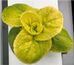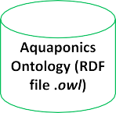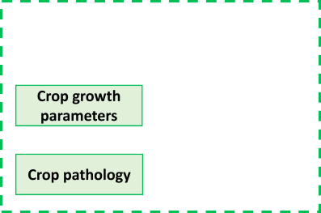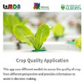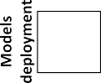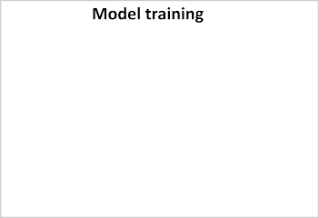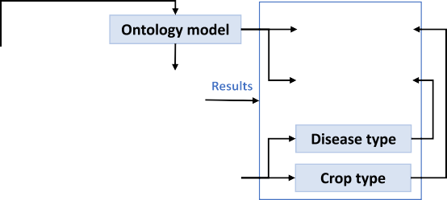

Fig. 1. Proposed methodology for disease detection and control recommendation system.

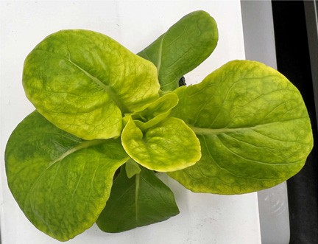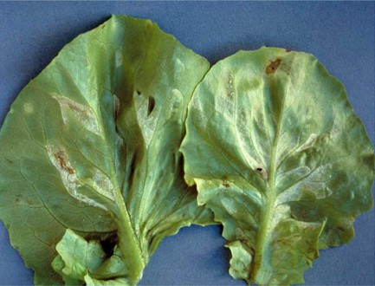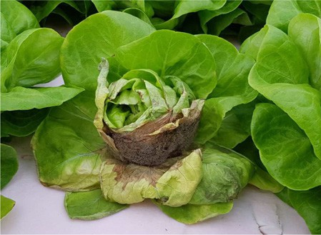



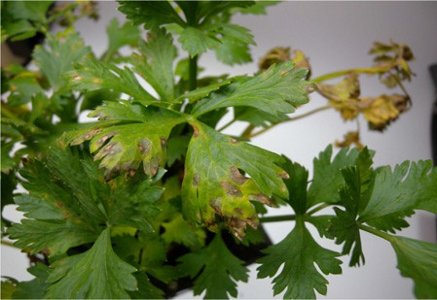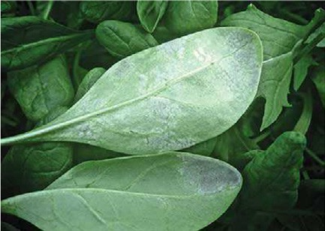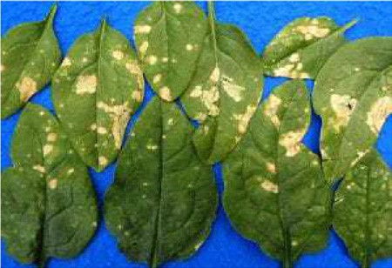



Fig. 2. Samples from leafy green image dataset. (For interpretation of the references to color in this figure legend, the reader is referred to the web version of this article.)

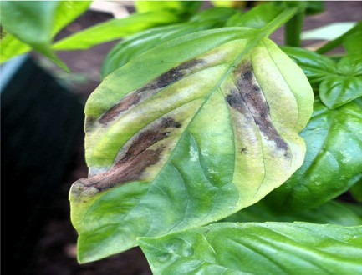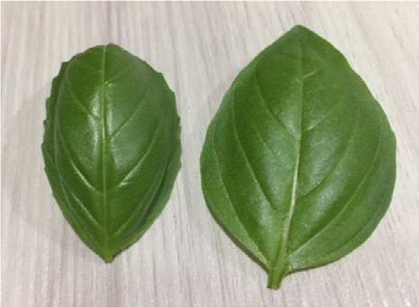are generated in COCO JSON and YOLO Darknet TXT formats because in the disease detection phase, two object detection models are tested to design the final system.

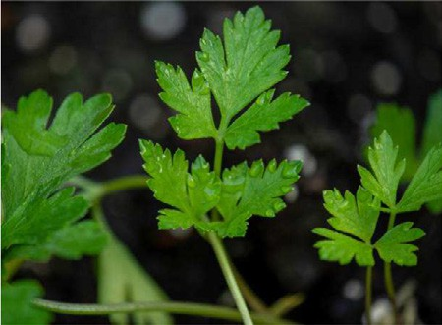

* + 1. *Data augmentation*

Next, the data augmentation process is performed to supplement and enrich the dataset. This helps increase the model's generalizability and overcome the problem of overfitting. Moreover, it also allows the model to learn as many relevant features as possible. This study uses Albumentations, a Python library, for fast and flexible image augmenta- tions (Buslaev et al., 2020). The different augmentation techniques ap- plied are flip, rotation, noise, blur, and brightness. Fig. 3 shows examples of different augmentation operations. After applying the data augmentation, the final dataset comprises of 2640 images with their annotations. The final distribution of the dataset is presented in Table 1.

* 1. *Disease detection model development*

Object detection is a complex task, and disease detection of leafy green crops comes with its own set of challenges. To overcome these challenges, the detection process in this study is divided into three pri- mary phases. Fig. 4 shows the detailed pipeline of the disease detection model.

The first phase of the proposed system uses a lightweight CNN ar- chitecture to classify input images into one of the four types of crops: lettuce, basil, parsley, and spinach. ResNet-50 is used as the base model for the CNN architecture in this study and its last layer is re- placed with one global average pooling layer, one dense layer (fully connected layer) of size 1024 and activation function ReLu, and one output layer that uses Softmax for classification task and making final predictions. ResNet050 is used as it has a simple design, high ac- curacy, and is suitable for small datasets (He et al., 2015). The crop

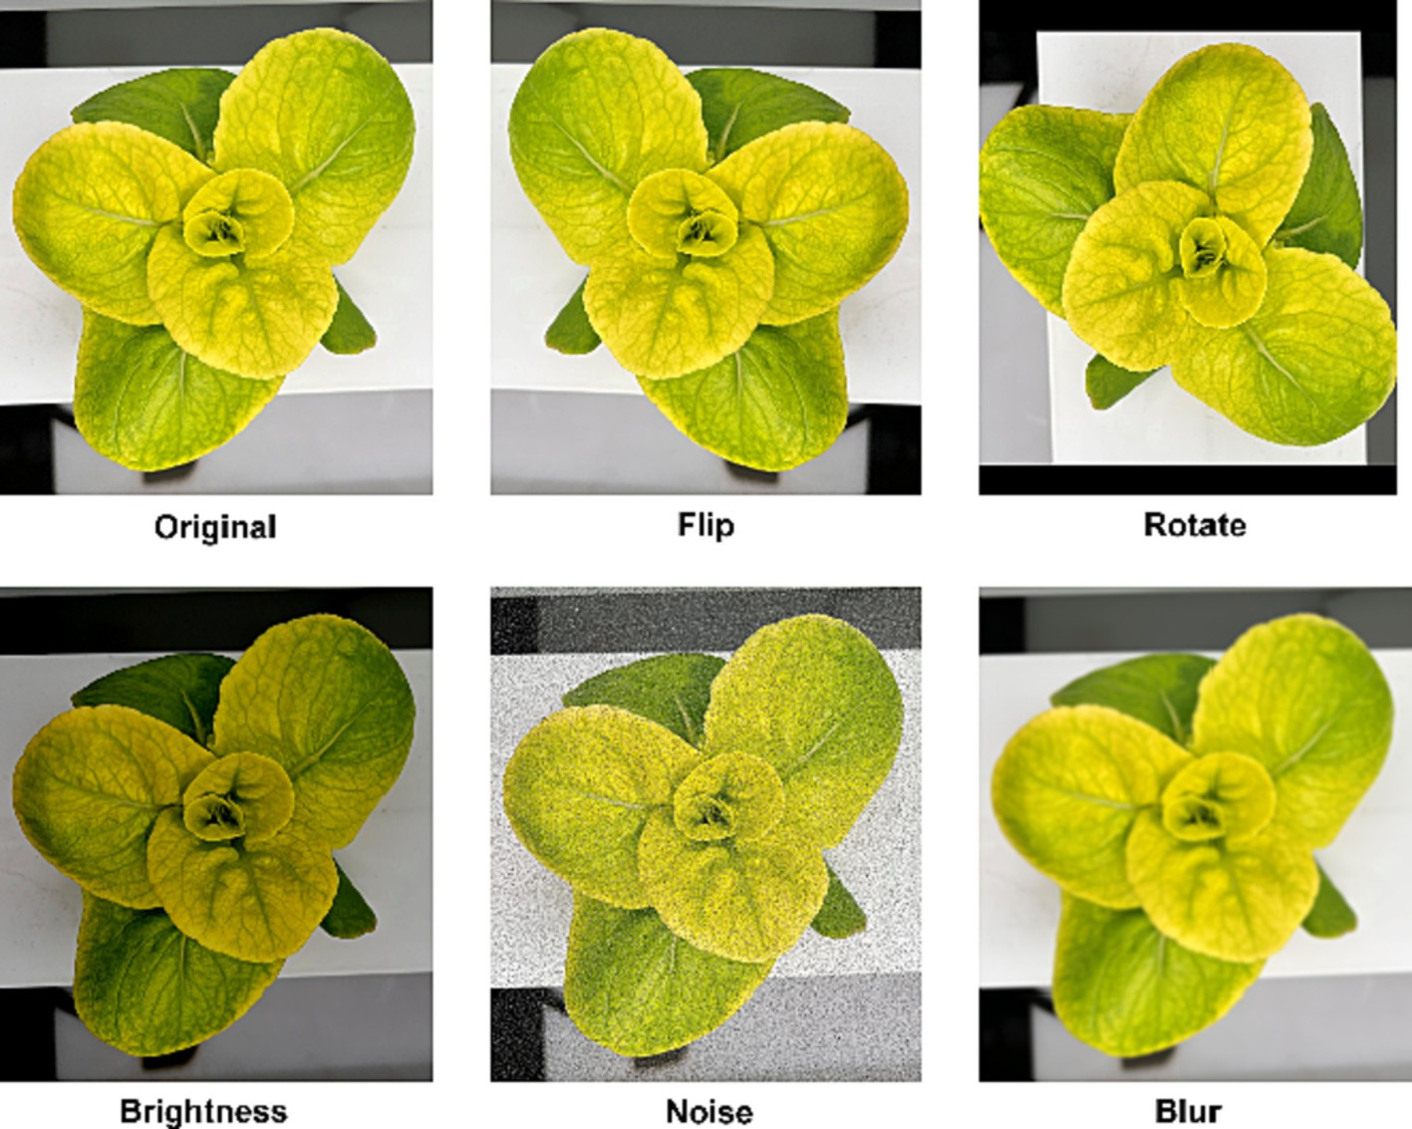

Fig. 3. Example of different augmentation operations applied on original image.

type identified in this stage saves to a folder and also acts as an input to the next phase.

Table 1

Distribution of crop information in the used dataset among the studied crops.

Phase 2 of the system also uses ResNet-50 and classifies the input

|  |  |  |  |  |
| --- | --- | --- | --- | --- |
| Crop | Healthy | Diseased |  | Total |
|  |  | Disease 1 | Disease 2 |  |
| Lettuce | 240 | 280 | 280 | 800 |
| Basil | 240 | 280 | – | 520 |
| Spinach | 240 | 280 | 280 | 800 |
| Parsley | 240 | 280 | – | 520 |

from phase 1 into one of the following eight classes.

1. Lettuce-Healthy
2. Lettuce-Diseased
3. Basil-Heathy
4. Basil-Diseased
5. Spinach-Healthy
6. Spinach-Diseased
7. Parsley -Healthy
8. Parsley-Diseased

The architectural design of ReNet-50 used in phase 2 is kept similar as in phase 1 except for the output layer which now has eight classes. If the input image classified into one of the ‘Diseased’ crop categories, it goes to phase 3. On the other hand, if any of the ‘Healthy’ crop categories are identified, the process ends, and the classified image does not go to the next phase for further processing.

The third phase of the proposed system is disease detection, which involves classifying and localizing the diseased spots in an image and classifying them into one of the disease classes mentioned below.

1. Lettuce-Bacterial leaf spot
2. Lettuce-Downy mildew
3. Basil-Downy mildew
4. Parsley-Septoria leaf spot
5. Spinach-Downy mildew
6. Spinach-Stemphylium leaf spot

Phase 3 activates only when the input from the previous phase is one of the ‘Diseased’ categories. To develop a disease detection model, an object detection algorithm is used. In the past recent years, advances in deep learning and computer vision have greatly accelerated the mo- mentum of object detection (Khan et al., 2022). Numerous object detec-

categories: i) two-stage detectors based on region proposal and ii) one-stage detectors based on regression or classification (Nguyen et al., 2020). The popular two-stage detectors are Fast-RCNN, Faster- RCNN, and Mask-RCNN, and one-stage detectors involve YOLO (You Only Look Once) family (Liu et al., 2021).

Khan et al. conducted a research where they ran three different models, Faster-RCNN, YOLOv4, and EfficientDet, to solve a similar kind of problem for apple crops (Khan et al., 2022). It has been observed that Faster RCNN with mAP (mean average precision) of 42.1% outperformed YOLOv4 (mAP of 41.4%) and EfficientDet (mAP of 38%). As per these results, Faster-RCNN seems the right choice for this study. But YOLOv5 model developed by Ultralytics (Glenn, 2023) has substan- tially improved the detection speed while maintaining the detection ac- curacy. Therefore, both approaches are tested in this study.

* 1. *Disease detection model training*

NVIDIA GeForce RTX 3090 is used to train all the models in three phases of the disease detection system. The classification model devel- oped in stage 1 is implemented in PyTorch (an open source machine learning framework based on the torch library developed by Meta AI5). Using the transfer learning (TL) approach, ResNet-50 pre-trained on ImageNet is used (Russakovsky et al., 2015). The pre-trained model

tion algorithms (object detectors) are developed and used in the disease

detection of crops. These detectors are broadly classified into two

5 <https://pytorch.org/hub/pytorch_vision_resnet/>.

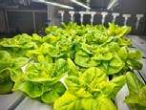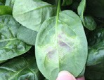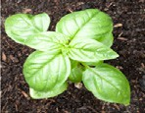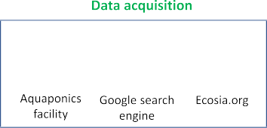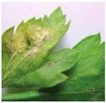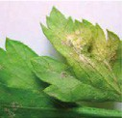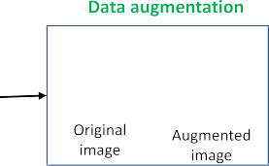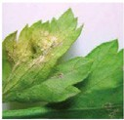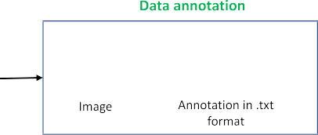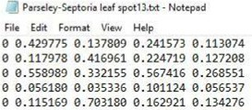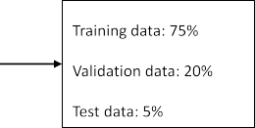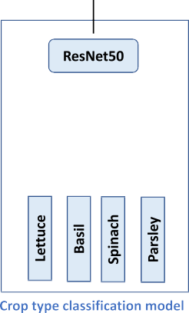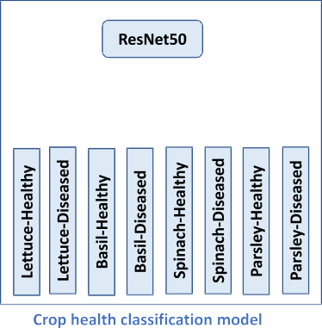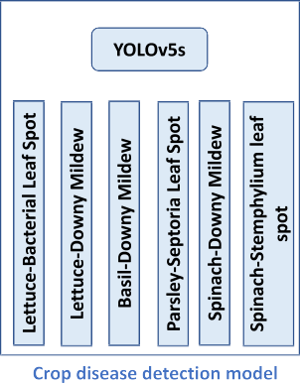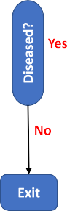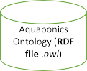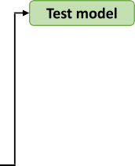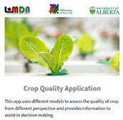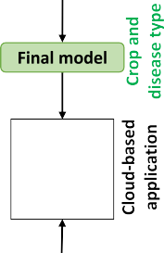

Fig. 4. Detailed pipeline for the crop diagnostic process.

saves a lot of time as it is already trained on some dataset and hence contains the weights and biases of previous training that represent the features of the dataset it was trained on, which are often transferable to different datasets (Abbas et al., 2021). Hence, model parameters are initialized using the TL approach and then retrained on a custom dataset prepared in section 3.1.1 with a learning rate of 0.0001, a batch size of 64, an input size of 224×224×3, and 100 epochs. The model was tuned using the Adam optimizer. For the classification model in phase 2, a batch size of 64 is used, and values of the remaining hyperparameters are kept the same.

For training the object detection models, the dataset is split into 75% for training, 20% for validation, and 5% for testing. The first model is im- plemented in Detectron2 that uses pre-trained architecture (trained on COCO dataset) ‘Faster-RCNN with ResNet-101 + FPN’. The model uses COCO JSON annotation format and is trained for 3000 iterations with the initial learning rate of 0.01 for the first 500 iterations and then

0.001 for the next 2500 iterations.

The second model, YOLOv5s, is implemented in PyTorch. Again, a pre-trained version of the algorithm is used to enhance the training pro- cess and reduce time. For YOLOv5s, the annotation format is YOLO Darknet TXT but with the addition of a YAML file containing model con- figuration and class values. The model is trained for 3000 iterations. The hyperparameters and their values for the two models are shown in Table 2.

* 1. *Ontology model*

The complete development and details of all the concepts and in- stances of ontology model ‘AquaONT’ developed by authors are avail- able at (Abbasi et al., 2021b). AquaONT is a unified ontology model that represents and stores the essential knowledge of an aquaponics

4.0 system. It consists of six concepts: Consumer Product, Ambient Envi- ronment, Contextual Data, Production System, Product Quality, and Pro- duction Facility. In this study, two classes, ‘Consumer Product’ and ‘Product Quality’ are used for knowledge extraction. The ‘Consumer Product’ class provides an abstract view of the type, growth status,

Table 2

Values of hypermeters used for two objection detection methods.

Hyperparameters Methods

|  |  |  |  |
| --- | --- | --- | --- |
|  | Faster-RCNN | YOLOv5s |  |
| Input size | 600 × 600 | 416 × 416 |  |
| Batch size | 16 | 16 |  |
| Learning rate | 0.001 | lr0 = 0.01, lrf = 0.001 |  |
| Momentum | 0.89 | 0.937 |  |
| Gamma value | 0.1 | fl_gamma = 0.0 |  |
| Weight decay | 0.0001 | 0.0005 |  |
| Training time | 1.5 h | 50 min |  |

attributes related to pathology (crop diseases, causes, and the ways and means by which these can be managed or controlled) and morphol- ogy (canopy dimensions such as area, length, width, etc.). Four crops: lettuce, basil, parsley, and spinach, are considered in this study. Their growth conditions and morphological and pathological attributes stored as instances of the respective classes are extracted once the crop and disease are classified. Fig. 5 shows the hierarchical architecture of the ‘Consumer Product’ and ‘Product Quality’ classes with their instances for the ‘Basil’ crop in Protégé6 (an open-source ontology editor and framework developed at Stanford University) environment.

* 1. *Cloud-based application*

The trained model of the crop disease detection system is then saved and deployed on a cloud-based application built on Streamlit. The ontol- ogy model ‘AquaONT’ is also deployed on application, and relevant clas- ses are integrated with the final disease detection model through Owlready2 library. The layout of the application is shown in Fig. 6. It consists of two user inputs ‘Select Model’ and ‘Upload Image’. ‘Select Model’ provides an option to select the model as per requirement, which in this study are ‘Crop Classification’ referring to phase 1, ‘Disease or No Disease’ referring to phase 2, and ‘Disease Type, causes and Treat- ments’ referring to phase 3 of the proposed disease detection system.

and growth parameters of ready-to-harvest crops in an aquaponics sys-

tem. Whereas the ‘Product Quality’ class provides knowledge on crop

6 <https://protege.stanford.edu/products.php#desktop-protege>.

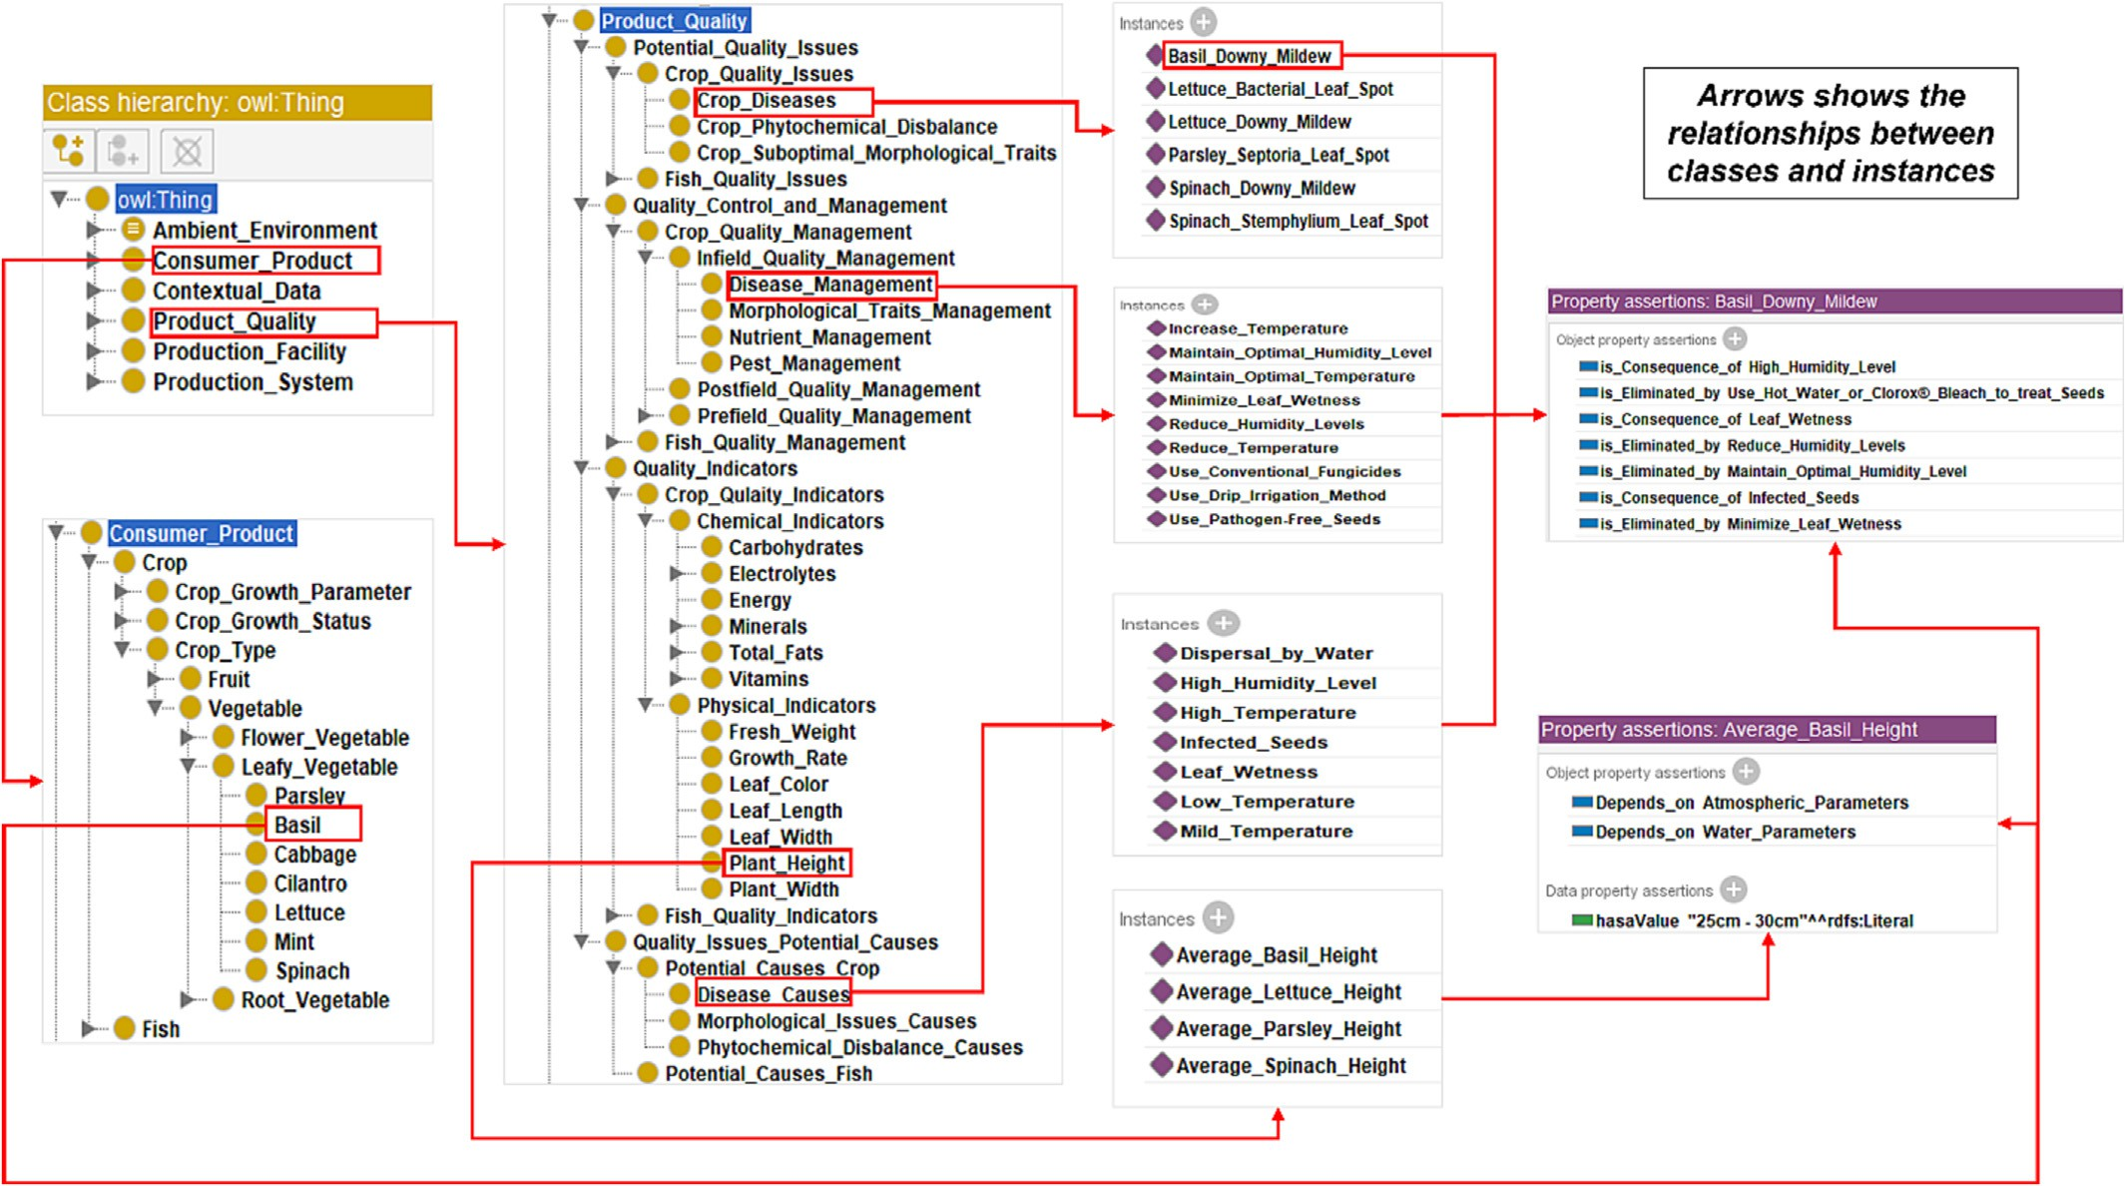

Fig. 5. Hierarchical structure of ‘Consumer Product’ and ‘Product Quality’ classes and respective instances in relation to Basil Crop.

After model selection, an image is uploaded which is used by all the models. Once the disease is detected and classified, the causes and treat- ments of the disease are extracted from the ontology model automati- cally and displayed on the application panel. This kind of information is useful as it will allow agricultural practitioners to determine the causes of diseases and take precautionary steps in the early stages to avoid crop wastage and economic loss.

1. Experimental results and discussion

This section presents the results of experiments performed in the current research work. First, the performance evaluation of deep learn- ing models in three phases of the disease detection system is discussed. Next, the trained and validated system is tested on new data. In the end, the significance of the complete system is presented.

The performance of the classification model in phase 1 is evalu- ated using a validation dataset. For this phase, there are four classes to be classified, namely lettuce, basil, spinach, and parsley. The distri- bution of labeled images in the validation set for this model is shown in Table 3.

The performance of the model is presented in the form of a confu- sion matrix (CM) shown in Fig. 7. The overall accuracy, precision, recall, and F-measure are computed by using the respective formulae, follow- ing common metrics for the performance of deep learning models in the literature (Khan et al., 2022). The computed metrics are summarized in Table 4.

The classification model in phase 1 has achieved an overall accuracy of 95.83%, average precision of 96.25%, average recall of 96%, and aver- age F1-score of 96.25%. As noted in Table 4, the performance metrics of the ‘spinach’ class are lower than the other classes. Most model con- fusion comes in between spinach, basil, and lettuce leaves, particularly during the initial stages of their growth cycle.

Next, the performance of the classification model in phase 2 is eval- uated in a similar fashion. For phase 2, there are six classes that model

classifies, which are mentioned in section 3.2. Table 5 shows the distri- bution of the validation set used for the model in phase 2.

The CM for this model is shown in Fig. 8 and performance metrics are summarized in Table 6.

The classification model in phase 2 has achieved an overall accuracy of 94.13%, average precision of 94%, average recall of 94%, and average F1-score of 93.6%. It can be observed from the CM in Fig. 8 that the model is also prone to confusion in distinguishing between some of the classes. For instance, six examples of LD (Lettuce-Diseased) are clas- sified among LH (1), BD (1), SH (2), and SD (2). This might be due to a lack of clarity in identifying leaf patterns and diseased spots.

Finally, the performance of selected models for the detection phase (phase 3) is evaluated using a validation dataset. For this phase, there are six different diseases that models have to detect in crop leaves. These six diseases and their distribution in the validation dataset are given in Table 7.

In this phase, the metric that is used to evaluate and compare the performance of two models, i-e, Faster-RCNN, and YOLOv5s, is mean av- erage precision (mAP). The mAP is the primary evaluation indicator used for the evaluation of object detection models (Khan et al., 2022). In particular, [mAP@0.5](mailto:mAP@0.5) (mean value of mAP at IOU threshold = 0.5) is evaluated. The comparison of the two models against all the classes is presented in Table 8. It can be seen that YOLOv5s with [mAP@0.5](mailto:mAP@0.5) of 82.13% have outperformed Faster R-CNN. The two models have achieved the best mAP score for Lettuce-Bacterial Leaf Spot (LBS), Parsley-Septoria Leaf Spot (PSS), and Spinach-Stemphylium Leaf Spot (SSS), whereas a low mAP score is observed for Lettuce-Downy Mildew (LDM), Basil-Downy Mildew (BDM), and Spinach-Downy Mildew (SDM). Downy Mildew initially causes light green to yellow angular spots on the upper surfaces of leaves and hence looks similar indepen- dently of the crop type. This causes confusion for the detector in distin- guishing the crop-specific Downy Mildew. But with more data, this issue can easily be resolved. Later in the growth cycle, the plant tissue affected with Downy Mildew turns tan in spinach, purplish brown in

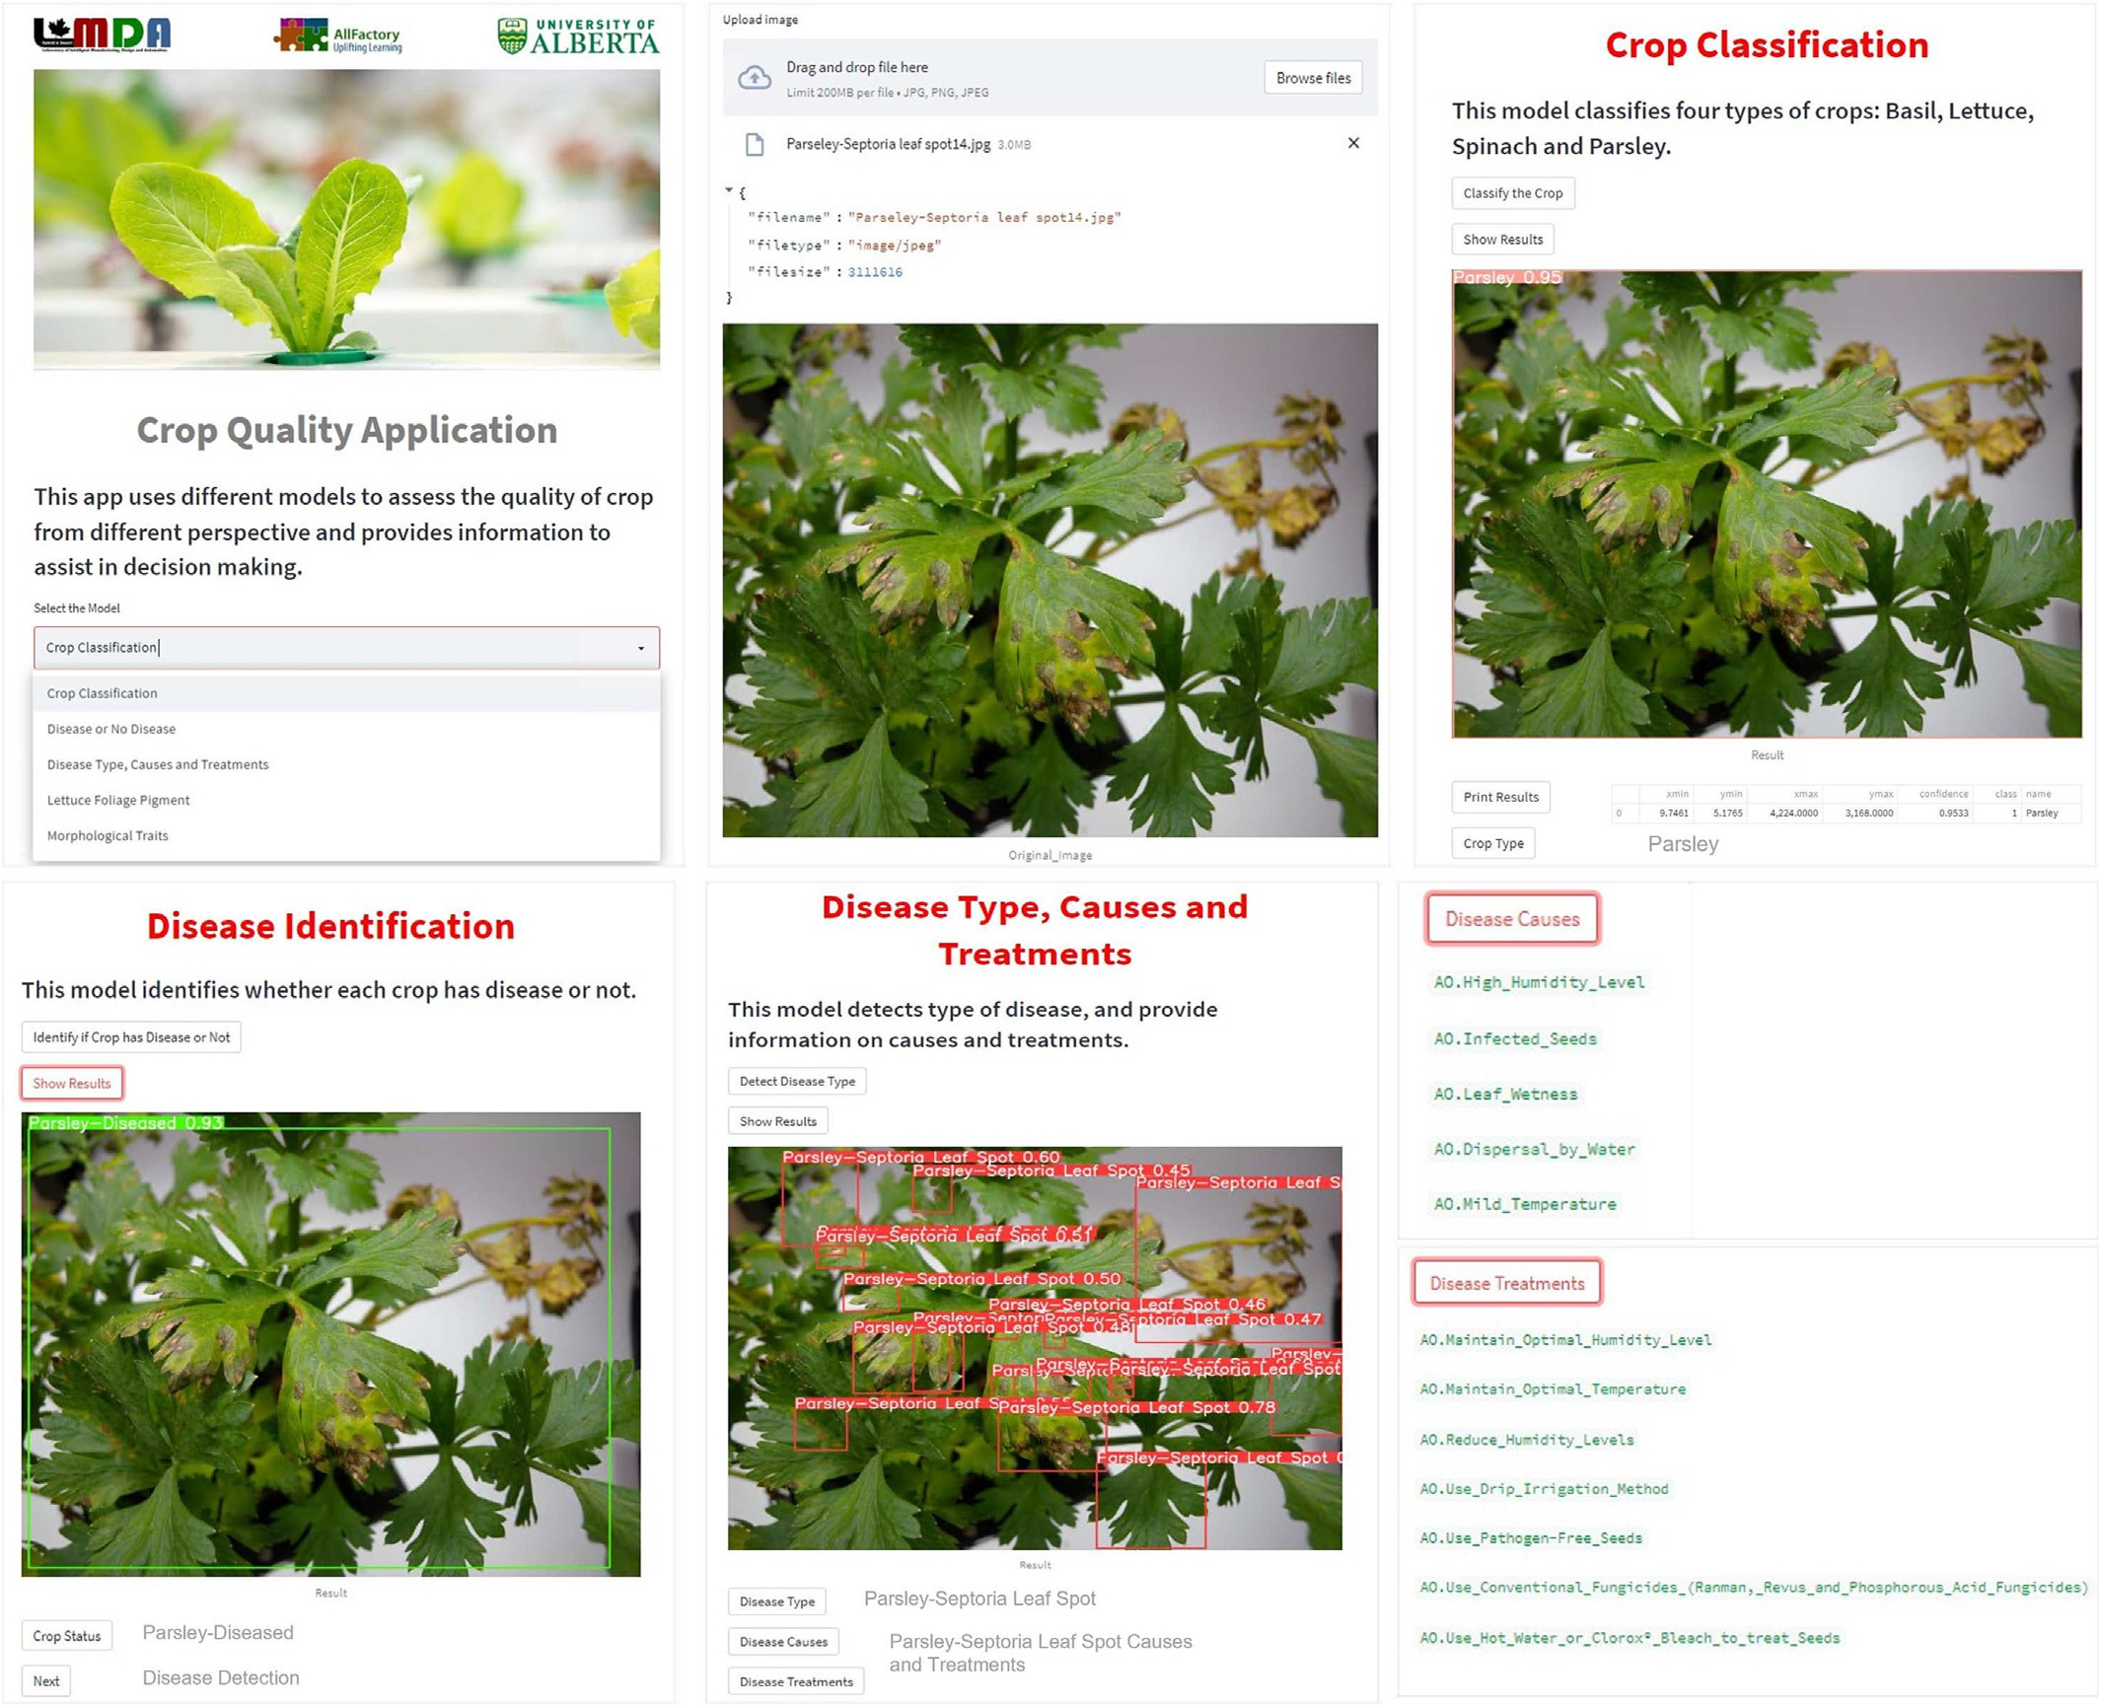

Fig. 6. Layout of cloud-based application for disease detection.

basil, and light brown in lettuce, which are correctly identified by the detector.

The performance evaluations of models in three phases have shown that detection models are not as straightforward as classification models. This is because an image consists of many objects which belong to either the same class or different classes. Hence, three things must be verified during evaluation, including object class, bounding box (object location), and confidence.

In the end, the two detection models are compared in terms of infer- ence time which is an important metric that determines the detection speed. It is observed that one-stage detector i-e., YOLOv5s with a

Table 3

Dataset distribution of validation set for phase 1.

|  |  |
| --- | --- |
| Class (Health + Diseased) | Number of images |
| Lettuce | 160 |
| Basil | 104 |
| Spinach | 160 |
| Parsley | 104 |

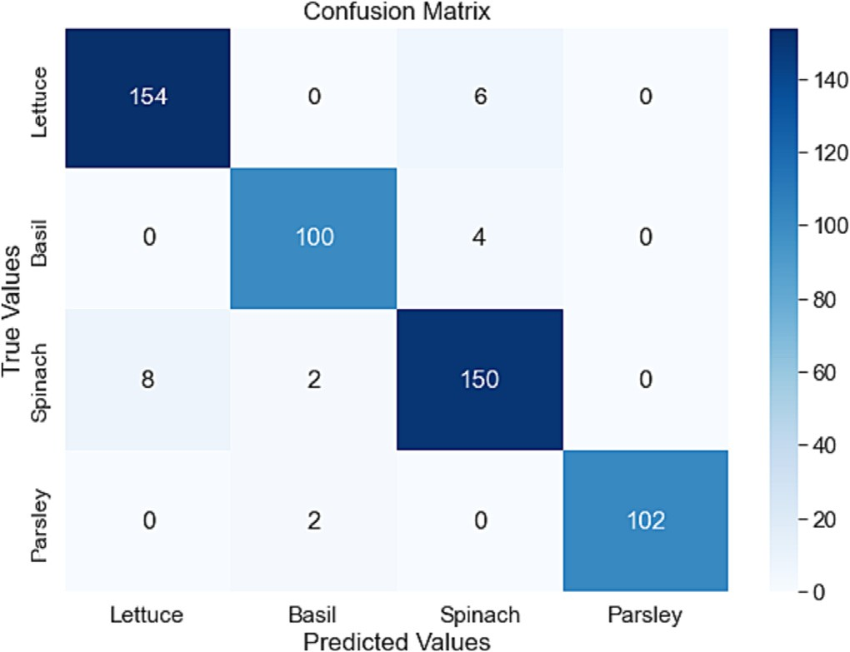

Fig. 7. Confusion matrix of classification results in phase 1.

Table 4

Results of classification model in phase 1.

Table 6

Performance metrics of classification model in phase 2.

|  |  |  |  |  |  |  |  |  |  |  |
| --- | --- | --- | --- | --- | --- | --- | --- | --- | --- | --- |
| Crop | Accuracy | Precision | Recall | F1-Score |  | Class | Accuracy | Precision | Recall | F1-score |
| Lettuce | 0.97 | 0.95 | 0.96 | 0.96 |  | LH | 0.979 | 0.86 | 0.92 | 0.89 |
| Basil | 0.98 | 0.96 | 0.96 | 0.96 |  | LD | 0.981 | 0.96 | 0.95 | 0.95 |
| Spinach | 0.96 | 0.94 | 0.94 | 0.94 |  | BH | 0.989 | 0.90 | 0.98 | 0.94 |
| Parsley | 0.99 | 1 | 0.98 | 0.99 |  | BD | 0.983 | 0.91 | 0.93 | 0.92 |
| Average | – | 96.25% | 96% | 96.25% |  | SH | 0.981 | 0.91 | 0.88 | 0.89 |
| Overall accuracy | 95.83% |  |  |  |  | SD | 0.983 | 0.96 | 0.96 | 0.96 |
|  |  |  |  |  |  | PH | 0.994 | 0.98 | 0.96 | 0.97 |
|  |  |  |  |  |  | PD | 0.992 | 0.98 | 0.96 | 0.97 |
|  |  |  |  |  |  | Average | – | 94% | 94% | 93.6% |

Table 5

Distribution of validation dataset for phase 2.

Class Number of images

Lettuce-Healthy (LH) 48

Lettuce-Diseased (LD) 112

Overall accuracy 94.13%

Table 7

Distribution of validation dataset in phase 3.

|  |  |  |  |  |
| --- | --- | --- | --- | --- |
| Basil-Healthy (BH)  Basil-Diseased (BD) | 48  56 |  | Class | Number of images |
| Spinach-Healthy (SH) | 48 |  | Lettuce-Bacterial Leaf Spot (LBS) | 56 |
| Spinach-Diseased (SD) | 112 |  | Lettuce-Downy Mildew (LDM) | 56 |
| Parsley-Healthy (PH) | 48 |  | Basil-Downy Mildew (BDM) | 56 |
| Parsley-Diseased (PD) | 56 |  | Parsley-Septoria Leaf Spot (PSS) | 56 |
|  |  |  | Spinach-Downy Mildew (SDM) | 56 |
|  |  |  | Spinach- Stemphylium Leaf Spot (SSS) | 56 |

detection speed of 52.8 FPS (frames per second) is faster than Faster- RCNN with a detection speed of 43.2 FPS. Moreover, it is also observed that YOLOv5s accurately detect objects of varying sizes with little to no overlapping boxes. All the comparisons between the two detection models show that YOLOv5s have a clear advantage in terms of accuracy and run speed. Therefore, in this study, YOLOv5s is used for developing the disease detection system.

After training and validation, the final crop disease detection system with YOLOv5s is tested using the test set containing new images. The system has shown promising results by effectively classifying and de- tecting the diseases in specified crops, which shows the system's ro- bustness in terms of dealing with a variety of objects having different shapes, patterns, textures, and colors. Fig. 9 shows examples where the system has accurately classified the crop and detected the diseased

and healthy spots in crop leaves. Images in the first row of Fig. 9 are the results from three phases of the disease detection system for the Lettuce crop, which is suffering from Bacterial Leaf Spot disease. Similarly, row 2 and row 3 are the results from three phases of the system showing Spin- ach and Parsley, respectively, and the diseases they are suffering from, such as Downy Mildew and Septoria Leaf Spot disease respectively.

The final crop disease detection system is then deployed on a cloud- based application developed in section 3.5. Fig. 6 shows the layout of the application. The ontology model discussed in section 3.4 is also inte- grated with the final system to build a complete real-time crop diagnos- tic system. The images are acquired wirelessly from the aquaponics facility through an interface developed on the Google Cloud Platform

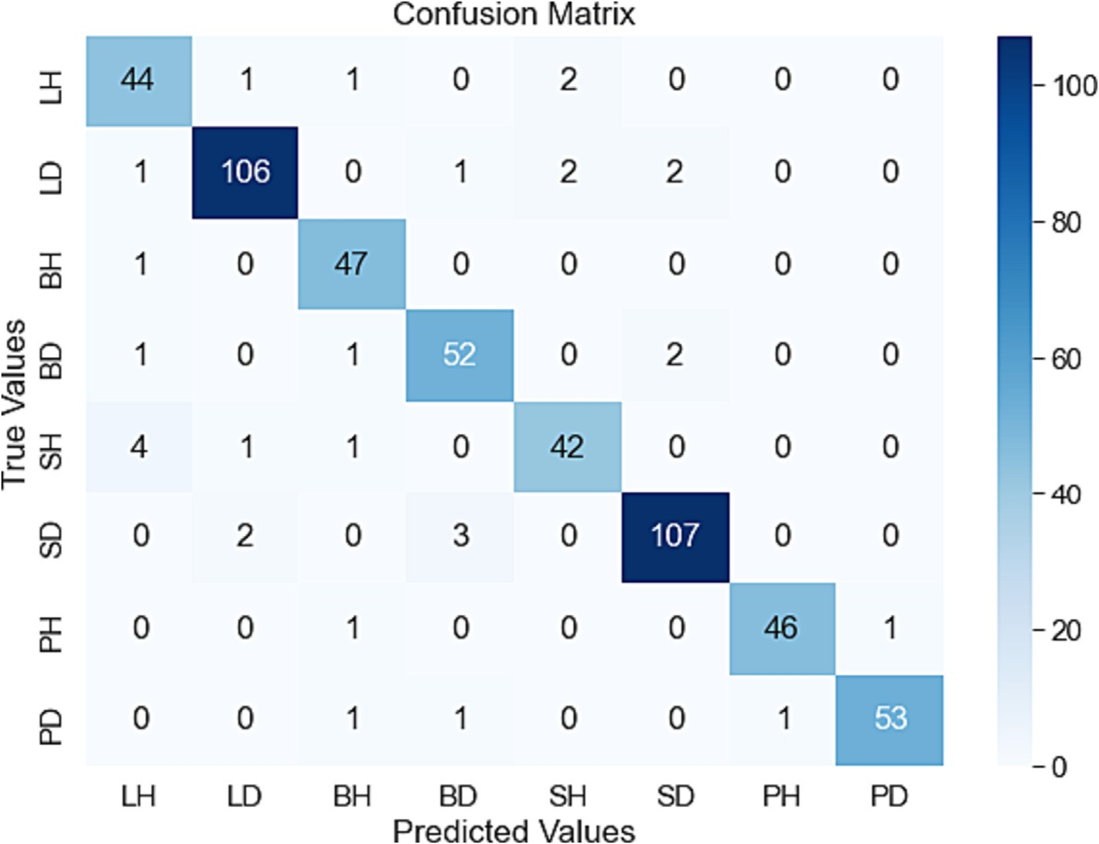

Fig. 8. Confusion matrix of classification results in phase 2.

Table 8

Class-wise comparison of two detection models.

|  |  |  |  |
| --- | --- | --- | --- |
| Class | mAP |  |  |
|  | Faster-RCNN | YOLOV5s |
| Lettuce-Bacterial Leaf Spot (LBS) | 77.32 | 83.86 |  |
| Lettuce-Downy Mildew (LDM) | 73.89 | 78.63 |  |
| Basil-Downy Mildew (BDM) | 75.47 | 80.11 |  |
| Parsley-Septoria Leaf Spot (PSS) | 78.63 | 84.55 |  |
| Spinach-Downy Mildew (SDM) | 74.19 | 79.87 |  |
| Spinach-Stemphylium Leaf Spot (SSS) | 79.52 | 85.74 |  |
| [mAP@0.5](mailto:mAP@0.5) | 76.34 | 82.13 |  |

by the authors in previous work (Abbasi et al., 2022b). The images are stored in a folder to be used by the crop diagnostic system. Once the crop type and its disease are identified, the causes and treatments are automatically extracted from the ontology model and displayed on the application panel. For instance, Fig. 6 shows an example of working crop diagnostic system for parsley crops. The disease detected by the system after image uploading is Septoria Leaf Spot. The crop diagnostic system extracts the knowledge about potential causes and general treatments of this disease from AquaONT. The primary causes of Septoria Leaf Spot in Parsley could be high humidity level, infected seeds, leaf wetness, etc. This disease could also be caused due to irregu- lar variations in air temperature. The potential preventive measures and treatments suggested by the system for this disease include:

maintaining optimal humidity and temperature levels in accordance with Parsley crop and indoor aquaponics environment throughout the growth cycle, treating seeds before germination with hot water or Clorox bleach, using conventional fungicides if the disease is spread out in multiple plants. Downy Mildew disease is one of the most com- mon diseases observed in different crops (McGrath, 2021). In the greenhouse or indoor farming environment, the potential causes of this disease are the same irrespective of crop type, which includes: high humidity, cool temperatures, infected seeds, and leaf wetness (Margaret Tuttle McGrath, 2021). Therefore, the methods to treat Downy Mildew in lettuce, basil, and spinach are also similar. This means that the classification of Downy Mildew disease with respect to crop type does not impact the results related to disease treatments. De- spite this independence, it is still significant to perform the classification of Downy Mildew for each crop individually as its symptoms for three crops, lettuce, basil, and parsley, change later in the growth cycle. This might cause confusion for the detector to distinguish Downy Mildew from other diseases. For instance, the lettuce tissue affected with Downy Mildew eventually turns brown in later stages and these symp- toms are similar to the Bacterial Leaf Spot symptom in lettuce, and both diseases have different treatment methods.

The significance of the proposed system is that it can act as a vital tool for agriculturalists who wants to develop and digitize aquaponics farm. This system will allow them to diagnose diseases at early stages and also assist them in decision-making regarding crop characteristics

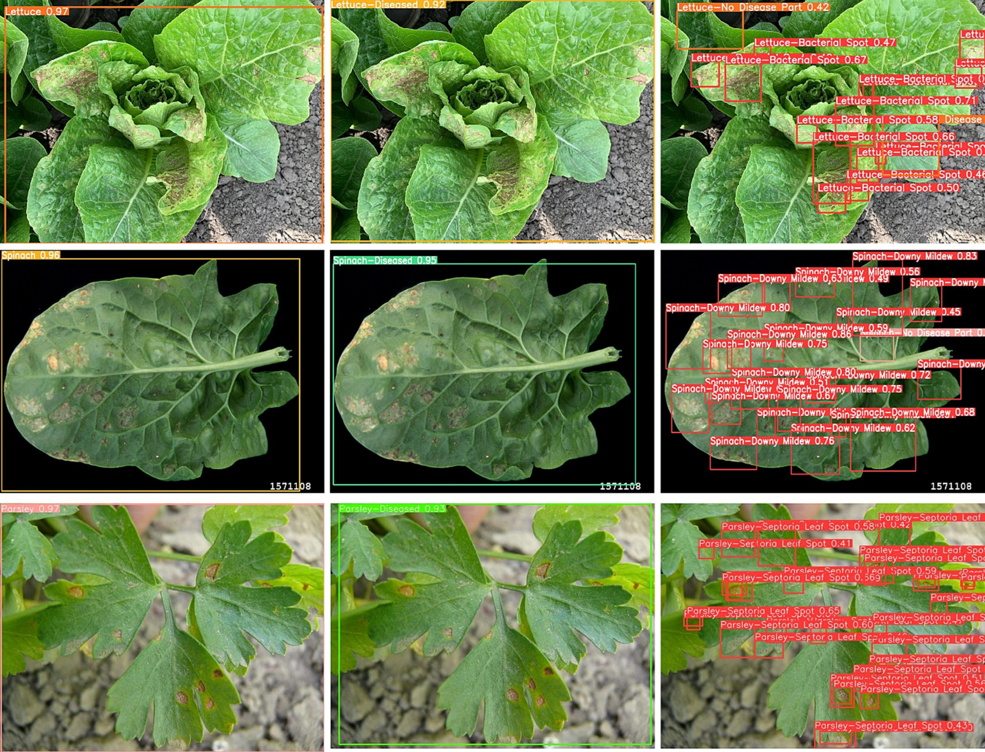

Fig. 9. Results from proposed disease detection system.

and treatments of diseases. Moreover, this study will also promote the introduction of new implementations, such as research on the complex relationship between dynamic parameters (environmental and water) and diseases in aquaponics farms and self-adapting farms in case of dis- ease detection. These smart technologies in the aquaponics system will reduce crop wastage and ensure both economic and environmental benefits.

1. Conclusions and future prospects

This study proposes a crop diagnostic system for leafy green crops grown in an aquaponics environment. Four leafy green crops, lettuce, basil, spinach, and parsley, are considered. The first dataset is devel- oped that contains 2640 healthy and diseased images of these four crops collected from various sources. Next, a system is proposed that can efficiently and effectively identify crops and diseases. The detection system works in three phases. The first phase classifies the crop type, the second phase classifies whether the crop is healthy or diseased, and then in the third phase, the disease is detected if the crop is classified as diseased in the previous phase. All the models used in this study are initialized using transfer learning and then trained on a dataset prepared for leafy green crops. The performance of the models is evaluated, and promising results are achieved. For in- stance, in the detection phase, YOLOv5s with [mAP@0.5](mailto:mAP@0.5) of 82.13% and detection speed of 52.8 FPS has outperformed Faster-RCNN. Based on the performance, YOLOv5s is selected as a final model for this study. The ontology model that contains knowledge related to causes and treatments of diseases is then integrated with the final crop dis- ease detection system. Finally, a cloud-based application is designed where the final crop diagnostic system consisting of a disease detec- tion system and ontology model is deployed. The proposed system proves to be accurate and flexible enough to be used in real scenarios and hence is not limited to being disturbed by potential changing conditions and environments. It can be a helpful tool for agricultural practitioners who want to explore modern farming practices and want to integrate smart techniques into their farms. This system will not only help them in disease diagnosis and quantification but will also assist them in decision-making regarding potential treat- ments against identified diseases at early stages.

For future work, the system will be extended to include other leafy green crops. Moreover, the dataset will also be extended, and more real-field images will be incorporated. Moreover, a mobile application will be constructed, reducing the latency, and providing data privacy, which normally occurs in cloud-based systems.

CRediT authorship contribution statement

R. Abbasi: Conceptualization, Methodology, Software, Validation, Formal analysis, Visualization, Investigation, Data curation, Writing – original draft, Writing – review & editing. P. Martinez: Conceptualiza- tion, Methodology, Visualization, Writing – review & editing, Supervision. R. Ahmad: Supervision, Funding acquisition, Project administration, Writing – review & editing.

Declaration of Competing Interest

The authors declare that they have no known competing financial interests or personal relationships that could have appeared to influ- ence the work reported in this paper.

Acknowledgments

The authors acknowledge the financial support of this work from the Natural Sciences and Engineering Research Council of Canada (NSERC) (Grant File No. ALLRP 545537-19 and RGPIN-2017-04516).

References

Abbas, A., Jain, S., Gour, M., Vankudothu, S., 2021. Tomato plant disease detection using transfer learning with C-GAN synthetic images. Comput. Electron. Agric. 187, 106279. <https://doi.org/10.1016/J.COMPAG.2021.106279>.

Abbasi, R., Martinez, P., Ahmad, R., 2021a. An ontology model to support the automated design of aquaponic grow beds. Proced. CIRP 100, 55–60. [https://doi.org/10.1016/j.](https://doi.org/10.1016/j.procir.2021.05.009) [procir.2021.05.009](https://doi.org/10.1016/j.procir.2021.05.009).

Abbasi, R., Martinez, P., Ahmad, R., 2021b. An ontology model to represent aquaponics 4.0 system’s knowledge. Inf. Process. Agric. <https://doi.org/10.1016/J.INPA.2021.12.001>.

Abbasi, R., Martinez, P., Ahmad, R., 2022a. The digitization of agricultural industry – a sys- tematic literature review on agriculture 4.0. Smart Agric. Technol. 2, 100042. [https://](https://doi.org/10.1016/J.ATECH.2022.100042) [doi.org/10.1016/J.ATECH.2022.100042](https://doi.org/10.1016/J.ATECH.2022.100042).

Abbasi, R., Martinez, P., A.R, 2022b. [Data acquisition and monitoring dashboard for IoT en-](http://refhub.elsevier.com/S2589-7217(23)00031-4/rf0025) [abled aquaponics facility. The 10th International Conference on Control,](http://refhub.elsevier.com/S2589-7217(23)00031-4/rf0025) [Mechatronics and Automation (ICCMA 2022) (Accepted). IEE](http://refhub.elsevier.com/S2589-7217(23)00031-4/rf0025)E.

Anami, B.S., Malvade, N.N., Palaiah, S., 2020. Deep learning approach for recognition and classification of yield affecting paddy crop stresses using field images. Artif. Intell. Agric. 4, 12–20. <https://doi.org/10.1016/J.AIIA.2020.03.001>.

Barosa, R., Hassen, S.I.S., Nagowah, L., 2019. Smart aquaponics with disease detection. 2nd Int. Conf. Next Gener. Comput. Appl. 2019, NextComp 2019 - Proc [https://doi.org/10.](https://doi.org/10.1109/NEXTCOMP.2019.8883437) [1109/NEXTCOMP.2019.8883437](https://doi.org/10.1109/NEXTCOMP.2019.8883437).

Bedi, P., Gole, P., 2021. Plant disease detection using hybrid model based on convolutional autoencoder and convolutional neural network. Artif. Intell. Agric. 5, 90–101. [https://](https://doi.org/10.1016/J.AIIA.2021.05.002) [doi.org/10.1016/J.AIIA.2021.05.002](https://doi.org/10.1016/J.AIIA.2021.05.002).

Buslaev, A., Iglovikov, V.I., Khvedchenya, E., Parinov, A., Druzhinin, M., Kalinin, A.A., 2020. Albumentations: Fast and flexible image augmentations. Inf. 11. [https://doi.org/10.](https://doi.org/10.3390/INFO11020125) [3390/INFO11020125](https://doi.org/10.3390/INFO11020125).

Chen, J., Zhang, D., Nanehkaran, Y.A., Li, D., 2020. Detection of rice plant diseases based on deep transfer learning. J. Sci. Food Agric. 100, 3246–3256. [https://doi.org/10.1002/](https://doi.org/10.1002/JSFA.10365) [JSFA.10365](https://doi.org/10.1002/JSFA.10365).

Dhal, S.B., Bagavathiannan, M., Braga-Neto, U., Kalafatis, S., 2022. Nutrient optimization for plant growth in Aquaponic irrigation using machine learning for small training datasets. Artif. Intell. Agric. 6, 68–76. <https://doi.org/10.1016/J.AIIA.2022.05.001>.

Dutot, M., Nelson, L.M., Tyson, R.C., 2013. Predicting the spread of postharvest disease in stored fruit, with application to apples. Postharvest Biol. Technol. 85, 45–56. [https://](https://doi.org/10.1016/J.POSTHARVBIO.2013.04.003) [doi.org/10.1016/J.POSTHARVBIO.2013.04.003](https://doi.org/10.1016/J.POSTHARVBIO.2013.04.003).

Fan, X., Zhou, J., Xu, Y., Peng, X., 2021. Corn disease recognition under complicated back- ground based on improved convolutional neural network. Nongye Jixie Xuebao/ transactions Chinese Soc. Agric. Mach. 52, 210–217. [https://doi.org/10.6041/J.ISSN.](https://doi.org/10.6041/J.ISSN.1000-1298.2021.03.023) [1000-1298.2021.03.023](https://doi.org/10.6041/J.ISSN.1000-1298.2021.03.023).

Fuentes, A., Yoon, S., Kim, S.C., Park, D.S., 2017. A robust deep-learning-based detector for real-time tomato plant diseases and pests recognition. Sensors 17, 2022. [https://doi.](https://doi.org/10.3390/S17092022) [org/10.3390/S17092022](https://doi.org/10.3390/S17092022).

Gillani, S.A., Abbasi, R., Martinez, P., Ahmad, R., 2022. Review on energy efficient artificial illumination in aquaponics. Clean. Circ. Bioecon. 2, 100015. [https://doi.org/10.1016/J.](https://doi.org/10.1016/J.CLCB.2022.100015) [CLCB.2022.100015](https://doi.org/10.1016/J.CLCB.2022.100015).

Glenn, 2023. Ultralytics/yolov5 [WWW Document]. URL. [https://github.com/ultralytics/](https://github.com/ultralytics/yolov5) [yolov5](https://github.com/ultralytics/yolov5).

He, K., Zhang, X., Ren, S., Sun, J., 2015. Deep residual learning for image recognition. Proc. IEEE Comput. Soc. Conf. Comput. Vis. Pattern Recognit. 2016-December, pp. 770–778 <https://doi.org/10.48550/arxiv.1512.03385>.

Horrocks, I., Patel-Schneider, P.F., Bechhofer, S., Tsarkov, D., 2005. OWL rules: a proposal and prototype implementation. Web Semant. [https://doi.org/10.1016/j.websem.](https://doi.org/10.1016/j.websem.2005.05.003) [2005.05.003](https://doi.org/10.1016/j.websem.2005.05.003).

Jearanaiwongkul, W., Anutariya, C., Racharak, T., Andres, F., 2021. An ontology-based ex- pert system for Rice disease identification and control recommendation. Appl. Sci. 11, 10450. <https://doi.org/10.3390/APP112110450>.

Jha, K., Doshi, A., Patel, P., Shah, M., 2019. A comprehensive review on automation in ag- riculture using artificial intelligence. Artif. Intell. Agric. 2, 1–12. [https://doi.org/10.](https://doi.org/10.1016/J.AIIA.2019.05.004) [1016/J.AIIA.2019.05.004](https://doi.org/10.1016/J.AIIA.2019.05.004).

Khan, A.I., Quadri, S.M.K., Banday, S., Latief Shah, J., 2022. Deep diagnosis: a real-time apple leaf disease detection system based on deep learning. Comput. Electron. Agric. 198, 107093. <https://doi.org/10.1016/J.COMPAG.2022.107093>.

Khirade, S.D., Patil, A.B., 2015. Plant disease detection using image processing. Proc. - 1st Int. Conf. Comput. Commun. Control Autom. ICCUBEA 2015, pp. 768–771. [https://doi.](https://doi.org/10.1109/ICCUBEA.2015.153) [org/10.1109/ICCUBEA.2015.153](https://doi.org/10.1109/ICCUBEA.2015.153).

Lisha Kamala, K., Anna Alex, S., 2021. Apple fruit disease detection for hydroponic plants using leading edge technology machine learning and image processing. Proc. - 2nd Int. Conf. Smart Electron. Commun. ICOSEC 2021, pp. 820–825. [https://doi.org/10.](https://doi.org/10.1109/ICOSEC51865.2021.9591903) [1109/ICOSEC51865.2021.9591903](https://doi.org/10.1109/ICOSEC51865.2021.9591903).

Liu, C., Zhu, H., Guo, W., Han, X., Chen, C., Wu, H., 2021. EFDet: an efficient detection method for cucumber disease under natural complex environments. Comput. Elec- tron. Agric. 189, 106378. <https://doi.org/10.1016/J.COMPAG.2021.106378>.

Ma, J., Du, K., Zheng, F., Zhang, L., Sun, Z., 2018. Disease recognition system for greenhouse cucumbers based on deep convolutional neural network. Nongye Gongcheng Xuebao/transactions Chinese Soc. Agric. Eng. 34, 186–192. [https://doi.org/10.11975/](https://doi.org/10.11975/J.ISSN.1002-6819.2018.12.022) [J.ISSN.1002-6819.2018.12.022](https://doi.org/10.11975/J.ISSN.1002-6819.2018.12.022).

Mathew, M.P., Mahesh, T.Y., 2022. Leaf-based disease detection in bell pepper plant using YOLO v5. Signal, Image Video Process. 16, pp. 841–847. [https://doi.org/10.1007/](https://doi.org/10.1007/S11760-021-02024-Y/FIGURES/12) [S11760-021-02024-Y/FIGURES/12](https://doi.org/10.1007/S11760-021-02024-Y/FIGURES/12).

McGrath, Margaret Tuttle, 2021. Pest management [WWW Document]. Cornell Univ URL <https://www.vegetables.cornell.edu/pest-management/> accessed 8.3.22.

Musa, A., Hamada, M., Aliyu, F.M., Hassan, M., 2021. An intelligent plant Dissease detec- tion system for smart hydroponic using convolutional neural network. Proc. - 2021

IEEE 14th Int. Symp. Embed. Multicore/Many-Core Syst. MCSoC 2021, pp. 345–351. <https://doi.org/10.1109/MCSOC51149.2021.00058>.

Nandhini, M., Kala, K.U., Thangadarshini, M., Madhusudhana Verma, S., 2022. Deep learn- ing model of sequential image classifier for crop disease detection in plantain tree cultivation. Comput. Electron. Agric. 197, 106915. [https://doi.org/10.1016/J.](https://doi.org/10.1016/J.COMPAG.2022.106915) [COMPAG.2022.106915](https://doi.org/10.1016/J.COMPAG.2022.106915).

Nguyen, N.D., Do, T., Ngo, T.D., Le, D.D., 2020. An evaluation of deep learning methods for small object detection. J. Electr. Comput. Eng. 2020. [https://doi.org/10.1155/2020/](https://doi.org/10.1155/2020/3189691) [3189691](https://doi.org/10.1155/2020/3189691).

Noyan, M.A., 2022. Uncovering Bias in the Plant Village Dataset. [https://doi.org/10.48550/](https://doi.org/10.48550/arxiv.2206.04374) [arxiv.2206.04374](https://doi.org/10.48550/arxiv.2206.04374).

Oppenheim, D., Shani, G., Erlich, O., Tsror, L., 2019. Using deep learning for image-based potato tuber disease detection. Phytopathology 109, 1083–1087. [https://doi.org/10.](https://doi.org/10.1094/PHYTO-08-18-0288-R) [1094/PHYTO-08-18-0288-R](https://doi.org/10.1094/PHYTO-08-18-0288-R).

Pathan, M., Patel, N., Yagnik, H., Shah, M., 2020. Artificial cognition for applications in smart agriculture: a comprehensive review. Artif. Intell. Agric. 4, 81–95. [https://doi.](https://doi.org/10.1016/J.AIIA.2020.06.001) [org/10.1016/J.AIIA.2020.06.001](https://doi.org/10.1016/J.AIIA.2020.06.001).

Paymode, A.S., Malode, V.B., 2022. Transfer learning for multi-crop leaf disease image classification using convolutional neural network VGG. Artif. Intell. Agric. 6, 23–33. <https://doi.org/10.1016/J.AIIA.2021.12.002>.

Qi, J., Liu, X., Liu, K., Xu, F., Guo, H., Tian, X., Li, M., Bao, Z., Li, Y., 2022. An improved YOLOv5 model based on visual attention mechanism: application to recognition of tomato virus disease. Comput. Electron. Agric. 194, 106780. [https://doi.org/10.1016/J.](https://doi.org/10.1016/J.COMPAG.2022.106780) [COMPAG.2022.106780](https://doi.org/10.1016/J.COMPAG.2022.106780).

Rahman, C.R., Arko, P.S., Ali, M.E., Iqbal Khan, M.A., Apon, S.H., Nowrin, F., Wasif, A., 2020. Identification and recognition of rice diseases and pests using convolutional neural networks. Biosyst. Eng. 194, 112–120. [https://doi.org/10.1016/J.BIOSYSTEMSENG.](https://doi.org/10.1016/J.BIOSYSTEMSENG.2020.03.020)

[2020.03.020](https://doi.org/10.1016/J.BIOSYSTEMSENG.2020.03.020).

Rodríguez-García, M.Á., García-Sánchez, F., Valencia-García, R., 2021. Knowledge-based system for crop pests and diseases recognition. Electron 10, 905. [https://doi.org/10.](https://doi.org/10.3390/ELECTRONICS10080905) [3390/ELECTRONICS10080905](https://doi.org/10.3390/ELECTRONICS10080905).

Russakovsky, O., Deng, J., Su, H., Krause, J., Satheesh, S., Ma, S., Huang, Z., Karpathy, A., Khosla, A., Bernstein, M., Berg, A.C., Fei-Fei, L., 2015. ImageNet large scale visual

recognition challenge. Int. J. Comput. Vis. 115, 211–252. [https://doi.org/10.1007/](https://doi.org/10.1007/S11263-015-0816-Y) [S11263-015-0816-Y](https://doi.org/10.1007/S11263-015-0816-Y).

Singh, D., Jain, N., Jain, P., Kayal, P., Kumawat, S., Batra, N., 2019. PlantDoc: a dataset for visual plant disease detection. ACM Int. Conf. Proceeding Ser. 249–253. [https://doi.](https://doi.org/10.1145/3371158.3371196) [org/10.1145/3371158.3371196](https://doi.org/10.1145/3371158.3371196).

Singh, V., Sharma, N., Singh, S., 2020. A review of imaging techniques for plant dis- ease detection. Artif. Intell. Agric. 4, 229–242. [https://doi.org/10.1016/J.AIIA.](https://doi.org/10.1016/J.AIIA.2020.10.002) [2020.10.002](https://doi.org/10.1016/J.AIIA.2020.10.002).

Stouvenakers, Gilles, Dapprich, Peter, Massart, Sebastien, Jijakli, M.H., Stouvenakers, G., Massart, S., Jijakli, M.H., Dapprich, P., 2019. Plant pathogens and control strategies in aquaponics. Aquapon. Food Prod. Syst. 353–378. [https://doi.org/10.1007/978-3-](https://doi.org/10.1007/978-3-030-15943-6_14) [030-15943-6_14](https://doi.org/10.1007/978-3-030-15943-6_14).

Studer, R., Benjamins, V.R., Fensel, D., 1998. Knowledge engineering: principles and methods. Data Knowl. Eng. <https://doi.org/10.1016/S0169-023X(97)00056-6>.

Subeesh, A., Mehta, C.R., 2021. Automation and digitization of agriculture using artificial intelligence and internet of things. Artif. Intell. Agric. 5, 278–291. [https://doi.org/10.](https://doi.org/10.1016/J.AIIA.2021.11.004) [1016/J.AIIA.2021.11.004](https://doi.org/10.1016/J.AIIA.2021.11.004).

Weaver, W.N., Ng, J., Laport, R.G., 2020. LeafMachine: using machine learning to automate leaf trait extraction from digitized herbarium specimens. Appl. Plant Sci. 8. [https://](https://doi.org/10.1002/APS3.11367) [doi.org/10.1002/APS3.11367](https://doi.org/10.1002/APS3.11367).

Yanes, A.R., Martinez, P., Ahmad, R., 2020. Towards automated aquaponics: a review on monitoring, IoT, and smart systems. J. Clean. Prod. [https://doi.org/10.1016/j.jclepro.](https://doi.org/10.1016/j.jclepro.2020.121571) [2020.121571](https://doi.org/10.1016/j.jclepro.2020.121571).

Yudha Pratama, I., Wahab, A., Alaydrus, M., 2020. Deep learning for assessing unhealthy lettuce hydroponic using convolutional neural network based on faster R-CNN with Inception V2. 2020 5th Int. Conf. Informatics Comput. 2020. ICIC. [https://doi.org/10.](https://doi.org/10.1109/ICIC50835.2020.9288554) [1109/ICIC50835.2020.9288554](https://doi.org/10.1109/ICIC50835.2020.9288554).

Zheng, Y.Y., Kong, J.L., Jin, X.B., Wang, X.Y., Su, T.L., Zuo, M., 2019. CropDeep: the crop vi- sion dataset for deep-learning-based classification and detection in precision agricul- ture. Sensors 19, 1058. <https://doi.org/10.3390/S19051058>.