[Artificial Intelligence in Agriculture 5 (2021) 64–71](https://doi.org/10.1016/j.aiia.2021.02.002)

Contents lists available at [ScienceDirect](http://www.sciencedirect.com/science/journal/)

Artificial Intelligence in Agriculture

journal homepage: [http://www.keaipublishing.com/en/journa ls/artificial- intelligence- in-agriculture/](http://www.keaipublishing.com/en/journals/artificial-intelligence-in-agriculture/)

[](http://crossmark.crossref.org/dialog/?doi=10.1016/j.aiia.2021.02.002&domain=pdf)Design and testing of the mechanical picking function of a high-speed seedling auto-transplanter

# Changjie Han a,⁎,1, Xianwei Hu b,1, Jing Zhang a, Jia You a, Honglei Li c

a *College of Mechanical and Electrical Engineering, Xinjiang Agricultural University, Urumqi 830052, China*

b *College of Mechanical and Electronic Engineering, Xinjiang Vocational University, Urumqi 830013, China*

c *Jinlida Machinery Manufacturing Co., Ltd., Dezhou 253400, China*

## a r t i c l e i n f o

*Article history:*

Received 1 January 2021

Received in revised form 9 February 2021 Accepted 23 February 2021

Available online 26 February 2021

*Keywords:*

Automatic transplanter Plug seedling

Planting on films Planting Index

## a b s t r a c t

To improve the low transplanting efficiencies and simplify the complex structures of current automatic trans- planters, a mechanical high-speed transplanter for picking plug seedlings that is suitable for planting on plastic films was designed. The main components were an automatic seedling picking system and a basket-type planting system, which were used for the following processes: automatic picking, planting, soil covering, and suppression

of plug seedlings. The performance test was performed on the automatic transplanter with 60-day-old pepper seedlings. The transplanting efficiency was tested at speeds of 40, 60, 90, and 120 plants·min−1. The results showed that the coefficient of variation (CV) of the plant spacing and the missed transplanting rate increased

with the planting frequency, whereas the qualified rate of planting perpendicularity and the qualified rate of planting decreased with the increase in the planting frequency. All planting indices met the JB/T 102912013 stan- dards. The results of this study showed that the auto-transplanter could perform high-speed transplanting on the basis of completing the following functions: automatic picking, planting, soil covering, and suppression of plug seedlings.

© 2021 The Authors. Publishing services by Elsevier B.V. on behalf of KeAi Communications Co., Ltd. This is an open access article under the CC BY license (<http://creativecommons.org/licenses/by/4.0/>).

Transplanting seedlings is an important task in crop production. Using transplants rather than direct seeding can avoid natural disasters, such as low temperatures and cold in spring, improving the survival rate of seedlings and the quality of crops (Brewer, 1994; Syed et al., 2019). At present, the transplanting machinery in China is still based on semi- automatic transplanting technology. The seedling planting mainly depends on manual processes (Choi et al., 2001; Han et al., 2019a), which suffer from low efficiency and high labor requirements and costs. Thus, it is urgent to design an automatic transplanting machine to replace the manual picking and discharging of seedlings (Han et al., 2019b; Yu et al., 2012).

Research on automatic transplanting machines has been previously reported (Yu et al., 2014). The Ferrari company in Italy developed the Futural series automatic transplanter based on the domestic agronomy, and it can automatically complete the picking and planting of five rows of plug tray seedlings with a planting frequency of 130

plants·row−1·min−1 (Ni et al., 2015; Prasanna Kumar and Raheman,

2011). The automatic transplanting machine developed by the British

Pearson company takes the seedlings out of the seedling trays using

* Corresponding author.

*E-mail address:* [hcj_627@163.com](mailto:hcj_627@163.com) (C. Han).

1 These authors contributed equally to this work and should be considered co-first authors.

the seedling needles and places them horizontally on a conveyor belt. The plug seedlings are sequentially sent to the soil through the conveyor

belt. The planting frequency is 100–135 plants·row−1·min−1 (Wang

et al., 2018; Wu et al., 2013). The HDl44 automatic transplanter devel-

oped by the Transplant Systems in Australia can complete the trans- plantation of six rows of plug seedlings with a planting frequency of

100 plants·row−1 min−1 (Kutz et al., 1987). The three aforementioned

transplanters perform ditched transplanting. In Japan, plots are small,

and most of the transplanters developed there punch holes in a plastic mulch film (Shaw, 1993), such as the PA1A developed by Yanmar and the SKP-100 T automatic transplanter developed by Kubota, which pick up the plug seedlings with an end effector and cooperate with the planter to push the plug seedlings into the soil. This machine has a compact structure, precise movement, and a planting frequency of up

to 50 plants·row−1·min−1 (Hu et al., 2016; Han et al., 2018; Han

et al., 2016a). However, the transplanter has only two rows of opera-

tions and the mechanism is complex; thus, it is less efficient than the three types of automatic transplanters mentioned above (Han et al., 2013; Yang et al., 2018; Tian et al., 2010).

Presently, the use of automatic transplanting machines is not popu- lar in China, mainly due to the complicated mechanical structures and high production costs, and it is difficult to combine agricultural machin- ery and agronomics effectively (Yu et al., 2011). Therefore, the transplanting frequency of transplanting machines is generally low.

<https://doi.org/10.1016/j.aiia.2021.02.002>

2589-7217/© 2021 The Authors. Publishing services by Elsevier B.V. on behalf of KeAi Communications Co., Ltd. This is an open access article under the CC BY license ([http://](http://creativecommons.org/licenses/by/4.0/) [creativecommons.org/licenses/by/4.0/](http://creativecommons.org/licenses/by/4.0/)).

An automatic transplanter was designed by Yan of Jiangsu University with a maximum transplanting efficiency of 60 plants·row−1·min−1 (Yan et al., 2013). The structure of the seedling pick-up component is

mainly driven by CAM, which wears out over time, thus reducing the precision of the whole machine (Han et al., 2015; Han et al., 2016b). The automatic transplanting machine developed by Han of Jiangsu Uni-

versity has a transplanting frequency of 60 plants·row−1·min−1. Be-

cause most of the seedling-picking devices use electrical control

systems, electrical problems occur during transplanting, which cannot be solved in a timely manner by farmers, so the adoption of these devices is limited (Liu et al., 2016). The transplanting efficiency of the 2ZXM-2 automatic plastic film mulching plug seedling trans- planter for vegetables developed by Li of Shi Hezi University is 62

plants·row−1·min−1 (Li et al., 2017). Due to the limited number of ma- nipulators used to pick seedlings, it cannot meet the supply require-

ments of 90 plants·row−1·min−1 for high-speed transplanting (Tai et al., 1994; Xu and Tang, 2019).

Based on the above analysis, to achieve high-speed transplanting of plug seedlings, a mechanical high-speed transplanting machine for plug seedlings is designed in this paper that can operate on a plastic film mulch, which can complete the functions of automatic picking, deliver- ing, planting, soil covering, and suppression of plug seedlings during transplanting operations.

1. Materials and methods
   1. *Overall structure*

The high-speed seedling auto-transplanter is mainly composed of an automatic seedling picking system and the basket-type planting system (Fig. 1). A ground wheel drives the basket-type planting sys- tem, which completes the transplanting process, and the automatic seedling picking system is responsible for continuously supplying plug seedlings to the basket-type planting system. The automatic seedling picking system is symmetric on both sides, which allows for film and double line reciprocating seedling picking. There is a fixed transmission ratio between the planting system and the auto- matic seedling picking system to ensure that the seedlings are accu- rately fed into the seedling cups. Its specific design parameters are presented in Table 1.

* + 1. *Structural schematic of automatic seedling picking system*

The main parts of the automatic seedling picking system include the lifting rod, seedling guide, locking mechanism, manipulator, frame, pressure plate, adjusting bolt, feeding mechanism, and trans- mission mechanism, which have a left–right symmetric arrangement. When the assembly of the manipulator moves to the discharge

Table 1

Main specifications of the machine.

Parameters

Connection method Pull type

Overall size (m × m × m) 3 × 2.37 × 1.6

Overall weight (kg) 1000

Planting rows 2

Plant spacing adjustment range (mm) 250–300

position of the plug seedling, the pressure plate presses the seedling rod to the bottom of the locking mechanism, and the manipulator opens and disperses with the guide groove of the seedling guide. When the manipulator returns to the seedling picking position, it closes with the guide groove of the seedling guide until the adjusting bolt and the locking mechanism touch, causing the lifting rod to lose the restriction of the locking mechanism; at this point, the lifting rod drives the manipulator to pick up the seedlings. The seedling feed- ing mechanism moves step by step, waiting for the next picking step (Fig. 2).

* 1. *Manipulator*

The structure of the manipulator is shown in Fig. 3. A compression spring is installed between adjacent clips, and one end is hinged to the slider. The slider can be moved up and down along the slide bar. When the slider moves upward, the clip is driven to move upward along the guide rod. At this time, the clips overcome the elastic force of the compression spring and the pressing force of the limit bearing, forcing the clips to close and completing the clamping of the plug seed- ling. When the slider continues to move upward along the guide rod, the two clips maintain a balanced force under the action of the compres- sion spring and the limit bearing, and the clamping force remains un- changed until the slider moves up to the top of the fixed base. When the slider moves down to the bottom of the fixed base, the limit bearing is exactly tangent to the depression of the clip. At this time, the clip loses the limitation of the limit bearing and is bounced off by the compression spring. Finally, the plug seedlings are accurately put into the basket-type planting system.

* + 1. *Analysis of manipulator*

The force analysis is conducted when the manipulator clip is closed to pick seedlings (Fig. 3a). The spring force of the compression spring, the extrusion force of the limit bearing, and the reaction force of the stem work together to reach a force balance, and the force analysis is as follows:

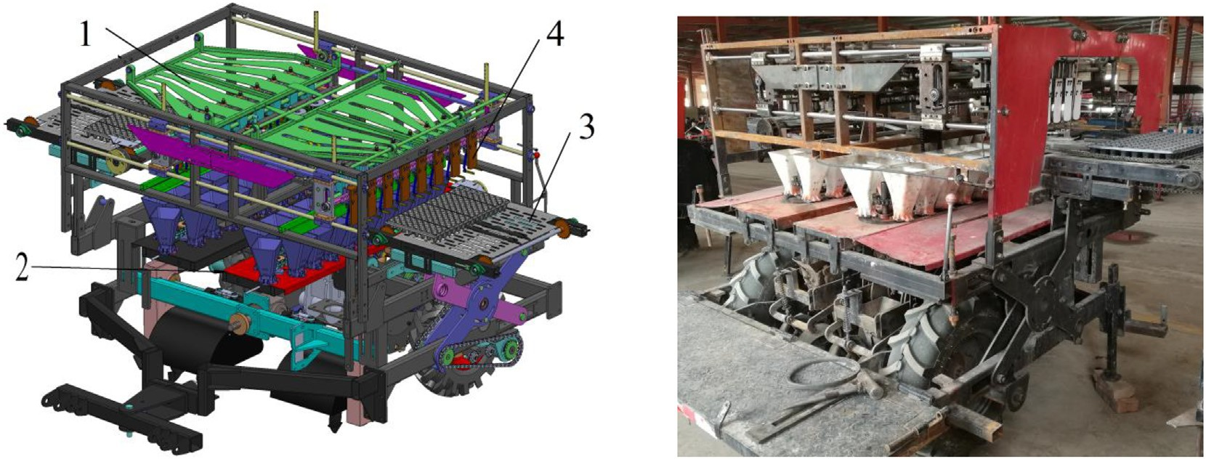

Fig. 1. Auto-transplanter overall structure. 1. automatic seedling picking system; 2. basket-type planting system; 3. feeding mechanism; 4. manipulator.

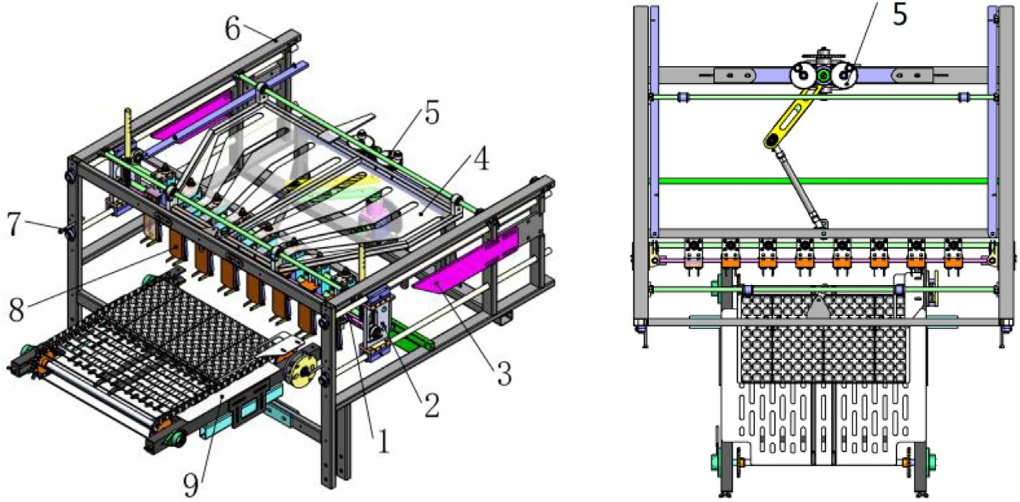

Fig. 2. Three-dimensional model of the automatic seedling picking system. 1. lifting rod; 2. locking mechanism; 3. pressure plate; 4. seedling guide; 5. transmission mechanism; 6. Frame; 7. adjustable bolt; 8. Manipulator; 9. feeding mechanism.

8> ∑*FX* = *FS* + *FC*−*FN* = 0

<

where *FS*´ is the reaction force of the compression spring on the clip (N),

*μN* is the coefficient of friction between the clip and limit bearing, *Ff* is

∑*FY* = *FP*−2*Ffr*−*Fft*−*G*≥0

>: ∑*M* = *FS*⋅*lAB*−*FN*⋅*l*AD + *FC*⋅*lAE* = 0

(1)

the force of friction between the clip and limit bearing (N), and *FP* is the lifting force of the clips (N).

When the manipulator grips the seedlings, *FC* and *FC´* are a pair of

where *lAB* is the effective length from point *A* to *B* (mm), *lAD* is the effec-

opposing forces, the force of the plug seedling is as follows:

tive length from point *A* to *D* (mm), *lAE* is the effective length from point

2 × *Ffr*≥*Fft* + *G*

*A* to *E* (mm), *G* is the gravitational force of the plug seedlings (N), *Ffr* is friction between the clamp and seedling stem (N), and *Fft* is the friction

*Fft* = *η* × *S*

(3)

between the matrix and acupoint disc (N).

When discharging the seedlings (Fig. 3b), the force analysis of the gripper of the manipulator is as follows:

where *η* is the viscosity coefficient of matrix and plug tray hole (Feng et al., 2013), and *S* is the contact area between the matrix and plug tray hole.

8< *FS*' × *lAB*−*FN* × *lAB* = 0

*Ff* = *μN* × *FN*

The clip dimensions are defined as follows: *lAB*

was 22 mm, *lAD*

was

: *FN*‐*Ff* ≥ *0* −2 *C*

(2)

98.3 mm, and *lAE* was 120 mm. The other measurable parameters

were as follows: *F*

was 23 N, *G* was 0.3 N, *S* was 34.2 cm2, and *η* was

0.04 N·cm

. Based on Eq. (1), the pulling force of the manipulator on

the plug seedlings *FP* was 3.34 N, and elastic force *FS* was 6.5 N.

* + 1. *Compression spring design*

When the manipulator reaches the position to pick and discharge the seedlings, the compression spring acts quickly to achieve the pre- cise clamping and discharging of the plug seedlings. If the spring stiff- ness is too small, the clips cannot be opened in time when the manipulator discharges the plug seedlings. As a result, plug seedlings cannot be fed into the basket-type planting system accurately. If the spring stiffness is too large, when the manipulator is used to clamp the plug seedlings, a greater lifting force is required to remove the plug seedlings. Therefore, the design of a reasonable spring structure parameters is important to improve the precision of the manipulator plug seedlings. Considering that the compression spring must exhibit a high strength and good performances, a C-grade carbon spring steel wire was selected. According to the mechanical design manual, the diameter of the compression spring wire *d0* was estimated to be 1 mm, so the bending stress *σB* was 1800 MPa, and the spring index *C* was 10. The specific structural parameters of the compression spring can be calculated as follows:



*FP*

*Fs'*

*FN*

*F f*



*FP*

A

1

*Fs*

B

2

C

3

4

*FN*

D

5

*FC*

*F*

E

*fr*

*FC'*

6

*F ft G*

*λ* max

*t* = *d* + *n* + Δ (4)

# (a) closing (b) opening

8><

*Gd*4*λ*

*n* = 8*FD*3

2

(5)

Fig. 3. Geometric description of the manipulator. 1. Slider; 2. compression spring; 3. fixed base; 4. Clips; 5. limit bearing; 6. plug seedling. (a) closing (b) opening.

>: [*τT*] = 0.4*σB*

>><

> *d* = 1.6s*F*ﬃﬃﬃ*S*ﬃﬃ*K*ﬃﬃﬃ*C*ﬃﬃﬃ

*D* = *D*2 + *d*

0

8> *D*2 = *C* · *d*

*K* =

.615 4

+

*C*

*C*−1

4*C*−4

(6)

: [*τT*]

where the shear modulus *G* was 80,000 MPa, the maximum deforma- tion *λmax* was 20 mm, and *Δ* was 0.29 mm. Eqs. (4)–(6) show that the diameter *d* of the compression spring wire was 0.5 mm, the mean diameter *D* of the spring was 6 mm, the pitch *t* of the spring was

2.13 mm, and effective working circle *n* was 15.

* 1. *Locking mechanism*

The opening and closing of the manipulator is determined by the locking mechanism, which is composed of a tension spring, slide panels, a separation rod, a return spring, and closed bearing bases (Fig. 4a). After the manipulator picks up seedlings at point C, the locking mecha- nism can keep the manipulator always closed during the C → A process. When the manipulator moves to point A, the pressure plate presses the lifting rod to the bottom of the slide panels, then the return spring resets the separation rod. The manipulator will open all the way during the A → C process, until the adjusting bolt touches the separation rod at point C. At this time, the seedling lifting rod loses the restriction of the separation rod, then the lifting rod will be dependent on the tension spring to complete the picking of the plug seedling (Fig. 4b).

* 1. *Seedling guide*

When picking seedlings, each plug seedling is required to be within the gripping range of the manipulator. When seedlings are discharged, each plug seedling can be aligned with the center of the rotating seed- ling cup. According to the plug tray parameters, the center distance of the guide groove at the end of picking and the spacing of guide grooves at the end of discharging can be determined, that is, *h* = 63.5 mm and *H* = 127 mm (Fig. 5).

The center lines of the guide grooves *aO*, *bO*, *cO*, and *dO* extend from point *O*. The seedling guide uses *OO*’ as the axis of symmetry to separate the guide grooves with a certain inclination angle. It is known from the geometric relationship in Fig. 5 that

1 1 1

*l* = *l* = *l* = *l* (7)

*O*'*d* 3 *O*'*c* 5 *O*'*b* 7 *O*'*a*

Fig. 5. Geometric description of the seedling guide.

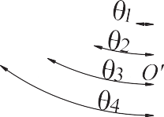

Therefore, to realize the equidistant expansion and closing of the seedling picking manipulator, the inclination angle of the guide groove must satisfy the following:

tan *θ*1 : tan *θ*2 : tan *θ*3 : tan *θ*4 = 1 : 3 : 5 : 7 (8)

* 1. *Transmission mechanism*

The transmission mechanism is mainly composed of the manipula- tor reciprocating mechanism, the gear train, the transmission case, and the support frame (Fig. 6).

The gear train is installed on the support frame, and the transmission ratio is 1:2. One end of the manipulator reciprocating mechanism is con- nected to the manipulator, and the other end is connected to the gear train and the output shaft of the transmission case. When the manipu- lator picks up the plug seedlings, the transmission case drives the crank to rotate, so that the manipulator picks up and discharges the plug seedlings back and forth.

* + 1. *Kinematic analysis of manipulator reciprocating mechanism*

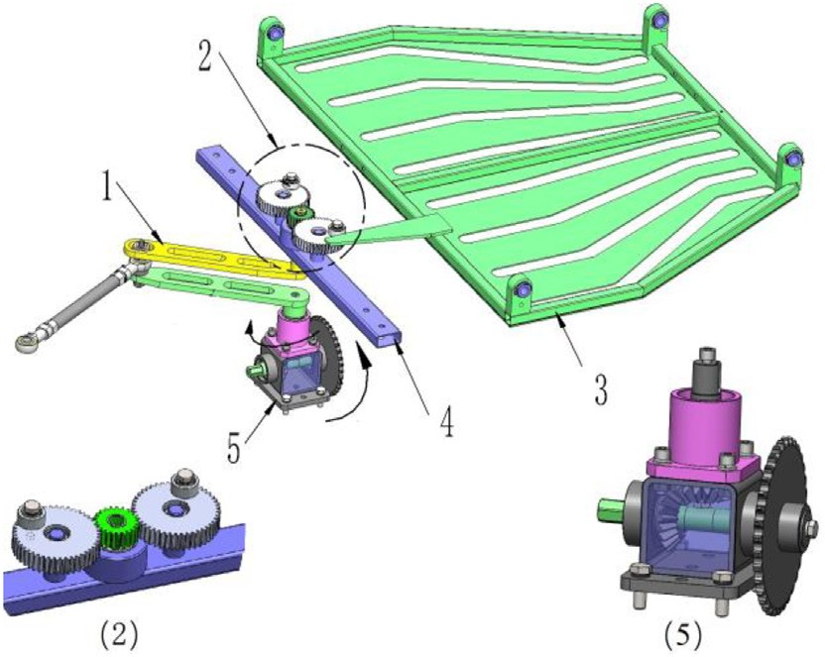The essential component of the manipulator reciprocating mecha- nism is the crank slider mechanism. The crank rotates around point A to C′, the manipulator picks seedlings at point C, and the crank rotates

1

2

3

5

4

6

7

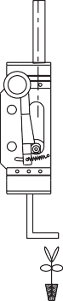

A

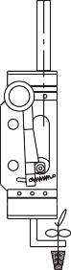

B

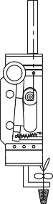

C

* + - 1. Structure (b) Operation process

Fig. 4. Schematic diagram of the locking mechanism. 1. tension spring; 2. slide panels; 3. separation rod; 4. lifting rod; 5. return spring; 6. closed bearing base; 7. manipulator.

(a) Structure (b) Operation process.

Fig. 6. Transmission mechanism. 1. manipulator reciprocating mechanism; 2. gear train; 3. seedling guide; 4. support frame; 5. transmission case.

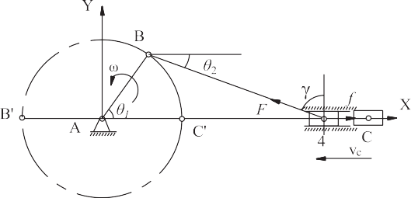8>< *v* = *dLn* = *dL*n ⋅ *dθ*1 = *ωLAB* sin *θ*1 + *λ* sin 2*θ*1

*dt*

*dv*

*dθ*1

*dv*

*dt dθ*1

2

(14)

>: a = *dt* = *dθ*1 ⋅ *dt* = *ω*2*LAB*( cos *θ*1 + *λ* sin 2*θ*1)

Fig. 7. Geometric description of the reciprocating mechanism.

around point A to point B′. The manipulator then moves to point C′ to discharge the seedlings (Fig. 7).

The travel velocity-ratio coefficient *K* was 1, the extreme position angle was 0°, and there was no sharp return phenomenon. According to the movement and installation requirements of the mechanism (Sun et al., 2015), the slider motion stroke *LCC*′ was 635 mm. To ensure that the mechanism provided good transmission and had a minimum structural size, the transmission angle *γmin* was 40°. The length of the connecting rod can be obtained from the following formulas:

*LCC* = 2*LAB* (9)

*LBC* = *LAB* (10)

cos *γ* min

* + 1. *Simulation analysis*

To determine the output torque of the transmission case, the maxi- mum transplanting frequency was set to 120 plants·min−1, and the crank speed was 1.57 rad·s−1, which were substituted into Eq. (14) to

simulate the motion state of the slider (Su, 2014). MATLAB was used

to calculate the motion state of the slider at any time (Pan, 2015).

In the interval (0, *π*), the slider moved away, and when the crank was turned to *π*, the movement speed dropped to 0 m·s−1. At this time, the manipulator picked multiple seedlings. In the interval

(*π*, 2*π*), the slider reversed movement, and when the crank was turned to 2*π*, the movement speed dropped to 0 m·s−1 from Fig. 8(a). At this time, the manipulator discharged multiple seedlings.

As shown in Fig. 8(b), the acceleration of the slider was greater than 0 m·s−2, and the force of the connecting rod on the slider was greater than the force of friction on the slider. When the crank angle *θ1* was *π*, the maximum slider acceleration was 1.25 m·s−2. It is known that the mass of the crank slider mechanism driving part was 18 kg, and the slid-

3

ing friction coefficient *μ* was taken as 0.2. Thus, the minimum output torque of the transmission case satisfied the following:

8< *F* × sin*θ*1‐ *f* = *m* × *a* max

*λ* = *LAB*

*LBC*

(11)

*f* = *m* × *g* × *μ*

: *Mmin* = *F* × *LAB*

(15)

where *LAB* was 318 mm, *LBC* was 415 mm, and λ = 0.8 is the connecting rod transmission ratio.

From the geometric relationship in Fig. 7, the displacement expres- sion between the slider's movement position and the farthest extreme position at any time can be obtained by the following formula:

*L*n = (*LAB* + *LBC* )−( cos *θ*1*LAB* + cos *θ*2*LBC* ) (12)

Application of Eqs. (11) and (12) gives the following equation of motion:

*λ*

*L*n = *LAB* (1‐ cos *θ*1) + 4 (1− cos 2*θ*1) (13)

The equation of motion of the slider speed *v* and acceleration *a* at any time are as follows:

where *F* is the driving force of the crank (N), *f* is the frictional force on the slider (N), and *Mmin* is the minimum driving force of the transmis- sion case (N·m). According to Eq. (15), because the crank slider mech- anism was symmetrically distributed on the left and right sides, the minimum torque required by the transmission case was 42.4 N·m.

* 1. *Feeding mechanism*

The seedling tray conveying mechanism is mainly composed of a pallet, chain cross rod, pressure plate, ratchet, and underframe (Fig. 9). The pallet is fixed on the underframe to support the plug seedling tray. The power is input by the ratchet, and the drive shaft is driven by the ratchet for intermittent rotation. The drive shaft drives the chain cross rod to move, making the plug seedling tray step shift. The platen above the ratchet is used to keep the seedling tray tightly attached to the pallet to prevent the seedling tray from shifting when the machine shakes. The seedling tray is placed between the pallet and the platen, the V-shaped gap of the seedling tray is stuck on the chain cross rods,



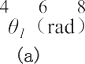    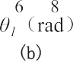   

Fig. 8. curve of Crank angle and speed (a) and curve of crank angle and acceleration (b).

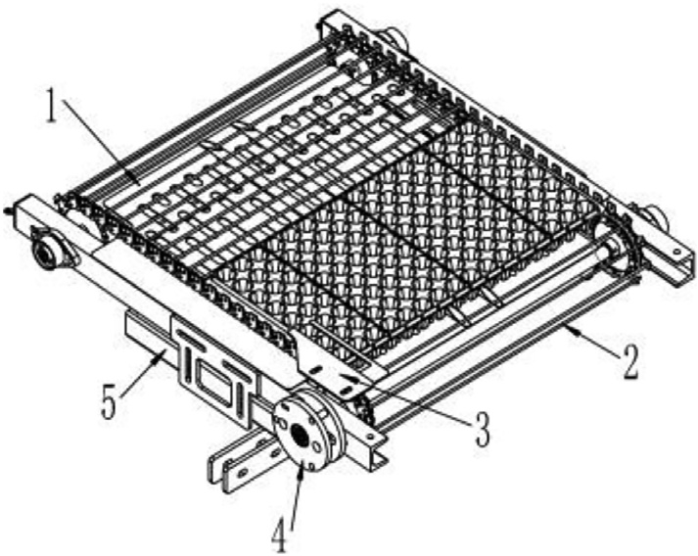

Fig. 9. Schematic diagram of the feeding mechanism. 1. Pallet; 2. chain cross rod; 3. pressure plate; 4. Ratchet; 5. underframe.

and the seedling tray can be stepped on the pallet with the chain cross rods.

* + 1. *Ratchet*

The stepping movement of the seedling tray is controlled by a ratchet, and the power is input by the pawl support, which drives the coaxial sprocket to rotate stepwise, and the chain cross rod drives the seedling tray to feed longitudinally (Fig. 10). The distance that the plug tray moves is equal to the arc length of the sprocket, and the central angle of the sprocket is equal to the central angle *α* of the ratchet. The plug tray has eight holes longitudinally, and the distance between adja- cent holes *l* is 31.75 mm. The number of ratchet teeth *n* is 8, and the modulus *m* is 6. The driving sprocket radius *R* and sprocket rotation angle *θ* satisfies the following conditions:

1

*n* × 2*πR* = *l* (16)

Table 2

Growth characteristics of seedlings used in the tests.

|  |  |  |  |  |
| --- | --- | --- | --- | --- |
| Root | Number | Plant | Age | Matrix |
| diameter  (mm) | of  leaves | height  (mm) | (d) | moisture  content (%) |
| 3 | 6 | 20 | 60 | 20 |

of planting agronomy, and the soil moisture content was about 15%. The transplanted object was a 128-cell-type pepper plug seedling tray, and the growth characteristics met the standards in Table 2.

The planting mode of this machine was “one film double rows,” the plant spacing *Xr* was adjusted to 0.25 m, and the row spacing was

0.43 m. During the whole operation, one operator was needed to install the plug seedling tray (Fig. 11).

* 1. *Evaluation indices*

According to the JB/T 10291–2013 standard, the machine was transplanted at a low speed at planting frequencies of 40, 60, and 90

plants·min−1 to verify the basic performance. It was then increased to 120 plants·min−1 to observe the operation effect during high-speed

transplanting. Each time 128 plants were transplanted in a single row, the first 8 plants were removed, and the next 120 were continuously tested. The number of missed, replanted, lodging, exposed, buried, and injured seedlings were then counted, and the main performance indices were calculated, such as the coefficient of variation (*CV*) of the plant spacing, missing transplanting rate, qualified rate of planting perpendic- ularity, and qualified rate of planting.

* + 1. *Coefficient of variation (CV) of plant spacing*

The distance *Xi* of two adjacent seedlings on the ground intersection *Xi* was measured, and the difference between the actual measured plant spacing *Xi* and the designed plant spacing *Xr* was calculated. The coeffi- cient of variation for the plant spacing (*CVX*) is determined as follows:

360∘

*θ* = *n*

= 45∘

(17)

>

8

*n*

∑ *Xi*

From Eqs. (16) and (17), the radius R of the sprocket is 40.45 mm.

*X* = *i*=1

>

(0.5*Xr*≤*Xi*≤1.5*Xr*)

Each time the ratchet moves, the sprocket rotates 45°, and the plug >< *n* 18

tray feeds 31.75 mm intermittently.

> *SX* = rﬃﬃﬃﬃ1ﬃﬃﬃﬃﬃﬃﬃ∑ﬃﬃﬃﬃﬃﬃ*n*ﬃﬃﬃﬃﬃﬃ ﬃﬃ*X*ﬃﬃﬃ*i*ﬃﬃ−ﬃﬃﬃﬃ*X*ﬃﬃﬃ ﬃﬃ2ﬃﬃ

(

)

*n*−1

*i*=1

> *SX*

1. Performance test

To evaluate the working performance of the automatic transplanter, performance tests were conducted in Ningjin County, Shandong Prov- ince, China, in June 2019. Before the field experiments, the land was re- quired to be ploughed completely flat without large soil blocks, stones, straw, or weeds. The quality of the cultivated land met the requirements

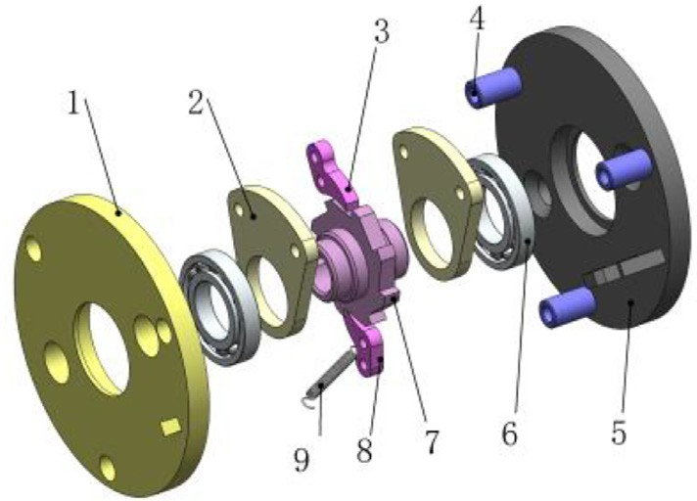

Fig. 10. Ratchet exploded view. 1. outer panel; 2. pawl support; 3. pawl; 4. support sleeve;

5. fixed plate; 6. Bearing; 7. ratchet; 8. lock pawl; 9. spring.

>: *CVX* = *X* × 100%

where *SX* is the standard deviation of the plant spacing (cm), and *X* is the average value of the plant spacing (cm).

* + 1. *Missing transplanting rate*

When the projected distance *Xi* between two adjacent seedlings and the intersection point of the ground was within the range of

1.5*X*r < *X*i ≤ 2.5*X*r, one seedling was recorded as missing; when

2.5*X*r < *X*i ≤ 3.5*X*r, two plants were missing, and so on. The evaluation

indices of the degree of missing seedlings was the rate of missing seed-

lings *M*:

*M* = *NLZ* × 100% (19)

*N*'

where *NLZ* is the number of missed plants, and *N´* is the number of designed plants in the measurement section.

* + 1. *Qualified rate of planting perpendicularity*

The angle between the main stem of the seedling and the ground was less than 30°. The lodging was evaluated as follows:

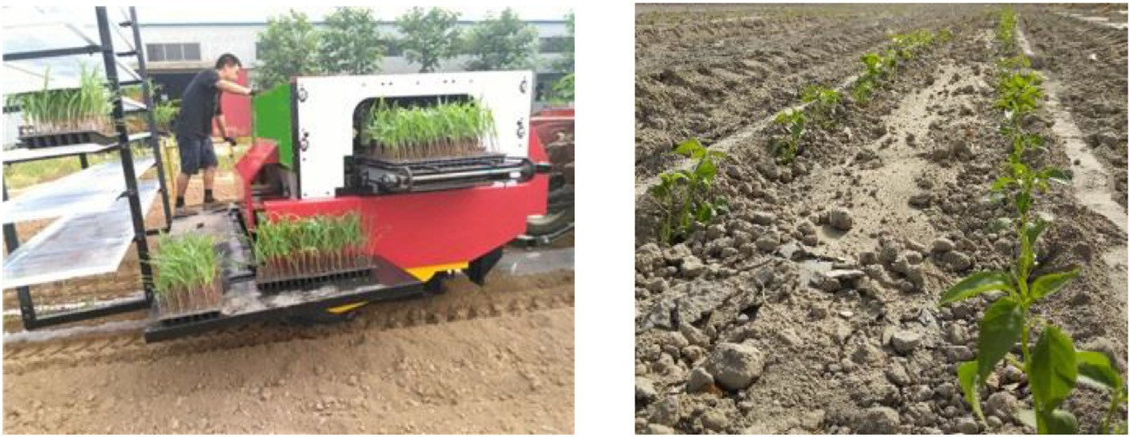

Fig. 11. Performance test of the auto-transplanter.

Table 3

Results of the automatic transplanter test.

|  |  |  |  |  |
| --- | --- | --- | --- | --- |
| Planting frequency (plants·min−1) | CVx (%) | M (%) | L (%) | Q (%) |
| 40 | 6.6 | 1.7 | 98.9 | 98 |
| 60 | 6.5 | 2.2 | 98.0 | 97.5 |
| 90 | 6.7 | 2.5 | 98.3 | 97.2 |
| 120 | 9.4 | 3.0 | 97.5 | 97.5 |

*CVx,* the coefficient of variation of plant spacing; *M*, the rate of missing seedlings; *L*, the qualified rate of planting perpendicularity; *Q*, the qualified rate of planting.

*L* = 1− *NDF* × 100% (20)

*N*'

where *L* is qualified rate of planting perpendicularity, and *NDF* is the number of lodging plants.

* + 1. *Qualified rate of planting*

The percentage of qualified plants in the measurement section relative to the number of designed plants was the qualified rate of planting *Q*, which can be calculated as follows:

( *NHG* = *N*−(*NLZ* + *NCZ* + *NDF* + *NMM* + *NLM* + *NSM*)

planting, the automatic transplanter could achieve high speeds in terms of picking, planting, and soil covering of the plug seedlings.

4. Conclusions

The aim of this study was to solve the problems of a low transplanting efficiency and complicated seedling picking mechanisms by designing a mechanical high-speed transplanter for picking seedlings suitable for plastic film transplanting. The machine consists of an auto- matic seedling picking system and a basket-type planting system, which can automatically complete the functions of picking plug seedlings, planting, and covering soil.

By analyzing the force when the manipulator picked the plug seed- lings, the structural parameters of the compression spring were deter- mined. The kinematics and dynamics of the reciprocating mechanism were analyzed, and the relationship between the velocity and accelera- tion of the manipulator was obtained using MATLAB when the planting

frequency was 120 plants·min−1. The minimum output torque of the transmission case was 42.4 N·m−1.

The mechanical high-speed transplanter for picking seedlings at

low speeds verified the basic performance. We then attempted to in- crease the planting frequency to 120 plants·min−1 for high-speed transplanting, under which the coefficient of variation for the plant

spacing was 9.4%, the rate of missed planting was 3%, the qualified

*Q* = *NHG* × 100%

*N*'

(21)

rate of planting perpendicularity was 97.5%, and the qualified rate of planting was 97.5%. All indices met the JB/T 10291–2013 requirements. The results showed that the auto-transplanter could achieve high-speed

where *NHG* is the number of successes in planting the seedlings, *N* is the total number of planted seedlings, *NCZ* is the number of repeated planted seedlings, *NMM* is the number of covered planted seedlings, *NLM* is the exposed number of planted seedlings, and *NSM* is the damaged number of planted seedlings.

3. Results and discussion

When the planting frequency increased from 40 to 90 plants·min−1 for low-speed transplanting, the *CV* increased from 6.5% to 6.7%, which was less than the national standard value of

15%. The highest missed planting rate was only 2.5%, which was less than the national standard value of 5%. The minimum qualified rate of planting perpendicularity was 98%, which was higher than 93%. The minimum qualified rate of planting was 97.2%, which was higher than 90% It can be seen from Table 3. Thus, the low- speed transplanting process of this machine had a good effect and could meet the pre-set working requirements.

When the machine was transplanted at a high-speed of 120 plants·min−1, the *CV* was 9.4%, *M* was 3%, *L* was 97.5%, and *Q* was 97.5%. Compared with low-speed transplanting, the *CV* and *M* increased

slightly, and *L* and *Q* decreased. However, all the indices met the JB/T 10291–2013 standard. This showed that in the process of high-speed

transplanting based on the completion of the basic functions of auto- matic picking, planting, soil covering, and suppression.

Declaration of Competing Interest

The authors declare that they have no known competing financial interests or personal relationships that could have appeared to influ- ence the work reported in this paper.

Acknowledgments

This wok was supported by the National Key Research Program of China (2017YFD0700800), the National Natural Science Foundation of China (50905153, 51565059), Autonomous Region Key Research Projects (2018B01001-3), and Autonomous Region Tianshan Youth Program (2017Q018).

We thank LetPub ([www.letpub.com](http://www.letpub.com/)) for its linguistic assistance during the preparation of this manuscript.

References

Brewer, H.L., 1994. Conceptual modeling automated seedling transfer from growing trays to shipping modules. T ASAE 37 (4), 1043–1051. [https://doi.org/10.13031/](https://doi.org/10.13031/2013.28174) [2013.28174](https://doi.org/10.13031/2013.28174).

Choi, W.C., Kim, D.C., Ryu, I.H., 2001. Development of a seedling pick-up device for vege- table transplanters. Trans. ASAE 45 (1), 13–19. <https://doi.org/10.13031/2013.7864>.

Feng, Q.C., Wang, X., Jiang, K., et al., 2013. Design and test of key parts on automatic trans- planter for flower seedling. Trans. Chin. Soc. Agric. Eng. 29 (06), 21–27. [https://doi.](https://doi.org/10.3969/j.issn.1002-6819.2013.06.003) [org/10.3969/j.issn.1002-6819.2013.06.003](https://doi.org/10.3969/j.issn.1002-6819.2013.06.003).

Han, C., Yang, W., Zhang, X., 2013. Design and test of automatic feed system for tray seed- lings transplanter. Trans. Chin. Soc. Agric. Eng. 29 (8), 51–61. [https://doi.org/10.3969/](https://doi.org/10.3969/j.issn.1002-6819.2013.08.006) [j.issn.1002-6819.2013.08.006](https://doi.org/10.3969/j.issn.1002-6819.2013.08.006).

Han, C., Yuan, P., Guo, H., Zhang, J., 2018. [Development of an automatic pepper plug seed-](http://refhub.elsevier.com/S2589-7217(21)00014-3/rf0025) [ling transplanter. IAEJ. 27 (2), 110–12](http://refhub.elsevier.com/S2589-7217(21)00014-3/rf0025)0.

Han, C.J., Xu, Y., You, J., et al., 2019b. Parameter optimization of opener of semi- automatic transplanter for watermelon seedlings raised on compression sub- strate. Trans. Chin. Soc. Agric. Eng. 35 (11), 48–56. [https://doi.org/10.11975/j.](https://doi.org/10.11975/j.issn.1002-6819.2019.11.006) [issn.1002-6819.2019.11.006](https://doi.org/10.11975/j.issn.1002-6819.2019.11.006).

Han, L., Mao, H., Hu, J., 2015. Development of a doorframe-typed swinging seedling pick- up device for automatic field transplantation. INIA. 13 (2), 2171–9292. [https://doi.](https://doi.org/10.5424/sjar/2015132-6992) [org/10.5424/sjar/2015132-6992](https://doi.org/10.5424/sjar/2015132-6992).

Han, L., Mao, H., Hu, J., 2016a. Design and test of automatic Transplanter for greenhouse plug seedlings. Trans. Chin. Soc. Agric. Mach. 47 (11), 59–67. [https://doi.org/](https://doi.org/10.5424/sjar/2019173-15358) [10.5424/sjar/2019173-15358](https://doi.org/10.5424/sjar/2019173-15358).

Han, L., Mao, H., Hu, J., 2016b. Design and test of automatic Transplanter for greenhouse plug seedlings. Trans. Chin. Soc. Agric. Mach. 47 (11), 59–67. [https://doi.org/](https://doi.org/10.6041/j.issn.1000-1298.2016.11.008) [10.6041/j.issn.1000-1298.2016.11.008](https://doi.org/10.6041/j.issn.1000-1298.2016.11.008).

Han, L.H., Mao, H.P., Hu, J., 2019a. Experiment on mechanical property of seedling pot for automatic transplanter. Trans. Chin. Soc. Agric. Eng. 29 (2), 24–29. [https://doi.org/](https://doi.org/10.3969/j.issn.1002-6819.2013.02.004) [10.3969/j.issn.1002-6819.2013.02.004](https://doi.org/10.3969/j.issn.1002-6819.2013.02.004).

Hu, J., Zhang, C., Wang, L., et al., 2016. Design and experiment on automatic greenhouse seedling transplanting machine. Trans. Chin. Soc. Agric. Mach. 47 (S1), 149–154. <https://doi.org/10.6041/j.issn.1000-1298.2016.S0.023>.

Kutz, L.J., Miles, G.E., Hammer, P.A., Krutz, G.W., 1987. Robotic transplanting of bedding plants. Trans. ASAE 30 (3), 586–590. <https://doi.org/10.13031/2013.30443>.

Li, H., Cao, W., Li, S., 2017. Development of 2ZXM-2 automatic plastic film mulching plug seedling. Trans. Chin. Soc. Agric. Eng. 33 (15), 23–33. [https://doi.org/10.11975/j.](https://doi.org/10.11975/j.issn.1002-6819.2017.15.003) [issn.1002-6819.2017.15.003](https://doi.org/10.11975/j.issn.1002-6819.2017.15.003).

Liu, J., Cao, W., Tian, D., 2016. Optimization experiment of transplanting actuator param- eters based on mechanical property of seedling pot. Trans. Chin. Soc. Agric. Eng. 32 (16), 32–39. <https://doi.org/10.11975/j.issn.1002-6819.2016.16.005>.

Ni, Y., Jin, C., Liu, J., 2015. Design and experiment of system for picking up and delivering seedlings in automatic transplanter. Trans. Chin. Soc. Agric. Eng. 31 (23), 10–19. <https://doi.org/10.11975/j.issn.1002-6819.2015.23.002>.

Pan, M., 2015. Standard crank mechanism dynamics simulation based on adams. Mech.

Eng. Autom. 03, 78–80. <https://doi.org/10.3969/j.issn.1672-6413.2015.03.031>.

Prasanna Kumar, G.V., Raheman, H., 2011. Development of a walk-behind type hand trac- tor powered vegetable transplanter for paper pot seedlings. Biosyst. Eng. 110 (2), 189–197. <https://doi.org/10.1016/j.biosystemseng.2011.08.001>.

Shaw, L.N., 1993. Changes needed to facilitate automatic field transplanting.

HortTechnology 3 (4), 418–420. <https://doi.org/10.21273/horttech.3.4.418>.

Su, Y., 2014. [Study on the Design of Bias Slider-crank Mechanism based on optimal trans-](http://refhub.elsevier.com/S2589-7217(21)00014-3/rf0095) [mission performance. J. Mech. Transm. 38 (3), 50–53](http://refhub.elsevier.com/S2589-7217(21)00014-3/rf0095).

Sun, H., Chen, Z., Ge, W., 2015. [Theory of Machines and Mechanisms. Higher Education](http://refhub.elsevier.com/S2589-7217(21)00014-3/rf0100) [Press, pp. 132–13](http://refhub.elsevier.com/S2589-7217(21)00014-3/rf0100)5.

Syed, T.N., Ji, L., Xin, Z., et al., 2019. Seedling-lump integrated non-destructive monitoring for automatic transplanting with Intel RealSense depth camera. Artific. Intellig. Agric. 3, 18–32. <https://doi.org/10.1016/j.aiia.2019.09.001>.

Tai, Y.W., Ling, P.P., Ting, K.C., 1994. Machine vision assisted robotic seedling transplanting. Trans. ASAE 37 (2), 661–667. <https://doi.org/10.13031/2013.28127>.

Tian, S., Qiu, L., Kondo, N., Yuan, T., 2010. Development of automatic transplanter for plug seedling. IFAC-Papers Online. 43 (26), 79–82. [https://doi.org/10.3182/20101206-3-](https://doi.org/10.3182/20101206-3-jp-3009.00013) [jp-3009.00013](https://doi.org/10.3182/20101206-3-jp-3009.00013).

Wang, Y., He, Z., Wang, J., 2018. Experiment on transplanting performance of automatic vegetable pot seedling transplanter for dry land. Trans. Chin. Soc. Agric. Eng. 34 (03), 19–25. <https://doi.org/10.11975/j.issn.1002-6819.2018.03.003>.

Wu, J., Yan, H., Jin, X., 2013. Research on disk conveying device and positioning control system for Transplanter. Trans. Chin. Soc. Agric. Mach. 44 (Supp1), 14–18. [https://](https://doi.org/10.6041/j.issn.1000-1298.2013.S1.003) [doi.org/10.6041/j.issn.1000-1298.2013.S1.003](https://doi.org/10.6041/j.issn.1000-1298.2013.S1.003).

Xu, H., Tang, H., 2019. MATLAB optimization design of crank-slider mechanism and Solidworks motion simulation. J. Baoji Univ. Arts Sci. 39 (02), 63–66. [https://doi.](https://doi.org/10.13467/j.cnki.jbuns.2019.02.002) [org/10.13467/j.cnki.jbuns.2019.02.002](https://doi.org/10.13467/j.cnki.jbuns.2019.02.002).

Yan, X., Hu, J., Wu, F., 2013. Design and experiment of full-row-pick-up and single- dropping seedling Transplanter. Trans. Chin. Soc. Agric. Mach. 44 (S1), 7–13. <https://doi.org/10.6041/j.issn.1000-1298.2013.S1.002>.

Yang, Q., Li, X., Shi, X., 2018. Design of seedlings separation device with reciprocating movement seedling cups and its controlling system of the full-automatic plug seed- ling transplanter. Comput. Electron. Agric. 147, 131–145. [https://doi.org/10.1016/j.](https://doi.org/10.1016/j.compag.2018.02.004) [compag.2018.02.004](https://doi.org/10.1016/j.compag.2018.02.004).

Yu, G., Liu, B., Zhao, Y., Sun, L., Xie, Y., 2011. Kinematic principle analysis of transplanting mechanism with planetary elliptic gears in automatic vegetable transplanter. T CSAM 42 (4), 53–57. <https://doi.org/10.3969/j.issn.1000-1298.2011.04.011>.

Yu, G.H., Chen, Z.W., Zhao, Yun, 2012. Study on vegetable plug seedling pick-up mecha- nism of planetary gear train with ellipse gears and incomplete non-circular gear.

J. Mechan. Eng. 48 (13), 32–39. <https://doi.org/10.3901/jme.2012.13.032>.

Yu, X., Zhao, Y., Chen, B., 2014. Current situation and prospect of transplanter. Trans. Chin. Soc. Agric. Mach. 45 (08), 44–53. [https://doi.org/10.6041/j.issn.1000-](https://doi.org/10.6041/j.issn.1000-1298.2014.08.008)

[1298.2014.08.008](https://doi.org/10.6041/j.issn.1000-1298.2014.08.008).