Available online at [www.sciencedirect.com](http://www.sciencedirect.com/)



AASRI Procedia 3 (2012) 291 – 298

2012 AASRI Conference on Modeling, Identification and Control

Designing of the Integral, Cascade and Hybrid Use Scheme, for the Kozani-8 Geothermal Water; Some Thermal and Economical Calculations

KODHELAJ Nevtona*, BODE Aidab, KOJA Nevinaa, ZEQO Esmeraldaa,

MERJEMAJ Boranac

*aDepartment of Energy Resources, Faculty of Geology And Mining, Tirana, Albania bDepartment of natural resources, Faculty of geology and mining, Tirana, Albania cNational agency of natural resources, Tirana, Albania*

**Abstract**

Albania is relatively rich with low up to the middle enthalpy, geothermal resources. Their temperature varies from 34°C up to 65.5°C to Kozani -8, the most important among the Albanian geothermal wells. It had been drilled in 1989. The well is located on the hills, 26km SE of Tirana. It encounters limestone strata at 1819m, penetrating 10m into the section. The yield of the well is 10.3 l/s, and is stable from more than 23 years. The geographical position of the well, placed in the middle of a village, very close to the corridor 8, are the basic parameters on choosing these waters for our designs and calculations. The design provides the cascade and integral use, but not only. It also provide the electricity generations, through a hybrid system. The centre will be also equipped with SPA, open and closed pools, fitness, massages, and greenhouse & also aquaculture pools. The economic analyses shows that this resource is completely competitive, and is

ving standards for the local community.



© 2012 The Authors. Published by Elsevier B.V. Open access under [CC BY-NC-ND license.](http://creativecommons.org/licenses/by-nc-nd/3.0/)

© 2012 Published by Elsevier B.V. Selection and/or peer rev[iew under responsi](http://creativecommons.org/licenses/by-nc-nd/3.0/)bility of American Applied Science Research Institute

Selection and/or peer review under responsibility of American Applied Science Research Institute

*Keywords:* Geothermal; Kozani-8; pool; temperature; cascade; heat exchanger;

* Nevton KODHELAJ. Tel.: +355 69 20 62 683;

*E-mail address:* [nevtonkodheli@yahoo.com.](mailto:nevtonkodheli@yahoo.com)

2212-6716 © 2012 The Authors. Published by Elsevier B.V. Open access under [CC BY-NC-ND license.](http://creativecommons.org/licenses/by-nc-nd/3.0/) Selection and/or peer review under responsibility of American Applied Science Research Institute doi:10.1016/j.aasri.2012.11.047

# Introduction

The Ishmi-

next to the Kruja historical city, the wonderful Adriatic Sea beaches & Lake of Ohrid. The demonstrative geothermal centre, with the cascade and integral use, but also combined with the solar panels (hybrid system), is designed for the Kozani-8 well waters. The choice had been made because of its temperature, on the value

huge economical loses. Among different processes of the cascade, will be released CO2 and H2S, which will be used for food products (conservation) and medical purposes. The hybrid system, combing of the middle enthalpy geothermal waters, with the solar panels, based on the fact that the Albanian climate allow such a thing (there are more than 280 sunny days on the area), will improve the economic efficiency of the project.

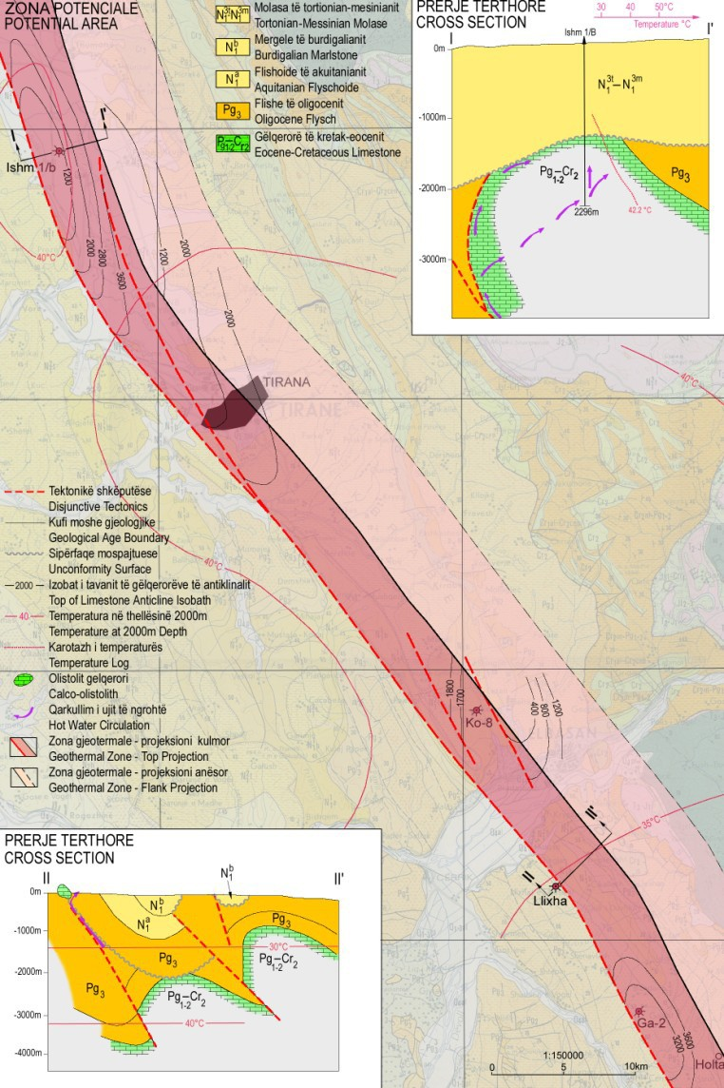

Figure 1: Map of the Ishmi-Kruja Geothermal zone



**Nomenclature**

the effective porosity of the limestone (P=5.8x10-3) m m= 2640 kg/m3)

cm specific heat capacity of the formation (cm=1.1 kJ/kgK)

w w= 980.37 kg/m3)

cw water specific heat (cw=4.1893 kJ/kgK) t1 formation temperature (t1=85°C)

t0 ground temperature (t0=16.5°C)

* 1. *The geological structure of the region*

Kozani-8 geothermal well lies on the limestone structure of Kozani, which lies about 180 km, with a width of 4-5 km [6]. On the regional point of view, sink up to the depth of 10 km, where they are placed above the Triassic evaporites formation Aliaj et al., 1996. In this depth the temperature reach the values of 120-150°C. Important for this region is the presence of the tectonic, related with the evaporites formations, Hyseni et al., 2000. Kozani-8 well is placed in the S-E of Tirana. The water comes from the interval 1816-1837 m of depth Frashëri et al., 2004. The formation temperature is 80°C, while the pressure is 191 bars. The wellhead pressure is 12 bars, while the temperature is 65.5°C. The mineralisation is 4.6 g/l, Frashëri et al., 2004.

* 1. *Energetic reserves evaluation of the Kozani limestone structure*

The formation heat is calculated through the relation Frashëri et al., 2004:

*m cm * *P*



*Q*0 1



*w cw t*1 *t*0  *A z*

*(1)*

*Q*0 1

5**.**8 103

2640

1100 

5**.**8 10 3

 980**.**37

4189**.**2 85

16**.**5

27 106

 2 103

 1**.**0712 1010 *GJ (2)*

The geothermal energy reserves are calculated through the relation:

*Q*1  *R*0 *Q*0

 1**.**0712 1018

 1**.**0712 109 *GJ*

*(3)*

R0=0.1 because Kozani-8 is the only well, erupting hot water. The recoverable geothermal energy is:

*E * *Qv tt * *tr*

*w cw*

*t *10**,**3 10 3 85

25 980**.**37

4189**.**3

365

86400  30

 2**,**401 106

*GJ (4)*

* 1. *The scheme for the integral, cascade and hybrid use of the Kozani-8 geothermal waters*



It was thought by the group of authors, that the best and more efficient way to use the geothermal waters of Kozani-8 well is the constructions of a multicenter. The center will include the SPA, massage and fitness center, open and closed pools (with different sizes and temperatures), greenhouse, aquaculture cultivation pools, conference rooms etc. The center will be heated through the geothermal direct use (through the installation of the heat exchangers) Ingersoll et al., 1950, while for the cooling will be installed a geothermal heat pump, Harlow & Klapper, 1952. The roof will be covered will solar panels, whose will provide the

sanitary water and also a part of them, will circulate the geothermal water, increase its temperature, allowing so the electricity production (the hybrid system). This electricity will serve for the lighting system of the center (green energy). In the Fig. 2, is showed the frontal and lateral view of the center, while in the Fig. 3, the principal sketch of the cascade and the hybrid system.

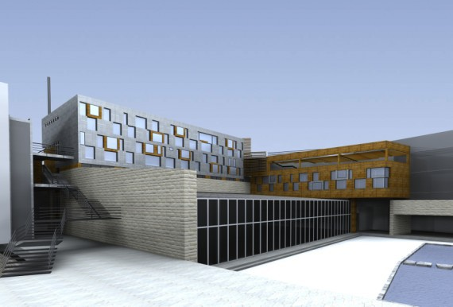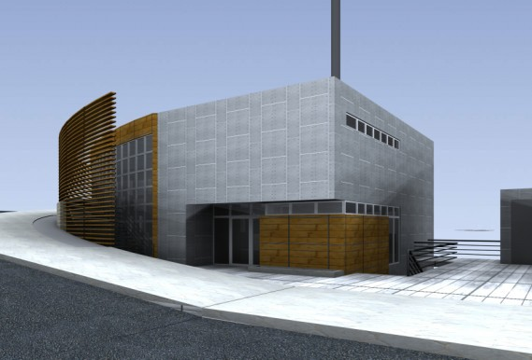

Figure 2: Frontal and lateral view of the Hotel-Clinic and SPA center

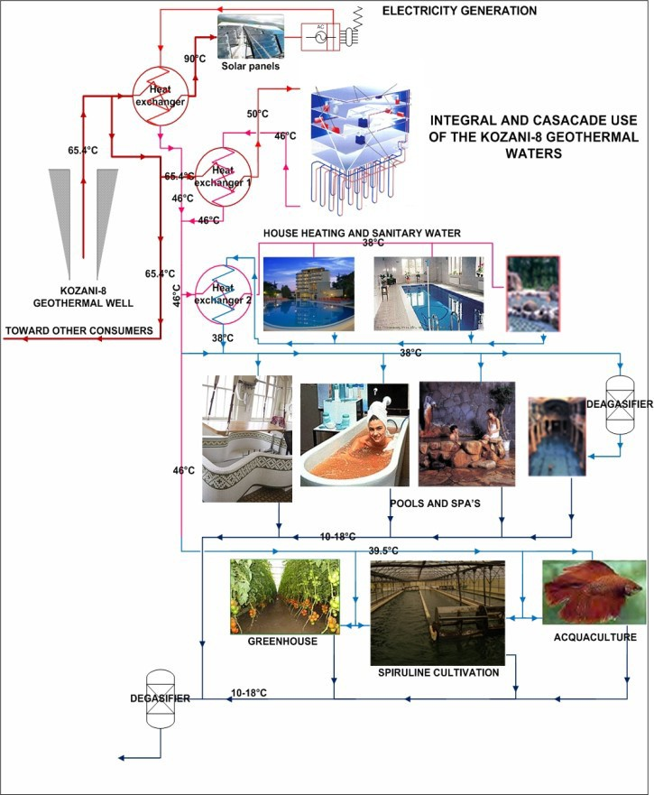

Figure 3: The principal sketch of the centre

* 1. *Heat looses*

The proposed centre will have several pools: 1 geothermal pool (designed as a natural pond, sized 10*8*0.5 m, water temperature 38°C-degasified); 1 open Olympic pool (sized 50*23*3 m, water temperature 30°C); 1 sweet water pool (sized 10*5*1.5 m-escalate, water temperature 38°C-degasified, lightly closed); 1 kids sweet water pool (sized 5*3*0.5 m-escalate, water temperature 30°C). The criteria for pool designing are: psychological and physiological comfort, roads width 1-3 m, height of the closed pools 4 m, temperature & humidity level, easy maintenance and the noise level below 60 dB. The thermal loads, based on their nature and effect on the thermal balance, can be calculated as loses or thermal increment. The heat loses of the system are influenced by a number of factors including the number of the guests, their physical activity, the

ctrical

super dimensioning. In the Fig. 4 is showed the water circulation scheme for the pools. On the first cascade the water will be used for house-heating and also for pools. The water discharged by the geothermal and hot water pool (38°C) will be used for the spirulina cultivation. On the first heat exchanger the water supply should be 22.69 t/h of water, for an installed capacity of 512 kW, Kodhelaj 2012. This amount of energy will be transmitted through the sweet water, heated at the level of 45-50°C. On the second heat exchanger are needed 15 [t/h of water] for an installed capacity of 480 kW. The water temperature in this heat exchanger should be in the range of 40-50°C, Kodhelaj 2012.

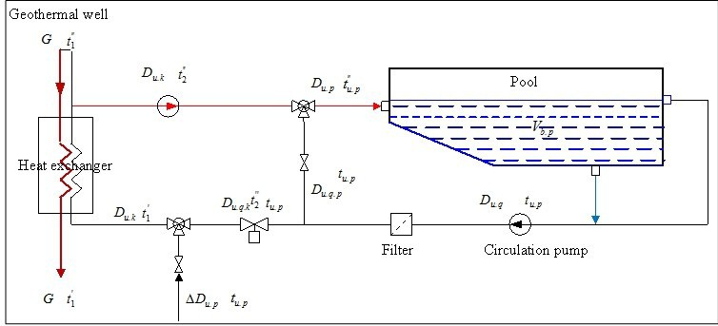

Figure 4: The pools circulation scheme

In the Table 1 are presented the thermal loads for the centre for both seasons: winter and summer, while in the Table 2 the parameters of the closed pools environment, Kodhelaj 2007:

Table 1: Seasonal thermal loads of the centre

**WINTER SUMMER**

|  |  |  |  |  |  |  |  |  |
| --- | --- | --- | --- | --- | --- | --- | --- | --- |
| **Room/environment** | **Thermal load** | **Air** | **Sanitary water** | **Total** | **Thermal load** | **Air** | **Sanitary water** | **Total** |
|  | **[kW]** | **[kW]** | **[kW]** | **[kW]** | **[kW]** | **[kW]** | **[kW]** | **[kW]** |
| Main building | 512 | 420 | 80 | *1012* | 100 | 130 | 53 | *283* |
| Closed pools | 32.3 | 63.6 | 130.5 | *226.4* |  |  |  | *130.5* |
| Geothermal pool (10x 8)m | 18 | 35 | 72 | *125* |  |  |  | *72* |
| Sweet water pool (10x5m) | 11 | 22 | 45 | *78* |  |  |  | *45* |
| Kids pool (5x3m) | 3.3 | 6.6 | 13.5 | *23.4* |  |  |  | *13.5* |
| ***Subtotal*** |  |  |  | ***1236.4*** |  |  |  | ***413.5*** |
| Closed pool (water) |  |  |  | *68* |  |  |  |  |
| Geothermal pool (water) |  |  |  | *48* |  |  |  |  |
| Sweet water pool (water) |  |  |  | *20* |  |  |  |  |
| Olympic pool (water) |  |  |  | *1300* |  |  |  |  |
| **Total** |  |  |  | **2674.4** |  |  |  | **413.5** |

Table 2: Closed loops environment parameters

# Environment Parameter

Vair=45 [m3/hm2]

Closed pools

Qfloor=220 [W/m2] Qsanitary water=0.90 [kW/m2]

 



Geothermal Center & SPA, Shijon, Elbasan. There can be clearly seen that the biggest investemnt should be done for the building (66.7%), while that the total investment is calculated to be 5 708 285 Euro, Kodhelaj 2007.

Table 3: Costs calculations for the Shijoni Recreational Geothermal Centre & SPA



**Constituent**

|  |  |
| --- | --- |
| Property (land acquisition) | 440 880 |
| Hotel Clinic center |  |
| Building | 3 808 280 |
| Acclimatize system | 654 560 |
| Furniture | 229 670 |
| Greenhouse | 186 710 |
| Spirulina cultivation center | 252 085 |
| Aquaculture installations | 136 100 |
| **Tota** | **5 708 285** |

Calculations for the NPV, with different yearly income and ROR=10%, shows that the NPV is equalized to

income it is positive, while Fig. 5, Kodhelaj 2007.

3E+007

2.315E+007

2E+007

**Net Present Value ( )**

1E+007

0E+000

2.417E+006

5E+005

3E+005 3E+005 4E+-010.0539E+0064E+005 5E+005 5E+005

**Yearly income ( )**

-1E+007

-1.14E+007

-2E+007

Figure 5: The NPV analyses

# Conclusions

 The Kozani-8 water temperature is suitable for the supply of an recreational center, including geothermal, indoor and outdoor pools;

 The water temperature is suitable for feeding of two cascades;

 The hybrid systemm will improve the economical efficience of the project;

 The construction of the center will improve the energetic balnace of the region;

 The construction of the center will help on diversifying the energy resources in Albania;  It will improve the living standards of the community;

 The economical analyses shows that it is feasible.

# References

[1].Aliaj, S., and Hyseni, A., 1996: *The neotectonic map of Albania, scale 1:200000.* Sh. B. L. U., Tirana, 87 pp.

[2]. *The geothermal atlas of Albania.* Sh. B. L. U. Tirana, 65-89. [3].Harlow, J. H. & Klapper, G. E. (1952): Residential Heat Pump Experiments in Philadelphia-Installation and Operating Experience.  *AIEE Trans 71/II*, pp. 366-375, New York.

[4].Hyseni, A., and Melo, V., 2000: *The geodynamics of new movements in Albania and their influence in resources and environment.* National programmer for research development, Toena, Tirana.

[5].Ingersoll, L. R., Adler, F. T., Plass, H. J. &Ingersoll, A. C. (1950): *Theory of Earth Heat Exchangers for the Heat Pump*.  ASHVE Trans. 56, 167-188.

[6]. 

waves in the seismologic station. *Bull. Of Geol. Sciences, 1,* 400-410.

[7].Kodhelaj, N., 2011: Albanian possibilities on geothermal direct utilization. *Renewable and sustainable energy review, Elsevier, 15/5, 2011*. 2534-2544 pp.

[8].Kodhelaj, N., 2007: The Llixha Elbasan hot springs in Albania, study of temperature conditions and utilization calculations, *Reports of the United Nations University, Geothermal Training Programme in 2007,* 157-199 pp.