Available online at [www.sciencedirect.com](http://www.sciencedirect.com/)



**ScienceDirect**

AASRI Procedia 9 (2014) 107 – 113

2014 AASRI Conference on Circuit and Signal Processing (CSP 2014)

Development of Innovative Tool Using Taguchi-methods

Ikuo Tanabea*, Hideki Sakamoto a* and Kazuhide Miyamoto a*

*aNagaoka University of Technology, 1603-1 Kamitomioka, Nagaoka, Niigata, 940-2188 Japan*

**Abstract**

The software for innovative tool using Taguchi-methods is developed and evaluated. There are two trials in the innovative tool using Taguchi-methods; First trial is accomplished for selecting important control factors and its optimum region, and Second trial decides the optimum combination of the control factors by more detail trial using only important control factors. The optimum condition regarding cooling system for cutting was investigated for evaluating this innovation tool in the experiment. It is concluded from the result that (1) Innovative tool using the Taguchi-methods was useful for development with short-term and lower cost, and (2) This tool could quickly and exactly decide the optimum cooling condition.

© 2014 The Authors. Published by Elsevier B. V. This is an open access article under the CC BY-NC-ND license ([http://creativecommons.org/licenses/by-nc-nd/3.0/).](http://creativecommons.org/licenses/by-nc-nd/3.0/))

© 2012. Published by Elsevier B.V.

Selection and/or peer review under responsibility of American Applied Science Research Institute

Peer-review under responsibility of Scientific Committee of American Applied Science Research Institute

*Keywords:* Taguchi-methods, innovation, oputimum condition

# Introduction

Recently developments with short-term and lower cost are strongly required for shorten products life cycle. Therefore Taguchi-methods [1],[2] are used for deciding optimum process conditions. However these methods are not enough to develop a new product with short time, lower cost, high quality and high accuracy. In this research, the software for innovative tool using Taguchi-methods is developed and evaluated. There are two trials in the innovative tool using Taguchi-methods. First trial investigates rough fuctions regarding all

* Corresponding author. Tel:+0081-258-47-9727; fax:+0081-258-47-9770

*E-mail address:* [tanabe@mech.nagaokaut.ac.jp.](mailto:tanabe@mech.nagaokaut.ac.jp)

2212-6716 © 2014 The Authors. Published by Elsevier B. V. This is an open access article under the CC BY-NC-ND license ([http://creativecommons.org/licenses/by-nc-nd/3.0/).](http://creativecommons.org/licenses/by-nc-nd/3.0/))

Peer-review under responsibility of Scientific Committee of American Applied Science Research Institute doi:10.1016/j.aasri.2014.09.018

levers of all control factors, then important control factors and meaningless control factors were sorted with the several comments for the second trial. At that time, maximum, intermediate and minimum values for each lever of the each control factor should used for pursuit of all possibilities. Second trial decides the optimum combination of the control factors by more detail trial using only important control factors. The second trial is tried for getting the best combination using the optimum level of each control factor. The optimum condition regarding cooling system for cutting was investigated for evaluating this innovation tool in the experiment.

# Explanation of Taguchi-methods

The Taguchi-methods is used to decide optimum processing conditions with narrow dispersion for robust design. Therefore the Taguchi-methods is explained in this section.

Control factors are equal to the design factors (See the control factors in Table 1). Noise factors are occurred for the error of function on the product (See the noise factors in Table1). Most designer can understand that the final functions of the developed product are strongly influenced for the each lever of each control factor under several noise factors. All combinations using all control factors are compressed by an orthogonal table (See the orthogonal array in Table 2).Then the experiment or the CAE analysis with influence of noise factors is performed by the orthogonal array. At last, the average and the standard deviation regarding all combinations using all control factors are calculated for the SN ratio and Sensitivity. Then most of users write the effective figure (Fig. 1) of the control factors and zealously search the combination of the control factors for large SN ratio. A product using the combination isn’t nearly influenced by noise factors.

Table 1. Control and noise factors in Taguchi-methods.

|  |  |  |  |  |  |  |
| --- | --- | --- | --- | --- | --- | --- |
| Control factors | | | | | | |
| Name | *A* | *B* | | *C* | | *D* |
| *Levels* | *A*1 | *B*1 | | *C*1 | | *D*1 |
| *A*2 | *B*2 | | *C*2 | | *D*2 |
| *A*3 | *B*3 | | *C*3 | | *D*3 |
| Noise factors | | | | | | |
| Name | *N* | | | | | |
| Levels | *N*1 | | *N*2 | | *N*3 | |

Table 2. Orthogonal array, SN ratio and sensitivity in the Taguchi-methods

|  |  |  |  |  |  |  |  |  |  |
| --- | --- | --- | --- | --- | --- | --- | --- | --- | --- |
| Trial. No. | Control factors | | | | Result with  noise factors | | | SN ratio (db) | Sensitivity (db) |
| *A* | *B* | *C* | *D* | *N*1 | *N*2 | *N*3 |
| 1 | *A*1 | *B*1 | *C*1 | *D*1 | 2.7 | 2.6 | 2.4 | 24.5 | 8.2 |
| 2 | *A*1 | *B*2 | *C*2 | *D*2 | 2.3 | 2.2 | 2.0 | 23.0 | 6.7 |
| 3 | *A*1 | *B*3 | *C*3 | *D*3 | 2.1 | 1.9 | 2.0 | 26.0 | 6.0 |
| 4 | *A*2 | *B*1 | *C*2 | *D*3 | 3.3 | 3.1 | 3.0 | 26.2 | 9.9 |
| 5 | *A*2 | *B*2 | *C*3 | *D*1 | 4.6 | 4.4 | 4.5 | 33.1 | 13.1 |
| 6 | *A*2 | *B*3 | *C*1 | *D*2 | 3.3 | 3.3 | 3.0 | 25.3 | 10.1 |

|  |  |  |  |  |  |  |  |  |  |
| --- | --- | --- | --- | --- | --- | --- | --- | --- | --- |
| 7 | *A*3 | *B*1 | *C*3 | *D*2 | 2.1 | 2.3 | 2.4 | 23.4 | 7.1 |
| 8 | *A*3 | *B*2 | *C*1 | *D*3 | 3.1 | 3.2 | 3.1 | 34.7 | 9.9 |
| 9 | *A*3 | *B*3 | *C2* | *D*1 | 4.7 | 5.1 | 4.9 | 27.8 | 13.8 |

(a) Effective figure for SN ration (b)Effective figure for Sensitivity



120

100

80

60

40

20

0

Best condition

Worst condition

Best condition

Worst condition

-20

-24

-28

-32

-36

*D*

*C*

*B*

*A*

Control factors

*D*

*C*

*B*

*A*

Control factors

*D*3

*D*2

*D*1

*C*3

*C*2

*C*1

*B*3

*B*2

*B*1

*A*3

*A*2

*A*1

Levels

*D*3

*D*2

*D*1

*C*3

*C*2

*C*1

*B*3

*B*2

*B*1

*A*3

*A*2

*A*1

Levels

SN ratio db

Sensitivity db

Fig.1. Relationship between (a) SN ratio or (b) Sensitivity and each lever of each control factor (In the case, the best condition was supposed at the smallest final function possible)

# Algorithm for innovative tool

Now, innovative development with short-term, low cost, labor saving and energy-saving is also required in the world. Therefore, in this research, the software for innovative tool using Taguchi-methods is developed and evaluated. At first, first trial investigates rough fuctions regarding all levers of all control factors, then important control factors and meaningless control factors were sorted with the several comments for the second trial. At that time, maximum, intermediate and minimum values for each lever of the each control factor should used for pursuit of all possibilities. Then second trial decides the optimum combination using the levels of the control factors by more detail trial using only important control factors. The second trial is tried for getting the best combination using the optimum level of each control factor.

The control factors consist of digital data and non digital data. When these data are inputted in the software of Taguchi-methods, the results of the effective figures for both SN ratio and Sensitivity can calculate such as Fig. 2. In case of Taguchi-methods, after several evaluations were performed by using the effective figures, the trial was completed. Therefore our original system starts from here; then Fig. 2 is rewritten to Fig. 3. At that time, horizontal axis is the levels of the each control, and vertical axis is used the average of function (desired property) or it standard deviation. In case of the digital data, a line graph is used such as Fig. 3(a), and in case of the non digital data, a line graph is used such as Fig. 3(b). Everyone can intuitively and visually feel the influences of the control factors by using the Fig. 3, can grasp for the physical image regarding the influences of the control factors. In case of the line graph, then the working of curb fit is performed by using exponential, linear, logarithmic, polynomial and radical approximations. In here, an operator can intutively understand the influences of the control factors. In case of a bar graph, Fig. 3(b) could not change to Fig. 4.

* 1. SN ratio ( =10*log*(*ȝ*2/*ı*2) )

**Non digital data**

**Digital data**

Control factors

**3**

**2**

**1**

**3**

**2**

**1**

Levels

●

●

●

●

●

●

SN ratio [db]

Sensitivity [db]

* 1. Sensitivity ( =10 *logȝ*2)

Fig.2. Effective figures of SN ratio and Sensitivity

**Non digital data**

**Digital data**

Control factors

**3**

**2**

**1**

**3**

**2**

**1**

Levels

●

●

●

●

●

●

~~● ●~~

●

Ė Value of control factor**Lev**Ė**el 2 Le**Ė**vel 3**

Average of function (Desired property)

Average of function (Desired property)

**Level 1**

1. In the case of digital datafor the control factor Fig.3. Effective figures of SN ratio and Sensitivity
2. In the case of non digital data for the control factor

**Non digital data**

**Level 3**

**Level 2**

**Level 1**

Result of 1sttrial

* + Recommended levels for 2nd trial

Average of function (Desired property)

Result of 1sttrial

* + Recommended levels for 2nd trial

Average

●

●

●

●

●

Level 2’

●

Level 1’

Level 3’



Changeable and maximum value of the level in 2nd trial

●

●

Average

●

Level 3’

* Level 2’

Level 1’

●

●

Average of function (Desired property)

Ė Value of control factor Ė Ė

Ė Ė Ė

Value of control factor

**Level 1 Level 2 Level 3 Level 1 Level 2 Level 3**

(a) Inside estimation (b) Outside estimation Fig.4. Recommendation of the levels for 2nd trial using the results of the 1st trial

The optimum levels of the control factors for the second trial were decided by using the results of the first trial. The method for selection of the optimum levels of the control factors is shown in Fig. 4. In the explanation, it suppose that the larger function is desired by everyone. The curve of Fig. 4(a) has a mountain shape, there is the optimun lever of the control factor in the region of first trial. Therefore new level 2’ is decided to the top of the mountain, new level 1’ is middle between the old level 1 and the new level 2’ , and new level 3’ is middle between the new level 2’and the old level 2. Level 1’, lavel 2’ and level 3’ are the optimum levels for the second tiral. The curve of Fig. 4(b) has a shape of graph rising to the right, there is the optimun lever of the control factor in the right region of first trial. Therefore new level 3’ is decided to the practicable large value, new level 1’ and new level 2’ devide into three regions between the new level 3’and

the old level 3. The operator of the software can select standard deviation for vertical axis, at that time, the operator can estimate stability for the noise factors.

# Experimental results for evaluation

At last, wet cutting using strong alkaline water with air of optimum quantity was used for evaluation of the innovative tool. Experimental set-up is shown in Fig. 5. Micro bubble is always supplied for high heat transfer coefficient in strong alkaline water. The strong alkaline water with micro bubble is dew from the vessel and is supplied to the blender for air. Air is also supplied to the blender for air by the compressor. Strong alkaline water and air are mixed in the blender for air and are supplied to the nozzle for outlet.

In the manufacturing field, everyone is desired high heat transfer coefficient. Therefore heat transfer coefficient is used for the function in the proposed innovative tool. The control and noise factors for first trial are shown in Table 3. Then, the optimum quantities of strong alkaline water and air were investigated for high cooling efficiency in the experiment with Table 3. At that time, the proposed innovative tool was used for plan of the second trial.

Ǿ1×12

Ǿ20

Flow meter F1

Valve I

Hose (InnerǾ8.5 mm)

Water pump

Terminal of air (Ǿ1×12)

1/2” steel

Strong alkaline water inlet

Air inlet

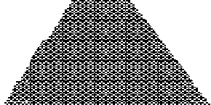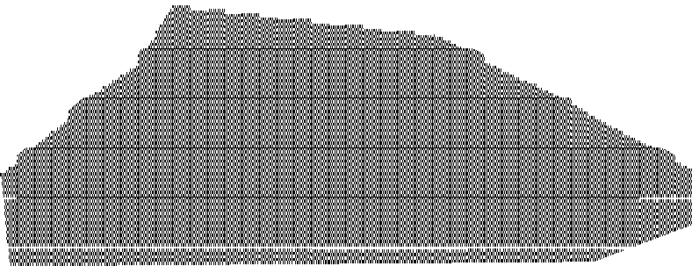

Details for outlet

Terminal of air Blender for air

Measuring device for heat transfer coefficient

Steel plates (5×5×0.06)

5 5

Power

Ceramics heater (5×5×1.75)

Thermocouples



ω 2800 mm ValveII

Flow meter

F2

1500 mm

Max. 2.1 MPa

Compressor Max.1.27MPa

T-joint

1/2” steel joint

1300 mm × InnerǾ14

Hose(Ǿ8.5 )

Distance *L*

Nozzle outlet

Ǿ6.0 mm

ω

Distance *D*



source

Drain ω

ψ

Intakeχ ω ω χ

χ

Vessel of strong alkali water (545×385×310 mm)

Micro bubble device

Fig.5. Schematic view regarding the new cooling system using strong alkaline water with air of optimum quantity

Table 3. Control and noise factors for 1st and 2nd trials regarding the cooling system for evaluation of the software. The cell with light blue is optimum conditions which was decided after 2nd trial.

|  |  |  |  |  |  |  |  |  |  |
| --- | --- | --- | --- | --- | --- | --- | --- | --- | --- |
| Control factors | | | | | | | | | Noise factor |
| Name of factors | Length *L* [mm] of hose between the blender for air and the nozzle for outlet | | Air pressure  *P* [MPa] | | Quantity of flow for strong alkaline water *Q* [L/min] | | Distance *D* [mm] between the nozzle  for outlet and the senso | | Number of experiments: 9 |
| 1st trial | 2nd trial | 1st trial | 2nd trial | 1st trial | 2nd trial | 1st trial | 2nd trial |
| Level 1 | 500 | 70 | 0.05 | 0.15 | 0.5 | 4.0 | 10 | 150 |
| Level 2 | 1000 | 250 | 0.2 | 0.2 | 3.0 | 5.0 | 200 | 200 |
| Level 3 | 5000 | 500 | 0.4 | 0.25 | 6.0 | 6.0 | 400 | 250 |

5000

4800

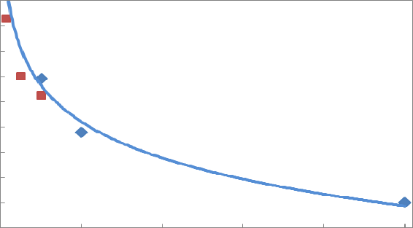

 : Results of 1st trial (Average value) ,  : Experimental results of 2nd trial ,

Average of function

(Heat transfer coefficient) W/m2K

4600

4400

4200

4000

3800

3600

3400

3200

0 1000 2000 3000 4000 5000

Value of control factor *L* mm

* 1. Length *L* mm of hose between the blender for air

5000

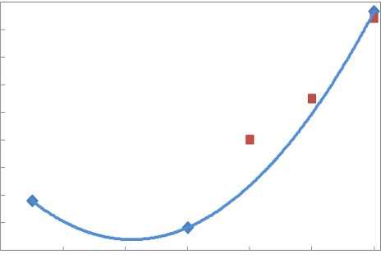

Average of function

(Heat transfer coefficient) W/m2K

4800

4600

4400

4200

4000

3800

3600

3400

3200 0 1 2 3 4 5 6

Value of control factor *Q* l/min

1. Quantity of flow for strong alkaline water *Q* l/min

: Recommendation area for 2nd trial

: Optimum conditions decided in 2nd trial 5000

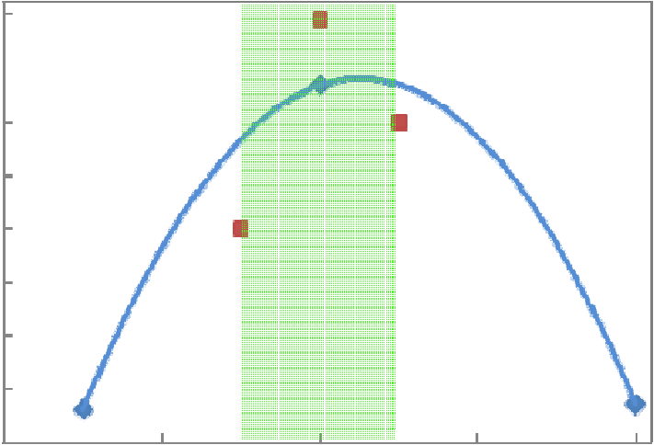

Average of function

(Heat transfer coefficient) W/m2K

4800

4600

4400

4200

4000

3800

3600

3400

0 0.1 0.2 0.3 0.4

Value of control factor *P* MPa

* 1. Air Pressure *P* MPa

5000

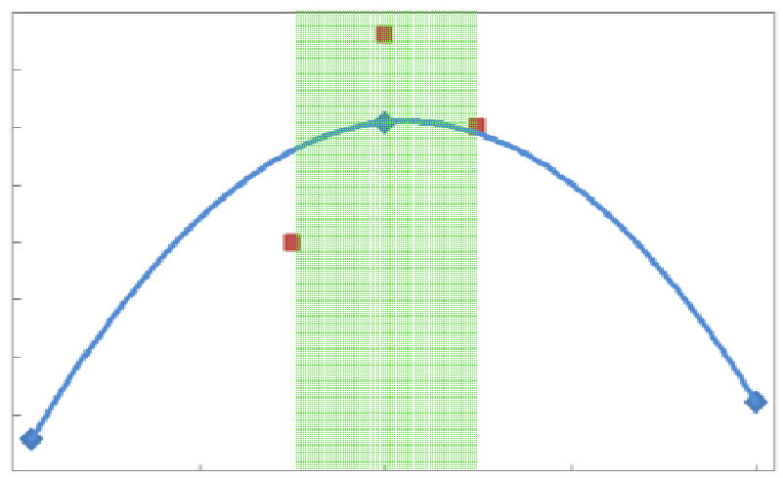

Average of function

(Heat transfer coefficient) W/m2K

4800

4600

4400

4200

4000

3800

3600

3400 0 100 200 300 400

Value of control factor *D* mm

1. Distance *D* mm between the nozzle for outlet and the sensor

Fig.6. Recommendation area (**Light green area**) of the levels for 2nd trial using the result (**Blue line**) of 1st trial regarding the cooling system. The results (**Brown square**) trial and The optimum conditions (**Green arrow**) decided after 2nd trial

Results of the first trial are shown in Fig. 6. There are the results of the first trial (Blue line) and the results of the recommendation area (Light green area) of the levels for 2nd trial in Fig.6. Shapes of graphs in (b) and

(d) are mountain shape. Therefore middle region were selected for the second trial regarding (b) and (d). As

(a) and (c) were graphs rising to the left and right, therefore the more left region and the more right region were selected for the second trial regarding (a) and (c), respectively.

The control factors and the noise factors for the second trial are also shown in Table 3. After the experiment with Table 3, the experimental results of the second trial were calculated by the proposed innovative tool (Brown square). The results of the second trial are also shown in Fig. 6. Averages of heat transfer coefficient for the second trial were larger than those for the first trial. The proposed innovative tool could estimate the good region for the second trial. The optimum levels of the each control factor are decided by using Fig. 6 (Green arrow). The optimum condition are also shown in Table 3 (  ); Optimum length *L* mm of hose between the blender for air and the nozzle for outlet is 70 mm, optimum air pressure *P* is 0.2 MPa, optimum quantity of flow for strong alkaline water *Q* is 6.0 l/min and optimum distance *D* mm between the nozzle for outlet and the sensor is 200 mm. And heat transfer coefficient of the proposed cooling system with optimum condition was improved to 8490 W/m2K.

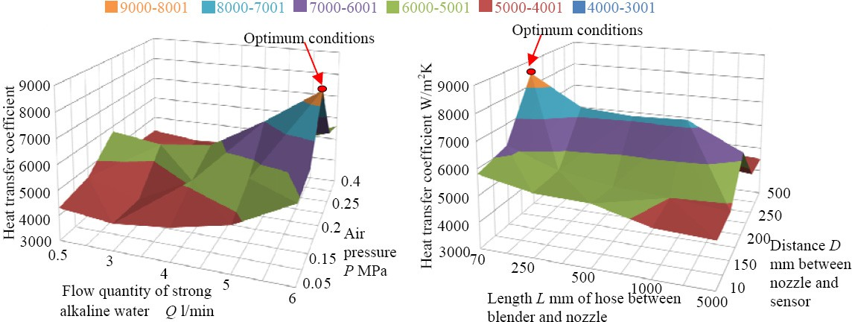

(a) At *L*=70mm, *D*=200mm constant (b) At *P*=0.2MPa, *Q*=6 l /min constant Fig.7. Comparison between the result with best condition in 2nd trial and the result with best condition in the detailed experiment

Hear transfer coefficient with several conditions with length *L* mm of hose between the blender for air and the nozzle for outlet, air pressure *P* MPa, quantity of flow for strong alkaline water *Q* l/min and distance *D* mm between the nozzle for outlet and the sensor were measured and were shown for comparison in Fig.7. Heat transfer coefficient 8490 W/m2K which was searched by the proposed innovative tool was the largest value in the all experiments. Therefore the proposed innovative tool is effective for innovative development in the industrial world.

# Conclusion

It is concluded from the result that;

1. Innovative tool using the Taguchi methods was useful for development with short-term and lower cost.
2. This tool could quickly and exactly decide the optimum cooling condition. The cooling system with optimum condition using the innovative tool was very effective. And heat transfer coefficient of the proposed cooling system with optimum condition was 8490 W/m2K.

# References

1. Tatebayashi, K., Computer Aided Engineering Combined with Taguchi-methods, *Proceeding of the 2005 Annual Meeting of the Japan Society of Mechanical Engineering*, No. 05-1 Vol. 8, pp. 224-225, 2005
2. Sugai, H., et al., Prediction of Optimum Machining Condition in Press Forming Using Taguchi- methods and FEM Simulation, Transactions of the JSME (in Japanese), Vol.72 No.721, pp. 3044-3051, 2006