Available online at [www.sciencedirect.com](http://www.sciencedirect.com/)



**ScienceDirect**

AASRI Procedia 9 (2014) 44 – 50

2014 AASRI Conference on Circuit and Signal Processing (CSP 2014)

Effect of Geometry Parameters on Low-speed Cavity Flow by Wind Tunnel Experiment

Guangjun Yanga,*, Jing Sunb, Yong Liangb,c, Yingchun Chend

*aNational Key Laboratory of Science and Technology on UAV, Xi’an 710065, China bSchool of Aeronautics, Northwestern Polytechnical University, Xi’an 710072, China cChina Aerodynamics Research and Development Center, Mianyang 622700, China dCommercial Aircraft Corporation of China Ltd, Shanghai 200232, China*

**Abstract**

In this paper, experiment platform for cavity flow is built in low-turbulence wind tunnel. based on the measurement of wall static pressure and sound pressure with microphones, the basic flow oscillation characteristics of different type cavity in low speed are studied. The effect of geometry parameters of length to depth ratio and width to depth ratio on cavity flow pattern and noise characteristics is obtained. The results show that in the incompressible flow state, the basic flow pattern of cavities is not affected by flow velocity; length-to-depth ratio of 1 to 12 covers the flow pattern from open to close, and with the length-to-depth ratio increase, the cavity radiation SPL increases; with aspect ratio increase, the sound pressure energy of cavity also increase.

© 2014 The Authors. Published by Elsevier B. V. This is an open access article under the CC BY-NC-ND license ([http://creativecommons.org/licenses/by-nc-nd/3.0/).](http://creativecommons.org/licenses/by-nc-nd/3.0/))

© 2014 Guang-jun Yang, Jing Sun, Yong Liang, Yingchun Chen. Published by Elsevier B.V. Selection and/or peer revie*w under responsibility of American Applied Science Research Institute

Peer-review under responsibility of Scientific Committee of American Applied Science Research Institute

*Keywords*: cavity; length to depth ratio; width to depth ratio; shear layer; sound pressure

* Yang Guangjun. Tel.: +86-029-8845-1160 E-mail address: [yanggj_1031@nwpu.edu.cn](mailto:yanggj_1031@nwpu.edu.cn)

Foundation item: Aeronautical Science Foundation of China (2010ZA53011, 2011ZA53013) Basic foundation of Northwestern Polytechnical University(JC20110287)

2212-6716 © 2014 The Authors. Published by Elsevier B. V. This is an open access article under the CC BY-NC-ND license ([http://creativecommons.org/licenses/by-nc-nd/3.0/).](http://creativecommons.org/licenses/by-nc-nd/3.0/))

Peer-review under responsibility of Scientific Committee of American Applied Science Research Institute doi:10.1016/j.aasri.2014.09.009

# Introduction

Cavity flow is a problem often encountered in practical engineering, and is currently a hot aerodynamics research field internationally. there are a variety of complex unsteady cavity flow such as aircraft landing gear, weapons bay, car sunroof and so on. When the flow passes over the cavity, flow oscillation will be produced and radiate noise. The research of cavity flow typically involving complex flow-sound-vortex interference, unsteady character and shear layer instability problems, which has great research significance.

For the study of cavity flow, since the 1950s, more tests have been carried out, and since the 1980s, numerical simulation was widely used in cavity flow study on mechanism and flow control design. Certain Studies [1-8] showed that the geometric parameters such as the length to depth ratio L/D, the aspect ratio W/D, flow parameters such as Mach number affect the cavity flow pattern and the acoustic characteristics.

In this paper, experiment platform for cavity flow studies was built in low-turbulence wind tunnel, with the use of wall pressure sensors and microphones, the effects cavity geometry on low-speed cavity flow oscillation characteristics were studied experimentally and provide reference for cavity noise suppression research.

# Experimental Method

* 1. *Experimental Model*

The Cavity model is structured by wood and the model blockage in wind tunnel is about 8%.

The maximum depth of the cavity 116mm, maximum length 700mm, and the maximum width 120mm.. Figure 1 shows the parameter definition of cavity geometry. The contact surface of cavity with wind tunnel is filled with soft foam padding to avoid local airflow crossing up and down and reduce the effects of wind tunnel vibration on the flow structure of cavity.

Length to depth ratio and width to depth ratio of Cavity vary by adding blocks in cavity or adjusting the cavity depth while the maximum width of the cavity remains unchanged. The effect of geometry changes on the aeroacoustic characteristics of cavity flow were discussed, and specified programs are shown in Table 1.

Table 1. Experimental program

L/D W/D Fixed parameter

|  |  |  |
| --- | --- | --- |
| 1 | 1 |  |
| 2 | 1 | D=116mm |
| 4 1 | | |
| 6 | 1 |  |
| 8 | 1.4 | D=700mm |
| 10 1.7 | | |
| 12 | 2.1 |  |
| 4 | 2 | D=58mm |
| 2 2 | | |

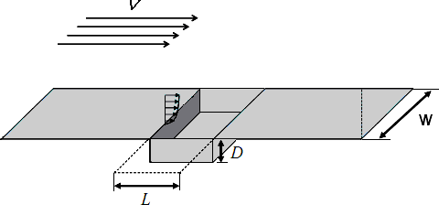

Fig.1. Cavity parameter definition

Along the centerline of the whole cavity bottom plate, static pressure holes are distributed evenly every 10mm, and meanwhile 6 acoustic probes are arranged on cavity wall: one is on the back wall and the other 5 are on the bottom.

Cavity model equipped in the 2D test section of low turbulence wind tunnel is shown in Figure 2.

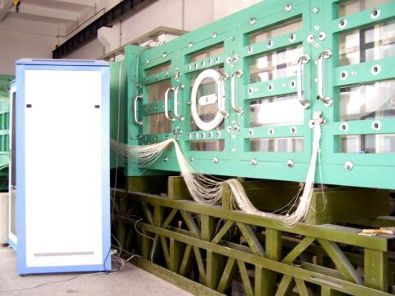 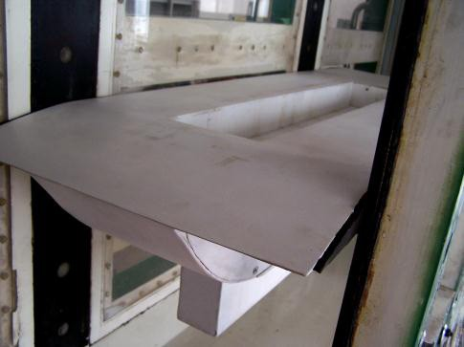

(a) 2D test section (b) cavity model installed in wind tunnel Fig.2. Experimental installation diagram

* 1. *Wind tunnel*

The wind tunnel test is carried out in low turbulence wind tunnel (LTWT) of Northwestern Polytechnical University. The test section of LTWT has two different layouts: three dimensional-only and three dimensional connected with two dimensional. In this paper, the cavity is tested in two dimensional test section which has the cross-sectional dimension of 1.0m × 0.4m. The wind speed operation range in wind tunnel is 5m/s~75m/s.

* 1. *Experimental Equipment*

The static pressure data are acquired using DSY 104 electron scanning micro-pressure measurement system, which has 192 channels with the channel scan rate of 50,000/ sec and the system accuracy is

±0.1%FS. Dynamic pressure measurement and spectrum acquisition are obtained by Belgian LMS dynamic measurement system. The system has LMS SCM01 Mobile 8-channel data acquisition front, PCB acoustic sensors, model 130P10/D10, and frequency range is 10-15KHz.

* 1. *Experimental conditions*

Experimental wind speed range is V=10~50m/s, Δ V=10m/s, the angle of attack α=0°. The Reynolds number based on the cavity depth D is between 0.397×105 ~ 3.97×105.

# Effect of length to depth ratio

Figure 3 and Figure 4 give out the averaged pressure distribution on cavity bottoms and 1/3 octave curve for sound pressure level measured at the center point of cavity bottoms under the same cavity inlet and wind speed of 30m/s.

Figure 3 shows that when the flow stream conditions is consistent, with length to depth ratio L/D varies from 1 to 12 , the pressure on cavity bottoms goes gently through the development from flat to step, covering four basic flow pattern from open to close, and the corresponding length to depth ratio L/D is2, 4, 8 and 12 respectively. For cavity of L/D=2, the pressure distribution is changed gently with the low pressure in middle, for L/D=4, the spoon-shaped distribution is formed, i.e., the front part pressure is high and flattening, and the rear part pressure decreases. As the ratio of length to depth continues to increase, the front pressure decreases, the rear end of the bottom pressure rise, till to L/D=12, the middle pressure forms a platform.

**0.6** 120

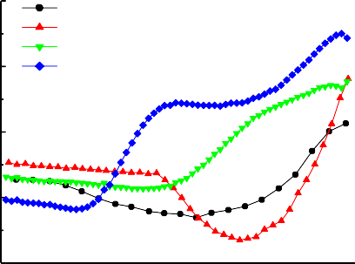

**L/D=2 L/D=4 L/D=8 L/D=12**

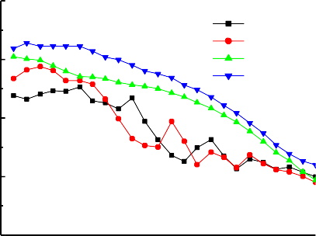

V=30m/s

**L/D=2 L/D=4 L/D=8 L/D=12**

**0.4** 100

**0.2** 80

**Cp**

**SPL(dB)**

**0.0** 60

**-0.2** 40

|  |  |  |  |  |  |  |  |
| --- | --- | --- | --- | --- | --- | --- | --- |
| **0.0 0.2 0.4 0.6 0.8 1.0** 100 1000 10000 | | | | | | | |
|  |  | **X/L** |  |  |  | **f(Hz)** |  |

Fig.3. pressure distribution on cavity bottom for L/D Fig.4. Noise spectrum for cavities measured at bottom center

Figure 4 shows that the noise in the cavity exhibits broadband characteristics, mainly due to low frequency radiation caused by the flow oscillations. When the flow velocity is 30m/s, with decreasing of length to depth ratio, sound pressure level radiated from cavity is reduced. For L/D=2, the maximum sound pressure level is 90dB, which is lower than L/D=12 by 15dB. Open cavity flow can generate oscillations which appear that certain frequencies amplified and sound pressure level forms peaks at some frequency.

# Wind speed effect

Figure 5 shows the static pressure distribution comparison within wind speed range of 10m/s~50m/s for cavity L/D=4,12. The results denoted that in the low speed (M <0.2) incompressible flow, the wind speed has less affect the averaged pressure distribution in a small magnitude, i.e., with the flow velocity increased, the cavity internal flow increase, but does not change the basic flow type of cavity.

Figure 6 gives out the noise characteristics on bottom center at different wind speeds for L/D=4, 12. As seen from the figure that for the same geometry, with the flow velocity increases, the radiated noise pressure

increases. For L/D=12, the maximum SPL reach to 109dB at 50m/s, 26dB more than that at 10m/s. This indicates that with the flow velocity increasing, the cavity pressure and density largely oscillate, which greatly increase the amplitude of noise, but the affect little on the oscillation frequency.

**0.6**

**0.4**

**Cp**

**0.6**

**0.4**

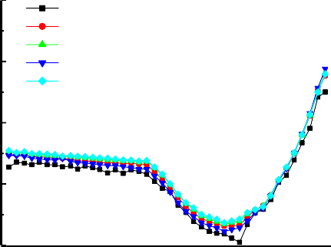

**V=10 V=20 V=30 V=40 V=50**

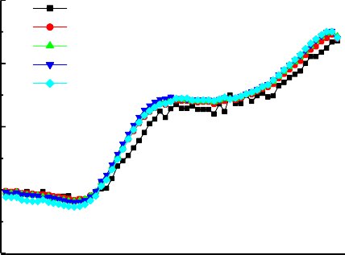

**V=10 V=20 V=30 V=40 V=50**

**0.2**

**Cp**

**0.2**

**0.0**

**0.0**

**-0.2**

**0.0 0.2 0.4 0.6 0.8 1.0**

**X/L**

**-0.2**

**0.0 0.2 0.4 0.6 0.8 1.0**

**X/L**

(a) L/D=4 (b) L/D=12

Fig.5. Effect of wind speed on the flow pattern of typical cavity

140

120

100

80

**SPL(dB)**

60

40

20

0

**L/D=4**

100 1000 10000

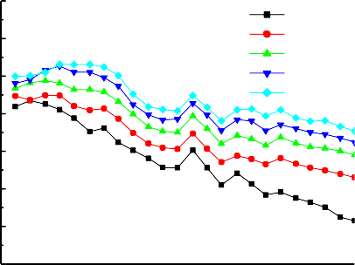

**V=10m/s V=20m/s V=30m/s V=40m/s V=50m/s**

**f(Hz)**

140

120

100

80

**SPL(dB)**

60

40

20

0

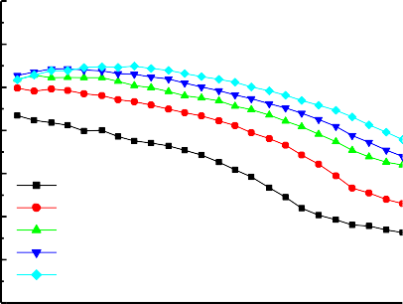

**L/D=12**

**V=10m/s V=20m/s V=30m/s V=40m/s V=50m/s**

100 1000 10000

**f(Hz)**

(a) L/D=4 (b) L/D=12

Fig.6. Effect of wind speed on noise spectrum on typical cavity bottom

# Effect of width to depth ratio

Under flow velocity of 30m/s, by adjusting the length and depth of the cavity with adding blocks and bottom lifting, the effect of width to depth ratio on open and transition-open flow pattern was discussed for L/D=2 and 4 respectively.

**0.6**

**0.4**

**0.6**

**0.4**

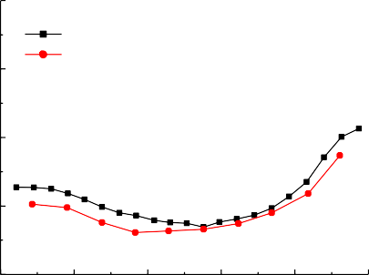

**L/D=2**

**W/D=1 W/D=2**

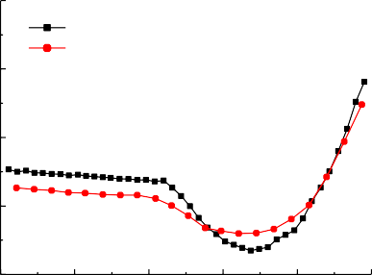

**L/D=4**

**W/D=1 W/D=2**

**0.2**

**Cp**

**0.2**

**Cp**

**0.0 0.0**

**-0.2**

**0.0 0.2 0.4 0.6 0.8 1.0**

**X/L**

**-0.2**

**0.0 0.2 0.4 0.6 0.8 1.0**

**X/L**

Fig.7. Effect of aspect ratio W/D on the pressure distribution along centerline of cavity bottom

120 120

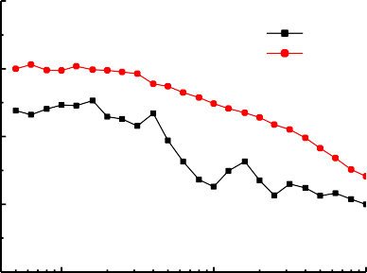

**L/D=2 W/D=1 W/D=2**

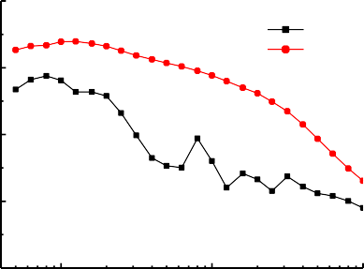

**L/D=4 W/D=1 W/D=2**

100 100

80 80

**SPL(dB)**

**SPL(dB)**

60 60

40

100 1000 10000

**f(Hz)**

40

100 1000 10000

**f(Hz)**

Fig.8. Effect of aspect ratio W/D on noise spectrum measured at bottom centre

Figure 7 shows that with the aspect ratio W/D increases, the spanwise flow enhanced which can effectively alleviate adverse pressure gradient on bottoms, so that the pressure distribution tends to be flat. For L/D=4, there are changes trends to the open flow type. Noise spectrum in Figure 8 shows that the changes of width to depth ratio greatly affect the cavity radiated noise, namely, with the aspect ratio increasing, the sound pressure peak is eliminated, but the maximum sound pressure level increases by at least 10dB.

# Conclusions

By low-speed and low-turbulence wind tunnel experiments, aerodynamic and acoustic property of cavities with various geometries was achieved. The basic conclusions are as followings:

1. with the same velocity, as length to depth ratio increases, radiated noise by the cavity flow increase, and for flow in cavities of L/D≤4, the acoustic spectrum appear as sound pressure peak at some frequencies.
2. at low speed incompressible flow state, when the cavity geometry is unchanged, with the velocity increases, little effect on the basic flow patterns and the noise frequency, but the noise amplitude increases greatly.
3. when aspect ratio W/D increased, there is a transform tendency for the cavity flow to open pattern, but noise radiation greatly increases at the meanwhile.

# References

1. C. K. W. Tam and P. J. W. Block, “On the tones and pressure oscillations induced by flow over

rectangular cavities”, J. Fluid Mech., 89:373-399, 1978.

1. Heller, H. H., and Holmes, D. G., “Flow Induced Pressure Oscillations in Shallow Cavities,” Journal of

Sound and Vibration,18(4): 545–553, 1971.

1. V. Sarohia, “Experimental and analytical investigation of oscillations in flows over cavities”, AIAA J.,

15:984-991, 1977.

1. L. N. III Cattafesta, M. S. Kegerise, and G. S. Jones, “Experiments on compressible flow-induced cavity oscillations”, AIAA Paper 98-2912, 1998.
2. D. F. Fuglsang and A. B. Cain, “Evaluation of shear layer cavity resonance mechanisms by numerical simulation”, AIAA Paper 92-0555, 1992.
3. Shieh, C. M., and Morris, P. J., “Comparison of Two- and Three-Dimensional Turbulent Cavity Flows”,

AIAA Paper 2001-0511, 2001.

1. M. Gharib and A. Roshko, “The effect of flow oscillations on cavity drag”, J. Fluid Mech., 177:501-530, 1987.
2. Chung, K., “Characteristics of Compressible Rectangular Cavity Flows,” Journal of Aircraft, 40(1): 137– 142, Jan. 2003.