Available online at [www.sciencedirect.com](http://www.sciencedirect.com/)



**ScienceDirect**

AASRI Procedia 9 (2014) 138 – 145

# 2014 AASRI Conference on Circuits and Signal Processing (CSP 2014)

Error Threshold for Individual Faulty Gates Using Probabilistic Transfer Matrix (PTM)

N. S. S. Singha*, N. H. Hamidb, V. S. Asirvadamc

*aFundamental and Applied Sciences Department, Universiti Teknologi PETRONAS, Bandar Seri Iskandar, Tronoh, Perak, Malaysia*

*b,cElectrical and Electronic Engineering Department Universiti Teknologi PETRONAS, Bandar Seri Iskandar, Tronoh, Perak, Malaysia*

**Abstract**

In the progression from CMOS technology to nanotechnology, being able to assess reliability of nano-based electronic circuits is fast becoming necessary. Due to this phenomenon, several computational-based approaches have been proposed for the reliability assessment of nanotechnology-based circuit systems. In quantifying reliability measure of the desired circuit system, faulty gates are considered as the most active part of the system. To have reliable circuit system, apart from its faulty gates, the size of error, *p*, in those faulty gates has to be lesser than a threshold, *ε\**. In other words, for the individual faulty gates to function reliably, the parameter interval of error in those faulty gates has to be 0  *p* < *ε\**, based on their respective gate error thresholds. This hypothesized that reliability of the desired circuit system does not only depend on its faulty gates, but it also depends on the error threshold of those faulty gates above which no reliable computation is possible. Therefore, there is a need to compute the exact error thresholds for individual faulty gates above which no circuit made up using those gates can calculate reliably. This paper shows the employment of Probabilistic Transfer Matrix (PTM) model in deriving the exact error threshold for individual faulty gates. The employed methodology provides simple and powerful analytic method to analyze reliability measure of nanotechnology-based circuit systems.

© 2014 The Authors. Published by Elsevier B. V. This is an open access article under the CC BY-NC-ND license ([http://creativecommons.org/licenses/by-nc-nd/3.0/).](http://creativecommons.org/licenses/by-nc-nd/3.0/))

© 2014 The Authors. Published by Elsevier B.V.

Selection and/or peer review under responsibility of American Applied Science Research Institute

Peer-review under responsibility of Scientific Committee of American Applied Science Research Institute

*Keywords:* Reliability; Reliability Assessment; Individual Faulty Gates; Exact Error Threshold; Probabilistic Transfer Matrix (PTM)

* Corresponding author. Tel.: +6019-5597597; fax: +605- 3654075.

*E-mail address:* [narinderjit@petronas.com.my.](mailto:narinderjit@petronas.com.my)

2212-6716 © 2014 The Authors. Published by Elsevier B. V. This is an open access article under the CC BY-NC-ND license ([http://creativecommons.org/licenses/by-nc-nd/3.0/).](http://creativecommons.org/licenses/by-nc-nd/3.0/))

Peer-review under responsibility of Scientific Committee of American Applied Science Research Institute doi:10.1016/j.aasri.2014.09.022

## Introduction

As CMOS technology scales down to nanometric scale, inconsistency in transistor performance will continue to increase, making the transistors less and less reliable.

This occurrence will subsequently affect the performance and downgrade the reliability of the desired circuit system made-up of these transistors [1]. Inconsistencies in the performance of transistors occur due to manufacturing ambiguity in the CMOS production process. Due to this physical-level of characteristics, non-deterministic behaviors will continue to develop in the circuit system which naturally affects the evolving technologies to have restrictions to operate reliably. Therefore, reliability has turn out to be the most important subject in the design entry of circuit systems and thus offer new challengers to circuit designers. Various probabilistic design methodologies have been implemented to assemble reliable circuit systems built out using unreliable devices [2, 3]. Due to the demand of having reliable design, a number of computational methodologies have been also proposed to assess reliability of nanotechnology-based circuits [4-12]. They are Probabilistic Transfer Matrix (PTM) [4-7], Probabilistic Gate Model (PGM) [8-10], Boolean Difference- based Error Calculator (BDEC) [11] and Bayesian Network (BN) [12].

Reliability of a desired circuit system is not only affected by its faulty gates, but it also depends on the size of the error, *p*, in those faulty gates. In order for the system to be reliable, the size of the error in its faulty gates has to be lesser than a threshold, *ε\**. The upper-limit of error in those faulty gates is increasingly important subject to be considered in the fault tolerance computation as it provides the exact bounds above which no circuit made up using those faulty gates can compute reliably. For this purpose, we have shown here that apart from computing reliability of the desired circuit system, Probabilistic Transfer Matrix (PTM) has also the ability to compute the fundamental error threshold for individual faulty gates.

Section 2 outlines Probabilistic Transfer Matrix (PTM). Section 3 exhibits the employment of PTM in deriving the exact error threshold for individual faulty gates. Extensive simulation results and discussion are shown in Section 4. The paper is concluded in Section 5.

## Probabilistic Transfer Matrix (PTM)

A relationship between input and output values for the operation of an integrated nano-based electronic circuit can be characterized by its truth table. Under certain circumstances, an incorrect output value can be generated by its input value. If we can identify how frequent this phenomenon is likely to occur, then we can demonstrate this occurrence using Probabilistic Transfer Matrix (PTM) [4-7]. PTM is represented in matrix form where column and row indicate input and output values respectively. For demonstration purpose, PTM for a two-input AND gate is shown in Eq. 1. The symbol *p* in Eq. 1 denotes the probability for wrong output value; sometimes we can also refer *p* as gate error probability. For a logic gate with *p* = 0, its PTM is termed as Ideal Transfer Matrix (ITM), in which the correct output value for that gate to occur, is assigned with a probability of 1. Eq. 2 shows the ITM matrix for AND logic gate.

# PTM  1 *p*

1 *p*

1 *p p* 

 *p p p* 1 *p* 

  *(1)*

# ITM  1 1 1 0 

0 0 0 1 

  *(2)*

Probabilistic Transfer Matrix (PTM) and Ideal Transfer Matrix (ITM) can represent any components from the desired circuit. These components can be divided into three special classes of gates namely standalone wires (uncorrelated), fan-out gates and swap of wires (correlated) as shown in [6].

* Standalone wire has no errors and denoted as 2 x 2 Identity Matrix, I.
* Fan-out gate refers to a gate where its output is associated to more than one input of the next gates. This gate is represented as Fn, where it feeds an output signal to n inputs of the next gates. Fig. 1 shows the F2 involving NAND gates. Its matrix representation is shown in Eq. 3.
* Swap of wires refers to crossing of wires. Fig. 2, Fig. 3 and Fig. 4 show swap of two-wires with one

crossing point, swap of three-wires with one crossing point and swap of three-wires with two crossing points respectively. In respective ways the swap of wires are shown in Eq. 4, Eq. 5 and Eq. 6.

Fig.1. 2-output fan-out NAND gates

# ⬆ 1 0 0 0

⬇ 0 0 0 1

 ✗

*(3)*

Fig.2. 2-wire swaps [6]

# ⬆ 1 0 0 0

⬇ 0 0 0 1

 ✗

*(4)*

Fig.3. 3-wire swaps [6]

# ⬆ 1 0

|  |  |  |  |  |  |
| --- | --- | --- | --- | --- | --- |
| 0 | 0 | 0 | 0 | 0 | 0 |
| 0 | 0 | 0 | 1 | 0 | 0 |
| 0 | 1 | 0 | 0 | 0 | 0 |
| 0 | 0 | 0 | 0 | 0 | 1 |
| 1 | 0 | 0 | 0 | 0 | 0 |
| 0 | 0 | 0 | 0 | 1 | 0 |
| 0 | 0 | 1 | 0 | 0 | 0 |
| 0 | 0 | 0 | 0 | 0 | 0 |

⬇ 0 0

⬇ 

# ⬇ 0 0

⬇ 0 0

⬇ 

# ⬇ 0 0

⬇ 

# ⬇ 0 0

⬇ 0 0

⬇ 

# ⬇ 0

1✗ *(5)*

Fig.4. 3-wire swaps [6]

# ⬆ 1 0

|  |  |  |  |  |  |
| --- | --- | --- | --- | --- | --- |
| 0 | 0 | 0 | 0 | 0 | 0 |
| 0 | 1 | 0 | 0 | 0 | 0 |
| 0 | 0 | 0 | 1 | 0 | 0 |
| 0 | 0 | 0 | 0 | 0 | 1 |
| 1 | 0 | 0 | 0 | 0 | 0 |
| 0 | 0 | 1 | 0 | 0 | 0 |
| 0 | 0 | 0 | 0 | 1 | 0 |
| 0 | 0 | 0 | 0 | 0 | 0 |

⬇ 0 0

⬇ 

# ⬇ 0 0

⬇ 0 0

⬇ 

# ⬇ 0 0

⬇ 

# ⬇ 0 0

⬇ 0 0

⬇ 

# ⬇ 0

1✗ *(6)*

There are two different types of connection for components in the desired circuit; either serially or parallelly as shown in Fig. 5. For a serial connection, circuit PTM is obtained as the product of PTM matrices for individual components as shown in Fig. 5(a). For a parallel connection, circuit PTM is obtained as the tensor product of PTM matrices for individual components as shown in Fig. 5(b) [4-7].

Fig.5. (a) Serial Connection and (b) Parallel Connection

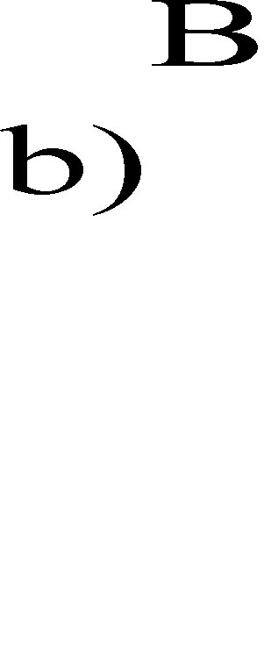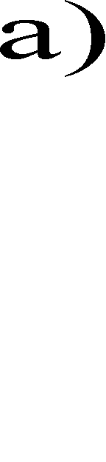

## System Design

Using the built-in feature of PTM, it can be hypothesized that reliability of the desired circuit system does not only depend on its faulty gates, but also on the error thresholds of those faulty gates above which no reliable computation is possible. For this purpose, PTM is employed to compute the exact error thresholds for individual noisy gates. In this approach, von-Neumann model has been considered. According to the model, the worst scenario in computing circuit reliability is attained when two input signals for a logic gate have same likelihood of being ‘1’ [8].

To determine the exact error threshold for NAND gate, PTM model is applied to a series of NAND gates as shown in Fig. 6. In this series of NAND gates, its order is labelled by index *j*, *j* = 1, 2, 3, ….., k, …., where the output signal of gate *j* converts to an input signal of gate *j* + 1. For any stationary *p* value, 0 < *p* ≤ 0.5, one randomly chooses an initial value of *X1* (likelihood of input signal being ‘1’). The likelihood of output signal being ‘1’ is computed for next stages until a sufficiently large number of stages are analyzed. This process of iteration is continued until the likelihood of output signal being ‘1’ converges to some fixed attractors. The attractors can be in the form of

* + a point for that specific *p*,
  + a number of distinct points for that specific *p*,
  + or chaos.

Once fixed attractors are obtained, those fixed attractors are plotted against each value of *p* as shown in Fig. 7 for NAND gate. By applying the same procedure on a series of other gates, one can obtain similar kind of graph plots as demonstrated in Fig. 8, Fig. 9 and Fig.10 for NOR, XOR and NOT gates respectively.



|  |  |  |
| --- | --- | --- |
|  |  |  |
|  |  |
|  |  | |

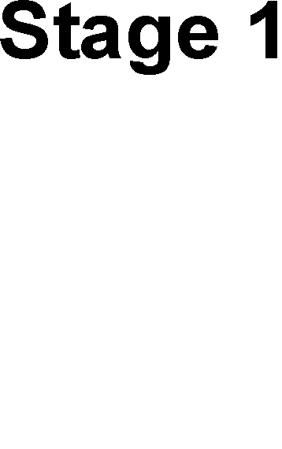Fig.6. Series of NAND gates

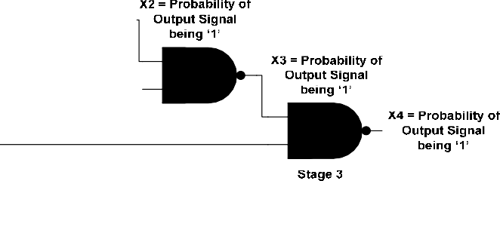

## Simulation Results and Discussion

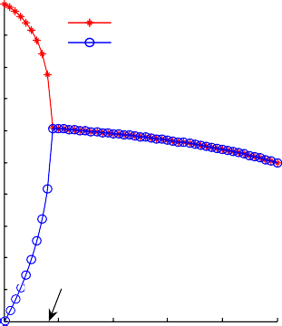1

0.9

0.8

Probability of Output Signal being '1'

0.7

0.6

0.5

0.4

0.3

0.2

0.1

0

even no. of NAND gates odd no. of NAND gates

Maximum Error Threshold

0 0.1 0.2 0.3 0.4 0.5

p

1

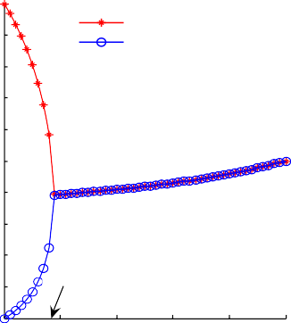0.9

0.8

Probability of Output Signal being '1'

0.7

0.6

0.5

0.4

0.3

0.2

0.1

0

even no. of NOR gates odd no. of NOR gates

Maximum Error Threshold

0 0.1 0.2 0.3 0.4 0.5

p

Fig.7. Graph Plot for NAND gate Fig.8. Graph Plot for NOR gate

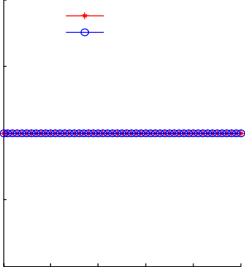1.5

1

Probability of Output Signal being '1'

even no. of XOR gates odd no. of XOR gates

1

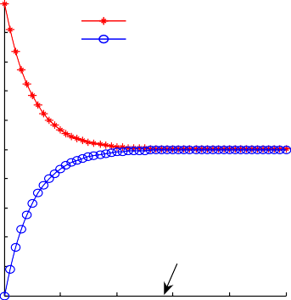0.9

0.8

Probability of Output Signal being '1'

0.7

even no. of NOT gates odd no. of NOT gates

0.6

0.5 0.5

0.4

0.3

0

0.2

0.1

Maximum Error Threshold

-0.5

0 0.1 0.2 0.3 0.4 0.5

0

0 1 2 3 4 5

p p x 10-3

Fig.9. Graph Plot for XOR gate Fig.10. Graph Plot for NOT gate

From the graph plots, when error in the faulty gate, *p* < maximum error threshold, then the gates can function reliably based on its even and odd numbers of logic gates. When error in the faulty gate *p* > maximum error threshold, then the output signal can be explained as neither being ‘1’ nor ‘0’. From Fig. 7 and Fig. 8, both NAND and NOR faulty gates share the same error threshold which is < 0.1. This phenomenon happened because the NOR gate is a duality of the NAND gate, so their behaviors, illustrated by Fig. 7 and Fig. 8, come out to be complementary to one another. For XOR gate in Fig. 9, its maximum error threshold is 0, or in other words a maximum error threshold never occurs for this gate. For NOR gate in Fig. 10, its maximum error threshold is < 3 x 10-3. Based on PTM approach, among all the faulty gates, NAND and NOR gates give the highest error threshold, followed by NOT gate and then by XOR gate. This indicates that from all the existing faulty gates, NAND and NOR gates would be preferably used the most in designing a circuit system due to their highest error threshold compare to other faulty gates.

## Conclusion

Reliability is fast becoming a critical subject in the design entry of nanotechnology-based circuits. Due to this occurrence, various computational-based approaches have been proposed to assess reliability of these circuit systems. Apart from assessing reliability, in this paper we briefly present an analytical approach based on Probabilistic Transfer Matrix (PTM) on how to derive exact error thresholds for general probabilistic computation. Exact error thresholds for faulty gates are significantly important subject to be considered in the designing nano-based circuit systems as it provides the exact bounds above which no reliable calculation is achievable.

## Acknowledgements

The authors are grateful to Universiti Teknologi PETRONAS for its financial support.

## References

1. D. Franco, M. Vasconcelos, L. Naviner and J. Naviner, “Signal probability for reliability evaluation of logic gates,” Microelectronics Reliability, 2008, 48 (8-9), pp. 1586-1591
2. I. Bahar, J. L. Mundy and J. Chen, “A probabilistic-based design methodology for nanoscale computation,” International Conference on Computer Aided Design, 2003, pp. 480-486
3. J. Han and P. Jonker, “A defect and fault-tolerant architecture for nanocomputers,” Nanotechnology, 2003, 14, pp. 224-230
4. S. Krishnaswamy, G. Viamontes, I. Markov, and J. Hayes, “Accurate reliability evaluation and enhancement via probabilistic transfer matrices,” Europe Conference and Exhibition on Design, Automation and Test, March 2005, pp. 282-287
5. K. Patel, I. Markov and J. Hayes, “Evaluating circuit reliability under probabilistic gate-level fault models,” International Workshop on Logic Synthesis, 2003, pp. 59-64
6. W. Ibrahim, V. Beiu, M. Sulieman, “On the reliability of majority gates full adders,” Nanotechnology, Jan 2008, 7, pp. 56-67
7. Azam Beg and Walid Ibrahim, “On Teaching Circuit Reliability,” 38th Annual Frontiers in Education Conference, Saratoga Springs, NY, USA, Oct 2008, pp. T3HI2–T3H17
8. J. Han, E. Taylor, J. Gao and J. Fortes, “Faults, error bounds and reliability of nanoelectronic circuits,” 16th International Conference on Application Specific Systems, Architecture and Processors, July 2005, pp. 247-253
9. J. Gao, Y. Qi and J. Fortes, “Bifurcations and fundamental error bounds for fault-tolerant computations,”

Nanotechnology, July 2005, 4, pp. 395-402

1. J. Han, E. Taylor, J. Gao and J. Fortes, “Reliability modeling of nanoelectronic circuits,” 5th International Conference on Nanotechnology, July 2005, pp. 104-107
2. N. Mohyuddin, E. Pakbaznia and M. Pedram, “Probabilistic error propagation in logic circuits using the boolean difference calculus,” 26th International Conference on Computer Design, October 2008, pp. 7-13
3. Rejimon T., Bhanja S., “Scalable probabilistic computing models using Bayesian Networks,” 48th Midewest Symposium on Circuits and Systems, 2005, pp. 712-715