[Artificial Intelligence in Agriculture 9 (2023) 76–88](https://doi.org/10.1016/j.aiia.2023.08.004)

Contents lists available at [ScienceDirect](http://www.sciencedirect.com/science/journal/)

Artificial Intelligence in Agriculture

journal homepage: [http://www.keaipublishing.com/en/journa ls/artificial- intelligence- in-agriculture/](http://www.keaipublishing.com/en/journals/artificial-intelligence-in-agriculture/)

[](http://crossmark.crossref.org/dialog/?doi=10.1016/j.aiia.2023.08.004&domain=pdf)Estimation of morphological traits of foliage and effective plant spacing in NFT-based aquaponics system

R. Abbasi a, P. Martinez b, R. Ahmad a,⁎

a *Aquaponics 4.0 Learning Factory (AllFactory), Department of Mechanical Engineering, University of Alberta, 9211 116 St., Edmonton, AB T6G 2G8, Canada*

b *Mechanical and Construction Engineering Department, Northumbria University, Newcastle upon Tyne NE7 7YT, UK*

a r t i c l e i n f o

*Article history:*

Received 18 October 2022

Received in revised form 8 August 2023 Accepted 20 August 2023

Available online 23 August 2023

*Keywords:*

Deep learning Ontology modeling Crop phenotyping Leafy crops Aquaponics

Digital farming Plant spacing

a b s t r a c t

Deep learning and computer vision techniques have gained significant attention in the agriculture sector due to their non-destructive and contactless features. These techniques are also being integrated into modern farming systems, such as aquaponics, to address the challenges hindering its commercialization and large-scale imple- mentation. Aquaponics is a farming technology that combines a recirculating aquaculture system and soilless hy- droponics agriculture, that promises to address food security issues. To complement the current research efforts, a methodology is proposed to automatically measure the morphological traits of crops such as width, length and area and estimate the effective plant spacing between grow channels. Plant spacing is one of the key design pa- rameters that are dependent on crop type and its morphological traits and hence needs to be monitored to ensure high crop yield and quality which can be impacted due to foliage occlusion or overlapping as the crop grows. The proposed approach uses Mask-RCNN to estimate the size of the crops and a mathematical model to determine plant spacing for a self-adaptive aquaponics farm. For common little *gem* romaine lettuce, the growth is esti- mated within 2 cm of error for both length and width. The final model is deployed on a cloud-based application and integrated with an ontology model containing domain knowledge of the aquaponics system. The relevant knowledge about crop characteristics and optimal plant spacing is extracted from ontology and compared with results obtained from the final model to suggest further actions. The proposed application finds its signifi- cance as a decision support system that can pave the way for intelligent system monitoring and control.

© 2023 The Authors. Publishing services by Elsevier B.V. on behalf of KeAi Communications Co., Ltd. This is an open access article under the CC BY-NC-ND license (<http://creativecommons.org/licenses/by-nc-nd/4.0/>).

1. Introduction

Aquaponics is a symbiotic integration of two technologies:

i) aquaculture (fish farming) and ii) hydroponics (the cultivation of plants in water without soil), which are combined within a closed recirculating system. There is a growing interest in this controlled envi- ronment farming method around the globe as it offers an environmen- tally friendly and sustainable way of agri-food production (Abbasi et al., 2021a). The correct design and management of the aquaponics system are of utmost importance to witness enhanced crop quality and farm productivity. Crop quality is evaluated by many indicators, one of which is crop morphological traits such as length, width, area, and pe- rimeter which are used to assess the health status as well as the market value of the crops (“Crop Quality - An Overview|ScienceDirect Topics,”, 2021). Hence, it is vital to monitor these parameters throughout the plantation cycle. Moreover, crop quality is directly impacted by plant spacing which is defined as the distance between growing sites of two

* Corresponding author.

*E-mail address:* [rafiq.ahmad@ualberta.ca](mailto:rafiq.ahmad@ualberta.ca) (R. Ahmad).

consecutive plants (Abbasi et al., 2021b). In traditional agriculture, crops compete with each other for resources, such as solar radiation, nu- trients, and moisture uptake to gain energy for their growth, for which they require reasonable root space and vegetative space (Zaman et al., 2021). The inadequate plant spacing may lead to several problems. For instance, the plants sited closely produce fewer leaves, flowers, and seeds, which causes reductions in final crop yields. Moreover, overcrowded plants are also susceptible to potential diseases, foliage damage as crops mature, and invasion by unwanted pathogens (Zaman et al., 2021). Many disease agents require a humid environment to develop and in crowded plantations, reduced airflow prevents mois- ture from evaporating from leaf surfaces, increasing the likelihood of diseases. Similarly, excessive plant spacing can also be a problem, as it hinders the pollination process. Unlike traditional agriculture, the as- pect of plant spacing is different in the NFT-based aquaponics system. The crop growing area (hydroponics) in the NFT system is a combina- tion of enclosed channels consisting of circular or squared-shaped pockets known as plant sites where plants reside in small plastic cups allowing their roots to access water and absorb nutrient-enriched effluent from aquaculture (Abbasi et al., 2021b). Plant spacing in NFT

<https://doi.org/10.1016/j.aiia.2023.08.004>

2589-7217/© 2023 The Authors. Publishing services by Elsevier B.V. on behalf of KeAi Communications Co., Ltd. This is an open access article under the CC BY-NC-ND license ([http://](http://creativecommons.org/licenses/by-nc-nd/4.0/) [creativecommons.org/licenses/by-nc-nd/4.0/](http://creativecommons.org/licenses/by-nc-nd/4.0/)).

systems refers to either distance between two plants on the same chan- nel or the distance between plants on adjacent channels. The plant spac- ing attribute on the same channel is normally fixed and is designed considering the full-grown size of the plant before the actual plantation. The plant spacing attribute between channels is also kept fixed in open- air farms but in indoor NFT-based systems, it can be varied depending on the crop type to efficiently utilize the limited space. In NFT systems, all the nutrients are directly delivered to the crops' root system and therefore, there is no competition for resources for the root system (Syed Abreez Gillani et al., 2022a). However, vegetative space still re- quires special attention as crops spend the most energy on vegetation to absorb more light (Maboko and Du Plooy, 2009). Plant spacing varies as a function of crop species and their morphological traits such as length, width, area, and perimeter (Singh et al., 2022). Therefore, to achieve maximum yields, the optimum plant spacing must be main- tained according to crop type and its morphological characteristics. Ad- ditionally, the crop growth cycle consists of various phases from seedling to vegetative and in each phase the area of crop foliage changes as it grows over time — requiring different plant spacing and illumina- tion conditions (Nakarmi and Tang, 2012).

The aforementioned challenges pose a need for a self-adaptive aquaponics system that determines the crop morphological traits, determines the distance between two plants and adjusts the spacing between channels. Traditionally, manual methods that require a high level of expertise and advanced equipment were used to determine morphological traits. These methods produce accurate results, but they are costly, labour-intensive, and time-consuming (Triki et al., 2021). To accelerate plant phenotyping, numerous semi-automatic tools are developed such as LeafJ, Easy Leaf Area, and TraitEx (Easlon and Bloom, 2014; Gaikwad et al., 2019; Maloof and Nozue, 2013). But these tools require pre-processing of the input images for utilizing mul- tiple automation degrees (Triki et al., 2021). To overcome the stated bottleneck, this study aims to propose an approach to automatically estimate morphological traits (foliage area, length, and width), the distance between plants and effective plant spacing between adjacent channels. Based on this information, the aquaponics system can adapt itself by adjusting the position of grow channels. The proposed ap- proach is deployed on a cloud-based application and integrated with the ontology model proposed by authors in previous work (Abbasi et al., 2021a).

1. Related work

With developments in deep learning and computer vision tech- niques, several methods have been developed and instantly grown in different visual recognition tasks such as the estimation of morphologi- cal traits of crops (Abbasi et al., 2022). A review of some of the latest and more relevant methods is presented here. Weaver et al. have proposed a tool ‘LeafMachine’ based on CNN (convolutional neural network) and SVM (support vector machine) to measure the leaf morphological traits from digitized herbarium specimen images autonomously (Weaver et al., 2020). Triki et al. used the same dataset and proposed a new and enhanced approach ‘Deep Leaf’ based on Mask-RCNN (region- based convolutional neural network), to determine the length, width, area, and perimeter of leaves (Triki et al., 2021). Hirigoyen et al. devel- oped a machine-learning model using SVM and RF (random forest) techniques to determine the leaf area index in Eucalyptus plantations (Hirigoyen et al., 2021). Lu et al. proposed a Mask R-CNN-based model to determine the growth rate of lettuce crops as a function of leaf area and time in a hydroponics system (Lu et al., 2019). Juyal (Gillani et al., 2022a) et al. proposed a method to estimate the length and width of trees for calculating the overall volume using Mask-RCNN (Juyal and Sharma, 2020). Reyes et al. proposed a methodology to determine the size of crops (height, width, depth, side view area, top view area) for assessing the growth rate and fresh weight of crops using Mask-RCNN (Reyes-Yanes et al., 2020). Even though the aforementioned methods

have made a great contribution to the research community, the analysis shows that none of the studies has focused on using these traits as a key feature to assess plant spacing. Hence, to complement the existing ef- forts, this study proposed a new methodology to determine morpholog- ical traits of lettuce crops grown in aquaponics facility and assess the plant spacing between grow channels. Additionally, based on the capa- bility of instance segmentation, Mask-RCNN is used to estimate the morphological attributes in this study (Kang et al., 2020; Lu et al., 2019).

1. Research methodology

An automated system is developed to monitor the morphological traits of the lettuce crop and estimate the plant spacing in the aquaponics facility using deep learning techniques. The overall method- ology is divided into five sequential modules: i) dataset preparation and pre-processing; ii) model development and parameter estimation; iii) model training and loss function calculation, iv) ontology modeling, and v) cloud-based application development. Fig. 1 shows the complete pipeline of this approach and details of all stages are explained in the following subsections.

* 1. *Dataset preparation and preprocessing*
     1. *Data acquisition*

For this study, a 12MP camera is used to capture images of thirty lettuce plants grown in NFT based aquaponics facility situated at the University of Alberta, Canada. Fifty images of 4032 × 3024 pixels are captured every day, half (25 images) at 9:00 am and a half at 6:00 pm from the top while keeping the distance between camera and channel at a constant value of 40 cm throughout the plantation cycle, i.e., five weeks. Each image contains two plants planted in adjacent channels. There are six grow channels, each having five plant sites. The channels are horizontally stacked, so the total number of plants in one of the rows of adjacent channels is six. In total, 1750 images are collected over 5 weeks and are saved in JPG format. Fig. 2 shows an example of some of the images of lettuce from different growth stages.

The manual measurements of morphological traits such as length, width, and height of 30 plants are also recorded twice a day at 9:00 am and 6:00 pm for five weeks using a calliper. For the ground truth value of foliage area, the number of pixels is counted manually by selecting the area of interest in Adobe Photoshop which is then converted to cm2. The area is also recorded twice a day at the given timings for five weeks. As the plants grow, their area, length and width also increase, consequently reducing the distance between two plants. This distance needs to be measured throughout the plantation cycle to determine the effective plant spacing and adjust the spacing between plants by adjusting the distance between channels. The distance between chan- nels is also used to determine the plant population and crop field in an NFT-based aquaponics system. The actual distance between plants is re- corded for all the plants by taking manual measurements twice a day at 9:00 am and 6:00 pm for five weeks using a scale. In total, 50 distance values are calculated every day for 30 plants growing on adjacent chan- nels. All the manual measurements are saved in a common excel file.

* + 1. *Data augmentation*

Next, an image augmentation process is performed to increase the dataset size, avoid overfitting, and enhance the reliability of the segmentation process despite the location and orientation of objects in the image by generating new images from existing images. In this study, Albumentations, a Python library is used for fast and flexible image augmentation (Buslaev et al., 2020). The different augmenta- tion techniques applied are horizontal flip, vertical flip, 90° rotation, and glass noise. In total, 250 images are selected randomly for the augmentation, which created 250 new images — increasing the size of the dataset to 2000 images. Fig. 3 shows an example of image augmentation.

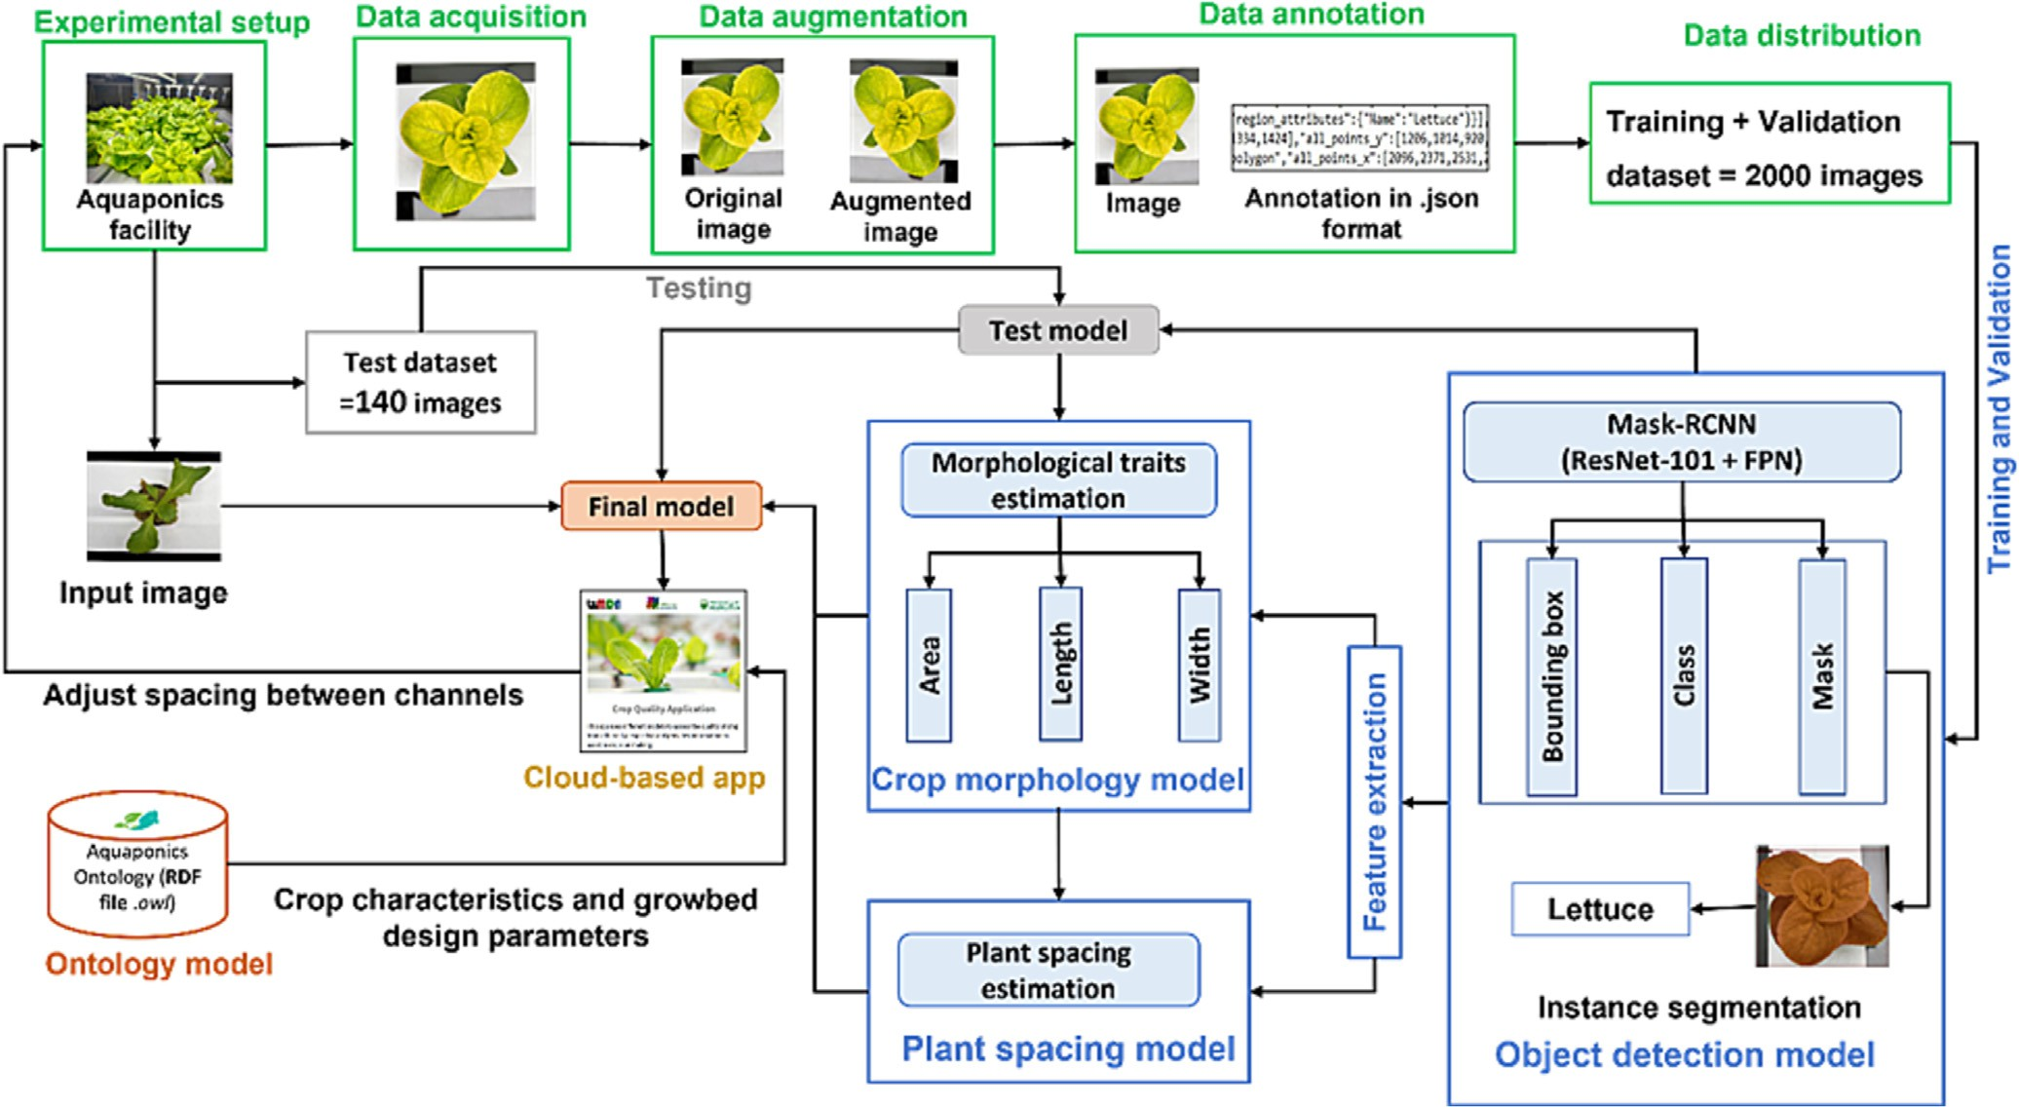

Fig. 1. Research methodology for estimating the morphological traits and effective plant spacing.

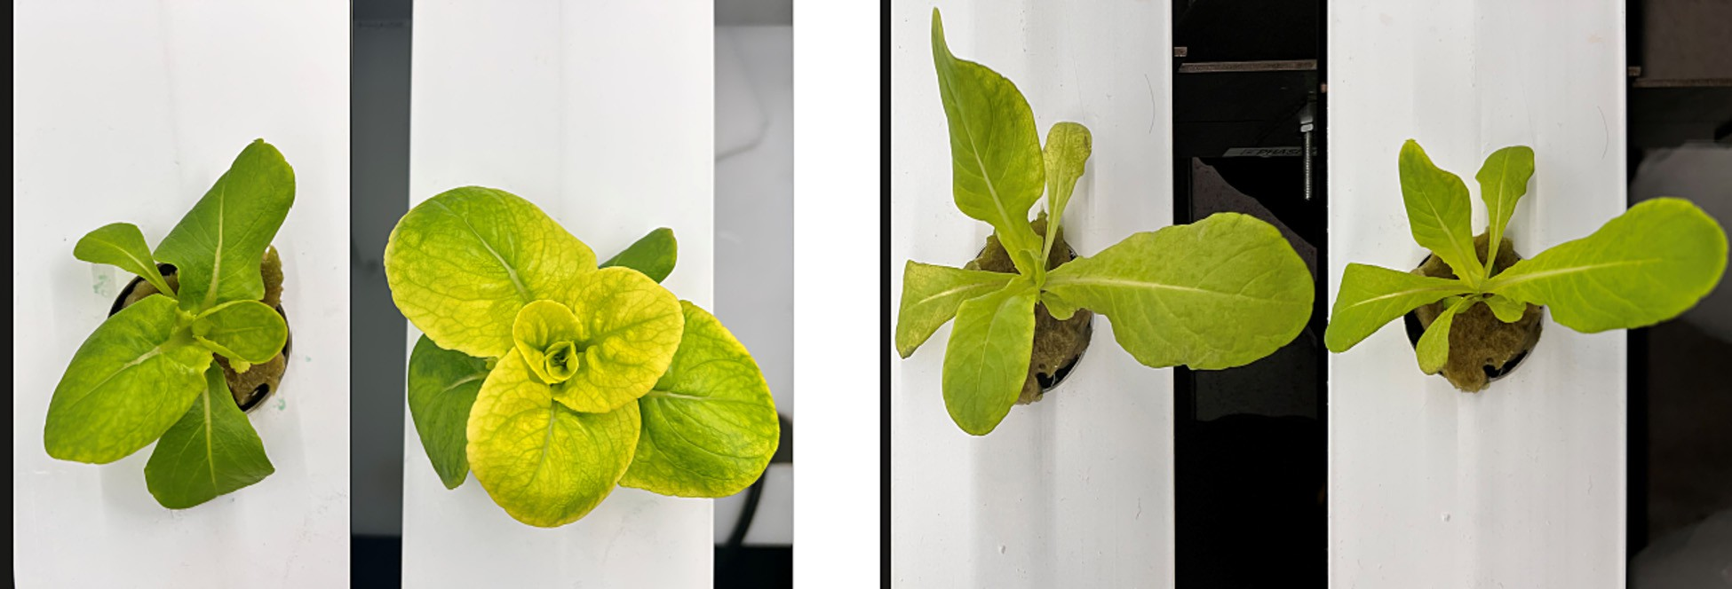

Fig. 2. Samples images from the aquaponics facility.

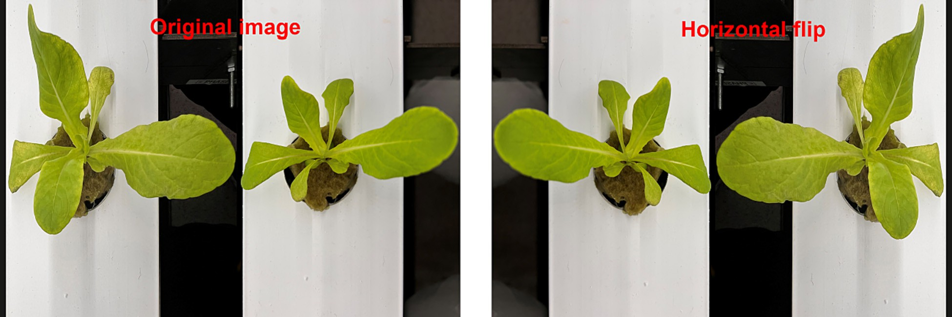

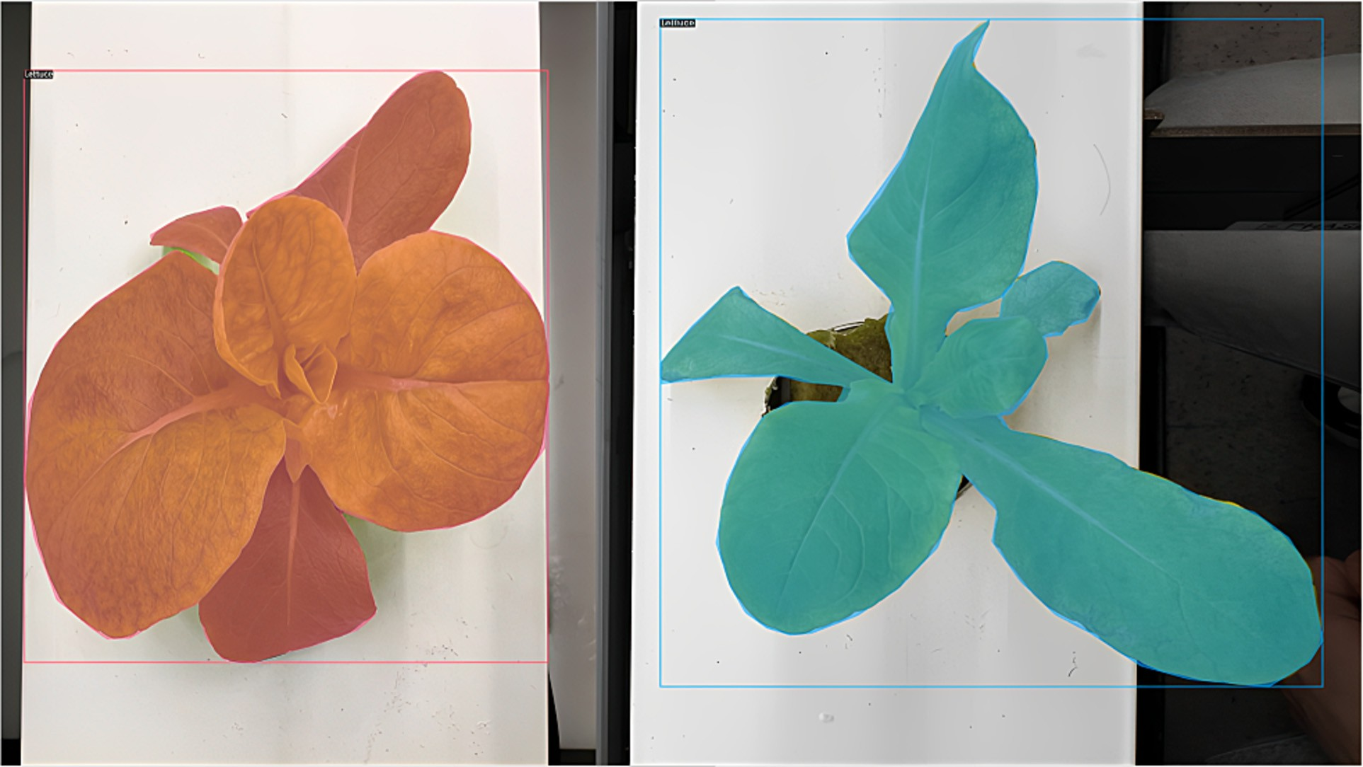

Fig. 4. Bounding boxes and masks after data annotation.

To reduce the computation and running time of the training and testing of the model, the sizes of all the images were scaled to 640 × 480. A total of 2000 images are used for the model training and parameter optimization of Mask R-CNN, with 80% as the training set and 20% at the validation set. For test data, a new batch of plants is grown. After the training, the performance of the trained model is eval- uated with a new set of images captured for the test dataset.

* + 1. *Data annotation*

Data annotation is one of the vital steps for the successful develop- ment of object detection models. The process is manual and involves la- belling the desired objects in an image with a label or tag that refers to a particular class. The labelled data is used during the training of the model. There are many open-source annotation tools, but in this study, VGG Image Annotator (VIA) is used (Dutta et al., 2019). In this study, Mask-RCNN is used. The relevant regions of the image are labelled, and the remaining region defaults to the background. Fig. 4 shows an example of ground truth bounding boxes and masks obtained after data annotation.

* 1. *Object detection and instance segmentation*

After data collection, object detection and instance segmentation are performed on crop images to achieve class, mask, and bounding box values for lettuce foliage. In this study, Mask R-CNN is used which is a state-of-the-art method in the field of object segmentation. Instance segmentation is a computer vision task for detecting and localizing an object in an image through the identification of boundaries at a detailed pixel level (Yu et al., 2019).

* + 1. *Mask-RCNN training*

NVIDIA GeForce RTX 3090 is used for training the Mask-RCNN. A total of 2000 images are split into 80% for the training set and 20% for the validation set. The Mask-RCNN is implemented in Detectron2 — Facebook AI Research's next-generation library written in PyTorch

on the COCO dataset) from the model zoo of the Detectron21 ‘Mask- RCNN with ResNet-101 + FPN’ is applied using the transfer learning ap- proach (Yu et al., 2019). The model is trained for 600 iterations with the image input batch size given as 32. The initial learning rate is kept at

0.001 for the first 100 iterations and is then adjusted per 100 iterations with an adjustment factor of 0.95. The category scores, bounding boxes, and masks of lettuce foliage for each input image are then obtained as the outputs of the model. The training process is completed in around 1 h for 600 iterations and the model loss function achieved a conver- gence state. The total loss of the proposed approach consists of two parts: the loss of classification and regression operations by RPN, and the training loss in the multi-branch predictive network, and can be cal- culated by using the formula Lfinal = LRPN + L mmulti_branch) (He et al., 2017). Where (*Lfinal*) represents the total loss, (*LRPN*) represents the training loss of the RPN (anchors classification loss (SoftMax Loss) and bounding box regression loss (SmoothL1 Loss)), and (*Lmulti*_*branch*) represents the training loss due to the three-branch structure (SoftMax Loss, SmoothL1 Loss, and Mask Loss). (*LRPN*) and (*Lmulti*_*branch*). The loss function value and accuracy per iteration of the model for 600 iterations are shown in Fig. 5. The loss function is showing a downward trend during the training process as can be seen in Fig. 5, which means that the prediction loss deviation is gradually decreasing by updating the loss function of the small sample batches during the optimization process. The loss function values for both the training set and validation set are reduced to less than 0.2 and tend to be stable when the number of iterations is more than 550. This indicates that the training of the model runs well, with a detection accuracy of lettuce foliage of more than 0.98.

* 1. *Crop morphological traits estimation model*

From the instance segmentation process, the predicted mask and bounding box of each instance are retrieved to determine lettuce mor- phological traits such as foliage area, length, and width. In this case,

that provides state-of-the-art detection and segmentation algorithms.

Since the dataset is small, the pre-trained version of Mask-CNN (trained

1 <https://ai.facebook.com/tools/detectron2/>.

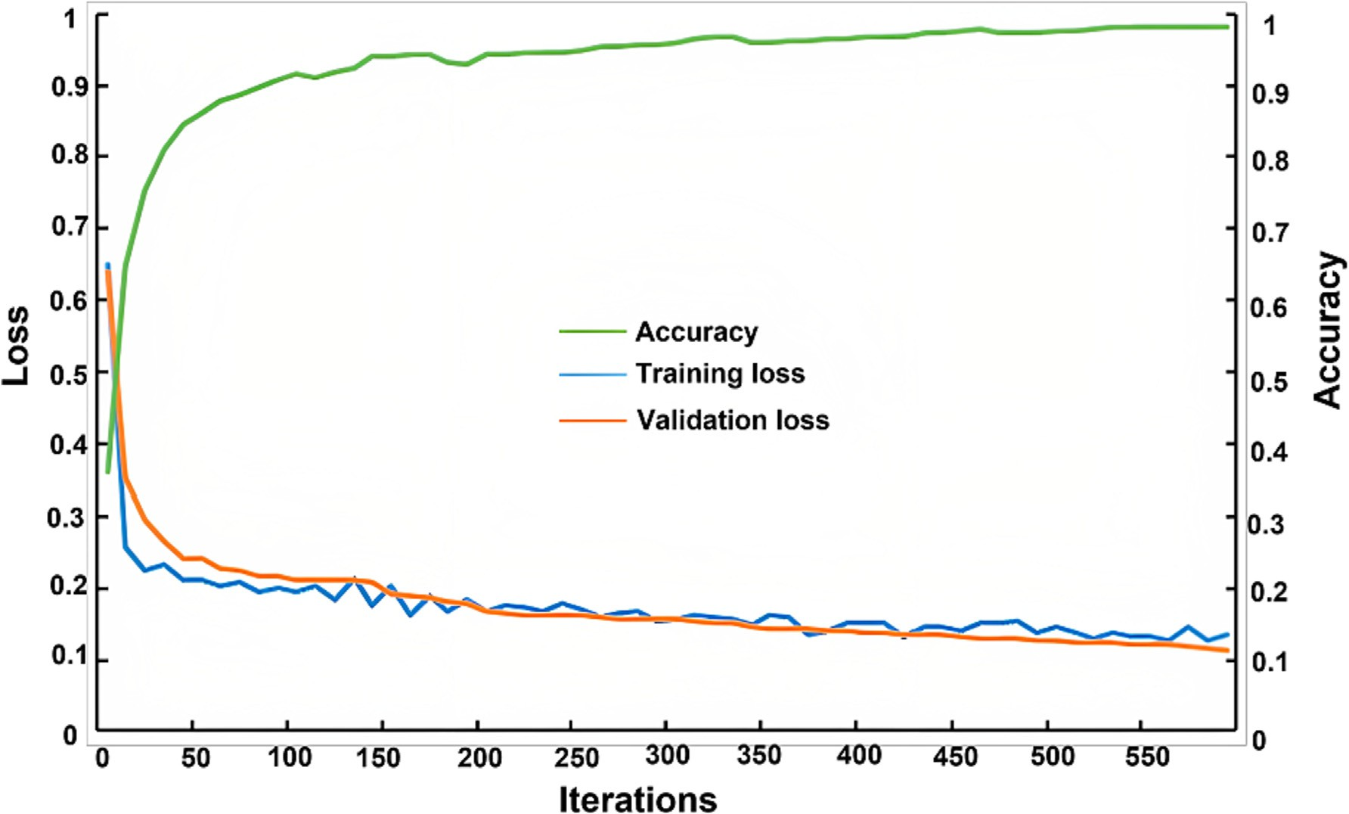

Fig. 5. Training losses, validation losses and accuracy per iteration.

there are two masks and two bounding boxes as each image consists of two lettuce foliage. The foliage area of two lettuce plants is calculated by extracting features from their respective predicted masks. The masks are a set of matrices that contain pixels belonging to the area of a seg- mented object (area of interest) which in this case are two lettuce fo- liage. These pixels are retrieved from the prediction and further processing is done to give this data useful meaning.

The distance between the camera and the object affects the pixel count of the image. The closer the camera, the greater the number of pixels of an object in an image and vice versa. Hence, in this study, the distance between the camera and channel is kept fixed at a value of 40 cm while taking the images and is denoted by (*D*). As we know, the height of the lettuce increases throughout the plantation cycle and affects the pixel count. To calculate the foliage area (*Af*), the height (*h*) of the crop is also taken into account. At the end of the plantation cycle, a boxplot is created shown in Fig. A1 of appendix A for the heights of 30 lettuce plants recorded manually and a scatter plot is created shown in Fig. A2 of appendix A using median values of plants' heights to derive a linear regression relationship between height (*h*) and the number of days (*x*), which is represented in Eq. 1.

*h* = 0.2521*x* + 2.9641 (1)

To adequately measure the morphological traits, the relationship be- tween real-world metrics, such as cm (centimeter) and actual pixel count (*pc*) on the image should be identified. Triki et al. used a scale bar object to determine this relationship (Triki et al., 2021). In this study, the width of the channel (*wc*) which is known to be 10 cm is used for this purpose. Eq. 2 shows the relationship between (*wc*) and (*pc*).At a constant distance of (*D*) the relationships (*k*) and (*k*′) between pixel count (*pc*) and channel width (*wc*) are given in Eqs. 3 and 4.

*wc* (*cm*) ≡ *pc* (*pixels*) (2)

*k* = *pc*  *pixels* (3)

*wc*

*cm*

*p* 2 *pixels*

= *wc* 2 *cm*2 ( )

*k*′ *c* 4

Let (*pm*) is the pixel count of the predicted mask, which is dependent on the height (*h*) of the plant. The height of the plant changes throughout the plantation cycle and hence affects the pixel count of the predicted mask. To compute foliage area (*Af*), Eq. 5 is developed.

*Af* = *pm* × *h* (5)

*k*′ *D*

×

Next, bounding boxes are retrieved from the model in the form of coordinates of opposite rectangle corners (top left (*x*1, *y*1) and bottom right (*x*2, *y*2). These coordinates are used to calculate the approximate width (*Wf*) and length (*Lf*) of foliage as shown in Fig. 6 using Eqs. 6 and 7 respectively.

*Wf* = *x*2 — *x*1 (*pixels*) (6)

*Lf* = *y*1 — *y*2 (*pixels*) (7)

The Eqs. 8 and 9 are developed for measuring the width and length of foliage in real-world metric units (centimeter).

*Wr* = *Wf* × *h* (*cm*) (8)

*k* × *D*

*Lr* = *Lf* × *h* (*cm*) (9)

*k* × *D*

The above process is performed for two lettuce foliage in a segmented image.

* 1. *Mathematical model for plant spacing calculation*

The most common configurations of plant spacing used for NFT

channels along with several dimensional characteristics are shown in

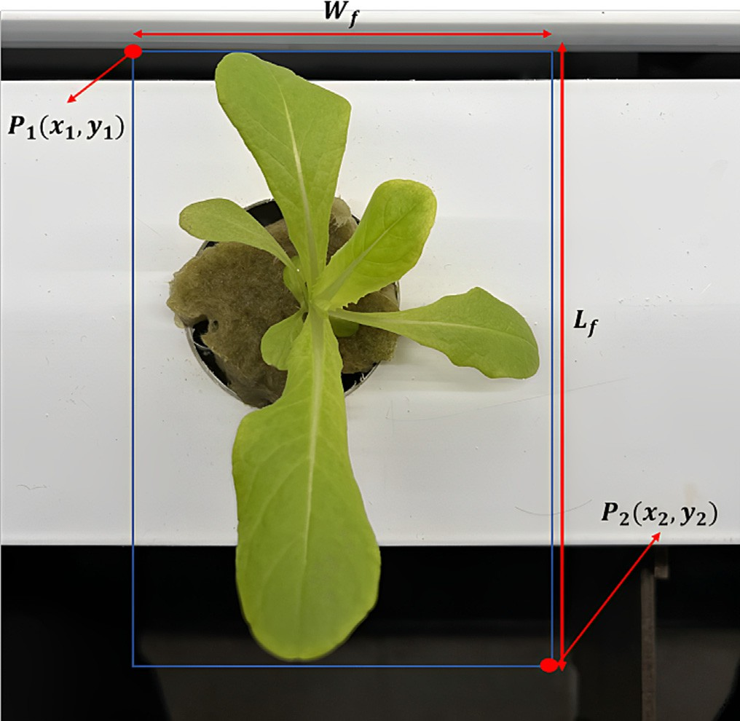channel, (*S*) and between channels (*S*′) is kept constant. The latter pa- rameter can be controlled to make a self-adaptive aquaponics. In Fig. 7, (*S*′) is the distance from the center of the plant site of one channel to the center of the plant site of the adjacent channel and is given in Eq. 10.

*S*′ = *wc*1 + *wc*2 + *s* (10)

2 2

Where (*wc*1 = *wc*2), (*wc*1) is the width of channel 1, (*wc*2) is the width of channel 2 and (*s*) is the distance between two adjacent channels. The width of channels is constant whereas (*s*) is a dynamic parameter. By changing (*s*), the horizontal channel spacing i-e., the dis- tance between channels can be changed.

To compute the distance between plants automatically, the initial and new values of (*S*′) and (*s*) are computed. Let (*S*′*n*−1) and (*sn*−1) refers to initial or previous values for (*S*′) and (*s*), respectively, and (*Sn*′ ) and (*sn*) refers to new values for (*S*′) and (*s*), respectively. Eqs. 11 and 12 represent the initial and new values of (*S*′).

' *wc*1 *wc*2

*S s* 11

= + + *n*−1 ( )

*n*−1 2 2

*S*' = *wc*1 + *wc*2 + *sn* (12)

Fig. 6. Dimensional characteristics of foliage.

*n* 2 2

Fig. 7. In configuration 1, the plant sites on two adjacent channels are in-line with each other and in configuration 2, the plant sites are at an angle. In this study, configuration 1 is considered for a case study but the proposed model can also be applicable to configuration 2. The plant spacing (*S*) is to be maintained on individual grow channels as well as between the channels (*S*′) to avoid foliage occlusions and overlapping which limit crop growth and affect crop quality. Generally,

To compute (*sn*), an incremental parameter (*si*) is defined, which determines the variation in plant spacing due to changes in foliage morphological traits. The incremental parameter (*si*) is calculated using the Euclidean distance (*d*) between two bounding boxes achieved through the prediction process shown in Fig. 8 and (*S*′*n*−1). The parameter (*si*) will only increment if (*d*) will be less than (*S*′*n*−1) i-e., *if d* < *S*′*n*−1. The value of (*d*), on the other hand, is dependent on the foliage area and length, which decreases as the area (*Af*) and length (*Lf*) of foliage increases. Eqs. 13, 14 and 15 provide the relationship for (*d*), (*sn*), and (*si*).

while designing the aquaponics system, the plant spacing on the

*d* = q(ﬃﬃ*x*ﬃﬃﬃ1ﬃﬃﬃ—ﬃﬃﬃﬃﬃﬃ*x*ﬃﬃ2ﬃﬃ)ﬃﬃ2ﬃﬃﬃ+ﬃﬃﬃﬃﬃ(ﬃﬃ*y*ﬃﬃ1ﬃﬃﬃﬃ—ﬃﬃﬃﬃﬃ*y*ﬃﬃﬃ2ﬃﬃ)ﬃﬃ2ﬃﬃ

(13)

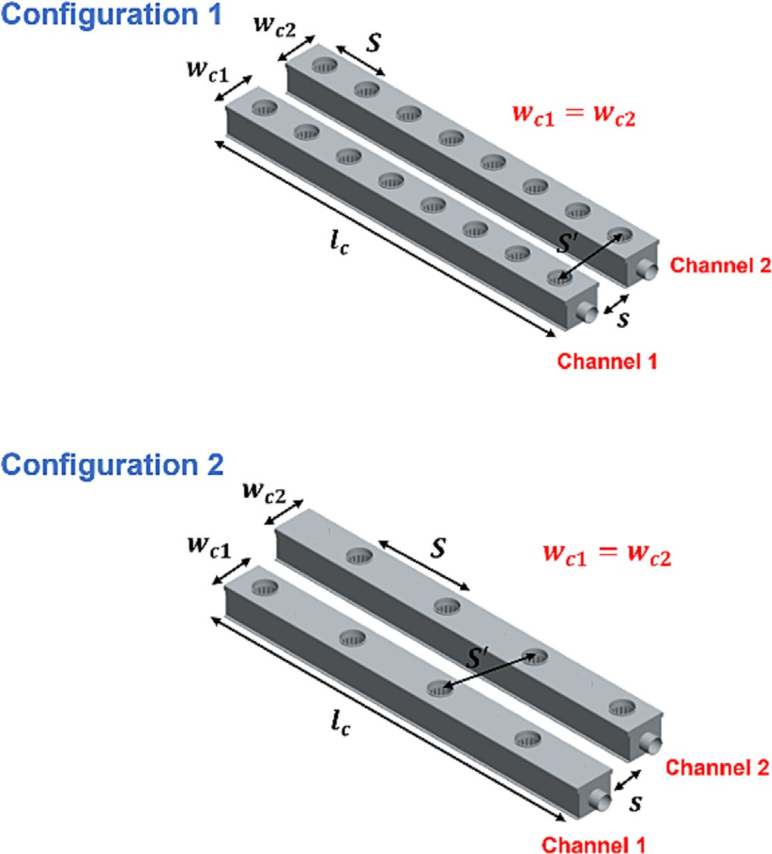*sn* = *sn* — 1 + *si* (14)

*si* = *S*′

*n* — 1

— *d* (15)

The new values for (*S*′) are then obtained by incrementing the values of (*s*) using the above process for all plants' pairs in images and converted to metric units (cm) using Eq. 2 The updated values of (*s*) can be used to estimate plant population (PD) using the Eq. 16 proposed by authors in previous work (Abbasi et al., 2021b).

*PD* = *NPSC* × *NC*

*L* × ((*NC* × W) + ((*NC* — 1) × *HCS*)

(16)

Where (*NPSC*) is the number of plant sites (circular or squared- shaped pockets) per channel, (*NC*) is the total number of channels, *L* is the length of each channel and is equivalent to (*lc*) shown in Fig. 7,

(W) is the width of each channel and is equivalent to (*wcj*) shown in Fig. 7 (j = 1,2,3…..n), and (*HCS*) is horizontal channel spacing and equivalent to (*s*).

* 1. *Ontology model*

Fig. 7. Dimensional characteristics of grow channels with respect to two configurations.

The complete development and details of all the concepts and instances of the ontology model ‘AquaONT’ developed by authors in previous work are available (Abbasi et al., 2021a). AquaONT is a unified ontology model that represents and stores the essential knowledge of an aquaponics 4.0 system. It consists of six concepts: Consumer_Product, Ambient_Environment, Contextual_Data, Production_System, Product_Quality, and Production_Facility. In this

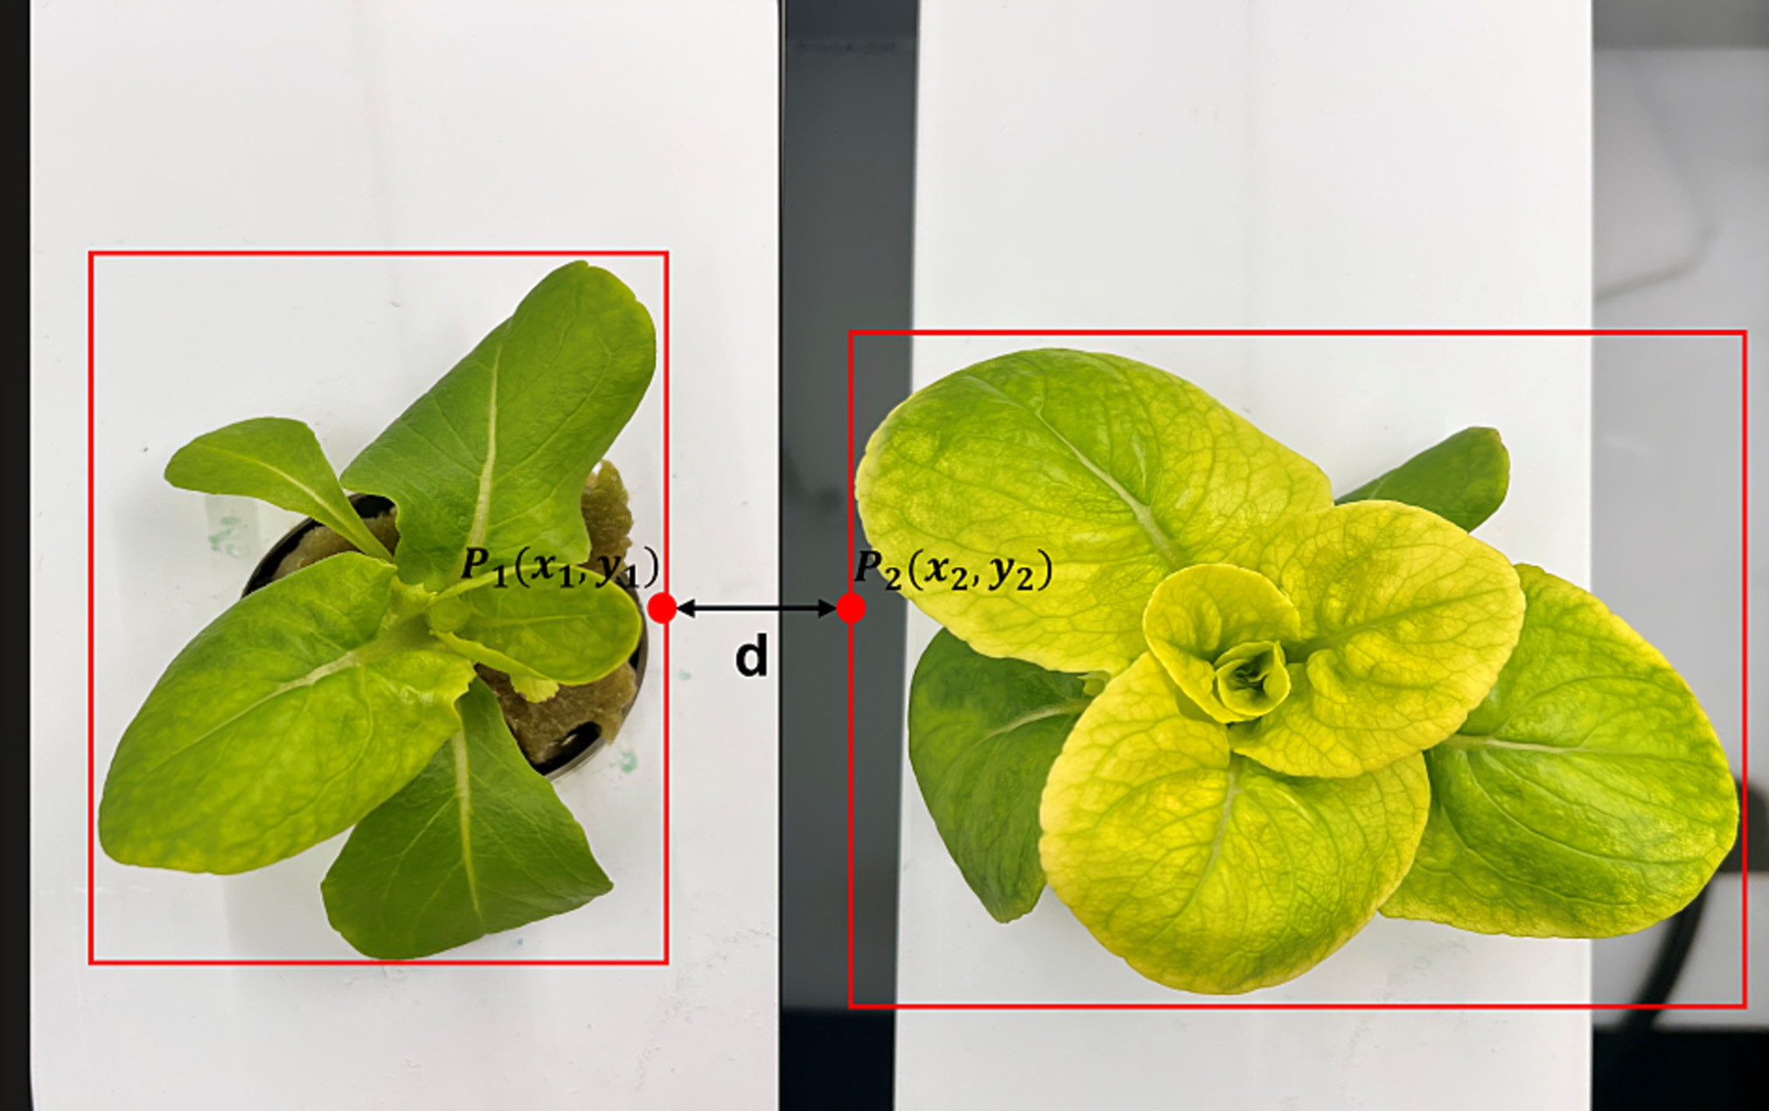

Fig. 8. Calculation of distance between plants using bounding boxes.

study, two classes, ‘Consumer Product’ and ‘Production_System’ are used for knowledge extraction. The ‘Consumer Product’ class provides an abstract view of the type, growth status, and growth parameters of ready-to-harvest crops in an aquaponics system. Whereas the ‘Production_System’ class provides knowledge on design parameters of the grow channels such as width, length and depth of channel and size of the plant site on the channel (Abbasi et al., 2021b). Fig. A3 in appendix A shows the hierarchical architecture of the ‘Consumer Product’ and ‘Product Quality’ classes with their instances for the ‘Basil’ crop in Protégé2 (an open-source ontology editor and framework developed at Stanford University) environment. The length and width of the channels can be extracted from ontology to be used to determine the plant spacing as well as the production capacity of the aquaponics facility using Eq. 16.

* 1. *Cloud-based application*

A cloud-based application is developed using Streamlit, where the final versions of both models developed in sections 3.3 and 3.4 are deployed. The layout of the application is shown in Fig. A4 of ap- pendix A. It consists of three tabs: i) Select model, ii) Upload image, and iii) Determine morphological traits and plant spacing. The first and second tabs are user inputs where the model is selected, and the image is uploaded respectively. The third tab activates the crop morphological model and plant spacing model respectively. The on- tology model is also deployed on a cloud-based application through the Owlready2 library. Once, the morphological traits are estimated and effective plant spacing is determined, the length of the channel is extracted from the ontology model to determine plant population and overall yield. Moreover, crop quality can also be assessed by comparing the predicted morphological traits of lettuce and standard

2 <https://protege.stanford.edu/products.php#desktop-protege>.

values stored in the ontology model. This type of application is useful as it provides access to remotely monitor and control the production facility.

1. Results and ﬁndings

To validate the research methodology, a new batch of plants is grown. The experimental setup used to capture the new dataset and validation results and findings is presented in the following subsections.

* 1. *Experimental setup*

The experimental setup is built in Allfactory 4.0, an NFT-based aquaponics facility situated at the University of Alberta, Canada, which focuses on smart indoor farming (Martinez and Ahmad, 2018). The aquaponics system is divided into five crop growth phases which repre- sent the complete growth cycle of the crop. For this study, only phase 1 is considered, which consists of six horizontally stacked grow channels and each channel has five plant sites. The length and width of each channel are 125 cm and 10 cm respectively. The distance between the center of plant sites (circular pockets) of two consecutive channels is 12 cm. A fresh batch of lettuce crop is grown for which fifty seeds of Lit- tle *gem* lettuce (*Lactuca sativa* L.) are placed in growth chambers with an ambient temperature of 18 °C, relative humidity of 70%, and illumina- tion of a 12-h (12 h light / 12 h dark) photoperiod (S.A. Gillani et al., 2022b). Twenty-one days after sowing, 30 healthy lettuce seedlings are transplanted in Rockwool cubes and placed in the six NFT channels in phase 1. The seedings are placed in NFT-based hydroponic systems for a period of five weeks (plantation cycle), after which each lettuce is harvested. A wireless sensing module (WSM) consisting of five sensors (pH, temperature, humidity, water temperature, electroconductivity and light) is installed on system to monitor the system and gather the sensor data. The complete development and working of WSM is detailed in a previous work by the authors

(Reyes-Yanes et al., 2021). Moreover, the images are captured in a sim- ilar fashion as discussed in section 3.1.1. But this time camera module consisting of four ELP 1080P webcams (2.8–12 mm HD Varifocal Lens) is used. All the webcams are attached at a distance of 40 cm and are scheduled to take one picture per day for five weeks. In total, 8 plant

samples are chosen for images and each image contains two plants.

overlap between ground truth and predicted bounding boxes or masks divided by the area encompassed by both the predicted bounding box and the ground-truth bounding box (Yu et al., 2019). For this purpose, the test dataset consisting of 140 images is used. The (*IoU*) is calculated as follows:

These plants are grown on adjacent channels and each day four pictures are taken automatically. At the end of plantation cycle, there are 140 im-

*IoU* = *AT* ∩ *AD*

*AT* ∪ *AD*

(17)

ages which are then used for testing and evaluation of the proposed models. The actual measurements for morphological traits and distance between plants are recorded in similar manner as discussed in section

3.1.1. The actual values of plant spacing (*S*′) are also computed manually using the actual distance between plants and formulas mentioned in section 3.4.

* 1. *Evaluation of trained mask-RCNN model*

To evaluate the detection accuracy of the trained Mask-RCNN model, the intersection over union (*IoU*) metric is used, which compares the predicted detection with ground truth. *IoU* is the ratio of the area of

Where (*AT*) and (*AD*) represent the target bounding box of the ground truth and the detected bounding box from the model, respectively. All 140 test images have shown (*IoU*) coefficient of 0.9 or above, indicating that there is a significant overlap between the two bounding boxes. Fig. 9 shows an example of an image showing detection with (*IoU*) of above 0.9. The green bounding box is the ground truth whereas the red bounding box is predicted by the model. All the targets in the lettuce image are aimed to be detected and marked with target category scores, bounding boxes, and instance segmentation masks. The detection performance of the Mask-RCNN is shown in Fig. 10. The final model is then used for modeling foliage mor- phological traits and plant spacing.

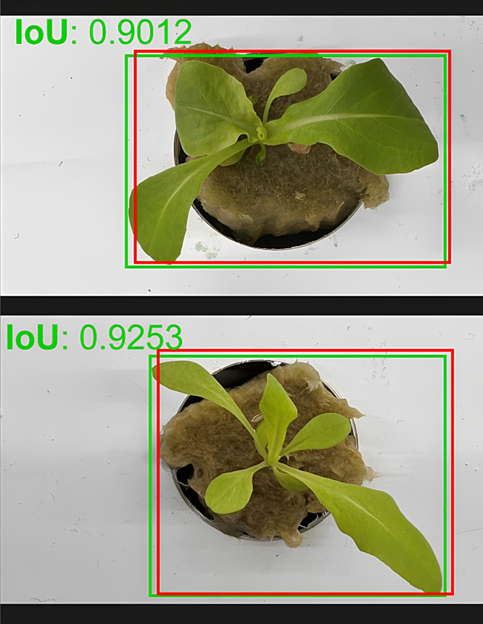

Fig. 9. Object detection by Mask-RCNN with the resulting IoU metric.

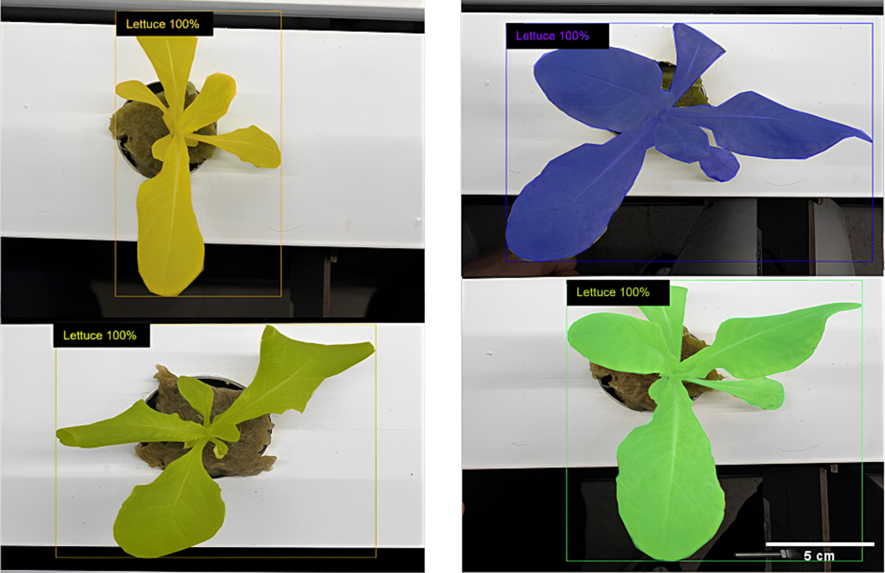

Fig. 10. Detection and instance segmentation of lettuce foliage.

* 1. *Evaluation of crop morphological model*

To evaluate the crop morphological model, the length, width, and area of lettuce foliage are computed from masks predicted by the trained model for the test dataset. The actual and the measured values for each morphological trait are compared. The increasing trend in the morphological traits is observed — indicating the growing behavior of the plants (increase in size). The estimation error between manual and masked dimensions for each trait per plant is then measured using root mean squared error (RMSE) using the formula given below.

test dataset in this study consists of four plant pairs. The minimum error is observed which demonstrates that the trained model is reliable for the calculation of the leaf area, length, and width in real-world sce- narios.

* 1. *Evaluation of plant spacing model*

To evaluate the plant spacing model, first, the distance between bounding boxes of two instances (two plants per image) is computed after instance segmentation is performed on images in the test dataset.

The plant spacing is then computed following the process mentioned in

*RMSE*

= ∑ ( *j* — *j* )

s1ﬃﬃﬃﬃﬃﬃ*k*ﬃﬃﬃﬃﬃﬃﬃ*x*ﬃﬃﬃﬃﬃﬃﬃﬃﬃﬃ*y*ﬃﬃﬃﬃﬃﬃ2ﬃﬃ

*j*=0

(18) section 3.4. The predicted values are then compared with actual mea- surements, which indicates that plant spacing increases with an

increase in foliage area and length. Table 2 presents the RMSE for each

Where (*xj*) is actual value, (*yj*) is the predicted value, Table 1 lists the RMSE calculated using the above equation for each measurement per plant. The test image set refers to a set of images taken throughout the plantation cycle for one pair of plants (Foliage 1 and Foliage 2). The

*n*

Table 1

RMSE of manual and estimated measurements of morphological traits.

Test image set Instance Length, *L**r*(cm) Width, *Wr* (cm) Area, *Af* (cm2)

1 Foliage 1 1.1 1.8 3.35

Foliage 2 1.3 1.1 2.9

test image set. The lower RMSE values indicate the reliability of the proposed model.

1. Discussion and future work

The objective of this study is to automatically measure the crop mor- phological traits from the lettuce images acquired from the aquaponics

Table 2

RMSE of manual and estimated measurements of plant spacing.

2

|  |  |  |  |  |  |  |  |
| --- | --- | --- | --- | --- | --- | --- | --- |
| Foliage 1  Foliage 2 | 0.95  1.05 | 1.5  1.3 | 3.1  2.79 | Test image | set Instance 1 | Instance 2 | Plant spacing, *S*′ (cm) |
| Foliage 1 | 1.27 | 0.99 | 3.2 | 1 | Foliage 1 | Foliage 2 | 1.1 |
| Foliage 2 | 1.37 | 1.21 | 3.12 | 2 | Foliage 1 | Foliage 2 | 0.95 |
| Foliage 1 | 1.31 | 1.32 | 3.23 | 3 | Foliage 1 | Foliage 2 | 1.27 |
| Foliage 2 | 1.18 | 1.27 | 2.87 | 4 | Foliage 1 | Foliage 2 | 1.31 |

3

4

facility and determine the effective plant spacing between grow channels. The idea is to develop an approach that can lead to a self-adaptive aquaponics system, where based on crop morphological attributes, the grow channels adjust their positions effectively to ensure high crop yield and quality by avoiding occlusions and foliage overlap- ping. The presented work has used the Mask-RCNN algorithm to enable a fine-grained detection of lettuce foliage within the images and the generation of a pixel-wise segmentation mask for each detected instance. The segmentation masks distinguish foliage from the back- ground and provide a mechanism to identify non-foliage classes, such as channel, Rockwool cubes, etc., by considering their high heterogeneity in form and texture.

The manual measurement of morphological traits is time- consuming and labor-intensive. Even for an experienced agriculturalist, it would take a significant amount of time to measure all morphological traits. The proposed approach can automatically estimate the morpho- logical traits of lettuce foliage that vary in size and shape. Plant spacing is one of the key features that impact crop growth. It is dependent on crop type as well as crop morphological traits. In this study, plant spac- ing is automatically measured for each segmented foliage using the mathematical model.

The final model is deployed on a cloud-based application and inte- grated with the ontology model. The ontology model provides informa- tion about crop characteristics and grow bed design parameters for a variety of crops grown in NFT-based aquaponics. The application acts as a decision support system, which analyses the results from the models, compares them with the relevant knowledge from the ontology model and suggests the final action by sending a control signal to the aquaponics facility for automatically adjusting the grow channels based on the value of plant spacing predicted by the proposed model.

While promising results are achieved from the proposed models, there is still scope for improvement. For instance, only one crop is con- sidered in this study for the estimation of morphological attributes and assessing the plant spacing between channels. Considering that, the po- tential solutions for estimating the morphological attributes of multiple crops will be investigated in future work. Subsequently, the dataset will be increased with more image variations and other leafy green crops as

well as fruits, flowers, and non-flowering plants. Furthermore, the im- pact of morphological traits on other design parameters of aquaponics facility will also be studied.

1. Conclusion

In this study, an automatic tool is developed to predict the morpho- logical traits of lettuce crops such as foliage area, length, and width and estimate effective plant spacing for NFT-based aquaponics facility. The results have shown that the growth of plants is estimated within 2 cm of error for both length and width, 4 cm for the area and

1.5 cm for plant spacing. The final model is then deployed on a cloud-based application and an ontology model is integrated with it. The proposed method is accurate and flexible and hence can easily be applied in real scenarios. This contribution has great significance to the research community as it promotes the implementation of a self- adaptive aquaponics system that can be constantly improved using dynamic data. Moreover, the presented methods offer the opportunity to rely on smart technologies for the application of new concepts such as research on complex relationships between optimal parameters, and detection of nutrient deficiency in crops using computer vision which will pave the way for large-scale implementation of aquaponics farming technology.

Declaration of Competing Interest

The authors declare that they have no known competing financial interests or personal relationships that could have appeared to influ- ence the work reported in this paper.

Acknowledgements

The authors acknowledge the financial support of this work by the Natural Sciences and Engineering Research Council of Canada (NSERC) (Grant File No. ALLRP 545537-19 and RGPIN-2017-04516).

Appendix A. Appendix

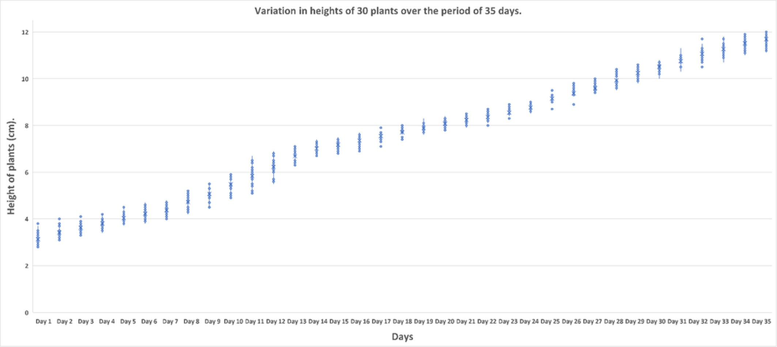

Fig. A1. Boxplot showing variations in the heights of thirty plants over the period of thirty days.

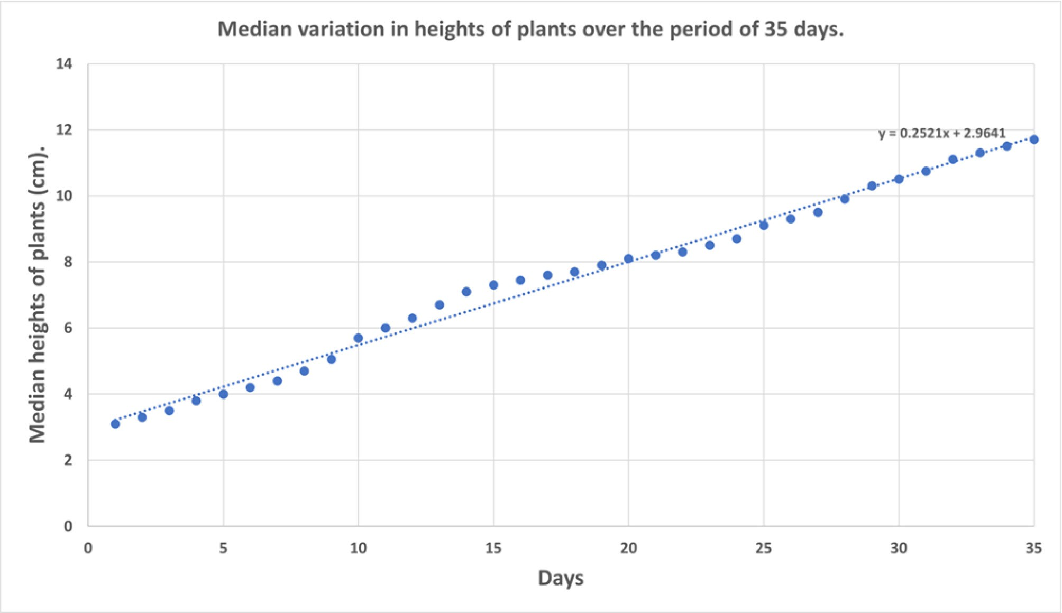

Fig. A2. Variations in median heights of plants.

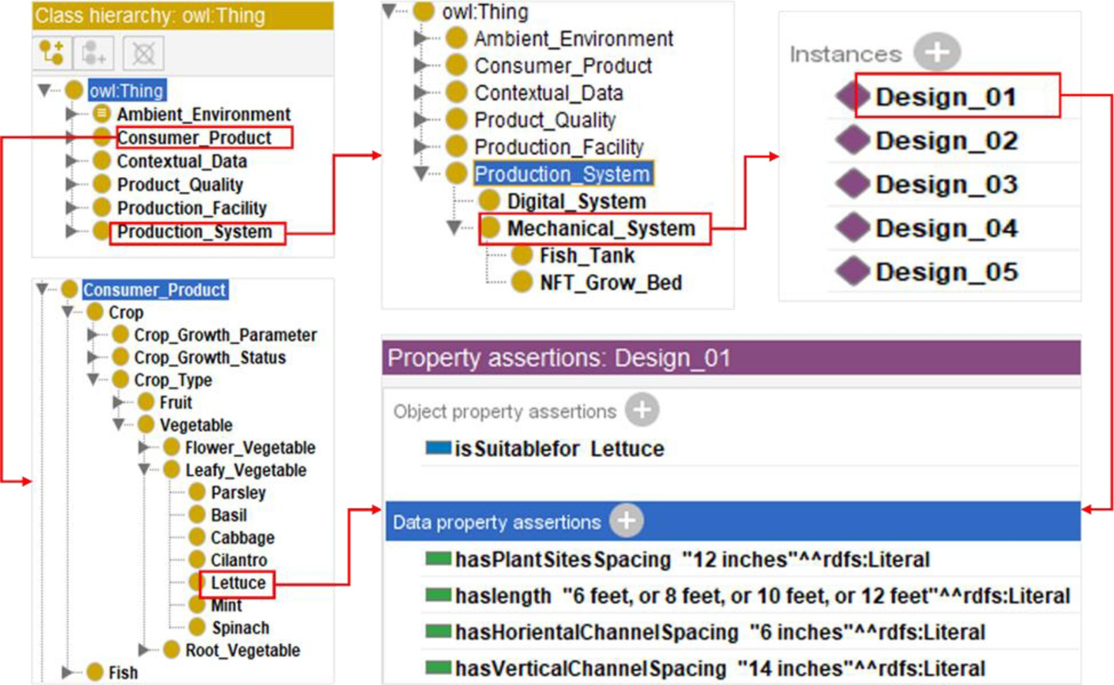

Fig. A3. Ontology model showing the instances of ‘Consumer_Product’ and ‘Production_System’ classes.

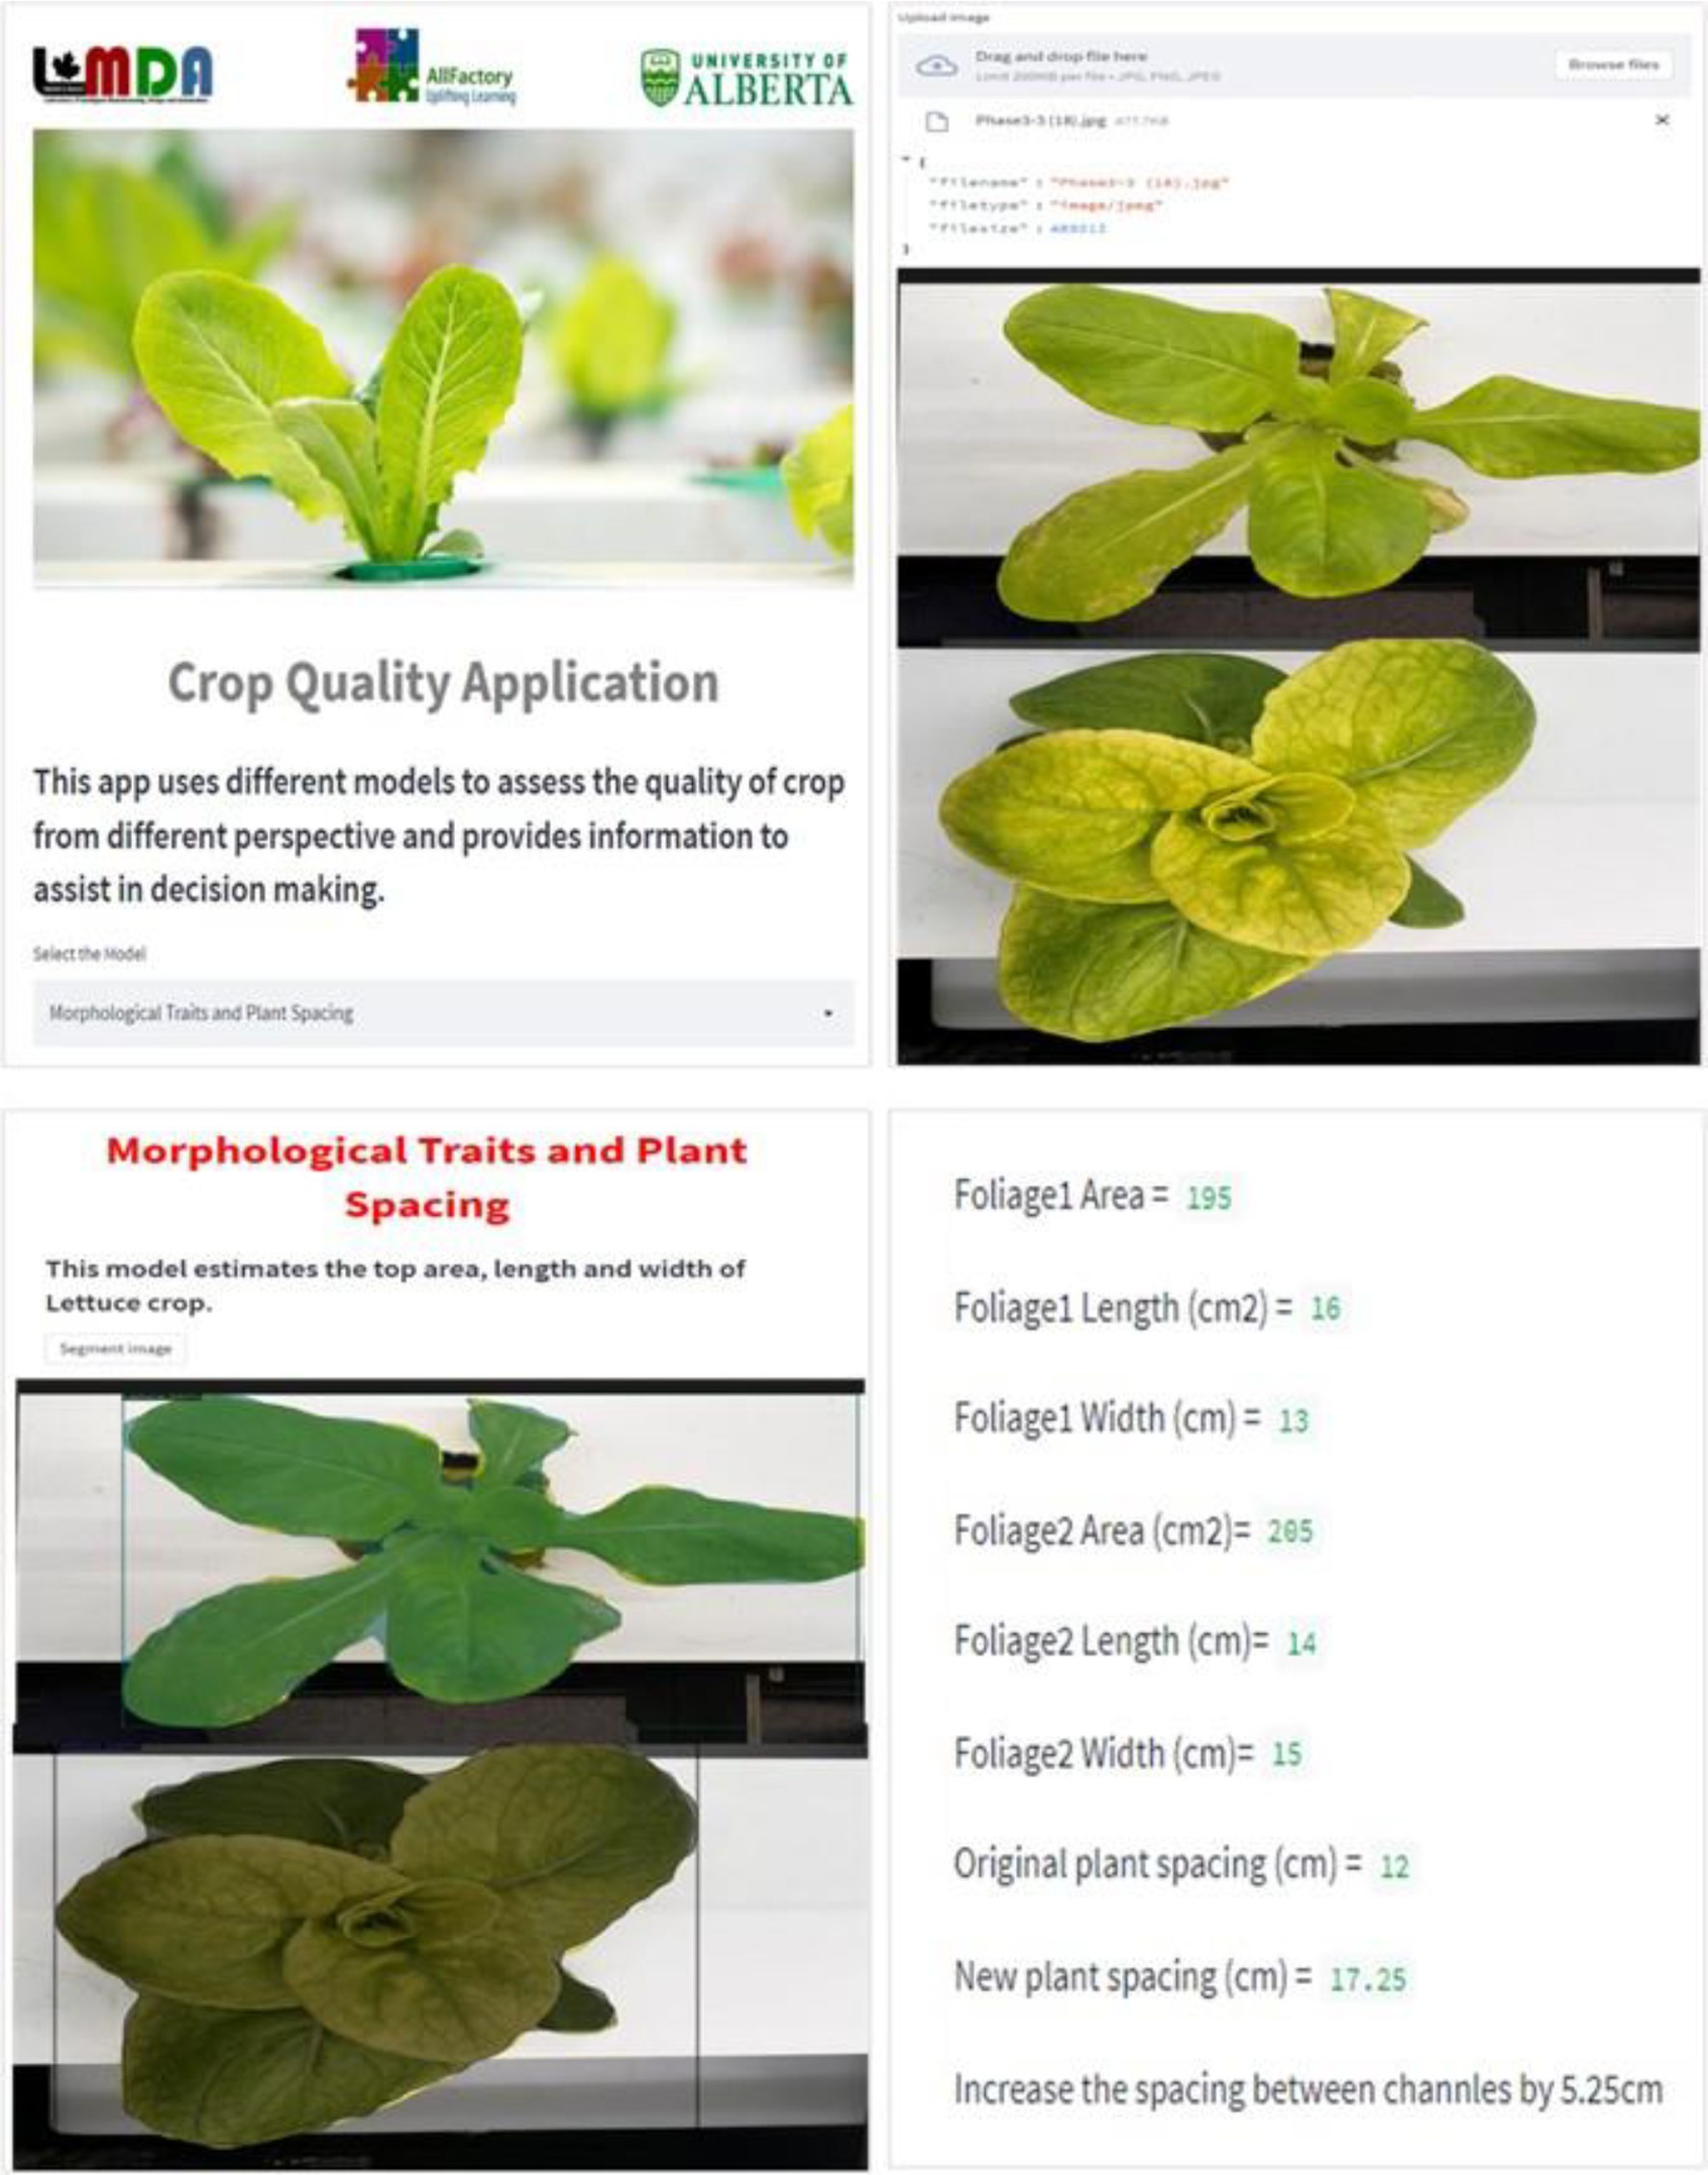

Fig. A4. Cloud-based application.

References

Abbasi, R., Martinez, P., Ahmad, R., 2021a. An ontology model to represent aquaponics 4.0 system’s knowledge. Inf. Process. Agric. <https://doi.org/10.1016/J.INPA.2021.12.001>.

Abbasi, R., Martinez, P., Ahmad, R., 2021b. An ontology model to support the automated design of aquaponic grow beds. Proc. CIRP 100, 55–60. [https://doi.org/10.1016/j.](https://doi.org/10.1016/j.procir.2021.05.009) [procir.2021.05.009](https://doi.org/10.1016/j.procir.2021.05.009).

Abbasi, R., Martinez, P., Ahmad, R., 2022. The digitization of agricultural industry – a sys- tematic literature review on agriculture 4.0. Smart Agric. Technol. 2, 100042. [https://](https://doi.org/10.1016/J.ATECH.2022.100042) [doi.org/10.1016/J.ATECH.2022.100042](https://doi.org/10.1016/J.ATECH.2022.100042).

Buslaev, A., Iglovikov, V.I., Khvedchenya, E., Parinov, A., Druzhinin, M., Kalinin, A.A., 2020. Albumentations: fast and flexible image augmentations. Inf. 11. [https://doi.org/10.](https://doi.org/10.3390/INFO11020125) [3390/INFO11020125](https://doi.org/10.3390/INFO11020125).

Crop Quality - An Overview|ScienceDirect Topics [WWW Document], 2021. URL [https://](https://www.sciencedirect.com/topics/agricultural-and-biological-sciences/crop-quality) [www.sciencedirect.com/topics/agricultural-and-biological-sciences/crop-quality](https://www.sciencedirect.com/topics/agricultural-and-biological-sciences/crop-quality) (accessed 7.13.21).

Dutta, A., International, A.Z.-P. of the 27th A. 2019, undefined, 2019. The VIA Annotation Software for Images, Audio and Video. dl.acm.org. , pp. 2276–2279. [https://doi.org/](https://doi.org/10.1145/3343031.3350535) [10.1145/3343031.3350535](https://doi.org/10.1145/3343031.3350535).

Easlon, H.M., Bloom, A.J., 2014. Easy leaf area: automated digital image analysis for rapid and accurate measurement of leaf area. Appl. Plant Sci. 2, 1400033. [https://doi.org/10.](https://doi.org/10.3732/APPS.1400033) [3732/APPS.1400033](https://doi.org/10.3732/APPS.1400033).

Gaikwad, J., Triki, A., Bouaziz, B., 2019. Measuring morphological functional leaf traits from digitized herbarium specimens using TraitEx software. J. Biodiver. Inform. Sci. Stand. 3, e37091. <https://doi.org/10.3897/biss.3.37091>.

Gillani, S.A., Abbasi, R., Martinez, P., Ahmad, R., 2022b. Review on energy efficient artificial illumination in aquaponics. Clean. Circ. Bioecon. 2, 100015. [https://doi.org/10.1016/J.](https://doi.org/10.1016/J.CLCB.2022.100015) [CLCB.2022.100015](https://doi.org/10.1016/J.CLCB.2022.100015).

Gillani, Syed Abreez, Abbasi, R., Martinez, P., Ahmad, R., 2022a. Ontology-based interac- tive learning approach for transdisciplinary teaching in learning factory. SSRN Elec- tron. J. <https://doi.org/10.2139/SSRN.4071925>.

He, K., Gkioxari, G., Dollar, P., Girshick, R., 2017. Mask R-CNN. [https://doi.org/10.1109/](https://doi.org/10.1109/ICCV.2017.322) [ICCV.2017.322](https://doi.org/10.1109/ICCV.2017.322).

Hirigoyen, A., Acosta-Muñoz, C., Salamanca, Jesús Ariza, Ángeles Varo-Martinez, M., Rachid-Casnati, C., Franco, J., Navarro-Cerrillo, R., Salamanca, A.A., Má, V.-M., 2021. A machine learning approach to model leaf area index in Eucalyptus plantations using high-resolution satellite imagery and airborne laser scanner data. Ann. For. Res 64, 165–183. <https://doi.org/10.15287/afr.2021.2073>.

Juyal, P., Sharma, S., 2020. Estimation of Tree Volume Using Mask R-CNN based Deep Learning. 2020 11th Int. Conf. Comput. Commun. Netw. Technol. ICCCNT 2020. <https://doi.org/10.1109/ICCCNT49239.2020.9225509>.

Kang, B.R., Lee, H., Park, K., Ryu, H., Kim, H.Y., 2020. BshapeNet: object detection and in- stance segmentation with bounding shape masks. Pattern Recogn. Lett. 131, 449–455. <https://doi.org/10.1016/J.PATREC.2020.01.024>.

Lu, J.Y., Chang, C.L., Kuo, Y.F., 2019. Monitoring growth rate of lettuce using deep convolutional neural networks. 2019 ASABE Annu. Int. Meet. 1. Doi: [10.13031/](https://doi.org/10.13031/AIM.201900341) [AIM.201900341](https://doi.org/10.13031/AIM.201900341).

Maboko, M.M., Du Plooy, C.P., 2009. Effect of plant spacing on growth and yield of lettuce (*Lactuca sativa* L.) in a soilless production system. S. Afr. J. Plant Soil. [https://doi.org/](https://doi.org/10.1080/02571862.2009.10639954) [10.1080/02571862.2009.10639954](https://doi.org/10.1080/02571862.2009.10639954).

Maloof, J., Nozue, K., M.M.-J, 2013. LeafJ: an ImageJ plugin for semi-automated leaf shape measurement. J. Vis. Exp.(71), e50028. <https://doi.org/10.3791/50028>.

Martinez, P., Ahmad, R., 2018. [All factory: An Aquaponics 4. 0 Transdisciplinary](http://refhub.elsevier.com/S2589-7217(23)00027-2/rf0080) [Educational and Applied Research Learning Factory at the University of Alberta.](http://refhub.elsevier.com/S2589-7217(23)00027-2/rf0080)

[pp. 5–](http://refhub.elsevier.com/S2589-7217(23)00027-2/rf0080)7.

Nakarmi, A.D., Tang, L., 2012. Automatic inter-plant spacing sensing at early growth stages using a 3D vision sensor. Comput. Electron. Agric. 82, 23–31. [https://doi.org/](https://doi.org/10.1016/J.COMPAG.2011.12.011) [10.1016/J.COMPAG.2011.12.011](https://doi.org/10.1016/J.COMPAG.2011.12.011).

Reyes-Yanes, A., Martinez, P., Ahmad, R., 2020. Real-time growth rate and fresh weight es- timation for little gem romaine lettuce in aquaponic grow beds. Comput. Electron. Agric. 179, 105827. <https://doi.org/10.1016/j.compag.2020.105827>.

Reyes-Yanes, A., Gelio, S., Martinez, P., Ahmad, R., 2021. Wireless sensing module for IoT aquaponics database construction. Int. J. Electron. Electr. Eng. 9, 43–47. [https://doi.](https://doi.org/10.18178/IJEEE.9.2.43-47) [org/10.18178/IJEEE.9.2.43-47](https://doi.org/10.18178/IJEEE.9.2.43-47).

Singh, S., Kumar, S., Singh, S.P., Yadav, Shatrunjay, Yadav, Sandeep, Singh, A., Awasthi, M.K., 2022. Plant spacing and cultivar on quality attributes in sprouting broccoli. S. Afr. J. Bot. 148, 737–741. <https://doi.org/10.1016/J.SAJB.2022.04.049>.

Triki, A., Bouaziz, B., Gaikwad, J., Mahdi, W., 2021. Deep leaf: mask R-CNN based leaf de- tection and segmentation from digitized herbarium specimen images. Pattern Recogn. Lett. 150, 76–83. <https://doi.org/10.1016/J.PATREC.2021.07.003>.

Weaver, W.N., Ng, J., Laport, R.G., 2020. LeafMachine: using machine learning to automate leaf trait extraction from digitized herbarium specimens. Appl. Plant Sci. 8. [https://](https://doi.org/10.1002/APS3.11367) [doi.org/10.1002/APS3.11367](https://doi.org/10.1002/APS3.11367).

Yu, Y., Zhang, K., Yang, L., Zhang, D., 2019. Fruit detection for strawberry harvesting robot in non-structural environment based on mask-RCNN. Comput. Electron. Agric. 163, 104846. <https://doi.org/10.1016/J.COMPAG.2019.06.001>.

Zaman, I., Ali, M., Shahzad, K., Tahir, M.S., Matloob, A., Ahmad, W., Alamri, S., Khurshid, M.R., Qureshi, M.M., Wasaya, A., Baig, K.S., Siddiqui, M.H., Fahad, S., Datta, R., 2021. Ef- fect of plant spacings on growth, physiology, yield and fiber quality attributes of cot- ton genotypes under nitrogen fertilization. Agron 11, 2589. [https://doi.org/10.3390/](https://doi.org/10.3390/AGRONOMY11122589) [AGRONOMY11122589](https://doi.org/10.3390/AGRONOMY11122589).