Available online at [www.sciencedirect.com](http://www.sciencedirect.com/)



AASRI Procedia 2 (2012) 56 – 61

AASRI

Procedia

[www.elsevier.com/locate/procedia](http://www.elsevier.com/locate/procedia)

2012 AASRI Conference on Power and Energy Systems

# Evaluation of the use of Near Infrared Spectroscopy (NIR) in on-line Monitoring of Power Transformer Insulation Oil

Borges, G.B.Ca,c*, Rohwedder, J.J.R.b, Bortoni, E.C.a

*aInstitute of Electrical Power and Energy, UNIFEI, Itajubá, Brazil*

*bAnalytical Chemistry Institute, UNICAMP, Campinas, Brazil*

*cCentro Federal de Educação Tecnológica de Minas Gerais,CEFET-MG,Varginha, Brazil*

Abstract

To maximize the lifetime expectance of power transformers, it is important to develop tools to monitor and to give diagnose information, allowing for real-time detection of incoming failures. Information from analysis of gases dissolved or free in insulating oil is one of the most valuable tools in evaluating the health of a transformer and has become an important part of preventive maintenance programs. The condition of the oil greatly affects the performance and the service life of transformers, and on-line monitoring has become a reliable method to ensure the safe operation of transformers. An on-line monitoring of dissolved gases generated by electrical transformers in operation was developed, which can be used as an important parameter for the detection of faults and monitoring the chemical degradation of mineral insulation oil. This paper proposes a method to analyze the generated gases, based on Near Infrared Spectroscopy (NIR) through a developed prototype that can be adapt on the Buchholz transformer relay. The combination used of NIR spectroscopy and chemometric tools has allowed for obtaining information over the samples. Recent developments of chemometrics software and computer technology have made NIR analysis the practical choice for process analysis applications.

© 2012 Published by Elsevier B.V. Selection and/or peer review under responsibility of American Applied Science Research Institute

© 2012 Published by Elsevier B.V. Selection and/or peer review under responsibility of American Applied Science Research Institute

© 2012 Borges, G.B.C, Rohwedder, J.J.R., Bortoni, E.C. Published by Elsevier B.V.

Selection and/o[r peer review under](http://creativecommons.org/licenses/by-nc-nd/3.0/) responsibility of American Applied Science Research Institute

Open access under [CC BY-NC-ND license.](http://creativecommons.org/licenses/by-nc-nd/3.0/)

*Keywords*: power transformers; insulation oil; spectroscopy; NIR; chemometrics; online monitoring.

* Corresponding author. Tel.: 055-35-32141611;

*E-mail address:* [gilzeborges@varginha.cefetmg.br.](mailto:gilzeborges@varginha.cefetmg.br)

2212-6716 © 2012 Published by Elsevier B.V. Selection and/or peer review under responsibility of American Applied Science Research Institute

Open access under [CC BY-NC-ND license.](http://creativecommons.org/licenses/by-nc-nd/3.0/) doi:10.1016/j.aasri.2012.09.014

1. Introduction

The demand for electric power is increasing and power transformers are vital elements for its transmission and distribution. Power transformers are the most important equipments and the most expensive component in a power transmission or distribution substation. To guarantee the reliable electricity supply, it is necessary control the maintenance and the lifetime of transformers. Several researches have been conducted to increase the system reliability, cost savings, to reduce the maintenance requirements in order to improve energy production. It has long been recognized that the degradation of oil-paper insulation system from electrical and thermal stress can be a good indicator of the transformers condition. To maximize the lifetime of transformers it is important to be aware of possible faults that may occur and how to identify and prevent them [1]. Such faults can be monitored from the concentration of hydrocarbon gases generated in the degradation of the oil and paper insulation in the transformers.

Monitoring system has become a perfect method to ensure the condition and safe performance of the equipment and help to make better maintenance decisions [2]. The influence of service conditions on the insulation of electrical devices during this equipment failures results on changes at the molecular levels with formation of new chemical compounds [1]. Especially in case of oil there are gases were formed like as hydrogen (H2), carbon oxides (CO and CO2), and some low molecular weight hydrocarbons such as methane (CH4), ethane (C2H6), ethylene (C2H4) and acetylene (C2H2). One way to detect these faults is evaluating the quantities of the hydrocarbon gases that are formed from the degradation on insulation systems and the ratio among the gas generated and the faults held on transformers is well established [3,4].

The importance of transformer fault gas analysis and interpretation is well recognized and documented. The deterioration of transformer oil and paper insulation results in the formation of by-products in the form characteristics gases. In the presence of an active fault, the rate of deterioration is considerably increased, and the type of these gases generated will vary with the nature of severity of the fault [5].

One of the most popular transformer fault diagnostics and prognostics is dissolved gas analysis (DGA), and this method has earned worldwide acceptance as a most valuable monitoring the condition of oil-filled power transformer, well-known from Guides for Interpretation of gases [4,6 ]. But some disadvantages can be listed such as the high number of samples to analyze on the specials laboratories, the long waiting time for the results, manual sampling, inappropriate storage and different results from laboratory to laboratory [6].

Because the importance to detect failures a very early stage and be able to provide near time data on the conditions, determining exhaust gases from on-line monitoring has become a reliable method to ensure safe operation [7]. The use of on-line and off-line monitoring methods of power transformer is increasing steadily and can provide powerful tool to reducing risk of several failure. The on-line monitoring of gas dissolved in oil or free gas collected from Buchholz relay can be a valuable tool to diagnostic and identify incipient faults on transformers in service. The gases produced beyond the saturation limit of the oil, come out and can be collected in Buchholz relay. When this occurs, the insulation strength of the transformer oil is reduced, which can lead to further failures [1].

This paper evaluates the use of Near Infrared Spectroscopy (NIR) and chemometric methods to analyze light gaseous hydrocarbons (methane, ethane, ethylene and acetylene) associated with faults in the insulation system. For this study was developed a spectrophotometer prototype with a measure cell for further application in monitoring gases in the Buchholz relay. The calibration procedures, measurement limitations and an error analysis are presented.

The technique of Near Infrared Spectroscopy (NIR) has taken on widely accepted in different areas mainly due to the industries. The analytical methods resulted from use of the NIR spectroscopic region reflect the most significant properties such as: fast, non-destructive, non-invasive, suitable for in-line or on-line use, nearly universal application (any molecule containing C-H, N-H, S-H or O-H bonds), with minimum sample

preparation. The combination of these characteristics with the instrument control, low maintenance and data treatment made this possible for this kind of application [8]. This analytical technique has been used with fiber-optic to identify and quantify water and oil in transformer insulating paper [9].

1. Experimental

The spectrophotometer prototype designed in the laboratory uses an acoustic optical tunable filter (AOTF, Brimrose) as a device for selecting the wavelength range between 1500 and 3000 nm and also has a arsenide indium detector (EG&G Optoelectronics), a tungsten light bulb of 50W as a radiation source, lock-in filter (Stanford) for signals modulation. The equipment is controlled by computer using a parallel interface 711S (Advantech) from a software written in Visual Basic (Microsoft).

The measuring cell (Figure 1) has an optical path length of 540mm and internal volume 490 mL. Valves are used to insert and remove the prepared gaseous mixtures and to clean the cell using pure gaseous nitrogen (N2). As component of the cell a pressure gauge and a Teflon septum used to withdraw rate of the gaseous mixture inside the cell, using a gastight syringe for injection into a gas chromatograph with a flame ionization detector (FID).

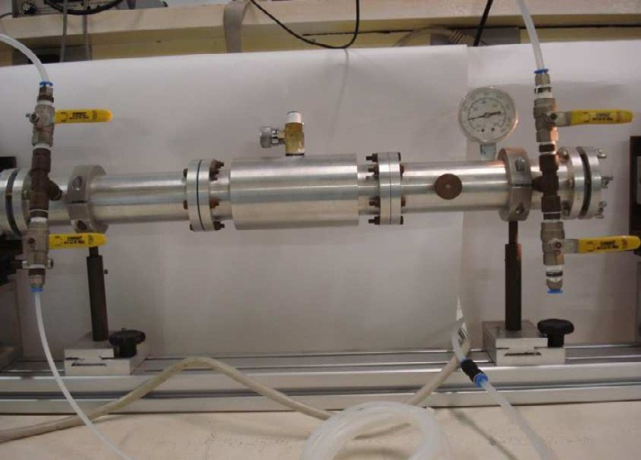

Fig. 1. Measurement cell with valves, septum and pressure gauge

Synthetic gas mixtures were prepared directly into the cell using flow meters (*Aalborg*) and pure gases (methane, ethane, ethylene, acetylene) diluted with nitrogen gas. The calibration set was formed by 29 gaseous mixtures and the prediction set by 10 gaseous mixtures. The ranges of concentration of gaseous hydrocarbon mixtures were 0, 5 to 2, 0 % (v/v). The chemometrics models were built using the software package *The Unscrambler 9.2* (CAMO) [6]. The concentration of the gases within the cell was determined using gas chromatograph as a reference method.

1. Results

The univariate calibration that is when only one substance (gas) is present within the cell was found using optical path length 540mm, the limit of detection (LD) and the limit of quantification was obtained. For methane the results was 0, 021 %( v/v) LD and 0,069% (v/v) LQ, to ethane was 0, 15% (v/v) LD and 0, 34% (v/v) LQ, to the ethylene 0, 23% (v/v) LD and 0, 43% (v/v) LQ and to the acetylene just 0, 91% (v/v) LQ (LD was not possible to determinate).

The Figure 2 illustrates the spectra of 39 hydrocarbon gaseous mixtures (methane, ethane, ethylene and acetylene), after treatment to correct baseline. The calibration model was obtained using 29 samples that were applied a multivariate regression and Partial Least Squares (PLS), while 10 samples were used for external validation.

It is observed that the spectrum of gaseous mixtures presents an overlap of absorption bands, the sum of the individual spectra of pure substances whose effect can be referred by the Beer´s additive law. When there is a mixture of gases, the sum of the spectra indicates that the overlap occurs in the entire spectral range, making it impossible to predict the concentration of individual gases by univariate calibration. This problem shows the need to use for the multivariate calibration measurement of the absorbance values of several different wavelengths, to compensate for the loss of chemical selectivity [8].

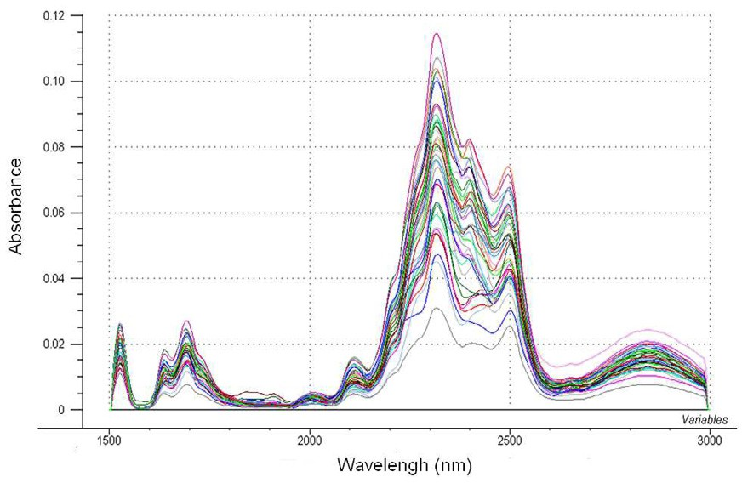

Fig. 2. Gaseous mixtures spectra (calibration and prediction samples)

The Table1 shows the results of Root Mean Square Error of calibration (RMSEC) and Root Square Error of Prediction (RMSEP) for each used gas in the mixtures. The results indicated the predicted concentrations in the gaseous mixtures samples with accuracy better than 0.2 % v/v, when an optical path 540 mm is used.

Table 1. Calibration and Prediction Model.

|  |  |  |  |  |
| --- | --- | --- | --- | --- |
| Gases | Calibration results |  | Prediction results |  |
|  | RMSEC %(v/v) | R (correlation) | RMSEP % (v/v) | R (correlation) |
| Methane | 0,16 | 0,9889 | 0,19 | 0,99422 |
| Acetylene | 0,18 | 0,9523 | 0,153 | 0,9882 |
| Ethylene | 0,18 | 0,9719 | 0,11 | 0,9939 |
| Ethane | 0,18 | 0,9725 | 0,14 | 0,9957 |

The table 1 shows the results for the model calibration and prediction by least squares regression (PLS), where can observe a good correlation between data obtained by chromatography and chemometric concentrations predicted by the model, with a correlation coefficient between 0, 9523 and 0.9889. For the prediction coefficients set the correlation were greater than 0.9882. The results indicate that the values predicted by the model were similar to values obtained by gas chromatography.

1. Conclusions and Future works

The results of the presented study indicate that Near Infrared Spectroscopy (NIR) with chemometrics techniques appears as a tool to be used for monitoring gas species produced in the decomposition of insulating oils. In this was found that the calibration model built by multivariate regression using the partial least squares (PLS), the results obtained with RMSEP such as 0.19% (v / v) to methane, 0.15% (v / v) to acetylene, about 0.11% (v / v) for ethylene and 0.14% (v / v) to the ethane, prove the chemometric model developed represents a good model to be applied to the hydrocarbons present in real samples. Furthermore it should be considered that found in on-line monitoring of power transformers. There is a new work has been developing a new type of cell measurement system based on multiple reflection which will lower the detection limits of the hydrocarbon gas to the range of a few ppm (parts per million).

Acknowledgements

The authors thank FINEP for financial support and UNIFEI and CEFET for partial financial support.

References

1. Singh S, Bandyopadhyay M. Dissolved gas analysis technique for incipient fault diagnosis in power transformers: A Bibliographic Survey. IEEE Electrical Insulation Magazine, 2010; vol.26, 6: 41-46.
2. Gockenbach E, Borsi H. Condition monitoring and diagnosis of power transformers. International Conference on Condition Monitoring and Diagnosis, 2008; pp. 21-24.
3. ArakelianV. Effective diagnostics for oil-filled equipment. IEEE Electrical Insulation Magazine, 2002; vol. 18, no. 6: 26-38.
4. IEEE Guide for The Interpretation of Gases Generated on Oil-Immersed Transformers, IEEE STD C57.104, 2008.
5. Ding H, Heywood R, Lapworth J, Ryder S. Learning form success and failure in transformer fault gas analysis and interpretation. International Conference on Reliability of Transmission and Distribution Networks, 2011; 1-6.
6. Mackenzie E, Crossey J, De Pablo A, Ferguson W. On-line monitoring and diagnostics for power

transformers. IEEE International Symposium on Electrical Insulation Conference, 2010; pp 1-5.

1. Snow T, McLarnon M. The implementation of continuous online Dissolved Gas Analysis (DGA) monitoring for all transmission and distribution substations. IEEE International Symposium on Electrical Insulation, 2010; pp. 1-4.
2. Pasquini C. Near Infrared Spectroscopy: fundamentals, practical aspects and analytical applications. Journal of Brazilian Chemical Society, 2003; vol. 14: 198-219.
3. Baird P, Herman H, Stevens G. Spectroscopic measurement and analysis of water and oil in transformer insulating paper. IEEE Transactions on Dielectrics and Electrical Insulation, 2006; vol.13: 293-308.
4. Unscrambler, Ex Use's Guide, versão 9.2, Camo A/S, Trondheim.