Available online at [www.sciencedirect.com](http://www.sciencedirect.com/)



**ScienceDirect**

AASRI Procedia 9 (2014) 158 – 164

2014 AASRI Conference on Circuit and Signal Processing (CSP 2014)

Experimental Study of Boundary Layer Effect on the Aeroacoustic Characteristics of the Incompressible Open Cavity

Jing Suna*, Guangjun Yangb, Yong Lianga,c, Yingchun Chend

*aSchool of Aeronautics, Northwestern Polytechnical University, Xi’an 710072, China bNational Key Laboratory of Science and Technology on UAV, Xi’an 710065, China cChina Aerodynamics Research and Development Center, Mianyang 622700, China dCommercial Aircraft Corporation of China Ltd, Shanghai 200232, China*

**Abstract**

An experiment platform of cavity flow study was built in the low-turbulence wind tunnel. With the method of installing blocks inside cavities, the boundary layer profiles which drag out the shear layer were changed. Averaged static pressure distribution along the centerline on cavity bottoms, and acoustic spectral characteristics of inspected points on cavity wall were obtained from experiments, to discuss the effect of boundary layer profile change under the condition of low-speed incompressible flow on the cavity (long depth ratio were 2 and 4 respectively) aerodynamic and acoustic characteristics. The results showed that, under the velocity of 30m/s, with the boundary layer thickness increasing, the averaged pressure increased with adverse pressure grads decreased, for cavity of L/D=2, the SPL going down in some degree and when L/D increasing to 4, the SPL increased highly in the range of medium to high frequency.

© 2014 Published by Elsevier B. V. This is an open access article under the CC BY-NC-ND license ([http://creativecommons.org/licenses/by-nc-nd/3.0/).](http://creativecommons.org/licenses/by-nc-nd/3.0/))

© 2014 Jing Sun, Yingchun Chen, Guang-jun Yang, Yong Liang. Published by Elsevier B.V. Selection and/or peer revie*w under responsibility of American Applied Science Research Institute

Peer-review under responsibility of Scientific Committee of American Applied Science Research Institute

*Keywords*: boundary layer; SPL; cavity; shear layer; aeroacoustic characteristics

* Sun Jing. Tel.: +86-029-8849-3808.

E-mail address: [sunjinglemon@nwpu.edu.cn](mailto:sunjinglemon@nwpu.edu.cn)

Foundation item: Aeronautical Science Foundation of China (2010ZA53011, 2011ZA53013) Basic foundation of Northwestern Polytechnical University(JC20110287)

2212-6716 © 2014 Published by Elsevier B. V. This is an open access article under the CC BY-NC-ND license ([http://creativecommons.org/licenses/by-nc-nd/3.0/).](http://creativecommons.org/licenses/by-nc-nd/3.0/))

Peer-review under responsibility of Scientific Committee of American Applied Science Research Institute doi:10.1016/j.aasri.2014.09.025

# Introduction

Oscillation caused by flow over Cavity can increase the drag greatly and even lead to structural vibration and fatigue damage. To identify the oscillation from noise generation mechanism accurately is essential and urgent. For the study of the flow in cavity, since the 1950s, many foreign experimental studies have been carried out. Since the 1980s, numerical simulation is more used in studies related to the mechanism of cavity flow and noise analysis. In China, the study for cavity flow starts only in recent years, and works mainly in the field of numerical simulation for small scale cavity. The aerodynamic center carried on experimental corresponding study of flow characteristics and acoustic characteristics for subsonic and supersonic cavity. Certain research results[1-7] show that the cavity geometric parameters such as length to depth ratio L / D, the aspect ratio W / D, and flow parameters such as Mach number Ma or other effects of the cavity shear layer instability, thereby affecting the flow types and noise spectral characteristics.

When the low speed turbulent flow pass through the rectangular cavity, the flow inside the cavity is very complex, and the pressure spectrum produced by the cavity contains both broad band noise and pure tones. The cavity experimental platform was built in a low-turbulence wind tunnel; conducted experiments to measure the cavity flow noise and to provide validate data for numerical simulation. This article focuses on the effect of changing boundary layer profiles in the cavity inlet on the aeroacoustic characteristics of cavity flow. With the measurement method of wall pressure sensors, microphones and hotwire, based on the open cavity of length-to depth ratio 2 and 4, the inlet boundary layer profile was changed through different block installation methods. The acoustic properties of cavity in different inlet boundary layer flow state were obtained, providing a basis for cavity flow noise suppression research.

# Experimental model

Open cavity model uses wooden structure. The model blockage degree in wind tunnel test section is about 8%. The maximum depth of the cavity Dmax=116mm, maximum length Lmax=700mm, and the maximum width Wmax=120mm. Cavity model was shown in Figure 1. the contact surface of Model with wind tunnel wall was padding with soft foam to avoid local flow cross up and down, while reducing the effects of wind tunnel vibration on the models flow structure.

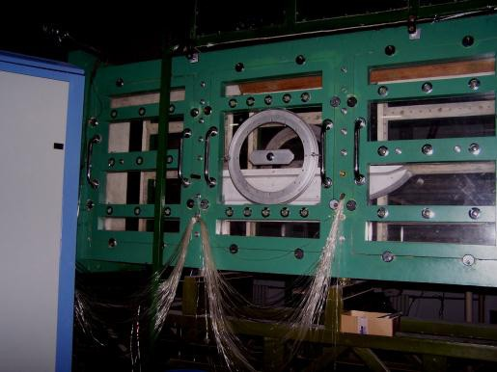 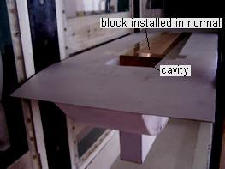

* 1. two dimensional test section (b) cavity model installed in wind tunnel Fig.1. Experimental installation diagram

By blocking the cavity along the flow direction from the front edge or back edge, the effects of different boundary layer at cavity inlet on flow aeroacoustic characteristics was discussed. Specified programs are shown in Table 1.

Table 1. Experimental program

|  |  |  |  |
| --- | --- | --- | --- |
| L/D | W/D | L(mm) | install method of block |
| 2 | 1 | 232 | from front edge(Nor) |
| 2  4 | 1  1 | 232  464 | from front edge(Rev)  D=116mm  from front edge(Nor) |
| 4 | 1 | 464 | from front edge(Rev) |

Along the centerline of the whole cavity bottom plate, static pressure holes are distributed evenly every 10mm. 6 acoustic probes are arranged on cavity wall: one is on the back wall and the other 5 are on the bottom, which is shown in Figure 2:.

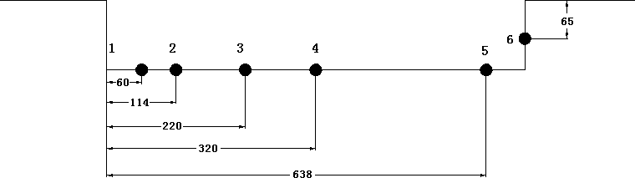

Fig.2. Number marks corresponding to different measuring locations of acoustic probes along center line on cavity bottom

# Experimental equipments

The experiment is carried out in low turbulence wind tunnel (LTWT) of Northwestern Polytechnical University. The cavity is tested in two dimensional test section which has the cross-sectional dimension of 1.0m × 0.4m. The wind speed for this paper is 30m/s.

Static pressure data acquisition use DSY104 scanning electron micro-pressure measurement system, which has 192 manometer channels, with channel scan rate of 50,000 / sec, and the system accuracy is ± 0.1%F.S.

Dynamic pressure spectrum was measured by Belgian LMS dynamic measurement system, which has the LMS SCM01 Mobile 8-channel data acquisition front, PCB acoustic sensors, model type 130P10/D10, and the frequency range 10-15 KHz.

The micro parameters in boundary layer, etc. were measured using one-dimensional hotwire probe 55P11. The hotwire was supported by high-precision 3-coordinate auto-move equipment with the smallest moving precision of 0.01mm. The assembling of 3-axis equipment on test section of the wind tunnel was shown in Figure 3.

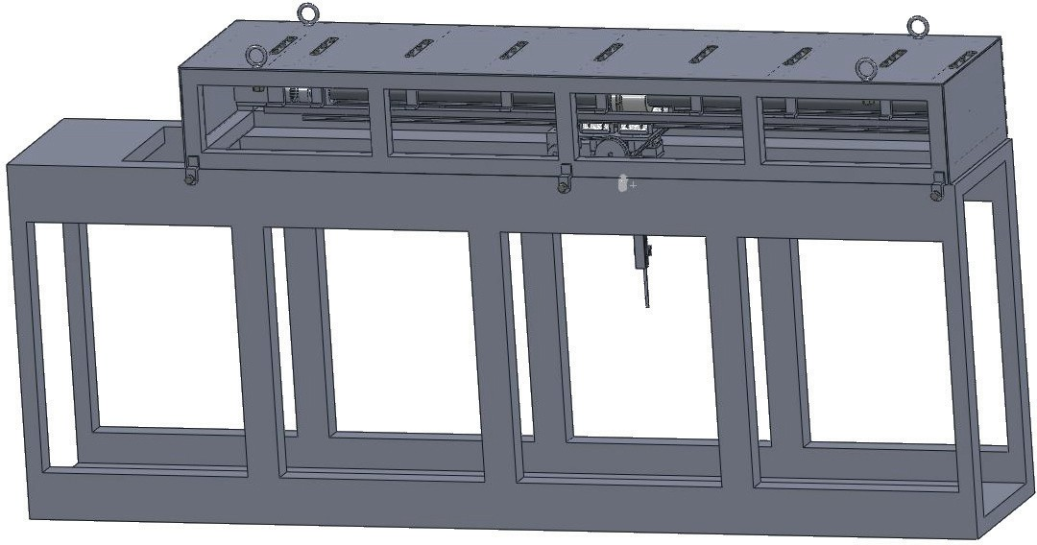

Fig.3. 2D test section of wind tunnel equipped with 3-coordinate high precision moving equipment

# Acoustic properties of different locations inside the same cavity

Figure 4 shows cavity noise characteristics of different measuring points for the open cavity (L/D=2 and 4) with the block installed in normal state.

For both L/D=2 and 4, Location 6 is the measuring point on the rear wall of the cavity, and Location 1 is in the front of the cavity bottom, the measuring points 2 and 3 are on bottom center for L / D = 2 and 4 respectively, and the measuring point 3 and 4 are located on the cavity bottom near the rear wall. As can be seen from the results, the radiation noise frequency is concentrated in the region of low-to-middle frequency; the rear wall is the main noise radiation area. SPL on rear wall is higher than the noise on bottom at least 10dB,which show the broadband characteristics with the peak reducing. For cavity L/D=2, the whole bottom locations are reflecting the flow characteristics of strong oscillation frequency peak. When the length-to-depth ratio increased to 4, the cavity noise reflects the fundamental frequency increase, and when close to the rear wall, the SPL increases to the same magnitude order with back wall.

120

100

120

100

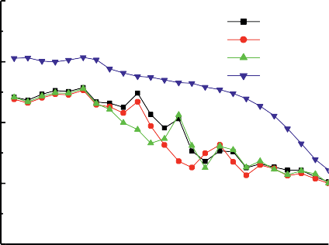

**L/D=2**

**location 1**

**location 2**

**location 3**

**location 6**

**L/D=4**

**1**

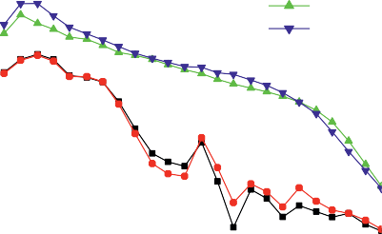

**location location location location**

**3**

**4**

**6**

80

**SPL(dB)**

**SPL(dB)**

80

60

40

100 1000 10000

**f(Hz)**

60

100 1000 10000

**f(Hz)**

Fig.4. Cavity noise characteristics at different measuring points(V=30m/s)

# Inlet boundary layer profile

In the experiments, the boundary layer profile just at the cavity inlet is changed by blocks installed inside cavity normally or reversed. Through the hotwire measurements, velocity profile of boundary layer was get for various conditions. Figure 5 gives out the static pressure along the central axis on cavity bottom when the flow velocity v=30m/s and the cavity bottom is lifted up to cover the cavity. Figure 6 shows the velocity profile comparison for L/D=2, 4 respectively with the block reversed installed.

Figure 5 shows out that from the normal leading edge, the pressure coefficient of approximately 20% of the cavity length increases along the flow direction, i.e., an adverse pressure gradient is present. After that, the pressure changed to be straight. That may due to the limitations of the model manufacture crafts, which caused a short flat from the curved leading edge to cavity inlet. The flat may produce a small separation bubble, and then formed stable reattachment turbulent layer. When the block reversely installed inside cavity, the cavity entrance for L/D=2 and 4 is at 33% and 66% of cavity whole length respectively. From the pressure distribution, it can be seen that at that location, the boundary layer is fully developed. boundary layer velocity profile shown in Figure 6 denote further that the velocity profile changed to be more plump with the boundary layer thickness increases when the blocks installed reversely to make the shear layer starts backward.

**0.4**

**V=30m/s**

**0.2**

**0.0**

**Cp**

**-0.2**

**0.0 0.2 0.4 0.6 0.8 1.0**

**X/L**

Fig.5. Pressure distribution along centerline on bottom which covered the cavity

35

normal ld2_rev ld4_rev

30

25

20

15

y(mm)

10

5

0

0.5 0.6 0.7 0.8 0.9 1.0

u/U

Fig.6. Velocity profile of boundary layer for different cavity inlet

# Effect of boundary layer profile on the cavity flow

Based on the two cavities of length-to-depth ratio 2 and 4, experiments were carried out with blocks installed inside cavities normally and reversed. The effect of boundary layer changes on flow pattern in cavities was obtained. The pressure distribution on bottoms are given out in Figure 7.

Figure 7 shows that the boundary layer profile affects the cavity flow pattern significantly. When the block installed reversely, boundary layer thickness increases, while making the overall pressure rise significantly, and on the other hand, adverse pressure gradient decreases. This indicates that, with the increase of turbulent kinetic energy in boundary layer flow, the cavity shear layer stability enhanced and the reverse flow velocity in cavity weakened.

**0.6 0.6**

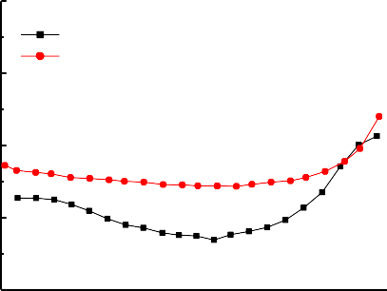

**L/D=2**

**Nor Rev**

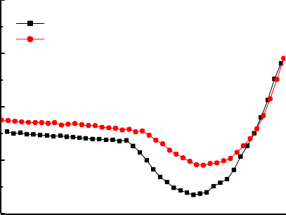

**L/D=4**

**Nor Rev**

**0.4 0.4**

**0.2 0.2**

**Cp**

**Cp**

**0.0 0.0**

**-0.2 -0.2**

|  |  |  |  |  |  |  |  |  |
| --- | --- | --- | --- | --- | --- | --- | --- | --- |
| **0.0 0.2 0.4 0.6 0.8 1.0 0.0 0.2 0.4 0.6** | | | | | | | | **0.8 1.0** |
|  |  | **X/L** |  |  |  |  | **X/L** |  |

Fig.7. Pressure distribution on cavity bottoms with inlet boundary layer change(V=30m/s)

Figure 8 shows the effect of boundary changes at cavity entrance on noise spectrum with measuring location on the bottom center and the rear wall respectively. the results indicate that the SPL at rear wall increases slightly, and the change magnitude is less than 3dB. For the length-to-depth ratio of 2, the SPL at bottom center changes intensely, with the boundary layer thickening, in a wide range (the low-frequency region less than 600 and high-frequency region higher than 1,500), noise radiation is greatly suppressed with the largest decreases of about 10dB. For the length-to-depth ratio of 4, in the middle and low frequency region, the sound pressure is slightly reduced when block installed reversely, however at the frequency about 1000Hz, SPL increases with the thickening of the boundary layer.

**L/D=2**

120

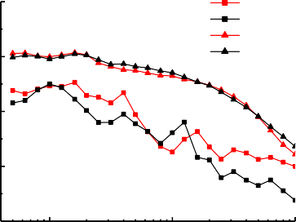

120

100

**bottom,Nor bottom,Rev back,Nor back,Rev**

80

60

40

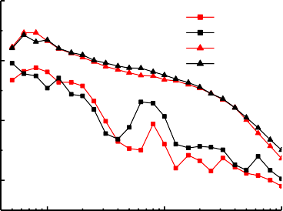

**L/D=4**

**bottom,Nor bottom,Rev back,Nor back,Rev**

100

80

**SPL(dB)**

**SPL(dB)**

100 1000 10000

**f(Hz)**

60

100 1000 10000

**f(Hz)**

Fig.8. Effect of boundary layer change on acoustic property in cavity (V=30m/s)

# Conclusions

On the basis of the cavity, with the measurement of wall pressure, hotwire and sound pressure acquisition, the clean cavity aeroacoustic characteristics under different inlet flow boundary conditions were studies, basic conclusions are as followings:

1. With the boundary layer thickness increases, the pressure on the cavity bottom increased greatly with adverse pressure gradient decreases;
2. When block installed reversely, for open cavity L/D=2, SPL greatly reduced, for L/D=4, the low frequency sound pressure is reduced with small amplitude, while sound pressure significantly increase in middle and high frequency.

# References

1. Clarence W. Rowley, Tim Colonius, etc.. On self-sustained oscillations in two-dimensional compressible flow over rectangular cavities. J. Fluid Mech., 455: 315-346, 2002.
2. Knisely, C., Rockwell D. Self-sustained low-frequency components in an impinging shear layer. J. Fluid Mech. 116, 157-186, 1982.
3. Heller, H. H. & Bliss, D. B. The physical mechanism of flow induced pressure fluctuationsin cavities and concepts for their suppression. AIAA Paper 75-491.
4. Roshko, A. Some measurements of flow in a rectangular cutout. NACA TN 3488, 1955.
5. Michael A. Kegerise and Eric F. Spina. Mode-switching and nonlinear effects in compressible flow over a cavity. Physic of Fluids, 16(3):678-687, 2004,
6. N. Chokani. Flow induced oscillations in cavities—a critical survey. AIAA Paper 92-02-159.
7. Alexandre Barbagallo, Denis Sipp, Laurent Jacquin. Control of an incompressible cavity flow using a reduced model based on global modes. AIAA 2008-3904.