Available online at [www.sciencedirect.com](http://www.sciencedirect.com/)



AASRI Procedia 2 (2012) 81 – 86

AASRI

Procedia

[www.elsevier.com/locate/procedia](http://www.elsevier.com/locate/procedia)

2012 AASRI Conference on Power and Energy Systems

# Hydropower Stations in Czech Water Supply System

Miroslava Gonoa, Miroslav Kyncla, Radomir Gonob,*

*a SmVaK a.s. Ostrava, 28. října 169, Ostrava 709 45, Czech Republic*

*bVSB - Technical University of Ostrava, 17. listopadu 15, Ostrava 708 33, Czech Republic*

Abstract

The paper outlines new possibilities in using renewable energy sources in the Czech Republic, namely using small-scale hydropower stations in water supply system for electricity production. It outlines a short history of small-scale hydropower stations in the Czech Republic and describes the principle of support for renewable energy sources and also the production of electricity and purchase price.

© 2012 Published by Elsevier B.V. Selection and/or peer review under responsibility of American Applied Science Research Institute

© 2012 Published by Elsevier B.V. Selection and/or peer review under responsibility of American Applied Science Research Institute

© 2012 Miroslava Gono, Miroslav Kyncl, Radomir Gono. Published by Elsevier B.V.

Selection and/o[r peer review under](http://creativecommons.org/licenses/by-nc-nd/3.0/) responsibility of American Applied Science Research Institute

Open access under [CC BY-NC-ND license.](http://creativecommons.org/licenses/by-nc-nd/3.0/)

*Keywords:* Small-scale hydropower station; water supply; turbines; renewable source

1. Introduction

Today, most of countries strive to provide electricity supply for its industries and inhabitants. While the demand for electricity and the prices of fossil fuels are growing and the nuclear electricity production is resisted in some countries, one of the ways to solve the problem is to increase production by renewable resources. Hydroelectric power plants do not pollute air, devastate the countryside by opencast or underground mining or by transport of fuels and raw materials. They are waste-free, independent of raw materials import and highly safe. Their flexible electricity production and ability to accumulate energy increases efficiency and reliability of power network [1].

* Corresponding author. Tel.: +420-597324554; fax: +420-597324132.

*E-mail address:* [radomir.gono@vsb.cz.](mailto:radomir.gono@vsb.cz)

2212-6716 © 2012 Published by Elsevier B.V. Selection and/or peer review under responsibility of American Applied Science Research Institute

Open access under [CC BY-NC-ND license.](http://creativecommons.org/licenses/by-nc-nd/3.0/) doi:10.1016/j.aasri.2012.09.018

1. Electricity Production in Small Hydropower Stations

In history, the Czech countries were at the top of Europe in terms of using hydro power and thanks to specific hydrologic conditions, the hydraulic propulsion was widespread. The last precise counting of establishments with hydraulic propulsion which included the numbers, type, and parameters of hydraulic engines was taken in 1930 by the Tax and Pensions Offices. The counting originated the List of hydraulic structures of Czechoslovakia (1934), the data of which was drawn upon in Table 1.

Table 1. Number and type of hydraulic structures in 1934

|  |  |  |
| --- | --- | --- |
| Hydro engine type | Number | Average output (*kW*) |
| Francis turbine | 4,397 | 35.8 |
| Kaplan turbine | 47 | 53.6 |
| Banki turbine | 55 |  |
| Girard turbine | 256 |  |
| Other types | 205 | 20.4 |
| Water wheels | 11,972 | 4.6 |

The numbers under the communist regime are only estimated. Today, the Czech Republic (CR) operates approx. 1,300 Small Hydropower Stations (SHS) with 60% of those with 100 kW maximum outputs.

Table 2 gives an overview of installed capacity of electricity production in Czech hydropower stations in 2008. In the CR, approximately 3.3 % of total electricity production is produced by hydropower stations which (including pumped storage) represent approximately 12 % of installed capacity of Czech power stations. Most of this capacity (90 % ap.) is produced on facilities with installed capacity more than 5 MW. In terms of the CR, an SHS is a facility with 10 MW maximum installed capacity, while in EU terms an SHS is a facility with 5 MW maximum installed capacity [2].

Table 2. Overview of installed capacity of hydroelectric plants and installed capacity and electricity production in the CR

|  |  |  |
| --- | --- | --- |
| Hydroelectric plants | Total installed capacity (MW) | Gross electricity production (GWh) |
| < 1 MW | 150.8 | 492.3 |
| 1 - 10 MW | 141.7 | 474.6 |
| > 10 MW | 752.8 | 1,057.5 |
| Pumped-storage power station | 1,146.5 | 352 |
| Total | 2,191.8 | 2,376.3 |

Most of them use out-of-date technology. Further increase in capacity of hydropower stations can be achieved by modernization of their technology or construction of SHSs on other sites.

The natural conditions for building hydraulic structures in the CR are not optimum. Our streams do not have the needed heads and the sufficient quantity of water. This is the reason for low share of hydroelectric power stations on total electricity production in the CR. Similarly to wind energy, there is little potential to be used as alternative energy source. The hydro power will always be only additional source, however, using more small-scale hydropower stations would be advantageous and beneficious because local resources in addition to the standard ones could be used. Moreover, compared with the wind power, the hydraulic power is more reliable and less costly.

Primarily thanks to subvention of purchasing prices of renewable resources, grants and low-interest loans, many SHSs have been built. These are hydroelectric plants with 10 MW max. installed capacity. Further increase of the output of hydroelectric power plants may be achieved by modernization of the technology or building of new plants in new areas. Most of so far unused areas have low heads, which would impede return on investments.

1. Production of Electricity in SHSs in Water Companies

Some of the Czech water companies have taken a significant opportunity - using the energy of water conveyed in ducts. Water companies produce and supply drinking water - great water volumes are conveyed in water ducts under pressure - this can be used for electricity production. They have started building SHSs at the entry points into the water treatment plants and water cisterns and using the hydroelectric potential of the conveyed water, both drinking and untreated. There is another important advantage – possible holding of water which means partial regulation of electricity supply [3].

The simplest machine set of a SHS contains an asynchronous generator and an adjusted water pump operating in a turbine regime [4]. A simple technical solution enables accurate regulation of pressure in consumption place with the help of servo-valve to deal with changing flow parameters, more machine sets working parallely can be positioned (Fig. 1). Series production components are used for assembly, which helps minimize the acquisition and service costs and speeds up the return on investments.

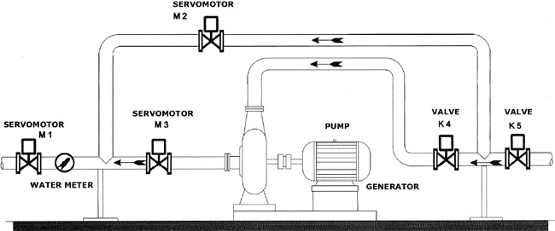

Fig. 1. SHS machine set

Fig. 2 shows an SHS on the penstock bringing untreated water into the water treatment plant. The systems used for regulation of turbines and fitting of bearings provide 100 % security in preserving the sanitariness of water, so it can be still classified as drinking water [5].

For electricity generation, an SHS uses the flow of drinking water from water treatment plant to water pipeline - water turns turbines connected to a generator. Its operation is automated as the inflow of raw water into the water treatment plant has to be adjusted according to variable demand of supply consumption area during the day.

In addition to electricity production, SHSs help to optimize drinking water treatment process. They aid to aeration of water after it goes through the turbine and it has another benefit - better mixing of additive with treated water after its distribution in the whole space of the contact tank.

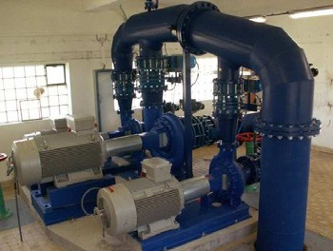 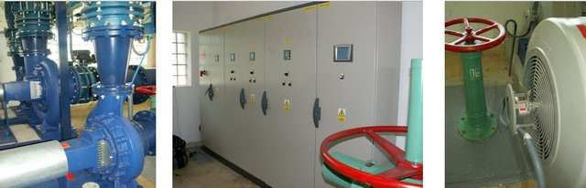

Fig. 2. SHS on a duct feeding untreated water into the water treatment plant

A similar case is utilizing the head of drinking water flow from water reservoir into the water pipeline (Fig. 3).

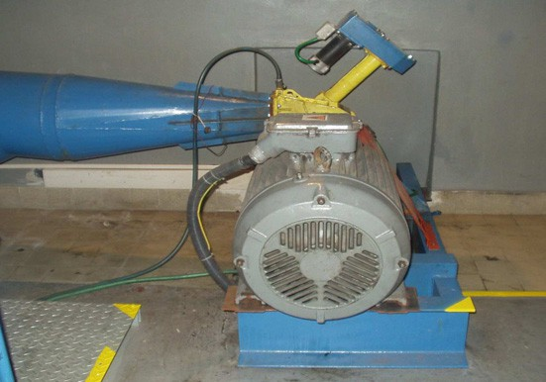

Fig. 3. SHS utilizing drinking water flow from water reservoir to water pipeline

Another advantage is the possibility of electricity production during profitable time of day, i. e. during high-tariff zone, which can bring higher profit [6].

Water companies are demanding in terms of electricity supply. However, a water treatment facility with an installed SHS can be self-sufficient and in many cases even able to sell extra power to public electricity network.

When installing an SHS, it is not necessary to cut water supply to public for long and there is no danger of water pollution. Rate of return on such projects is from 2 to 5 years.

Before putting an SHS into operation, it is necessary to obtain a license for business activities in power industry. A working SHS must meet the requirements specified by Water Law Office in the water treatment permit.

There are a lot of water treatment facilities using SHSs in the CR, however their volume of produced electricity does not go public. That is why there is no integrated statistic of GWh generated by SHSs. According to accessible data the amount of produced electricity from one SHS is more than 90 MWh/year for an SHS installation in a water reservoir and up to 2.5 GWh for SHS installation in water treatment plant. There are tens of SHSs in a water supply structure.

Last year the SHSs in our water company produced approx. 22 GWh; their total installed capacity is 7.5 MW. The most frequently used turbines in the Czech SHSs are Banki, Pelton, Francis and pump turbines.

1. Support for Renewable Resources Energy Production in CR

Production of electricity from renewable sources is supported in the Czech Republic. By law, power distributors have to connect every renewable energy source into the network. The price of electricity produced in such way is determined by The Energy Regulatory Office [7]. The minimal purchase price is by law guaranteed for 15 years in advance with the possibility of an annual correction +- 5%.

Table 3 gives an overview of purchase prices and green bonuses according to the Energy Regulatory Office. The price depends on the date when SHS started its operation. In case of a top-class and semi-class power plants, the operation of which is determined in the water treatment permit, two-tariff zones are set:

* + HT – high tariff zone for 8 hrs determined by the distribution network operator.
  + NT – low tariff zone for the hours when HT is not valid, determined by the distribution network operator.

Table 3. Overview of installed capacity of hydroelectric plants and installed capacity and electricity production in the CR

|  |  |  |
| --- | --- | --- |
| Date of put SHS into operation | Purchase prices (EUR / MWh) | Green bonuses (EUR / MWh) |
| SHS put into operation from 1 / 1 to 31 / 12 2010 | 123 | 83 |
| SHS put into operation from 1 / 1 2008 to 31 / 12 2009 | 113 | 67 |
| SHS put into operation from 1 / 1 2006 to 31 / 12 2007 | 106 | 67 |
| SHS put into operation after 1 / 1 2005 and reconstructed SHS | 96 | 57 |
| SHS put into operation before 1 / 1 2005 | 75 | 35 |

The purchase price is subordinated to the condition of guaranteed simple payback period of 15 years. If produced electricity is not supplied into network but used to cover the company's own energy consumption, a model of financial support called “green bonuses“ is introduced. It means that the market price of electricity is increased and covered for by the operator of the local distribution or transmission network to the benefit of the SHS owner.

The value of the above mentioned types of financial support cannot be combined; only one option is to be applied. The first possibility means more security and less trouble, while the other can bring slightly higher profit

The water management companies derive benefit from this support and they save hundreds of thousands EUR annually by production of electricity in SHSs.

1. Conclusion

Putting small scale hydropower stations into operation will be increasingly advantageous, as they can exploit the hydraulic potential of the given region. They represent a permanent source of propulsion which belongs to what we call “clean“, renewable energy sources. Their construction does not demand the use of technologies which jeopardize the environment. Their operation takes only minimum electricity necessary for the service of the facility and does not pollute the environment. With respect to the lack of suitable regions, the construction of small-scale hydropower stations on water feeders and exploitation of unused heads is natural. With the support of purchase prices and approving attitude of distributors to connecting of such power stations into network, more small-scale hydropower stations can be built.

In contrast to photovoltaic or wind power stations, the amount of electricity produced by them does not fluctuate with the change of day into the night or immediate weather changes. It is possible to plan supplies better and then power network is not overloaded.

SHSs are very often operated in areas where the most of produced electricity is consumed. That is why losses caused by electricity distribution are eliminated.

Additionally, an SHS gives a higher return on investment due to low capital investment and operational and maintenance costs.

Acknowledgements

This work was supported by the Czech Science Foundation (No. GA ČR 102/09/1842) and by the Ministry of Education, Youth and Sports of the Czech Republic (No. CZ.1.05/2.1.00/03.0069 and No. SP2012/188).

References

1. Gono R, Kratky M, Rusek S. Analysis of Distribution Network Failure Databases. Przegląd elektrotechniczny 2010; vol. 86, no. 8, 168-171.
2. Matusiak B, Pamula A, Zielinski J. Energia odnawialna w klastrze. Rynek Energii 2010, N 4.
3. Gono M, Kyncl M, Gono R. Operation of small hydro power plants at the water management company. International Conference Electric Power Engineering, VŠB-TU Ostrava 2011; 678-681.
4. Gasiorowska E, Paska J, Surma T. Wytwarzanie energii elektrycznej z wykorzystaniem zasobów odnawialnych – realizacja celów roku 2010 oraz perspektywy 2020. Rynek Energii 2011, N 2.
5. Gono M, Kyncl M, Gono R. Practical experience with electricity production from unused energy at the water management company. ICREPQ´11, Vigo: Vigo University, 2011; 663-666.
6. Kozak M. Problemy automatyzacji malej elektrowni wodnej. Rynek Energii 2008, N 3.
7. Energy Regulatory Office, [http://www.eru.cz.](http://www.eru.cz/)