Available online at [www.sciencedirect.com](http://www.sciencedirect.com/)



AASRI Procedia 1 (2012) 244 – 247

AASRI

Procedia

[www.elsevier.com/locate/procedia](http://www.elsevier.com/locate/procedia)

2012 AASRI Conference on Computational Intelligence and Bioinformatics

# Icing Rate Sensor Based on Infrared Spectrum Absorption

Zhao Yong a, Peng You-xinb, Zhang Bo b,Zhang Kai a,*

***a*** *School of Aerospace Engineering, Beijing Institute of Technology, Beijing and 10081, China*

**b** *Wuhan Aviation Instrument Co. , Ltd, Wuhan and 430074, China*

**Abstract**

An icing rate sensor based on infrared spectrum absorption is researched in this paper, which two infrared laser diodes are used in. Two laser diodes are driven by pulse circuit, and the key technology of the icing rate sensor based on infrared spectrum absorption is put forward. The icing rate sensor is smaller cubage, easier to extend and more steadfast components than the traditional circumvolving filter project.

© 2012 Published by Elsevier B.V. Open access under [CC BY-NC-ND license.](http://creativecommons.org/licenses/by-nc-nd/3.0/)

Selection and/or peer review under responsibility of American Applied Science Research Institute

Key words: Infrared Spectrum Absorption; Icing Rate Sensor; Lamp-house Drive Circuit; Photoelectricity Detection Circuit

## Introduction

Structural icing is one of the main climatic conditions leading to flight disaster for general aircraft. The formation of ice is very quickly, which can destroy aerodynamics of the wings and other surfaces resulting to decrease flight efficiency or ability to fly. Icing can consume engine power, leading breakdowns of control panel, brakes and landing gear, and many other problems. Therefore, the aircraft surface icing can lead to very serious flight accidents, especially for those aircrafts which are unable to fly over the icing conditions. The icing rate sensor is designed based on infrared spectrum absorption. The significant advantage of this sensor is highly precise, and that it can test rate of surface icing when a helicopter hovers.

* Zhang Kai. Tel: 15210616269; fax:01068911040.

*E-mail address:* [youhorse@163.com.](mailto:youhorse@163.com)

2212-6716 © 2012 Published by Elsevier Ltd. Open access under [CC BY-NC-ND license.](http://creativecommons.org/licenses/by-nc-nd/3.0/)

doi:10.1016/j.aasri.2012.06.038

*Zhao Yong et al. / AASRI Procedia 1 (2012) 244 – 247* 245

## Design of icing rate sensor based on infrared spectrum absorption

The specific implementation of the infrared spectrum absorption icing rate sensor is shown in Figure 1. Light source 1, 2 are controlled by lamp-house drive circuit 1, 2 respectively, and that lamp-house drive circuit 1, 2 are on and off alternately are controlled by the electrical pulses issued by the control circuit. Alternating light intensity pulses emitted by two light sources pass through 1550nm fiber A, B, into the 1×2 fiber coupler, and then enter into the same light probe, and shine to the measured ice surface alternating. The intensity of transmitted light through the ice surface is perceived by photoelectric detector, and converted into a corresponding electrical signal. [1]

Alternating two-way signals are amplified by preamplifier circuit separately, and filtered. Filtered electrical signals are converted into digital signals by the AD converter in the detection circuit. The digital signals are converted into analogue signals by DA converter of the signal detection circuit, and analogue signals characterized by ice thickness are send to a higher level system or display device via the communication interface circuit of the signal detection circuit. [2]

|  |  |  |  |  |  |  |
| --- | --- | --- | --- | --- | --- | --- |
|  | | Light Source 1  Light Source 2 | A  B | 1×2  fiber coupler | light probe  measured ice surface | photoelec detecto |
| Light |  |
| Drive 1 |  |
|  | |
| Light |  |
| Drive 2 |  |
|  | |

Figure 1 Infrared icing rate sensor functional block diagram



Control circuit

Higher level system or display device

tric r

Preamplifier circuit

Filter circuit

Detection circuit

## Light modulation technology

As mentioned earlier, the icing rate sensor based on infrared absorption needs high light intensity and spectral stability. In addition to light its own nature, the ambient temperature and the lamp-house drive current of light source are the greatest impacts on light intensity and spectral stability. Therefore, it is a key technology of an infrared icing rate sensor to control light source intensity and spectral stability. The program intends to design high-precision constant current source drive circuit and temperature control circuit to guarantee access to high-performance light source.

The ACC operation mode is used in constant current source of the program. The depth of negative feedback control theory is adopted in the overall design to provide effective control of the drive current directly, resulting minimum current deviation and the highest stability of the laser output. The constant current source circuit schematic is shown in Figure 2. The entire constant current source consists of voltage reference circuit, the voltage-current converter circuit, and protection circuit. The program uses a 2.5V voltage reference, which produces a stable reference voltage which is send into the operational amplifier

246 *Zhao Yong et al. / AASRI Procedia 1 (2012) 244 – 247*

inverting input after appropriate amplification. The operational amplifier controls the conduction of the transconductance amplifier, obtaining the corresponding output current. The output current generates sampling voltage on sampling resistor, and the sampling voltage amplified as the feedback voltage feeds back to the voltage amplifier inverting input side. After the voltage of inverting input side is compared with the voltage of the non inverting input side (the voltage produced by voltage reference and pre-amplified), the output voltage is adjusted, and then the output current of the transconductance amplifier so that the whole closed loop feedback system is in dynamic equilibrium, in order to achieve the goal of stabilizing the output current. [3]

## Infrared optical signal detection techniques

The electrical signals, generated by the infrared light and received by infrared detector, are very weak, and easily disturbed by outside world. Because one of the stable and reliable preamplifier circuit is infrared icing rate sensor technology, this program is to be adopted AD8304 as the core high-precision, low drift of the analog amplifier circuit, and the narrow-band filter circuit to improve the signal detection performance of the system. [4]

Because the dynamic range of the intensity of the signals is wide, and can reach 120dB, from microwatts to watts, the ordinary linear amplifier is difficult to meet the requirements. Optical power measurement chip logarithmic amplifier AD 8304 is used in the program. The chip converts current signals into voltage signals directly, and compresses the optical power dynamic range into a small area, which can effectively solve the signal large dynamic range.[5] Furthermore, the chip integrates two zoom functions, which can simplify circuits to improve reliability of the system. The schematic diagram of AD8304 chip is shown in Figure 3.

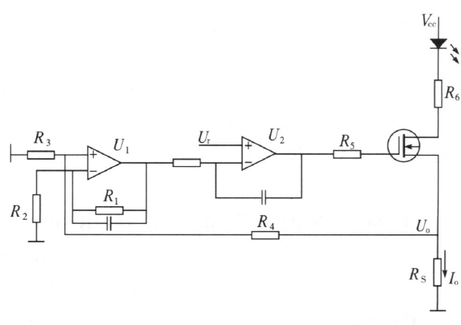

Figure 2 Feedback constant current source circuit diagram

*Zhao Yong et al. / AASRI Procedia 1 (2012) 244 – 247* 247

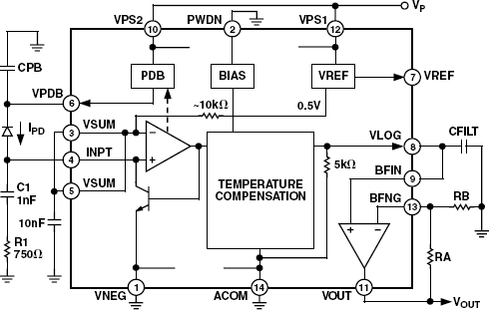

Figure 3 The schematic diagram of AD8304 chip

## Conclusion

Compared with the conventional rotary filter mirror chopper program, the significant advantages of the dual-light program designed by this paper are small, light, easy to expand the sensor into large ones, all-solid- state, and low-cost, etc. The program can also be used for applications such as detecting gas of infrared absorption, and measuring thickness of thin film, with a wide range of practical and economic value.

## References

1. J. F. Marchman. A Cheap, Effective Icing Detector for General Aviation Aircraft. AIAA AIRCRAFT SYSTEMS AND TECHNOLOGY MEETING[J]. 1979;(8):23-31.
2. Gan Hong, Pan Dan, Zhang Hong-chun. Single chip microcomputer-based carbon dioxide sensing system with infrared absorption. Journal of Guilin University of Electronic Technology. [J]. 2007;27(1):19-22.
3. Wang Zhong-lin, Yan Ming-mei. Research and Design of High-power Semiconductor Laser Diode Driver.

Journal of Binzhou University [J]. 2007;23(3):30-32

1. Xiong You-hui, Jiang Tai-yi. Non-dispersed Infrared (NDIR) Gas Sensors Based on Pulsable IR Sourse. Instrument Technique and Sensor [J]. 2003;(11):22-26.
2. Analog Devices. 160 dB Range (100pA – 10mA) Logarithmic Converter. [www.analog.com.](http://www.analog.com/)