Available online at [www.sciencedirect.com](http://www.sciencedirect.com/)



AASRI Procedia 3 (2012) 127 – 132

2012 AASRI conference on Modeling, Identification and Control

Identification the tool wear mechanisms and forms at drilling of a new stainless steels

Jozef Jurkoa*, Anton Pandaa

*a Slovak Republic*



**Abstract**

The basic hypothesis of this science focuses on the study of cutting tool wear with regard to the elimination of occurrence of poor-quality holes when drilling into new austenitic ELC (Extra Low Carbon) stainless steels. The problem of drilling holes with diameter D=2 to 5 mm resides in the fact that 35 to 50 % of these holes do not comply with prescribed requested requirements. The cutting tools screw drills as monoliths get damaged and wear out. The result of the damage is very often the unforeseen destruction of the cutting tools; therefore their operational lifespan is reduced. On the basis of practical experience and experiments carried out in the past 25 years, we have observed that the operational lifespan of screw drills is reduced by 50 %. This work presents the results of experiments focusing on the study of the damage process in screw drills with diameter d=4 mm when drilling into new low-carbon stainless steels. The paper is to contribute to the development of the theory of the cutting process, especially with new and practical experience, and new insights on the process of cutting the technological methods - drilling.

© 2012 The Authors. Published by Elsevier B.V. Open access under [CC BY-NC-ND license.](http://creativecommons.org/licenses/by-nc-nd/3.0/)

© 2012 Published by Elsevier B.V. Selection and/or peer rev[iew under responsi](http://creativecommons.org/licenses/by-nc-nd/3.0/)bility of American Applied Science Research Institute

Selection and/or peer review under responsibility of American Applied Science Research Institute

*Keywords:* Machining, Cutting Tool, Tool Wear, Plastic Deformation, ELC Steel X01Cr18Ni10TiN

* Corresponding author. Tel.: +421-51-7722603; fax: +421-51-7733453.

*E-mail address:* [jozef.jurko@tuke.sk.](mailto:jozef.jurko@tuke.sk)

2212-6716 © 2012 The Authors. Published by Elsevier B.V. Open access under [CC BY-NC-ND license.](http://creativecommons.org/licenses/by-nc-nd/3.0/) Selection and/or peer review under responsibility of American Applied Science Research Institute doi:10.1016/j.aasri.2012.11.022

# Introduction

The present market requires high quality products and the corresponding properties. Requirements that are imposed on these products (eg. resistance to various aggressive environments, resistance to heat and temperature effects, resistance to high mechanical loads, etc.) they can meet only materials with special physical, chemical, mechanical and other properties. In doing so, the technological process, the requirements for reliability, durability, and to reduce the weight of structures directly and indirectly affect the development and use of special new material.

The study of metal cutting can be accessed in several ways. When analyzing the theoretical foundations of cutting metals to describe these regularities and phenomena: regularities and processes of formation of particles on surfaces cut, regularities wear process of cutting tools, regularities drive the cutting process, cutting zone phenomena Davim, 2008 and Jurko, 2009. The current development in the theory of knowledge is characterized by cutting the fact that the study area are the cutting zone, which are in the close proximity to transformation of layer of material removal to chip. This approach is not correct. Since the that formed during cutting complex dynamic phenomena, the field should in theory be extended to the cutting technological properties of machine-tool-object-fixture, and in particular the continuity properties of the elements with the rules of the system mentioned above. The main models orientated on the quality surface of parts is:

MS (machined surface) = *function* (M-FT-FW-T-W + CC + PM + S)

**Nomenclature**

M machine

F fixture for tool (T) and for workpiece (W) CC cutting conditions

MW material of workpiece S surroundings

PM process medium

The foundation of the cutting process rests in the complete plastic deformation of the separated material (in the form of chips) at T<i>W, for defined conditions and a defined technological system M-F. With respect to economics, the application of progressive cutting tools should bring the following: a faster return on investment (e.g. cost of a new machine), increasing the machine performance (e.g. if we use a technically older machine) and increase of the productivity of operator work. Currently, one of the cost items that has an effect on production costs for 1 component piece is: cutting tool cost. Every company includes a different percentage of cost of the cutting tool for their total costs of producing one component piece, Nakazawa, 1989. Although cost of the cutting tool make up only part of the total costs for producing one component piece (5 % to 10 %), they have a significant impact particularly on the following:

Cutting process T<i>W. Affects the overall result (e.g. damage to the cutting tool, roughness of the machined surface, failures, defects and changes to the mechanical properties of the work piece) of the machined surface on the component. Extent of machine stand time  damaged cutting tool (e.g. its durability, or service life ), ensuring system logistics (e.g. storage, maintenance, service). Number of required operations

 change in the technological procedure, a quality progressive tool can result in saving costs (e.g. making an accurate hole - drilling, roughing, reaming out).

The duration a component is required to stay within the company (e.g. during changes to the technological procedure). The number of cutting tools, which must be in stock (e.g. to ensure the availability of tools, and their logistics). One of the fundamental conditions for the economic utilization of CNC production machines is the optimal course of machining process for the criteria defined, Shaw, 2005.

# Experiments and results

For the experiments was applied technological system machine-tool-workpiece-fixture: CNC Chiron FZ12, helical drill with a diameter *d*=4.0 mm, the new design of the cutting edge with uncoated cemented carbide. Fixture for the cutting tool: high precision hydraulic clamping head, the workpiece fixture: mechanical vise. Workpiece: stainless steel-austenitic ELC X01Cr18Ni10TiN. The materials to be machined were type of a new austenitic stainless steels with chemical composition: Chemical composition of stainless steel is: C=max.0.16; Si=max. 0.50; Mn=max.1.60; P=max. 0.035; Ti=max. 0.08; S= max. 0.025; Cr=17.8-18.2;

Ni=10, N=max. 0.08. Experiments were used for sample size hxbxl (50x50x50) mm, for drilling holes 12 mm in depth and definition to the evaluation of internal machined surface. Experiments were realized in the workplace: Research and development center in Norimberg, in cutting conditions: cutting speed of *vc*=interval of 40-50 m/min, feed *f*=interval from 0.01 to 0.06 mm per revolution, depth of cut *ap*=2.0 mm. Method of machining and dry machining. Workpieces of steel ELC X01Cr18Ni10TiN, obtained by drilling, were analyzed for electron microscopy. To deformed the steel-hardening layer, was rated a hard layer width from the cut surface, a hard layer microhardness, and surface finish has been rated *Ra* surface roughness and surface morphology.

Analyses of samples plastically deformed layers under the surface of machined steel ELC X01Cr18Ni10TiN can confirm these allegations. Autors indicates that for steel ELC X01Cr18Ni10TiN, resizing a layer of plastic deformation is related mainly to the material structure and properties of austenitic grain size. Hardening uneven layer width from 18 m to 280 m, example as shown in Fig 1, generated by the cutting conditions of 40 m/min to 45 m/min and feeds on larger than 0.04 mm.

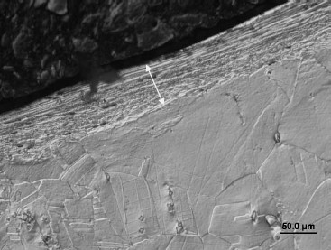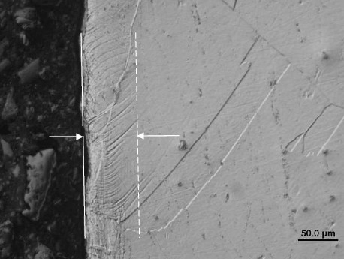

Fig. 1. Plastic deformation of the surface to a depth of 200 m, local plastic deformation in the austenitic grain

For evaluation of the cutting tools life were applied criterion *VBK*=0.05 mm. Measurements were made using an optical microscope without removing the cutting tool from the fixture. Cutting tools and the chips were analyzed for electron microscopy (SEM). Plastic deformation initiates the so-called cutting edge wear. chipping, especially for the discontinuous method of machining such as drilling. Tool wear occurred continuously for steel with the use of a cutting tool in dry machining. In this respect, at increasing cutting speeds tool plastic deformation takes place with gradual laminar flaking of the surface on the cutting tool Fig 2a and with destruction of the coat (frittering) over the front area Fig 2b; tool wear is influenced by the formation of built-up edges and by coat flaking. Stainless steels are influenced by charging due to intensive mechanical reinforcement during machining, Peckner, 1999.

a) 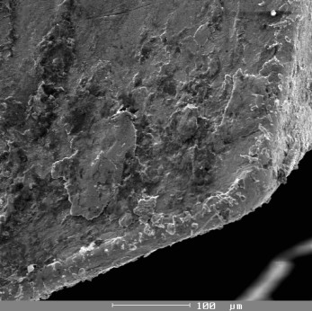 b) 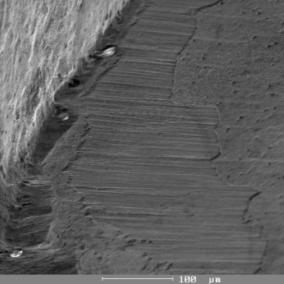

Fig. 2 (a) Tool wear frittering, (b) Tool wear - flaking

The example shows the distribution of temperatures in the cutting zone for drilling Fig 3 and for turning Fig 4, Jurko, 2009. The chip should conduct most heat away, meaning that for separation from the front surface of the cutting tool, the element - chip has a high temperature.

a) 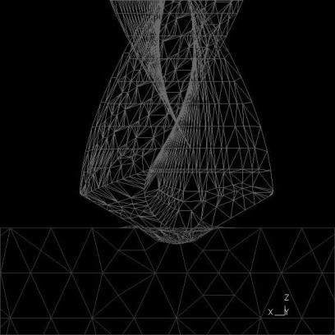 b) 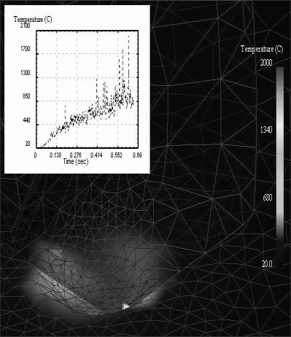

Fig. 3 Conducting heat through primary technological system elements for drilling

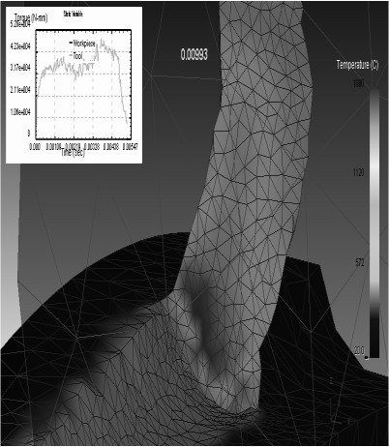High temperatures in the cutting zone are caused by the process medium evaporating, which can result in reducing the durability or the service life of the cutting tool respectively. Interrupted cutting sequences can cause changes in temperature within the cutting element, causing temperature differences in the cutting element, which leads to thermal cracks and breaking Jurko, 2010 and Cheng, 2009.



T=20 %

MW=8 %

S=10 %

Fig. 4 Conducting heat through primary technological system elements for turning

CH=62 %

The examination of reinforced surfaces can be carried out by measuring the micro-hardness of the bottom part of the fragment; indeed, the bottom part of the fragment can be considered as the most deformed fragment zone. The results of micro-hardness examination are reported in Fig 5.

250

40

45

50

245

240

Hardness HV (20g)

235

230

225

220

0 0.04 0.08 0.12

Distance from machined surface  [mm]

Fig. 5 Relation between machined workpiece micro-hardness and different cutting speed

The process of cutting is the mutual interaction between the tool and the workpiece, which is controlled by many phenomena. It is important to define the shear level in the cutting zone.

# Conclusion

When drilling, the first important factor of success for the cutting process is the drill penetrating (first contact) the material of the object. One way how to ensure a good quality hole is to guarantee the drill penetrates the object perpendicularly. The drill, however, can manage to penetrate convex and concave shapes and into oblique or irregular surfaces (by properly adjusting the feed). The conditions for convex surfaces are relatively good, for the center of the drill reaches the material first, meaning normal torque is induced. When penetrating an oblique surface, cutting wedges are unevenly loaded, which can lead to the drill wear off prematurely. Uneven loads represent the need to use very stable tools (with a small length to diameter ratio) to prevent vibrations and observe the required tolerance. If the surface inclination before cutting is larger than three degrees, the feed should be reduced to a third of the recommended value. When penetrating a concave surface, the drill mesh changes according to the surface curvature radius and hole diameter to cutting point ratio. If the concave surface curvature radius is small compared to the hole diameter, the perimeter of the drill will be in mesh first. The feed must be reduced to a third of the recommended value to limit the gradient deviating the tool from the initial position. When penetrating asymmetrical curvature surfaces, the drill attempts to deviate from the axis in the direction towards the center of the surface curvature, the same way as when penetrating an oblique surface. It is necessary to reduce the feed to a third of the recommended value for penetrating concave surfaces. Uneven surfaces can be broken or otherwise damaged during the drilling process on the other side where the drill exits the material.

# Acknowledgements

The authors would like to thank in words the KEGA grant agency for supporting research work and co- financing the projects Project Nr. 011TUKE-4/2012.

# References

1. Davim,J.P. Machining - Fundamentals and Recent Advances. Springer, ISBN 978-1-84800-212-8, 2008.
2. Cheng, K. Machining Dynamics-Fundamentals, Applications and Practices, Springer : Springer Series in Advanced Manufacturing, XVIII, ISBN: 978-1-84628-367-3, 2009.
3. Jurko,J. The use of TiAlN coated carbide tool when finish drilling of stainless steel X4Cr17ni8TiN. Applied Mechanics and Materials, TTP : Zurich, ISSN 1660-9336, 2010.
4. Jurko,J. Verification of cutting zone machinability during drilling of austenitic stainless steels. In: Proceeding of SPIE: SPIE - International society for optics and photonics. 2009.
5. Jurko,J.-Panda, A.-  turning of stainless steels. International Journal Machining and Machinability of Materials, 2009.
6. Nakazawa, T. - Abo, H. - Tanino,M. - Komatsu, H. - Nishida, T. - Tashimo,M. Effects of Nitrogen and Carbon on Creep Properties of Type 316 Stainless Steels. In: Foct,J.-Henry,A. (Eds.). Proceedings of the International, London: The Institute of Metals, 1989.
7. Peckner,D.-Bernstein,I.M. Handbook of Stainless Steels. New York: McGraw-Hill, 1999.
8. Shaw,M.C. Metal cutting principles, NY: Oxford University Press, 2005.