Available online at [www.sciencedirect.com](http://www.sciencedirect.com/)

**ScienceDirect**

AASRI Procedia 5 (2013) 262 – 267

2013 AASRI Conference on Parallel and Distributed Computing Systems

Improved Particle Filter for Target Tracing Application Based on ChinaGrid

Yuqiang Lia,*, Xixu Hea, Haitao Jiab,

*aInformation Center, University of Electronic Science and Technology of China, Chengdu 610054, China*

*bRIEST, UESTC, Chengdu, China*

**Abstract**

Most practical target tracking are usually maneuvering, while most target tracking algorithm are linear filter. More estimation error is introduced from linear filter. Nowadays more and more researchers pay their attention in Maneuvering Target Tracking algorithm. Particle filter has been developed for estimation of nonlinear system states. This paper presents an improved particle filter, which can apply the maneuvering target tracking problem. In practice, the particle filter would take abundant computation for estimate the maneuvering target tracking. The ChinaGrid system use the agile and distributed federations to reduce the computing time, which achieve to fast resolution for particle filter computation of target tracing application. Lastly the simulation proves it.

© 2013 The Authors. Published by Elsevier B.V. Open access under [CC BY-NC-ND license.](http://creativecommons.org/licenses/by-nc-nd/3.0/)

© 2013 The Authors. Published by Elsevier B.V.

Selection and/or peer review under responsibility of American Applied Science Research Institute

Selection and/or peer review under responsibility of American Applied Science Research Institute

*Keywords*: Target tracing; Particle filter; ChinaGrid;

# Introduction

Target tracking is used in many application areas, such as defense system, radar system, sonar system, aeronautical system, satellite system, autonomous robots, etc. [1] For anyone target tracing system, it must

Supported by the Fundamental Research Funds for the Central Universities (No.ZYGX2010J150 )

* Corresponding author. Tel.: +86-28-83204056; fax: +86-28-83200666.

*E-mail address:* [yqli@uestc.edu.cn.](mailto:yqli@uestc.edu.cn)

2212-6716 © 2013 The Authors. Published by Elsevier B.V. Open access under [CC BY-NC-ND license.](http://creativecommons.org/licenses/by-nc-nd/3.0/) Selection and/or peer review under responsibility of American Applied Science Research Institute doi:10.1016/j.aasri.2013.10.087

solve two basic tasks. One is the estimation refining procedure, which need to infer the accurate estimation target position from noise measurement data. The other is to predict the target position in next time that information used to form forecasting windows limiting the target in the future. [2] So the kernel problem of target tracing is to estimate the states of the moving target, such as position, velocity and acceleration. Most target tracing algorithms belong to Bayesian theoretic. Kalman filter and particle filter are popular Bayesian filters for target tracing based on their probabilistic nature. [3]

The paper presented by Isard is first publication for the particle filter algorithm [4]. The typical particle filter framework is shown in figure 1.

Sampling Propagation

Resampling

Importance

Inference

Fig.1. The typical particle filter

Particle filter uses a mass of particles with the target status to approximate posterior distribution for the target, which main idea is from the Monte Carlo Simulation Theory. Particle filter prefer much particle approximation method to directly estimation. However it can improve the tracing performance, its computation is very high. Only using a large numbers of particles might the particle filter achieve better estimation results dealing with complex target tracking. Therefore huge and highly efficient architecture is needed for particle filter.

The huge sharing of computing and storage resources can be proved by the Grid technology, which uses the virtual method to arrange the compute mission to distributing machines. [5] So the problem in particle filter for maneuvering target tracing which is restricted by the capability of computer can be solved by taking the Grid framework. This papers proposed a framework for particle filter in maneuvering target tracing, which take the ChinaGrid as the base. The simulation proves that this framework can work well for complex target tracking.

# Particle filter

Consider a single target tracking problem in which t *x* is the target motion state vector at time *k*

*k*

*x * *f* (*x* ) 

*k k* 1

*v*

*k*

*(1)*

*z * *h*(*x* ) 

*k k* 1

*w*

*k*



*k*

where *v*

*k*

~ *N* ( , )

, *N* (, ) denoting the Gaussian distribution with mean  and covariance matrix  . *v* is

noise sequence of independent. *f* () is nonlinear state function. *z* is observation vector obtained at time *k* .

*k*

*k*

*h*()

is nonlinear measurement function.

*w* is observation noise sequence of independent.[6] Let

*X * {*x* , *x* ...*x* } and *Z * {*z* , *z* ...*z* } as the sequence vectors of the target motion states and the observation

0:*k*

0 1 *k*

0:*k*

0 1 *k*

dates up to time *k* .In the discrete time domain the Bayesian rule is to use the posterior conditional probability

*k*

density function

*p*(*x* | *Z*

0:*k*

) to prediction and updating.[7]

Target tracing procedure is

1. Use state function *f* () to predict the next time target state *x* :

*k* 1

*p*( *x* ) *f* ( *x*

) *p*(*x* | *Z* )*dx*

*(2)*

*k k* 1

*k* 1 0:*k* 1 *k* 1

1. Use Bayesian Formula to estimate target state *x* [9]:

*k* 1

*p*( *z* | *x* ) *p*( *x* | *Z* )

*p*( *x* | *Z*

)   *k* 1 *k* 1 *k* 1 0:*k*

*(3)*

*k* 1 0:*k *1

*k* 1

*p*( *z* | *Z*0:*k* )

In practice, the *p*(*x* | *Z* ) computation is very intractable from formula 3. Sequential Monte Carlo is

*k* 1 0:*k *1

used for generating sufficient weighted particles with the sampling target states to implement the filter. That is

to say, particle filter takes a set of so called particles {*x*(*i*)}*N* to approximate the probability density

*t i* 1

function.[10]

*N*



*i t*

*p*(*x* | *Z*

*t*

*t*

*t*

0:*k*

)

*i* 1

(*x * *x*(*i*) )

*(4)*

Here *x*(*i*) is the state of the *i* th particle in *t* time, and *i* is its importance weight which is associated to

*t t*

*x*(*i*) . The particle would have higher weight when its states estimation approaches the real value. [11] So the particle filter formulate can be expressed as (5) by the important sampling theory.

*t*

1. Based on prior probability density function initialize the particles{*x*(*i*)}*M* .[12]
2. Input the observation date

0 *i* 1

*z* , and update the importance weight *i*

*i * *p*(*z* | *x*(*i*)

), *i*

*k*

 1...*M*

*t*

*(5)*

*t k k*|*k* 1

1. Normalize the weights

~ *i*

*i t*

*(6)*

*t*

*j*



*t*

*j* 1

1. Resampling particle if necessary, create N new particle with replacement for *j*

~

 1..*N*

Pr(*x*( *j*)

*x*( *j* ) )

*j* , *j*

 1...*N (7)*

*k k*|*k* 1 *t*

1. Update the particle states

*x*(*i*)

~ *p*(*x*

| *x*(*i*) )

*(8)*

*k *1|*k k *1|*k k*|*k*

1. *k * *k *1, and iterate from step 2.

From above discussed, we can easily draw a conclusion that the more particle number is the more accurate the filter result is. This conclusion is agreed by other researchers [13].So we will take compute grid to achieve this goal.

# Use ChinaGrid Support Particle filter (CGSP)

Nowadays ChianGrid has been covered over about one hundred famous universities in China, which purpose to build a national-wide system for grid computing to provide the service for education. The ChinaGrid makes use of most advanced internet and distributing computing, sharing technology. [8] ChinaGrid framework provides a platform for the user to development their application in the ChinaGrid, which is called as ChinaGrid Support Platform (CGSP). This platform works as a tool suit with API function for each application. The figure 2 shows the framework of CGSP.

From the figure 2, it can be found that the Job manager module, Information Center module and Data Manager module is key layer for the ChinaGrid, which provide the base function. And the Security Manager module and Service Container module supports the whole system. Domain Manager, Grid Monitor and Portal

Engine module are the portal of the ChinaGrid. The user can obtain better service in sharing and storage service without thinking the whole machine physical distributing.

Security Manager

Service Container

CGSP System Module (services)

Grid Monitor

Job Manager

Domain Manager

Interoperrating BrokerI

|  |  |
| --- | --- |
| Portal Engineer | Grid Developing toolkie |
|  | |

|  |  |  |
| --- | --- | --- |
| Information Center |  | Data Manager |



Fig.2. the architecture of CGSP Fig.3. normal corner maneuvering route

# Improved particle filter

Particle filter bases the Bayesian rule. If target state is stabilization, the filter performance will satisfy the practice requirement. When tracing system wants to catch a maneuvering target, the particle filter does not suit to this condition. And this paper addresses an improved method based on particle filter which can deal with maneuvering target tracing. Fig.3 shows a normal corner maneuvering route.

From above figure we can find that in the corner of the route the target motion state, such as acceleration and velocity, change vary much. Almost tracing filter predicts the future position by accumulation on the target motion state estimation. So in the point where target begin maneuvering, the performance decline very much.

About target maneuvering, we can take it as the aberrance for target motion states. According this idea, we can introduce the aberrance into particle. Like nature, the preservation species take the aberrance to deal with circumstance variety. The improved particle filter every time will take some particles to vary states. When target begin maneuvering, there are some aberrant particle that can catch the target. The improved particle filter flow is shown Fig.4.

To satisfy the requirement of maneuvering target tracing, tracing system must create more and more particles. Here we use the ChinaGrid to support improved particle filter for maneuvering target tracing. Its framework is shows as figure 5.

Here we use a particle package as a interface which takes every particle as a computer unit into ChinaGrid to run. Because every particle is independence, so the computer for particle can be paralleled in ChinaGrid framework.

Resampling the particle

Using the observation data to computer importance weights

Predict target future ststes

Output the filter results

Create the foremost particle

based on prior probability density

Create the aberrance particle

Particle parkage

Based on target maneuvering feature set the aberrance range for the particle

Set the aberrance particle number

|  |  |
| --- | --- |
| Portal Engineer | Grid Developing toolkie |
|  | |

Fig.4. Improved particle filter flow Fig.5. Based ChinaGrid improved particle filter framework

Predict target future ststes

Create the aberrance particle

Resampling the particle

Output the filter results

Using the observation data to computer importance weights

Create the foremost particle based on Prior probability density

Based on target maneuvering feature set the aberrance range for the particle

Set the aberrance particle number

CGSP System Module (services)

Service Container

Security Manager

Grid Monitor

Domain Manager

Interoperrating BrokerI

|  |  |  |  |  |
| --- | --- | --- | --- | --- |
| Job Manag |  | Information Center |  | Data Manager |

# Simulation Result

Based on this framework we build an improved particle filter for tracing maneuvering target application to get some simulations results.

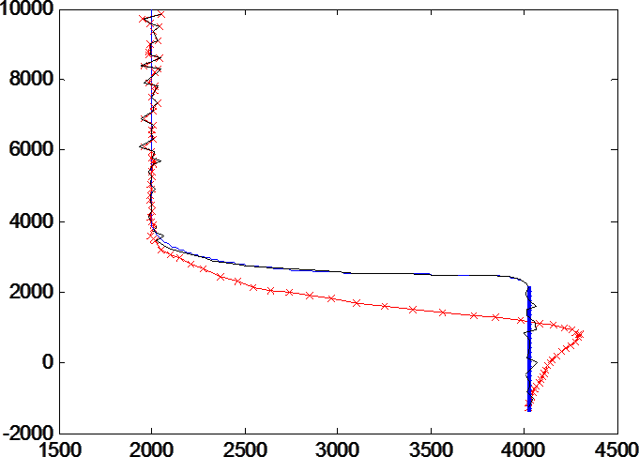

Target real track Normal particle filter Improved particle filter

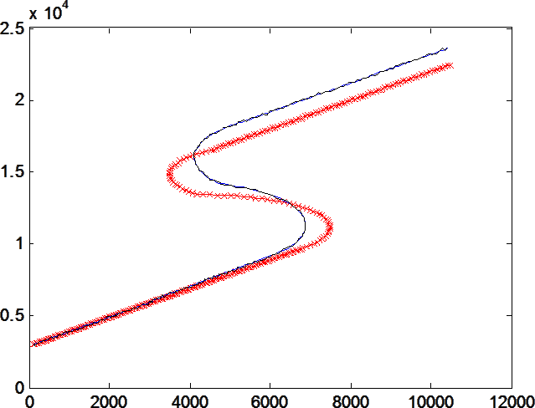

Target real track Normal particle filter Improved particle filter

Fig.6. Filter performance simulation result Fig.7. Filter performance simulation result

Figure 6 shows the simulation result of maneuvering target tracing. The red track is the result from normal particle filter and blue is improved particle filter. The figure 7 shows the corner maneuvering tracing results.

# Conclusion

This paper build an improved particle filter based on ChinaGrid framework for maneuvering target tracing system. And the lastly simulation proves that our algorithm can deal with maneuvering target tracing problem. And the ChinaGrid system provides the computer resource for huge particle computer. This technology will help practice target tracing system.

# Acknowledgment

We are acknowledging other researchers in the lab have helped us.

# References

634, 2004.

[2

of IEEE Aerospace Conference, Big Sky, MO, 2007. [3

International Conference on Acoustics, Speech and Signal Processing, Honolulu (Hawaii), 2007. [4



29, pp. 528, 1998.

[5]Hai. Jin, ChinaGrid: Making Grid Computing a Reality, Digital Libraries: International Collaboration and Cross-Fertilization - Lecture Notes in Computer Science, Vol.3334, pp.13-24. [6

Proceedings of IEEE Aerospace Conference, Big Sky, MO, 2007 [7



nonlinear/non- 188, 2002.

[8] ChinaGrid, [http://www.chinagrid.edu.cn/.](http://www.chinagrid.edu.cn/)

[9

924, 2007.

[10

Aerospace Conference, Big Sky, MO, 2003.

1. A. Doucet, N. de Freitas, and N. Gordon, Eds., Sequential Monte Carlo Methods in Practice, Springer, New York, 2001.
2. X. Sheng and Y- ce localization using acoustic energy



53,

2005.

1. G.C. Goodwin and J.C, State and Parameter Estimation for Linear and Nonlinear Systems, Proc of the 7th International Conf. On Control Automation, Robotics and Vision. 2002.