[Array 14 (2022) 100182](https://doi.org/10.1016/j.array.2022.100182)



Contents lists available at [ScienceDirect](http://www.elsevier.com/locate/array)

Array

journal homepage: [www.elsevier.com/locate/array](http://www.elsevier.com/locate/array)

Improving novelty detection using the reconstructions of nearest neighbours

Michael Mesarcik a,∗, Elena Ranguelova b, Albert-Jan Boonstra c, Rob V. van Nieuwpoort a,b

a *University of Amsterdam, Science Park 904, Amsterdam, 1098XH, The Netherlands*

b *eScience Center, Science Park 140, Amsterdam, 1098XG, The Netherlands*

c *ASTRON, the Netherlands Institute for Radio Astronomy, Oude Hoogeveensedijk 4, Dwingeloo, 7991PD, The Netherlands*

A R T I C L E I N F O A B S T R A C T

*Keywords:* Anomaly detection Autoencoders

Semi-supervised learning

We show that using nearest neighbours in the latent space of autoencoders (AE) significantly improves performance of semi-supervised novelty detection in both single and multi-class contexts. Autoencoding methods detect novelty by learning to differentiate between the non-novel training class(es) and all other unseen classes. Our method harnesses a combination of the reconstructions of the nearest neighbours and the latent-neighbour distances of a given input’s latent representation. We demonstrate that our nearest-latent- neighbours (NLN) algorithm is memory and time efficient, does not require significant data augmentation, nor is reliant on pretrained networks. Furthermore, we show that the NLN-algorithm is easily applicable to multiple datasets without modification. Additionally, the proposed algorithm is agnostic to autoencoder architecture and reconstruction error method. We validate our method across several standard datasets for a variety of different autoencoding architectures such as vanilla, adversarial and variational autoencoders using either reconstruction, residual or feature consistent losses. The results show that the NLN algorithm grants up to a 17% increase in Area Under the Receiver Operating Characteristics (AUROC) curve performance for the multi-class case and 8% for single-class novelty detection.

# Introduction

Novelty detection is an important field of research as identifying previously unknown behaviours in systems is critical for their main- tenance and smooth operation. It is the procedure in which a model is able to identify new classes of data that it has not been exposed to before. Novelty detection is a far-reaching topic having been applied extensively in fields such as manufacturing [1], cyber-security [2], biomedical analysis [3,4], astronomy [5] and many more [6].

Novelty, anomaly, outlier, abnormality and out-of-distribution (OOD) detection are closely related topics [7]. The distinction be- tween them is vague across variety of literature studies [3,8–11]. For clarity purposes, we consider novelty detection to be the over- arching paradigm, since it makes contextual sense to have novel abnormalities/anomalies/outliers but the converse does not apply.

Approaches for novelty and anomaly detection can be divided into a number of categories [6,12–14]. In this work we exclusively focus on autoencoder-based novelty detection. As it offers a data agnostic method that does not rely on significant data augmentation [15], finding negative samples [16,17] or pretraining on large labelled datasets [18] such as ImageNet [19].

Autoencoders (AEs) are widely used as novelty detectors [8–10,20– 25]. The underlying mechanism that governs the AE’s detection abili- ties is that they are firstly trained on data without abnormal, anomalous

or outlying samples. Then, during inference, the AE is exposed to novel samples which result in higher errors thus enabling novelty detection. Methods such as mean-square-error (MSE) [22], residual error [3], structural-similarity (SSIM) [26] or feature consistency [27] are used to calculate the pixel-wise difference.

A common problem with using autoencoding methods for novelty detection is that AEs can generalise to unseen classes thereby perform- ing poorly as novelty detectors [28]. In [9], this issue is addressed by placing a classifier in the training path of a multi-discriminator based autoencoder, which results in a fairly complicated and costly training procedure. On the contrary, we propose the Nearest-Latent- Neighbours (NLN) algorithm which uses the reconstructions of the nearest-neighbours in the latent space of autoencoders in-order to combat the aforementioned generalisation problem.

Unlike existing nearest neighbours methods [29], our NLN algo- rithm uses both the *reconstruction error* between a given sample and its neighbours in the latent space as well as the average latent-distance to its neighbours. Fig. 1 illustrates how a vanilla autoencoder generalises to reconstruct unseen samples whereas the reconstructions of an input’s nearest-latent-neighbours more closely resemble the non-novel training set thereby offering improved novelty detection.

∗ Corresponding author.

*E-mail address:* [m.mesarcik@uva.nl](mailto:m.mesarcik@uva.nl) (M. Mesarcik).

<https://doi.org/10.1016/j.array.2022.100182>

Received 4 February 2022; Received in revised form 2 May 2022; Accepted 3 May 2022

Available online 11 May 2022

2590-0056/© 2022 The Author(s). Published by Elsevier Inc. This is an open access article under the CC BY license (<http://creativecommons.org/licenses/by/4.0/>).

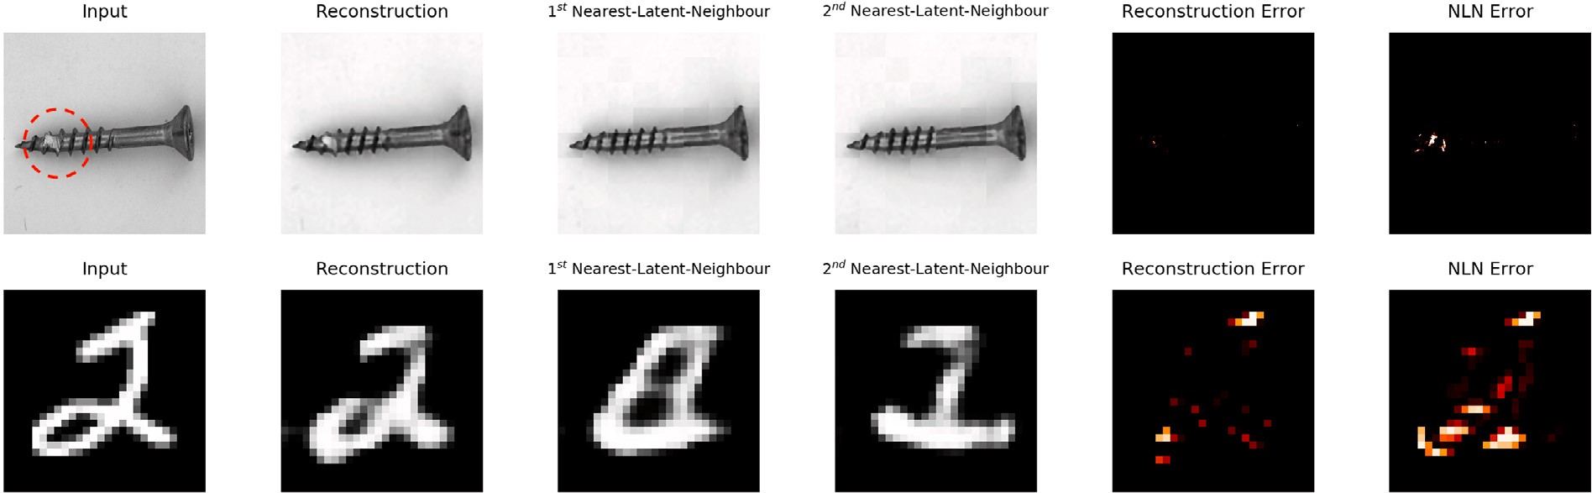

**/ig. 1.** Comparison between the MSE and the Nearest-Latent-Neighbours (NLN) based error using a vanilla AE. The top row shows an AE trained on the non-anomalous *screw* images of the MVTec-AD dataset, with the anomaly in the input circled in red, and the bottom row illustrates an AE trained on all MNIST digits except for ‘‘*2*’’. The first column is the input to the AE, the second is the AE’s output and the following two columns show the reconstructions of the input’s NLNs. The final two columns show the difference between the MSE and the NLN-based error, where in this work maximising the error on novel classes effectively performs novelty detection. It is clear that the AE learns to reconstruct unseen classes whereas the reconstructions of the NLNs do not. (For interpretation of the references to colour in this figure legend, the reader is referred to the web version of this article.)

We evaluate the proposed method using the novelty detection framework described in [30] and prove its effectiveness in a two- stage testing strategy. Firstly by comparing different architecture’s performance with and without the use of our NLN algorithm. Secondly we compare our best performing model with the current state-of-the-art AEs. We show that NLN is competitive with the state-of-the-art methods across a number of datasets.

In summary, the main contributions of this paper are: (1) a novel nearest-neighbour based algorithm that harnesses the reconstruction error of a given sample’s nearest-latent-neighbours and their latent- neighbour distances. (2) The formulation of the NLN algorithm applied to a variety of autoencoding architectures using several different error calculation methods. (3) Improved performance to the state-of-the-art autoencoders using NLN, a fairly simple, cheap and intuitive method, across a number of standard datasets.

# Background and related work

In novelty, anomaly, outlier, abnormality and OOD detection one or more of the following steps are required for the detection of a novel, anomalous or outlying sample: (1) a model of the distribution of the (non-anomalous/non-novel) data. (2) A suitable measure of fitness describing whether a given sample lies within the modelled distribution. (3) A decision rule to determine whether the measure is above or below a threshold [13].

A critical distinction among all related work is whether supervised, semi-supervised, or unsupervised methods have been used [31]. Su- pervised methods typically relate more strongly to anomaly detection scenarios, where both the normal and anomalous data classes are known *a-priori* [13]. However, supervision is not applicable in many settings, as anomalous classes are either underrepresented or just not known [13]. In the unsupervised setup, we have no *a-priori* information if the available data contains normal or abnormal samples [31].

Semi-supervised methods are the most common in practice, as nor- mal (non-anomalous, non-novel) data is most easily collected from most systems [6]. In this case, models are designed to represent the expected operating conditions of a system and any deviations from that are considered novel. These deviations may, in some cases, be considered anomalous, however this is dependent on the context of operation [7]. For the remainder of the paper we focus on semi-supervised methods, where we designate particular classes of a dataset as novel and all other as *expected*.

* 1. *Reconstruction based novelty detection*

Semi-supervised reconstruction based methods leverage the fact that a model trained on the *normal* data cannot suitably reconstruct novel samples. In effect, the difference between the input and reconstructed output can be used as a novelty detector. Autoencoders (AE) are com- monly used for reconstruction based novelty and anomaly detection [8– 10,20–25]. They operate by jointly learning latent representations and reconstructions of the training data. Once trained, a reconstruction error can be calculated between the input sample and the model’s decoded output. These models achieve improved performance when regularising the latent space [21] using variational AEs (VAE) [32] or adversarial losses [33].

It has been demonstrated that reconstruction-error based meth- ods alone are not particularly robust to noise, changing backgrounds and viewing angles [7]. In generative autoencoding models such as VAEs, reconstruction probability or attention-mechanisms are used to improve performance [21,25,34]. Furthermore Generative Adver- sarial Networks (GANs) [35] are used for reconstruction-error based anomaly detection [3,36,37]. Here the *residual error* is calculated as the difference between the training and generated images using their intermediate representations provided by the discriminator. More re- cently, self-supervised learning (SSL) has been applied to AEs and offers improved performance in novelty detection by using in-painting [23] or position prediction [38] pretext tasks.

In our work we use the *reconstructions* of a given sample’s la- tent neighbours in conjunction with their latent-distances. We show that this offers performance increases across a variety of architectures and datasets. Additionally, we utilise several autoencoding models and show that the NLN algorithm offers performance improvements irrespective of architecture.

* 1. *Statistical methods*

Statistical methods typically focus on modelling a distribution of inliers through learning their distribution parameters [10]. In effect, all expected/normal sample should lie in high density regions of the distribution, while outliers should have a low probability under the learnt distribution. Works such as One-class SVM [39], KNN [31] and isolation forests [40] have been shown to be suitable anomaly detectors applied in this context.

Furthermore, [30] demonstrates that using discriminative measures in the latent space of AEs improves accuracy over reconstruction error. Here, discriminative novelty measures such as One-class SVM and Local Outlier Factor (LOF) [41] are applied to the latent space of AEs.

In our work, we propose a hybrid approach, where we combine a nearest neighbours based approach, that is typically used in distance- based anomaly detection, with a reconstruction error-based approach. This is done by considering the reconstruction error between neigh- bouring points in the latent space with some input query that may

where **𝐱** is the input, **𝐳** is the input’s latent representation and *𝜃𝑓* are the parameters of the encoder. Additionally, R*𝑝* is the *𝑝*-dimensional image-space and R*𝑙* is the *𝑙*-dimensional latent-space. Now consider the decoder with an input, **𝐳**, and a reconstructed output **𝐱***̂* such that

*𝑔*(**𝐳**; *𝜃* ) = **𝐱***̂, 𝑔*(**𝐳**; *𝜃* ) ∶ R*𝑙* → R*𝑝* (2)

be novel or not. We show that our work enables robustness and *𝑔 𝑔*

improvements to existing state-of-the-art research.

* 1. *Single and mutli-class novelty detection*

In the context of deep learning, one-class (single-class) novelty de- tection [9,10,42–45] is the paradigm where a single class is considered normal and all other classes are novel. In practice, a model is trained

where *𝜃𝑔* are the decoder’s parameters, such that the decoder maps

from the *𝑙*-dimensional latent space to the *𝑝*-dimensional image space.

The encoder and decoder pair is trained in an end-to-end manner

Entropy(BCE). Once trained, the AE’s novelty score (*𝜂*) is computed for using a loss function such as Mean-Square-Error (MSE) or Binary-Cross- the *𝑖*th sample using

*𝑁 𝑀*

1 ∑ ∑

on a dataset consisting of only a single class and during inference the

*𝜂* =

*𝑁𝑀*

|**𝐱***𝑖*[*𝑛, 𝑚*] − **𝐱***̂𝑖*[*𝑛, 𝑚*]| (3)

novelty detector is exposed to all classes and should identify all unseen classes as novel.

For multi-class novelty detection, multiple classes are considered inliers and a single class is considered novel [8,20,27,36]. This is an inherently more challenging evaluation framework as the model should be able to generalise to multiple classes and still be capa- ble of detecting novel samples. In this work we evaluate our NLN- enabled models in both a Multiple-Inlier-Single-Outlier (MISO) and Single-Inlier-Multiple-Outlier (SIMO) contexts as defined by [30].

# NLN: Nearest Latent Neighbours

Here we present our novelty detection framework for autoencoders. We show that using a simple addition to existing autoencoding architec- tures we can significantly increase their novelty detection performance.

where *𝑛* and *𝑚* are the pixel-indexes for an image of size *𝑁* ×*𝑀* . This

score is typically thresholded in order to determine whether a sample

is novel and the threshold is calculated using AUROC-based methods that are explained in more detail in Section 4.

In order to motivate our use of nearest-neighbours to solve the generalisation problem of AEs, we assume that the high-dimensional training data is concentrated on a low-dimensional data manifold in

k*𝑙* that we attempt to learn using an autoencoder [50]. The learnt

manifold is illustrated in Fig. 2. Here we demonstrate that closely-

connected regions on the learnt manifold contain points similar to non-anomalous inputs and dissimilar to those which are novel. We exploit this fact to improve the anomaly score robustness by including the nearest-latent neighbours into the reconstruction error. This is done

by including the neighbours of the *𝑖*th test sample in the latent space

R*𝑙* in the calculation of the novelty score (*𝜂*nln). Such that

*𝐾 𝑁 𝑀*

1. *Motivation*

*𝜂*nln = *𝛼* ∑ ∑ ∑ |**𝐱** [*𝑛, 𝑚*] − *𝑔*(**𝐳***𝑘*; *𝜃* )[*𝑛, 𝑚*]|

*𝐾𝑁𝑀*

*𝐾*

*𝐾 𝑖 𝑖*

*𝑖 𝑖 𝑔*

(4)

In [9,28] the generalisation problem of autoencoders when used for one-class novelty detection is described. They show that when an AE is trained on the relatively complex *8*-class from the MNIST dataset [46], the AE is able to implicitly learn the representations of digit classes such as the *1*, *3*, *6* and *7*. In effect, reconstruction-based novelty detectors are prone to misidentify these implicitly learnt classes.

In order to solve this problem, [9] propose placing a classifier in the training path of a multi-discriminator-based AE to decrease the training signal for the reconstructions of implicitly learnt novel classes. Conversely, we show that if we consider both the distance to, and the reconstruction of, a given sample’s nearest latent neighbours we can effectively mitigate this issue, as demonstrated in Fig. 1. In addition to the improved performance over [9,28] shown in Table 4 we find that the AE-backbones of our NLN algorithm have significantly better training stability and are less prone to mode-collapse [47].

Furthermore, we motivate our focus on AEs for novelty detection as they are applicable to a variety of datasets without significant augmen- tation [15,17], do not need pretraining on large labelled datasets [18, 48] and require far fewer network parameters [49]. Additionally, their structure provides segmentation maps for free without the need of many small patches [38] that result in a significantly more expensive KNN search1 or additional networks for segmentation [15].

1. *Problem formulation and approach*

Considering an autoencoding model with encoder, *𝑓* , and decoder,

*𝑔*, then

*𝑓* (**𝐱**; *𝜃𝑓* ) = **𝐳***, 𝑓* (**𝐱**; *𝜃𝑓* ) ∶ R*𝑝* → R*𝑙* (1)

1 In [38] 2 KNN searches are performed on patches sizes of 32 and 64, whereas we only need a single lookup for patches of size 128.

+ 1 − *𝛼* ∑ |**𝐳** − **𝐳***𝑘*|

where *𝑘* is the neighbour index such that **𝐳***𝑘* is **𝐳***𝑖*’s nearest neigh- bours in the latent space. *𝐾* is the maximum number of latent neigh- bours and *𝛼* is the hyper-parameter (∈ [0*,* 1]) used to tune the contribu-

*𝑖*

tion of latent-space and image-space based distances respectively.

It must be noted that Eq. (4) shows the critical difference be- tween [18,29] and our work. We propose using the reconstruction error

in the image space, R*𝑝*, whereas earlier work only use the difference of

extracted feature vectors in R*𝑙*. We find that there is additional infor-

mation that can be leveraged for novelty detection in the image space

of autoencoding methods, this is shown experimentally by the results in Tables 3 and 4. Furthermore, for purposes of anomaly segmentation as in done in the MVTec-AD dataset [18] the latent space error cannot give pixel-level segmentation maps whereas the NLN-algorithm can.

* 1. *Discriminative considerations*

Discriminative autoencoding models use discriminators in the train- ing of autoencoders. This is done to either improve the *realism* of the AE’s outputs or to regularise the latent space to a prior distribution. In

this work we focus on the former case. Given a discriminator *𝑑***𝐱** , trained

on inputs **𝐱** and **𝐱***̂* = *𝑔*(**𝐳**; *𝜃𝑔* ) then

*𝑑***𝐱** (**𝐱**; *𝜃𝑑* ) ∶ R*𝑚* → [0*,* 1]*.* (5)

**𝐱**

Where the discriminator on **𝐱** maps between the image space and

on whether the sample **𝐱** is taken from the training set or if it is a value on the interval between 0 and 1. It returns *0* or *1* based generated by the decoder, *𝑔*. The discriminator’s training objective is

stated as [35]

Gdisc = E[log(*𝑑***𝐱** (**𝐱**))] + E[log(1 − *𝑑***𝐱** (**𝐱***̂*))] (6)

In addition to improving the regularisation, discriminators can also be used for novelty detection. Novelty is calculated through the difference

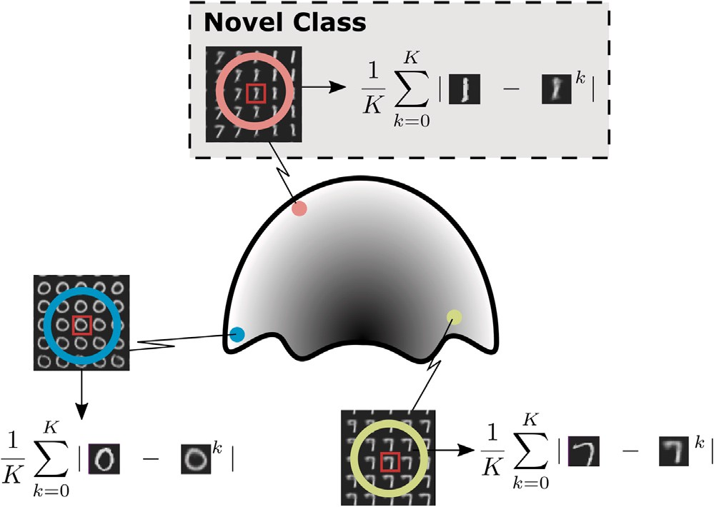

**/ig. 2.** Illustration of the learnt MNIST data manifold trained without the class of *1*’s (the class of *1*’s are novel). The closely-connected regions of the novel class of *1*’s contain dissimilar digits resembling *7* and *9* whereas the non-novel classes consisting of *0* and *7* do not.

between the representations of a sample **𝐱***𝑖*, and its respective decoded output **𝐱***̂𝑖*, from an intermediate layer, *𝑞*, of *𝑑***𝐱** . This is also referred to

as the residual error [3] and we include the nearest-latent-neighbours by

space generated by the training data. This process is represented by the left-most half of Fig. 3.

In the first mode of operation, the error is computed between the test sample and both the decodings and positions of its latent- neighbours in the non-novel latent space. Whereas when discriminative

representation from the discriminator *𝑑***𝐱** of the test sample and all its methods are used, the error is computed between the intermediate

case, the error is computed between the encoding via *𝑓*con of the given decoded latent neighbours in the training data. In the feature-consistent

Fig. 3 these three operations are represented by the *⋆* operator. sample and all its nearest-latent-neighbours in the training data. In

When performing novelty detection, one of the three methods’ errors are aggregated over all neighbours and normalised after which they are added to the aggregated and normalised latent-neighbour distance vector. Then they are thresholded to result in an anomaly score and a segmentation map. The threshold is determined by the AUROC method described in Section 4. This methodology is illustrated in the right half of Fig. 3.

# Experiments

We evaluate our method2 experimentally in both multi-class and single-class novelty detection contexts as outlined in [30]. Further- more, we compare our best performing NLN-enabled autoencoder using both pixel-level and image-level anomaly detection metrics on the MVTec-AD dataset with state-of-the-art autoencoders.

*𝐻 𝐾*

*𝜂*res = *𝛼* ∑ ∑ |*𝑞*(**𝐱** )[*ℎ*] − *𝑞*(*𝑔*(**𝐳***𝑘*; *𝜃* ))[*ℎ*]|

* 1. *Evaluation methodology*

*𝐻𝐾 𝑖*

*𝐾*

*𝑖 𝑔*

(7)

+ 1 − *𝛼* ∑ |**𝐳** − **𝐳***𝑘*|

*𝐾*

*𝑖*

*𝑖*

To measure the performance of the NLN-enabled models, they are

trained multiple times on a specific dataset, each time removing a

where *ℎ* in an index of the output from an intermediate layer *𝑞* with

size *𝐻* .

* 1. *Feature consistency*

It has been shown in [8] that adding an additional encoder in the training path of the autoencoder improves performance. This paradigm is referred to as feature consistency [27] and can be integrated in our nearest-latent-neighbours method by

*𝐿 𝐾*

*𝜂*con = *𝛼* |*𝑓* (**𝐱** ; *𝜃* )[*𝑙*] − *𝑓*con(**𝐱***̂𝑘*; *𝜃* )[*𝑙*]|

∑ ∑

different class or classes from the training set, thereby testing the novelty detection performance on every class present in a given dataset. We do this according to [30], such that both the single-class or Single- Inlier-Multiple-Outlier (SIMO) and the multi-class or Multiple-Inliers- Single-Outlier (MISO) performance are evaluated.

We use the Area Under the Receiver Operating Characteristic (AU- ROC) score to evaluate and compare the performance of the NLN- algorithm. The AUROC metric measures the area under the ROC curve of true positive rates and false positive rates for different threshold

values. Furthermore, we evaluate the per-pixel detection performance

*𝐿𝐾*

*𝐾*

*𝑖 𝑓*

*𝑖 𝑓*con

(8)

of our NLN-enabled models using Intersection over Union (IoU) score.

+ 1 − *𝛼* ∑ |**𝐳** − **𝐳***𝑘*|*.*

*𝐾*

*𝑖*

*𝑖*

The IoU metric is a measure of the overlap between the predicted

regions and their corresponding ground-truth.

Where *𝑓*con is the additional encoder that takes **𝐱***̂* as an input, with parameters, *𝜃𝑓*con . Furthermore, *𝐿* is the latent space dimensionality, which is maintained between the first encoder, *𝑓* , and the second encoder, *𝑓*con and is indexed by *𝑙*. The encoder is trained jointly with

the rest of the discriminative autoencoder as described in [8].

1. *The NLN algorithm*

Our work concerns the integration of the NLN technique into ex- isting autoencoding models. For this reason we explain three different modes of operation for three different novelty scores. In the first case, a vanilla autoencoding model is used with a standard reconstruction error, as shown in Eq. (4). The second uses the autoencoding architec- ture in [8] and the feature consistency error in Eq. (8). Finally, the third makes use of a discriminative autoencoding architecture and use of the residual error in Eq. (7).

In all cases, an autoencoding model is first trained on a dataset with some novel class(es) removed. During testing, a sample is randomly

We limit our evaluation to only autoencoders as we find comparison with methods that rely on SSL [16,38,51], pretrained feature extrac- tors [16,51–53] or computationally expensive inference [38] are not easily comparable on AUCROC alone across multiple datasets. It has been well documented that using pretrained feature extractors and SSL losses result in improved performance. However, they typically require orders of magnitude more parameters [49], and are not easily applicable across datasets or evaluation strategies. Furthermore, we regard the simplicity of AEs a crucial attribute. This is in contrast with the significant augmentation found in [15] and the challenge of applying patch-dependent methods [38] to different datasets of varying resolutions and anomaly types.

* 1. *Datasets*

We evaluate our work on four different datasets, namely MNIST [46], CIFAR-10 [54], Fashion-MNIST [55] and MVTec-AD [24]. MNIST

chosen (which may be novel or not) and is input into the encoder. Then

the nearest neighbours of the encoded sample are found in the latent 2 Source code available at: <https://github.com/mesarcik/NLN>.

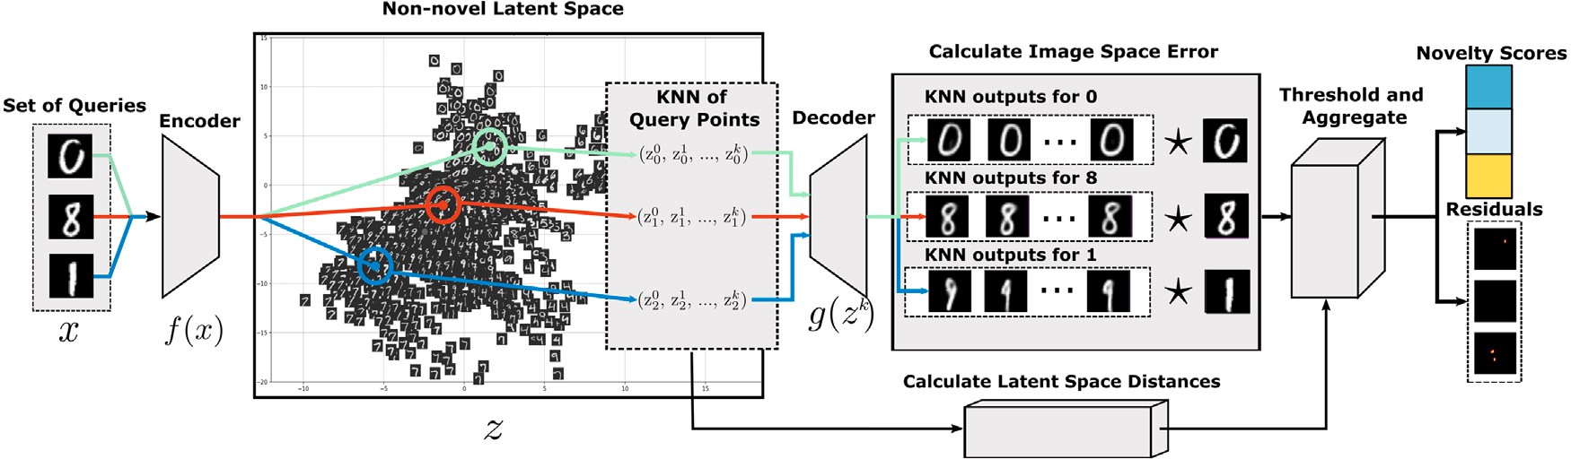

novel). Each of the three input’s latent representations are found and their nearest neighbours (relative to the training set) are computed. The *⋆* represents the chosen error **/ig. 3.** An illustration of our NLN algorithm, with three different samples from MNIST used as inputs to an autoencoding model, trained without the class of *1*’s (i.e., *1*’s are

calculation operator. Finally, the error is thresholded and the residual-error maps and novelty scores are produced.

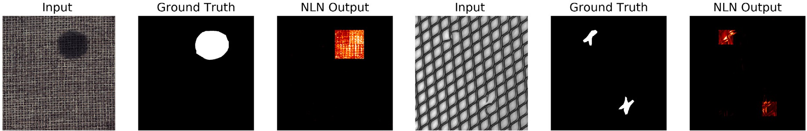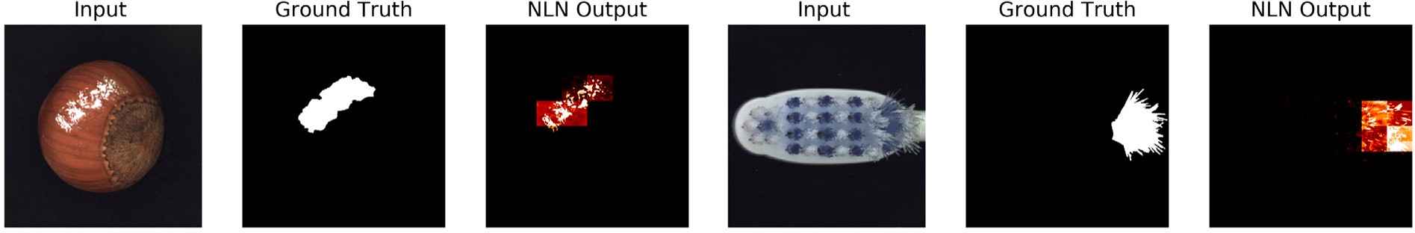



**/ig. 4.** Pixel-level anomaly detection using NLN for four different MVTec-AD classes in the textures (top) and objects (bottom) categories.

is a dataset consisting of 28 × 28 × 1 handwritten digits between 0 and

forms best on it. Similarly, Fashion-MNIST is composed of 28 × 28 × 1 9. The complexity of the dataset is low and therefore our method per-

images of different types of articles of clothing. This dataset is used as an intermediary difficulty, between MNIST and CIFAR-10. CIFAR-10 is

an object recognition dataset consisting of 32 × 32 × 3 images of 10

different classes. It is the most challenging dataset for novelty detection

as each of the semantic classes may appear at different scales, viewing angles and have changing backgrounds [7]. The MVTec-AD dataset

|  |  |  |  |  |  |  |
| --- | --- | --- | --- | --- | --- | --- |
| is an industrial anomaly detection dataset consisting of 15 different |  | AE | AAE | VAE | AE-res | AE-con |
| classes in 2 categories — objects and textures. The 10 object classes | MNIST | 3.45% | 4.92% | 3.99% | 3.47% | 4.21% |
| contain regularly positioned objects photographed in high resolution  from the same viewing angle and the 5 texture classes contain repet- | CIFAR-10  F-MNIST | 7.65%  5.66% | 8.81%  5.12% | 6.36%  5.31% | 6.89%  5.65% | 8.02%  3.49% |

**Table 1**

Mean MISO AUROC percentage increase using NLN.

|  |  |  |  |  |  |
| --- | --- | --- | --- | --- | --- |
|  | AE | AAE | VAE | AE-res | AE-con |
| MNIST | 9.80% | 17.65% | 11.65% | 10.13% | 14.18% |
| CIFAR-10 | 6.92% | 7.41% | 1.29% | 7.30% | 6.68% |
| F-MNIST | 11.52% | 9.53% | 10.31% | 11.95% | 11.52% |

**Table 2**

Mean SIMO AUROC percentage increase using NLN.

itive patterns. For training on the MVTec-AD dataset we follow the augmentation scheme proposed in [24], where random rotations and

crops are applied to the dataset that is broken into 128 × 128 patches.

For more details about the dataset’s composition and the augmentation

performed see [24] (see Table 2).

* 1. *Model and parameter selection*

In order to evaluate our work across a number of different datasets we adapt our models accordingly. We adopt autoencoding the architec- ture specified in [24] for the evaluation of the NLN algorithm on the MVTec-AD dataset. For MNIST, CIFAR-10 and F-MNIST we modify a LeNet [56] based autoencoding architecture. The encoder consists of 3

convolutional layers and the decoder has 3 transposed-convolutional layers. A base number of filters of 32 is used for the AE and is increased or decreased on each subsequent layer by a factor of 2. We use *ReLU* activations for all models and they are trained for 50 epochs

using ADAM [57] with a learning rate of 1 × 10−4. The image-based

discriminators *𝑑***𝐱** use the same architecture as the encoder, except the

final layer, which is a dense layer with a *sigmoid* activation. The latent

discriminator for the AAE consists of 3 dense layers with *Leaky ReLU* activations and a dropout rate of 0.3. The base layer size is 64 and is increased by a factor of 2 for each subsequent layer. Furthermore, we

**Table 3**

Mean MISO novelty detection AUROC, bold is best.

|  |  |  |  |
| --- | --- | --- | --- |
| Model | MNIST | CIFAR-10 | F-MNIST |
| GANomaly [8] | 0.753 | 0.532 | 0.679 |
| Skip-GAN [20] | 0.492 | 0.629 | 0.515 |
| OC-GAN [9] | 0.683 | 0.510 | 0.678 |
| VAE [21] | 0.515 | 0.497 | 0.521 |
| AnoGAN [3] | 0.632 | 0.434 | 0.510 |
| EGBAD [36] | 0.656 | 0.496 | 0.500 |
| DKNN [18] | 0.791 | **0.714** | 0.746 |
| **Ours** | **0.921** | 0.560 | **0.763** |

**Table 4**

Mean SIMO novelty detection AUROC, bold is best.

|  |  |  |  |  |
| --- | --- | --- | --- | --- |
| Model | MNIST | CIFAR-10 | F-MNIST | MVTec-AD |
| GANomaly [8] | 0.965 | 0.695 | 0.906 | 0.762 |
| OC-GAN [9] | 0.975 | 0.657 | 0.924 | 0.756 |
| AnoGAN [3] | 0.912 | 0.618 | 0.817 | 0.600 |
| LFD [28] | 0.977 | – | 0.927 | 0.777 |
| CBiGAN [37] | – | – | – | 0.770 |
| CAVGA-D*𝑢* [34] | **0.986** | 0.737 | 0.885 | – |
| DKNNa [18] | 0.917 | **0.890** | 0.938 | 0.750 |
| **Ours** | 0.974 | 0.658 | **0.941** | **0.783** |

a We use the authors implementation for all datasets other than MVTec-AD, here we use our own Tensorflow-based implementation.

treat the maximum number of neighbours, *𝐾*, the latent dimensionality,

*𝐿*, and the NLN contribution, *𝛼*, as hyper-parameters of our algorithm.

* 1. *Results*

We evaluate the performance increase of the NLN algorithm for a variety of autoencoding models across a number of different datasets in both the MISO-context in Table 1 and SIMO-context in Table 2. Here the best performing reconstruction error-based AUROC is compared with the best performing NLN-enabled model for each architecture. The NLN-based AEs achieve a performance increase between 17% and 1% across the three MISO-datasets and 8% and 3% for the SIMO-case. We suspect the low performance gains in the SIMO-case of the NLN-enabled AEs are due there being fewer latent neighbours to select from, thereby reducing performance.

In Table 3 we present the MISO-based class-averaged AUROC com- parison of autoencoding models. For MNIST, the optimal configuration

is a feature consistent AE with *𝐾* = 2, *𝐿* = 32 and *𝛼* = 1*.*0, for

CIFAR-10 we use the discriminative AE when *𝐾* = 1, *𝐿* = 32 and

*𝛼* = 0*.*5. Finally for F-MNIST, we use a discriminative AE when *𝐾* = 1,

*𝐿𝐷* = 64 and *𝛼* = 0*.*9. Here we see that the NLN-algorithm gives

significant performance increases for MNIST and F-MNIST, even above

the pretrained ResNet-50 proposed by [18]. Furthermore, we see that OCGAN [9] is not performant in a MISO context, this indicates that our NLN algorithm may offer a more robust solution to the generalisability problem in AEs. We show that AEs do not perform particularly well on CIFAR-10. This is expected, as images from the same class in contain substantially different pixel-level information. For example the *aero- plane* class contains images of both the cockpit of a grounded Boeing 747 as well a fighter-jet photographed from the side-view in mid-flight. In effect, the MSE between non-novel images in the same class, can be greater than novel images thereby reducing the efficacy of MSE based novelty detectors on CIFAR-10.

We present the class-averaged AUROC scores for the SIMO-based evaluation in Table 4. Here the optimal method for MNIST is a dis-

criminative AE, with *𝐿𝐷* = 128, *𝐾* = 3 and *𝛼* = 1*.*0 and for CIFAR-10

we find the optimal method to be a vanilla AE with *𝐿𝐷* = 256, *𝐾* = 1 and *𝛼* = 0*.*75. Furthermore, we find the best performing method on F-MNIST to be a VAE with *𝐿𝐷* = 32, *𝐾* = 3 and *𝛼* = 0*.*9. For the MVTec-AD dataset we use a discriminative AE with *𝐿𝐷* = 128, *𝐾* = 1 and *𝛼* = 0*.*8. It is clear that the attention guided VAE (CAVAGA) [34]

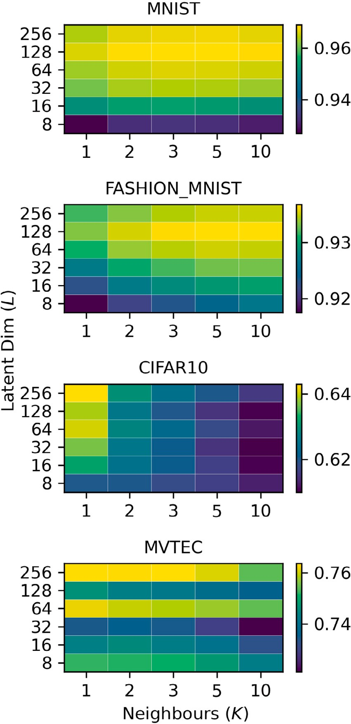

dimensions in SIMO-context for *𝛼* = 0*.*8. **/ig. 5.** Vanilla Autoencoder AUROC sensitivity to number of neighbours and latent

method performs best on MNIST whereas DKNN [18] on CIFAR-10. However, it is evident that the NLN-enabled autoencoding models offer increased performance over existing autoencoding and ResNet-based architectures for both the F-MNIST and MVTec-AD datasets in the SIMO context.

In Fig. 5 we show the effect of varying *𝐿* and *𝐾* on AUROC scores for

vanilla AE in the SIMO context when *𝛼* = 0*.*8. For F-MNIST and MNIST a maximum AUROC score is found for *𝐿* = 128 and *𝐾 >* 3, whereas for CIFAR-10 the optimal is found when *𝐿* = 256 and *𝐾* = 1. Finally it is

when *𝐿* = 256 and *𝐾* = 3. shown that the vanilla AE offers best image-based AUROC performance

We evaluate the pixel-level anomaly detection performance in

and object classes. In all cases we use a vanilla AE with *𝐾* = 1, Table 5, and illustrate the model outputs in Fig. 4 of both texture

*𝐿* = 128 and *𝛼* = 0*.*6. It is clear that the NLN-enabled AE demonstrates

performance increases in the object classes of MVTec-AD. However, this

is not the case for the texture classes. We suspect that this is due to our NLN-enabled AE not being able to distinguish between different texture-patches. This behaviour is similarly demonstrated in [24], and we believe that this is an inherent weakness of standard autoencoding architectures.

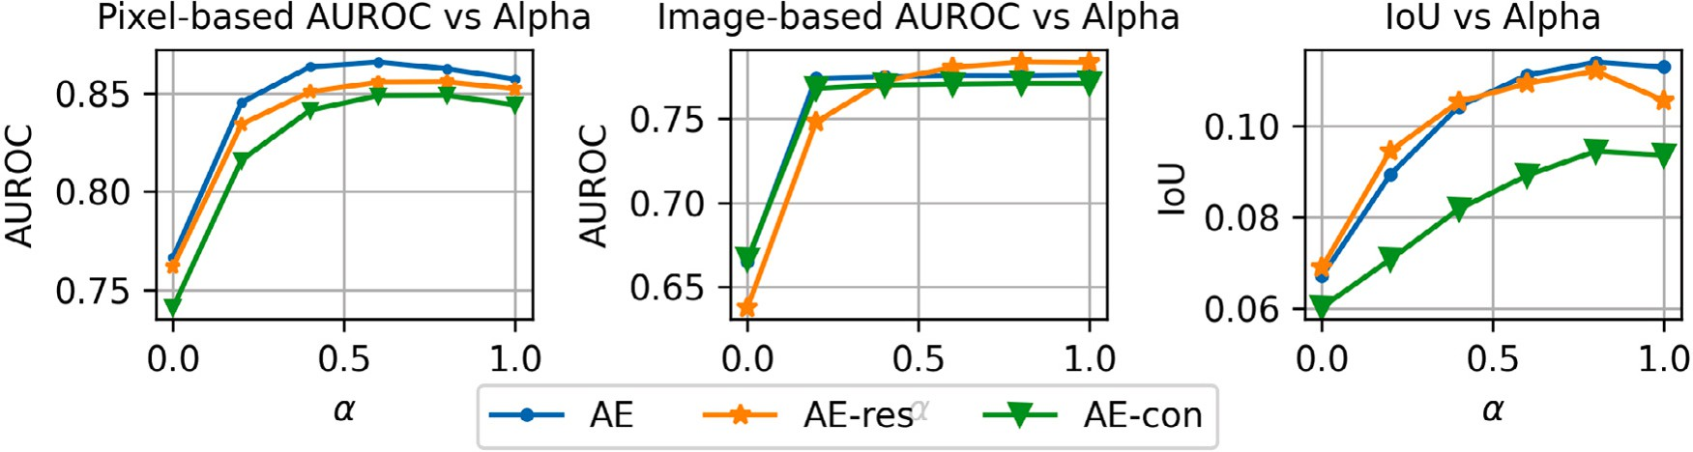

**/ig. 6.** AUROC and IoU sensitivity to varying *𝛼* of the NLN-enabled autoencoding models applied to the MVTec-AD dataset.

**Table 5**

Pixel-based novelty detection (Segmentation) AUROC score for autoencoding models, where bold is best.

Class AE-L2 [24] AE-SSIM [24] SMAI L2 [23] VE-VAE [25] Ours

**Table 6**

MISO AUROC performance of AE-con for different losses terms when *𝐾* = 2, *𝐿* = 32

and *𝛼* = 0*.*9.

Dataset Grecon GNLN Gcon Gtotal

|  |  |  |  |  |  |  |  |  |  |  |  |
| --- | --- | --- | --- | --- | --- | --- | --- | --- | --- | --- | --- |
| Carpet | 0.59 | 0.87 | **0.88** | 0.78 | 0.82 |  | MNIST | 0.778 | 0.822 | 0.913 | 0.921 |
| Grid | 0.90 | 0.94 | **0.97** | 0.73 | 0.86 |  | FMNIST | 0.669 | 0.702 | 0.719 | 0.738 |
| Textures Leather | 0.75 | 0.78 | 0.86 | **0.95** | 0.85 |  | CIFAR-10 | 0.511 | 0.513 | 0.551 | 0.553 |
| Tile | 0.51 | 0.59 | 0.62 | **0.80** | 0.51 |  |  |  |  |  |  |
| Wood | 0.73 | 0.73 | **0.80** | 0.77 | 0.72 |  |  |  |  |  |  |
| Mean | 0.70 | 0.78 | **0.83** | 0.81 | 0.75 |  | | | | | |
| Bottle | 0.86 | 0.93 | 0.86 | 0.87 | **0.95** |  | | | | | |
| Cable | 0.86 | 0.82 | **0.92** | 0.90 | 0.90 |  | | | | | |
| Capsule | 0.88 | **0.94** | 0.93 | 0.74 | **0.94** |  | | | | | |
| Hazelnut | 0.95 | 0.97 | 0.97 | **0.98** | **0.98** |  | | | | | |
| Objects Metal nut | 0.86 | 0.89 | 0.92 | **0.94** | 0.88 |  | | | | | |
| Pill | 0.85 | 0.91 | **0.92** | 0.83 | **0.92** |  | | | | | |
| Screw | 0.96 | 0.96 | 0.96 | **0.97** | **0.97** |  | | | | | |
| Toothbrush | 0.93 | 0.92 | 0.96 | 0.94 | **0.97** |  | | | | | |
| Transistor | 0.86 | 0.90 | 0.85 | **0.93** | 0.85 |  | | | | | |
| Zipper | 0.77 | 0.88 | 0.9 | 0.78 | **0.96** |  | | | | | |
| Mean | 0.88 | 0.91 | 0.92 | 0.89 | **0.93** |  | | | | | |

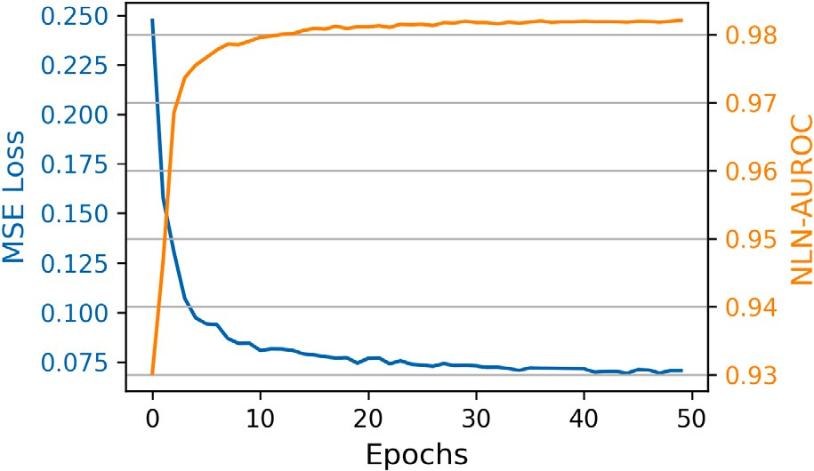In Fig. 6 we illustrate the effect on varying alpha for the NLN- enabled autoencoding models used for the MVTec-AD dataset. Here it is demonstrated, that the NLN-based model obtain optimal AUROC

segmentation-performance when 0*.*25 *< 𝛼 <* 0*.*8, whereas to op-

timal AUROC detection-performance occurs when *𝛼 >* 0*.*6. Finally we illustrate that the optimal IoU value is obtained at *𝛼* = 0*.*8,

thus demonstrating the benefit of including the reconstructions of nearest-neighbours in the calculation of the anomaly score.

* 1. *Time and memory efficiency*

The NLN-algorithm requires a forward pass through an encoder, a KNN search of the latent-space generated by the training samples, and a forward pass of a given point’s nearest neighbours through a decoder. We evaluate the models on a Nvidia T4, where a forward pass of a single image from the MVTec-AD dataset takes 7.41 ms for the encoder and 9.63 ms for the decoder. In comparison, a ResNet50 used in [18,58,59] requires 43.3 ms for a forward pass of a single image.

This means that our method is between 1.3× and 2.5× more efficient

for a forward pass, depending on the architecture used.

search, which has a inference time complexity of U(*𝐾𝐿* log *𝑁* ). Where For the KNN search we use a k-d tree implementation of the KNN

*𝐾* is the number of neighbours, *𝐿* is the latent dimensionality and *𝑁* is

the number of points in the training set. In the case of the NLN-enabled

models presented in this work, we find a latent dimensionality of 128

space. This means that our work offers a 16× reduction in KNN search sufficient, whereas the ResNet50 in [18] uses 2048 dimensional latent

inference time in comparison with [18].

Finally, our method has comparable storage requirements as other AE based models [49] in terms of number of trainable parameters.

with *𝛼* = 0*.*8*, 𝐿* = 128 and *𝐾* = 5. **/ig. 7.** MSE Loss and SIMO-based AUROC on the *0*-class of MNIST for a vanilla AE

For comparison, the AE-con model used for MVTec-AD has 1.79 mil- lion parameters, whereas the ResNet-50 from [18] has 25.58 million parameters. The only storage-based overhead of the NLN-algorithm is the requirement of amortising the embeddings of the training set as suggested in [18]. In the case of the bottle-class of the MVTec-AD dataset, there is an additional storage requirement of 6.85 MB3

# Ablation study

The AUROC performance of the NLN-algorithm is demonstrated in Table 6 when the loss function varied. The term in the first column, Grecon, represents the standard reconstruction error given by Eq. (3) and GNLN shows the NLN-based reconstruction loss given in the first half of Eq. (4). Gcon represents the feature consistent adaption given by the first half of Eq. (8) and Gtotal is equivalent to the score obtained from Eq. (8). It can be seen that through the utilisation of all terms in NLN-loss formulation we obtain optimal performance.

In Fig. 7 we illustrate the MSE loss and the SIMO-based novelty detection performance of a vanilla AE trained without the class of **0**’s (i.e. the 0-class is novel). Here we see that within the specified 50 training epochs, the MSE converges to 0.075 whilst the AUROC converges to approximately 0.99.

3 209 images × 16 × 4 augmented patches × 128 latent dimensions ×

32 bits = 6*.*85 MB of additional memory.

# Discussion and conclusions

Autoencoders learn to generalise to unseen classes which is a problem when they are used for novelty detection. In this work, we demonstrate that when the reconstructions of a model’s nearest- latent-neighbours are harnessed we can more effectively and efficiently mitigate this problem in comparison with the state-of-the-art. This is achieved through a fairly simple algorithm that is agnostic to both the AE’s architecture and its error method. We experimentally prove that the addition of the NLN algorithm consistently yields performance increases for various autoencoding architectures and various datasets and is competitive with the state-of-the-art autoencoding models. This is achieved without complex augmentation, using pretrained networks or computationally expensive inference. We note that the complexity of CIFAR-10 and the texture classes of MVTec-AD result in modest performance, but we expect this can be solved using more robust error functions or using SSL to obtain even better latent representations.

**CRediT authorship contribution statement Michael Mesarcik:** Conceptualisation, Methodology, Software, Data

curation, Writing – original draft, Visualisation, Investigation, Valida-

tion. **Elena Ranguelova:** Supervision, Methodology, Validation, Writ- ing – review & editing, Funding acquisition. **Albert-Jan Boonstra:** Su- pervision, Methodology, Validation, Writing – review & editing, Fund- ing acquisition. **Rob V. van Nieuwpoort:** Supervision, Methodology, Validation, Writing – review & editing.

# Acknowledgements

This work is part of the *Perspectief* research programme Efficient Deep Learning ([EDL](https://efficientdeeplearning.nl/)), which is financed by the Dutch Research Council (NWO) domain Applied and Engineering Sciences (TTW).

# References

1. [Kim Dongil, Kang Pilsung, Cho Sungzoon, Lee Hyoung Joo, Doh Seungy-](http://refhub.elsevier.com/S2590-0056(22)00038-8/sb1) [ong. Machine learning-based novelty detection for faulty wafer detection in](http://refhub.elsevier.com/S2590-0056(22)00038-8/sb1) [semiconductor manufacturing. Expert Syst Appl 2012;39(4):4075–83.](http://refhub.elsevier.com/S2590-0056(22)00038-8/sb1)
2. [Xu Haowen, Chen Wenxiao, Zhao Nengwen, Li Zeyan, Bu Jiahao, Li Zhihan,](http://refhub.elsevier.com/S2590-0056(22)00038-8/sb2) [Liu Ying, Zhao Youjian, Pei Dan, Feng Yang, Chen Jie, Wang Zhaogang,](http://refhub.elsevier.com/S2590-0056(22)00038-8/sb2) [Qiao Honglin. Unsupervised anomaly detection via variational auto-encoder for](http://refhub.elsevier.com/S2590-0056(22)00038-8/sb2) [seasonal KPIs in web applications. In: The web conference 2018 - proceedings](http://refhub.elsevier.com/S2590-0056(22)00038-8/sb2) [of the world wide web conference, WWW 2018, Vol. 2. 2018, p. 187–96.](http://refhub.elsevier.com/S2590-0056(22)00038-8/sb2)
3. [Schlegl Thomas, Seeböck Philipp, Waldstein Sebastian M, Schmidt-Erfurth Ur-](http://refhub.elsevier.com/S2590-0056(22)00038-8/sb3) [sula, Langs Georg. Unsupervised anomaly detection with generative adversarial](http://refhub.elsevier.com/S2590-0056(22)00038-8/sb3) [networks to guide marker discovery. In: Lecture notes in computer science](http://refhub.elsevier.com/S2590-0056(22)00038-8/sb3) [(including subseries lecture notes in artificial intelligence and lecture notes in](http://refhub.elsevier.com/S2590-0056(22)00038-8/sb3) [bioinformatics). LNCS, vol. 10265, 2017, p. 146–7.](http://refhub.elsevier.com/S2590-0056(22)00038-8/sb3)
4. [Baur Christoph, Wiestler Benedikt, Albarqouni Shadi, Navab Nassir. Deep autoen-](http://refhub.elsevier.com/S2590-0056(22)00038-8/sb4) [coding models for unsupervised anomaly segmentation in brain MR images. In:](http://refhub.elsevier.com/S2590-0056(22)00038-8/sb4) [Crimi Alessandro, Bakas Spyridon, Kuijf Hugo, Keyvan Farahani, Reyes Mauricio,](http://refhub.elsevier.com/S2590-0056(22)00038-8/sb4) [van Walsum The, editors. Brainlesion: Glioma, multiple sclerosis, stroke and](http://refhub.elsevier.com/S2590-0056(22)00038-8/sb4) [traumatic brain injuries. Springer International Publishing; 2019, p. 161–9.](http://refhub.elsevier.com/S2590-0056(22)00038-8/sb4)
5. [Margalef-Bentabol Berta, Huertas-Company Marc, Charnock Tom, Margalef-](http://refhub.elsevier.com/S2590-0056(22)00038-8/sb5) [Bentabol Carla, Bernardi Mariangela, Dubois Yohan, Storey-Fisher Kate,](http://refhub.elsevier.com/S2590-0056(22)00038-8/sb5) [Zanisi Lorenzo. Detecting outliers in astronomical images with deep generative](http://refhub.elsevier.com/S2590-0056(22)00038-8/sb5) [networks.. Mon Not R Astron Soc 2020;000(0000).](http://refhub.elsevier.com/S2590-0056(22)00038-8/sb5)
6. [Markou Markos, Singh Sameer. Novelty detection: a review. Signal Process](http://refhub.elsevier.com/S2590-0056(22)00038-8/sb6) [2003;83(12):2499–521.](http://refhub.elsevier.com/S2590-0056(22)00038-8/sb6)
7. [Ahmed Faruk, Courville Aaron. Detecting semantic anomalies. 2019.](http://refhub.elsevier.com/S2590-0056(22)00038-8/sb7)
8. [Akcay Samet, Atapour-Abarghouei Amir, Breckon Toby P. GANomaly: Semi-](http://refhub.elsevier.com/S2590-0056(22)00038-8/sb8) [supervised anomaly detection via adversarial training. In: Computer vision –](http://refhub.elsevier.com/S2590-0056(22)00038-8/sb8) [ACCV 2018. Springer International Publishing; 2019, p. 622–37.](http://refhub.elsevier.com/S2590-0056(22)00038-8/sb8)
9. Perera Pramuditha, Nallapati Ramesh, Xiang Bing. OCGAN: One-class novelty detection using gans with constrained latent representations. In: Proceedings of the IEEE computer society conference on computer vision and pattern recognition; 2019, p. 2893–901.
10. [Pidhorskyi Stanislav, Almohsen Ranya, Adjeroh Donald A, Doretto Gianfranco.](http://refhub.elsevier.com/S2590-0056(22)00038-8/sb10) [Generative probabilistic novelty detection with adversarial autoencoders. Adv](http://refhub.elsevier.com/S2590-0056(22)00038-8/sb10) [Neural Inf Process Syst 2018;(NeurIPS):6822–33.](http://refhub.elsevier.com/S2590-0056(22)00038-8/sb10)
11. [Khan Shehroz S, Madden Michael G. A survey of recent trends in one class](http://refhub.elsevier.com/S2590-0056(22)00038-8/sb11) [classification. In: Lecture notes in computer science (including subseries lecture](http://refhub.elsevier.com/S2590-0056(22)00038-8/sb11) [notes in artificial intelligence and lecture notes in bioinformatics). LNAI, vol.](http://refhub.elsevier.com/S2590-0056(22)00038-8/sb11) [6206, 2010, p. 188–97.](http://refhub.elsevier.com/S2590-0056(22)00038-8/sb11)
12. [Sipple John. Interpretable, multidimensional, multimodal anomaly detection with](http://refhub.elsevier.com/S2590-0056(22)00038-8/sb12) [negative sampling for detection of device failure. 2020.](http://refhub.elsevier.com/S2590-0056(22)00038-8/sb12)
13. [Chandola Varun, Banerjee Arindam, Kumar Vipin. Anomaly detection. ACM](http://refhub.elsevier.com/S2590-0056(22)00038-8/sb13) [Comput Surv 2009;41(3):1–58.](http://refhub.elsevier.com/S2590-0056(22)00038-8/sb13)
14. [Chalapathy Raghavendra, Chawla Sanjay. Deep learning for anomaly detection:](http://refhub.elsevier.com/S2590-0056(22)00038-8/sb14) [A survey. 2019, p. 1–50.](http://refhub.elsevier.com/S2590-0056(22)00038-8/sb14)
15. [Li Chun-Liang, Sohn Kihyuk, Yoon Jinsung, Pfister Tomas. CutPaste:](http://refhub.elsevier.com/S2590-0056(22)00038-8/sb15) [Self-supervised learning for anomaly detection and localization. 2021.](http://refhub.elsevier.com/S2590-0056(22)00038-8/sb15)
16. [Sohn Kihyuk, Li Chun-Liang, Yoon Jinsung, Jin Minho, Pfister Tomas. Learning](http://refhub.elsevier.com/S2590-0056(22)00038-8/sb16) [and evaluating representations for deep one-class classification. 2020, p. 1–32.](http://refhub.elsevier.com/S2590-0056(22)00038-8/sb16)
17. [Fei Ye, Huang Chaoqin, Jinkun Cao, Li Maosen, Zhang Ya, Lu Cewu. At-](http://refhub.elsevier.com/S2590-0056(22)00038-8/sb17) [tribute restoration framework for anomaly detection. IEEE Trans Multimed](http://refhub.elsevier.com/S2590-0056(22)00038-8/sb17) [2020;(April):1–14.](http://refhub.elsevier.com/S2590-0056(22)00038-8/sb17)
18. [Bergman Liron, Cohen Niv, Hoshen Yedid. Deep nearest neighbor anomaly](http://refhub.elsevier.com/S2590-0056(22)00038-8/sb18) [detection. 2020.](http://refhub.elsevier.com/S2590-0056(22)00038-8/sb18)
19. [Fei-Fei L, Deng J, Li K. ImageNet: Constructing a large-scale image database. J](http://refhub.elsevier.com/S2590-0056(22)00038-8/sb19) [Vis 2010;9(8):1037.](http://refhub.elsevier.com/S2590-0056(22)00038-8/sb19)
20. Akcay Samet, Atapour-Abarghouei Amir, Breckon Toby P. Skip-GANomaly: Skip connected and adversarially trained encoder-decoder anomaly detection. In: Proceedings of the international joint conference on neural networks, Vol. 2019-July; 2019.
21. [An Jinwon, Sungzoon Cho. Variational autoencoder based anomaly detection](http://refhub.elsevier.com/S2590-0056(22)00038-8/sb21) [using reconstruction probability. Spec Lect IE 2015;20(6).](http://refhub.elsevier.com/S2590-0056(22)00038-8/sb21)
22. [Larsen Anders Boesen Lindbo, Sønderby Søren Kaae, Larochelle Hugo,](http://refhub.elsevier.com/S2590-0056(22)00038-8/sb22) [Winther Ole. Autoencoding beyond pixels using a learned similarity metric. In:](http://refhub.elsevier.com/S2590-0056(22)00038-8/sb22) [33rd international conference on machine learning, ICML 2016, Vol. 4. 2016, p.](http://refhub.elsevier.com/S2590-0056(22)00038-8/sb22) [2341–9.](http://refhub.elsevier.com/S2590-0056(22)00038-8/sb22)
23. [Li Zhenyu. Superpixel masking and inpainting for self-supervised anomaly](http://refhub.elsevier.com/S2590-0056(22)00038-8/sb23) [detection. Bmvc 2020.](http://refhub.elsevier.com/S2590-0056(22)00038-8/sb23)
24. [Bergmann Paul, Fauser Michael, Sattlegger David, Steger Carsten. MVTec AD](http://refhub.elsevier.com/S2590-0056(22)00038-8/sb24)

[— A comprehensive real-world dataset for unsupervised anomaly detection. In:](http://refhub.elsevier.com/S2590-0056(22)00038-8/sb24) [2019 IEEE/CVF conference on computer vision and pattern recognition (CVPR).](http://refhub.elsevier.com/S2590-0056(22)00038-8/sb24) [IEEE; 2019, p. 9584–92.](http://refhub.elsevier.com/S2590-0056(22)00038-8/sb24)

1. [Liu Wenqian, Li Runze, Zheng Meng, Karanam Srikrishna, Wu Ziyan, Bhanu Bir,](http://refhub.elsevier.com/S2590-0056(22)00038-8/sb25) [Radke Richard J, Camps Octavia. Towards visually explaining variational au-](http://refhub.elsevier.com/S2590-0056(22)00038-8/sb25) [toencoders. In: 2020 IEEE/CVF conference on computer vision and pattern](http://refhub.elsevier.com/S2590-0056(22)00038-8/sb25) [recognition (CVPR). IEEE; 2020, p. 8639–48.](http://refhub.elsevier.com/S2590-0056(22)00038-8/sb25)
2. Bergmann Paul, Löwe Sindy, Fauser Michael, Sattlegger David, Steger Carsten. Improving unsupervised defect segmentation by applying structural similarity to autoencoders. In: VISIGRAPP 2019 - Proceedings of the 14th international joint conference on computer vision, imaging and computer graphics theory and applications, Vol. 5; 2019, p. 372–80.
3. [Lee Wei-Yu, Wang Yu-Chiang Frank. Learning disentangled feature representa-](http://refhub.elsevier.com/S2590-0056(22)00038-8/sb27) [tions for anomaly detection. In: 2020 IEEE international conference on image](http://refhub.elsevier.com/S2590-0056(22)00038-8/sb27) [processing (ICIP). IEEE; 2020, p. 2156–60.](http://refhub.elsevier.com/S2590-0056(22)00038-8/sb27)
4. [Hong Eungi, Choe Yoonsik. Latent feature decentralization loss for one-class](http://refhub.elsevier.com/S2590-0056(22)00038-8/sb28) [anomaly detection. IEEE Access 2020;8:165658–69.](http://refhub.elsevier.com/S2590-0056(22)00038-8/sb28)
5. [Guo Jia, Liu Guannan, Zuo Yuan, Wu Junjie. An anomaly detection framework](http://refhub.elsevier.com/S2590-0056(22)00038-8/sb29) [based on autoencoder and nearest neighbor. In: 2018 15th international confer-](http://refhub.elsevier.com/S2590-0056(22)00038-8/sb29) [ence on service systems and service management, ICSSSM 2018. IEEE; 2018, p.](http://refhub.elsevier.com/S2590-0056(22)00038-8/sb29) [1–6.](http://refhub.elsevier.com/S2590-0056(22)00038-8/sb29)
6. Burlina Philippe, Joshi Neil, Wang I Jeng. Where’s wally now? Deep generative and discriminative embeddings for novelty detection. In: Proceedings of the IEEE computer society conference on computer vision and pattern recognition, Vol. 2019-June; 2019, p. 11499–508.
7. [Gu Xiaoyi, Akoglu Leman, Rinaldo Alessandro. Statistical analysis of near-](http://refhub.elsevier.com/S2590-0056(22)00038-8/sb31) [est neighbor methods for anomaly detection. Adv Neural Inf Process Syst](http://refhub.elsevier.com/S2590-0056(22)00038-8/sb31) [2019;32(NeurIPS):1–11.](http://refhub.elsevier.com/S2590-0056(22)00038-8/sb31)
8. [Kingma Diederik P, Welling Max. Auto-encoding variational Bayes. 2013, p.](http://refhub.elsevier.com/S2590-0056(22)00038-8/sb32) [1–14, ArXiv e-prints, (Ml).](http://refhub.elsevier.com/S2590-0056(22)00038-8/sb32)
9. [Makhzani Alireza, Shlens Jonathon, Jaitly Navdeep, Goodfellow Ian, Frey Bren-](http://refhub.elsevier.com/S2590-0056(22)00038-8/sb33) [dan. Adversarial autoencoders. 2015.](http://refhub.elsevier.com/S2590-0056(22)00038-8/sb33)
10. [Venkataramanan Shashanka, Peng Kuan Chuan, Singh Rajat Vikram, Maha-](http://refhub.elsevier.com/S2590-0056(22)00038-8/sb34) [lanobis Abhijit. Attention guided anomaly localization in images. In: Lecture](http://refhub.elsevier.com/S2590-0056(22)00038-8/sb34) [notes in computer science (including subseries lecture notes in artificial in-](http://refhub.elsevier.com/S2590-0056(22)00038-8/sb34) [telligence and lecture notes in bioinformatics). LNCS, vol. 12362, 2020, p.](http://refhub.elsevier.com/S2590-0056(22)00038-8/sb34) [485–503.](http://refhub.elsevier.com/S2590-0056(22)00038-8/sb34)
11. [Goodfellow Ian J, Pouget-Abadie Jean, Mirza Mehdi, Xu Bing, Warde-](http://refhub.elsevier.com/S2590-0056(22)00038-8/sb35) [Farley David, Ozair Sherjil, Courville Aaron, Bengio Yoshua. Generative](http://refhub.elsevier.com/S2590-0056(22)00038-8/sb35) [adversarial nets. Adv Neural Inf Process Syst 2014;3(January):2672–80.](http://refhub.elsevier.com/S2590-0056(22)00038-8/sb35)
12. [Zenati Houssam, Foo Chuan Sheng, Lecouat Bruno, Manek Gaurav, Chan-](http://refhub.elsevier.com/S2590-0056(22)00038-8/sb36) [drasekhar Vijay Ramaseshan. Efficient GAN-based anomaly detection. 2018.](http://refhub.elsevier.com/S2590-0056(22)00038-8/sb36)
13. [Carrara Fabio, Amato Giuseppe, Brombin Luca, Falchi Fabrizio, Gennaro Claudio.](http://refhub.elsevier.com/S2590-0056(22)00038-8/sb37) [Combining GANs and AutoEncoders for efficient anomaly detection. 2021, p.](http://refhub.elsevier.com/S2590-0056(22)00038-8/sb37) [3939–46.](http://refhub.elsevier.com/S2590-0056(22)00038-8/sb37)
14. [Yi Jihun, Yoon Sungroh. Patch SVDD: Patch-level SVDD for anomaly detection](http://refhub.elsevier.com/S2590-0056(22)00038-8/sb38) [and segmentation. 2020, p. 1–16, ArXiv.](http://refhub.elsevier.com/S2590-0056(22)00038-8/sb38)
15. [Erfani Sarah M, Rajasegarar Sutharshan, Karunasekera Shanika, Leckie Christo-](http://refhub.elsevier.com/S2590-0056(22)00038-8/sb39) [pher. High-dimensional and large-scale anomaly detection using a linear](http://refhub.elsevier.com/S2590-0056(22)00038-8/sb39) [one-class SVM with deep learning. Pattern Recognit 2016;58:121–34.](http://refhub.elsevier.com/S2590-0056(22)00038-8/sb39)
16. [Tony Liu Fei, Ming Ting Kai, Zhou Zhi-Hua. Isolation forest. In: ICDM. 2008.](http://refhub.elsevier.com/S2590-0056(22)00038-8/sb40)
17. [Breunig Markus M, Kriegel Hans-Peter, Ng Raymond T, Sander Jörg. LOF. ACM](http://refhub.elsevier.com/S2590-0056(22)00038-8/sb41) [SIGMOD Record 2000;29(2):93–104.](http://refhub.elsevier.com/S2590-0056(22)00038-8/sb41)
18. Abati Davide, Porrello Angelo, Calderara Simone, Cucchiara Rita. Latent space autoregression for novelty detection. In: Proceedings of the IEEE computer society conference on computer vision and pattern recognition, Vol. 2019-June; 2019, p. 481–90.
19. Sabokrou Mohammad, Khalooei Mohammad, Fathy Mahmood, Adeli Ehsan. Adversarially learned one-class classifier for novelty detection. In: Proceedings of the IEEE computer society conference on computer vision and pattern recognition; 2018, p. 3379–88.
20. [Khan Shehroz S, Madden Michael G. One-class classification: taxonomy of study](http://refhub.elsevier.com/S2590-0056(22)00038-8/sb44) [and review of techniques. Knowl Eng Rev 2014;29(3):345–74.](http://refhub.elsevier.com/S2590-0056(22)00038-8/sb44)
21. Zenati Houssam, Romain Manon, Foo Chuan Sheng, Lecouat Bruno, Chan- drasekhar Vijay. Adversarially learned anomaly detection. In: Proceedings - IEEE international conference on data mining, ICDM; 2018, p. 727–36.
22. [LeCun Yann, Cortes Corinna, Burges CJ. MNIST handwritten digit database. ATT](http://refhub.elsevier.com/S2590-0056(22)00038-8/sb46) [Labs 2010;2.](http://refhub.elsevier.com/S2590-0056(22)00038-8/sb46)
23. [Saxena Divya, Cao Jiannong. Generative adversarial networks (GANs). ACM](http://refhub.elsevier.com/S2590-0056(22)00038-8/sb47) [Comput Surv 2021;54(3):1–42.](http://refhub.elsevier.com/S2590-0056(22)00038-8/sb47)
24. [Reiss Tal, Cohen Niv, Bergman Liron, Hoshen Yedid. PANDA: ADapting](http://refhub.elsevier.com/S2590-0056(22)00038-8/sb48) [pretrained features for anomaly detection and segmentation. 2020.](http://refhub.elsevier.com/S2590-0056(22)00038-8/sb48)
25. [Bergmann Paul, Batzner Kilian, Fauser Michael, Sattlegger David, Steger Carsten.](http://refhub.elsevier.com/S2590-0056(22)00038-8/sb49) [The MVTec anomaly detection dataset: A comprehensive real-world dataset for](http://refhub.elsevier.com/S2590-0056(22)00038-8/sb49) [unsupervised anomaly detection. Int J Comput Vis 2021;129(4):1038–59.](http://refhub.elsevier.com/S2590-0056(22)00038-8/sb49)
26. [Goodfellow Ian, Bengio Yoshua, Courville Aaron. Deep learning. The MIT Press;](http://refhub.elsevier.com/S2590-0056(22)00038-8/sb50) [2016.](http://refhub.elsevier.com/S2590-0056(22)00038-8/sb50)
27. [Chen Yuanhong, Tian Yu, Pang Guansong, Carneiro Gustavo. Unsupervised](http://refhub.elsevier.com/S2590-0056(22)00038-8/sb51) [anomaly detection with multi-scale interpolated Gaussian descriptors. 2021.](http://refhub.elsevier.com/S2590-0056(22)00038-8/sb51)
28. [Hendrycks Dan, Mazeika Mantas, Dietterich Thomas. Deep anomaly detection](http://refhub.elsevier.com/S2590-0056(22)00038-8/sb52) [with outlier exposure. 2018, p. 1–18.](http://refhub.elsevier.com/S2590-0056(22)00038-8/sb52)
29. [Tack Jihoon, Mo Sangwoo, Jeong Jongheon, Shin Jinwoo. CSI: Novelty detection](http://refhub.elsevier.com/S2590-0056(22)00038-8/sb53) [via contrastive learning on distributionally shifted instances. (NeurIPS). 2020.](http://refhub.elsevier.com/S2590-0056(22)00038-8/sb53)
30. [Krizhevsky A. Learning multiple layers of features from tiny images. Technical](http://refhub.elsevier.com/S2590-0056(22)00038-8/sb54) [report, 2009.](http://refhub.elsevier.com/S2590-0056(22)00038-8/sb54)
31. [Xiao Han, Rasul Kashif, Vollgraf Roland. Fashion-MNIST: a novel image dataset](http://refhub.elsevier.com/S2590-0056(22)00038-8/sb55) [for benchmarking machine learning algorithms. 2017, p. 1–6.](http://refhub.elsevier.com/S2590-0056(22)00038-8/sb55)
32. [Lecun Yann, Bottou Le’on, Bengio Yoshua, Haffner Parick. Gradient-based](http://refhub.elsevier.com/S2590-0056(22)00038-8/sb56) [learning applied to document recognition. Proc IEEE 1998;86(11):2278–324.](http://refhub.elsevier.com/S2590-0056(22)00038-8/sb56)
33. [Kingma Diederik P, Ba Jimmy Lei. Adam: A method for stochastic optimization.](http://refhub.elsevier.com/S2590-0056(22)00038-8/sb57) [In: 3rd international conference on learning representations, ICLR 2015 -](http://refhub.elsevier.com/S2590-0056(22)00038-8/sb57) [conference track proceedings. 2015, p. 1–15.](http://refhub.elsevier.com/S2590-0056(22)00038-8/sb57)
34. Bergmann Paul, Fauser Michael, Sattlegger David, Steger Carsten. Uninformed students: Student-teacher anomaly detection with discriminative latent embed- dings. In: Proceedings of the IEEE computer society conference on computer vision and pattern recognition; 2020, p. 4182–91.
35. Perera Pramuditha, Patel Vishal M. Deep transfer learning for multiple class novelty detection. In: Proceedings of the IEEE computer society conference on computer vision and pattern recognition; 2019, p. 11536–44.