Available online at [www.sciencedirect.com](http://www.sciencedirect.com/)



AASRI Procedia 3 (2012) 440 – 444

2012 AASRI Conference on Modelling, Identification and Control

Influence of Sound Absorbing Wedge to the underwater Sound Radiation Characteristics of a Sonar Platform

Di Jia a, Xiaozhong Xieb , Fuzhen Pangb, Xuhong Miaoa

*

a92857 Unit of People's Liberation Army, Beijing, 100007, China

bCollege of Shipbuilding Engineering, Harbin Engineering University, Harbin 150001, China

Abstract

The numerical prediction of the low-frequency self-noise of the sonar platform with sound absorbing wedge is carried out. Considering the acoustic-solid coupling effects of sonar district in the flow field, the structural response of the platform and sound radiation pressure is calculated. The vibration characteristics of the sonar platform and the vibration/noise reduction of the sound absorbing wedge are analyzed. Based on the sound absorbing wedge laying methods, four arithmetic conditions are designed. The influences of different covering arrangement on the acoustic radiation characteristics of the sonar platform are compared.

© 2012 The Authors. Published by Elsevier B.V. Open access under [CC BY-NC-ND license.](http://creativecommons.org/licenses/by-nc-nd/3.0/)

© 2012 Published by Elsevier B.V. Selection and/or peer rev[iew under responsib](http://creativecommons.org/licenses/by-nc-nd/3.0/)ility of American Applied Science Research Institute

Selection and/or peer review under responsibility of American Applied Science Research Institute

*Keywords* Sonar platform Sound absorbing wedge Self -noise Covering arrangement

1. Introduction

The self-noise level of sonar platform area is highly related to the performance of sonar. Reducing the self- noise level can not only improve the detection signal capacity of sonar, but increase working distance as well. The prediction of self-noise can estimate its level quantitatively, in addition, the prediction of different noise resources effects on self-noise can help to determine the measures to control self-noise and its quantitative technical indicators.

* Corresponding author. Tel.: 18345157156; fax: 086-0451-82518296. E-mail address: [xiaozhongxie@163.com.](mailto:xiaozhongxie@163.com)

2212-6716 © 2012 The Authors. Published by Elsevier B.V. Open access under [CC BY-NC-ND license.](http://creativecommons.org/licenses/by-nc-nd/3.0/) Selection and/or peer review under responsibility of American Applied Science Research Institute doi:10.1016/j.aasri.2012.11.069

1. Basic theory

The sonar platform is composed by upper-platform, lower-platform, back wall, supporting cylinder and fiberglass shroud, as shown in Fig.1.

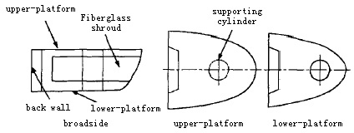

Fig.1 Diagram of sonar platform

The structure generates steady-state dynamic response because of harmonic excitation, induces structural noise and radiation in surrounding fluid. The radiated sound power is

*W*  *cs*  *V* 2  **

*(1)*

*rad rad*

Radiation coefficient ** *radi* means the ability of acoustic radiation.

** *radi*  *Rradi* / *cSi*

*(2)*

In order to reduce the self-noise in the sound cavity, we cover part of the steel structure surfaces with sound-absorbing wedge [1-3]. In that case, calculations of self-noise of the sound cavity should take the damping and sound absorption performance of acoustic materials into consideration.

*V*  1.0 109 *m* / *s*

0

*Lpi*  20 lg( *Vi*  /*V*0 ) 10 lg** *radi* 10 lg(*Sii* / *A*)  63.74

A is total sound absorption in the sound cavity 

*A*   *Sii*

*(3)*

*(4)*

Bulleted lists may be included and should look like this:

*Si* is surface area. *i* is the sound absorption coefficient. The total sound pressure level in sound cavity is got.

*Lpt*

 10 lg *m* 10*lpi* /10 

*(5)*

 *i*1 

 

1. Calculation model and laying conditions
   1. *Three-dimensional finite element modeling*

The frequency response of the entire hull and the fore part is generally below 20Hz. The average local vibration frequency is above 15Hz. So the following measures are taken for modeling.

* + - Regard the pressure hull of forward part as a rigid support of the head structure.
    - Modeling the fore body structure as a whole.
    - Regard platform structure as a two-sided water-contacted board and a grillage to calculate the additional water mass.
    - Divide into two sections during the sound-absorbing wedge processing [4].
  1. *Sound absorbing wedge covering condition*

This article studies the noise and vibration reduction effects of sound absorbing wedge in low frequency comprehensively, as well as the influence of arrangement of sound absorbing wedge on the vibration and sound radiation characteristics [5]. The specific conditions are shown in Tab.1.

Table.1. Calculation conditions

|  |  |  |
| --- | --- | --- |
| Conditions | Conditions described | Abbreviation |
| Condition 1 | Not lay Sound absorbing wedge on the surface of the platform area | 0% covering |

Condition 2 Lay 100% sound absorbing wedge on the surface of the back wall and the

upper and lower platforms

Condition 3 Lay 75% sound absorbing wedge on the surface of the back wall and the

upper and lower platforms

Condition 4 Lay 50% sound absorbing wedge on the surface of the back wall and the

upper and lower platforms

100% covering

75% covering

50% covering

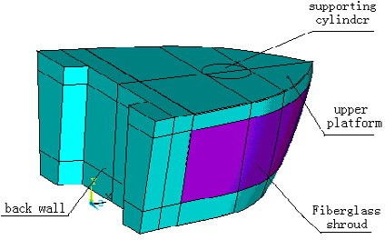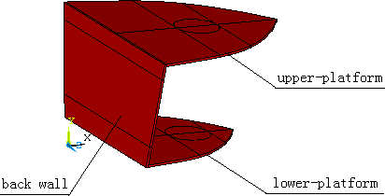

Fig.2 (a) FE model of sonar platform Fig.2 (b) Laying out schematic of sound absorbing wedge Fig.2. (a) FE model of sonar platform; (b) Laying out schematic of sound absorbing wedge

1. Analysis of results

Fig.3 shows that the coverage of sound absorbing wedge can reduce the sound radiation of sonar platform.

And the average reduction of sound radiation is about 25dB from 20Hz~10k Hz.

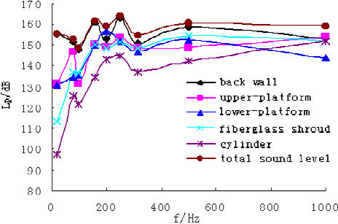

a 0% covering

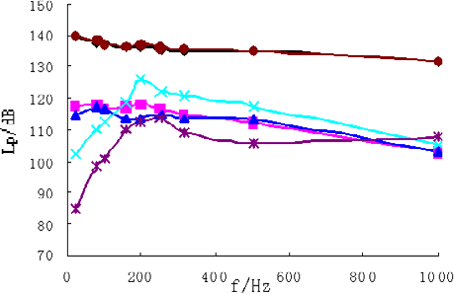

b  100% covering

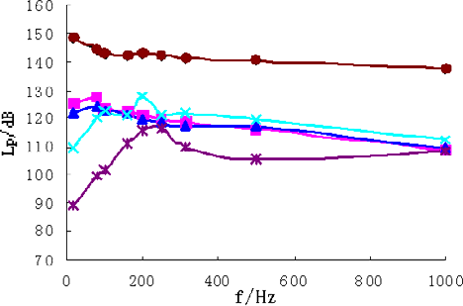

d 50% covering

Fig.3. *SPL* of sonar platform versus covering of sound absorbing wedge

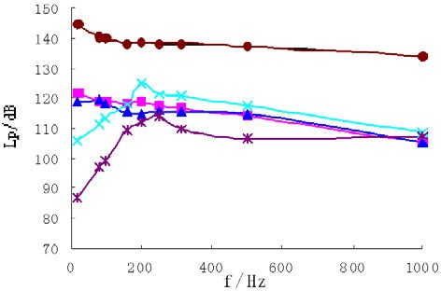

c 75% covering

Compare the shape of radiation sound pressure curves in Fig.3(a) and Fig.3(b) we can find that covering the sound absorbing wedge significantly weaken the peak of radiation sound pressure level of the back wall, the upper-platform and the lower-platform and the total self-noise pressure level of the platform area.

In the 75% covering and 50% covering conditions, the total self-noise pressure has an average reduction of 18dB and 15dB respectively. The following Figures show radiation sound pressure level curves of various components in four conditions.

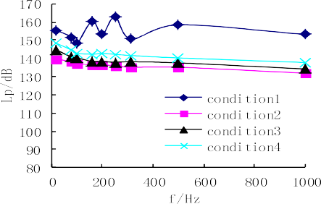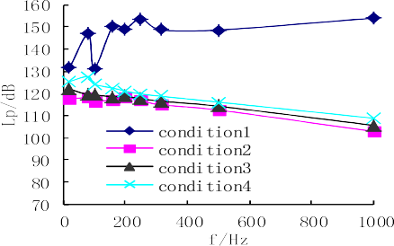

(a) *SPL* of back wall (b) *SPL* of upper-platform

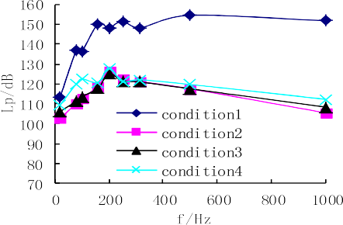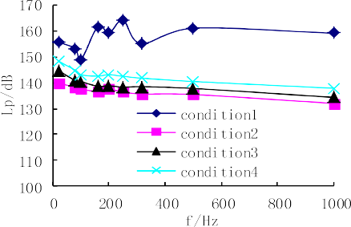

(c) *SPL* of shroud (d) Total *SPL* of the sonar platform Fig.4. *SPL* of the sonar platform with variant coverage of sound absorbing wedge

Fig.4 shows that the various laying methods under100Hz do not have obvious effects on reducing radiation sound pressure level of various components. Exclude the excitation frequency: above 100Hz, which has a resonance effect. The highest radiation sound pressure level is in the 50% covering condition, followed by the

75% covering condition. It can be shown that 100% covering sound absorbing wedge in the fore body platform area has the best effect.

As shown in Fig.4, in the single-frequency excitation of no laying conditions, the model has multi-order natural frequency. The peaks appear in 160Hz and 250Hz on the radiation sound pressure curves. The sound absorbing wedge material characteristics weaken the peaks of radiation sound pressure in the back wall, the upper-platform and the lower-platform and the total self-noise pressure of the platform area significantly.

1. Conclusions

This article predicts the effect of the sound absorbing wedge covering methods on the radiation characteristics of the sonar platform area, and compares the 100% covering condition with the 75% covering and 50% covering conditions. The following conclusions are got:

1. The noise and vibration reduction effect in the 100% covering condition is most obvious and the radiation sound pressure levels of various components in platform are the lowest.
2. The sound absorbing wedge material characteristics weaken the peaks of radiation sound pressure in the back wall, the upper-platform and the lower-platform and the total self-noise pressure of the sonar platform area significantly.
3. With the reduction of the sound-absorbing wedge covering, the inherent frequency of the upper- platform, the lower-platform and the shroud in the 50% covering condition appears.
4. The total self-noise sound levels of the back wall, the upper-platform and the lower-platform reduce significantly after covering the sound absorbing wedge.

References

[1]. Pang Fuzhen, Yao Xiongliang; Sun Longquan, Kang Fenghui. Experiment of underwater acoustic characteristic of sonar platform equipped with sound absorption wedges [J]. Huazhong Ligong Daxue Xuebao, 2011, 39(4): 106-109. (in Chinese)

[2]. Pang Fu-Zhen, Yao Xiong-Liang, Jia Di, Yu Dan-Zhu. Experimental investigation of the effects of sound absorption wedges on the underwater acoustic characteristic within a Compound Plate & Cylindrical Shell Structure [J]. Journal of Ship Mechanics, 2011, 15(5): 570-576. (in Chinese)

[3]. YU Mengsa. Prediction and Control Method of Self-noise in Ship's Sonar Domes [J]. Journal of Ship Mechanics, 2002, (5): 80-94. (in Chinese)

[4]. YANG Deqing, GUO Fengjun. Topology optimal design of a gearbox mounting with vibration level difference constraints [J].Journal of vibration shock, 2008, 27(6): 173-177. (in Chinese)

[5]. TING Qing. Viscoelasticity [M]*.* Wuhan: Huazhong University of Science and Technology Press, 1989