[Array 14 (2022) 100183](https://doi.org/10.1016/j.array.2022.100183)



Contents lists available at [ScienceDirect](https://www.elsevier.com/locate/array)

Array

journal homepage: [www.elsevier.com/locate/array](http://www.elsevier.com/locate/array)

Low-fidelity design optimization and development of a VTOL swarm UAV with an open-source framework

Nikhil Sethi a,∗, Saurav Ahlawat b

a *Department of Mathematics and Computer Science, South Asian University, New Delhi, India*

b *Department of Aerospace Engineering, University of Illinois, Urbana-Champaign, IL, USA*

A R T I C L E I N F O A B S T R A C T

*Keywords:* Drones CFD MDO

Aircraft design Open source PSO

Hybrid configurations in aircraft design are highly favorable as they can achieve the appropriate trade-offs required to develop a generalized unmanned aerial system (UAS). Rapid prototyping of such systems at the student level is challenging because commercial software is expensive and difficult to interlink with other tools for creating a multi-disciplinary design. We address this challenge by conceptualizing an aircraft design framework made entirely of open-source software, libraries, and in-house code. We then use this framework to design an all-electric unmanned aerial system with transitioning Vertical Take-off and Landing (VTOL) and Fixed-Wing (FW) modes. The UAV is capable of long-range surveillance up to 100 Kilometers and carrying a maximum relief payload of 1 kg while operating in an ad-hoc wi-fi network with a swarm of similar UAVs. A low fidelity particle swarm optimization algorithm (PSO) and a comprehensive propulsion architecture is also incorporated and validated against commercial software. To validate the design, a prototype is fabricated from glass-fiber and XPS foam, integrated with appropriate sensors and tuned using ArduPilot software. The results show that low-fidelity design is a safe starting point for prototyping under constrained timelines. The study is concluded by discussing the technical challenges of using free software, and some practical considerations while flight testing a UAV with a hybrid configuration.

# Introduction

The development of Unmanned Aerial Vehicles (UAV) is gaining popularity with the advent of more research and robust tools for the same. An even more recent development is the VTOL hybrid concept which combines the advantages of both fixed-wing and vertical thrust configurations [1,2]. They can adapt to the mission scenario while keeping good performance characteristics throughout. The first chal- lenge in developing such vehicles is the added weight and parasite drag of the vertical thrust components as compared to conventional de- signs [3]. The low operating Reynolds number of Micro Aerial Vehicles (MAVs) makes this an even more difficult problem to tackle.

Secondly, undergraduate students and inexperienced designers face the unavailability of consolidated resources to learn and develop good designs. This is even more pronounced in the case of aircraft design, where the intertwined relationships of multiple disciplines are pro- found. Commercial tools act as a proponent in such a case as they do not provide the user with the freedom to learn and customize accordingly. Open-source tools and the development of custom li- braries/components help in learning from scratch, and the leverage to create and use such tools has never been greater than before.

Finally, a complete end-to-end solution, from conceptual design to autopilot testing, is rarely completed in academic environments due to a lack of funding or constrained timelines for publishing research. A complete document addressing the various challenges while design- ing, developing, and testing a swarm-capable UAV can benefit the emerging field of unmanned aerial systems and swarm robotics. This paper recognizes the above challenges and attempts to alleviate them by developing a sound methodology spread across various entirely free tools and in-house code. Our research is aimed primarily to help students and upcoming researchers develop feasible designs for student competitions or learning aircraft design. Formally, the rationale of our research is centered around the following outcomes:

1. A low-fidelity design framework using Particle Swarm Opti- mization for a VTOL hybrid UAV within the defined aerodynamic and stability constraints.
2. Inculcation of completely open-source tools and libraries for the entire design and testing routine to move towards ‘‘free design’’ methodologies.
3. End-to-end fabrication and testing of the UAV equipped with appropriate communication sensors for operating in a homogeneous swarm.

∗ Corresponding author.

*E-mail address:* [nikhilsethi_bt2k16@dtu.ac.in](mailto:nikhilsethi_bt2k16@dtu.ac.in) (N. Sethi).

<https://doi.org/10.1016/j.array.2022.100183>

Received 17 January 2022; Received in revised form 29 April 2022; Accepted 3 May 2022

Available online 11 May 2022

2590-0056/© 2022 The Author(s). Published by Elsevier Inc. This is an open access article under the CC BY license (<http://creativecommons.org/licenses/by/4.0/>).

To the best of our knowledge, this is the first work that develops a blended wing tri-copter UAV configuration by incorporating a set of completely open-source tools into a reusable design pipeline. The paper is organized as follows: A background and literature review of the current state of research is carried out in Section 2. This is followed by establishing a custom open-source design pipeline in Section 3. Sections 4 to 8 go through the entire design process from concept to rendering. We also fabricate a prototype of the UAV in Section 9 and explain the challenges faced during the testing of the same in Section 10.1. To conclude, some final comments and discussions on the design, methods, and platforms used are also carried out. Note: This research extensively uses the term ‘‘hybrid’’ which is not to be confused with hybrid-electric propulsion, which relies on gasoline- powered generators to produce electric power. Instead, ‘‘hybrid’’ here would only refer to the aircraft’s operational capabilities as both a multi-rotor and a fixed-wing craft unless stated otherwise.

# Background

A VTOL fixed-wing UAV can take off and land vertically along with sustained cruised flight. These hybrid UAVs combine VTOL capability with the standard forward propulsion of a fixed-wing UAV. Rotary lift propellers are typically incorporated into the aircraft’s wings in many hybrid VTOL UAVs, enabling a transition to forward flight. VTOL fixed-wings have several advantages over typical fixed-wing unmanned aircraft. They require much less space to launch and recover, as they do not need to use a specified area for Take-Off [4]. They are suited to applications where aerial inspection and monitoring are needed, allowing the aircraft to hover over a position for some time.

A study of [5] covers the use of SUAVE, a software used to analyze, optimize, and design a range of small UAVs, which is a flexible aircraft design tool with the unique ability to handle alternative energy systems and unconventional designs. In [6], a configuration similar to our work is explored using standard low fidelity analyses. The nature of the software and tools used is not stated, however. In [7], potential design strategies are presented and compared, identifying various de- sign variables and constraints that take precedence during a particular optimization while taking a novel weight build-up approach. This work simplifies the more extensive study of optimizing the sensitivity of constraints while removing implicitly resolved parameters alongside reducing the computational cost. Inculcation of stable open-source tools to address problems in aircraft design is discussed in [8].

Various tools and resources were used while designing and develop- ing the UAV in this paper. Brief descriptions of each of them and their capabilities are highlighted below

1. *FreeCAD*1: It is a powerful open-source solid modeling software written in C++ with a highly inter-operable Python API. It has multiple workbenches to deal with different kinds of geome- try. Owing to the software’s long tenure, the documentation is sufficient and has a well-maintained forum.
2. *OpenFoam*2 + *ParaView*3: An automated numerical solver written

in C++ for continuum mechanics problems in computational fluid dynamics [9]. It has a powerful file-based API and pre- processing utilities like Snappy-Hex-Mesh. The library is also distributed with ParaView: a versatile post-processing software to visualize the computed fields. OpenFOAM is well-regarded in the research community and has been linked with several applications to further its development [10,11]

1 <https://www.freecadweb.org/>.

2 <https://github.com/OpenFOAM/OpenFOAM-dev>.

3 <https://github.com/Kitware/ParaView>.

1. *LuxCoreRender* 4: This rendering software provides designers with a powerful tool to create realistic and accurate images. It is very flexible and does not compromise on quality and physical correctness by making ‘unbiased’ designs using equations that model light flow. There are many standard features like config- uration file systems and acceleration with a CUDA backend.
2. *OpenVSP*5: It is a parametric aircraft geometry tool where the user is allowed to create a 3D model of an aircraft defined by standard engineering parameters. This model can be processed into formats suitable for engineering analysis. This software was released as an open-source project under NASA’s open-source Agreement (NOSA) version 1.3. giving the advanced tools of aircraft design for use to the general public. OpenVSP has gained recognition through the years and is popular among researchers for extending it to a complete MDO software [12,13].
3. *XFLR5*6: It is an analysis software for airfoils, wings, and planes operating at low Reynolds Numbers, which includes XFoil’s Di- rect and Inverse analysis capabilities with wing design and analysis capabilities based on the Lifting Line Theory, on the Vortex Lattice Method, and a 3D Panel Method. It is prevalent among students and novice researchers as it has a good learning curve and an interactive GUI.
4. *Ardupilot* *SITL*7 + *Mission Planner* 8: The SITL (software in the

loop) simulator allows us to run Plane and Copter simulations. It

is a build of the autopilot code using the original C++ compiler, giving us a native executable that allows one to test the code’s behavior without implementation on the hardware itself. The simulator uses the sensor data from various flight dynamics models in a flight simulator. This allows testing of ArduPilot SITL on a number of vehicle types, essential for testing a hybrid system such as ours.

# Design methodology

Incorporating completely open-source tools for the conceptual pre- liminary and detailed design is a challenge because of three factors:

1. The accuracy of results.
2. Lack of documentation.
3. Lack of experienced users/populated forums.

Considering the above challenges and the fidelity required for the design, the tools and the design process are shown in Fig. 1.

The high degree of interrelation between disciplines in aircraft design makes it difficult to dodge locally optimal designs developed by intuition. Multidisciplinary Design Optimization (MDO) has become a necessary part of the toolbox of aerospace designers. The approach used in the following sections is not a full-scale MDO solution by any means but a novel, low-fidelity attempt at design exploration. A human is kept in the loop at all stages to guide the design and perform validation checks. Further methods pertaining to the same are explained in the following sections.

# Conceptual design

We start by using a systems engineering approach to establish high level design requirements and timelines for the project. This was completed using V-models and system design timelines, which are not covered here for compactness but are included in supplementary material (S1). For the purpose of this research, we model our aircraft

4 <https://github.com/LuxCoreRender/LuxCore>.

5 <https://github.com/OpenVSP/OpenVSP>.

6 <https://sourceforge.net/projects/xflr5/>.

7 <https://github.com/ArduPilot/ardupilot>.

8 <https://ardupilot.org/planner/>.

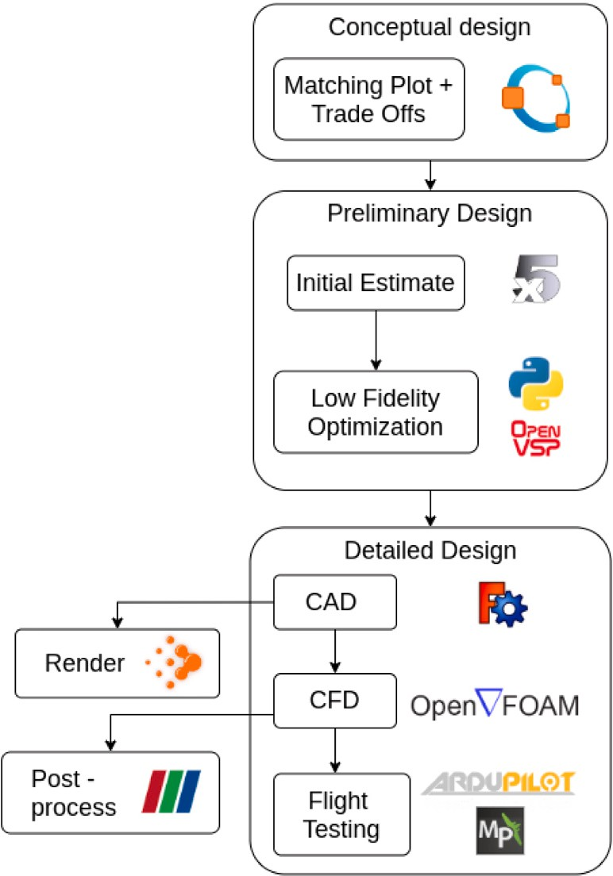

**/ig. 1.** High level design process.

to maximize its flight range up to 100 Kilometers (Kms), cruising at

25 m/s without sacrificing its VTOL functionality. The aircraft will keep a standard mission profile with vertical take-off, cruised flight, surveillance and target detection, payload delivery, and vertical land- ing. It is also kept in mind that multiple similar UAVs may be used in a collaborative swarm which is advantageous in many applications. A concept of operations for the entire mission profile was also envisioned and a video of the same has been included in the supplementary material (S2).

* 1. *Configuration selection*

There are many configuration parameters to consider, and respec- tive trade-offs for each are carried out using a Pugh matrix analysis. These matrices (given in supplementary material (S3)) are filled with weighted scores for each configuration, and the scores are summed up to compare and evaluate. Since the design is conceptual at this stage, inherent safety factors and design experience play a crucial role in selection.

A hybrid of a blended flying wing configuration supplemented with a tri-copter configuration with two forward tilting motors is arrived at. The front motors tilt forward for transition to cruise flight after a vertical take-off and tilt back to multi-rotor while landing. These motors can be vectored along the aircraft’s pitch axis to stabilize the yawing moment. The rear motor is operational for the multi-rotor segment of the flight. The following equation gives the total drag component of the UAV and can be used to determine the areas which can be altered to lower the drag.

the various components (for eg. *𝑆𝑣𝑡𝑜𝑙* = wetted area of VTOL motor, tilt-

rotor mechanisms, aluminum struts etc.) and their ratios with respect

to the wetted wing area. A blended flying wing will prove to be a better candidate for long-endurance missions with significantly reduced

(*𝐶𝐷𝑜*)*ℎ𝑡* component, better performance of winglets to reduce vortex

induced drag, and an overall lower (*𝐶𝐷𝑜*)*𝑣𝑡* component (Supplementary

material S2b).

Most commercially available products use a quad-plane configura- tion, which is essentially a quad-copter attached to the frame of an independent fixed-wing aircraft. This solution, save for its simplicity,

more (*𝐶𝐷𝑜*)*𝑣𝑡𝑜𝑙* components. The extra deadweight while cruising would added greater structural weight and reinforcement, which resulted in

not be an optimal choice for a high endurance mission.

in terms of weight and lower (*𝐶𝐷𝑜*)*𝑣𝑡𝑜𝑙*. Even though planes with greater A tri-plane with two forward tilt motors is a highly favorable choice

number of rotors provide better stability and airworthiness, their cost and weight diminish the advantages in financially constrained environ- ments. Therefore, a tri-copter configuration was chosen due to its lower current draw, less dead weight, and lower cost (Supplementary material S2a). Note that such trade-offs, while feasible at a conceptual stage, do not provide the entire picture, and actual flight tests were done on a prototype frame to confirm/refute the assumptions. The challenges regarding the same are discussed thoroughly in Section 10.1.

# Propulsion

The propulsion selection is one of the most important trade-offs to obtain the most out of the aircraft’s endurance and reach the desired range. During cruise flight, all the load will be on the forward motors whereas, during hover, all the three motors would share the load. This introduces the issue of transition where the forward motors have to be chosen in such a way to provide sufficient thrust during hover and have optimal RPM and pitch speed for a sustained cruised flight in the mission.

As trends dictates, we must have a minimum thrust to weight ratio (T/W) of 1.5 for a hovering craft for sufficient thrust during maneuvers. Further, existing aircraft design trends show a T/W of 0.75 to be sufficient during cruise. This allows us to arrive at an initial thrust

margin for all the motors and a ratio of 1 ∶ 1 ∶ 2 between the

left-front, right-front, and rear motors, respectively. This distribution

was necessary to ensure that the forward motors operate at their peak optimum during cruise. The rear motor, only operational during hover segments, is optimized for the same, and its thrust is finalized only after calculating the safe thrust for the front motors during cruise. This is primarily done because the cruise segment dominates the mission profile.

# Weight estimation

The initial estimation is done by analyzing historical data, collecting the necessary features, and arriving at a hypothesis akin to the methods in [14]. Since the payload is defined within the constraints, the payload fraction was used as the most important feature at this stage, and a linear regression curve was fitted to the data (supplementary material S4a). This trend line, and the quadratic equation generated are solved

It is interesting to note how the value of *𝑏* is larger than typically analytically (Supplementary material S4b) to give a suitable prediction. obtained for fixed-wings (≈0*.*7). This is in line with expectations and

( *𝑆ℎ𝑡*

*𝑆𝑣𝑡*

primarily attributed to the extra weight used to carry VTOL systems at

*𝐶𝐷𝑜*)*𝑡𝑜𝑡𝑎𝑙* = (*𝐶𝐷𝑜*)*𝑤* + (*𝐶𝐷𝑜*)*ℎ𝑡 𝑆* + (*𝐶𝐷𝑜*)*𝑣𝑡 𝑆* + ⋯

the expense of better aerodynamic efficiency.

*...* + (*𝐶* )

*𝑆𝑣𝑡𝑜𝑙*

*𝑊𝑒* = *𝑎.𝑊*

+ *𝑏* (1)

*𝐷𝑜 𝑣𝑡𝑜𝑙 𝑆*

*𝑊𝑜 𝑜*

Here (*𝐶𝐷𝑜*)*𝑤* is the total zero-lift drag of the wing, (*𝐶𝐷𝑜*)*ℎ𝑡* and (*𝐶𝐷𝑜*)*𝑣𝑡*

are the horizontal and vertical tail zero-lift drags, and (*𝐶𝐷𝑜*)*𝑣𝑡𝑜𝑙* accounts

necessary for transition operations). *𝑆* represents the wetted areas of for the drag in extra mechanisms (motors and structural components

*𝑊𝑜* = *𝑊𝑒* + *𝑊𝑝* (2)

where,

*𝑎* = −0*.*00468; *𝑏* = 0*.*887 (3)

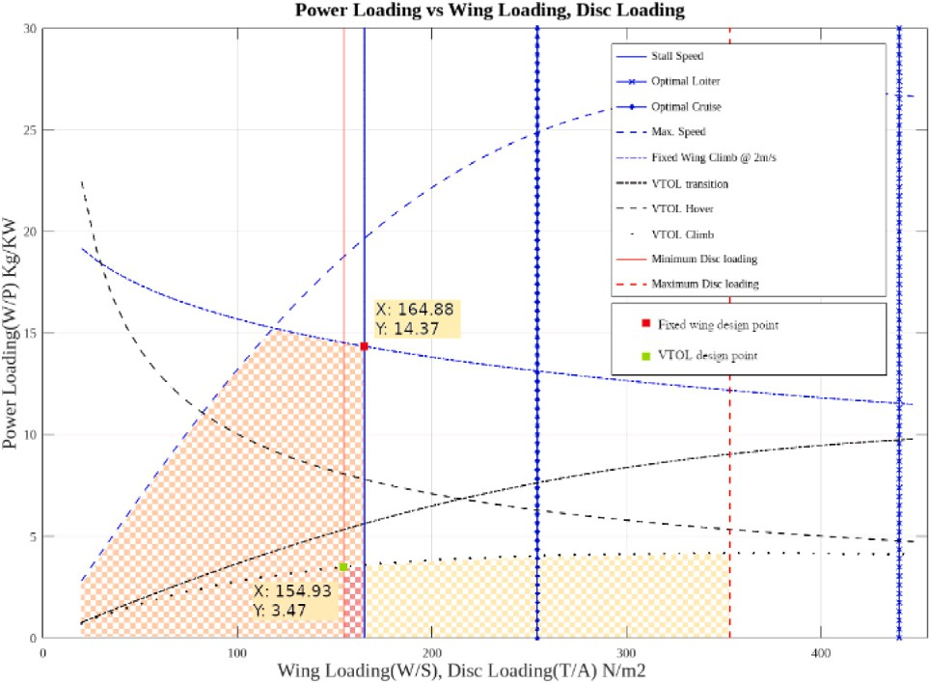The above regression analysis yields an empty weight (*𝑊𝑒*) of 5.84 kg and, therefore, an estimated total mass (*𝑊𝑜*) of 6.84 kg to carry 1 kg of payload (*𝑊𝑝*). This estimate is further qualified by including a safety

margin of 160 g based on prior experience, possible dead-weights, and accumulation of weight after repairs because of potential crashes.

*𝑊𝑝* = 1 kg (4)

*𝑊𝑜* = 6*.*84 + 0*.*16 ≈ 7 kg (5)

# Preliminary design

The preliminary design stage makes use of extensive mathematical optimization. The objective of the optimization process is to design a geometry and propulsion system to maximize the range — which implies minimizing power and maximizing cruise efficiency. In our case, we have divided the optimization and design process into three stages.

* 1. *Initial sizing*

The first stage gives a good estimate of the two driving factors for

*( 𝑊 )*

**/ig. 2.** Linear programming model.

= 1

any design: wing loading and power loading. Appropriate relations for

*𝑃 𝑐𝑙𝑖𝑚𝑏*

*𝑘*1*𝑉𝑦*

*𝑘*1 *√* 2

2 (*𝐷𝐿*)

the transition, hover, and climb phases for the tri-copter sizing [15] are also included to account for disk loading using an approach similar to the one in [14]. Since a rough but mathematically sound estimate is de-

*𝑉𝑦* −

2 + 2

*𝑉𝑦* +

*𝜌𝑜*

+ ⋯

*𝜌𝑜𝑉* 3 *( 𝜎𝐶 )*

sired at this stage, a design space is created using Linear programming based on the formulae in [14,16][17]. As a result, we only include brief explanations of the equations here.

*𝑊*

*𝑃 𝑡𝑟𝑎𝑛𝑠*

*( )*

= 1

*𝑑*1 + *𝑑*2 + *𝑑*3

*...* +

*𝑡𝑖𝑝 𝑑*

(*𝐷𝐿*) 8

(12)

(13)

Eq. (6) gives the wing loading at which the plane stalls. This is usually the constraint that sets the lower bound on the wing area. In

cases where the stall speed is high and the cruise ceiling is also high

where,

*√√* − 2

*√√(*

−*𝑉* 2 *)*2

enough, Eqs. (7) might set this lower bound. Eqs. (8), (9) and (10) give

certain rate (*𝑅𝑂𝐶*), and moving with *𝑉𝑚𝑎𝑥* velocity at sea level (*𝑆𝐿*) the optimal wing loadings for maximizing endurance, climbing at a altitude respectively. They are derived in [14,17]. Here *𝜂𝑝* = 0*.*8 is the

*𝑑*1

*𝑘*

sin *(𝜃𝑡𝑖𝑙𝑡)*

= 1 *√√*

2

*𝑉* ∞ + *√√*  ∞

+ ⋯

2

2

*( 𝐷𝐿 )*

2*𝜌*sin *(𝜃 )*

*...* +

(14)

propeller efficiency, *𝐴𝑅* = 8 the aspect ratio, (*𝐿*∕*𝐷*)

*𝑚𝑎𝑥*

= 11, and *𝑒* = 0*.*8

*𝜌𝑉* 3 *( ( ))*

*𝑡𝑖𝑙𝑡*

is the Ostwald’s efficiency factor. Note that these values, especially for

*𝐴𝑅* and (*𝐿*∕*𝐷*)*𝑚𝑎𝑥* are just educated guesses and must be iterated and

changed depending on the final results.

*𝑑*2 =

*𝑇 𝑖𝑝*

*𝐷𝐿*

*( )*

2

*𝑜*

*𝑊*

*𝜌𝑜𝑉*∞

*𝜎𝐶𝑑*

8

∞

*𝐷𝑜*

1 + 4*.*6*𝜇*2

(15)

*( 𝑊 )*

*)*

*𝑠𝑡𝑎𝑙𝑙*

*𝐿𝑚𝑎𝑥*

*(*

*𝑠𝑡𝑎𝑙𝑙*

*𝑆*

*𝑊*

= 0*.*5*𝜌*(*𝑉*

)2*𝐶*

(6)

*𝑑*3 = *⎛**⎜* 1 *𝜌 𝑉* 3 *𝐶*

1 + 2*𝐾*

*𝑆*

*( 𝑊 )⎞⎟*

*𝑆*

(16)

*𝑆 𝑚𝑎𝑥𝑟𝑎𝑛𝑔𝑒*

*𝑊*

*( * *)*

*𝑆 𝑚𝑎𝑥𝑙𝑜𝑖𝑡𝑒𝑟*

*( )*

(7)

*⎜⎝*

*⎟⎠*

*𝐷𝑜*

= *𝑞√*3*𝜋*(*𝐴𝑅*)*𝑒𝐶𝐷𝑜*

*√*

= *𝑞*

*𝜋*(*𝐴𝑅*)*𝑒𝐶*

(8)

The LPP outputs a comfortable design (Fig. 2) space to choose points from depending on the desired performance. To make the analysis more

constrained, minimum and maximum values of disk loading are also

*𝑊*

*𝑃 𝑅𝑂𝐶*

= 1

(9)

used depending on the motors and their rated propeller sizes. The

*𝑅𝑂𝐶*

+ *√√* 2

*( 𝑊 ) ⎛⎜*

1*.*155 *⎞⎟*

VTOL and fixed-wing design points are far apart, both constrained by

their climb limits. The maximum power points are chosen for each

*𝜂𝑝 √ 𝜌√* 3*𝐶𝐷𝑜*

*𝑆 ⎜ ( 𝐿 )*

*𝜂𝑝 ⎟*

configuration to incorporate a safety factor.

*( 𝑊 )*

*𝐾*

= *𝜂𝑝*

*⎝ 𝐷*

*𝑚𝑎𝑥 ⎠*

(10) *𝑊*

*𝑃𝑆𝐿*

*𝑉𝑚𝑎𝑥*

1 *𝜌 𝑉* 3 *𝐶*

1 + 2*𝐾*

*( 𝑊 )*

*𝑆𝑤𝑖𝑛𝑔* = *𝑜*

(17)

2 *𝑜*

*𝑚𝑎𝑥*

*𝐷𝑜 𝑊*

*𝑆*

*( )*

*𝜌𝜎𝑎𝑖𝑟𝑉𝑚𝑎𝑥 𝑆*

(*𝑊* ∕*𝑆*)*𝑜𝑝𝑡*

*𝑃* = *𝑊𝑜*

(18)

The following equations are used to size the propellers’ total area

(*𝐷𝐿*) characterizes this area. Eq. (13) is used to size the propeller area that provides vertical thrust. Similar to the wing loading, a disk loading

during transition. This relation aims to keep a constant velocity during

*𝑐𝑟𝑢𝑖𝑠𝑒*

*𝑃𝑉 𝑇 𝑂𝐿*

(*𝑊* ∕*𝑃* )*𝐹 𝑊*

= *𝑊𝑜*

(*𝑊* ∕*𝑃* )*𝑉 𝑇 𝑂𝐿*

(19)

tilting angle (*𝜃𝑡𝑖𝑙𝑡*). The angle here is taken as constant. However, one the shift from hover to cruise mode and is therefore dependent on the

might also explore a varying angle with a constant rate which closely matches with how real systems transition. These equations are derived in [16]

*( √)*

* 1. *Geometry optimization*
     1. *Initial estimate*

The aircraft performance is first estimated on XFLR5 to obtain initial but educated estimates of static stability parameters. The analysis starts with the selection of a reflexed airfoil and rudimentary optimization at

*𝑊*

*( )*

*𝑃 ℎ𝑜𝑣𝑒𝑟*

= *𝐹 𝑂𝑀* 2*𝜌* (11)

*𝐷𝐿*

multiple angles of attacks by observing peak *𝐶𝑙* ∕*𝐶𝑑* values (Fig. 4(a))

and stall qualities (Fig. 4(b)) at cruising altitude and Reynold’s number.

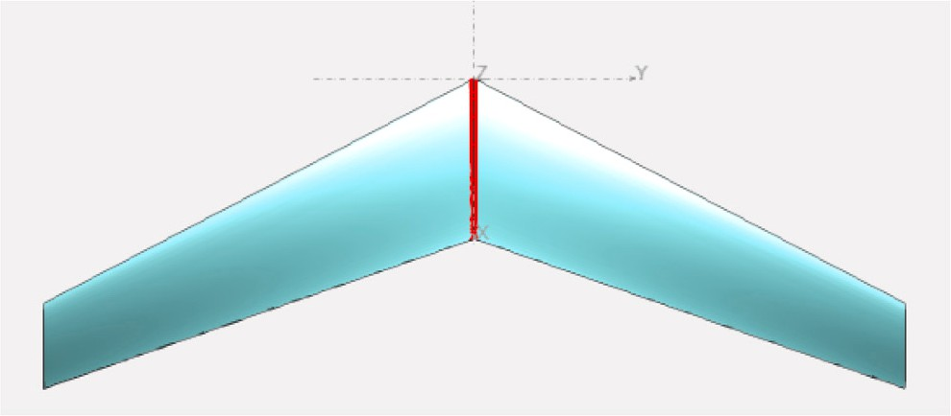

**/ig. 3.** Wing top view.

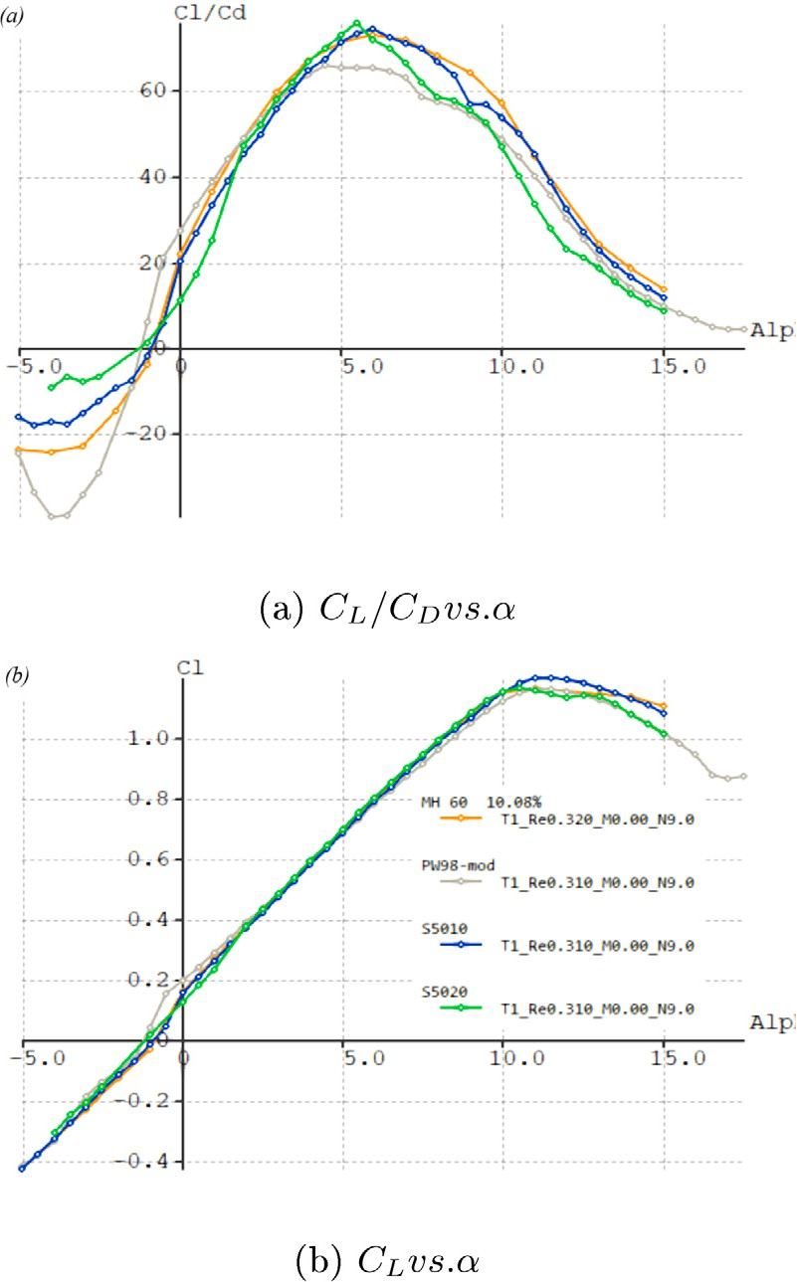

**/ig. 4.** XFoil curves.

The methods for the same are taken from [18] and a trade-off matrix is given in supplementary material (S2d).

Fixed lift analysis is then conducted on the operating GTOW of the flying wing (Fig. 3) to introduce static stability into the aircraft. Iterations were performed on the design variables to optimize the cruise

*𝐶𝑙* ∕*𝐶𝑑* of the whole wing while balancing out the Center of Gravity

(CoG) placement to ensure close to null *𝐶𝑚* (pitching moment). The resultant twist in the wing subsequently reduced the *𝐶𝐿* of the whole

wing, making the wing area more than initial calculations.

A rough and conceptual estimate of the intended design (Fig. 5) is also analyzed to ensure consistency in performance estimates.

* + 1. *Problem setup*

The second stage is the optimization of geometry. While being decoupled from propulsion selection is not optimal, it makes the devel- opment of the interface and debugging easier. Owing to the small num-

**/ig. 5.** Preliminary design.

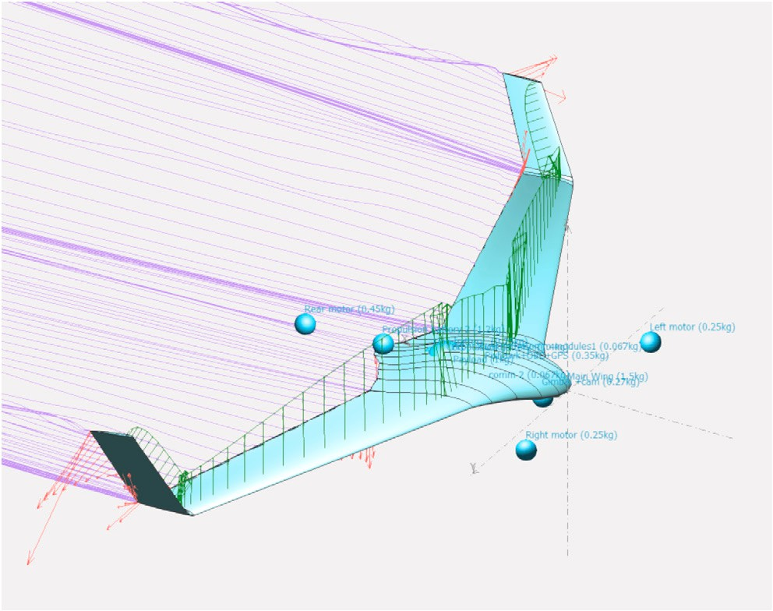**Table 1**

PSO parameter settings.

|  |  |  |  |
| --- | --- | --- | --- |
| Parameter | Initial | Final | Method |
| *𝑐*1 (Cognitive weight) | 2.5 | 0.5 | Linear decay |
| *𝑐*2 (Social weight) | 2.5 | 2.5 | Constant |
| *𝑤* (Inertia weight) | 0.9 | 0.4 | Linear decay |
| *𝑁* (generations) | 0 | 100 | Linear |

decreased over generations to exploit high fitness solutions [20]. The objective function used for the problem is just the weighted sum of each individual objectives (Eq. (20)). For simplicity all the weights

(*𝑤*) are taken as equal and only have opposite signs based on the

namely the aspect ratio (*𝐴𝑅*), root-tip twist (*𝛩𝑟𝑒𝑙* ), taper-ratio (*𝜆*) and minimization/maximization of each of the objectives. Four variables leading edge sweep (*𝛬𝐿𝐸* ) are used to parameterize the problem. The

combined objective function accounts for the following three factors:

* + - 1. Drag: the analysis is done at constant lift coefficient (Eq. (23)) which is equal to the airfoil lift coefficient at cruise condition taken with a margin to account for a 2D cross-section vs 3D wing [14].
      2. Lift distribution: The actual lift distribution (*𝐶𝑎* ) is a function

*𝐿*

used to match the target curve(*𝐶𝑡* ) of the load distribution. A of twist, taper ratio and sweep. A least squares cost function is

*𝐿*

separate python script calculates this.

* + - 1. Stability: Since optimizing for stability often requires compro- mise on performance, the damping ratios of the short period

(*𝜏𝑆𝑃* ), Dutch roll (*𝜏𝐷𝑅*) and Phugoid (*𝜏𝑃 𝐻* ) mode are incor-

porated within the objective. For static stability however, two

constraints to the allowable static margin (S.M. Eq. (24)) at zero moment at the design lift coefficient (Eq. (25)) are enough. The stability coefficients and ‘‘BaseAero’’ values are sought from the

.stab file output by OpenVSP and converted to a data frame for further processing.

The values in constraint Eqs. (28) to (31) are sensible values which closely follow trends in supplementary material (S4(a)).

#*𝐽*

*∑*

*𝑀𝑖𝑛𝑥 𝑤𝑖𝐽𝑖* (20)

*𝑖*=1

1 *∑*

*𝐿*

*𝐿*

ber of variables, ease of writing code, and pre-existing libraries [19], a particle swarm optimizer is used. The parameter settings for the

*𝐽* =

*{𝐶𝐷,*

*𝑏*∕2

(*𝐶𝑡* (*𝑦*) − *𝐶𝑎* (*𝑦*))2 *𝜏𝑆𝑃 , 𝜏𝐷𝑅, 𝜏𝑃 𝐻 }*

(21)

same are given in Table 1. The inertial and cognitive weights were

*𝑛 𝑦*=0

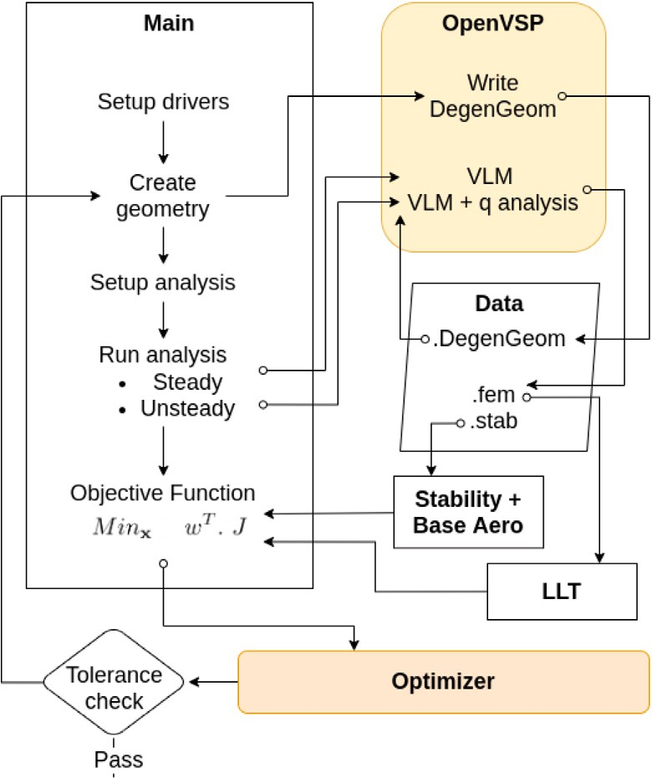

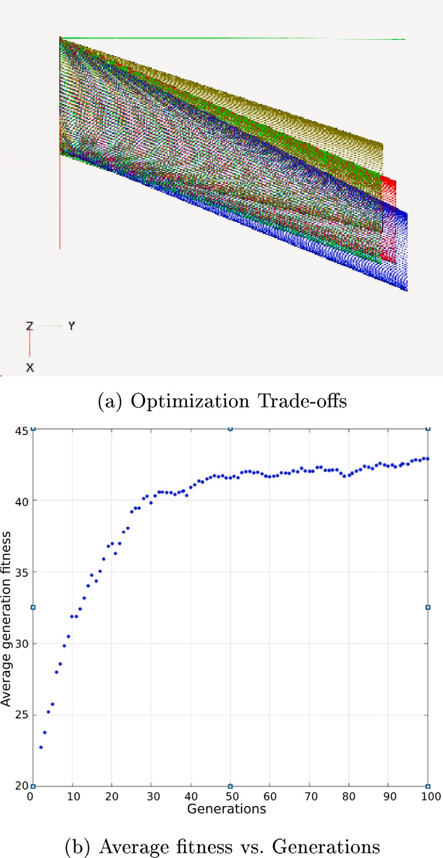**/ig. 6.** Optimization architecture.

*𝑙*

|  |  |  |  |
| --- | --- | --- | --- |
| *𝑥* = [*𝐴𝑅, 𝛩𝑟𝑒𝑙 , 𝜆, 𝛬𝐿𝐸* ] | (22) |  | |
| *𝐶𝐿* = 0*.*9*𝐶𝑐* | (23) |
| *𝑆.𝑀.* = 4% | (24) |
| *𝐶𝑀* ≈ 0 | (25) |
| *𝐶𝑡* (*𝑦*) = Target lift | (26) |
| *𝐶𝑎* (*𝑦*) = Actual lift | (27) |
| 5 ≤ *𝐴𝑅* ≤ 10 | (28) |
| – 1 ≤ *𝛩𝑟𝑒𝑙* ≤ −5 | (29) |
| 0*.*4 ≤ *𝜆* ≤ 0*.*9 | (30) |  | **/ig. 7.** Optimization Results. |
| 20 ≤ *𝛬𝐿𝐸* ≤ 30 | (31) | **Table 2** |  |
|  |  | Aircraft parameters | . |

*𝐿*

*𝐿*

* + 1. *Architecture*

Python was chosen as the scripting language to minimize the cost function with appropriate weights using a Particle Swarm Optimization algorithm. The libraries/software used for the design have a well exposed API that helps create custom loops and carry out efficient numerical computation using multiple processes. A detailed analysis for such an interface selection is done in [13]. The geometry is arrived upon by interfacing a python script with *OpenVSP* and conducting a Vortex Lattice method analysis. The process loop for the same in shown in Fig. 6.

* + 1. *Results*

The particle swarm optimizer is run for a total of 100 generations, with the fitness increasing and then saturating over time 7(b). Some design trade-offs in *OpenVSP* are shown in Fig. 7(a). Since the code does not address the problem of structures and aeroelasticity, an appropriate and feasible design is chosen with respect to design experience. The geometry for the chosen design is given in Table 2. A factor of safety during weight estimation is also considered for this. Some comments regarding the tools are written to help the reader understand the available sophistication level and possible caveats.

1. Vortex lattice method works well for lift analysis, but it is not an accurate method for determining the overall drag. Therefore the values are further verified by CFD analysis in 8.2.

Parameter Values

Wing loading 164.88 N/m2

Power loading 3.47 kg/kW

Wing area 0.418 m2

Aspect ratio 7.35

Taper ratio 0.689

Wing incidence 5◦

Relative twist −2◦

Leading edge sweep 26.5◦

1. The focus of the geometry optimization is primarily for the cruise phase (therefore conducted at the cruising angle of attack), as this will have the most significant effect on performance.
2. Since this is not a full-scale MDO solution, a human in the loop is necessary to guide and remove suboptimal/non-convex geometries.
   1. *Propulsion*

A propulsion architecture is conceived to drive the aircraft at its optimal performance with the maximum range and/or endurance.

* + 1. *Forward motors*

The forward motors are essential for the cruising segment of the flight. The right combination of propeller size, pitch and the motor

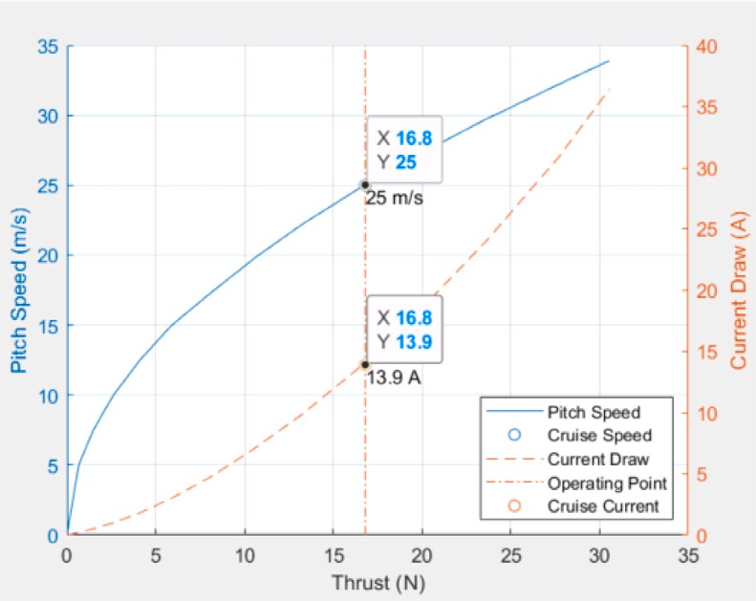

**/ig. 8.** Forward motor optimal thrust.

combination was combed through in Eqs. (35)–(39) to achieve the required performance of the motors while cruising at 25 m/s. This was matched with the pitch speed of the motor operating on the thrust needed to overcome drag at cruise (Eq. (36)) and hence maximizing endurance. The optimal thrust curve in Fig. 8 explains this method graphically.

The initial design of our fixed-wing yielded a cruise drag *𝐶𝑐* , which

*𝑑*

achievable ranges of propeller pitches (*𝑥𝑝𝑖𝑡𝑐ℎ* Eq. (38)) that were avail- would have to be overcome by the forward cruise motors. We keep

(*𝛺𝑐𝑟𝑢𝑖𝑠𝑒* (32)) is taken to calculate the motor KV. able in local markets to match our requirements. The cruise RPM

A scaling factor *𝛷𝑐* is introduced in Eq. (34) keeping in mind that

the required *𝛺𝑐𝑟𝑢𝑖𝑠𝑒* (Eq. (32)) increases quadratically with the required

thrust for a constant pitch propeller powered by a Brush-Less Direct

to what its RPM would likely be at *𝑇𝑐𝑟𝑢𝑖𝑠𝑒* and *𝑇𝑚𝑎𝑥*. Note that the Current (BLDC) motor (37). This factor scales the motor RPM at cruise

calculations and ratios in this section include the combined thrust of both forward motors.

Eq. (39) defines safety margins of required thrust for cruise motor selection, out of which design changes would be necessary.

60 *𝑣𝑝𝑖𝑡𝑐ℎ*

**Table 3**

|  |  |
| --- | --- |
| Battery data. |  |
| Parameter | Values |
| Form factor | 18 650 |
| Cell voltage (nominal) | 22.2 V |
| Cell capacity | 3300 mAh |
| Cell discharge | 3C (9.9 A) |
| Cell discharge (Peak) | 4C (13.2 A) |
| Weight (cell) | 48 g |

**Table 4**

Final motors selection.

Forward motor (×2) Value

EMAX MT3515

Type BLDC 22.2 V

KV rated 650 RPM/V

Maximum power 630 W

Propeller 25.4 cm x 15.24 cm

Max thrust 2660 g

Weight 131 g

Rear motor (×1) Value

T-MOTOR MN501-S

Type BLDC 22.2 V

KV rated 360 RPM/V

Maximum power 1000 W

Propeller 50.8 cm x 15.24 cm

Max thrust 5372 g

Weight 171 g

* + 1. *Battery selection*

Observing modern trends in electric propulsion, Lithium-Ion battery packs prove to be the best energy density as they can hold more amperage than their Lithium Polymer counterparts. Lithium-Ion battery packs do have their drawbacks of limited current discharge. To confirm before selecting, the current draw was evaluated for all flight segments and was found low enough to use Li-ion batteries.

A theoretical flight range (*𝑅𝑡ℎ*) of 107 km and cruise endurance

(*𝐸𝑐𝑟𝑢𝑖𝑠𝑒*) of 71 min were subsequently calculated by estimating the

at a 6S 10P configuration. Here *𝐶𝑐𝑒𝑙𝑙* is battery capacity of one cell given battery usage in cruised flight. Battery weight is estimated to be 2880 g

in Table 3.

*𝛺𝑐𝑟𝑢𝑖𝑠𝑒* =

0*.*0254 *𝑥*

*𝑝𝑖𝑡𝑐ℎ*

(32)

*𝜂𝑡𝑜𝑡𝑎𝑙* = *𝜂𝑝𝑟𝑜𝑝𝑒𝑙𝑙𝑒𝑟𝜂𝑚𝑜𝑡𝑜𝑟𝜂𝑏𝑎𝑡𝑡𝑒𝑟𝑦* (40)

*𝐾𝑉* = *[ 𝛺𝑐𝑟𝑢𝑖𝑠𝑒 𝛷 ]* (33)

*√*

*𝑉*

*𝑐*

*𝑐𝑟𝑢𝑖𝑠𝑒*

*𝐼𝑐𝑟𝑢𝑖𝑠𝑒𝑛𝑚𝑜𝑡𝑜𝑟𝑠*

*𝑡𝑜𝑡𝑎𝑙*

*𝐸* = *𝐶𝑐𝑒𝑙𝑙 𝑛𝑝𝑎𝑟𝑎𝑙𝑙𝑒𝑙 𝜂*

(41)

*𝛷𝑐*

= *𝑇𝑚𝑎𝑥*

*𝑇𝑐𝑟𝑢𝑖𝑠𝑒*

(34)

*𝑅𝑡ℎ* = *𝑣𝑐𝑟𝑢𝑖𝑠𝑒𝐸𝑐𝑟𝑢𝑖𝑠𝑒* (42)

where,

*𝑣𝑝𝑖𝑡𝑐ℎ* = 25 m∕s (35)

* + 1. *Rear motor*

With the forward motors handling half of the thrust required during hover segments, the rear motor handles the remaining. Its only goal

*𝑇* = 1 *𝜌𝑣*2*𝑆𝐶𝑐*

(36)

is to draw the least amount of current to be as efficient as possible

*𝑐𝑟𝑢𝑖𝑠𝑒* 2 *𝑑*

*𝑉* = 22*.*2 V(6SBattery) (37)

10*.*16 cm ≤ *𝑥𝑝𝑖𝑡𝑐ℎ* ≤ 20*.*32 cm (38)

0*.*6 ≤ ( *𝑇* ) ≤ 0*.*8 (39)

*𝑊*

*𝑚𝑎𝑥*

BLDC motors operating at 22.2 V (6S) battery packs were searched, which could give the required thrust of 17 N at an altitude of 500 meters and a pitch speed of 25 m/s. EMAX MT3515 650 KV motor

coupled with a 25.4 cm (10 in.) × 15.24 cm (6 in.) propeller was

finalized after iterations of motor’s various KV (RPM/voltage) ratings.

The maximum load that the selected motor can handle is 26 N of thrust

— comfortable for flying at a max T/W of 0.74 This distribution can

in hover. Motors with larger propeller size, lower pitch, and lower RPM (KV rating) draw lesser current compared to their short as the induced pitch speed is lesser than those with smaller length, higher pitch, and higher RPM [21]. The rear propeller was finalized by limiting the propeller disk diameter such that it does not intersect with the

the theoretical value. The size of 50*.*8 cm(20 in*.*) for the propeller fuselage and has enough disk loading to keep the thrust as close to

hence limited the motor KV range between 330 to 390 KV, and the appropriate motor was sourced from local markets (Table 4).

The collective propulsion results are also validated on *eCalc*9: a paid propulsion selection tool. The results are in close agreement with the developed formulae.

easily climb with a thrust margin of 1.48:1 and therefore with a ratio

of 1:1:2, which aligns with our assumptions in Section 5. 9 <https://www.ecalc.ch/>.

* 1. 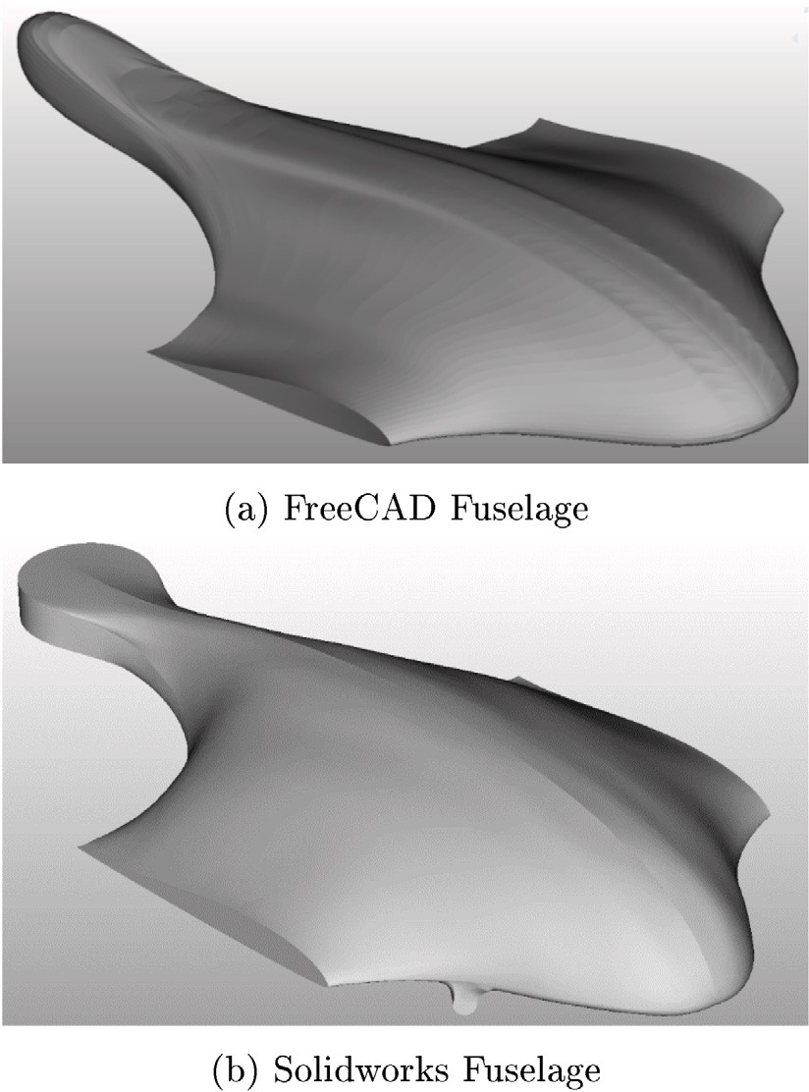*Tilt mechanism*

The tilt mechanism needs to be mechanically robust to rotate and transfer the thrust and torque from drive system aiding in transition between different flight modes. It is required to rotate 90 degrees during cruise and further 10 odd degrees during vectored yaw in tri- copter mode. Initially, a gearing mechanism was chosen over a push rod tilting mechanism due to its high efficiency during rotation. The pressure angle of spur gears was chosen 20 degree, a standard value because of its stronger tooth quality, higher load carrying capacity and

as 1:1. The minimum number of teeth (*𝑍𝑚𝑖𝑛*) were calculated using its greater length of contact [22]. The gear ratio of gears was taken

Eq. (43) to be 17 so as to avoid interference.

2

*𝑍* =

*𝑚𝑖𝑛 𝑠𝑖𝑛*2*𝜙*

(43)

where,

*𝜙* = Pressure angle

# Detailed design

The preliminary design outputs a flyable aircraft to satisfy the theoretical performance objectives. More sophisticated software for computational fluid dynamics and aircraft control simulation engines are used at this point to validate the design.

* 1. *CAD and pre-processing*

The solid model with all internal features is designed on *FreeCAD* (Fig. 9(a)). Extensive use of the part design and draft workbenches allows the creation of complex models and geometries. The commercial

**Table 5**

Mesh parameters.

**/ig. 9.** Fuselage comparison.

tool used for comparison is *SolidWorks*. As shown below, *FreeCAD* can capture most of the geometry, but the tail is off-design due to the lack of sophisticated lofting features with guide curves as compared to Solidworks (Fig. 9(b)).

Triangulation for the CFD model is done using the draft, part, and mesh design workbench. Each part and face are sequentially upgraded using the draft upgrade, fused using the ’boolean fuse’ option, and finally, the entire fusion is converted to a mesh. Owing to the tedious processing time of a Netgen mesh, the standard mesh was used, and further mesh optimizations and quality improvements were completed in the CFD tool.

* 1. *CFD and post-processing*

A computational fluid dynamics analysis was set up on OpenFOAM to calculate the lift and drag more accurately than the low fidelity analysis.

For pre-processing, *blockMesh* and *snappyHexMesh* were used with the parameters given in Table 5. Some refinement regions were added in particular areas like the leading edge and winglet-wing blend (Fig. 10). The edge mesh was extracted and refined on *Blender* 10 to remove dou- ble points and line intersections. Some parameters were interactively tuned in the mesh quality dictionary. Table 5 shows only the edited values.

The basic steady-state *simpleFoam* solver was used to obtain the coefficients at the cruise state. The solver was run for 500 itera- tions but resulted in satisfactory residual convergence in 200 iterations (Fig. 11(c)). The comparison of results between a low and high fidelity analysis is summarized in Table 6. There is a marked difference in the glide ratio, which is attributed to the lack of sophisticated viscous drag calculation with algorithms like Vortex Lattice Method (VLM) and Lifting Line Theory (LLT). The CFD analysis outputs a value of 10.6 for

*𝐶𝐿*∕*𝐶𝐷* which is very close to our initial assumption of 11.

10 <https://www.blender.org/>.

Parameter Value

addLayers False

Leading edge refinement levels (1E15 8)

Winglet refinement levels (1E15 7)

Front motor refinement levels (1E15 7)

Local refinement box levels (1E15 5)

implicitFeatureSnap False

mergeTolerance 1e−6

maxNonOrtho 60

minTwist −1e+30

minVol −1e+30

minDeterminant −1

minFaceWeight −1

minTriangleTwist −1

**Table 6**

Coefficients comparison.

|  |  |  |
| --- | --- | --- |
| Coefficient | XFLR5 | OpenFOAM |
| CD | 0.018 | 0.038 |
| CL | 0.477 | 0.403 |

* 1. *Render*

While rendering is not essential to the design process, it is required in some commercial sectors. Conventionally, it is done using expensive tools and software. Contrarily, we have used *LuxCoreRenderer* as the open-source tool to do the same and included it in the design loop.

The ray-tracing module of FreeCAD is used to output a *.lxs* config- uration file, which is modified accordingly. Note that the default *.lxs* file template has preset sizes and transformations of area light sources, and one can either change the configuration file or the CAD itself. Our option was to choose the former, highlighting the freedom offered by open-source software. The changes to the default configuration are given. The entire render with a final noise pass error of about 0.001 took about 15 min to complete on an *Intel* i7 7th gen laptop CPU. The configuration used for the LuxCoreRender file is given in Fig. 12.

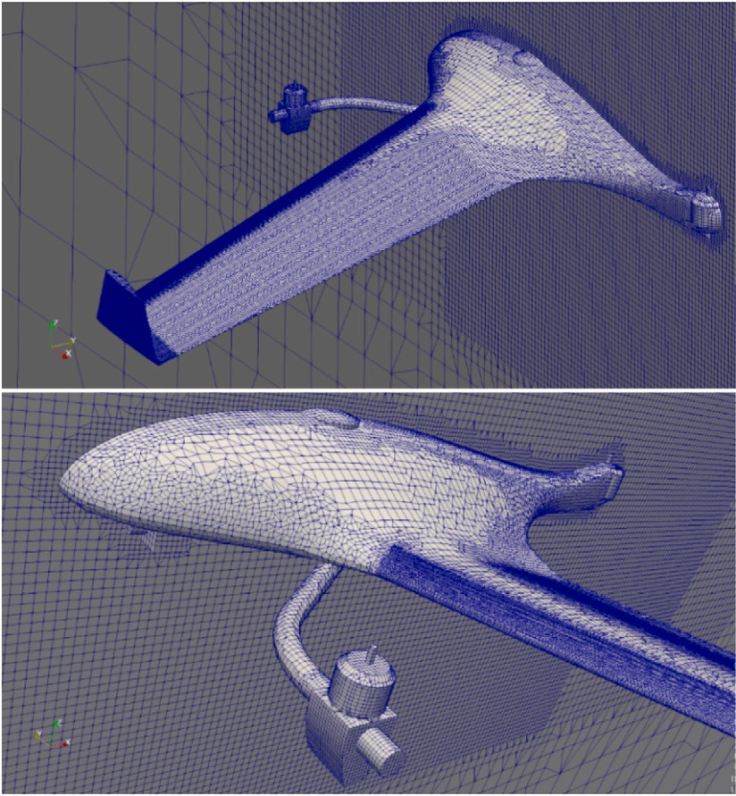 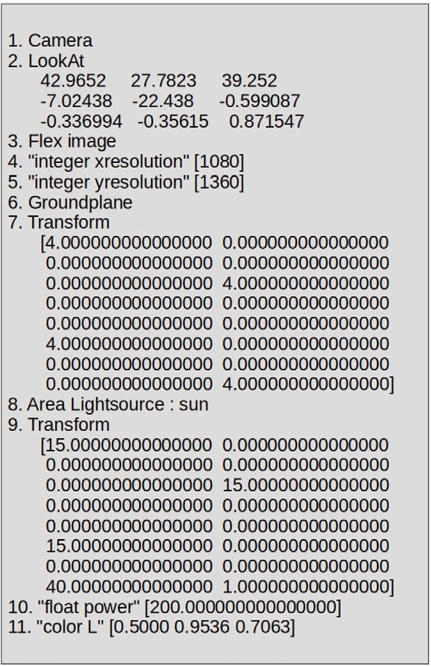

**/ig. 10.** Snappy Hex Mesh results.

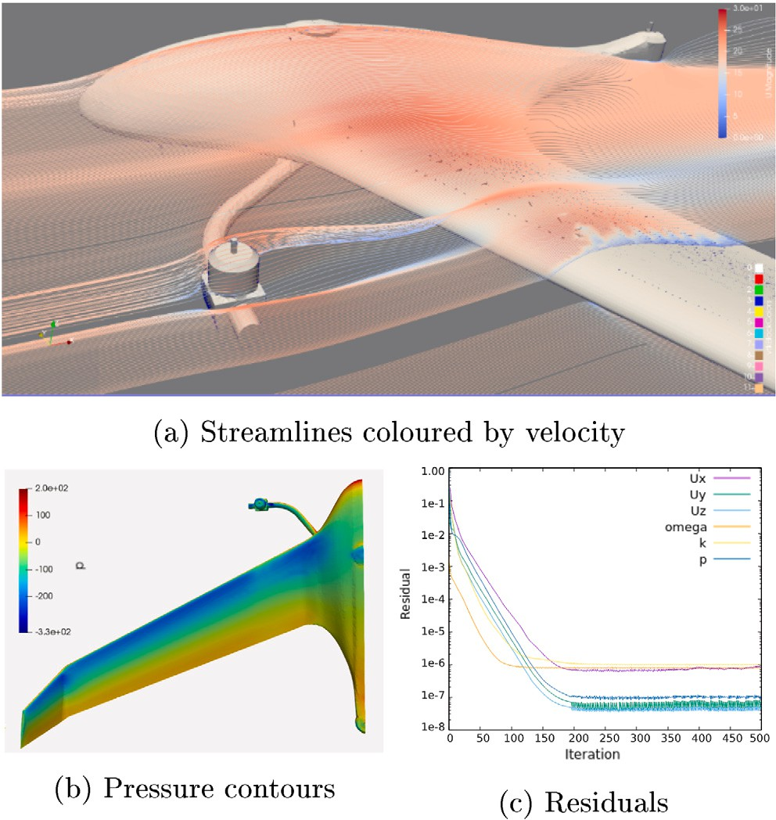

**/ig. 11.** CFD results.

A comparison between *SolidWorks* + *PhotoView 360* and *FreeCAD* + *LuxCore* is shown in Figs. 13(a) and 13(b). As shown, both the software output remarkable results with marginal differences.

# Development and integration

* 1. *UAV fabrication*

A prototype body is fabricated to validate some performance and stability characteristics of the aircraft. The body is made of Extruded polystyrene foam (XPS), and glass fiber fabric through a vacuum- assisted wet layup method. Some aspects of the configuration were altered depending on the resources available. The fuselage is made by hot-wiring the foam along each orthographic projection plane. This

**/ig. 12.** LuxCore render configuration.

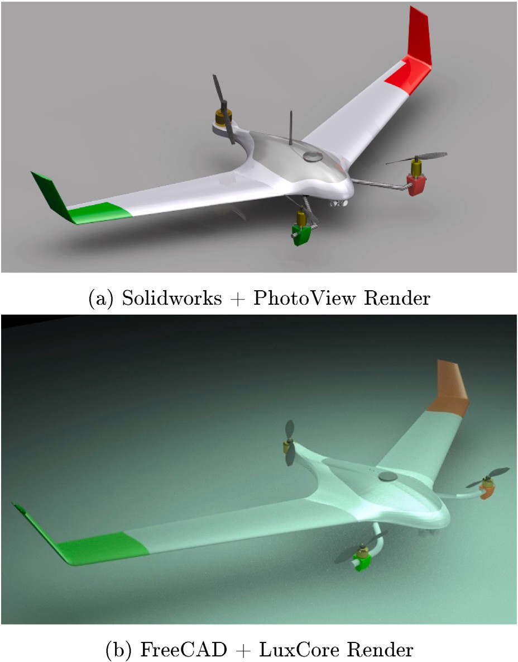

**/ig. 13.** Render comparison.

method was highly efficient in terms of time and ensured minimum sanding of the foam to get the final shape (Fig. 15(a)). Aluminum pipes were used to define the structure of the tri-copter assembly, and the foam blended wing body was integrated along with it (Fig. 15(d)). An in-depth analysis and comparison of the materials used and their rationale is beyond the scope of this paper but has been completed in [23].

The tilt-rotor system for the UAV was a highly sensitive component to design and fabricate. Initially, a geared system was designed and printed out of ABS plastic (Fig. 14(b)). The calculations of the required

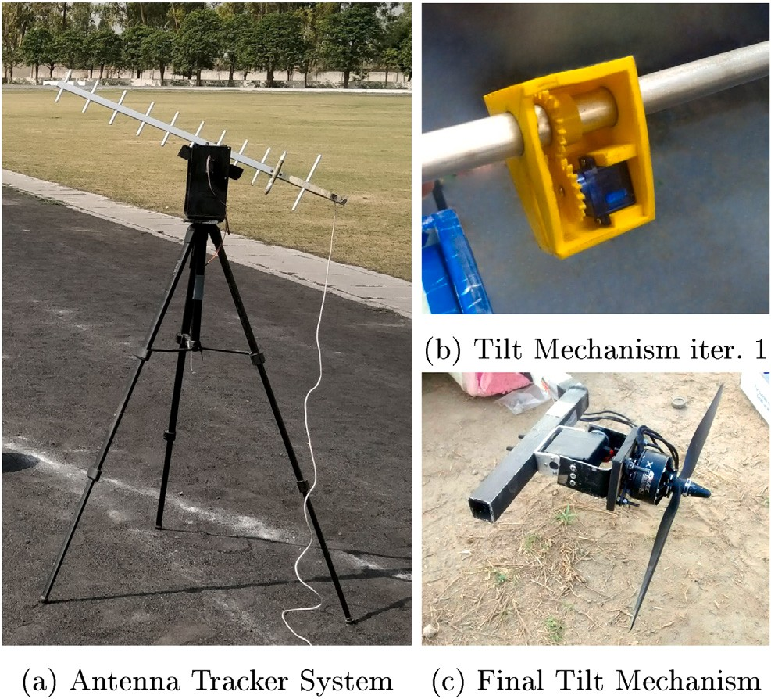

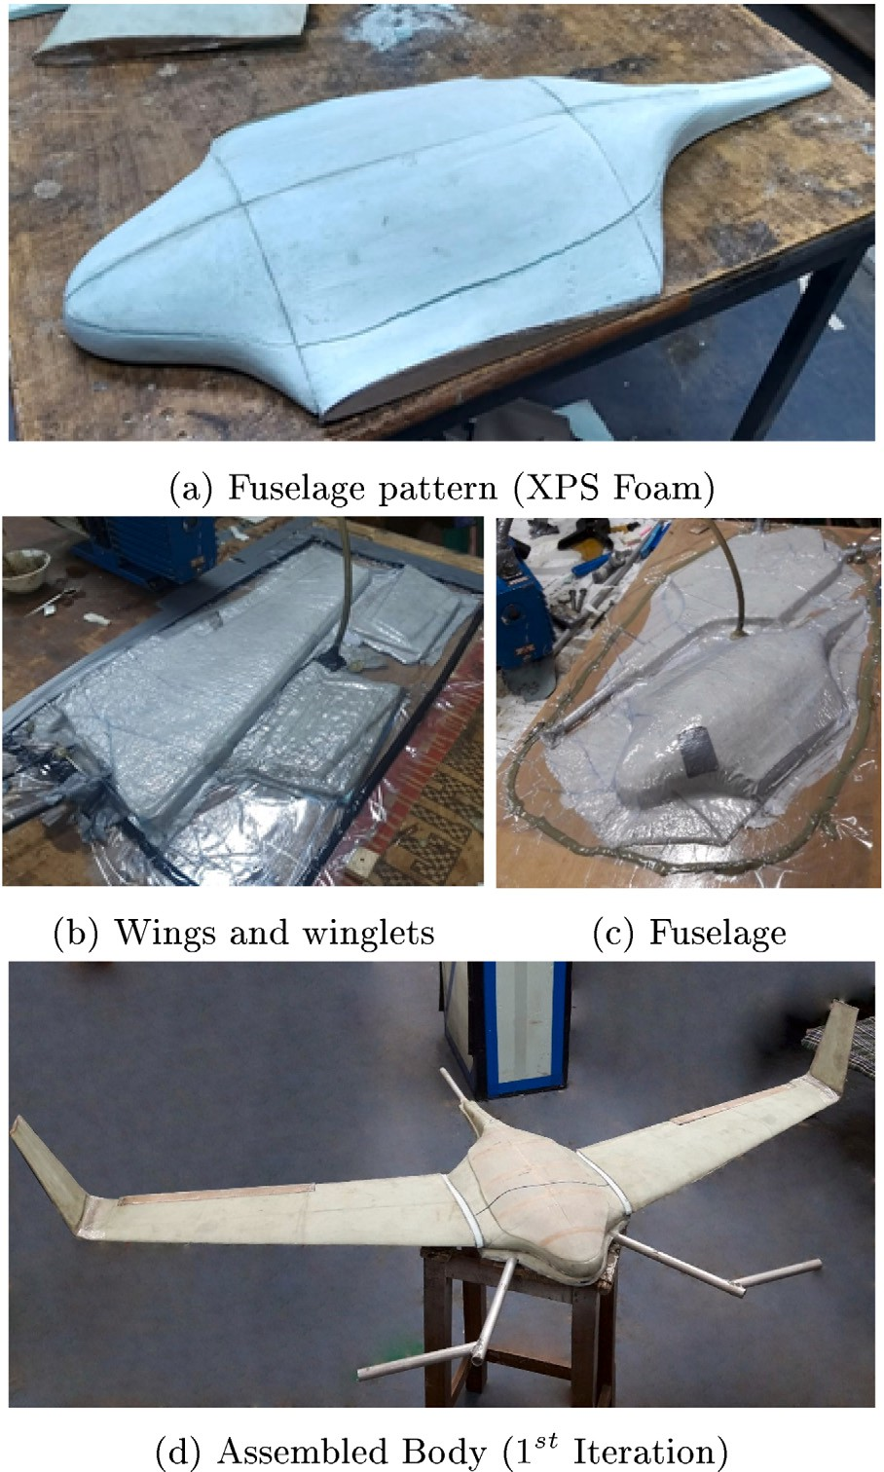**/ig. 14.** Mechanical subsystems.

servo torque were satisfied theoretically, and the mechanism was also bench-tested successfully at the motor’s burst thrust. However, it was found that on flight testing the UAV, the mechanism kept failing due to the vibrations and persistent servoing by the autopilot to maintain stability. After trying out many iterations, it was found that the gears in the mechanism could not be created by the 3D printer at our disposal with sufficient accuracy so as to resist the dynamic forces. The mechanism had to be replaced by a more expensive but robust pre-fabricated tilt servo, as shown in Fig. 14(c).

To track the UAV autonomously and ensure a proper line of com- munication from the ground control station, an antenna tracker system (ATS) was also developed (Fig. 14(a)). The ATS has two axes (Yaw and Pitch) made from Medium Density Fiberboard (MDF). The sys- tem is actuated by high torque servos and can be controlled using a transmitter.

**Table 7**

**/ig. 15.** Vacuum Wet-Layup fabrication.

* 1. *Subsystems and integration*

A well-defined architecture is shown in Fig. 16 highlighting data flow between the subsystems. A brief description of some of the com- ponents is given:

1. *Pixhawk 2 Cube*: An autopilot is necessary to carry out custom missions and provide additional stability during flight. It also allows the UAV to maintain a level altitude while transitioning into a cruise state.
2. *Here* GPS: A GPS is used to localize the UAV in its environment.
3. *RFD 900x* It is used to create a link between the ground sys- tems and the UAV. To plan missions dynamically with Mission Planner, this link is necessary.
4. External Sensors: These include everything ranging from the Battery Eliminator Circuits (BEC) and airspeed sensors.
5. *GitUp Git2P*: An on-board electro-optical camera selected for its FOV required in the mission.
6. *Tarot T4 3D*: A 3-Axis gimbal used to mount and stabilize the imaging sensor during flights.
7. *Nvidia Jetson Nano*: The onboard computer’s primary purpose is, to carry out the image recognition task among other necessary mission scripts.
8. *TP-Link 2.4 GHz* Wi-fi Modules: These Wi-fi modules are re- sponsible for publishing state information to other agents in the ad-hoc mesh network.

Tuned flight parameters.

|  |  |  |
| --- | --- | --- |
| Parameter | Original | Changed |
| ARSPD_FBW_MAX | 30 | 28 |
| ARSPD_FBW_MIN | 10 | 16 |
| PTCH2SRV_D | 0.200000003 | 0.04 |
| PTCH2SRV_P | 2.5 | 1 |
| Q_FRAME_CLASS | 1 | 7 |
| Q_TILT_YAW_ANGLE | 20 | 30 |
| Q_A_RAT_PIT_P | 0.25 | 0.2 |
| Q_A_RAT_YAW_P | 0.1800000072 | 0.25 |
| Q_A_THR_MIX_MAN | 0.1000000015 | 0.5 |

A key feature is the form of the modular propulsion battery cells. Multiple Lithium-Ion cells can be used to form arrangements so as to fit into the body (Fig. 17). The blended design offers a lot of payload volume, which is exploited by stacking nine parallel sets of six cells, each connected in series. Some battery packs are strategically placed very close to the CoG, allowing the user to swap the pack for additional payloads or sensors. The integration process is shown in Fig. 18.

# Results and discussions

* 1. *Flight testing*

The final prototype (Fig. 19) is tested physically over a few flight tests to evaluate flight dynamics and tune the autopilot. To tune

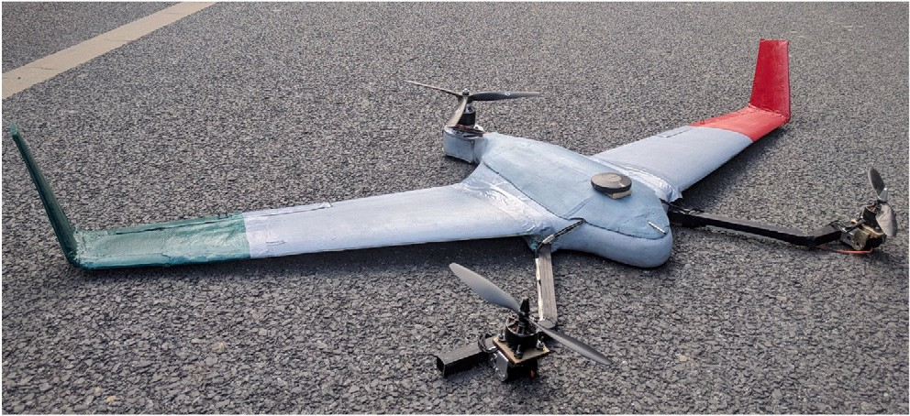

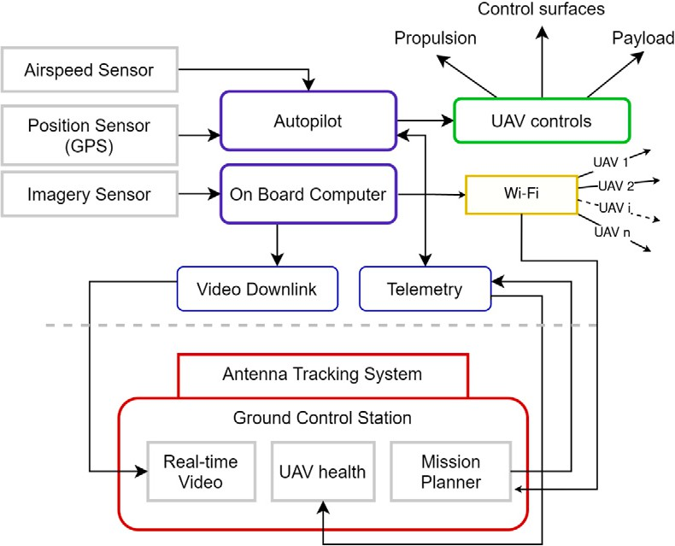**/ig. 16.** System architecture.

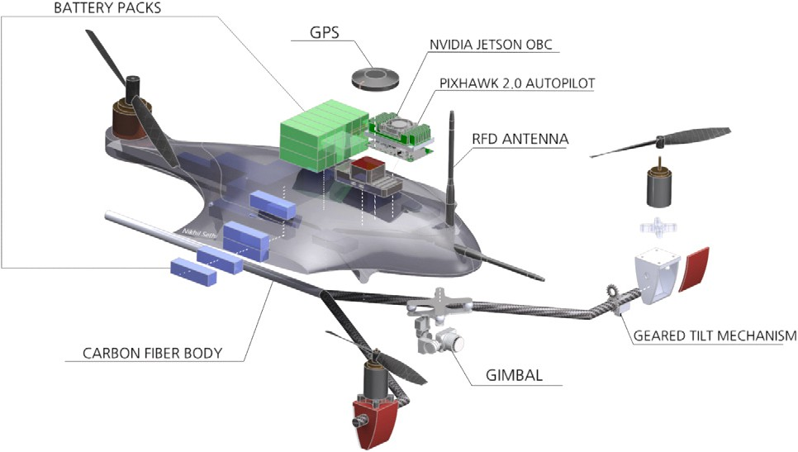

**/ig. 17.** Exploded view of subsystems.

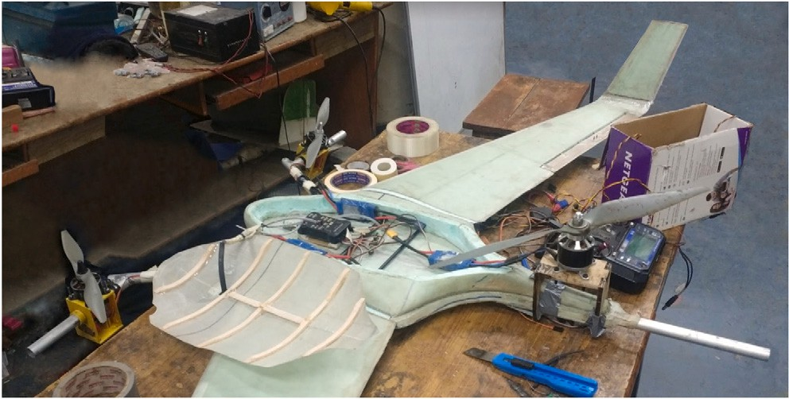

**/ig. 18.** Integration.

the Pixhawk autopilot, ArduPlane’s VTOL firmware is combined with Mission Planner. The Plane is successfully tuned in both hover and cruise modes and some important parameters with respect to the transition and stability are given in Table 7. Various parameters were tweaked to achieve stability. Maximum and minimum air-speeds (AR- SPD_FBW_MAX and MIN) during Fly-By-Wire mode were limited to the fixed-wing’s flight envelope. PTCH2SRV_D was lowered to 0.04 as the earlier value resulted in higher oscillations in the cruise phase. The Q_TILT_YAW_ANGLE was increased from 20 to 30 as our for- ward motors were closer to the center of gravity and therefore had a shorter moment arm for vectored yaw. The increase in Q_A_RAT_YAW_P resulted in reduced overall vibrations. To avoid damage to wings Q_A_THR_MIX_MAN was increased as it now prioritized attitude control over throttle.

However, further testing resulted in many unforeseen circumstances and truly revealed a VTOL system’s complex and dynamic behavior. A

**/ig. 19.** Final prototype.

flight video has been accompanied in the supplementary material (S5) representing this behavior. Some discussions and failures with respect to the same are done below:

* The hover mode is highly stable with a fast rate of climb as calculated in the propulsion section.
* The forward speed at about 45% throttle reached about 20 m/s, matching the expectation.
* It was noticed that whenever the aircraft’s speed increased, it be- came susceptible to even the slightest of disturbances in vectored yaw motion of the tilt mechanism. This made the aircraft turn on its axis, and the high stall speed (due to high wing loading) made a recovery from such an event nearly impossible.
* The above effect became even more pronounced in our case, where the cost and quality of 3D printed materials used in the tilt mechanism were meager due to the constrained budget.
* Some electronic failures such as interference and the overheating of components were also observed in certain flights. This is at- tributed to the higher current draw of the motors as compared to a normal fixed-wing or multi-rotor UAV.
* The lack of prior experience and exposure in handling or operat- ing a hybrid craft made it very challenging as there was no obvi- ous error to debug. The crashes occurred due to a combination of mechanical and electronic failures.
* Even post debugging the problem, finding the right solution was a tedious task due to the vast number of PID parameters and mechanical factors to tune. A significant help at this time was the shared experience of the community at the Arduplane forums.

As a result, a complete range test to evaluate performance became infeasible as the cost of repairs and extra parts exceeded the budget over time. However, the authors were able to set up a large number of good practices and organized debugging routines for VTOL aircraft to establish a foundation for future work in the same laboratory.

* 1. *Swarm testing*

Testing of the swarm communication architecture and algorithms was decoupled with that of the VTOL UAV. This was done to make debugging easier. There were two modes of testing completed:

* Fixed-wing: To test problems like the scalability of velocity with the number of UAVs and communication range, individual Sky- Surfer v4 model kits were used. (Fig. 20).
* VTOL: To test collective intelligence algorithms and subsystems that were independent of aerodynamic testing (eg. payload drop, ground communication link, formation flying etc.), swarm testing was also carried out in parallel on DJI 450 quad-copters (Fig. 21). The methodology and results have been published by the software team in [24], and are not covered here for the sake of brevity.

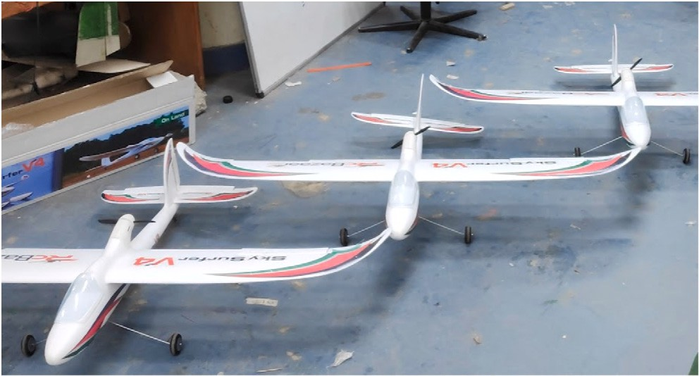

**/ig. 20.** SkySurfer v4 models used for swarm.

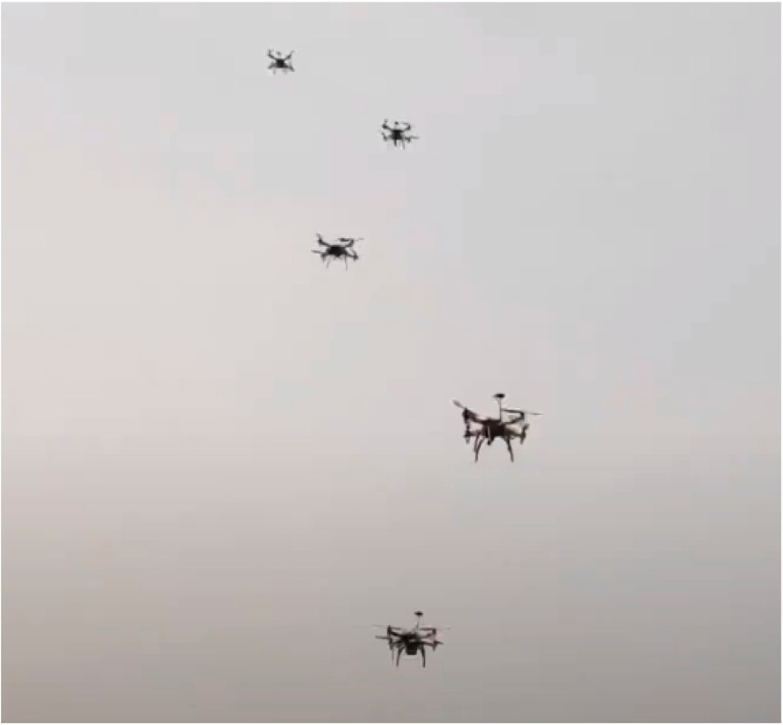

**/ig. 21.** Formation flying on DJI 450.

* 1. *Open source software*

While designing, particular care was taken that no commercial tools or codes be used. Using completely open-source tools has its own sets of challenges and advantages. Some of these are discussed below:

* Open-source tools are not without their limitations. Therefore, a significant effort was required to get acquainted with all tools at every stage and produce meaningful results.
* A key difference that tends to take up significant time is the lack of standardized coordinate systems, conventions of unit systems, and a general understanding of concepts among different soft- ware. This is because open-source software, while guided by some core teams, are collaborative. This results in different conventions on each platform. An effort from the user’s side is required to understand this point and change models/configurations accord- ingly.
* The above point becomes more important when there is a signifi-

cant lack of documentation, discussion forums, and code contrib- utors. This can be overcome by having multiple specialists work in a team to avoid learning conventions and background theory for two completely different software.

* The issue of ‘accuracy’ of results was verified collectively by

reading up on literature and conducting some of the analyses parallelly on commercial software and calculating errors.

# Outcome

The work in this paper can be summarized into the following tangible outcomes:

1. An aircraft design framework was conceptualized and used in practice to design a VTOL-FW UAV using a mix of traditional tools like aircraft constraint analysis and modern multidisci- plinary design methods.
2. The primary drivers of this design are the geometry optimiza- tion and propulsion architecture which were both developed specifically to solve the problem in this paper.
3. Both high and low fidelity tools were compared in the detailed design stage to give an estimate of possible shortcomings and advantages of using low-fidelity open-source software.
4. A number of parameters and configuration values with respect to each design software (PSO, CFD, rendering) were corroborated and presented in each section.
5. The UAV was fabricated using innovative manufacturing meth- ods and tuned using ArduPilot. The tuned parameters and their explanations were also presented.
6. An in-depth discussion was followed, which gives insight into the design process, shortcomings, and merits of using the framework conceived in this paper.

# Conclusion

In this paper, a VTOL-FW hybrid unmanned aerial system with a 100 km theoretical range and payload carrying capabilities was designed and fabricated. Some flight testing and tuning results were also corroborated, and the challenges were discussed for the same in the previous sections. The discussions in the above sections show the discrepancy between theoretical and experimental results, especially for VTOL systems. Such gaps need to be filled with better tools, further research into the causes of these differences and targeted flight-time practices to address the same. Aircraft design will always be a multi- disciplinary task where no linear approach exists. When equipped with suitable sensory payloads, hybrid systems like VTOL aircraft can boost target acquisition capabilities, use AI to take informed decisions, and even show collaborative behavior with homogeneous swarming agents. The authors hope to advance research for such generalized intelligent systems to solve problems in various fields like defense, agriculture, and humanitarian search and rescue.

# CRediT authorship contribution statement

**Nikhil Sethi:** Conceptualization, Methodology (systems, optimiza- tion, aircraft sizing, CAD, CFD, rendering, integration, flight testing), Writing – original draft, Software. **Saurav Ahlawat:** Conceptualization, Methodology (systems, propulsion, integration, flight testing), Writing – original draft, Formal Analysis.

# Declaration of competing interest

The authors declare that they have no known competing finan- cial interests or personal relationships that could have appeared to influence the work reported in this paper.

# Acknowledgments

The fabrication of the UAV in this paper was completed at the Unmanned Aerial Systems laboratory at Delhi Technological Univer- sity (UAS-DTU), and the authors acknowledge the help of the team members for the same.

# Appendix A. Supplementary data

Supplementary material related to this article can be found online at <https://doi.org/10.1016/j.array.2022.100183>. It contains system de- sign procedures, configuration trade-offs, data for regression analysis, and videos.

# References

1. [Gu Haowei, Lyu Ximin, Li Zexiang, Shen Shaojie, Zhang Fu. Development](http://refhub.elsevier.com/S2590-0056(22)00039-X/sb1) [and experimental verification of a hybrid vertical take-off and landing (VTOL)](http://refhub.elsevier.com/S2590-0056(22)00039-X/sb1) [unmanned aerial vehicle (UAV). In: 2017 international conference on unmanned](http://refhub.elsevier.com/S2590-0056(22)00039-X/sb1) [aircraft systems (ICUAS). IEEE; 2017, p. 160–9.](http://refhub.elsevier.com/S2590-0056(22)00039-X/sb1)
2. [Czyba Roman, Lemanowicz Marcin, Gorol Zbigniew, Kudala Tomasz. Construc-](http://refhub.elsevier.com/S2590-0056(22)00039-X/sb2) [tion prototyping, flight dynamics modeling, and aerodynamic analysis of hybrid](http://refhub.elsevier.com/S2590-0056(22)00039-X/sb2) [VTOL unmanned aircraft. J Adv Transp 2018;2018.](http://refhub.elsevier.com/S2590-0056(22)00039-X/sb2)
3. [Dündar Özgür, Bilici Mesut, Ünler Tarık. Design and performance analyses of a](http://refhub.elsevier.com/S2590-0056(22)00039-X/sb3) [fixed wing battery VTOL UAV. Eng Sci Technol Int J 2020;23(5):1182–93.](http://refhub.elsevier.com/S2590-0056(22)00039-X/sb3)
4. [Hadi Ghozali Suhariyanto, Kusnaedi Muhammad Ramadhan, Dewi Puspita,](http://refhub.elsevier.com/S2590-0056(22)00039-X/sb4) [Budiyarto Aris, Budiyono Agus. Design of avionics system and control scenario](http://refhub.elsevier.com/S2590-0056(22)00039-X/sb4) [of small hybrid vertical take-off and landing (VTOL) UAV. J Instrum Autom Syst](http://refhub.elsevier.com/S2590-0056(22)00039-X/sb4) [2015;2(2):67–71.](http://refhub.elsevier.com/S2590-0056(22)00039-X/sb4)
5. [Botero Emilio M, Alonso Juan J. Conceptual design and optimization of small](http://refhub.elsevier.com/S2590-0056(22)00039-X/sb5) [transitioning uavs using SUAVE. In: 18th AIAA/ISSMO multidisciplinary analysis](http://refhub.elsevier.com/S2590-0056(22)00039-X/sb5) [and optimization conference. 2017, p. 4149.](http://refhub.elsevier.com/S2590-0056(22)00039-X/sb5)
6. [Ozdemir Ugur, Aktas Yucel Orkut, Vuruskan Aslihan, Dereli Yasin,](http://refhub.elsevier.com/S2590-0056(22)00039-X/sb6) [Tarhan Ahmed Farabi, Demirbag Karaca, Erdem Ahmet, Kalay-](http://refhub.elsevier.com/S2590-0056(22)00039-X/sb6) [cioglu Ganime Duygu, Ozkol Ibrahim, Inalhan Gokhan. Design of a commercial](http://refhub.elsevier.com/S2590-0056(22)00039-X/sb6) [hybrid VTOL UAV system. J Intell Robot Syst 2014;74(1):371–93.](http://refhub.elsevier.com/S2590-0056(22)00039-X/sb6)
7. [Clarke Matthew, Smart Jordan, Botero Emilio M, Maier Walter, Alonso Juan J.](http://refhub.elsevier.com/S2590-0056(22)00039-X/sb7) [Strategies for posing a well-defined problem for urban air mobility vehicles. In:](http://refhub.elsevier.com/S2590-0056(22)00039-X/sb7) [AIAA scitech 2019 forum. 2019, p. 0818.](http://refhub.elsevier.com/S2590-0056(22)00039-X/sb7)
8. [Böhnke Daniel, Rizzi Arthur, Zhang Mengmeng, Nagel Bjoern. Towards a](http://refhub.elsevier.com/S2590-0056(22)00039-X/sb8) [collaborative and integrated set of open tools for aircraft design. In: 51st AIAA](http://refhub.elsevier.com/S2590-0056(22)00039-X/sb8) [aerospace sciences meeting including the new horizons forum and aerospace](http://refhub.elsevier.com/S2590-0056(22)00039-X/sb8) [exposition. 2013, p. 222.](http://refhub.elsevier.com/S2590-0056(22)00039-X/sb8)
9. [Jasak Hrvoje. OpenFOAM: open source CFD in research and industry. Int J Nav](http://refhub.elsevier.com/S2590-0056(22)00039-X/sb9) [Archit Ocean Eng 2009;1(2):89–94.](http://refhub.elsevier.com/S2590-0056(22)00039-X/sb9)
10. [He Ping, Mader Charles A, Martins Joaquim RRA, Maki Kevin J. Dafoam: An](http://refhub.elsevier.com/S2590-0056(22)00039-X/sb10) [open-source adjoint framework for multidisciplinary design optimization with](http://refhub.elsevier.com/S2590-0056(22)00039-X/sb10) [openfoam. AIAA J 2020;58(3):1304–19.](http://refhub.elsevier.com/S2590-0056(22)00039-X/sb10)
11. [Sun Luning, Gao Han, Pan Shaowu, Wang Jian-Xun. Surrogate modeling for](http://refhub.elsevier.com/S2590-0056(22)00039-X/sb11) [fluid flows based on physics-constrained deep learning without simulation data.](http://refhub.elsevier.com/S2590-0056(22)00039-X/sb11) [Comput Methods Appl Mech Engrg 2020;361:112732.](http://refhub.elsevier.com/S2590-0056(22)00039-X/sb11)
12. [Segui Marine M, Ghazi Georges, Botez Ruxandra M, Thompson Emily M. Design,](http://refhub.elsevier.com/S2590-0056(22)00039-X/sb12) [development and validation of a cessna citation x aerodynamic model using](http://refhub.elsevier.com/S2590-0056(22)00039-X/sb12) [openVSP software. In: 2018 modeling and simulation technologies conference.](http://refhub.elsevier.com/S2590-0056(22)00039-X/sb12) [2018, p. 3256.](http://refhub.elsevier.com/S2590-0056(22)00039-X/sb12)
13. [Herbst Sebastian, Staudenmaier Adrian. Using OpenVSP in a conceptual aircraft](http://refhub.elsevier.com/S2590-0056(22)00039-X/sb13) [design environment in MATLAB. In: Congress of the international council of the](http://refhub.elsevier.com/S2590-0056(22)00039-X/sb13) [aeronautical sciences. 2016.](http://refhub.elsevier.com/S2590-0056(22)00039-X/sb13)
14. [Sadraey Mohammad H. Aircraft design: a systems engineering approach. John](http://refhub.elsevier.com/S2590-0056(22)00039-X/sb14) [Wiley & Sons; 2012.](http://refhub.elsevier.com/S2590-0056(22)00039-X/sb14)
15. [Tyan Maxim, Van Nguyen Nhu, Kim Sangho, Lee Jae-Woo. Comprehensive](http://refhub.elsevier.com/S2590-0056(22)00039-X/sb15) [preliminary sizing/resizing method for a fixed wing–VTOL electric UAV. Aerosp](http://refhub.elsevier.com/S2590-0056(22)00039-X/sb15) [Sci Technol 2017;71:30–41.](http://refhub.elsevier.com/S2590-0056(22)00039-X/sb15)
16. [Serrano A Ramirez. Design methodology for hybrid (VTOL+ Fixed Wing)](http://refhub.elsevier.com/S2590-0056(22)00039-X/sb16) [unmanned aerial vehicles. Aeronaut Aeros Open Access J 2018;2(3):165–76.](http://refhub.elsevier.com/S2590-0056(22)00039-X/sb16)
17. [Raymer Daniel P. Aircraft design: a conceptual approach (AIAA education series).](http://refhub.elsevier.com/S2590-0056(22)00039-X/sb17) [Reston, Virginia; 2012.](http://refhub.elsevier.com/S2590-0056(22)00039-X/sb17)
18. [Dagur Rishabh, Singh Vikrant, Grover Shabir, Sethi Nikhil, Arora BB. Design of](http://refhub.elsevier.com/S2590-0056(22)00039-X/sb18) [flying wing UAV and effect of winglets on its performance. Int J Emerg Technol](http://refhub.elsevier.com/S2590-0056(22)00039-X/sb18) [Adv Eng 2018;8(3).](http://refhub.elsevier.com/S2590-0056(22)00039-X/sb18)
19. [Miranda Lester James. Pyswarms: a research toolkit for particle swarm](http://refhub.elsevier.com/S2590-0056(22)00039-X/sb19) [optimization in python. J Open Source Softw 2018;3(21):433.](http://refhub.elsevier.com/S2590-0056(22)00039-X/sb19)
20. [Chih Mingchang, Lin Chin-Jung, Chern Maw-Sheng, Ou Tsung-Yin. Parti-](http://refhub.elsevier.com/S2590-0056(22)00039-X/sb20) [cle swarm optimization with time-varying acceleration coefficients for the](http://refhub.elsevier.com/S2590-0056(22)00039-X/sb20) [multidimensional knapsack problem. Appl Math Model 2014;38(4):1338–50.](http://refhub.elsevier.com/S2590-0056(22)00039-X/sb20)
21. [Sahin Huseyin, Oktay Tugrul. Powerplant system design for unmanned tricopter.](http://refhub.elsevier.com/S2590-0056(22)00039-X/sb21) [Eurasia Proc Sci Technol Eng Math 2017;(1):9–21.](http://refhub.elsevier.com/S2590-0056(22)00039-X/sb21)
22. [Mobley R Keith. Gears and gearboxes. In: Plant engineer’s handbook. Elsevier;](http://refhub.elsevier.com/S2590-0056(22)00039-X/sb22) [2001, p. 629–37.](http://refhub.elsevier.com/S2590-0056(22)00039-X/sb22)
23. [Sethi Nikhil, Chauhan Prabhash, Bansal Shashwat, Singari Ranganath M. Robust](http://refhub.elsevier.com/S2590-0056(22)00039-X/sb23) [vehicle development for student competitions using fiber-reinforced composites.](http://refhub.elsevier.com/S2590-0056(22)00039-X/sb23) [In: Advances in manufacturing and industrial engineering. Springer; 2021, p.](http://refhub.elsevier.com/S2590-0056(22)00039-X/sb23) [61–76.](http://refhub.elsevier.com/S2590-0056(22)00039-X/sb23)
24. [Agrawal Anuj, Gupta Aniket, Bhowmick Joyraj, Singh Anurag, Nallan-](http://refhub.elsevier.com/S2590-0056(22)00039-X/sb24) [thighal Raghava. A novel controller of multi-agent system navigation and](http://refhub.elsevier.com/S2590-0056(22)00039-X/sb24) [obstacle avoidance. Procedia Comput Sci 2020;171:1221–30.](http://refhub.elsevier.com/S2590-0056(22)00039-X/sb24)