Available online at [www.sciencedirect.com](http://www.sciencedirect.com/)



AASRI Procedia 1 (2012) 52 – 57

AASRI

Procedia

[www.elsevier.com/locate/procedia](http://www.elsevier.com/locate/procedia)

2012 AASRI Conference on Computational Intelligence and Bioinformatics

# Mean-Shift Algorithm Apply for Infrared Imaging Tracking

zhang shuang1,2 *, qin yu-ping1

*1.The engineering & technical college of chengdu university of technology, leshan, 614000,china;*

*2.Department of Electrical and Electronics Engineering, Faculty of Science and Technology, University of Macau, Macau SAR, CHINA*

**Abstract**

An improved algorithm based on the modified histogram & mean shift is proposed in order to deal with difficulties in tracking small target of infrared imaging under complex background. The new algorithm is based on a lower dimension combining characteristic weighted histogram, the analogical degree measurement is determined by the Bhattacharyya coefficient, and the target is located through the mean shift. In order to improve the precision and robustness of the modified mean shift algorithm, particle filtering is used to obtain the optimal position estimate. Test results show that, the tracking point fluctuation could be reduced to no more than 2 pixels with the modified algorithm, for the test case.

© 2012 Published by Elsevier B.V. Open access under [CC BY-NC-ND license.](http://creativecommons.org/licenses/by-nc-nd/3.0/)

Selection and/or peer review under responsibility of American Applied Science Research Institute

*Keywords:*Target tracking; Small target of infrared imaging; features joint distribution; Mean shift; particle filtering

##### 1.Introduction

Small infrared target tracking under complex background is the key technology of precision-guided and early warning system. Compared with visible images, infrared images generally have the problems of low Signal Noise Ratio (SNR) and poor imaging contrast. The poor visibility of small target, the negative impact of illumination and Image noise, and the lack of homogeneity of the brightness in background area, would make tracking become more difficult. Mean Shift algorithm, which utilizes probability density function of pixels within the target region as the feature and transforms tracking to an optimization problem of a similarity function [1], is widely used in target tracking because of the characteristics of simple, robust, and real-time performance. However, because of the disability of characteristic information extraction from small target by using weighted histogram, the algorithm is not so desirable for tracking small

* Corresponding author. Tel.: 13541386694

*E-mail address:* [zhangshuanghua1@126.com](mailto:zhangshuanghua1@126.com)

2212-6716 © 2012 Published by Elsevier Ltd. Open access under [CC BY-NC-ND license.](http://creativecommons.org/licenses/by-nc-nd/3.0/)

doi:10.1016/j.aasri.2012.06.010

infrared target when the target moves too fast or has partially similarity with the backgrounds, which would cause the system unstable to miss the tracking target. This paper presents an improved mean shift tracking algorithm. By extracting several characteristic from target area, the algorithm structures a lower dimension combining characteristic weighted histogram, and combines mean shift with particle filtering [2], in order to precisely locate the small target and steadying in sequence infrared images. Test results show that the improvements on classical mean shift tracking algorithm are quite effective.

##### Algorithm descriptions

The new algorithm mainly includes target pattern definition, similarity measure, mean shift and particle filter.

###### *Target Pattern Definition*

Classical mean shift tracking algorithm uses gray histogram to describe the target appearance. Each pixel within the target region is given a larger value when calculating the probability histogram. The inner pixels are given a large weight, and outer pixels are given a smaller one. Given a set {***x****i*} *i=*1*m* of ***n*** points in the 2D space R2, the multivariate kernel density estimation with kernel ***k1*** (||) and window radius ***h***, computed in the point ***y*** is given by

*n*  **y**  **x** 2 

*p*ˆ **y**   *C*  *k*   *i* ** *b* **x**   *u* 

*u*  1⋯*m*

(1)

*u* 1 1  **h**   *i* 

*i*1  

Where ** (*x*) is the Delta function, C1 is normalization constant, it can be calculated from *m*

*u*1

*p*ˆ*u*

 1 . The

minimization of the average global error between the estimate and the true density yields the multivariate Epanechnikov kernel

1

##  2

*k* **x**  **

**x**  **x**  1

(2)

1 

##  0

### *otherwise*

It is not reliable to describe characteristics of infrared small target by the original grayscale only. Aiming at the problem upon, more characteristics should be extracted for structuring a joint character space, like local contrast mean difference, local average gradient strength, and local gray level probability, which are defined as

* + 1. Local Contrast Mean Difference (*LCMD*)

*LCMD*(*i*, *j*)  1  *f* (*k*, *l*)  1 

*f* (*k*, *l*)

(3)

*nin* (*k* ,*l* )*Nin* (*i*, *j* ) *nout* (*k* ,*l* )*Nin* (*i*, *j* )

Local contrast mean difference will be calculated both inside and outside of the local window in formula (3), where (*i*, *j*) is the center point of the window, (*k*, *l*) is the pixel location within the window.

* + 1. Local Average Gradient Strength (*LAGS*)

*LAGS*(*i*, *j*)  1

### *n*

 *Gin*

(*k*, *l*)  1

### *n*

 *Gout*

(*k*, *l*)

(4)

Where

*in* (*k* ,*l* )(*i*, *j* )

*out* (*k* ,*l* )(*i*, *j*)

*G* (*k*, *l*)  *Gh*  *Gv* , *Gh*  *f* (*k*,*l*)  *f* (*k*,*l* 1) , *Gv* 

*f* (*k*,*l*)  *f* (*k* 1,*l*)

*in in in in in*

* + 1. Local Gray Level Probability (*LGLP*)

*LGLP* (*m*, *n*) 

*f* (*i*  *m*, *j*  *n*)

(5)

*ij r r*

 

*x* *r y* *r*

*f* (*i*  *x* , *j*  *y* )

Where *m*, *n*  (*r*, *r* 1,⋯,0⋯, *r* 1, *r*) ,

*f* (*i*, *j*) is the gray value of any pixel in the local window.

Calculating

*p LCMD* , *pLCGS* , *pLGLP* , *pGRAY*

by formula (1), and merging them, we can get a new target

*u u u u*

histogram model as follow

*P fusion*  **  *pLCMD*  **  *pLCGS*  **  *pLGLP*  **  *pGRAY*

*u u u u u*

(6)

Where

**  0.2*C*

 *LCMD*

, **  0.2*C*

 *LCGS*

, **  0.2*C*

 ** *LGLP* ,

*u y u y u y*

**  0.4*C*  *GRAY* ,used to balance the proportion of each characteristic in the weighted histogram. ** is

*u y y*

similarity coefficient,and *Cu* is normalization constant,which is calculated from **  **  ** ** 1. Figure 1(c) shows the new histogram which is calculated by formula (6).Compared with the classical histogram in figure 1(b), the new histogram can take a more balanced probability distribution and more target information, which will benefit the follow-up tracking.

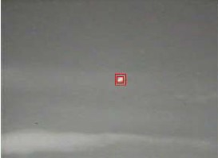 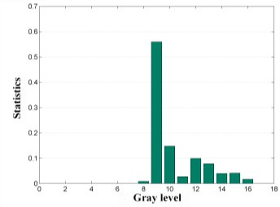 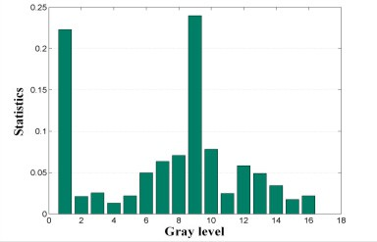

(a) Original image (b) The classical histogram (c) The modified histogram

Fig.1 Target histogram comparison

###### *Similarity Measure*

Without loss of generality, we denote by ***P0*** the density distribution of the original target model and by ***Py*** that of the candidate at location ***y*** in next image frame, so ***P0*** and ***Py*** can be defined as

***P***



0

*u*

Original:

ˆ  *p*ˆ

*u* 1⋯*m*

(7)

Candidate:

***P***ˆ***y***  *p*ˆ*u* ***y***

(8)

And here we use the Bhattacharyya coefficient as similarity function [4], which is defined as

*u* 1⋯*m*

**  ***P*ˆ ,*P*ˆ  *m p*ˆ *p*ˆ ***y***

(9)

***y*** 0 ***y***

*u u*

*u* 1

###### *Mean Shift*

Mean shift is a kind of non-parametric density estimation method, which was expected to be applied to in objects Segmentation and tracking. The successful application was done by Dorin Comaniciu .etc [5] [3]. Then based on Taylor series expansion of the formula (9), *****y*** can be approximated as

1 *m*

*p*ˆ*u* **y**0  *p*ˆ*u*

*C n*  **y**  **x** 2 

** **P** , **P**  

 

 1  *w k*   *i* 

(10)

Where,

0 **y**

*u* 1

2

*i* 1

*i*1  

2

**h**

*m*

*wi*  

*u*1

*p*ˆ*u*

*p*ˆ0

**y**0

**[*b* **x***i*   *u*]

(11)

The candidate center ***y***j+1 re-positioned in each iteration is calculated as follow

**y** *j*  **x***i* **h**

 *n* 

 *n* 



 ⋯ (12)

**y** *j*  **x***i* **h**

**y** *j*1

**x***i wi k*1  

*wi k*1  

*j* 1, 2

*i*1

  *i*1  

###### *Particle Filtering*

Particle filtering is used to improve the tracking performance of mean shift, and the method of MSPF (the Combination of Mean Shift and Particle Filtering) is as follows.

1. Initializing the searching frame

We can Sample N particles from the prior probability distribution

*ppri* ( *x* ) , and this particles is denoted by *xi* , *wi* .

1. Importance sampling
   1. Sampling:

0 0 0

*x*(*i*)  *Mean*  *Shift*(*x*(*i*) )  *v* , *v* ~ *N* (**,** ) Where, ** is the mean value of system noise, ** is the

*k* 0:*k* 1 *k* 1 *k*

variance of system noise, calculated as follow

*m*

**  ( *yi*

*i*1

− *y*1 )*i*

*m*

2

, **  ( *y*

*i*

*i*1

* *y*1
* **)2 *m*

(13)

* 1. Calculating the weight:

(*i* )

*w*



*k*

1 *d* 2

#### exp( ) 

2**

2** 2

*N*

2**

#### 1 exp(

1 **(*q*(*i*), *py* (*i*))) 2** 2

* 1. Normalization: *w*˜ (*i*)  *w*(*i*)[ *w*( *j*) ]1

*k k k*

*j* 1

1. Target position estimate

*E*(*x* )   *x*(*i*)*w*(*i*)

*k k k*

*i*

(14)

1. Fixed re-sampling
   1. Calculating the cumulative weights from the sample set: *c*(*i*)  *c*(*i*1)  *w*(*n*)

*k k k*

* 1. Searching for the minimum value of *n* to suit for *c*(*n*)  *u* from the sample set, where *u* is a random number which is distributed in range (0, 1) uniformly, and setting *x*(*i*)  *x*(*n*) .

*k*

*k k*

##### Tests

To verify the effectiveness of the proposed algorithm, the target tracking tests are carried out. The size of infrared image for test is 320*240 pixels, the image’s SNR is about 3.8754, the frame rate of the video is 15 frames per second. All the implementations of the classical tracking algorithm (algorithm1) and the modified algorithm (algorithm2) have been

tested on a 2.8GHz PC.

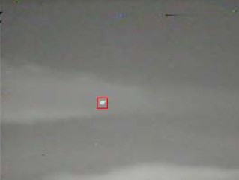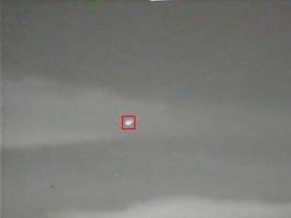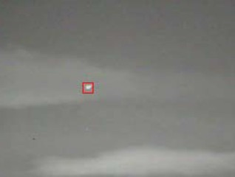

52nd frame 53rd frame 54th frame

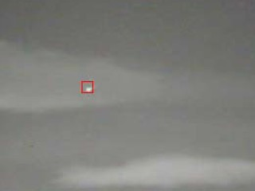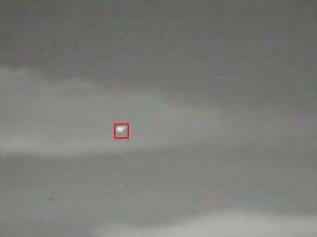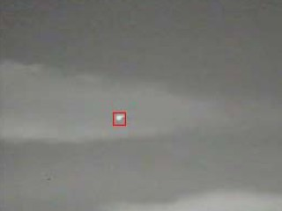

58th frame 59th frame 60th frame

Fig.2 The tracking results by the algorithm2

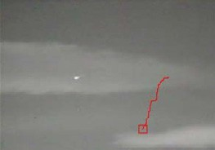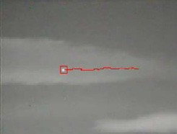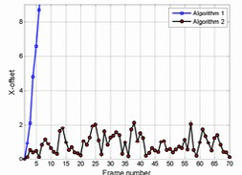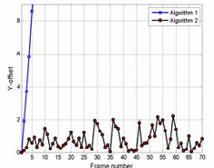

(a) algorithm 1 (b) algorithm 2 (a) Horizon (b) Vertical

Fig.3 Trace of the tracking points Fig.4 Tracking point shift with the algorithm 1 and algorithm 2

Among the 70 frame images from a image sequence, the modified algorithm could accurately track the target location. Target acquisition probability was close to 100%. Figure 2 shows several frames among the tracking results by the modified algorithm. It is observed that, the tracking effect can be well maintained even the background luminance of images obviously changed. Figure 3 shows the trace of the tracking points by algorithm1 and algorithm2. From figure 3(a), it can be seen that algorithm 1 lost its efficacy obviously. Compared with algorithm 1, the whole process of algorithm 2 was robust as we have seen in Figure 3(b). Figure 4 shows the tracking error of the two algorithms on horizontal and vertical direction. The statistical results show that, with algorithm 1, the tracking point seriously deviated from original target before long. While using the proposed algorithm 2, the tracking point fluctuation could be reduced to no more than 2 pixels successfully.

##### Conclusions

This paper presents a modified algorithm for small target tracking of infrared imaging. Aiming at the problem that the target characteristic distilling method based on weighted grave histogram is complex and unable to detect targets motion locus timely, sampling efficiency of which is low, a lower dimension combining characteristic weighted histogram method was put forward. In order to precisely locate the target, a small target tracking method based on both mean shift and particle filtering was brought forward. The tests show that the algorithm is able to locate the small target precisely in sequence images when the target is moving swiftly in complex circumstances. It can adapt to the changes of light and similar background, improve the robustness of tracking algorithm.

##### References

1. K. FUKUNAGA, L. D. HOSTETLER. The Estimation of the Gradient of a Density Function with Applications in Pattern Recognition [J].IEEE Trans. Information Theory, 1975 21(5): 32-40.
2. M. ARULAMPALAM, S. MASKELL, N. Gordon. A Tutorial on Particle Filters for Online Nonlinear/Non-Gaussian Bayesian Tracking [J]. IEEE Trans. On Signal Processing, 2002, 50(2):174-188
3. Dorin COMANICIU, Visvanathan RAMESH, Peter MEER. Kernel-based Object Tracking [J]. IEEE Trans. Pattern Anal. Mach. Intell., 2003, 24(5): 564-577.
4. T. KAILATH. The Divergence, Bhattacharyya Distance Measures in Signal Selection [J]. IEEE Trans. Comm. Technology, 1999, 15(2): 253-259.
5. Dorin COMANICIU, Peter MEER. Mean Shift: a Robust Approach toward Feature Space Analysis [J]. IEEE Trans. Pattern Anal. Mach. Intell., 2002, 24(5): 603-619.