Available online at [www.sciencedirect.com](http://www.sciencedirect.com/)



AASRI Procedia 2 (2012) 256 – 261

AASRI

Procedia

[www.elsevier.com/locate/procedia](http://www.elsevier.com/locate/procedia)

2012 AASRI Conference on Power and Energy Systems

# Methodology for Thermal Analysis of Bayonet Reactor

Alexander Mendozaa*, Juan-Luis Francoisa, Pamela Nelsona, Alejandro Anayab

*aDepartamento de Sistemas Energéticos, Facultad de Ingeniería – UNAM, Paseo Cuauhnáhuac No. 8532, Jiutepec, Morelos, C.P. 62550, Mexico.*

*b Departamento de Ingeniería de Proyectos, Facultad de Química – UNAM, Circuito Exterior SN, Ciudad Universitaria, Coyoacán, D.F.,*

*C.P. 04510, Mexico.*

Abstract

Whether green house gas emissions are mainly responsible for global warming or not, the truth is that they have to be reduced in order to improve air quality and to be able to face many problems which span from environmental issues to economical and political ones. Nuclear hydrogen production (NHP), defined as those processes that obtain energy from nuclear reactors to drive the chemical plants in which hydrogen is produced, have been studied since the early 70's as an effective way to provide clean fuels to the automotive and electricity industry. In the past, this concept was really far from industrial application; however, recent advances in nuclear and chemical technology are bringing these plants closer to reality. Two of the most promising NHP technologies have an important step in common: sulfuric acid decomposition, this part of the process is the most energy demanding and the one which operates at the highest temperature; therefore if some improvements in energy usage can be done in this section they will have a strong and positive impact on the whole process efficiency. In the present study, a very simple but realistic methodology is presented to simulate and analyze this important section, validation is achieved through direct comparison with experimental data and a thermal optimization is performed. A 4% reduction in energy consumption is achieved by varying the reactor's outlet temperature.

© 2012 Published by Elsevier B.V. Selection and/or peer review under responsibility of American Applied Science Research Institute

© 2012 Published by Elsevier B.V. Selection and/or peer review under responsibility of American Applied Science Research Institute

© 2012 Published by Elsevier B.V.

Selection and/or peer review under responsibility of American Applied Science Research Institute

Open access under [CC BY-NC-ND license.](http://creativecommons.org/licenses/by-nc-nd/3.0/)

*Keywords*: Nuclear hydrogen production, Bayonet reactor, Sulfuric acid decomposition.

* Corresponding author. Tel.: +52 55 5622 30 48; fax: +52 55 5622 30 48.

*E-mail address:* [*iqalexmdz@yahoo.com.mx*](mailto:iqalexmdz@yahoo.com.mx)

2212-6716 © 2012 Published by Elsevier B.V. Selection and/or peer review under responsibility of American Applied Science Research Institute

Open access under [CC BY-NC-ND license.](http://creativecommons.org/licenses/by-nc-nd/3.0/) doi:10.1016/j.aasri.2012.09.043

1. Introduction

The bayonet reactor is one of the most important pieces of equipment in the Sulfur-Iodine Process and Sulfur Hybrid Process [1], both of which are leading the emerging technologies for clean hydrogen production [2]. Inside this device is where heat, coming from nuclear reactors or from solar plants through thermal fluids, is converted into chemical energy by splitting the sulfuric acid molecule into water, sulfur dioxide and oxygen, according to the following chemical reactions [2].

H2SO4 → H2O + SO3 (1)

SO3 → SO2 + ½O2 (2)

At the inlet of the bayonet reactor a minimum of 40% mol concentration is desirable [3], therefore water evaporation starts downstream with a flash concentration section. The concentrated acid is sent to the recirculation mixer where it is mixed with the condensed acid that remains after passing through the decomposer, the mix entering the reactor is preheated with the hot effluent, recovering energy by this operation. Figure 1 shows a schematic view of the reactor.

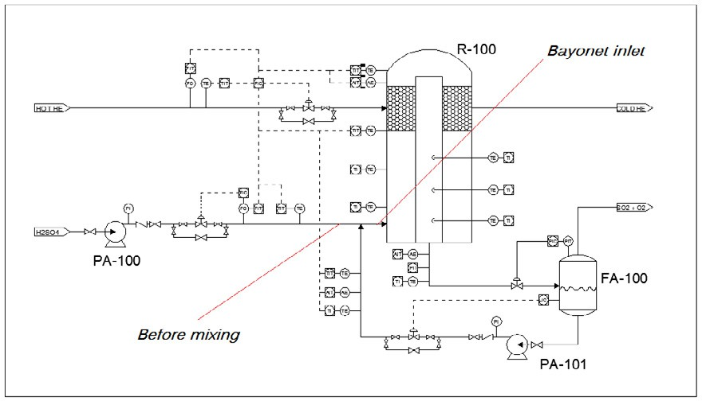

Fig. 1. Bayonet reactor

A progressive acid vaporization followed by: chemical decomposition (reaction 1), gas heating and finally another chemical reaction (reaction 2) occur inside the reactor. For thermal integration purposes, this is called cold stream. After exiting the catalytic section, the hot gas starts a cooling process in which its residual heat is transferred to the cold stream; this is called hot stream.

Once that heat has been recovered the net energy difference is covered by the heat source through the thermal fluid loop, in this sense the higher the thermal recuperation, the lower the net energy requirement is.

As the gas is cooled a portion of water and sulfuric acid condenses, the rate of condensable gases in the gas phase to the total moles in the system is called vaporization rate and is defined in a later section of this paper.

1. Methodology for simulation of sulfuric acid decomposition

A study of the experimental data reported in Chemical Engineer's Handbook [4] was performed along with numerical analysis. Dynamic interpolation and extrapolation based on this data and computational programming are the basis for SEAS V 0.1, a sulfuric acid modeler which has been developed by this research group.

Table 1 shows the main data sources and basic methods to model the different stages of sulfuric acid decomposition.

Table 1. Data for calculation

Physical phenomenon

Phase Method Source of data for physical equilibrium and enthalpy calculation*

Acid heating Liquid Quadratic interpolation and

numerical model for pressure and temperature extrapolation.

FIG. 2-30 Enthalpy-concentration diagram for aqueous sulfuric acid at 1 atm.

TABLE 2-12 Water Partial Pressure, bar, over Aqueous Sulfuric Acid Solutions.

Acid Evaporation

/ Condensation

Liquid – Gas Quadratic interpolation and

Antoine parameters derived from experimental data

TABLE 2-13 Sulfur Trioxide Partial Pressure, bar, over Aqueous Sulfuric Acid Solutions.

TABLE 2-14 Sulfuric Acid Partial Pressure, bar, over Aqueous Sulfuric Acid.

TABLE 2-15 Total Pressure, bar, of Aqueous Sulfuric Acid Solutions

FIG. 2-30 Enthalpy-concentration diagram for aqueous sulfuric acid at 1 atm.

Acid decomposition

Liquid – Gas and Gas

Gibbs energy minimization TABLE 2-220 Heats and Free Energies of Formation of Inorganic Compounds

Gas heating / cooling

Gas Partial pressure and polynomial addition of specific heats + pressure correction

TABLE 2-194 Heat Capacities of the Elements and Inorganic Compounds

* Perry Chemical Engineer's Handbook, Seventh Edition, McGraw-Hill, 1999.

* 1. *Two phase modeling*

Analysis of two phase region of sulfuric acid system considers:

* + - Physical equilibrium
    - Chemical equilibrium
    - Sulfur trioxide formation in the gaseous phase
    - Mass balance

Figure 2 shows a generic system in which a fresh solution of sulfuric acid is partially evaporated and exits as a vapor stream and a liquid one. Equation 3 represents the global molar balance in the system.

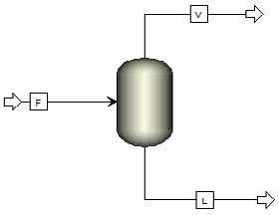

Fig.2. Sulfuric acid evaporation

|  |  |  |  |
| --- | --- | --- | --- |
|  | | *F*  *V*  *L*  *R* | (3) |
| F | = Molar feed to the system |  | [=] kmol/s |
| V | = Vapor flow |  | [=] kmol/s |
| L | = Liquid flow |  | [=] kmol/s |
| R | = Sulfur Trioxide conversion rate (Eq. 1) |  | [=] kmol/s |

From initial and final liquid compositions, conversion rate R can be calculated using the next equation:

*FxV* (*xF*  *xL* )

*R*  *SO*3 *H* 2 *SO*4 *H* 2*SO*4

 *x*

 (*x*

1)* *x*

(4)

*V SO*3

*x*

*V*

*H* 2 *SO*4

*V SO*3

*L*

*H* 2 *SO*4

*y z*

*x*

by:

= Molar fraction of “z” component in the “y” phase [=] ---

For a known pressure and a specific liquid equilibrium composition, all other parameters are obtained

*xV*   (*x L*

, *P*)

(4)

*H* 2 *SO*4

*V*

*x*

*H* 2*O*

1

  2

*H*2 *SO*4

*L*

(*x*

*H* 2 *SO*4

, *P*)

(5)

*xV*   (*x L*

, *P*)

(6)

*SO*3 3 *H* 2 *SO*4

 1  *x*



*L*

*x*

*H* 2*O*

*L H*2 *SO*4

(7)

*i* = Correlation functions obtained with SEAS V0.1 [=] ---

P = Total pressure [=] Bar

Defining the vaporization fraction as:

**  *V*

*V*  *L*

(8)

Then:

*FxV*

*R*  *SO*3

1 *xV*

*SO*3

(9)

Liquid equilibrium composition can be calculated for any vaporization fraction:

1  **

1  ** * *xV* 

*xV*  

*x L*

 *xV*

* *x F*

 *SO*3   *e*

(10)

*H* 2 *SO*4

  *H* 2 *SO*4

 

**

*SO*3

1  ** 

*H* 2 *SO*4  **





1  ** * *xV* 



*xV*  

*x L*

 *xV*

* *x F*

 *SO*3 

*H* 2 *SO*4

 ** 

*H* 2 *SO*4

*SO*3

*H* 2 *SO*4  ** 

(11)

*x L*

  *x L*

   

*H* 2 *SO*4 *n*1

*H* 2 *SO*4 *n*

 *e* 

 

 *x L* 

 *H* 2 *SO*4  *P*,**

1. Methodology Validation

Figure 3 shows a comparison between experimental data of a bayonet reactor [5], obtained from an international cooperation, and the results of applying the previous methodology.

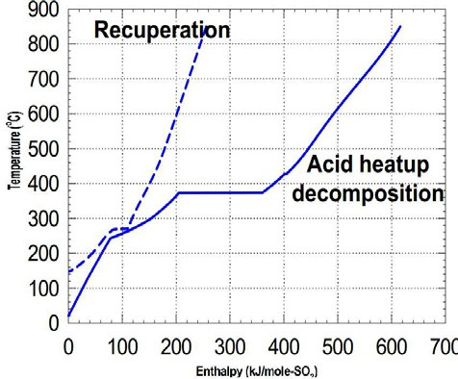900

Hot

Cold

800

700

600

Temperature ˚C

500

400

300

200

100

0

0 100 200 300 400 500 600 700

kJ/mol of SO2

Fig.3. Comparison of experimental and simulated data

Figure 4 shows a screen shot of SEAS V 0.1, where the difference of energy requirements is explained. When the reference substance is the sulfuric acid feed to the bayonet (see fig. 1 for reference points), both data, experimental and simulated correspond to 370 kJ/mol [5].

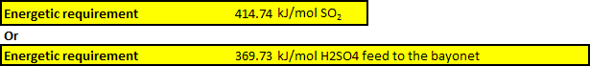

Fig.4. Energy requirement considering two different reference points

1. Thermal optimization of bayonet reactor

Due to constraints on the extension of this paper, the optimization path cannot be fully described, but it is important to describe that the outlet stream's vaporization fraction (alpha) is the variable for thermal

optimization. Figure 5 shows results for this study. According to figure 5, an alpha of 79%, corresponding to an outlet temperature of 144°C reduces the energy consumption in 4% compared to an exit alpha of 70% or the equivalent outlet temperature of 127°C. This case is calculated for an inlet stream at 40°C and 40%mol of sulfuric acid.

kJ/mol SO2



434

432

430

428

426

424

422

420

418

416

414

412

70%

72%

74% 76%

78%

80%

82% 84%

86%

88%

Outlet stream vaporization fraction

Fig.5. Thermal optimization

1. Conclusions

The methodology presented in this paper, although simple and based on public information, is a useful tool to perform analysis on sulfuric acid decomposition systems even when they are as complex as the bayonet reactor.

Acknowledgements

To the National Council of Science and Technology (CONACYT) for the doctoral scholarship awarded to Alexander Mendoza. Additionally, thanks to the National Autonomous University of Mexico for their support through the research project PAPIIT IN106310.

References

1. Brown Nicholas, “Analysis Model for SI and HYS Termochemical Cycle Coupled to High Temperature Gas Cooled Reactor”, 2007 International Topic Meeting on Safety and Technology of Nuclear Hydrogen Production, Control and Management, Estados Unidos, 2007
2. United States Department of Energy, “Hydrogen Posture Plan an Integrated Research, Development and Demonstration Plan”, United States (2006).
3. Junhu Zhou, “Thermodynamics and kinetics modeling for reactions and thermal efficiency evaluation of open-loop SI thermochemical cycle”, World Hydrogen Energy Conference, Lyon, France, 2006.
4. Perry Robert, Chemical Engineer's Handbook, Seventh Edition, McGraw-Hill, 1999
5. Moore, R.C., et. al., “An Integrated Laboratory-Scale Experiment on the S-I Thermochemical Cycle for Hydrogen Production”, 4th Int. Meeting on High Temperature Reactor Technology, Washington, D.C., 2008.