[Artificial Intelligence in Agriculture 5 (2021) 185–195](https://doi.org/10.1016/j.aiia.2021.08.002)

Contents lists available at [ScienceDirect](http://www.sciencedirect.com/science/journal/)

Artificial Intelligence in Agriculture

journal homepage: [http://www.keaipublishing.com/en/journa ls/artificial- intelligence- in-agriculture/](http://www.keaipublishing.com/en/journals/artificial-intelligence-in-agriculture/)

[](http://crossmark.crossref.org/dialog/?doi=10.1016/j.aiia.2021.08.002&domain=pdf)Modeling the energy gain reduction due to shadow in flat-plate solar collectors; Application of artificial intelligence

Morteza Taki ⁎, Rouhollah Farhadi

*Department of Agricultural Machinery and Mechanization Engineering, Agricultural Sciences and Natural Resources University of Khuzestan, P.O. Box: 6341773637, Mollasani, Iran*

a r t i c l e i n f o

*Article history:*

Received 13 May 2021

Received in revised form 10 July 2021 Accepted 25 August 2021

Available online 24 September 2021

*Keywords:*

Multilayer perceptron Optimization

Energy

Sensitivity analysis

a b s t r a c t

Energy lost due to shadow in the absorber plate of solar collectors can decrease the solar energy gain. In some studies, mathematical modeling was applied for calculating the energy gain reduction due to shadow in flat- plate solar collectors. In this study, ANN method was developed for modeling the energy gain reduction. Multi- layer Perceptron (MLP) with one hidden layer and a range of neurons (5–30) by two training algorithms (LM and BR) and tangent sigmoid activation function (TanSig) were used by help of K-fold cross validation method. In the first section, six set of solar collector dimensions were used (1×1; 1×1.5; 1×2; 1.5×1.5; 1.5×2 and 2×2). In the second section all the range of dimensions were used as the inputs. The results of the first section showed that MLP with BR training algorithm can predict the energy gain reduction with minimum MAPE and RMSE in all the categories. The best results related to (1.5×1.5) dimension that achieved a MAPE of 0.15 ± 0.09% and RMASE of 4.42 ± 2.43 KJm−2 year−1, respectively. The results of the second section indicated that BR is a better training algorithm than LM. The MAPE and R2 factors for the best topology (5-27-1) were 0.0610 ± 0.0051% and 0.9999 ± 0.0001, respectively. The results of the sensitivity analysis showed that height has the biggest impact on total energy gain reduction due to shadow in flat-plate solar collectors. Finally, the results of this study indi- cated that by using ANN and decrease the energy lost, the efficiency of solar collectors can be increased in all applications such as industry and agriculture.

© 2021 The Authors. Publishing services by Elsevier B.V. on behalf of KeAi Communications Co., Ltd. This is an open access article under the CC BY-NC-ND license (<http://creativecommons.org/licenses/by-nc-nd/4.0/>).

1. Introduction

Fossil fuels are not good sources for future energy supply because of limited resources, price fluctuations, environmental pollution, etc. (Fadaei et al., 2018). So, the human should find another replacement re- source for energy generation. Solar energy can be continuously used by humans because of its cleanliness and abundance (Kalani et al., 2017). Between all the solar energy systems, solar collectors and especially flat-plate solar collectors are widely used by people as a cheap and inex- pensive energy system for warming air and water (Al-Waeli et al., 2019). They are simpler to manufacture, they receive direct and indirect radiation and do not require solar trackers (Kalogirou, 2014). Solar col- lectors can be used in agriculture and industry. In agriculture, the green- house extended the use of solar energy from post-harvest to crop- production (Taki et al., 2018a). Today greenhouses are ubiquitous with a huge variety of designs providing a wide range of modified cli- mates for plant growth. Solar energy also finds use in agriculture in solar water pumping for irrigation and in the desalination of brackish water (Farhadi and Taki, 2020). Solar cooking has taken the use of

* Corresponding author.

*E-mail address:* [mtaki@asnrukh.ac.ir](mailto:mtaki@asnrukh.ac.ir) (M. Taki).

solar energy in the food production chain directly to the end-user. Broader industrial uses of solar energy have also tended to be linked to food and beverage production because the temperatures required can be satisfied readily in many climates by a well-designed solar ther- mal system. Non-agricultural technologies such as solar furnaces have considerable potential but have had limited practical use to-date (Taki et al., 2018b).

Flat-plate solar collectors typically have one or two layers of trans- parent glass on the absorber plate to reduce losses due to convective air flow (Duffie and Beckman, 2013). This transparent glass is located at a distance from the absorbent plate. Increasing this distance reduces convective losses. But, it creates shadows on the absorbent plate and re- duces the absorption radiation of the sun and ultimately decreases the performance (Farhadi and Taki, 2020). This distance is suggested in some researches between 4 and 5 cm (Nahar and Garg, 1980). The best distance can be calculated by shadow estimation, which has been done in previous research by Farhadi and Taki (2020). In this study, the authors decided to introduce a fast and accurate method for calcu- lating the energy gain reduction in flat-plate solar collectors due to shadow by using Artificial Intelligence (AI).

AI with some simplistic modeling of real neural systems, is widely used for solving various science problems. The scope of AI application

<https://doi.org/10.1016/j.aiia.2021.08.002>

2589-7217/© 2021 The Authors. Publishing services by Elsevier B.V. on behalf of KeAi Communications Co., Ltd. This is an open access article under the CC BY-NC-ND license ([http://](http://creativecommons.org/licenses/by-nc-nd/4.0/) [creativecommons.org/licenses/by-nc-nd/4.0/](http://creativecommons.org/licenses/by-nc-nd/4.0/)).

is so wide (Taki et al., 2018a). It covers classification to applications, such as interpolation, estimation, detection, etc. (Rohani et al., 2019; Amini et al., 2020). Maybe the most important advantage of this method is its high speed and acceptable accuracy than traditional mathematical methods (Alonso et al., 2012). Nowadays various models of AI including Artificial Neural Network (ANN), Support Vector Machine (SVM), Adap- tive Neuro Fuzzy Inference System (ANFIS) and …, are used in most as- pects of engineering science (Elsheikh et al., 2019). ANNs are dynamic systems that transmit empirical knowledge or the law behind the data into a network structure. These systems learn general rules based on the calculations of the numerical data or examples and are intelligent systems (Alonso et al., 2012). The scientists predict that ANN will be used in the future in all aspect of human life because of its ability to modeling the linear and nonlinear systems as well as the need for no preconditions (Rohani et al., 2018).

Application of AI in solar energy systems in some studies was evalu- ated. Table 1 indicates some of the recent researches on different types of solar energy systems using AI. In a research, ANN with three hidden layers was used for evaluation the output of Photovoltaic Thermal (PV/T) air collector (Dimri et al., 2019). In this study, ANN applied for prediction the output fluctuating (thermal and electrical energy gain and also overall thermal energy and exergy gain). The results indicated that the traditional techniques were complex compared to ANN method. The ANN model based on the three inputs (global, diffuse and ambient solar radiation) showed a reasonable prediction accuracy

(MSE = 0.086) and (*R* = 0.9997). Some other researchers used differ- ent types of ANN models for PV/T systems and reported reasonable pre- diction accuracy than traditional methods (Jia et al., 2019). In another study, ANN was used to predict the output in parabolic trough solar col- lector tube (Heng et al., 2019). The results showed that ANN is fast and accurate prediction method for calculating the exit temperature in par- abolic trough solar collectors. Some others studies showed the ANN method is accurate, fast and reliable (Rohani et al., 2019; Al-Waeli et al., 2019; Amini et al., 2020; Rohani et al., 2018; Taki et al., 2018b).

* 1. *Scope, innovations and structure*

Based on the above literatures and Table 1, this research attempts to apply ANN for calculating the energy gain reduction due to shadow in flat-plate solar collectors. This study considers all the latitudes and the dimensions of the flat plate solar collectors. So, the results can be useful for all the solar energy engineers in the world. Main goals of this research are: Application of ANN-MLP model using two training algo- rithms include Levenberg Marquardt (LM) and Bayesian Regularization (BR), Application of K-fold cross validation method for increasing the accuracy and reliability of the results and sensitivity analysis for indicat- ing the share of the inputs on output changing.

It is also the first attempt to investigate the application of ANN for calculating the energy gain reduction in one of the solar energy systems. In this study, Section 2 shows the methodology of the article – focusing

Table 1

Literature review of ANN application in solar energy systems.

|  |  |  |  |
| --- | --- | --- | --- |
| No | Solar energy system | Authors | Model |
| 1 | Solar collectors | Benli, 2013 | FFNN |
|  |  | Hamdan et al., 2016 | ANN model using resilient BP learning algorithm |
|  |  | Kalogirou, 2006 | ANN |
|  |  | Heng et al., 2019 | ANN |
|  |  | Tomy et al., 2016 | ANN |
|  |  | Loni et al., 2018 | ANN (group method of data handling ANN) |
| 2 | Solar air heaters | Esen et al., 2009 | ANN-MLP and WNN models |
|  |  | Ghritlahre and Prasad, 2017 | ANN with four different training algorithms |
|  |  | Aidinlou and Nikbakht, 2017 | ANN |
|  |  | Varol et al., 2010 | ANN, SVM and ANFIS |
|  |  | Ghritlahre and Prasad, 2018 | ANN with LM training algorithm |
|  |  | Saravanakumar et al., 2013 | ANN |
| 3 | Solar water heaters | Kalogirou et al., 1999 | ANN with three different activation functions in hidden layer |
|  |  | Kalogirou and Panteliou, 2000 | ANN with three different activation functions in hidden layer |
|  |  | Souliotis et al., 2009 | ANN integrated with TRNSYS |
|  |  | Jahangiri Mamouri and Bénard, 2018 | ANN |
|  |  | Assari et al., 2018 | ANN |
|  |  | Mostafaeipour et al., 2017 | ANN |
| 4 | Solar assisted heat pumps | Mohanraj et al., 2008 | A feed forward network with LM training algorithm |
|  |  | Kai et al., 2009 | ANN-RBF |
|  |  | Kumar et al., 2016 | ANN integrated with GA |
|  |  | Esen et al., 2017 | ANN and ANFIS |
|  |  | Mohanraj et al., 2018 | ANN |
|  |  | Hematian et al., 2021 | Modeling |
| 5 | Photovoltaic/thermal (PV/T) systems | Nemati et al., 2016 | ANN |
|  |  | Kalani et al., 2017 | ANN (MLP and RBF)-ANFIS |
|  |  | Elsheikh and Abd Elaziz, 2018 | PSO |
|  |  | Mellit et al., 2013 | ANN with Hyperbolic tangent sigmoid for hidden layer |
|  |  | Graditi et al., 2016 | ANN |
|  |  | Khatib et al., 2018 | ANN |
| 6 | Solar cookers and solar stills | Kurt et al., 2008 | ANN-FFNN based on BP algorithm |
|  |  | Nkhonjera et al., 2017 | ANN-MLP |
|  |  | Joshi and Jani, 2015 | ANN |
|  |  | Herez et al., 2018 | ANN |
|  |  | Mashaly and Alazba, 2015 | ANN with tree different training functions |
|  |  | Rai et al., 2005 | ANN with sigmoid and hyperbolic transfer function |
|  |  |  | tangent transfer functions |
| 7 | Solar dryers and solar greenhouses | Tripathy and Kumar, 2009  Çakmak and Yıldız, 2011 | ANN with five different training algorithms  ANN-FFNN |
|  |  | Taki et al., 2018b | ANN (MLP-RBF)-SVM |
|  |  | Taki et al., 2016 | ANN-MLP |
|  |  | Castañeda-Miranda and Castaño, 2017 | ANN with LM training algorithm |
|  |  | Fourati, 2014 | ANN with an Elman structure |

Table 2

Some statistical parameters of data used in each category in this study.

|  |  |  |  |  |
| --- | --- | --- | --- | --- |
| Dimensions | Average | Standard deviation | Kurtosis | skewness |
|  | (KJm−2 year−1) | (KJm−2 year−1) |  |  |
| 1×1 | 1902 | 445 | 0.11 | −0.74 |
| 1×1.5 | 1972 | 427 | 0.11 | −0.80 |
| 1×2 | 2009 | 417 | 0.10 | −0.82 |
| 1.5×1.5 | 2013 | 413 | 0.17 | −0.84 |
| 1.5×2 | 2051 | 403 | 0.14 | −0.86 |
| 2×2 | 2073 | 396 | 0.15 | −0.88 |

Table 3

Total inputs of ANN model for the second section in this study.

Length of collector Width of collector Height of collector Tilt angle Latitude

(m) (m) (m)

0.5–2.5 0.5–2.5 0.01–0.2 0.01–80° 0.01–65°

on data, ANN method and statistical parameters. Section 3 report the results of ANN method with real data and also presents a guideline of future researches. The last section is the overall conclusions and recom- mendations of this study.

1. Materials and methods
   1. *Data collection*

Flat-plate solar collectors are getting more attention every day due to their simplicity and reasonable price. The absorber plate in these collec- tors is enclosed to reduce heat loss with a transparent glass above and heat-insulated walls from around. But often shadow covers some part of

absorber plate, which reduces the performance. In the previous study (Farhadi and Taki, 2020), a mathematical model was used to determine the factors affecting shadow formation (latitude, tilt angle and collector dimensions). The results showed that height and width had the highest effect and latitude had the least share in shadow formation. In the present study, the authors try to estimate the energy loss due to shadow in flat- plate solar collectors using AI. The required data was extracted from the study of Farhadi and Taki (2020). In the first step, the data were catego- rized based on the dimensions. So, based on the Table 2, six categories were selected based on the popular and practical purpose.

In the second section, all the data were used for analysis (Table 3). In this section, more than 8000 rows of data were extracted and prepared for ANN analysis.

* 1. *Artificial neural network*

The MLP neural network will generate the output vector (*zq*) for each q (*q* = 1.2.3…*Q*) by receiving the input vector (*xq*). The goal is to adopt the correct network parameters to achieve the actual output that is close to the desired output with high accuracy (Ranjbar et al., 2013). In this study, basic Back Propagation (BP) algorithm was used for learning the network. Initially, the data were randomly divided into two groups: training set (60% of total data) and test set (40% of total data). If this seg- mentation does not produce the desired results, this step can be repeated again. Before applying the raw data, the data must be normalized, be- cause the learning algorithm with the raw data cannot produce the suit- able results. When using the Tangent Sigmoid (TanSig) activation function, the best data conversion range is [−1 to +1]. Linear normaliza- tion was used to convert the data (Rohani et al., 2018):

xn = x−xmin × (rmax−rmin) + rmin (1)

x −x

max min

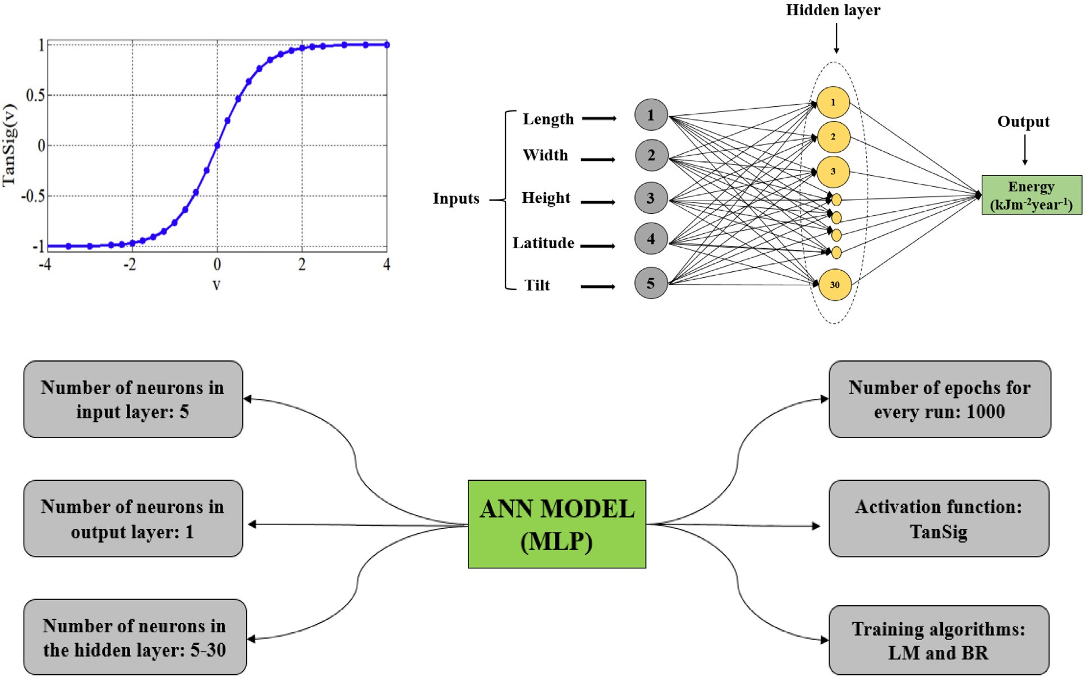

**(A)**

**(B)**

**(C)**

Fig. 1. A: TanSig activation function (Yilmaz et al., 2019); B: Overall structure of MLP applied for modeling; C: The organization of MLP structure in this study.

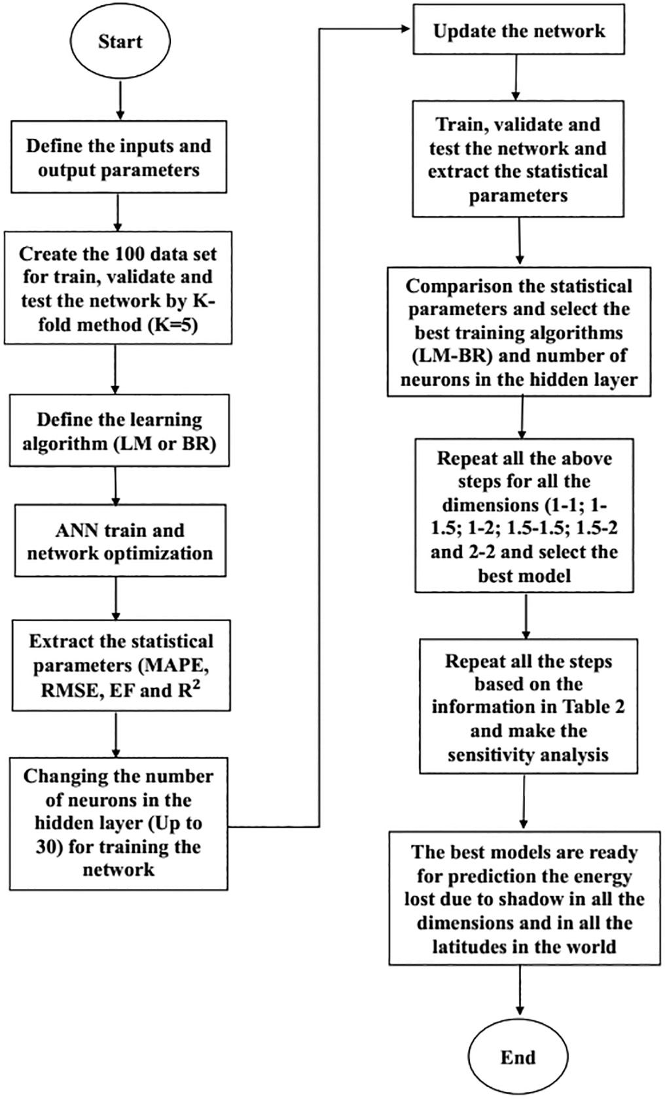where, x is the raw and *xn* is normalized data, *xmax* and *xmin* are the maximum and minimum values of the primary data, and *rmax* and *rmin* are the upper and lower limits of data ranges, respectively.

In this study two training algorithms were used: Levenberg Marquardt (LM) and Bayesian regularization (BR). Due to the high speed of network response and avoidance of complexity, a single layer network was used in this study (Ranjbar et al., 2013). The number of neurons in hidden layer increased as the results improved and was con- sidered constant after the error increased. In this study, the maximum number of neurons in hidden layer was 30. Fig. 1. shows the overall structure of MLP model with all the components in this study.

* 1. *K-fold cross validation*

In this research, K-fold cross validation method was used for increas- ing the confidence of ANN outputs. In this method, the validation data are divided into different categories of K, based on their type and num- ber, and are evaluated by each algorithm. In each step, K subsets is used for accreditation and the others (K-1) are applied for training (Rodriguez et al., 2010). This K procedure is repeated and all data are used for training and validation (in this study, K = 5). Finally, the aver- age results are validated as a final estimation. Application of K-fold as a stochastic subdivision in this method can increase the distribution in the ANN process and makes the neural network normally used as a practical method with acceptable results (Taki et al., 2018a). In some studies, this method was used and the authors reported that the results can be used in the experimental sections because of reliability (Taki et al., 2018b; Rohani et al., 2019; Amini et al., 2020).

In order to evaluate the performance of ANN-MLP model, Mean Ab- solute Percentage Error (MAPE), coefficient of determination (R2), Root Mean Square Error (RMSE) and Efficiency Factor (EF) were used (Rohani et al., 2019):

1 n d −pi

.

dj

( )

MAPE

= ∑

n j=1

j 100 2

*R*2 =

n  !2

∑ dj−d

j=1

n 2

∑

j=1

dj−d

*p*j−*p*

n 2

∑

j=1

*p*j−*p*

(3)

Fig. 2. Methodology process for ANN modeling in this study as a flowchart.

RMSE = t

vuﬃ∑ﬃﬃﬃﬃﬃﬃnﬃﬃﬃﬃﬃﬃﬃ ﬃﬃdﬃﬃﬃﬃﬃ−ﬃﬃﬃﬃpﬃﬃﬃﬃ ﬃﬃﬃ2ﬃﬃ

j=1 j j

n

(4)

standard method for solving the least squares problem in nonlinear

functions (Najafi et al., 2009). Bayesian Regularization (BR) algorithm is more robust than other traditional algorithms such as standard

∑

EF = j=1

dj−d

−∑ pj−dj

j=1

n  2 n 2

back-propagation and can decrease the need for long cross-validation. BR is a mathematical process that change a nonlinear regression into a

n 2

(5)

well-posed statistical problem in the manner of a ridge regression. The

∑

j=1

dj−d

advantage of BR is that this method is robust and the validation process, such as back propagation, is unnecessary (Amini et al., 2020). For trans-

Where *dj* is the *jth* component of the actual output for the *jth* pattern;

*pj* is the component of the predicted output produced by the network for

the *jth* pattern; dand p are the average of the whole actual and predicted output and n is the number of variable outputs. A model with the smallest RMSE, MAPE and largest EF is considered to be the best. Also, MATLAB software 2018a was used to analyze neural network and regression methods. Fig. 2 shows the whole procedure of methodology in this study.

1. Results and discussion
   1. *The best algorithm for MLP*

In this study two training algorithms were used for MLP model (LM and BR). The Levenberg-Marquardt (LM) algorithm is a method for find- ing the minimum of a multivariate nonlinear function that has become a

fer function, TanSig was used. This type of transfer function is very pop- ular and many researchers applied this method in ANN studies (Taki et al., 2018b; Ranjbar et al., 2013; Rohani et al., 2019). In the first section, six types of data based on the collector dimensions were used for modeling. Two training algorithms and several number of neurons in hidden layer (1,2, 3….,30) were used for ANN process. Fig. 3. shows the results of MLP model with two training algorithm (LM-BR) to pre- dict the energy lost due to shadow for different dimensions of flat- plate solar collectors. As the results show, the BR algorithm has the bet- ter performance than LM in all the six categories. The MAPE factor was varied between 0.119%–0.267% and 0.879%–1.87%, for BR and LM algo- rithms, respectively.

The results show that the BR algorithm can make accurate output data and based on the K-fold cross validation, this model (MLP-BR) can use in real experimental applications. So for other analysis, the BR

2

1.5

1

MAPE (%)

3

2.5

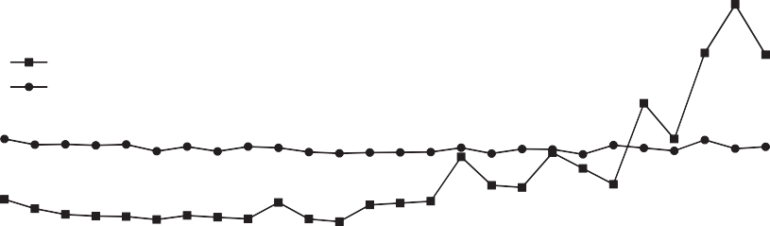

BR

LM

2

MAPE (%)

1.5

0.5

0

3

2.5

2

MAPE (%)

1.5

1

0.5

5 7 9 11 13 15 17 19 21 23 25 27 29

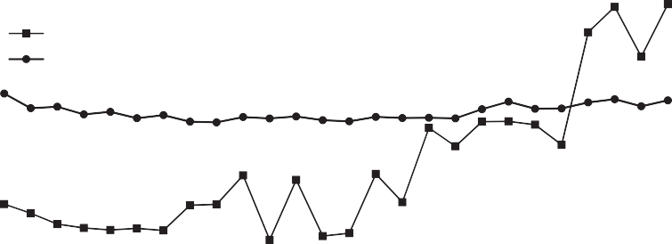

BR

LM

Number of nerouns in hidden layer

# (A)

1

0.5

0

2.5

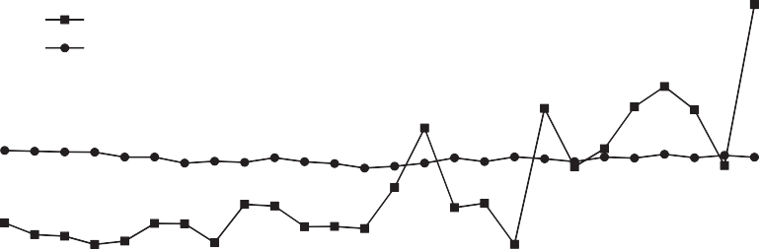

BR

LM

2

1.5

MAPE (%)

1

0.5

5 7 9 11 13 15 17 19 21 23 25 27 29

Number of nerouns in hidden layer

# (D)

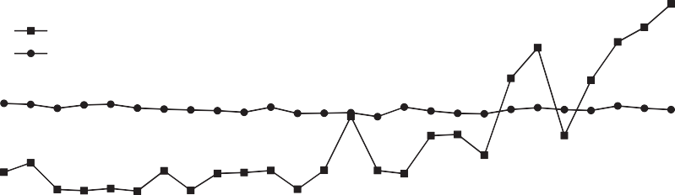

BR

LM

0

5.5

5

4.5

4

3.5

**MAPE (%)**

3

2.5

2

1.5

1

0.5

0

5 7 9 11 13 15 17 19 21 23 25 27 29

Number of nerouns in hidden layer

# (B)

0

2

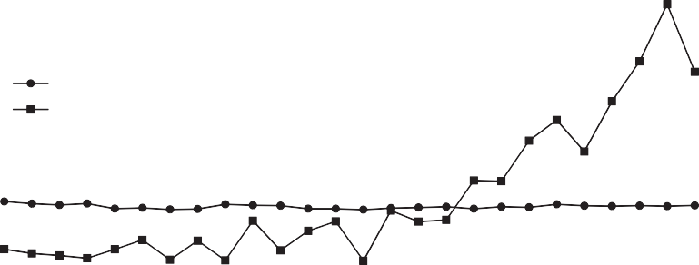

LM

BR

1.5

1

MAPE (%)

0.5

0



BR LM

5 7 9 11 13Numbe1r5of ner1o7uns in 1h9idden l2a1yer

# (E)

23 25 27 29

5 7 9 11 13 15 17 19 21 23 25 27 29

Number of nerouns in hidden layer

# (C)

5 7 9 11 13 15 17 19 21 23 25 27 29

Number of nerouns in hidden layer

# (F)

*M. Taki and R. Farhadi*

*Artificial Intelligence in Agriculture 5 (2021) 185*–*195*

189

Fig. 3. The results of MLP model with two training algorithm (LM-BR) to predict the energy lost due to shadow for different dimensions of flat-plate solar collectors, A: (1-1), B: (1-1.5), C: (1-2), D: (1.5-1.5), E: (1.5-2), F: (2-2).

al-

g-

o-

ri-

t-

h- m

1.000

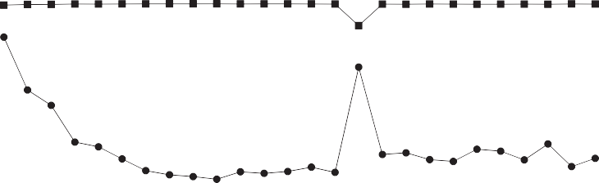

0.980

0.960

0.940

R2

0.920

0.900

Best topology: 5-14-1 R2

RMSE

12.000

10.000

8.000

RMSE (KJm-2year-1)

R2

6.000

4.000

2.000

0.000

1 60

50

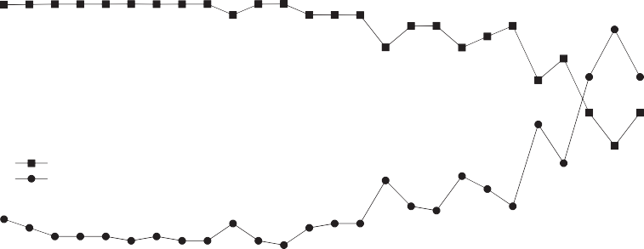

Best topology: 5-16-1

R2 RMSE

0.95

RMSE (KJm-2year-1)

40

0.9 30

20

0.85

10

0.8 0

5 7 9 11 13 15 17 19 21 23 25 27 29

Number of nerouns in hidden layer

# (A)

1.000

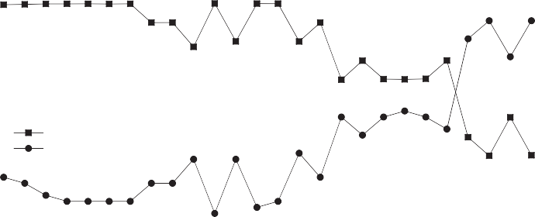

Best topology: 5-15-1 R2

RMSE

0.980

0.960

R2

0.940

0.920

40.000

30.000

20.000

10.000

1

0.95

RMSE (KJm-2year-1)

0.9

R2

5 7 9 11 13 15 17 19 21 23 25 27 29

Number of nerouns in hidden layer

# (D)

60

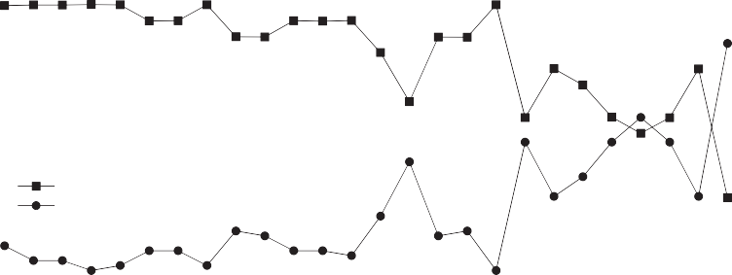

Best topology: 5-8-1 R2

RMSE

50

40

RMSE (KJm-2year-1)

30

20

10

0.900

1.000

0.800

0.600

0.400

R2

0.200

0.000

5 7 9 11 13 15 17 19 21 23 25 27 29

Number of nerouns in hidden layer

# (B)

5 7 9 11 13 15 17 19 21 23 25 27 29

Number of nerouns in hidden layer

# (C)

0.000

120.000

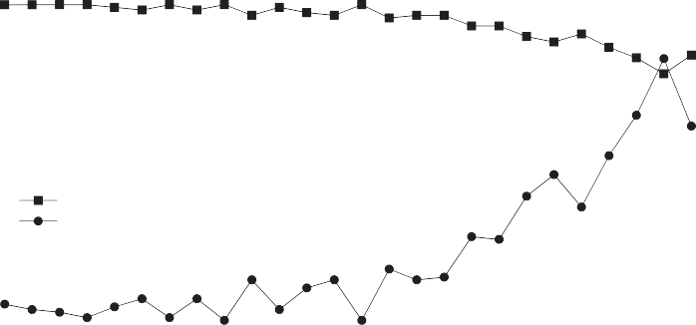

Best topology: 5-18-1 R2

RMSE

100.000

80.000

RMSE (KJm-2year-1)

R2

60.000

40.000

20.000

0.000

0.85

1

0.95

0.9

0.85

0

5 7 9 11 13 15 17 19 21 23 25 27 29

Number of nerouns in hidden layer

# (E)

60

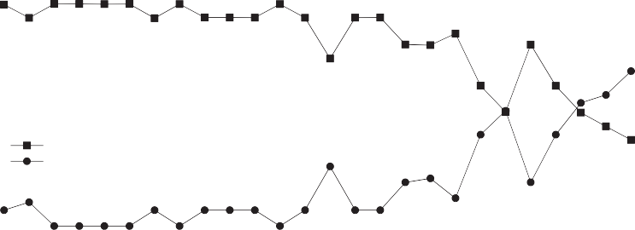

Best topology: 5-10-1 R2

RMSE

40

RMSE (KJm-2year-1)

20

0

5 7 9 11 13 15 17 19 21 23 25 27 29

Number of nerouns in hidden layer

# (F)

*M. Taki and R. Farhadi*

*Artificial Intelligence in Agriculture 5 (2021) 185*–*195*

190

Fig. 4. The results of MLP model with BR training algorithm (MLP-BR) or the best topologies, to predict the energy lost due to shadow for different dimensions of flat-plate solar collectors, A: (1-1), B: (1-1.5), C: (1-2), D: (1.5-1.5), E: (1.5-2), F: (2-2).

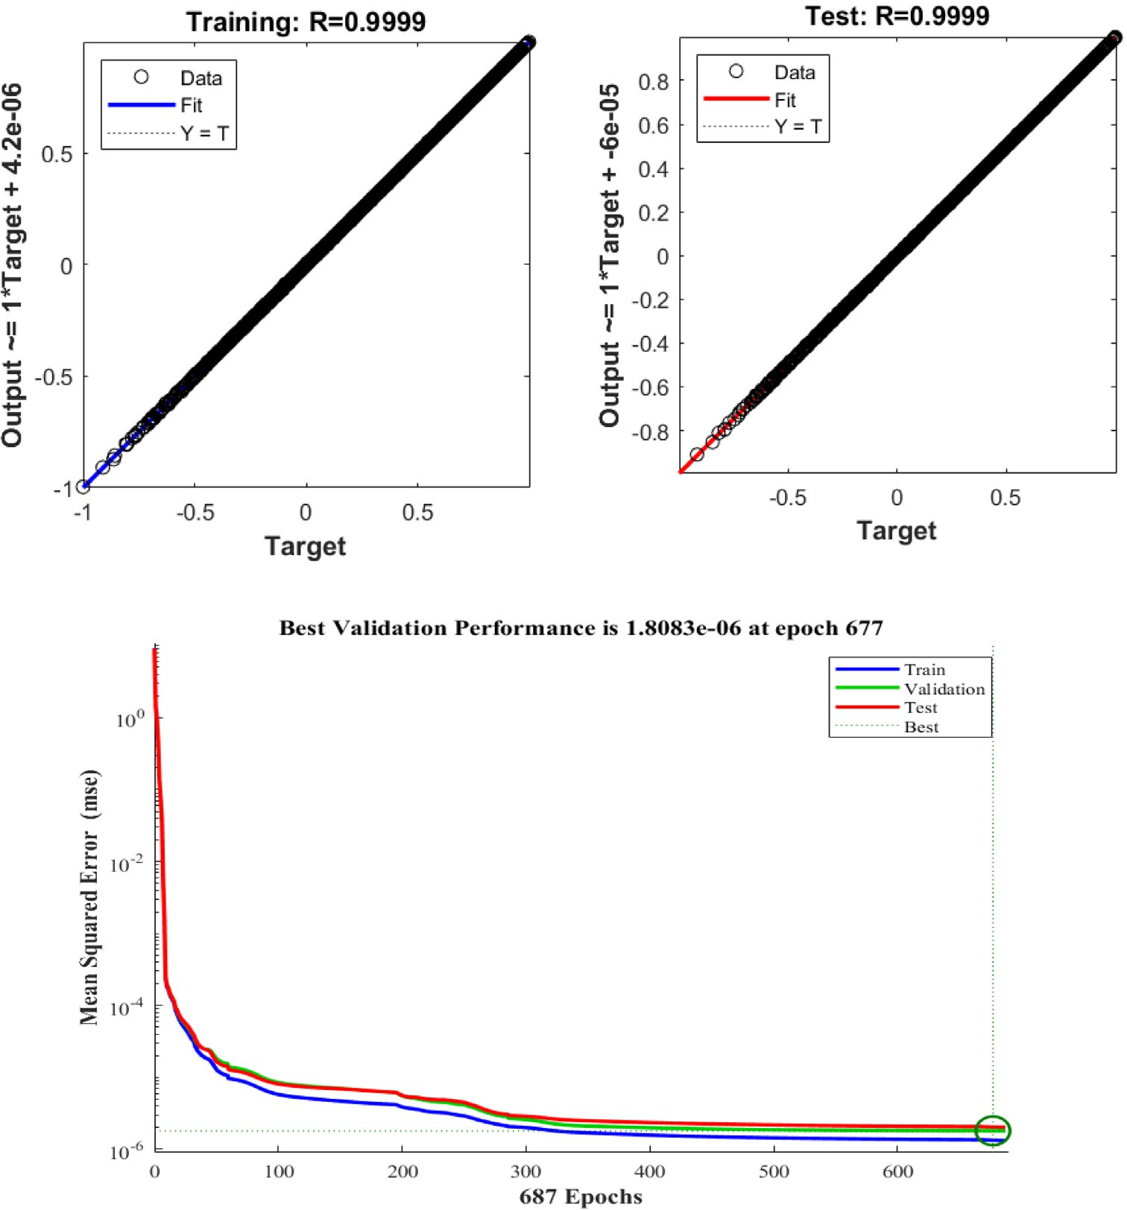

**(A)**

**(B)**

Fig. 5. A: The agreement between the actual and predicted data by MLP model with BR training algorithm; B: The convergence diagram of MLP-BR model to predict the energy lost due to shadow in flat-plate solar collectors.

was used. Fig. 4 shows the RMSE and EF factors for the best neuron in the hidden layer by BR algorithm. The results of Fig. 5 show that for the six dimensions (1×1; 1×1.5; 1×2; 1.5×1.5; 1.5×2 and 2×2) the

best topologies are: 5-14-1; 5-15-1; 5-8-1; 5-18-1; 5-16-1; 5-10-1, re- spectively. The lowest RMSE is related to (1.5×1.5) dimension. Also this dimension has the highest EF (0.9999). The results of this figure show that the number of neurons in the hidden layer can play an impor- tant role in the final performance but the higher number of neurons in

the hidden layer is not always a reason for increasing the efficiency and accuracy of the neural network model. Table 4 shows the overall performance of MLP model for the best neurons in the hidden layer by BR algorithm in the train and test phases. The results of Table 5 show that MLP model with proposed structure can predict the energy lost due to shadow for all the dimensions with high accuracy. For flat-plate solar collectors with (1.5×1.5) dimension, MLP model can use with higher performance than other dimensions.

Table 4

The statistical parameters of the of MLP-BR model with optimal neuron in hidden layer to predict the energy lost due to shadow in flat-plate solar collectors. Dimensions Topology Train Test

RMSE

(KJm-2 year−1) (*x*±SD)

MAPE % (*x*±SD)

EF (−)

(*x*±SD)

R2 (−)

(*x*±SD)

RMSE

(KJm-2 year−1) (*x*±SD)

MAPE % (*x*±SD)

EF (−)

(*x*±SD)

R2 (−)

(*x*±SD)

1×1 5–14-1 2.97 ± 2.5 0.15 ± 0.12 0.99 ± 0.01 0.99 ± 0.01 4.48 ± 2.9 0.18 ± 0.11 0.99 ± 0.01 0.99 ± 0.01

1×1.5 5–15-1 4.08 ± 4.4 0.18 ± 0.19 0.99 ± 0.01 0.99 ± 0.01 6.84 ± 5.6 0.27 ± 0.23 0.99 ± 0.01 0.99 ± 0.01

1×2 5–8-1 5.02 ± 3.51 0.21 ± 0.15 0.99 ± 0.01 0.99 ± 0.01 7.59 ± 4.87 0.30 ± 0.19 0.99 ± 0.01 0.99 ± 0.01

1.5×1.5⁎ 5-18-1 1.60 ± 1.48 0.07 ± 0.07 0.99 ± 0.01 0.99 ± 0.01 4.42 ± 2.43 0.15 ± 0.09 0.99 ± 0.01 0.99 ± 0.01

1.5×2 5–16-1 3.45 ± 4.36 0.14 ± 0.18 0.99 ± 0.01 0.99 ± 0.01 5.43 ± 5.59 0.20 ± 0.21 0.99 ± 0.01 0.99 ± 0.01

2×2 5–10-1 3.32 ± 4.34 0.14 ± 0.18 0.99 ± 0.01 0.99 ± 0.01 4.94 ± 5.42 0.18 ± 0.21 0.99 ± 0.01 0.99 ± 0.01

* The bold numbers are the statistical parameters of the best predictive model.

Selection the best neuron in MLP model with LM algorithm by application of K-fold cross validation method.

|  |  |  |  |  |  |  |  |  |  |  |  |  |
| --- | --- | --- | --- | --- | --- | --- | --- | --- | --- | --- | --- | --- |
| Number of neurons | Train |  |  |  | Test |  |  |  | Total |  | | |
|  | MAPE % |  | R2 (−) |  | MAPE % |  | R2 (−) |  | MAPE % |  | R2 (−) |  |
|  | (*x*±SD) |  | (*x*±SD) |  | (*x*±SD) |  | (*x*±SD) |  | (*x*±SD) |  | (*x*±SD) |  |
| 5 | 1.3873 ± 0.0911 |  | 0.9937 ± 0.0008 |  | 1.4055 ± 0.0977 |  | 0.9935 ± 0.0009 |  | 1.3982 ± 0.0935 |  | 0.9936 ± 0.0008 |  |
| 6 | 1.3357 ± 0.1348 |  | 0.9942 ± 0.0011 |  | 1.3499 ± 0.1400 |  | 0.9941 ± 0.0012 |  | 1.3442 ± 0.1367 |  | 0.9941 ± 0.0012 |  |
| 7 | 1.3030 ± 0.1535 |  | 0.9945 ± 0.0013 |  | 1.3221 ± 0.1539 |  | 0.9944 ± 0.0013 |  | 1.3145 ± 0.1527 |  | 0.9944 ± 0.0013 |  |
| 8 | 1.2683 ± 0.1750 |  | 0.9948 ± 0.0014 |  | 1.2822 ± 0.1714 |  | 0.9947 ± 0.0014 |  | 1.2766 ± 0.1720 |  | 0.9947 ± 0.0014 |  |
| 9 | 1.2108 ± 0.2075 |  | 0.9954 ± 0.0015 |  | 1.2298 ± 0.2114 |  | 0.9953 ± 0.0015 |  | 1.2222 ± 0.2091 |  | 0.9954 ± 0.0015 |  |
| 10 | 1.2150 ± 0.2032 |  | 0.9955 ± 0.0014 |  | 1.2279 ± 0.2073 |  | 0.9953 ± 0.0015 |  | 1.2228 ± 0.2051 |  | 0.9954 ± 0.0014 |  |
| 11 | 1.1904 ± 0.2267 |  | 0.9957 ± 0.0016 |  | 1.2068 ± 0.2331 |  | 0.9956 ± 0.0016 |  | 1.2002 ± 0.2299 |  | 0.9956 ± 0.0016 |  |
| 12 | 1.1828 ± 0.2124 |  | 0.9959 ± 0.0014 |  | 1.1933 ± 0.2115 |  | 0.9958 ± 0.0014 |  | 1.1891 ± 0.2110 |  | 0.9959 ± 0.0014 |  |
| 13 | 1.1230 ± 0.2359 |  | 0.9961 ± 0.0016 |  | 1.1373 ± 0.2406 |  | 0.9961 ± 0.0017 |  | 1.1316 ± 0.2383 |  | 0.9961 ± 0.0016 |  |
| 14 | 1.1559 ± 0.2281 |  | 0.9962 ± 0.0015 |  | 1.1700 ± 0.2280 |  | 0.9961 ± 0.0015 |  | 1.1643 ± 0.2275 |  | 0.9961 ± 0.0015 |  |
| 15 | 1.1440 ± 0.2116 |  | 0.9963 ± 0.0013 |  | 1.1575 ± 0.2203 |  | 0.9962 ± 0.0014 |  | 1.1521 ± 0.2163 |  | 0.9962 ± 0.0013 |  |
| 16 | 1.1445 ± 0.2372 |  | 0.9963 ± 0.0015 |  | 1.1629 ± 0.2399 |  | 0.9961 ± 0.0016 |  | 1.1556 ± 0.2383 |  | 0.9962 ± 0.0016 |  |
| 17 | 1.1028 ± 0.2283 |  | 0.9966 ± 0.0014 |  | 1.1159 ± 0.2276 |  | 0.9965 ± 0.0015 |  | 1.1106 ± 0.2274 |  | 0.9965 ± 0.0015 |  |
| 18 | 1.0991 ± 0.2559 |  | 0.9965 ± 0.0015 |  | 1.1168 ± 0.2560 |  | 0.9965 ± 0.0015 |  | 1.1097 ± 0.2554 |  | 0.9965 ± 0.0015 |  |
| 19 | 1.0904 ± 0.2255 |  | 0.9967 ± 0.0014 |  | 1.1045 ± 0.2297 |  | 0.9966 ± 0.0014 |  | 1.0988 ± 0.2275 |  | 0.9966 ± 0.0014 |  |
| 20⁎ | 1.0286 ± 0.2879 |  | 0.9971 ± 0.0016 |  | 1.0470 ± 0.2900 |  | 0.9970 ± 0.0017 |  | 1.0397 ± 0.2888 |  | 0.9970 ± 0.0017 |  |
| 21 | 1.1367 ± 0.2467 |  | 0.9964 ± 0.0016 |  | 1.1521 ± 0.2440 |  | 0.9963 ± 0.0016 |  | 1.1459 ± 0.2445 |  | 0.9963 ± 0.0016 |  |
| 22 | 1.0907 ± 0.2549 |  | 0.9965 ± 0.0016 |  | 1.1110 ± 0.2630 |  | 0.9964 ± 0.0016 |  | 1.1029 ± 0.2591 |  | 0.9965 ± 0.0016 |  |
| 23 | 1.1405 ± 0.2543 |  | 0.9965 ± 0.0015 |  | 1.1558 ± 0.2574 |  | 0.9964 ± 0.0015 |  | 1.1497 ± 0.2556 |  | 0.9964 ± 0.0015 |  |
| 24 | 1.0942 ± 0.2470 |  | 0.9967 ± 0.0015 |  | 1.1065 ± 0.2463 |  | 0.9966 ± 0.0016 |  | 1.1016 ± 0.2461 |  | 0.9966 ± 0.0016 |  |
| 25 | 1.0958 ± 0.2718 |  | 0.9966 ± 0.0016 |  | 1.1182 ± 0.2758 |  | 0.9965 ± 0.0016 |  | 1.1092 ± 0.2739 |  | 0.9965 ± 0.0016 |  |
| 26 | 1.1076 ± 0.2617 |  | 0.9966 ± 0.0015 |  | 1.1243 ± 0.2636 |  | 0.9965 ± 0.0015 |  | 1.1176 ± 0.2624 |  | 0.9965 ± 0.0015 |  |
| 27 | 1.0810 ± 0.2615 |  | 0.9968 ± 0.0015 |  | 1.0962 ± 0.2599 |  | 0.9967 ± 0.0015 |  | 1.0902 ± 0.2601 |  | 0.9968 ± 0.0015 |  |
| 28 | 1.0580 ± 0.2738 |  | 0.9970 ± 0.0015 |  | 1.0738 ± 0.2750 |  | 0.9970 ± 0.0015 |  | 1.0675 ± 0.2742 |  | 0.9970 ± 0.0015 |  |
| 29 | 1.1162 ± 0.2794 |  | 0.9965 ± 0.0017 |  | 1.1336 ± 0.2853 |  | 0.9964 ± 0.0018 |  | 1.1266 ± 0.2824 |  | 0.9965 ± 0.0017 |  |
| 30 | 1.1215 ± 0.2789 |  | 0.9967 ± 0.0016 |  | 1.1388 ± 0.2789 |  | 0.9966 ± 0.0017 |  | 1.1319 ± 0.2784 |  | 0.9966 ± 0.0017 |  |

* The bold numbers are the statistical parameters of the best topology.

There is not any similar research about collectors but in other appli- cations, some researchers reported similar results about ANN models. For example, Kalogirou (2006), applied ANN model to estimate the col- lector performance parameters and reported that this method can use with high precision. Also the authors indicate that the performance of

ANN can be improved by more training and use other new and sufficient algorithms.

In a similar study, ANN models (MLP and RBF) were applied to pre- dict the output yield of wheat production (Taki et al., 2018b). The results showed that ANN models can use with high performance to predict the

Table 6

Selection the best neuron in MLP model with BR algorithm by application of K-fold cross validation method.

|  |  |  |  |  |  |  |  |  |  |  |  |  |
| --- | --- | --- | --- | --- | --- | --- | --- | --- | --- | --- | --- | --- |
| Number of neurons | Train |  |  |  | Test |  |  |  | Total |  | | |
|  | MAPE (%) |  | R2 (−) |  | MAPE (%) |  | R2 (−) |  | MAPE (%) |  | R2 (−) |  |
|  | (*x*±SD) |  | (*x*±SD) |  | (*x*±SD) |  | (*x*±SD) |  | (*x*±SD) |  | (*x*±SD) |  |
| 5 | 0.8884 ± 0.1460 |  | 0.9976 ± 0.0010 |  | 0.8717 ± 0.1504 |  | 0.9975 ± 0.0010 |  | 0.8664 ± 0.1482 |  | 0.9975 ± 0.0010 |  |
| 6 | 0.6196 ± 0.0913 |  | 0.9987 ± 0.0004 |  | 0.6328 ± 0.0911 |  | 0.9987 ± 0.0004 |  | 0.6275 ± 0.0918 |  | 0.9987 ± 0.0004 |  |
| 7 | 0.4546 ± 0.0888 |  | 0.9993 ± 0.0003 |  | 0.4672 ± 0.0902 |  | 0.9993 ± 0.0003 |  | 0.4621 ± 0.0894 |  | 0.9993 ± 0.0003 |  |
| 8 | 0.3571 ± 0.0627 |  | 0.9996 ± 0.0002 |  | 0.3679 ± 0.0636 |  | 0.9996 ± 0.0002 |  | 0.3636 ± 0.0631 |  | 0.9996 ± 0.0002 |  |
| 9 | 0.3054 ± 0.0523 |  | 0.9997 ± 0.0001 |  | 0.3161 ± 0.0541 |  | 0.9997 ± 0.0001 |  | 0.3118 ± 0.0532 |  | 0.9997 ± 0.0001 |  |
| 10 | 0.2627 ± 0.0348 |  | 0.9998 ± 0.0001 |  | 0.2731 ± 0.0365 |  | 0.9998 ± 0.0001 |  | 0.2689 ± 0.0356 |  | 0.9998 ± 0.0001 |  |
| 11 | 0.2257 ± 0.0223 |  | 0.9998 ± 0.0001 |  | 0.2363 ± 0.0232 |  | 0.9998 ± 0.0001 |  | 0.2321 ± 0.0225 |  | 0.9998 ± 0.0001 |  |
| 12 | 0.2058 ± 0.0184 |  | 0.9999 ± 0.0001 |  | 0.2160 ± 0.0183 |  | 0.9999 ± 0.0001 |  | 0.2119 ± 0.0180 |  | 0.9999 ± 0.0001 |  |
| 13 | 0.1882 ± 0.0148 |  | 0.9999 ± 0.0001 |  | 0.1985 ± 0.0154 |  | 0.9999 ± 0.0001 |  | 0.1944 ± 0.0148 |  | 0.9999 ± 0.0001 |  |
| 14 | 0.1733 ± 0.0143 |  | 0.9999 ± 0.0001 |  | 0.1831 ± 0.0144 |  | 0.9999 ± 0.0001 |  | 0.1792 ± 0.0140 |  | 0.9999 ± 0.0001 |  |
| 15 | 0.1599 ± 0.0116 |  | 0.9999 ± 0.0001 |  | 0.1697 ± 0.0107 |  | 0.9999 ± 0.0001 |  | 0.1658 ± 0.0108 |  | 0.9999 ± 0.0001 |  |
| 16 | 0.1482 ± 0.0118 |  | 0.9999 ± 0.0001 |  | 0.1589 ± 0.0129 |  | 0.9999 ± 0.0001 |  | 0.1546 ± 0.0121 |  | 0.9999 ± 0.0001 |  |
| 17 | 0.1347 ± 0.0113 |  | 0.9999 ± 0.0001 |  | 0.1445 ± 0.0116 |  | 0.9999 ± 0.0001 |  | 0.1406 ± 0.0112 |  | 0.9999 ± 0.0001 |  |
| 18 | 0.1250 ± 0.0131 |  | 0.9999 ± 0.0001 |  | 0.1349 ± 0.0130 |  | 0.9999 ± 0.0001 |  | 0.1309 ± 0.0128 |  | 0.9999 ± 0.0001 |  |
| 19 | 0.1169 ± 0.0113 |  | 0.9999 ± 0.0001 |  | 0.1269 ± 0.0125 |  | 0.9999 ± 0.0001 |  | 0.1229 ± 0.0117 |  | 0.9999 ± 0.0001 |  |
| 20 | 0.1066 ± 0.0103 |  | 0.9999 ± 0.0001 |  | 0.1165 ± 0.0115 |  | 0.9999 ± 0.0001 |  | 0.1126 ± 0.0108 |  | 0.9999 ± 0.0001 |  |
| 21 | 0.1018 ± 0.0109 |  | 0.9999 ± 0.0001 |  | 0.1111 ± 0.0115 |  | 0.9999 ± 0.0001 |  | 0.1074 ± 0.0111 |  | 0.9999 ± 0.0001 |  |
| 22 | 0.0990 ± 0.0143 |  | 0.9999 ± 0.0001 |  | 0.1086 ± 0.0143 |  | 0.9999 ± 0.0001 |  | 0.1048 ± 0.0142 |  | 0.9999 ± 0.0001 |  |
| 23 | 0.0903 ± 0.0098 |  | 0.9999 ± 0.0001 |  | 0.1002 ± 0.0113 |  | 0.9999 ± 0.0001 |  | 0.0963 ± 0.0105 |  | 0.9999 ± 0.0001 |  |
| 24 | 0.0880 ± 0.0112 |  | 0.9999 ± 0.0001 |  | 0.0982 ± 0.0115 |  | 0.9999 ± 0.0001 |  | 0.0942 ± 0.0113 |  | 0.9999 ± 0.0001 |  |
| 25 | 0.0804 ± 0.0080 |  | 0.9999 ± 0.0001 |  | 0.0899 ± 0.0092 |  | 0.9999 ± 0.0001 |  | 0.0861 ± 0.0085 |  | 0.9999 ± 0.0001 |  |
| 26 | 0.0771 ± 0.0097 |  | 0.9999 ± 0.0001 |  | 0.0869 ± 0.0115 |  | 0.9999 ± 0.0001 |  | 0.0830 ± 0.0107 |  | 0.9999 ± 0.0001 |  |
| 27⁎ | 0.0552 ± 0.0052 |  | 0.9999 ± 0.0001 |  | 0.0648 ± 0.0053 |  | 0.9999 ± 0.0001 |  | 0.0610 ± 0.0051 |  | 0.9999 ± 0.0001 |  |
| 28 | 0.0717 ± 0.0092 |  | 0.9999 ± 0.0001 |  | 0.0812 ± 0.0109 |  | 0.9999 ± 0.0001 |  | 0.0774 ± 0.0101 |  | 0.9999 ± 0.0001 |  |
| 29 | 0.0672 ± 0.0071 |  | 0.9999 ± 0.0001 |  | 0.0769 ± 0.0076 |  | 0.9999 ± 0.0001 |  | 0.0730 ± 0.0073 |  | 0.9999 ± 0.0001 |  |
| 30 | 0.0650 ± 0.0093 |  | 0.9999 ± 0.0001 |  | 0.0744 ± 0.0850 |  | 0.9999 ± 0.0001 |  | 0.0706 ± 0.0088 |  | 0.9999 ± 0.0001 |  |

* The bold numbers are the statistical parameters of the best topology.

Table 7

Selection the best topology between the results of the MLP-LM and MLP-BR models.

Training algorithm Topology Statistical parameters (Total phase)

|  |  |  |  |  |  |  |
| --- | --- | --- | --- | --- | --- | --- |
|  | | MAPE (%) (*x*±SD) | RMSE (KJm-2 year−1) (*x*±SD) | EF (−)  (*x*±SD) | R2 (−)  (*x*±SD) |  |
| LM (Levenberg Marquardt) | 5–20-1 | 1.0397 ± 0.2888 | 25.4883 ± 6.8241 | 0.9962 ± 0.0020 | 0.9970 ± 0.0016 |  |
| BR (Bayesian regularization) | 5–27-1 | 0.0609 ± 0.0050 | 1.5210 ± 0.1232 | 0.9999 ± 0.0001 | 0.9999 ± 0.0001 |  |

wheat yield for the next cultivation. In another study, Ghritlahre and Prasad (2018), developed MLP and Multiple Linear Regression (MLR) models to predict the heat transfer of two different types of roughened solar air heaters. The results showed that ANN models with 5-10-1 to- pology can predict the heat transfer characteristics with high accuracy (R2 = 0.9953) than MLR. In another study, ANN-MLP model was used to predict the performance of solar chimney filled with phase change materials (Fadaei et al., 2018). The results showed that the correlation coefficient between the actual and predicted data was more than 0.99 and also the relative error is less than 3%.

In the second section, all the data based on the Table 2 were used for ANN analysis. In this section the effect of data size can be evaluated. So as the last section, the TanSig transfer function with LM and BR training algorithms and the different number of neurons in hidden layer (1,2,3…,30) were used for ANN modeling. Table 5 shows the results of MLP-LM model with different number of neurons in the hidden layer in train, test and total phases.

The results of Table 6 indicated that, the best topology with highest performance is 5–20-1. Total MAPE and R2 for this structure are 1.0397 ± 0.2888 and 0.9970 ± 0.0017, respectively. Based on the Table 5, the MAPE of MLP-LM structure in total phase was varied be- tween 1.0397 and 1.3982%. Also, this table show that the data size of training has not a significant effect on total MAPE of MLP-LM structure in this study. So the analysis was repeated for MLP-BR model with same structure of MLP-LM (Table 6). The results of Table 6 show that MAPE and R2 at total phase for the best topology with MLP-BR structure (5–27-1) are 0.0610 ± 0.0051% and 0.9999 ± 0.0001, respectively. MAPE for different number of neurons in the hidden layer is varied be- tween 0.0610 ± 0.0051 to 0.8664 ± 0.1482%. The results of MLP-BR analysis show that the standard deviation in train, test and total phases is very low compared with the same results of MLP-LM. The MAPE for the best topology (5–27-1) in MLP-BR is more than 16 times lower than the same MAPE for the best topology by MLP-LM (5–20-1). Table 7 shows a brief comparison with all statistical parameters be- tween the best topologies by LM and BR training algorithms.

Fig. 5.A shows Cross-Correlation of predicted and actual values by the best topology (5–27-1) and B: shows the convergence diagram of this topology at train, test and validation phases. Fig. 5A shows that after 677 repetitions, the MSE for train, test and total phases reached to the minimum value and MLP-BR model was learned to predict the output with lowest error. Also the next section (B) shows that this to- pology can accounted more than 99% of total actual variability in the real data. The correlation coefficient between the actual and predicted data in train, test, validation and total phases are very high. So, this model can show the relation between the inputs and output with high accuracy and can be accepted for experimental applications. Many re- searchers reported that the ANN model could solve problem equation and predict the results with high accuracy in all aspect of sciences (Elsheikh et al., 2019). Sözen et al. (2008), applied ANN method to eval- uate the performance of flat-plate solar collector and reported that the maximum deviation between the actual and predicted data by ANN model was about 2.55%.

* 1. *Sensitivity analysis*

In the last section, the sensitivity analysis was evaluated for MLP-BR structure. By sensitivity analysis, the share of each inputs on the output can be calculated. Fig. 6 shows the sensitivity analysis for MLP-BR (5–27-1) in this study. As it can be seen, the share of height on the en- ergy gain reduction due to shadow in flat-plate solar collectors, is higher than other parameters. This is similar to the result of mathematical modeling (Farhadi and Taki, 2020). So, finding the best height in all the dimensions and in all the latitudes and tilts, is a main factor for op- timization the energy lost due to shadow in flat-plate solar collectors. By the results of this study, engineers can find the energy lost in flat-plate solar collectors in the world and the optimum dimensions and height can be find by ANN model before construction. The authors strongly suggested to adopt the best ANN models for every county based on the local dimensions of flat-plate solar collectors and decrease the en- ergy lost and improve the efficiency of solar collectors.



**37%**

**51%**

**14%**

**Length Width Height Latitude Tilt**

**42%**

**3%**

**4%**

Fig. 6. The sensitivity analysis of the inputs and their effects on the output for MLP-BR with (5–27-1) topology.

1. Conclusion

In this study, ANN-MLP method was developed for modeling the en- ergy gain reduction due to shadow in flat-plate solar collectors. Two training algorithms (LM-BR) with TanSig transfer function and K-fold cross validation method were used for ANN modeling. Four statistical parameters including Root Mean Square Error (RMSE), Mean Absolute Percentage Error (RMSE), Efficiency Factor (EF) and correlation of deter- mination (R2) were used for evaluate the precision of ANN model. The inputs including Latitude, Length, Width, Height and tilt were extracted from Farhadi and Taki (2020). In this study, two scenarios were evalu- ated. In the first scenario, the dimensions (Length×Width) were divided into 5 categories including (1×1; 1×1.5; 1×2; 1.5×1.5; 1.5×2 and 2×2) and in the second, all the range of dimensions (Length: 0.5–2.5 and Wight: 0.5–2.5 m) were used in the inputs data. The results showed that MLP-BR has the lowest MAPE and RMSE than MLP-LM in the two scenarios. MAPE for different number of neurons in the hidden layer was varied between 0.0610 ± 0.0051 to 0.8664 ± 0.1482% in the second scenario. Also, the best topology was (5–27-1) that achieved to MAPE and R2 of 0.0610 ± 0.0051% and 0.9999 ± 0.0001, respectively. The re- sults of sensitivity analysis indicated that height has the biggest effect on the output (42%) followed by tilt (37%) and latitude (14%). The re- sults of this study showed that ANN method can predict the output data with reasonable accuracy and also combination the K-fold cross validation with ANN can increase the reliability of the ANN outputs.

Declaration of Competing Interest

The authors do not have any type of conflict of interest.

Acknowledgement

The authors would like to thank the editor in chief and the anony- mous referees for their valuable suggestions and useful comments that improved the paper content substantially. This study was supported by a grant (981/38) from Agricultural Sciences and Natural Resources Uni- versity of Khuzestan, Iran. The authors are grateful for the support pro- vided by this University.

References

Aidinlou, H.R., Nikbakht, A.M., 2017. [Intelligent modeling of thermohydraulic behavior in](http://refhub.elsevier.com/S2589-7217(21)00026-X/rf0005) [solar air heaters with artificial neural networks. Neural Comput. & Applic. 31,](http://refhub.elsevier.com/S2589-7217(21)00026-X/rf0005) [3279–3293](http://refhub.elsevier.com/S2589-7217(21)00026-X/rf0005).

Alonso, J.P., Garcia, M.P., Romera, M.P., Ferre, A., 2012. [Performance analysis and neural](http://refhub.elsevier.com/S2589-7217(21)00026-X/rf0010) [modeling of a greenhouse integrated photovoltaic system. Renew. Sust. Energ. Rev.](http://refhub.elsevier.com/S2589-7217(21)00026-X/rf0010) [16, 4675–4685](http://refhub.elsevier.com/S2589-7217(21)00026-X/rf0010).

Al-Waeli, A.H.A., Sopian, K., Yousif, P., 2019. [Artificial neural network modeling and anal-](http://refhub.elsevier.com/S2589-7217(21)00026-X/rf0015) [ysis of photovoltaic/thermal system based on the experimental study. Energy](http://refhub.elsevier.com/S2589-7217(21)00026-X/rf0015) [Convers. Manag. 186, 368–37](http://refhub.elsevier.com/S2589-7217(21)00026-X/rf0015)9.

Amini, S., Taki, M., Rohani, A., 2020. [Applied improved RBF neural network model for](http://refhub.elsevier.com/S2589-7217(21)00026-X/rf0020) [predicting the broiler output energies. Appl. Soft Comput. J. 87, 106006](http://refhub.elsevier.com/S2589-7217(21)00026-X/rf0020).

Assari, M.R., Basirat Tabrizi, H., Savadkohy, M., 2018. [Numerical and experimental study of](http://refhub.elsevier.com/S2589-7217(21)00026-X/rf0025) [inlet-outlet locations effect in horizontal storage tank of solar water heater. Sustain.](http://refhub.elsevier.com/S2589-7217(21)00026-X/rf0025) [Energy Technol. Assess. 25, 181–19](http://refhub.elsevier.com/S2589-7217(21)00026-X/rf0025)0.

Benli, H., 2013. [Determination of thermal performance calculation of two different types](http://refhub.elsevier.com/S2589-7217(21)00026-X/rf0030) [solar air collectors with the use of artificial neural networks. Int. J. Heat Mass Transf.](http://refhub.elsevier.com/S2589-7217(21)00026-X/rf0030) [60, 1–](http://refhub.elsevier.com/S2589-7217(21)00026-X/rf0030)7.

Çakmak, G., Yıldız, C., 2011. [The prediction of seedy grape drying rate using a neural net-](http://refhub.elsevier.com/S2589-7217(21)00026-X/rf0035) [work method. Comput. Electron. Agric. 75 (1), 132–13](http://refhub.elsevier.com/S2589-7217(21)00026-X/rf0035)8.

Castañeda-Miranda, A., Castaño, V.M., 2017. [Smart frost control in greenhouses by neural](http://refhub.elsevier.com/S2589-7217(21)00026-X/rf0040) [networks models. Comput. Electron. Agric. 137, 102–11](http://refhub.elsevier.com/S2589-7217(21)00026-X/rf0040)4.

Dimri, N., Tiwari, A., Tiwari, G.N., 2019. [An overall exergy analysis of glass-tedlar photo-](http://refhub.elsevier.com/S2589-7217(21)00026-X/rf0045) [voltaic thermal air collector incorporating thermoelectric cooler: a comparative](http://refhub.elsevier.com/S2589-7217(21)00026-X/rf0045) [study using artificial neural networks. Energy Convers. Manag. 195, 1350–1358](http://refhub.elsevier.com/S2589-7217(21)00026-X/rf0045).

Duffie, J.A., Beckman, W.A., 2013. [Solar Engineering of Thermal Processes. New Jersey,](http://refhub.elsevier.com/S2589-7217(21)00026-X/rf0050) [John Wiley & Sons, Inc., Hoboke](http://refhub.elsevier.com/S2589-7217(21)00026-X/rf0050)n.

Elsheikh, A.H., Abd Elaziz, M., 2018. [Review on applications of particle swarm optimiza-](http://refhub.elsevier.com/S2589-7217(21)00026-X/rf0055) [tion in solar energy systems. Int. J. Environ. Sci. Technol. 16, 1159–1170](http://refhub.elsevier.com/S2589-7217(21)00026-X/rf0055).

Elsheikh, A.H., Sharshir, S.W., Abd Elaziz, M., Kabeel, A.E., Guilan, W., Haiou, Z., 2019. [Modeling of solar energy systems using artificial neural network: a comprehensive](http://refhub.elsevier.com/S2589-7217(21)00026-X/rf0060) [review. Sol. 180, 622–63](http://refhub.elsevier.com/S2589-7217(21)00026-X/rf0060)9.

Esen, H., Ozgen, F., Esen, M., Sengur, A., 2009. [Artificial neural network and wavelet neural](http://refhub.elsevier.com/S2589-7217(21)00026-X/rf0065) [network approaches for modelling of a solar air heater. Expert Syst. Appl. 36 (8),](http://refhub.elsevier.com/S2589-7217(21)00026-X/rf0065) [11240–11248](http://refhub.elsevier.com/S2589-7217(21)00026-X/rf0065).

Esen, H., Esen, M., Ozsolak, O., 2017. [Modelling and experimental performance analysis of](http://refhub.elsevier.com/S2589-7217(21)00026-X/rf0070) [solar-assisted ground source heat pump system. J. Exp. Theor. Artif. Intell. 29, 1–17](http://refhub.elsevier.com/S2589-7217(21)00026-X/rf0070). Fadaei, N., Yan, W.M., Tafarroj, M.M., Kasaeian, A., 2018. [The application of artificial neural](http://refhub.elsevier.com/S2589-7217(21)00026-X/rf0075) [networks to predict the performance of solar chimney filled with phase change ma-](http://refhub.elsevier.com/S2589-7217(21)00026-X/rf0075)

[terials. Energy Convers. Manag. 171, 1255–1262](http://refhub.elsevier.com/S2589-7217(21)00026-X/rf0075).

Farhadi, R., Taki, M., 2020. [The energy gain reduction due to shadow inside a flat-plate](http://refhub.elsevier.com/S2589-7217(21)00026-X/rf0080) [solar collector. Renew. Energy 147, 730–74](http://refhub.elsevier.com/S2589-7217(21)00026-X/rf0080)0.

Fourati, F., 2014. [Multiple neural control of a greenhouse. Neurocomputing. 139, 138–14](http://refhub.elsevier.com/S2589-7217(21)00026-X/rf0085)4. Ghritlahre, H.K., Prasad, R.K., 2017. [Prediction of thermal performance of unidirectional](http://refhub.elsevier.com/S2589-7217(21)00026-X/rf0090) [flow porous bed solar air heater with optimal training function using artificial neural](http://refhub.elsevier.com/S2589-7217(21)00026-X/rf0090)

[network. Energy Procedia 109, 369–37](http://refhub.elsevier.com/S2589-7217(21)00026-X/rf0090)6.

Ghritlahre, H.K., Prasad, R.K., 2018. [Prediction of heat transfer of two different types of](http://refhub.elsevier.com/S2589-7217(21)00026-X/rf0095) [roughened solar air heater using artificial neural network technique. Therm. Sci.](http://refhub.elsevier.com/S2589-7217(21)00026-X/rf0095) [Eng. Prog. 8, 145–15](http://refhub.elsevier.com/S2589-7217(21)00026-X/rf0095)3.

Graditi, G., Ferlito, S., Adinolfi, G., Tina, G.M., Ventura, C., 2016. [Energy yield estimation of](http://refhub.elsevier.com/S2589-7217(21)00026-X/rf0100) [thin-film photovoltaic plants by using physical approach and artificial neural net-](http://refhub.elsevier.com/S2589-7217(21)00026-X/rf0100) [works. Sol. Energy 130, 232–24](http://refhub.elsevier.com/S2589-7217(21)00026-X/rf0100)3.

Hamdan, M.A., Abdelhafez, E.A., Hamdan, A.M., Khalil, R.A.H., 2016. [Heat transfer analysis](http://refhub.elsevier.com/S2589-7217(21)00026-X/rf0105) [of a flat-plate solar air collector by using an artificial neural network. J. Infrastruct.](http://refhub.elsevier.com/S2589-7217(21)00026-X/rf0105) [Syst. 22 (4), 4–14](http://refhub.elsevier.com/S2589-7217(21)00026-X/rf0105).

Hematian, A., Ajabshirchi, Y., Ranjbar, F., Taki, M., 2021. [An experimental analysis of a](http://refhub.elsevier.com/S2589-7217(21)00026-X/rf0110) [solar-assisted heat pump (SAHP) system for heating a semisolar greenhouse. Energy](http://refhub.elsevier.com/S2589-7217(21)00026-X/rf0110) [Sourr. Part A: Recov. Utiliz. Environ. Effects. 43 1724–17](http://refhub.elsevier.com/S2589-7217(21)00026-X/rf0110)4.

Heng, S.Y., Asako, Y., Suwa, T., Nagasaka, K., 2019. [Transient thermal prediction method-](http://refhub.elsevier.com/S2589-7217(21)00026-X/rf0115) [ology for parabolic trough solar collector tube using artificial neural network.](http://refhub.elsevier.com/S2589-7217(21)00026-X/rf0115) [Renew. Energy 131, 168–179](http://refhub.elsevier.com/S2589-7217(21)00026-X/rf0115).

Herez, A., Ramadan, M., Khaled, M., 2018. [Review on solar cooker systems: economic and](http://refhub.elsevier.com/S2589-7217(21)00026-X/rf0120) [environmental study for different Lebanese scenarios. Renew. Sust. Energ. Rev. 81,](http://refhub.elsevier.com/S2589-7217(21)00026-X/rf0120) [421–432](http://refhub.elsevier.com/S2589-7217(21)00026-X/rf0120).

Jahangiri Mamouri, S., Bénard, A., 2018. [New design approach and implementation of](http://refhub.elsevier.com/S2589-7217(21)00026-X/rf0125) [solar water heaters: a case study in Michigan. Sol. Energy 162, 165–177](http://refhub.elsevier.com/S2589-7217(21)00026-X/rf0125).

Jia, Y., Alva, G., Fang, G., 2019. [Development and applications of photovoltaic–thermal sys-](http://refhub.elsevier.com/S2589-7217(21)00026-X/rf0130) [tems: a review. Renew. Sust. Energ. Rev. 102, 249–26](http://refhub.elsevier.com/S2589-7217(21)00026-X/rf0130)5.

Joshi, S.B., Jani, A.R., 2015. [Design, development and testing of a small scale hybrid solar](http://refhub.elsevier.com/S2589-7217(21)00026-X/rf0135) [cooker. Sol. Energy 122, 148–15](http://refhub.elsevier.com/S2589-7217(21)00026-X/rf0135)5.

Kai, W., Bo, F., Yilin, Z., Qi, X., 2009. [The Simulation Research of Solar Assisted Heat Pump](http://refhub.elsevier.com/S2589-7217(21)00026-X/rf0140) [System with the Neutral Network. Springer, Berlin Heidelberg, Berlin, Heidelberg,](http://refhub.elsevier.com/S2589-7217(21)00026-X/rf0140)

[pp. 833–83](http://refhub.elsevier.com/S2589-7217(21)00026-X/rf0140)6.

Kalani, H., Sardarabadi, M., Passandideh-Fard, M., 2017. [Using artificial neural network](http://refhub.elsevier.com/S2589-7217(21)00026-X/rf0145) [models and particle swarm optimization for manner prediction of a photovoltaic](http://refhub.elsevier.com/S2589-7217(21)00026-X/rf0145) [thermal nanofluid based collector. Appl. Therm. Eng. 113, 1170–1177](http://refhub.elsevier.com/S2589-7217(21)00026-X/rf0145).

Kalogirou, S.A., 2006. [Prediction of flat-plate collector performance parameters using arti-](http://refhub.elsevier.com/S2589-7217(21)00026-X/rf0150) [ficial neural networks. Sol. Energy 80 (3), 248–259](http://refhub.elsevier.com/S2589-7217(21)00026-X/rf0150).

Kalogirou, S.A., 2014. [Solar Energy Engineering: Processes and Systems. Academic Press,](http://refhub.elsevier.com/S2589-7217(21)00026-X/rf0155) [California](http://refhub.elsevier.com/S2589-7217(21)00026-X/rf0155).

Kalogirou, S.A., Panteliou, S., 2000. [Thermosiphon solar domestic water heating systems:](http://refhub.elsevier.com/S2589-7217(21)00026-X/rf0160) [long-term performance prediction using artificial neural networks. Sol. Energy 69](http://refhub.elsevier.com/S2589-7217(21)00026-X/rf0160) [(2), 163–17](http://refhub.elsevier.com/S2589-7217(21)00026-X/rf0160)4.

Kalogirou, S.A., Panteliou, S., Dentsoras, A., 1999. [Modeling of solar domestic water](http://refhub.elsevier.com/S2589-7217(21)00026-X/rf0165) [heating systems using artificial neural networks. Sol. Energy 65 (6), 335–342](http://refhub.elsevier.com/S2589-7217(21)00026-X/rf0165).

Khatib, T., Ghareeb, A., Tamimi, M., Jaber, M., Jaradat, S., 2018. [A new offline method for](http://refhub.elsevier.com/S2589-7217(21)00026-X/rf0170) [extracting I–V characteristic curve for photovoltaic modules using artificial neural](http://refhub.elsevier.com/S2589-7217(21)00026-X/rf0170) [networks. Sol. Energy 173, 462–46](http://refhub.elsevier.com/S2589-7217(21)00026-X/rf0170)9.

Kumar, K.V., Paradeshi, L., Srinivas, M., Jayaraj, S., 2016. [Parametric studies of a simple di-](http://refhub.elsevier.com/S2589-7217(21)00026-X/rf0175) [rect expansion solar assisted heat pump using ANN and GA. Energy Procedia 90,](http://refhub.elsevier.com/S2589-7217(21)00026-X/rf0175) [625–634](http://refhub.elsevier.com/S2589-7217(21)00026-X/rf0175).

Kurt, H., Atik, K., Özkaymak, M., Recebli, Z., 2008. [Thermal performance parameters esti-](http://refhub.elsevier.com/S2589-7217(21)00026-X/rf0180) [mation of hot box type solar cooker by using artificial neural network. Int. J. Therm.](http://refhub.elsevier.com/S2589-7217(21)00026-X/rf0180) [Sci. 47 (2), 192–20](http://refhub.elsevier.com/S2589-7217(21)00026-X/rf0180)0.

Loni, R., Asli-Ardeh, E.A., Ghobadian, B., Ahmadi, M.H., Bellos, E., 2018. [GMDH modeling](http://refhub.elsevier.com/S2589-7217(21)00026-X/rf0185) [and experimental investigation of thermal performance enhancement of hemispher-](http://refhub.elsevier.com/S2589-7217(21)00026-X/rf0185) [ical cavity receiver using MWCNT/oil nanofluid. Sol. Energy 171, 790–803](http://refhub.elsevier.com/S2589-7217(21)00026-X/rf0185).

Mashaly, A.F., Alazba, A., 2015. [Comparative investigation of artificial neural network](http://refhub.elsevier.com/S2589-7217(21)00026-X/rf0190) [learning algorithms for modeling solar still production. J. Water Reuse Desalinat. 5](http://refhub.elsevier.com/S2589-7217(21)00026-X/rf0190) [(4), 480–49](http://refhub.elsevier.com/S2589-7217(21)00026-X/rf0190)3.

Mellit, A., Sağlam, S., Kalogirou, S.A., 2013. [Artificial neural network-based model for esti-](http://refhub.elsevier.com/S2589-7217(21)00026-X/rf0195) [mating the produced power of a photovoltaic module. Renew. Energy 60, 71–78](http://refhub.elsevier.com/S2589-7217(21)00026-X/rf0195).

Mohanraj, M., Jayaraj, S., Muraleedharan, C., 2008. [Modeling of a direct expansion solar](http://refhub.elsevier.com/S2589-7217(21)00026-X/rf0200) [assisted heat pump using artificial neural networks. Int. J. Green Energy. 5 (6),](http://refhub.elsevier.com/S2589-7217(21)00026-X/rf0200) [520–532](http://refhub.elsevier.com/S2589-7217(21)00026-X/rf0200).

Mohanraj, M., Belyayev, Y., Jayaraj, S., Kaltayev, A., 2018. [Research and developments on](http://refhub.elsevier.com/S2589-7217(21)00026-X/rf0205) [solar assisted compression heat pump systems – a comprehensive review (part a:](http://refhub.elsevier.com/S2589-7217(21)00026-X/rf0205) [modeling and modifications). Renew. Sust. Energ. Rev. 83, 90–123](http://refhub.elsevier.com/S2589-7217(21)00026-X/rf0205).

Mostafaeipour, A., Zarezade, M., Goudarzi, H., Rezaei-Shouroki, M., Qolipour, M., 2017. [In-](http://refhub.elsevier.com/S2589-7217(21)00026-X/rf0210) [vestigating the factors on using the solar water heaters for dry arid regions: a case](http://refhub.elsevier.com/S2589-7217(21)00026-X/rf0210) [study. Renew. Sust. Energ. Rev. 78, 157–16](http://refhub.elsevier.com/S2589-7217(21)00026-X/rf0210)6.

Nahar, N.M., Garg, H.P., 1980. [Free convection and shading due to gap spacing between an](http://refhub.elsevier.com/S2589-7217(21)00026-X/rf0215) [absorber plate and the cover glazing in solar energy flat-plate collectors. Appl. Energy](http://refhub.elsevier.com/S2589-7217(21)00026-X/rf0215) [7, 129–14](http://refhub.elsevier.com/S2589-7217(21)00026-X/rf0215)5.

Najafi, G., Ghobadian, B., Tavakoli, T., Buttsworth, D.R., Yusaf, T.F., Faizollahnejad, M., 2009. [Performance and exhaust emissions of a gasoline engine with ethanol blended gaso-](http://refhub.elsevier.com/S2589-7217(21)00026-X/rf0220) [line fuels using artificial neural network. Appl. Energy 86, 630–63](http://refhub.elsevier.com/S2589-7217(21)00026-X/rf0220)9.

Nemati, O., Ibarra, L.M.C., Fung, A.S., 2016. [Review of computer models of air-based,](http://refhub.elsevier.com/S2589-7217(21)00026-X/rf0225) [curtainwall-integrated PV/T collectors. Renew. Sust. Energ. Rev. 63, 102–117](http://refhub.elsevier.com/S2589-7217(21)00026-X/rf0225).

Nkhonjera, L., Bello-Ochende, T., John, G., King’ondu, C.K., 2017. [A review of thermal en-](http://refhub.elsevier.com/S2589-7217(21)00026-X/rf0230) [ergy storage designs, heat storage materials and cooking performance of solar](http://refhub.elsevier.com/S2589-7217(21)00026-X/rf0230) [cookers with heat storage. Renew. Sust. Energ. Rev. 75, 157–16](http://refhub.elsevier.com/S2589-7217(21)00026-X/rf0230)7.

Rai, P., Majumdar, G.C., DasGupta, S., De, S., 2005. [Prediction of the viscosity of clarified](http://refhub.elsevier.com/S2589-7217(21)00026-X/rf0235) [fruit juice using artificial neural network: a combined effect of concentration and](http://refhub.elsevier.com/S2589-7217(21)00026-X/rf0235) [temperature. J. Food Eng. 68 (4), 527–533](http://refhub.elsevier.com/S2589-7217(21)00026-X/rf0235).

Ranjbar, I., Ajabshirchi, Y., Taki, M., Ghobadifar, A., 2013. [Energy consumption and model-](http://refhub.elsevier.com/S2589-7217(21)00026-X/rf0240) [ing of output energy with MLP Neural Network for dry wheat production in Iran.](http://refhub.elsevier.com/S2589-7217(21)00026-X/rf0240) [Elixir Agric. 62, 17949–17953](http://refhub.elsevier.com/S2589-7217(21)00026-X/rf0240).

Rodriguez, J.D., Perez, A., Lozano, J.A., 2010. [A study of cross-validation and bootstrap for](http://refhub.elsevier.com/S2589-7217(21)00026-X/rf0245) [accuracy estimation and model selection. Proceeding of the International Joint Con-](http://refhub.elsevier.com/S2589-7217(21)00026-X/rf0245) [ference on Artificial Intelligence. 32, pp. 569–57](http://refhub.elsevier.com/S2589-7217(21)00026-X/rf0245)5.

Rohani, A., Taki, M., Abdollahpour, M., 2018. [A novel soft computing model (Gaussian pro-](http://refhub.elsevier.com/S2589-7217(21)00026-X/rf0250) [cess regression with K-fold cross validation) for daily and monthly solar radiation](http://refhub.elsevier.com/S2589-7217(21)00026-X/rf0250) [forecasting (part: I). Renew. Energy 115, 411–42](http://refhub.elsevier.com/S2589-7217(21)00026-X/rf0250)2.

Rohani, A., Taki, M., Bahrami, G., 2019. [Application of artificial intelligence for separation](http://refhub.elsevier.com/S2589-7217(21)00026-X/rf0255) [of live and dead rainbow trout fish eggs. Artif. Intell. Agricult. 1, 27–34](http://refhub.elsevier.com/S2589-7217(21)00026-X/rf0255).

Saravanakumar, P.T., Mayilsamy, K., Sabareesh, V.B., Sabareesan, K.J., 2013. [ANN modeling](http://refhub.elsevier.com/S2589-7217(21)00026-X/rf0260) [of forced convection solar air heater. In: 2013 International Conference on Current](http://refhub.elsevier.com/S2589-7217(21)00026-X/rf0260) [Trends in Engineering and Technology. 1, pp. 57–62](http://refhub.elsevier.com/S2589-7217(21)00026-X/rf0260).

Souliotis, M., Kalogirou, S., Tripanagnostopoulos, Y., 2009. [Modelling of an ICS solar water](http://refhub.elsevier.com/S2589-7217(21)00026-X/rf0265) [heater using artificial neural networks and TRNSYS. Renew. Energy 34 (5),](http://refhub.elsevier.com/S2589-7217(21)00026-X/rf0265) [1333–1339](http://refhub.elsevier.com/S2589-7217(21)00026-X/rf0265).

Sözen, A., Menlik, T., Ünvar, S., 2008. [Determination of efficiency of flat-plate solar collec-](http://refhub.elsevier.com/S2589-7217(21)00026-X/rf0270) [tors using neural network approach. Expert Syst. Appl. 35 (4), 1533–1539](http://refhub.elsevier.com/S2589-7217(21)00026-X/rf0270).

Taki, M., Ajabshirch, Y., Ranjbar, S.F., Rohani, A., Matloobi, M., 2016. [Heat transfer and MLP](http://refhub.elsevier.com/S2589-7217(21)00026-X/rf0275) [neural network models to predict inside environment variables and energy lost in a](http://refhub.elsevier.com/S2589-7217(21)00026-X/rf0275) [semi-solar greenhouse. Energy Build. 110, 34–32](http://refhub.elsevier.com/S2589-7217(21)00026-X/rf0275)9.

Taki, M., Abdanan-Mehdizadeh, S., Rohani, A., Rahnama, M., Rahnati-Joneidabad, M., 2018a. [Applied machine learning in greenhouse simulation; new application and](http://refhub.elsevier.com/S2589-7217(21)00026-X/rf0280) [analysis. Inform. Process. Agricult. 5, 253–26](http://refhub.elsevier.com/S2589-7217(21)00026-X/rf0280)8.

Taki, M., Rohani, A., Soheili-Fard, F., Abdeshahi, A., 2018b. [Assessment of energy consump-](http://refhub.elsevier.com/S2589-7217(21)00026-X/rf0285) [tion and modeling of output energy for wheat production by neural network (MLP](http://refhub.elsevier.com/S2589-7217(21)00026-X/rf0285) [and RBF) and Gaussian process regression (GPR) models. J. Clean. Prod. 172,](http://refhub.elsevier.com/S2589-7217(21)00026-X/rf0285) [3028–3041](http://refhub.elsevier.com/S2589-7217(21)00026-X/rf0285).

Tomy, A.M., Ahammed, N., Subathra, M.S.P., Asirvatham, L.G., 2016. [Analysing the perfor-](http://refhub.elsevier.com/S2589-7217(21)00026-X/rf0290) [mance of a flat plate solar collector with silver/water nanofluid using artificial neural](http://refhub.elsevier.com/S2589-7217(21)00026-X/rf0290) [network. Procedia Comput. Sci. 93, 33–40](http://refhub.elsevier.com/S2589-7217(21)00026-X/rf0290).

Tripathy, P.P., Kumar, S., 2009. [Neural network approach for food temperature prediction](http://refhub.elsevier.com/S2589-7217(21)00026-X/rf0295) [during solar drying. Int. J. Therm. Sci. 48 (7), 1452–1459](http://refhub.elsevier.com/S2589-7217(21)00026-X/rf0295).

Varol, Y., Koca, A., Oztop, H.F., Avci, E., 2010. [Forecasting of thermal energy storage perfor-](http://refhub.elsevier.com/S2589-7217(21)00026-X/rf0300) [mance of phase change material in a solar collector using soft computing techniques.](http://refhub.elsevier.com/S2589-7217(21)00026-X/rf0300) [Expert Syst. Appl. 37 (4), 2724–2732](http://refhub.elsevier.com/S2589-7217(21)00026-X/rf0300).

Yilmaz, C., Koyuncu, I., Alcin, M., Tuna, M., 2019. [Artificial neural networks based thermo-](http://refhub.elsevier.com/S2589-7217(21)00026-X/rf0305) [dynamic and economic analysis of a hydrogen production system assisted by geo-](http://refhub.elsevier.com/S2589-7217(21)00026-X/rf0305) [thermal energy on field programmable gate array. Int. J. Hydrog. Energy 44 (33),](http://refhub.elsevier.com/S2589-7217(21)00026-X/rf0305) [17443–17459](http://refhub.elsevier.com/S2589-7217(21)00026-X/rf0305).