[](Journal%20logo)[Artificial Intelligence in Agriculture 2 (2019) 85–98](https://doi.org/10.1016/j.aiia.2019.07.002)

Contents lists available at [ScienceDirect](http://www.sciencedirect.com/science/journal/)

Artificial Intelligence in Agriculture

journal homepage: [http://www.keaipublishing.com/en/j ournals/artificial- intelligence-in-agriculture/](http://www.keaipublishing.com/en/journals/artificial-intelligence-in-agriculture/)

[](http://crossmark.crossref.org/dialog/?doi=10.1016/j.aiia.2019.07.002&domain=pdf)Optical non-destructive techniques for small berry fruits: A review

Shuping Li a,c, Hongpei Luo b, Menghan Hu a,b,⁎, Miao Zhang a,d, Jianlin Feng a, Yangtai Liu b,

Qingli Dong b, Baolin Liu b

a *Shanghai Key Laboratory of Multidimensional Information Processing, East China Normal University, Shanghai 200241, China*

b *School of Medical Instrument and Food Engineering, University of Shanghai for Science and Technology, 516 Jun Gong Rd., Shanghai 200093, China*

c *Meng Xiancheng College of ECNU, East China Normal University, Shanghai 200241, China*

d *College of Fine Arts, East China Normal University, Shanghai 200241, China*

a r t i c l e i n f o

*Article history:*

Received 15 June 2019

Received in revised form 19 July 2019

Accepted 19 July 2019

Available online 29 July 2019

*Keywords:*

Berry fruit

Optical non-destructive measurement Food quality and safety

### Contents

a b s t r a c t

### Small berries including strawberry and blueberry are extensively consumed fruits with great economic values due to their characteristic flavor and appearance as well as potential health benefits. This review elaborated the optical non-destructive techniques viz. Vis-NIR spectroscopy, computer vision system, hyperspectral imaging, multispectral imaging, laser-induced method and thermal imaging, and their ap- plications for quality and safety control of small berry fruits. The discussion regarding the photoacoustic technique, X-ray technique, Terahertz spectroscopy, odor imaging, micro-destructive testing and smart mobile terminal-based analyzer was also presented. Furthermore, we proposed our personal under- standing of the technical challenges and further trends for these optical non-destructive techniques:

### owing to the relatively low detection limit, the so-called micro-destructive techniques may be alter- native to the traditional non-destructive techniques in both practical and fundamental research; 2) we suggest that the research articles like “collecting data first, and then modeling the relevant properties of agricultural products by machine learning” should be less produced in related fields. That's because such research methods are likely to be suspected of “cheating”. It is recommended that some modeling competitions can be carried out in the agricultural engineering field to avoid or reduce the “cheating” model.

### © 2019 The Authors. Production and hosting by Elsevier B.V. on behalf of KeAi Communications Co., Ltd. This is an open access article under the CC BY-NC-ND license (<http://creativecommons.org/licenses/by-nc-nd/4.0/>).

* 1. Introduction 86
  2. Main optical non-destructive approaches 86
     1. Vis-NIR (visible-near infrared) spectroscopy 86
     2. Computer vision system 86
     3. Hyperspectral imaging 89
     4. Multispectral imaging 91
     5. Laser-induced method 92
  3. Other optical non-destructive approaches 92
     1. Thermal imaging 92
     2. Photoacoustic spectroscopy or imaging 93
     3. X-ray technique 93
     4. Terahertz (THz) technology 94
     5. Odor visualization 94
     6. Micro-destructive testing 94
     7. Smart mobile terminal-based analyzer 94
  4. Conclusion 95

* Corresponding author at: Shanghai Key Laboratory of Multidimensional Information Processing, East China Normal University, Shanghai 200241, China.

*E-mail address:* [humenghan89@163.com](mailto:humenghan89@163.com) (M. Hu).

<https://doi.org/10.1016/j.aiia.2019.07.002>

2589-7217/© 2019 The Authors. Production and hosting by Elsevier B.V. on behalf of KeAi Communications Co., Ltd. This is an open access article under the CC BY-NC-ND license ([http://](http://creativecommons.org/licenses/by-nc-nd/4.0/) [creativecommons.org/licenses/by-nc-nd/4.0/](http://creativecommons.org/licenses/by-nc-nd/4.0/)).

### Acknowledgements 95

### References 95

# Introduction

Small berry fruits including strawberry, blueberry, bayberry, mul- berry, raspberry and gooseberry are widely consumed due to their char- acteristic flavor and appearance, and were proved to potentially inhibit the growth of cancer cells (Manganaris et al., 2014; Seeram et al., 2006; Zanini et al., 2015). Applying non-destructive testing techniques to the quality and safety control of small berry fruits can provide the consistent and safe as well as nutritious products for consumers (Chen et al., 2013b), thereby greatly increasing their economic values (Opara and Pathare, 2014). Optical non-destructive approaches are based on the brief principle of analyzing the signals which have been interacted with the testing materials (Mollazade et al., 2012). Over the last two de- cades, the optical non-destructive measurements for controlling quality and safety of food and agricultural products have attracted much scien- tific attention and industrial concerns (Zhang et al., 2018).

Hence, the aim of this article is to review the research progress of op- tical non-destructive techniques such as the Vis-NIR spectroscopy, com- puter vision, and hyperspectral imaging on small berry fruits. In addition, we present the personal understanding on the explanations and perspectives of optical non-destructive measurements. Table 1 summarizes optical non-detective techniques used for quality detection of small berry fruits.

# Main optical non-destructive approaches

Table 2 demonstrates the advantages and disadvantages of optical non-destructive techniques for the detection of small berries. Detailed explanations of optical non-destructive techniques used for quality de- tection of small berry fruits are listed as follows.

## *Vis-NIR (visible-near infrared) spectroscopy*

Vis-NIR spectroscopy (Vis: 380–780 nm; NIR: 780–2500 nm) has been considered as a validated screening tool for analyzing chemical and physical properties of biological materials (Balage et al., 2015; Fernandes Barbin et al., 2015). This optical spectroscopy is usually oper- ated in (diffuse) reflectance, (diffuse) transmittance, and interactance modes, and reflectance is the mostly used mode for small berry fruits (Fig. 1). The fundamentals of Vis-NIR spectroscopy have been summa- rized in detail by Cozzolino et al. (2011), Magwaza et al. (2012), and Manley (2014). The reason why the Vis-NIR spectroscopy works when detecting the chemical and physical properties of biological materials such as berry fruits is: some groups in biological materials will cause ab- sorption bands at certain spectra (Nicolai et al., 2007).

In the case of strawberry, Guo et al. (2013) established the predic- tion model based on NIR spectra for strawberry soluble solid content (SSC) with correlation coefficient of prediction set (Rp) of 0.939. Similar experiment was conducted by Shi et al. (2011), they attained a slightly better result in strawberry SSC prediction (Rp = 0.941). However, Nishizawa et al. (2009) related the NIR spectra to strawberry SSC with Rp of 0.86, and the obvious reasons for this decrease were that the sam- ple configurations and devices as well as data processing methods were various among different researches. In this study, concentrations of glu- cose, fructose, and sucrose were also estimated with Rp of 0.74, 0.50 and 0.51, respectively; the low Rp value might be attributed to the lower level of these substances than SSC in strawberry. Shao and He (2008) measured the strawberry acidity using Vis-NIR reflectance spectra with Rp of 0.802. NIR qualitative application on strawberry focused on the recognition of cultivars (Kim et al., 2009; Niu et al., 2012). Relatively

comprehensive NIR studies for the strawberry quality were carried out by Sanchez et al. (2012) and Giovannini et al. (2014), who used NIR data for predicting the color indicators and internal quality parameters containing SSC, firmness and titratable acidity. A research group from Turkey used NIR spectroscopy as the analytical tool for assessing the ef- fects of ultrasound treatment (Aday et al., 2013) and active modified at- mosphere packaging on strawberry (Aday and Caner, 2013; Aday et al., 2011; Kartal et al., 2012). These investigators qualitatively analyzed the reflectance or transmittance NIR profiles rather than developing the prediction models.

With regard to blueberry, Zhang et al. (2019a) leveraged the Monte Carlo multi-layered (MCML) simulation and the spectroscopy with the spectral ranges of 500–800 nm and 930–1400 nm to investigate the light propagation model of blueberries. They found that the near infrared spectral region (930–1400 nm) is sensitive to the bruise of blueberries. Their study inspires us that we can use the near infrared spectrometer to effectively detect the damage of blueberries. Sinelli et al. (2008) veri- fied the capability of near and mid-infrared spectroscopy for evaluating both blueberry mature stage and nutritional properties including pheno- lic compounds, total flavonoids and total phenols contents. The perfor- mance of Vis-NIR spectroscopy was also reported to be acceptable on the quantification of blueberry total anthocyanins, total flavonoids and SSC contents as well as Young's modulus (Guidetti et al., 2009). More de- tailed researches were implemented by Bai et al. (2014), and they re- ported that the performance of NIR spectroscopy on some blueberry ingredients prediction such as organic acid was highly influenced by the measurement modes and positions. For qualitative study, Beghi et al. (2013) defined two Vis-NIR spectral ratios with linear combination as blueberry ripeness index to determine the optimal harvest date in the field. Peshlov et al. (2009) detected insect infestation in blueberries using two NIR spectroscopies and one imaging spectrograph with differ- ent wavelength ranges and detector types, and their results showed that the former two instruments outperformed the latter with accuracies of 82% and 76.9% versus 58.9%. With exception of the NIR application for monitoring the changes of chemical constituents during the dehydration treatment (Sinelli et al., 2011), very limited work has been conducted on deep-processing of blueberry.

For the other small berries, the performance of Vis-NIR spectroscopy on bayberry was evaluated for discriminating varieties (Li et al., 2007), and measuring the pH value (Li and He, 2006), titratable acidity, malic and citric acid (Xie et al., 2011). Moreover, the pH value (Shao et al., 2007) and individual sugar such as glucose, fructose and sucrose (Xie et al., 2009) in bayberry juice were quantified by the use of this spectral technique. Huang et al. (2011) reported the feasibility of Vis-NIR spec- troscopy for predicting the internal quality of fruits with a bumpy sur- face such as mulberry.

The main disadvantage of the spectroscopic techniques is a lack of the spatial information (Manley, 2014). Although some investigators attempted to add spatial data by the use of spatially-resolved spectros- copy (Nguyen Do Trong et al., 2014a; Nguyen Do Trong et al., 2014b), it would not meet the increasing experimental demand for the non- homogenous biological materials. Unlike spectroscopic techniques, the computer vision can operate in the spatial dimension, hence allowing the detection of material external quality, especially for heterogeneous samples.

## *Computer vision system*

Computer vision system is mainly composed of an illumination sys- tem, and a camera connecting to data processing and analysis units

Table 1

Optical non-destructive techniques for quality detection of small berry fruits.

Non-destructive technique

*p*

Food product

Used algorithm or method Detection index Prediction set or result Reference

Vis-NIR

spectroscopy

*p*

Strawberry Partial least square discriminant

analysis

Strawberry Synergy interval partial least

squares(siPLS) algorithms

Soluble solid content (SSC) *r*2=0.733, RMSEP = 0.66, RPD = 1.96 (Shen et al., 2018) Soluble solid content (SSC) RMSEP = 0.2892, *R*2=0.9390 (Guo et al., 2013)

Strawberry Backward interval partial least

squares (BiPLS) and simulated annealing algorithm (SAA)

Soluble solid content (SSC) *Rc* = 0.9478, *rp* = 0.9412 RMSEC = 0.403,

RMSEP = 0.428

(Shi et al., 2011)

Strawberry Wavelet transform (WT) combined with partial least squares PLS)

Acidity Rc = 0.856, RMSEP = 0.026 (Shao and He, 2008)

Blueberry Partial least squares (PLS) Total soluble solids (TSS), total

phenols, total flavonoids and total anthocyanins, ascorbate and spectroscopic analysis

Blueberry Partial least squares (PLS) Sugars, organic acids and

anthocyanins

Total phenols (RMSECV = 0.14 mg catechin/g), total flavonoids (RMSECV = 0.20 mg catechin/g and RMSEP = 0.25 mg catechin/g) and total anthocyanins (RMSECV = 0.25 mg malviding/g and RMSEP = 0.22 mg catechin/g)

NIR spectroscopy can be used to determine the contents of constituent sugars, organic acids and anthocyanins in blueberry fruits

(Sinelli et al., 2008)

(Bai et al., 2014)

Computer vision system

Blueberry Random frog algorithm Hardness Rp (Rc) = 0.9419 (0.8453), RMSEp (RMSEc) =

51.76 g (62.19 g)

Strawberry Segmented image analysis Changes of chromatic attributes Only the red coordinate values of the reddish

sections of the samples correlated with anthocyanin degradation

(Hu et al., 2018c)

(Agudelo-Laverde et al., 2013)

Strawberry Ostu algorithm, HOG, H component variance

Strawberry Regression analysis, support vector

machine (SVM), the area and perimeter parameters, Elliptic Fourier descriptor.

Shape and color Average recognition rate of mature strawberries by CaffeNet = 95%

Weight and shape Accuracy: for weight grading: 89.5%; for shape

grading: 96.7%; average calculation time: 64 ms and 39 ms respectively

(Xin et al., 2018)

(Zhang et al., 2019b)

Strawberry Spectrophotometric and high

performance liquid chromatography (HPLC) analyses

Levels of anthocyanins UV-excited fluorescent phenolic compounds

Anthocyanin content was well estimated based on the color values of the cut surface images, UV-excited fluorescence images were markedly correlated with the levels of those fluorescent compounds as evaluated by HPLC analysis

(Yoshioka et al., 2013)

Strawberry Single Shot Multibox Detector

(SSD)

Strawberry OmniSurface machine vision

method

Geometric shape and color Detection speed = 1.63 frames per second;

average precision = 0.842

Volume Weight measurement of raw produce can be used as a non-destructive method to estimate unit volume for sorting and grading purposes

(Lamb and Mooi Choo, 2018) (Meyer et al., 2018)

Strawberry Convolution neural network (CNN) Disease Accuracy = 92% (Hyeon et al., 2018)

Strawberry 3-layer neural network Diameter, length and apex

angle

Blueberry CIEL*a*b*scale Quality indicators (color, presence of epicuticular wax, size, dehydratation and microbial growth)

The classification accuracy was between 94 and 97% and the average processing time for one strawberry (one piece) was below 0.45–0.5 s Computer vision analysis is useful to objective quality evaluation of fruits

(Oo and Aung, 2018)

(Matiacevich et al., 2011)

Blueberry Linear SVM, KNN, TMWE and HOG. Maturity For KNN classifier, the best average accuracy:

86.0% for young fruit, 94.2% for intermediate fruit and 96.0% for mature fruit. The proposed TMWE classifier gives relatively high accuracy at lower computation cost

(Tan et al., 2018)

Blueberry Active learning algorithm, SVM Damage Accuracy = 0.87, precision = 0.93, recall = 0.78 (Hu et al., 2018a)

Blueberry ResNet, ResNeXt Damage Average accuracy: 0.8844 for the fine-tuned

ResNet, 0.8784 for the ResNeXt; F1-score: 0.8952 for the fine-tuned ResNet, 0.8905 for the ResNeXt. Classification for each testing sample:

5.2 ms for ResNet; 6.5 ms for ResNeXt

(Wang et al., 2018)

Blueberry Pattern recognition algorithms,

classification algorithms and cross-validation

Stem and calyx ends The average classifier performance of 96.82

(10-fold cross-validation), the best average classifier performances of 96.7, 100.0 and 90% for shriveled blue berries, fungally decayed blueberries, and mechanically damaged blueberries

(Leiva-Valenzuela and Aguilera, 2013)

Blueberry One-way analysis of variance

(ANOVA)

Drying rate, shrinkage, and color changes

Blueberry color can be used as an early stage indicator of quality degradation in the process of drying

(Chen and Martynenko, 2013; Vasquez

et al., 2013)

Raspberry One-way Anova and correlation

analysis, gliding box algorithm.

Color and texture One of the results of applying this algorithm was

that N80% of good products were recognized

(Markovic et al., 2018)

Cape Gooseberry

ANN, SVMs, decision trees, KNN algorithms and principal component analysis (PCA).

Color The models based on the L*a*b* color space and the SVM classifier achieved the highest

f-measure regardless of the color spaces, and the

(Castro et al., 2019)

*(continued on next page)*

*p*

|  |  |  |  |  |  |
| --- | --- | --- | --- | --- | --- |
| Table 1 (*continued*) |  | | | | |
| Non-destructive | Food | Used algorithm or method | Detection index | Prediction set or result | Reference |
| technique | product |  |  |  |  |
|  |  |  |  | principal component analysis combination of |  |
|  |  |  |  | color spaces improved the performance of the |  |
|  |  |  |  | models at the cost of increased complexity |  |
|  | Red berry | Principal component-support | Bruises | The classification models based on fractal | (Lu et al., 2011) |
|  |  | vector machine (PC-SVM) |  | parameters achieved 100% total accuracy rate |  |
|  | *Phyllanthus* | Colorization algorithm and | Color and texture features | For browning effect, they gave priority to minor | (Patel et al., 2013) |
|  | *emblica* | extracting value parameters | (Minor axis, major axis, area, | axis |  |
|  | (gooseberry) |  | eccentricity) |  |  |
| Hyperspectral | Strawberry | Multi-band segmentation | The ratio of the bruised to | The improvement in performance using the | (Nanyam et al., |
| imaging |  | algorithm | unbruised areas | decision-fusion strategy was statistically | 2012) |
|  |  |  |  | significant |  |
|  | Strawberry | Partial least squares (PLS) | Moisture content (MC)), total | MC, TSS, and Ph were 0.90, 0.80, and 0.87 with | (ElMasry et al., |
|  |  |  | soluble solids (TSS), and acidity | SEC of 6.685, 0.233, and 0.105 and SEP of 3.874, | 2007) |
|  |  |  | (expressed as pH) | 0.184, and 0.129 |  |
|  | Strawberry | Minimum noise fraction (MNF), | Bruise, fungal infection | Hyperspectral reflectance imaging technology | (Liu et al., 2018) |
|  |  | successive projection algorithms |  | has the potential for identifying defective |  |
|  |  | (SPA), linear and non-linear |  | strawberries and provides theoretical basis for |  |
|  |  | algorithms |  | the development of online classification of |  |
|  |  |  |  | different defected fruits |  |
|  | Strawberry | Supervised classification models | Total anthocyanin content (AC), | Hyperspectral imaging technique has potential | (Siedliska et al., |
|  |  |  | soluble solid content (SSC) and | for rapid and non-invasive detection of fungal | 2018) |
|  |  |  | total phenolic content (TPC) | infection and for predicting and visualizing AC |  |
|  | Strawberry | Successive projection algorithm, | Total water-soluble sugar | and SSC in strawberry fruit during storage  Predicted TWSS content: *R*2=0.807, RPD = | (Liu et al., 2019) |
|  |  | one-way analysis of variance | (TWSS) content | 2.603; excellent performance for classification |  |
|  |  | (ANOVA), SVM |  | accuracy among the three stages of decay: 89.4  to 95.4% for calibration; 87.0 to 94.4% for |  |
|  | Blueberry | Partial least squares method using | Firmness and soluble solids | prediction  Firmness predictions (*R* = 0.87), SSC predictions | (Leiva-Valenzuela |
|  |  | cross validation | content (SSC) | (*R* = 0.79) | et al., 2014) |
|  | Blueberry | Regional feature selection (RFS), | Rot disease | The spectral information segmentation (SIS) and | (He et al., 2019) |
|  |  | combined with CARS and SPA; |  | regional feature selection (RFS) provide a new |  |
|  |  | relevance vector machines (RVM) |  | reference method for on-line detection and |  |
|  |  | and radial basis function (RBF). |  | sorting of blueberries |  |
|  | Blueberry | Random frog algorithm, partial least squares (PLS) | Hardness, springiness,  resilience, force, max and final force | Hardness predictions Rp (RPD) = 0.86 (1.78),  springiness predictions Rp (RPD) = 0.72 (1.73), resilience predictions (RPD) = 0.79 (1.78), force | (Hu et al., 2015b) |
|  |  |  |  | max predictions (RPD) = 0.77 (1.51), final force |  |
|  |  |  |  | (RPD) = 0.84 (1.72) |  |
|  | Mulberry | Principal component analysis | Thiophanate-methyl residue | This research confirmed the feasibility of using | (Wu et al., 2019) |
|  |  | (PCA) and partial least square |  | LIBS and HSI for the rapid detection of |  |
|  |  | regression (PLSR) |  | thiophanate-methyl residue on mulberry fruit |  |
| Multispectral | Blueberry | Absorbance images applied to | Foreign materials (leaves and | This research makes it possible to distinguish | (Sugiyama et al., |
| imaging |  | absorbance of pixels | stems) | foreign materials from blueberry at only two | 2010) |
|  |  |  |  | wavelengths |  |
|  | Blueberry | Partial least squares-discriminant | Internal bruise | Two HSI systems with complementary spectral | (Fan et al., 2018) |
|  |  | analysis (PLS-DA), support vector |  | ranges can improve blueberry internal bruising |  |
|  |  | machine (SVM) |  | detection |  |
| Laser-induced | Strawberry | Dynamic speckle pattern analysis | The age from observation of its | After only one day the ripening process of the | (Mulone et al., |
| method | Strawberry | Partial least squares (PLS) | dynamic speckle pattern Native phenolic compounds | strawberry can be detected  r2 and RMSEP b 8% for *p-coumaroyl*-glucose, and r2 = 0.99 and RMSEP b 24% for | 2013)  (Wulf et al., 2008) |
|  |  |  |  | cinnamoyl-glucose |  |
|  | Blueberry | The laser air-puff | Firmness | The firmness index derived from the laser | (Li et al., 2011) |
|  |  |  |  | air-puff tester achieved a significant correlation |  |
|  |  |  |  | with the firmness values measured by the  Firmtech (R2 = 0.8.) |  |
|  | Mulberry | Principal component analysis | Thiophanate-methyl residue | This research confirmed the feasibility of using | (Wu et al., 2019) |
|  |  | (PCA) and partial least square |  | LIBS and HSI for the rapid detection of |  |
|  |  | regression (PLSR) |  | thiophanate-methyl residue on mulberry fruit |  |
| Thermal | Strawberry | Carbon isotope composition | Water use efficiency (WUE) | All cultivars responded to water deficit by | (Grant et al., |
| imaging |  | analysis |  | lowering stomatal conductance and hence | 2012) |
|  |  |  |  | increasing WUE |  |
|  | Blueberry | RELIEFF algorithm | Bruise | Classification accuracy: up to 88% | (Kuzy et al., 2018) |
| Photoacoustic | Raspberry | Laser photoacoustic spectroscopy | Concentration of ethylene | The concentration of ethylene from nonorganic | (Popa et al., 2014) |
| spectroscopy | and |  |  | raspberry and strawberry fruits was greater than |  |
| or | strawberry |  |  | from organic ones |  |
| X-ray technique | Blueberry | X-ray dark-field radiography | Contrast-to-noise (CNR) | In this proof-of-principle study they were able to | (Nielsen et al., |
|  | and |  |  | discern between the raw and frozen state of two | 2014) |
|  | blackberry |  |  | kinds of berries |  |

(Brosnan and Sun, 2004; Zareiforoush et al., 2015). Xu and Zhao (2010) developed a computer vision system for automatically grading the strawberries in terms of shape, size and color. These appearance

attributes of strawberries were utilized for the overall quality evalua- tions and cultivar identification (Yamamoto et al., 2015). In order to evaluate the effect of water content on freeze-dried strawberry slices,

Table 2

Summary of the advantages and disadvantages of optical non-destructive techniques for quality detection of small berries.

as well as visible mechanical damages (Leiva-Valenzuela and Aguilera, 2013). The computer vision system was also configured to the dry ma- chine for real-time measuring blueberry bulk shrinkage and color

Main approaches

Advantages Disadvantages

changes (Chen and Martynenko, 2013; Martynenko, 2014; Vasquez et al., 2013). It was known that the capability of computer vision tech-

Vis-NIR

spectroscopy

Hyperspectral imaging

Multispectral imaging

Laser-induced method

Thermal imaging

Photoacoustic spectroscopy or imaging

X-ray

techniques

High spectral resolution; small amount of data; high analysis efficiency; cheap equipment. Having spectral and spatial resolution simultaneously.

Having both spectral and spatial resolution; cheaper equipment than hyperspectral imaging; faster imaging speed than hyperspectral imaging.

Low cost; quick to perform; real time evaluation.

Able to obtain thermal characteristic of material; having spatial information.

Strong penetrating power; go deep inside material to get deep information.

Very strong penetrating power; go deep inside material to get deep information.

Lack spatial resolution

Expensive equipment; large amount of data; low analysis efficiency.

Lower spectral resolution than hyperspectral imaging.

Low spatial resolution.

Strongly affected by external temperature; rather expensive equipment.

May be difficult to build equipment.

Having radiation to the samples and environment

nique was significantly influenced by the inconsistent ambient illumi- nation and complex background. In order to solve these problems, Li et al. (2014) proposed a novel method based on the stepwise algorithm to identify the blueberry mature stages under natural outdoor lightings in the branch. The alternative solution for varying lighting was to use the flash light for the exposure compensation (Hu et al., 2015a; Wang et al., 2012).

With respect to the other small berries, Lu et al. (2011) successfully sorted the bayberries as the healthy and bruised categorizations using computer vision system. Patel et al. (2013) evaluated the appearance quality such as color, shape and size of gooseberry for the purpose of promoting the export industry.

Future research opportunities have been and are still being focused on multi-dimensional vision techniques (Adamczak et al., 2015). For ex- ample, Uyar and Erdogdu (2009) used 3-dimensional scanners to esti- mate the surface area and volume of irregular shaped fruits such as strawberry.

As shown in Fig. 2, compared to the traditional computer vision sys-

Odor imaging Allows the differentiation among

chemically diverse analyses

Poor performance of gas sensors; high power consumption

tem, the on-line computer vision system is installed on the production

line to achieve real-time measurement; for the multi-camera computer vision system, it can enlarge the whole view fields by putting several cameras at different angles to obtain multi-dimensional images. Fig. 3 briefly shows the main procedures and lifecycle of computer vision

Agudelo-Laverde et al. (2013) exploited the computer vision technique to monitor the variations of color attributes. With the aid of ultraviolet light, Yoshioka et al. (2013) captured the fluorescence images of straw- berries to estimate fluorescent phenolic compound levels. This indi- cated that the addition of light source operating outside the visible spectral range might extend the application scope of computer vision system.

Matiacevich et al. (2011) conducted the computer vision analysis for evaluating the external quality indicators of blueberries including the color, size and presence of epicuticular wax and funguses. The other group of investigators built classifiers using computer vision technique for detecting the blueberry orientations, fungal diseases and shrinkage

system.

## *Hyperspectral imaging*

Hyperspectral imaging integrating both spectroscopic and computer vision techniques enables spectral and spatial information to be ob- tained simultaneously (Pu et al., 2015; Zhang et al., 2014b). Detailed in- formation regarding to the fundamental principle of hyperspectral imaging technique could refer to a review by Wu and Sun (2013). Fig. 4 demonstrates the existing hyperspectral imaging systems used by investigators.

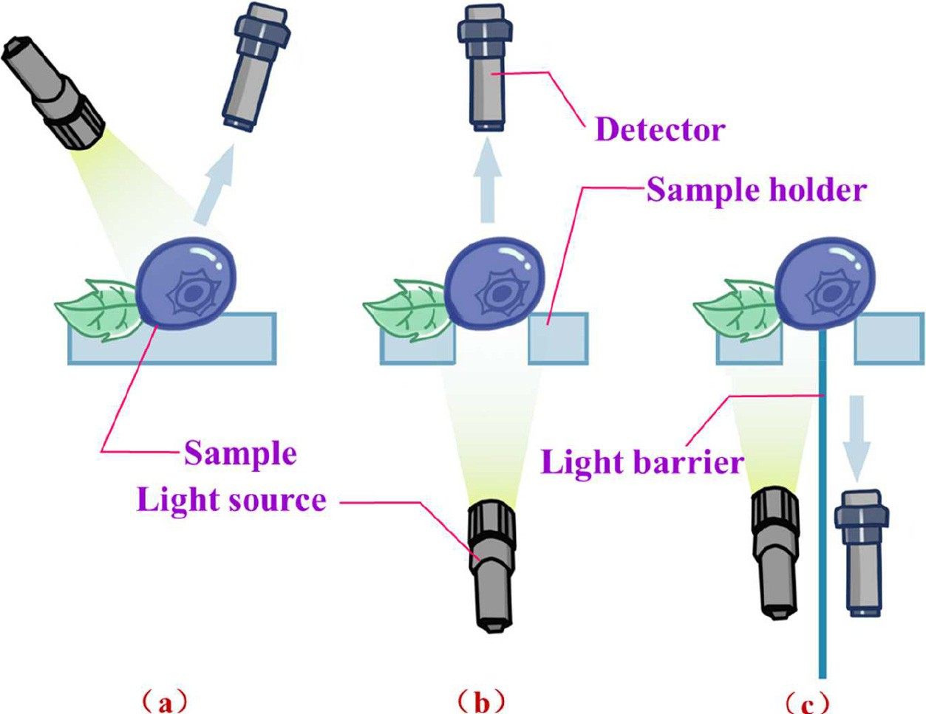

Fig. 1. Different modes for spectroscopic technique: a) reflectance mode; b) transmittance mode; c) interactance mode.

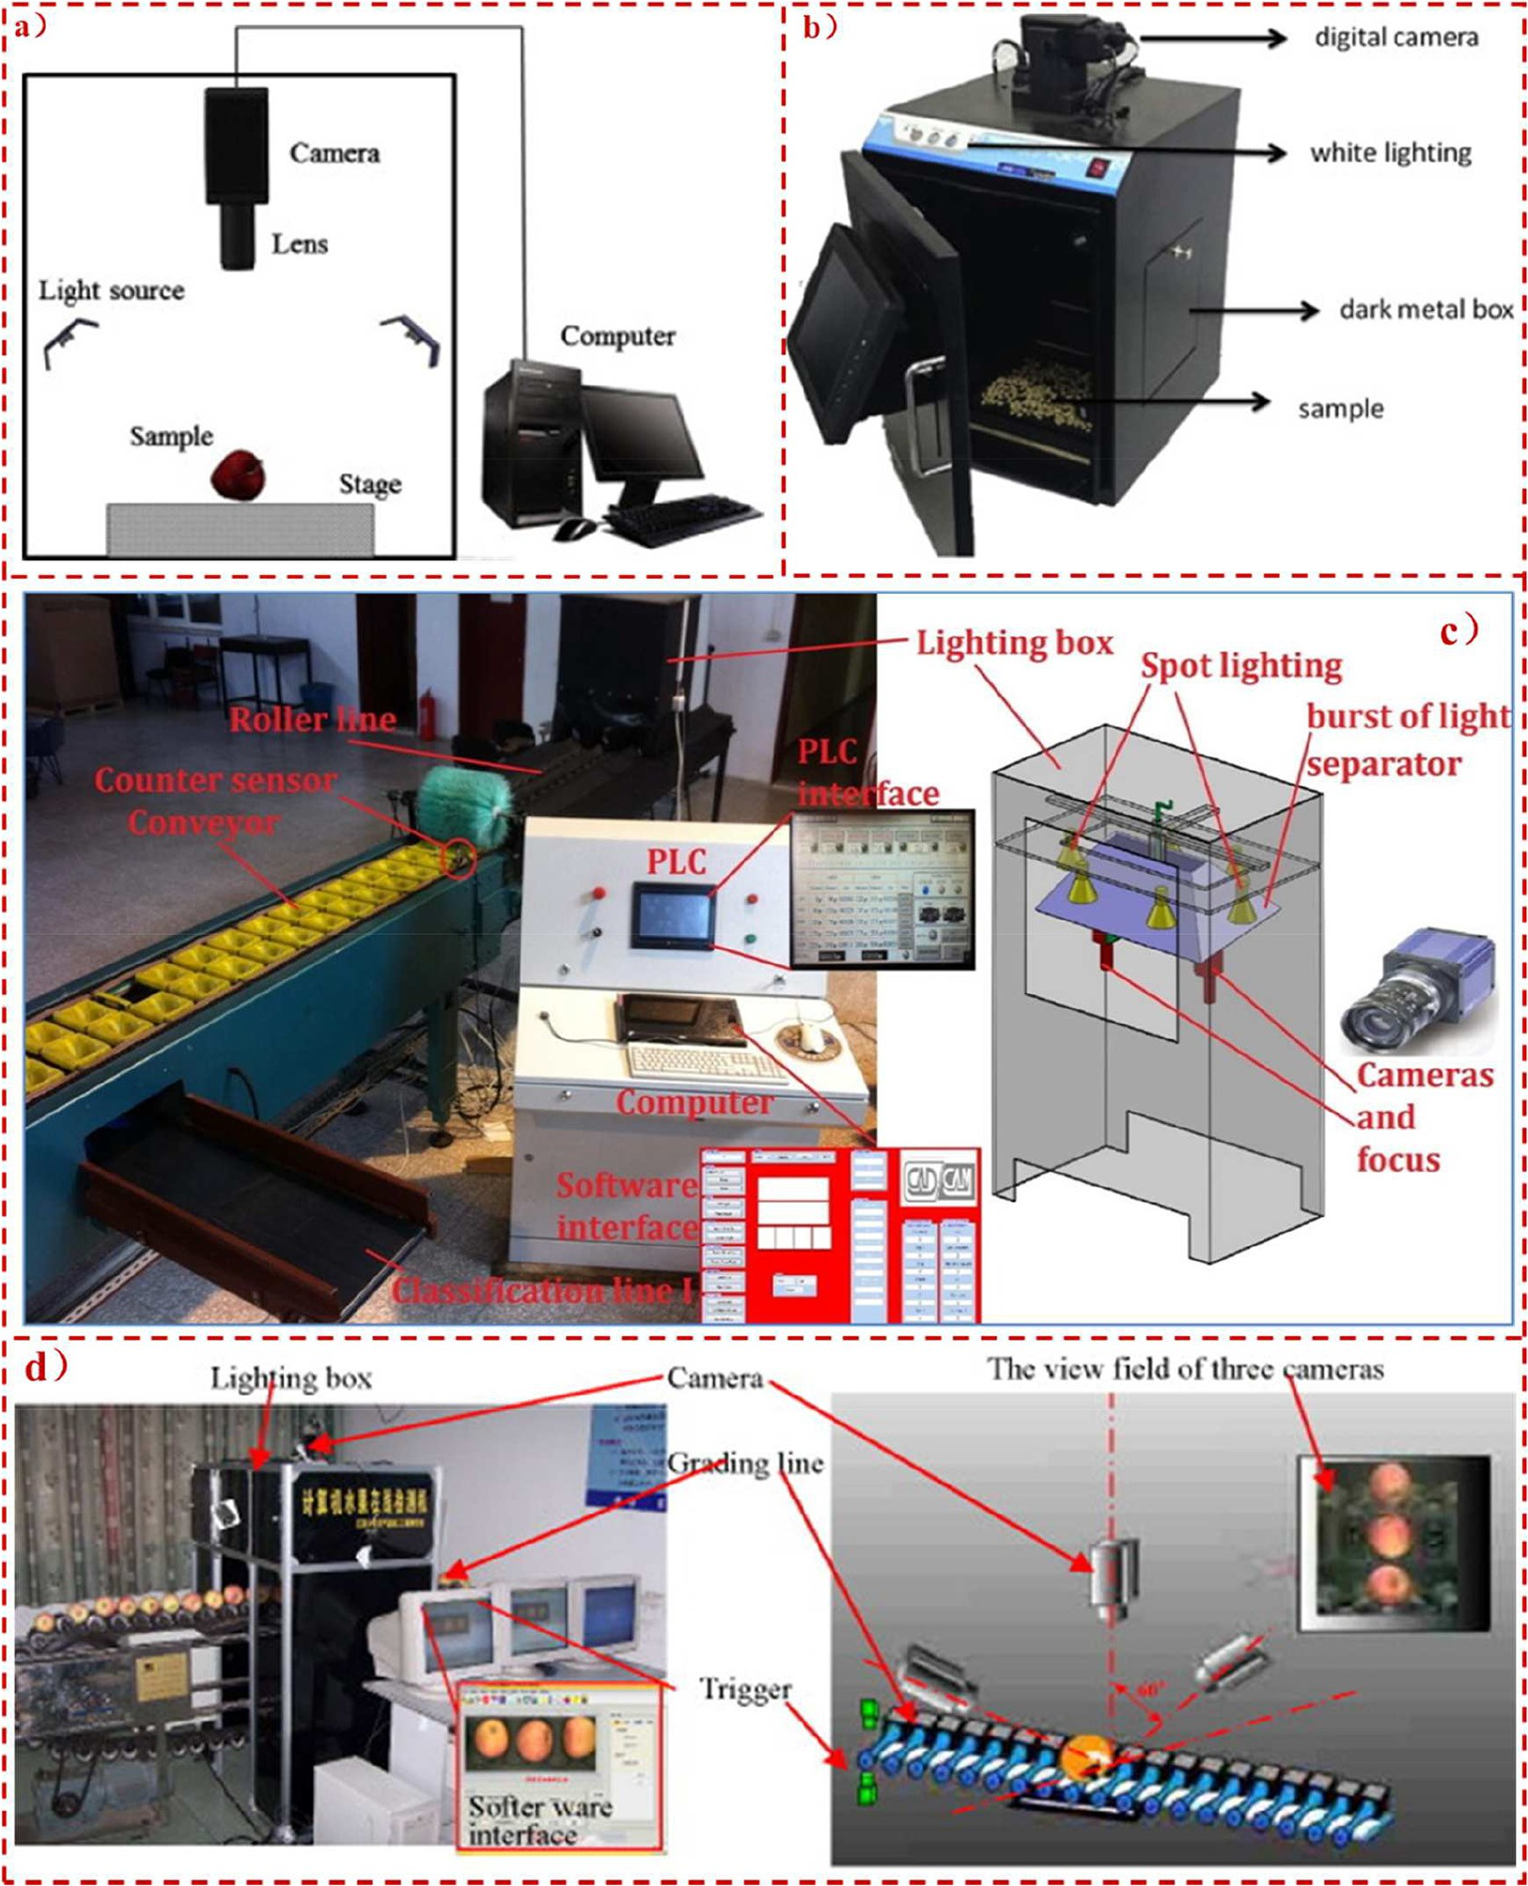

Fig. 2. Commonly used computer vision systems: a) and b) are two traditional computer vision systems by Zhang et al. (2014a) and de Oliveira et al. (2016), respectively; c) online computer vision system (Sofu et al., 2016); and d) multi-camera online computer vision system (Zou et al. Zou et al., 2010).

Nanyam et al. (2012) used hyperspectral reflectance mode to clas- sify the bruised and unbruised areas in strawberry. Whitaker et al. (2014) reported that hyperspectral reflectance had emerged as a high throughput screening tool for strawberry nematode control. For blue- berry, the firmness and soluble solids content were measured by the hyperspectral reflectance (Leiva-Valenzuela et al., 2013) and transmit- tance as well as their combined sensing modes (Leiva-Valenzuela et al., 2014). An improved hyperspectral imaging system was developed by Hu et al. (2015b) for predicting the comprehensive mechanical prop- erties of blueberry derived from the compression and puncture tests using a random frog based algorithm. The scattering and interactance modes were also incorporated into this imaging system. The experi- mental results of Jiang et al. (2016) demonstrated that there is the sig- nificant difference between healthy and bruised tissues of blueberries at the reflectance hyperspectral range of 1280–1650 nm. Their study

which used near-infrared reflectance hyperspectral imaging to screen the blueberry bruise is comprehensive and worthy of reference. Another study conducted by the same research group showed that the hyperspectral transmittance imaging technique was capability of de- tecting bruised blueberries as soon as 30 min after mechanical damage (Zhang et al., 2017). The feasibility of hyperspectral fluorescence imag- ing for small berry fruit quality and safety assessment was required in the further study (Zhang et al., 2012).

In contrast to the above literature, ElMasry et al. (2007) extracted image textural features calculated from grey-level co-occurrence matrix for classifying the strawberry ripeness stages. Recent researches in hyperspectral imaging concentrated on using spectral features such as mean spectra for the evaluation of food quality leading to the loss of spa- tial data. In our unpublished research work, when the textural features were acquired from the background-eliminated hypercubes (the

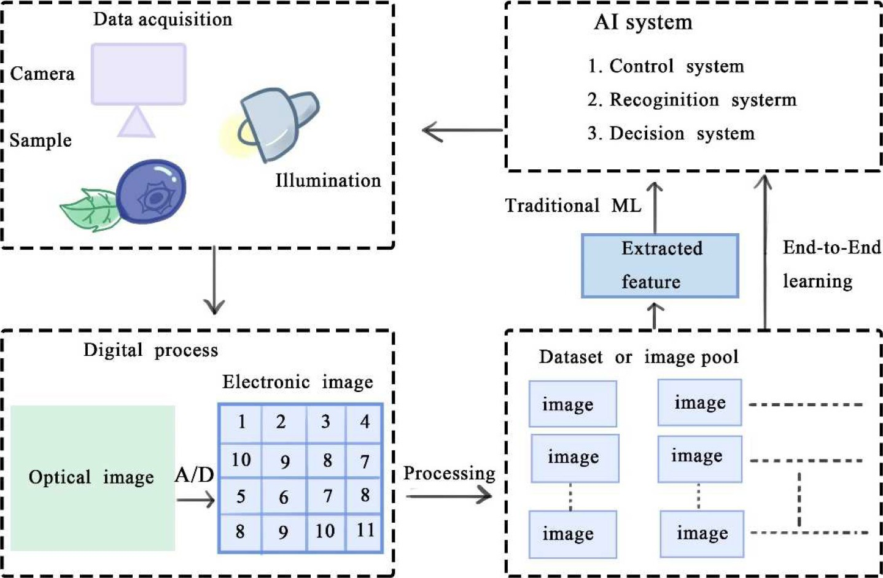

Fig. 3. Principle and lifecycle of computer vision system.

images were subjected to the image segmentation operation to elimi- nate the background pixels), the signal only existed on the beginning of spectral range owing to the low signal-noise ratio; however, as the background was taken into account, the signal pattern and intensity would be perfect for the following analysis (Fig. 5). Nonetheless, the texture of the background was not responsible for the fruit quality pa- rameters; consequently, the image textural features might be not ade- quate for investigating food hyperspectral data, at least for blueberry.

The equipment of the polaroid in the front of lens in the hyperspectral imaging system might create the possible fundamental research opportunity. In addition, setting the suitable exposure times

for the corresponding spectral intervals would make each spectrum contain more useful information (Wu and Sun, 2013). The practical ap- plications of hyperspectral imaging were confronted by a huge amount of data, and therefore, many investigators established multispectral im- aging system fitting for online detection.

## *Multispectral imaging*

Multispectral imaging system is generally constructed on the basis of the informative wavelengths which were extracted from hundreds of contiguous spectra in hypercubes by using variable selection

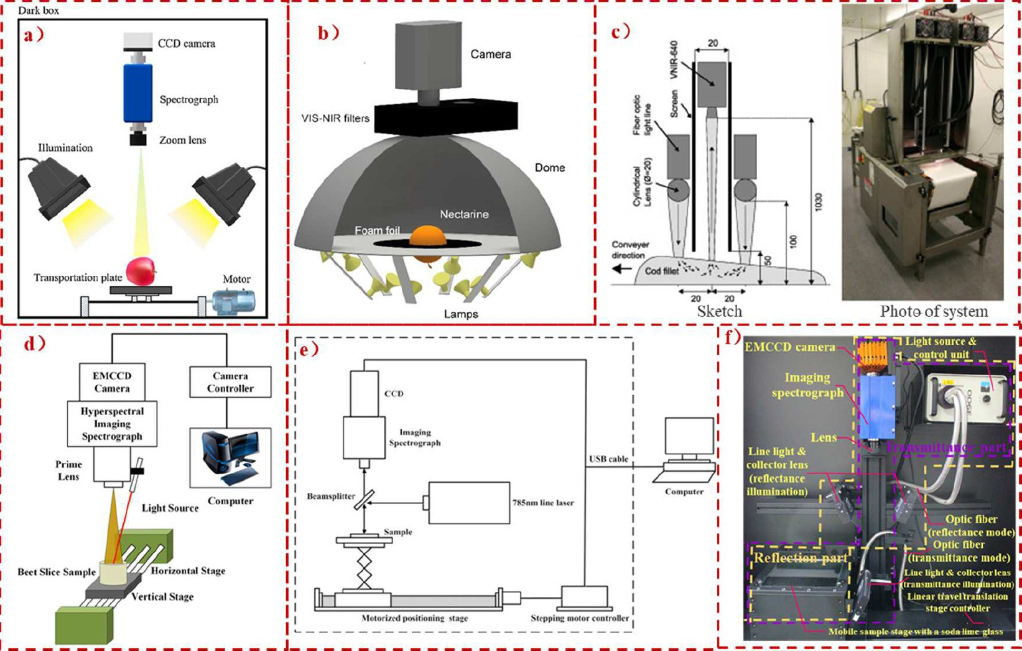

Fig. 4. Existing hyperspectral imaging systems used by investigators: a) hyperspectral reflectance imaging system (Fan et al., 2016); b) hyperspectral transmittance imaging system (Munera et al., 2019); c) hyperspectral interactance imaging system (Sivertsen et al., 2012); d) hyperspectral scattering imaging system (Pan et al., 2016); e) hyperspectral Raman imaging system (Wang et al., 2017a; Wang et al., 2017b; Wang et al., 2017c); f) the pushbroom hyperspectral reflectance, transmittance and interactance imaging system modified from (Hu et al., 2016).

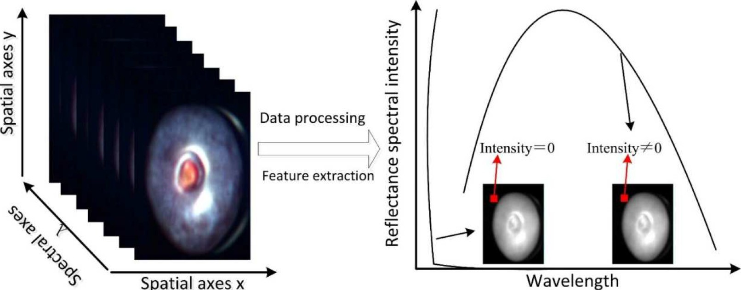

Fig. 5. Typical image textural signals for blueberry original and background-eliminated hypercubes.

algorithms. Fig. 6 shows a multispectral computer vision system, includ- ing camera, multi-spectral device, filters, lens and halogen lamp. Liu et al. (2014) concluded that the multispectral imaging coupled with ap- propriate calibration models could rapidly and non-destructively deter- mine the strawberry quality traits and maturity stages. Yang et al. (2012) used multispectral sensing to preliminarily distinguish blue- berry fruit in various ripeness stages and leaves for estimating its yield in the field. The detection of foreign substances in blueberries was car- ried out by the use of the spectral imaging at the wavelengths of 1268 nm and 1317 nm (Sugiyama et al., 2010).

## *Laser-induced method*

According to the previous literature, the later-induced biospeckle technology could be categorized into the static and dynamic biospeckle. The former, also termed as backscattering imaging, has been extensively used for food quality evaluation as the simple imaging processing tech- niques were required in its data analysis (De Belie et al., 1999; Hashim et al., 2013). The advantage compared to the static biospeckle is that, due to the additional temporal dimension, the dynamic biospeckle can reflect the particle movement at the cellular and/or sub-cellular scale (Zdunek and Herppich, 2012). However, the requirement of video

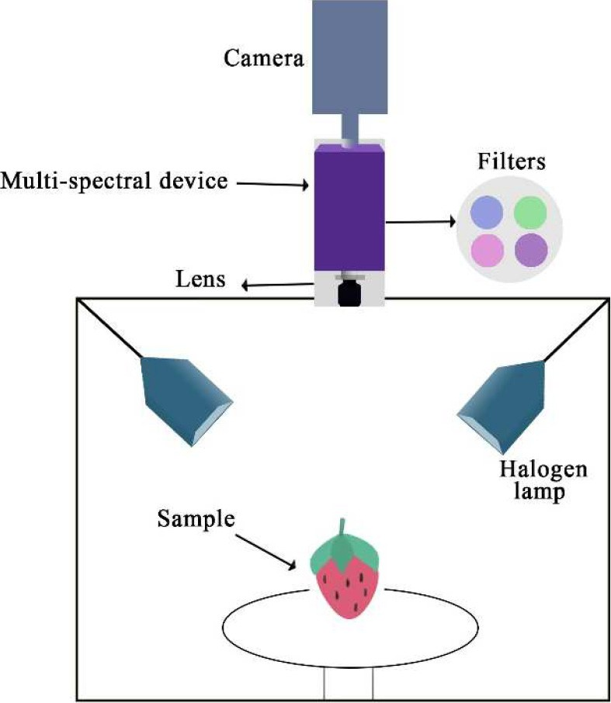

Fig. 6. Multispectral imaging system.

processing techniques hindered the applications of dynamic biospeckle on on-line quality detection. For strawberries, Mulone et al. (2013) de- termined their maturation via analyzing the statistical descriptors of dy- namic biospeckle. In our preliminary experiments (Hu et al., 2013), we found that the biospeckle quality captured by zoom lens was superior to that by fixed lens (Fig. 7). As shown in Fig. 7, the four haloes could be clearly observed on the zoom lens biospeckle image, indicating the much more useful information. Therefore, it was necessary to compare the effects of fixed and zoom lens biospeckles on the final experimental results.

In terms of other laser-excited techniques, Wulf et al. (2008) tested the potential usage of the laser-induced fluorescence spectroscopy for quantifying the blueberry *p*-coumaroyl-glucose and cinnamoyl- glucose contents. Li et al. (2011) estimated the blueberry firmness using a laser air-puff instrument with the correlation coefficient of

0.80 related to the traditional destructive method.

Raman spectroscopy could be considered as a laser-induced tech- nique for the reason that the Raman signals were excited by the laser. In most cases, Raman spectroscopy was operated in destructive ways (Fan et al., 2014). Some researchers used Raman spectroscopy as the non-destructive (Dhakal et al., 2014; He et al., 2014; Qin et al., 2012) and micro-destructive (Fang et al., 2015) analytical tools for controlling food safety and quality. The discussion of micro-destructive techniques would be presented in Section 3.6. To date, there is still no relevant study for the use of Raman spectroscopy on small berry fruits.

# Other optical non-destructive approaches

## *Thermal imaging*

Thermal imaging is a passive and energy efficient green imaging technique, and it can capture the emitted energy from the objects whose absolute temperature is higher than zero without any external stimulation such as harmful radiation and illumination (Hu et al., 2018b). Depending on the users' requirements, the infrared ranges are very different. Generally, we consider that the object emits the thermal radiation within the spectral range from 3 μm to 13 μm (Lu and Lu, 2017). Thermal imaging is initially applied to military (Gowen et al., 2010; Opara and Pathare, 2014), and then used in biomedical engineer- ing (Hu et al., 2017) and criminal investigation (Li et al., 2018). Recently, it has also been used as a non-destructive technique for various agricul- tural applications, such as the detections of insect infestation (Mahajan et al., 2015), foreign substances (Vadivambal and Jayas, 2011) and bruise damage (Baranowski et al., 2012). Meinlschmidt and Margner (2002) verified the feasibility of using the thermal imaging to distin- guish the foreign bodies among the small berry fruits. The principle of using thermal imaging to distinguish the foreign bodies among the

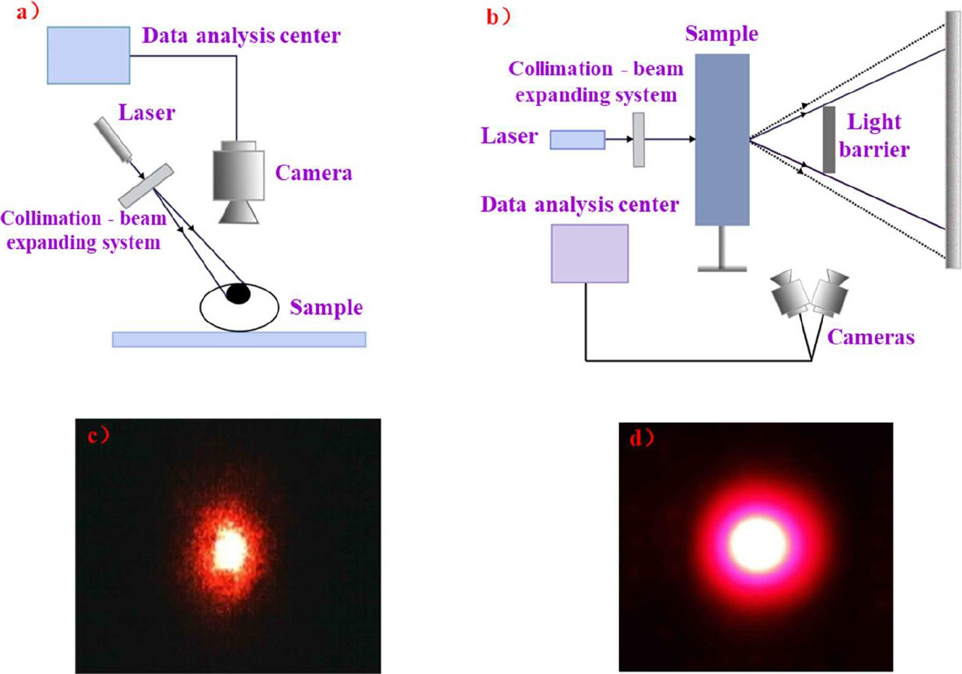

Fig. 7. Reflectance-type (a) and transmission-type (b) biospeckle measurement devices; (c) and (d) are biospeckle images obtained by fixed lens and zoom lens, respectively.

small berry fruits is that: any plant breathes and exhales heat; the berry fruit is one of plants, and therefore it breathes more intense than other foreign objects; we can use the difference of thermal properties to effec- tively screen foreign body out. The capability of thermal imaging for early detecting the physical, chemical or biological damages of small berry fruits should be explored in the further study.

## *Photoacoustic spectroscopy or imaging*

Based on photoacoustic effect, the photoacoustic measurement is a unique technique monitoring the non-radiative relaxation processes (Bageshwar et al., 2010). In other words, this technique uses the modu- lated or pulsed laser source to excite the local heating of the sample ma- trix, thus allowing the subsequent acquisition of resulting signal in the sound form (Bageshwar et al., 2010). The basic components of photo- acoustic technique include the excitation source, acoustic cells, and acoustic detector (West et al., 1983). Due to the ability of detecting acoustic or ultrasonic signals from optically thick samples, the photo- acoustic approach has been considered as “super vision” to offer an

alternative or a complementary strategy to pure optical technologies (Meralitimes, 2015).

Recently, in food and agricultural research, the photoacoustic ap- proach has been used for determining nitrogen in rapeseed (Lu et al., 2015) and quantifying pesticide residue in apple cuticle (Liu et al., 2015). In terms of small berries, Popa et al. (2014) validated the hypoth- esis that the nonorganic raspberry and strawberry fruits released more ethylene gas than organic ones via the photoacoustic spectroscopy. Since most of biological materials are turbid or opaque in nature, the photoacoustic spectroscopy or the imaging technique deserves a lot of attention in the further study.

## *X-ray technique*

X-ray technique is commonly applied to security inspection in air- ports and customs, and recently it has been extensively used in food and agricultural domain (Jiang et al., 2008; Mathanker et al., 2013a), in- cluding detecting fruit pest infestation (Chuang et al., 2011), determin- ing food density (Kelkar et al., 2015), inspecting the foreign bodies (Li et al., 2015), charactering fruit internal structure (Magwaza and

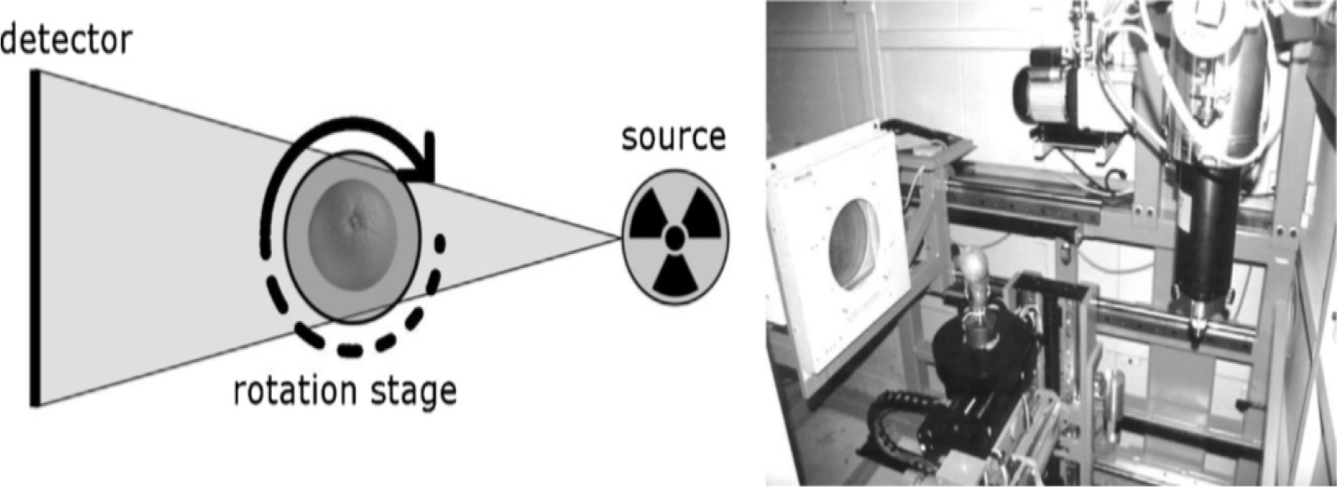

Fig. 8. A schematic presentation of X-ray technique for fruits detection (van Dael et al., 2016).

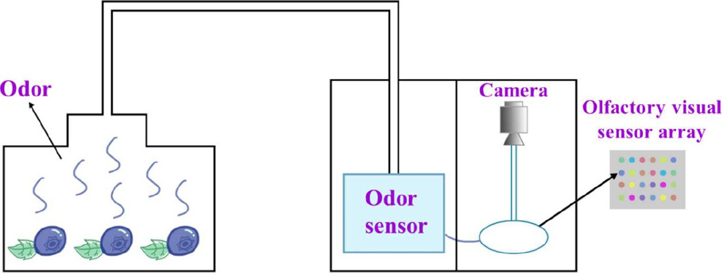

Fig. 9. A schematic of odor visualization.

Opara, 2014) and micro-structure (Cantre et al., 2014). The fundamen- tal principle behind X-ray techniques inclusive of X-ray Computed To- mography (CT) is based on the fact that the radial absorption capabilities are different between the foreign materials and food pro- duces (Nielsen et al., 2013). Fig. 8 shows a schematic presentation of the X-ray computed tomography geometry (left) and the actual setup (right).

For small berry fruits, Nielsen et al. (2014) differentiated frozen and defrosted blueberry and blackberry fruits from the X-ray images. In the further research, large data volumes in X-ray CT posed a challenge in image acquisition and processing. Developments in the multimodal ma- chine vision system containing computer vision, hyperspectral imaging and X-ray technique (Wang and Li, 2015) bring not only more useful in- formation, but also the increasing redundant information.

## *Terahertz (THz) technology*

In contrast to X-ray systems, THz systems can offer not only the dis- crimination of low-density organic materials such as insects and plastics in a food matrix but also the safe detection owing to the non-ionizing ra- diation (Gyeongsik et al., 2014; Ok et al., 2015). In food and agricultural area, due to the sensitivity to active substances, the strong penetration into specific materials, the relatively low photon energy and the high resolution (Won-Hui and Wangjoo, 2014), THz technology has received considerable attention for the detection of chemical and physical con- taminants in food (Gyeongsik et al., 2014; Qin et al., 2015), the identifi- cation of transgenic food (Liu and Li, 2014; Xu et al., 2015) and the application in fundamental research (Shiraga et al., 2013). The detailed fundamentals and applications of THz technology could be found in the reviews by El Haddad et al. (2013), Gowen et al. (2012), Mathanker et al. (2013b), and Qin et al. (2013).

According to our unpublished data, the THz reflectance spectroscopy was validated to be not applicable for blueberry quality evaluation be- cause of the curved surface (data not shown). Further researches are re- quired to overcome some technical hurdles such as the attenuation by water and scattering by inhomogeneous media (Ok et al., 2014).

## *Odor visualization*

Odor visualization/imaging is based on colorimetric sensor array to produce the unique color fingerprints using image acquisition devices such as the scanner (Chen et al., 2013a) and camera (Chen et al., 2013b), which in turn allows the differentiation among chemically di- verse analytes (Rakow and Suslick, 2000). As Fig. 9 displays, the odor produced by fruits is absorbed by odor sensor, generating signals which will be processed by olfactoty visual sensor array then, and the processed signals will change into a kind of specific spectrum. Finally, the device such as camera will capture the spectral images. Some inves- tigators have extensively applied this techniques to food and

agricultural area (Chen et al., 2013b). The further research on small berries can be explored due to the volatile materials emitted by these fruits during the postharvest operations.

## *Micro-destructive testing*

Due to the intrinsic limitations in non-destructive measurements such as the low detection limit, we presented a novel concept termed as a micro-destructive method in food and agricultural area.

Such micro-destructive technique must allow the minimally inva- sive assessment of food and agricultural products – the samples after testing should maintain the basically same quality compared to those before testing. In addition, the biological behavior of the slightly de- structive samples should be the same as completely healthy samples. This technique has been used for the diagnostic study on dyes (Aceto et al., 2015) and archaeometric investigation of Roman tesserae (van der Werf et al., 2009). One of the possible optical micro-destructive frameworks which can be applicable for fruits is proposed in Fig. 10. Changing the types of the generator and detectors as shown in Fig. 10 enables the other measurement modes like the electrical micro- destructive testing.

## *Smart mobile terminal-based analyzer*

Smart mobile terminals equipped with various sensors such as the excited illumination source and accelerometer make them promising tools for the diverse practical applications (Hossain et al., 2015a; Pongnumkul et al., 2015; Preechaburana et al., 2014), including the color evaluation (Intaravanne and Sumriddetchkajorn, 2015;

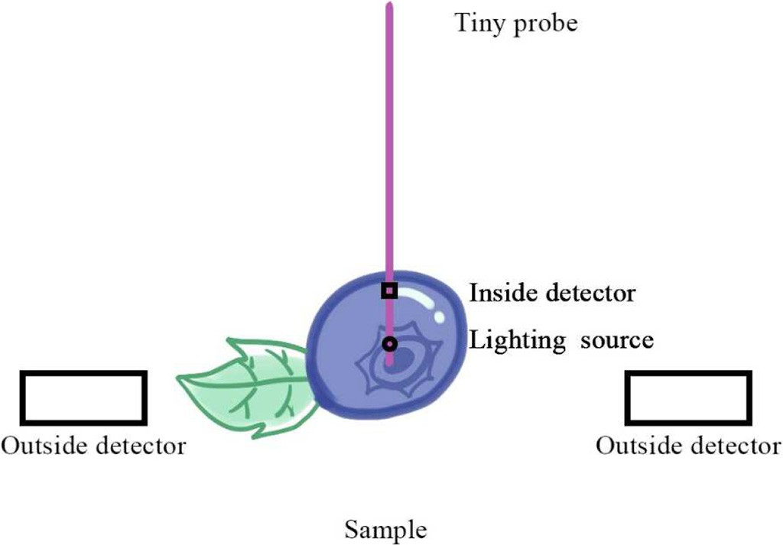

Fig. 10. Schematic diagram of a possible optical micro-destructive system.

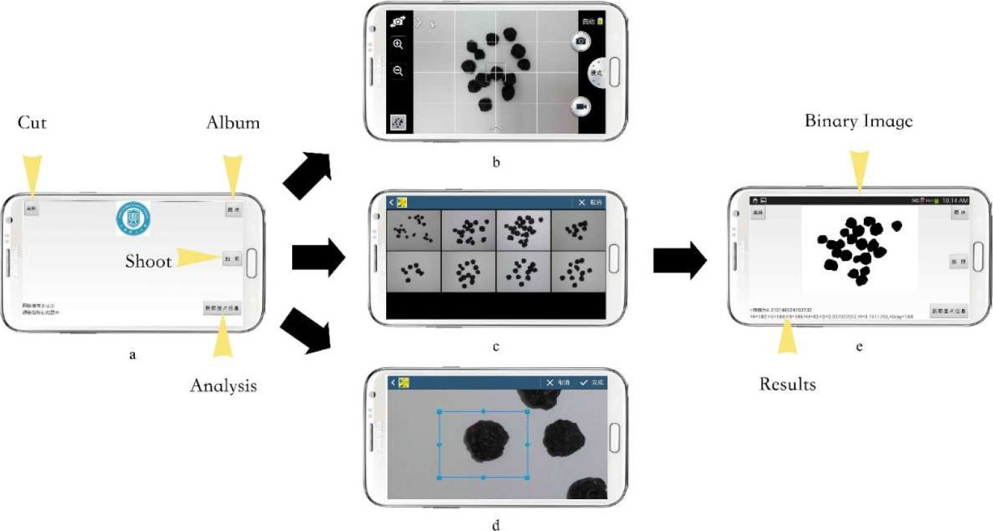

Fig. 11. Procedures of the Android app developed for color and image textural analysis of dried blueberries: a) main interface; b) shoot interface; c) album interface; d) cutting interface;

e) results interface.

Intaravanne et al., 2012; Sumriddetchkajorn et al., 2014), chemical com- ponent determination (Hossain et al., 2015b; Lopez-Ruiz et al., 2014; Masawat et al., 2015) and dietary assessment (Oliveira et al., 2014). Pertot et al. (2012) established a visual identificator based on the smart terminals including the mobile phone for assisting non- professional persons to distinguish strawberry diseases. We have also developed an Android app capable of color and image textural analysis (Fig. 11), and the following work is to apply this app for analyzing the appearance quality of small berry fruits or the other biological materials.

# Conclusion

# This review summarized the optical non-destructive techniques and their applications for quality and safety control of small berry fruits. Also, we presented our personal understanding of the technical chal- lenges and further trends for these optical non-destructive techniques. Particularly, due to the relatively low detection limit, we believe that the so-called micro-destructive techniques may be alternative to the traditional non-destructive techniques in both practical and fundamen- tal research. In addition, we suggest that the research articles like “collecting data first, and then modeling the relevant properties of agri- cultural products by machine learning” should be less produced in re- lated fields. That's because such research methods are likely to be suspected of “cheating”: the researchers of a paper can constantly adjust the parameters of models in the validation dataset to make the model acceptable before submitting the article. As the data is in hands of the researchers, they are always capable to figure out an appropriate model through various methods. However, from a practical perspective, such models may not be very significant. Hence, it is recommended that some modeling competitions as said below can be carried out in the ag- ricultural engineering field. In the match, the organizer keeps part of the testing data and opens the training data and the validation data to the public so that the participants have access to them to do the modeling research. After the match, competitors hand in models for verification by the organizer, while the models with better performance can be pub- lished in relevant conferences or journals. This measure is of great sig- nificance as it will help the academia and even the industry find out excellent models while preventing the “cheating” models appearing.

Acknowledgements

This work was supported by the Shanghai Sailing Program under Grant 19YF1414100, the China Postdoctoral Science Foundation funded

project under Grant 2016M600315, the Innovation Fund Project for Graduate Student of Shanghai (JWCXSL1401), and the STCSM (No. 18DZ2270700). We are grateful to Prof. Yi-Ming Zhu, Dr. Hong-Wei Zhao, Mr. Wei Xiao and Mr. Jing Chen from School of Optical-Electrical and Computer Engineering, University of Shanghai for Science and Technology for their valuable helps in THz experiments. We are also grateful to Dr. Chao-Hui Feng from College of Food Science, Sichuan Ag- ricultural University.

References

Zou, X.-b., Zhao, J.-w., Li, Y., Holmes, M., 2010. [In-line detection of apple defects using](http://refhub.elsevier.com/S2589-7217(19)30023-6/rf0005) [three color cameras system. Comput. Electron. Agric. 70, 129–134](http://refhub.elsevier.com/S2589-7217(19)30023-6/rf0005).

Niu, X.-y., Shao, L.-m., Zhao, Z.-l., Zhang, X.-y., 2012. [Nondestructive discrimination of](http://refhub.elsevier.com/S2589-7217(19)30023-6/rf0010) [strawberry varieties by NIR and BP-ANN. Spectrosc. Spectr. Anal. 32, 2095–2099](http://refhub.elsevier.com/S2589-7217(19)30023-6/rf0010).

Aceto, M., Arrais, A., Marsano, F., Agostino, A., Fenoglio, G., Idone, A., Gulmini, M., 2015. [A](http://refhub.elsevier.com/S2589-7217(19)30023-6/rf0015) [diagnostic study on folium and orchil dyes with non-invasive and micro-destructive](http://refhub.elsevier.com/S2589-7217(19)30023-6/rf0015) [methods. Spectrochim. Acta A Mol. Biomol. Spectrosc. 142, 159–16](http://refhub.elsevier.com/S2589-7217(19)30023-6/rf0015)8.

Adamczak, L., Chmiel, M., Florowski, T., Pietrzak, D., Witkowski, M., Barczak, T., 2015. [A](http://refhub.elsevier.com/S2589-7217(19)30023-6/rf0020) [potential use of 3-D scanning to evaluate the chemical composition of pork meat.](http://refhub.elsevier.com/S2589-7217(19)30023-6/rf0020)

[J. Food Sci. 80, E1506–E151](http://refhub.elsevier.com/S2589-7217(19)30023-6/rf0020)1.

Aday, M.S., Caner, C., 2013. [The shelf life extension of fresh strawberries using an](http://refhub.elsevier.com/S2589-7217(19)30023-6/rf0025) [oxygen absorber in the biobased package. LWT-Food Science and Technology](http://refhub.elsevier.com/S2589-7217(19)30023-6/rf0025) [52, 102–109.](http://refhub.elsevier.com/S2589-7217(19)30023-6/rf0025)

Aday, M.S., Caner, C., Rahvali, F., 2011. [Effect of oxygen and carbon dioxide absorbers on](http://refhub.elsevier.com/S2589-7217(19)30023-6/rf0030) [strawberry quality. Postharvest Biol. Technol. 62, 179–18](http://refhub.elsevier.com/S2589-7217(19)30023-6/rf0030)7.

Aday, M.S., Temizkan, R., Buyukcan, M.B., Caner, C., 2013. [An innovative technique for ex-](http://refhub.elsevier.com/S2589-7217(19)30023-6/rf0035) [tending shelf life of strawberry: ultrasound. Lwt-Food Science and Technology 52,](http://refhub.elsevier.com/S2589-7217(19)30023-6/rf0035) [93–10](http://refhub.elsevier.com/S2589-7217(19)30023-6/rf0035)1.

Agudelo-Laverde, L.M., Schebor, C., Buera, M.D., 2013. [Water content effect on the chro-](http://refhub.elsevier.com/S2589-7217(19)30023-6/rf0040) [matic attributes of dehydrated strawberries during storage, as evaluated by image](http://refhub.elsevier.com/S2589-7217(19)30023-6/rf0040) [analysis. Lwt-Food Science and Technology 52, 157–16](http://refhub.elsevier.com/S2589-7217(19)30023-6/rf0040)2.

Bageshwar, D.V., Pawar, A.S., Khanvilkar, V.V., Kadam, V.J., 2010. [Photoacoustic spectros-](http://refhub.elsevier.com/S2589-7217(19)30023-6/rf0045) [copy and its applications–a tutorial review. Eurasian J. Anal. Chem. 5, 187–20](http://refhub.elsevier.com/S2589-7217(19)30023-6/rf0045)3.

Bai, W.M., Yoshimura, N., Takayanagi, M., 2014. [Quantitative analysis of ingredients of](http://refhub.elsevier.com/S2589-7217(19)30023-6/rf0050) [blueberry fruits by near infrared spectroscopy. J. Near Infrared Spectrosc. 22,](http://refhub.elsevier.com/S2589-7217(19)30023-6/rf0050) [357–36](http://refhub.elsevier.com/S2589-7217(19)30023-6/rf0050)5.

Balage, J.M., Silva, S.D.E., Gomide, C.A., Bonin, M.D., Figueira, A.C., 2015. [Predicting pork](http://refhub.elsevier.com/S2589-7217(19)30023-6/rf0055) [quality using Vis/NIR spectroscopy. Meat Sci. 108, 37–43](http://refhub.elsevier.com/S2589-7217(19)30023-6/rf0055).

Baranowski, P., Mazurek, W., Wozniak, J., Majewska, U., 2012. [Detection of early bruises in](http://refhub.elsevier.com/S2589-7217(19)30023-6/rf0060) [apples using hyperspectral data and thermal imaging. J. Food Eng. 110, 345–35](http://refhub.elsevier.com/S2589-7217(19)30023-6/rf0060)5.

Beghi, R., Giovenzana, V., Spinardi, A., Guidetti, R., Bodria, L., Oberti, R., 2013. [Derivation of](http://refhub.elsevier.com/S2589-7217(19)30023-6/rf0065) [a blueberry ripeness index with a view to a low-cost, handheld optical sensing device](http://refhub.elsevier.com/S2589-7217(19)30023-6/rf0065) [for supporting harvest decisions. Trans. ASABE 56, 1551–1559](http://refhub.elsevier.com/S2589-7217(19)30023-6/rf0065).

Brosnan, T., Sun, D.W., 2004. [Improving quality inspection of food products by computer](http://refhub.elsevier.com/S2589-7217(19)30023-6/rf0070) [vision - a review. J. Food Eng. 61, 3–16](http://refhub.elsevier.com/S2589-7217(19)30023-6/rf0070).

Cantre, D., East, A., Verboven, P., Trejo Araya, X., Herremans, E., Nicolaï, B.M., Pranamornkith, T., Loh, M., Mowat, A., Heyes, J., 2014. [Microstructural characterisa-](http://refhub.elsevier.com/S2589-7217(19)30023-6/rf0075) [tion of commercial kiwifruit cultivars using X-ray micro computed tomography. Post-](http://refhub.elsevier.com/S2589-7217(19)30023-6/rf0075) [harvest Biol. Technol. 92, 79–86](http://refhub.elsevier.com/S2589-7217(19)30023-6/rf0075).

Castro, W., Oblitas, J., De-la-Torre, M., Cotrina, C., Bazan, K., Avila-George, H., 2019. [Classi-](http://refhub.elsevier.com/S2589-7217(19)30023-6/rf0080) [fication of cape gooseberry fruit according to its level of ripeness using machine](http://refhub.elsevier.com/S2589-7217(19)30023-6/rf0080) [learning techniques and different color spaces. IEEE Access 7, 27389–2740](http://refhub.elsevier.com/S2589-7217(19)30023-6/rf0080)0.

Chen, Y.G., Martynenko, A., 2013. [Computer vision for real-time measurements of shrink-](http://refhub.elsevier.com/S2589-7217(19)30023-6/rf0085) [age and color changes in blueberry convective drying. Dry Technology 31,](http://refhub.elsevier.com/S2589-7217(19)30023-6/rf0085) [1114–1123](http://refhub.elsevier.com/S2589-7217(19)30023-6/rf0085).

Chen, Q., Liu, A., Zhao, J., Ouyang, Q., 2013a. [Classification of tea category using a portable](http://refhub.elsevier.com/S2589-7217(19)30023-6/rf0090) [electronic nose based on an odor imaging sensor array. J. Pharm. Biomed. Anal. 84,](http://refhub.elsevier.com/S2589-7217(19)30023-6/rf0090) [77–89](http://refhub.elsevier.com/S2589-7217(19)30023-6/rf0090).

Chen, Q.S., Zhang, C.J., Zhao, J.W., Ouyang, Q., 2013b. [Recent advances in emerging imag-](http://refhub.elsevier.com/S2589-7217(19)30023-6/rf0095) [ing techniques for non-destructive detection of food quality and safety. TrAC Trends](http://refhub.elsevier.com/S2589-7217(19)30023-6/rf0095) [Anal. Chem. 52, 261–274](http://refhub.elsevier.com/S2589-7217(19)30023-6/rf0095).

Chuang, C.-L., Ouyang, C.-S., Lin, T.-T., Yang, M.-M., Yang, E.-C., Huang, T.-W., Kuei, C.-F., Luke, A., Jiang, J.-A., 2011. [Automatic X-ray quarantine scanner and pest infestation](http://refhub.elsevier.com/S2589-7217(19)30023-6/rf0100) [detector for agricultural products. Comput. Electron. Agric. 77, 41–59](http://refhub.elsevier.com/S2589-7217(19)30023-6/rf0100).

Cozzolino, D., Cynkar, W.U., Shah, N., Smith, P., 2011. [Multivariate data analysis applied to](http://refhub.elsevier.com/S2589-7217(19)30023-6/rf0105) [spectroscopy: potential application to juice and fruit quality. Food Res. Int. 44,](http://refhub.elsevier.com/S2589-7217(19)30023-6/rf0105) [1888–1896](http://refhub.elsevier.com/S2589-7217(19)30023-6/rf0105).

van Dael, M., Lebotsa, S., Herremans, E., Verboven, P., Sijbers, J., Opara, U.L., Cronje, P.J., Nicolai, B.M., 2016. [A segmentation and classification algorithm for online detection](http://refhub.elsevier.com/S2589-7217(19)30023-6/rf0110) [of internal disorders in citrus using X-ray radiographs. Postharvest Biol. Technol.](http://refhub.elsevier.com/S2589-7217(19)30023-6/rf0110) [112, 205–21](http://refhub.elsevier.com/S2589-7217(19)30023-6/rf0110)4.

De Belie, N., Tu, K., Jancsók, P., De Baerdemaeker, J., 1999. [Preliminary study on the influ-](http://refhub.elsevier.com/S2589-7217(19)30023-6/rf0115) [ence of turgor pressure on body reflectance of red laser light as a ripeness indicator](http://refhub.elsevier.com/S2589-7217(19)30023-6/rf0115) [for apples. Postharvest Biol. Technol. 16, 279–28](http://refhub.elsevier.com/S2589-7217(19)30023-6/rf0115)4.

Dhakal, S., Li, Y.Y., Peng, Y.K., Chao, K.L., Qin, J.W., Guo, L.H., 2014. [Prototype instrument](http://refhub.elsevier.com/S2589-7217(19)30023-6/rf0120) [development for non-destructive detection of pesticide residue in apple surface](http://refhub.elsevier.com/S2589-7217(19)30023-6/rf0120) [using Raman technology. J. Food Eng. 123, 94–10](http://refhub.elsevier.com/S2589-7217(19)30023-6/rf0120)3.

El Haddad, J., Bousquet, B., Canioni, L., Mounaix, P., 2013. [Review in terahertz spectral](http://refhub.elsevier.com/S2589-7217(19)30023-6/rf0125) [analysis. TrAC Trends Anal. Chem. 44, 98–10](http://refhub.elsevier.com/S2589-7217(19)30023-6/rf0125)5.

ElMasry, G., Wang, N., ElSayed, A., Ngadi, M., 2007. [Hyperspectral imaging for nonde-](http://refhub.elsevier.com/S2589-7217(19)30023-6/rf0130) [structive determination of some quality attributes for strawberry. J. Food Eng.](http://refhub.elsevier.com/S2589-7217(19)30023-6/rf0130) [81, 98–107.](http://refhub.elsevier.com/S2589-7217(19)30023-6/rf0130)

Fan, Y., Lai, K., Rasco, B.A., Huang, Y., 2014. [Analyses of phosmet residues in apples with](http://refhub.elsevier.com/S2589-7217(19)30023-6/rf0135) [surface-enhanced Raman spectroscopy. Food Control 37, 153–15](http://refhub.elsevier.com/S2589-7217(19)30023-6/rf0135)7.

Fan, S., Zhang, B., Li, J., Liu, C., Huang, W., Tian, X., 2016. [Prediction of soluble solids content](http://refhub.elsevier.com/S2589-7217(19)30023-6/rf0140) [of apple using the combination of spectra and textural features of hyperspectral re-](http://refhub.elsevier.com/S2589-7217(19)30023-6/rf0140) [flectance imaging data. Postharvest Biol. Technol. 121, 51–61](http://refhub.elsevier.com/S2589-7217(19)30023-6/rf0140).

Fan, S.X., Li, C.Y., Huang, W.Q., Chen, L.P., 2018. [Data fusion of two hyperspectral imaging](http://refhub.elsevier.com/S2589-7217(19)30023-6/rf0145) [systems with complementary spectral sensing ranges for blueberry bruising detec-](http://refhub.elsevier.com/S2589-7217(19)30023-6/rf0145) [tion. Sensors 18, 446](http://refhub.elsevier.com/S2589-7217(19)30023-6/rf0145)3.

Fang, H., Zhang, X., Zhang, S.J., Liu, L., Zhao, Y.M., Xu, H.J., 2015. [Ultrasensitive and quanti-](http://refhub.elsevier.com/S2589-7217(19)30023-6/rf0150) [tative detection of paraquat on fruits skins via surface-enhanced Raman spectros-](http://refhub.elsevier.com/S2589-7217(19)30023-6/rf0150) [copy. Sensors Actuators B Chem. 213, 452–45](http://refhub.elsevier.com/S2589-7217(19)30023-6/rf0150)6.

Fernandes Barbin, D., Valous, N.A., Passos Dias, A., Camisa, J., Hirooka, E.Y., Yamashita, F., 2015. [VIS-NIR spectroscopy as a process analytical technology for compositional](http://refhub.elsevier.com/S2589-7217(19)30023-6/rf0155) [characterization of film biopolymers and correlation with their mechanical proper-](http://refhub.elsevier.com/S2589-7217(19)30023-6/rf0155) [ties. Materials Science and Engineering: C, Materials for Biological Applications 56,](http://refhub.elsevier.com/S2589-7217(19)30023-6/rf0155) [274–27](http://refhub.elsevier.com/S2589-7217(19)30023-6/rf0155)9.

Giovannini, D., Quacquarelli, I., Ranieri, M., Faedi, W., 2014. [Feasibility study of NIR appli-](http://refhub.elsevier.com/S2589-7217(19)30023-6/rf0160) [cation to strawberry internal fruit quality traits. VII International Strawberry Sympo-](http://refhub.elsevier.com/S2589-7217(19)30023-6/rf0160) [sium 1049, 947–954](http://refhub.elsevier.com/S2589-7217(19)30023-6/rf0160).

Gowen, A.A., Tiwari, B.K., Cullen, P.J., McDonnell, K., O'Donnell, C.P., 2010. [Applications of](http://refhub.elsevier.com/S2589-7217(19)30023-6/rf0165) [thermal imaging in food quality and safety assessment. Trends Food Sci. Technol. 21,](http://refhub.elsevier.com/S2589-7217(19)30023-6/rf0165) [190–20](http://refhub.elsevier.com/S2589-7217(19)30023-6/rf0165)0.

Gowen, A.A., O'Sullivan, C., O'Donnell, C.P., 2012. [Terahertz time domain spectroscopy and](http://refhub.elsevier.com/S2589-7217(19)30023-6/rf0170) [imaging: emerging techniques for food process monitoring and quality control.](http://refhub.elsevier.com/S2589-7217(19)30023-6/rf0170) [Trends Food Sci. Technol. 25, 40–46](http://refhub.elsevier.com/S2589-7217(19)30023-6/rf0170).

Grant, O.M., Davies, M.J., James, C.M., Johnson, A.W., Leinonen, I., Simpson, D.W., 2012. [Thermal imaging and carbon isotope composition indicate variation amongst straw-](http://refhub.elsevier.com/S2589-7217(19)30023-6/rf0175) [berry (Fragaria × ananassa) cultivars in stomatal conductance and water use effi-](http://refhub.elsevier.com/S2589-7217(19)30023-6/rf0175) [ciency. Environ. Exp. Bot. 76, 7–15](http://refhub.elsevier.com/S2589-7217(19)30023-6/rf0175).

Guidetti, R., Beghi, R., Bodria, L., Spinardi, A., Mignani, I., Folini, L., 2009. [Prediction of blue-](http://refhub.elsevier.com/S2589-7217(19)30023-6/rf0180) [berry (Vaccinium corymbosum) ripeness by a portable Vis-NIR device. IX Interna-](http://refhub.elsevier.com/S2589-7217(19)30023-6/rf0180) [tional Vaccinium Symposium 810, 877–88](http://refhub.elsevier.com/S2589-7217(19)30023-6/rf0180)5.

Guo, Z., Huang, W., Chen, L., Wang, X., Peng, Y., 2013. [Nondestructive evaluation of soluble](http://refhub.elsevier.com/S2589-7217(19)30023-6/rf6000) [solid content in strawberry by near infrared spectroscopy. Proc. SPIE Int. Soc. Opt.](http://refhub.elsevier.com/S2589-7217(19)30023-6/rf6000) [Eng. 8761, 87610O](http://refhub.elsevier.com/S2589-7217(19)30023-6/rf6000).

Gyeongsik, O., Hyun Jung, K., Hyang Sook, C., Sung-Wook, C., 2014. [Foreign-body detec-](http://refhub.elsevier.com/S2589-7217(19)30023-6/rf0185) [tion in dry food using continuous sub-terahertz wave imaging. Food Control 42,](http://refhub.elsevier.com/S2589-7217(19)30023-6/rf0185) [284–28](http://refhub.elsevier.com/S2589-7217(19)30023-6/rf0185)9.

Hashim, N., Pflanz, M., Regen, C., Janius, R.B., Abdul Rahman, R., Osman, A., Shitan, M., Zude, M., 2013. [An approach for monitoring the chilling injury appearance in bananas](http://refhub.elsevier.com/S2589-7217(19)30023-6/rf0190) [by means of backscattering imaging. J. Food Eng. 116, 28–36](http://refhub.elsevier.com/S2589-7217(19)30023-6/rf0190).

He, L., Chen, T., Labuza, T.P., 2014. [Recovery and quantitative detection of thiabendazole](http://refhub.elsevier.com/S2589-7217(19)30023-6/rf0195) [on apples using a surface swab capture method followed by surface-enhanced](http://refhub.elsevier.com/S2589-7217(19)30023-6/rf0195) [Raman spectroscopy. Food Chem. 148, 42–46](http://refhub.elsevier.com/S2589-7217(19)30023-6/rf0195).

He, K., Tian, Y., Qiao, S., Yao, P., Gu, W., 2019. [Detection of rot blueberry disease by](http://refhub.elsevier.com/S2589-7217(19)30023-6/rf0200) [hyperspectral imaging with SIS and RFS. Chinese Journal of Luminescence 40,](http://refhub.elsevier.com/S2589-7217(19)30023-6/rf0200) [413–42](http://refhub.elsevier.com/S2589-7217(19)30023-6/rf0200)1.

Hossain, M.A., Canning, J., Ast, S., Cook, K., Rutledge, P.J., Jamalipour, A., 2015a. [Combined](http://refhub.elsevier.com/S2589-7217(19)30023-6/rf0205) [“dual” absorption and fluorescence smartphone spectrometers. Opt. Lett. 40,](http://refhub.elsevier.com/S2589-7217(19)30023-6/rf0205) [1737–1740](http://refhub.elsevier.com/S2589-7217(19)30023-6/rf0205).

Hossain, M.A., Canning, J., Ast, S., Rutledge, P.J., Yen, T.L., Jamalipour, A., 2015b. [Lab-in-a-](http://refhub.elsevier.com/S2589-7217(19)30023-6/rf0210) [phone: smartphone-based portable fluorometer for pH measurements of environ-](http://refhub.elsevier.com/S2589-7217(19)30023-6/rf0210) [mental water. IEEE Sensors J. 15, 5095–5102.](http://refhub.elsevier.com/S2589-7217(19)30023-6/rf0210)

Hu, M., Dong, Q., Liu, B., Tu, K., Song, X., 2013. [Application of biospeckle on analysis of ag-](http://refhub.elsevier.com/S2589-7217(19)30023-6/rf0215) [ricultural products quality. Transactions of the Chinese Society of Agricultural Engi-](http://refhub.elsevier.com/S2589-7217(19)30023-6/rf0215) [neering 29, 284–29](http://refhub.elsevier.com/S2589-7217(19)30023-6/rf0215)2.

Hu, M.-H., Dong, Q.-L., Liu, B.-L., Pan, L.-Q., Walshaw, J., 2015a. [Image segmentation of ba-](http://refhub.elsevier.com/S2589-7217(19)30023-6/rf0220) [nanas in a crate using a multiple threshold method. J. Food Process Eng. 2016,](http://refhub.elsevier.com/S2589-7217(19)30023-6/rf0220) [427–43](http://refhub.elsevier.com/S2589-7217(19)30023-6/rf0220)2.

Hu, M.H., Dong, Q.L., Liu, B.L., Opara, U.L., Chen, L., 2015b. [Estimating blueberry mechani-](http://refhub.elsevier.com/S2589-7217(19)30023-6/rf0225) [cal properties based on random frog selected hyperspectral data. Postharvest Biol.](http://refhub.elsevier.com/S2589-7217(19)30023-6/rf0225) [Technol. 106, 1–10](http://refhub.elsevier.com/S2589-7217(19)30023-6/rf0225).

Hu, M.-H., Dong, Q.-L., Liu, B.-L., Opara, U.L., 2016. [Prediction of mechanical properties of](http://refhub.elsevier.com/S2589-7217(19)30023-6/rf0230) [blueberry using hyperspectral interactance imaging. Postharvest Biol. Technol. 115,](http://refhub.elsevier.com/S2589-7217(19)30023-6/rf0230) [122–13](http://refhub.elsevier.com/S2589-7217(19)30023-6/rf0230)1.

Hu, M.-H., Zhai, G.-T., Li, D., Fan, Y.-Z., Chen, X.-H., Yang, X.-K., 2017. [Synergetic use of](http://refhub.elsevier.com/S2589-7217(19)30023-6/rf0235) [thermal and visible imaging techniques for contactless and unobtrusive breathing](http://refhub.elsevier.com/S2589-7217(19)30023-6/rf0235) [measurement. J. Biomed. Opt. 22, 036006](http://refhub.elsevier.com/S2589-7217(19)30023-6/rf0235).

Hu, M.-H., Zhao, Y., Zhai, G.-T., 2018a. [Active learning algorithm can establish classifier of](http://refhub.elsevier.com/S2589-7217(19)30023-6/rf0240) [blueberry damage with very small training dataset using hyperspectral transmittance](http://refhub.elsevier.com/S2589-7217(19)30023-6/rf0240) [data. Chemom. Intell. Lab. Syst. 172, 52–57](http://refhub.elsevier.com/S2589-7217(19)30023-6/rf0240).

Hu, M., Zhai, G., Li, D., Li, H., Liu, M., Tang, W., Chen, Y., 2018b. [Influence of image resolu-](http://refhub.elsevier.com/S2589-7217(19)30023-6/rf0245) [tion on the performance of remote breathing rate measurement using thermal imag-](http://refhub.elsevier.com/S2589-7217(19)30023-6/rf0245) [ing technique. Infrared Phys. Technol. 93, 63–69](http://refhub.elsevier.com/S2589-7217(19)30023-6/rf0245).

Hu, M.H., Zhai, G.T., Zhao, Y., Wang, Z.D., 2018c. [Uses of selection strategies in both spec-](http://refhub.elsevier.com/S2589-7217(19)30023-6/rf0250) [tral and sample spaces for classifying hard and soft blueberry using near infrared](http://refhub.elsevier.com/S2589-7217(19)30023-6/rf0250) [data. Sci. Rep. 8, 6671](http://refhub.elsevier.com/S2589-7217(19)30023-6/rf0250).

Huang, L., Wu, D., Jin, H., Zhang, J., He, Y., Lou, C., 2011. [Internal quality determination of](http://refhub.elsevier.com/S2589-7217(19)30023-6/rf0255) [fruit with bumpy surface using visible and near infrared spectroscopy and](http://refhub.elsevier.com/S2589-7217(19)30023-6/rf0255) [chemometrics: a case study with mulberry fruit. Biosyst. Eng. 109, 377–384](http://refhub.elsevier.com/S2589-7217(19)30023-6/rf0255).

Hyeon, P., Eun, J., Se-Han, K., 2018. [Crops disease diagnosing using image-based deep](http://refhub.elsevier.com/S2589-7217(19)30023-6/rf0260) [learning mechanism. IEEE International Conference on Computing and Network](http://refhub.elsevier.com/S2589-7217(19)30023-6/rf0260) [Communications, pp. 23–26](http://refhub.elsevier.com/S2589-7217(19)30023-6/rf0260).

Intaravanne, Y., Sumriddetchkajorn, S., 2015. [Android-based rice leaf color analyzer for](http://refhub.elsevier.com/S2589-7217(19)30023-6/rf0265) [estimating the needed amount of nitrogen fertilizer. Comput. Electron. Agric. 116,](http://refhub.elsevier.com/S2589-7217(19)30023-6/rf0265) [228–23](http://refhub.elsevier.com/S2589-7217(19)30023-6/rf0265)3.

Intaravanne, Y., Sumriddetchkajorn, S., Nukeaw, J., 2012. [Cell phone-based two-](http://refhub.elsevier.com/S2589-7217(19)30023-6/rf0270) [dimensional spectral analysis for banana ripeness estimation. Sensors Actuators B](http://refhub.elsevier.com/S2589-7217(19)30023-6/rf0270) [Chem. 168, 390–39](http://refhub.elsevier.com/S2589-7217(19)30023-6/rf0270)4.

Jiang, J.-A., Chang, H.-Y., Wu, K.-H., Ouyang, C.-S., Yang, M.-M., Yang, E.-C., Chen, T.-W., Lin, T.-T., 2008. [An adaptive image segmentation algorithm for X-ray quarantine inspec-](http://refhub.elsevier.com/S2589-7217(19)30023-6/rf0275) [tion of selected fruits. Comput. Electron. Agric. 60, 190–200](http://refhub.elsevier.com/S2589-7217(19)30023-6/rf0275).

Jiang, Y., Li, C., Takeda, F., 2016. [Nondestructive detection and quantification of blueberry](http://refhub.elsevier.com/S2589-7217(19)30023-6/rf0280) [bruising using near-infrared (NIR) hyperspectral reflectance imaging. Sci. Rep. 6,](http://refhub.elsevier.com/S2589-7217(19)30023-6/rf0280) [35679](http://refhub.elsevier.com/S2589-7217(19)30023-6/rf0280).

Kartal, S., Aday, M.S., Caner, C., 2012. [Use of microperforated films and oxygen scavengers](http://refhub.elsevier.com/S2589-7217(19)30023-6/rf0285) [to maintain storage stability of fresh strawberries. Postharvest Biol. Technol. 71,](http://refhub.elsevier.com/S2589-7217(19)30023-6/rf0285) [32–40](http://refhub.elsevier.com/S2589-7217(19)30023-6/rf0285).

Kelkar, S., Boushey, C.J., Okos, M., 2015. [A method to determine the density of foods using](http://refhub.elsevier.com/S2589-7217(19)30023-6/rf0290) [X-ray imaging. J. Food Eng. 159, 36–41](http://refhub.elsevier.com/S2589-7217(19)30023-6/rf0290).

Kim, S.W., Min, S.R., Kim, J., Park, S.K., Kim, T.I., Liu, J.R., 2009. [Rapid discrimination of com-](http://refhub.elsevier.com/S2589-7217(19)30023-6/rf0295) [mercial strawberry cultivars using Fourier transform infrared spectroscopy data com-](http://refhub.elsevier.com/S2589-7217(19)30023-6/rf0295) [bined by multivariate analysis. Plant Biotechnology Reports 3, 87–93](http://refhub.elsevier.com/S2589-7217(19)30023-6/rf0295).

Kuzy, J., Jiang, Y., Li, C., 2018. [Blueberry bruise detection by pulsed thermographic imag-](http://refhub.elsevier.com/S2589-7217(19)30023-6/rf0300) [ing. Postharvest Biol. Technol. 136, 166–17](http://refhub.elsevier.com/S2589-7217(19)30023-6/rf0300)7.

Lamb, N., Mooi Choo, C., 2018. [A Strawberry Detection System Using Convolutional Neural](http://refhub.elsevier.com/S2589-7217(19)30023-6/rf0305) [Networks](http://refhub.elsevier.com/S2589-7217(19)30023-6/rf0305).

Leiva-Valenzuela, G.A., Aguilera, J.M., 2013. [Automatic detection of orientation and dis-](http://refhub.elsevier.com/S2589-7217(19)30023-6/rf0310) [eases in blueberries using image analysis to improve their postharvest storage qual-](http://refhub.elsevier.com/S2589-7217(19)30023-6/rf0310) [ity. Food Control 33, 166–17](http://refhub.elsevier.com/S2589-7217(19)30023-6/rf0310)3.

Leiva-Valenzuela, G.A., Lu, R., Miguel Aguilera, J., 2013. [Prediction of firmness and soluble](http://refhub.elsevier.com/S2589-7217(19)30023-6/rf0315) [solids content of blueberries using hyperspectral reflectance imaging. J. Food Eng.](http://refhub.elsevier.com/S2589-7217(19)30023-6/rf0315) [115, 91–98](http://refhub.elsevier.com/S2589-7217(19)30023-6/rf0315).

Leiva-Valenzuela, G.A., Lu, R., Aguilera, J.M., 2014. [Assessment of internal quality of blue-](http://refhub.elsevier.com/S2589-7217(19)30023-6/rf0320) [berries using hyperspectral transmittance and reflectance images with whole spectra](http://refhub.elsevier.com/S2589-7217(19)30023-6/rf0320) [or selected wavelengths. Innovative Food Sci. Emerg. Technol. 24, 2–13](http://refhub.elsevier.com/S2589-7217(19)30023-6/rf0320).

Li, X.L., He, Y., 2006. [Non-destructive measurement of acidity of Chinese bayberry using](http://refhub.elsevier.com/S2589-7217(19)30023-6/rf0325) [Vis/NIRS techniques. Eur. Food Res. Technol. 223, 731–73](http://refhub.elsevier.com/S2589-7217(19)30023-6/rf0325)6.

Li, X.L., He, Y., Fang, H., 2007. [Non-destructive discrimination of Chinese bayberry varieties](http://refhub.elsevier.com/S2589-7217(19)30023-6/rf0330) [using Vis/NIR spectroscopy. J. Food Eng. 81, 357–36](http://refhub.elsevier.com/S2589-7217(19)30023-6/rf0330)3.

Li, C., Luo, J., MacLean, D., 2011. [A novel instrument to delineate varietal and harvest](http://refhub.elsevier.com/S2589-7217(19)30023-6/rf0335) [effects on blueberry fruit texture during storage. J. Sci. Food Agric. 91,](http://refhub.elsevier.com/S2589-7217(19)30023-6/rf0335) [1653–1658.](http://refhub.elsevier.com/S2589-7217(19)30023-6/rf0335)

Li, H., Lee, W.S., Wang, K., 2014. [Identifying blueberry fruit of different growth stages](http://refhub.elsevier.com/S2589-7217(19)30023-6/rf0340) [using natural outdoor color images. Comput. Electron. Agric. 106, 91–10](http://refhub.elsevier.com/S2589-7217(19)30023-6/rf0340)1.

Li, F., Liu, Z., Sun, T., Ma, Y., Ding, X., 2015. [Confocal three-dimensional micro X-ray scatter](http://refhub.elsevier.com/S2589-7217(19)30023-6/rf0345) [imaging for non-destructive detecting foreign bodies with low density and low-Z ma-](http://refhub.elsevier.com/S2589-7217(19)30023-6/rf0345) [terials in food products. Food Control 54, 120–12](http://refhub.elsevier.com/S2589-7217(19)30023-6/rf0345)5.

Li, D., Zhang, X.-P., Hu, M., Zhai, G., Yang, X., 2018. [Physical password breaking via thermal](http://refhub.elsevier.com/S2589-7217(19)30023-6/rf0350) [sequence analysis. IEEE Transactions on Information Forensics and Security 14,](http://refhub.elsevier.com/S2589-7217(19)30023-6/rf0350) [1142–1154](http://refhub.elsevier.com/S2589-7217(19)30023-6/rf0350).

Liu, J.J., Li, Z., 2014. [The terahertz spectrum detection of transgenic food. Optik 125,](http://refhub.elsevier.com/S2589-7217(19)30023-6/rf0355) [6867–6869](http://refhub.elsevier.com/S2589-7217(19)30023-6/rf0355).

Liu, C.H., Liu, W., Lu, X.Z., Ma, F., Chen, W., Yang, J.B., Zheng, L., 2014. [Application of mul-](http://refhub.elsevier.com/S2589-7217(19)30023-6/rf0360) [tispectral imaging to determine quality attributes and ripeness stage in strawberry](http://refhub.elsevier.com/S2589-7217(19)30023-6/rf0360) [fruit. PLoS One 9, e8781](http://refhub.elsevier.com/S2589-7217(19)30023-6/rf0360)8.

Liu, L.X., Wang, Y.F., Gao, C.M., Huan, H.T., Zhao, B.X., Yan, L.J., 2015. [Photoacoustic spec-](http://refhub.elsevier.com/S2589-7217(19)30023-6/rf0365) [troscopy as a non-destructive tool for quantification of pesticide residue in apple cu-](http://refhub.elsevier.com/S2589-7217(19)30023-6/rf0365) [ticle. Int. J. Thermophys. 36, 868–87](http://refhub.elsevier.com/S2589-7217(19)30023-6/rf0365)2.

Liu, Q., Sun, K., Peng, J., Xing, M., Pan, L., Tu, K., 2018. [Identification of bruise and fungi con-](http://refhub.elsevier.com/S2589-7217(19)30023-6/rf0370) [tamination in strawberries using hyperspectral imaging technology and multivariate](http://refhub.elsevier.com/S2589-7217(19)30023-6/rf0370) [analysis. Food Anal. Methods 11, 1518–1527](http://refhub.elsevier.com/S2589-7217(19)30023-6/rf0370).

Liu, Q., Wei, K., Xiao, H., Tu, S., Sun, K., Sun, Y., Pan, L., Tu, K., 2019. [Near-infrared](http://refhub.elsevier.com/S2589-7217(19)30023-6/rf0375) [hyperspectral imaging rapidly detects the decay of postharvest strawberry based](http://refhub.elsevier.com/S2589-7217(19)30023-6/rf0375) [on water-soluble sugar analysis. Food Anal. Methods 12, 936–94](http://refhub.elsevier.com/S2589-7217(19)30023-6/rf0375)6.

Lopez-Ruiz, N., Curto, V.F., Erenas, M.M., Benito-Lopez, F., Diamond, D., Palma, A.J., Capitan-Vallvey, L.F., 2014. [Smartphone-based simultaneous pH and nitrite colori-](http://refhub.elsevier.com/S2589-7217(19)30023-6/rf0380) [metric determination for paper microfluidic devices. Anal. Chem. 86, 9554–9562](http://refhub.elsevier.com/S2589-7217(19)30023-6/rf0380).

Lu, Y., Lu, R., 2017. [Non-destructive defect detection of apples by spectroscopic and imag-](http://refhub.elsevier.com/S2589-7217(19)30023-6/rf0385) [ing technologies: a review. Trans. ASABE 60, 1765–1790](http://refhub.elsevier.com/S2589-7217(19)30023-6/rf0385).

Lu, H.F., Zheng, H., Hu, Y., Lou, H.Q., Kong, X.C., 2011. [Bruise detection on red bayberry](http://refhub.elsevier.com/S2589-7217(19)30023-6/rf0390) [(Myrica rubra Sieb. & Zucc.) using fractal analysis and support vector machine.](http://refhub.elsevier.com/S2589-7217(19)30023-6/rf0390)

[J. Food Eng. 104, 149–15](http://refhub.elsevier.com/S2589-7217(19)30023-6/rf0390)3.

Lu, Y., Du, C., Yu, C., Zhou, J., 2015. [Determination of nitrogen in rapeseed by Fourier trans-](http://refhub.elsevier.com/S2589-7217(19)30023-6/rf0395) [form infrared photoacoustic spectroscopy and independent component analysis.](http://refhub.elsevier.com/S2589-7217(19)30023-6/rf0395) [Anal. Lett. 48, 1150–1162](http://refhub.elsevier.com/S2589-7217(19)30023-6/rf0395).

Magwaza, L.S., Opara, U.L., 2014. [Investigating non-destructive quantification and charac-](http://refhub.elsevier.com/S2589-7217(19)30023-6/rf0400) [terization of pomegranate fruit internal structure using X-ray computed tomography.](http://refhub.elsevier.com/S2589-7217(19)30023-6/rf0400) [Postharvest Biol. Technol. 95, 1–](http://refhub.elsevier.com/S2589-7217(19)30023-6/rf0400)6.

Magwaza, L.S., Opara, U.L., Nieuwoudt, H., Cronje, P.J.R., Saeys, W., Nicolai, B., 2012. [NIR](http://refhub.elsevier.com/S2589-7217(19)30023-6/rf0405) [spectroscopy applications for internal and external quality analysis of citrus fruit-a](http://refhub.elsevier.com/S2589-7217(19)30023-6/rf0405) [review. Food Bioprocess Technol. 5, 425–44](http://refhub.elsevier.com/S2589-7217(19)30023-6/rf0405)4.

Mahajan, S., Das, A., Sardana, H.K., 2015. [Image acquisition techniques for assessment of](http://refhub.elsevier.com/S2589-7217(19)30023-6/rf0410) [legume quality. Trends Food Sci. Technol. 42, 116–13](http://refhub.elsevier.com/S2589-7217(19)30023-6/rf0410)3.

Manganaris, G.A., Goulas, V., Vicente, A.R., Terry, L.A., 2014. [Berry antioxidants: small](http://refhub.elsevier.com/S2589-7217(19)30023-6/rf0415) [fruits providing large benefits. J. Sci. Food Agric. 94, 825–83](http://refhub.elsevier.com/S2589-7217(19)30023-6/rf0415)3.

Manley, M., 2014. [Near-infrared spectroscopy and hyperspectral imaging: non-](http://refhub.elsevier.com/S2589-7217(19)30023-6/rf0420) [destructive analysis of biological materials. Chem. Soc. Rev. 43, 8200–8214.](http://refhub.elsevier.com/S2589-7217(19)30023-6/rf0420)

Markovic, I., Markovic, D., Ilic, J., Simonovic, V., Veg, E., Sinikovic, G., Gubeljak, N., 2018. [Application of statistical indicators for digital image analysis and segmen-](http://refhub.elsevier.com/S2589-7217(19)30023-6/rf0425) [tation in sorting of agriculture products. Tehnicki Vjesnik-Technical Gazette 25,](http://refhub.elsevier.com/S2589-7217(19)30023-6/rf0425) [1739–1745.](http://refhub.elsevier.com/S2589-7217(19)30023-6/rf0425)

Martynenko, A., 2014. [True, particle, and bulk density of shrinkable biomaterials: evalua-](http://refhub.elsevier.com/S2589-7217(19)30023-6/rf0430) [tion from drying experiments. Dry Technology 32, 1319–1325](http://refhub.elsevier.com/S2589-7217(19)30023-6/rf0430).

Masawat, P., Harfield, A., Namwong, A., 2015. [An iPhone-based digital image colorimeter](http://refhub.elsevier.com/S2589-7217(19)30023-6/rf0435) [for detecting tetracycline in milk. Food Chem. 184, 23–29](http://refhub.elsevier.com/S2589-7217(19)30023-6/rf0435).

Mathanker, S.K., Weckler, P.R., Bowser, T.J., 2013a. [X-ray applications in food and agricul-](http://refhub.elsevier.com/S2589-7217(19)30023-6/rf0440) [ture: a review. Trans. ASABE 56, 1227–1239](http://refhub.elsevier.com/S2589-7217(19)30023-6/rf0440).

Mathanker, S.K., Weckler, P.R., Wang, N., 2013b. [Terahertz (THz) applications in food and](http://refhub.elsevier.com/S2589-7217(19)30023-6/rf0445) [agriculture: a review. Trans. ASABE 56, 1213–1226](http://refhub.elsevier.com/S2589-7217(19)30023-6/rf0445).

Matiacevich, S., Silva, P., Enrione, J., Osorio, F., 2011. [Quality assessment of blueberries by](http://refhub.elsevier.com/S2589-7217(19)30023-6/rf0450) [computer vision. 11th International Congress on Engineering and Food. vol. 1,](http://refhub.elsevier.com/S2589-7217(19)30023-6/rf0450)

[pp. 421–42](http://refhub.elsevier.com/S2589-7217(19)30023-6/rf0450)5.

Meinlschmidt, P., Margner, V., 2002. [Detection of foreign substances in food using ther-](http://refhub.elsevier.com/S2589-7217(19)30023-6/rf0455) [mography. In: Maldague, X.P., Rozlosnik, A.E. (Eds.), Thermosense Xxiv. Spie-Int Soc](http://refhub.elsevier.com/S2589-7217(19)30023-6/rf0455) [Optical Engineering, Bellingham, pp. 565–571](http://refhub.elsevier.com/S2589-7217(19)30023-6/rf0455).

Meralitimes, Z., 2015. [Super vision. Nature 518, 158–16](http://refhub.elsevier.com/S2589-7217(19)30023-6/rf0460)0.

Meyer, A.C., Eifert, J., Wang, H.J., Sanglay, G., 2018. [Volume estimation of strawberries,](http://refhub.elsevier.com/S2589-7217(19)30023-6/rf0465) [mushrooms, and tomatoes with a machine vision system. Int. J. Food Prop. 21,](http://refhub.elsevier.com/S2589-7217(19)30023-6/rf0465) [1867–1874](http://refhub.elsevier.com/S2589-7217(19)30023-6/rf0465).

Mollazade, K., Omid, M., Tab, F.A., Mohtasebi, S.S., 2012. [Principles and applications of](http://refhub.elsevier.com/S2589-7217(19)30023-6/rf0470) [light backscattering imaging in quality evaluation of agro-food products: a review.](http://refhub.elsevier.com/S2589-7217(19)30023-6/rf0470) [Food Bioprocess Technol. 5, 1465–1485](http://refhub.elsevier.com/S2589-7217(19)30023-6/rf0470).

Mulone, C., Budini, N., Vincitorio, F.M., Freyre, C., Diaz, A.J.L., Rego, A.R., 2013. [Analysis of](http://refhub.elsevier.com/S2589-7217(19)30023-6/rf0475) [strawberry ripening by dynamic speckle measurements. 8th Iberoamerican Optics](http://refhub.elsevier.com/S2589-7217(19)30023-6/rf0475) [Meeting and 11th Latin American Meeting on Optics, Lasers, and Applications. vol.](http://refhub.elsevier.com/S2589-7217(19)30023-6/rf0475) [8785](http://refhub.elsevier.com/S2589-7217(19)30023-6/rf0475).

Munera, S., Blasco, J., Amigo, J.M., Cubero, S., Talens, P., Aleixos, N., 2019. [Use of](http://refhub.elsevier.com/S2589-7217(19)30023-6/rf0480) [hyperspectral transmittance imaging to evaluate the internal quality of nectarines.](http://refhub.elsevier.com/S2589-7217(19)30023-6/rf0480) [Biosyst. Eng. 182, 54–64](http://refhub.elsevier.com/S2589-7217(19)30023-6/rf0480).

Nanyam, Y., Choudhary, R., Gupta, L., Paliwal, J., 2012. [A decision-fusion strategy for fruit](http://refhub.elsevier.com/S2589-7217(19)30023-6/rf0485) [quality inspection using hyperspectral imaging. Biosyst. Eng. 111, 118–12](http://refhub.elsevier.com/S2589-7217(19)30023-6/rf0485)5.

Nguyen Do Trong, N., Erkinbaev, C., Tsuta, M., De Baerdemaeker, J., Nicolaï, B., Saeys, W., 2014a. [Spatially resolved diffuse reflectance in the visible and near-infrared wave-](http://refhub.elsevier.com/S2589-7217(19)30023-6/rf0490) [length range for non-destructive quality assessment of ‘Braeburn’ apples. Postharvest](http://refhub.elsevier.com/S2589-7217(19)30023-6/rf0490) [Biol. Technol. 91, 39–48](http://refhub.elsevier.com/S2589-7217(19)30023-6/rf0490).

Nguyen Do Trong, N., Rizzolo, A., Herremans, E., Vanoli, M., Cortellino, G., Erkinbaev, C., Tsuta, M., Spinelli, L., Contini, D., Torricelli, A., Verboven, P., De Baerdemaeker, J., Nicolaï, B., Saeys, W., 2014b. [Optical properties–microstructure–texture relationships](http://refhub.elsevier.com/S2589-7217(19)30023-6/rf0495) [of dried apple slices: spatially resolved diffuse reflectance spectroscopy as a novel](http://refhub.elsevier.com/S2589-7217(19)30023-6/rf0495) [technique for analysis and process control. Innovative Food Sci. Emerg. Technol. 21,](http://refhub.elsevier.com/S2589-7217(19)30023-6/rf0495) [160–16](http://refhub.elsevier.com/S2589-7217(19)30023-6/rf0495)8.

Nicolai, B.M., Beullens, K., Bobelyn, E., Peirs, A., Saeys, W., Theron, K.I., Lammertyn, J., 2007. [Nondestructive measurement of fruit and vegetable quality by means of NIR spec-](http://refhub.elsevier.com/S2589-7217(19)30023-6/rf0500) [troscopy: a review. Postharvest Biol. Technol. 46, 99–118](http://refhub.elsevier.com/S2589-7217(19)30023-6/rf0500).

Nielsen, M.S., Lauridsen, T., Christensen, L.B., Feidenhans'l, R., 2013. [X-ray dark-field imag-](http://refhub.elsevier.com/S2589-7217(19)30023-6/rf0505) [ing for detection of foreign bodies in food. Food Control 30, 531–53](http://refhub.elsevier.com/S2589-7217(19)30023-6/rf0505)5.

Nielsen, M.S., Christensen, L.B., Feidenhans'l, R., 2014. [Frozen and defrosted fruit revealed](http://refhub.elsevier.com/S2589-7217(19)30023-6/rf0510) [with X-ray dark-field radiography. Food Control 39, 222–22](http://refhub.elsevier.com/S2589-7217(19)30023-6/rf0510)6.

Nishizawa, T., Mori, Y., Fukushima, S., Natsuga, M., Maruyama, Y., 2009. [Non-destructive](http://refhub.elsevier.com/S2589-7217(19)30023-6/rf0515) [analysis of soluble sugar components in strawberry fruits using near-infrared spec-](http://refhub.elsevier.com/S2589-7217(19)30023-6/rf0515) [troscopy. Journal of the Japanese Society for Food Science and Technology-Nippon](http://refhub.elsevier.com/S2589-7217(19)30023-6/rf0515) [Shokuhin Kagaku Kogaku Kaishi 56, 229–23](http://refhub.elsevier.com/S2589-7217(19)30023-6/rf0515)5.

Ok, G., Park, K., Kim, H.J., Chun, H.S., Choi, S.-W., 2014. [High-speed terahertz imaging to-](http://refhub.elsevier.com/S2589-7217(19)30023-6/rf0520) [ward food quality inspection. Appl. Opt. 53, 1406–1412.](http://refhub.elsevier.com/S2589-7217(19)30023-6/rf0520)

Ok, G., Park, K., Chun, H.S., Chang, H.-J., Lee, N., Choi, S.-W., 2015. [High-performance sub-](http://refhub.elsevier.com/S2589-7217(19)30023-6/rf0525) [terahertz transmission imaging system for food inspection. Biomedical Optics Ex-](http://refhub.elsevier.com/S2589-7217(19)30023-6/rf0525) [press 6, 1929–1941](http://refhub.elsevier.com/S2589-7217(19)30023-6/rf0525).

Oliveira, L., Costa, V., Neves, G., Oliveira, T., Jorge, E., Lizarraga, M., 2014. [A mobile, light-](http://refhub.elsevier.com/S2589-7217(19)30023-6/rf0530) [weight, poll-based food identification system. Pattern Recogn. 47, 1941–1952](http://refhub.elsevier.com/S2589-7217(19)30023-6/rf0530).

de Oliveira, E.M., Leme, D.S., Groenner Barbosa, B.H., Rodarte, M.P., Fonseca Alvarenga Pereira, R.G., 2016. [A computer vision system for coffee beans classification based](http://refhub.elsevier.com/S2589-7217(19)30023-6/rf0535) [on computational intelligence techniques. J. Food Eng. 171, 22–27](http://refhub.elsevier.com/S2589-7217(19)30023-6/rf0535).

Oo, L.M., Aung, N.Z., 2018. [A simple and efficient method for automatic strawberry shape](http://refhub.elsevier.com/S2589-7217(19)30023-6/rf0540) [and size estimation and classification. Biosyst. Eng. 170, 96–10](http://refhub.elsevier.com/S2589-7217(19)30023-6/rf0540)7.

Opara, U.L., Pathare, P.B., 2014. [Bruise damage measurement and analysis of fresh horti-](http://refhub.elsevier.com/S2589-7217(19)30023-6/rf0545) [cultural produce—a review. Postharvest Biol. Technol. 91, 9–24](http://refhub.elsevier.com/S2589-7217(19)30023-6/rf0545).

Pan, L., Lu, R., Zhu, Q., Tu, K., Cen, H., 2016. [Predict compositions and mechanical proper-](http://refhub.elsevier.com/S2589-7217(19)30023-6/rf0550) [ties of sugar beet using hyperspectral scattering. Food Bioprocess Technol. 9,](http://refhub.elsevier.com/S2589-7217(19)30023-6/rf0550) [1177–1186](http://refhub.elsevier.com/S2589-7217(19)30023-6/rf0550).

Patel, R.K., Jain, K.R., Patel, T.R., 2013. [Non-destructive quality evaluation technique for](http://refhub.elsevier.com/S2589-7217(19)30023-6/rf0555) [processed Phyllanthus emblica (gooseberry) using image processing. In: Tomar,](http://refhub.elsevier.com/S2589-7217(19)30023-6/rf0555) [G.S., Dixit, M., Wang, F.Z. (Eds.), 2013 International Conference on Communication](http://refhub.elsevier.com/S2589-7217(19)30023-6/rf0555) [Systems and Network Technologies. IEEE, New York, pp. 69–73](http://refhub.elsevier.com/S2589-7217(19)30023-6/rf0555).

Pertot, I., Kuflik, T., Gordon, I., Freeman, S., Elad, Y., 2012. [Identificator: a web-based tool](http://refhub.elsevier.com/S2589-7217(19)30023-6/rf0560) [for visual plant disease identification, a proof of concept with a case study on straw-](http://refhub.elsevier.com/S2589-7217(19)30023-6/rf0560) [berry. Comput. Electron. Agric. 84, 144–15](http://refhub.elsevier.com/S2589-7217(19)30023-6/rf0560)4.

Peshlov, B.N., Dowell, F.E., Drummond, F.A., Donahue, D.W., 2009. [Comparison of three](http://refhub.elsevier.com/S2589-7217(19)30023-6/rf0565) [near infrared spectro photo meters for infestation detection in wild blueberries](http://refhub.elsevier.com/S2589-7217(19)30023-6/rf0565) [using multivariate calibration models. J. Near Infrared Spectrosc. 17, 203–21](http://refhub.elsevier.com/S2589-7217(19)30023-6/rf0565)2.

Pongnumkul, S., Chaovalit, P., Surasvadi, N., 2015. [Applications of smartphone-based sen-](http://refhub.elsevier.com/S2589-7217(19)30023-6/rf0570) [sors in agriculture: a systematic review of research. Journal of Sensors 2015, 1–18](http://refhub.elsevier.com/S2589-7217(19)30023-6/rf0570).

Popa, C., Dumitras, D.C., Patachia, M., Banita, S., 2014. [Testing fruit quality by photoacous-](http://refhub.elsevier.com/S2589-7217(19)30023-6/rf0575) [tic spectroscopy assay. Laser Phys. 24, 105702](http://refhub.elsevier.com/S2589-7217(19)30023-6/rf0575).

Preechaburana, P., Suska, A., Filippini, D., 2014. [Biosensing with cell phones. Trends](http://refhub.elsevier.com/S2589-7217(19)30023-6/rf0580) [Biotechnol. 32, 351–35](http://refhub.elsevier.com/S2589-7217(19)30023-6/rf0580)5.

Pu, Y.-Y., Feng, Y.-Z., Sun, D.-W., 2015. [Recent progress of hyperspectral imaging on qual-](http://refhub.elsevier.com/S2589-7217(19)30023-6/rf0585) [ity and safety inspection of fruits and vegetables: a review. Compr. Rev. Food Sci.](http://refhub.elsevier.com/S2589-7217(19)30023-6/rf0585) [Food Saf. 14, 176–188](http://refhub.elsevier.com/S2589-7217(19)30023-6/rf0585).

Qin, J., Chao, K., Kim, M.S., 2012. [Nondestructive evaluation of internal maturity of toma-](http://refhub.elsevier.com/S2589-7217(19)30023-6/rf0590) [toes using spatially offset Raman spectroscopy. Postharvest Biol. Technol. 71, 21–31](http://refhub.elsevier.com/S2589-7217(19)30023-6/rf0590).

Qin, J.Y., Ying, Y.B., Xie, L.J., 2013. [The detection of agricultural products and food using](http://refhub.elsevier.com/S2589-7217(19)30023-6/rf0595) [terahertz spectroscopy: a review. Appl. Spectrosc. Rev. 48, 439–45](http://refhub.elsevier.com/S2589-7217(19)30023-6/rf0595)7.

Qin, J.Y., Xie, L.J., Ying, Y.B., 2015. [Determination of tetracycline hydrochloride by terahertz](http://refhub.elsevier.com/S2589-7217(19)30023-6/rf0600) [spectroscopy with PLSR model. Food Chem. 170, 415–42](http://refhub.elsevier.com/S2589-7217(19)30023-6/rf0600)2.

Rakow, N.A., Suslick, K.S., 2000. [A colorimetric sensor array for odour visualization. Nature](http://refhub.elsevier.com/S2589-7217(19)30023-6/rf0605) [406, 710–71](http://refhub.elsevier.com/S2589-7217(19)30023-6/rf0605)3.

Sanchez, M.-T., Jose De la Haba, M., Benitez-Lopez, M., Fernandez-Novales, J., Garrido- Varo, A., Perez-Marin, D., 2012. [Non-destructive characterization and quality control](http://refhub.elsevier.com/S2589-7217(19)30023-6/rf0610) [of intact strawberries based on NIR spectral data. J. Food Eng. 110, 102–10](http://refhub.elsevier.com/S2589-7217(19)30023-6/rf0610)8.

Seeram, N.P., Adams, L.S., Zhang, Y., Lee, R., Sand, D., Scheuller, H.S., Heber, D., 2006. [Black-](http://refhub.elsevier.com/S2589-7217(19)30023-6/rf0615) [berry, black raspberry, blueberry, cranberry, red raspberry, and strawberry extracts](http://refhub.elsevier.com/S2589-7217(19)30023-6/rf0615) [inhibit growth and stimulate apoptosis of human cancer cells in vitro. J. Agric. Food](http://refhub.elsevier.com/S2589-7217(19)30023-6/rf0615) [Chem. 54, 9329–9339](http://refhub.elsevier.com/S2589-7217(19)30023-6/rf0615).

Shao, Y., He, Y., 2008. [Nondestructive measurement of acidity of strawberry using Vis/NIR](http://refhub.elsevier.com/S2589-7217(19)30023-6/rf0620) [spectroscopy. Int. J. Food Prop. 11, 102–11](http://refhub.elsevier.com/S2589-7217(19)30023-6/rf0620)1.

Shao, Y.N., He, Y., Mao, J.Y., 2007. [Quantitative analysis of bayberry juice acidity based on](http://refhub.elsevier.com/S2589-7217(19)30023-6/rf0625) [visible and near-infrared spectroscopy. Appl. Opt. 46, 6391–6396.](http://refhub.elsevier.com/S2589-7217(19)30023-6/rf0625)

Shen, F., Zhang, B., Cao, C.J., Jiang, X.S., 2018. [On-line discrimination of storage shelf-life](http://refhub.elsevier.com/S2589-7217(19)30023-6/rf0630) [and prediction of post-harvest quality for strawberry fruit by visible and near infrared](http://refhub.elsevier.com/S2589-7217(19)30023-6/rf0630) [spectroscopy. J. Food Process Eng. 41, e12866](http://refhub.elsevier.com/S2589-7217(19)30023-6/rf0630).

Shi, J.-Y., Zou, X.-B., Zhao, J.-W., Mao, H.-P., 2011. [Selection of wavelength for strawberry](http://refhub.elsevier.com/S2589-7217(19)30023-6/rf0635) [NIR spectroscopy based on BiPLS combined with SAA. Journal of Infrared and Milli-](http://refhub.elsevier.com/S2589-7217(19)30023-6/rf0635) [meter Waves 30, 458–462](http://refhub.elsevier.com/S2589-7217(19)30023-6/rf0635).

Shiraga, K., Ogawa, Y., Kondo, N., Irisawa, A., Imamura, M., 2013. [Evaluation of the hydra-](http://refhub.elsevier.com/S2589-7217(19)30023-6/rf0640) [tion state of saccharides using terahertz time-domain attenuated total reflection](http://refhub.elsevier.com/S2589-7217(19)30023-6/rf0640) [spectroscopy. Food Chem. 140, 315–32](http://refhub.elsevier.com/S2589-7217(19)30023-6/rf0640)0.

Siedliska, A., Baranowski, P., Zubik, M., Mazurek, W., Sosnowska, B., 2018. [Detection of](http://refhub.elsevier.com/S2589-7217(19)30023-6/rf0645) [fungal infections in strawberry fruit by VNIR/SWIR hyperspectral imaging. Posthar-](http://refhub.elsevier.com/S2589-7217(19)30023-6/rf0645) [vest Biol. Technol. 139, 115–12](http://refhub.elsevier.com/S2589-7217(19)30023-6/rf0645)6.

Sinelli, N., Spinardi, A., Di Egidio, V., Mignani, I., Casiraghi, E., 2008. [Evaluation of quality](http://refhub.elsevier.com/S2589-7217(19)30023-6/rf0650) [and nutraceutical content of blueberries (Vaccinium corymbosum L.) by near and](http://refhub.elsevier.com/S2589-7217(19)30023-6/rf0650) [mid-infrared spectroscopy. Postharvest Biol. Technol. 50, 31–36](http://refhub.elsevier.com/S2589-7217(19)30023-6/rf0650).

Sinelli, N., Casiraghi, E., Barzaghi, S., Brambilla, A., Giovanelli, G., 2011. [Near infrared (NIR)](http://refhub.elsevier.com/S2589-7217(19)30023-6/rf0655) [spectroscopy as a tool for monitoring blueberry osmo-air dehydration process. Food](http://refhub.elsevier.com/S2589-7217(19)30023-6/rf0655) [Res. Int. 44, 1427–1433.](http://refhub.elsevier.com/S2589-7217(19)30023-6/rf0655)

Sivertsen, A.H., Heia, K., Hindberg, K., Godtliebsen, F., 2012. [Automatic nematode detec-](http://refhub.elsevier.com/S2589-7217(19)30023-6/rf0660) [tion in cod fillets (Gadus morhua L.) by hyperspectral imaging. J. Food Eng. 111,](http://refhub.elsevier.com/S2589-7217(19)30023-6/rf0660) [675–68](http://refhub.elsevier.com/S2589-7217(19)30023-6/rf0660)1.

Sofu, M.M., Er, O., Kayacan, M.C., Cetisli, B., 2016. [Design of an automatic apple sorting sys-](http://refhub.elsevier.com/S2589-7217(19)30023-6/rf0665) [tem using machine vision. Comput. Electron. Agric. 127, 395–40](http://refhub.elsevier.com/S2589-7217(19)30023-6/rf0665)5.

Sugiyama, T., Sugiyama, J., Tsuta, M., Fujita, K., Shibata, M., Kokawa, M., Araki, T., Nabetani, H., Sagara, Y., 2010. [NIR spectral imaging with discriminant analysis for detecting for-](http://refhub.elsevier.com/S2589-7217(19)30023-6/rf0670) [eign materials among blueberries. J. Food Eng. 101, 244–252](http://refhub.elsevier.com/S2589-7217(19)30023-6/rf0670).

Sumriddetchkajorn, S., Chaitavon, K., Intaravanne, Y., 2014. [Mobile-platform based color-](http://refhub.elsevier.com/S2589-7217(19)30023-6/rf0675) [imeter for monitoring chlorine concentration in water. Sensors Actuators B Chem.](http://refhub.elsevier.com/S2589-7217(19)30023-6/rf0675) [191, 561–56](http://refhub.elsevier.com/S2589-7217(19)30023-6/rf0675)6.

Tan, K., Lee, W.S., Gan, H., Wang, S., 2018. [Recognising blueberry fruit of different maturity](http://refhub.elsevier.com/S2589-7217(19)30023-6/rf0680) [using histogram oriented gradients and colour features in outdoor scenes. Biosyst.](http://refhub.elsevier.com/S2589-7217(19)30023-6/rf0680) [Eng. 176, 59–72](http://refhub.elsevier.com/S2589-7217(19)30023-6/rf0680).

Uyar, R., Erdogdu, F., 2009. [Potential use of 3-dimensional scanners for food process](http://refhub.elsevier.com/S2589-7217(19)30023-6/rf0685) [modeling. J. Food Eng. 93, 337–343](http://refhub.elsevier.com/S2589-7217(19)30023-6/rf0685).

Vadivambal, R., Jayas, D.S., 2011. [Applications of thermal imaging in agriculture and food](http://refhub.elsevier.com/S2589-7217(19)30023-6/rf0690) [industry—a review. Food Bioprocess Technol. 4, 186–19](http://refhub.elsevier.com/S2589-7217(19)30023-6/rf0690)9.

Vasquez, C., Diaz-Calderon, P., Enrione, J., Matiacevich, S., 2013. [State diagram, sorption](http://refhub.elsevier.com/S2589-7217(19)30023-6/rf0695) [isotherm and color of blueberries as a function of water content. Thermochim. Acta](http://refhub.elsevier.com/S2589-7217(19)30023-6/rf0695) [570, 8–15](http://refhub.elsevier.com/S2589-7217(19)30023-6/rf0695).

Wang, W., Li, C., 2015. [A multimodal machine vision system for quality inspection of on-](http://refhub.elsevier.com/S2589-7217(19)30023-6/rf0700) [ions. J. Food Eng. 166, 291–30](http://refhub.elsevier.com/S2589-7217(19)30023-6/rf0700)1.

Wang, Q., Wang, H., Xie, L., Zhang, Q., 2012. [Outdoor color rating of sweet cherries using](http://refhub.elsevier.com/S2589-7217(19)30023-6/rf0705) [computer vision. Comput. Electron. Agric. 87, 113–12](http://refhub.elsevier.com/S2589-7217(19)30023-6/rf0705)0.

Wang, X., Huang, W., Wang, Q., Liu, C., Wang, C., Yang, G., Zhao, C., 2017a. [Raman](http://refhub.elsevier.com/S2589-7217(19)30023-6/rf0710) [hyperspectral image analysis of benzoyl peroxide additive. J. Mol. Struct. 1138, 6–11](http://refhub.elsevier.com/S2589-7217(19)30023-6/rf0710). Wang, X., Huang, W., Zhao, C., Wang, Q., Liu, C., Yang, G., 2017b. [Quantitative analysis of](http://refhub.elsevier.com/S2589-7217(19)30023-6/rf0715) [BPO additive in flour via Raman hyperspectral imaging technology. Eur. Food Res.](http://refhub.elsevier.com/S2589-7217(19)30023-6/rf0715)

[Technol. 243, 2265–2273](http://refhub.elsevier.com/S2589-7217(19)30023-6/rf0715).

Wang, X., Zhao, C., Huang, W., Wang, Q., Liu, C., Yang, G., 2017c. [Effective detection of ben-](http://refhub.elsevier.com/S2589-7217(19)30023-6/rf0720) [zoyl peroxide in flour based on parameter selection of Raman hyperspectral system.](http://refhub.elsevier.com/S2589-7217(19)30023-6/rf0720) [Spectrosc. Lett. 50, 364–369](http://refhub.elsevier.com/S2589-7217(19)30023-6/rf0720).

Wang, Z.D., Hu, M.H., Zhai, G.T., 2018. [Application of deep learning architectures for accu-](http://refhub.elsevier.com/S2589-7217(19)30023-6/rf0725) [rate and rapid detection of internal mechanical damage of blueberry using](http://refhub.elsevier.com/S2589-7217(19)30023-6/rf0725) [hyperspectral transmittance data. Sensors 18, 112](http://refhub.elsevier.com/S2589-7217(19)30023-6/rf0725)6.

van der Werf, I., Mangone, A., Giannossa, L.C., Traini, A., Laviano, R., Coralini, A., Sabbatini, L., 2009. [Archaeometric investigation of Roman tesserae from Herculaneum (Italy) by](http://refhub.elsevier.com/S2589-7217(19)30023-6/rf0730) [the combined use of complementary micro-destructive analytical techniques.](http://refhub.elsevier.com/S2589-7217(19)30023-6/rf0730)

[J. Archaeol. Sci. 36, 2625–2634.](http://refhub.elsevier.com/S2589-7217(19)30023-6/rf0730)

West, G.A., Barrett, J.J., Siebert, D.R., Reddy, K.V., 1983. [Photoacoustic spectroscopy. Rev.](http://refhub.elsevier.com/S2589-7217(19)30023-6/rf0735)

[Sci. Instrum. 54, 797–81](http://refhub.elsevier.com/S2589-7217(19)30023-6/rf0735)7.

Whitaker, V.M., Price, J.F., Peres, N.A., MacRae, A.W., Santos, B.M., Folta, K.M., Noling, J.W., 2014. [Current Strawberry Research at the University of Florida. VII International](http://refhub.elsevier.com/S2589-7217(19)30023-6/rf0740) [Strawberry Symposium. vol. 1049 pp. 161–16](http://refhub.elsevier.com/S2589-7217(19)30023-6/rf0740)6.

Won-Hui, L., Wangjoo, L., 2014. [Food inspection system using terahertz imaging. Microw.](http://refhub.elsevier.com/S2589-7217(19)30023-6/rf0745)

[Opt. Technol. Lett. 56, 1211–1214](http://refhub.elsevier.com/S2589-7217(19)30023-6/rf0745).

Wu, D., Sun, D.-W., 2013. [Advanced applications of hyperspectral imaging technology for](http://refhub.elsevier.com/S2589-7217(19)30023-6/rf0750) [food quality and safety analysis and assessment: a review — part I: fundamentals. In-](http://refhub.elsevier.com/S2589-7217(19)30023-6/rf0750) [novative Food Sci. Emerg. Technol. 19, 1–14](http://refhub.elsevier.com/S2589-7217(19)30023-6/rf0750).

Wu, D., Meng, L., Yang, L., Wang, J., Fu, X., Du, X., Li, S., He, Y., Huang, L., 2019. [Feasibility of](http://refhub.elsevier.com/S2589-7217(19)30023-6/rf0755) [laser-induced breakdown spectroscopy and hyperspectral imaging for rapid detec-](http://refhub.elsevier.com/S2589-7217(19)30023-6/rf0755) [tion of thiophanate-methyl residue on mulberry fruit. Int. J. Mol. Sci. 20, 1–14](http://refhub.elsevier.com/S2589-7217(19)30023-6/rf0755).

Wulf, J.S., Ruhmann, S., Rego, I., Puhl, I., Treutter, D., Zude, M., 2008. [Nondestructive appli-](http://refhub.elsevier.com/S2589-7217(19)30023-6/rf0760) [cation of laser-induced fluorescence spectroscopy for quantitative analyses of pheno-](http://refhub.elsevier.com/S2589-7217(19)30023-6/rf0760) [lic compounds in strawberry fruits (Fragaria × ananassa). J. Agric. Food Chem. 56,](http://refhub.elsevier.com/S2589-7217(19)30023-6/rf0760) [2875–2882](http://refhub.elsevier.com/S2589-7217(19)30023-6/rf0760).

Xie, L.J., Ye, X.Q., Liu, D.H., Ying, Y.B., 2009. [Quantification of glucose, fructose and sucrose](http://refhub.elsevier.com/S2589-7217(19)30023-6/rf0765) [in bayberry juice by NIR and PLS. Food Chem. 114, 1135–1140.](http://refhub.elsevier.com/S2589-7217(19)30023-6/rf0765)

Xie, L.J., Ye, X.Q., Liu, D.H., Ying, Y.B., 2011. [Prediction of titratable acidity, malic acid, and](http://refhub.elsevier.com/S2589-7217(19)30023-6/rf0770) [citric acid in bayberry fruit by near-infrared spectroscopy. Food Res. Int. 44,](http://refhub.elsevier.com/S2589-7217(19)30023-6/rf0770) [2198–2204](http://refhub.elsevier.com/S2589-7217(19)30023-6/rf0770).

Xin, L., Jun, L., Jing, T., 2018. [A Deep Learning Method for Recognizing Elevated Mature](http://refhub.elsevier.com/S2589-7217(19)30023-6/rf0775) [Strawberries](http://refhub.elsevier.com/S2589-7217(19)30023-6/rf0775).

Xu, L., Zhao, Y., 2010. [Automated strawberry grading system based on image processing.](http://refhub.elsevier.com/S2589-7217(19)30023-6/rf0780)

[Comput. Electron. Agric. 71, S32–S3](http://refhub.elsevier.com/S2589-7217(19)30023-6/rf0780)9.

Xu, W., Xie, L., Ye, Z., Gao, W., Yao, Y., Chen, M., Qin, J., Ying, Y., 2015. [Discrimination of](http://refhub.elsevier.com/S2589-7217(19)30023-6/rf0785) [transgenic rice containing the Cry1Ab protein using terahertz spectroscopy and](http://refhub.elsevier.com/S2589-7217(19)30023-6/rf0785) [chemometrics. Sci. Rep. 5, 11115](http://refhub.elsevier.com/S2589-7217(19)30023-6/rf0785).

Yamamoto, K., Ninomiya, S., Kimura, Y., Hashimoto, A., Yoshioka, Y., Kameoka, T., 2015. [Strawberry cultivar identification and quality evaluation on the basis of multiple](http://refhub.elsevier.com/S2589-7217(19)30023-6/rf0790) [fruit appearance features. Comput. Electron. Agric. 110, 233–24](http://refhub.elsevier.com/S2589-7217(19)30023-6/rf0790)0.

Yang, C., Lee, W.S., Williamson, J.G., 2012. [Classification of blueberry fruit and leaves based](http://refhub.elsevier.com/S2589-7217(19)30023-6/rf0795) [on spectral signatures. Biosyst. Eng. 113, 351–36](http://refhub.elsevier.com/S2589-7217(19)30023-6/rf0795)2.

Yoshioka, Y., Nakayama, M., Noguchi, Y., Horie, H., 2013. [Use of image analysis to estimate](http://refhub.elsevier.com/S2589-7217(19)30023-6/rf0800) [anthocyanin and UV-excited fluorescent phenolic compound levels in strawberry](http://refhub.elsevier.com/S2589-7217(19)30023-6/rf0800) [fruit. Breed. Sci. 63, 211–21](http://refhub.elsevier.com/S2589-7217(19)30023-6/rf0800)7.

Zanini, S., Marzotto, M., Giovinazzo, F., Bassi, C., Bellavite, P., 2015. [Effects of dietary com-](http://refhub.elsevier.com/S2589-7217(19)30023-6/rf0805) [ponents on cancer of the digestive system. Crit. Rev. Food Sci. Nutr. 55, 1870–1885](http://refhub.elsevier.com/S2589-7217(19)30023-6/rf0805).

Zareiforoush, H., Minaei, S., Alizadeh, M., Banakar, A., 2015. [Potential applications of com-](http://refhub.elsevier.com/S2589-7217(19)30023-6/rf0810) [puter vision in quality inspection of rice: a review. Food Eng. Rev. 7, 321–345](http://refhub.elsevier.com/S2589-7217(19)30023-6/rf0810).

Zdunek, A., Herppich, W.B., 2012. [Relation of biospeckle activity with chlorophyll content](http://refhub.elsevier.com/S2589-7217(19)30023-6/rf0815) [in apples. Postharvest Biol. Technol. 64, 58–63](http://refhub.elsevier.com/S2589-7217(19)30023-6/rf0815).

Zhang, R.Y., Ying, Y.B., Rao, X.Q., Li, J.B., 2012. [Quality and safety assessment of food and](http://refhub.elsevier.com/S2589-7217(19)30023-6/rf0820) [agricultural products by hyperspectral fluorescence imaging. J. Sci. Food Agric. 92,](http://refhub.elsevier.com/S2589-7217(19)30023-6/rf0820) [2397–2408](http://refhub.elsevier.com/S2589-7217(19)30023-6/rf0820).

Zhang, B., Huang, W., LiZhao, C., Jiangbo, Fan, S., Wu, J., Liu, C., 2014a. Principles, develop- ments and applications of computer vision for external quality inspection of fruits and vegetables: a review. Food Res. Int. 62, 326–343.

Zhang, B.H., Huang, W.Q., Li, J.B., Zhao, C.J., Fan, S.X., Wu, J.T., Liu, C.L., 2014b. [Principles,](http://refhub.elsevier.com/S2589-7217(19)30023-6/rf0825) [developments and applications of computer vision for external quality inspection](http://refhub.elsevier.com/S2589-7217(19)30023-6/rf0825) [of fruits and vegetables: a review. Food Res. Int. 62, 326–343](http://refhub.elsevier.com/S2589-7217(19)30023-6/rf0825).

Zhang, M., Li, C., Takeda, F., Yang, F., 2017. [Detection of internally bruised blueberries](http://refhub.elsevier.com/S2589-7217(19)30023-6/rf0830) [using hyperspectral transmittance imaging. Trans. ASABE 60, 1489–1502](http://refhub.elsevier.com/S2589-7217(19)30023-6/rf0830).

Zhang, B., Gu, B., Tian, G., Zhou, J., Huang, J., Xiong, Y., 2018. [Challenges and solutions of](http://refhub.elsevier.com/S2589-7217(19)30023-6/rf0835) [optical-based nondestructive quality inspection for robotic fruit and vegetable grad-](http://refhub.elsevier.com/S2589-7217(19)30023-6/rf0835) [ing systems: a technical review. Trends Food Sci. Technol. 81, 213–231](http://refhub.elsevier.com/S2589-7217(19)30023-6/rf0835).

Zhang, M., Li, C., Yang, F., 2019a. [Optical properties of blueberry flesh and skin and Monte](http://refhub.elsevier.com/S2589-7217(19)30023-6/rf0840) [Carlo multi-layered simulation of light interaction with fruit tissues. Postharvest Biol.](http://refhub.elsevier.com/S2589-7217(19)30023-6/rf0840) [Technol. 150, 28–41](http://refhub.elsevier.com/S2589-7217(19)30023-6/rf0840).

Zhang, Q., Zou, X., Lin, G., Sun, Y., 2019b. [Image feature extraction and online grading](http://refhub.elsevier.com/S2589-7217(19)30023-6/rf0845) [method for weight and shape of strawberry. Journal of System Simulation 31, 7–15](http://refhub.elsevier.com/S2589-7217(19)30023-6/rf0845).