[](Journal%20logo)[Artificial Intelligence in Agriculture 4 (2020) 74–80](https://doi.org/10.1016/j.aiia.2020.05.002)

Contents lists available at [ScienceDirect](http://www.sciencedirect.com/science/journal/25897217)

Artificial Intelligence in Agriculture

journal homepage: [http://www.keaipublishing.com/en/j ournals/artificial- intelligence-in-agriculture/](http://www.keaipublishing.com/en/journals/artificial-intelligence-in-agriculture/)

[](http://crossmark.crossref.org/dialog/?doi=10.1016/j.aiia.2020.05.002&domain=pdf)Precise in-situ characterization and cross-validation of the electromagnetic properties of a switched reluctance motor

Xiao Ling, Liang Gong ⁎, Bingchu Li, Chengling Liu

*The State Key Laboratory of Mechanical System and Vibration, School of Mechanical Engineering, Shanghai Jiao Tong University, China*

# a r t i c l e i n f o

*Article history:*

Received 1 November 2019

Received in revised form 14 May 2020

Accepted 14 May 2020

Available online 28 May 2020

*Keywords:*

Switched reluctance motor Electromagnetic property characterization Self-inductance

Incremental inductance Flux linkage

In-situ measurement

# a b s t r a c t

The electrical-magnetic characteristics of a Switched Reluctance Motor (SRM) exhibit highly nonlinear relation- ship with respect to the rotor position and excitation current, which poses challenges for both precise static mea- surements and exact calculation of these properties in real-time control. To guarantee that an in-lab test result can be used in the application, firstly a measurement method is proposed to characterize the SRM's electromag- netic properties such as the flux linkage, magnetic co-energy, phase inductance and electromagnetic torque on the basis of an installed SRM control circuitry and half-bridge power converter. By this means the characteriza- tion process is equivalent to the online observation in its results. Secondly, a theoretical model is built to discrim- inate the physical meaning between the incremental inductance and the phase inductance, which is the origin of other relevant parameters. This helps to guide the correct utilization of the characterization result. Thirdly an in-situ cross-validation experimentation according to the magnetizing and demagnetizing status measurement verifies the feasibilities and accuracy of the proposed inductance measuring method, which avoid a dubious FEM-based comparison between the numerical calculation and experimental results. Cross-validation experi- ment shows that the proposed in-situ characterization scheme obtains an accurate full-range electromagnetic properties. The proposed methodology breaks the barrier between the in-lab measurement and on-line utiliza- tion of the SRM parameters, highlighting the merits that it completely includes the in-situ factors and replicates the operational scenario without the need of specifically designed instrumentation, which is especially suitable for rapid field characterization for high power motors.

© 2020 The Authors. Publishing services by Elsevier B.V. on behalf of KeAi Communications Co. Ltd. This is an open access article under the CC BY-NC-ND license (<http://creativecommons.org/licenses/by-nc-nd/4.0/>).

1. Introduction

Due to simple and rugged motor construction, potentially low pro- duction cost, excellent torque/speed characteristics, high operating effi- ciency, and inherent fault tolerance, switched reluctance motors (SRMs) are emerging as an attractive drive unit ranging from modern electrical vehicles to high speed aircraft applications (Kamalakannan et al., 2011; Wen et al., 2013). In recent years, substantial research efforts have been devoted to various aspects of SRM such as speed regulation perfor- mance analysis, controller design and instrumentation, drive applica- tion, where the accurate knowledge of the SRM's electromagnetic characteristics is a defining property for all these cases.

Generally speaking, there are four principal parameters com- monly used in high performance control of SRMs, namely the flux linkage ψ, magnetic co-energy *W*, phase inductance *L* and yielded electromagnetic torque *T*. Precise characterization of these electro- magnetic properties is essential for SRM applications. For example,

* Corresponding author.

*E-mail addresses:* [lingxiao@sjtu.edu.cn](mailto:lingxiao@sjtu.edu.cn) (X. Ling), [gongliang_mi@sjtu.edu.cn](mailto:gongliang_mi@sjtu.edu.cn) (L. Gong), [bchli@sjtu.edu.cn](mailto:bchli@sjtu.edu.cn) (B. Li), [chlliu@sjtu.edu.cn](mailto:chlliu@sjtu.edu.cn) (C. Liu).

strategies in speed-position control, energy-efficient control and po- sition sensor elimination control are highly dependent upon the ac- curacy of phase inductance (Yoo et al., 2009; Kjaer et al., 1995; Brauer et al., 2012; Yu et al., 2015). Soft computing of electromag- netic torque, instead of using a torque transducer, is extensively adopted for torque ripple minimization and noise reduction (Cai and Deng, 2012; Moron et al., 2012; Lee et al., 2012; Vujicic, 2012; Zeng et al., 2014). Flux linkage and magnetic co-energy are employed to realize high-performance four-quadrant operation (Goto et al., 2010; Wong et al., 2009; Cheok and Fukuda, 2002; Shin et al., 2005).

To date it remains challenging when precisely characterizing the pa- rameters for control purpose since an SRM presents highly nonlinear characteristics due to the motor's doubly salient structure and its inten- tional operation in deep magnetic saturation for higher power density (Miller, 2001; Dowlatshahi et al., 2014). Moreover, a prominent sub- problem associated is that the current accurate in-lab measurement re- sults are rarely applicable in engineering, especially when the precise parameter evaluation is desired. The considerable errors between the in-lab characterization and field application stem from manufacturing and material variations from the prototype, neglect of phase mutual

<https://doi.org/10.1016/j.aiia.2020.05.002>

2589-7217/© 2020 The Authors. Publishing services by Elsevier B.V. on behalf of KeAi Communications Co. Ltd. This is an open access article under the CC BY-NC-ND license ([http://](http://creativecommons.org/licenses/by-nc-nd/4.0/) [creativecommons.org/licenses/by-nc-nd/4.0/](http://creativecommons.org/licenses/by-nc-nd/4.0/)).

1. Electrical model of the SRM

Nomenclature

A.C. Alternating Current

COTS Commercial Off-the-Shelf D Diode

D.C. Direct Current

DSP Digital Signal Processor

FPGA Field Programmable Gate Array

i Instantaneous Phase Current for Integration (A)

*I* Phase Current

IGBT Insulated Gate Bipolar Transistor

*L* Phase Inductance

*l* Incremental Inductance

1. Phase Resistance
2. Power Switch (IGBT)

SDRAM Synchronous Dynamic Random Access Memory SRM Switched Reluctance Motor

1. Electromagnetic Torque

u Instantaneous Phase Voltage [V]

*W* Magnetic Co-energy

*We* Input Electrical Energy

*Wm* Mechanical Energy

*Wf* Magnetic Field Energy

3D Three Dimension

*Greeks*

Ψ Phase Flux linkage [*Wb*]

Θ rotor angular position [*rad*]

τ Integration Time[s]

Determination of the magnetic characteristics can be realized nu- merically or experimentally. Measurement-based approaches show the merits of high precision, isolation of manufacturing variation and in- dependence of prerequisite knowledge of material magnetics when compared to typical FEA numerical methods. In this section we present the theoretical fundamentals for motor characterization and clarify an important notation on the inductance, then propose a COTS apparatus based approach capable of easily characterizing the SRMs with high power ratings and the advantages are discussed.

* 1. *Characterization fundamentals*

Characterization of an SRM normally stems from measuring the flux linkage profile in one motor phase, and then other relevant properties can be derived using standard electrical machine theory. After blocking the rotor to a certain position, a pulse voltage is applied and the phase current responses are recorded and the measurement is repeated for different rotor positions to profile the motor properties according to the following electrical equations. By Faraday's law the voltage equation for one phase

*u* = *Ri* + *dψ*(*iθ*)

*dt*

(1)

couplings, diverse winding copper and iron losses, and the chopping loss of power electronics devices. Therefore, although precisely charac- terizing the SRMs is extensively investigated (Zhang et al., 2010; Parreira et al., 2005; Wang et al., 2014) and gives perfect insight into the physics, there still exists a necessity to develop a rapid approach on characterizing the motors individually. In this sense the core issue is how to comprehensively replicate the operating scenario during the characterization process, where an in-situ characterization lends itself to serve this goal.

In engineering it deserves measurement innovations under several regards, including the convenience of experimental setup configuration, replication of the operating conditions and regimes, and security con- sideration for high power rating machines. Fortunately, these consider- ations can be encompassed via using the power and control circuitries readily equipped for a COTS motor product, given that the characteriza- tion abides by the operating state in all electrical tractor. With this orig- inal intention an in-situ method is proposed for precise measurement of SRM's electromagnetic properties in this paper. Additionally, an analyt- ical solution is addressed to clarify the physical meaning of phase and incremental inductances, laying a theoretical foundation for different monitoring and control strategy designs for electrical motor. The verifi- cation of this characterization plays an importance role in reliably utiliz- ing the result, and correspondingly a cross-validation approach is developed.

The organization of this paper is as follows. Section 2 proposes a pre- cise SRM characterization model for an SRM, with an emphasis on dis- criminating the definition of phase and incremental inductance. Section 3 describes a COTS circuitry based in-situ characterizing ap- proach for the motor, and the merits of this measuring method are also highlighted. Parameter measurement results and parameter char- acteristics are illustrated in Section 4, followed by a reliable in-situ cross-validation method. Some conclusions are given in Section 5.

where *U* is the instantaneous voltage across the terminals of a single phase of an SRM, *i* is the phase current, and *R* is the phase resistance. *ψ* is the flux linked per phase whose change rate with respect to time can be obtained.

The phase inductance *L* is defined by

*ψ*(*i*; *θ*) = *L*(*i*; *θ*)*i* (2)

when given a fixed rotor position *θ*

*τ*

*ψ i θ* Z *u*−*Ri dt* 3

( ; ) = ( ) ( )

0

here when the phase current *I* traverses from zero to its maximum, the flux linkage can be computed accordingly. And the inductance profile can be calculated by partially deriving Eq. (3).

From the view angle of energy conservation, the input electrical en- ergy *We* is equal to the sum of energy stored in the coil *Wf* and the en- ergy converted into the mechanical work *Wm.*

*We* = *W f* + *Wm* (4)

We can define the stored magnetic energy *Wf* and its counterpart electromagnetic co-energy *W* as

*ψ*

*W* Z *i ψ θ* d*ψ* 5

*f* = ( ; ) ( )

0

*I*

*W* Z *ψ i θ* d*i* 6

= ( ; ) ( )

0

The electromagnetic co-energy is introduced since it is common to express the electromagnetic torque in terms of current rather than flux linkage. And obviously there exist relations as

*iψ* = *W f* + *W* (7)

and

*L i θ* 1 Z *i l i θ di* 16

∂*W f* .∂*θ* =

−∂*W* .∂*θ*

(8)

( ; ) = *i*

( ; ) ( )

0

For the case of constant excitation, the incremental mechanical work is equal to the change rate of co-energy W, which is nothing but the complement of the field energy *Wf*. Hence the incremental mechanical work done can be written as

*δWm* = *δW* (9)

where

Note that the self-inductance is different from the incremental in- ductance when the operating condition is not linear, which is usually the case in an SRM drive system. It can be further disserted that only the incremental inductance can be used to evaluate the dynamic induc- tive characteristics such as in an algorithm for position sensorless con- trol (Cai and Deng, 2012; Cai and Deng, 2013). Two inductance models can be mutually converted by Eq. (16). Hence in the following sections, only the phase inductance is analyzed unless there is any

need to discriminate them.

*W* Z *i ψ θ i di* 10

= ( ; )

0

( )

1. In-situ characterizing approach

The electromagnetic torque T in terms of the co-energy represented as a function of rotor position and phase current is

Zhang et al. (Zhang et al., 2010) proposed a current saturation

method for accurately measuring the SRM inductance, which uses low frequency and low voltage to minimize the machine loss. Although

*T* = *δWm* =

*δθ*

∂ *i ψ*(*i*; *θ*) d*i*

∂*θ* =

0

R

∂ *i L i*; *θ i* d*i*

∂*θ* (11)

0

R ( )

this measuring setup is simple, unfortunately the proposed solution is not suitable for high-power SRMs up to multiple hundred KW power ratings. In this section we utilize a COTS SRM control circuitry and

In conclusion, once the flux linkage versus *i* and θ is profiled, all the

other electromagnetic properties of an SRM can be hereby deduced.

*2.2. Distinct inductance models*

We read from Eq. (2) that the excitation current and the flux linkage define an inductance in an instantaneous status, which partially reflects the stationary behavior of the winding impedance. However, when both the dynamic and the stationary inductive characteristics are to be discussed, two distinct models, namely the phase self-inductance *L* and the incremental inductance l need to be derived.

Differentiate Eq. (2), we note that

half-bridge power converter to conduct the measurement, which means the commercially available switched reluctance drive can be used without requiring additional measuring apparatus. A decaying cur- rent method is employed to facilitate the high power SRM characterization.

Both COTS SRM development kits and industrial application solu- tions are extensively provided by semiconductor manufacturers such as Fairchild, Infineon, and Texas Instrument that offer supports not only for the independent central control units, power converters, and integrated motor drivers but also for the comprehensive solution (DiRenzo, 2000). A general-purpose SRM drive circuit is shown in Fig. 1. The A.C. power source is rectified and filtered to provide a D.C.

*dψ*(*i*; *θ*)

*di dL*(*i*; *θ*)

bus voltage, the power switches (IGBTs) S and diodes D are integrated

*dt* = *L*(*i*; *θ*)|*θ*=*constdt* + *i dt*

Alternatively,

|*i*=*const*

(13)

modules to form a compact asymmetry half bridge power converter for SRM. Take Phase A for an example, when S1 and S2 are switched on simultaneously, the phase winding is excited by the D.C. source up to rated current, which is limited by a comparing circuitry associated

d*ψ*(*i*; *θ*)

∂*ψ*(*i*; *θ*)d*i*

∂*ψ*(*i*; *θ*)d*θ*

d*i* ∂*ψ*(*i*; *θ*)

with the COTS SRM drive component. When S1 and S2 are switched

d*t* = ∂*i* d*t* +

where

∂*θ* d*t* = *l*(*i*; *θ*)d*t* +

∂*θ ω* (14)

off, the current decreases.

The SRM electromagnetic characteristics measurement is based on the voltage equation of the SRM in terms of the phase current and flux

linkages. As mentioned in previous section, to obtain the parameters

*l*(*i*; *θ*) =

∂*ψ*(*i*; *θ*)

∂*i* =

∂ *τ u*−*Ri* d*t*

∂*i* (15)

0

R ( )

for various positions, this experiment can be repeated by applying a pulse voltage in one phase for various locked rotor positions ranging from the aligned to the unaligned position of the stator and rotor

Meanwhile, the relationship between two representations of phase inductive behavior is

poles. Thereby the three-dimensional relationship of *ψ*(*θ*, *i*) vs. *i* vs. θ

can be plotted. This is sufficient for the evaluation of magnetic co-

[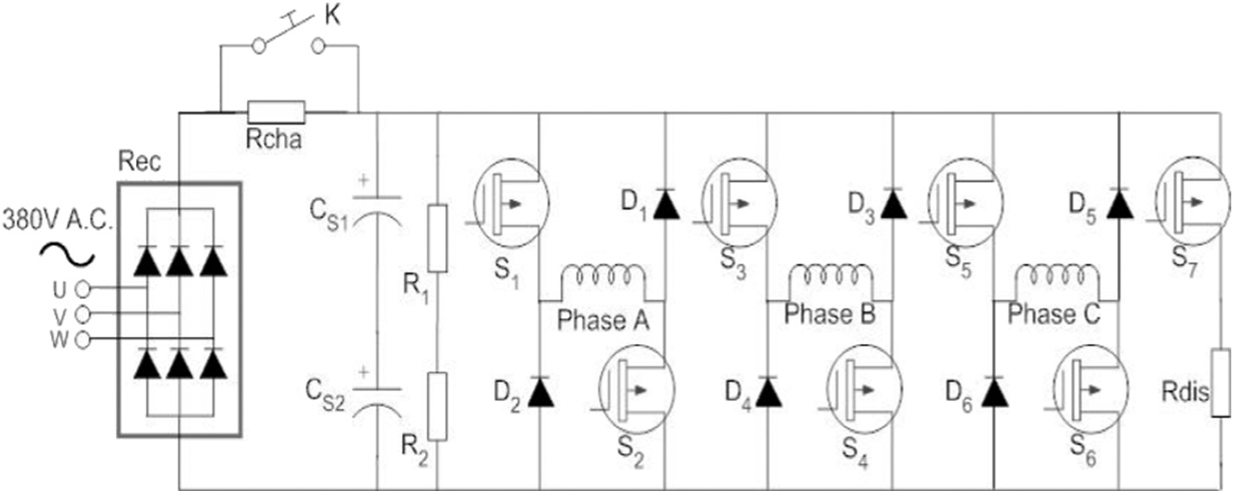](Image%20of%20Fig.%201)

Fig. 1. Asymmetry half-bridge power converter for SRMs.

[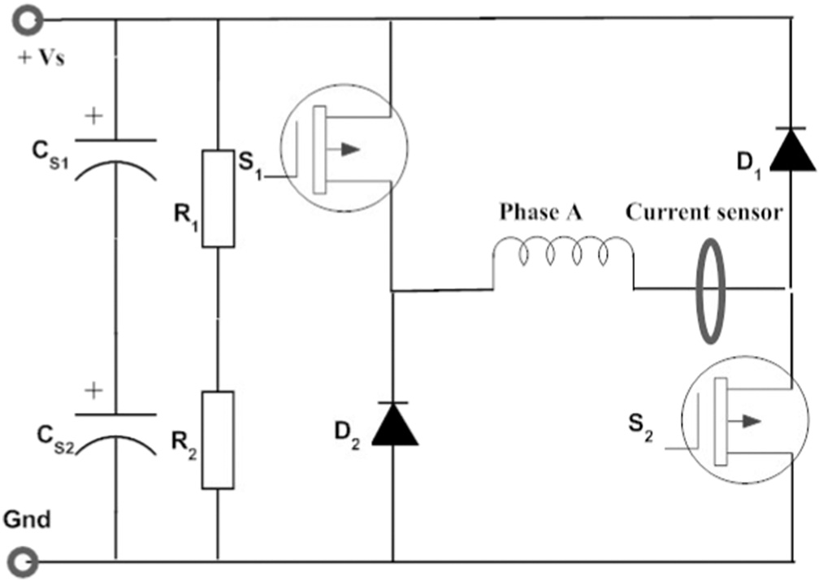](Image%20of%20Fig.%202)

Fig. 2. Asymmetry half-bridge power converter for SRMs.

energy and instantaneous electromagnetic torque for any given current and rotor position. A schematic diagram for measurement is shown in Fig. 2.

The measurement could be conducted by monitoring either rising or decaying current in the phase windings. Clearly, Eq. (1) describes a magnetizing process when the current flow as “+Vs-S1-Phase A-S2- Gnd” while the demagnetizing current along “Gnd-D2-Phase A-D1-

+Vs”. theoretically,

1. Implementation and experimental results
   1. *Experimental setup*

On an 8/6 SRM with the rated power of 750 W and 310 V D.C. bus voltage, a COTS power converter is connected in a half-bridge topology. Figs. 3 and 4 show the photographs of the experimental platform and control circuitry respectively. And refer to the appendix for the detailed parameters of the motor.

In the SRM control board the instantaneous maximum phase current is limited to 13.0A during test, and the maximum current during motor operation is 9.0A. The current sensor is LEM HMS 05-P with the accuracy of 1%. The encoder is OMRON E6C2-C with the resolution of 2000 pulse/ round. The general controller is a 32-bit 150MIPS TMS320LF2812 DSP which includes a 16-channel 12-bit on-chip 3D converter with the

12.5 M sampling bandwidth. An Altera FPGA EP2C8Q208C8 (8 speed grade) is selected to expand the I/O and execute online CMAC NN com- putation, which has 8256 logic cells and 165,888 memory bits. Mean- while the FPGA has a 16 M byte SDRAM for temporarily reserving the sensor-acquired data.

* 1. *Experimentation of characterizing an SRM*

For characterizing an SRM the proposed decaying current method applies a D.C. voltage with given width at each rotor position. The time span of the voltage pulse is determined by the current's rising to the maximum. Fig. 5 demonstrates a rising and decaying current slope when a 700us pulse voltage is applied at certain rotor position. By this means the phase current will reach its maximum at all the rotor posi- tions, which enable the characterization covers the entire motor operat-

−*u* = *Ri* +

d*ψ*(*i*; *θ*)

d*t* (17)

ing regime. The decaying stage is recorded for characterizing the SRM. As can be noticed the current shape is not absolutely symmetry due to the machine loss and bus voltage fluctuation.

Since the mechanical period of an 8/6 SRM is 60° for each phase, the

here using the decaying current profile is more appropriate for higher currents since the voltage fluctuation during a falling current is negligi- ble and fairly constant (Gobbi et al., 2006). This is because the measure- ment during a decaying current is carried out by eliminating the applied voltage to the winding, and an alternative path to the winding current is provided through a freewheeling diode connected across the machine phase, hence no current drains from the filter capacity. The voltage across the winding during the decaying current is only the forward volt- age drop of the diode. In contrast, the applied source voltage varies while the current is increasing, giving rise to errors due to quantization and its use in the evaluation of flux linkages (Krishnan, 2001).

The manner in which the flux linkage is obtained is crucial to the ac-

curacy and application of the results. Generally speaking, the proposed characterization method offers three advantages. First, its technical merits and practical value of using the COTS based experimentation setup lie in easily characterizing high-power motors and performing the real application in-system testing. The readily-equipped power con- vert avoids customizing a specific high power source, and the installed Hall current sensor directly measures the excitation current and elimi- nates the need for a high power rating data-acquiring precise resistor. Further the phase current limitation is reliably curbed by using an on-board protective circuitry. Therefore, the COTS circuit based experi- mentation leads to a paradigm shift from laboratory prototyping to manufacturer on-site characterization. Second, using the decaying cur- rent to characterize the SRMs ensures a high accuracy via minimizing the voltage fluctuation. Third, although the iron/copper losses and phase mutual inductance complicate the measurement of the electro- magnetic properties, the proposed method is capable of genuinely re- vealing the properties since it realistically duplicates the operating scenario in converter, such as the current path and individual compo- nent loss. Therefore, the proposed method can be applied in character- izing a wide spectrum of SRMs.

measurements starts from the rotor/stator completely unaligned posi- tion −30° and terminates at +30° by 1° interval. The 0° position hints the rotor and stator are strictly aligned. Technically an interpolation al- gorithm is utilized to obtain fine granular I and θ mesh, and finally we obtain the θ [−30°, 30°] with 0.3° resolution and the current [0A,9.0A] with 0.045A interval. Hence the input set fields are divided into a 201 × 201 mesh, which means a mapping that uses a table looking-up algorithm will require at least 161,604 byte memory cells for 40,401 sin- gle precision floating point data storage. The amount of memory occu- pation indicates the direct table looking-up is not suitable for obtaining multiple parameters in embedded control system, which ne- cessitates a model-based algorithm to solve this problem.

[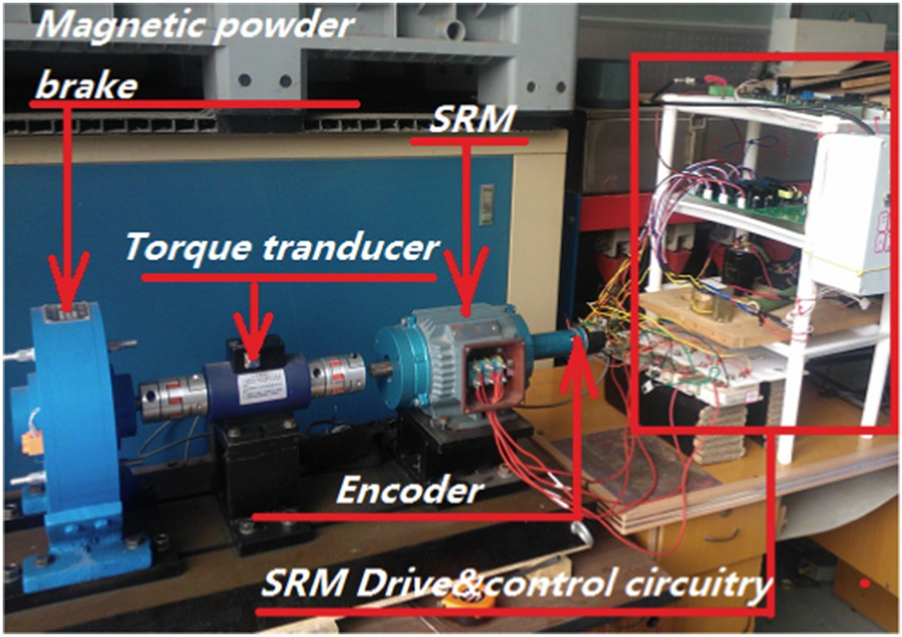](Image%20of%20Fig.%203)

Fig. 3. Experimental system of an SRM.

[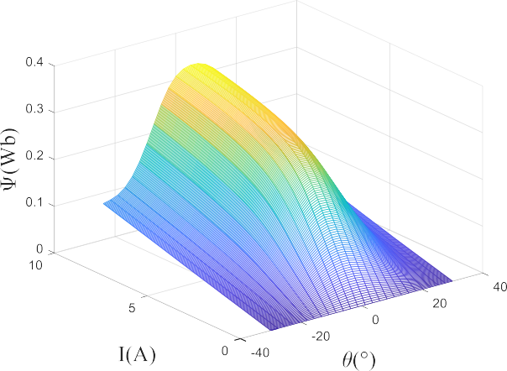](Image%20of%20Fig.%206)

[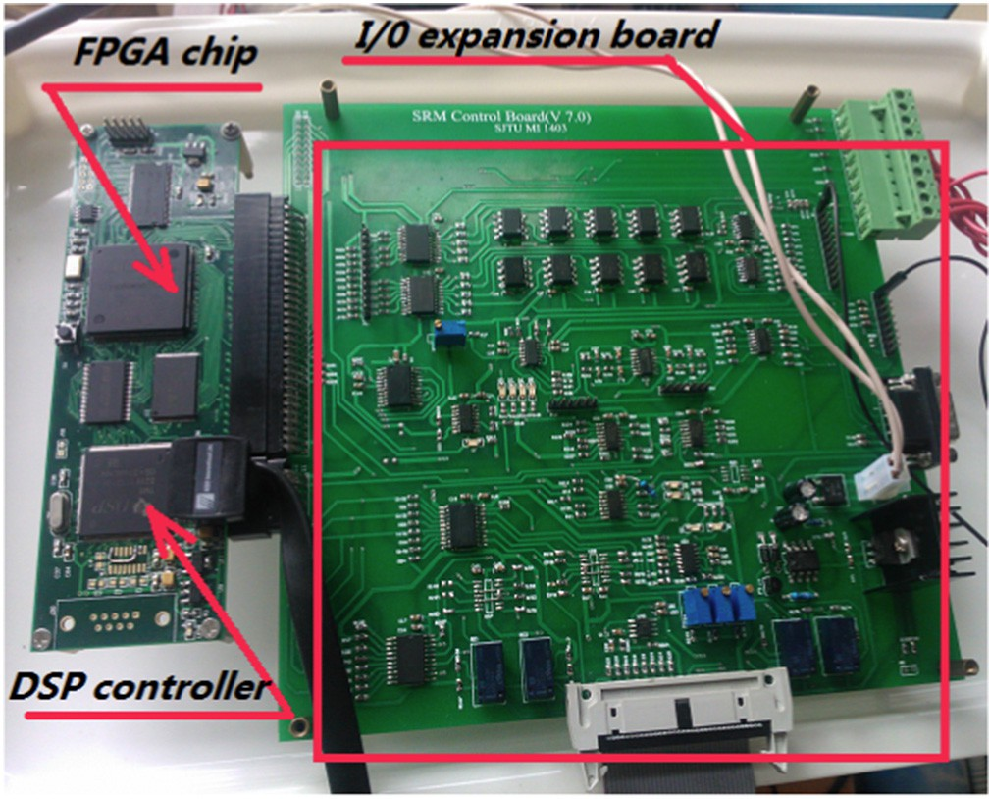](Image%20of%20Fig.%204)Fig. 4. Control and drive circuitry for the SRM with DSP and FPGA processors

According to the equations established in Section 1, the electromag- netic properties can be characterized. Figs. 6–9 render the 3-D relation- ship among the variables *θ, I* and flux linkage *ψ*, phase inductance *L*, magnetic co-energy W, electro torque T respectively.

* 1. *Cross-validating the characterization result*

Traditionally we often resort to an FEM-based approach to validate the testing result, which is dubious due to the errors induced by mis- matches between simulation parameters and the real case.

In order to validate the effectiveness and accuracy of the characteri- zation, two aspects are considered in this paper. First, decaying current is used to characterize the incremental inductance and at the same po- sition the rising current is used to validate its result. This approach is name after cross-validation because both the currents are shapes by the identical inductance regarding to the fixed position. The second as- pect is that a numerical model is built according to the decaying current model and then a full process is simulated and experimentally recorded to show their agreement.

At a randomly selected rotor position 41.3066°, a 1100 μs pulse volt-

age is applied so as to allow the phase current approach its maximum. The voltage width and the phase current response are recorded to

[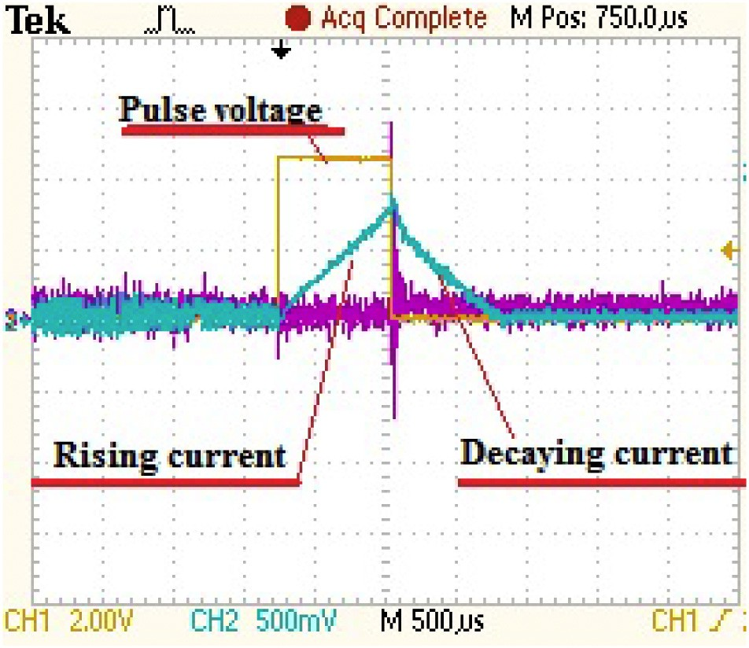](Image%20of%20Fig.%205)

Fig. 5. Phase current profile when a pulse voltage is applied.

Fig. 6. Linkage flux as a function of the rotor position and the phase current.

[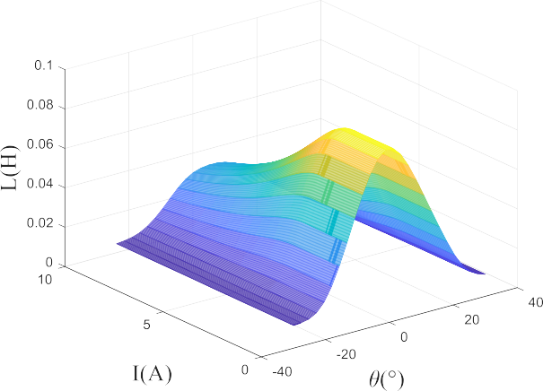](Image%20of%20Fig.%207)

Fig. 7. Inductance as a function of the rotor position and the phase current.

perform the simulation. On the basis of the flux linkage characterization shown in Fig. 6, the excitation current profile is generated accordingly. The simulation MATLAB/SIMULINK procedure is shown in Fig. 10, and the experimentally measured current profile and the simulation re- sult are compared in Fig. 11. Fig. 11 shows that the simulated phase cur- rent response to a fixed voltage pulse matches the measured current, and it proves that the electromagnetic properties characterization are accurate at the full spectrum of current and rotor position. The current

[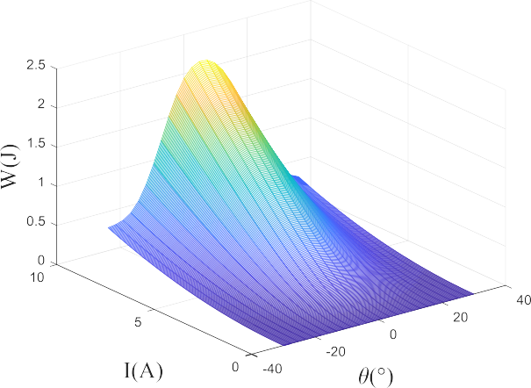](Image%20of%20Fig.%208)

Fig. 8. Magnetic co-energy as a function of the rotor position and the phase current.

[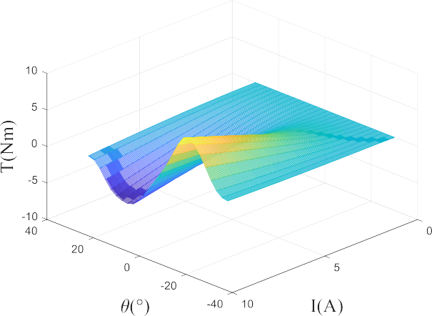](Image%20of%20Fig.%209)

Fig. 9. Electromagnetic torque as a function of the rotor position and the phase current.

plateau at 9A embodies the overcurrent chopping effect in the protec- tion circuit.

Clearly, this in-situ validation approach can be conducted immedi- ately after the characterization process, and the results can be evaluated by simply check the agreement of two one dimensional curves.

1. Conclusion

The proposed methodology, including both of the characterization and verification techniques for SRMs, opens up the possibility of pre- cisely calculating its electromagnetic characteristics in real time, which lays a foundation stone for versatile advanced control schemes that require obtaining accurate electromagnetic parameters in corresponding models. A model-based in-situ measuring system instru- mented in COTS platform enables fast, applicable machine-by-machine characterization in a massive production line of the motor manufac- turers, which can be easily involved in an existing infrastructure. Exper- imental results proved that the proposed method could achieve an encouraging performance. Conclusions are listed as follows.

1. The proposed measuring approach utilize the off-the-shelf devices and circuitry to support in-factory SRM test and characterization, easing the burden of developing an ad hoc test bench and possessing the ability of including all physical effects that exist in the real application.
2. The precisely measured electromagnetics data and established model enable detailed and precise examination of SRM behavior over a wide variety of simulated operating conditions without the limitations associated with drive circuits, transducers or instrumen- tation, as the case we used for validating the characterization preci- sion in Section 4.2. And it worth noting that all the electromagnetic parameters are able to be manipulated under a unified computa- tional framework.

[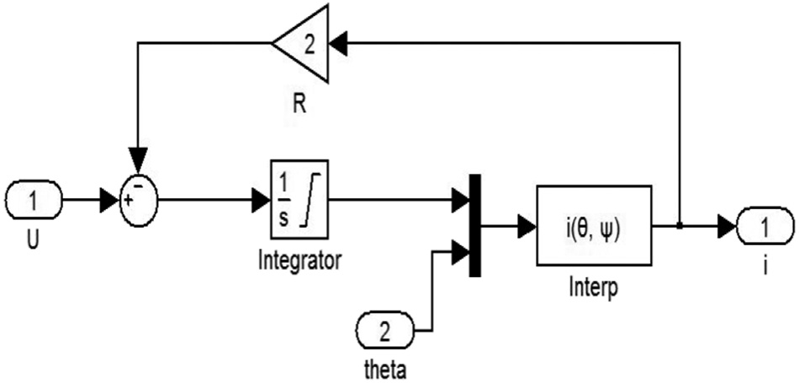](Image%20of%20Fig.%2010)

Fig. 10. MATLAB/Simulink procedure for simulating the phase current response to a voltage pulse.

1. Highly reliable cross validation methodology is proposed for verify- ing the in-situ characterization result, which does not need any spe- cifically design instrument either.

CRediT authorship contribution statement

Xiao Ling:Conceptualization, Data curation, Formal analysis, Meth- odology, Validation, Writing - original draft.Liang Gong:Data curation, Formal analysis, Investigation, Methodology, Validation, Writing - orig- inal draft, Writing - review & editing.Bingchu Li:Data curation, Method- ology, Validation.Chengling Liu:Funding acquisition, Project administration, Visualization, Writing - review & editing.

Acknowledgements

The authors gratefully acknowledge the financial support provided by the National Natural Science Foundation of China (project No. 11202125 and project No. 51305258).

Appendix A

Motor data:

Number of phases 4; Number of rotor poles 6; Rated power 750 W; Rated torque 5.0 N m;

Maximum speed 1500 r/min; Phase current limitation 9A;

Design specification of the aligned phase inductance 22 mH; Design specification of the unaligned phase inductance0.5 mH; Phase resistance 1.3 Ohm

Bus D.C. voltage 300 V; Lamination material: M19 steel

References

Brauer, H.J., Hennen, M.D., De Doncker, R.W., Jan. 2012. [Control for polyphase switched](http://refhub.elsevier.com/S2589-7217(20)30015-5/rf0005) [reluctance machines tominimize torque ripple and decrease ohmic machinelosses.](http://refhub.elsevier.com/S2589-7217(20)30015-5/rf0005) [IEEE Transactions on Power Electronics 27 (1), 370–37](http://refhub.elsevier.com/S2589-7217(20)30015-5/rf0005)8.

Cai, J., Deng, Z.Q., Jul. 2012. [Sensorless control of switched reluctance motor based on](http://refhub.elsevier.com/S2589-7217(20)30015-5/rf0010) [phase inductance vectors. IEEE Transactions on Power Electronics 27 (7), 3410–3423](http://refhub.elsevier.com/S2589-7217(20)30015-5/rf0010).

Cai, J., Deng, Z.Q., Mar., 2013. [A position sensorless control of switched reluctance motors](http://refhub.elsevier.com/S2589-7217(20)30015-5/rf0015) [based on phase inductance slope. Journal of Power Electronics 13 (2), 264–27](http://refhub.elsevier.com/S2589-7217(20)30015-5/rf0015)4.

Cheok, A.D., Fukuda, Y., Apr. 2002. [A new torque and flux control method for switched re-](http://refhub.elsevier.com/S2589-7217(20)30015-5/rf0020) [luctance motor drives. IEEE Transactions on Power Electronics 17 (4), 543–55](http://refhub.elsevier.com/S2589-7217(20)30015-5/rf0020)7.

DiRenzo, Michael T., Feb., 2000. [Switched Reluctance Motor Control – Basic Operation and](http://refhub.elsevier.com/S2589-7217(20)30015-5/rf0025) [Example Using the TMS320F240. Tech. Memo.spra420a*Texas Instruments Inc*., Austin](http://refhub.elsevier.com/S2589-7217(20)30015-5/rf0025).

Dowlatshahi, M., Saghaiannejad, S.M., Ahn, J.W., et al., Mar. 2014. [Copper loss and torque](http://refhub.elsevier.com/S2589-7217(20)30015-5/rf0030) [ripple minimization in switched reluctance motors considering nonlinear and mag-](http://refhub.elsevier.com/S2589-7217(20)30015-5/rf0030) [netic saturation effects. Journal of Power Electronics 14 (2), 351–36](http://refhub.elsevier.com/S2589-7217(20)30015-5/rf0030)1.

Gobbi, R., Sahoo, N.C., Rajandran, R. Vejian, 2006. [Rising and falling current methods for](http://refhub.elsevier.com/S2589-7217(20)30015-5/rf0035) [measurement of flux-linkage characteristics of switched reluctance motors: a com-](http://refhub.elsevier.com/S2589-7217(20)30015-5/rf0035) [parative study. Proc.of IEEE PECON’06, pp. 383–38](http://refhub.elsevier.com/S2589-7217(20)30015-5/rf0035)7.

Goto, H., Nishimiya, A., Guo, H.J., Jan. 2010. [Instantaneous torque control using flux-based](http://refhub.elsevier.com/S2589-7217(20)30015-5/rf0040) [commutation and phase-torque distribution technique for SR motor EV. COMPEL-](http://refhub.elsevier.com/S2589-7217(20)30015-5/rf0040) [International Journal for Computation and Mathematics in Electrical and Electronic](http://refhub.elsevier.com/S2589-7217(20)30015-5/rf0040) [Engineering 29 (1), 173–18](http://refhub.elsevier.com/S2589-7217(20)30015-5/rf0040)6.

Kamalakannan, C., Kamaraj, V., Paramasivam, S., Paranjothi, S.R., *2011*. [Switched reluc-](http://refhub.elsevier.com/S2589-7217(20)30015-5/rf0045) [tance machine in automotive applications — a technology status review. Proc.](http://refhub.elsevier.com/S2589-7217(20)30015-5/rf0045) [ICEES, pp. 187–19](http://refhub.elsevier.com/S2589-7217(20)30015-5/rf0045)7.

Kjaer, P.C., Nielsen, P., Andersen, L., Blaabjerg, F., May 1995. [A new energy optimizing con-](http://refhub.elsevier.com/S2589-7217(20)30015-5/rf0050) [trol strategy for switched reluctance motors. IEEE Transactions on Industry Applica-](http://refhub.elsevier.com/S2589-7217(20)30015-5/rf0050) [tions 31 (5), 1088–1095](http://refhub.elsevier.com/S2589-7217(20)30015-5/rf0050).

Krishnan, R., 2001. [In: Irwin, J.D. (Ed.), Switched Reluctance Motor Drives: Modeling, Sim-](http://refhub.elsevier.com/S2589-7217(20)30015-5/rf0055) [ulation, Analysis, Design, and Applications. Boca Raton, London New York](http://refhub.elsevier.com/S2589-7217(20)30015-5/rf0055) [Washington, D.C.](http://refhub.elsevier.com/S2589-7217(20)30015-5/rf0055)

Lee, D.H., Ahn, S.Y., Ahn, J.W., Jan. 2012. [A simple negative torque compensation scheme](http://refhub.elsevier.com/S2589-7217(20)30015-5/rf0060) [for a high speed switched reluctance motor. Journal of Power Electronics 12 (1),](http://refhub.elsevier.com/S2589-7217(20)30015-5/rf0060) [58–66](http://refhub.elsevier.com/S2589-7217(20)30015-5/rf0060).

Miller, T.J.E., 2001. [Electronic Control of Switched Reluctance Machines. Newnes D.C, Bur-](http://refhub.elsevier.com/S2589-7217(20)30015-5/rf0065) [lington MA,USA](http://refhub.elsevier.com/S2589-7217(20)30015-5/rf0065).

Moron, C., Garcia, A., Tremps, E., Apr 2012. [Torque control of switched reluctance motors.](http://refhub.elsevier.com/S2589-7217(20)30015-5/rf0070)

[IEEE Trans. Magn. 48 (4), 1661–1664](http://refhub.elsevier.com/S2589-7217(20)30015-5/rf0070).

[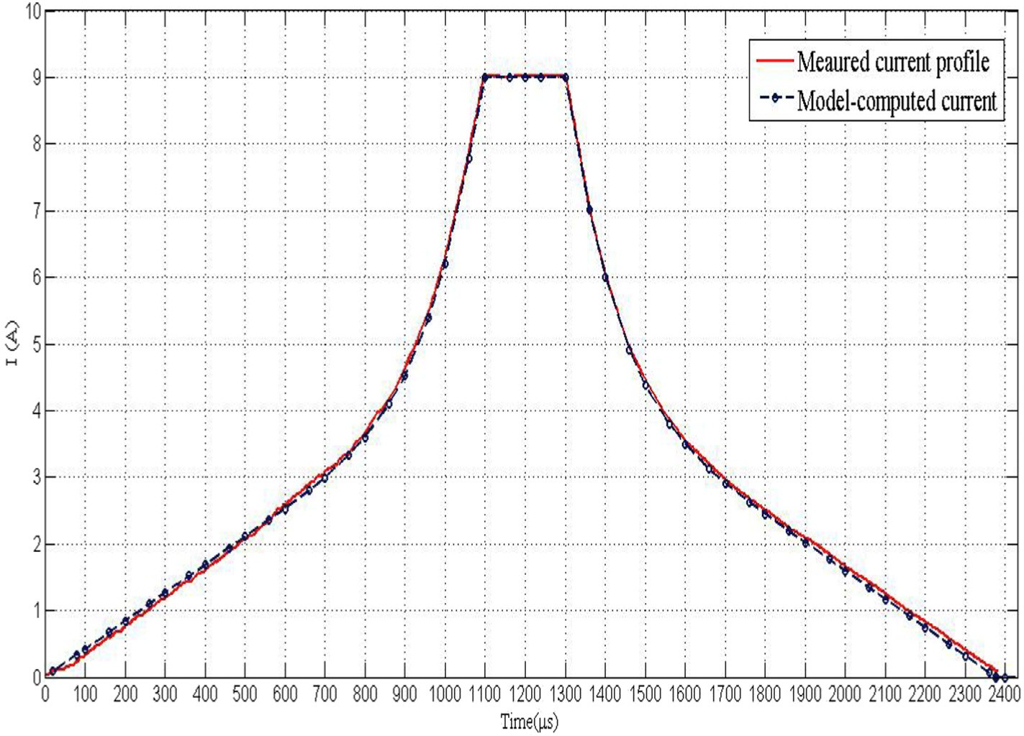](Image%20of%20Fig.%2011)

Fig. 11. A comparison between the measured current and the model-generated current.

Parreira, B., Rafael, S., Pires, A.J., Branco, P.J. Costa, Jun. 2005. [Obtaining the magnetic char-](http://refhub.elsevier.com/S2589-7217(20)30015-5/rf0075) [acteristics of an 8/6 switched reluctance machine: from FEM analysis to the experi-](http://refhub.elsevier.com/S2589-7217(20)30015-5/rf0075) [mental test. IEEE Transactions on Industrial Electronics 52 (6), 1635–1643.](http://refhub.elsevier.com/S2589-7217(20)30015-5/rf0075)

Shin, D.S., Li, Y.C., Yang, H.Y., et al., Mar. 2005. [Rotor position sensing method for switched](http://refhub.elsevier.com/S2589-7217(20)30015-5/rf0080) [reluctance motors using an indirect sensor. Journal of Power Electronics 5 (3),](http://refhub.elsevier.com/S2589-7217(20)30015-5/rf0080) [173–17](http://refhub.elsevier.com/S2589-7217(20)30015-5/rf0080)9.

Vujicic, P. Vladan, Jan. 2012. [Minimization of torque ripple and copper losses in switched](http://refhub.elsevier.com/S2589-7217(20)30015-5/rf0085) [reluctance drive. IEEE Transactions on Power Electronics 27 (1), 388–39](http://refhub.elsevier.com/S2589-7217(20)30015-5/rf0085)9.

Wang, B., Lee, D.H., Lee, C.W., et al., Sep. 2014. [Characteristics analysis of a novel segmen-](http://refhub.elsevier.com/S2589-7217(20)30015-5/rf0090) [tal rotor axial field switched reluctance motor with single teeth winding. Journal of](http://refhub.elsevier.com/S2589-7217(20)30015-5/rf0090) [Power Electronics 14 (5), 852–858](http://refhub.elsevier.com/S2589-7217(20)30015-5/rf0090).

Wen, D., Liu, L., Lou, J.Y., Mar 2013. [Design and control of a high-speed switched reluc-](http://refhub.elsevier.com/S2589-7217(20)30015-5/rf0095) [tance machine with conical magnetic bearings for aircraft application. IET Electronic](http://refhub.elsevier.com/S2589-7217(20)30015-5/rf0095) [Power Applications 7 (3), 179–190](http://refhub.elsevier.com/S2589-7217(20)30015-5/rf0095).

Wong, K.F., Cheng, K.W.E., Ho, S.L., Mar 2009. [Four-quadrant instantaneous torque control](http://refhub.elsevier.com/S2589-7217(20)30015-5/rf0100) [of switched reluctance machine at low speed based on co-energy control. IET Elec-](http://refhub.elsevier.com/S2589-7217(20)30015-5/rf0100) [tronic Power Applications 3 (5), 431–44](http://refhub.elsevier.com/S2589-7217(20)30015-5/rf0100)4.

Yoo, A., Sul, S.K., Lee, D.C., Jun, C.S., Dec 2009. [Novel speed and rotor position estimation](http://refhub.elsevier.com/S2589-7217(20)30015-5/rf0105) [strategy using a dual observer for low-resolution position sensors. IEEE Transactions](http://refhub.elsevier.com/S2589-7217(20)30015-5/rf0105) [on Power Electronics 24 (12), 2897–2906](http://refhub.elsevier.com/S2589-7217(20)30015-5/rf0105).

Yu, S.Y., Feng, F.G., Lee, D.H., et al., Jan. 2015. [High efficiency operation of a switched reluc-](http://refhub.elsevier.com/S2589-7217(20)30015-5/rf0110) [tance generator over a wide speed range. Journal of Power Electronics 15 (1),](http://refhub.elsevier.com/S2589-7217(20)30015-5/rf0110) [123–13](http://refhub.elsevier.com/S2589-7217(20)30015-5/rf0110)0.

Zeng, H., Chen, Z., Chen, H., Mar. 2014. [Smooth torque speed characteristic of switched re-](http://refhub.elsevier.com/S2589-7217(20)30015-5/rf0115) [luctance motors. Journal of Power Electronics 14 (2), 341–350](http://refhub.elsevier.com/S2589-7217(20)30015-5/rf0115).

Zhang, P., Cassani, P.A., Williamson, S.S., Sept. 2010. [An accurate inductance profile mea-](http://refhub.elsevier.com/S2589-7217(20)30015-5/rf0120) [surement technique for switched reluctance machines. IEEE Transactions on Indus-](http://refhub.elsevier.com/S2589-7217(20)30015-5/rf0120) [trial Electronics 57 (9), 2972–2979.](http://refhub.elsevier.com/S2589-7217(20)30015-5/rf0120)