[Array 14 (2022) 100148](https://doi.org/10.1016/j.array.2022.100148)

Contents lists available at [ScienceDirect](http://www.sciencedirect.com/science/journal/25900056)

Array

journal homepage: [www.sciencedirect.com/journal/array](https://www.sciencedirect.com/journal/array)

Realization of ideal architecture of IoTs

Chi-Yu Chen a, Chun-Liang Lin a,b,*, Yang-Yi Chen a

a *Department of Electrical Engineering, National Chung Hsing University, Taichung, 402, Taiwan*

b *Center of Sustainable Agriculture, National Chung Hsing University, Taichung, 402, Taiwan*

A R T I C L E I N F O

*Keywords:*

Internet of Things (IoTs) Health care application Cloud computing

A B S T R A C T

As people are accustomed to the popularization of information services, immersive experiences are emphasized, which drives the vigorous development of virtual reality. In practice, devices are limited by their computing capabilities and rely on cloud computing to complete the overall service provided. As a result, technologies of the Internet of Things (IoT) emerge to respond to this demand. As an ideal IoT, in addition to lightweight, it is ideally to possess the following features: easy installation of devices, intelligent networking capability, multi-field

equipment sharing, and customizable to meet various needs. However, most of the current IoTs are “Internet of Targets” rather than “Internet of Things”. The Internet of Targets is lacking interoperability because of incompatible communication protocols and interface features among a variety of “devices” leading to different barriers thus hindering its applicability. This research task proposes two new ideas-refactor and feedback. The

former meant that the system is able to change transmission path intelligently. The later enables the system reacts and acts appropriately in real time when receiving a stimulation. On the basis of the two factors we

construct a conscious system served as the core of the “ideal IoT”. For the practical operating framework, we build a service model that integrates different data formations with feedback. We demonstrate the presented

design by realizing a compact IoT system for long-term health care.

# Introduction

Internet of Things (IoT) reveals the concept that connects all digital and electronic devices into the information world which is proposed for enhancing the quality of human lives and exploring innovative appli- cations beyond traditional thoughts. The goal of IoT is that various de- vices can cooperate smoothly and continuously to replenish each object with correct identification and appropriate timing.

IoT has been used in a wide range of applications, such as smart cities [1,2], security, industrial manufacturing, agriculture [3], and even forestry [4] since the idea was unveiled in 2008 in which health care represents one of the most acceptable applications because of its po- tential to give rise to several medical applications such as remote health

monitoring, chronic diseases, elderly care, and more [5–10]. IoT also inspires many innovative business models. The research of [11] dis-

cusses how IoT devices organize consumers’ behavior to create better marketing strategies in social media.

The cutting-edge of IoTs can be roughly divided into wearable de- vices, portable instruments [12], security [13,14], communication protocol comparison and optimization [15–17], and edge computing

architecture [18–20] in terms of technical development.

Due to advances in technology and economy of scale, the hardware cost is significantly decreasing with years. As a result, advanced sensors are being integrated into various kinds of systems. However, even though a variety of sensors are being adopted to certain areas, the range of IoT applications is still limited. This is because the concept of IoT nowadays is restricted to the traditional Internet OSI 7-layer model (ISO/IEC 7498-1) structure. Although there are research tasks trying to improve the architecture such as five-layer architecture, which addi- tionally includes the processing and business layers [21], the entire system is still designed as a columnar structure. Thus, it is impossible to outline the blueprint of the interaction between human and things. In addition, the current network topology from measurement equipment to service systems is mostly vertically integrated, it is still hard to expand its functions to all kinds of application scenarios.

There have been many papers discussing IoT since 2000. The research directions and fields are quite diverse. The authors of [2] have collected some relevant smart city methods and compared them to yield a general reference framework for the design of an urban IoT. This paper has observed uncertainty and the problems caused by such a framework

* Corresponding author. Department of Electrical Engineering, National Chung Hsing University, Taichung, 402, Taiwan.

*E-mail address:* [chunlin@dragon.nchu.edu.tw](mailto:chunlin@dragon.nchu.edu.tw) (C.-L. Lin).

<https://doi.org/10.1016/j.array.2022.100148>

Received 5 December 2021; Received in revised form 14 February 2022; Accepted 1 April 2022

Available online 19 April 2022

2590-0056/© 2022 The Authors. Published by Elsevier Inc. This is an open access article under the CC BY-NC-ND license ([http://creativecommons.org/licenses/by-](http://creativecommons.org/licenses/by-nc-nd/4.0/) [nc-nd/4.0/](http://creativecommons.org/licenses/by-nc-nd/4.0/)).

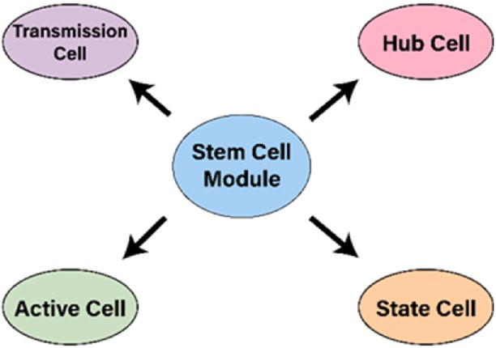

**Fig. 1.** Diagram of differentiation ability.

in the face of massive integrated networks.

The authors of [22] propose IoT requirements that fall into three categories and several items. The transmission category has latency, bandwidth, energy, and overhead; the storage category has storage balance and recovery; the computation category has computation loading, priority, and pricing. The work, different from Zanella’s

approach, uses centralized computing to focus on edge computing so as

to meet the needs of a massive integrated network. In Ref. [3], the au- thors use principal components analysis (PCA) to conduct data compression and anomaly detection, and divide the concept of edge computing into detailed steps, endpoint device computing, and fog computing. The attempt purposes to optimize the PCA model by calcu- lating data from the endpoint devices on the server, and updating pa- rameters of the PCA to the fog computing device in real-time. This allows IoT to correct uncertainties and errors in Ref. [2] when facing diversified environments.

As time evolves, the features of IoTs have to be refined. The new network architecture is no longer based on the traditional internet models to discuss the distribution of computation or scale-up only but to deal with the complete system by considering total services and appli- cations. The research task [23] proposes the concept of self-adaptive frameworks and the platform-as-a-service model. It emphasizes the importance of application-independent decentralized services and various IoT applications by the same devices.

As described, the specific characteristics of the IoT system exist in cross-domain applications or services. Therefore, the development of machine intelligence is imperative. However, most of the previous studies show high dependence on data amount making their de- velopments limited by the speed of data collection. In Ref. [24] the

authors put forward another machine intelligence, named “human-- centered cognitive computing”. That is, humans become aware of ambient environments through their own perceptive sense organs as

inputs. The input signals are transmitted to the brain through nerves for memory, analysis, and learning. The human also perceives responses to various body parts through the nervous system to react appropriately. The task of [25] proposes a paragraph of edge/cloud computing trans- parency and the IoT computing topology to share data and multi-device management for different service units. However, the design makes the IoT architecture a bit heavy resulting in higher cost while deploying these application units. In Ref. [26], the authors propose identi- fier/locator split and identity to identifier split schemes to accomplish the above requirements.

To resolve the critical issues mentioned above, this paper proposes and builds a prototype lightweight IoT system. We define two major

features to characterize an ideal IoT, i.e. “refactor” and “feedback”, which serve as the core parts of the proposed scheme. Refactoring is

simply to change the transmission path intelligently with three ways:

1. Self-protection route transmission:

The proposed cell network system has a self-built network function. If the transmission path is damaged or busy during data transmission, the system will automatically select the next-shortest cell for data

transmission.

1. Automatic cell replacement:

When the transmission cells are damaged, the cells can be replaced manually or by the stock box, and the cells will be automatically con- nected to the transmission path without resetting.

1. Variability transmission paths:

When a user wears an identity device, the device can act as a transmission cell, allowing the overall cellular network to change its transmission structure.

The Feedback has two modes: Response and Reflex. Response is like that one endows the overall IoT system with a thinking capability. When data is transmitted to the server, the respective computing resource re- sponds accordingly. Reflex, on the other hand, is analogous to the human nervous system, it reacts and acts in real time when receiving a stimulation.

On the basis of the two features, a more ideal IoT structure, named the “conscious system”, is proposed which consists of four major quadrants-Memory, Recognition, Reaction, Adaptation. The quadrant’s

responsibilities and how they interact with each other will be explained

in the main text. Moreover, an epoch-making network topology, named “stem cellular network”, that mimics the function of creatures’ stem cells forming a set of interstitial transmission systems for connection and

communication between real world and digital IoT world is also pro- posed. The prototype is realized and verified in an elder health care center for demonstration.

# Description of ideas

An ecosystem is a community of living things in conjunction with nonliving components of the environment, which interact with each other and the environment constitutes a complete system. The current IoT systems are mostly isolated and unable to open and easily connect to the environment or other systems. This fact makes it impossible for the current IoT to become an ecosystem. We propose here the idea of “bio-

design” and presents a bionic IoT architecture to fulfill the characteris-

tics of an ideal IoT. It’s not our aim to build up the entire ecosystem, but

to discuss a single individual first, emphasize the interaction and cycle between a living body and environment.

The general human life is composed of three parts: sensor and motor, message transmission network, and cognitive learning capability. Our proposed IoT architecture mimics the latter two where a stem cellular network (SCN) describes the message transmission component and a conscious system (CS) describes the cognitive component.

* 1. *Stem cellular network*

Stem cells are undifferentiated or partially differentiated cells that can be variated into various types of cells; this property is called “Po- tency”. Self-renewal is another important property, it is the ability to go

through numerous cycles of cell growth and cell division while main-

taining the undifferentiated state.

As for the transmission system, the IoT, which can be widely used, might no longer be entered from the perspective of information theory. Rather, it is appropriate to discuss from the perspective of biological cells. The major difference is that traditional network structures are to preset a goal to achieve and divide the goal into different specific pro- cesses and finally to complete the detailed implementation.

Our approach doesn’t intend to build a creature as sophisticated as mammals, but learn and extend from the organism’s features to realize our idea. We take the advantage of two features of stem cells, i.e., po-

tency and self-renewal. As illustrated in Fig. 1, the potency property of a stem cell is differentiated into various tissue cells while the basic cell

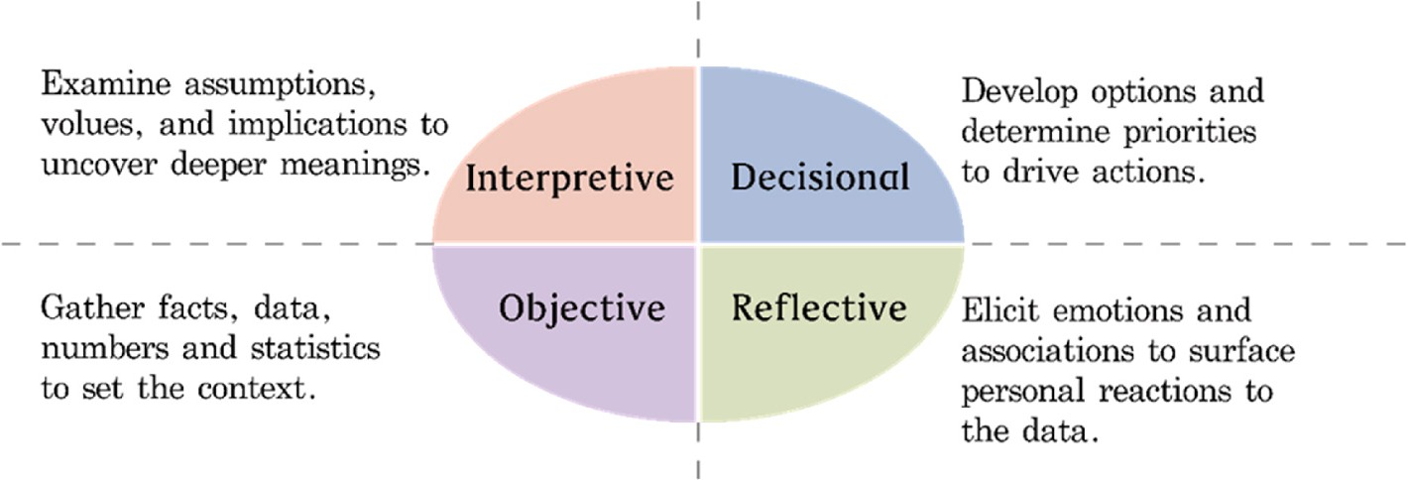

**Fig. 2.** Description of the ORID mechanism.

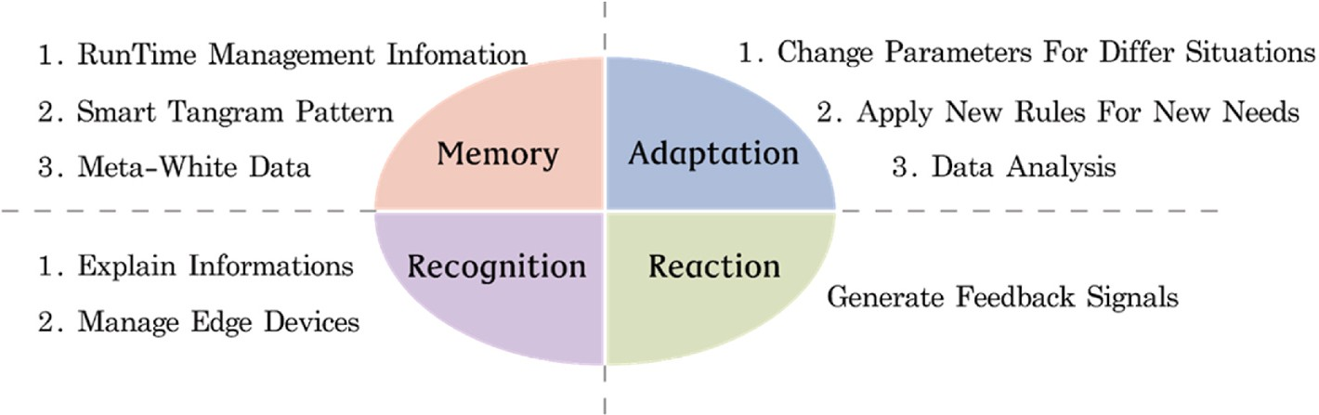

**Fig. 3.** Graphical illustration of the proposed conscious system.

module is differentiated into various functional cells. Since electronic devices cannot duplicate by themselves, we thus introduce the feature of self-renewal. It is expected that all devices can be replaced fluently without the need for complicated parameter settings as those in the traditional IoTs. Based on the feature analogy, we name the transmission system as the stem cellular network (SCN).

To simplify presentation, only the definitions of a few minimum units (i.e. cells) are regulated, and the specific realization of the IoT is completed by the exchange of each unit itself. Fundamental definitions of cells are listed below:

* Every cell is evolved from the stem cells which meant that all cells possess common characteristics.
* Unique identification of each cell makes all cells distinguishable.
* Cells can communicate with each other.
* Cells can adapt to environments and alternate action patterns or modes.
  1. *Conscious system*

The IoT collects real-time information of the objects’ concerns in the real world. The major problem is “How could one handle these hetero- geneous signals meaningfully?”

ORID is a group discussion method (also known as the focused

conversation method) [27] that moves the objective information, through their initial responses and interpretations, to develop solid conclusions. Fig. 2 explains the process of how human cognize actual data and deal with their responses to undertake analysis and make decision.

We propose a system architecture inspired by the ORID. The idea consists of four quadrants: Memory, Recognition, Reaction, Adaptation into a complete platform. Unlike the previous studies, we use “Quad-

rant” to define its basic elements instead of blocks or layers. The four

elements are closely associated with others, rather than independently executing plan and construction.

As shown in Fig. 3, the CS is composed of four quadrants. First, the

“Memory” quadrant is responsible for handling data access optimization

and compression. Regarding the interaction with other quadrants, three memory zones are needed: RunTime Management In-formation, Meta- White Data, and Smart Tangram Pattern. RunTime Management In- formation records the operating status of each part of the system, which includes authorization, environment, and connection quality. Meta-White Data records the effective features obtained by all end ob- jects, which include time, value, upstream route, surrounding object parameters, etc. Smart Tangram Pattern records data structure, which include original data samples, their representative meaning, and inter- pretation; it also includes the system operating rules and the changing history. The importance of this part is to make data to be arranged reasonably. It can restore digital data to reality and define the procedure for incorporating new objects.

Secondly, the “Recognition” quadrant is responsible to manage edge

devices and explain the information returned from the end-sensing components. Since most of the sensors placed around people’s lives are getting sophisticated, the unneglectable problem is not the lack of

data but the clear relationship between the physical environment and data. For example, temperature measurement within an oven or in the living room may use a similar sensor but with a totally different control strategy. The goal of this quadrant is to distinguish the usage or scenario of sensors by interpreting the received information across time, space, and type. Also, because the way of interpretation can be changed ac- cording to the content of the Memory quadrant, it is thus called Recognition. If the above narrative is difficult to understand when this function or program comes to the real world, this paper suggests some thinking directions that can be used as design guidelines: i) How to construct the state machine of edge devices. ii) Who can provide infor- mation and its format. iii) To whom to respond, its response rules and information contained.

Next, the “Reaction” quadrant generates feedback signals to the related objects or the same end objects based on the recognized results.

The overall system interacts with users through these signals. Among them, this quadrant can be subdivided into two aspects: Response and Reflex. The major difference between the two aspects is that Response needs to go through Recognize first, while Reflex doesn’t. In general,

Response needs to go through a more complicated calculation process

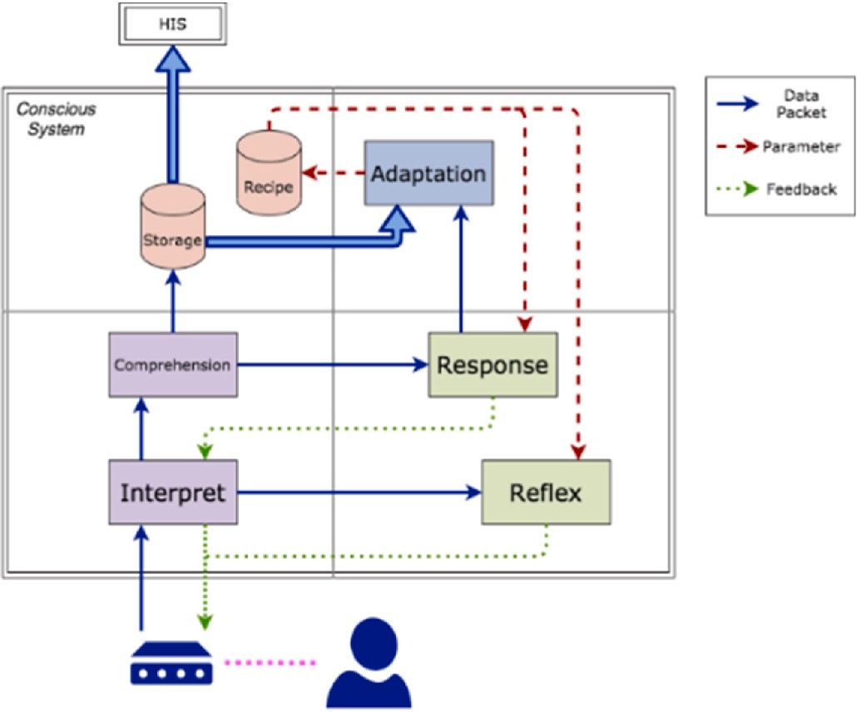

**Fig. 4.** Structure of the CS.

that can even be connected to other data analysis systems to acquire more reliable and stable signal feedback. Reflex undergoes a simplified process, for example, a threshold, interval, or signal existence, to ach- ieve the least feedback delay. It is usually used in the situation of emergency or the highest priority feedback.

Lastly, when a system is developed, it will naturally have one or more goals and meet different needs. However, the needs might change with time, and even needed to be adapted to local conditions. The system architecture of this research supposes that the following issues are considered at the early design stage: i) Create new rules in response to new needs. ii) Use different parameters according to different applica- tions. iii) Eliminate expired or no longer applicable services. The re-

sponsibility of the “Adaptation” quadrant is to determine the purpose and change the ‘Recognition and Reaction’ rules based on the re- quirements adapted to the current goals. The formulation of its rules can

be based on the results of professional research and analysis in the application field or developed from the information in memory analyzed by machine learning.

# Case study and framework design

An elder nursing home is an appropriate place for experimental verification. After conducting a field survey, this study plans a series of services and creates a simulated field. There are already mature hospital information systems (HIS). Therefore, this research task doesn’t go into

any details of the function that the HIS already has.

Early prevention and control of diseases are the keys to maintaining a healthy body status. These could be done by measuring and recording the condition or state of the body or bodily functions regularly and periodically. Although physiological measurement products have been widely developed on the market, perennial data are still not efficiently generated or collected. The major reason is that current approaches for collecting measured data rely heavily on tedious human operations. Nowadays, the digitization of data for most instruments still stays in a semi-automatic stage. Even for some of the advanced instruments that

can automatically upload data, most of the instruments don’t consider the situation of multiple users, leading to incompatible data formats. In

addition, the database access specifications provided by various in- strument brands are developed independently. Therefore, it is difficult to integrate instruments produced by different manufacturers in practice.

* 1. *Case study*

This section proposes a simple and complete solution on a simulated field as the case study. In this scheme, all instruments can automatically uplink data with detailed information and ID code and integrated into a unified database.

There are various dynamic and static measurements in practical health care applications. The former sets tracking requirements of the residents according to their medical conditions, and notify active nursing staff to assist with the measurement, such as an intensive glucose monitor needed by diabetics. The examples in common include blood pressure, blood sugar, uric acid, thermometer, body weight, etc. The static measurement meant that the instrument can continuously measure the residents after the initial framework is completed. In this research task, a physiological detection mattress is developed which can

help nursing staff to monitor the bed-ridden status of the patient’s sleeping time, position, heart rate, and breathing. Besides, long-term

mattress data are collected and used to analyze patient’s sleeping sta- tus and issue warning signals when an abnormal heartbeat or breathing

is detected.

The second part is the identification method. A heart rate measuring bracelet is utilized for this purpose. The bracelet automatically sub- stitutes the ID code into the instrument. However, with the diversifica- tion of requirements, the newly developed devices can be incorporated into the system through the established format and procedure, for example, the face recognition technique. The bracelet confirms the pa-

tient’s status via regular heart rate detection. When the system receives information of the user’s status, it proceeds to execute access control or

area management. Since the bracelet is equipped with a human face feature for recognition, multi-factor authentication applications can be realized.

* 1. *Structure design of SCN*

As SCN is the transmission channel of the IoT, it exhibits features of low power consumption, small size, and discrete data. Through stan- dardized interfaces, it can be combined with various instruments. Ac- cording to the instrument type and purpose, cells here are divided into active, status, transmission, and hub. Among them, the active cell refers to objects that are deliberately used or can be actuated in response to instructions. The status cell refers to an object that represents the status of an individual rather than a deliberately used one, which is built into the individual identification bracelet in this research. The transmission cell transmits data packets to communicate between the active and hub cells. The hub cell is the interface with CS. Details of which are explained in the follows.

Four types of cell complete three features of the SCN:

1. Auto-state sensing before transmission

The active cell automatically senses information of the neighboring state cells, receives the value of its matching instrument, and packs it into a data packet before transmission. Since this research task puts force on health care, the state cell design includes residents and nursing members only. Therefore, each active cell is specified to receive at most two-state cells when activated.

1. Continually repeat connecting transmission

The purpose of SCN is to provide a wide-area and lightweight transmission network. Therefore, the hub cell being densely arranged like a Wi-Fi router is not expected. When a transmission cell cannot directly deliver data packets to the hub cell, it needs to be directed to connect through other transmission cells. However, this results in another problem, i.e. excessively complex routing rules will increase difficulty of computing the transmission cell, which violates the

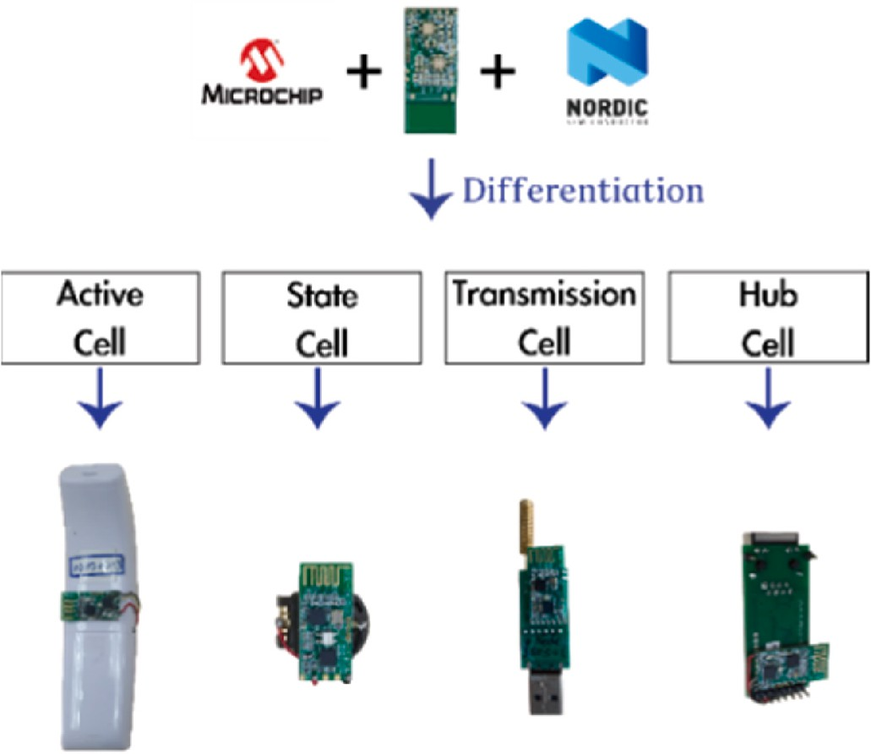

**Fig. 5.** Graphical Configuration of the conscious system.

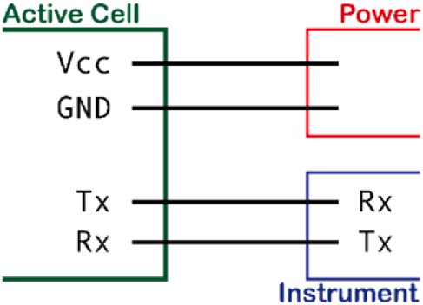

**Fig. 6.** Link between active cell and instrument.

principle of lightweight. Under the premise of not using complex routing rules, to avoid data packets from echoing in the network, a polarity setting is included in the transmission cell. The transmitting cell com- pares the polarity of the data packet with itself to determine the trans- mission direction.

1. Self-adaptive network environment

Following the feature mentioned, the transmission cell detects the hub cell and other transmission nodes within the signal range and sets its own polarity according to the environment. After the transmitting cell completes the initialization and polarity setting, it will be able to receive data packets from the state and the active nodes. When the active cell is activated, i.e. the instrument has completed measurement, it detects the status node information, and sends data packets to the hub cell through the transmitting cell.

* 1. *Structure design of CS*

The architecture of CS is illustrated in Fig. 4 with each unit corre- sponding to a quadrant. The biggest feature of the IoT is that it connects reality and virtuality via various sensing and actuating mechanisms. To process the object signals transmitted through the SCN, the first step of CS is to set up the connection interface, called the interpret unit. The interpret unit initially processes data packets transmitted from SCN to facilitate subsequent Ethernet connection. It fulfills the preliminary data processing to facilitate the subsequent passages on the ethernet. When data packets come from SCN, the interpret unit checks and verifies checksum to ensure correctness of the transmitted data. As data packets need to go through Ethernet, the interpret unit is also responsible for

encryption and decryption to ensure transmission security of the public network.

The role of the comprehension unit is to expand data to a high-level format. It includes data decompression, decryption, and format con- version. That is to convert data into information. The signal of the object is re-directed to the physical meaning through the virtual data. For example, it converts the biological resistance value to the body fat scale. An important feature of the IoT is to interact with users through real- time feedback. There are two parts, reflex unit and response unit, which are designed to generate feedback signals. Both of which refer to the definition of a Recipe block to determine the object and content of the feedback. The Recipe block stores parameters of the reflex and response units. The reflex unit feedback to the measuring instrument depends solely on the input signal that makes users get reactions instantly. The response unit refers to the information in the database to generate

feedback signals making users receive fully-analyzed reactions.

Because IoTs are constantly changing with real-world applications, it is impossible to deal with such a changing situation with fixed parameter settings. Only an adaptable unit can integrate all feedback from the response unit with information in the storage block to change parame- ters in the recipe block.

For the “Memory” quadrant, there are two blocks, storage block, and recipe block. There are four storage types in the storage block, i.e.,

simple, combine, complex, and real-time. The simple type stores sin- gular data such as weight or temperature. Data of the combined type are mutually supportive such as blood pressure, systolic blood pressure, and diastolic blood pressure. Those are related data and cannot be utilized separately. For example, the feature vector obtained by face recognition should only be interpreted by other models. Only the key information being stored is classified as the complex type. Real-time type is for time- sensitive data, i.e. the data will be expired in a limited period.

# Implementation and demonstration

As shown in Fig. 5, we first define the cell name for the explanation in the following section. Fig. 6 shows the connection of the cells and devices.

* 1. *Implementation of stem cell network*

Nordic nRF24L01 is used as the main physical carrier to realize IoT signal transmission. As illustrated in Fig. 5, the structure of cells involves active cells, state cells, transmission cells, and hub cells. Tx and Rx, are the data transmission tunnels based on the uART protocol, see Fig. 6. The operational flow chart is shown in Fig. 7 which describes the operational process of active and state cells. Both active and state cells regularly check whether they have been specialized. If not, the cells keep waiting for the external signal to issue specialized information through Rx and store it in the electrically-erasable programmable read-only memory (EEROM) of the cell. At the same time, through the mentioned specialization process, each cell is assigned a unique ID code. Since it has been written in the EEROM, the ID code cannot be altered after being written in.

In SCN we define three types of identification. PID, SID, and DID referred, respectively, to the primary state cell ID code, the secondary state cell ID code, and the active cell ID code which performs measurement.

The state cell first configs its working mode, i.e. resident or nursing mode. Since both hub and transmission cells form a communication field, the state cell constantly confirms whether it is still within the field. When within the field, the status information is broadcasted to the communication field. At the same time, it monitors whether there is an active cell asking for its own information.

Both transmission and hub cells deal with data packet transmission and decide direction by the polarity of data packet. The difference be- tween the twos is that the transmission cell transmits signal wirelessly,

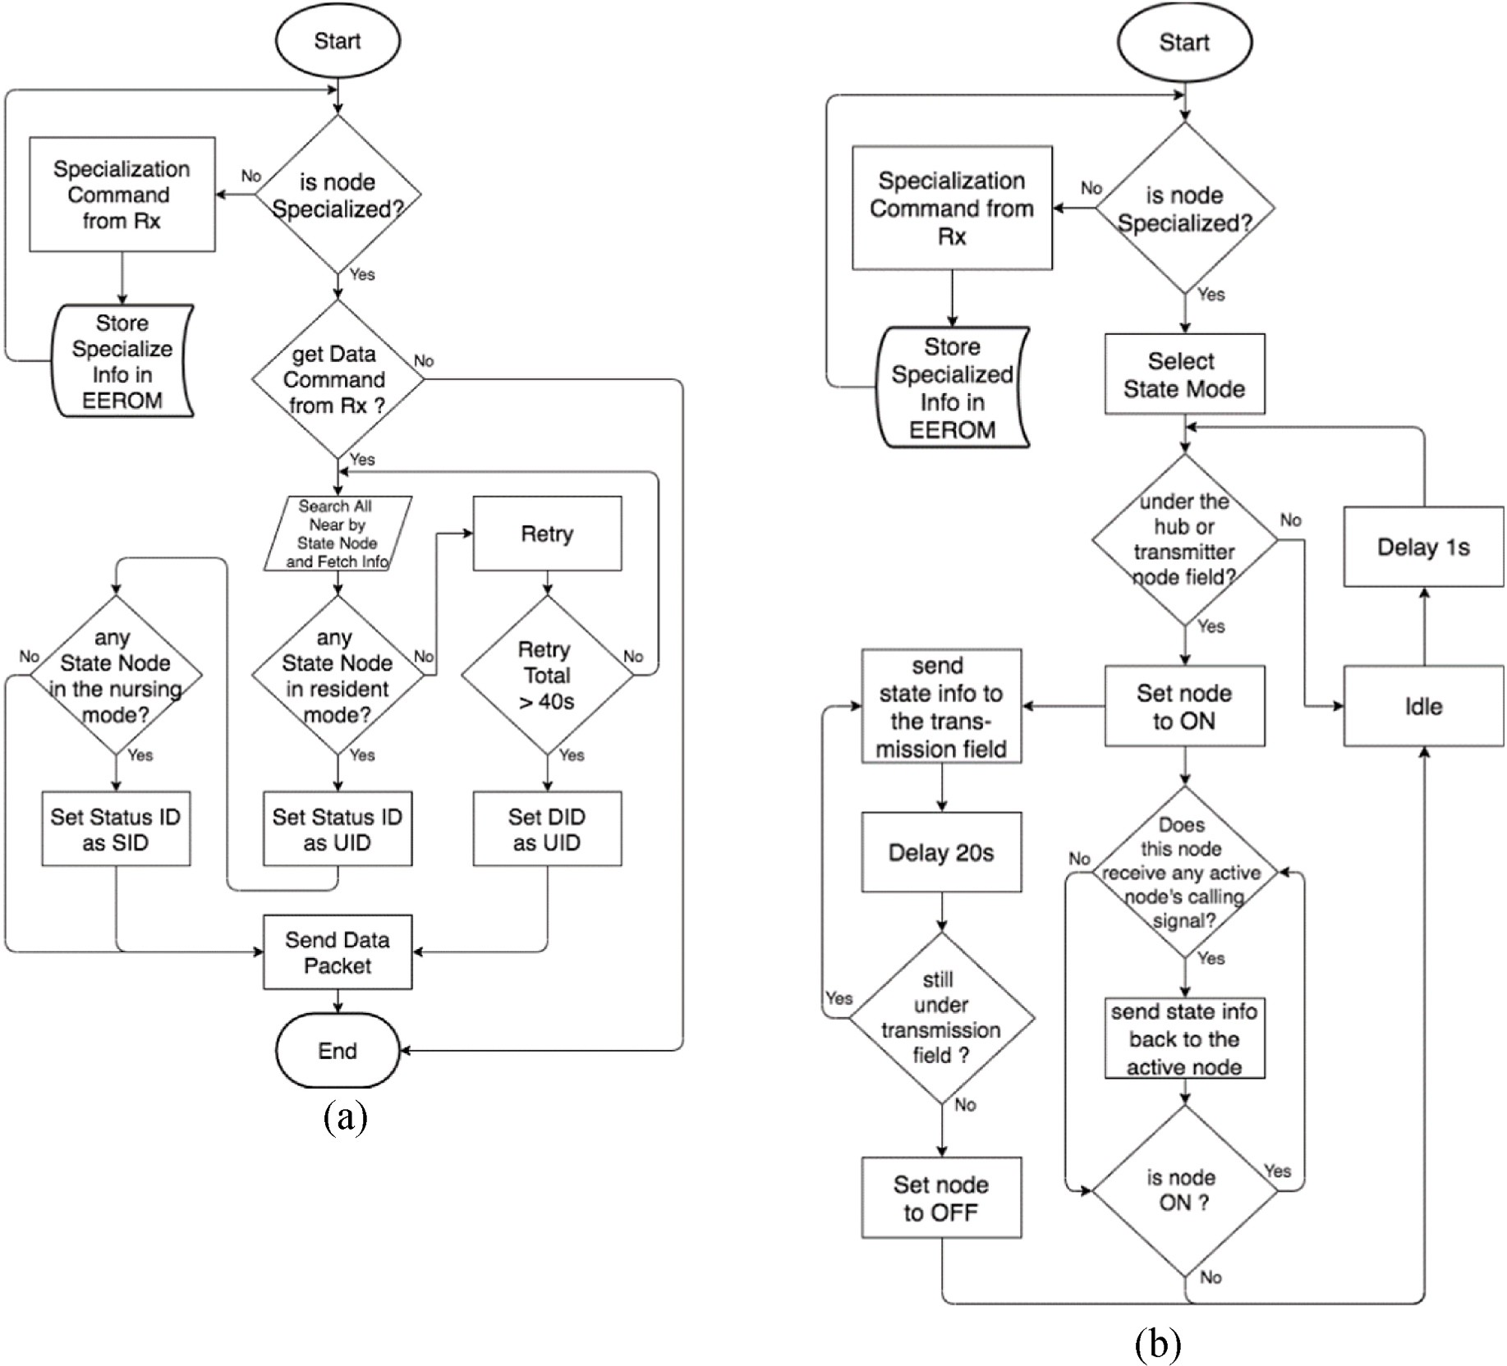

**Fig. 7.** Operational flows for (a) active cell, (b) state cell.

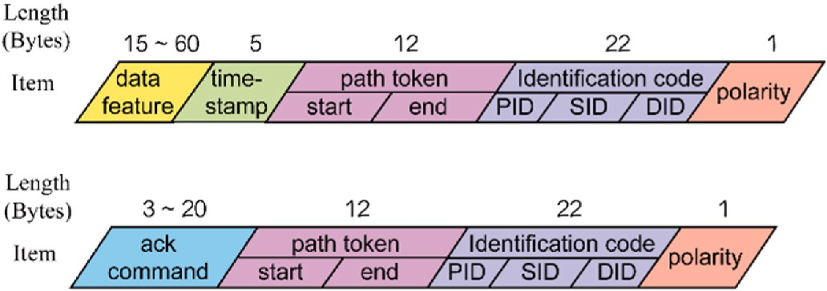

**Fig. 8.** Data packet format.

while the hub cell converts wireless signals to wired signals and connects to the CS.

The application scenarios and interaction of various cells are described in the follows：

* The state cell contains the basic information of each person including the identity. When the state cell enters within the communication

field created by the hub and transmission cells, it will automatically match the object with the field to set the appropriate working mode as the resident mode or the nursing. mode. Here, we define the resident mode as institutional residents and the nursing mode as caregivers.

* When the device with the built-in active cell is used by the caregiver,

it will obtain the closest resident mode state cell and nursing mode state cell information. We presume that the residents of the organi- zation are the main measurement objects, the information of the resident mode state cell will be placed in the PID, and the nursing mode state cell will be placed in the SID. After necessary information are integrated, a data packet is sent out wirelessly so that the transmission cell or the hub cell can deliver it to the CS thereby completing one measurement collection.

* By this way, caregivers can use various devices and tools more flexible at any time, avoiding distraction from unnecessary settings

and records.

* We allow the SID area in the data packet to be blank and provide self- use devices for residents to perform self-care. This would bring more

flexibility in the management and operation of the entire organization.

* 1. *Data packet in stem cell network*

As shown in Fig. 8, a complete data packet covers data feature, ack command, path token, timestamp, ID code and packet polarity. The data length is marked in the figure in byte strings. Format of the upper row is for carrying measurement data of the instrument while format of the lower row is assigned for instrument settings. We specify the target

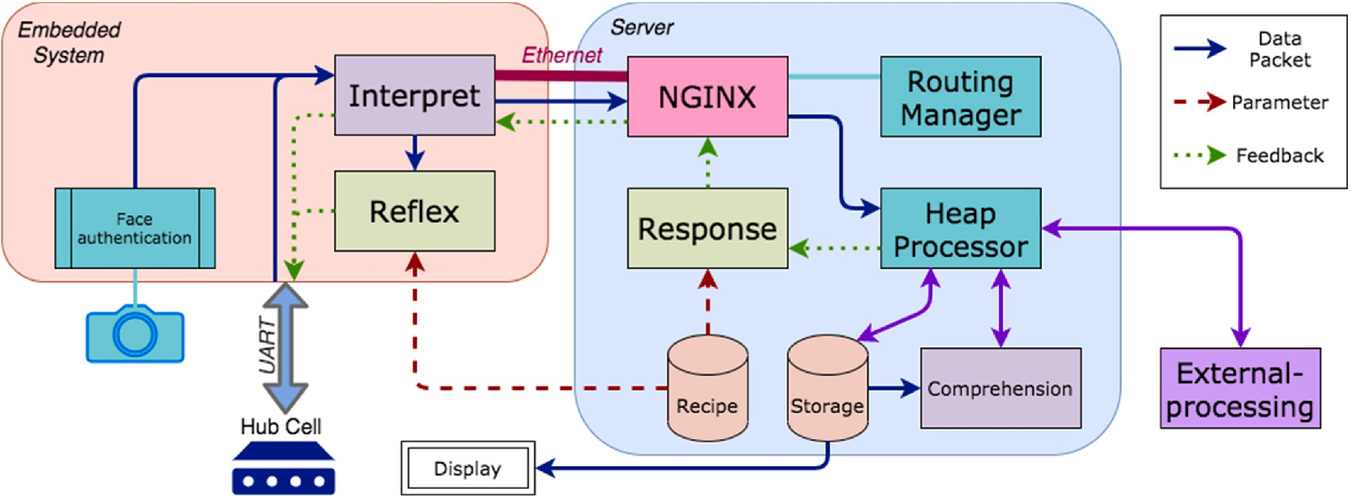

**Fig. 9.** Configuration of the conscious system.

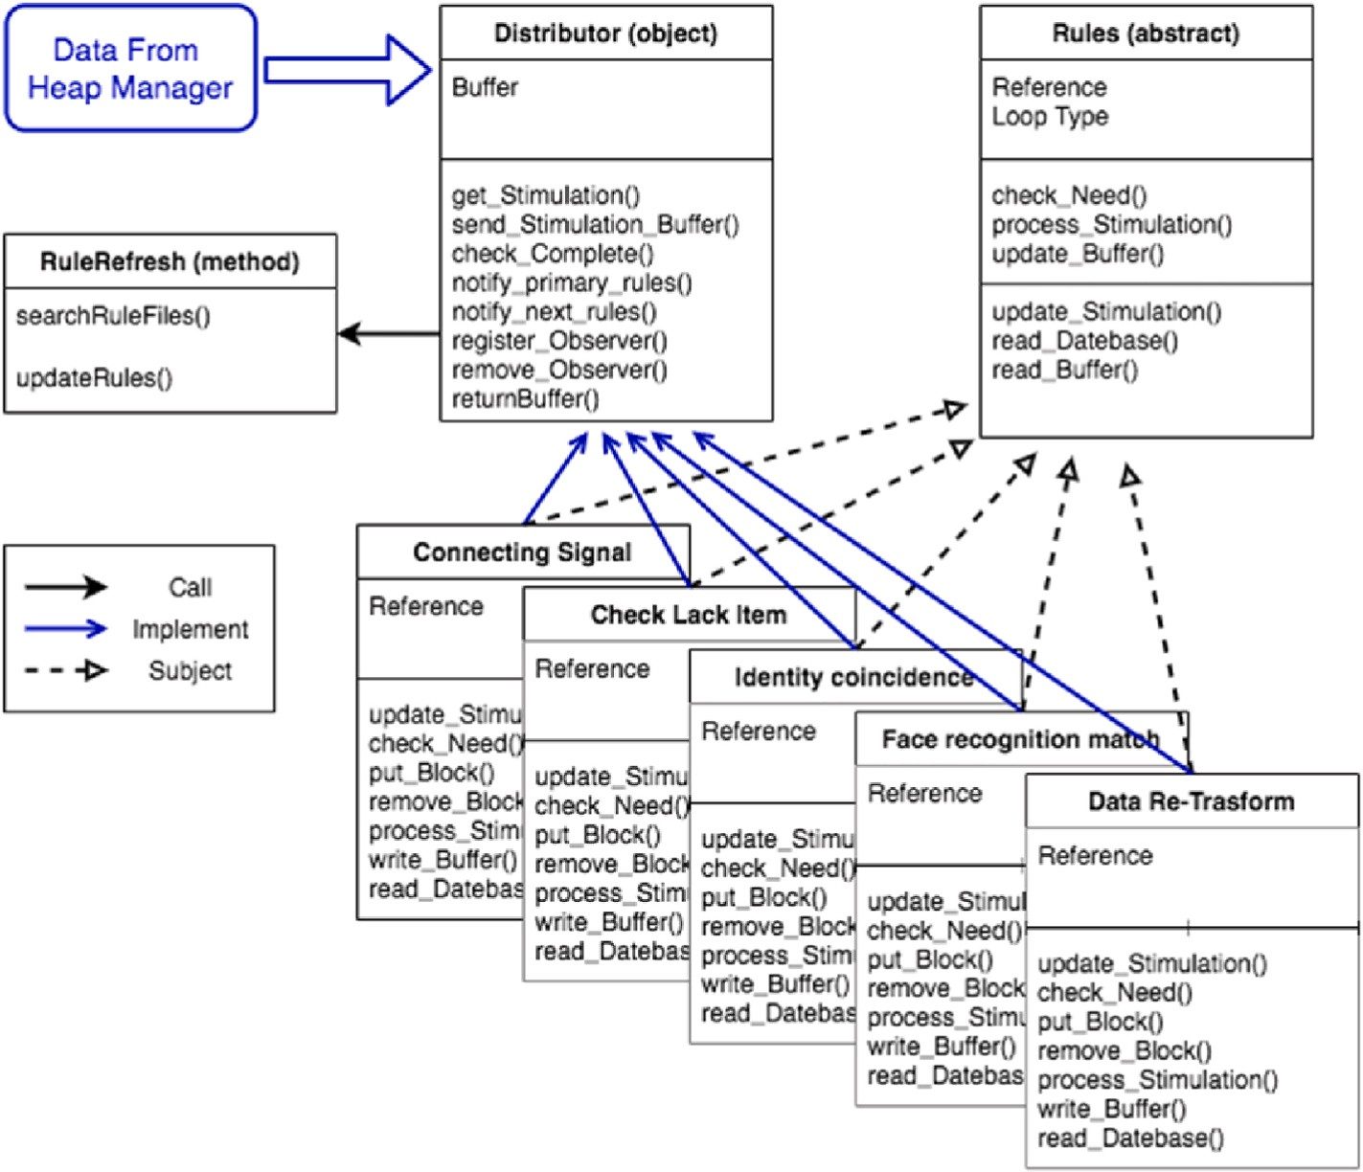

**Fig. 10.** Structure of the comprehension unit.

instrument for transmission by path token and ID code.

The data feature is the digital signal that the instrument needs to transmit through SCN. The path token records ID codes of the first and last transmission cells on the transmission path.

The ID code takes three parts, PID, SID and DID. Packet polarity is used to package and indicate the direction of transmission in SCN.

* 1. *Implementation of conscious system*

To explain the different processing modes from SCN and avoid confusion, we introduce a new type of data packet of CS named the issue packet. It is divided into three categories: instrument issue, adjunction issue, and request issue. Instrument issue refers to signals transmitted from the instrument through SCN. Adjunction refers to the issue packet derived after data processing of the comprehension unit. Request refers

to the data processing requirements from the external request, such as reading historical data for other HIS from the database.

We proceed to describe details of the implementation of CS with the structure illustrated in Fig. 9. The embedded system is an adapter con- necting CS and SCN. We integrate the interpret and reflex units in the embedded system and leave the response and comprehension units in the server. Such a plan cannot only reduce server loading since the usage of distributed computing but allows the system to partially working when it is offline.

The byte string containing data packets transmitted to SCN is con- verted to the issue packet in the interpret unit for CS usage; the issue packet will be sent to the reflex and response units to generate signals feedback to SCN to complete the reaction process. The format of the issue packet adopts the JSON design which is easy to process by computer.

**Table 1**

Communication protocol.

Prefix letter Description

A(n) Information for external processing

D(n) Instrument measuring value (in decimal)

F(n) Data for *Reflex* feedback

G0 Active cell type

G1 Start path token (trans cell id code)

G2 End path token (trans cell id code)

G4, G5 Primary state cell id code (PID)

G6 Primary state cell type

G7, G8 Secondary state cell id code (SID)

G9 Secondary state cell type

G10, G11 Active cell id code (DID)

G13 Random code

H(n) Instrument measurement value (in hexadecimal)

T Time

R(n) Data for *Response* feedback

X0 Issue packet status

X1 Checksum

The format is described as follows. A web server, Nginx, is used to assist the server in establishing the connection to the embedded system in the ethernet. It also handles the request for load balancing. The in- formation of connection between the embedded system and the server is stored and managed in the routing managing unit.

The heap processor unit is responsible for allocating the issue packet processing schedule. The double-headed arrow in the figure represents data circulation. Each measured signal is firstly calculated by the comprehension unit or sent to the external-processing module, which then enters to the response unit for generating feedback or conducting data storage.

The structure of comprehension unit is relatively complicated, and hot-swappable plug-ins is used to realize the dynamic service update of the system and maintain scalability and maintainability of the system.

The internal structure consists of a distributor and several policies as illustrated in Fig. 10. Policies are replaceable sub-programs, they can be changed or modified without rebooting the whole SC system. It handles all the issue packets reaching the CS, including signal format translation, data comparison or processing according to the requirements. The distributor is responsible for allocating the issue packet to the required policy and managing its multi-tasking process.

Five policies are established to respond the needs:

* **Data Re-Transform:** The function for reconverting the measured information. For example, the general household body fat meter is measured by the bioelectrical impedance analysis method, which needs to be matched with other physiological data for accuracy alignment. Therefore, the instrument itself only outputs the measured value of its human body impedance, and the correct data should be obtained after conducting necessary conversion.
* **Face Recognition:** The face authentication and anti-spoofing system developed in Ref. [28] performs feature calculation and matches to the server to perform a secondary verification. By this way, the timeliness and high safety of this function are ensured.
* **Identity Unification:** This is used to align identities. In practical applications, a user may have multiple IDs. This policy enables measurement data to be mapped to the correct personal profile based on these IDs.
* **Check Missing Item:** This is used to check missing items of the measurement. In practical applications, there will be a standardized

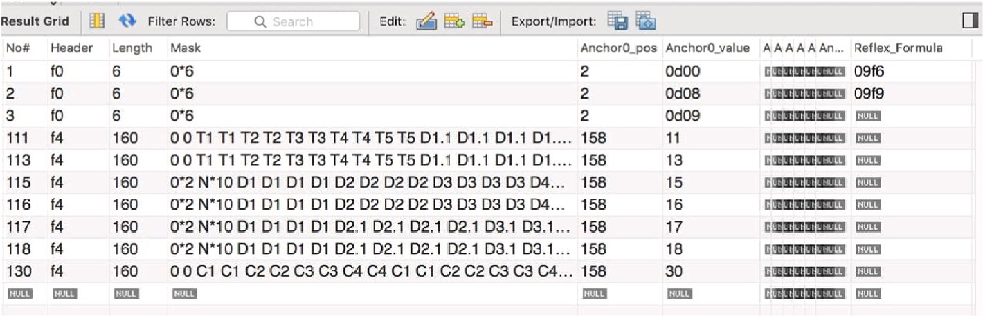

**Fig. 11.** Smart tangram pattern database.

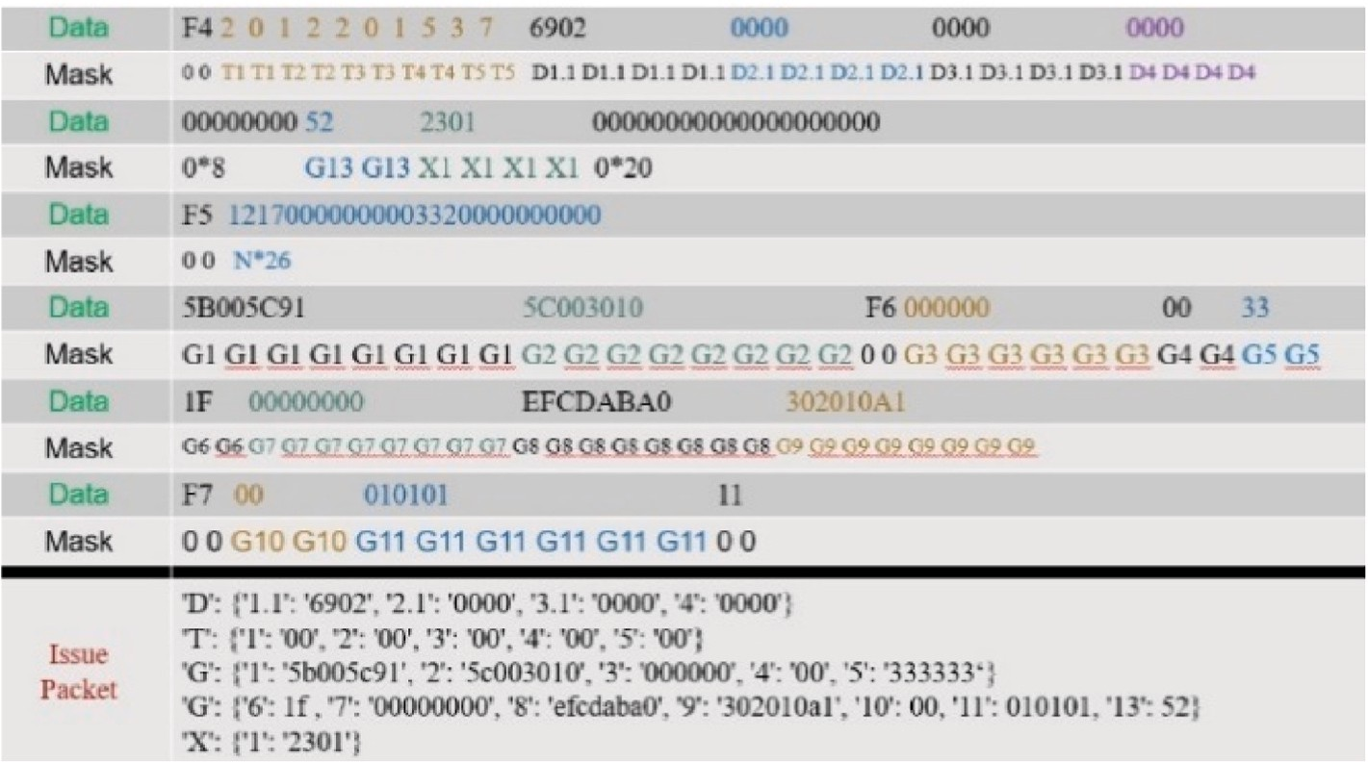

**Fig. 12.** Example of interpreting data packet into issue packet.

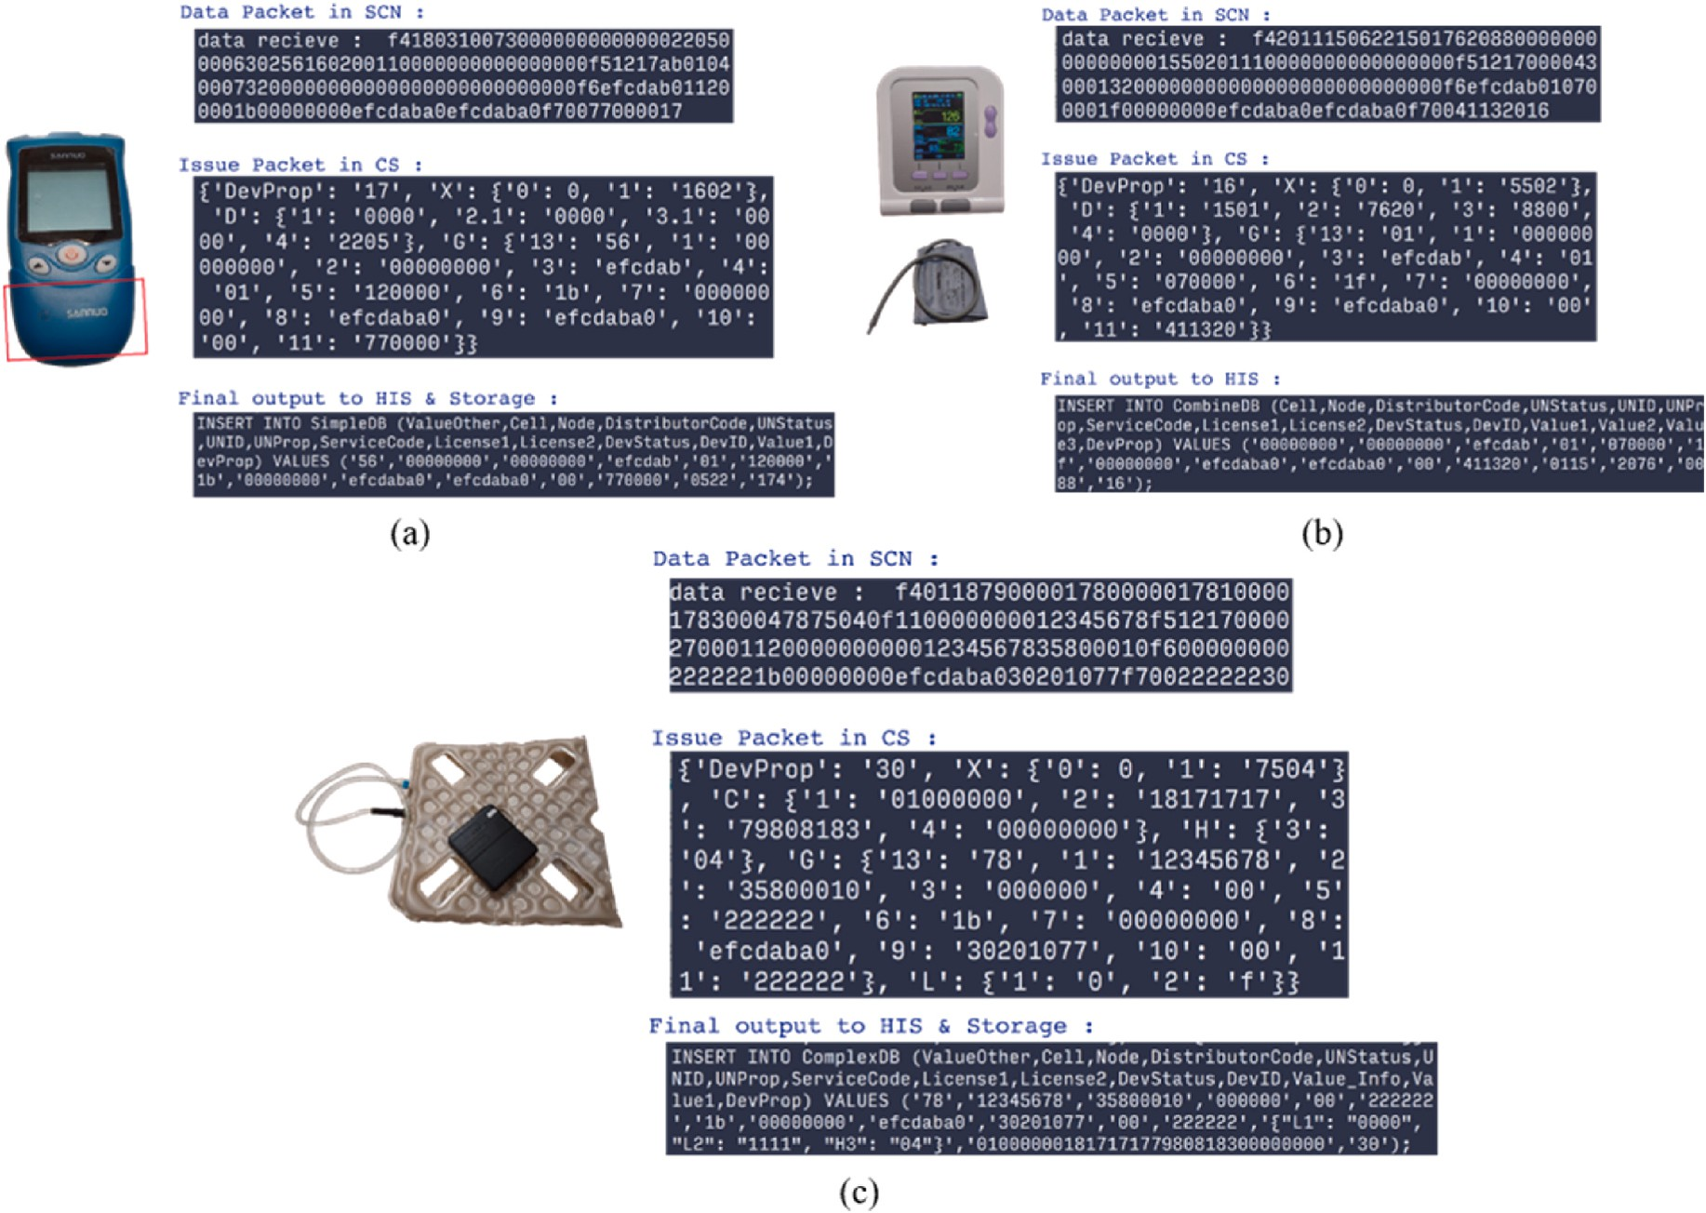

**Fig. 13.** Issue packet instruments and packet flow: (a) Blood sugar/uric acid meter (b) sphygmomanometer for dynamic measurement (c) smart mattress for static measurement.

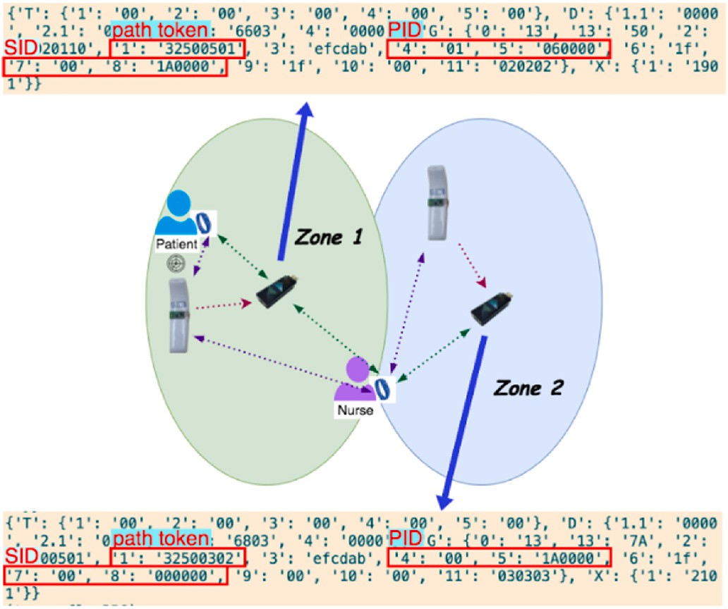

**Fig. 14.** Demonstration of communication between devices.

routine check. This policy confirms completion of each resident and issues a reminder when it is overdue.

* **Connect Signal:** Sometimes one needs to check the physiological condition by examining the trend of the value, not just a single measurement, such as heartbeat, breathing, etc. This policy is designed to connect the fragmented signals for trend analysis.

Since the implementation of our work is still in its embryonic stage,

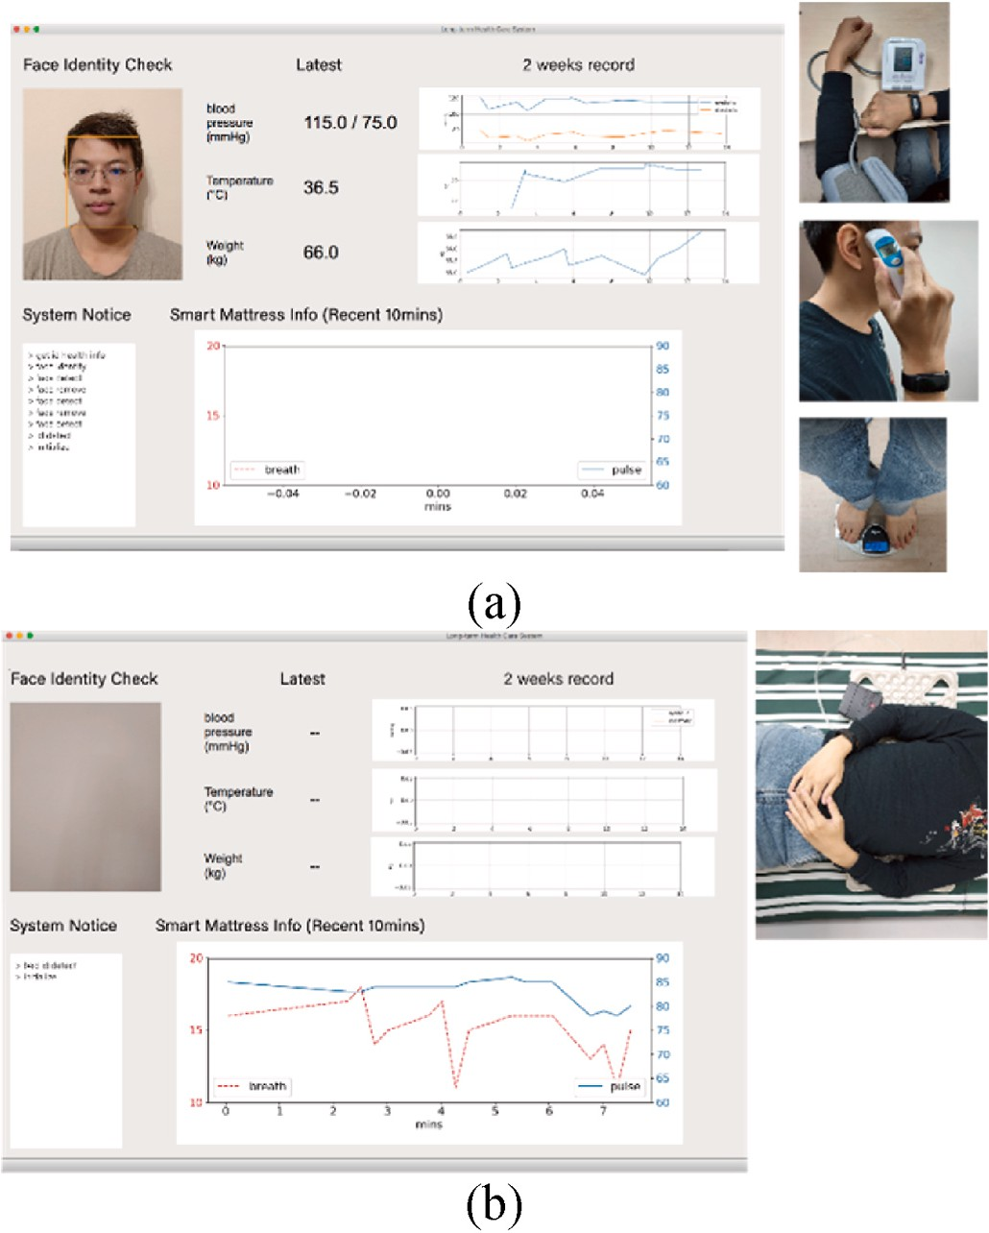**Fig. 15.** (a) Dynamic measuring scenario (b) static measuring scenario.



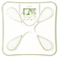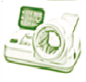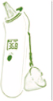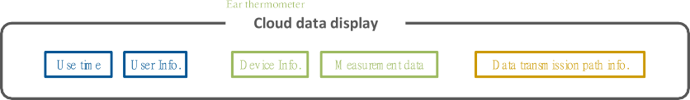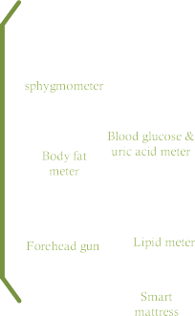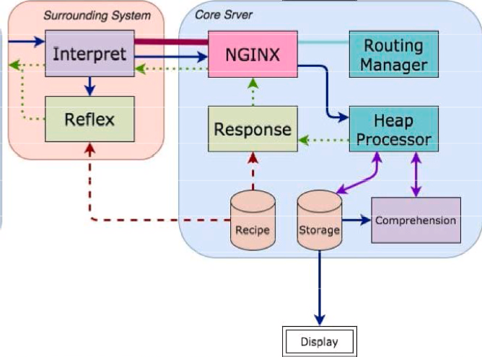

**Fig. 16.** Overview of the entire scheme.

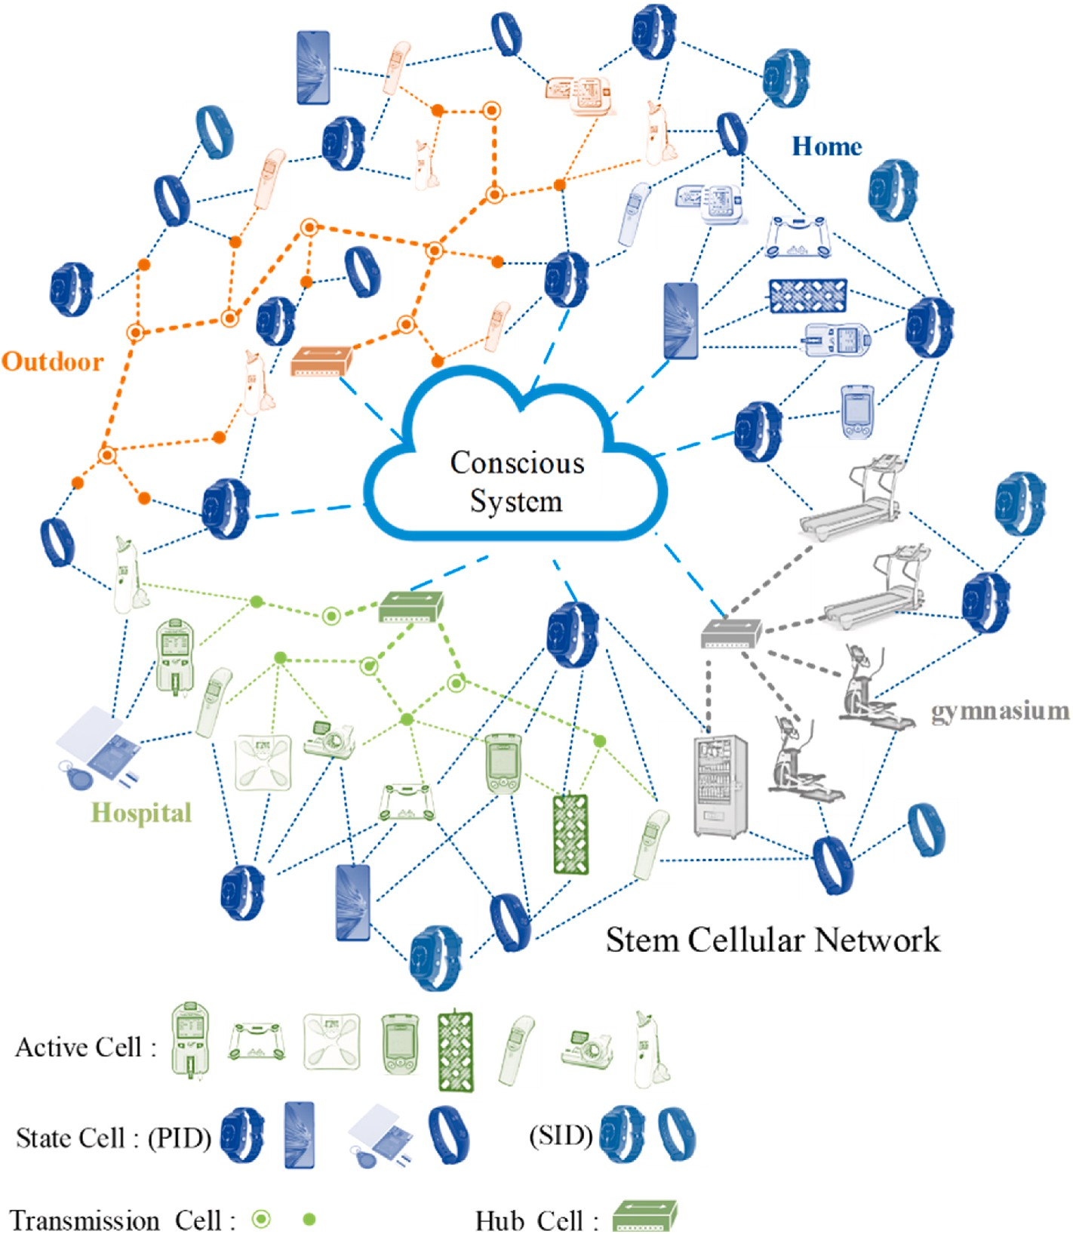

**Fig. 17.** Illustration of the complete IoT.

**Table 2**

Comparison of typical IoT architectures.

|  |  |  |  |  |  |  |  |
| --- | --- | --- | --- | --- | --- | --- | --- |
| Survey Article | Architecture | Implementability &  scalability | Device interoperate ability | Feedback | Target | Orientation | Extendibility (refactor) |
| Internet of Things | layer-wise | Use WebService to | not covered | not covered | measurement of | Database | Complexity for interpreting |
| for Smart Cities |  | intergret applications, |  |  | the urban |  | protocols between |
|  |  | need huge effort to |  |  | environment |  | applications grows |
|  |  | coordinate |  |  |  |  | exponentially |
| Intelligent | cloud & fog | not covered | not covered | mechine learning | medical cognitive, | Semantic | Data can transform to |
| Differential | base |  |  | feedback to | emotion |  | different application |
| Evolution |  |  |  | system’s parameter | communication, |  | domains |
| Scheme for |  |  |  |  | robot |  |  |
| Network |  |  |  |  |  |  |  |
| Resources in IoT |  |  |  |  |  |  |  |
| IoT-Based | layer-wise | Use developed | not covered | Data feedback to | healthcare | Service | Stubborn structure and |
| Healthcare |  | technology like RFID, |  | the nursing staff or |  |  | database make the system |
| Support System |  | GPS, GSM to reduce |  | family member on |  |  | can barely apply to another |
| for Alzheimer’s |  | technical obstacles |  | screen by mobile |  |  | domain |
| Patients |  |  |  | device. |  |  |  |
| Our Research | conscious | Use simple UART | Full interact | Reflex and | healthcare | Event | Smart Tangram Pattern |
|  | system | interface to join new type | between active | Response feature |  | Database | features increase new |
|  |  | of devices | cell and state | generate both low |  | Semantic | processing rules easily by |
|  |  |  | cell. | latency feedback |  |  | adding policy in the |
|  |  |  |  | and complete |  |  | comprehension unit |
|  |  |  |  | analysis. |  |  |  |

surely, there are still issues worthy of further investigation. For example, the efficiency and stability when facing the high concurrency situation. However, the lightweight modular architecture designed for this work makes it easy to maintain and modify, in addition, it brings up a sig- nificant potential for performance or functional evolution.

* 1. *Issue data packet in conscious system*

Here, letters are used as prefixes to represent different data meanings and digital codes are used for both comprehension and heap processing units. Table 1 shows the protocol of the data packet considered.

* 1. *Demonstration*

This section shows the integrated instrument and its data flow including data packet transmitted in SCN, how issue packet is process- ing, and the final output. Fig. 11 displays data format of the Smart Tangram Pattern database. The behaviour of both interpret and reflex units in CS takes the info in this database as the reference.

The data comes from SCN being interpreted according to the Smart Tangram Pattern (STP) database. Firstly, the data is identified by checking its length, header, and anchor abbreviated “Header”, “Length”,

“Anchor0_pos”, and “Anchor0_value” columns in the STP database.

Next, the data are interpreted, based on the “Mask” column. Finally, the CS creates reflex signals from the “Reflex_Formula” column. In Fig. 12, we have provided an example to interpret data when transmitting it

from SCN to CS.

Fig. 13 interprets data flow from three devices. The red box in Fig. 13

(a) and (b) marks the active cell attached to the instruments. There are thermometers, weight scale, sphygmomanometer, and blood sugar/uric acid meter as dynamic measurements. We have built a smart mattress as an example for static measurement, see Fig. 13(c). This smart mattress can detect the user’s heartbeat, breathing rate and possesses the emer-

gency call function. The detection mechanism will be automatically

activated and taken measurement every 15 s and regularly sent to the SCN when a user lies on it.

Next, we show the capability of communication between two de- vices. In Fig. 14, there are two transmission cells establishing two transmission fields in zones 1 and 2. When the nurse uses a thermometer

to measure the patient’s body temperature in zone 1, the system rec- ognizes that the measured value is for the patient. When the nurse

conducts a body temperature self-check-in zone 2, the system marks the

result in the nurse’s profile. The system automatically completes the procedure waving extra user operations.

Fig. 15(a) demonstrates the practical usage scenarios and HIS interface. It shows that after the user measures blood pressure, body temperature, and weight, the interface automatically updates the latest measured value; the two-week data collection shows the trend of physical statuses. To secure user privacy, the interface displays the

physiological information only after confirming the user’s ID. Fig. 15(b) demonstrates that users can track their breathing and heartbeat records

via a pneumatic mattress. The comprehension unit in the CS connects discretized signals from the pneumatic mattress to monitor various physiological signals. The data could be, for example, used for the study of polysomnography or insomnia.

* 1. *Overview of implementation*

This section describes the way of realization for a fundamental stem cell module with an RF chip and constructs the entire SCN. In addition to building a wireless channel of information, physiologically measuring devices and wearable devices are integrated into the SCN. The CS is next implemented to coordinate all devices in the SCN and display the analysis result. The complete steps of IoT services applying to a long- term health care scenario are illustrated in Fig. 16 that illustrates the proposed IoT configuration. This real-world implementation presents the capability of mobility, scalability, fast response, low power con- sumption, low implementation cost and providing the function of object positioning. It exhibits two major features, feedback and refactors, as mentioned previously.

The concept of SCN cellularizes all IoT components, each cell has its own task and can be matched at will. The CS architecture design uses a simplified structure to accept information from various internet- connected devices. After processing, the information can be fed back to a suitable object for operation. Fig. 17 illustrates the whole archi- tecture of an ideal IoTs. On the mobile link, we have realized a multi- dimensional mesh link, that can respond to the change of the trans- mission structure of the user (PID). Through the adaptation of CS, in- formation received from different application fields can be integrated to provide appropriate data to observers and for artificial intelligence (AI) applications.

Table 2 compares operational differences among benchmarked ap- proaches of the IoT applications. Advantages of the proposed one can be perceived from the aspects of easy implementation, scalability, and

expandability.

# 5. Conclusions

This paper presents the idea for implementation of an idealized IoT. The IoT structures seen on the market are mostly target-oriented such as for smart city, intelligent agriculture, or manufacturing, etc. Those IoTs

meant “Internet of Targets” rather than “Internet of Things”. The former is lacking of interoperability leading to a barrier hindering its applica-

bility. The ideal IoT introduced here aims to challenge the problem by providing an alternative solution. Through emulating organisms and human behavior, this research task has implemented the core parts, i.e. SCN and CS, in a health-care center and demonstrated their functions.

The presented work accomplishes a prototype in terms of a simplified framework. Still, there are remnants to be tackled: (i) with the increasing application fields to be implemented, calibration and testing have to be gradually accomplished and data have to be accumulated; (ii)

implementing the vigorous function of the self-integrated “adaptation”

quadrant; (iii) integrating and developing diverse peripheral equipment to expand the cross-domain applications.

# Credit Author Statement

C. L. L.: Conceptualization, Methodology, Project administration, funding acquisition

C. Y. C.: Writing—original draft preparation, Conceptualization, Methodology, Formal analysis, Investigation

Y. Y. C.: Writing—original draft preparation and review and editing.

# Declaration of competing interest

The authors declare that they have no known competing financial interests or personal relationships that could have appeared to influence the work reported in this paper.

# Acknowledgments

This work was supported by the Ministry of Science and Technology, Taiwan, under the Grant MOST 110-2634-F-005-006.

# References

1. [Sanchez L, Munoz L, Galache JA, Sotres P, Santana JR, Gutierrez V, Ramdhany R,](http://refhub.elsevier.com/S2590-0056(22)00017-0/sref1)

[Gluhak A, Krco S, Theodoridis E, Pfisterer D. Smartsantander: Iot experimentation](http://refhub.elsevier.com/S2590-0056(22)00017-0/sref1) [over a smart city testbed. Comput Network 2014;61:217–38](http://refhub.elsevier.com/S2590-0056(22)00017-0/sref1).

1. [Zanella A, Bui N, Castellani A, Vangelista L, Zorzi M. Internet of things for smart](http://refhub.elsevier.com/S2590-0056(22)00017-0/sref2)

[cities. IEEE Internet Things J 2014;1:22–32](http://refhub.elsevier.com/S2590-0056(22)00017-0/sref2).

1. [Yu XY, Guo XH. Data anomaly detection and data fusion based on incremental](http://refhub.elsevier.com/S2590-0056(22)00017-0/sref3)

[principal component analysis in fog computing. Ksii Trans Internet Inf Syst 2020;](http://refhub.elsevier.com/S2590-0056(22)00017-0/sref3) [14:3989–4006](http://refhub.elsevier.com/S2590-0056(22)00017-0/sref3).

1. Sulyova D, Koman G. The significance of iot technology in improving logistical

processes and enhancing competitiveness: a case study on the world’s and

Slovakia’s wood-processing enterprises. Sustainability 2020;12. [https://doi.org/](https://doi.org/10.3390/su12187804) [10.3390/su12187804](https://doi.org/10.3390/su12187804).

1. [Pang Z. Technologies and architectures of the internet-of-things (iot) for health and](http://refhub.elsevier.com/S2590-0056(22)00017-0/sref5) [well-being. 2013](http://refhub.elsevier.com/S2590-0056(22)00017-0/sref5).
2. Bellandi V, Ceravolo P, Cristiano A, Damiani E, Sanna A, Trojaniello D. A design methodology for matching smart health requirements. Concurrency Comput Pract Ex 2020. <https://doi.org/10.1002/cpe.6062>.
3. [Kwon D, Hodkiewicz MR, Fans J, Shibutani T, Pecht MG. Iotbased prognostics and](http://refhub.elsevier.com/S2590-0056(22)00017-0/sref7)

[systems health management for industrial applications. IEEE Access 2016;4:](http://refhub.elsevier.com/S2590-0056(22)00017-0/sref7) [3659–70](http://refhub.elsevier.com/S2590-0056(22)00017-0/sref7).

1. Oddershede A, Macuada C, Quezada L, Montt C. Automation factors influencing

the operation of iot in health institutions: a decision support methodology. Int J Comput Commun Control 2020;15. <https://doi.org/10.15837/ijccc.2020.4.3878>.

1. [Rodrigues J, Segundo DBD, Junqueira HA, Sabino MH, Prince RM, Al-Muhtadi J,](http://refhub.elsevier.com/S2590-0056(22)00017-0/sref9) [De Albuquerque VHC. Enabling technologies for the internet of health things. IEEE](http://refhub.elsevier.com/S2590-0056(22)00017-0/sref9)

[Access 2018;6:13129–41](http://refhub.elsevier.com/S2590-0056(22)00017-0/sref9).

1. Yoo H, Han S, Chung K. A frequency pattern mining model based on deep neural network for real-time classification of heart conditions. Healthcare 2020;8. [https://](https://doi.org/10.3390/healthcare8030234) [doi.org/10.3390/healthcare8030234](https://doi.org/10.3390/healthcare8030234).
2. Maiorescu I, Bucur M, Georgescu B, Moise D, Strat VA, Zgura ID. Social media and iot wearables in developing marketing strategies. do smes differ from large enterprises? Sustainability 2020;12. <https://doi.org/10.3390/su12187292>.
3. [Yang G, Xie L, Mantysalo M, Zhou XL, Pang ZB, Xu LD, KaoWalter S, Chen Q,](http://refhub.elsevier.com/S2590-0056(22)00017-0/sref12) [Zheng LR. A health-iot platform based on the integration of intelligent packaging,](http://refhub.elsevier.com/S2590-0056(22)00017-0/sref12) [unobtrusive bio-sensor, and intelligent medicine box. IEEE Trans Ind Inf 2014;10:](http://refhub.elsevier.com/S2590-0056(22)00017-0/sref12)

[2180–91](http://refhub.elsevier.com/S2590-0056(22)00017-0/sref12).

1. [Li T, Qian Q, Ren YJ, Ren YZ, Xia JY. Privacy-preserving recommendation based on](http://refhub.elsevier.com/S2590-0056(22)00017-0/sref13)

[kernel method in cloud computing. Comput Mater Continua (CMC) 2021;66:](http://refhub.elsevier.com/S2590-0056(22)00017-0/sref13) [779–91](http://refhub.elsevier.com/S2590-0056(22)00017-0/sref13).

1. Huang XC, Nazir S. Evaluating security of internet of medical things using the

analytic network process method, vol. 2020. Security and Communication Networks; 2020. <https://doi.org/10.1155/2020/8829595>.

1. [Morin E, Maman M, Guizzetti R, Duda A. Comparison of the device lifetime in](http://refhub.elsevier.com/S2590-0056(22)00017-0/sref15) [wireless networks for the internet of things. IEEE Access 2017;5:7097–114](http://refhub.elsevier.com/S2590-0056(22)00017-0/sref15).
2. Han DS, Liu T, Qi YC. Optimization of mixed energy supply of iot network based on

matching game and convex optimization. Sensors 2020;20. [https://doi.org/](https://doi.org/10.3390/s20195458) [10.3390/s20195458](https://doi.org/10.3390/s20195458).

1. [Adelantado F, Vilajosana X, Tuset-Peiro P, Martinez B, Melia-Segui J, Watteyne T.](http://refhub.elsevier.com/S2590-0056(22)00017-0/sref17) [Understanding the limits of lorawan. IEEE Commun Mag 2017;55(9):34–40](http://refhub.elsevier.com/S2590-0056(22)00017-0/sref17).
2. [Perera C, Qin YR, Estrella JC, Reiff-Marganiec S, Vasilakos AV. Fog computing for](http://refhub.elsevier.com/S2590-0056(22)00017-0/sref18)

[sustainable smart cities: a survey. ACM Comput Surv 2017;50:1–43](http://refhub.elsevier.com/S2590-0056(22)00017-0/sref18).

1. [Lin J, Yu W, Zhang N, Yang XY, Zhang HL, Zhao W. A survey on internet of things:](http://refhub.elsevier.com/S2590-0056(22)00017-0/sref19)

[architecture, enabling technologies, security and privacy, and applications. IEEE](http://refhub.elsevier.com/S2590-0056(22)00017-0/sref19) [Internet Things J 2017;4:1125–42](http://refhub.elsevier.com/S2590-0056(22)00017-0/sref19).

1. I. E. Agbehadji, S. O. Frimpong, R. C. Millham, S. J. Fong, and J. J. Jung,

“Intelligent energy optimization for advanced iot analytics edge computing on wireless sensor networks,” Int J Distributed Sens Netw, vol. 16, 2020.

1. [Sethi P, Sarangi SR. Internet of things: Architectures, protocols, and applications.](http://refhub.elsevier.com/S2590-0056(22)00017-0/sref21) [J Electr Comput Eng 2017;2017:9324035](http://refhub.elsevier.com/S2590-0056(22)00017-0/sref21).
2. [Yu W, Liang F, He XF, Hatcher WG, Lu C, Lin J, Yang XY. A survey on the edge](http://refhub.elsevier.com/S2590-0056(22)00017-0/sref22) [computing for the internet of things. IEEE Access 2018;6:6900–19](http://refhub.elsevier.com/S2590-0056(22)00017-0/sref22).
3. [Fanitabasi F, Gaere E, Pournaras E. A self-integration testbed for decentralized](http://refhub.elsevier.com/S2590-0056(22)00017-0/sref23)

[socio-technical systems. Future Generat Comput Syst-Int J Esci 2020;113:541–55](http://refhub.elsevier.com/S2590-0056(22)00017-0/sref23).

1. [Chen M, Herrera F, Hwang K. Cognitive computing: architecture, technologies and](http://refhub.elsevier.com/S2590-0056(22)00017-0/sref24) [intelligent applications. IEEE Access 2018;6:19774–83](http://refhub.elsevier.com/S2590-0056(22)00017-0/sref24).
2. [Da B, Esnault PP, Hu S, Wang C. Identity/identifier-enabled networks (IDEAS) for](http://refhub.elsevier.com/S2590-0056(22)00017-0/sref25)

[Internet of Things (IoT). IEEE 4th World Forum on Internet of Things (WF-IoT);](http://refhub.elsevier.com/S2590-0056(22)00017-0/sref25) [2018. p. 412–5](http://refhub.elsevier.com/S2590-0056(22)00017-0/sref25).

1. [Lo´pez Pen˜a MA, Mun˜oz Fern´andez I. SAT-IoT: an architectural model for a high-](http://refhub.elsevier.com/S2590-0056(22)00017-0/sref26)

[performance Fog/Edge/Cloud IoT platform. In: IEEE 5th World Forum on Internet](http://refhub.elsevier.com/S2590-0056(22)00017-0/sref26) [of Things (WF-IoT); 2019. p. 633–8](http://refhub.elsevier.com/S2590-0056(22)00017-0/sref26).

1. [Stanfield B. The art of focused conversation: 100 ways to access group wisdom in](http://refhub.elsevier.com/S2590-0056(22)00017-0/sref27)

[the workplace. New Society Publishers; 2000](http://refhub.elsevier.com/S2590-0056(22)00017-0/sref27).

1. [Huang DY, Lin CL, Chen YY. Securable networked scheme with face authentication.](http://refhub.elsevier.com/S2590-0056(22)00017-0/sref28) [IET Biom 2022;11(Iss. 2):97–108](http://refhub.elsevier.com/S2590-0056(22)00017-0/sref28).