Available online at [www.sciencedirect.com](http://www.sciencedirect.com/)



**ScienceDirect**

AASRI Procedia 8 (2014) 50 – 56

2014 AASRI Conference on Sports Engineering and Computer Science (SECS 2014)

Research on the Surface Potential of Spinal Cord Based on the Finite Element Analysis

Bo Hong, Xiaoyan Shen*, Yong Liu, Fang Wu

*School of electronics and information, Nantong University, 9th Seyuan Road, Nantong, Jiangsu, 226019, China*

**Abstract**

Finite element analysis can research the change of the structure and the interior field intensity of human and animal body organs and tissues through simulation experiment. We use finite element analysis software to analyze the spinal cord surface potential and research the transmission feature of signals generated by interneurons in spinal cord which are related with body motion control and sensory processing. A three dimensional model of electrical source in rat’s spinal cord was built, the influence on potential distribution on spinal cord surface caused by position changes of electrical source in transverse direction and dorsoventral direction was analyzed and calculated. We obtained the potential distribution curves of spinal cord surface and compared the results with data from animal experiments, verifying the feasibility of scheme of locating the excitatory through potential distribution on spinal cord surface.

© 2014 The Authors. Published by Elsevier B. V. This is an open access article under the CC BY-NC-ND license ([http://creativecommons.org/licenses/by-nc-nd/3.0/).](http://creativecommons.org/licenses/by-nc-nd/3.0/))

© 2014 The Authors. Published by Elsevier B.V.

Selection and/or peer review under responsibility of American Applied Science Research Institute

Peer-review under responsibility of Scientific Committee of American Applied Science Research Institute

*Keywords:* Finite element analysis; Interneuron; Spinal cord; Potential.

# Introduction

In recent years, scholars in the field of basic science put forward the spinal central pattern generator (CPG) theory that the CPG, which is made up of intermediate neural networks is located in the central nervous

* Corresponding author. Tel.: +86- 0513-81052663; fax: +086-0513-85012626.

*E-mail address:* [xiaoyansho@ntu.edu.cn.](mailto:xiaoyansho@ntu.edu.cn)

2212-6716 © 2014 The Authors. Published by Elsevier B. V. This is an open access article under the CC BY-NC-ND license ([http://creativecommons.org/licenses/by-nc-nd/3.0/).](http://creativecommons.org/licenses/by-nc-nd/3.0/))

Peer-review under responsibility of Scientific Committee of American Applied Science Research Institute doi:10.1016/j.aasri.2014.08.009

system. It can produce neuronal circuits of self-excitation sustained behavior, such as walking, breathing, chew, etc. And it is the center control unit of the rhythmic motion[1]. Spinal cord interneurons play an important role in the body motion control and sensory processing. They provide not only the plasticity for the restructuring of the spinal cord loop but also play a vital role in recovery of spinal cord injured (SCI) patients. Theoretically, if we exert direct stimulation at some points or sensory input in the uninjured spinal cord CPG loop, rhythmic motion under damaged parts can be restored [2],[3]. We think that the diverse positions of the excitatory neurons in the spinal cord result in the diversity of potential distribution on spinal cord surface. In return, if we know the relationship between the location of the excitatory neuron and the regularity of potential distribution on spinal cord surface, then we can locate the excitatory neuron in the spinal cord through regularity of potential distribution on spinal cord surface we obtained before.

Therefore, this article is based on the finite element analysis software . We built a three dimensional model of electrical source in rat’s spinal cord, and the influence on potential distribution on spinal cord surface caused by position changes of electrical source in transverse direction, dorsoventral direction and rostro caudal direction was analyzed.

# Distribution calculation model on spinal cord surface

* 1. *The three-dimensional model of rat spinal cord*

In order to study the transmission characteristics of nerve signals in the spinal cord and establishing of the nerve electric source model, various morphologic parameters of rat spinal cord were assessed. Experimental animals: Sprague Dawley rats of clean grade supplied by Nantong University Laboratory Animal Center. We selected L2 which controls hind limbs movement as the modeling section. Figure 1 (a) shows the slice of L2 (bar = 500ȝm). Origin of coordinates locates in the central canal, the rightward transverse direction is the positive direction of X axis and the dorsal side of the dorsoventral direction is the positive direction of Y axis. The coordinates of the key-points on the outline of the right side L2 are shown as below(unit: ȝm) :

grey matter:(0,0); (520,400); (1040,0); (1200,400); (1300,900); (720,1400); (400,1200); (300,880); (0,660),

white matter:(20,-540); (800,-940); (1780,0); (0,1360).

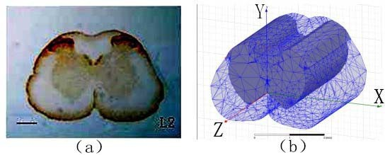

Fig.1. (a)The L2 segment slice figure in lumber spinal cord of rat; (b) Three dimensional model of spinal cord

Spinal cord segmental model was built in the Maxwell three dimensional model of electrical source according to the morphologic parameters of rat spinal cord (See figure 1 (b)).The size of simulation model is 2560ȝm 2300ȝm 3000ȝm, then the model was meshed into tetrahedron units. The established three-

dimensional finite element model is consistent with the morphology of slice and can be rotated, scaled and observed in different angles.

* 1. *Material attributes of the three-dimensional model*

After the three-dimensional model of the spinal cord was built we set electrical conductivity properties of tissues. Because the resistance effect of nerve fiber is much greater than the capacitance effect of spinal cord, so the latter can be neglected. The conductivity of gray matter is 0.23 S/m and the conductivity of white matter is 0.60S/m (vertical), 0.083 S/m (horizontal).

# Research on the simulation of potential distribution on spinal cord surface

Foreign scholars used activity-dependent labeling, the localization of spinal cord neurons active during locomotor activity, they found mainly labeled cells in L1-L6 located bilaterally near the central canal and in the medial intermediate zone [4],[5],[6].In the cat, the responses to intraspinal microstimulation of the lumbar spinal cord have been studied at the level of limb kinematic responses, muscle activation, or single joint torques with stimulation delivered in the ventral portion(ventral laminaď,and laminaT-K)[7]. So we choose T-K layer, an area consists of motor nucleus clonies comprised of big type motor neurons and small type interneurons which control skeletal muscles, as shown in figure 2,the part enveloped by blue dashed line in the right side of gray matter of spinal cord.

The influence on potential distribution on spinal cord surface caused by position changes of electrical source in transverse direction and dorsoventral direction was researched. We recorded the potential on spinal cord surface in accordance with the direction of red dashed arrows shown in figure2.

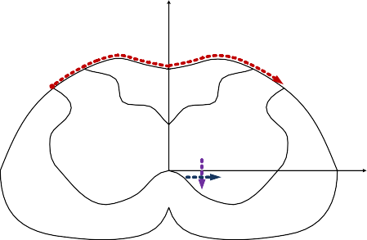

Y

**transverse**

**dorsoventral**

X

o

Fig.2. The potential distribution picture on spinal cord surface

* 1. *The influence on potential distribution on spinal cord surface caused by position changes of electrical source in transverse direction*

In research of the influence on potential distribution on spinal cord surface caused by position changes of electrical source in transverse direction, the position moves a distance of equal proportion, such as 3%, 6%, 9% of the transverse direction. Suppose A (324ȝm,-200ȝm,50ȝm) and B (432ȝm,-200ȝm,50ȝm), C (540ȝm,

-200ȝm,50ȝm), D (648ȝm,-200ȝm,50ȝm), E (756ȝm,-200ȝm,50ȝm) respectively are electrical sources along the transverse direction shown in figure 2, generating 8 mV nervous impulse. We can see in figure 3 that

spinal cord surface potential mainly concentrates on range of 137ȝV~169ȝV, the closer the electrical sources are to the dorsal median suleus on sagittal plane, the more conspicuous the peak voltages are in the distribution curves and there is no peak voltage if the electrical sources are distant from the sagittal plane. That is to say, the spinal cord surface potential is on a rise from left to right. According to the results, if we find the data got from the experiment appear to be monotonic, it shows that the position is distant from the sagittal plane, on the contrary, if some of the data shows extreme high voltages, it shows that the position is close to the sagittal plane.

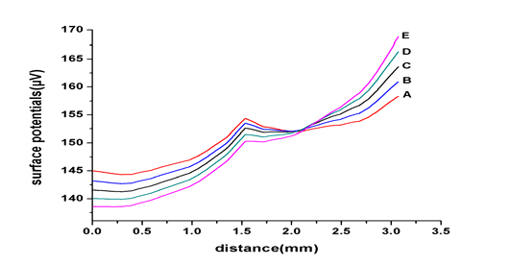

Fig.3. The influence on potential distribution on spinal cord surface caused by position changes of interneurons in transverse direction

* 1. *The influence on potential distribution on spinal cord surface caused by position changes of electrical source in dorsoventral direction*

In research of the influence on potential distribution on spinal cord surface caused by position changes of electrical source in dorsoventral direction, the position moves a distance of equal proportion, such as 3%, 6%, 9% of the dorsoventral direction. Suppose F(540ȝm,-62ȝm,50ȝm), G(540ȝm,-131ȝm,50ȝm ), H(540ȝm,- 200ȝm,50ȝm ), I(540ȝm,-269ȝm,50ȝm ), J(540ȝm,-338ȝm,50ȝm )respectively are electrical sources along the dorsoventral direction shown in figure 2, generating 8 mV nervous impulse. We can see in figure 4 that spinal cord surface potential mainly concentrates on range of 138ȝv~169ȝV, the trend of the distribution curves maintain unchanged while electrical sources are moving along the dorsoventral direction, just the potential values are bigger when the electrical sources are close to the dorsal part.

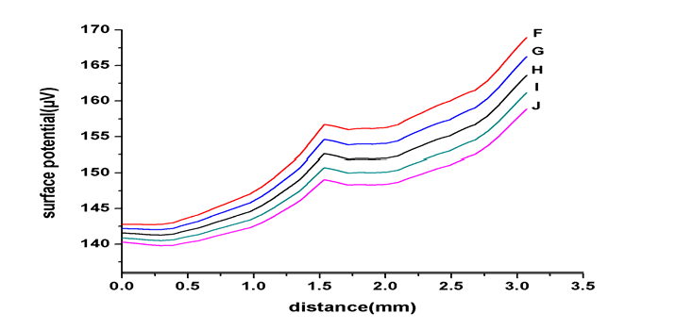

Fig.4. The influence on potential distribution on spinal cord surface caused by position changes of interneurons in dorsoventral direction

# The experiment of recording the potential on spinal cord surface

To verify the feasibility of confirming the location of excitatory neuron in the spinal cord through potential distribution on spinal cord surface, we conducted the experiment of recording the potential on spinal cord surface with rats. The recording electrode we used were self-made acupuncture needle electrodes, with a diameter of 0.16mm and coating material of excellent biocompatibility(Parylene insulating layer) on surface. 4 needles were fixed with silicone and kept them parallel with a 0.5mm-pitch between each other. The needle electrodes could properly cover the spinal cord surface. We used signal generator MASTER-9 to generate double-polarity pulse whose negative pulse width is 200ȝs, and an ISO - Flex isolator to generate current of

0.3 mA~1.5 mA to stimulate the right sciatic nerve (increased by 0.2mA a time). Synchronous record software (LabChart signal recording system) was used to record potentials collected form needle electrodes, as shown in figure 5.

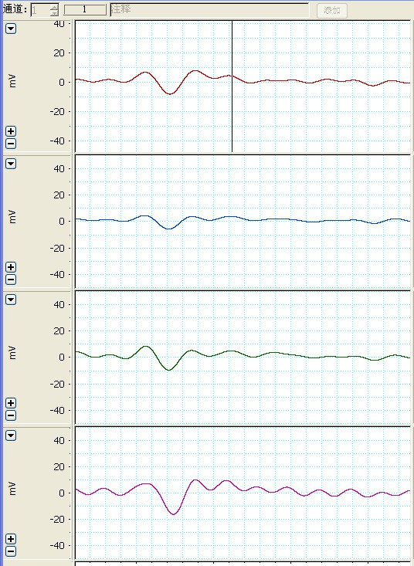

Fig.5. The synchronous recording picture of video and potential signal

The potential distribution recorded on spinal cord surface was shown as figure 6. After repeated experiments we found that potentials on spinal cord surface would basically increase with the increase of the stimulated current. Except the 0.9mA stimulated current, under the rest of the stimulated current the potential distribution also showed a trend of rising from left to right, which resembled with the simulation results that the potential distribution on the surface of the spinal cord is on a rise from left to right.

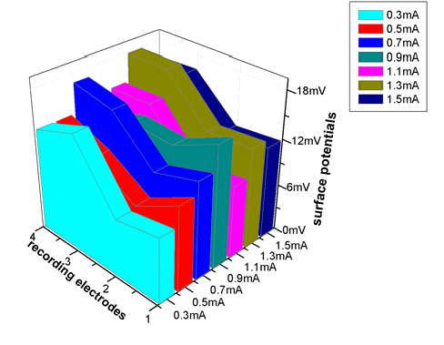

Fig.6. Experiment of recording potentials on spinal cord surface

# Conclusion and future work

In this paper, we used three dimensional module of electrical source in finite element analysis software Ansoft to analyze potential distribution on spinal cord surface after the interneurons activated by external stimulation acquiring the influence on potential distribution on spinal cord surface caused by position changes of electrical source in transverse direction and dorsoventral direction.

compared the results with data from animal experiments, verifying the feasibility of scheme of locating the excitatory neuron through potential distribution on spinal cord surface. In the future work, we can enlarge the number of electrodes in transverse direction and dorsoventral direction to make the results more accurate and make preparation for locating the active interneurons through potential distribution on spinal cord surface.

# Acknowledgements

This work was supported by National Science Foundation of China (81371663) and Natural Science Foundation of Nantong University (13B06).

# References

1. Marder E, Bucher D. Central pattern generators and the control of rhythmic movements. Curr Biol, 2001; 11: 986-996.
2. Edgerton VR, Leon RD, et al. Retraining the injured spinal cord. J Physio*l*, 2001; 533:15-22.
3. Rossignol S. Locomotion and its recovery after spinal injury. Curr Opin Neurobiol, 2000; 10:708-716.
4. Viala D, Buisseret-Delmas C, Portal J J. An attempt to localize the lumbar locomotor generator in the rabbit using 2-deoxy-[14C]glucose autoradiography. Neurosci.Lett, 1988; 86(2):139-143.
5. Dai X, Noga, B R, Douglas J R, Jordan L M. Localization of spinal neurons activated during locomotion using the c-fosim munohistochemical method. Neurophysiol, 2005; 96(3):3442-3452.
6. Kjaerulff O, Barajon I, Kiehn O. Sulphorhodamine-labelled cells in the neonatal rat spinal cord following chemically induced locomotor activity in vitro. Physiol, 1994; 478(2):265-273.
7. Michel A Lemay, Dane Grasse, Warren M Grill. Hindlimb Endpoint Forces Predict Movement Direction Evoked by Intraspinal Microstimulation in Cats. Neural Systems and Rehabilitation Engineering, IEEE Transactions on, 2009; 17(4):379-389.