Available online at [www.sciencedirect.com](http://www.sciencedirect.com/)



AASRI Procedia 2 (2012) 69 – 74

AASRI

Procedia

[www.elsevier.com/locate/procedia](http://www.elsevier.com/locate/procedia)

2012 AASRI Conference on Power and Energy Systems

# STATCOM Interface for Renewable Energy Sources with Power Quality Improvement

Ilango Ka, Bhargav.Ab, Trivikram.Ac, Kavya.P.Sd , Mounika.Ge Vivek.Nf and Manjula G. Nairg*

*Department of Electrical and Electronics Engineering, Amrita Vishwa Vidyapeetham University, Amrita School of Engineering (Bengaluru Campus), 5600035,India*

Abstract

The increasing hitches related to environmental issues have forced researchers to look out for safe and efficient methods of power generation, which consequentially calls for the renewable energy sources, out of which wind energy is recognized as the most rapidly growing technically viable and cost-efficient renewable source for power generation. Implementation of renewable energy source needs extensive usage of power electronics based utility interfaces to effectively meet the IEEE 1547 renewable energy power quality standards. In this paper, a digital controller based on modified ‘IcosФ’ algorithm has been developed for achieving an effective custom power device interface, with power sharing between the grid and renewable energy source, along with reactive power compensation and power factor correction on a dynamically varying linear load system.

© 2012 Published by Elsevier B.V. Selection and/or peer review under responsibility of American Applied Science Research Institute

© 2012 Published by Elsevier B.V. Selection and/or peer review under responsibility of American Applied Science Research Institute

© 2012 The Authors. Published by Elsevier B.V.

Selection and/o[r peer review under](http://creativecommons.org/licenses/by-nc-nd/3.0/) responsibility of American Applied Science Research Institute

Open access under [CC BY-NC-ND license.](http://creativecommons.org/licenses/by-nc-nd/3.0/)

*Keywords*:Renewable Energy Source, Power Quality Improvement, Ponit of Common Coupling, Modified IcosФ controller

* Manjula G Nair. Tel.:+91 80 28439565; fax:.080-2844 0092

*E-mail* [*address:*cp.manju@gmail.com](mailto:cp.manju@gmail.com)

2212-6716 © 2012 Published by Elsevier B.V. Selection and/or peer review under responsibility of American Applied Science Research Institute

Open access under [CC BY-NC-ND license.](http://creativecommons.org/licenses/by-nc-nd/3.0/) doi:10.1016/j.aasri.2012.09.016

1. Introduction

The concern for the environment has given rise to electricity generation from renewable resources. Today wind energy is one of the most economically competitive renewable energy technologies and several countries around the world have plans to significantly increase the contribution of wind energy to their electricity supply. The wind power generation is increasingly considered as a promising alternative from the aspect of the potential economy and essential environmental advantages. Interconnection of wind electric generators to power system grid could lead to many disturbances, such as: voltage fluctuations, flickers, harmonics, instability, blind power regulation problems and transients reported in various literatures. These challenges regarding the network integration of wind power mainly consists of keeping an acceptable voltage level and power balance of the system. In order to efficiently harness the energy from a wind source suitable interface techniques[3-4] are chosen from various interface possibilities, a very novel invention called ‘Custom Power Device’ is implemented, in which STATCOM is used as an interfacing unit between grid, renewable energy source and load. The scheme proposed here counter-acts the power quality problems.

The power quality standards for renewable energy sources interconnection issues and IEEE 1547 [6] have levied directives on various interconnection standards to achieve improved grid communications and operations. The above mentioned renewable energy source and STATCOM unit are driven by a simple and versatile algorithm called ‘modified IcosФ algorithm’, which provides the reference currents for the STATCOM enabling the necessary reactive power compensation and power factor correction of load.

In this paper, STATCOM interface configuration for renewable energy system is described in section II along with the facets and mathematical proof .The modelling of control algorithm have been focused in section III. Section IV and section V deals the simulation results and discussions of proposed configuration.

1. STATCOM Interface Configuration for Renewable Energy Source

The schematic representation of the STATCOM interface for Renewable Energy Source (wind energy system) with its proposed controller circuit shown in Fig.1, which comprises of a three phase source (grid) of 400V, 50Hz, and two linear RL loads of 5.6kW real power and 3kVAr are switched at different time intervals. The STATCOM unit is designed for reactive power compensation and power factor correction as demanded by the load; the STATCOM unit is an inverter with DC link capacitor which gets its control signal in the form of pulses from a controller circuit. The control pulses are generated using modified IcosФ algorithm, which in turn causes the STATCOM to provide the reactive power compensation and power factor

improvement with real power support from the wind energy system as and when required by the load.

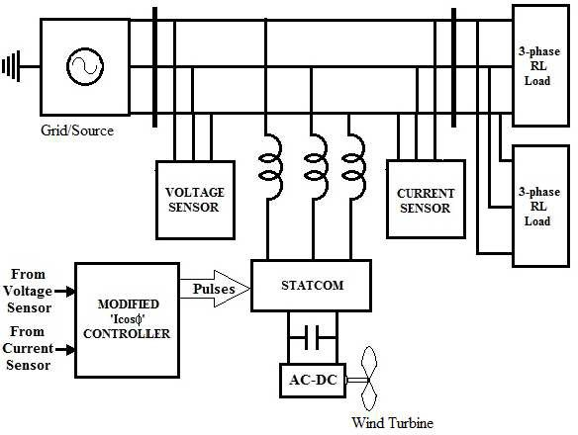

Fig.1. Schematic of STATCOM Interface for Renewable energy source (wind energy system)

1. Proposed Modified ‘IcosФ’ Algorithm for STACOM control

The Icosφ algorithm is able to provide harmonic, reactive and unbalance compensation in a three phase system with balanced/unbalanced source and load conditions. This has been proved and reported in [1]. Here the algorithm aimed to provide reactive power compensation, power factor correction and real power exchange from the renewable energy source.

The sensed load current and source voltage are given as the input to the controller circuit. The load current is given as an input to a second-order low pass filter (which has 50 Hz as its cut-off frequency), this filter is used to extract the fundamental load current which has an inherent phase shift of 90 . ‘Detect negative’ logic is being used to detect the zero crossing instant of the source phase voltage. The corresponding response is given as one of the input to the sample and hold circuit and the other input is derived from the second order low pass filter along with the 90° phase shift. The output of the sample and hold circuit is the required amount of ‘IcosФ’ magnitude. The ‘IcosФ’ magnitude is now multiplied with the unit amplitude of the corresponding source phase voltage to get the desired mains/source current for each phase.

The reference compensation currents for the STATCOM are deduced as the difference between the actual load current and the desired mains current in each phase. The detailed mathematical analysis about the ‘modified IcosФ’ algorithm is explained below:

The reference compensation currents for the STATCOM is thereby deduced as the difference between the actual load current and the desired source current in each phase

*Ia*(*comp*)  *ILa*

* *Isa*(*ref*

) ; *Ib*(*comp*)  *ILb*

* *Isb*(*ref*

) ; *Ic*(*comp*)  *ILc*

* *Isc*(*ref* ) ;

(1)

The desired (reference) source currents in the three phases are therefore given as:

*I sa*(ref )  *K* I*s*(ref )

 U*a* =K I*s*(ref ) sin** t; *Isb*(*ref*

)  *K Is*(*ref*

)  *Ub*  *K Is*(*ref*

) sin(*t* - 120);

*Isc*(*ref*

)  *K Is*(*ref*

)  *Uc*  *K Is*(*ref*

) sin(*t*  120)

(2)

where *K* is the load factor which determines how much real power has to be supplied by the source/grid. Let Ua , Ub and Uc are the unit amplitude templates of the phase to ground source voltages in the three

phases respectively.

Ua = 1.sinωt ; *Ub*  1.sin(*t* - 120) ; *Uc*  1. sin(*t*  120)

(3)

Further, a hysteresis current controller is used such that, the relay is ‘on’ till input drops below the value of switch off point. The relay is ‘off’ till input exceeds the value of switch on point, now this pulse is sent through a data type conversion block and a NOT gate in order to get the complimentary pulse for the STATCOM unit.

The control over the real power exchange has been introduced by including gain factor ‘k’. The magnitude of the gain is chosen by the user depending upon the load requirements and availability of renewable energy source generation. For instance, when the magnitude of the gain is chosen as ½, the real power supply from the mains is reduced by half and the rest is supplied by renewable energy source (wind energy) using the STATCOM controller circuit as an interface.

1. STATCOM Interface for Renewable energy sources

The design and modelling of the three phase system for STATCOM interface for renewable energy source (wind energy system) has been done using MATLAB Simulink. For the simulation purpose the wind energy system output considered as a rectified DC voltage connected to DC link of STATCOM to provide the real

power support for the load. The following section is divided into two subsections for understanding of stated objective of the system.

* 1. *System configuration without STATCOM interface*

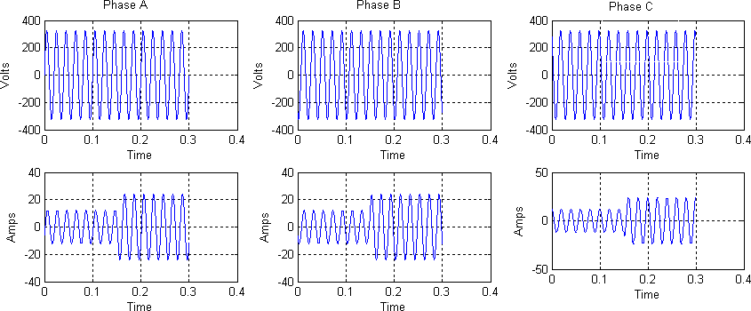The system consists of three phase source/grid of 400V, 50Hz which supplies real and reactive power to a combination of two linear RL loads switched at different time intervals. Here the source (grid) is solely responsible for handling the real power and reactive power demands of the load.

Fig.2.Three phase source voltages and currents (grid) side

Fig.2 shows the voltage and current waveforms of the three phase system, taken at the load side. By seeing this wave forms currents are lagging the voltages by some angles based in reactive power requirement of linear dynamic load.

* 1. *STATCOM as an Interfacing unit and real power exchange from Renewable energy source*

The STATCOM acts an effective interfacing link between the renewable energy source (wind energy) and grid system. The STATCOM unit performs regular role of delivering the required amount of reactive power and power factor corrector, which works with the gating pulses generated from the ‘modified IcosФ’ based controller circuit.

Apart from merely being an interfacing unit, another imperative function of a STATCOM is the ability of real power exchange from renewable energy source to load and grid. It has been perceived that when the load requires power that is more than the power supplied by the source, the STATCOM unit takes an active part and supplies the required active and reactive power. Similarly, when the renewable energy output is higher than that of the load power, the STATCOM unit delivers the excessive power back to the grid. But small amount power loss will take place at STATCOM unit at light load conditions .These cases have been proven in the simulation analysis and the results are tabulated in Table 1.

Table 1. Power sharing between grid and renewable energy source using STATCOM interface

|  |  |  |
| --- | --- | --- |
|  | Load1  (Time <0.15 sec) | Load1+Load2  (Time > 0.15 sec) |
| Real power drawn load (kW) | 5.19 | 10.40 |
| Reactive power drawn by load (kVA) | 2.76 | 5.52 |
| Real power delivered by Renewable energy via STATCOM (kW) | 2.395 | 5.25 |
| Reactive power delivered by Renewable energy via STATCOM (kVA) | 2.883 | 5.761 |
| Real power supplied by source (kW) | 2.595 | 5.20 |
| Reactive power supplied by source (kVA) | -0.123 | -0.242 |

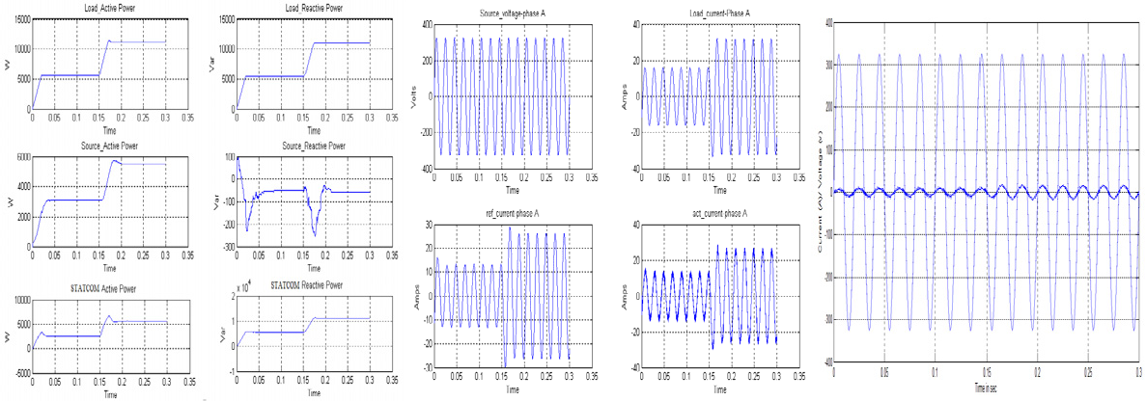

Fig. 3. (a) Real and reactive power drawn by linear RL load, source and filter when switched at different time intervals, using modified ‘IcosФ’ algorithm; (b) Source voltage, load current, reference current and actual STATCOM current (c)Source voltage and current of phase –‘a’ for power factor verification

1. Power factor correction using STATCOM Interface

The following simulation results are shown for the ‘Modified IcosФ’ controller performance with dynamic load system

The Fig.3.(b) shows the source voltage and load current along with the comparison of reference current generated by the Modified IcosФ controller and the actual current produce by the STATCOM for reactive power compensation and power factor correction.

Fig.3. (c) shows the phase ‘a’ grid voltage and current after reactive power compensation. This waveform makes clear that grid voltage and current are in phase and thereby the power factor of the three phase system is improved.

Table2. Power factor correction using STATCOM interface along with renewable energy source

|  |  |  |  |  |  |  |  |
| --- | --- | --- | --- | --- | --- | --- | --- |
| Load p.f. | PL(kW) | QL(kVA) | PS(kW) | QS(kVA) | PSTATCOM | QSTATCOM(kVA) | Improved |
| before comensation |  |  |  |  | (kW) |  | p.f |
| 0.4 | 11.8 | 25.40 | 20.5 | 5.66 | -9.32 | 19.75 | 0.96 |
| 0.6 | 11.8 | 14.77 | 14.5 | 0.10 | -3.40 | 14.7 | 0.99 |
| 0.7 | 11.18 | 11.00 | 13.60 | 0.05 | -2.50 | 11.00 | 0.99 |
| 0.8 | 11.18 | 7.19 | 5.42 | 0.05 | 5.76 | 7.25 | 0.99 |
| 0.9 | 11.18 | 5.35 | 5.39 | 0.068 | 5.79 | 5.42 | 0.99 |

Table.2.its clear that load real power kept at constant value but reactive power various according to power factor. For the low power factor loss in STATCOM is more and less for high load power factor. The reactive power delivered by the STATCOM is higher than the reactive power supplied by the source for all case of power factor. The proposed Modified IcosФ controller validates the ability of achieving power factor improvement, reactive power compensation along with real power support from the renewable energy source for a dynamic linear load system with STATCOM interface.

1. Conclusion

In this work the STATCOM interface for renewable energy source (wind energy system) has been modeled and simulated. The versatile modified ‘IcosФ’ control algorithm performance is analyzed and it is also proven that the modified ‘Icosφ’ controller is a feasible solution for reactive power compensation, power factor improvement along with real power support from renewable energy source. Finally, STATCOM is found to be an effective interface unit between the renewable energy source (RES) and the grid, acting as an important link for effective power compensation

Acknowledgements

This work has been funded by DST SERC under Fast Track Scheme for Young Scientists No: 100/IFD/2769. The authors are also grateful to Amrita Vishwa Vidya Peetham University, Amrita School of Engineering, Bengaluru campus for extending support for this project.

References

1. G. Bhuvaneswari, Manjula G. Nair, “Design, Simulation and Analog Circuit Implementation of a Three – Phase Shunt Active Filter Using the IcosФ Algorithm”, IEEE Transactions on Power Delivery April 2008.
2. J. G. Pinto, R. Pregitzer, Luis F. C. Monteiro, Joao L. Afonso, “3-Phase 4-Wire Shunt Active Power Filter with Renewable Energy Interface”.
3. Joseph A. Carr, Juan Carlos Balda, H. Alan Mantooth, “A Survey of Systems to Integrate Distributed Energy Recourses and Energy Storage on the Utility Grid”, IEEE Energy 2030 Atlanta, Georgia, USA, 17-18 November 2008
4. L. G. B. Rolim, A. Ortiz, M. Aredes, R. Pregitzer, J. G. Pinto, Joao L. Afonso, “Custom Power Interfaces for Renewable Energy Sources”, 1-4244-0755-9/07 IEEE 2007.
5. H. Akagi, Y. Kanazawa and A. Nabae, “Instantaneous Reactive Power Compensators comprising Switching Devices without Energy Storage Component”, IEEE Transac. On Industry Applications, 1984.
6. H. L. Jou, “Performance Comparison of the three – phase active – power – filter algorithms”, IEE Proc. Vol. 142. No. 6, November 1995.
7. Marta Molinas, Jon Are Suu and Tore Undeland “Improved grid interface of induction generators for renewable energy by use of STATCOM” 1-4244-0632-3/07IEEE 2007.
8. Samira Dib, Brahim Ferdi, Chellali Benachaiba “Wind Energy Conversion Using Shunt Active Power Filter” Journal of Scientific Research Nov. vol. 2 .2010
9. Thomas S. Basso, and Richard DeBlasio, “IEEE 1547 Series of Standards: Interconnection Issues” IEEE Transaction Power Electronics, Vol.19, No.5, Sep 2004
10. E. Belenguer, H. Beltrán, N. Aparicio, ‘Distributed Generation Power Inverters as Shunt Active Power Filters for Losses Minimization in the Distribution Network’ 1-8787-0435- 2/06 2006 IEEE.
11. K.J.P. Macken, ‘Active filtering and load balancing with small wind energy systems’. 0-7803-7671- 41021517.00 02002 IEEE.
12. W. Kramer, S. Chakraborty, B. Kroposki, and H. Thomas “Advanced Power Electronic Interfaces for Distributed Energy Systems”, Technical Report NREL/TP-581-42672 March 2008.