Available online at [www.sciencedirect.com](http://www.sciencedirect.com/)



AASRI Procedia 2 (2012) 205 – 215

AASRI

Procedia

[www.elsevier.com/locate/procedia](http://www.elsevier.com/locate/procedia)

2012 AASRI Conference on Power and Energy Systems

Stability Enhancement of HVDC System Using Fuzzy Based STATCOM

M Ramesh a*, I Swathib, A Jaya Laxmic

*a* Associate Professor and HOD*

*Dept of EEE, Medak College of Engineering and Technology,Kondapak,Medak Dist and Research Scholar, EEE Dept., Jawaharlal Nehru Technological University, Anantapur-515002, Andhra Pradesh, India*

*bResearch Scholar, EEE Dept., Jawaharlal Nehru Technological University, Hyderabad, College of Engineering, Kukatpally,*

*Hyderabad-500085, Andhra Pradesh, India*

c *Dept of EEE, Jawaharlal Nehru Technological University ,Hyderabad, College of Engineering, Kukatpally, Hyderabad -500085, Andhra Pradesh, India*

*E-mail:* [*marpuramesh223@gmail.com,*](mailto:marpuramesh223@gmail.com)[*swathi.indrapati@gmail.com*](mailto:swathi.indrapati@gmail.com)[*,ajl1994@yahoo.co.in*](mailto:%2Cajl1994@yahoo.co.in)

**Abstract**

The necessity to deliver cost effective energy in the power market has become a major concern in this emerging technology era. Therefore, establishing a desired power condition at the given points are best achieved using power controllers such as the well known High Voltage Direct Current (HVDC) and Flexible Alternating Current Transmission System (FACTS) devices. High Voltage Direct Current (HVDC) is used to transmit large amounts of power over long distances or for interconnections between asynchronous grids. The system planner must consider DC alternative in transmission expansion. The factors to be considered are Cost, Technical Performance and Reliability. All these equipment provide controllability to the AC transmission system by adjusting the transmission parameters. In recent years fuzzy logic control is beginning to receive more attention. Power system operation conditions and topologies are time varying and the disturbances are unforeseeable. These uncertainties make it very difficult to effectively deal with power system stability problems through conventional controller that is based on linearized system model. Therefore the fuzzy logic control approach, is one area of artificial intelligence, has been emerging in recent years as a complement to the conventional approach. The focus of this Paper is to identify the improved transient Stability through control scheme and comprehensive analysis for a Static Synchronous Compensator (STATCOM) on the basis of theory computer simulation. By Introducing FACTS Controller into HVDC system we can improve the power transmission capability and System stability.

© 2012 Published by Elsevier B.V. Selection and/or peer review under responsibility of American Applied Science Research Institute

© 2012 The Authors. Published by Elsevier B.V.

Selection and/or peer review under responsibility of American Applied Science Research Institute

Open access under [CC BY-NC-ND license.](http://creativecommons.org/licenses/by-nc-nd/3.0/)

*Keywords: Flexible AC Transmission System (FACTS), High-Voltage DC Transmission (HVDC), STATCOM, Power transfer controllability, Fuzzy Controller, Faults in HVDC System.*

* Corresponding author. Tel.:+ 919908109043; fax: +91 0857 240033

*E-mail address:* [marpuramesh223@gmail.com](mailto:marpuramesh223@gmail.com)

2212-6716 © 2012 Published by Elsevier B.V. Selection and/or peer review under responsibility of American Applied Science Research Institute

Open access under [CC BY-NC-ND license.](http://creativecommons.org/licenses/by-nc-nd/3.0/) doi:10.1016/j.aasri.2012.09.036

## Introduction

High-Voltage direct current (HVDC) transmission is an economic way for long distance power delivery and/or interconnection of asynchronous systems with different frequency. With the development of modern power system, HVDC system plays much more important role in power grids due to their huge capacity and capability of long distance Transmission. Electric power transmission was originally developed with direct current (DC). However, the transmission systems used in most countries nowadays are alternating current (AC) due to rapid development of transformers, synchronous generators and induction motors. DC transmission now becomes practical and economical when power transmission for long distance was involved. A Flexible Alternating Current Transmission System (FACTS) is a system composed of static equipment used for the AC transmission of electrical energy. It is meant to enhance controllability and increase power transfer capability of the network. It is generally a power electronics-based system. FACTS devices have four well-known types which are used in many power systems in the world. ‘Single’ type controller is a type of FACTS Controller that is installed in series or shunt in an AC transmission line, while ‘unified’ type controller is a combined converter type of FACTS controllers like STATCOM. [3].The past work generally concluded that fuzzy logic could improve the performance of HVDC systems under various fault conditions or operating point changes, by decreasing the number of commutation failures, improving the commutation margin, or dampening oscillations [4,6].

The development of FACTS-devices has started with the growing capabilities of power electronic components. Devices for high power levels have been made available in converters for high and even highest voltage levels. The overall starting points are network elements influencing the reactive power or the impedance of a part of the power system. The series devices are compensating reactive power. With their influence on the effective impedance on the line they have an influence on stability and power flow [7, 8].

## STATCOM (Static Synchronous Compensator)

A static synchronous compensator (STATCOM) is a regulating device used on alternating current electricity transmission networks. It is based on a power electronics voltage-source converter and can act as either a source or sink of reactive AC power to an electricity network STATCOM reactive power output is independent of voltage magnitude – i.e. Constant current even under low voltage limit. With the commercial breakthrough of high power gate turn-off devices, the road is paved for an additional step forward in flexibility of AC transmission and distribution systems: STATCOM, or the Static Synchronous Compensator [3, 8]. The name is an indication that STATCOM has a characteristic similar to the synchronous condenser, but as an electronic device it has no inertia and is superior to the synchronous condenser in several ways, such as better dynamics, a lower investment cost and lower operating and maintenance costs. The use of a STATCOM is that the reactive power provision is independent from the actual voltage on the connection point [2].

A STATCOM structure is based on Voltage Sourced Converter (VSC) topology and utilizes either Gate-Turn- off Thyristor (GTO) or Isolated Gate Bipolar Transistors (IGBT) devices. The STATCOM is a very fast acting, electronic equivalent of a synchronous condenser [5, 6].

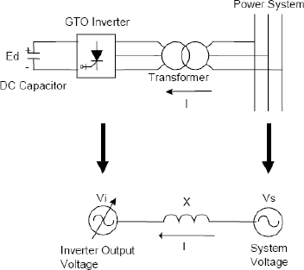

Fig.1. Equivalent circuit of STATCOM

The figure1 shows the equivalent circuit of a STATCOM system. The GTO converter with a dc voltage source and the power system are illustrated as variable ac voltages in this figure. These two voltages are connected by a reactance representing the transformer leakage inductance [1].

# Block Diagram Of Statcom

The STATCOM (Phasor Type) block models an IGBT-based STATCOM (fixed DC voltage). However, as details of the inverter and harmonics are not represented, it can be also used to model a GTO-based STATCOM in transient stability studies. The figure below shows a single-line diagram of the STATCOM and a simplified block diagram of its control system. The STACOM block is a phasor model which does not include detailed representations of the power electronics. You must use it with the phasor simulation method, activated with the Power gui block. It can be used in three-phase power systems together with synchronous generators, motors, dynamic loads and other FACTS and DR systems to perform transient stability studies and observe impact of the STATCOM on electromechanical oscillations and transmission capacity at fundamental frequency [3].

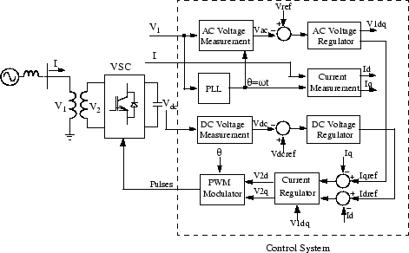

Fig.2. Single-line Block Diagram of a STATCOM

# Simulation Results

The rectifier and the inverter are 12-pulse converters using two Universal Bridge blocks connected in series. The converters are interconnected through a 110-km line and 0.5H smoothing reactors as shown in Fig.3. The converter transformers (Wye grounded/Wye/Delta) are modelled with Three-Phase Transformer (Three- Winding) blocks. The tap position is rather at a fixed position determined by a multiplication factor applied to the primary nominal voltage of the converter transformers (0.90 on the rectifier side, 0.96 on the inverter side). Here, MATLAB/SIMULINK program is used as the simulation tool.

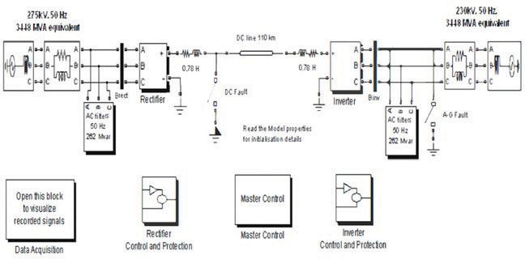

Fig.3 Simulink diagram of the HVDC Circuit.

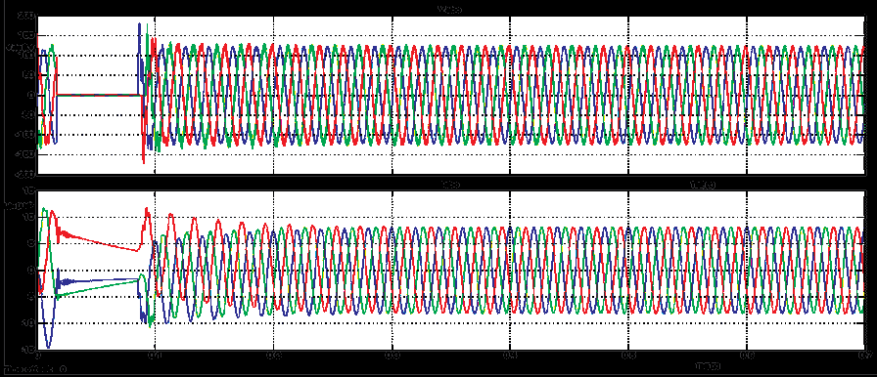Two 6-pulse Graetz bridges are connected in series to form a 12-pulse converter. The two 6-pulse bridges are 275KV, 60 Hz totally identical except there is an in phase shift of 30° for the AC supply voltages. Some of the harmonic effects are cancelled out with the presence of 30° phase shift. The harmonic reduction can be done with the help of filters. Firing angle at rectifier station and extinction angle at inverter station are varied to examine the system performance and the characteristics of the HVDC system. Both AC and DC filters act as large capacitors at fundamental frequency.

Fig.4 HVDC system when three phase fault occurs on Inverter.

In Fig .4, it is observed that a 3-phase fault is created in the inverter side of HVDC system. The Fuzzy Controller activates and clears the fault. The fault can be seen first by a straight line of ‘0’Voltage between t=0.03sec to t=0.08sec. Before the fault Vabc=0.38pu and Iabc=0.05pu. After the Fault is cleared at t=0.1sec, the recovery is slow and there are oscillations in DC voltage and current of The magnitude 0.4pu and 0.06pu respectively. The rectifier DC voltage and current oscillate and Settles to the prefault values in about 4 cycles after the fault is cleared.

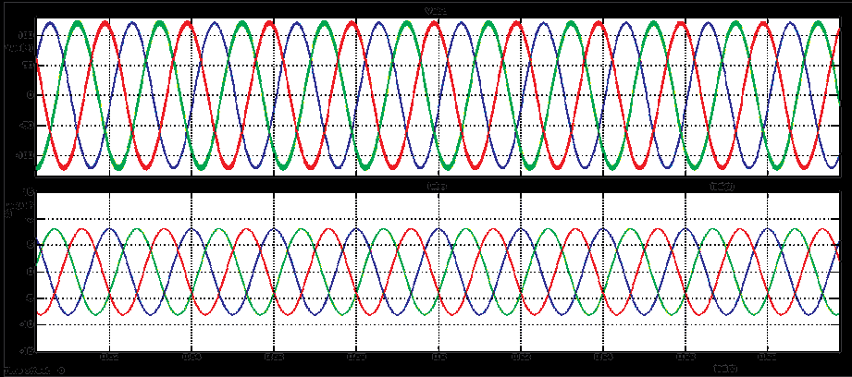

Fig 5 HVDC system with STATCOM when three phase fault occurs on Inverter.

From Fig. 5, It is observed that three phase is created in the inverter side of HVDC system at t=0.03 sec. When these faults occur in the system, it takes more time to reach the steady state operation. The Fuzzy controller activates and clears the fault. Further, with the addition of STATCOM the system reduces oscillations and get pure sinusoidal waveform at voltage Vabc=0.36p. u and current Iabc=0.042 p.u at time t=0.3 sec.

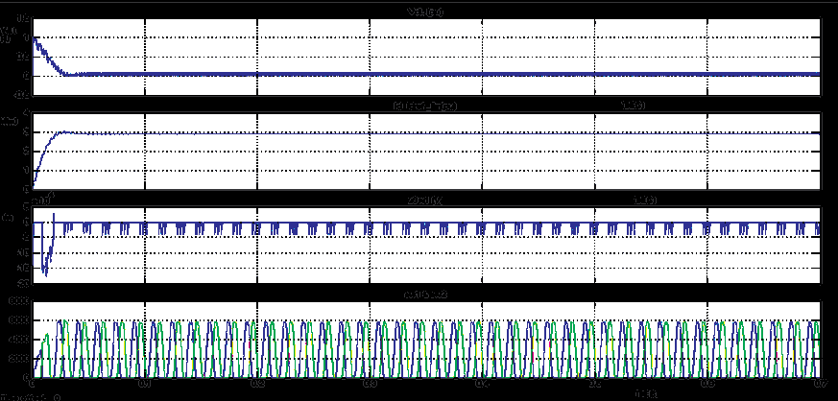

Fig. 6 Steady state operation of HVDC system on rectifier side.

At the rectifier side, when the fault is applied at time t=0.03sec, voltage and current magnitudes are of the order of 1pu and 3 p u respectively and alpha angle is equal to 15 degrees which is shown in Fig .6.If alpha angle is changed to higher value the system takes longer time to reach steady state .If alpha value increases, current value decreases. The waveforms obtained at rectifier side are same for different types of faults.

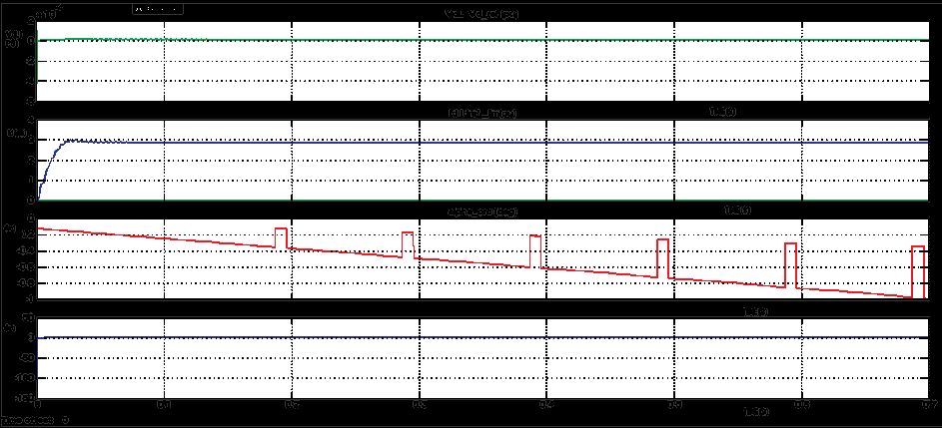

Fig .7 Steady state operation of HVDC system on Inverter side.

At the inverter side, when the fault is applied at time t=0.03sec,voltage and current magnitudes are of the order of 0.1pu and 2.8pu respectively and extension angle is equal to 168 degrees which is shown in Fig 7. The waveforms obtained at inverter side are same for different types of faults.

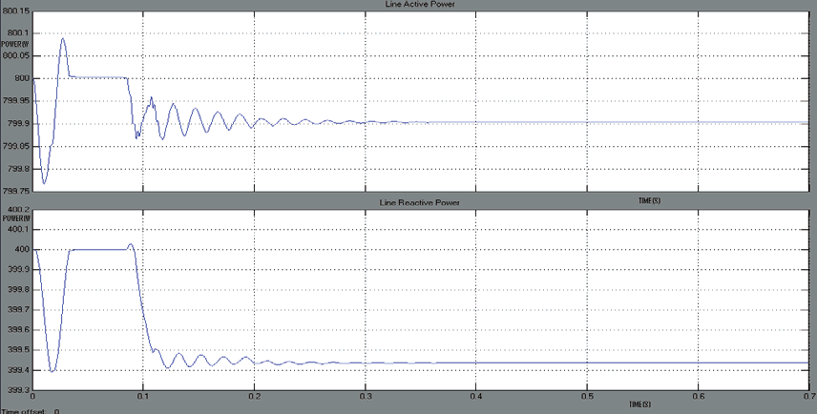

Fig .8 Active and Reactive powers of HVDC system (Three phase fault).

In Fig .8, when three phase fault is created at time t=0.1sec, the active and reactive power is maintained at 800KW and 400KVAR respectively from time t=0.02sec to t=0.2sec.At time t=0.35sec both active and reactive power attain stability and becomes steady state. It is observed that no power fluctuations occur in P and Q after t=0.35sec.

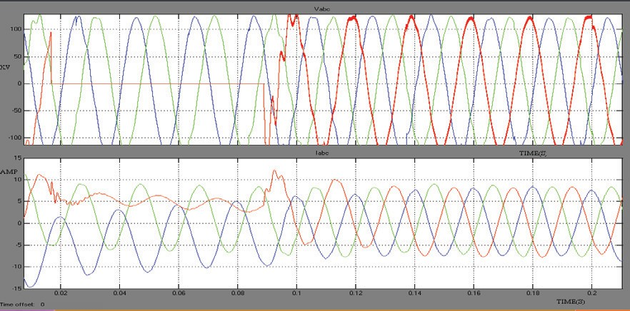

Fig.9 HVDC system when Line to Ground fault occurs on Inverter side.

In Fig 9, It is observed that a Line to Ground fault is created in the inverter side of HVDC system at time t=0.01sec. The Fuzzy controller activates and clears the fault. Before the fault a Vabc=0.36pu and Iabc=0.06pu. After the fault is cleared at t=0.09sec, the recovery is slow and there are oscillations in DC voltage and current of the magnitude 0.36pu and 0.04pu respectively.

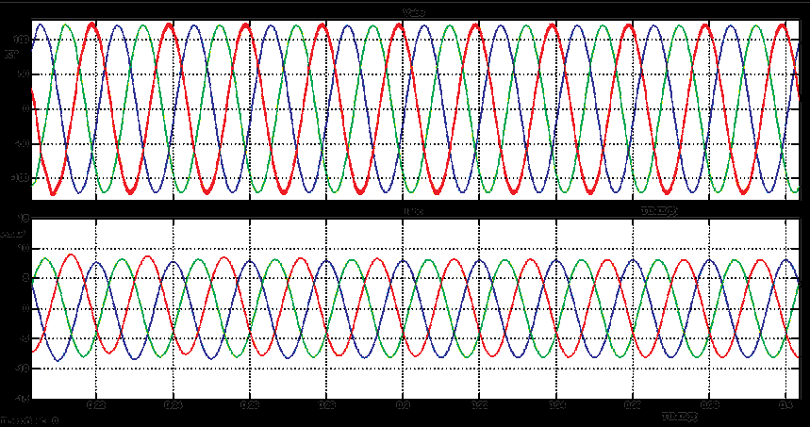

Fig .10 HVDC system with STATCOM when Line to Ground fault.

From Fig 10, It is observed that line to ground fault is created in the inverter side of HVDC system at t=0.01 sec. When these faults occur in the system, it takes more time to reach the steady state operation. The Fuzzy controller activates and clears the fault. Further, with the addition of STATCOM the system reduces oscillations and get pure sinusoidal waveform at voltage Vabc=0.36 p. u and current Iabc=0.04p.u at time t=0.3 sec.

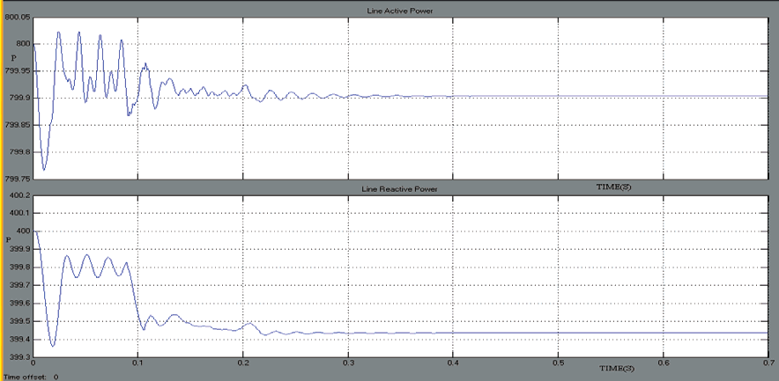

Fig .11 Active and Reactive powers of HVDC system (L-G Fault).

In Fig 11, when a fault is created at time t=0.01sec, the active and reactive power is maintained at 800KW and 400KVAR respectively from time t=0.02sec to t=0.35sec.At time t=0.35sec both active and reactive power attain stability and becomes steady state. It is observed that no power fluctuations occur in P and Q after t=0.35sec.

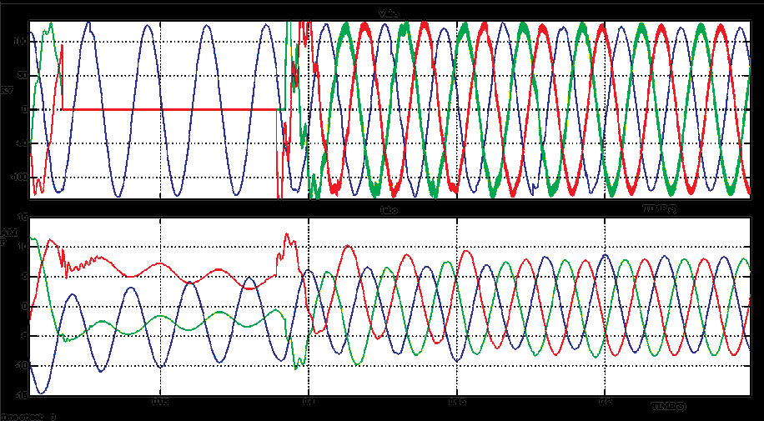

Fig. 12 HVDC system when Double Line to Ground faults.

In Fig. 12, It is observed that Double Line to Ground fault is created in the inverter side of HVDC system at time t=0.01sec. The Fuzzy controller activates and clears the fault. Before the fault a Vabc=0.36pu and Iabc=0.06pu. After the fault is cleared at t=0.09sec, the recovery is slow and there are oscillations in DC voltage and current of the magnitude 0.36pu and 0.04pu respectively.

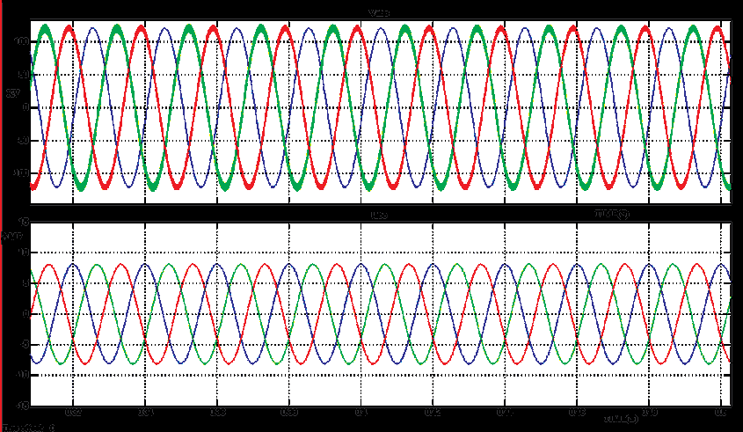

Fig .13 HVDC systems when Double Line to Ground faults with STATCOM.

From Fig 13, It is observed that Double line to ground is created in the inverter side of HVDC system at t=0.01 sec. When these faults occur in the system, it takes more time to reach the steady state operation. The Fuzzy controller activates and clears the fault. Further, with the addition of STATCOM the system reduces oscillations and get pure sinusoidal waveform at voltage Vabc=0.36 p. u and current Iabc=0.04p.u at time t=0.3 sec.

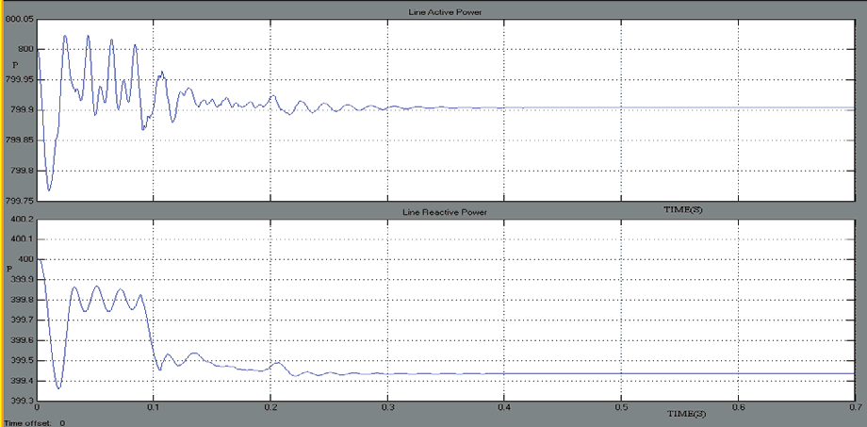

Fig. 14 Active and Reactive powers of HVDC system (LL-G Fault)

In Fig 14, when a fault is created at time t=0.01sec, the active and reactive power is maintained at 800KW and 400KVAR respectively from time t=0.02sec to t=0.35sec.At time t=0.35sec both active and reactive power attain stability and becomes steady state. It is observed that no power fluctuations occur in P and Q after t=0.35sec.

## Conclusion

According to the results, the STATCOM improves the system performance under the transient and the normal conditions. However, it can control the power flow in the transmission line, effectively. With the addition of STATCOM, the magnitude of fault current reduces and oscillations of excitation voltage also reduce. The "current margin" is essential to prevent misfire of the thyristor valves. DC filters and AC filters can not only eliminate the harmonic effects but also reduce the Total Harmonic Distortion (THD) as well. The current waveform in the case of a conventional controller has a lot of crests and dents and suffers from prolonged oscillations, whereas by using Fuzzy controller, DC current fast returns to its nominal value. The overshoot in case of the Fuzzy controller is slightly less than conventional controllers. It is more economical for the HVDC transmission system to transfer more power as the power factor is almost near to unity and the energy loss is low. STATCOM, however, has shown its flexibility in easing line congestion and promoting a more controllable flow in the lines. STATCOM will be very useful for deregulated energy market as an alternative choice for more power generation to the load area.

## References

1. Narain G. Hingorani, L. Gyugyi, "Understanding FACTS Concepts and Technology of Flexible AC Transmission Systems", IEEE Press, 2000.
2. P.K.Steimer, H. E. Gruning, J. Weminger, E.Carroll, S. Klaka, and S. Linder, "IGCT A New Emerging Technology for High Power, Low Cost Inverters", IEEE Industry Applications Magazine,pp. 12-18, July 1999.
3. P.Rao,LM. Crow, Zhiping Yang, "STATCOM Control for Power System Voltage Control Applications", IEEE Trans. On Power Delivery, Vol. 15, No. 4, pp. 1311-1317, October 2000.
4. A. Ajami, S.H. Hosseini, S. Khanmohammadi, G.B. Gharehpetian, "Voltage Stability and Reactive Power Compensation of AC Transmission System by Fuzzy controlled STATCOM", WSEAS Transactions on Circuits and Systems, Vol. 4, Issue 11, Nov. 2005.
5. N.C. Sahoo, B.K. Panigrahi, "Application of a Multivariable Feedback Linearization Scheme for

STATCOM Control", Electric Power Systems Research, pp. 81-91, 2002.

1. Timothy J. Ross, Fuzzy Logic with Engineering Applications, McGraw-Hill, 1995.
2. Hideaki Fujita, Yasuhiro Watanabe, and Hirofumi Akagi, “Control and Analysis of a Unified Power Flow Controller” IEEE Transactions on Power Electronics,Vol.14, No. 6, November 1999.

[8]. N.G. Hingorani, L. Gyugyi, "Understanding FACTS," New York: IEEE Press, pp. 2, 2000.