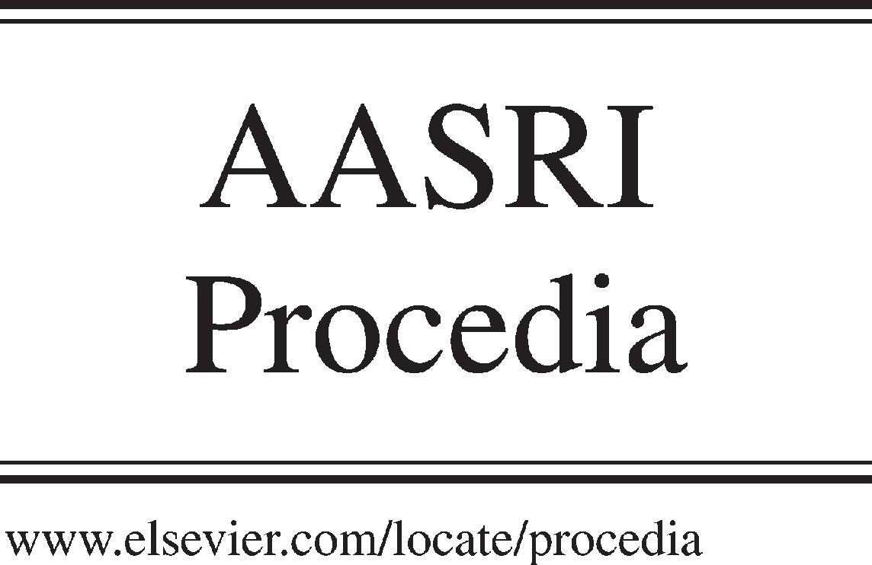Available online at [www.sciencedirect.com](http://www.sciencedirect.com/)



AASRI Procedia 3 (2012) 421 – 426

2012 AASRI Conference on Modelling, Identification and Control

Study on the Change Law of Centroid for Six-track Rescue Robot with Four Swinging Arms

Hongwei Ma  Chuanwei Wang  Zengqiang Wang

*School of Mechanical Engineering, Xi'an University of Science and Technology, Xi'an, 710054, Shaanxi, China*

**Abstract**

The centroid change equation, which is about six-track rescue robot with four swinging arms for mine emergency rescue, is solved by center of mass theory the relationship between the centroid and angle of swing arms is derived. The graphs of the robot’s centroid and the chart of the angle of the swing arms are drawn by calculation and Adams simulation, the results are agreement with each other. The rationality of the formula inference and the correctness of secondary development of Adams are verified. Then the plot of centroid changes is drown when rescue robot acrosses three steps, which provides the theoretical basis for the future study for controlling of robot’s posture and the judgment of its stability when it crosses barriers.

© 2012 The Authors. Published by Elsevier B.V. Open access under [CC BY-NC-ND license.](http://creativecommons.org/licenses/by-nc-nd/3.0/)

© 2012. Published by Elsevier B.V.

Selection and/or peer review under responsibility of American Applied Science Research Institute

Selection and/or peer review under responsibility of American Applied Science Research Institute

Keywords: Six-track rescue robot with four swinging arms; Matlab simulation calculation; Adams Secondary development; Centroid

# Preface

Virtual prototype simulation has been used in all walks of life, and Adams is the most widely used simulation software, namely Automatic Dynamic Analysis of Mechanical Systems. The system can simulate the motion of a mechanical structure and output the curves of the motion’s displacement, velocity, acceleration, torque and so on, but it cannot directly output the displacement curves of the center of mass for motion mechanism. Centroid change have a very important meaning in motion mechanism design and research. With the aid of the secondary development in Adams simulation software, the center of mass’s change curve of the motion mechanism is solved.

2212-6716 © 2012 The Authors. Published by Elsevier B.V. Open access under [CC BY-NC-ND license.](http://creativecommons.org/licenses/by-nc-nd/3.0/)

Selection and/or peer review under responsibility of American Applied Science Research Institute doi:10.1016/j.aasri.2012.11.066

Six-track rescue robot with four swinging arm designed mainly for coal mine gas explosion accident rescue[1], is required superior climbing obstacle capability and fast, stable movement ability. The four-arms can move separately, and, through controlling the angle of the swing arm to make robot keep stationarity in various conditions.

# Modeling of rescue robot’s centroid change

* 1. *Theoretical calculation of solving centroid*

Fig. 1. robot’s centroid distribution

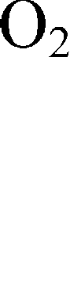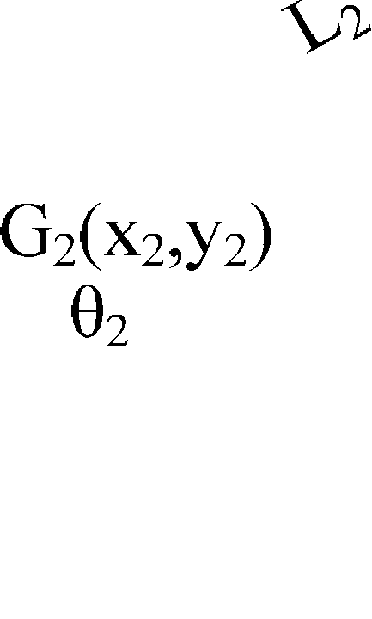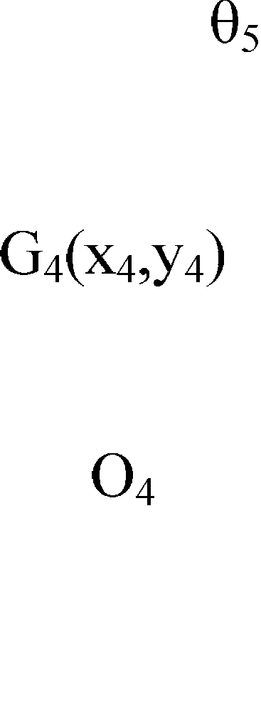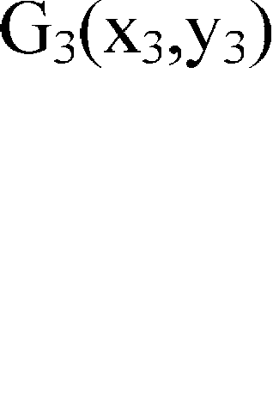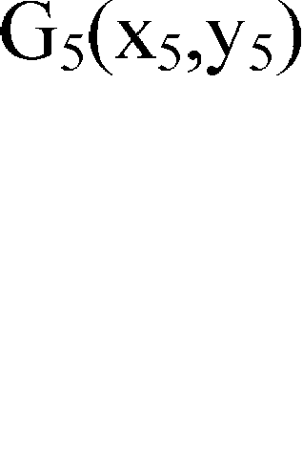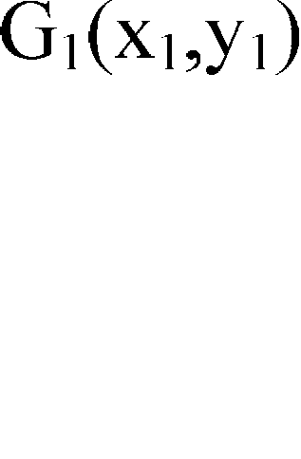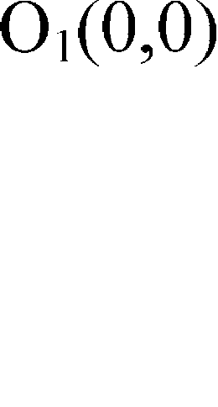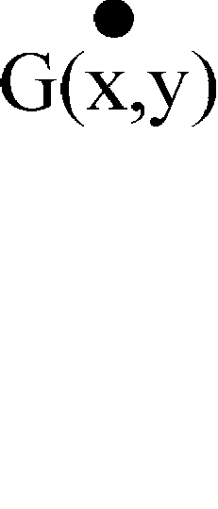

As shown in Fig.1, the origin of the coordinate system is been established on the robot’s driving wheel axis, the axial center of the driven wheel is O6, and the axial center of the four-arm wheel are respectively O2,O3,O4 and O5. Six-track rescue robot with four swinging arm can be divided into five particle, ie front left arm, front right arm, the main body, rear left swing arm, rear right swing arm, and five centroid is Gi, the quality of the i- th dot is mi, the coordinates is (xi, yi), i = 1,2,3,4,5, and the coordinates of the centroid of the entire robot is G (x, y). The distance between O1 and O6,O1 and G1,O1 and O2,O1 and O3,O6 and G4,O6 and O5 is respectively

L L1 L2 L3 L4 and L5. The angle of vehicle body and four arm with X-axis direction is

1

2 , 3 ,

4 , 5 .

Because the angle 1 of the vehicle body with X-axis direction are determined by the angle of the four

swing arms, so the angle 1 is jointly determined by the changes of 2 ,

3 , 4 ,

5 . Then make assumption that

the function of 1 is about 2 , 3 , 4 , 5 :

1 = 2 ,



3 , 4 , 5

*(1)*

Because the four swing arm’s length and quality are equal, make the assumption that:L2=L3=L4=L5=L m2=m3=m4=m5=m , then six tracked robot’s centroid formula is arranged as following:

XG 2 ,



3 , 4 , 5

*m*1 *L*1  2*m* ' *L * *Cos*

*m*1 *L*1  2*m* ' *L Sin*



2 ,

2 ,



3,

3,

4 , 5

4 , 5

5

*m* ' *L* ' 

*i* 2

*m*1  4*m* '

5

*m* ' *L* '

*Cosi*

*Sini*

*(2)*

YG 2 , 3 , 4 , 5



*i* 2

*m*1  4*m* '

In the formula, *( *2 ,

3 , 4 , 5

 [0,  / 2] *)*

* 1. *Formula inference*
     1. Under the assumption that the initial angles of the front and rear swing arms on the robot are equal and



opposite, then the robot body remains parallel to the ground( 1 =

2 , 3 ,

4 , 5

=0 )  when the four swing

arms swing upward or downward at the same time, the angle of the robot body will not be changed. Under the condition that the four swing arms swing upward or downward at the same time, the relationship between

2 , 3 , 4 ,

5 will satisfy the equation as follows, 2 3

X ,  ,  ,



4

= m1L1 +2m'L

5 ,so the formula can be written as:

G 2 3 4 5

YG 2 , 3, 4 , 5



m1 +4m' 4m'L'Sin i

=

m1 +4m'

*(3)*

It is obvious that the centroid change of robot is a straight line which is parallel to the Y axis and through the certain point ( (m1L1 +2m'L) / (m1 +4m') 0), the change of value in the Y direction coordinate is a

sinusoidal relationship with 2 ,

3 , 4 ,

5 .On the condition that 2 =

3 = 4 =

5 =/2 , the maximum value of robot

centroid in the Y direction will be acquired.

* + 1. Assuming that the four swing arms of the robot with three ground-contacting stationary, while the left one is dangling and can swing freely. With out touching the ground, the equation can be a function about an independent variable *r i* , and *r i* is a fixed value, the equation is as follows shown: [2]

XG =

i

YG =

i

m1L1 +2m'L  Cos

m1L1 +2m'L Sin

5

1 +m'L' Cos

r=2

r i

m1 +4m'

5

1 +m'L' Sin

r=2

r i

m1 +4m'

r +m'L'Cos i

r +m'L'Sin i

*(4)*

Because formula is long, for the convenience of writing, so:

5 5

*m*1 *L*1

 2*m* ' *L * *Cos*1  *m* ' *L* '

*r* 2

*r i*

*m*1  4*m* '

*Cosr*

*m*1 *L*1

*a* ;

*r i*

 2*m* ' *L * *Sin*1  *m* ' *L* '

*r* 2

*m*1  4*m* '

*Sinr*

*m* ' *L* '

*b* ; *c* ;

*m*1  4*m* '

Finishing the formula for:

X -a + Y -b =c2

i

i

2 2

0,  / 2 , *i*

 2, 3, 4, 5

*(5)*

G G *i*

It can be seen from the formula that the coordinate value in the X direction of the robot’s centroid is a cosine relationship about the swing arm angle *i* , while the value in the Y direction is a sinusoid relationship about the swing arm angle *i* . The centroid curve of XG and YG is a circular arc based on (a, b)as the center, c is the radius of the arc.

# Simulate and analyze of the centroid changes

* 1. *Adams secondary development*

Adams has a strong secondary development function. There are two main forms of cycle command: for/End and while/End. For/End command is mainly adopted in this article. Adams conditional loop commands are adopted to redact codes and establish .CMD file through a text editor. The file will be done according to the program flow diagram (Fig.2), and then open the motion mechanism which requires solving the centroid from the Adams simulation software. At last, carrying out the kinematic simulation of virtual prototype, the centroid displacement curve can be plotted in the Adams /Postprocessor.

Fig.2. program flow chart

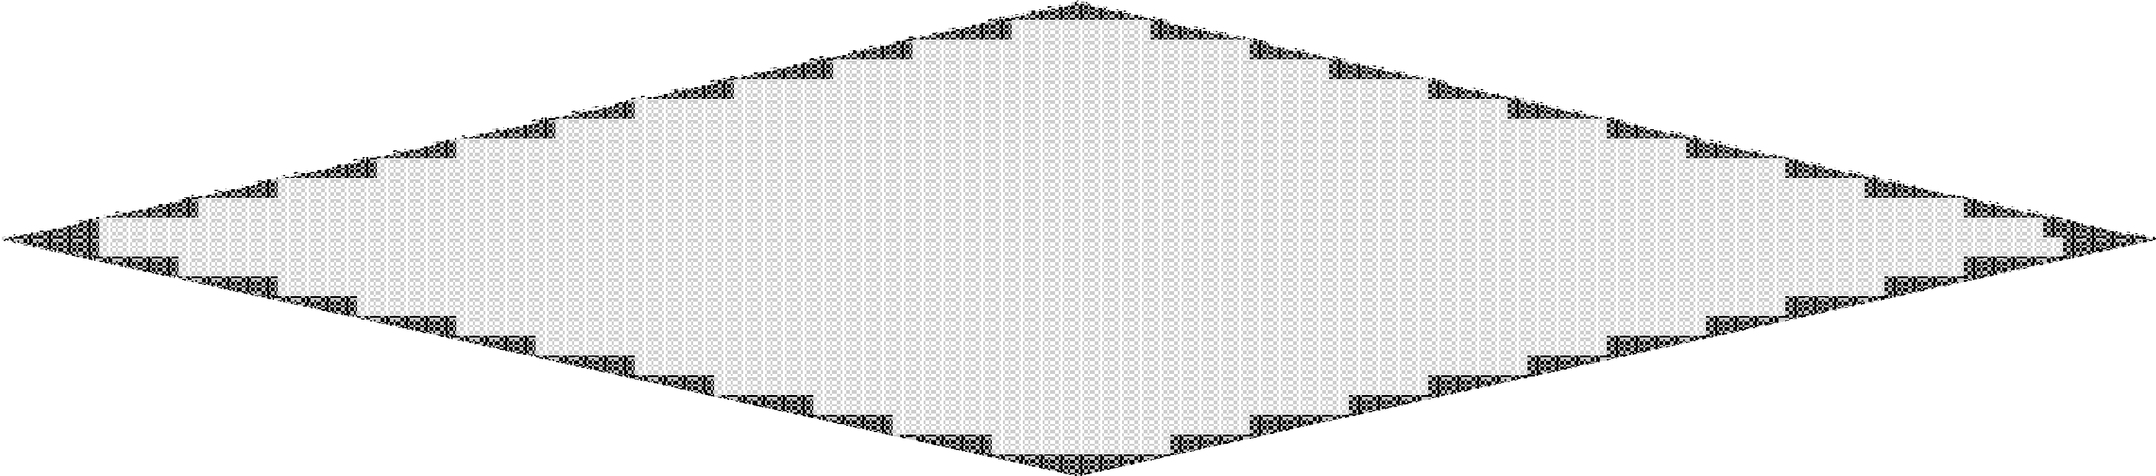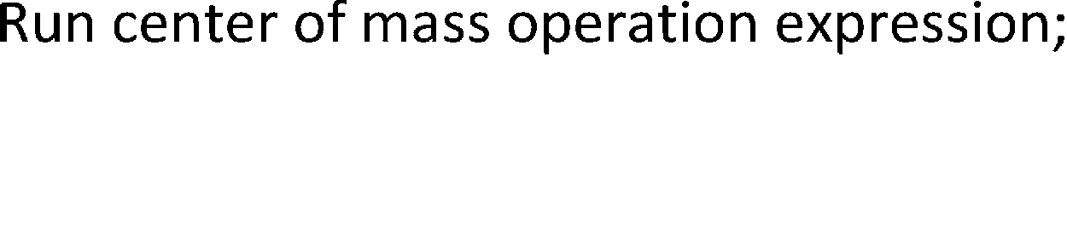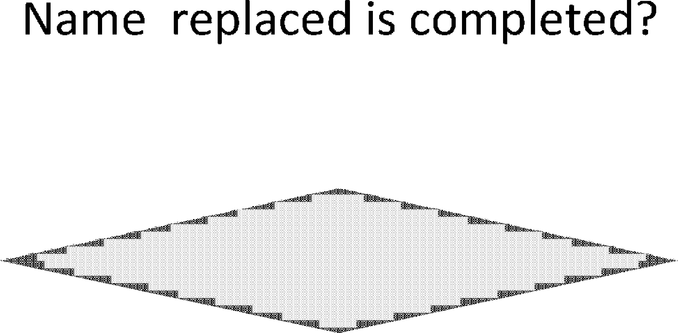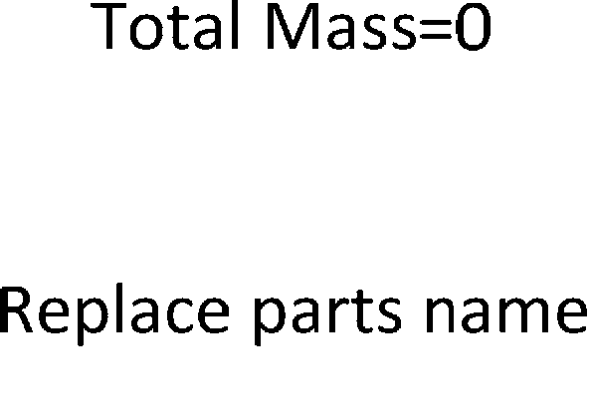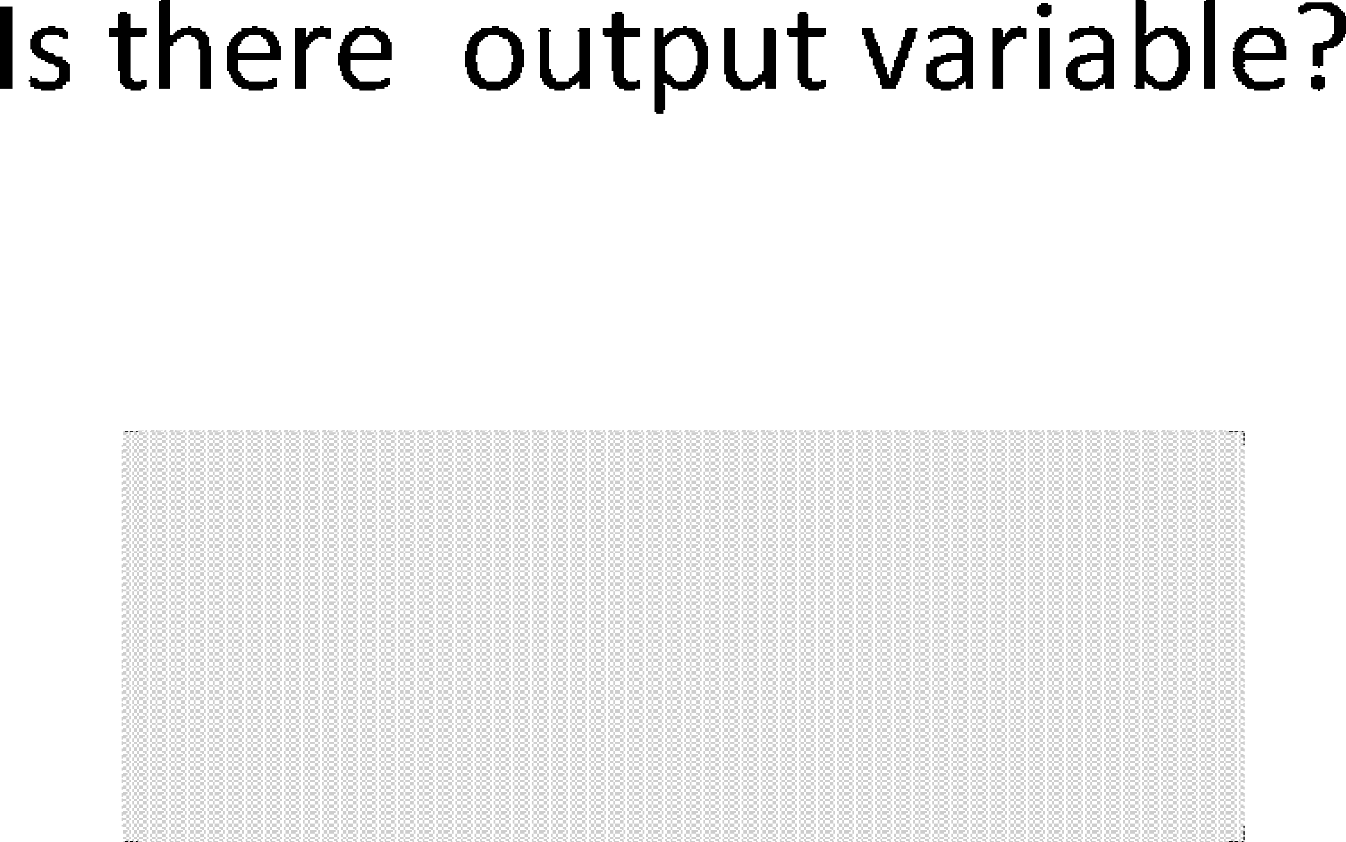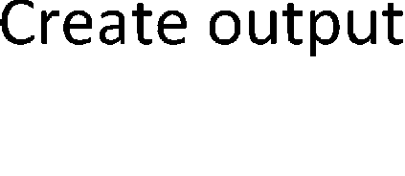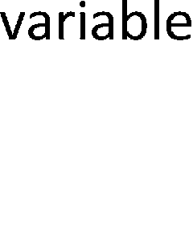

* 1. *Matlab simulation calculation and ADAMS virtual simulation*

In the Matlab simulation calculation, each parameter of the rescue robot will be brought into the formula (3) and (4). The robot main body mass is m1=80.12Kg, swing arm mass is 1.97Kg, L=498mm L’=177mm. The curve is draw by using Matlab, and it is shown in (a) and (c) of Fig.3. The dynamics model is established for the six-track rescue robot with four swinging arms according to the requirements of simulation in Adams, then the appropriate software environment and parameters are been set , posture of robot is been adjusted.

The graphs, showing the relationship between the centroid change of rescue robot and the change of swing arm angle of the four swing arms, are been drawn through Adams/Solve. The simulation results are been shown in the (b) and (d) of Fig.3.

Various parameters of the robot are used in the Matlab simulation calculation, the curve of the centroid change compared to that gotten through the use of Adams simulation software, which establish a three- dimensional simulation model. The analysis results are shown in Fig.3. In the two special circumstances of hypothesis, the simulation experiment is consistent with theoretical calculations, so it is verify the rationality of centroid curve formula and the correctness of Adams secondary development, which measure the centroid

position of a motion mechanism. The numerical errors are caused by the inaccurate value of mass and the coordinate of centroid in theoretical analysis, while the each parameter of robot can be calculated exactly in the process of Adams simulation, and the precision is higher.

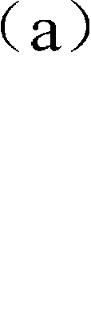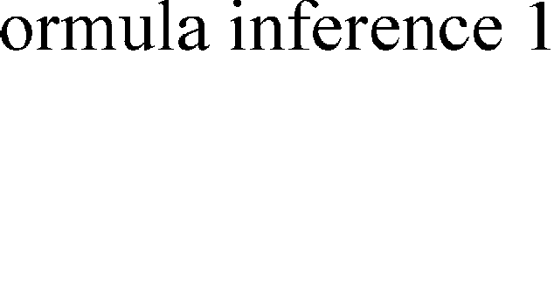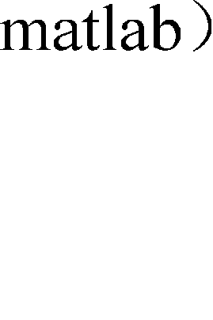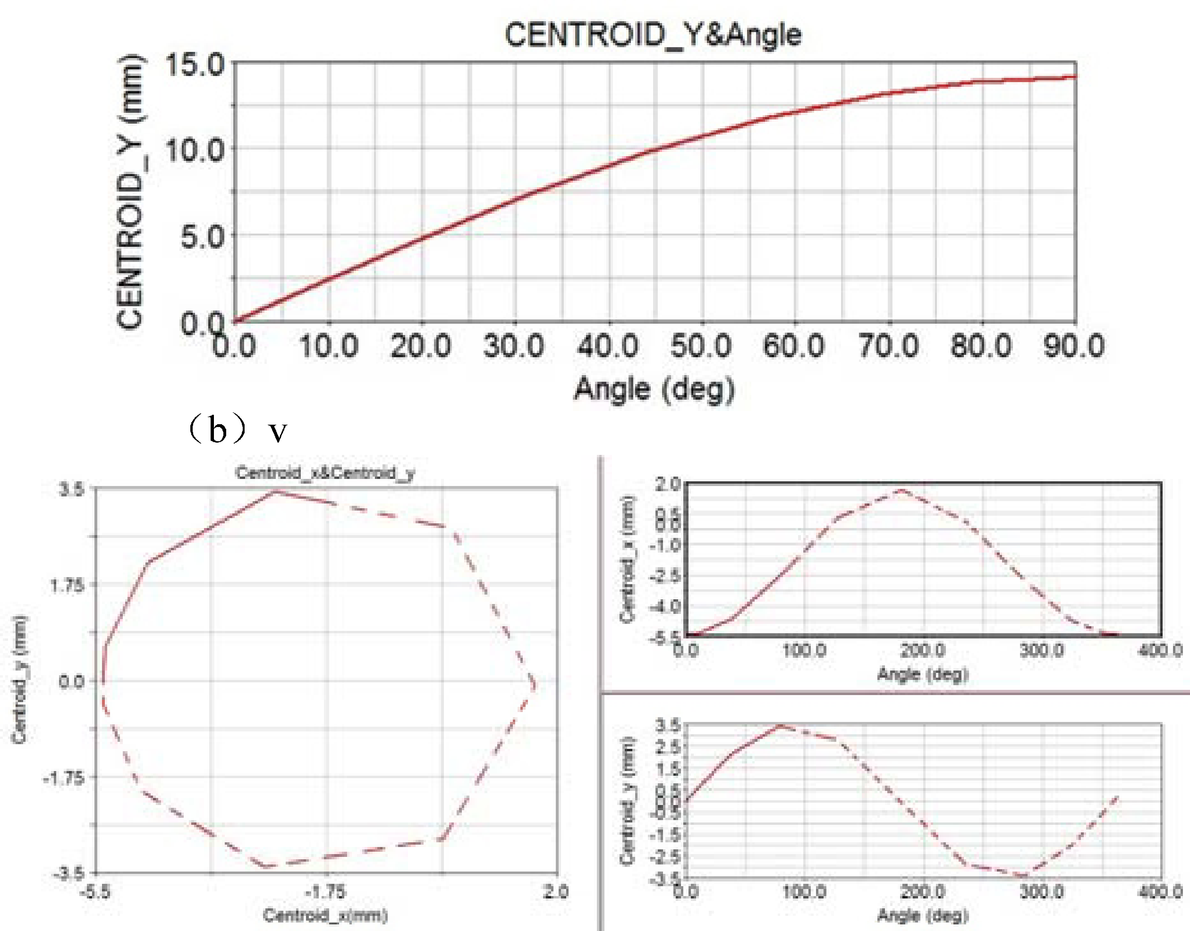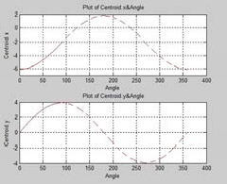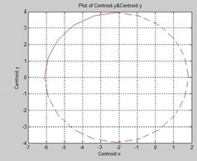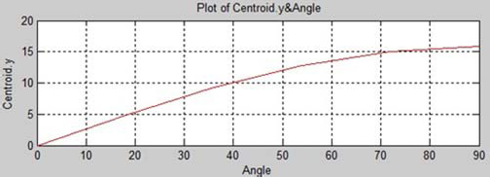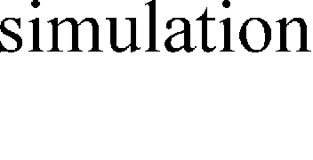

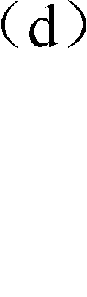Fig.3. the diagram of centroid change with the swing arms swing

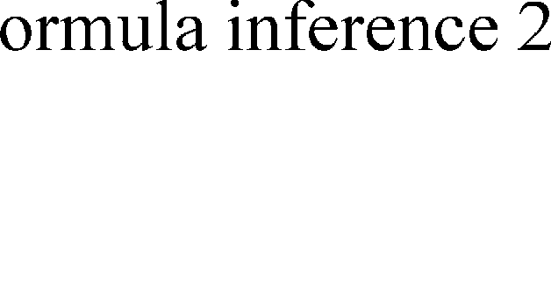

* 1. *The research and analysis of the centroid change theory in the process of robot crosses barrier*

Fig.4. The graph of centroid when the robot climbs three-step

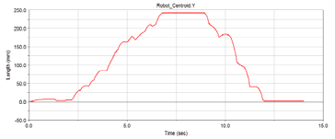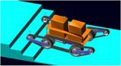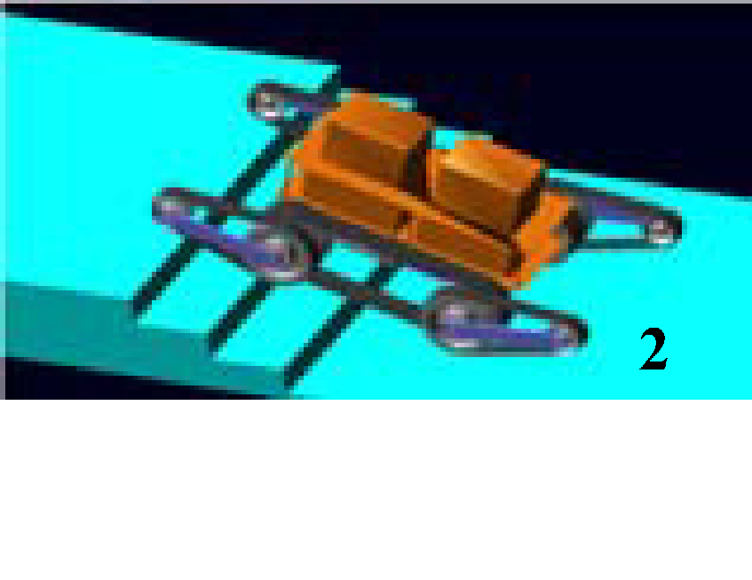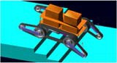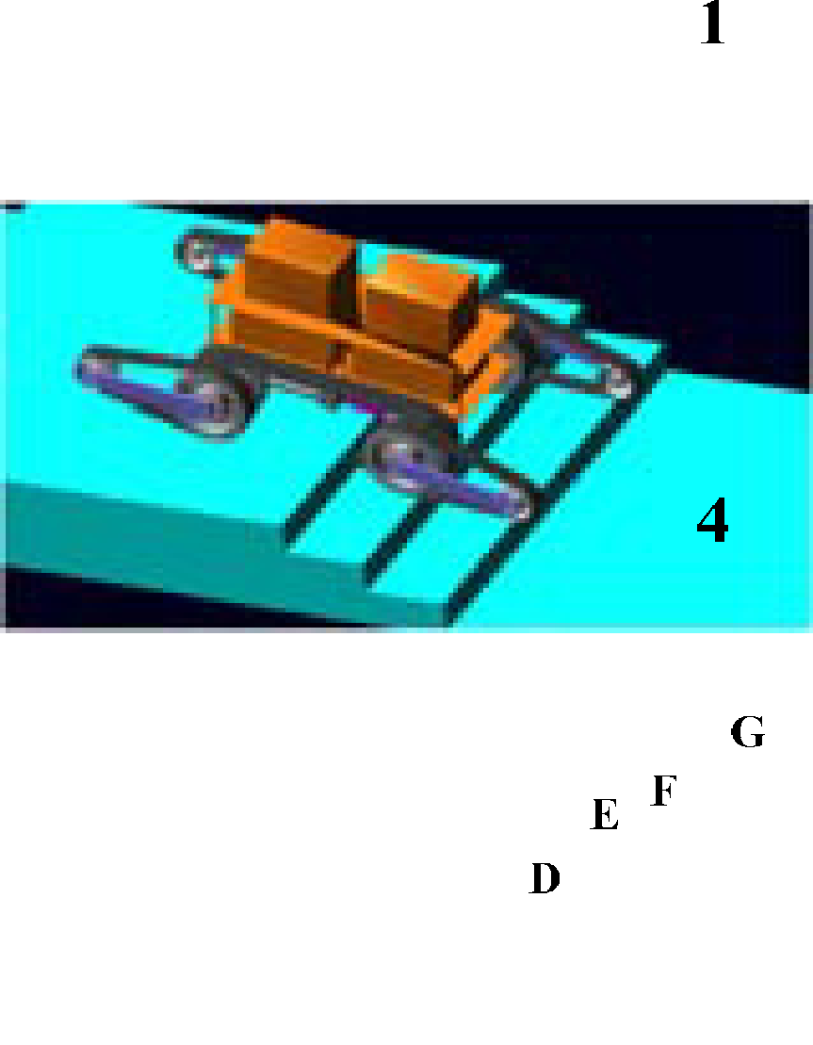

Six-track rescue robot with four swinging arms is designed for the environment which is more complex and uncertain. In order to adjust the rescue plan timely, the people who control the robot can track the robot and learn about working condition through the centroid curve of the robot. To take robot climb stairs as an example, it can be seen that the centroid changes over time about points of A B C D E F in Fig.4. At the very beginning, the four swing arms of robot are parallel to the ground, A, B are the point that the front swing arms contact with the first and second steps. C is the contact point between the driving wheel and the first step, D is the contact point of the front arm and the third step, E is the contact point of the driving wheel

and the second step, EF is the phase of rear swing arms adjusting the posture to support the robot up, FG is the phase of driven wheel climbing the second step, GH is the phase of driven wheel climbing the second step, after the H-point, the phase is the process of robot climbing the third step and downing stairs successfully.

# Conclusion

In this paper, the centroid change of six-track rescue robot with four swinging arms has been analyzed by means of center of mass theory. The relationship between centroid curve and the angle of swing arm are been reasoned analysed. And then, the relationship is verified by the simulation software. At last, the main conclusions are as follows:

1. The four swing arms have the same initial angle, and when they swing at the same time and the same direction, the coordinate value in the Y direction of the robot’s centroid is a sinusoid relationship about the swing arm angle, while the value in the X direction of the robot’s centroid is irrelevant to the swing angle.
2. The three of four swing arms are fixed to the ground, and the other one is dangling and can freely swing but it don’t contact the ground, the centroid YG can get the relationship of sinusoid function with the swing angle, and the centroid XG can get the relationship of cosine function with the swing angle. Meanwhile the centroid XG and YG are the arc curves.
3. Via secondary development, the problem that the centroid change for motion mechanism can’t be drawn is successfully be solved. This method can not only settle the problem on centroid change of the moving robot based on Adams simulation, but also can be applied to other researches on kinematics simulation with complex structure.

# Acknowledgements

This study was supported by National Natural Science Foundation of China (Grant No. 50674075) .

# References

1. Wei Juan, Jia Guangli, Ma Hongwei. Simulation Analysis of the Virtual Prototyping of a Mine Rescue Robot[J]. Mechanical Science and Technology. November 2008.
2. Li Yunwang, Ge Shirong, Zhu Hua etc. Obstacle-surmounting Mechanism and Capability of Four-track Robot with Two Swing Arms[J]. ROBOT, The 32nd(2) in March 2010.
3. Chen Shuyan, Chen Wenjia. Secondary development of tracked vehicle modeling based on ADAMS[J]. Machinery design and manufacture, October 2008.
4. Ma Peng, Fu Maohai, Xiang yang ETC. Vehicle End Connection Installment Relative Position Simulating Platform Based on ADAMS/Rail Redevelopment [J]. Electric Drive for Locomotives. July 2011.
5. Chen Liping, Zhang Yunqing, Ren Weiqun.etc. Mechanical system dynamics analysis and ADAMS application tutorial[M]. Beijing: Tsinghua University Press,2005:313-364
6. Li Jun, Xing Junwen. ADAMS tutorial examples[M]. Beijing: Beijing Institute of Technology Press, July 2002.
7. Xing Junwen, Tao Yongzhong. MSC. ADAMS/View advanced training tutorial[M]. Beijing: Tsinghua University Press,2004