Available online at [www.sciencedirect.com](http://www.sciencedirect.com/)

**ScienceDirect**

AASRI Procedia 5 (2013) 274 – 280

2013 AASRI Conference on Parallel and Distributed Computing and Systems

The Analysis for Small-World Network's Evolution Based on Network Entropy

Liangxun Shuo, Yiying Chen, Zexin Zhang and Wenbin Li*

*Information & Network Security lab, Shijiazhuang University of Economics, Shijiazhuang, Hebei 050031, China*

**Abstract**

In modeling algorithms of Scale-free or Small-World network, the modification for nodes denotes the metabolism of the system components, and the change for edges represents the metabolism of the system structure. Due the modifications of nodes and edges, network structure as well as the network's entropy is changed. Therefore, the entropy of the network is used to depict the metabolic processes of the system in this paper Based on the network entropy, the WS model is analyzed. The conclusions are that firstly the change of network entropy of WS network is U-shaped. Secondly, under the same conditions, the value of p affects the rate of decrease and increase in the entropy's graphic. And, K decides the timing of change from drop to rising.

© 2013 The Authors. Published by Elsevier B.V. Open access under [CC BY-NC-ND license.](http://creativecommons.org/licenses/by-nc-nd/3.0/)

© 2013 Liangxun Shou, YiYing Chen, Zexin Zhang and Wenb[in Li. Published](http://creativecommons.org/licenses/by-nc-nd/3.0/) by Elsevier B.V. Selection and/or peer review under responsibility of American Applied Science Research Institute

Selection and/or peer review under responsibility of American Applied Science Research Institute

*Keywords:* complex network; entropy; WS model

# Introduction

Two articles were published in "Nature" and "Science" in 1998 and 1999 were considered to be the pioneering work of small-world networks [1] and scale-free network [2]. Since then, the empirical research of

* Wenbin Li. Tel.: +86-0311-87207591; fax: +86-0311-87208591.

*E-mail address:* [mr.liwb@gmail.com.](mailto:mr.liwb@gmail.com)

2212-6716 © 2013 The Authors. Published by Elsevier B.V. Open access under [CC BY-NC-ND license.](http://creativecommons.org/licenses/by-nc-nd/3.0/) Selection and/or peer review under responsibility of American Applied Science Research Institute doi:10.1016/j.aasri.2013.10.089

the structural characteristics of the different networks and a variety of network modeling algorithms have been released, causing the boom of the complex network research.

At present, the study of complex networks mainly focus in three areas [3]: evolution of model of network, the stability of complex networks, complex network dynamics. The creation of complex network refers to the network formation process. The creating algorithm is called as an evolution model of complex network. In recent years, this area is the most active research one. Studies in this area are mainly focused on: rules of network formation mechanisms, generation mechanism and model of random map, generation mechanism and model of small-world network, generation mechanism and model of scale-free network, formation mechanism of evolution network and formation mechanism of deterministic network and so on. Although the results in this area is quite rich, but there are still some problems [3]: further studies on new mechanism of small-world effects is needed, random network model with a recognized three statistical properties of the real system is lack; ***the understanding of the analytical method of the evolution network topology still need to explore***; the models considering the dynamics and other factors are less; the formation mechanisms of power-law of specific networks in real life still need in-depth research.

This work focuses on exploring the formation mechanism of WS small-world network to understand the classical evolutionary algorithm. Based on graph entropy, features of the generated network by WS model are analyzed. On one hand, for researchers, the methods and conclusions of this paper are useful for further solving the problem in the field of modeling complex networks. On the other hand, it provides a new vision for proposing new models of complex network. In our opinion, this is a new attempt.

# Network Entropy and the Analysis for WS Model

From the network point of view, the generation and evolution of the system can be summarized into two aspects: the first is node changes; the second is the connection changes [4]. The former represents the metabolism of the system components; the latter is on behalf of the metabolism of the system structure.Naturally, we wonder how the entropy changes in the metabolic processes of the system. Is it increase, decrease, cyclically or irregularly change? Only have a full understanding of the metabolic, "control" is possible on the system. This "control" is reflected in the design of more realistic network model. The WS, NW [5], BA model (or other model), due to changes in the node or edge of the network, the entropy of the network changes with structure is changing. Therefore, the use of the network entropy depicts the system of metabolic processes is a natural thing.

* 1. *Network Entropy*

Suppose that there exists multipl*n*e events in a system *S*, denoted by *S* = {*E*1,...,*En*}, the probability of

occurrence of the event *Ei* is *pi*, and  *pi*

*i *1

*I E * log*b pi*

*i*

 1, then the amount of *Ei*'s information is

*(1)*

Where, *b* is 2 or the natural constant *e*.

It is not difficult to see from *e.q.*(1), the amount of information carried by smaller probability events is more than that carried by higher probability events.

Entropy is defined as the average amount of information of the entire system *S*, namely:

*n*

*Hs * *pi IE i*1

*i*

*n*

 *pi* log*b pi*

*i*1

*(2)*

The entropy reflects the ordering degree of a system. Entropy is larger; the system is more disorder. It is not difficult to know, when all the probability is equal, the entropy obtain the maximum. When *p*i = 0 (*i* = 1, ..., *n*), the entropy gets minimum value 0, that is, *Hs*> = 0.

A complex network with *N* nodes (*i.e*, *S*), whose network entropy is defined and normalized as:

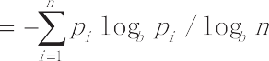*(3)*

where, *pi* is defined as *pi*

*n*

*di* /  *di i*1

*di* denotes the degree of the *i*th node.

* 1. *The Analysis Algorithms Based on Network Entropy*

For analyzing the WS model [1], Algorithm 1 is proposed. In the process of network evolution, the network entropy is constantly changing. One by one, algorithm 1 will record the network entropy generated in the process. The trend of the network entropy reflects the change of entropy experienced by the WS model in its generation process. According to the changed of the network entropy, the characteristics of the WS model can be analyzed, and thus we can improve or even propose a new model.

The linked list defined in Line 1 of Algorithm 1 is used to record the network entropy computed in each iteration. Line 3 is used to select the edge *e* to be re-connected. When the condition (*i.e.*, 1-*p* <= *p* ') in line 5 is satisfied, then *e* will be connected (see lines 6~9). 1-*p* is greater, then *p* is smaller. And the possibility of *p*' fall on the shadow area is smaller. In other words, the execution possibility of the IF statement is smaller under smaller *p.* It means that the likely of re-connection of *e* is less. Conversely, the smaller 1-*p* results the greater likelihood of reconnection of *e*. Every reconnection means that the network entropy changes. After the edge is re-connected, the network entropy of the "new" network will be calculated (see line 11). The entropy of the network just got will be saved to the linked list (see line 12). The network entropies recorded in the linked list clearly reflect the metabolic trend during the formation of the system.

**Algorithm 1.** The analysis algorithm for the WS model based on network entropy

**Input**: A nearest-neighbor coupled network consisting of *N* nodes arranged in a ring, where each node *i* is adjacent to its neighbor nodes, *i* = 1, 2,..., *K*/2, with *K* being even. Here, *K* = 2*k* (1

<= *k* <= *N*/2).

**Ouput**: link list of network entropy

**Process**:

* + 1. Initialized a link list *L* of network entropy;

//*i* denotes the *i*th edge in the network

* + 1. FOR(*i* = 1; *i* <= *N*\**k*; ++*i*)
    2. To select the *i*th edge (denoted as *e*), suppose that its two nodes respectively are: *ei*0, *ei*1;
    3. To generate a random number *p*' in the range (0, 1];

5. IF(1-*p* < *p*') THEN //randomly rewire each edge of the network with probability *p*

1. Randomly select a node of *e,* suppose it is *ei*0;
2. //*P* represents the set of all nodes
3. Randomly select a node in *P* (suppose it is *e'i*1), *e'i*1 can not previously connect with *ei*0;
4. To connect *ei*0 with *e'i*1;
5. To delete *e*;
6. To compute the network entropy of current small-world network;

12. To add above network entropy to the link list *L*;

* 1. *Experimental Results and Analysis*

In this paper, we conducted a series of experiments on the WS model based on the Algorithm 1; aim to reveal the impact of main parameters on the structure. At the same time, based on the variation of the network entropy, the WS model is analyzed. We mainly consider various combinations of *n*, *K* and *p*.

**Experiment I.** It includes nine small experiments. In the nine experiments, *n* is fixed at 100, *K* and *p* individually has three varied values. Specifically, *k* respectively set to 2, 8 or 40, and *p* = 0.1, 0.5 or 0.9. Fig. 1 (a)-(d) shows the results of the nine experiments.

It is not difficult to draw the following conclusions from this figure: 1) Overall, in the early stage of modeling, the network entropy shows a downward trend. However, it renders upward trend in the late. Overall, the changes are in U-shape. 2) In the case with same *n* and *K*, greater *p* makes the point that the network entropy converts from decrease to increase fell into more front. 3) With appropriate parameters, the entropy will finally be close to the initial level when the network evolves to a certain extent. 4) When the number of iterations and the *p* value are set to enough large, the entropy shows downward trend to a rising trend while the algorithm complete about half iterations. 5) For a particular *n*, *p*, *K*, in the latter phase of evolution, the network entropy goes back to a larger value, indicating that the network becomes more regular again (*i.e.*, the degree of each node becomes more uniform again). We explain this phenomenon as: by re-shuffling (edge reconnection), the network from the initial rules to the new rules. That is the nearest neighbor coupling network evolves to another one.

Fig. 1(c) shows the red curve (on behalf of *K* = 40, *n* = 100, *p* = 0.1 Experimental results) appear to be a straight line. For this reason, we separately presented the experimental results in Fig. 1(d). Observed from Fig. 1(d), the change in network entropy of this experiment is obvious.

**Experiment II:** It also includes 9 small experiments. In the nine experiments, *n* is fixed at 1000, *K* is respectively set to 4, 20 or 100. Compared to the experiment I, the value of *n* in this experiment becomes larger; correspondingly, *K* becomes large too. The setting of *p* is same with the experiment I. Fig. 1(e)-(i) shows the results of the experiment II. These results again confirm the conclusion of the experiment I. This is to say, overall, the trends of the network entropy is irrelevant to *n*, *K* and *p*. The figures obeys the U-shaped law (*i.e.*, from the drop to rise, and finally to the stability). Similarly, in order to more clearly show the result of the experiment with *K* = 100, *n* = 1000, *p* = 0.1, Fig. 1(i) is given.

**Experiment III:** It includes three small experiments. In these experiments, *n* is fixed at a large value 10000, and *K* is fixed to a small value 4. Respectively, *p* = 0.1, 0.5 or 0.9. In these 3 small experiments, it was found that when *n* is large enough, the overall trend of the network entropy is same with the first two experiments.

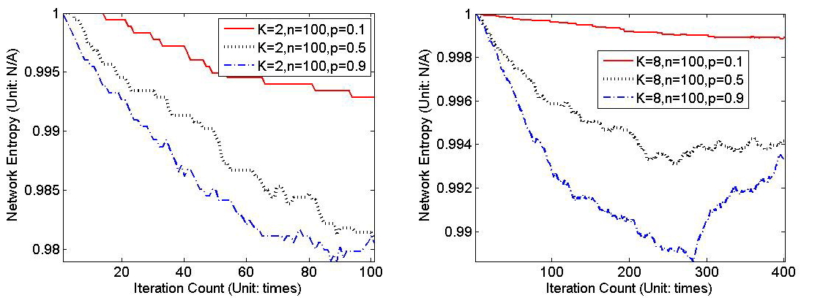

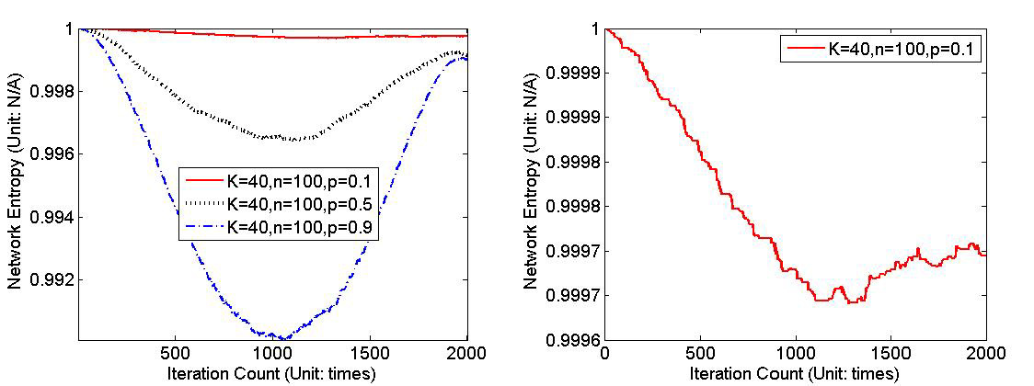(a) (b)

(c) (d)

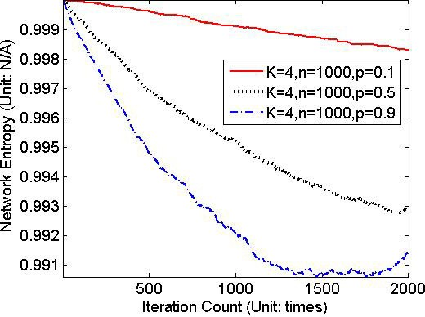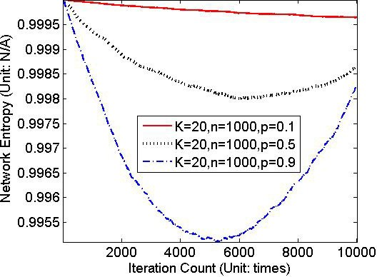

(e) (f)

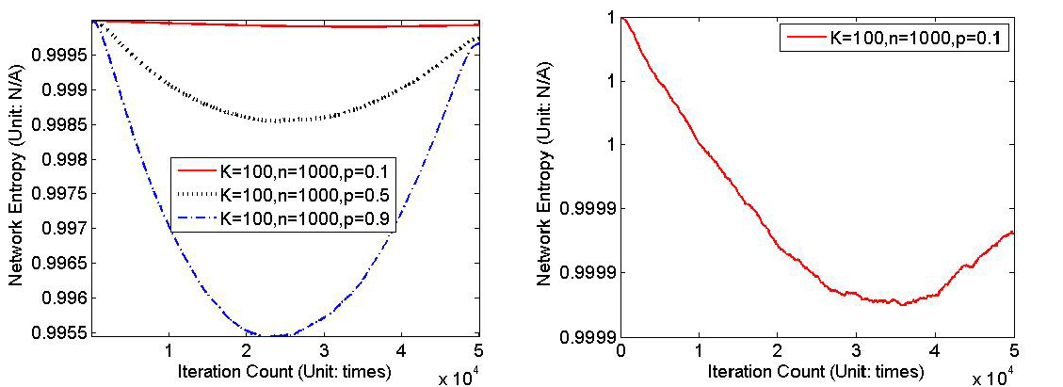

(h) (i)

Fig. 1. Network entropy trend in Experiments

The conclusions drawn from the above results are as follows. 1) Under the same conditions, the *p*-value affects the flat degree of entropy. Specifically, *p* is larger; the graph of the network entropy is steeper. Conversely, it is more flat. 2) Under the same conditions, the *K*-value affects the timing dropped into the rising. Specifically, *K* is larger; the timing goes to more frontward. Conversely, it is more rearward.

Mentioned earlier, the WS network is built by "re-connecting edges" of a rule network given in advance. Accord to this, the reasons for the above conclusions can be surmised as follows. 1) Under the same conditions, greater *p* means greater probability of re-connecting the selected edge. The count of re-connected edges has greater potential impact on network entropy. Necessarily, this makes the change trend of network entropy is more obvious. 2) Under the same conditions, for one node, bigger *K* bigger means that there are more other nodes connecting to it. Further, the edges in the network are more. On the whole, more reconnection will occur. As a result, it more likely causes network entropy change. This is bound to make evident change of the network entropy. The network entropy change is gentler, the timing from down to rise will inevitably postpone.

# Conclusions

This paper analyzes the small-world network modeling algorithm. Based on network entropy, it studies the trend of network entropy in the process of the establishment of WS networks. For the WS model, *p* and *K* have some impact on its network entropy. Overall, the trend of the network entropy of the WS model shows U-shaped. Further research includes: how the trend of the network entropy of scale-free networks is? From the perspective of the network entropy, we are going to consider designing a new modeling algorithm of small- world networks.

# References

1. D.J. Watts , S.H. Strogatz. Collective dynamics of small-world networks. Nature 393, 1998: 440-442.
2. A. L. Barabasi, R.Albert and H. Jeong. Mean-field theory for scale-free random networks, Physica A 272, 1999: 173-187.
3. Z. Z. Zhang. Complex network evolution model. Doctoral Dissertation of Dalian University of Technology, 2006. (in Chinese)
4. D. S. Miao. The System Science University Speech. Renmin University of China Press, Beijing, 2007.
5. T. C. He. Complex network model. Economic market. 2007, (2): 81-85. (in Chinese)
6. X.F. Wang, X. Li, R. Chen. Complex network theory and application, Tsinghua University Press, Beijing, 2006. (in Chinese)
7. M. E. J. Newman, D. J. Watts. Renormalization group analysis of the small-world network model, Phys. Lett. A 263, 1999: 341-346.
8. A. Barrat, M. Weigt. On the properities of small world networks, Europ. Phys. J. B 13, 2000:547.
9. M. E. J. Newman. The structure and function of complex networks. SIAM review, 2003, 45:167-256.