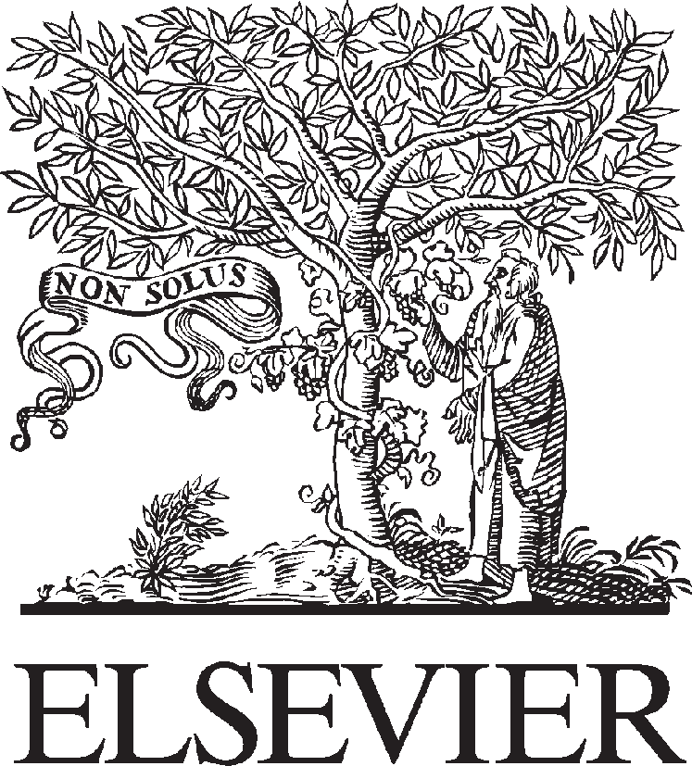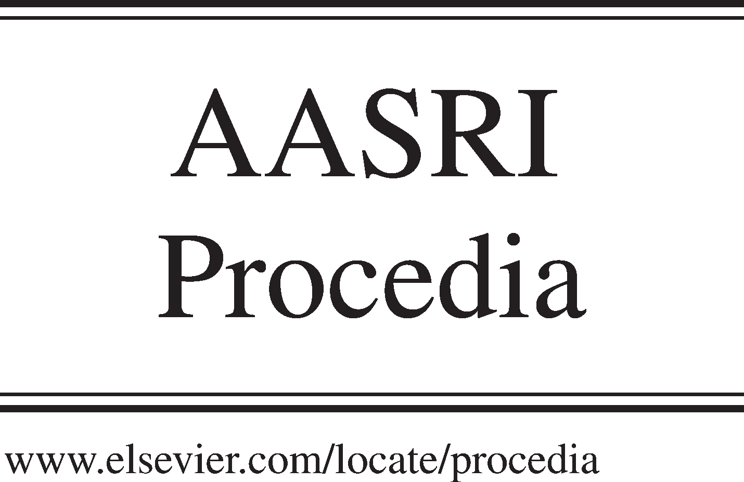Available online at [www.sciencedirect.com](http://www.sciencedirect.com/)



**ScienceDirect**

AASRI Procedia 7 (2014) 3 – 7

2013 2nd AASRI Conference on Power and Energy Systems

The Co-Cracking Experiment and Application Route of Waste Plastics and Heavy Oil

Shikui Wua*, Kaixiong Xua,b, Lusen Jianga, Li Wanga

*aGuangdong University of Petrochemical Technology, Guangdong province, Maoming 525000, China;*

*bLiaoning Shihua University, Liaoning province, Fushun 113000, China*

**Abstract**

The co-cracking experiment of waste plastics and heavy oil was done in the condition of 400 ? and pressure not higher than 2.0 MPa. The experimental results showed that the yield of heavy oil and coke decreased but the light oil and gas yield increased with the increasing amount of waste plastics. The products of heavy oil’s solidifying point, flash point, viscosity and density decreased and had a good pour point depression effect. Heavy oil containing heat conduction oil and solvent contributed to heat transfer, melting and transport and had the effect of dissolution and co-cracking. It would have a good prospect when the co-cracking of waste plastics and heavy oil was applied to the combination processes of visbreaking and delayed coking and catalytic cracking and delayed coking.

© 2014 The Authors. Published by Elsevier B. V. This is an open access article under the CC BY-NC-ND license ([http://creativecommons.org/licenses/by-nc-nd/3.0/).](http://creativecommons.org/licenses/by-nc-nd/3.0/))

© 2013 Published by Elsevier B.V.

Selection and/or peer review under responsibility of American Applied Science Research Institute

Peer-review under responsibility of Scientific Committee of American Applied Science Research Institute

*Keywords:* Waste plastics; heavy oil; co-cracking; application

# Introduction

Waste plastics have become a great public hazard of society because of polluting environment seriously. In order to protect the environment, all countries in the world began to make the law to solve the threat to human survival environmental problem, and try to recycle waste plastics. The current treatment methods of waste plastics mainly included landfill, incineration and recycling. Recycling can be divided into two categories. One is mechanical (physical) cycle that waste plastics were used as a plastic raw material to produce similar products or lower quality products. The other one is feeding (chemical) cycle that waste plastics were cracked into chemical raw materials or fuels through chemical reactions. Waste plastics cracking into liquid fuels

2212-6716 © 2014 The Authors. Published by Elsevier B. V. This is an open access article under the CC BY-NC-ND license ([http://creativecommons.org/licenses/by-nc-nd/3.0/).](http://creativecommons.org/licenses/by-nc-nd/3.0/))

Peer-review under responsibility of Scientific Committee of American Applied Science Research Institute doi:10.1016/j.aasri.2014.05.020

(gasoline, diesel oil, etc.) or chemical raw materials can not only effectively solve the problem of white pollution, but also can alleviate the energy shortage to a certain extent. Recycling of waste plastics is expected to become the most effective way. Waste plastics’ recycling, regenerating and utilizing have become a hot spot of research at home and abroad and gradually formed a new industry [1].

Fund project: Natural Science Foundation of Guangdong University of Petrochemical Technology

* Corresponding author. Tel.: 0668-2923553, E-mail address: [wsk65@139.com.](mailto:wsk65@139.com)

Cracking processes of waste plastics mainly included thermal cracking, catalytic thermal cracking, thermal cracking--catalytic modification. Waste plastics’ cracking was easy to coke and poor efficiency of cracking because of its poorer heat-conducting property. And plastics containing filling agent also had a great influence on the cracking process. Therefore, the effective research work have been carried out at home, such as the effective thermal conductivity, cracking characteristics and special reactor’s design of waste plastics’ cracking. And the co-cracking of mixture large organic molecules such as waste plastics and waste lubricating oil has also been studied [2-6].

Heavy oils such as waste lubricating oil were selected to mix with waste plastics’ cracking because heavy oils containing the heat conduction oil and solvent could contribute to heat transfer, melting, transport and had the effect of dissolution and co-cracking.

# Experiment part

* 1. *Raw materials*

Heavy oils (From maoming petrochemical company) Waste plastics (Used plastic bags and plastic packing)

* 1. *Experimental unit*

The experimental unit of cracking was made up of the reaction kettle and cooling receivers of oil and gas (as shown in Fig. 1). The customized reaction kettle was designed to be the volume of 2 L, the working temperature of 530? and the pressure of 3MPa by Weihai Kunchang chemical machinery company.

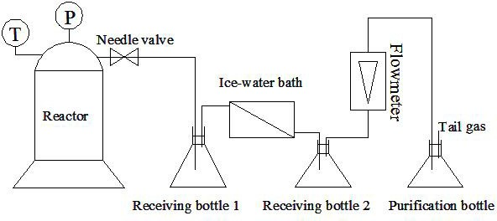

Fig. 1 The thermal cracking experimental device of heavy oil

* 1. *Experimental research*

Add 800 g heavy oil to the high pressure reaction kettle and the temperature was heated to about 110 ? and gradually add waste plastics which had been pretreated, weighed and stirring. Waste plastics begin to soften, blister and melt in this temperature. After adding the waste plastics, disconnect the power supply and cover the kettle cover and connect experimental unit well as shown in Fig. 1.

Heat up and start the stirrer and connect the cooling water. With the temperature increasing, the cracking reaction strengthens and the pressure rises. When reaching a certain pressure, open the needle valve (control pressure not more than 2.0 MPa) and vent the oil gas of cracking to the fume cupboard after air cooling and water cooling and measuring the non-condensable gas and alkali washing purification. Keep the scheduled cracking temperature for 60 minutes, then stop heating. Stir continuously until the temperature drops to 200 ?, disconnect the power supply. When the temperature drops to 50 ?, the oil produced in the kettle and the residual carbon produced in the coking reaction process were respectively taken out and weighed. The liquid products are collected, weighed, mixed to distill (< 200 ? fraction is light oil, > 200 ? fraction is heavy oil), and made property analysis. Record the change of the temperature and pressure during the experiment process and observe the reaction conditions under different temperatures.

# Results and discussion

Controlling temperature at 400 ? and pressure not higher than 2.0 MPa, the yield distribution of cracking products and the basic physical properties of heavy oil are shown in Table 1. As shown in Table 1, the yield of heavy oil and coke decreased but the light oil and gas yield increased with the increasing amount of waste plastics. When the amount of waste plastics is added above 10%, the coke in the product is hard to be observed.

With increasing the amount of waste plastics, the products of heavy oil’s solidifying point, flash point, viscosity and density decrease and have a good pour point depression effect. Visibly, the co-cracking of waste plastics and heavy oil has a better synergistic effect.

Table 1. The yield distribution of cracking products and the basic physical properties of heavy oil

Items Products distribution The properties of product heavy oil

|  |  |  |  |  |  |  |  |  |  |  |  |
| --- | --- | --- | --- | --- | --- | --- | --- | --- | --- | --- | --- |
| Heavy | | Light oil | | Gas | Coke | | Solidifying | d20 | Flash | Viscosity | Viscosity |
| oil /% | | /% | | /% | /% | | point /? | 4 | point /? | /mm2/s  (50?) | /mm2/s  (100?) |
| Heavy oil of | | - - - - | | | | | 42.0 | 0.9 | 235 | 163.18 | 14.85 |
| raw materials | |  | | | | |  | 827 |  |  |  |
| Heavy oil +0% | 93.20 | | 1.72 |  | 4 | 0.9 | 27.0 | 0.9 | 125 | 112.66 | 12.14 |
| waste plastics |  | |  | .14 |  | 4 |  | 780 |  |  |  |
| heavy oil +5% | 88.57 | | 2.08 |  | 8 | 0.4 | 24.0 | 0.9 | 113 | 98.98 | 11.47 |
| waste plastics |  | |  | .91 |  | 4 |  | 738 |  |  |  |
| heavy oil | 88.00 | | 4.33 |  | 7 | 0 | 23.0 | 0.9 | 94 | 87.81 | 10.57 |
| +10% waste plastics |  | |  | .68 |  |  |  | 751 |  |  |  |
| heavy oil | 81.95 | | 10.1 |  | 7 | 0 | 19.0 | 0.9 | 77 | 68.76 | 9.14 |
| +15% waste |  | | 2 | .93 |  |  |  | 746 |  |  |  |

plastics

heavy oil

+20% waste plastics

80.83 12.7

5

6

.42

0 18.0 0.9

651

72 59.82 9.06

# The co-cracking applied route of waste plastics and heavy oil

The co-cracking experimental results of heavy oil and waste plastics show that heavy oil containing heat conduction oil and solvent can contribute to heat transfer, melting, transport and have the effect of dissolution and co-cracking. The co-cracking of waste plastics and heavy oil has a better synergistic effect than pure heavy oil cracking.

Increasing thermal cracking temperature, the light oil yield, the co-cracking depth of waste plastics and heavy oil can be improved. At the same time, coke can be easy to be produced. The appropriate technological route is that waste plastics, which have been pretreated, make visbreaking with heavy oil and then enter into the delayed coking unit. The combination processes of visbreaking and delayed coking are shown in Fig. 2. The filling agents of plastics enter into the coke at last.

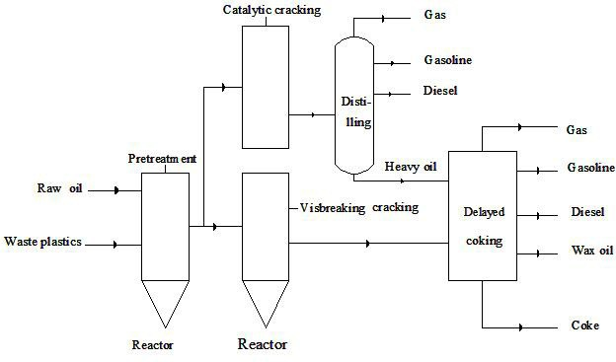

Fig.2 The co-cracking applied route of waste plastics and heavy oil

The combination processes of catalytic cracking and delayed coking can also be adopted. Waste plastics, which have been pretreated, make catalytic co-cracking with heavy oil and then enter into the delayed coking unit after distilling (as shown in Fig. 2).

# Conclusions

1. The co-cracking of waste plastics and heavy oil has a better synergistic effect than pure heavy oil cracking.
2. The co-cracking experimental results of heavy oil and waste plastics show that heavy oil containing heat conduction oil and solvent can contribute to heat transfer, melting, transport and have the effect of dissolution and co-cracking.
3. It will have a good prospect when the co-cracking of waste plastics and heavy oil is applied to the combination processes of visbreaking and delayed coking and catalytic cracking and delayed coking.

# Reference

1. Zhu Xiangxue, An Jie, Wang Yuzhong, et al. Progress of producing vehicle fuels from cracking waste plastics [J]. Chemical industry and engineering progress, 2012, 31(S):398-401.
2. Liu Guangyu, Luan Jian, Ma Xiaobo, er al. Pyrolysis of MSW plastics: technologies and their reactors [J].Environmental Engineering, 2009, 27(S):383-388.
3. Zheng Dianmo, Lu Qianfeng, Liu Ming, et al. Study on the catalytic cracking of waste plastics and waste lubricating oil for producing fuel oil [J]. Modern Chemical Industry, 2011, 31(8): 47-49.
4. Ding Yafeng, Huang Xiuling, Wang Zhiwei, et al. The research and design of a new type of waste plastic cracking reactor [J].Machinery Design & Manufacture,2013,(1):20-22.
5. Wang Chao, Ma Xiaobo, Wang Hai, et al. Study on effective thermal conductivity coefficient of plastic wastes pyrolysis process [J]. Materials Review, 2013, 27(5):108-111.
6. Liu Yibin, Ma Xiaobo, Chen Dezhen, et al. Copyrolysis characteristics and kinetic analysis of typical constituents of plastic wastes [J].Proceedings of the CSEE, 2010,30(23):55-61.