Available online at [www.sciencedirect.com](http://www.sciencedirect.com/)



AASRI Procedia 3 (2012) 284 – 290

# 2012 AASRI Conference on Modeling, Identification and Control

The Research on Inductive Gas Rotameter Transmission System

Xiaoting Lia, Yujiao Lianga, Lide Fanga,*, Qing Hea, Yao Zhanga

*aCollege of Quality and Technical Supervision, Hebei University, Baoding, 071000, China*

Abstract

The glass tube rotameter is usually used only for site instructions, without remote transmission. In this paper, the inductance sensor detects the float's displacement, with the coil around the inner tube, core installed on the float. As a result, the displacement of the float caused by the flow can reflect the inductor changes. It turns the inductance changes to voltage amplitude changes through the three-point capacitance oscillator circuit, and we can get the DC voltage signal by filtering the sine wave through high-frequency filter circuit. After sampling process in AD converter, the output voltage can be measured. Based on the relationship between voltage and inductance, and inductance and flow, we can program in the MSP430 to get flow. The realization of non-electrify electrometric measurement by transforming float displacement changes to inductance changes improves the measurement accuracy, and achieves the remote transmission by precision current transmitter.

© 2012 The Authors. Published by Elsevier B.V. Open access under [CC BY-NC-ND license.](http://creativecommons.org/licenses/by-nc-nd/3.0/)

© 2012 Published by Elsevier B.V.Selection and/or peer revi[ew under respons](http://creativecommons.org/licenses/by-nc-nd/3.0/)ibility of American Applied Science Research Institute

Selection and/or peer review under responsibility of American Applied Science Research Institute

*Keywords*: gas rotameter; inductance sensor; wave filtering rectifier; MSP430.

1. Introduction

Glass rotameter generally only plays an indication role but without transmission system in the production site. Considered of the inconvenience in reading, and the subjective errors of directly engraved in the conical tube, it cannot meet modern industrial production needs. Based on the formers' researches, this paper makes

* Lide Fang. Tel.: 0312-5079330; fax: 0312-5092717.

*E-mail address:* [fanglide@sina.com.](mailto:fanglide@sina.com)

2212-6716 © 2012 The Authors. Published by Elsevier B.V. Open access under [CC BY-NC-ND license.](http://creativecommons.org/licenses/by-nc-nd/3.0/) Selection and/or peer review under responsibility of American Applied Science Research Institute doi:10.1016/j.aasri.2012.11.046

full use of the function between float displacement and inductor, and the function between inductor and measured flow, measures inductor instead of flow rate, and fulfils the non-electrify electrometric. By converting the float displacement measurement for the inductor measurement after a series of circuit which is connected with the inductance sensor, and corresponding to the flow rate through the MSP430 processing, it finally accomplishes the functions of displaying the flow rate in scene and remote transmitting [1]. It also accomplishes the digital and intelligent measurement.

1. The hardware design of the inductance sensor displacement detection system
   1. *The sensor system design*

In the system, the inductance sensor is used to measure the float displacement. In the glass tube rotameter, the coil is around the inner tube and the core is installed on the float, so that the inductor can change with the float displacement which is changed by the flow rate. As shown in Fig 1(a).

* 1. *The inductor measurement circuit*

There are three methods to measure inductor: voltage-current method, alternating current bridge method, and LC resonant circuit method. The first method is easy but imprecise, and the measurement is accurate only when the air-core coil inductance value is great [2]. The second method can improve the measurement accuracy by adjusting the parameters and precision of the various components, but not suitable for dynamic measurement. The third method is used to generate high-frequency sine wave and can get the inductance value by measuring the parameters of the sine wave signal. The three-point LC resonant circuit is most adopted [3]. In this design, the range of the inductance value is 0.1mH~0.8mH and can be for dynamic measurement. To improve the precision it requires minimize the effects of the size and precision of other components as little as possible. Considered three methods, it chooses the LC resonant circuit-Kela Bo oscillation circuit-to measure the inductance, as Fig 1(b) [4].

In the design, there is a certain function between the output frequency and the inductance value theoretically in the Kela Bo oscillation circuit. However, in the experiment, not the output sine wave signal's frequency but the amplitude of output sine wave signal has a large change as the inductance changes. What's more, they have inversely proportional relationship, so we take advantage of the relationship between the amplitude and the inductance to get the flow rate and get verified.

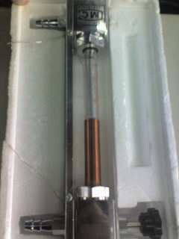 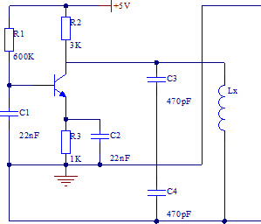

Fig. 1. (a) the inductance sensor; (b) the actual oscillation circuit

* 1. *The rectifier and filter circuit*

The rectifier circuit which makes full use of the rectifier components with unipolar conductivity rectifies the positive and negative alternating sine wave AC voltage to the pulse voltage in signal direction [5]. However, the unidirectional pulsating voltage tends to have great pulsating components, far from the ideal. The filter, composed of capacitors, inductances and other energy storage devices, can remove the pulse elements as much as possible, so that the output voltage can be relatively smooth.

The rectifier circuit takes advantage of the diodes capability-unidirectional conductivity to turn the AC voltage into unidirectional pulsating voltage. For the least pulse component of the output waveform, we should take single-phase full-wave rectifier circuit in theory; the output frequency is so high that the single- phase half wave rectifier circuit can meet the demand, shown as Fig 2(a). The filter circuit after the rectifier circuit can help get a smoother DC output signal; in actual, the output is small in voltage and current, and we can choose the capacitor filter circuit.

The frequency of the sine wave signal output is about 1MHz, amplitude about 2V~4V; therefore, we choose the diode IN4148ST--a high speed switching diode. Besides, the silicon capacitance component is a dynamic energy storage device so that it has the ability to absorb and release energy [6]; the capacitance together with the load resistor in parallel can make up a first—order low—pass filter circuit which makes use of the function--the capacitance can charge or discharge in the resistance [7]. The actual rectifier filter circuit is as Fig 2(b).The overall measurement circuit is shown in Fig 2(c).

1. The experiment
   1. *Introduction to experimental system*

When flow changes, the float makes displacement, resulting the change of the inductance values and the DC voltage; so, there is a certain function between the flow and the DC voltage amplitude. In the experiment, the flowmeter inlet port receives the regulator tank for regulator airflow supply, the outlet of the flowmeter with the bell-type gas flow standards device, and the differential pressure transmitter to the bell-type gas standard device for temperature and pressure compensation. The entire experimental system is shown as Fig 3. In the experiment, all devices are as follow: a bell-type gas flow device (accuracy: 0.5%, pressure fluctuations: 50MPa, nominal capacity: 100L, working pressure: 1.6KPa), LZB-10 model glass tube rotameter, the differential pressure transmitter, the regulator tank, stopwatch, YB4320F/40F oscilloscope, the

THQWD—1 type temperature sensor characteristics test tester, multimeter.

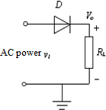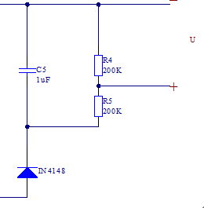

—

+5V

R2

R1

3K

600K

C3

R4 200K

Lx

C5

1uF

470pF

C1

R5 200K

22nF R3 C2

1K 22nF

C4

IN4148

470pF

U

+

Fig. 2. (a) signal-phase half wave rectifier circuit; (b) the actual rectifier filter circuit; (c) the overall measurement circuit

H

Buffer Tank

Air Compressor

MSP 430

Glass Rotameter (the sensor)

The Bell Gas Flow Standard Device

24V power

Transmitter

L

Air

Fig. 3. The entire experimental system flow chart

* 1. *Data processing*

Adjust the flow from the buffer tank, and voltage changes correspondingly. According to the voltage range 1.37V~2.34V, we divide every 0.1V into 10 points. When the voltage stabilize at a certain point, the stopwatch records the rise time of 20 small cells in the bell gas flow standard device. Each small grid is on behalf of 0.125L volume flow. The temperature and pressure are recorded by the pressure transmitter. In the end, the gas volume flow under standard conditions can be calculated as equation (1).

*Q*  293.16*V*1 *P*  101.3

0

*(1)*

101.3*t**T*1  273.16

After many experiments in pros and cons of stroke, we get the parameter values and the gas volume flow values corresponding to the voltage values, and the contrast of the flow rate in lift and return of the three sets of experiment data as in Fig 4.

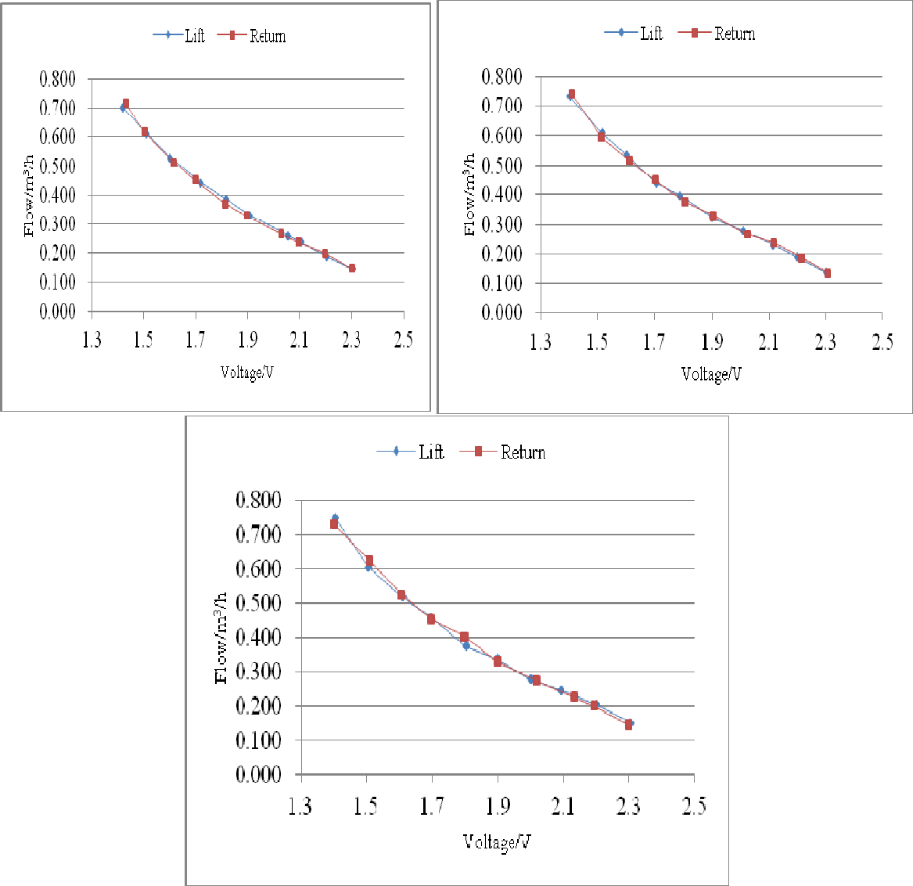

Fig. 4. (a)the contrast of the lift and return flow value in the first experiment; (b) the contrast of the lift and return flow value in the second experiment; (c) the contrast of the lift and return flow value in the third experiment

From all three sets of experiment, we can compare the lift and return flow value in contrast as Fig 5, and the fitted curve of the voltage with the flow can be made as equation (2).

# *y*  0.5908*x*3  3.7046*x* 2  8.1812*x*  6.5538

*(2)*

Among them, y represents value of gas flow, unit is m3/h; x represents the voltage value, and unit is V.

The absolute error, relative error and reference error by comparing experimental data and the fitting curve is as Fig 6. We have found that the result of curve fitting is relatively ideal, and that absolute error ranges of

−0.025m³/h+0.020m³/h, reference error −2.00%+2.00%; so we can draw a conclusion that the designed measurement circuit system can not only achieve remote transmission, but also improve the accuracy.

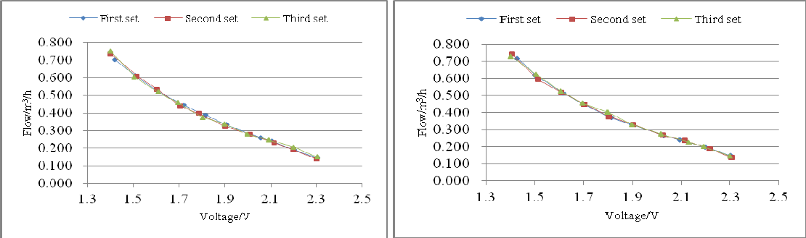

Fig. 5. (a) three sets of data lift flow values in contrast; (b) three sets of data return flow values in contrast

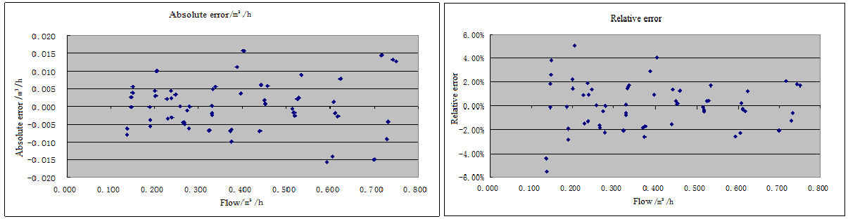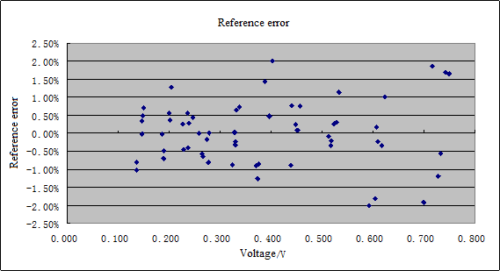

Fig. 6. (a) the absolute error; (b) the relative error; (c) the reference error

1. Conclusions

In the design, we make use of the capacitance three-point oscillator circuit to achieve the conversion from the inductance to the voltage value and extract the voltage value by the AD conversion in the MSP430 MCU. We get the functional relationship between the voltage value and the gas flow by experiment and accomplish the function calculation by processing. As a conclusion, the method can achieve the remote transmission of the signal of the glass rotameter and improve the measurement accuracy by the correction function. The

absolute error of the measurement ranges in −0.025m³/h  +0.020m³/h, the reference ranges in −2.00% 

+2.00%, and the repeatability is less than 0.6%.

Acknowledgements

This work was supported by the Natural Science Foundation of China (61074174), Natural Science Foundation of Hebei Province(F2011201040), Natural Science Foundation of Hebei University(2009-169), and Major Project of Education Department in Hebei(ZH2012064).

References

1. Wei HL. Detecting the position of floating element with magnetoresistance sensors. Tianjin University 2007.
2. Liu CD, Liu JH. A simple circuit and method to measure the inductance. Physical experiments 1987; 7: 206.
3. Syracuse(sine wave) oscillator design. Baidu Library 2011.01.08.
4. 4.2LC sine wave oscillator circuit. Baidu Library 2010.11.16.
5. Yang SX. Analog electronic technology foundation concise course. 3rd ed. Beijing: High Education Press; 2005, 47-66,353-367.
6. Qiu GY, Luo XJ. Electric circuit, 5th ed. Beijing: High Education Press; 2006, 126-129.
7. Zhang GX. Measurement and control circuit, 2nd ed. Beijing: Mechanical Industry Press; 2006, 91-103.