[Artificial Intelligence in the Life Sciences 1 (2021) 100006](https://doi.org/10.1016/j.ailsci.2021.100006)

 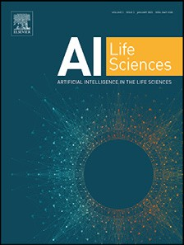

Contents lists available at [ScienceDirect](http://www.ScienceDirect.com/)

Artificial Intelligence in the Life Sciences

journal homepage: [www.elsevier.com/locate/ailsci](http://www.elsevier.com/locate/ailsci)

The development trend of artificial intelligence in medical: A patentometric analysis

Yang Xina,b,∗, Wang Mana,b, Zhou Yia,b

a *Fudan University Intellectual Property Information Service Center, Shanghai 200433, China*

b *Fudan University Library, Shanghai 200433, China*

a r t i c l e i n f o a b s t r a c t

*Keywords:*

Patentometric

Social network analysis Artificial intelligence Medical

Despite the burgeoning development of artificial intelligence (AI) applied in the medical field, there have been little bibliometric and collaboration network researches on the patents related to this inter-disciplinary research domain. Patentometric and Social Network Analysis (SNA) are used to conduct the characterizations of patent applications and cooperative networks, mapping a holistic landscape related to the AI-medical field. Derwent Innovation Index database (DII) is adopted as the patent data source. The results indicate that the quantity of AI-medical-related patent applications has been increasing explosively since 2011. The United States of Amer- ica (US) is both the foremost country developing related technologies and the primary target of patent filing by non-residents. The hotspot of the current research include medical image recognition, computer-aided diagnosis, disease monitoring, disease prediction, bioinformatics, and drug development, etc. Low density of the assignees cooperation network implies the slight patent collaboration. Companies and academic institutions are the friski- est innovation subjects in the AI-medical field. The geographical proximity has a positive influence on the patent collaboration because co-owned patents are concentrated on the institutes in the same nation. Domestic collabo- ration is the major collaborative pattern. The spatial agglomeration of trans-regional patent cooperation is fairly sparse, which requires a further escalation in knowledge circulation. It has practical significance to understand the developing situation and patent cooperation network in the AI-medical field, providing a reference for future strategy planning, development, and technological marketization.

# Introduction

In recent ten years, Artificial Intelligence (AI) techniques have been booming globally, due to the accumulation of big data, innovation of al- gorithms, and improvement of the computer processing capacity. AI is already notably promoting the major progress of technology and indus- try, from autonomous vehicles to medical diagnosis to advanced manu- facturing. In terms of the life and medical sciences field, AI techniques have broad applications, for instance, drug design [4,10,27], prediction of disease/drug risk [24], medical diagnosis [1,30], facilitating detec- tion of cancer, medical image analysis [23,26,31], genomics, physio- logical parameter monitoring [2,6], and so on. These applications of AI techniques are expected to change the work pattern of doctors and com- plement traditional medical tools, availably enhancing the accuracy and eﬃciency of diagnosis.

The patent data is regarded as a unique resource for the study of technological change [14]. Based on the patentometrics analysis, it can investigate the technique development trend [18,45]. Meanwhile, the importance of the collaboration network in promoting knowledge pro-

duction and diffusion has also been extensively studied [32,38], and collaborations can facilitate the improvement of research quality, result- ing in more effective scientific production [34]. Many studies are con- cerned on the co-author networks [33], co-citation networks [20], co- word networks [39], international collaborations [21,37,38], and cross- institution collaborations [7], in publications (e.g. papers and journals), which adopt the social network analysis (SNA) to study the relation- ships involved in the networks. However, to our knowledge, there is no bibliometric and collaboration network analysis based on patents in this inter-disciplinary research field.

Therefore, the patentometric is applied to gain a comprehensive view of the AI-medical techniques, and predict the development trend. The patent application year, technology life cycle, geographical distribution, and the collaboration relations of assignees are delved deeper into the status of technological development. SNA is carried out to investigate the collaboration network formed between institutions that are engaged in the AI-medical field. The schematic diagram of patent analysis is ex- hibited in Fig. 1.

∗ Corresponding author.

*E-mail addresses:* [yang_xin@fudan.edu.cn](mailto:yang_xin@fudan.edu.cn) (Y. Xin), [manwang@fudan.edu.cn](mailto:manwang@fudan.edu.cn) (W. Man), [zhouyi88@fudan.edu.cn](mailto:zhouyi88@fudan.edu.cn) (Z. Yi).

<https://doi.org/10.1016/j.ailsci.2021.100006>

Received 27 April 2021; Received in revised form 14 June 2021; Accepted 30 June 2021

Available online 6 July 2021

2667-3185/© 2021 The Authors. Published by Elsevier B.V. This is an open access article under the CC BY-NC-ND license (<http://creativecommons.org/licenses/by-nc-nd/4.0/>)

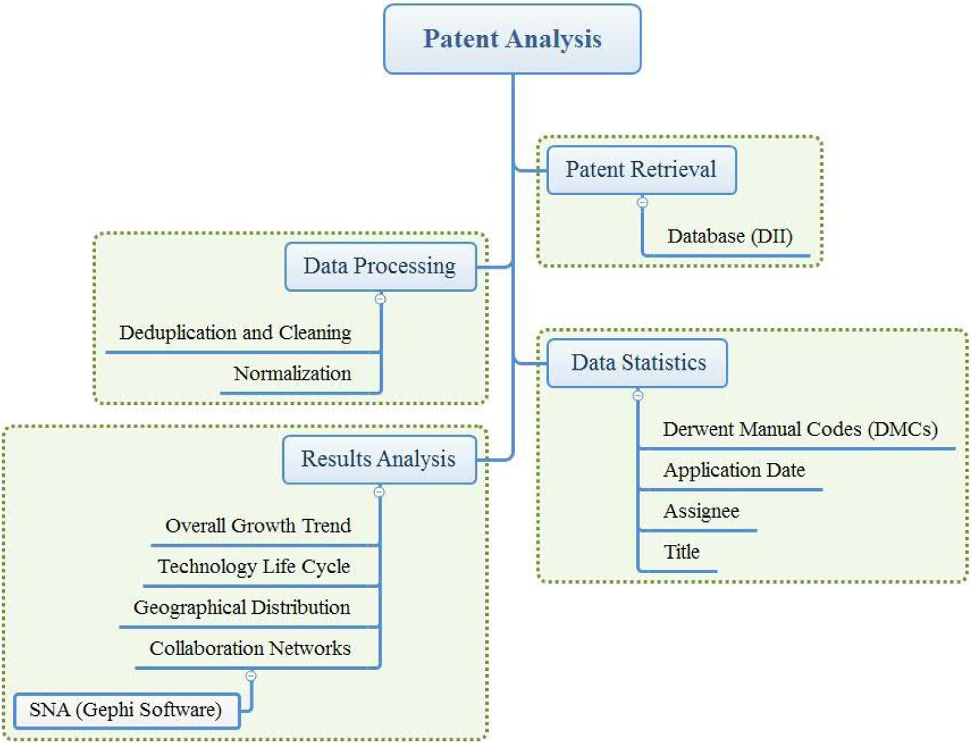

**Fig. 1.** Schematic research pathway of patent analysis.

**Table 1**

Search strategies used in Derwent Innovation Index [43].

Information Data

Retrieval tactics Topic: ("artificial intelligen∗" or "depth learning∗" or "deep

learning∗" or "natural language processing∗" or "speech recognition∗" or "computer vision∗" or "gesture control∗" or "smart robot∗" OR "Video recognition∗" OR "Voice translation∗" OR "Image Recognition∗" OR "machine intelligen∗" or "Machine learning∗") AND

Derwent Manual Code: (B01∗ OR B02∗ OR B03∗ OR B04∗ OR B05∗ OR B06∗ OR B07∗ OR B08∗ OR B09∗ OR B10∗ OR B11∗ OR B12∗ OR B14∗ OR B15∗)

Timespan All years (1963–2019)

Date of retrieval December 16, 2019

Results 1282 patent family records

# Method and data

* 1. *Data collection and pre-processing*

The patent search strategies are presented in Table 1 [43], which consists of topic search and Derwent Manual Code (DMC) search. DMC is a hierarchical system of the DII database itself, providing a consider- ably detailed classification of technical subjects and the technical nov- elty of an invention [44]. According to the standard of DMCs, patents are divided into 21 sections (A to X, except I, O, R), and each section is subdivided into more specific classes. Section B (pharmaceuticals) is taken for the patent retrieval, which includes 15 subdivisions of the codes. 1282 records from Derwent Innovation Index (DII) database are retrieved and exported on December 16, 2019. Each record represents a patent family, a group of related inventions filed in one or multiple

patent authorities [28]. Key elements of records include patent num- ber(s), priority application information, DMCs, titles, designated states, application details, inventor(s), assignee(s), patent details, IPC classifi- cation number, cited patents, cited articles. Each of these patent family records is showed as a single patent. After manually removing dupli- cates, 3610 items of single patent information are acquired [43]. The data of assignees and patent quantity information is cleaned, grouped, and rearranged in an Excel spreadsheet.

* 1. *Data analysis*

The visualization software of Gephi and Tableau are employed for patent analysis. The patent cooperation network of the AI-medical field is carried out by the SNA method, using Gephi to view the relation- ships among network participants (assignees). Gephi is an open-source software based on the Java Virtual Machine (JVM), which can be used for the exploration of complex networks. In the network, the assignees correspond to the collaborative relationships, and the patent quantity denotes the weight given to the link between assignees. Each assignee is expressed as a node, and links between two nodes are regarded as the patent cooperation relationship. The structural features of the patent collaboration network are expressed by the SNA indicators, such as de- gree, density, and weighted PageRank.

The degree of a node is the number of connections incident upon it [16], which is a parameter to evaluate the significance of nodes in a network graph.

The density (*D*) of an undirected network is the ratio of the actual link quantity to the count of all possible links within the network, as shown in Eq. (1) [41].

D = L (1)

N(N − 1)∕2

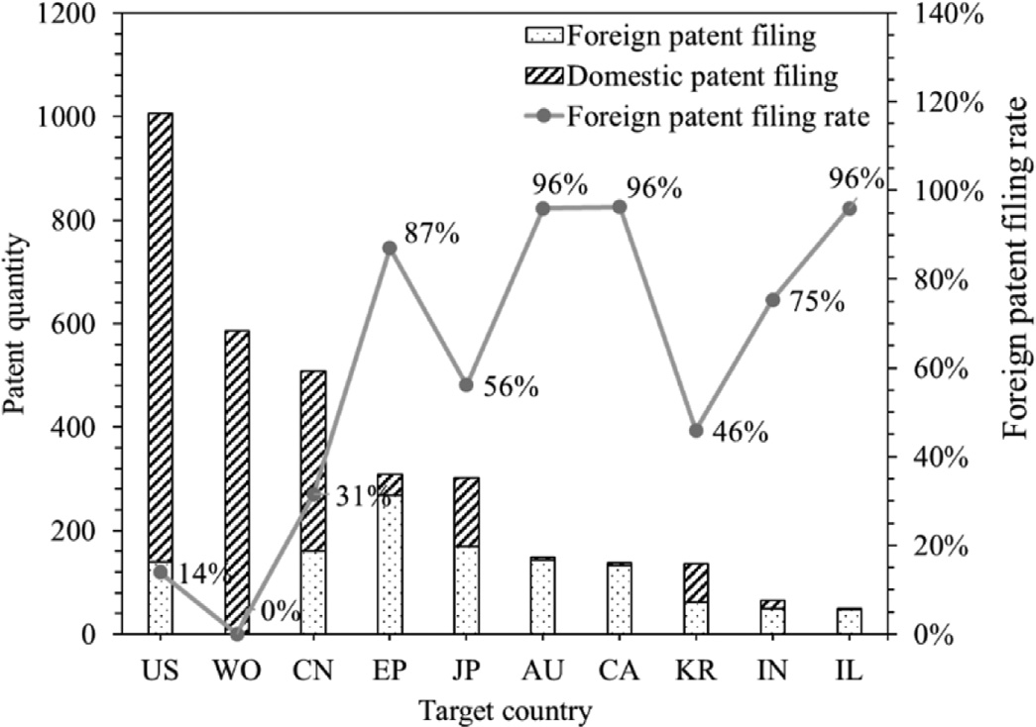

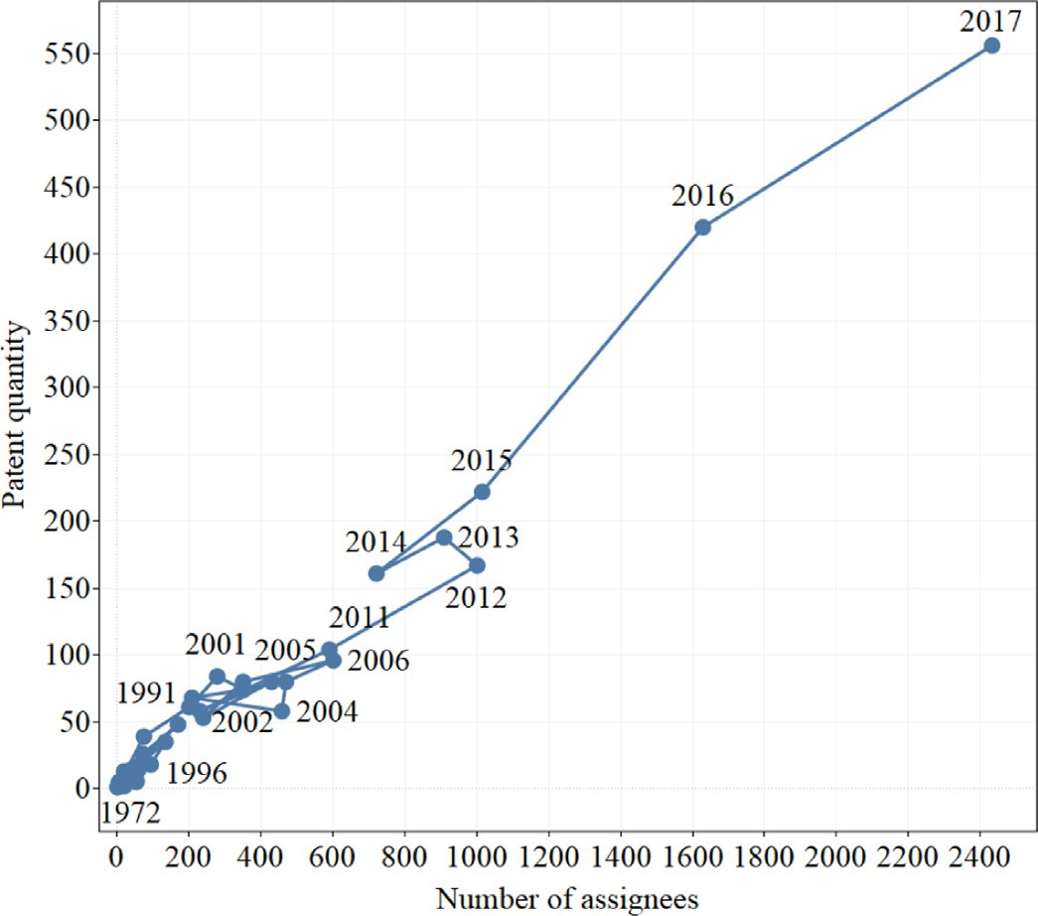**Fig. 2.** Technology life cycle of AI-medical-related patents.

where *L* and *N* are the total amount of links and nodes in a network, respectively.

Weighted PageRank is a graph-based ranking algorithm to estimate the importance of the node by measuring the quantity and quality of links to a node [9]. The amount of Weighted PageRank is calculated as follows:

*𝑘*

**Fig. 3.** Number of AI-medical-related patents filed by domestic and foreign in the top 10 countries or regions.

game of Jeopardy! Eventually, Watson prevailed over the two highest- ranked human players and obtained the victory. For general intelli- gence, Watson hits a symbolic milestone because it can comb through electronic medical records and the medical literature (e.g. journals), to make a clinical decision for human diseases [11,36]. This promotion results in a significant breakthrough in AI-medical technology develop- ment in a short term. After that, numerous enterprises or institutions initiate to invest in “Artificial Intelligence for Healthcare” from 2014, leading to a remarkable increase in the patent and assignee quantities.

PR_W(P )= (1 − d) w(p) +d ∑ PR(p*𝑖* )

(2)

* 1. *Geographical distribution*

i *𝑁*

∑

*𝑖*=1

w(p*𝑖*)

*𝑖*=1

L(p*𝑖*)

The quantity of AI-related patents on the medical field by domestic

where *W*(*P*i) is the weight matrix for the nodes in the network; *d* is a damping factor that is set as 0.85 [46]; *L*(*P*i) is the amount of edges that is linked to *P*i.

# Results and discussion

* 1. *Patent life cycle*

Patent information can be employed to predict the tendency of in- dustry development, especially in terms of market analysis and competi- tion [29]. Patent life cycle, the change of cumulative patent amount via assignees, has been used as an S-curve to predict the technology devel- opment and life circle stage. Ernst [12] introduced four different devel- opment stages of the technology life cycle: (1) emerging; (2) growth; (3) maturity; and (4) saturation. As depicted in Fig. 2, the technology life cy- cle of AI-medical-related patents can be segmented into two phases: (1) Emerging period (from the year 1972 to 2010), the technology has expe- rienced approximately 40 years of slow development. The AI-medical- related patents in the emerging stage merely occupy 30% of the total.

(2) Growth period (from the year 2011 to 2017), the number of patents (assignees) rise rapidly in this stage, from 104 (590) in 2011 to 556 (2433) in 2017. The patents in 2018 and 2019 are excluded, as a result of the 18-month confidentiality period of patent applications.

The development phases of AI-medical-related patents are consis- tent with the history of AI techniques. Although the term “artificial intelligence” was coined at a Dartmouth conference in 1956, it expe- rienced the twists and turns development progress over the subsequent forty years, commonly known as “AI summers and winters”. In 1997, an IBM computer called IBM’s Deep Blue, defeated the world chess cham- pion in a six-game match. However, Deep Blue couldn’t do anything ex- cept playing chess. In 2011, IBM researchers utilized the open-domain question-answering (QA) system, nicknamed Watson, to compete on the

and foreign countries or regions is presented in Fig. 3. Domestic patent fillings correspond to the patent applications that first field in the coun- tries or regions; foreign patent fillings represent the subsequent filings (countries or regions of second filing). There is an obvious heterogeneity across countries or regions. Concerning the rate of total foreign patent filing, the top 5 countries/regions are in the following order: Australia (96%), Canada (96%), Israel (96%), Europe (87%), and India (75%). The result demonstrates that these five countries, their own national Research and Development (R&D) in the AI-medical field are of com- parative weakness. By contrast, the US has the lowest rate of total for- eign patent filing (14%), indicating its powerful R&D capability in the AI-medical field.

Looking at the number of total foreign patent filings, the country or region ranked first in the AI-medical field is European with 268 records, followed by Japan (169 records), China (160 records), Australia (143 records), and the US (140 records). These are the most popular foreign patent filing countries or regions in the field of AI-medical, standing for the major competitive markets in the globe.

* 1. *Productive assignees*

The top 25 assignees are demonstrated in Table 2, which together account for 23.40% of all patent applications in the AI-medical field. As shown in Table 2, companies are particularly active, making up about 72% of the top 25 holders. Other patent holders include 4 universities, 2 research institutions, and an individual.

There are 18 American organizations or individuals in the ranking, of which the leader is the University of California (Table 2). France is ranked second with 3 organizations on the list. The other four listed assignees are from Cayman Islands, Switzerland, German, and Nether- lands, respectively. It is noticed that the top 25 assignees are all from the developed countries and regions. Cantner and Rake [5] also report

**Table 2**

Main assignees of AI-medical-related patents.

|  |  |  |  |  |  |  |
| --- | --- | --- | --- | --- | --- | --- |
| No | Assignee | Organization Type | Country/Region origin | Patent Quantity | Patent Cooperation Quantity | Partners |
| 1 | University of California | University | USA | 79 | 42 | 3 |
| 2 | Berg Pharma | Enterprise | USA | 62 | 0 | 0 |
| 3 | uBiome | Enterprise | USA | 62 | 0 | 0 |
| 4 | NantOmics | Enterprise | USA | 61 | 0 | 0 |
| 5 | Roche | Enterprise | Switzerland | 54 | 13 | 3 |
| 6 | IBM | Enterprise | USA | 37 | 0 | 0 |
| 7 | YouHealth | Enterprise | Cayman Islands | 34 | 34 | 2 |
| 8 | Philips | Enterprise | Netherlands | 32 | 0 | 0 |
| 9 | Pandya Ashish A | Individual | USA | 32 | 0 | 0 |
| 10 | Prometheus Lab | Enterprise | USA | 32 | 7 | 1 |
| 11 | AP-HP | Hospital | France | 31 | 31 | 10 |
| 12 | HeartFlow | Enterprise | USA | 30 | 0 | 0 |
| 13 | Gritstone Oncology | Enterprise | USA | 29 | 0 | 0 |
| 14 | CNRS | Research Institution | France | 27 | 27 | 7 |
| 15 | Cireca Theranostics | Enterprise | USA | 26 | 13 | 3 |
| 16 | INSERM | Research Institution | France | 25 | 25 | 10 |
| 17 | Sera Prognostics | Enterprise | USA | 25 | 0 | 0 |
| 18 | Yale University | University | USA | 25 | 4 | 3 |
| 19 | Eastern Virginia Medical School | University | USA | 24 | 0 | 0 |
| 20 | Intel | Enterprise | USA | 24 | 0 | 0 |
| 21 | Osio | Enterprise | USA | 24 | 0 | 0 |
| 22 | Stanford University | University | USA | 24 | 2 | 3 |
| 23 | Medtronic | Enterprise | USA | 23 | 0 | 0 |
| 24 | SIEMENS | Enterprise | German | 23 | 0 | 0 |
| 25 | Bio-Rad | Enterprise | USA | 22 | 21 | 5 |

**Table 3**

Core patents of top 25 assignees.

|  |  |  |  |
| --- | --- | --- | --- |
| Publication Number | Application dates | Title | Assignee |
| US9984201 | 2015–12–31 | Method and system for determining cancer status | Youhealth |
| US10093986 | 2017–02–16 | Leukemia methylation markers and uses thereof | Youhealth |
| US7666583 | 2005–01–18 | Identification of cancer protein biomarkers using proteomic techniques | Yale University |
| US8975379 | 2009–12–22 | Identification of cancer protein biomarkers using proteomic techniques | Yale University |
| US7790463 | 2006–02–02 | Methods of determining whether a pregnant woman is at risk of developing preeclampsia | Yale University |
| US7873479 | 2006–11–30 | Methods of diagnosing inflammatory bowel disease | Prometheus Lab |
| US7759079 | 2005–05–11 | Methods of diagnosing inflammatory bowel disease | Prometheus Lab |
| US8463553 | 2007–08–20 | Methods for diagnosing irritable bowel syndrome | Prometheus Lab |
| US8200599 | 2011–06–29 | 100 gbps security and search architecture using programmable intelligent search memory | Pandya Ashish A. |
| US9086580 | 2013–08–09 | Contact lens use in the treatment of an ophthalmologic condition | Osio |
| CN104823100 | 2013–08–09 | Contact lenses and methods of determining the fit of a contact lens for an eye of an individual | Osio |
| US7410763 | 2005–09–01 | Multiplex data collection and analysis in bioanalyte detection | Intel |
| US10398386 | 2013–05–16 | Systems and methods for estimating blood flow characteristics from vessel geometry and physiology | Heartflow |
| US10055540 | 2017–03–22 | Neoantigen identification, manufacture, and use | Gritstone |
| CN103501859 | 2012–03–02 | Probing analysis and its application based on cell | Berg |

that the core of the network about scientific publications related to phar- maceutical research is dominated by high-income Organization for Eco- nomic Cooperation and Development (OECD) countries. This may be ascribed to the knowledge-concentrated characteristic of the pharma- ceutical industry, with the highest investment R&D intensity [22].

In Table 2, the University of California is the leading institution with the largest number of patents (around 2.19% of total), followed by the Berg Pharma LLC. and uBiome Inc. (both with 62 patents). Innogra- phy platform is conducted to filter representative patents by the eval- uation indicator of patent strength [17]. There are 110 items of core patents (patent strength≥90) in the AI-medical field. Table 3 lists the core patents of the top 25 assignees, and the whole patent information can be found in the supplementary material.

Most patents of the University of California contain claims for the uti- lization of biomarker (e.g. methylation) in various cancer, the method for predicting protein binding from primary structure data, disease mon- itoring. The patents of Berg Pharma LLC. and uBiome Inc. are focused on their independently developed system and platform. The former is used to analyze the biological process (e.g., disease condition, drug-induced toxicity condition); the latter is for analyzing a microorganism-related condition (e.g., human behavior condition, disease-related condition, etc.).

Regarding the quantities of partners and co-owned patent applica- tions, the French public health agent of Assisance Publique-Hopitaux de Paris (AP-HP) holds the first place, of which the patents contain claims for the biomarkers combination for the prognosis of hepatic fibrosis or Hepatitis C Virus treatment. The AP-HP possesses 31 co-ownership patents with 10 co-assignees. The deeply multilateral cooperation of AP- HP might be in connection with its international strategy that develops larger-scale cooperation projects with other institutions, for the benefit of global health [3].

There are 14 assignees without co-ownership patents, in the top 25 assignees. The Berg Pharma LLC. (a clinical-stage, AI-powered biotech- nology company), uBiome Inc. (a company providing microbiome test- ing services in the United States), and NantOmics LLC. (a molecular testing company), despite being the critical assignees, they do not have any technological partners in the AI-medical field. Among the top 25 assignees, Roche Inc., YouHealth Inc., Cireca Theranostics LLC., and Prometheus Laboratories Inc. are the only five companies that possess co-assigned patents with other organizations. The low patent cooper- ation rate of companies may be attributed to the potential knowledge leakage risks accompanied by collaboration, although companies col- laborate with partners or co-opetitors can bring more opportunities for knowledge acquisition and generate technological breakthroughs [42].

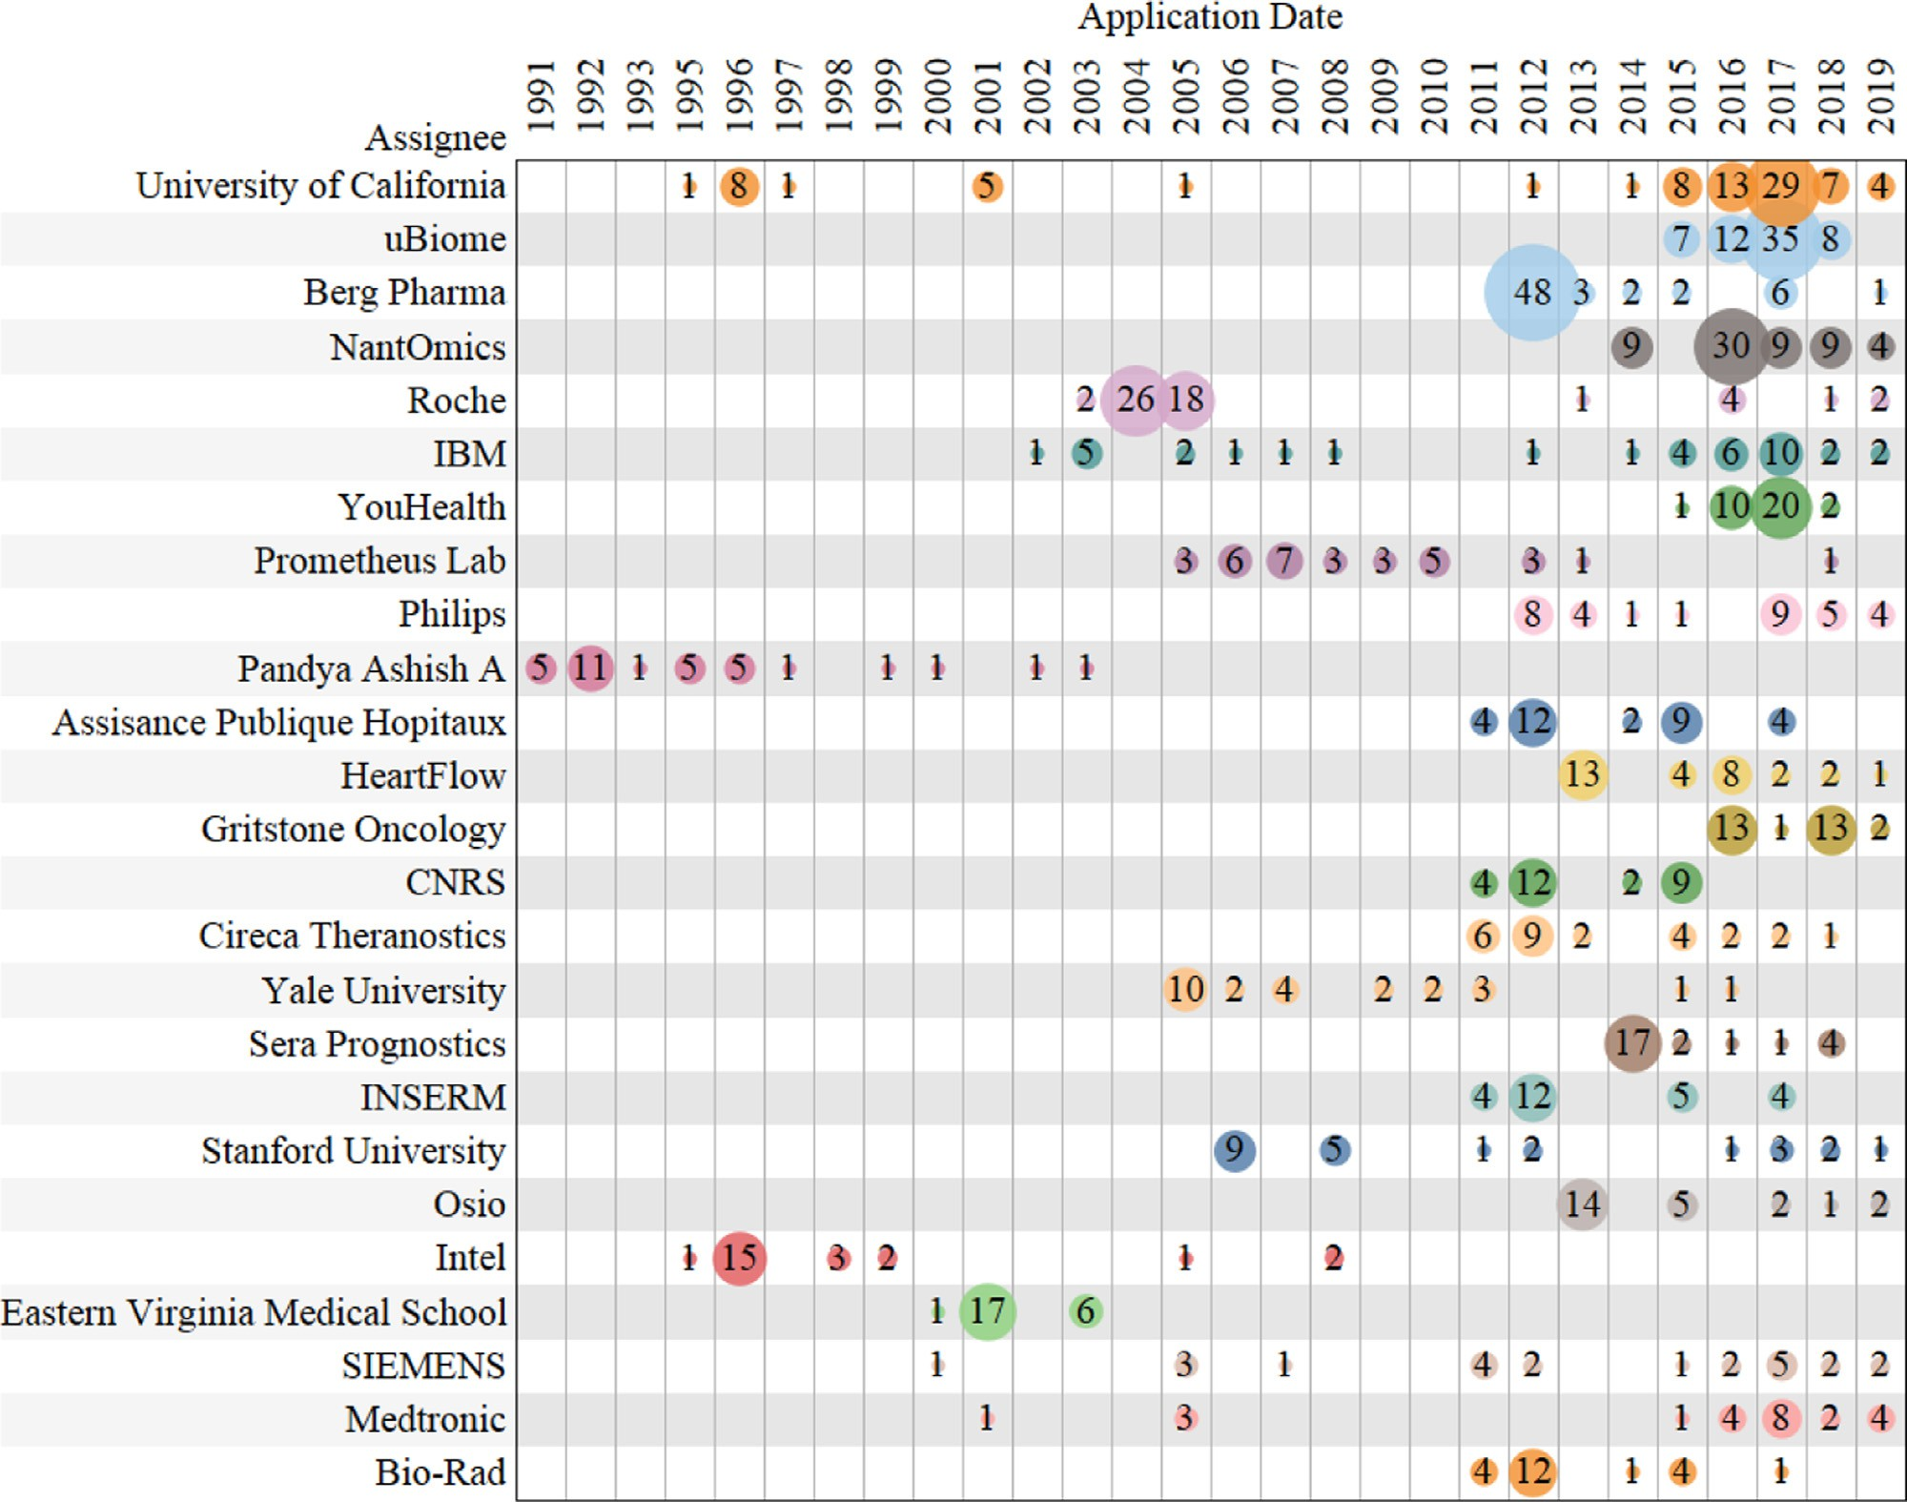

**Fig. 4.** Temporal evolution of patent applications for the top 25 assignees.

Thus, multinational corporations (MNCs) generally choose to establish overseas subsidiaries or overseas R&D laboratories, to source knowledge from the host location [35].

Fig. 4 exhibits the patent applications temporal evolution of the top 25 assignees. It can be seen that the patents of majority assignees have been filed mostly since 2011. For Pandya Ashish A, Intel, and Eastern Virginia Medical School, the patent applications are in the top ranks of quantity. Nevertheless, the patents of these assignees in the AI-medical domain are all filed before 2008, indicating the lack of subsequent re- searches.

* 1. *Patents cooperation network*

The collaboration network of patent assignees has been proven to evaluate what positions organizations occupy in a special technology field [8,25]. The SNA method is conducted to characterize the coopera- tive network of AI-medical-related patents, using the visualization tool Gephi. Fig. 5 shows the evolution of patent collaborative networks in the AI-medical field, the correlative network parameters are listed in Table 4. Each node stands for an assignee, of which the area has a pos- itive correlation with the total patent quantity of the relevant assignee. The links represent the cooperative relationships among the AI-medical- related patents, of which the thickness demonstrates the collaboration strength between two assignees, that is, the quantity of co-ownership patents.

work (*<* 0.01) indicates the slight collaboration. The number of nodes The low density of the AI-medical-related patent cooperative net-

and links is increasing, but the growth rate of nodes is higher than that of links, leading to a downward trend of density in the cooperative net- works. Because AI technology in the medical field is still in a rapidly developing stage, and the cooperative groups are small and unstable.

To view the cooperative relation, Fig. 6 exhibits the collaboration network with nodes whose degrees are over one, excluding the location where a node without connection to other nodes. The color of nodes is related to the category of assignees.

Overall, 396 assignees participate in the technological collabora- tions, and 185 assignees occupy more than one external partner. The inter-organizational collaboration network is involved in 143 enter- prises, 4 government departments, 12 hospitals, 19 research institutions, 66 universities, and 152 individuals. The corresponding main assignees are shown in Table 5. It can be seen that companies and individuals take the predominant positions in the network. Nevertheless, there are no ob- vious collaboration clusters in the collaboration network, which may be due to the fact that AI-medical-related technology is in the continued rapid development stage.

Table 6 exhibits the top ten assignees of AI-medical-related patents with high Degree and Weighted PageRank. It is observed that the AP-HP and French National Institute of Health and Medical Research (INSERM) simultaneously possess a high Weighted PageRank and a high Degree, demonstrating the greater importance and influence of them than other assignees in the AI-medical field.

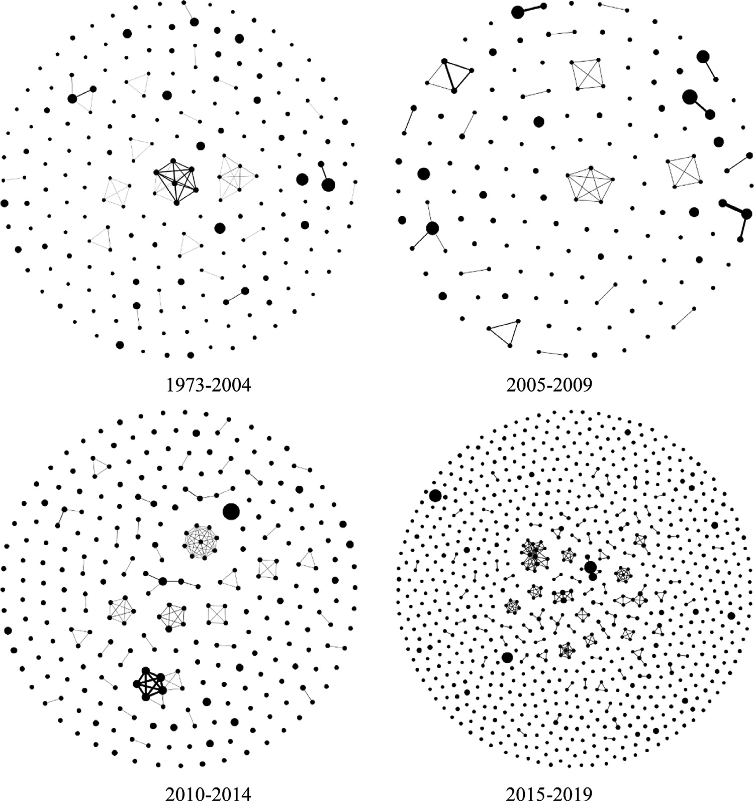

**Table 4**

Parameters of the collaborative network from 1973 to 2019.

**Fig. 5.** Evolution of patent collaborative net- works in the AI-medical field.

|  |  |  |  |  |  |
| --- | --- | --- | --- | --- | --- |
| Periods | Node | Edge | Average Degree | Network Density | Network Diameter |
| 1973–2004 | 208 | 68 | 0.654 | 0.003 | 2 |
| 2005–2009 | 145 | 48 | 0.662 | 0.005 | 2 |
| 2010–2014 | 271 | 132 | 0.974 | 0.004 | 3 |
| 2015–2019 | 829 | 265 | 0.639 | 0.001 | 4 |

**Table 5**

Top 10 assignees for patent applications in the AI-medical field.

|  |  |  |  |  |  |  |  |  |
| --- | --- | --- | --- | --- | --- | --- | --- | --- |
| No | Enterprise | NOP1 | Individual | NOP | Research Institution | NOP | University | NOP |
| 1 | uBiome | 62 | Pandya Ashish A | 32 | Prometheus Lab | 32 | University of California | 79 |
| 2 | Berg Pharma | 62 | Zhou Tiger | 20 | CNRS | 27 | Yale University | 25 |
| 3 | NantOmics | 61 | Fernandez Dennis | 19 | INSERM | 25 | Stanford University | 24 |
| 4 | Roche | 54 | Zhou Andrew | 14 | Hudsonalpha Institute For Biotechnology | 12 | Eastern Virginia Medical School | 24 |
| 5 | IBM | 37 | Randox | 13 | Cdx Lab | 11 | Harvard University | 22 |
| 6 | YouHealth | 33 | Ben Hador David | 11 | Agency For Science Technology & Research Astar | 7 | Columbia University | 21 |
| 7 | Philips | 32 | Pachmann Ulrich | 11 | London Health Sciences Centre Research | 6 | Case Western Reserve University | 12 |
| 8 | HeartFlow | 30 | Pachmann Katharina | 11 | Fred Hutchinson Cancer Research Center | 5 | Chinese University of Hong Kong | 12 |
| 9 | Gritstone Oncology | 29 | Dugas Martin | 9 | Cleveland Clinic | 5 | Ludwig Maximilians University Munich | 11 |
| 10 | Cireca Theranostics | 26 | Haferlach Torsten | 9 | National Cancer Center | 4 | MIT | 10 |
|  |  |  | Tian Ge | 9 | Korea Advanced Institute of Science & Technology | 4 | Seoul National University | 10 |
|  |  |  | Kern Wolfgang | 9 | Parkland Center for Clinical Innovation | 4 |  |  |
|  |  |  | Yee Richard W | 9 | Industrial Technology Research Institute | 4 |  |  |
|  |  |  | Kolhmann Alexander | 9 | Chinese Academy of Sciences | 4 |  |  |

1 NOP: Number of Patents.

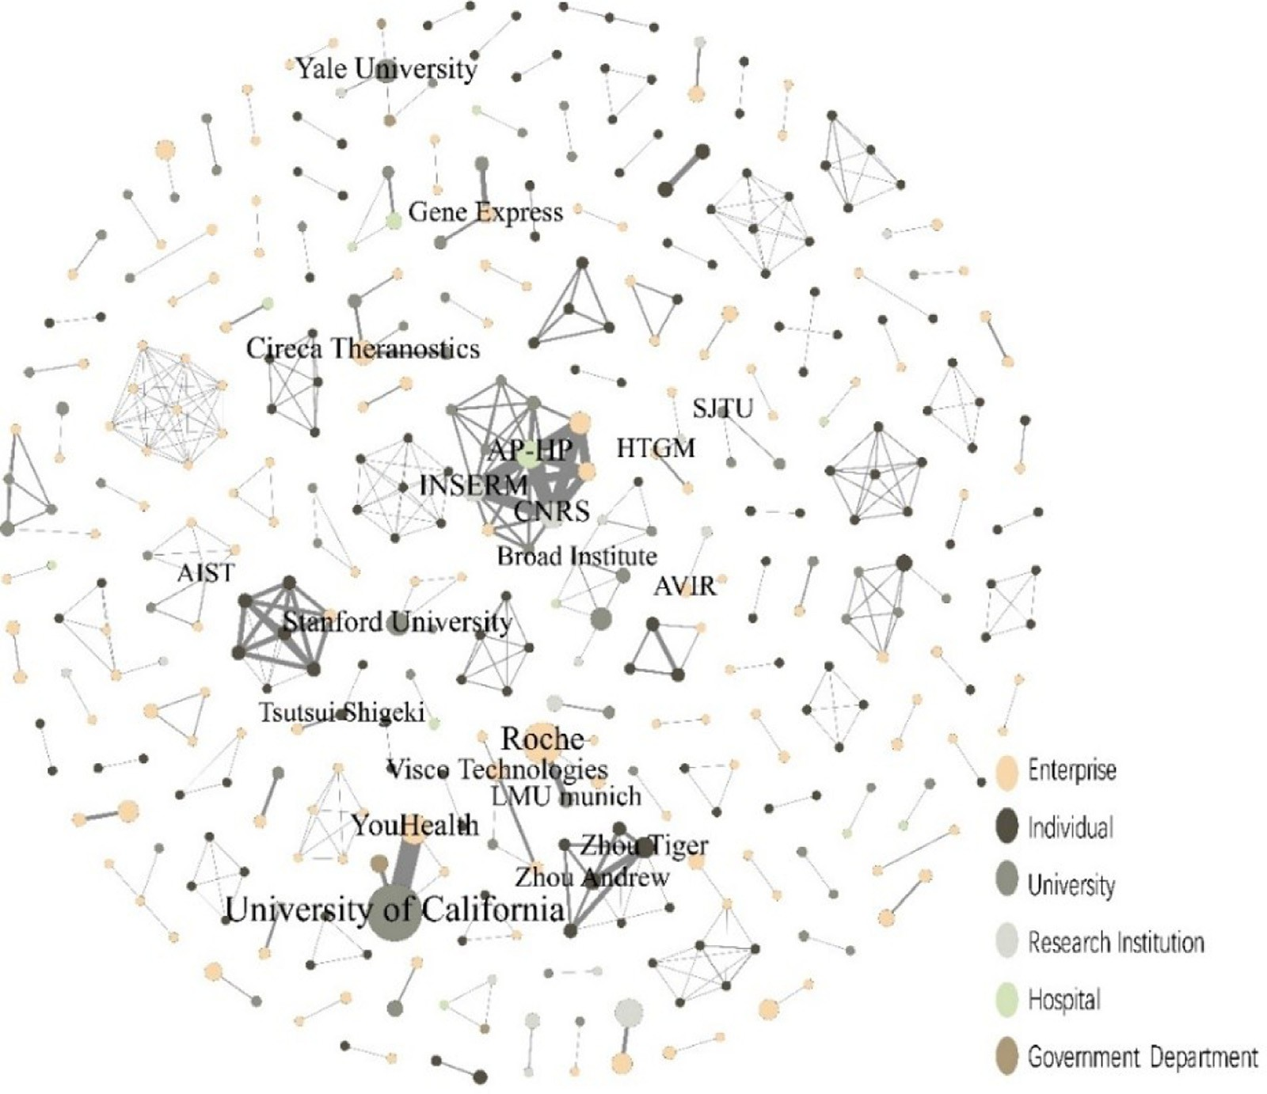

**Fig. 6.** Main cooperative network of AI-medical-related patents (degree≥1)

AP-HP: Assisance Publique-Hopitaux de Paris; AIST: National Institute of Advanced Industrial Science and Technology; HTGM: HTG Molecular Diagnostics; LMU: Ludwig Maximilians University; SJTU: Shanghai Jiao Tong University.

**Table 6**

Top 10 assignees with high Degree and Weighted PageRank.

|  |  |  |  |  |  |  |  |
| --- | --- | --- | --- | --- | --- | --- | --- |
| No | Assignee | Category | Degree | No | Assignee | Category | Weighted PageRank |
| 1 | AP-HP | Hospital | 10 | 1 | AH–HP | Hospital | 0.003890 |
| 2 | INSERM | Research Institution | 10 | 2 | Zhou Tiger | Individual | 0.003698 |
| 3 | VAREC | Enterprise | 8 | 3 | Roche | Enterprise | 0.003681 |
| 4 | Abacus Innovations Technology | Enterprise | 8 | 4 | Cireca Theranostics | Enterprise | 0.003671 |
| 5 | Reveal Imaging Technologies | Enterprise | 8 | 5 | Yale University | University | 0.003570 |
| 6 | QTC Management | Enterprise | 8 | 6 | University of California | University | 0.003544 |
| 7 | Systems Made Simple | Enterprise | 8 | 7 | INSERM | Research Institution | 0.003352 |
| 8 | SYTEX | Enterprise | 8 | 8 | Visco Technologies | Enterprise | 0.003303 |
| 9 | OAO | Enterprise | 8 | 9 | Broad Institute | Enterprise | 0.003281 |
| 10 | Lockheed Martin Industrial Defender | Enterprise | 8 | 10 | AVST | Research Institution | 0.003170 |

The AP-HP also has the most partners and co-owned patent applica- tions. This French medical institution owns 31 cooperation patents to- gether with 10 co-assignees, including two French research institutions (CNRS-Center National de la Recherche Scientifique, and INSERM), five French universities, two US enterprises (Ariana Pharma Inc., and Bio- Rad Inc.), and one U.K. enterprise (Heron International). Around 70 percent cooperators of AP-HP are from France. For the University of California, this US university has filed 42 cooperation patents with three companies that are YouHealth Inc. (the US, 34 patents), Lawrence Liver- more National Security, LLC (the US, 8 patents), and Guangzhou Youze Biotech Inc. (China, 1 patent), respectively. Nearly all of its co-owned patents are in partnership with US companies in the AI-medical field. Results suggest that the geographical location of partners plays a sig- nificant role in inter-organizational collaboration. Enterprises and aca- demic institutions locating in the same geographic region, cooperate

more closely in terms of patents. Domestic collaborations have a ma- jor implication for firm innovation [19]. Guellec and van Pottelsberghe

[15] find that countries, blessed with geographical proximity and tech- nological proximity, are more liable to collaborate. This is owing to the lower distance among the cooperators, the higher likelihood of frequent interactions among them [42]. Even if the influence of geography fac- tor has reduced recently, because of the rapid growth of internet and transportation networks [13]. Therefore, the spatial agglomeration of trans-regional patent cooperation in the AI-medical field needs to be further strengthened to accelerate the circulation of knowledge.

* 1. *IPCs co-occurrence network*

The IPC co-occurrence network can be utilized to reveal novel con- vergence patterns [40]. Fig. 7 shows the IPCs co-occurrence network of

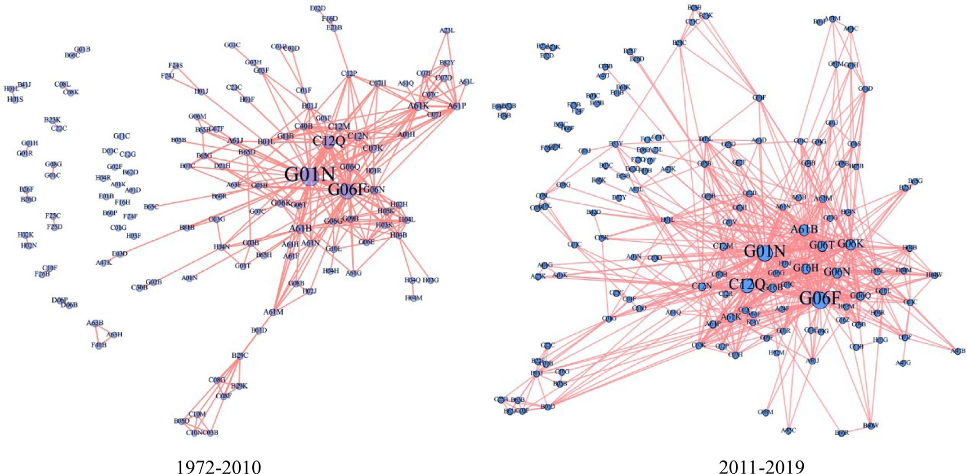

**Fig. 7.** IPCs co-occurrence network of AI-medical-related patents.

**Table 7**

Top 20 IPCs of AI-medical-related patents.

1972–2010 2011–2019

|  |  |  |  |  |  |  |  |  |  |
| --- | --- | --- | --- | --- | --- | --- | --- | --- | --- |
| No | IPC | Frequency | Degree | PageRank | No | IPC | Frequency | Degree | PageRank |
| 1 | G01N | 473 | 37 | 0.094844 | 1 | G06F | 721 | 57 | 0.070316 |
| 2 | G06F | 357 | 33 | 0.067699 | 2 | G01N | 644 | 61 | 0.084289 |
| 3 | C12Q | 239 | 24 | 0.050388 | 3 | C12Q | 519 | 31 | 0.058841 |
| 4 | A61B | 99 | 19 | 0.025953 | 4 | A61B | 337 | 49 | 0.042702 |
| 5 | A61K | 82 | 20 | 0.021537 | 5 | G06K | 293 | 47 | 0.042102 |
| 6 | G06N | 67 | 19 | 0.02273 | 6 | G06N | 280 | 35 | 0.036697 |
| 7 | C07K | 63 | 12 | 0.017223 | 7 | G06T | 259 | 30 | 0.033535 |
| 8 | C12N | 62 | 11 | 0.018162 | 8 | G16H | 241 | 33 | 0.036397 |
| 9 | C12M | 56 | 12 | 0.01871 | 9 | A61K | 164 | 30 | 0.024917 |
| 10 | G06Q | 49 | 14 | 0.015439 | 10 | G16B | 153 | 22 | 0.021886 |
| 11 | G06K | 47 | 12 | 0.009135 | 11 | G06Q | 139 | 31 | 0.017608 |
| 12 | A61P | 45 | 16 | 0.016056 | 12 | C12N | 130 | 28 | 0.021812 |
| 13 | A61M | 32 | 10 | 0.006691 | 13 | C12M | 86 | 24 | 0.013107 |
| 14 | B01J | 32 | 8 | 0.011515 | 14 | A61P | 73 | 16 | 0.010357 |
| 15 | C40B | 31 | 16 | 0.010851 | 15 | A61M | 68 | 18 | 0.009575 |
| 16 | B01L | 31 | 8 | 0.012352 | 16 | C40B | 43 | 15 | 0.008514 |
| 17 | A61J | 29 | 9 | 0.011245 | 17 | G06G | 41 | 11 | 0.011459 |
| 18 | G06G | 29 | 14 | 0.010834 | 18 | G10L | 40 | 18 | 0.0099 |
| 19 | A61N | 27 | 7 | 0.010606 | 19 | H04L | 35 | 17 | 0.008081 |
| 20 | G06T | 24 | 9 | 0.007821 | 20 | A61F | 32 | 5 | 0.006322 |

two periods (1972–2010 and 2011–2019), and the Force Atlas algorithm is adopted in the layout.

Each node stands for an IPC, and the links represent the co- occurrences of IPCs in one patent. The nodes with higher frequency are located in the center of the IPCs co-occurrence network. It can be seen that the rapid development of AI technology brings about a larger-scale of IPCs co-occurrence network in the recent decade. The network den- sity increases from 0.033 (1972–2010) to 0.053 (2011–2019).

The frequency, degree and PageRank of main IPCs are exhibited in Table 7. Compared to the period of 1972–2010, there is five new high- frequency IPCs appeared in 2011–2019, which respectively are G16H (healthcare informatics), G16B (bioinformatics), G10L (speech analysis or synthesis; speech recognition; speech or voice processing; speech or audio coding or decoding), H04L (transmission of digital information), A61F (filters implantable into blood vessels; prostheses; devices provid-

ing patency to, or preventing collapsing of, tubular structures of the body). Furthermore, G06K (recognition of data) slips from 11th to 5th rank, and G06T (image data processing or generation) moves up from 20th to 7th place in the rankings. The PageRank of these two IPCs has increased by nearly three times over the past ten years, revealing that the focus in 2011–2019 is G06K and G06T.

Table 8 lists the primary IPCs co-occurrence relation of AI-medical- related patents. G01N (investigating or analyzing materials by deter- mining their chemical or physical properties) and C12Q (measuring or testing processes involving enzymes, nucleic acids or microorganisms; compositions or test papers therefore; processes of preparing such com- positions; condition-responsive control in microbiological or enzymo- logical processes) are the most frequent IPCs co-occurrence association in the two periods. Compared to the period of 1972–2010, the new IPCs associations in 2011–2019 can be contributed to find out the emerging

**Table 8**

Top 20 IPCs technology convergence of AI-medical-related patents.

|  |  |  |  |  |  |
| --- | --- | --- | --- | --- | --- |
| 1972–2010 | | 2011–2019 | | | |
| No | IPCs Association | Frequency | No | IPCs Association | Frequency |
| 1 | G01N-C12Q | 170 | 1 | G01N-C12Q | 210 |
| 2 | G06F-G01N | 152 | 2 | G06N-G06F | 128 |
| 3 | G06F-C12Q | 105 | 3 | G06F-C12Q | 121 |
| 4 | G01N-A61B | 76 | 4 | G06T-G06K | 113 |
| 5 | G06N-G06F | 63 | 5 | G06F-G01N | 112 |
| 6 | G01N-C12N | 56 | 6 | C12Q-C12N | 72 |
| 7 | G01N-C12M | 47 | 7 | G06N-G06K | 64 |
| 8 | A61P-A61K | 45 | 8 | G16B-C12Q | 58 |
| 9 | C12Q-C12M | 44 | 9 | A61P-A61K | 55 |
| 10 | G01N-C07K | 43 | 10 | G16H-G01N | 55 |
| 11 | C12Q-C12N | 43 | 11 | G06T-G01N | 55 |
| 12 | G06Q-G06F | 34 | 12 | G01N-A61B | 54 |
| 13 | G06N-G01N | 34 | 13 | G16H-A61B | 53 |
| 14 | G06F-C12M | 33 | 14 | G06K-G06F | 53 |
| 15 | G06Q-G01N | 31 | 15 | G06F-A61B | 52 |
| 16 | G01N-B01L | 31 | 16 | G16B-G01N | 52 |
| 17 | G06F-C07K | 30 | 17 | G06N-A61B | 52 |
| 18 | G06F-C12N | 26 | 18 | G06T-A61B | 50 |
| 19 | A61N-A61B | 24 | 19 | G06K-A61B | 49 |
| 20 | G06F-A61B | 24 | 20 | G16H-G16B | 47 |

trends, e.g. G06T-G06K (AI in medical image recognition), G06N-G06K (AI in medical diagnostic system), G16B-C12Q (prediction of enzyme activity), etc. The results suggest that the application of AI technolo- gies in the medical field mainly focuses on medical image recognition, computer-aided diagnosis, disease monitoring, disease prediction, bioin- formatics, and drug development, etc.

# Conclusion

The study systematically investigates the development trend and technical cooperation of AI techniques in the medical field, through the patentometric and SNA method. The results demonstrate that numbers of AI-medical-related patent applications have been in a period of rapid growth since 2011, which is attributable to the breakthrough progress of artificial intelligence algorithms and the accumulation of big data. America is both the significant technical innovation country in the AI- medical field and the primary competitive market. The main applica- tions are medical image recognition, computer-aided diagnosis, disease monitoring, disease prediction, bioinformatics, and drug development, etc. The active and key players in the AI-medical domain are compa- nies and academic institutions. Furthermore, the geographical location of institutions influences patent cooperation, and the major collabora- tive pattern is domestic collaboration.

# Declaration of Competing Interest

The authors declare that they have no known competing financial interests or personal relationships that could have appeared to influence the work reported in this paper.

# Acknowledgments

This research did not receive any specific grant from funding agen- cies in the public, commercial, or not-for-profit sectors. An earlier ver- sion of this paper was presented as a poster paper at 18th International Conference on Scientometrics & Informetrics.

# References

1. [Amato F, Lopez A, Pena-Mendez EM, Vanhara P, Hampl A, Havel J. Artificial neural networks in medical diagnosis. J Appl Biomed 2013;11(2):47–58.](http://refhub.elsevier.com/S2667-3185(21)00006-4/sbref0001)
2. [Amin HU, Yusoff MZ, Ahmad RF. A novel approach based on wavelet analysis and arithmetic coding for automated detection and diagnosis of epileptic seizure in EEG signals using machine learning techniques. Biomed Signal Process Control 2020(56):101707.](http://refhub.elsevier.com/S2667-3185(21)00006-4/sbref0002)
3. AP-HP. (2020), International, <https://www.aphp.fr/international>. Accessed 20 April

2020.

1. [Burbidge R, Trotter M, Buxton B, Holden S. Drug design by machine learn- ing: support vector machines for pharmaceutical data analysis. Comput Chem 2001;26(1):5–14.](http://refhub.elsevier.com/S2667-3185(21)00006-4/sbref0004)
2. [Cantner U, Rake B. International research networks in pharmaceuticals: structure and dynamics. Res Policy 2014;43(2):333–48.](http://refhub.elsevier.com/S2667-3185(21)00006-4/sbref0005)
3. [Cao P, Li X, Mao K, Lu F, Ning G, Fang L, et al. A novel data augmentation method to enhance deep neural networks for detection of atrial fibrillation. Biomed Signal Process Control 2020(56):101675.](http://refhub.elsevier.com/S2667-3185(21)00006-4/sbref0006)
4. [Chen X, Xie H, Cheng G, Poon LKM, Leng M, Wang FL. Trends and features of the ap- plications of natural language processing techniques for clinical trials text analysis. Appl Sci 2020;10(6):2157.](http://refhub.elsevier.com/S2667-3185(21)00006-4/sbref0007)
5. [De Prato G, Nepelski D. Global technological collaboration network: network anal- ysis of international co-inventions. J Technol Transf 2012(39):358–75.](http://refhub.elsevier.com/S2667-3185(21)00006-4/sbref0008)
6. [Ding Y, Yan E, Frazho A, Caverlee J. PageRank for ranking authors in co-citation networks. J Am Soc Inform Sci Technol 2009;60(11):2229–43.](http://refhub.elsevier.com/S2667-3185(21)00006-4/sbref0009)
7. [Ekins S, Mestres J, Testa B. In silico pharmacology for drug discovery: methods for virtual ligand screening and profiling. Br J Pharmacol 2007;152(1):9–20.](http://refhub.elsevier.com/S2667-3185(21)00006-4/sbref0010)
8. [Epstein AS, Zauderer MG, Gucalp A, Seidman AD, Caroline A, Fu J, et al. Next steps for IBM Watson oncology: scalability to additional malignancies. J Clin On- col 2014;32(15_suppl):6618.](http://refhub.elsevier.com/S2667-3185(21)00006-4/sbref0011)
9. [Ernst H. The use of patent data for technological forecasting: the diffusion of CNC-technology in the machine tool industry. Small Bus Econ 1997;9(4):361–81.](http://refhub.elsevier.com/S2667-3185(21)00006-4/sbref0012)
10. [Geum Y, Lee S, Yoon B, Park Y. Identifying and evaluating strategic partners for col- laborative R&D: index-based approach using patents and publications. Technovation 2013;33(6–7):211–24.](http://refhub.elsevier.com/S2667-3185(21)00006-4/sbref0013)
11. [Griliches Z. Patent statistics as economic indicators-a survey [article]. J Econ Lit 1990;28(4):1661–707.](http://refhub.elsevier.com/S2667-3185(21)00006-4/sbref0014)
12. [Guellec D, van Pottelsberghe De La Potterie B. The internationalisation of technology analysed with patent data. Res Policy 2001;30(8):1253–66.](http://refhub.elsevier.com/S2667-3185(21)00006-4/sbref0015)
13. [Gupta N, Narain A, Arora A, Sharma D. Correlating centralities of social networks. Paper presented at the 2016 IEEE International Conference on Advanced Networks and Telecommunications Systems (ANTS) Bangalore, India; 2016.](http://refhub.elsevier.com/S2667-3185(21)00006-4/sbref0016)
14. [Gou J. Development status and global competition trends analysis of Maglev trans- portation technology based on patent data. Urban Rail Transit 2018;4(3):117–29.](http://refhub.elsevier.com/S2667-3185(21)00006-4/sbref0017)
15. [Hao T, Chen X, Li G, Yan J. A bibliometric analysis of text mining in medical research. Soft comput 2018;22(23):7875–92.](http://refhub.elsevier.com/S2667-3185(21)00006-4/sbref0018)
16. [Heaton C, Kolluru S, Mukhopadhaya P. Collaboration and innovation: an em- pirical study of Indian technological enterprises. Econ Transit Inst Change 2020;28(2):245–63.](http://refhub.elsevier.com/S2667-3185(21)00006-4/sbref0019)
17. [Hsieh W, Chien T, Kuo S, Lin H. Whether productive authors using the national health insurance database also achieve higher individual research metrics. Medicine (Baltimore) 2020;99(2):e18631.](http://refhub.elsevier.com/S2667-3185(21)00006-4/sbref0020)
18. [Hu H, Wang D, Deng S. Global collaboration in artificial intelligence: bibliometrics and network analysis from 1985 to 2019. J Data Inform Sci 2020;4(5):86–115.](http://refhub.elsevier.com/S2667-3185(21)00006-4/sbref0021)
19. [Hu Y, Scherngell T, Qiu L, Wang Y. R&D internationalisation patterns in the global pharmaceutical industry: evidence from a network analytic perspective. Technol Anal Strateg Manag 2015;27(5):532–49.](http://refhub.elsevier.com/S2667-3185(21)00006-4/sbref0022)
20. [Kooi T](http://refhub.elsevier.com/S2667-3185(21)00006-4/sbref0023), [Litjens G](http://refhub.elsevier.com/S2667-3185(21)00006-4/sbref0023), [van Ginneken B](http://refhub.elsevier.com/S2667-3185(21)00006-4/sbref0023), [Gubern-Merida A](http://refhub.elsevier.com/S2667-3185(21)00006-4/sbref0023), [Sancheza CI](http://refhub.elsevier.com/S2667-3185(21)00006-4/sbref0023), [Mann R](http://refhub.elsevier.com/S2667-3185(21)00006-4/sbref0023), [et al. Large scale deep learning for computer aided detection of mammographic lesions. Med Image Anal 2017(35):303–12.](http://refhub.elsevier.com/S2667-3185(21)00006-4/sbref0023)
21. [Kulkarni A, Rubin N, Tholkes T, Prizment A, Ryan CJ, Rao A. Real-world cardiovas- cular outcomes with novel anti-androgen agents in prostate cancer patients. J Clin Oncol 2019;37(15_suppl):e16510.](http://refhub.elsevier.com/S2667-3185(21)00006-4/sbref0024)
22. [Li S, Garces E, Daim T. Technology forecasting by analogy-based on social net- work analysis: the case of autonomous vehicles. Technol Forecast Soc Change 2019(148):119731.](http://refhub.elsevier.com/S2667-3185(21)00006-4/sbref0025)
23. [Litjens G, Kooi T, Bejnordi BE, Setio AAA, Ciompi F, Ghafoorian M, et al. A survey on deep learning in medical image analysis. Med Image Anal 2017(42):60–88.](http://refhub.elsevier.com/S2667-3185(21)00006-4/sbref0026)
24. [Liu M, Wu Y, Chen Y, Sun J, Zhao Z, Chen X, et al. Large-scale prediction of adverse drug reactions using chemical, biological, and phenotypic properties of drugs. J Am Med Inform Assoc 2012;19(e1):e28–35.](http://refhub.elsevier.com/S2667-3185(21)00006-4/sbref0027)
25. [Ma J, Porter AL. Analyzing patent topical information to identify technology path- ways and potential opportunities. Scientometrics 2015;102(1):811–27.](http://refhub.elsevier.com/S2667-3185(21)00006-4/sbref0028)
26. [Maravilhas S. Patent information visualization: the use of social media for its selective dissemination and to leverage innovation. Univ Access Inform Soc 2017;16(4):913–19.](http://refhub.elsevier.com/S2667-3185(21)00006-4/sbref0029)
27. [Oktay AB, Kocer A. Differential diagnosis of Parkinson and essential tremor with convolutional LSTM networks. Biomed Signal Process Control 2020(56):101683.](http://refhub.elsevier.com/S2667-3185(21)00006-4/sbref0030)
28. [Pereira S, Pinto A, Alves V, Silva CA. Brain Tumor Segmentation Using Convolutional Neural Networks in MRI Images. IEEE Trans Med Imaging 2016;35(5SI):1240–51.](http://refhub.elsevier.com/S2667-3185(21)00006-4/sbref0031)
29. [Phelps C, Heidl R, Wadhwa A. Knowledge, networks, and knowledge networks. J Manage 2012;38(4):1115–66.](http://refhub.elsevier.com/S2667-3185(21)00006-4/sbref0032)
30. [Skaf L, Buonocore E, Dumontet S, Capone R, Franzese PP. Applying network analysis to explore the global scientific literature on food security. Ecol Inform 2020(56):101062.](http://refhub.elsevier.com/S2667-3185(21)00006-4/sbref0033)
31. [Song Xu, Cai. Academic Collaboration in Entrepreneurship Research from 2009 to 2018: a Multilevel Collaboration Network Analysis. Sustainability 2019;11(19):5172.](http://refhub.elsevier.com/S2667-3185(21)00006-4/sbref0034)
32. [Song J, Asakawa K, Chu Y. What determines knowledge sourcing from host locations of overseas R&D operations?: a study of global R&D activities of Japanese multina- tionals. Res Policy 2011;40(3):380–90.](http://refhub.elsevier.com/S2667-3185(21)00006-4/sbref0035)
33. [Strickland E. Watson goes to Med school IBM’s AI program mastered “Jeopardy!” Next Up. Oncology 2013;50(1):42–5.](http://refhub.elsevier.com/S2667-3185(21)00006-4/sbref0036)
34. [Su F. Cross-national digital humanities research collaborations: structure, patterns and themes. J Doc 2020;76(6):1295–312.](http://refhub.elsevier.com/S2667-3185(21)00006-4/sbref0037)
35. [Syed S, Ní Aodha L, Scougal C, Spruit M. Mapping the global network of fisheries science collaboration. Fish Fish 2019;20(5):830–56.](http://refhub.elsevier.com/S2667-3185(21)00006-4/sbref0038)
36. [Tang M, Teng W, Lin M. Determining the critical thresholds for co-word network based on the theory of percolation transition. J Doc 2019;76(2):462–83.](http://refhub.elsevier.com/S2667-3185(21)00006-4/sbref0039)
37. [Tang Y, Lou X, Chen Z, Zhang C. A Study on dynamic patterns of technology conver- gence with IPC Co-occurrence-based analysis: the case of 3D printing. Sustainability 2020;12(7):2655.](http://refhub.elsevier.com/S2667-3185(21)00006-4/sbref0040)
38. [Wang H, Sun B, Wang P. Dominant technology identification model based on patent information toward sustainable energy development. IEEE Access 2019(7):141374–85.](http://refhub.elsevier.com/S2667-3185(21)00006-4/sbref0041)
39. [Yan Y, Dong JQ, Faems D. Not every coopetitor is the same: the impact of techno- logical, market and geographical overlap with coopetitors on firms’ breakthrough inventions. Long Range Plann 2020;53(1):101873.](http://refhub.elsevier.com/S2667-3185(21)00006-4/sbref0042)
40. [Yang X. Artificial intelligence in pharmaceuticals: bibliometric and collaboration network analysis of patents. In: 18th International Conference on Scientometrics & Informetrics. LEUVEN: International Society for Scientometrics and Informetric- s-ISSI; 2021. p. 1567–8.](http://refhub.elsevier.com/S2667-3185(21)00006-4/sbref0043)
41. [Yang X, Yu X, Liu X. Obtaining a sustainable competitive advantage from patent information: a patent analysis of the graphene industry. Sustainability 2018;10(12):4800.](http://refhub.elsevier.com/S2667-3185(21)00006-4/sbref0044)
42. [Yeung AWK, Heinrich M, Atanasov AG. Ethnopharmacology-a bibliometric analysis of a field of research meandering between medicine and food science? Front Phar- macol 2018(9):215.](http://refhub.elsevier.com/S2667-3185(21)00006-4/sbref0045)
43. [Zhong B, Hei Y, Li H, Rose T, Luo H. Patent cooperative patterns and development trends of Chinese construction enterprises: a network analysis. J Civ Eng Manag 2019;25(3):228–40.](http://refhub.elsevier.com/S2667-3185(21)00006-4/sbref0046)