[Array 11 (2021) 100083](https://doi.org/10.1016/j.array.2021.100083)

Contents lists available at [ScienceDirect](http://www.sciencedirect.com/science/journal/25900056)

Array

journal homepage: [www.sciencedirect.com/journal/array](https://www.sciencedirect.com/journal/array)

Towards a high-precision contactless fingerprint scanner for biometric authentication

Uzoma I. Oduah a,*, Ifeanyichukwu F. Kevin b, Daniel O. Oluwole b, Josephat U. Izunobi c

a *Department of Physics, University of Lagos, Akoka-Yaba, 100213, Lagos, Nigeria*

b *Department of Electrical and Electronics Engineering, University of Lagos, Akoka-Yaba, 100213, Lagos, Nigeria*

c *Department of Chemistry, University of Lagos, Akoka-Yaba, 100213, Lagos, Nigeria*

A R T I C L E I N F O

*Keywords:* Authentication Biometric

Blue light COVID-19

Fingerprint

Pattern recognition

A B S T R A C T

The raging COVID-19 pandemic accentuates the urgent and compelling need for non-contact fingerprinting biometric authentication devices to mitigate the transmission of the severe acute respiratory syndrome coro- navirus 2 (SARS-CoV-2) and other contagious infections. Current approaches to contactless fingerprinting scanners suffer limitations ranging from poor compatibility with two-dimensional equivalent touch-based fingerprint images to perspective distortions, inconstant resolution, motion blur images and low correlation factors. Herein, these constraints are tackled by implementing a system that enables the positioning of the target finger(s) at fixed vertical and horizontal distances away from the camera lens without the physical contact of the fingers with the device framework during scanning. A high-precision fingerprint pattern recognition of up to 97.51% correlation factor has been achieved, using this contactless method, by varying the background illu- minating light and implementing two-dimensional imaging techniques and near-constant resolution. Addition- ally, a convenient contactless fingerprint acquisition process is reinforced through a unique architectural design.

# Credit author statement

Conceptualization: Uzoma I. Oduah, Investigation: Ifeanyichukwu F. Kevin and Daniel O. Oluwole, Methodology: Uzoma I. Oduah, Ifea- nyichukwu F. Kevin and, Daniel O. Oluwole: Analysis: Uzoma I. Oduah and Josephat U. Izunobi, Writing – Original Draft, Uzoma I. Oduah,

Ifeanyichukwu F. Kevin, Daniel O. Oluwole and Josephat U. Izunobi,

Writing – Review & Editing, Josephat U. Izunobi and Uzoma I. Oduah.

# Introduction

There is an urgent and growing need, in today’s rapidly changing and

disease-prone world, for non-contact biometric authentication devices to aid hygiene and safety, and mitigate the spread of contagious in- fections [1]. Fingerprint biometrics is one of the most widely used forms of recognition for the purposes of identification and authentication due to its convenience, reliability and accuracy but it is also one of the most susceptible agents of transmission for contagious infections [43]. This drawback is especially accentuated, now, in the wake of the recent emergence of the severe acute respiratory syndrome coronavirus 2 (SARS-CoV-2) [3].

Prior to the onset of the COVID-19 pandemic, however, efforts had been on-going towards the development of contactless fingerprint bio- metric scanners mainly because of the limitations of touch-based fingerprint scanners. Some of the limitations of these scanners, which operate on optical or capacitive systems, include: non-linear distortions; introduced by the elastic deformation of the skin during scans, irregular attributes associated with dry skin, diseases, sweat, dirt and humidity, security issues; with latent fingerprints deposited on the scan plate after each use, which can be fraudulently replicated, and inconsistent pres-

sures of the fingers during scans, amongst others [4–8].

It is noteworthy that contactless fingerprint scanners have been previously developed [9–11] but have suffered some underlying chal- lenges, such as: inefficient fingerprint acquisition techniques, ineffective

approaches to reconciling differences between the salient features of the images captured by touch-based fingerprint devices and those captured via contactless fingerprint devices, and the adaptability of the contact- less fingerprint system to the automated fingerprint identification sys- tem (AFIS); commonly used in the touch-based (contact) method of fingerprinting [9–13].

Two approaches have been reported for contactless fingerprint

acquisition, namely: two-dimensional (2-D) and three-dimensional (3-

* Corresponding author.

*E-mail address:* [uoduah@unilag.edu.ng](mailto:uoduah@unilag.edu.ng) (U.I. Oduah).

<https://doi.org/10.1016/j.array.2021.100083>

Received 11 February 2021; Received in revised form 22 June 2021; Accepted 28 July 2021

Available online 6 August 2021

2590-0056/© 2021 The Authors. Published by Elsevier Inc. This is an open access article under the CC BY-NC-ND license ([http://creativecommons.org/licenses/by-](http://creativecommons.org/licenses/by-nc-nd/4.0/) [nc-nd/4.0/](http://creativecommons.org/licenses/by-nc-nd/4.0/)).

D) imaging techniques. The 2-D method uses a single camera to capture images whereas the 3-D technique employs multiple cameras, which require the superimposition of images and use of complex algorithms

[14–16]. The available contactless fingerprint 2-D scanners are, how- ever, limited by their fingerprint acquisition styles. They are also

affected by background illumination variations and reflections thereby producing poor resolution fingerprint images [17,19,44]. Unsurpris- ingly, most of the existing contactless fingerprint scanners deploy the 3-D technique to capture more detailed fingerprints.

The 3-D approach emphasizes on gathering more details of the fingerprint by incorporating the dimensions in the *x*, *y*, *z* axis. The various 3-D image acquisition techniques are multiple-view setup, structured lights or photometric stereo methods [45]. Unfortunately, the additional details introduce errors of perspective distortions and inconstant resolution, which reduce the correlation factors. The problem is evident in the computation of touch-equivalent fingerprints from 3-D

to 2-D images [21–23]. Similarly, the absorption of light by the skin’s

epidermis during finger scans reduces the resolution of the images produced via the contactless method.

The acceptable standard for the matching and verification of fingerprinting patterns is governed by the automated fingerprint iden- tification systems (AFIS), which makes it mandatory for acquired fingerprint images, whether 2-D or 3-D, to be converted to the equiva- lent touch fingerprint 2-D images, described as touch-equivalent images (TEI), for uniformity and compatibility [24–26,46]. It is notable that

available contactless fingerprint scanners use neural network classifiers

to reconstruct the generated three-dimensional images to equivalent two-dimensional touch images.

The correlation factor is a key factor in the evaluation of the per- formance of fingerprint scanners [28]. It is a percentage measure of how the enrolled fingerprint image matches the one captured during verifi- cation. It is therefore crucial for the enrolled true fingerprint images, with the extracted unique minutiae features of ridges and valleys, to match the captured fingerprint images at the point of verification [28–32]. This is termed pattern recognition.

Several strategies have been implemented towards improving the

correlation factors of contactless fingerprint scanners compared to touch-based fingerprint scanners, such as the introduction of back- ground subtraction and contextual filtering algorithms [33] but most contactless fingerprint systems exploit resolution normalization, which involves adopting a constant resizing factor based on the estimated distance between the lens camera and target finger, placed for scanning [34].

It is pertinent to point out that in the touch-based fingerprint scan- ners, where there is elastic deformation of the finger skin, for instance, during scans due to pressure, the elastic deformation is compensated for during verification thereby nullifying the error initially introduced during enrollment by the same user. Consequently, the fingerprints captured during verification match the enrolled fingerprints. However, where enrollment is done using a touch-based fingerprint scanner but verification is with a contactless fingerprint scanner, the errors due to elastic deformation become consequential; leading to a mismatch and poor correlation factor as the captured contactless fingerprints lack the elastic deformation distortions elicited by a touch-based fingerprint scanner.

Furthermore, the scanning of multiple fingers simultaneously is re- ported to enhance correlation factor and reduce false positive errors [10]. Generally, the method of coalescing multiple fingers presents features, which make sampling and pattern recognition more precise [14]. Nevertheless, multiple-finger scanners require more space and could be, therefore, considered cumbersome.

A major challenge in the capturing of fingerprints in the contactless mode remains the positioning of the target finger to maintain a fixed distance between it and the camera during scans. Existing devices employ finger placement guides positioned at designated distances from the lens of the camera; with the fingers oftentimes making contact with

the guides. This was of no concern previously as the focus was to create higher-resolution scanners. With the occurrence of the COVID-19 pandemic, however, the need for well-resolved, robust contactless fingerprint scanners is more germane and urgent in order to, amongst others, help in containing the spread of SARS-CoV-2 without compro- mising on security and safety.

Herein, we outline various efforts implemented towards enhancing the correlation factor of the contactless fingerprint scanner whilst reducing its false positive errors. In addition, the developed device is compared with relevant existing technologies to highlight its unique and innovative features. The major contributions of the proposed method include achieving actual contactless fingerprint scans with precision, enhanced correlation factors; derived from the high-precision finger- print acquisition process, and an effective, efficient and convenient fingerprinting architectural technique.

# Materials and method

The flowchart for the development of the contactless fingerprint scanner is presented in Fig. 1.

* 1. *Contactless positioning of finger*

In this work, a convenient and precise method of positioning the finger in a fixed position, vertically and horizontally, away from the camera lens, without making contact with the device, was designed and developed (*cf*. Fig. 2). With the aid of two infrared-proximity sensors at the sides of the camera, the target finger was guided until it was properly aligned at a designated spot in the *x*, *y*, *z* axes. A red-spot light beam flashed to indicate that the finger was properly aligned in an exact po- sition (of designated *x*, *y*, *z* coordinates) and activate the camera to capture the image, simultaneously.

A microcontroller was used to perform the logic gate to control and synchronize the actions of the infrared-proximity sensors with the laser

beam and the camera’s aperture during the scanning operations. The

unique architecture of the device provided a non-touch easy guide for the positioning of the target finger during scanning. Different correla- tion factors were assessed based on differently set vertical distances away from the camera in order to identify an ideal distance between the camera and target finger. Different light intensities and wavelengths

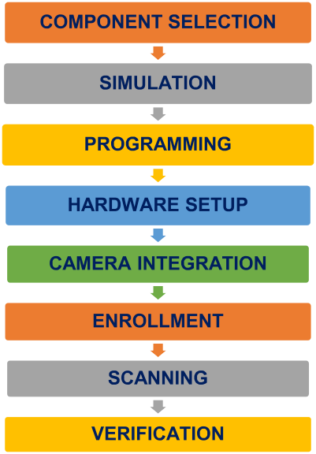

**Fig. 1.** Flowchart for the development of the contactless fingerprint scanner, showing the component selection and simulation described in the coupling of the electronic circuit.

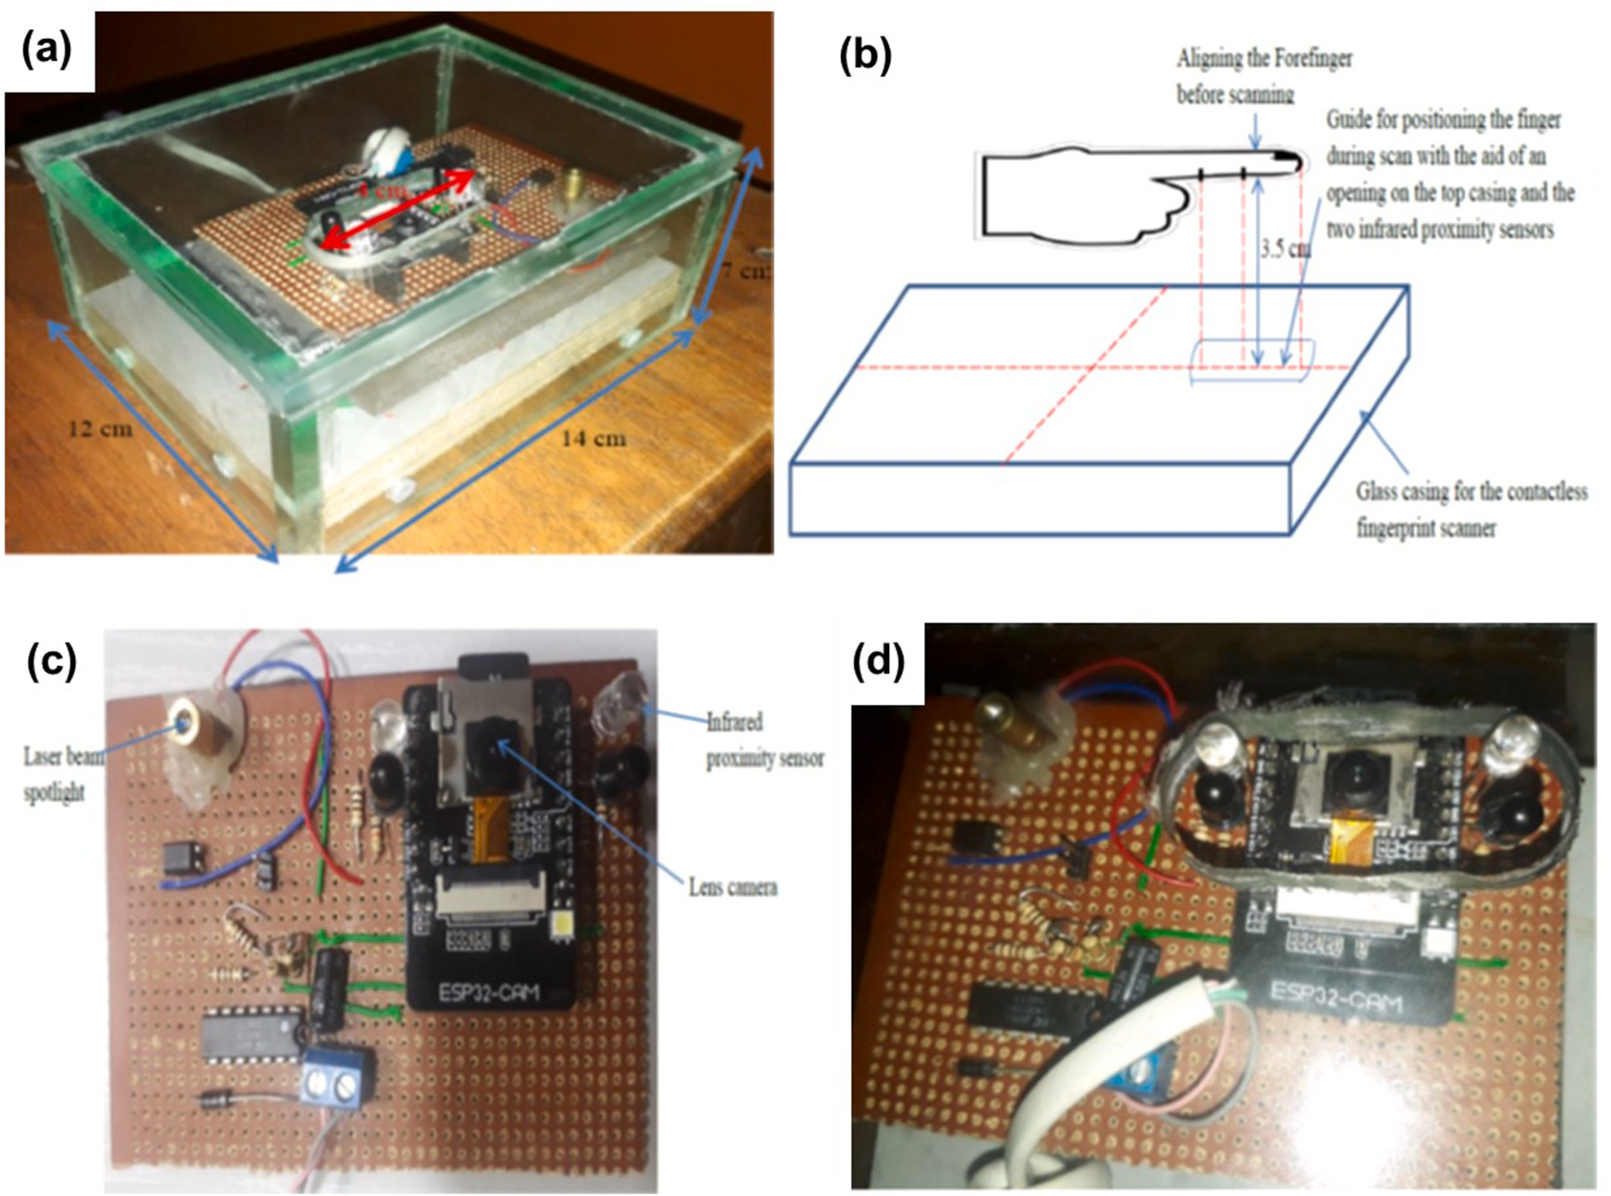

**Fig. 2.** (a) Contactless fingerprint biometric scanner revealing the dimensions of the device. The opening guiding the placement of the finger is 4 cm. A glass casement covers the device and protects the electronic components from damage, (b) illustrates the positioning of the target finger at 3.5 cm, away from the camera during scanning operations. The fingerprint scanner is separated from the area the finger is placed during scanning to avoid physical contact, (c) shows the key components of the contactless fingerprint scanner, with the location of the camera and two infrared proximity sensors. The infrared proximity sensors and the camera are in position for the placement of the target finger and (d) shows the opening that guides the alignment of the target finger during the scanning operation.

were also investigated for optimal utility.

* 1. *Coupling of the electronic circuit*

The circuit components were coupled following the layout design shown in Fig. 3. The circuit consists of the lens camera (ESP 32 CAM), infrared-proximity sensors and laser light, as indicator. The two infrared-proximity sensors were each placed on both sides of the camera and equidistant from the camera. A blue light-emitting diode (LED) light beam was implemented as the camera’s flashlight. The ESP 32 CAM is

also power-saving as it has the capacity to go into sleep mode when no

finger is detected by the infrared-proximity sensors. The contactless scanning device can be powered via a USB charger or the USB port of a personal computer.

* 1. *The programming of the device and webpage interface*

The contactless fingerprint scanner microcontroller (Aithinker ESP 32 WROOM) was programmed in C-language, using the Arduino IDE. The webpage interface was designed using HTML and CSS as shown in Fig. 4. The WiFi capability of the ESP 32 CAM enabled the connectivity of the device to smartphones, laptops and all WiFi-enabled devices. The operation of the contactless fingerprint biometric scanner followed the algorithm in steps. The device implements the pattern recognition al- gorithms in machine learning language (MLL); in which the fingerprint is first enrolled and stored in a database, where any scanned fingerprint data can be sampled and matched within the verification stage. Python language was deployed in the programming.

The scanner used the images (pictures) captured by the camera to

identify the different fingers, just like the traditional fingerprint scan- ners. The images were stored and processed using image recognition algorithms similar to the ones used in face recognition. Each image file was converted into a binary file, which was then analyzed pixel by pixel. Whenever a finger is scanned, the system searches the database for a match. The more the samples of a particular fingerprint stored, the better and more robust the results of the scan.

Once the device is switched on, it searches for an available programme-compatible WiFi device to pair and continues to search for a WiFi-enabled device if none is available. On securing a connection, it waits for the infrared-proximity sensors to detect a target finger for scanning. Once a finger is detected at the predetermined distance from the camera, the detected finger is scanned. It then stores the newly captured fingerprint data in the memory storage device (when the ENROLL button is enabled from the webpage; *cf.* Fig. 4) for later use. On the other hand, when the enroll button is not selected (from the web- page), the device compares the captured fingerprint images with the previously stored fingerprint data, computes the correlation factor from the sample and displays the value of the achieved correlation factor for analysis.

* 1. *WiFi-enablement for enrollment and verification*

The device was designed to match a high population of users needing its services since multiple-user enrollment and verification devices are known to be ideal for authentication purposes in public domains with high population indices [35]. To ensure easy availability and fast turn-around-times during the verification process, the microcontroller Aithinker ESP32 WROOM was implemented. It enables the WiFi

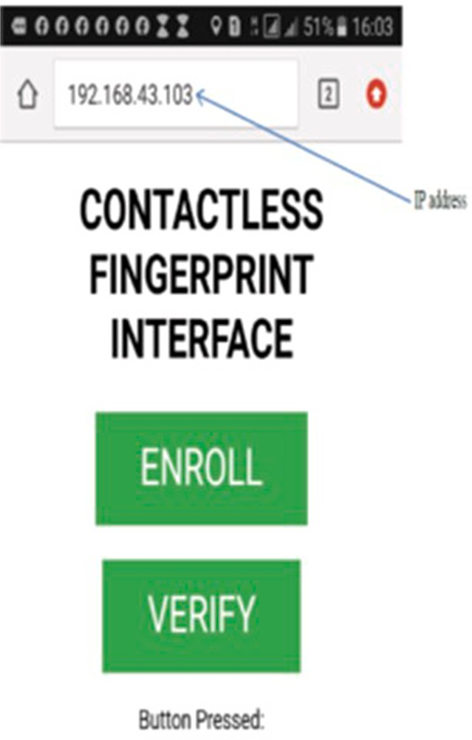

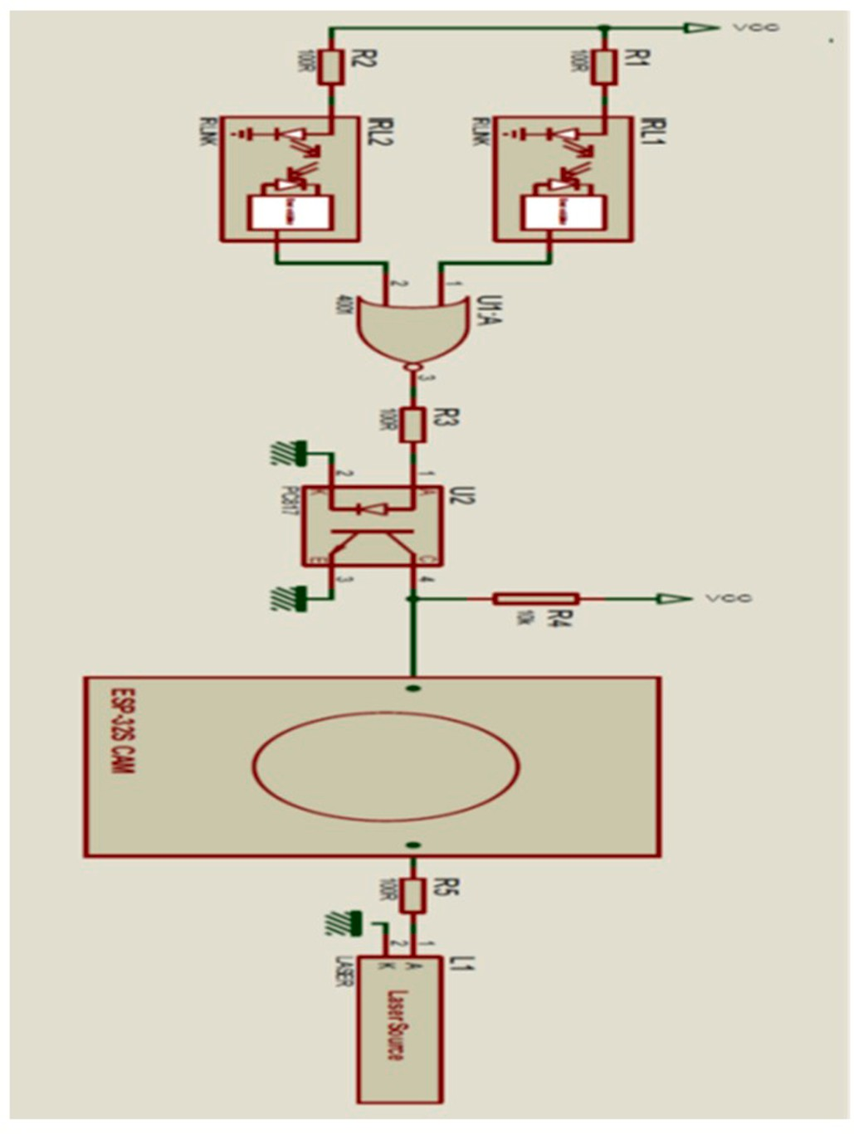**Fig. 3.** Schematic of the layout of the electronic components on the circuit board. IRL1 and IRL2 are infrared-proximity sensors. L1 is a laser point beam, which indicates that the target finger is properly aligned before scanning. EPS- 325 CAM is the lens camera; It captures the image of the fingerprint at the prompt of the microcontroller. U1 and U2 are transistors in the microcontroller that performs the logic gate functions. When the target finger is sensed by the two infrared-proximity sensors at a fixed vertical and horizontal distance away from the camera, the laser point beam switches on and the camera simulta- neously captures the image. The microcontroller performs the logic functions controlling the two infrared-proximity sensors, lens camera and laser point beam.

connection of the contactless fingerprint biometric scanner to other WiFi-enabled devices, such as mobile phones, ipads, laptops, personal computers, etc. A snapshot of the webpage is shown in Fig. 4, displaying the internet protocol (IP).

* 1. *Packaging of the device*

The packaging of the developed device is robust and compact, with an opening on top to guide the user on the positioning of the target finger. The fingerprint scanner is delineated in Fig. 2(a) with a dimen- sion of 14 cm (length) by 12 cm (width) by 7 cm (height) in size. This is different from current approaches, with openings to let the target finger inside a casing with a physical framework to confine the finger during scanning [36]. The contactless fingerprint scanner herein has been designed in such a manner that the target finger is neither confined nor

in contact with the scanner’s architecture. The scanner is positioned separately from where the finger is aligned, in open space, to the

camera.

The coupling of the electronic components on the circuit board was also implemented with the image-capturing components properly posi- tioned at points where they can function without obstructions. The circuit diagram layout is presented in Fig. 3. The two infrared-proximity

**Fig. 4.** Shows a graphical user-interface of the contactless fingerprint biometric scanner. The scanner is WiFi-enabled and can connect to WiFi-enabled devices, such as mobile phones, ipads, personal computers and laptops.

sensors go into sleep mode when there is no finger in scanning view. The inactive mode of the sensors conserves electric power, making the de- vice energy efficient.

# Results

Varying the set distances between the finger and camera was observed to affect the values of the correlation factor, in agreement with previous reports [34]. Consequently, to determine the ideal distance of the target finger from the camera during scanning, the two infrared-proximity sensors were set-up to detect at different distances between the camera and target finger, and the correlation factors for the distances were recorded (*cf.* Table 1). The contactless scanner was able

to capture fingerprint images at distances within 0.5–9.5 cm, from the camera to the target finger, with the highest correlation factor of 59.9%

at a distance of 3.5 cm from the camera.

Furthermore, it was noticed that the achieved correlation factor varied slightly with the intensity of the illuminating background light. Therefore, the effect on the correlation factor was tested by applying a

light beam of different intensities (50–280 lm) at 3.5 cm (Table 2). The results indicate that the higher the light intensity, the better the

fingerprint image resolution, which in turn enhances the correlation factor.

It is well-known that the percentages of light reflected, transmitted and/or absorbed contribute to the resolutions of the images obtained during fingerprint scanning and these, in turn, influence the correlation

**Table 1**

Determination of the ideal distance from camera lens to target finger for highest correlation factor.

Distance (cm)

|  |  |  |  |  |  |  |  |  |
| --- | --- | --- | --- | --- | --- | --- | --- | --- |
|  | 0.5 | 2.0 | 3.5 | 5.0 | 6.5 | 8.0 | 9.5 |  |
| Correlation | 47.57 | 54.99 | 55.13 | 55.56 | 49.22 | 46.18 | 51.47 |  |
| Factor (%) | 49.05 | 54.64 | 55.48 | 45.16 | 52.75 | 49.71 | 47.19 |  |
|  | 46.84 | 56.07 | 58.07 | 47.52 | 51.26 | 51.11 | 47.95 |  |
|  | 46.64 | 51.02 | 59.90 | 50.76 | 45.35 | 45.74 | 54.77 |  |
|  | 44.33 | 53.74 | 55.25 | 47.51 | 43.22 | 42.13 | 49.48 |  |

**Table 2**

Determination of ideal luminous flux using white light at ideal distance for highest correlation factor.

Light Intensity (lm)

|  |  |  |  |  |  |  |
| --- | --- | --- | --- | --- | --- | --- |
|  | L0 = 50 | L3 =  150 | L6 =  180 | L9 =  210 | L12 =  280 |  |
| Correlation Factor | 51.43 | 51.04 | 58.36 | 60.77 | 78.12 |  |

images, resulting in their improved correlation factors.

Cognizant of the reports that white light and other longer wave- length radiations are absorbed by the epidermal layer of the skin [40, 41], white light was substituted with blue light (500 nm), which is less absorbed by the skin, and its impact on correlation factor was assessed. A corollary is that the blue illuminating light enhanced the correlation factors of the fingerprint images, with the highest value at 97.51%. The

|  |  |  |  |  |  |  |
| --- | --- | --- | --- | --- | --- | --- |
| (%) | 49.55 | 50.28 | 56.91 | 57.81 | 73.05 | excellent values obtained for the correlation factors using blue light can |
|  | 43.73 | 60.48 | 66.95 | 63.22 | 69.98 | be attributed to the high-resolution fingerprint images generated, |
|  | 49.07  49.55 | 57.48  56.20 | 63.91  50.21 | 58.00  61.54 | 75.80  72.73 | which, due to reduced absorption by the skin, more clearly outlined the  ridges and valleys of the target finger. The import of this wavelength |

factors obtained [34]. Nonetheless, light irradiance at long wavelengths is absorbed by the epidermis. To ameliorate skin damage, blue light (*λ* = 500 nm), which is less absorbed by the skin, was implemented for the background illumination at 25 lumens at the 3.5 cm distance. The results are collected in Table 3.

Blue light at 280 lumens was also tested to examine its impact at higher intensity. Gratifyingly, the highest correlation factor of 97.51% was obtained using blue light of 500 nm at 280 lumens intensity and a

3.5 cm distance between the target finger and lens camera (*cf.* Table 3).

# Discussion

The high-precision contactless fingerprint biometric scanner devel- oped in this project overcomes the challenge of positioning the target finger at a fixed point during scanning, without contact. Previous technologies implemented finger placement guides to achieve the alignment of the target finger at a fixed position but with the possibility of the finger touching the placement guides, leading to the spread of contagious infections. Other unconstrained acquisition setups are faced with problems of motion blur and inconstant fingerprint image resolu- tions [37,38]. Herein, two infrared-proximity sensors have been deployed with an electronic logic-controlled microcontroller to achieve the non-touch alignment of the target finger in a fixed constant position away from the camera.

The distance between the target finger and lens camera during scan operations was found to be optimal at 3.5 cm, with a correlation factor of 59.9% (Table 1). Other factors that influence the correlation factor of the contactless fingerprint scanners were also investigated, with a view to improving it. For instance, most contactless fingerprint scanners implement diffused white light for background illumination. This is reported to produce a uniform but low resolution, which results in a reduction in the correlation factor [39]. The background light intensity was varied between 50 lm and 280 lm in this study (Table 2). It is also significant to note that the luminous flux range of the samples investi- gated was within that of liquid crystal display (LCD) units in mobile phones and laptops. The highest fingerprint correlation factor was achieved at 280 lm, with a correlation factor of 78.12%. It is evident that the increased light intensity enhanced the resolution of the fingerprint

**Table 3**

Determination of the ideal luminous flux using blue light (500 nm) at the ideal distance (3.5 cm) for the highest correlation factor.

|  |  |  |  |
| --- | --- | --- | --- |
|  | Blue Light (lm) |  |  |
| 25 | 280 |
| Correlation Factor (%) | 81.17 | 89.17 |  |
|  | 87.08 | 95.08 |  |
|  | 89.51 | 97.51 |  |
|  | 72.82 | 80.82 |  |
|  | 71.85 | 79.85 |  |
|  | 75.80 | 83.80 |  |
|  | 80.35 | 88.35 |  |
|  | 80.88 | 88.88 |  |
|  | 75.02 | 85.02 |  |
|  | 89.14 | 95.14 |  |

change from illuminating white to blue light is, therefore, not only an improved correlation factor but also a device benign to the skin and environmentally friendly.

Fig. 5 compares the correlation factors obtained using blue illumi- nating light (*λ* = 500 nm) at both low (25 lm) and high (280 lm) in- tensities (*cf*. Table 3), highlighting the fact that increased light intensity enhances correlation factor by improving the resolution of the finger- print images. This was similarly observed with white light (*cf*. Table 2). The robustness of this fingerprint scanner is demonstrated with variations in the intensities of the illuminating background light be- tween 50 lm and 280 lm, and variations of the luminous flux for blue light at 500 nm. The developed fingerprinting device delivered improved correlation factors and was observed to perform best when the target finger was placed at a vertical distance of 3.5 cm away from the

camera lens, applying blue light of 500 nm at an intensity of 280 lm.

The correlation factor values obtained when using white light of 280 lm intensity for background illumination in our model contactless fingerprint scanner, with an optimal distance of 3.5 cm between the target finger and lens camera, was also compared to those generated using blue light at both 25 lm and 280 lm (Fig. 6). Overall, blue light proved better resolving, with higher correlation factor values, than white light at 280 lm intensity although the values of the correlation factor obtained with white light of 280 lm were comparable to those of 25 lm blue illuminating light.

One of the major concerns of fingerprint authentication is the issue of security and privacy. The fingerprint biometric scanners can be vulnerable to such system failures as intrinsic failures, which include failures caused by faulty sensors and inaccurate sample matching as well as failures due to fingerprint features extraction or false errors [42]. Non-intrinsic failures, on the other hand, are mainly attributable to malicious attacks. Therefore, the protection of the fingerprint data during the acquisition, storage, sampling and verification exercises is paramount. Pertinently, the fingerprint acquisition techniques imple- mented herein eliminate the risks associated with the fraudulent acquisition of latent fingerprints. The security concepts and methods implemented to address fingerprint data confidentiality, authenticity and integrity as well as its diversity, non-repudiation and revocability in the software development of this device will be reported elsewhere.

# Conclusions

In this study, a new approach to fingerprint image acquisition technology using a system that enforces contactless fingerprinting in a precise and efficient manner has been successfully demonstrated. It generates great potentials in the replacement of the conventional touch- fingerprint scanners and is especially apropos in the wake of the pre- vailing COVID-19 pandemic to mitigate the spread of the virus and other contagious infections transmitted through surfaces.

The findings suggest best techniques towards achieving optimal fingerprint correlation factor values with reduced false positive errors. The contactless fingerprint biometric scanner developed herein is pres- ently at its proof-of-concept stage and a requisite patent has been filed in Nigeria (with registration number NG/PT/NC/2020/4853).

It is vital to point out that in order to ensure the compatibility of the contactless fingerprint biometric systems with already-existing touch-

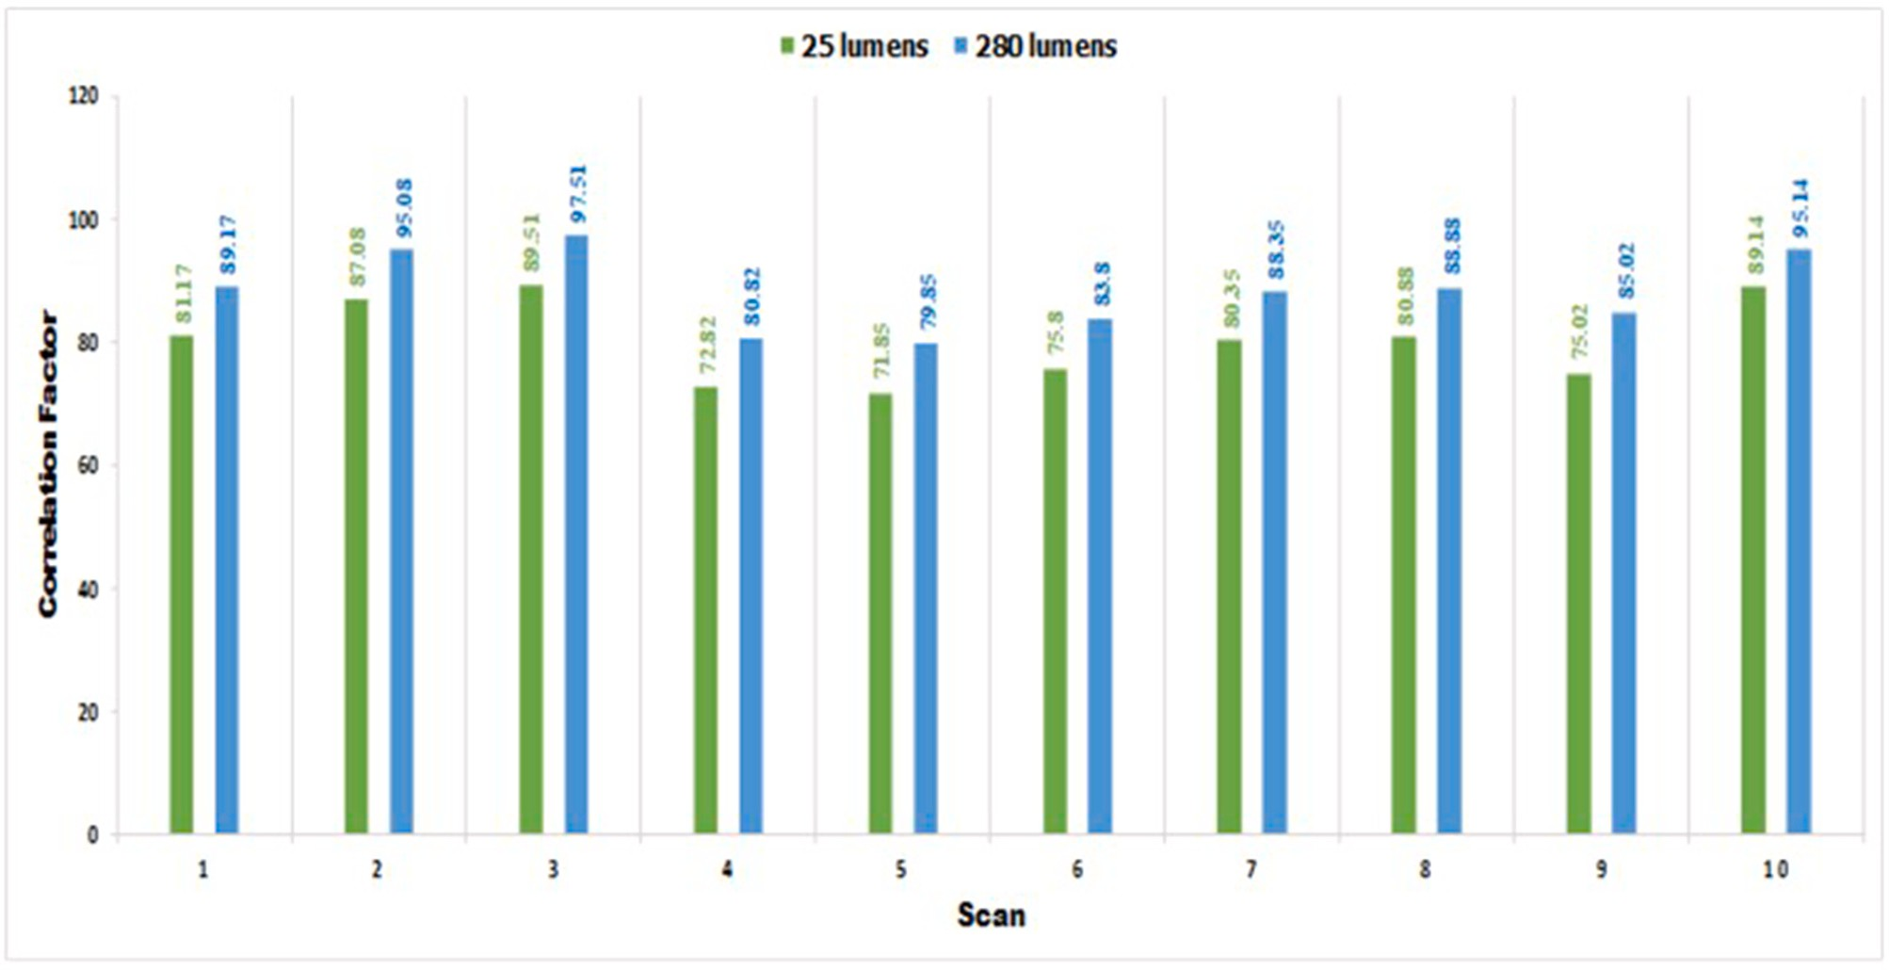

**Fig. 5.** Determination of the optimum luminous flux using blue light (500 nm) at intensities of 25 lm and 280 lm.

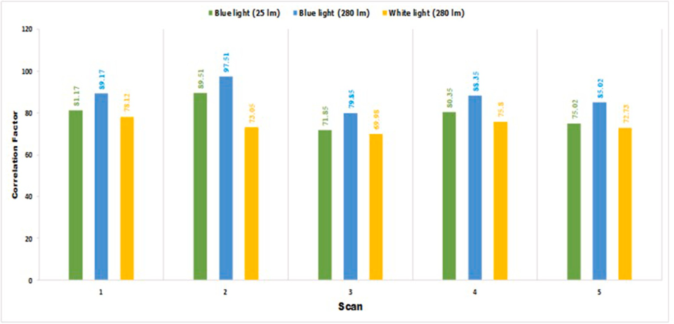

**Fig. 6.** Comparative luminous fluxes using blue light at intensities of 25 lm and 280 lm, and white light at 280 lm.

based equivalent fingerprint images, the device developed in this work possesses the unique feature of producing 2-D images with improved correlation factors. It is common knowledge that fingerprint scanners that operate by using the 3-D scene reconstruction of images suffer the challenges of occlusion, scale and light variations, and perspective dis- tortions, which reduce their correlation factors especially when applied in the verification of 2-D images already captured with touch-based fingerprint scanners.

To surmise, high-precision contactless fingerprint scans and enhanced correlation factors have been achieved in this protocol as well as an effective, efficient and convenient fingerprinting architectural technique, which not only bodes well for mitigating the 3-D/2-D image resolution dichotomy but also the spread of contagions, such as the

SARS-CoV-2.

# Declaration of competing interest

The authors declare that they have no known competing financial interests or personal relationships that could have appeared to influence the work reported in this paper.

# References

[1] [Kumar A. Towards more accurate matching of contactless palmprint images under](http://refhub.elsevier.com/S2590-0056(21)00031-X/sref1) [less constrained environments. IEEE Trans Inf Forensics Secur 2019;14:34–47](http://refhub.elsevier.com/S2590-0056(21)00031-X/sref1).

1. Lai C-C, Shih T-P, Ko W-C, Tang H-J, Hsueh P-R. Severe acute respiratory syndrome

coronavirus 2 (SARS-CoV-2) and coronavirus disease-2019 (COVID-19): the

epidemic and the challenges. Int J Antimicrob Agents 2020;55:105924. [https://](https://doi.org/10.1016/j.ijantimicag.2020.105924) [doi.org/10.1016/j.ijantimicag.2020.105924](https://doi.org/10.1016/j.ijantimicag.2020.105924).

1. [Patil S, Sheelvant S. Survey on image quality assessment techniques. Indian J Sci](http://refhub.elsevier.com/S2590-0056(21)00031-X/sref4) [Res 2015;4:1756–9](http://refhub.elsevier.com/S2590-0056(21)00031-X/sref4).
2. [Sampat MP, Wang Z, Gupta S, Bovik AC, Markey MK. Complex wavelet structural](http://refhub.elsevier.com/S2590-0056(21)00031-X/sref5)

[similarity: a new image similarity index. IEEE Trans Image Process 2009;18:](http://refhub.elsevier.com/S2590-0056(21)00031-X/sref5) [2385–401](http://refhub.elsevier.com/S2590-0056(21)00031-X/sref5).

1. [Hildebrandt M, Dittmann J, Vielhauer C. Statistical latent fingerprint residue in](http://refhub.elsevier.com/S2590-0056(21)00031-X/sref6)

[contactless scans to support fingerprint segmentation. In: 18](http://refhub.elsevier.com/S2590-0056(21)00031-X/sref6)th [international](http://refhub.elsevier.com/S2590-0056(21)00031-X/sref6) [conference on digital signal processing (DSP); 2013. p. 1–6. Santorini, Greece](http://refhub.elsevier.com/S2590-0056(21)00031-X/sref6).

1. Fiumara G, Flanagan P, Schwarz M, Tabassi E, Boehnen C. NIST special database

301: nail to nail fingerprint challenge dry run. Natl. Inst. Stand. Technol. Tech. Note 2018:22pp. <https://doi.org/10.6028/NIST.TN.2002>. 2002.

1. [Oduah UI. The application of photorefractive effect of Lithium Niobate in the](http://refhub.elsevier.com/S2590-0056(21)00031-X/sref8) [development of a biometric fingerprint scanner with unique sensitivity. Int J Electr](http://refhub.elsevier.com/S2590-0056(21)00031-X/sref8)

[Comput Eng 2014;6:236–9](http://refhub.elsevier.com/S2590-0056(21)00031-X/sref8).

1. [Chen Y, Parziale G, Diaz-Santana E, Jain AK. 3D touchless fingerprints:](http://refhub.elsevier.com/S2590-0056(21)00031-X/sref9) [compatibility with legacy rolled images. In: Proceedings of bio-metric symposium.](http://refhub.elsevier.com/S2590-0056(21)00031-X/sref9)

[Baltimore, MD: Biometric Consortium Conference; 2006. p. 1–6](http://refhub.elsevier.com/S2590-0056(21)00031-X/sref9).

1. [Ericson L, Shine S. Evaluation of contactless versus contact fingerprint data, phase](http://refhub.elsevier.com/S2590-0056(21)00031-X/sref10)

[2 (version 1.1). Fairmont, WV.: DOJ Office of Justice Programs, National Institute](http://refhub.elsevier.com/S2590-0056(21)00031-X/sref10) [of Justice; 2015. p. 1–117](http://refhub.elsevier.com/S2590-0056(21)00031-X/sref10).

1. [Donida-Labati R, Genovese A, Piuri V, Scotti F. Toward unconstrained fingerprint](http://refhub.elsevier.com/S2590-0056(21)00031-X/sref11)

[recognition: a fully touchless 3-D system based on two views on the move. IEEE](http://refhub.elsevier.com/S2590-0056(21)00031-X/sref11) [Trans. Syst. Man Cybern. Syst. 2016;46:202–19](http://refhub.elsevier.com/S2590-0056(21)00031-X/sref11).

1. [Feng J. Combining minutiae descriptors for fingerprint matching. Pattern Recogn](http://refhub.elsevier.com/S2590-0056(21)00031-X/sref12)

[2008;41:342–52](http://refhub.elsevier.com/S2590-0056(21)00031-X/sref12).

1. [Agrawal A, Raskar R, Chellappa R. What is the range of surface reconstructions](http://refhub.elsevier.com/S2590-0056(21)00031-X/sref13) [from a gradient field?. In: Leonardis A, Bischof H, Pinz A, editors. Computer vision](http://refhub.elsevier.com/S2590-0056(21)00031-X/sref13)

[– ECCV 2006 lecture notes in computer science, vol. 3951. Berlin Heidelberg:](http://refhub.elsevier.com/S2590-0056(21)00031-X/sref13) [Springer-Verlag; 2006. p. 578–91](http://refhub.elsevier.com/S2590-0056(21)00031-X/sref13).

1. [Gamassi M, Piuri V, Scotti F. Fingerprint local analysis for high-performance](http://refhub.elsevier.com/S2590-0056(21)00031-X/sref14)

[minutiae extraction. In: Proceedings of the 2005 IEEE international conference on](http://refhub.elsevier.com/S2590-0056(21)00031-X/sref14) [image processing (ICIP 2005); 2005. p. 265–8. Genoa, Italy](http://refhub.elsevier.com/S2590-0056(21)00031-X/sref14).

1. [Kumar A, Kwong C. Towards contactless, low-cost and accurate 3D fingerprint](http://refhub.elsevier.com/S2590-0056(21)00031-X/sref15)

[identification. In: Proceedings of the 2013 IEEE conference on computer vision and](http://refhub.elsevier.com/S2590-0056(21)00031-X/sref15) [pattern recognition workshops (CVPRW ’13). Portland, OR: IEEE Computer](http://refhub.elsevier.com/S2590-0056(21)00031-X/sref15) [Society; 2013. p. 3438–43](http://refhub.elsevier.com/S2590-0056(21)00031-X/sref15).

1. [Jain AK, Prabhakar S, Hong L, Pankanti S. Filter bank-based fingerprint matching.](http://refhub.elsevier.com/S2590-0056(21)00031-X/sref16)

[IEEE Trans Image Process 2000;9:846–59](http://refhub.elsevier.com/S2590-0056(21)00031-X/sref16).

1. [Yin X, Zhu Y, Hu J. Contactless fingerprint recognition based on global minutia](http://refhub.elsevier.com/S2590-0056(21)00031-X/sref17) [topology and loose genetic algorithm. IEEE Trans Inf Forensics Secur 2019;15:](http://refhub.elsevier.com/S2590-0056(21)00031-X/sref17)

[28–41](http://refhub.elsevier.com/S2590-0056(21)00031-X/sref17).

[19] [Maltoni D, Maio D, Jain AK, Prabhakar S. Handbook of fingerprint recognition. 2nd](http://refhub.elsevier.com/S2590-0056(21)00031-X/sref19) [ed. London: Springer; 2009](http://refhub.elsevier.com/S2590-0056(21)00031-X/sref19).

1. Donida-Labati R, Genovese A, Piuri V, Scotti F. Accurate 3D fingerprint virtual environment for biometric technology evaluations and experiment design. In: Proceedings of the 2013 IEEE international conference on computational intelligence and virtual environments for measurement systems and applications

(CIVEMSA). Milan, Italy: IEEE; 2013. p. 43–8. [https://doi.org/10.1109/](https://doi.org/10.1109/CIVEMSA.2013.6617393) [CIVEMSA.2013.6617393](https://doi.org/10.1109/CIVEMSA.2013.6617393).

1. Mil’shtein S, Pillai A. Perspectives and limitations of touchless fingerprint. In: 16[th](http://refhub.elsevier.com/S2590-0056(21)00031-X/sref22) [IEEE international symposium on technologies for homeland security (HST ’17).](http://refhub.elsevier.com/S2590-0056(21)00031-X/sref22) [Waltham, MA.: IEEE; 2017. p. 1–6](http://refhub.elsevier.com/S2590-0056(21)00031-X/sref22).
2. [Donida-Labati R, Genovese A, Piuri V, Scotti F. Touchless fingerprint biometrics: A](http://refhub.elsevier.com/S2590-0056(21)00031-X/sref23) [survey on 2D and 3D technologies. J Internet Technol 2014;15:327–34](http://refhub.elsevier.com/S2590-0056(21)00031-X/sref23).
3. [Zhou W, Hu J, Petersen IR, Wang S, Bennamoun M. A benchmark 3D fingerprint](http://refhub.elsevier.com/S2590-0056(21)00031-X/sref24)

[database. In: Proceedings of the 11](http://refhub.elsevier.com/S2590-0056(21)00031-X/sref24)th [international conference on fuzzy systems and](http://refhub.elsevier.com/S2590-0056(21)00031-X/sref24) [knowledge discovery (FSKD 2014); 2014. p. 935–40. Xiamen, China](http://refhub.elsevier.com/S2590-0056(21)00031-X/sref24).

1. [Wang Y, Lau DL, Hassebrook LG. Fit-sphere unwrapping and performance analysis](http://refhub.elsevier.com/S2590-0056(21)00031-X/sref25)

[of 3D fingerprints. Appl Opt 2010;49:592–600](http://refhub.elsevier.com/S2590-0056(21)00031-X/sref25).

1. [Tang Y, Jiang L, Hou Y, Wang R. Contactless fingerprint image enhancement](http://refhub.elsevier.com/S2590-0056(21)00031-X/sref26) [algorithm based on hessian matrix and STFT. 2](http://refhub.elsevier.com/S2590-0056(21)00031-X/sref26)nd [international conference on](http://refhub.elsevier.com/S2590-0056(21)00031-X/sref26) [multimedia and image processing (ICMIP 2017). Wuhan, China: ICMIP; 2017.](http://refhub.elsevier.com/S2590-0056(21)00031-X/sref26)

[p. 156–60](http://refhub.elsevier.com/S2590-0056(21)00031-X/sref26).

1. [Feng L, David Z. 3D fingerprint reconstruction system using feature](http://refhub.elsevier.com/S2590-0056(21)00031-X/sref28)

[correspondences and prior estimated finger model. Pattern Recogn 2014;47:](http://refhub.elsevier.com/S2590-0056(21)00031-X/sref28) [178–93](http://refhub.elsevier.com/S2590-0056(21)00031-X/sref28).

1. [Song Y, Lee C, Kim J. A new scheme for touchless fingerprint recognition system.](http://refhub.elsevier.com/S2590-0056(21)00031-X/sref29)

[In: Ko SJ, editor. Proceedings of 2004 international symposium on intelligent](http://refhub.elsevier.com/S2590-0056(21)00031-X/sref29) [signal processing and communication systems (ISPACS 2004). Seoul, Korea:](http://refhub.elsevier.com/S2590-0056(21)00031-X/sref29) [ISPACS; 2004. p. 524–7](http://refhub.elsevier.com/S2590-0056(21)00031-X/sref29).

1. [Boult T. Beyond image quality: failure analysis from similarity surface techniques.](http://refhub.elsevier.com/S2590-0056(21)00031-X/sref30) [Gaithersburg, MD: NIST Biometric Quality Workshop; 2006. p. 1–23](http://refhub.elsevier.com/S2590-0056(21)00031-X/sref30).
2. [Zheng Q, Kumar A, Pan G. Contactless 3D fingerprint identification without 3D](http://refhub.elsevier.com/S2590-0056(21)00031-X/sref31)

[reconstruction. Sassari, Italy: International Workshop on Biometrics and Forensics](http://refhub.elsevier.com/S2590-0056(21)00031-X/sref31) [(IWBF); 2018. p. 1–6](http://refhub.elsevier.com/S2590-0056(21)00031-X/sref31).

1. [Liu X, Pedersen M, Charrier C, Cheikh FA, Bours P. An improved 3-step contactless](http://refhub.elsevier.com/S2590-0056(21)00031-X/sref32)

[fingerprint image enhancement approach for minutiae detection. In: Proceedings](http://refhub.elsevier.com/S2590-0056(21)00031-X/sref32) [of the 6](http://refhub.elsevier.com/S2590-0056(21)00031-X/sref32)th [European workshop on visual information processing (EUVIP). Marseille,](http://refhub.elsevier.com/S2590-0056(21)00031-X/sref32)

[France: EUVIP; 2016. p. 1–6](http://refhub.elsevier.com/S2590-0056(21)00031-X/sref32).

1. [Donida-Labati R, Genovese A, Piuri V, Scotti F. Contactless fingerprint recognition:](http://refhub.elsevier.com/S2590-0056(21)00031-X/sref33) [a neural approach for perspective and rotation effects reduction. In: Proceedings of](http://refhub.elsevier.com/S2590-0056(21)00031-X/sref33)

[the IEEE workshop on computational intelligence in biometrics and identity](http://refhub.elsevier.com/S2590-0056(21)00031-X/sref33) [management (CIBIM 2013). Singapore: IEEE; 2013. p. 22–30](http://refhub.elsevier.com/S2590-0056(21)00031-X/sref33).

1. [Liu F, Zhang D, Song C, Lu G. Touchless multiview fingerprint acquisition and](http://refhub.elsevier.com/S2590-0056(21)00031-X/sref34)

[mosaicking. IEEE Trans. Instrum. Meas. 2013;62:2492–502](http://refhub.elsevier.com/S2590-0056(21)00031-X/sref34).

1. Derawi MO, Yang B, Busch C. Fingerprint recognition with embedded cameras on mobile phones. In: Prasad R, Farkas K, Schmidt AU, Lioy A, Russello G, Luccio FL, editors. Security and privacy in mobile information and communication systems

(MobiSec 2011). Computer sciences, social informatics and telecommunications engineering, vol. 94. Berlin Heidelberg: Springer; 2012. 136–147.. [https://doi.org/](https://doi.org/10.1007/978-3-642-30244-2_12) [10.1007/978-3-642-30244-2_12](https://doi.org/10.1007/978-3-642-30244-2_12).

1. Wang Y, Hassebrook LG, Lau DL. Noncontact depth-detailed 3D fingerprinting. SPIE Newsroom 2009:1–3. <https://doi.org/10.1117/2.1200912.002552>.
2. Parziale G, Diaz-Santana E, Hauke R. The Surround ImagerTM: A multi-camera touchless device to acquire 3D rolled-equivalent fingerprints. In: Zhang D, Jain AK,

editors. Advances in biometrics (ICB 2006), lecture notes in computer science, vol. 3832. Berlin Heidelberg: Springer; 2005. p. 244–50. [https://doi.org/10.1007/](https://doi.org/10.1007/11608288_33) [11608288_33](https://doi.org/10.1007/11608288_33).

1. Khutlang R, Khanyile N, Makinana S, Nelwamondo F. High resolution feature extraction from optical coherence tomography acquired internal fingerprint. Proceedings of the 17th IEEE/ACIS international conference in software engineering, artificial intelligence, networking and parallel/distributed computing.

Shanghai, China: IEEE/ACIS; 2016. p. 637–41. [https://doi.org/10.1109/](https://doi.org/10.1109/SNPD.2016.7515971) [SNPD.2016.7515971](https://doi.org/10.1109/SNPD.2016.7515971).

1. [Donida-Labati R, Genovese A, Piuri V, Scotti F. Measurement of the principal](http://refhub.elsevier.com/S2590-0056(21)00031-X/sref39) [singular point in contact and contactless fingerprint images by using computational](http://refhub.elsevier.com/S2590-0056(21)00031-X/sref39) [intelligence techniques. In: Proceedings of the 2010 IEEE international conference](http://refhub.elsevier.com/S2590-0056(21)00031-X/sref39)

[on computational intelligence for measurement systems and applications (CIMSA](http://refhub.elsevier.com/S2590-0056(21)00031-X/sref39) [2010). Taranto, Italy: IEEE; 2010. p. 18–23](http://refhub.elsevier.com/S2590-0056(21)00031-X/sref39).

1. Kumar A, Zhou Y. Contactless fingerprint identification using level zero features.

In: 2011 IEEE computer society conference on computer vision and pattern recognition workshops (CVPR workshops 2011); 2011. 114–119.. [https://doi.org/](https://doi.org/10.1109/CVPRW.2011.5981823) [10.1109/CVPRW.2011.5981823](https://doi.org/10.1109/CVPRW.2011.5981823). IEEE, Colorado Springs, CO.

1. [Oduah UI, Yang W. Advanced photodetector chip. IEEE Sensor J 2016;16:5610–7](http://refhub.elsevier.com/S2590-0056(21)00031-X/sref41).
2. [Zhao F, Tang X. Preprocessing and post-processing for skeleton-based fingerprint](http://refhub.elsevier.com/S2590-0056(21)00031-X/sref42) [minutiae extraction. Pattern Recogn 2007;40:1270–81](http://refhub.elsevier.com/S2590-0056(21)00031-X/sref42).
3. [Zhang D, Liu F, Zhao Q, Lu G, Luo N. Selecting a reference high resolution for](http://refhub.elsevier.com/S2590-0056(21)00031-X/optunjG4bqTZF)

[fingerprint recognition using minutiae and pores. IEEE Trans. Instrum. Meas. 2011;](http://refhub.elsevier.com/S2590-0056(21)00031-X/optunjG4bqTZF) [60:863–71](http://refhub.elsevier.com/S2590-0056(21)00031-X/optunjG4bqTZF).

1. [Zhao X, Evangelopoulos G, Chu D, Shah S, Kakadiaris AI. Minimizing illumination](http://refhub.elsevier.com/S2590-0056(21)00031-X/optbcsGLheGuW)

[differences for 3D to 2D face recognition using lighting maps. IEEE Trans. Cybern.](http://refhub.elsevier.com/S2590-0056(21)00031-X/optbcsGLheGuW) [2014;44:725–36](http://refhub.elsevier.com/S2590-0056(21)00031-X/optbcsGLheGuW).

1. [Wang Y, Hassebrook LG, Lau DL. Data acquisition and processing of 3-D](http://refhub.elsevier.com/S2590-0056(21)00031-X/optTp9wc59JOh)

[fingerprints. IEEE Trans. Inf. Forensics Secur. 2010;5:750–60](http://refhub.elsevier.com/S2590-0056(21)00031-X/optTp9wc59JOh).

1. [Xiao Q. Technology review: biometrics-technology application challenge and](http://refhub.elsevier.com/S2590-0056(21)00031-X/opthq06I4A3eU) [computational intelligence solutions. IEEE Comput. Intell. Mag. 2007;2(2):5–25](http://refhub.elsevier.com/S2590-0056(21)00031-X/opthq06I4A3eU).