

Saudi Computer Society, King Saud University

Applied Computing and Informatics

([http://computer.org.sa)](http://computer.org.sa/) [www.ksu.edu.sa](http://www.ksu.edu.sa/) [www.sciencedirect.com](http://www.sciencedirect.com/science/journal/22108327)

ORIGINAL ARTICLE

Transmission performances of solitons in optical wired link



I.S. Amiri *, M.M. Ariannejad, M. Ghasemi, H. Ahmad

*Photonics Research Centre, University of Malaya, 50603 Kuala Lumpur, Malaysia*

Received 8 March 2016; revised 28 April 2016; accepted 16 June 2016

Available online 24 June 2016

Abstract Chaotic signal generation from microring resonators (MRRs) is presented. Two 1.5 lm Gaussians with spectral profile having powers of 600 mW are input into the system of MRRs. Using nonlinear conditions, the chaotic signals can be generated and propagated within the ring medium. Results show that the chaotic signals can be controlled and manipulated by using additional Gaus- sian input into the add port of the MRRs. A balance should be achieved between dispersion and nonlinear lengths when the propagating pulse is soliton. Chaotic output signals from the ring res- onator can be converted to logic codes then inserted into an optical fiber transmission link which has a length of 180 km in order to perform the transmission performance. The transmitted signals in the form of spatial and temporal solitons can be detected at the end of the transmission link.

© 2016 The Authors. Production and hosting by Elsevier B.V. on behalf of King Saud University. This is

KEYWORDS

Microring resonator; Chaotic signals; Spatial and temporal solitons

an open access article under the CC BY-NC-ND license (<http://creativecommons.org/licenses/by-nc-nd/4.0/>).

1. Introduction

Nonlinear light behavior inside a microring resonator (MRR) occurs when a strong signal of light is inputted into the ring system [1,2]; this is used for many applications in signal pro- cessing and communication such as wired/wireless cable sys- tems and indoor–outdoor communication [3]. The optical Kerr effect manifests itself temporally as self-phase modula- tion, a self-induced phase- and frequency-shift of a pulse of light as it travels through a medium [4]. This process, along

* Corresponding author.

Peer review under responsibility of King Saud University.

**Production and hosting by Elsevier**

with dispersion, can produce optical solitons [5]. Spatially, an intense beam of light in a medium will produce a change in the medium’s refractive index that mimics the transverse intensity pattern of the beam [6]. The pulse of optical soliton can be used to create a spectrum of light over a wide range [7–9]. They are powerful laser pulses that can be applied to generate chaotic filter features. Therefore, the solitons are con- sidered as stable pulse. The solitons have been extensively investigated in many physics studies [10–12]. The MRR system that comprises one centered ring resonator connected to two smaller ring resonators on the right and left sides. MRRs can be used as filter devices where trapping of optical fre- quency or wavelength can be obtained using suitable system parameters. MRRs are simulated using waveguide, where the medium has Kerr effect-type nonlinearity [13]. The Kerr effect, also called the quadratic electro-optic effect (QEO effect), is a change in the refractive index of a material in response to an applied electric field [14].

<http://dx.doi.org/10.1016/j.aci.2016.06.001>

2210-8327 © 2016 The Authors. Production and hosting by Elsevier B.V. on behalf of King Saud University. This is an open access article under the CC BY-NC-ND license (<http://creativecommons.org/licenses/by-nc-nd/4.0/>).

Advantage of using soliton pulses instead of conventional laser pulses in optical communication systems is to remain the shape of the pulse almost unaltered over a long distance [15–18]. The chaotic signals can be transmitted within an opti- cal fiber transmission link, where the multi transmitted ultra- short spatial and temporal solitons can be generated [19,20].

resonators is proposed. The Gaussians can be used as an input signal into the system via the input and add ports. Parameter *c* is nonlinear parameter that takes into account the nonlinear properties of a fiber medium. Parameter *b*1 is in real case always positive [30–32]. The dispersion parameter *D* (ps/nm/km) can be defined as follows:

The Generation of multi soliton pulses has become an interest-

*D* = *dk*

=— *k*2 *b*2 (3)

ing approach to enlarging communication channel capacity

[21,22]. The dynamics of ultra-short pulse propagation in a

*d*  1

*mg*

2*pc*

MRR system have recently attracted research interest because such pulses are characterized by wide bandwidths and high speeds. One main advantage of a multiple soliton transmission system made of integrated microring resonator is the high data-rate transmission for short and long distance [23,24]. The narrower pulses of soliton are recommended in order to improve the system performances. The attenuation of such soliton signals during propagation is much lower compared to the conventional laser pulses which emit peaks of microme-

2

As we know, dispersion parameter *D* is a monotonically increasing function of wavelength. Eq. (3) has only two solu- tions, in the form of either dark or bright soliton. The bright soliton corresponds to the light pulse but dark soliton is rather a pulse shaped dip in CW light ‘‘background”. In other words, the dark soliton is in a fact negation of the bright soliton [33–35]. Where there is maximum of light in the bright soliton, there is minimum of the light in the dark soliton and vice versa. Eq. (2) can be normalized in the form of

ter [25–27]. In this study chaotic signals in the form of logic

codes are generated by the MRR system and are transmitted via fiber optics of 180 km, where the nonlinear behavior of

*i* ∂*u*

∂*z*

*s* ∂2*u*

— 2 ∂*s*2

|*u*| *u* (4)

the fiber causes the signals to be compressed along the trans-

mission link. The simulation/modeling is performed using the

*D*

MATLAB software, utilizing the iterative method to obtain

using the transform of

*s* = (*t* — *b Z*)/*T* , *z* = *Z*/*L*

1

0

*D*

, *u* = p|ﬃﬃ*c*ﬃﬃ|ﬃ*L*ﬃﬃﬃﬃﬃﬃ*A* (5)

the presented results in this communication.

1. Theoretical background

We will suppose, that a solution for electric filed E has a form of

*E*(*r*, *t*)= *A*(*Z*, *t*)*F*(*X*, *Y*) exp(*ib*0*Z*) (1)

where *F*(*X*, *Y*) is transverse field distribution that corresponds to the fundamental mode of single mode fiber. *A*(*Z*, *t*) is along propagation axis *Z* and on time *t* dependent amplitude of the mode. After some math manipulations one can come to the equation that governs pulse propagation in optical fibers.

where *T*0 is moving time window width (very often set to the pulse width) and *LD* = *T*2/*b*2 is dispersion length [36–38]. Using inverse scattering method reveals that solution of above- mentioned equation has a form of

*u*(*z*, *s*)= *N*  2 *eiz*/2 = *N* sec *h* (*s*)*eiz*/2 (6)

0

*es* + *e*—*s*

If *N* is an integer, it represents the order of the soliton pulse. Very interesting situation comes when *N* = 1. In this case of first order soliton, the pulse does not change its shape at all as it propagates in optical fiber [39–41]. It is evident that for telecommunication purposes is the soliton of first order most suitable, because in this application it is necessary to keep a

pulse shape stable [42–44]. We define *N* as

∂*A* ∂*A ib* ∂2*A*

+ *b* + = *ic*|*A*| *A* (2)

2 2

sﬃﬃﬃﬃﬃﬃﬃ

∂*Z* 1 ∂*t* 2 ∂*t*2

*N* = *T*0

*P*0*c*

|*b* |

(7)

The parameters *b*1 and *b*2 include the effect of dispersion to

first and second orders, respectively [28,29]. Physically,

*b*1 = 1/*v*g, where *v*g is group velocity associated with the pulse

2

*T*0 [s] corresponds to input pulse width, *P*0 [W] is peak power,

*b* [s2/m] takes into account group velocity dispersion and *c*

and *b*2

takes into account the dispersion of group velocity. For

2

[(Wm)

-1] is nonlinear parameter of the fiber material. The sys-

this reason, *b*2 is called the group velocity dispersion (GVD)

parameter. The system to generate chaotic signal can be seen in Fig. 1, where an MRR consisting of three microring

tem of MRRs is shown in Fig. 1.

The refractive index (*n*) of the medium varies due to the Kerr effect caused by the nonlinear condition [45]. It can be expressed by Eq. (8). The electric field of the left and right rings of the MRRs system is given by Eqs. (10) and (11). The inte- rior signals can be expressed by Eqs. (12)–(15). Output electric fields of the MRRs system given by *Et*1 and *Et*2 are expressed by Eqs. (16) and (17) [46–49]:

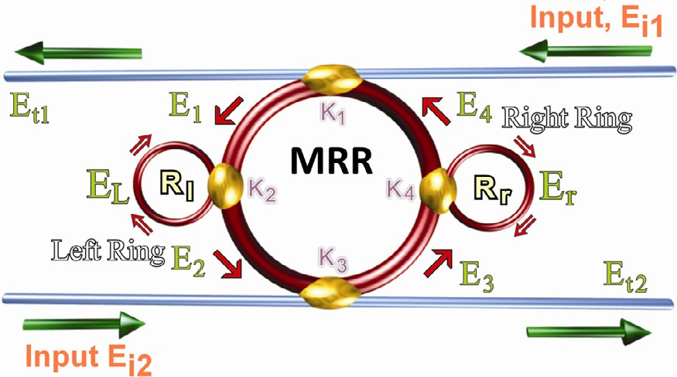*n* = *n* + *n I* = *n*

*n*2

+ *P* (8)

0 2 0

*Aeff*

*E* (*t*)= *E* (*t*)= *E* exp *z* — *ix t* , (9)

*i*1

*i*2

0

2*LD*

0

2

2

2

pﬃﬃﬃﬃﬃﬃﬃﬃﬃﬃﬃﬃ

,1ﬃﬃﬃﬃ—ﬃﬃﬃﬃﬃ*j*ﬃﬃﬃﬃ — p1ﬃﬃﬃﬃ—ﬃﬃﬃﬃﬃ*c*ﬃﬃﬃ*e*—*aLL* —*jkn LL*

*L* =( 1

*E*

*E*

1 — *c* )× 2 2 2 . (10)

Figure 1 Microring resonator system.

2 1 — p(ﬃﬃ1ﬃﬃﬃﬃ—ﬃﬃﬃﬃﬃ*c*ﬃﬃﬃﬃ)ﬃ(ﬃﬃ1ﬃﬃﬃﬃ—ﬃﬃﬃﬃ*j*ﬃﬃﬃﬃﬃ)ﬃﬃ*e*—*aLL* —*jkn LL*

pﬃﬃﬃﬃﬃﬃﬃﬃﬃﬃﬃﬃ

,ﬃﬃﬃﬃﬃﬃﬃﬃﬃﬃﬃﬃﬃ pﬃﬃﬃﬃﬃﬃﬃﬃﬃﬃﬃﬃ —*aLR* —*jkn LR*

*r* 3 4

*E*

= (*E*

chaotic signals are distributed over the wavelength ranges from

1 — p1ﬃﬃﬃﬃ—ﬃﬃﬃﬃﬃ*c*ﬃﬃﬃ,1ﬃﬃﬃﬃ—ﬃﬃﬃﬃﬃ*j*ﬃﬃﬃﬃ*e*—*aLR* —*jkn LR*

1.48 lm to 1.52 lm. These types of signals can be used as car-

rier signals, where information can be carried out by the sig-

*jx* ,*j*ﬃﬃﬃﬃﬃ*E* + *x y* ,*j*ﬃﬃﬃﬃﬃ*E E e*—*aL*—*jkn L*

1 — *c* ) 1 — *j*4 — 1 — *c*4*e* 2 , (11)

4

4

2

*E*

=

1

1

*i*1

2 1

3

*r*

*i*2

4

2

, (12)

nals via an optical communication link [66–68]. In order to

1 — *x x y y E E e*—*aL*—*jkn L*

transmit the signals, a fiber optic transmission link can be used;

1

2

1 2

*L*

*r*

2

therefore, multi soliton pulses can be generated and used in

1

*E* = *E E e*—*aL*—*jkn L* ,

2 *L* 1 4 2

(13)

many applications in optical communications [69–71]. Gener- ated logic code is as ‘‘0010100010010000010110110110001001 011101101101001” within the chaotic signals shown by Fig. 5.

*E* = *x* h*y E E e*—*aL*—*jkn L* + *j*,*j*ﬃﬃﬃﬃﬃ*E* i, (14)

3

2

2

*L*

1

4

2

3

*i*2

The potential of multi soliton pulses can be used for many

applications such as high capacity and secured optical commu-

*E E E e*—*aL*—*jkn L*

nication [72–74]. Thus, the chaotic signals from the through

4 = *r* 3 4

2 . (15)

port of the system in the form of codes can be input into the

*G*2*BE*

*e*—*aL*—*jkn L*

fiber optic transmission link to perform the optical quantum

*Et*1

= *AEi*1

*i*2 4 2

— 1 — *FG*2 [*CEi*1

+ *DEi*2*G*], (16)

transmission process [75–78]. The transmission link system is shown in Fig. 6.

*E G x*2*y*2*Ei*2,*j*ﬃﬃﬃ1ﬃﬃ*j*ﬃﬃﬃ3ﬃ *AE E D E G*

The attenuation of the fiber is 0.4 dB/km, and it has a dis-

17

*t*2 =

1

1

3

*r*

1 — *FG*2 [

*L i*1 + *x j* ,*j*ﬃﬃﬃﬃﬃ*E*

*i*2 ], ( )

persion of 1.67 ps/nm/km and group delay of 0.2 ps/km [79–

[81]](#_bookmark40). Fig. 7 shows the transmitted chaotic signals in the commu-

nication system, which leads to generate spatial multi solitons.

*A* = *x*1*x*2, *B* = *x*1*x*2*y* ,*j*ﬃﬃﬃ1ﬃﬃ*Er*, *C* = *x*2*x*2*j*1,*j*ﬃﬃﬃ3ﬃﬃ*ELEr*,

where

2

1

The ultra-short soliton signals can be obtained after the

*G* = *e*—*aL*—*jkn L* , *D* = (*x x* )2*y y* ,*j j E E*2,

4

2

1

2

1 2

1

3

*L*

*r*

ﬃﬃﬃﬃﬃﬃﬃﬃﬃ

*F* = *x x y y E E* , *x* = (1 — *c* ) , *x* = (1 — *c* ) ,

1/2

1/2

1

2 1 2

*L*

*r*

1

1

2

3

chaotic signals were transmitted along the fiber optic transmis-

sion link, where finally the signals are received by suitable opti- cal receiver; thus, the detection process can be performed via

the optical receiver. The FWHM and FSR of the spatial multi

*y*1 = (1 — *j*1) , and *y*2 = (1 — *j*3) .

1/2

1/2

with *n*0 and *n*2 that are indexes. The optical intensity and the power are presented by *I* and *P*. *E*0 and *z* are the amplitude of optical field and propagation distance respectively [50–52]. *LD* is the dispersion length where, frequency shift of the signal

is *x*0. *j* is the intensity coupling coefficient, *k* = 2*p*/*k* is the wave propagation, *LL* 2*p Rl*, and here, *LR* 2*pRr* and *Rr* is the radius of right ring, and *L* is the circumference of the

= =

MRRs [53–56].

1. Result and discussion

The Gaussians with centered wavelength 1.55 lm and 600 mW power are inputs. In order to form the multi-function opera- tions, for instance, control, tune, amplify, the additional input such as Gaussian with spectral profile is introduced into the system. The ring system exhibits a nonlinear Kerr effect, where the linear and nonlinear refractive indices of the system are *n*0 = 3.34 and *n*2 = 2.7 × 10—17, respectively [57–59]. The

selected radius of the centered ring resonator is *R*MRR =5 lm,

where the right/left rings have equal radius of 1 lm, respec- tively. To make a compact ring, a small bend radius is required [60–62]. The coupling coefficients of the MRRs are chosen as *j*1 = 0.35, *j*2 = 0.2, *j*3 = 0.1, and *j*4 = 0.95. Considering the MRR with radius of 5 lm and coupling coefficient of 0.1, the result of bistability and bifurcation due to the nonlin- ear condition of the medium is presented in Fig. 2.

The interior intensities within the MRRs system (Fig. 1) are presented in Fig. 3.

By generating large bandwidth of chaotic signals, more channel capacity can be obtained and controlled [63–65]. Therefore, stable signals of the chaotic signals and multi soli- ton signals can be seen within the through and drop ports of the system respectively shown in Fig. 4.

Fig. 4 shows the through port chaotic signals where the expansion of the signals can be seen in Fig. 4(b). The generated

soliton signals are 1.34 pm and 80 pm respectively. The tempo-

ral shape of the multi soliton pulses can be seen in Fig. 8. Here the temporal pulses with FWHM of 100 ps could be generated. Therefore, transmission of the chaotic signals along the fiber optics is performed, where the spatial and temporal soli- tons can be generated and detected using a suitable optical receiver. A further investigation on system performance was conducted using a bit-error-rate (BER) calculation. As illus-

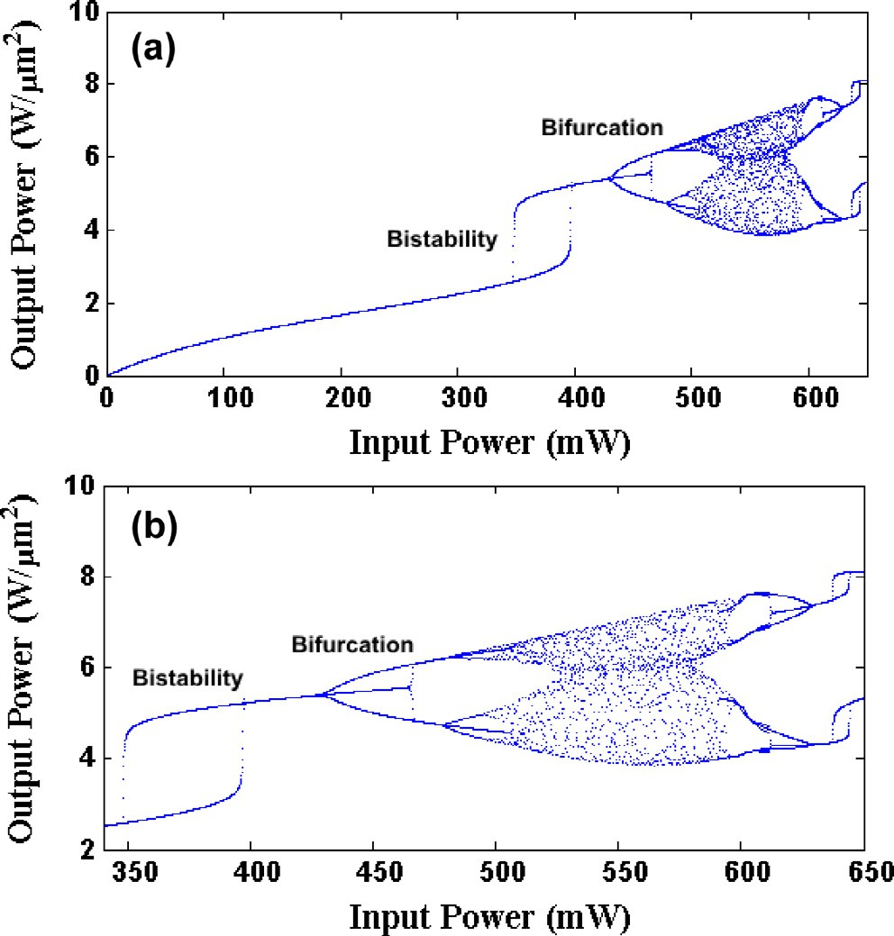

Figure 2 (a) Bifurcation and bistability; input poser versus output power and (b) magnifying (a).

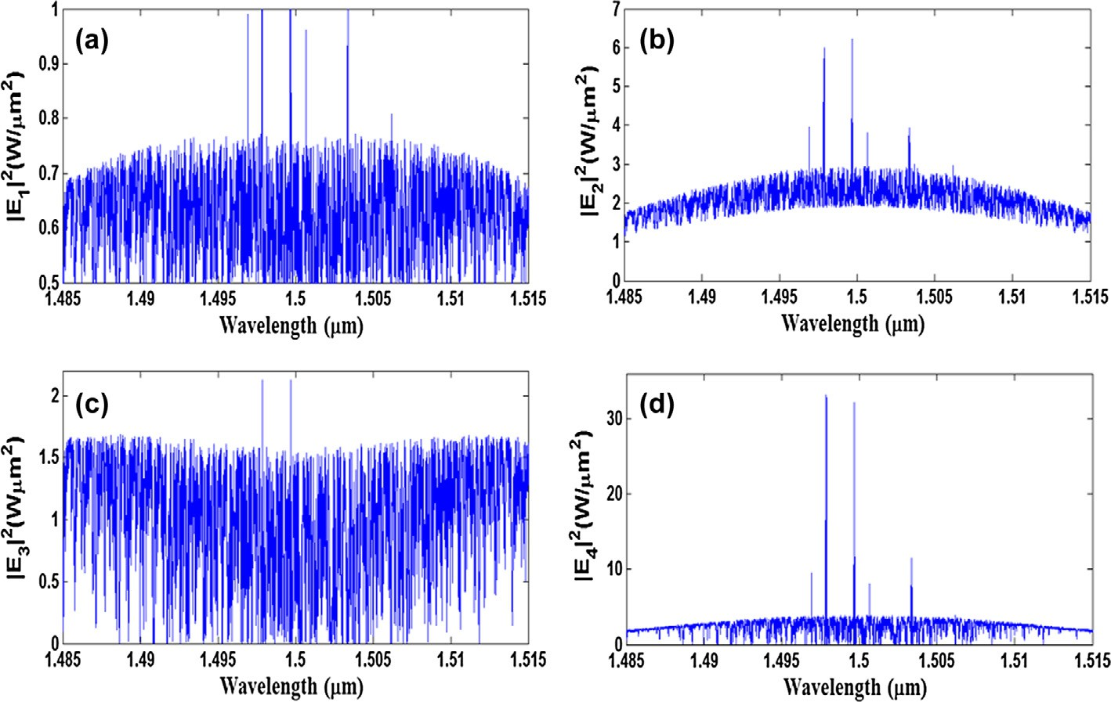

Figure 3 Interior signal generation in the MRRs system, where (a) intensity before *R*l, (b) intensity after *R*l, (c) intensity before *R*r and

(d) intensity after *R*r.

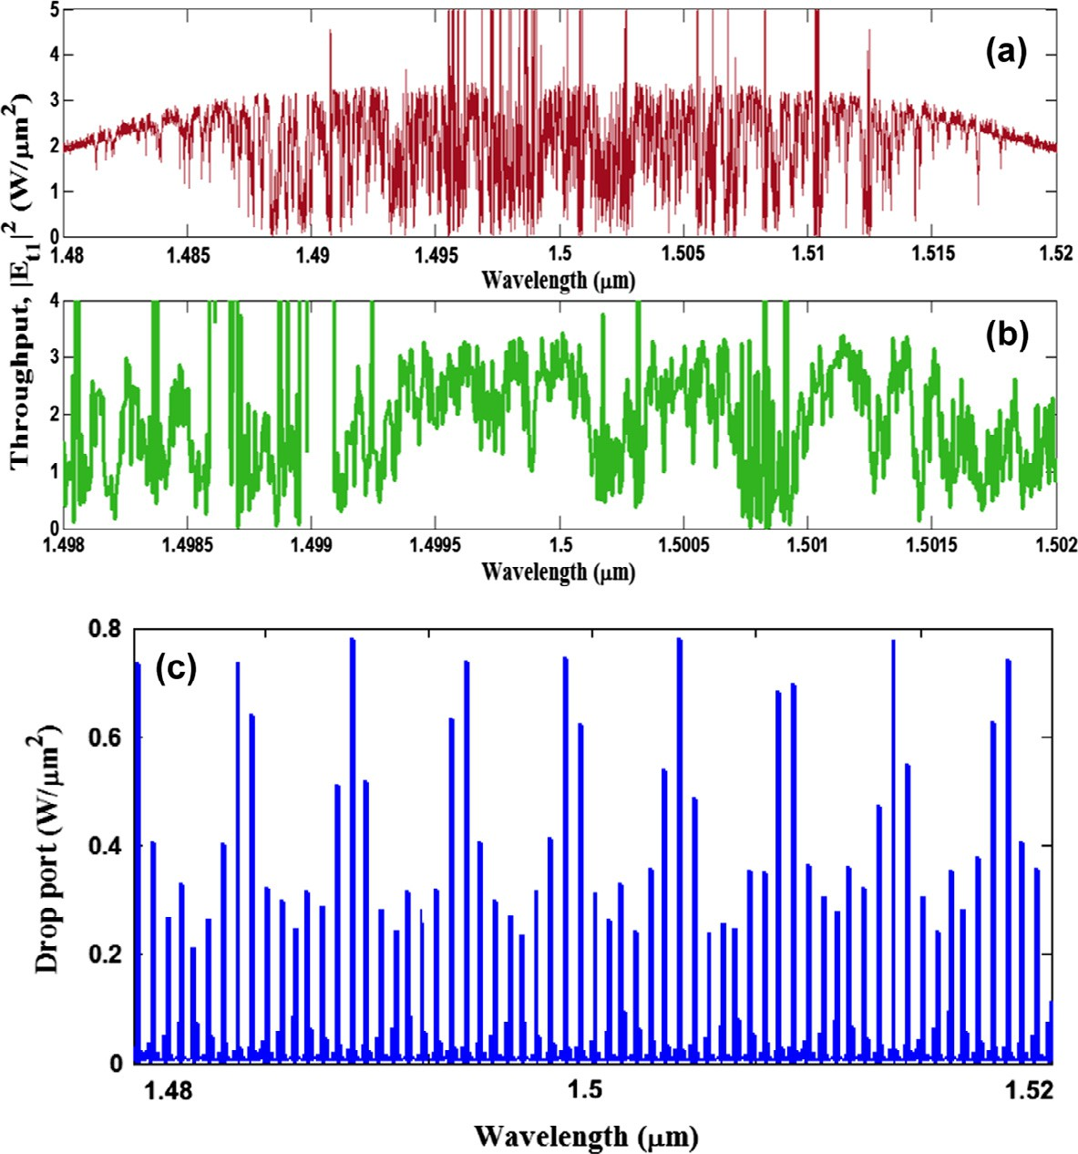

Figure 4 (a) Throughput chaotic signals, (b) expansion of the throughput chaotic signals, and (c) drop port signals.

trated in Fig. 9, the system performance was investigated under three fiber lengths (50, 120 km and 180 km). The

3.8 10—3 of BER in Fig. 8 is the threshold for successful

×

transmission. At the threshold BER there are 22.2, 21.2, and 20 dBm sensitivities for the receiver at fiber transmis- sions at 50, 120 km and 180 km respectively.

—

— —

Therefore, generation of multi soliton pulses and logic code are performed using the microring resonator (MRR) system which is considered as waveguide based device, where the transmission link uses the fiber optics in order to transmit the multi soliton pulses in the form of code thus performing the optical quantum transmission process.

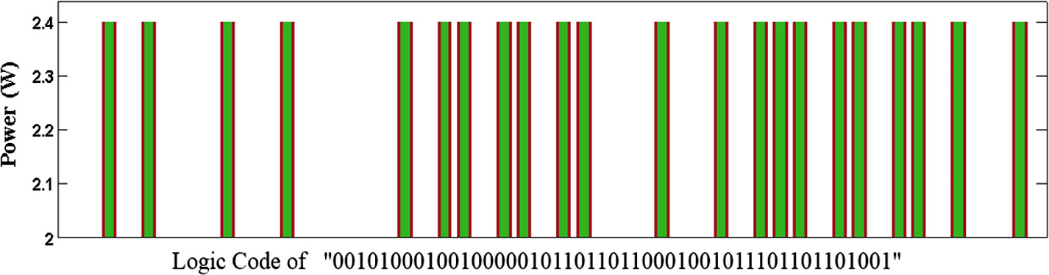

Figure 5 Randomly generated logic codes within the chaotic signals with minimum and maximum intensity power of 2 and 2.4 W/lm2.

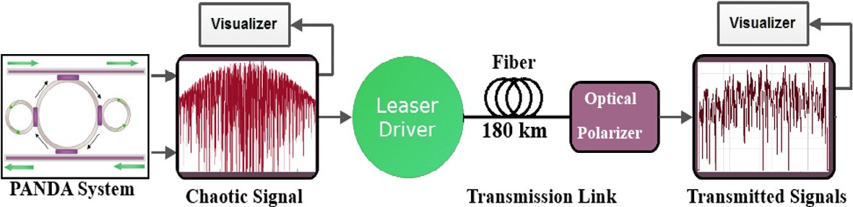

Figure 6 Optical transmission link.

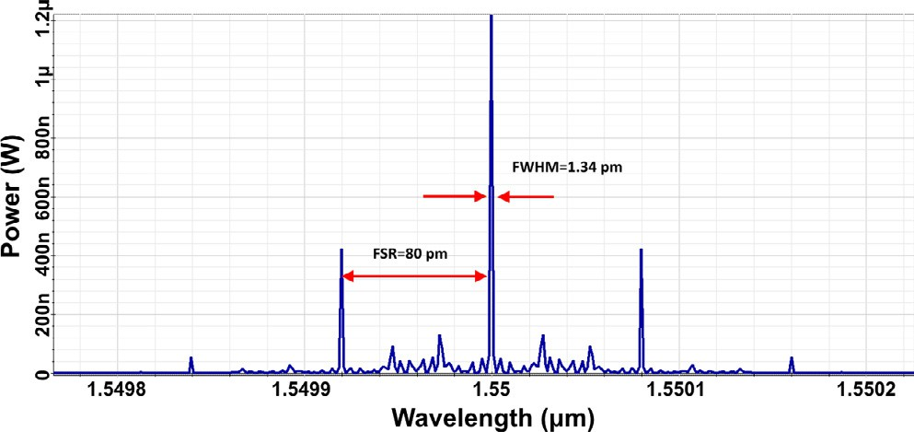

Figure 7 Spatial multi solitons with FWHM = 1.34 pm and FSR = 80 pm.

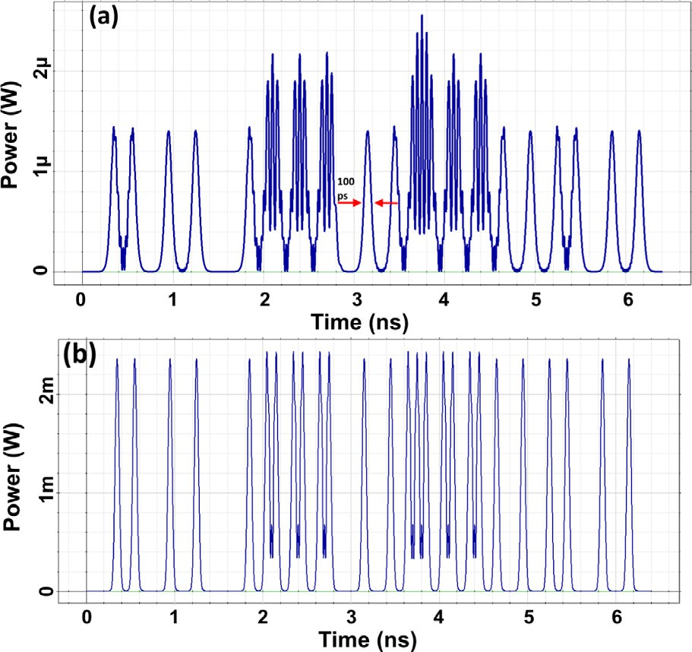

Figure 8 Temporal multi soliton pulses with FWHM of 100 ps,

(a) before filtering and amplification, after filtering and amplification.

Figure 9 System performance under 50, 120 and 180 km fiber lengths.

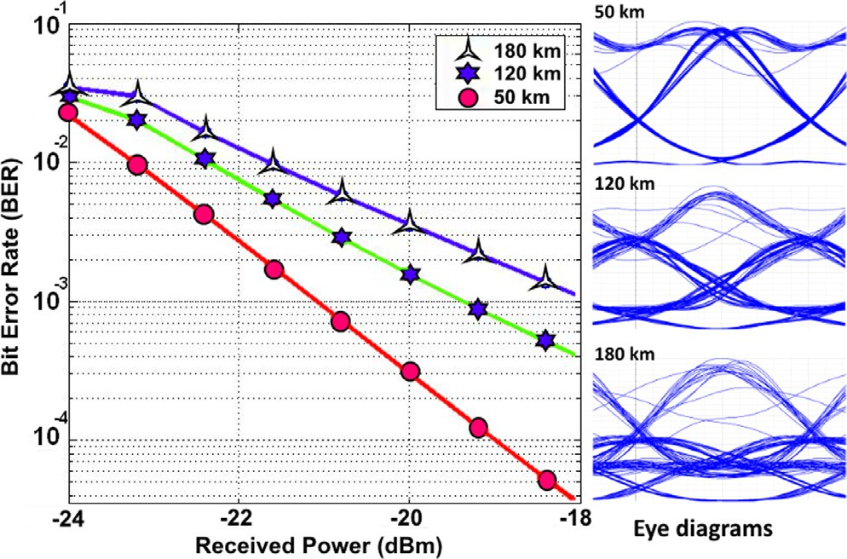The chaos can be generated in MRRs due to the nonlinear- ities [82], where soliton signals are generated due to balancing both nonlinear (Kerr effect) and linear (dispersion) effects [83]. In the proposed system the results of throughput port show more chaos behavior, where the results from drop port show generation of stable signals as solitons. In this study we used the chaotic signals to generate arbitrary code to be used in a communication system. The function of the proposed micror- ing resonators (MRRs) is to combine and filter the inputs as Gaussians with spectral profile. The filtering process was per- formed during round-trip of the inputs within the MRRs on the right and left sides of the centered MRR, therefore, slicing the spectrums obtained.

1. Conclusion

In conclusion, the MRRs are presented to show an application of soliton generation and transmission. The high capacity of chaotic signals can be generated using the MRR system. In order to compress the noisy chaotic signals, we transmit them

as codes via an optical fiber optic transmission link with the length of 180 km. Clear and filtered signals of spatial and tem- poral solitons can be generated and used for many applications in optical communications. Here the spatial and temporal sig- nals with FWHM of 1.34 pm and 100 ps could be generated respectively.

Acknowledgments

IS Amiri would like to acknowledge the grant number LRGS (2015)NGOD/UM/KPT and GA010-2014 (ulung) from the University of Malaya (UM).

References

1. [I.S. Amiri, S.E. Alavi, H. Ahmad, Optically generation and](http://refhub.elsevier.com/S2210-8327(16)30016-3/h0005) [transmission ultra-wideband mode-locked lasers using dual-](http://refhub.elsevier.com/S2210-8327(16)30016-3/h0005) [wavelength fiber laser and microring resonator system, Horizons](http://refhub.elsevier.com/S2210-8327(16)30016-3/h0005) [in World Physics, vol. 287,](http://refhub.elsevier.com/S2210-8327(16)30016-3/h0005) [Novascience, USA, 2015](http://refhub.elsevier.com/S2210-8327(16)30016-3/h0005).
2. [I.S. Amiri, S.E. Alavi, H. Ahmad, Microring resonators used to](http://refhub.elsevier.com/S2210-8327(16)30016-3/h0010) [gain the capacity in a high performance hybrid wavelength](http://refhub.elsevier.com/S2210-8327(16)30016-3/h0010) [division multiplexing system, Horizons in World Physics, vol.](http://refhub.elsevier.com/S2210-8327(16)30016-3/h0010) [287,](http://refhub.elsevier.com/S2210-8327(16)30016-3/h0010) [Novascience, USA, 2015](http://refhub.elsevier.com/S2210-8327(16)30016-3/h0010).
3. I.S. Amiri, S. Alavi, M. Soltanian, R. Penny, A. Supa’at, N. Fisal, H. Ahmad, 2×2 MIMO-OFDM-RoF generation and transmission of double V-band signals using microring resonator system, Opt. Quant. Electron. (2015), [http://dx.doi.](http://dx.doi.org/10.1007/s11082-015-0280-5) [org/10.1007/s11082-015-0280-5](http://dx.doi.org/10.1007/s11082-015-0280-5).
4. [I. Amiri, M. Soltanian, H. Ahmad, Application of microring](http://refhub.elsevier.com/S2210-8327(16)30016-3/h0020) [resonators (MRRs) in optical soliton communications, in:](http://refhub.elsevier.com/S2210-8327(16)30016-3/h0020) [Optical Communication Systems: Fundamentals, Techniques](http://refhub.elsevier.com/S2210-8327(16)30016-3/h0020) [and Applications, Novascience Publisher, 2015, pp. 25–44](http://refhub.elsevier.com/S2210-8327(16)30016-3/h0020).
5. [Iraj Sadegh Amiri, Abdolkarim Afroozeh, Harith Ahmad,](http://refhub.elsevier.com/S2210-8327(16)30016-3/h0025) [Integrated Micro-Ring Photonics: Principles and Applications](http://refhub.elsevier.com/S2210-8327(16)30016-3/h0025) [as Slow Light Devices, Soliton Generation and Optical](http://refhub.elsevier.com/S2210-8327(16)30016-3/h0025) [Transmission, CRC Press, United States, 2015](http://refhub.elsevier.com/S2210-8327(16)30016-3/h0025).
6. [I. Amiri, S. Alavi, A. Supa’at, J. Ali, H. Ahmad, Temporal](http://refhub.elsevier.com/S2210-8327(16)30016-3/h0030) [soliton: generation and applications in optical communications,](http://refhub.elsevier.com/S2210-8327(16)30016-3/h0030) [Jurnal Teknologi 78 (3) (2016)](http://refhub.elsevier.com/S2210-8327(16)30016-3/h0030).
7. [H. Ahmad, M.R.K. Soltanian, I.S. Amiri, S.E. Alavi, A.R.](http://refhub.elsevier.com/S2210-8327(16)30016-3/h0035) [Othman, A.S.M. Supa’at, Carriers generated by mode-locked](http://refhub.elsevier.com/S2210-8327(16)30016-3/h0035) [laser to increase serviceable channels in radio over free space](http://refhub.elsevier.com/S2210-8327(16)30016-3/h0035) [optical systems, IEEE Photonics J. 7 (5) (2015)](http://refhub.elsevier.com/S2210-8327(16)30016-3/h0035).
8. [S.E. Alavi, I.S. Amiri, M. Khalily, A.S.M. Supa’ at, N. Fisal, H.](http://refhub.elsevier.com/S2210-8327(16)30016-3/h0040) [Ahmad, S.M. Idrus, W-band OFDM for radio-over-fibre direct-](http://refhub.elsevier.com/S2210-8327(16)30016-3/h0040) [detection link enabled by frequency nonupling optical up-](http://refhub.elsevier.com/S2210-8327(16)30016-3/h0040) [conversion, IEEE Photonics J. 6 (6) (2014)](http://refhub.elsevier.com/S2210-8327(16)30016-3/h0040).
9. [I.S. Amiri, S.E. Alavi, S.M. Idrus, A.S.M. Supa’at, J. Ali, P.P.](http://refhub.elsevier.com/S2210-8327(16)30016-3/h0045) [Yupapin, W-band OFDM transmission for radio-over-fiber link](http://refhub.elsevier.com/S2210-8327(16)30016-3/h0045) [using solitonic millimeter wave generated by MRR, IEEE J.](http://refhub.elsevier.com/S2210-8327(16)30016-3/h0045) [Quantum Electron. 50 (8) (2014) 622–628](http://refhub.elsevier.com/S2210-8327(16)30016-3/h0045).
10. [I.S. Amiri, A. Afroozeh, M. Bahadoran, Simulation and](http://refhub.elsevier.com/S2210-8327(16)30016-3/h0050) [analysis of multisoliton generation using a PANDA ring](http://refhub.elsevier.com/S2210-8327(16)30016-3/h0050) [resonator system, Chin. Phys. Lett. 28 (10) (2011) 104205](http://refhub.elsevier.com/S2210-8327(16)30016-3/h0050).
11. I.S. Amiri, S.E. Alavi, S.M. Idrus’, Solitonic pulse generation and characterization by integrated ring resonators, in: Presented at the 5th International Conference on Photonics 2014 (ICP2014), Kuala Lumpur, 2014.
12. [M.R.K. Soltanian, I.S. Amiri, W.Y. Chong, S.E. Alavi, H.](http://refhub.elsevier.com/S2210-8327(16)30016-3/h0060) [Ahmad, Stable dual-wavelength coherent source with tunable](http://refhub.elsevier.com/S2210-8327(16)30016-3/h0060) [wavelength spacing generated by spectral slicing a mode-locked](http://refhub.elsevier.com/S2210-8327(16)30016-3/h0060) [laser using microring resonator, IEEE Photonics J. 7 (6) (2015)](http://refhub.elsevier.com/S2210-8327(16)30016-3/h0060).
13. [A. Afroozeh, I.S. Amiri, K. Chaudhary, J. Ali, P.P. Yupapin,](http://refhub.elsevier.com/S2210-8327(16)30016-3/h0065) [Analysis of optical ring resonator, in: Advances in Laser and](http://refhub.elsevier.com/S2210-8327(16)30016-3/h0065) [Optics Research, Nova Science, New York, 2015, pp. 133–146](http://refhub.elsevier.com/S2210-8327(16)30016-3/h0065).
14. [I.S. Amiri, M.H. Khanmirzaei, M. Kouhnavard, P.P. Yupapin,](http://refhub.elsevier.com/S2210-8327(16)30016-3/h0070)

[J. Ali, Quantum entanglement using multi dark soliton](http://refhub.elsevier.com/S2210-8327(16)30016-3/h0070) [correlation for multivariable quantum router, in:](http://refhub.elsevier.com/S2210-8327(16)30016-3/h0070) [A.M. Moran](http://refhub.elsevier.com/S2210-8327(16)30016-3/h0070) [(Ed.), Quantum Entanglemen](http://refhub.elsevier.com/S2210-8327(16)30016-3/h0070)t, [Nova Science Publisher, New](http://refhub.elsevier.com/S2210-8327(16)30016-3/h0070) [York, 2012, pp. 111–122](http://refhub.elsevier.com/S2210-8327(16)30016-3/h0070).

1. [S.E. Alavi, I.S. Amiri, S.M. Idrus, A.S.M. Supa’at, J. Ali,](http://refhub.elsevier.com/S2210-8327(16)30016-3/h0075) [Chaotic signal generation and trapping using an optical](http://refhub.elsevier.com/S2210-8327(16)30016-3/h0075) [transmission link, Life Sci. J. 10 (9s) (2013) 186–192](http://refhub.elsevier.com/S2210-8327(16)30016-3/h0075).
2. [I. Sadegh Amiri, M. Nikmaram, A. Shahidinejad, J. Ali,](http://refhub.elsevier.com/S2210-8327(16)30016-3/h0080) [Generation of potential wells used for quantum codes](http://refhub.elsevier.com/S2210-8327(16)30016-3/h0080) [transmission via a TDMA network communication system,](http://refhub.elsevier.com/S2210-8327(16)30016-3/h0080) [Sec. Commun. Netw. 6 (11) (2013) 1301–1309](http://refhub.elsevier.com/S2210-8327(16)30016-3/h0080).
3. [I.S. Amiri, A. Nikoukar, J. Ali, GHz frequency band soliton](http://refhub.elsevier.com/S2210-8327(16)30016-3/h0085) [generation using integrated ring resonator for WiMAX optical](http://refhub.elsevier.com/S2210-8327(16)30016-3/h0085) [communication, Opt. Quant. Electron. 46 (9) (2013) 1165–1177](http://refhub.elsevier.com/S2210-8327(16)30016-3/h0085).
4. I.S. Amiri, M.R.K. Soltanian, S.E. Alavi, A.R. Othman, M.Z.A. Razak, H. Ahmad, Microring resonator for transmission of solitons via wired/wireless optical communication, J. Opt. (2015), <http://dx.doi.org/10.1007/s12596-015-0269-2>.
5. [I.S. Amiri, R. Ahsan, A. Shahidinejad, J. Ali, P.P. Yupapin,](http://refhub.elsevier.com/S2210-8327(16)30016-3/h0095) [Characterisation of bifurcation and chaos in silicon microring](http://refhub.elsevier.com/S2210-8327(16)30016-3/h0095) [resonator, IET Commun. 6 (16) (2012) 2671–2675](http://refhub.elsevier.com/S2210-8327(16)30016-3/h0095).
6. [S.E. Alavi, I.S. Amiri, M.R.K. Soltanian, R. Penny, A.S.M.](http://refhub.elsevier.com/S2210-8327(16)30016-3/h0100) [Supa’at, H. Ahmad, Multiwavelength generation using an add-](http://refhub.elsevier.com/S2210-8327(16)30016-3/h0100) [drop microring resonator integrated with InGaAsP/InP sampled](http://refhub.elsevier.com/S2210-8327(16)30016-3/h0100) [grating distributed feedback (SG-DFB), Chin. Optics Lett. 14](http://refhub.elsevier.com/S2210-8327(16)30016-3/h0100)

[(2) (2016) 021301](http://refhub.elsevier.com/S2210-8327(16)30016-3/h0100).

1. [I.S. Amiri, J. Ali, Data signal processing via a Manchester](http://refhub.elsevier.com/S2210-8327(16)30016-3/h0105) [coding-decoding method using chaotic signals generated by a](http://refhub.elsevier.com/S2210-8327(16)30016-3/h0105) [PANDA ring resonator, Chin. Opt. Lett. 11 (4) (2013), 041901](http://refhub.elsevier.com/S2210-8327(16)30016-3/h0105)

[(4)](http://refhub.elsevier.com/S2210-8327(16)30016-3/h0105).

1. [I.S. Amiri, S.E. Alavi, J. Ali, High capacity soliton transmission](http://refhub.elsevier.com/S2210-8327(16)30016-3/h0110) [for indoor and outdoor communications using integrated ring](http://refhub.elsevier.com/S2210-8327(16)30016-3/h0110) [resonators, Int. J. Commun Syst 28 (1) (2015) 147–160](http://refhub.elsevier.com/S2210-8327(16)30016-3/h0110).
2. [I.S. Amiri, M. Ranjbar, A. Nikoukar, A. Shahidinejad, J. Ali, P.](http://refhub.elsevier.com/S2210-8327(16)30016-3/h0115) [Yupapin, Multi optical soliton generated by PANDA ring](http://refhub.elsevier.com/S2210-8327(16)30016-3/h0115) [resonator for secure network communication, in: Computer and](http://refhub.elsevier.com/S2210-8327(16)30016-3/h0115) [Communication Engineering (ICCCE) Conference, Malaysia,](http://refhub.elsevier.com/S2210-8327(16)30016-3/h0115) [2012, pp. 760–764](http://refhub.elsevier.com/S2210-8327(16)30016-3/h0115).
3. [I.S. Amiri, M. Ebrahimi, A.H. Yazdavar, S. Gorbani, S.E.](http://refhub.elsevier.com/S2210-8327(16)30016-3/h0120) [Alavi, Sevia M. Idrus, J. Ali, Transmission of data with](http://refhub.elsevier.com/S2210-8327(16)30016-3/h0120) [orthogonal frequency division multiplexing technique for](http://refhub.elsevier.com/S2210-8327(16)30016-3/h0120) [communication networks using GHz frequency band soliton](http://refhub.elsevier.com/S2210-8327(16)30016-3/h0120) [carrier, IET Commun. 8 (8) (2014) 1364–1373](http://refhub.elsevier.com/S2210-8327(16)30016-3/h0120).
4. [S.E. Alavi, I.S. Amiri, S.M. Idrus, A.S.M. Supa’at, J. Ali, Cold](http://refhub.elsevier.com/S2210-8327(16)30016-3/h0125) [laser therapy modeling of human cell/tissue by soliton tweezers,](http://refhub.elsevier.com/S2210-8327(16)30016-3/h0125) [Optik 126 (5) (2015) 578–582](http://refhub.elsevier.com/S2210-8327(16)30016-3/h0125).
5. [P. Sanati, A. Afroozeh, I.S. Amiri, J. Ali, Lee Suan. Chua,](http://refhub.elsevier.com/S2210-8327(16)30016-3/h0130) [Femtosecond pulse generation using microring resonators for](http://refhub.elsevier.com/S2210-8327(16)30016-3/h0130) [eye nano surgery, Nanosci. Nanotechnol. Lett. 6 (3) (2014) 221–](http://refhub.elsevier.com/S2210-8327(16)30016-3/h0130)

[226](http://refhub.elsevier.com/S2210-8327(16)30016-3/h0130).

1. [I.S. Amiri, S.E. Alavi, M.R.K. Soltanian, A.S.M. Supa’at, N.](http://refhub.elsevier.com/S2210-8327(16)30016-3/h0135) [Fisal, H. Ahmad, Generation of femtosecond soliton tweezers](http://refhub.elsevier.com/S2210-8327(16)30016-3/h0135) [using a half-panda system for modeling the trapping of a human](http://refhub.elsevier.com/S2210-8327(16)30016-3/h0135) [red blood cell, J. Comput. Theoret. Nanosci. (JCTN) 12 (1)](http://refhub.elsevier.com/S2210-8327(16)30016-3/h0135) [(2015) 10–18](http://refhub.elsevier.com/S2210-8327(16)30016-3/h0135).
2. [I.S. Amiri, S.E. Alavi, H. Ahmad, Increasing access points in a](http://refhub.elsevier.com/S2210-8327(16)30016-3/h0140) [passive optical network, Opt. Photonics News (2015), Issue:](http://refhub.elsevier.com/S2210-8327(16)30016-3/h0140) [December 2015](http://refhub.elsevier.com/S2210-8327(16)30016-3/h0140).
3. [A. Nikoukar, I.S. Amiri, A. Shahidinejad, A. Shojaei, J. Ali, P.](http://refhub.elsevier.com/S2210-8327(16)30016-3/h0145) [Yupapin, MRR quantum dense coding for optical wireless](http://refhub.elsevier.com/S2210-8327(16)30016-3/h0145) [communication system using decimal convertor, in: Computer](http://refhub.elsevier.com/S2210-8327(16)30016-3/h0145) [and Communication Engineering (ICCCE) Conference,](http://refhub.elsevier.com/S2210-8327(16)30016-3/h0145) [Malaysia,](http://refhub.elsevier.com/S2210-8327(16)30016-3/h0145) [2012, pp. 770–774](http://refhub.elsevier.com/S2210-8327(16)30016-3/h0145).
4. [I.S. Amiri, A. Afroozeh, I.N. Nawi, M.A. Jalil, A. Mohamad, J.](http://refhub.elsevier.com/S2210-8327(16)30016-3/h0150) [Ali, P.P. Yupapin, Dark soliton array for communication](http://refhub.elsevier.com/S2210-8327(16)30016-3/h0150) [security, Proc. Eng. 8 (2011) 417–422](http://refhub.elsevier.com/S2210-8327(16)30016-3/h0150).
5. [I.S. Amiri, A. Afroozeh, M. Bahadoran, J. Ali, P.P. Yupapin,](http://refhub.elsevier.com/S2210-8327(16)30016-3/h0155) [Molecular transporter system for qubits generation, Jurnal](http://refhub.elsevier.com/S2210-8327(16)30016-3/h0155) [Teknologi (Sci. Eng.) 55 (2012) 155–165](http://refhub.elsevier.com/S2210-8327(16)30016-3/h0155).
6. [A. Afroozeh, M. Bahadoran, I.S. Amiri, A.R. Samavati, J. Ali,](http://refhub.elsevier.com/S2210-8327(16)30016-3/h0160)

[P.P. Yupapin, Fast light generation using GaAlAs/GaAs](http://refhub.elsevier.com/S2210-8327(16)30016-3/h0160) [waveguide, Jurnal Teknologi (Sci. Eng.) 57 (2012) 17–23](http://refhub.elsevier.com/S2210-8327(16)30016-3/h0160).

1. [S.E. Alavi, I.S. Amiri, H. Ahmad, N. Fisal, A.S.M. Supa’at,](http://refhub.elsevier.com/S2210-8327(16)30016-3/h0165) [Optical amplification of tweezers and bright soliton using an](http://refhub.elsevier.com/S2210-8327(16)30016-3/h0165) [interferometer ring resonator system, J. Comput. Theoret.](http://refhub.elsevier.com/S2210-8327(16)30016-3/h0165) [Nanosci. (JCTN) 12 (4) (2015) 624–629](http://refhub.elsevier.com/S2210-8327(16)30016-3/h0165).
2. [A. Afroozeh, A. Zeinalinezhad, I.S. Amiri, S.E. Pourmand, Stop](http://refhub.elsevier.com/S2210-8327(16)30016-3/h0170) [light generation using nano ring resonators for read only](http://refhub.elsevier.com/S2210-8327(16)30016-3/h0170) [memory, J. Comput. Theoret. Nanosci. (JCTN) 12 (3) (2014)](http://refhub.elsevier.com/S2210-8327(16)30016-3/h0170)

[468–472](http://refhub.elsevier.com/S2210-8327(16)30016-3/h0170).

1. [A. Afroozeh, I.S. Amiri, A. Samavati, J. Ali, P. Yupapin, THz](http://refhub.elsevier.com/S2210-8327(16)30016-3/h0175) [frequency generation using MRRs for THz imaging, in:](http://refhub.elsevier.com/S2210-8327(16)30016-3/h0175) [International Conference on Enabling Science and](http://refhub.elsevier.com/S2210-8327(16)30016-3/h0175) [Nanotechnology (EsciNano), Kuala Lumpur, Malaysia, 2012,](http://refhub.elsevier.com/S2210-8327(16)30016-3/h0175)

[pp. 1–2](http://refhub.elsevier.com/S2210-8327(16)30016-3/h0175).

1. [A. Afroozeh, I.S. Amiri, J. Ali, P.P. Yupapin, Determination of](http://refhub.elsevier.com/S2210-8327(16)30016-3/h0180) [FWHM for solition trapping, Jurnal Teknologi (Sci. Eng.) 55](http://refhub.elsevier.com/S2210-8327(16)30016-3/h0180) [(2012) 77–83](http://refhub.elsevier.com/S2210-8327(16)30016-3/h0180).
2. [A. Afroozeh, I.S. Amiri, M. Kouhnavard, M. Jalil, J. Ali, P.](http://refhub.elsevier.com/S2210-8327(16)30016-3/h0185) [Yupapin, Optical dark and bright soliton generation and](http://refhub.elsevier.com/S2210-8327(16)30016-3/h0185) [amplification, AIP Conf. Proc. 1341 (2010) 259–263](http://refhub.elsevier.com/S2210-8327(16)30016-3/h0185).
3. [I.S. Amiri, A. Afroozeh, J. Ali, P.P. Yupapin, Generation of](http://refhub.elsevier.com/S2210-8327(16)30016-3/h0190) [quantum codes using up and down link optical solition, Jurnal](http://refhub.elsevier.com/S2210-8327(16)30016-3/h0190) [Teknologi (Sci. Eng.) 55 (2012) 97–106](http://refhub.elsevier.com/S2210-8327(16)30016-3/h0190).
4. [I.S. Amiri, S.E. Alavi, M. Bahadoran, A. Afroozeh, H. Ahmad,](http://refhub.elsevier.com/S2210-8327(16)30016-3/h0195) [Nanometer bandwidth soliton generation and experimental](http://refhub.elsevier.com/S2210-8327(16)30016-3/h0195) [transmission within nonlinear fiber optics using an add-drop](http://refhub.elsevier.com/S2210-8327(16)30016-3/h0195) [filter system, J. Comput. Theoret. Nanosci. (JCTN) 12 (2) (2015)](http://refhub.elsevier.com/S2210-8327(16)30016-3/h0195) [221–225](http://refhub.elsevier.com/S2210-8327(16)30016-3/h0195).
5. [A. Shahidinejad, A. Nikoukar, I.S. Amiri, M. Ranjbar, A.](http://refhub.elsevier.com/S2210-8327(16)30016-3/h0200) [Shojaei, J. Ali, P. Yupapin, Network system engineering by](http://refhub.elsevier.com/S2210-8327(16)30016-3/h0200) [controlling the chaotic signals using silicon micro ring resonator,](http://refhub.elsevier.com/S2210-8327(16)30016-3/h0200) [in: Computer and Communication Engineering (ICCCE)](http://refhub.elsevier.com/S2210-8327(16)30016-3/h0200) [Conference, Malaysia, 2012, pp. 765–769](http://refhub.elsevier.com/S2210-8327(16)30016-3/h0200).
6. [M. Kouhnavard, I.S. Amiri, M. Jalil, A. Afroozeh, J. Ali, P.P.](http://refhub.elsevier.com/S2210-8327(16)30016-3/h0205) [Yupapin, QKD via a quantum wavelength router using spatial](http://refhub.elsevier.com/S2210-8327(16)30016-3/h0205) [soliton, AIP Conf. Proc. 1347 (2010) 210–216](http://refhub.elsevier.com/S2210-8327(16)30016-3/h0205).
7. [I.S. Amiri, A. Nikoukar, A. Shahidinejad, T. Anwar, J. Ali,](http://refhub.elsevier.com/S2210-8327(16)30016-3/h0210) [Quantum transmission of optical tweezers via fiber optic using](http://refhub.elsevier.com/S2210-8327(16)30016-3/h0210) [half-panda system, Life Sci. J. 10 (12s) (2014) 391–400](http://refhub.elsevier.com/S2210-8327(16)30016-3/h0210).
8. [Iraj Sadegh Amiri, Falah Jabar Rahim, Ari Sabir Arif, Sogand.](http://refhub.elsevier.com/S2210-8327(16)30016-3/h0215) [Ghorbani, Parisa Naraei, David Forsyth, Jalil Ali, Single soliton](http://refhub.elsevier.com/S2210-8327(16)30016-3/h0215) [bandwidth generation and manipulation by microring](http://refhub.elsevier.com/S2210-8327(16)30016-3/h0215) [resonator, Life Sci. J. 10 (12s) (2014) 904–910](http://refhub.elsevier.com/S2210-8327(16)30016-3/h0215).
9. [I. Amiri, S. Alavi, A. Supa’at, J. Ali, H. Ahmad, Temporal](http://refhub.elsevier.com/S2210-8327(16)30016-3/h0220) [soliton: generation and applications in optical communications,](http://refhub.elsevier.com/S2210-8327(16)30016-3/h0220) [Jurnal Teknologi (Sci. Eng.) 78 (3) (2015)](http://refhub.elsevier.com/S2210-8327(16)30016-3/h0220).
10. [I.S. Amiri, B. Barati, P. Sanati, A. Hosseinnia, H.R. Mansouri](http://refhub.elsevier.com/S2210-8327(16)30016-3/h0225) [Khosravi, S. Pourmehdi, A. Emami, J. Ali, Optical stretcher of](http://refhub.elsevier.com/S2210-8327(16)30016-3/h0225) [biological cells using sub-nanometer optical tweezers generated](http://refhub.elsevier.com/S2210-8327(16)30016-3/h0225) [by an add/drop microring resonator system, Nanosci.](http://refhub.elsevier.com/S2210-8327(16)30016-3/h0225) [Nanotechnol. Lett. 6 (2) (2014) 111–117](http://refhub.elsevier.com/S2210-8327(16)30016-3/h0225).
11. [I.S. Amiri, J. Ali, Generating highly dark-bright solitons by](http://refhub.elsevier.com/S2210-8327(16)30016-3/h0230) [gaussian beam propagation in a PANDA ring resonator, J.](http://refhub.elsevier.com/S2210-8327(16)30016-3/h0230) [Comput. Theoret. Nanosci. (JCTN) 11 (4) (2014) 1092–1099](http://refhub.elsevier.com/S2210-8327(16)30016-3/h0230).
12. [I.S. Amiri, J. Ali, Picosecond soliton pulse generation using a](http://refhub.elsevier.com/S2210-8327(16)30016-3/h0235) [PANDA system for solar cells fabrication, J. Comput. Theoret.](http://refhub.elsevier.com/S2210-8327(16)30016-3/h0235) [Nanosci. (JCTN) 11 (3) (2014) 693–701](http://refhub.elsevier.com/S2210-8327(16)30016-3/h0235).
13. [I.S. Amiri, M.R.K. Soltanian, S.E. Alavi, H. Ahmad, Multi](http://refhub.elsevier.com/S2210-8327(16)30016-3/h0240) [wavelength mode-lock soliton generation using fiber laser loop](http://refhub.elsevier.com/S2210-8327(16)30016-3/h0240) [coupled to an add-drop ring resonator, Opt. Quant. Electron. 47](http://refhub.elsevier.com/S2210-8327(16)30016-3/h0240)

[(8) (2015) 2455–2464](http://refhub.elsevier.com/S2210-8327(16)30016-3/h0240).

1. [I.S. Amiri, S.E. Alavi, H. Ahmad, Radio frequency signal](http://refhub.elsevier.com/S2210-8327(16)30016-3/h0245) [generation and wireless transmission using PANDA and](http://refhub.elsevier.com/S2210-8327(16)30016-3/h0245)

[add/drop systems, J. Comput. Theoret. Nanosci. (JCTN) 12](http://refhub.elsevier.com/S2210-8327(16)30016-3/h0245)

[(8) (2015) 1770–1774](http://refhub.elsevier.com/S2210-8327(16)30016-3/h0245).

1. [C. Tanaram, C. Teeka, R. Jomtarak, P.P. Yupapin, M.A. Jalil,](http://refhub.elsevier.com/S2210-8327(16)30016-3/h0250)

[I.S. Amiri, J. Ali, ASK-to-PSK generation based on nonlinear](http://refhub.elsevier.com/S2210-8327(16)30016-3/h0250) [microring resonators coupled to one MZI arm, Proc. Eng. 8](http://refhub.elsevier.com/S2210-8327(16)30016-3/h0250) [(2011) 432–435](http://refhub.elsevier.com/S2210-8327(16)30016-3/h0250).

1. [A. Afroozeh, I.S. Amiri, S.E. Pourmand, A. Zeinalinezhad, S.E.](http://refhub.elsevier.com/S2210-8327(16)30016-3/h0255) [Alavi, H. Ahmad, Comparison of control light using Kramers-](http://refhub.elsevier.com/S2210-8327(16)30016-3/h0255) [Kronig method by three waveguides, J. Comput. Theoret.](http://refhub.elsevier.com/S2210-8327(16)30016-3/h0255) [Nanosci. (JCTN) 12 (8) (2015) 1864–1868](http://refhub.elsevier.com/S2210-8327(16)30016-3/h0255).
2. [I.S. Amiri, S.E. Alavi, Sevia M. Idrus, A. Nikoukar, J. Ali,](http://refhub.elsevier.com/S2210-8327(16)30016-3/h0260) [IEEE 802.15.3c WPAN standard using millimeter optical soliton](http://refhub.elsevier.com/S2210-8327(16)30016-3/h0260) [pulse generated by a panda ring resonator, IEEE Photonics J. 5](http://refhub.elsevier.com/S2210-8327(16)30016-3/h0260)

[(5) (2013) 7901912](http://refhub.elsevier.com/S2210-8327(16)30016-3/h0260).

1. [I. Amiri, S. Alavi, A. Supa’at, J. Ali, H. Ahmad, The analysis of](http://refhub.elsevier.com/S2210-8327(16)30016-3/h0265) [phase, dispersion and group delay in InGaAsP/InP microring](http://refhub.elsevier.com/S2210-8327(16)30016-3/h0265) [resonator, Jurnal Teknologi (Sci. Eng.) 78 (3) (2015)](http://refhub.elsevier.com/S2210-8327(16)30016-3/h0265).
2. [I.S. Amiri, S.E. Alavi, H. Ahmad, Analytical treatment of the](http://refhub.elsevier.com/S2210-8327(16)30016-3/h0270) [ring resonator passive systems and bandwidth characterization](http://refhub.elsevier.com/S2210-8327(16)30016-3/h0270) [using directional coupling coefficients, J. Comput. Theoret.](http://refhub.elsevier.com/S2210-8327(16)30016-3/h0270) [Nanosci. (JCTN) 12 (3) (2015) 418–424](http://refhub.elsevier.com/S2210-8327(16)30016-3/h0270).
3. [I.S. Amiri, S. Soltanmohammadi, A. Shahidinejad, J. Ali,](http://refhub.elsevier.com/S2210-8327(16)30016-3/h0275) [Optical quantum transmitter with finesse of 30 at 800-nm](http://refhub.elsevier.com/S2210-8327(16)30016-3/h0275) [central wavelength using microring resonators, Opt. Quant.](http://refhub.elsevier.com/S2210-8327(16)30016-3/h0275) [Electron. 45 (10) (2013) 1095–1105](http://refhub.elsevier.com/S2210-8327(16)30016-3/h0275).
4. [I.S. Amiri, P. Naraei, J. Ali, Review and theory of optical](http://refhub.elsevier.com/S2210-8327(16)30016-3/h0280) [soliton generation used to improve the security and high](http://refhub.elsevier.com/S2210-8327(16)30016-3/h0280) [capacity of MRR and NRR passive systems, J. Comput.](http://refhub.elsevier.com/S2210-8327(16)30016-3/h0280) [Theoret. Nanosci. (JCTN) 11 (9) (2014) 1875–1886](http://refhub.elsevier.com/S2210-8327(16)30016-3/h0280).
5. [C. Teeka, S. Songmuang, R. Jomtarak, P. Yupapin, M. Jalil, I.](http://refhub.elsevier.com/S2210-8327(16)30016-3/h0285)

[S. Amiri, J. Ali, ASK-to-PSK generation based on nonlinear](http://refhub.elsevier.com/S2210-8327(16)30016-3/h0285) [microring resonators coupled to one MZI arm, AIP Conf. Proc.](http://refhub.elsevier.com/S2210-8327(16)30016-3/h0285) [1341 (1) (2011) 221–223](http://refhub.elsevier.com/S2210-8327(16)30016-3/h0285).

1. [S.E. Alavi, I.S. Amiri, S.M. Idrus, A.S.M. Supa’at, Generation](http://refhub.elsevier.com/S2210-8327(16)30016-3/h0290) [and wired/wireless transmission of IEEE802.16m signal using](http://refhub.elsevier.com/S2210-8327(16)30016-3/h0290) [solitons generated by microring resonator, Opt. Quant.](http://refhub.elsevier.com/S2210-8327(16)30016-3/h0290) [Electron. 47 (5) (2014) 975–984](http://refhub.elsevier.com/S2210-8327(16)30016-3/h0290).
2. [I.S. Amiri, J. Ali, Nano particle trapping by ultra-short tweezer](http://refhub.elsevier.com/S2210-8327(16)30016-3/h0295) [and wells using MRR interferometer system for spectroscopy](http://refhub.elsevier.com/S2210-8327(16)30016-3/h0295) [application, Nanosci. Nanotechnol. Lett. 5 (8) (2013) 850–856](http://refhub.elsevier.com/S2210-8327(16)30016-3/h0295).
3. [B. Bortnik, Y.-C. Hung, H. Tazawa, B.-J. Seo, J. Luo, A.K. Jen,](http://refhub.elsevier.com/S2210-8327(16)30016-3/h0300)

[W.H. Steier, H.R. Fetterman, Electrooptic polymer ring](http://refhub.elsevier.com/S2210-8327(16)30016-3/h0300) [resonator modulation up to 165 GHz, IEEE J. Select. Topics](http://refhub.elsevier.com/S2210-8327(16)30016-3/h0300) [Quant. Electron. 13 (1) (2007) 104–110](http://refhub.elsevier.com/S2210-8327(16)30016-3/h0300).

1. [Q. Xu, D. Fattal, R.G. Beausoleil, Silicon microring resonators](http://refhub.elsevier.com/S2210-8327(16)30016-3/h0305) [with 1.5-lm radius, Opt. Express 16 (6) (2008) 4309–4315](http://refhub.elsevier.com/S2210-8327(16)30016-3/h0305).
2. [W. Bogaerts, P. Dumon, D. Van Thourhout, D. Taillaert, P.](http://refhub.elsevier.com/S2210-8327(16)30016-3/h0310) [Jaenen, J. Wouters, S. Beckx, V. Wiaux, R.G. Baets, Compact](http://refhub.elsevier.com/S2210-8327(16)30016-3/h0310) [wavelength-selective functions in silicon-on-insulator photonic](http://refhub.elsevier.com/S2210-8327(16)30016-3/h0310) [wires, IEEE J. Select. Topics Quant. Electron. 12 (6) (2006)](http://refhub.elsevier.com/S2210-8327(16)30016-3/h0310) [1394–1401](http://refhub.elsevier.com/S2210-8327(16)30016-3/h0310).
3. [I.S. Amiri, J. Ali, P.P. Yupapin, Enhancement of FSR and](http://refhub.elsevier.com/S2210-8327(16)30016-3/h0315) [finesse using add/drop filter and PANDA ring resonator](http://refhub.elsevier.com/S2210-8327(16)30016-3/h0315) [systems, Int. J. Mod. Phys. B 26 (04) (2012) 1250034](http://refhub.elsevier.com/S2210-8327(16)30016-3/h0315).
4. [I.S. Amiri, S.E. Alavi, M.R.K. Soltanian, H. Ahmad, N. Fisal,](http://refhub.elsevier.com/S2210-8327(16)30016-3/h0320)

[A.S.M. Supa’at, Experimental measurement of fiber-wireless](http://refhub.elsevier.com/S2210-8327(16)30016-3/h0320) [(Fi-Wi) transmission via multi mode locked solitons from a ring](http://refhub.elsevier.com/S2210-8327(16)30016-3/h0320) [laser EDF cavity, IEEE Photonics J. 7 (2) (2015)](http://refhub.elsevier.com/S2210-8327(16)30016-3/h0320).

1. [A. Afroozeh, I.S. Amiri, M.A. Jalil, M. Kouhnavard, J. Ali, P.P.](http://refhub.elsevier.com/S2210-8327(16)30016-3/h0325) [Yupapin, Multi soliton generation for enhance optical](http://refhub.elsevier.com/S2210-8327(16)30016-3/h0325) [communication, Appl. Mech. Mater. 83 (2011) 136–140](http://refhub.elsevier.com/S2210-8327(16)30016-3/h0325).
2. [S.E. Alavi, I.S. Amiri, H. Ahmad, A.S.M. Supa’at, N. Fisal,](http://refhub.elsevier.com/S2210-8327(16)30016-3/h0330) [Generation and transmission of 3](http://refhub.elsevier.com/S2210-8327(16)30016-3/h0330) × [3 W-band MIMO-OFDM-](http://refhub.elsevier.com/S2210-8327(16)30016-3/h0330) [RoF signals using micro-ring resonators, Appl. Opt. 53 (34)](http://refhub.elsevier.com/S2210-8327(16)30016-3/h0330) [(2014) 8049–8054](http://refhub.elsevier.com/S2210-8327(16)30016-3/h0330).
3. [I.S. Amiri, A. Nikoukar, A. Shahidinejad, J. Ali, P. Yupapin,](http://refhub.elsevier.com/S2210-8327(16)30016-3/h0335) [Generation of discrete frequency and wavelength for secured](http://refhub.elsevier.com/S2210-8327(16)30016-3/h0335) [computer networks system using integrated ring resonators, in:](http://refhub.elsevier.com/S2210-8327(16)30016-3/h0335)

[Computer and Communication Engineering (ICCCE)](http://refhub.elsevier.com/S2210-8327(16)30016-3/h0335) [Conference, Malaysia, pp. 775–778](http://refhub.elsevier.com/S2210-8327(16)30016-3/h0335).

1. [A. Afroozeh, I.S. Amiri, M. Bahadoran, J. Ali, P.P. Yupapin,](http://refhub.elsevier.com/S2210-8327(16)30016-3/h0340) [Simulation of soliton amplification in micro ring resonator for](http://refhub.elsevier.com/S2210-8327(16)30016-3/h0340) [optical communication, Jurnal Teknologi (Sci. Eng.) 55 (2012)](http://refhub.elsevier.com/S2210-8327(16)30016-3/h0340) [271–277](http://refhub.elsevier.com/S2210-8327(16)30016-3/h0340).
2. [S.E. Alavi, I.S. Amiri, S.M. Idrus, A.S.M. Supa’at, J. Ali, P.P.](http://refhub.elsevier.com/S2210-8327(16)30016-3/h0345) [Yupapin, All optical OFDM generation for IEEE802.11a based](http://refhub.elsevier.com/S2210-8327(16)30016-3/h0345) [on soliton carriers using microring resonators, IEEE Photonics](http://refhub.elsevier.com/S2210-8327(16)30016-3/h0345)

[J. 6 (1) (2014)](http://refhub.elsevier.com/S2210-8327(16)30016-3/h0345).

1. [M. Soltanian, I.S. Amiri, S.E. Alavi, H. Ahmad, All optical](http://refhub.elsevier.com/S2210-8327(16)30016-3/h0350) [ultra-wideband signal generation and transmission using mode-](http://refhub.elsevier.com/S2210-8327(16)30016-3/h0350) [locked laser incorporated with add-drop microring resonator](http://refhub.elsevier.com/S2210-8327(16)30016-3/h0350) [(MRR), Laser Phys. Lett. 12 (6) (2015)](http://refhub.elsevier.com/S2210-8327(16)30016-3/h0350).
2. [I.S. Amiri, S.E. Alavi, N. Fisal, A.S.M. Supa’at, H. Ahmad, All-](http://refhub.elsevier.com/S2210-8327(16)30016-3/h0355) [optical generation of two IEEE802.11n signals for 2](http://refhub.elsevier.com/S2210-8327(16)30016-3/h0355) × [2 MIMO-](http://refhub.elsevier.com/S2210-8327(16)30016-3/h0355) [RoF via MRR system, IEEE Photonics J. 6 (6) (2014)](http://refhub.elsevier.com/S2210-8327(16)30016-3/h0355).
3. [Y.S. Neo, S.M. Idrus, M.F. Rahmat, S.E. Alavi, I.S. Amiri’,](http://refhub.elsevier.com/S2210-8327(16)30016-3/h0360) [Adaptive control for laser transmitter feedforward linearization](http://refhub.elsevier.com/S2210-8327(16)30016-3/h0360) [system, IEEE Photonics J. 6 (4) (2014)](http://refhub.elsevier.com/S2210-8327(16)30016-3/h0360).
4. [I.S. Amiri, K. Raman, A. Afroozeh, M.A. Jalil, I.N. Nawi, J.](http://refhub.elsevier.com/S2210-8327(16)30016-3/h0365) [Ali, P.P. Yupapin, Generation of DSA for security application,](http://refhub.elsevier.com/S2210-8327(16)30016-3/h0365) [Proc. Eng. 8 (2011) 360–365](http://refhub.elsevier.com/S2210-8327(16)30016-3/h0365).
5. [S.E. Alavi, I.S. Amiri, S.M. Idrus, J. Ali, Optical wired/wireless](http://refhub.elsevier.com/S2210-8327(16)30016-3/h0370) [communication using soliton optical tweezers, Life Sci. J. 10](http://refhub.elsevier.com/S2210-8327(16)30016-3/h0370) [(12s) (2013) 179–187](http://refhub.elsevier.com/S2210-8327(16)30016-3/h0370).
6. [I.S. Amiri, J. Ali, Femtosecond optical quantum memory](http://refhub.elsevier.com/S2210-8327(16)30016-3/h0375) [generation using optical bright soliton, J. Comput. Theoret.](http://refhub.elsevier.com/S2210-8327(16)30016-3/h0375) [Nanosci. (JCTN) 11 (6) (2014) 1480–1485](http://refhub.elsevier.com/S2210-8327(16)30016-3/h0375).
7. [I.S. Amiri, S.E. Alavi, M.R.K. Soltanian, N. Fisal, A.S.M.](http://refhub.elsevier.com/S2210-8327(16)30016-3/h0380) [Supa’at, H. Ahmad, Increment of access points in integrated](http://refhub.elsevier.com/S2210-8327(16)30016-3/h0380) [system of wavelength division multiplexed passive optical](http://refhub.elsevier.com/S2210-8327(16)30016-3/h0380) [network radio over fiber, Sci. Rep. 5 (2015)](http://refhub.elsevier.com/S2210-8327(16)30016-3/h0380).
8. [I.S. Amiri, S.E. Alavi, H. Ahmad, A.S.M. Supa’at, N. Fisal,](http://refhub.elsevier.com/S2210-8327(16)30016-3/h0385) [Numerical computation of solitonic pulse generation for terabit/](http://refhub.elsevier.com/S2210-8327(16)30016-3/h0385) [sec data transmission, Opt. Quant. Electron. 47 (7) (2014) 1765–](http://refhub.elsevier.com/S2210-8327(16)30016-3/h0385)

[1777](http://refhub.elsevier.com/S2210-8327(16)30016-3/h0385).

1. [S.E. Alavi, I.S. Amiri, A.S.M. Supa’at, S.M. Idrus, Indoor data](http://refhub.elsevier.com/S2210-8327(16)30016-3/h0390) [transmission over ubiquitous infrastructure of powerline cables](http://refhub.elsevier.com/S2210-8327(16)30016-3/h0390) [and LED lighting, J. Comput. Theoret. Nanosci. (JCTN) 12 (4)](http://refhub.elsevier.com/S2210-8327(16)30016-3/h0390) [(2015) 599–604](http://refhub.elsevier.com/S2210-8327(16)30016-3/h0390).
2. [I.S. Amiri, J. Ali, Optical quantum generation and transmission](http://refhub.elsevier.com/S2210-8327(16)30016-3/h0395) [of 57–61 GHz frequency band using an optical fiber optics, J.](http://refhub.elsevier.com/S2210-8327(16)30016-3/h0395) [Comput. Theoret. Nanosci. (JCTN) 11 (10) (2014) 2130–2135](http://refhub.elsevier.com/S2210-8327(16)30016-3/h0395).
3. [M.R.K. Soltanian, H. Ahmad, A. Khodaie, I.S. Amiri, M.F.](http://refhub.elsevier.com/S2210-8327(16)30016-3/h0400) [Ismail, S.W. Harun, A stable dual-wavelength thulium-doped](http://refhub.elsevier.com/S2210-8327(16)30016-3/h0400) [fiber laser at 1.9 lm using photonic crystal fiber, Sci. Rep. 5](http://refhub.elsevier.com/S2210-8327(16)30016-3/h0400) [(2015). Article number: 14537](http://refhub.elsevier.com/S2210-8327(16)30016-3/h0400).
4. [S.E. Alavi, M.R.K. Soltanian, I.S. Amiri, M. Khalily, A.S.M.](http://refhub.elsevier.com/S2210-8327(16)30016-3/h0405) [Supa’at, H. Ahmad, Towards 5G: a photonic based millimeter](http://refhub.elsevier.com/S2210-8327(16)30016-3/h0405) [wave signal generation for applying in 5G access fronthaul, Sci.](http://refhub.elsevier.com/S2210-8327(16)30016-3/h0405) [Rep. 6 (2016)](http://refhub.elsevier.com/S2210-8327(16)30016-3/h0405).
5. [P. Yupapin, W. Suwancharoen, Chaotic signal generation and](http://refhub.elsevier.com/S2210-8327(16)30016-3/h0410) [cancellation using a micro ring resonator incorporating an optical](http://refhub.elsevier.com/S2210-8327(16)30016-3/h0410) [add/drop multiplexer, Opt. Commun. 280 (2) (2007) 343–350](http://refhub.elsevier.com/S2210-8327(16)30016-3/h0410).
6. [C. Pask, A. Vatarescu, Spectral approach to pulse propagation](http://refhub.elsevier.com/S2210-8327(16)30016-3/h0415) [in a dispersive nonlinear medium, JOSA B 3 (7) (1986) 1018–](http://refhub.elsevier.com/S2210-8327(16)30016-3/h0415)

[1024](http://refhub.elsevier.com/S2210-8327(16)30016-3/h0415).