Available online at [www.sciencedirect.com](http://www.sciencedirect.com/)



**ScienceDirect**

AASRI Procedia 8 (2014) 22 – 29

2014 AASRI Conference on Sports Engineering and Computer Science (SECS 2014)

Validity Analysis of Wii Balance Board Versus Baropodometer Platform Using an Open Custom Integrated Application

Francesco Sgrò*a, Giuseppe Monteleone b, Marica Pavone a, Mario Lipomaa

*a University of Enna “Kore”, Cittadella Universitaria, Enna, Italy*

*bUniversity of Catania, Catania, Italy*

**Abstract**

Standing balance tests represent the most common way to assess person’s functional ability and they were realized by means of specialized and expensive platforms, especially in clinicians’ environments. Wii Balance Board (WBB) is video- game based device that measures center of pressure (CoP) oscillations and it showed promising performance compared with ‘gold standard’ force platforms. In this paper we propose an open integrated custom application to define balance outcomes using WBB. These outcomes were used to execute a validity analysis of WBB performance compared with baropodometer platform (BP). Ten subjects performed two standing balance tests with open and closed eyes respectively on WBB and BP in separate occasion. Validity analysis was carried out using r-Pearson correlation coefficient, ICC analysis, paired-sample t-Test and Bland-Altman plots. Results confirmed that the WBB, although has a fraction of cost of other platforms, represents a tool suitable for some clinician analysis

© 2014 The Authors. Published by Elsevier B. V. This is an open access article under the CC BY-NC-ND license ([http://creativecommons.org/licenses/by-nc-nd/3.0/).](http://creativecommons.org/licenses/by-nc-nd/3.0/))

© 2014. Published by Elsevier B. V.

Selection and/or peer review under responsibility of American Applied Science Research Institute

Peer-review under responsibility of Scientific Committee of American Applied Science Research Institute

*Keywodrs:* Wii Balance Board, Baropodometer Platform, Balance Assessment, Custom Application, Validity analysis

* Corresponding author. Tel.: +390935536536; fax: +0-000-000-0000 .

*E-mail address:* [francesco.sgro@unikore.it](mailto:francesco.sgro@unikore.it)

2212-6716 © 2014 The Authors. Published by Elsevier B. V. This is an open access article under the CC BY-NC-ND license ([http://creativecommons.org/licenses/by-nc-nd/3.0/).](http://creativecommons.org/licenses/by-nc-nd/3.0/))

Peer-review under responsibility of Scientific Committee of American Applied Science Research Institute doi:10.1016/j.aasri.2014.08.005

# Introduction

Nintendo released Wii Balance Board (WBB) in December 2007. It is a gaming device which requires the players perform physical activities on it. The WBB was associated to the Wii Fit software, which allows users to monitor their physical activity level performing the exercises proposed by the game. Given the ability to measure weight and estimate postural data like centre of pressure (CoP) path, WBB got similarities to equipment employed for clinical diagnostic, such as force and baropodometer platforms. In comparison, WBB has some advantages like cheapness, availability and portability. Many works compared WBB to professional clinician equipment suited for static and dynamic postural analysis. Some studies aimed to assess the validity of the Wii Fit software as a tool for evaluating the balance ability: the in-game metrics used to evaluate users balance ability are not comparable to clinical standards (Gras et al., 2009; Wikstrom, 2012). However, capabilities of WBB (in conjunction with Wii Fit or custom written application) to improve the balance ability were largely investigated. These studies showed that Wii Fit intervention is moderately effective on healthy older adults (Franco et al., 2012; Toulotte et al., 2012). Modest results were obtained too in rehabilitating patients affected by multiple sclerosis through a selection of Wii Fit activities (Nilsagard et al., 2013). Other works aimed to compare standalone WBB, controlled by custom software, with standard balance intervention equipment. Mainly, WBB capability to evaluate CoP path was investigated (Deans and Mae, 2011; Young et al., 2011). The validations were made by means of different force platforms and the results showed that WBB CoP data is reliable and valid. The main aim of this work was to address the validity of WBB measurements against baropodometer platform. In addition, a custom software application was developed and proposed in order to control the WBB and to process its data.

# Method

* 1. *Participants*

Ten volunteers (male = 8, female = 2, age = 28 ± 9,41), without discernable lower limb and major back abnormalities or pathologies, were recruited for this study. They depictured a wide range of weight (72.88 ± 18.13 kg) and height (1,72 ± 0,12 m). Before start the acquisition procedure, each subject was informed about research aims and they subscribed a informed consent. Almost every participant was familiar with the WBB. The Kore University Ethic Committee approved this research.

* 1. *Apparatus and custom integrated application*

Balance assessment was carried out using a baropodometer platform (FREEMED FM040, SensorMedica, Rome, Italy) and Wii Balance Board (Nintendo Co. Ltd. Kyoto, Japan).

The FREEMED FM040 (BP) contains passive plates consisting of resistive conductive rubber gold coated sensors. The platform can work at a sampling rate up to 500 Hz, while its active area measures 40 cm x 40 cm. BP was controlled by proprietary software, FreeSTEP. This software, in combination with the platform, can perform several types of analysis and measurement, such as static and dynamic analysis, postural and stabilometric analysis, and biomechanical analysis (gait analysis).

WBB contains four uni-axial vertical force transducers, located at the corners of the board, which are used to assess force distribution (Bartlett et al., 2014). Sensors on the board work at a factory sampling frequency of 40 Hz and they can accurately measure up to 150 kg (330 pounds). The usable surface of the WBB measures 45 x 26.5 cm. The board communicates wirelessly with other devices using Bluetooth protocol. In

Fig. 1 WBB platform dimensions, the position of force sensors and the reference frame used to define Medio- Lateral (x) and Antero-Posterior (y) oscillation, were illustrated.

Custom application was written in C# to interact with WBB; complementary to C# language, XNA Framework (XNA, 2010) was chosen as underlying platform for graphics and interaction elements. The application was implemented as a game, while the participants to study could be considered as players. After each game (trial test), frame time and raw data acquired from each sensors, carried out as temporal structure, were saved in a tabbed file. WBB data were processed with a Matlab script in order to perform stabilometric analysis by means of center of pressure (CoP) oscillations. CoP was calculated using the equation number 1 for Medio-Lateral oscillations and the equation number 2 for Antero-Posterior oscillations:

*COP*   *L* ((*TR*  *BR*)  (*TL*  *BL*))

*(1)*

*x* 2 *TR*  *TL*  *BR*  *BL*

*COP*  *W* ((*TR*  *TL*)  (*BR*  *BL*))

*y* 2 *TR*  *TL*  *BR*  *BL*

*(2)*

Using previous equations, a Matlab script carried out numerical variables used both for balance assessment (see paragraph 2.3) that for the validity analysis proposed in this work; moreover, they were used to make plots typically used in clinician environment, showed in Fig. 2.

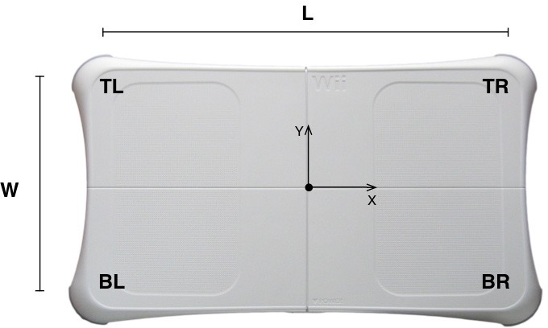

Fig.1. WBB dimensions, reference frame system and sensors position

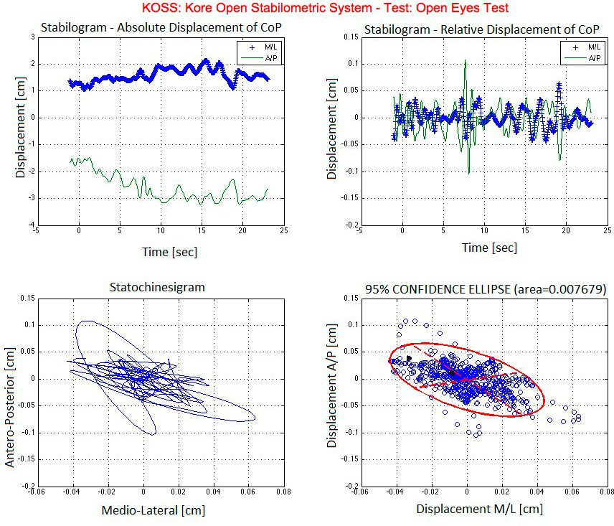

Stabilogram – Absolute Displacement of CoP

Stabilogram – Relative Displacement of CoP

Time [sec]

Time [sec]

Statochinessigram

95% CONFIDENCE ELLIPSE (area=0.007679)

Medio-Lateral [cm]

Displacement M/L[cm]

Fig.2. Balance Graphs scores: (a) Absolute displacement stabilogram, (b) Relative displacement stabilogram, (c) Statokinesigram, (d) 95% Confidence Ellipse Area

KOSS represents the open stabilometric application that integrates C# game-based application and Matlab script used for stabilometric analysis. However, we developed this application in order to eventually integrate other assessment devices.

* 1. *Balance Parameter*

Validity of two devices was carried out using total CoP path length (TPL) parameters. Total CoP path length was estimated using formula number 3 (Duarte and Freitas, 2010).

*TPL*  

(*COP* (*i*  *i*)  *COP* (*i*))2  (*COP* (*i*  *i*)  *COP* (*i*))2

*AP*

*AP*

*ML*

*ML*

*(3)*

*i*

We choose this outcome because it is known to be a reliable and valid measure of standing balance control (Salavati et al., 2009). Moreover, considering the predetermined period of trials, total CoP path length resulted analogous to average CoP velocity (path length/ period) (Clark et al., 2010).

* 1. *Procedures*

Tests were conducted in a gym. Participants were asked to perform two standing tasks: double limb support standing with open (OE) and closed eyes (CE), with feet at comfortable distance apart. During open eyes test, participants observed a fixed point away from them about one meter. Both tests were conducted by means of the baropodometer platform and the WBB. The length of the standing tests was 25 seconds per trial and it was repeated twice per device. No predetermined order was followed by the participants which performed tests in a random sequence. Baropodometer platform did not require any calibration procedure. WBB was calibrated using the same procedure proposed by Clark. Baropodometer platform, by means of FreeStep software, exported data in report style, while WBB exported raw data acquired from their sensors. Before they could be processed, data were filtered with a 8-order Butterworth filter with a cut frequency of 12 Hz. Data was acquired at 25 Hz from both devices.

* 1. *Statistical analysis*

Statistical analysis was carried out to assess concurrent validity of two devices in two different balance tests. First of all it was examined the internal validity of the variable used to address between-device validity. A repeated measures ANOVA was carried out for total CoP path length within two trials and tests. Later a Pearson correlation analysis tried to outline the relation between measures obtained with two instruments (Bland and Altman, 1986). Furthermore variables were examined with single measure interclass correlation coefficient test (ICC(2,1)), Bland-Altman plots and a paired-samples t-Test to address agreement of two instruments. Outcomes of the ICCs were interpreted as follows: poor (0-0.39), modest (0.4-0.74) and excellent (0.75-1) (Fleiss, 1986). Bland-Altman plots were realized by plotting the difference for analyzed variables between two instruments against the mean results (Bland and Altman, 1986). In each graphs we located a thin black line for mean value, two thick black lines for limit agreement (mean±1.96*deviation standard) and two red thin lines for 95% confidence interval of mean differences (mean±1.96*standard error). Absolute error within–device balance protocol results were finally estimated. Repeated measures ANOVA, Pearson’s correlation, interclass correlation and paired-samples t-Test analysis were carried out using the Statistical Package for the Social Science for Apple (SPSS Inc. Version 20.0, Chicago IL, U.S.A). Bland- Altman plots were realized using Matlab script. Alpha level was established to 0.05 for statistical procedures.

# Results

Repeated measures ANOVA showed no significant systematic error for TPL, so mean values of two trials were used for further analysis. Table 1 presents descriptive analysis and r-Pearson correlation coefficient for two balance tests; high scores with significance level were found in both tests.

Table 1. Descriptive statistics and r-Pearson correlation coefficient of balance scores in millimetres.

|  |  |  |  |  |
| --- | --- | --- | --- | --- |
| Mean (WBB) | Std. Deviation (WBB) | Mean (BP) | Std. Deviation (BP) | *r*-Pearson (p-Value) |
| Total CoP path length – OE Test 168.77 | 65.89 | 189.97 | 139,04 | 0.847 (p<0.01) |
| Total CoP path length – CE Test 256.79 | 110.39 | 198.88 | 119.28 | 0.718 (p=0.01) |

In order to address agreement between two instruments, Table 2 shows absolute mean differences and ICC values with 95% interval confidence of total CoP path length examined for open and closed eyes tests respectively.

Table 2. ICC point and absolute mean differences

ICC (95%CI) *p*-Value

Mean Differences (mm) (95%CI)

Total CoP path length – OE Test 0.79 (0.16 – 0.94) 0.01 -9.00 (-43.53, 25.51)

Total CoP path length – CE Test 0,83 (0.33 – 0.95) 0.07 -9.41 (-77.29, 58.46)

Total CoP path length ICC points range (ICCs = 0.79 – 0.83) was in the excellent classification level (Fleiss, 1986) and it outlined validity in both two tests. Bland-Altman plots, see Fig. 3, confirmed the good agreement of two devices showed by means of ICC test.

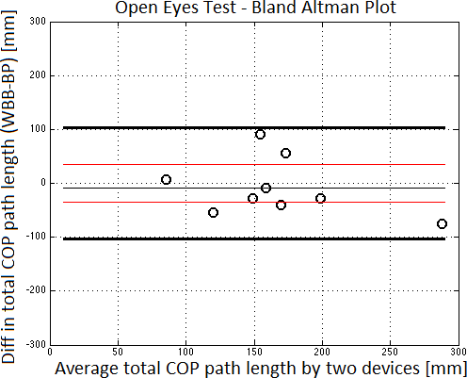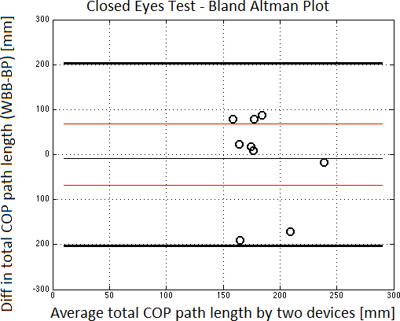

Fig.3. Bland-Altman plot of total CoP path length - (a) Open Eyes Test; (b) Closed Eyes Test

Indeed, paired-sample *t*-Test had the following values: in OE test, TPL had t = - 0.743 (p=0.477) while in CE test it had t = 2.112 (p=0.064). *t*-Test scores confirmed the high validity between two devices.

# Discussion

In this work we addressed the validity of Wii Balance Board to evaluate balance level typically assessed by means of baropodometer platform. In order to fulfill our purposes, we compared results obtained in two balance tests: balance standing with open and closed eyes. Variable chosen for the comparison was total CoP path length. TPL represents a reliable and valid measure of standing balance (Salavati et al., 2009).

Validity analysis was carried out using most commons statistical procedures. Correlation analysis suggested probably agreement between two instruments to assess postural sway path by means of total CoP path length scores. Indeed, OE and CE test revealed high Pearson’s correlation coefficients with significant p- value. As suggested by the authors (Bland and Altman, 1986), in order to define agreement’s level between devices correlation analysis had to be followed by more specific investigations, using inter-class correlation coefficient analysis (ICC) and Bland-Altman plot. ICCs ranked total CoP path length measurement to an excellent level of within-devices correlation. (Fleiss, 1986). Bland-Altman plot, as showed in Fig. 2, outlined the goodness of validity for the aforementioned variable. Moreover, mean differences were consistent with results proposed by Clark and his colleagues (Clark et al., 2010).

Total CoP path length variable results confirmed the promising role of WBB as balance assessment tool, even if any limitations did not permit to think that WBB could immediately replace baropodometer platform, especially for some clinicians’ valuations. Baropodometer platform was assembled with high number of sensors that were able to perform foot scanning and postural loads-map: these analyses are used to design specific orthotics. WBB had only four strain gauge sensors so it could not perform the same evaluations. WBB required a custom-written software and clinicians did not have enough skills to implement this application. Several clinicians used directly the balance tests applications proposed by Nintendo games WiiFit (Franco et al., 2012) even if Wikstrom stated that WiiFit balance activity scores had poor validity with usually CoP measures (Wikstrom, 2012). If custom software could be represented a limitation for clinicians, the flexibility of WBB open new issues for computer science researchers which can work with physical activity colleagues to develop software also for custom game-based physical activity experience (Sgrò et al., 2013).

In conclusion, agreement scores of WBB and baropodometer platform confirmed the promising role of the first as portable, low cost and friendly device for balance assessment. Moreover, the high level spread of WBB and the flexibility of this platform represent an interesting opportunity to promote home-based physical activity training session. In addition, we believe that WBB had the characteristics to represent a digital aided also in educational environment.

# Acknowledgments

The authors would like to gratefully knowledge to Cristian Francavilla and Andrea Olivi for their support within this research and to the volunteers for their collaboration.

# References

1. Gras L.Z, Hummer A.D, Hine E.R. “Reliability and Validity of the Nintendo Wii Fit”. J CyberTher Rehabil 2009; 2.4:329–335.
2. Wikstrom, E.A. “Validity and reliability of Nintendo Wii Fit balance scores”. Journal of Athletic Training 2012; 47.3:306-313.
3. Franco J.R., Jacobs K., Inzerillo C., Kluzik J. “The effect of the Nintendo Wii Fit and exercise in improving balance and quality of life in community dwelling elders”. Technology and Health Care 2012; 20.2:95–115.
4. Toulotte C., Toursel C., Olivier N. “Wii Fit® training vs. Adapted Physical Activities: which one is the most appropriate to improve the balance of independent senior subjects? A randomized controlled study”. Clin Rehabil 2012; 26.9:827–835.
5. Nilsagard Y.E., Forsberg A.S., von Koch L. “Balance exercise for persons with multiple sclerosis using Wii games: a randomised, controlled multi-centre study”. Multiple Sclerosis Journal 2013; 19.2:209–216.
6. Deans, S.M. “Determining the validity of the Nintendo Wii balance board as an assessment tool for balance". UNLV Theses/Dissertations/Professional Papers/Capstones. 2011 Paper 1238.
7. Young W., Ferguson S., Brault S., Craig C. “Assessing and training standing balance in older adults: a novel approach using the ‘Nintendo Wii’ Balance Board”. Gait Posture 2011, 33.2:303–305
8. Bartlett H. L., Lena H.T., Jeffrey T.B. “Accuracy of force and center of pressure measures of the Wii Balance Board". Gait & Posture 2014; 39.1:224-228.
9. XNA, <http://msdn.microsoft.com/xna>
10. Duarte M., Freitas S.M.. "Revision of posturography based on force plate for balance evaluation". Brazilian Journal of physical therapy 2010; 14.3: 183-192.
11. Salavati M., Hadian M.R., Mazaheri M., Negahban H., Ebrahimi I., Talebian S., et al. “Test–retest reliability of center of pressure measures of postural stability during quiet standing in a group with musculoskeletal disorders consisting of low back pain, anterior cruciate ligament injury and functional ankle instability”. Gait Posture 2009; 29.3:460–4.
12. Clark R.A., Bryant A.L., Pua Y., McCrory P., Bennell K., Hunt M. “Validity and reliability of the Nintendo Wii Balance Board for assessment of standing balance”. Gait&Posture 2010; 31.3:307–310.
13. Bland M.J., Altman D.G. "Statistical methods for assessing agreement between two methods of clinical measurement." The lancet, 1986; 327.8476:307-310.
14. Fleiss J. “The Design and Analysis of Clinical Experiments”. New York, USA:Jonh Wiley & Sons; 1986.
15. Sgrò F., Schembri R., Nicolosi S., Barresi M., Lipoma, M. "Exergames for physical education: an overview about interaction design perspectives".World Journal on Educational Technology 2013;5.2:248-256