Available online at [www.sciencedirect.com](http://www.sciencedirect.com/)



**ScienceDirect**

AASRI Procedia 7 (2014) 32 – 37

2013 AASRI Conference on Power and Energy Systems

Vehicle Dynamics Conversion into Power (Dynapower)

# Habib NASSERa

*a Univ. Savoie, SYMME, F-74000 Annecy, France*

**Abstract**

This paper aims to develop a new system that converts vehicle motion into electrical energy. It exploits aerodynamics and ground-wheel dynamics to generate power. When the vehicle moves, an aerodynamic phenomenon is created on surfaces and the suspensions vibrate. The main objective consists on the exploitation of these dynamics to produce power and charge the batteries. A vehicle equipped with anemometer and sensors is used in order to invent a new device.

First, we present a wind turbine design and use cases. Then, we develop a new system which can convert suspension movement into power. The whole system is called “DynaPower”.

© 2014 The Authors. Published by Elsevier B. V. This is an open access article under the CC BY-NC-ND license ([http://creativecommons.org/licenses/by-nc-nd/3.0/).](http://creativecommons.org/licenses/by-nc-nd/3.0/))

© 2013 Authors. Published by Elsevier B.V.

Selection and/or peer review under responsibility of **A**merican **A**pplied **S**cience **R**esearch **I**nstitute

Peer-review under responsibility of Scientific Committee of American Applied Science Research Institute

*Keywords:* Vehicle, wind, observer, suspension, motion, power, design.

## Introduction

The increased use of petrol for powering vehicles has raised concern for environmental issues such as pollution, noise and ozone depletion. Indeed some companies have proposed braking energy, electric and hybrid vehicles [1], [2], [3]. These solutions have many limitations as the weak autonomy of the batteries and the high cost. Keeping in mind all these drawbacks, researchers proposed to mount the wind turbine at the vehicle top [4]. However, this system disturbs the car aerodynamics, the engine consumes more power, the vehicle becomes instable at high speed and it prevents to add roof bars for example.

Therefore lot of research is being done to improvise upon them and come up with new devices to resolve the flaws of these solutions. In the same, we have come up with a device called “DynaPower”. In fact, we develop a new system that uses the wind energy and the suspension dynamics to produce power.

2212-6716 © 2014 The Authors. Published by Elsevier B. V. This is an open access article under the CC BY-NC-ND license ([http://creativecommons.org/licenses/by-nc-nd/3.0/).](http://creativecommons.org/licenses/by-nc-nd/3.0/))

Peer-review under responsibility of Scientific Committee of American Applied Science Research Institute doi:10.1016/j.aasri.2014.05.025

First, we present an experimental P308 car with a number of sensors in order to measure the wind velocity and the road profiles [5]. The wind turbine was designed with CAO software. For road slop estimation, a classical Luenberger observer is used. Then, the ground-wheel contact creates generalized forces that can be spread to the suspension as kinetic energy. A rack and pinion system which converts linear motion into rotational one is used to produce power. Both wind turbines and suspension power form a global connected system called “DynaPower”.

## Wind turbines

The vehicle movement generates a wind with high kinetic energy around outdoor area. Thus, wind turbines convert this kinetic energy into electrical power. This part presents a new design that can be used to produce power without disturbing aerodynamics.

* 1. *Wind velocity*

In order to have an experimental demonstrator for the implementation of the system previously proposed and subsequently be able to validate all desired ideas. A device using the new Arduino technology, containing a set of sensors (Gyroscope, accelerometer, GPS...) [6] and an anemometer, has been developed in order to implement a robust supervision in real time of the studied system, enabling instrumentation with wireless and serial communications. The set of sensors is able to estimate wind and vehicle velocities and to save these data (see Fig. 1).

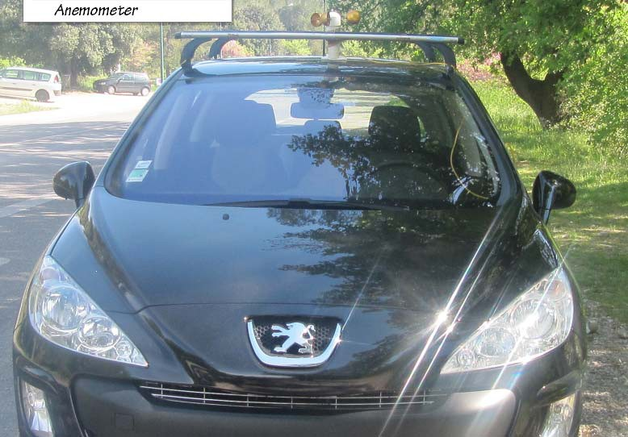

Fig 1. Experimental vehicle P308

In order to observe wind velocity, we picked a quiet day with no wind to do tests. The figure 2 shows that more the vehicle speed increases more the wind velocities become significant on surfaces. The vehicle speed values are greater than the wind one.

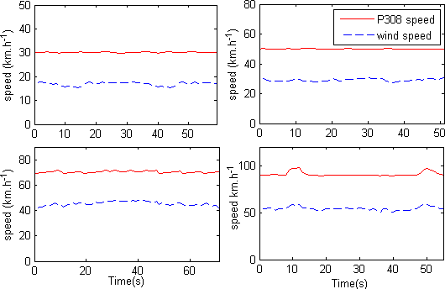

Fig 2. Wind velocity for 30, 50, 70 and 90 Km/h

Even without wind, the vehicle movement generates forces that will make the blades rotate. The blades are mounted on the rotor coupled with the generator through a shaft in order to produce power. This electrical energy will charge the batteries or supply accessories [7].

* 1. *Wind turbines design*

To not perturb the vehicle aerodynamics, an extruded cut in the roof is planned to place wind turbines. This device can be opened to enter wind energy and induce power (see Fig.3).

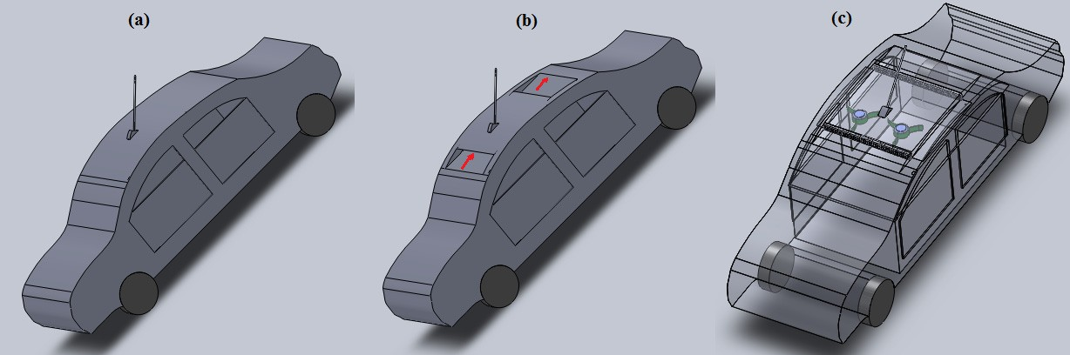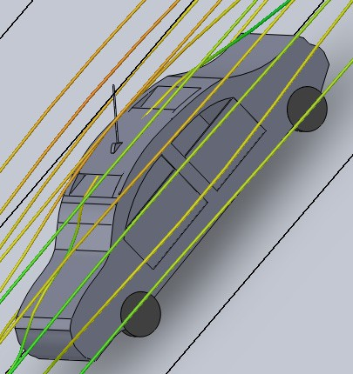

**(b)**

Fig.3. (a) Closed system (b) Operating system (c) wind turbines system

When the car moves, the wind will enter to the air duct from the front and rotate the blades which are coupled to a generator through an axle. The system will be used in some cases else actuators will close the front and the back of the roof as in Fig.3 (a).

The system consists of two vertical turbines, small generators and two honeycomb structures in the front and in the back of car top (see Fig.3. c). These structures are utilized to obtain laminar flow, to not perturb the car dynamics and to protect the whole system. The devise will be opened in the following cases:

* + - When the pilot brakes and when the vehicle is parked in a safe place,
    - On a slope.

Compared to other solutions, this system has two main advantages. First, when the devise is closed, the aerodynamics will not be affected. Then, the system can be acted on a downhill because the kinetic energy is more significant than on a flat road.

* 1. *Results*

The slope estimation is studied with linear observer. We considered that the slope angle variation is zero; otherwise the road does not present bumps [8]. Generally, the road slope is less than ten degrees, thus we can approximate sinus (Į) § Į.

 ..  1 (*F* 

. ²  *gα*)

*x xi*

*M*



 *α* 

.

*Cx x* 



# 0 

..

*(1)*

Thus, the system (1) can be written in the following linear form ( *X*  *AX*  *BU* ). For the road slope estimation, we opted for a classical Luenberger observer which is given by [9]:

. ^

*X*  *A X+ BU + L(Y*  *CX* )

*(2)*

^ ^

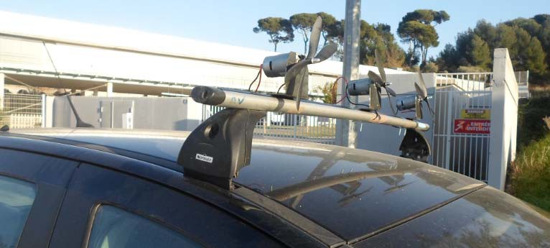*Y*  *C X*

Fig.4. A first experimental device

L is the observer gain [eq. 2]. The Fig.5 draws the shape of the road and to estimate the slope angle. A Matlab simulation [10] is used with the following gain vectors L: L2 =5. L1= [1.9 -1] T.

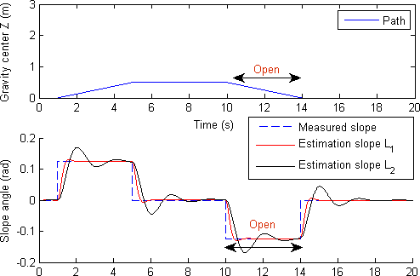When the slope angle becomes negative (see Fig.5), we open the device in order to charge the battery. As a first experimental device, three horizontal wind turbines are mounted to the roof bars. This removable system can be used in park, in picnic and in trips to charge accessories (see Fig.4).

Fig.5. Road slope estimation

From T=10s to 14s, the observer detects a descent then the system is acted and the wind enters with a high kinetic energy in order to rotate blades and produce power (see Fig. 3 (b)).

## Suspension energy

This part presents a new device to convert suspension motion into power. The contact ground-wheel induces a translation movement [11], [12]. This dynamics can be converted into electrical energy by adding a simple mechanism. We just need to transform translation movement to rotation one in order to produce power.

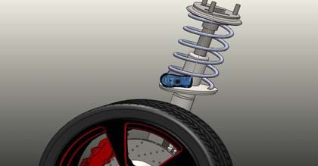

Fig. 6: suspension mechanism

Indeed a rack and pinion system is proposed and can be added to the vehicle suspension. The rack mechanism can be fixed with the suspension mobile part. The pinion will be coupled to a generator to charger batteries (see Fig. 6).

So, as long as the vehicle moves, its batteries will get continuous supply of power. This simple device can be developed to ameliorate damping and produce more electrical energy. Each suspension can be equipped with a rack and pinion mechanism. The synergy between the suspension device and the wind turbines sets up the concept of “DynaPower”. We aim to exploit the lost energy from dynamics in order to produce power.

## Conclusion

In this paper, a new system called “Dynapower” is proposed. The philosophy of this concept is to exploit the dynamics of the vehicle and its environment to produce power. First, a new wind turbines system is designed with CAD software. A slope angle observer is studied in order to use the high kinetic energy when vehicle moves along its descent path. An instrumented P308 car is utilized to make some experiments. A first wind turbines device attached to the roof bars is developed.

Then, a rack and pinion mechanism is proposed to convert suspension dynamics into electric energy. As a perspective work, we will develop an embedded board to control “DynaPower” system and to define optimal management of stored power. Moreover, we will exploit other motions to produce more energy.

## Acknowledgements

The financial support of this work was obtained from SMecatronix Startup grants.

## References

1. Husain, I. Electric and hybrid vehicle design fundamentals. CRC Press, ISBN 0 8493 1466 6, 2003.
2. Baumann, B. M.; Washington, G.; Glenn, B. C.; Rizzoni, G. Mechatronic design and control of hybrid electric vehicles. IEEE/ASME Trans. Mechatronics, vol. 5, no. 1, pp. 58-72, 2000.
3. Chan, C. C. The State of the Art of Electric, Hybrid, and Fuel Cell Vehicles. Proc IEEE, Vol. 95, 2007.
4. Tickoo, S. (2011). Wind Turbine for Automobiles. Conference Proceedings of the American Society for Engineering Education, Vancouver, B.C.
5. K. N. M’SIRDI, J. B, N. Habib and N. Aziz: Sliding Modes Observers for Vehicle Dynamics and Variable Structure Automatic Systems (SMO-VSAS), in IEEE VSS’10, Mexico City.
6. N. HABIB, N. Msirdi and Aziz Naamane “Wireless Sensor Network for monitoring, diagnosis and supervision” IEEE, REM 2012, Paris.
7. Richardson, R.D.; McNerney, G.M. “Wind energy systems” IEEE proceedings, Vol 81, 1993.
8. Moustapha Doumiati, Alessandro Victorino, Ali Charara and Daniel Lechner “Estimation of road profile for vehicle dynamics motion: experimental validation” American control conference 2011, USA.
9. J.P. Gauthier & G. Bornard. Observabilty for Any U (T) of a Class of Nonlinear Systems. IEEE Tran. on Automatic control, vol. 26, no. 4, pages 922–926, 1981.
10. Habib NASSER - Kouider nacer M'SIRDI "Decoupled model for motorcycle and identification of dynamic parameters" The 8th IEEE/ASME, Suzhou, China, 2012
11. Pacejka, H.B., Besseling, I.: Magic Formula Tyre Modelwith Transient Properties. 2nd International Tyre Colloquium on Tyre Models for Vehicle Dynamic Analysis, Berlin, Germany (1997).
12. C. S. T, N. K. and N. M.: “Adaptive Impedance Control Applied to a Pneumatic Legged Robot”. Journal of Intelligent and Robotic Systems 1997.