[Array 17 (2023) 100277](https://doi.org/10.1016/j.array.2023.100277)

Contents lists available at [ScienceDirect](http://www.sciencedirect.com/science/journal/25900056)

Array

journal homepage: [www.sciencedirect.com/journal/array](https://www.sciencedirect.com/journal/array)

Volitional control of upper-limb exoskeleton empowered by EMG sensors and machine learning computing

Biao Chen a,b, Yang Zhou a, Chaoyang Chen a,c,*, Zain Sayeed c, Jie Hu b,**, Jin Qi b, Todd Frush c,

Henry Goitz c, John Hovorka d, Mark Cheng a,e, Carlos Palacio d

a *Department of Biomedical Engineering, Wayne State University, Detroit, MI, 48201, USA*

b *State Key Laboratory of Mechanical System and Vibration, Shanghai Jiao Tong University, Shanghai, 200240, China*

c *Orthopaedic Surgery and Sports Medicine, Detroit Medical Center, Detroit, MI, 48201, USA*

d *South Texas Health System* – *McAllen Department of Trauma, McAllen, TX, 78503, USA*

e *Department of Electrical and Computer Engineering, University of Alabama, Tuscaloosa, AL, 35487, USA*

A R T I C L E I N F O

*Keywords:* Exoskeleton EMG

Sensor Wearable device

Machine learning Volitional control

Motion pattern recognition

A B S T R A C T

Processing multiple channels of bioelectrical signals for bionic assistive robot volitional motion control is still a challenging task due to the interference of systematic noise, artifacts, individual bio-variability, and other fac- tors. Emerging machine learning (ML) provides an enabling technology for the development of the next gen- eration of smart devices and assistive systems and edging computing. However, the integration of ML into a robotic control system faces major challenges. This paper presents ML computing to process twelve channels of shoulder and upper limb myoelectrical signals for shoulder motion pattern recognition and real-time upper arm exoskeleton volitional control. Shoulder motion patterns included drinking, opening a door, abducting, and resting. ML algorithms included support vector machine (SVM), artificial neural network (ANN), and Logistic regression (LR). The accuracy of the three ML algorithms was evaluated respectively and compared to determine the optimal ML algorithm. Results showed that overall SVM algorithms yielded better accuracy than the LR and

ANN algorithms. The offline accuracy was 96 ± 3.8% for SVM, 96 ± 3.8% for ANN, and 93 ± 6.3% for LR, while

the online accuracy was 90 ± 9.1% for SVM, 86 ± 12.0% for ANN, and 85 ± 11.3% for LR respectively. The offline pattern recognition had a higher accuracy than the accuracy of real-time exoskeleton motion control. This study demonstrated that ML computing provides a reliable approach for shoulder motion pattern recognition and real-time exoskeleton volitional motion control.

# Introduction

Processing multiple channels of bioelectrical signals for bionic as- sistive robot volitional motion control is still a challenging task due to the interference of systematic noise, artifacts, individual bio-variability, a difference of sensors or devices used for signal acquisition, and human limb motion speeds [1,2]. Scientists have devoted efforts to the devel- opment of assistive robots and bionic limbs empowered by edge computing [3]. Machine learning (ML) has been a significant trend to be applied in along with other technologies for the development of the next generation of smart devices. Scientists believe that integrating ML into embedded systems can be an important approach to building the next generation of intelligent devices [4]. However, the deployment of an ML

model on an embedded system faces major challenges. An embedded system used in a robotic exoskeleton system imposes constraints in terms of system performance accuracy, user experience, energy consumption, processing speed, size, and cost aiming at product commercialization [5]. An additional challenge is a feasibility of implementing the ML training process on the device for the robotic sensory and motion control systems that can be adapted online and used instantly. Online learning and adaptation are still important tasks and are required for the future generation of computing system when tackling real life challenges in unpredictable and dynamically changing environments. This paper presents an approach to adapting the ML computing to process twelve channels of shoulder myoelectrical signals for shoulder motion pattern recognition and real-time upper arm exoskeleton volitional control.

* Corresponding author. Department of Biomedical Engineering, Wayne State University, Detroit, MI, 48201, USA.

** Corresponding author.

*E-mail addresses:* [cchen@wayne.edu](mailto:cchen@wayne.edu) (C. Chen), [hujie@sjtu.edu.cn](mailto:hujie@sjtu.edu.cn) (J. Hu).

<https://doi.org/10.1016/j.array.2023.100277>

Received 14 November 2022; Received in revised form 15 January 2023; Accepted 20 January 2023

Available online 23 January 2023

2590-0056/© 2023 The Authors. Published by Elsevier Inc. This is an open access article under the CC BY-NC-ND license ([http://creativecommons.org/licenses/by-](http://creativecommons.org/licenses/by-nc-nd/4.0/) [nc-nd/4.0/](http://creativecommons.org/licenses/by-nc-nd/4.0/)).

Upper-Limb Exoskeletons have been designed for use in the indus- trial working environment [1,6–8] and medical rehabilitation [9,10]. Stroke survivors need long-term physical rehabilitation services [11].

The effective outcome of a traditional rehabilitation depends on the skill of therapists and the timeline of rehabilitation plans [12,13]. The traditional manual hands-on approach is labor-intensive and cannot provide long-term rehabilitation services at a low cost. The upper-limb exoskeleton systems have been studied and developed for upper-limb rehabilitation since two decades ago [14], which has shown encour- aging results in the rehabilitation of upper limbs [15–17]. However,

there are still many limitations and issues that exist in this area [18]. It

still lacks a bionic/ergonomic mechanical design for the upper-limb exoskeleton, primarily focused on human-machine joint misalignment. Also, bioelectric signal-based volitional control for upper-limb exo- skeletons is still far from satisfactory. The development of robust and reliable systems is still required targeting the recovery of lost motor control [10]. The use of active devices in rehabilitation was proved to be feasible [17], with direct benefits limited not only to patients with neuromotor injuries but also to other human movement areas of opti- mization of the working environment [6].

Most of the current assistive upper limb robotic rehabilitation de- vices use a conventional user interface (UI) such as a pushbutton or joystick, hands-free and intuitive interfaces are a desire of users. Current commercial upper arm exoskeletons used on-off mode control, this control strategy does not always align with patients’ intentions. Thus, a

more intuitive control strategy is needed for the upper arm exoskeleton,

which could be operated by the user’s intention.

The myoelectrical signals (electromyography, EMG) contain human neural information that interprets the human motion intents. Stroke patients can still generate weak EMG signals during limb motion or static muscle contraction, making it feasible for an EMG-based pattern recognition approach in post-stroke robot-aided rehabilitation [19].

EMG-control mechanisms can be divided into two groups: motion pattern recognition-based and non-motion pattern recognition-based [20]. Motion pattern recognition needs artificial intelligence (AI) for signal processing to generate classifications. Non-motion pattern recognition controllers are mainly constructed on threshold control and finite state machines, thus output limited and predefined control com- mands according to a sequence of input signals [21].

The implementation of computational techniques based on AI tech- niques embedded in a robotic upper limb exoskeleton system represents the main topic for the present study. In this paper, a novel EMG-based online shoulder motion recognition and control system is introduced. The online signal sensation system and robot motion control system are connected by LabVIEW software using a graphical computer program- ming approach. The essential role of this system is to connect the EMG

acquisition system (the Delsys system) and stream all the sensors’ data into the analysis module of the software. The system collected raw EMG

data for the offline machine learning (ML) training process to generate a trained ML model, then the trained ML model was used for online EMG activation-based motion pattern recognition and robot motion control.

# Related works

* 1. *EMG for upper arm motion pattern recognition*

The myoelectric signals (electromyography, EMG) have been considered a promising physiological signal for detecting motion intents and used in rehabilitation therapy [22–24], but system performance

accuracy can be affected by many factors including systematic noise and

artifacts [25–27] and individual bio-variabilities [28,29], leading to

special procedures or electrodes required for filtering off the noise and on-site calibration for system setup [30,31]. Aiming at developing user-friendly systems, ML-based motion pattern recognition methods have been proposed to avoid the efforts devoted to noise removal or complex multiple-channel EMG signal processing [32–35]. Surface EMG

(sEMG) pattern recognition has been studied for the feasibility of voluntary control of a robotic device [19,35,36], including EMG-based pattern recognition for upper-limb motion pattern recognition [37, 38]. Most of the studies processed EMG signals only for one DoF motion pattern recognition [39]. We have started to develop a computer system that can sense muscle activation patterns and process the multiple channels of EMG signals for upper limb exoskeleton motion control to assist the activities of daily living (ADL) [34,35]. The performance has been evaluated and preliminary outcomes published in papers [35,40], however, the architecture of the EMG-controlled, ML-based computer system has not been introduced or published. This paper presents detail information regarding online data acquisition, signal processing, and system connection. This paper also compares the difference between offline analysis accuracy and online performance accuracy.

* 1. *Shoulder exoskeleton control based on the motion pattern*

Processing EMG signals for robotic upper arm control has been developed according to the neuromuscular characterization, but robot motions are still cumbersome because of the complexity of the muscu- loskeletal system of the upper limb [41]. The EMG-controlled prosthesis also faces challenges from electrode placement location and pattern changes of EMG activation over time, leading to a longer training pro- cess [42]. To date, most of the literatures have reported the mechanisms of hand/wrist control with fewer DoFs (degree of freedom) of motions compared with shoulder joint [41]. The bionic control of an upper-limb exoskeleton is more complex that the control of other joint exoskeletons such as the wrist, knee, or ankle joint exoskeletons. Currently, there are only a few of literature that reported the studies of EMG-controlled

upper limb/shoulder exoskeletons [43–46]. Artificial intelligence-based wearable robotic exoskeletons for upper limb reha-

bilitation have been proposed, the main trend in the research is the development of wearable robotic exoskeletons controlled by the fusion of data collected from multiple sensors with the training of intelligent algorithms [10]. The focus of our current study is on shoulder/upper limb exoskeleton intuitive control for carrying out activities of daily living (ADL). The long-term goal of our research is to develop reliable systems through industrial or clinical validation and improvement of technical features targeting at intuitive control of the robot in order to have positive impacts on human strength augment and the rehabilita- tion process. The current study reports an approach of EMG-based multiple-sensors signal fusion for shoulder motion pattern recognition and integration of the sensor system and ML processing system into a customized prototype of an upper limb exoskeleton system for intuitive control. This approach will enable the systems to be used in various applications related to robotic exoskeletons, including human perfor- mance enhancement, workload reduction, medical rehabilitation, or support for daily living activities.

* 1. *Machine learning in EMG sing processing*

Machine learning (ML) computing can extract the specified features from the targeted data and quantify the features for model training using a supervised learning process [47], including K-Nearest Neighbor (KNN) [48], Linear Discriminant Analysis (LDA) [49], Support Vector Machine (SVM) [48,50,51], and Artificial Neural Networks (ANN) [52,53]. These supervised ML methods have been used in on EMG signal-based limb motion recognition, robot control, rehabilitation, and clinical research [54]. The accuracy of feature extraction from the EMG signals is affected by many factors, including EMG recording methods (such as different electrodes, electrode placement locations on the body surface, or recording devices), bio-variability (age and BMI (body mass index)), environmental factor (room temperature), electrical power line noise, and motion artifact. These factors reduce the efficiency of system robustness and accuracy of recognition [55], and extra efforts are sub- sequently required in signal processing with complex procedures.

Embedded software and firmware can be used to remove systemic noise as shown in a signal channel system [27], multiple channels systems required significant efforts and computing in system setup. ML may be the optimal approach to processing multiple-channel EMG signals for robot control without devoting effort to noise removal.

To improve the accuracy of ML in motion pattern recognition, deep learning (DL) has been proposed in signal processing, DL has made remarkable progress in image recognition, natural language, and behavior prediction [35,56–58]. Hinton et al. reduced the dimension-

ality of data using multiple layers of neural network algorithms [59],

leading to the development of deep neural network structures, the convolutional neural network (CNN), and the recurrent neural network (RNN) [60–62]. DL has been used for EMG signal processing for motion

recognition, unlike other machine learning algorithms such as KNN and

LDA DL does not manually set standards to extract features. Through repeated iterations of the neural network structure to optimize the al- gorithm, DL implements the propagation rules from the training data. CNN algorithm yielded better outcomes in motion pattern recognition by processing EMG signals [51,63–65]. The SVM and NN algorithms

have been applied in shoulder pattern recognition without controlling a

robot system using EMG signals recorded from six muscles of the upper limb among 7 healthy subjects, the results showed that NN yielded an accuracy of up to 88.7% during the training process while SVM obtained an accuracy up to 85.9% in model validation [66]. Using EMG signals recorded from 12 muscles of the upper limb among 15 healthy subjects, the results showed that CNN obtained a recognition accuracy between 79.64% and 97.57%, the accuracy was affected by motion speed and the devices used for EMG signal recording [40].

Extreme learning machine (ELM) is a newer machine learning method for EMG signal processing to detect motion patterns [67]. During multiple EMG channel processing, the structural features of each EMG channel including time domain, frequency domain, and time-frequency domain information should be considered. For this reason, synergy feature extraction is required across multiple EMG channels for motion pattern recognition to simplify control strategy including the control dimensionality reduction [68]. ELM demonstrated an optimal performance for synergetic feature extraction of multiple channels of EMG signals to classify upper limb motions [69–71].

# Materials and methods

* 1. *Experiment setup and experimental protocol*

Twenty-eight healthy subjects (seven males and three females, 26 ± 3.3 years) with no reported shoulder injury nor neuromuscular disorders were tested in this study. All of their right shoulders were used in this study. They were informed and signed an informed content sheet. They were instructed and practiced the specified movement before the real test. Eighteen subjects participated in the offline EMG recognition experiment, and 10 subjects participated in the real-time control experiment. This experiment has been approved by the ethics committee (Institutional Review Board) of Wayne State University and conforms to the Helsinki declaration.

Twelve muscles’ surface EMG signals were acquired by a commercial EMG acquisition system (Delsys Trigno wireless system, Delsys Inc, MA,

USA). The twelve muscles and their corresponding functions were listed in Table 1. These muscles activate all shoulder and partial elbow degrees of freedom. All sensors were placed at the muscle belly along the muscle fiber direction. The skin underneath the sensors was cleaned with 70% alcohol, and excessive hair was removed if needed. The EMG signal sampling rate for each sensor was 1.11 kHz. Fig. 1 shows the system setup for the experiment.

The EMG signals were processed in a real-time environment for shoulder motion pattern recognition using ML computing executed by Machine Learning Toolbox embedded in LabView software (National Instrument, Austin, TX). The motion pattern recognition outcomes were

**Table 1**

EMG Sensors channel and muscle function.

|  |  |  |
| --- | --- | --- |
| sEMG Sensor | Muscle | Functional Action |
| 1 | Middle Deltoid | Humerus Abduction |
| 2 | Anterior Deltoid | Humerus forward flexion |
| 3 | Posterior Deltoid | Humerus backward extension |
| 4 | Supraspinatus | Humerus abduction in initial 0-30◦ |
| 5 | Pectoralis | Humerus Abduction/Inner rotation |
| 6 | Trapezius | Shoulder elevation |
| 7 | Infraspinatus | Humerus external rotation |
| 8 | Teres Major | Humerus extension toward the spine |
| 9 | Bicep | Long head – abducts the arm, rotating medially |
|  |  | Short head – abducts the arm |
|  |  | Flexes the shoulder joint |
| 10 | Triceps | Extensor of the elbow |
|  |  | The long head extends the arm |
| 11 | Wrist flexor | Wrist joint flexion and rotation |
| 12 | Wrist extensor | Wrist joint extension and rotation |

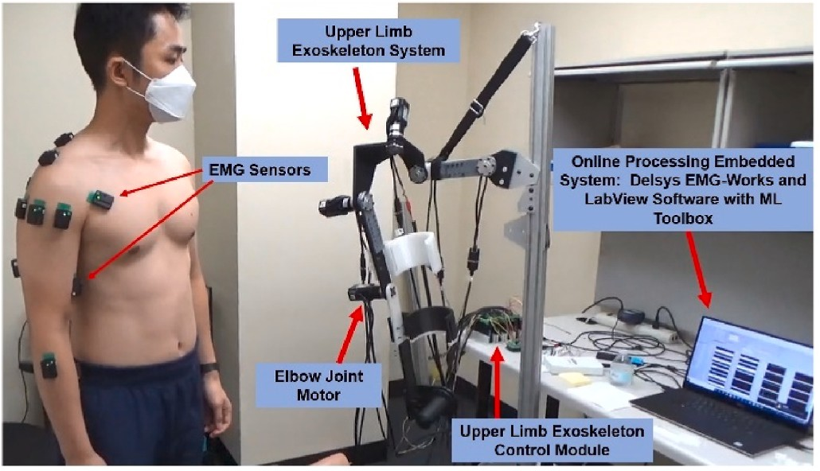

**Fig. 1.** The illustration of the real-time ML-based motion pattern recognition and exoskeleton motion control system. Twelve wireless Delsys EMG sensors are placed on the muscles indexed in Table 1 for EMG signal acquisition. The EMG signals are processed instantly for shoulder motion pattern recognition using ML computing executed by ML Toolbox embedded in LabView software. This system was used for the control of an upper-limb exoskeleton system to perform upper-limb motions based on the user’s intents.

used for the control of an upper-limb exoskeleton system to perform upper-limb trajectory movements based on the user’s intents.

The experiment was divided into two sessions: 1) offline data anal-

ysis to determine the accuracy of ML algorithms in shoulder motion pattern recognition, 2) real-time shoulder motion pattern recognition, and instant upper arm exoskeleton movement control to determine the accuracy of whole system performance.

* 1. *The design of an offline EMG recognition system*

Eighteen healthy subjects (ten males and eight females aged 25 ± 3.1 years) participated in the experiment aiming at motion pattern recog- nition based on offline data analysis. Each subject was asked to follow a pre-recorded video performing a series of shoulder movements. The shoulder movements were repeated twenty times for each action, and all the movements should be controlled at a constant speed. The constant speed of movements was beneficial for the EMG data segmentation and feature extraction using a fixed time window during offline data analysis.

The EMG sensors were placed on the muscle as shown in Table 1. Delsys EMGworks (Boston, Massachusetts) was used for the EMG signals recording and segmentation into datasets. Delsys EMGworks data acquisition system is a wireless EMG recording and processing system with 16 channels available for EMG signal recording. Twelve channels of EMG sensors were used in this study.

There were four consecutive phases during a movement including arm motion initialization, arm elevation, arm isometric hold, and arm return to rest. The activities of daily living (ADL) including drinking, open-door, abduction, and resecting were selected for motion pattern recognition. The detailed movements of ADL were listed in Table 2. These shoulder movements were studied because they are frequently used in rehabilitation movement training in post-stroke therapy [72,73], as well as in the industrial workforce [74].

All the EMG data were recorded by Delsys Trigno wireless system, and the Delsys EMGworks was used to segment and label the EMG data. Fig. 2 shows the flowchart of the offline EMG recognition system. Each subject performed 7 movements, and each movement was repeated 20 times. For each subject, there were 140 segmented EMG signals sets. In the EMG model training process, 80% of the dataset was used as the training data, and 20% was used as the testing data.

* 1. *The design of a real-time EMG volitional control experiment*
     1. *The overview of the real-time control system*

Ten healthy subjects (seven males and three females, 28 ± 3.5 years) without reported shoulder injury or neuromuscular disorders were recruited and tested in this real-time EMG-controlled system study. Four different movements including arm abduction adduction, drinking, arm forward and backward, and resting state was tested. Each subject was asked to stand still and relax the tested arm for a resting state. The subject performed other 3 movements respectively following a pre- recorded video paradigm to ensure the same movement speed of arm movements.

The real-time control system consisted of two subsystems: the EMG- models-ML training subsystem and the online EMG-based motion pattern recognition subsystem. The EMG-model-training subsystem collected EMG raw data and performed feature extraction, and then the features were used for data training to generate trained machine learning models.

The online-EMG-based-motion-pattern-recognition subsystem down streamed EMG raw signal data and perform feature extraction. The system then loaded the trained machine learning model from the EMG acquisition & training subsystem and performed real-time EMG-based motion pattern recognition and classification. The workflow of the two subsystems is shown in Fig. 3.

* + 1. *The EMG models training subsystem*

Connected with the Delsys EGM data acquisition system, the Lab- VIEW acquisition program was run to read all EMG signals from the Delsys system and perform the feature extraction process simulta- neously. Both raw EMG signals and EMG features were saved by the program as a CSV formatted file. Subjects were asked to perform a non- stop single pattern of motion repetitive twenty times following the pre- recorded video paradigm. For each motion, two CSV format files (one for raw EMG, one for EMG features) were saved. After the acquisition process, Python programs were developed to combine all EMG features files and label the EMG features for the later training process.

**Table 2**

The movement studied in the experiment.

NO Name of movement Abbreviation of movement

* + - 1. picking up a cup to mouth PU
      2. putting down a cup from the mouth PD
      3. pushing forward on the horizontal plane without PF resistance
      4. pulling backward on the horizontal without PB resistance
      5. shoulder abduction 90◦ on the coronal plane AB
      6. shoulder adduction 90◦ on the coronal plane AD
      7. resting of arm RE

A customized offline machine learning training LabVIEW system was then used to generate machine learning models for the online EMG recognition process. In this study, SVM models (linear kernel-based and RBF kernel-based), one single-layer neural network model, and linear regression model were generated. The offline machine learning training LabVIEW system was developed using the Analytics and Machine Learning Toolkit. This system read the training data from the CSV file and generated JSON format trained models, which were used in the real- time system.

The first step of the model training process was to input the CSV file path into the system and define the hyperparameters of the SVM and the ANN methods. The second step was to run the LabVIEW program. Then the system saved the trained models as JASON files. For each subject, three machine learning models including LR (logistic regression), SVM (support vector machine), and ANN (artificial neural network) were trained by their training data [35].

* + 1. *The real-time EMG recognition subsystem*

The real-time EMG recognition subsystem consisted of two real-time EMG processing functions and real-time recognition function. The EMG processing function was the same as the EMG acquisition and processing module used in the offline training process (section 2.2). The EMG processing function directly streamed the feature data into the online EMG recognition function. This EMG processing function used the trained model from the offline training process and made a classification decision based on the real-time input from the EMG processing and feature extraction subsystem. After the classification decision was made, a motion command was sent to the upper-limb exoskeleton system to perform the responding motion. In the system performance test, each subject was asked to perform the selected motions ten times for each motion, and the accuracy of the system performance was determined. Also, the tests were repeated for each machine learning model.

* + 1. *TCP/IP connection between LabVIEW and the Delsys system for real- time system*

Trigno SDK software was used in the development of the EMG real- time control system. The Trigno SDK software was used to connect Trigno Avati EMG acquisition hardware and software to the LabVIEW software (NI, TX) for two software system interactions. Using LabVIEW, the program connected the Trigno SDK through an IP address and then communicate with a NI data board through a command port. The time window frame interval for Trigno SDK was set at 13.5 ms.

For the EMG data acquisition, there were 12 EMG channels in total, and the sampling rate was fixed at 1.11 kHz. Since the Trigno SDK frame rate was fixed at 13.5 ms, thus 15 EMG samples were streamed in every frame interval. And 960 bytes were read from the EMG port in each frame interval. This accurate number of bytes (960) was defined in the LabVIEW program set to be read for each loop to ensure the data be properly translated into readable and meaningful numbers. Fig. 4 shows the data structure of EMG signals processing output for control.

* 1. *Signal processing and machine learning implementation*

Multiple channels of EMG signals were processed using processing was performed to eliminate noise and extract EMG features for pattern recognition using the machine learning method in the next step.

After noise filtering, the features of EMG data were extracted. In this study, sliding root mean square (RMS) was used to extract the features from the raw EMG signals of 12 muscles with a sliding window of 540 ms and an overlapping window of 81 ms. These features were then input into the pattern recognition module. A pre-trained machine learning module was loaded into the system for shoulder motion pattern recognition.

Three algorithms were used in our study: support vector machine (SVM), artificial neural network (ANN), and linear regression (LR). All three algorithms were designed to perform multi-patterns classification.

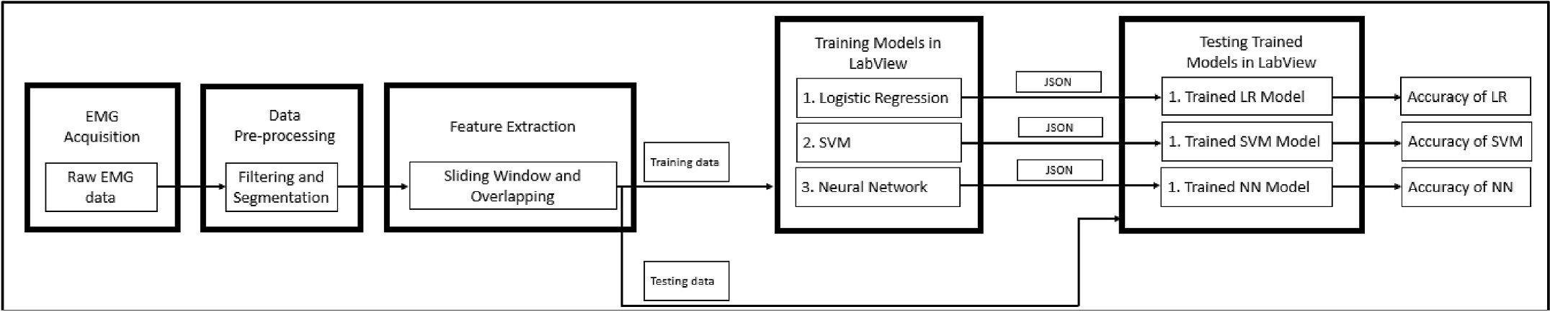

**Fig. 2.** Flowchart of training and testing trained machine models.

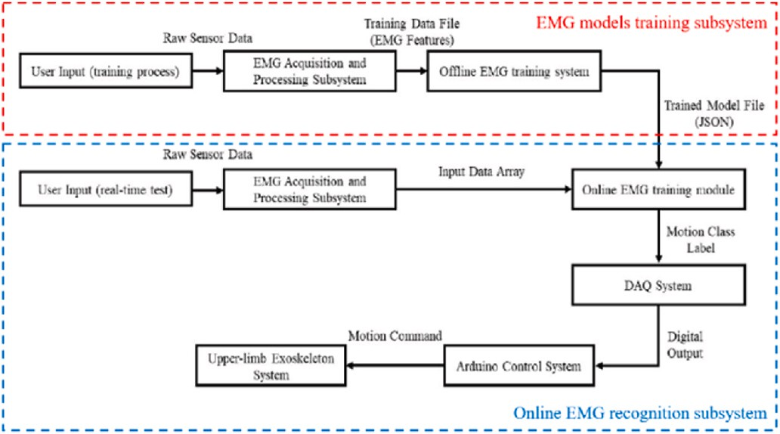

**Fig. 3.** The workflow of EMG models training subsystem and online EMG recognition subsystem. The motion classification outcomes were used to control the upper-limb exoskeleton to perform pre-defined motions.

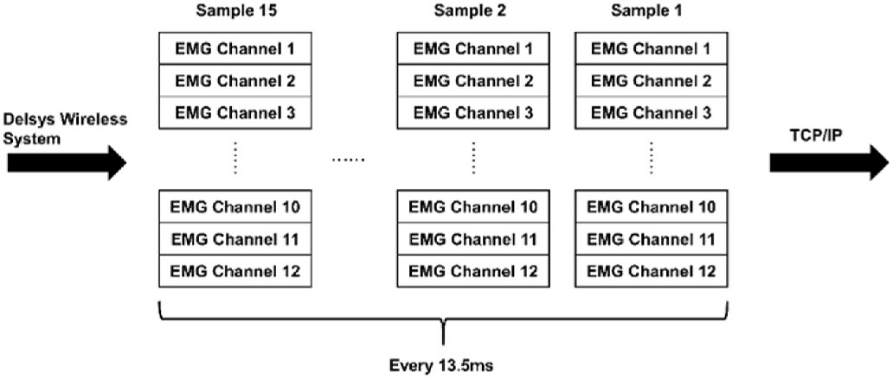

**Fig. 4.** The data structure and flowchart of EMG signals for processing and transporting to the communication port. Fifteen EMG datasets were streamed through TCP/IP every 13.5 ms. The LabVIEW software read 960 bytes every

13.4 ms in order to downstream the whole EMG data. Twelve EMG sensors were used for signal acquisition from 12 upper limb muscles.

*β* is the weight vector with k+1 dimensions

*p*(*y* = 1|*x*)) is the probability of y = 1 for a known instance of x LabVIEW 2018 (National Instruments, USA) and Analytics and Ma-

chine Learning (ML) package were used to build the training process and testing processes of the three machine learning models [76]. The same toolbox software was used to implement the SVM and ANN ML processes.

The support vector machine (SVM) finds a hyperplane in N-dimen- sional space (N– the number of features) that distinguishes the data points. The algorithm finds a plane with the maximum margin so that

the feature dataset can be classified with maximal confidence. The SVM algorithms can implemented using a kernel. The most common kernels include the linear kernel, polynomial kernel, and radial kernel. A polynomial kernel was used in this study. SVM algorithm has been used in wrist motion classification [77] and multiple channels of EMG signals for gait pattern recognition [78]. In this study, the same SVM ML method was used for multi-DoF shoulder related motions classification and exoskeleton motion control thereafter. Fig. 5 shows the ML method and procedures of training and validating an SVM model in the LabVIEW platform, as well as the online exoskeleton motion control.

The artificial neural network (ANN) [79–81] used in this study is a feed-forward neural network, as shown in Fig. 6. Multiple hidden layer

neuron numbers (5,10, 20, 40,60) were tested. Also, the influence of using multiple hidden layers was also tested. The number of output layer neurons was equivalent to the number of movement classes (4 classes). The four neurons of the output layer show the probabilities range [0,1] of the four-movement classes. The activation functions were set differ- ently for each layer: rectified linear unit function (ReLu) for the hidden layer and Softmax for the output layer.

* 1. *Statistical analysis*

One-way ANOVA with PostHoc LSD was used to determine the sta- tistical difference in the average accuracy of motion pattern recognition between different ML algorithms. The Chi-Square Pearson test was

ANN in LabVIEW has three types of layers: the input layer, the hidden layer, and the output layer with all hyperparameters used to implement ANN algorithms [75].

A sigmoid function was adopted in logistic regression (LR) algorithm implementation. After the input dataset training, LR generated decision boundaries to determine classification based on the highest probability. In the application of multi-class classification, LR used the one vs. rest method. For classification with more than two classes, the one vs. rest method generated and trains LR models for each class vs. the rest of the classes. The following equation defines the logistic regression model.

( ) = ( = 1| )) =

*p x p y x*  1

1 + exp ( — (*β*0*x*0 + *β*1*x*1 + ⋯ + *βkxk*))

where.

x is the input vector with k+1 dimensions where x0 is always 1. y is the output vector with a value 0 or 1.

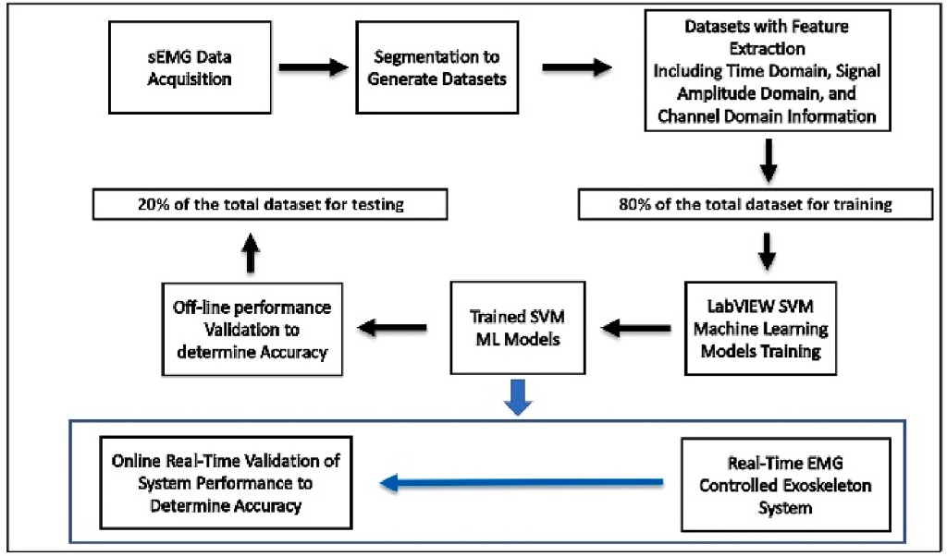

**Fig. 5.** The flowchart of SVM based EMG processing for exoskeleton mo- tion control.

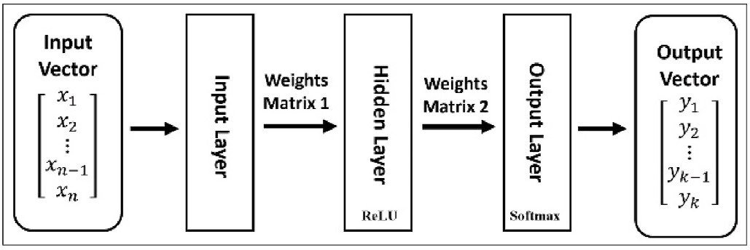

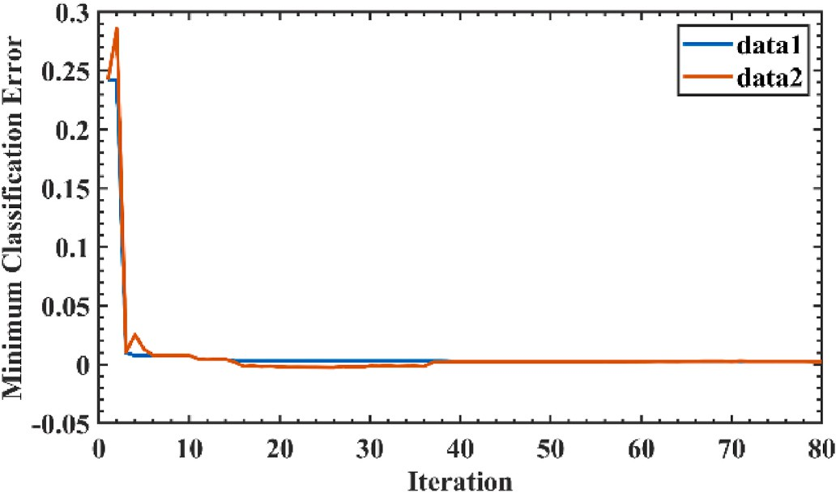**Fig. 6.** Flowchart of ANN in EMG signal processing.

performed to determine the difference in accuracy of each motion pattern recognition among the three individual machine learning algo- rithms for different motion patterns. The accuracy of motion recognition was also compared between offline analysis and real-time performance. SPSS software (Version 28, IBM, Armonk, NY) was used for statistical analysis. A p value smaller than 0.05 was considered to be statistically significant.

# Result

* 1. *Result of offline EMG model experiment*
     1. *Comparison of offline model training process*

LR training showed that loss value decreased over the iterations (Fig. 7). The loss value of the LR model converged rapidly in the early stage of training. The loss curve plateaued after about 16 iterations, indicating that the model had converged after 16 iterations. The cost function of LR is:

**Fig. 8.** SVM training loss value over iterations.

*J θ* 1 [ ∑*m y*

*log h* *x* )

*y* )*log h*

*x* )]

( ) = — *m*

where.

*i*=1

(*i*)

*θ* (*i*)

+ 1 — (*i*)

*θ* 1 —

(*i*)

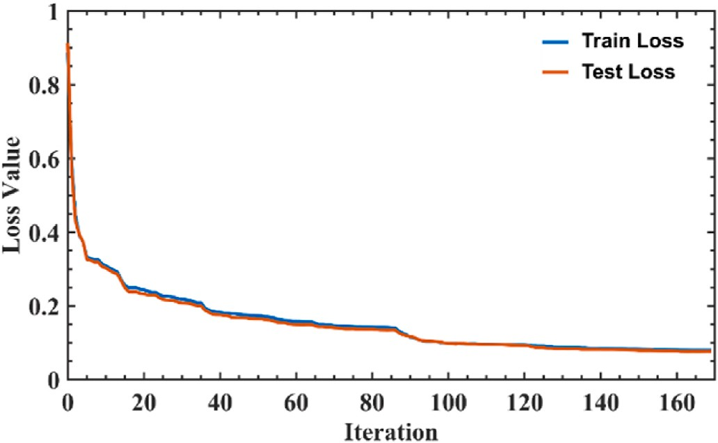**Fig. 9.** ANN training loss value over iterations.

*hθ* is the hypothesis of the LR,

*x*(*i*) is the feature of the *i*th sample,

*y*(*i*) is the predicted label of the *i*th sample.

The process of automatic optimization of the SVM model showed the observed error decreased with the increase in iterations (Fig. 8). At the 37th iteration, the SVM model had the smallest observed loss value, indicating that the SVM model achieved the most optimal parameters. The optimizer for SVM is Bayesian Optimization.

The typical loss curves were found in the ANN model training and model validation (Fig. 9). The loss curve plateaued after about 120 it- erations, indicating that the model has converged after 120 iterations. The loss function of ANN is cross-entropy

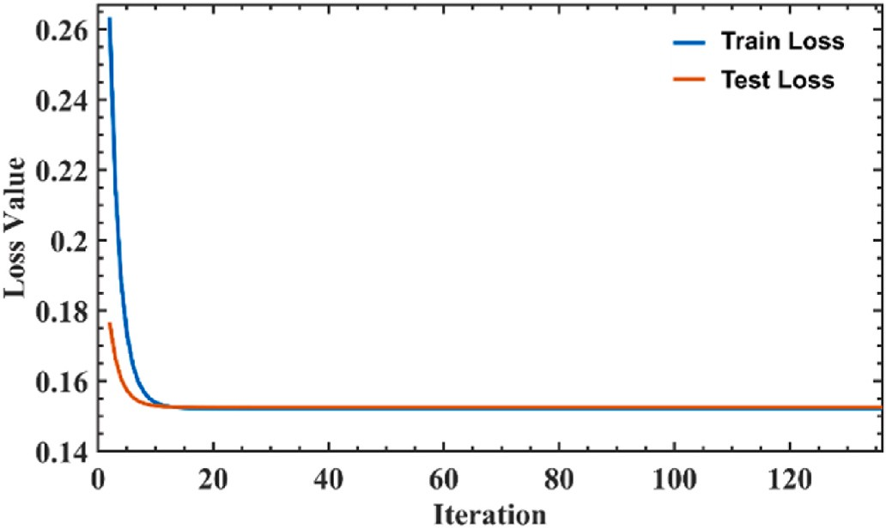

**Fig. 7.** LR training loss over iterations.

*n*

*Loss* = *yi logyi i*=1

∑ ̂

where.

*yi* is the true label of the *i*th sample

*y* is the predicted label of the *i*th sample.

̂*i*

* + 1. *Comparison of classification accuracy of four ML algorithms*

Fig. 10 shows the results of three confusion matrices of validation from one subject’s dataset using the three machine learning algorithms as classifiers. The columns in each matrix show the number of accuracies

of each motion which were predicted by the machine learning models, while the rows show the accuracy of these subjects’ actual motion out- comes. The numbers on the diagonal line of these matrices show the

correct prediction accuracy for the different designated motions, while other cells show the accuracy of the wrongly prediction. The accuracy was calculated from true positive, true negative, false positive, and false negative cases derived from the confusion matrix. The accuracy, together with precision, recall, and f1 score for each specific motion were thus obtained.

* 1. *Result of real-time robotic motion control experiment*

Fig. 11(a) shows the average accuracy of the real-time system per- formance following the subject’s motion using SVM as a classifier with a scanning time window of 135 ms. The average accuracy was 97% for

abduction motion recognition, 99% for resting recognition 99%, 84% for drinking motion recognition, and 81% for pushing forward. The results showed 16% of real drinking motions were misclassified as abduction

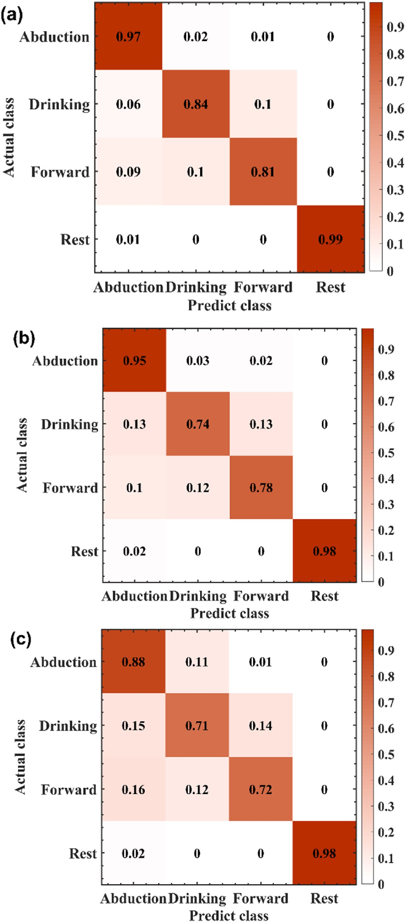

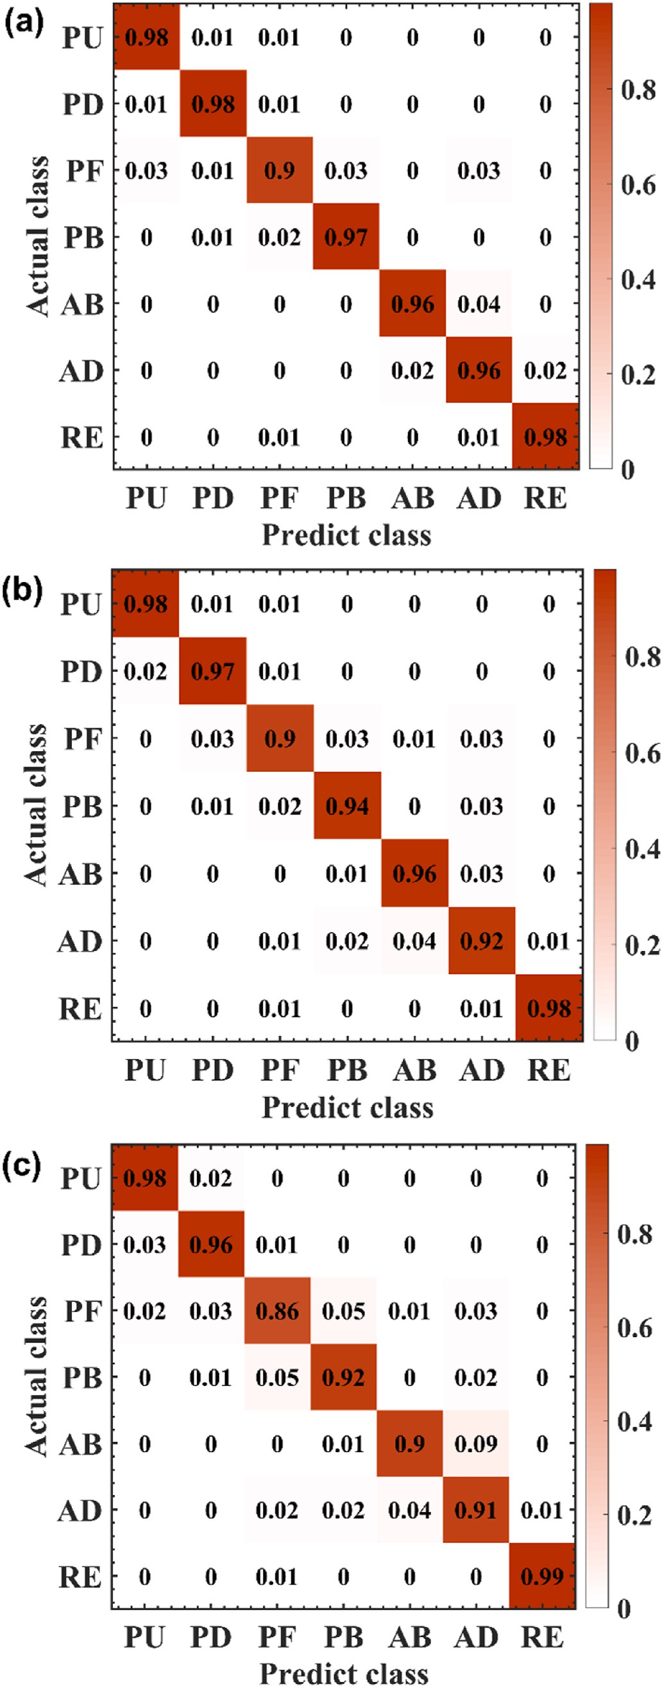**Fig. 10.** Confusion matrices of offline EMG model experiment. (a) SVM; (b) ANN; (c) LR. The number in the cells represents the accuracy. The number in cells is indexed for percentage, for example, 0.98 mean 98% of accuracy.

**Fig. 11.** Confusion matrices of real-time EMG model experiment. (a) SVM; (b) ANN; (c)LR.

and pushing forward while 19% of really pushing forward motions were misclassified as abduction and drinking.

Fig. 11(b) the average accuracy of the real-time exoskeleton system performance following the subject’s motion using ANN as a classifier. The scanning time window was kept unchanged. The average accuracy of exoskeleton motion followed subject’s motion was 95% for abduction, 98% for resting, 74% for drinking, and 78% for pushing forward motion.

The results showed that 26% of real-time drinking motions were

misclassified as abduction or pushing forward, while 22% of really pushing forward motions were misclassified as abduction and drinking. Fig. 11(c) shows the average accuracy of the real-time exoskeleton

system performance following the subject’s motion using LR as a clas- sifier and the time window is 135 ms. The average accuracy of the

system performance following a subject’s motion was 88% for abduc- tion, 98% for resting 71% for drinking, and 72% for pushing forward.

The results show 29% of real drinking motions were recognized as abduction and pushing forward, leading to the exoskeleton performed a wrong motion. And 28% of real-time pushing forward motions were misclassified as abduction and drinking.

* 1. *Comparisons of offline analysis and real-time performance*

The average accuracy of offline analysis (97.0%) was higher than real-time performance (74%) for drinking motion pattern recognition and robot control (Chi-Square, Pearson test, p < 0.001).

There was no a statistical difference of performance accuracy be-

tween off-analysis (88.0%) and real-time performance (95%) for abduction motion pattern recognition and robot control (Chi-Square, Pearson test, p = 0.128).

The average accuracy of offline analysis (89.0%) was higher than real-time performance (78%) for forward motion pattern recognition and robot control (Chi-Square, Pearson test, p = 0.036).

There was no a statistical difference of performance accuracy be- tween offline analysis (99.0%) and real-time performance (98%) for

resting status motion pattern recognition and robot control (Chi-Square, Pearson test, p = 0.516).

For offline analysis, the accuracy of LR was lower than SVM and ANN (One-Way ANOVA PostHoc LSD, p < 0.001). For real-time motion pattern recognition and robot control, the accuracy of SVM was higher than ANN and LR (One-Way ANOVA PostHoc LSD, p < 0.001) (Table 3).

# Discussion

This research demonstrated that multiple channels of EMG signals can be processed for real-time machine-learning-based upper limb mo- tion pattern recognition and subsequent upper-limb exoskeleton motion control. The system consisted of twelve channels of EMG signal acqui- sition sensors and ML-based signal processing toolkit software, a robotic motion control board and embedded algorithms, and an upper limb exoskeleton system. Three machine learning algorithms were evaluated

for the efficiency in EMG signal processing for motion pattern recogni- tion and then real-time exoskeleton motion control following the user’s intents.

The novelties of this study included that an ML-based computing platform in a wearable sensor-controlled exoskeleton system was built that can be used to test various ML algorithms in the future. New AI techniques are emerging such as deep learning (DL), and extreme learning machine (ELM), etc., an effective platform is required to test new AI techniques including their applications in volitional control robot system. The outcomes of this study demonstrated the system developed in this study can perform the tasks as we desired.

The development of a volitional controlled exoskeleton system has

**Table 3**

Classification accuracy of offline analysis and real-time control.

|  |  |  |  |  |  |  |  |  |
| --- | --- | --- | --- | --- | --- | --- | --- | --- |
|  | Offline |  |  |  | Real-time |  | | |
| SVM | ANN | LR |  | SVM | ANN | LR |  |
| Abduction | 96% | 96% | 90% |  | 97% | 95% | 88% |  |
| Drinking | 98% | 98% | 98% |  | 84% | 74% | 71% |  |
| Forward | 90% | 90% | 86% |  | 81% | 78% | 82% |  |
| Rest | 98% | 98% | 99% |  | 99% | 98% | 98% |  |
| Average | 96 ± | 96 ± | 93 ± |  | 90 ± | 86 ± | 85 ± |  |
|  | 3.8% | 3.8% | 6.3% |  | 9.1% | 12.0% | 11.3% |  |

become a hot research topic recently. In past years, research has shown that a volitional control mechanism can improve the exoskeleton per- formance and a user’s experience [82,83]. Myoelectrical signal (EMG

signal) is a promising physiological signal used for understanding a

user’s motion intention, and EMG signal has been widely used in robot-assistive rehabilitation therapy [23,24,83–85]. However, there

are still challenges in EMG signal processing for robot control, including removing systematic noise and artifacts [25,26], increasing bio-fidelity quality such as signal-noise ratio (SNR) using special electrodes [28, 29,31], precisely determining the onset and offset of muscle contraction [30,86], and reducing the complexity of algorithms [41,87]. In this study, using ML computing toolkits and the newer ML computing al- gorithms, we spared of manual noise filtering, on-site threshold setup and calibration, and heavy-duty complex algorithm preparation for EMG processing steps.

There are studies reported shoulder sEMG-based motion classifica- tion algorithm for controlling the exoskeleton system in real-time, most studies remain on an offline analysis level [44,88,89], however, to our best knowledge, no groups have developed a real-time ML-based EMG-based control system for the upper arm multiple joint exo- skeletons, hence the performance difference has not been studied pre- viously. The results of this study demonstrated that the accuracy of offline motion pattern recognition was higher than the accuracy of

real-time motion following a subject’s designated motions. This could be caused by the difference in the testing environment. A subject could pay

attention to the exoskeleton’s motion in real-time motion control

testing, while the subject only focused on upper limb motion, indicative of a distraction from checking robot motion. There was a pause between each test in real-time motion control testing to waiting for the robot to complete its movement, while during the pure motion pattern recogni- tion for offline analysis, a subject performed the designated motion consecutively without waiting for the completion of exoskeleton movements.

These three ML algorithms performed upper limb motion pattern recognition and exoskeleton motion control with an accuracy ranging between 71% and 98. In real-time motion pattern recognition and mo- tion control, SVM outperformed ANN and LR. SVM is designed for small- size dataset applications. ANN fits better for medium-sized datasets. The dataset we collected in this study was smaller; thus, SVM revealed better performance [90]. LR fits better for dichotomous data [91,92] since the datasets in this study consisted of multiple-dimension information including EMG channel, EMG amplitude, and time point variables, hence the LR could yield a relatively lower accuracy in motion pattern recognition.

In real-time exoskeleton motion control testing, the system recog- nized resting and abduction with higher accuracy than drinking and pushing forward motions. One reason might be that these two kinds of motions are very similar, especially during the initial phase of motion. This could cause the machine-learning-based system confused in motion pattern recognition during the initial phase of drinking and pushing forward actions.

Various rehabilitation robotic devices have been developed for upper-limb training in stroke patients. Among them, MIT-Manus (1999)

[93] was one of the first systems to be developed and can provide stroke survivors with plane movements. Furthermore, MIME (2005) [94], GENTLE/s (2008) [95], T-WREX (2011) [96], and NEREBOT (2014)

[97] were proposed to permit three-dimensional exercise training for patients with impaired arms [98]. Most of these upper-limb rehabilita- tion robots were developed targeting robot-assisted therapy for the upper limb after a stroke. Our upper limb exoskeleton system was also developed aiming for medical rehabilitation; however, it can also be applied to industrial robots.

In this study, twelve upper-limb muscles were recorded by Delsys wireless sensors. The EMG signals were processed and used for training machine-learning models which can be used for motion recognition. The users didn’t wear the upper-limb exoskeleton for safety concerns since

this upper-limb exoskeleton has not been validated through the FDA investigation device evaluation process.

Limitations of this study include that this real-time system can only recognize four different motion patterns, which is far from enough for the activity of daily life (ADL) training. The motion control is trajectory instead of adaptive motion control. Twelve EMG modules were used to recognize 4 kinds of discrete actions of ADL. Too many sensors may increase the complexity of actual use and commercial product devel- opment. The minimal number of sensors for optimal performance was not studied. This EMG-controlled shoulder/upper limb exoskeleton has not been tested among clinical patients or industrial workers, it is un- known how the system will work among patients with remnant weak EMG signal.

Future work will focus on the development of a better computing system for the wearable sensor-controlled upper-limb exoskeleton sys- tem to better discriminate similar motions. The investigation will be performed to determine the minimal number of EMG sensors for optimal performance. The effects of ML-based EMG signals on the adaptive control of an upper limb exoskeleton will be studied.

Since we have built a platform for EMG signal processing using ML techniques, new machine learning algorithms, and new features can be tested using this platform. More research will be performed to discover a better solution for the shorter responsiveness time and higher accuracy.

# Conclusion

This study demonstrated the feasibility of ML computing in multiple channels of EMG signal processing for a real-time shoulder motion pattern recognition and wearable exoskeleton motion control. SVM yielded better accuracy than the LR and ANN in performance. The off- line pattern recognition had a higher accuracy than the accuracy of real- time exoskeleton motion control.

# Credit author statement

Biao Chen: Conceptualization, methodology, investigation, software, data curation, formal analysis, original draft preparation. Yang Zhou: Conceptualization, methodology, investigation, software, data curation, formal analysis, original draft preparation. Chaoyang Chen: Conceptu- alization, investigation, methodology, validation, resources, wri-

ting—review and editing, supervision, project administration, funding acquisition. Zain Sayeed: Conceptualization, methodology, investiga-

tion, writing—review and editing. Jie Hu: Conceptualization, method- ology, resources, writing—review and editing, supervision. Jin Qi: Conceptualization, methodology, resources, writing—review and edit- ing. Todd Frush: Conceptualization, methodology, resources, wri-

ting—review and editing. Henry Goitz: Conceptualization, methodology, resources, writing—review and editing. John Hovorka: Conceptualization, methodology, resources, writing—review and edit- ing. Mark Cheng: Conceptualization, investigation, methodology, soft-

ware, validation, writing—review and editing, supervision. Carlos Palacio: Conceptualization, methodology, resources, writing—review and editing.

# Declaration of competing interest

The authors declare that they have no known competing financial interests or personal relationships that could have appeared to influence the work reported in this paper.

# Data availability

Data will be made available on request.

# Acknowledgements

This study was performed in the Department of Orthopaedic Surgery and Sports Medicine, Detroit Medical Center, and the Robotic Rehabil- itation Laboratory, Department of Biomedical Engineering, Wayne State University, Detroit, Michigan, USA. This work is supported by the Wayne State University UPTF Professional Development Grant (Grant# 20201020) and Rehabilitation Institute of Michigan Foundation (Grant# 22-2-003) and by the National Natural Science Foundation of China (Grant# 51975360, 52035007). The authors would like to thank Edward Rozek, Rachel Toccalino, and Linda Gross assistance in this research.

# References

1. [Manna SK, Dubey VN. Comparative study of actuation systems for portable upper](http://refhub.elsevier.com/S2590-0056(23)00002-4/sref1) [limb exoskeletons. Med Eng Phys 2018;60:1–13](http://refhub.elsevier.com/S2590-0056(23)00002-4/sref1).
2. [Esposito D, Centracchio J, Andreozzi E, Gargiulo GD, Naik GR, Bifulco P. Biosignal-](http://refhub.elsevier.com/S2590-0056(23)00002-4/sref2)

[based human-machine interfaces for assistance and rehabilitation: a survey.](http://refhub.elsevier.com/S2590-0056(23)00002-4/sref2) [Sensors 2021;21](http://refhub.elsevier.com/S2590-0056(23)00002-4/sref2).

1. [Aguiar Noury G, Walmsley A, Jones RB, Gaudl SE. The barriers of the assistive](http://refhub.elsevier.com/S2590-0056(23)00002-4/sref3) [robotics market-what inhibits health innovation? Sensors 2021:21](http://refhub.elsevier.com/S2590-0056(23)00002-4/sref3).
2. [Xu Y, Liu X, Cao X, Huang C, Liu E, Qian S, Liu X, Wu Y, Dong F, Qiu CW, Qiu J,](http://refhub.elsevier.com/S2590-0056(23)00002-4/sref4) [Hua K, Su W, Wu J, Xu H, Han Y, Fu C, Yin Z, Liu M, Roepman R, Dietmann S,](http://refhub.elsevier.com/S2590-0056(23)00002-4/sref4) [Virta M, Kengara F, Zhang Z, Zhang L, Zhao T, Dai J, Yang J, Lan L, Luo M, Liu Z,](http://refhub.elsevier.com/S2590-0056(23)00002-4/sref4) [An T, Zhang B, He X, Cong S, Liu X, Zhang W, Lewis JP, Tiedje JM, Wang Q, An Z,](http://refhub.elsevier.com/S2590-0056(23)00002-4/sref4) [Wang F, Zhang L, Huang T, Lu C, Cai Z, Wang F, Zhang J. Artificial intelligence: a](http://refhub.elsevier.com/S2590-0056(23)00002-4/sref4) [powerful paradigm for scientific research. Innovation 2021;2:100179](http://refhub.elsevier.com/S2590-0056(23)00002-4/sref4).
3. [Tiboni M, Borboni A, V´erit´e F, Bregoli C, Amici C. Sensors and actuation](http://refhub.elsevier.com/S2590-0056(23)00002-4/sref5)

[technologies in exoskeletons: a review. Sensors 2022;22](http://refhub.elsevier.com/S2590-0056(23)00002-4/sref5).

1. [Moeller T, Krell-Roesch J, Woll A, Stein T. Effects of upper-limb exoskeletons](http://refhub.elsevier.com/S2590-0056(23)00002-4/sref6) [designed for use in the working environment-A literature review. Front Robot AI](http://refhub.elsevier.com/S2590-0056(23)00002-4/sref6) [2022;9:858893](http://refhub.elsevier.com/S2590-0056(23)00002-4/sref6).
2. [Weston EB, Alizadeh M, Hani H, Knapik GG, Souchereau RA, Marras WS.](http://refhub.elsevier.com/S2590-0056(23)00002-4/sref7)

[A physiological and biomechanical investigation of three passive upper-extremity](http://refhub.elsevier.com/S2590-0056(23)00002-4/sref7) [exoskeletons during simulated overhead work. Ergonomics 2022;65:105–17](http://refhub.elsevier.com/S2590-0056(23)00002-4/sref7).

1. [De Bock S, Rossini M, Lefeber D, Rodriguez-Guerrero C, Geeroms J, Meeusen R, De](http://refhub.elsevier.com/S2590-0056(23)00002-4/sref8)

[Pauw K. An occupational shoulder exoskeleton reduces muscle activity and fatigue](http://refhub.elsevier.com/S2590-0056(23)00002-4/sref8) [during overhead work. IEEE Trans Biomed Eng 2022;69:3008–20](http://refhub.elsevier.com/S2590-0056(23)00002-4/sref8).

1. [Maciejasz P, Eschweiler J, Gerlach-Hahn K, Jansen-Troy A, Leonhardt S. A survey](http://refhub.elsevier.com/S2590-0056(23)00002-4/sref9)

[on robotic devices for upper limb rehabilitation. J NeuroEng Rehabil 2014;11:3](http://refhub.elsevier.com/S2590-0056(23)00002-4/sref9).

1. [V´elez-Guerrero MA, Callejas-Cuervo M, Mazzoleni S. Artificial intelligence-based](http://refhub.elsevier.com/S2590-0056(23)00002-4/sref10) [wearable robotic exoskeletons for upper limb rehabilitation: a review,. Sensors](http://refhub.elsevier.com/S2590-0056(23)00002-4/sref10) [2021;21](http://refhub.elsevier.com/S2590-0056(23)00002-4/sref10).
2. [Young J, Forster A. Review of stroke rehabilitation. BMJ 2007;334:86–90](http://refhub.elsevier.com/S2590-0056(23)00002-4/sref11).
3. [Azma K, RezaSoltani Z, Rezaeimoghaddam F, Dadarkhah A, Mohsenolhosseini S.](http://refhub.elsevier.com/S2590-0056(23)00002-4/sref12) [Efficacy of tele-rehabilitation compared with office-based physical therapy in](http://refhub.elsevier.com/S2590-0056(23)00002-4/sref12) [patients with knee osteoarthritis: a randomized clinical trial. J Telemed Telecare](http://refhub.elsevier.com/S2590-0056(23)00002-4/sref12)

[2018;24:560–5](http://refhub.elsevier.com/S2590-0056(23)00002-4/sref12).

1. [Longley V, Peters S, Swarbrick C, Bowen A. What factors affect clinical decision-](http://refhub.elsevier.com/S2590-0056(23)00002-4/sref13)

[making about access to stroke rehabilitation? A systematic review. Clin Rehabil](http://refhub.elsevier.com/S2590-0056(23)00002-4/sref13) [2019;33:304–16](http://refhub.elsevier.com/S2590-0056(23)00002-4/sref13).

1. [Vukobratovic MK. When were active exoskeletons actually born? Int J Humanoid](http://refhub.elsevier.com/S2590-0056(23)00002-4/sref14)

[Rob 2011;4:459–86](http://refhub.elsevier.com/S2590-0056(23)00002-4/sref14).

1. [Pons JL. Rehabilitation exoskeletal robotics. IEEE Eng Med Biol Mag 2010;29:](http://refhub.elsevier.com/S2590-0056(23)00002-4/sref15) [57–63](http://refhub.elsevier.com/S2590-0056(23)00002-4/sref15).
2. [Dellon B, Matsuoka Y. Prosthetics, exoskeletons, and rehabilitation [grand](http://refhub.elsevier.com/S2590-0056(23)00002-4/sref16)

[challenges of robotics]. IEEE Robot Autom Mag 2007;14:30–4](http://refhub.elsevier.com/S2590-0056(23)00002-4/sref16).

1. [Mekki M, Delgado AD, Fry A, Putrino D, Huang V. Robotic rehabilitation and spinal](http://refhub.elsevier.com/S2590-0056(23)00002-4/sref17) [cord injury: a narrative review. Neurotherapeutics 2018;15:604–17](http://refhub.elsevier.com/S2590-0056(23)00002-4/sref17).
2. [Gorgey AS. Robotic exoskeletons: the current pros and cons. World J Orthoped](http://refhub.elsevier.com/S2590-0056(23)00002-4/sref18)

[2018;9:112–9](http://refhub.elsevier.com/S2590-0056(23)00002-4/sref18).

1. [Cesqui B, Tropea P, Micera S, Krebs HI. EMG-based pattern recognition approach in](http://refhub.elsevier.com/S2590-0056(23)00002-4/sref19) [post stroke robot-aided rehabilitation: a feasibility study. J NeuroEng Rehabil](http://refhub.elsevier.com/S2590-0056(23)00002-4/sref19) [2013;10:75](http://refhub.elsevier.com/S2590-0056(23)00002-4/sref19).
2. [Hudgins B, Parker P, Scott RN. A new strategy for multifunction myoelectric](http://refhub.elsevier.com/S2590-0056(23)00002-4/sref20) [control. IEEE (Inst Electr Electron Eng) Trans Biomed Eng 1993;40:82–94](http://refhub.elsevier.com/S2590-0056(23)00002-4/sref20).
3. [Oskoei MA, Hu H. Myoelectric control systems—a survey. Biomed Signal Process](http://refhub.elsevier.com/S2590-0056(23)00002-4/sref21)

[Control 2007;2:275–94](http://refhub.elsevier.com/S2590-0056(23)00002-4/sref21).

1. [Yin G, Zhang X, Chen D, Li H, Chen J, Chen C, Lemos S. Processing surface EMG](http://refhub.elsevier.com/S2590-0056(23)00002-4/sref22) [signals for exoskeleton motion control. Front Neurorob 2020;14:40](http://refhub.elsevier.com/S2590-0056(23)00002-4/sref22).
2. [Kawase T, Sakurada T, Koike Y, Kansaku K. A hybrid BMI-based exoskeleton for](http://refhub.elsevier.com/S2590-0056(23)00002-4/sref23) [paresis: EMG control for assisting arm movements. J Neural Eng 2017;14:016015](http://refhub.elsevier.com/S2590-0056(23)00002-4/sref23).
3. [Gordleeva SY, Lobov SA, Grigorev NA, Savosenkov AO, Shamshin MO,](http://refhub.elsevier.com/S2590-0056(23)00002-4/sref24)

[Lukoyanov MV, Khoruzhko MA, Kazantsev VB. Real-time EEG–EMG](http://refhub.elsevier.com/S2590-0056(23)00002-4/sref24)

[human–machine interface-based control system for a lower-limb exoskeleton. IEEE](http://refhub.elsevier.com/S2590-0056(23)00002-4/sref24) [Access 2020;8:84070–81](http://refhub.elsevier.com/S2590-0056(23)00002-4/sref24).

1. [McCool P, Fraser GD, Chan AD, Petropoulakis L, Soraghan JJ. Identification of](http://refhub.elsevier.com/S2590-0056(23)00002-4/sref25) [contaminant type in surface electromyography (EMG) signals. IEEE Trans Neural](http://refhub.elsevier.com/S2590-0056(23)00002-4/sref25)

[Syst Rehabil Eng 2014;22:774–83](http://refhub.elsevier.com/S2590-0056(23)00002-4/sref25).

1. [Roland T, Amsuess S, Russold MF, Baumgartner W. Ultra-low-power digital](http://refhub.elsevier.com/S2590-0056(23)00002-4/sref26) [filtering for insulated EMG sensing. Sensors 2019;19:959](http://refhub.elsevier.com/S2590-0056(23)00002-4/sref26).
2. [Chen B, Chen C, Hu J, Nguyen T, Qi J, Yang B, Chen D, Alshahrani Y, Zhou Y,](http://refhub.elsevier.com/S2590-0056(23)00002-4/sref27) [Tsai A, Frush T, Goitz H. A real-time EMG-based fixed-bandwidth frequency-](http://refhub.elsevier.com/S2590-0056(23)00002-4/sref27) [domain embedded system for robotic hand. Front Neurorob 2022;16:880073](http://refhub.elsevier.com/S2590-0056(23)00002-4/sref27).
3. [Zhang X, Chen C, Ni G, Hai Y, Chen B, Zhou Y, Zhang B, Chen G, Cheng MMC.](http://refhub.elsevier.com/S2590-0056(23)00002-4/sref28) [Carbon multi-electrode arrays as peripheral nerve interface for neural recording](http://refhub.elsevier.com/S2590-0056(23)00002-4/sref28) [and nerve stimulation. Med Dev Sensors 2019;2:e10026](http://refhub.elsevier.com/S2590-0056(23)00002-4/sref28).
4. [Fu Y, Zhao J, Dong Y, Wang X. Dry electrodes for human bioelectrical signal](http://refhub.elsevier.com/S2590-0056(23)00002-4/sref29) [monitoring. Sensors 2020;20:3651](http://refhub.elsevier.com/S2590-0056(23)00002-4/sref29).
5. [Xu Q, Quan Y, Yang L, He J. An adaptive algorithm for the determination of the](http://refhub.elsevier.com/S2590-0056(23)00002-4/sref30) [onset and offset of muscle contraction by EMG signal processing. IEEE Trans Neural](http://refhub.elsevier.com/S2590-0056(23)00002-4/sref30)

[Syst Rehabil Eng 2012;21:65–73](http://refhub.elsevier.com/S2590-0056(23)00002-4/sref30).

1. [Chen B, Zhang B, Chen C, Hu J, Qi J, He T, Tian P, Zhang X, Ni G, Cheng MM-C.](http://refhub.elsevier.com/S2590-0056(23)00002-4/sref31) [Penetrating glassy carbon neural electrode arrays for brain-machine interfaces.](http://refhub.elsevier.com/S2590-0056(23)00002-4/sref31)

[Biomed Microdevices 2020;22:1–10](http://refhub.elsevier.com/S2590-0056(23)00002-4/sref31).

1. [P´erez-Reynoso F, Farrera-Vazquez N, Capetillo C, M´endez-Lozano N, Gonz´alez-](http://refhub.elsevier.com/S2590-0056(23)00002-4/sref32)

[Guti´errez C, Lo´pez-Neri E. Pattern recognition of EMG signals by machine learning](http://refhub.elsevier.com/S2590-0056(23)00002-4/sref32) [for the control of a manipulator robot. Sensors 2022;22](http://refhub.elsevier.com/S2590-0056(23)00002-4/sref32).

1. [Zha X, Wehbe L, Sclabassi RJ, Mace Z, Liang YV, Yu A, Leonardo J, Cheng BC,](http://refhub.elsevier.com/S2590-0056(23)00002-4/sref33) [Hillman TA, Chen DA, Riviere CN. A deep learning model for automated](http://refhub.elsevier.com/S2590-0056(23)00002-4/sref33) [classification of intraoperative continuous EMG. IEEE Trans Med Robot Bionics](http://refhub.elsevier.com/S2590-0056(23)00002-4/sref33)

[2021;3:44–52](http://refhub.elsevier.com/S2590-0056(23)00002-4/sref33).

1. [Jiang Y, Chen C, Zhang X, Chen C, Zhou Y, Ni G, Muh S, Lemos S. Shoulder muscle](http://refhub.elsevier.com/S2590-0056(23)00002-4/sref34) [activation pattern recognition based on sEMG and machine learning algorithms.](http://refhub.elsevier.com/S2590-0056(23)00002-4/sref34) [Comput Methods Progr Biomed 2020;197:105721](http://refhub.elsevier.com/S2590-0056(23)00002-4/sref34).
2. [Zhou Y, Chen C, Cheng M, Alshahrani Y, Franovic S, Lau E, Xu G, Ni G,](http://refhub.elsevier.com/S2590-0056(23)00002-4/sref35) [Cavanaugh JM, Muh S. Comparison of machine learning methods in sEMG signal](http://refhub.elsevier.com/S2590-0056(23)00002-4/sref35) [processing for shoulder motion recognition. Biomed Signal Process Control 2021;](http://refhub.elsevier.com/S2590-0056(23)00002-4/sref35) [68:102577](http://refhub.elsevier.com/S2590-0056(23)00002-4/sref35).
3. [Meeker C, Park S, Bishop L, Stein J, Ciocarlie M. EMG pattern classification to](http://refhub.elsevier.com/S2590-0056(23)00002-4/sref36) [control a hand orthosis for functional grasp assistance after stroke. In: 2017](http://refhub.elsevier.com/S2590-0056(23)00002-4/sref36)

[international conference on rehabilitation robotics. IEEE; 2017. p. 1203–10.](http://refhub.elsevier.com/S2590-0056(23)00002-4/sref36) [ICORR)](http://refhub.elsevier.com/S2590-0056(23)00002-4/sref36).

1. [Liu J, Zhang D, Sheng X, Zhu X. Quantification and solutions of arm movements](http://refhub.elsevier.com/S2590-0056(23)00002-4/sref37) [effect on sEMG pattern recognition. Biomed Signal Process Control 2014;13:](http://refhub.elsevier.com/S2590-0056(23)00002-4/sref37)

[189–97](http://refhub.elsevier.com/S2590-0056(23)00002-4/sref37).

1. [Tsai A-C, Hsieh T-H, Luh J-J, Lin T-T. A comparison of upper-limb motion pattern](http://refhub.elsevier.com/S2590-0056(23)00002-4/sref38) [recognition using EMG signals during dynamic and isometric muscle contractions.](http://refhub.elsevier.com/S2590-0056(23)00002-4/sref38)

[Biomed Signal Process Control 2014;11:17–26](http://refhub.elsevier.com/S2590-0056(23)00002-4/sref38).

1. [Nazmi N, Abdul Rahman MA, Yamamoto S, Ahmad SA, Zamzuri H, Mazlan SA.](http://refhub.elsevier.com/S2590-0056(23)00002-4/sref39) [A review of classification techniques of EMG signals during isotonic and isometric](http://refhub.elsevier.com/S2590-0056(23)00002-4/sref39) [contractions. Sensors 2016;16](http://refhub.elsevier.com/S2590-0056(23)00002-4/sref39).
2. [Jiang Y, Chen C, Zhang X, Chen C, Zhou Y, Ni G, Muh S, Lemos S. Shoulder muscle](http://refhub.elsevier.com/S2590-0056(23)00002-4/sref40) [activation pattern recognition based on sEMG and machine learning algorithms.](http://refhub.elsevier.com/S2590-0056(23)00002-4/sref40) [Comput Methods Progr Biomed 2020;197:105721](http://refhub.elsevier.com/S2590-0056(23)00002-4/sref40).
3. [Jarque-Bou NJ, Sancho-Bru JL, Vergara M. A systematic review of EMG](http://refhub.elsevier.com/S2590-0056(23)00002-4/sref41) [applications for the characterization of forearm and hand muscle activity during](http://refhub.elsevier.com/S2590-0056(23)00002-4/sref41) [activities of daily living: results, challenges, and open issues. Sensors 2021:21](http://refhub.elsevier.com/S2590-0056(23)00002-4/sref41).
4. [Johnson SS, Mansfield E. Prosthetic training: upper limb. Phys Med Rehabil Clin](http://refhub.elsevier.com/S2590-0056(23)00002-4/sref42) [2014;25:133–51](http://refhub.elsevier.com/S2590-0056(23)00002-4/sref42).
5. [Trigili E, Crea S, Mois`e M, Baldoni A, Cempini M, Ercolini G, Marconi D,](http://refhub.elsevier.com/S2590-0056(23)00002-4/sref43)

[Posteraro F, Carrozza MC, Vitiello N. Design and experimental characterization of a](http://refhub.elsevier.com/S2590-0056(23)00002-4/sref43)

[shoulder-elbow exoskeleton with compliant joints for post-stroke rehabilitation.](http://refhub.elsevier.com/S2590-0056(23)00002-4/sref43) [IEEE ASME Trans Mechatron 2019;24:1485–96](http://refhub.elsevier.com/S2590-0056(23)00002-4/sref43).

1. [Amanpreet K. Machine learning-based novel approach to classify the shoulder](http://refhub.elsevier.com/S2590-0056(23)00002-4/sref44)

[motion of upper limb amputees. Biocybern Biomed Eng 2019;39:857–67](http://refhub.elsevier.com/S2590-0056(23)00002-4/sref44).

1. [Rivela D, Scannella A, Pavan EE, Frigo CA, Belluco P, Gini G. Analysis and](http://refhub.elsevier.com/S2590-0056(23)00002-4/sref45)

[comparison of features and algorithms to classify shoulder movements from sEMG](http://refhub.elsevier.com/S2590-0056(23)00002-4/sref45) [signals. IEEE Sensor J 2018;18:3714–21](http://refhub.elsevier.com/S2590-0056(23)00002-4/sref45).

1. [Rivela D, Scannella A, Pavan EE, Frigo CA, Belluco P, Gini G. Processing of surface](http://refhub.elsevier.com/S2590-0056(23)00002-4/sref46)

[EMG through pattern recognition techniques aimed at classifying shoulder joint](http://refhub.elsevier.com/S2590-0056(23)00002-4/sref46) [movements. In: 37th annual international conference of the IEEE engineering in](http://refhub.elsevier.com/S2590-0056(23)00002-4/sref46)

[medicine and biology society (EMBC). IEEE; 2015. p. 2107–10. 2015](http://refhub.elsevier.com/S2590-0056(23)00002-4/sref46).

1. [Phinyomark A, Quaine F, Charbonnier S, Serviere C, Tarpin-Bernard F, Laurillau Y.](http://refhub.elsevier.com/S2590-0056(23)00002-4/sref47) [EMG feature evaluation for improving myoelectric pattern recognition robustness.](http://refhub.elsevier.com/S2590-0056(23)00002-4/sref47)

[Expert Syst Appl 2013;40:4832–40](http://refhub.elsevier.com/S2590-0056(23)00002-4/sref47).

1. [Atzori M, Gijsberts A, Castellini C, Caputo B, Hager AG, Elsig S, Giatsidis G,](http://refhub.elsevier.com/S2590-0056(23)00002-4/sref48) [Bassetto F, Muller H. Electromyography data for non-invasive naturally-controlled](http://refhub.elsevier.com/S2590-0056(23)00002-4/sref48) [robotic hand prostheses. Sci Data 2014;1:140053](http://refhub.elsevier.com/S2590-0056(23)00002-4/sref48).
2. [Khushaba RN, Kodagoda S. Electromyogram (EMG) feature reduction using mutual](http://refhub.elsevier.com/S2590-0056(23)00002-4/sref49) [components analysis for multifunction prosthetic fingers control. In: 2012 12th](http://refhub.elsevier.com/S2590-0056(23)00002-4/sref49) [international conference on control automation robotics & vision (ICARCV). IEEE;](http://refhub.elsevier.com/S2590-0056(23)00002-4/sref49)

[2012. p. 1534–9](http://refhub.elsevier.com/S2590-0056(23)00002-4/sref49).

1. [Atzori M, Muller H. Control capabilities of myoelectric robotic prostheses by hand](http://refhub.elsevier.com/S2590-0056(23)00002-4/sref50) [amputees: a scientific research and market overview. Front Syst Neurosci 2015;9:](http://refhub.elsevier.com/S2590-0056(23)00002-4/sref50) [162](http://refhub.elsevier.com/S2590-0056(23)00002-4/sref50).
2. [Atzori M, Cognolato M, Muller H. Deep learning with convolutional neural](http://refhub.elsevier.com/S2590-0056(23)00002-4/sref51) [networks applied to electromyography data: a resource for the classification of](http://refhub.elsevier.com/S2590-0056(23)00002-4/sref51) [movements for prosthetic hands. Front Neurorob 2016;10](http://refhub.elsevier.com/S2590-0056(23)00002-4/sref51).
3. [Meng L, Pang J, Wang Z, Xu R, Ming D. The role of surface electromyography in](http://refhub.elsevier.com/S2590-0056(23)00002-4/sref52) [data fusion with inertial sensors to enhance locomotion recognition and prediction.](http://refhub.elsevier.com/S2590-0056(23)00002-4/sref52) [Sensors 2021:21](http://refhub.elsevier.com/S2590-0056(23)00002-4/sref52).
4. [Ahsan MR, Ibrahimy MI, , O.O.J.E.J.o.S.R., Khalifa. EMG signal classification for](http://refhub.elsevier.com/S2590-0056(23)00002-4/sref53) [human computer interaction. Review 2009;33:480–501](http://refhub.elsevier.com/S2590-0056(23)00002-4/sref53).
5. [Kuiken TA, Miller LA, Turner K, Hargrove LJ. A comparison of pattern recognition](http://refhub.elsevier.com/S2590-0056(23)00002-4/sref54)

[control and direct control of a multiple degree-of-freedom transradial prosthesis.](http://refhub.elsevier.com/S2590-0056(23)00002-4/sref54) [Ieee J Transl Eng He 2016;4](http://refhub.elsevier.com/S2590-0056(23)00002-4/sref54).

1. [Jiang N, Dosen S, Muller KR, Farina D. Myoelectric control of artificial limbs-is](http://refhub.elsevier.com/S2590-0056(23)00002-4/sref55) [there a need to change focus? Ieee Signal Proc Mag 2012;29:147–50](http://refhub.elsevier.com/S2590-0056(23)00002-4/sref55).
2. [Liu S, Deng W. Very deep convolutional neural network based image classification](http://refhub.elsevier.com/S2590-0056(23)00002-4/sref56)

[using small training sample size. In: 2015 3rd IAPR Asian conference on pattern](http://refhub.elsevier.com/S2590-0056(23)00002-4/sref56) [recognition (ACPR). IEEE; 2015. p. 730–4](http://refhub.elsevier.com/S2590-0056(23)00002-4/sref56).

1. [Zhou B, Lapedriza A, Khosla A, Oliva A, Torralba A. Places: a 10 million image](http://refhub.elsevier.com/S2590-0056(23)00002-4/sref57)

[database for scene recognition. IEEE Trans Pattern Anal Mach Intell 2018;40:](http://refhub.elsevier.com/S2590-0056(23)00002-4/sref57) [1452–64](http://refhub.elsevier.com/S2590-0056(23)00002-4/sref57).

1. [Tu Z, Xie W, Qin Q, Poppe R, Veltkamp RC, Li B, Yuan J. Multi-stream CNN:](http://refhub.elsevier.com/S2590-0056(23)00002-4/sref58)

[learning representations based on human-related regions for action recognition.](http://refhub.elsevier.com/S2590-0056(23)00002-4/sref58) [Pattern Recogn 2018;79:32–43](http://refhub.elsevier.com/S2590-0056(23)00002-4/sref58).

1. [Hinton GE, Salakhutdinov RR. Reducing the dimensionality of data with neural](http://refhub.elsevier.com/S2590-0056(23)00002-4/sref59)

[networks. Science 2006;313:504–7](http://refhub.elsevier.com/S2590-0056(23)00002-4/sref59).

1. [LeCun Y, Bengio Y, Hinton G. Deep learning, Nature 2015;521:436–44](http://refhub.elsevier.com/S2590-0056(23)00002-4/sref60).
2. [Szegedy C, Liu W, Jia YQ, Sermanet P, Reed S, Anguelov D, Erhan D, Vanhoucke V,](http://refhub.elsevier.com/S2590-0056(23)00002-4/sref61) [Rabinovich A. Going deeper with convolutions. Proc Cvpr Ieee 2015:1–9](http://refhub.elsevier.com/S2590-0056(23)00002-4/sref61).
3. [Hochreiter S, Schmidhuber J. Long short-term memory. Neural Comput 1997;9:](http://refhub.elsevier.com/S2590-0056(23)00002-4/sref62)

[1735–80](http://refhub.elsevier.com/S2590-0056(23)00002-4/sref62).

1. [Zhai XL, Jelfs B, Chan RHM, Tin C. Self-recalibrating surface EMG pattern](http://refhub.elsevier.com/S2590-0056(23)00002-4/sref63) [recognition for neuroprosthesis control based on convolutional neural network.](http://refhub.elsevier.com/S2590-0056(23)00002-4/sref63) [Front Neurosci-Switz 2017;11](http://refhub.elsevier.com/S2590-0056(23)00002-4/sref63).
2. [Allard UC, Nougarou F, Fall CL, Giguere P, Gosselin C, Laviolette F, Gosselin B.](http://refhub.elsevier.com/S2590-0056(23)00002-4/sref64) [A convolutional neural network for robotic arm guidance using sEMG based](http://refhub.elsevier.com/S2590-0056(23)00002-4/sref64)

[frequency-features. In: 2016 Ieee/Rsj International Conference on Intelligent](http://refhub.elsevier.com/S2590-0056(23)00002-4/sref64) [Robots and Systems (Iros 2016); 2016. p. 2464–70](http://refhub.elsevier.com/S2590-0056(23)00002-4/sref64).

1. [Du Y, Jin WG, Wei WT, Hu Y, Geng WD. Surface EMG-based inter-session gesture](http://refhub.elsevier.com/S2590-0056(23)00002-4/sref65)

[recognition enhanced by deep domain adaptation. Sensors-Basel 2017;17](http://refhub.elsevier.com/S2590-0056(23)00002-4/sref65).

1. [Guo S, Pang M, Gao B, Hirata H, Ishihara H. Comparison of sEMG-based feature](http://refhub.elsevier.com/S2590-0056(23)00002-4/sref66) [extraction and motion classification methods for upper-limb movement. Sensors](http://refhub.elsevier.com/S2590-0056(23)00002-4/sref66)

[2015;15:9022–38](http://refhub.elsevier.com/S2590-0056(23)00002-4/sref66).

1. [Peng F, Chen C, Lv D, Zhang N, Wang X, Zhang X, Wang Z. Gesture recognition by](http://refhub.elsevier.com/S2590-0056(23)00002-4/sref67) [ensemble extreme learning machine based on surface electromyography signals.](http://refhub.elsevier.com/S2590-0056(23)00002-4/sref67) [Front Hum Neurosci 2022;16:911204](http://refhub.elsevier.com/S2590-0056(23)00002-4/sref67).
2. [Muceli S, Boye AT, d’Avella A, Farina D. Identifying representative synergy](http://refhub.elsevier.com/S2590-0056(23)00002-4/sref68)

[matrices for describing muscular activation patterns during multidirectional](http://refhub.elsevier.com/S2590-0056(23)00002-4/sref68) [reaching in the horizontal plane. J Neurophysiol 2010;103:1532–42](http://refhub.elsevier.com/S2590-0056(23)00002-4/sref68).

1. [Antuvan CW, Bisio F, Cambria E, Masia L. Muscle synergies for reliable](http://refhub.elsevier.com/S2590-0056(23)00002-4/sref69)

[classification of arm motions using myoelectric interface. In: 37th annual](http://refhub.elsevier.com/S2590-0056(23)00002-4/sref69) [international conference of the IEEE engineering in medicine and biology society.](http://refhub.elsevier.com/S2590-0056(23)00002-4/sref69)

[EMBC); 2015. p. 1136–9. 2015](http://refhub.elsevier.com/S2590-0056(23)00002-4/sref69).

1. [Antuvan CW, Bisio F, Marini F, Yen SC, Cambria E, Masia L. Role of muscle](http://refhub.elsevier.com/S2590-0056(23)00002-4/sref70) [synergies in real-time classification of upper limb motions using extreme learning](http://refhub.elsevier.com/S2590-0056(23)00002-4/sref70) [machines. J NeuroEng Rehabil 2016;13:76](http://refhub.elsevier.com/S2590-0056(23)00002-4/sref70).
2. [Anam K, Al-Jumaily A. Adaptive myoelectric pattern recognition for arm](http://refhub.elsevier.com/S2590-0056(23)00002-4/sref71)

[movement in different positions using advanced online sequential extreme learning](http://refhub.elsevier.com/S2590-0056(23)00002-4/sref71) [machine. Annu Int Conf IEEE Eng Med Biol Soc 2016:900–3. 2016](http://refhub.elsevier.com/S2590-0056(23)00002-4/sref71).

1. [Alt Murphy M, Will´en C, Sunnerhagen KS. Movement kinematics during a drinking](http://refhub.elsevier.com/S2590-0056(23)00002-4/sref72)

[task are associated with the activity capacity level after stroke. Neurorehabilitation](http://refhub.elsevier.com/S2590-0056(23)00002-4/sref72) [Neural Repair 2012;26:1106–15](http://refhub.elsevier.com/S2590-0056(23)00002-4/sref72).

1. [Gottlieb D, Kipnis M, Sister E, Vardi Y, Brill S. Validation of the 50 ml3 drinking](http://refhub.elsevier.com/S2590-0056(23)00002-4/sref73)

[test for evaluation of post-stroke dysphagia. Disabil Rehabil 1996;18:529–32](http://refhub.elsevier.com/S2590-0056(23)00002-4/sref73).

1. [Cools AM, Struyf F, De Mey K, Maenhout A, Castelein B, Cagnie B. Rehabilitation of](http://refhub.elsevier.com/S2590-0056(23)00002-4/sref74) [scapular dyskinesis: from the office worker to the elite overhead athlete. Br J Sports](http://refhub.elsevier.com/S2590-0056(23)00002-4/sref74)

[Med 2014;48:692–7](http://refhub.elsevier.com/S2590-0056(23)00002-4/sref74).

1. [Zhou Y, Chen C, Cheng M, Alshahrani Y, Franovic S, Lau E, Xu G, Ni G,](http://refhub.elsevier.com/S2590-0056(23)00002-4/sref75) [Cavanaugh JM, Muh S, Lemos S. Comparison of machine learning methods in](http://refhub.elsevier.com/S2590-0056(23)00002-4/sref75) [sEMG signal processing for shoulder motion recognition. Biomed Signal Process](http://refhub.elsevier.com/S2590-0056(23)00002-4/sref75) [Control 2021;68](http://refhub.elsevier.com/S2590-0056(23)00002-4/sref75).
2. [Elliott C, Vijayakumar V, Zink W, Hansen R. National Instruments LabVIEW: a](http://refhub.elsevier.com/S2590-0056(23)00002-4/sref76)

[programming environment for laboratory automation and measurement, JALA.](http://refhub.elsevier.com/S2590-0056(23)00002-4/sref76) [J Assoc Lab Autom 2007;12:17–24](http://refhub.elsevier.com/S2590-0056(23)00002-4/sref76).

1. [Oskoei MA, Hu H. Support vector machine-based classification scheme for](http://refhub.elsevier.com/S2590-0056(23)00002-4/sref77)

[myoelectric control applied to upper limb. IEEE Trans Biomed Eng 2008;55:](http://refhub.elsevier.com/S2590-0056(23)00002-4/sref77) [1956–65](http://refhub.elsevier.com/S2590-0056(23)00002-4/sref77).

1. [Fricke C, Alizadeh J, Zakhary N, Woost TB, Bogdan M, Classen J. Evaluation of](http://refhub.elsevier.com/S2590-0056(23)00002-4/sref78)

[three machine learning algorithms for the automatic classification of EMG patterns](http://refhub.elsevier.com/S2590-0056(23)00002-4/sref78) [in gait disorders. Front Neurol 2021;12:666458](http://refhub.elsevier.com/S2590-0056(23)00002-4/sref78).

1. [Gandolla M, Ferrante S, Ferrigno G, Baldassini D, Molteni F, Guanziroli E, Cotti](http://refhub.elsevier.com/S2590-0056(23)00002-4/sref79)

[Cottini M, Seneci C, Pedrocchi A. Artificial neural network EMG classifier for](http://refhub.elsevier.com/S2590-0056(23)00002-4/sref79) [functional hand grasp movements prediction. J Int Med Res 2017;45:1831–47](http://refhub.elsevier.com/S2590-0056(23)00002-4/sref79).

1. [Schabron B, Alashqar Z, Fuhrman N, Jibbe K, Desai J. Artificial neural network to](http://refhub.elsevier.com/S2590-0056(23)00002-4/sref80)

[detect human hand gestures for a robotic arm control. Annu Int Conf IEEE Eng Med](http://refhub.elsevier.com/S2590-0056(23)00002-4/sref80) [Biol Soc 2019:1662–5. 2019](http://refhub.elsevier.com/S2590-0056(23)00002-4/sref80).

1. [Zhang Z, Yang K, Qian J, Zhang L. Real-time surface EMG pattern recognition for](http://refhub.elsevier.com/S2590-0056(23)00002-4/sref81)

[hand gestures based on an artificial neural network. Sensors 2019;19](http://refhub.elsevier.com/S2590-0056(23)00002-4/sref81).

1. [Lotze M, Braun C, Birbaumer N, Anders S, Cohen LG. Motor learning elicited by](http://refhub.elsevier.com/S2590-0056(23)00002-4/sref82) [voluntary drive. Brain 2003;126:866–72](http://refhub.elsevier.com/S2590-0056(23)00002-4/sref82).
2. [Gui K, Liu H, Zhang D. A practical and adaptive method to achieve EMG-based](http://refhub.elsevier.com/S2590-0056(23)00002-4/sref83)

[torque estimation for a robotic exoskeleton. IEEE ASME Trans Mechatron 2019;24:](http://refhub.elsevier.com/S2590-0056(23)00002-4/sref83) [483–94](http://refhub.elsevier.com/S2590-0056(23)00002-4/sref83).

1. [Yao S, Zhuang Y, Li Z, Song R. Adaptive admittance control for an ankle](http://refhub.elsevier.com/S2590-0056(23)00002-4/sref84)

[exoskeleton using an EMG-driven musculoskeletal model. Front Neurorob 2018;12:](http://refhub.elsevier.com/S2590-0056(23)00002-4/sref84) [16](http://refhub.elsevier.com/S2590-0056(23)00002-4/sref84).

1. [Li M, Chen J, He G, Cui L, Chen C, Secco EL, Yao W, Xie J, Xu G, Wurdemann H.](http://refhub.elsevier.com/S2590-0056(23)00002-4/sref85) [Attention enhancement for exoskeleton-assisted hand rehabilitation using fingertip](http://refhub.elsevier.com/S2590-0056(23)00002-4/sref85) [haptic stimulation. Front Robot AI 2021;8:144](http://refhub.elsevier.com/S2590-0056(23)00002-4/sref85).
2. [Yin G, Zhang X, Chen D, Li H, Chen J, Chen C, Lemos S. Processing surface EMG](http://refhub.elsevier.com/S2590-0056(23)00002-4/sref86) [signals for exoskeleton motion control. Front Neurorob 2020;14](http://refhub.elsevier.com/S2590-0056(23)00002-4/sref86).
3. [Türkler L, Akkan T, Akkan L. Usage of evolutionary algorithms in swarm robotics](http://refhub.elsevier.com/S2590-0056(23)00002-4/sref87) [and design problems. Sensors 2022;22](http://refhub.elsevier.com/S2590-0056(23)00002-4/sref87).
4. [Yamaba H, Kurogi T, Aburada K, Kubota S-I, Katayama T, Park M, Okazaki N. On](http://refhub.elsevier.com/S2590-0056(23)00002-4/sref88) [applying support vector machines to a user authentication method using surface](http://refhub.elsevier.com/S2590-0056(23)00002-4/sref88)

[electromyogram signals. Artif Life Robot 2018;23:87–93](http://refhub.elsevier.com/S2590-0056(23)00002-4/sref88).

1. [Cai S, Chen Y, Huang S, Wu Y, Zheng H, Li X, Xie L. SVM-based classification of](http://refhub.elsevier.com/S2590-0056(23)00002-4/sref89) [sEMG signals for upper-limb self-rehabilitation training. Front Neurorob 2019;13:](http://refhub.elsevier.com/S2590-0056(23)00002-4/sref89) [31](http://refhub.elsevier.com/S2590-0056(23)00002-4/sref89).
2. [Chen B, Chen C, Hu J, Sayeed Z, Qi J, Darwiche HF, Little BE, Lou S, Darwish M,](http://refhub.elsevier.com/S2590-0056(23)00002-4/sref90) [Foote C, Palacio-Lascano C. Computer vision and machine learning-based gait](http://refhub.elsevier.com/S2590-0056(23)00002-4/sref90) [pattern recognition for flat fall prediction. Sensors 2022;22](http://refhub.elsevier.com/S2590-0056(23)00002-4/sref90).
3. [Wirtz MA. [Basic statistical measures for dichotomous data formats: risk, odds,](http://refhub.elsevier.com/S2590-0056(23)00002-4/sref91) [logits, relative risk, odds ratio]. Rehabilitation 2017;56:264–71](http://refhub.elsevier.com/S2590-0056(23)00002-4/sref91).
4. [Rijnhart JJM, Twisk JWR, Eekhout I, Heymans MW. Comparison of logistic-](http://refhub.elsevier.com/S2590-0056(23)00002-4/sref92)

[regression based methods for simple mediation analysis with a dichotomous](http://refhub.elsevier.com/S2590-0056(23)00002-4/sref92) [outcome variable. BMC Med Res Methodol 2019;19:19](http://refhub.elsevier.com/S2590-0056(23)00002-4/sref92).

1. [Krebs HI, Hogan N, Volpe BT, Aisen ML, Edelstein L, Diels C. Overview of clinical](http://refhub.elsevier.com/S2590-0056(23)00002-4/sref93)

[trials with MIT-MANUS: a robot-aided neuro-rehabilitation facility. Technol Health](http://refhub.elsevier.com/S2590-0056(23)00002-4/sref93) [Care 1999;7:419–23](http://refhub.elsevier.com/S2590-0056(23)00002-4/sref93).

1. [Lum PS, Burgar CG, Van der Loos M, Shor PC, Majmundar M, Yap R. The MIME](http://refhub.elsevier.com/S2590-0056(23)00002-4/sref94)

[robotic system for upper-limb neuro-rehabilitation: results from a clinical trial in](http://refhub.elsevier.com/S2590-0056(23)00002-4/sref94) [subacute stroke. In: 9th international conference on rehabilitation robotics. ICORR](http://refhub.elsevier.com/S2590-0056(23)00002-4/sref94) [2005.; 2005. p. 511–4. 2005](http://refhub.elsevier.com/S2590-0056(23)00002-4/sref94).

1. [Coote S, Murphy B, Harwin W, Stokes E. The effect of the GENTLE/s robot-](http://refhub.elsevier.com/S2590-0056(23)00002-4/sref95)

[mediated therapy system on arm function after stroke. Clin Rehabil 2008;22:](http://refhub.elsevier.com/S2590-0056(23)00002-4/sref95) [395–405](http://refhub.elsevier.com/S2590-0056(23)00002-4/sref95).

1. [Gijbels D, Lamers I, Kerkhofs L, Alders G, Knippenberg E, Feys P. The Armeo Spring](http://refhub.elsevier.com/S2590-0056(23)00002-4/sref96)

[as training tool to improve upper limb functionality in multiple sclerosis: a pilot](http://refhub.elsevier.com/S2590-0056(23)00002-4/sref96) [study. J NeuroEng Rehabil 2011;8:5](http://refhub.elsevier.com/S2590-0056(23)00002-4/sref96).

1. [Masiero S, Armani M, Ferlini G, Rosati G, Rossi A. Randomized trial of a robotic](http://refhub.elsevier.com/S2590-0056(23)00002-4/sref97) [assistive device for the upper extremity during early inpatient stroke rehabilitation.](http://refhub.elsevier.com/S2590-0056(23)00002-4/sref97)

[Neurorehabilitation Neural Repair 2014;28:377–86](http://refhub.elsevier.com/S2590-0056(23)00002-4/sref97).

1. [Cai S, Chen Y, Huang S, Wu Y, Zheng H, Li X, Xie L. SVM-based classification of](http://refhub.elsevier.com/S2590-0056(23)00002-4/sref98) [sEMG signals for upper-limb self-rehabilitation training. Front Neurorob 2019;13:](http://refhub.elsevier.com/S2590-0056(23)00002-4/sref98) [31](http://refhub.elsevier.com/S2590-0056(23)00002-4/sref98).