

Saudi Computer Society, King Saud University

Applied Computing and Informatics

([http://computer.org.sa)](http://computer.org.sa/) [www.ksu.edu.sa](http://www.ksu.edu.sa/) [www.sciencedirect.com](http://www.sciencedirect.com/science/journal/22108327)

Weak signal acquisition enhancement in software GPS receivers – Pre-filtering combined post- correlation detection approach



G. Arul Elango a,*, G.F. Sudha a, Bastin Francis b

a *Department of Electronics and Communication Engineering, Pondicherry Engineering College, Pondicherry, India*

b *Tata Consultancy Services Limited, Bangalore, India*

Received 27 April 2014; revised 30 September 2014; accepted 28 October 2014

Available online 6 November 2014

Abstract The Civilian Global Positioning System (GPS) receivers often encounter problems of interference and noise which degrade the receiver performance. The conventional methods of par- allel code phase search acquisition with coherent, non-coherent and differential coherent detection for weak signal acquisition fail to enhance the signal for all conditions especially, when the Carrier to Noise ratio (*C*/*N*0) falls below 15 dB-Hz. Hence, the GPS receiver has to employ sophisticated techniques to excise the noise and to improve the Signal-to-Noise Ratio (SNR) of the signal for fur- ther processing. In this paper, a pre-filtering technique of reduced rank Singular Spectral Analysis (SSA) is proposed for noise excision and is processed through coherent, non-coherent and differen- tial detection postcorrelation methods to retrieve the signal embedded in noise. Monte Carlo sim- ulations carried out to examine the acquisition sensitivity at various power levels with the different postcorrelation approaches indicate that the SSA combined with differential detection approach provides a significant performance improvement with lesser mean acquisition time. It has 96% probability of detection at a worst signal power level of —159 dBm (i.e. *C*/*N*0 15 dB-Hz), compared to other conventional methods.

© 2014 The Authors. Production and hosting by Elsevier B.V. on behalf of King Saud University. This is

KEYWORDS

GPS;

Singular Spectral Analysis; Weak GPS signal acquisition

an open access article under the CC BY-NC-ND license (<http://creativecommons.org/licenses/by-nc-nd/3.0/>).

1. Introduction

* Corresponding author.

E-mail addresses: [arulelango2012@gmail.com](mailto:arulelango2012@gmail.com) (G. Arul Elango), [gfsudha@pec.edu](mailto:gfsudha@pec.edu) (G.F. Sudha), [bastinfrancis@gmail.com](mailto:bastinfrancis@gmail.com) (B. Fran- cis).

Peer review under responsibility of King Saud University.

**Production and hosting by Elsevier**

Global Positioning System satellites use spread spectrum type of ‘L’ band carrier signal ‘L1’ with carrier frequency 1575.42 MHz and ‘L2’ with carrier frequency 1227.6 MHz which are modulated on 50-bps data stream. This is spread with a pseudorandom code called Coarse and Acquisition (C/A) code consisting of a 1023 chip sequence having a period of 1 ms and a chip rate of 1.023 MHz [1]. In comparison with traditional hardware GPS receivers, presently, software based

<http://dx.doi.org/10.1016/j.aci.2014.10.002>

2210-8327 © 2014 The Authors. Production and hosting by Elsevier B.V. on behalf of King Saud University. This is an open access article under the CC BY-NC-ND license (<http://creativecommons.org/licenses/by-nc-nd/3.0/>).

GPS receivers are gaining popularity not only for their re- configurability [2] but also provide an excellent research tool for investigating and improving the receiver performance in a wide range of conditions. Also software based GPS receivers allow flexibility in dealing with noise excision. The exploitation of spectrum transforms and mathematical tools are more fea- sible in software and faster performance is achieved [3]. The signal acquired by a GPS receiver is deteriorated by interfer- ence and receiver noise giving false information about the vis- ibility of satellite and is unable to provide a precise position of the user. This paper proposes an approach for signal acquisi- tion enhancement based on software approach for a L1 GPS receiver. The typical *C*/*N*0 value of an ideal GPS receiver ranges from 37 to 45 dB-Hz. Under noisy conditions, the GPS signal needs to be acquired with the power level ranging from 160 dBW to 200 dBW [4]. In tracking stage of ideal GPS receiver, signal strength up to 25 dB-Hz is allowed but acquisition is limited to about 35 dB-Hz [5], so acquisition sen- sitivity is more compared to tracking.

— —

A variety of algorithms have been proposed for estimating and acquisition of the weak signal. The wavelet de-noising method coupled with differential coherent integration (DFC) proposed by Lei et al. [6] achieved a worst case improvement of 2 dB gain within 10 ms integration period at 176 dBW (i.e. 28 dB-Hz) compared to traditional DFC algorithm. An adapted acquisition algorithm depicted by Tian et al., based on DFC with coherent integration time of 1 ms with 60 DFC accumulation is able to detect the weak signal up to 30 dB-Hz. By increasing the integration time to 5 ms and 10 ms, the extremely feeble signal of 22 and 20 dB-Hz is detected with 90% detection [7]. The indoor and outdoor envi- ronment acquisition capability of DFC algorithm is mentioned by Ba et al. [4] with signal strength of 177 dBW (indoor) and 155 dBW (outdoor) acquired with 179 and 1 ms integration times. Yang and Tian [8] compared various weak signal acqui- sition algorithms and reported coherent correlation with DFC has larger output SNR 3–5 dB gain compared to other works but there seems a high complexity in implementation. The iner- tial navigation system (INS) aided acquisition algorithm can successfully capture the signal with *C*/*N*0 as low as 150 dBm [9] while a Block Acquisition Method for *C*/*N*0 as low as 21 dB-Hz [10]. A new peak finding algorithm [11] was able to locate the peak location accurately and provides faster performance in a software based acquisition for a *C*/*N*0 of 19 dB-Hz. Similarly, a block average model based on the accu- mulation of synchronized and phase corrected signal blocks of Fast Fourier Transform (FFT) was found suitable for Gaus- sian noise, narrow band interference and weak signals [12]. Likewise, a Signal Existence Verification Process was proposed to detect and subsequently verify low power-received GPS sig- nals even if the estimated code delay information had an offset of half chip from the correct one based on the time–frequency representation [13]. More recently, full bit acquisition algo- rithm for software GPS receiver in a weak signal environment

—

—

—

—

problem in the navigation data decoding. Performing non- coherent integration also goes in vain, since extending the inte- gration time to 20 s to fulfill the required Processing Gain (*Gp*) to more than 20 dB, delays the time to first position fix during cold start conditions.

The present study investigates noise using Singular Spectral Analysis (SSA), as a pre-filtering approach which provides bet- ter weak signal detection without changing the traditional acquisition methods but with reduced mean acquisition time. The SSA is used as it is a powerful technique for noise reduc- tion irrespective of the environment whether it is stationary or mobile, linear or non-linear, Gaussian or non-Gaussian and it does not require prior assumptions about the data [15].

When the GPS signal is corrupted by an additive white Gaussian noise (AWGN), the worst case signal power level lies in the range of 160 dBm. In order to boost up the processing gain at lower SNR, different postcorrelation detection tech- niques are used. The traditional postcorrelation detection methods use coherent, non-coherent and differential detection approaches. To address the conventional postcorrelation detection techniques failing to recover a noisy GPS signal as low as 159 dBm (C/No of 15 dB-Hz), the present study employs postcorrelation techniques, combined with SSA for weak signal acquisition enhancement (Fig. 1). In the presence of noise, the GPS trajectory matrix becomes full rank. When the rank is reduced to the minimum extent using reduced rank SVD process it decomposes the data matrix into signal sub- space and noise subspace. Keeping only the signal subspace, the data matrix is said to be noise free. The residue matrix (noise) is found by subtracting the reduced rank matrix from the full rank trajectory matrix. However this rank reduction destroys the structure (Toeplitz/Hankel) of the matrix, thus demanding a step to re-establish the special structure of the matrix. The rank reduction process is repeated k times, fol- lowed by structure restoration till the minimum Frobenius norm is achieved. The reduced rank SVD is known as Singular Spectral Analysis (SSA) if the number of iteration is limited to 1, i.e., *k* = 1 [16].

—

—

The traditional postcorrelation detection techniques fail to recover a noisy GPS signal of signal strength as low as 159 dBm (C/No of 15 dB-Hz), therefore present investigation combines postcorrelation techniques with SSA for weak signal acquisition enhancement. The effectiveness of the SSA com- bined with differential coherent method is compared to other conventional methods in terms of processing gain and mean

—

acquisition time for various power levels.

1. Simulation results and analyses

The received GPS ‘L1’ signal from the Radio Frequency (RF) front end is converted to Intermediate Frequency (IF) of 4.1304 MHz and sampled at a frequency of 16.367 MHz. For 1 ms of data, the number of samples can be found as 1/1000

was found capable of improving the *C*/*N*0 by 2 dB-Hz when

of the sampling frequency i.e., 16.367 × 106/1000 = 16367

the noncoherent integration time equals 40 ms [14]. The earlier reported weakest signal that can be detected in 4 s of data using full bits method is with a *C*/*N*0 of 19 dB-Hz [10]. Signal acquisition in the range of 15 dB-Hz can be accomplished by increasing the integration time up to 20 s. But when the *C*/ *N*0 falls below 15 dB-Hz, performing acquisition with coherent detection beyond 10 ms does not work due to data transition

samples with a single bit resolution. To ensure good probabil- ity of successful acquisition, we have confined the *N* value as 16,367 samples. The digitized data obtained after analog to digital conversion are given as the input to the acquisition pro- cess to determine the code phase and Doppler frequency of vis- ible satellites. The simulation parameters are mentioned in Table 1.

Decision statistic **(S)**



**SSA based Pre-filtering**

**Post-correlation**

**Select Win ow size (M)**

Single msec detection

**Set Rank = r**

**Economy SVD**

X(r) = URS RVRT

**K**

**i t e r a t i o**

**n**

**Rank Restoration of signal subspace (S)**

Toeplitz **(**T**)**

No

Yes

**One dimensional GPS Signal (y) extraction**

Differential detection

Non-coherent detectio

Coherent detection

**Compute Trajectory matrix(X)**

Toeplitz over Han**k**el **(**TH)

Han**k**el **(**H**)**

Mo**d**ifie**d** Covariance (XMo**d**.CO**V)**

Co-Variance ( CO**V)**

Auto- Co**r**relation **(**XAUTO**)**

**Noisy Input GPS Data yN = [y0, y1, y2…….yN-1]**

Figure 1 Flow chart for proposed pre-filtering combined postcorrelation detection in GPS receivers.

* 1. *Choice of window size (M) and rank (r)*

The choice of setting window size (*M*) is based on the *W*-correlation value q*w* = (*x*(*r*);*x*(*n*))*w* ; where (*x*(*r*); *x*(*n*)) = *n w x*(*r*)*x*(*n*). If *x*(*r*); *x*(*n*) are approximately separable and q*w* 0. Though there is no universal rule existing for the selec- tion of the window length (*M*), it is generally accepted that



*x*(*r*) *x*(*n*)

≈

*F*

*i*=1

*i*

*i*

*i*

*w*

P

achieved with larger *M*. However, too large values of *M* lead to an undesirable decomposition which in turn yields mixing of residual components. Sometimes small transitions in *M* reduce the mixing and lead a better separation, hence SSA analysis was repeated several times using different values of *M* [17].

At extreme noise level ( 159 dBm) the de-noising is based on iterative SSA, initially the SVD is carried out with certain

—

*M* 6 *N*/2. For (*x*(*r*)

*F*

) *x*(*n*)  ); a better separation is

window size (*M*1) which splits the trajectory matrix into signal

subspace (*Xr*) and noise subspace (*Xn*). The SVD is performed with another window size (*M*2) on noise subspace where it is decomposed into (*X*1*r*) and (*X n*). This is continued up to sev- eral window sizes and finally all the signal subspace compo- nents (*Xr*)+ (*X*1*r*) + ... (*Xr*) are added. This yields good separation of signals from noise. By repetitive trials, the value

Table 1 Simulation parameters for GPS signal.

Parameters Values

Input sample data length 16,367

IF frequency 4.1304 MHz

Sampling frequency *f*s 16.367 MHz

Doppler frequency search ±10 kHz

1

*n*

of *M* was chosen to be 13 for weak signal of 150 dBm and 250 for extremely weak signal of 159 dBm.

—

—

Normalized singular values for varying ranks are plotted as shown in Fig. 2a for a GPS signal of power level —150 dBm. A

noise signal typically decreases with sequence of singular val- ues. In our case a significant drop in a singular value occurs around the rank value of 2 which could be interpreted as a

start of noise floor.

Similarly the extreme weak GPS signal of power level

1 *N*—1+*M*

^eaut = *M*

X

*n*=0

1 X*N*—1

X

^ecov =

*Mn*=*M*

|*e*(*n*)|

|*e*(*n*)|

2

(1)

159 dBm is tested and their normalized singular values for

2

—

varying rank values are plotted in Fig. 2b. A rapid drop in the singular value occurs at the rank value of 2. So we have

1 *N*—1

^emod.cov = *M*

*n*=*M*

|*e*+(*n*)|

— |*e*—(*n*)|

chosen rank (*r*) as 1 for both cases of GPS signal. To under- stand the effect of rank in restoration of weak GPS signals, the noisy GPS signal of power level 150 dBm is applied to the pre-filtering based SSA approach. As per the definition of SSA the number of iteration (*k*) is limited to 1. The recon- structed GPS signal with rank values of 1, 2 and 3 for three dif- ferent trajectory matrices, autocorrelation, covariance and modified covariance are plotted in Fig. 3.

—

2

2

The autocorrelation method with rank 1 Hankel structure based restoration provides a better version of the reconstructed signal when compared other methods as shown in Fig. 3b. Hence, this is selected for further processing of GPS signal.

The spectrum for an actual input GPS data at 130 dBm (Fig. 4a) and noisy GPS data with 150 dBm power level (Fig. 4c) for a sampling frequency of 16.367 MHz with an IF of 4.13 MHz is shown in Fig. 4b and d respectively. The results after application of SSA on noisy GPS data are shown in Fig. 4e and f. From this we infer that the shape of the spectrum after SSA is preserved and the center frequency is approxi- mately located around 4.13 MHz. If the power level goes below 159 dBm, i.e., for an extremely weak signal, the pre- filtering alone does not alleviate the detection of visible satel- lites. Hence further enhancement by postcorrelation analysis is required in the GPS receiver to fulfill the processing gain.

—

—

—

The simulation results for selection of the trajectory matrix depending on the three performance metrics namely Mean Square Error (^e), maximum correlation peak and Processing Gain (*Gp*) are given in Table 7. Considering that the correla- tion peak is a measure of perfect alignment of the incoming GPS signal with the C/A code, higher correlation peak signifies maximum alignment between incoming signal and the local C/

A code replica indicating better acquisition. Processing gain is the measure of total gain obtained after the signal acquisition and indicates how well the trajectory matrix is able to acquire a weak signal. Along with the processing gain *Gp* and correlation peak, the other performance metric chosen is Mean Square Error. The mean squared error ^e between the actual and the estimated signal is given as ^e = 1 *N*—1|*e*(*n*)|2.

*M*

*n*=0

P

For the three cases of trajectory matrices, autocorrelation,

covariance and modified covariance, the Mean Square Error is given by the following expression

where *e*+ *n* and *e*— *n* are the errors in the computation of upper Hankel and lower Toeplitz matrices respectively.

The results demonstrate that the autocorrelation type of trajectory matrix combined with differential detection in GPS acquisition, achieves the maximum postcorrelation pro- cessing gain of 20 dB at signal level of 150 dBm (Table 7) which is more compared to covariance (17.3 dB) and modified covariance (18.2 dB) methods. Similarly, autocorrelation type of trajectory matrix has produced the highest correlation peak. Though Covariance method is widely used in the SSA approach [18], the autocorrelation method has a full version of trajectory matrix that avoids the reacquisition of GPS data by making 5 satellites to be visible. Also, the Minimum Mean Square Error of 0.2346 is achieved by this method compared to others approaches. The perfect alignment of pseudorandom noise (PRN) code with the incoming signal has been achieved for SVN 31 with high *Gp*. From the simulation results, it is clear that this method is capable of correcting the code phase of satellites. The combination of autocorrelation with differen- tial detection is the best choice among the others to enhance the signal in the worst case SNR level.

—

( ) ( )

* 1. *Performance comparison of SSA with other pre-filters*

To demonstrate the efficacy of SSA pre-filtering, it is com- pared with other pre-filters such as Butterworth, Chebyshev and Wavelet techniques [6]. The filters are being tested with an extremely weak GPS signal having SNR of 29 dB, a cen- ter frequency of 4.13 MHz and sampling frequency of

—

16.367 MHz. A Butterworth filter of order 14 and Chebyshev filter of order 5 are designed with a pass band width of

2.2 MHz. For a wavelet based filtering, Haar wavelet with 8 level decomposition is used to de-noise the signal. A compar- ison of SNRs and achieved gain using the different filters shows that the Butterworth filter has obtained a gain of 5.8452 dB little more than Chebyshev filter and wavelet de- noising is able to get only an additional gain of 0.3438 dB. In contrast, the SSA pre-filter outperforms other methods with an impressive amount of 23 dB gain (see Table 2).

1 1

normalized singular values

|  |  |  |  |  |  |
| --- | --- | --- | --- | --- | --- |
|  |  |  |  |  |  |
|  |  |  |  |  |  |
|  |  |  |  |  |  |
|  |  |  |  |  |  |
|  |  |  |  |  |  |

0.8 0.8

normalized singular values

0.6 0.6

0.4 0.4

0.2

0 1 2 3 4 5 6 7 8 9 10 11 12

rank

0.2

0

50 100 150 200 250 300

rank

(a) (b)

Figure 2 Selection of singular values (a) GPS signal of —150 dBm and (b) extremely weak signal of —159 dBm.

5 GPS SIGNAL (-130dBm)

0

amplitude

-5 0 500 1000 1500

samples

(a)

20 rank=1,number of iterations(k) =1

10

amplitude

0

-10

-20

0 500 1000 1500

samples

100

50

rank=2

auto correlation method

amplitude

0

-50

-1000 500 1000 1500

samples

(b) (c)

150 rank=3

autocorrelation method

100

amplitude

50

0

-50

-100

-150 0 500 1000 1500

samples

60 rank=1

40

cov method

amplitude

20

0

-20

-40 0 500 1000 1500

samples

(d) (e)

40 rank=2

cov method

20

amplitude

0

-20

-40 0 500 1000 1500

samples

60 rank=3

40

cov method

amplitude

20

0

-20

-40

-60 0 500 1000 1500

samples

(f) (g)

mod cov method

50 rank=1

mod cov method

amplitude

0

-50 0 500 1000 1500

samples

100 rank=2

50

amplitude

0

-50

-100 0 500 1000 1500

samples

(h) (i)

150 rank=3

mod cov method

100

amplitude

50

0

-50

-100

-150 0 500 1000 1500

samples

(j)

Figure 3 Reconstructed GPS signal for rank values 1, 2 and 3 (a) actual GPS signal. (b–d) – autocorrelation method (e–g) – covariance method (h–j) – modified covariance method.

* 1. *Parallel code phase search acquisition scheme for single msec data*

A weak GPS signal with SNR of —150 dBm (*C*/*N*0 of 24 dB-

imum value is large enough, the probability of false alarm will be decreased.

The threshold condition for peak search is given in Eq. (2) [11]

Hz) is tested with the circular correlation based traditional FFT frequency domain technique. The Parallel Code Phase Peak search algorithm for determining the threshold is being

max[*S*(*n*)] — mean[*S*(*n*)] > *VT*1(0.3)

max[*S*(*n*)] — 2ndmax[*S*(*n*)] > *VT*2(0.15)

(2)

used to determine the dominant peak [11] with the assumption that if the difference between maximum value and second max-

As per the conditions mentioned in Eq. (2), the difference between maximum and mean peak values and difference

GPS SIGNAL (-130 dBm)

5

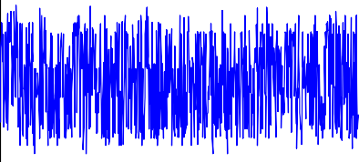

SPECTRUM OF GPS SIGNAL

30

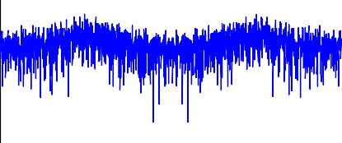

20

amplitude

Magnitude (dB)

0

10

-50 100 200 300 400 500 600 700 800 00 2 4 6 8 10 12 14 16

samples

Frequency (Hz)

x 106

(a) (b)

100

50

amplitude

0

-50

NOISY GPS SIGNAL (-150dBm)

SPECTRUM OF NOISY GPS SIGNAL

30

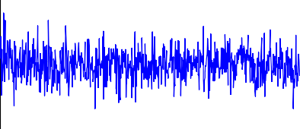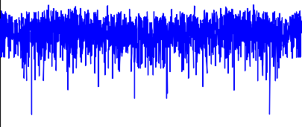

25

Magnitude (dB)

20

15

10

-100 0 100 200 300 400 500 600 700 800

5

0 2 4 6 8 10 12 14 16

samples

Frequency (Hz)

x 106

(c) (d)

20

10

amplitude

0

-10

NOISE EXCISED GPS SIGNAL THROUGH SSA

30

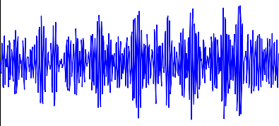

20

Magnitude (dB)

10

0

-10

SPECTRUM OF NOISE EXCISED SIGNAL THROUGH SSA

-200 100 200 300 400 500 600 700 800 -200 2 4 6 8 10 12 14 16

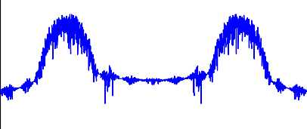

samples

Frequency (Hz)

x 106

(e) (f)

Figure 4 Simulation results of SSA on noisy GPS signal. (a) GPS signal at —130 dBm, (b) spectrum of the GPS signal, (c) noisy GPS signal of —150 dBm, (d) spectrum of noisy GPS signal. (e) Noise excised GPS signal and (f) spectrum of noise stripped GPS signal.

Table 2 Type of filters used for noise excision (SNR of weak signal before filtering = —29 dB).

Pre-filter type used

SNR(dB)= 10 * log P

P

*N*

—

1

*n*

*x*(*n*

)

2

1

=

0

*N*—

After filtering

Gain (dB)

*n*=0 (*x*(*n*)—*x*~(*n*))

2

Butterworth filter

Chebyshev filter Wavelet de-noising

Singular spectral analysis

—23.1548

—23.3740

—22.6816

—6.3529

5.8452

5.6260

6.1894

22.7335

between 1st maximum and 2nd maximum peak values should be greater than 0.3 and 0.15. In order to get a minimum probability of false alarm 10—2, the thresholds *VT*1 and *VT*2 values are chosen as 0.99 and 0.25 respectively. In case, the correlation output crosses the above predetermined threshold with only one period time of C/A code, the GPS receiver can- not produce an SNR gain to make a reliable detection. It is observed that the weak signal detection with single msec data does not satisfy the condition. As it fails to give a maximum value of the decision statistic (*S*) and hence no satellites are visible. The simulation results of testing one msec data for Satellite Vehicle Number (SVN) 31 indicate that both with SSA and without SSA fail to excise the noise (Fig. 5a and b). For reasonable acquisition of signals around 35 dB-Hz with nominal amount of false alarm [5], single msec data is sufficient, still in order to meet the specified threshold values for weak signal (<35 dB-Hz), longer duration data are needed.

* 1. *SSA combined coherent detection based post-correlation approach*

The coherent detection method is tested for 150 dBm power level at 4 ms integration time. The method is unable to satisfy the maximum value of the decision statistic (*S*) and poor cor- relation performance of SVN 31 (Fig. 6a) and the data are tested with the SSA method. Among the locally generated 32-PRN codes correlated with the incoming signal, only SVN-31 crosses the peak condition (Fig. 6b) requiring mini- mum of 4 satellites to find out the user position. Increasing the acquisition data length beyond 10 ms leads to data transi- tion. Longer duration coherent detection increases number of frequency bins to be searched which restricts extending the integration time during weak signal conditions. As coherent integration even when combined with SSA is not able to detect weak signals less than *C*/*N*0 24 dB-Hz, therefore non-coherent integration is next to study.

—

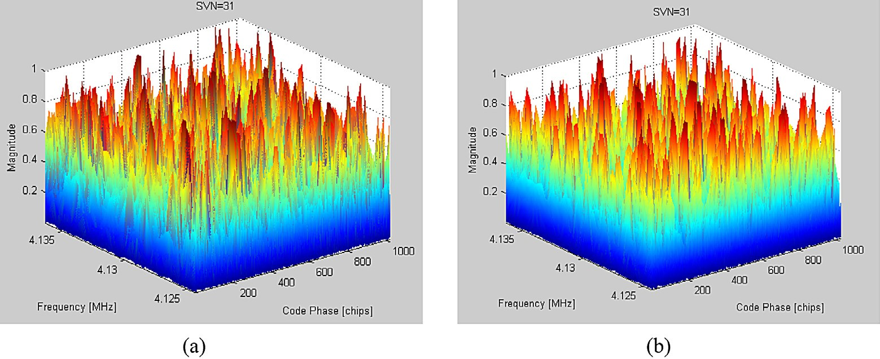

Figure 5 Correlation output of SVN-31 tested with 1 ms integration time for input power level of —150 dBm (*C*/*N*0 of 24 dB-Hz). (a) Single msec data and (b) single msec processed using SSA.

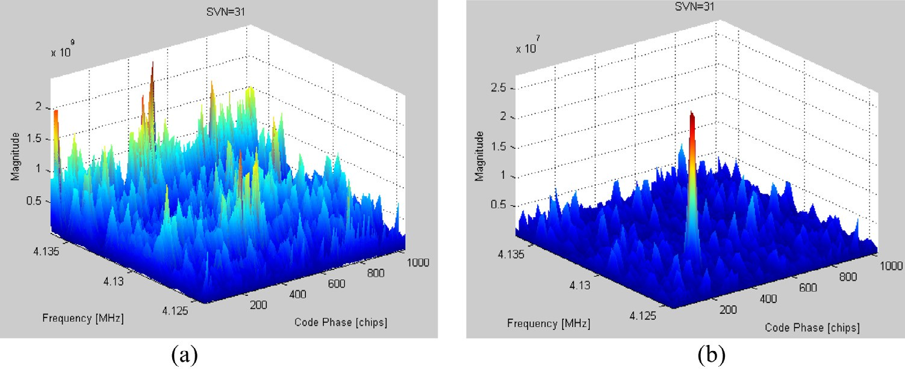

Figure 6 Correlation output of SVN-31 tested with coherent detection (4msec) for input power level of —150 dBm (*C*/*N*0 of 24 dB-Hz).

* + 1. Coherent integration time and (b) SSA combined with coherent integration time.
  1. *SSA combined noncoherent detection based post-correlation approach*

The 150 dBm GPS data are tested for 40 ms duration nonco- herent integration time. Fig. 7.a shows the non-coherent detec- tion result of SVN 31 without SSA where the maximum value of the decision statistic (*S*) is not arrived, the required thresh- old conditions, and the signal is declared absent. While testing noncoherent integration with SSA, only SVN-31 is found with dominant peak (Fig. 7b). Studies have demonstrated that the Signal Sensitivity increases roughly with square root of inte- gration time [19] and a 10 ms longer integration time gives only 5 dB increase in sensitivity. Hence it is concluded that 100 ms non-coherent integration correlation i.e. one tenth of second data are required to acquire a signal having *C*/*N*0 up to 24 dB-Hz [5].

—

* 1. *SSA combined differential coherent detection based postcorrelation approach*

The 16 ms duration noisy data are tested for differential coher- ent detection approach at 150 dBm power level. The SVN-31 correlation performance is tested and it surpasses the threshold value. But at lower power level (below 159 dBm) the decision statistic (*S*) does not cross the predetermined threshold values

—

—

for SVN-31.This is because the noise independent property has capability of removing the squaring loss up to certain SNR values only. On examining Fig. 8a and b it is inferred that dif- ferential coherent scheme is able to detect only one visible SVN-31 for SNR level of 150 dBm. When the signal level is weaker ( 159 dBm), even an increase in integration time to 100 ms does not make any satellite to be visible.

In the proposed work, the SSA approach is combined with differential detection and five SVNs are visible and the decision threshold conditions have been satisfied without any con- straints. Perfect correlation has been achieved and many false secondary peaks owing to noise are eliminated. The five SVNs (2, 17, 26, 27, and 31) meet the threshold condition for the sig- nal range of *C*/*N*0 24 dB-Hz and 15 dB-Hz (Table 3). Fig. 9a–e shows the five SVN’s 3-D correlation and their corresponding code phase i.e., perfect alignment with the C/A code samples is plotted in Fig. 9f–j. Table 4 summarizes the comparison of the results of 15 dB-Hz weak GPS signal tested with different detection methods. The proposed method i.e. SSA combined with differential detection performs better in obtaining visible satellites for 16 ms weak GPS data and acquiring 5 SVNs to initiate the tracking process. Even though the differential detection scheme has dominant peak but the threshold condi- tion 1 is not satisfied for all the SVNs. The code phase and Doppler frequency comparison between different detection techniques are listed in Table 5. The data show that the differ-

—

—

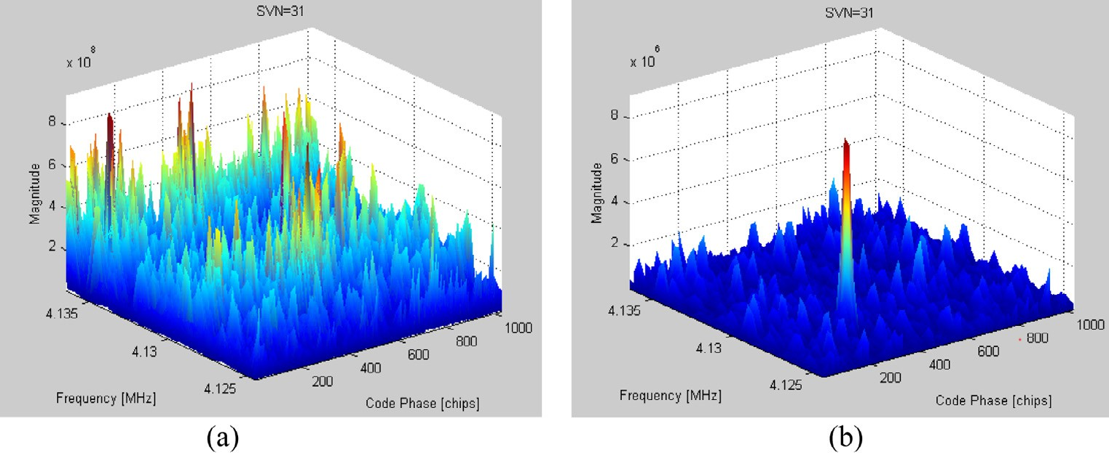

Figure 7 Correlation output of SVN-31 tested with non-coherent detection (40 ms) for input power level of —150 dBm (*C*/*N*0 of 24 dB Hz). (a) Non-coherent integration time and (b) SSA combined with Non-coherent integration time.

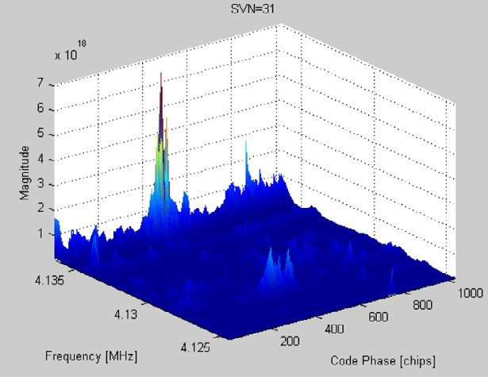Deviation in code phase and doppler frequency

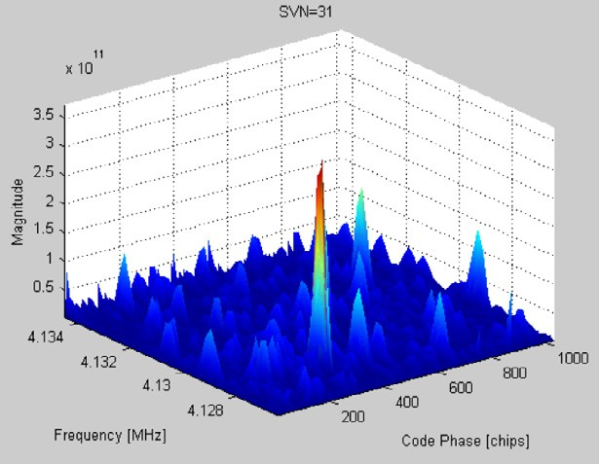

(a) (b)

Figure 8 Acquisition correlation output of SVN-31 tested with differential detection for input power level of —150 dBm (*C*/*N*0 of 24 dB Hz) and —159 dBm (*C*/*N*0 of 15 dB Hz). (a) 16 ms integration time at —150 dBm power level and (b) 100 ms integration time at

—159 dBm power level.

Table 3

Power level

Comparison of different detection techniques at two power levels.

Peak search condition = Max peak-mean peak >0.99 and Max peak-secondary peak >0.25 Detection type

1 ms data Coherent post-correlation

Noncoherent post-

correlation

Differential post-correlation

Without Pre-filter

pre-filter combined

No visible No visible SVN SVN

Without

pre-filter

No visible SVN

Pre-filter

combined

1 SVN (31)

Without

pre-filter

No visible SVN

Pre-filter

combined

1 SVN (31)

Without

pre-filter

1 SVN (31)

Pre-filter combined

—150 dBm

—159 dBm

5 SVN (2, 17, 26, 27

and 31)

No visible

SVN

No visible

SVN

No visible

SVN

No visible

SVN

No visible

SVN

No visible

SVN

No visible

SVN

5 SVN (2, 17, 26, 27

and 31)

ential coherent detection technique with pre-filtering approach corrects the deviation in code phase of 22.1 chips and Doppler frequency of 164 Hz of the SVN-31 caused by noise at

—150 dBm when compared to differential detection.

1. Acquisition sensitivity analysis
   1. *Processing Gain (*Gp*) estimation in software GPS receiver*

The nominal signal strength of a typical C/A code receiver is

—130 dBm [20]. The noise floor for 1 kHz is at —144 dBm; thus

the corresponding SNR is 14 dB (—130 + 144). The input power level of incoming GPS signal varies from —130 dBm to —159 dBm and the locally generated PRN-31 is correlated with incoming signal for the probability of false alarm (*p*fa of 10—2. The probability of detection and the *Gp* are computed

for different integration periods. The Monte Carlo simulation is carried out for 10,000 trials to ensure the effectiveness of the performance comparison between the three detection methods. A weak GPS signal of 140 dBm (34 dB-Hz) i.e. SNR of ( 140 + 144) = 4 dB was set as power level. In order to achieve nominal SNR of 14 dB, a gain of 10 dB is required,

)

—

—

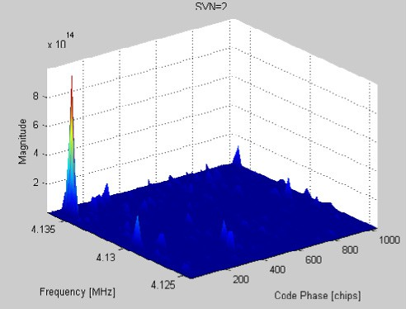 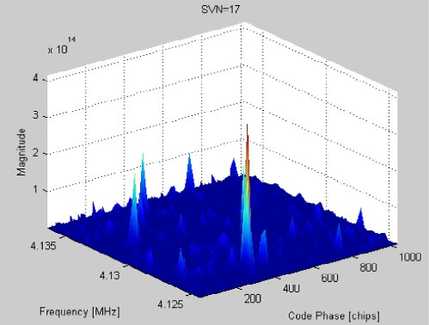 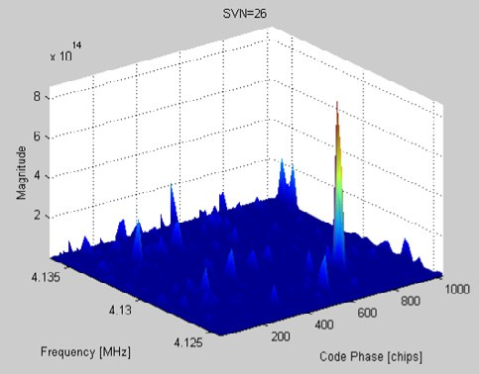

(a) SVN 2 (b) SVN 17 (c) SVN 26

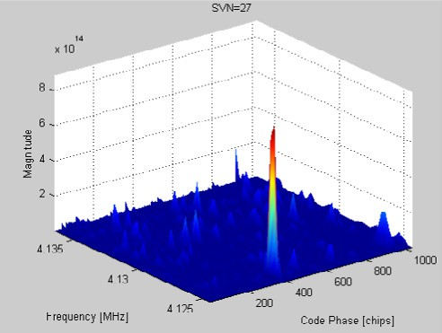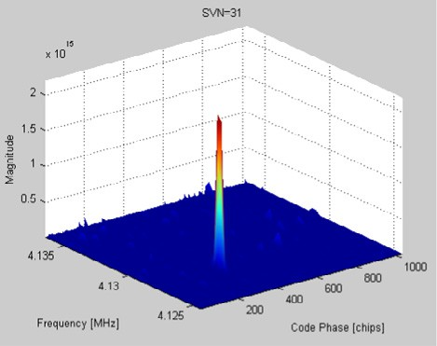

(d) SVN 27 (e) SVN 31

x 1014

10

8

Magnitude

6

4

2

SVN-2

x 1014

5



4

Magnitude

3

2

1

SVN-17

x 1014 SVN-26

10

8

Magnitude

6

4

2

0

0 2000 4000 6000 8000 10000 12000 14000 16000

Samples

0

0 2000 4000 6000 8000 10000 12000 14000 16000

Samples

0

0 2000 4000 6000 8000 10000 12000 14000 16000

Samples

(f) (g) (h)

x 1014

10



8

Magnitudes

6

4

2

0

SVN-27

x 1015

2.5

2

Magnitude

1.5

1

0.5

0

SVN-31

0 2000 4000 6000 8000 10000 12000 14000 16000

Samples

(i)

0 2000 4000 6000 8000 10000 12000 14000 16000

Samples

(j)

Figure 9 Correlation outputs of visible SVN tested with GPS data of input power level of —159 dBm (*C*/*N*0 15 dB-Hz) using SSA combined differential coherent approach. (a–e) – 3D search correlation results for SVN 2, 17, 26, 27 and 31 (f–j) – code phase for SVN 2, 17, 26, 27 and 31.

Table 4 Determination of visible SVN based on peak search condition tested for different detection techniques processed through

SSA at —159 dBm power level.

SVN Pre-filter combined coherent

Pre-filter combined non-

coherent

Differential [6–8]

Pre-filter combined differential

detection

Max 2nd max

peak peak

(e+07) (e+07)

2 3.364 0.795

17 2.166 0.715

26 3.127 1.545

27 3.167 1.559

31 4.983 1.206

Avg

peak (e+07)

0.183

0.161

0.193

0.228

0.202

*S*

×

×

×

×

×

Max 2nd max

peak peak

(e+07) (e+07)

4.205 0.993

2.708 0.894

3.909 1.931

3.959 1.948

6.229 1.508

Avg

peak (e+07)

0.229

0.201

0.242

0.285

0.253

*S*

×

×

×

×

×

Max 2nd max

peak peak

(e+19) (e+18)

0.195 0.265

0.167 1.003

0.208 0.389

2.180 0.087

0.702 3.139

Avg

Peak (e+18)

0.114

0.126

0.133

1.057

0.302

*S*

×

×

×

×

×

Max

peak (e+15)

0.9945

0.4122

0.8596

0.8814

2.182

2nd max

peak (e+14)

0.555

0.449

2.098

2.135

1.279

5.007

3.808

5.680

7.442

Avg *S*

peak (e+12)

p

6.414

p

p p p

*S* – Whether detection threshold condition satisfied – p – Yes and × – No.

hence signal must be averaged over a sufficiently long non- coherent integration time (20 ms) to build up the SNR to a reliable level (10 dB) (Fig. 10a). In a similar fashion, the power is varied at different levels and the corresponding probability of detection and the *Gp* are examined. The detection metrics

for the three detection methods have been presented in Table 6 for different values of signal quality. SNR after correlation is also determined with longer integration times. The SNR com- putation in the software receiver is defined as the ratio between the accumulated and averaged in phase arm (*I*^arm) power to the

Table 5

Power level

Acquisition output for different detection techniques processed through SSA pre-filtering.

SVN

Pre-filter combined coherent

Pre-filter combined non-

coherent

Differential detection

Pre-filter combined

differential detection

—150 dBm

2

17

26

27

31

Code phase

(chips)

×

×

×

×

322.9

2400

Doppler

frequency (Hz)

×

×

×

×

322.9

Code phase

(chips)

×

×

×

×

2400

Doppler

frequency (Hz)

×

×

×

×

Code phase

(chips)

×

×

×

345

×

2564

Doppler

frequency (Hz)

×

×

×

×

Code phase

(chips)

56.5

347.8

750.4

365.9

322.9

Doppler

frequency

—4800

4500

2700

5400

2400

—159 dBm 2 ×

17 ×

26 ×

27 ×

31 ×

×

×

×

×

×

×

×

×

×

×

×

×

×

×

×

×

×

×

×

×

×

×

×

×

×

56.5

347.8

750.4

365.9

322.9

—4800

4500

2700

5400

2400

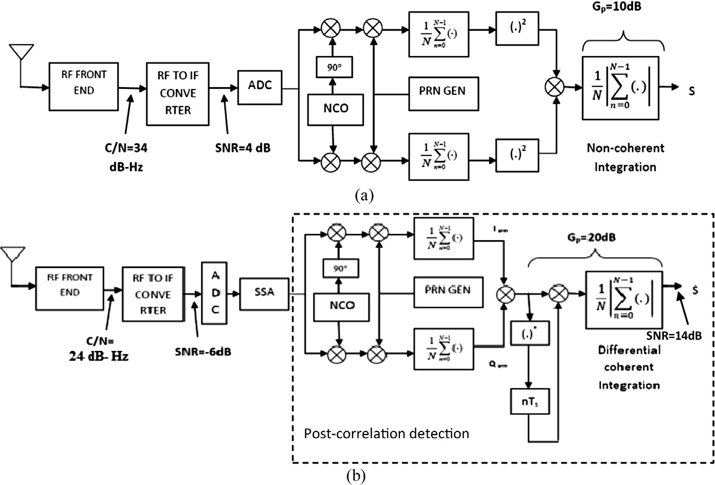

Figure 10 Acquisition sensitivity improvement at different power levels for PRN-31. (a) *Gp* improvement of 10 dB through 50 ms non- coherent integration at 34 dB-Hz power level and (b) *Gp* improvement of 20 dB through 16 ms pre-filtering combined differential coherent integration at 24 dB-Hz power level.

accumulated and averaged noise power (*Q*^arm) given by Eq. (3) [21]

during the simulation. More than a second of data is required to get the 100% of detection at the power level of —150 dBm.

*SNR* = 10log10

2

^2

arm

*I*

2*Q*

^2

arm

!dB

(3)

As the required gain goes beyond 20 dB in the incredibly lower

SNR, an increment of 1000 ms integration time results only in1.5 dB improvement in gain. So a group of data i.e. 20 s is

required to attain the gain of 25 dB which is practically impos-

*I*^2

2

= (*fs*s) *c* and *Q*^2

= *f* sr

sible. Processing non-coherent integration of 20 s data on a

arm 2

arm *s y*

Personal Computer (PC) of 1.46 GHz processor with 1 GB

where s – integration time, *C* – carrier power, r2

*y*

variance.

– noise

memory runs 14 h time which delays the time to fix the first position of the satellite in the acquisition stage. Such expensive

Theoretically noncoherent integration time of 20 ms is enough to obtain the gain of 10 dB at 140 dBm, however, 50 ms is required to get the highest probability of detection

—

computations will be feasible only for off-line applications [5]. The differential detection scheme shows appreciable perfor- mance compared to non-coherent detection with lower acqui-

|  |  |  |  |  |  |
| --- | --- | --- | --- | --- | --- |
| Table 6 Required integration time, Processing Gain (*Gp*) and mean acquisition time (*T*acq) at different power levels of GPS signal. | | | | | |
| Detection type | Input *C*/*N*0 (dB- | Integration time | Probability of detection | *Gp* | Mean acquisition time |
|  | Hz) | (ms) | (%) | (dB) | (s) |
| Noncoherent detection | 44 (—130 dBm) | 1 | 100 | – | 23.39 |
|  | 34 (—140 dBm) | 2 | 1.8 | 2.20 | 46.78 |
|  |  | 10 | 3.62 | 6.71 | 233.92 |
|  |  | 20 | 10.53 | 8.46 | 467.85 |
|  |  | 50 | 97.30 | 10.67 | 1.16e+03 |
|  | 24 (—150 dBm) | 50 | 26.66 | 10.67 | 1.16e+03 |
|  |  | 100 | 34.54 | 12.29 | 2.33e+03 |
|  |  | 500 | 92.76 | 15.94 | 1.16e+04 |
|  |  | 1000 | 98.45 | 17.48 | 2.33e+04 |
|  |  | 1500 | 100 | 18.37 | 3.50e+04 |
|  | 19 (—155 dBm) | 2000 | 93.23 | 19.01 | 4.67e+04 |
|  |  | 10,000 | 100 | 22.54 | 2.33e+05 |
|  | 15 (—159 dBm) | 20,000 | 91.22 | 24.05 | 4.67e+05 |
| Differential detection [7] | 44 | 4 | 100 | – | 25.07 |
|  | 34 | 8 | 100 | 9.30 | 40.09 |
|  | 24 | 16 | 100 | 19.72 | 78.56 |
|  | 19 | 32 | 98.56 | 23.42 | 124.76 |
|  | 15 | 64 | 68.24 | 24.32 | 153.23 |
| SSA combined with differential | 44 | 2 | 100 | – | 70.93 |
| detection | 34 | 2 | 100 | 10.03 | 70.93 |
|  | 24 | 4 | 100 | 19.22 | 112.90 |
|  | 19 | 8 | 99.44 | 24.50 | 131.28 |
|  | 15 | 16 | 96.11 | 29 | 269.88 |
|  |  |  |  |  |  |

1

0.9

0.8

0.7

0.6

0.5

PD

0.4

0.3

0.2

0.1

0

Monte Carlo Simulation Results

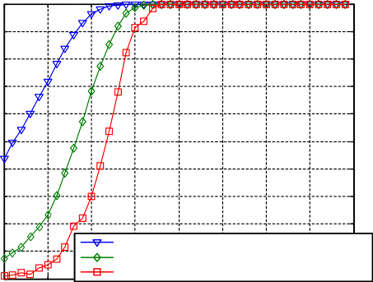pre-filtering combined differential coherent-16 msec differential coherent-32 accumulations (Tcoh=10msec) noncoherent-2sec

5 10 15 20 25 30 35 40 45

C/N (dB-Hz)

45

40

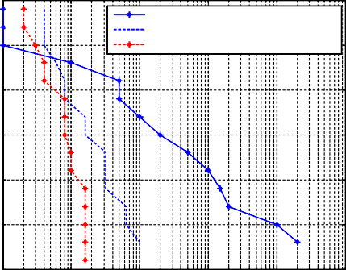

noncoherent

differential coherent(Tcoh=10msec)

pre-filtering combined differential coherent

35

C/N0 [dB-Hz]

30

25

20

15 0 1 2 3 4 5

10 10 10 10 10 10

Integration Time [m.sec]

(a) (b)

106

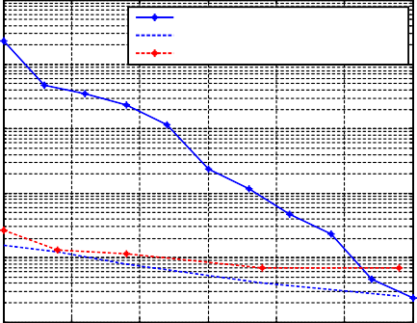

noncoherent

differential coherent(Tcoh=10msec)

pre-filtering combined differential coherent

105

104

mean acquisition time [sec]

103

102

101

15 20 25 30 35 40 45

C/N0 [dB-Hz]

(c)

Figure 11 Performance comparison of various detection techniques. (a) *C*/*N*0 versus probability of detection, (b) integration time versus

*C*/*N*0 and (c) *C*/*N*0 versus mean acquisition time.

Table 7 Selection of trajectory matrix tested for SVN-31 at

—150 dBm.

Parameters Type of trajectory matrix

Autocorrelation Autocovariance

Mean square

0.2346

0.7789

Modified

covariance

0.6356

Maximum

correlation peak

*Gp* (dB)

error (^e)

2.182e15

2.8549e13

4.5627e13

20

17.3

18.2

sition time, however, for dealing with15 dB-Hz weak signal, even after extending the integration time to 100 ms is not suf- ficient enough to meet the decision statistic and the detection probability is around 0.68 only. On the other hand, the SSA combined differential detection does well in the lower SNR level. Fig. 10b shows the *Gp* improvement of 20 dB under the power level 24 dB-Hz while performing 16 ms differential inte- gration time combined with SSA. The pre-filtering combined differential coherent approach provides a significant *Gp* of 29 dB within the integration time of 16 ms having 96% of probability of detection under the signal level of 159 dBm. An additional gain of 3 dB with a detection probability of

—

0.96 is being provided by the pre-filtering combined differential coherent method (Fig. 11) compared with the differential detection approach in the signal range lower than *C*/*N*0 20 dB-Hz. Integration Time versus *C*/*N*0 is plotted where *C*/ *N*0 goes below the nominal level (Fig. 11b), the required non-coherent integration time is in the order of 104 ms whereas performing pre-filtering combined differential coherent detec- tion the required integration is about 20 ms.

* 1. *Mean acquisition time computation*

Mean acquisition time (*T*acq) for coarse acquisition (C/A) code is computed for a parallel code phase search acquisition system [22].

computations. In total, a worst case complexity of O (*N*2)+O (*N*3)+O (*N*2)=O (*N*3) operations are required for SSA algo- rithm computation. While running the SSA algorithm on

1.46 GHz processor with 1 GB memory in MATLAB simula- tor, the average computation time of SVD stage is only around 9.5773 s, rank reduction stage is 7.883210 s and reconstruction stage is 6.767183 s. Hence total computation time of SSA is only 24.227 s. The 16 ms DFC based parallel code phase search acquisition algorithm takes 241.2868 s. Therefore the total mean acquisition time for the SSA based differential scheme for 15 dB-Hz *C*/*N*o is 269.88 s as shown in Table 6. Hence the inclusion of the SSA stage has significantly increased the overall computation time. Therefore with the proposed approach, the extremely weak signal has been acquired with less acquisition time without much increase in computational time.

1. Conclusion and future work

The SSA based de-noising approach relies on finding the econ- omy SVD of the autocorrelation trajectory matrix of noisy input samples and maintaining the structure of the matrix by applying suitable rank reconstruction (Toeplitz/Hankel) meth- ods. On testing with noisy GPS signal, this method combined with DFC efficiently handles lower power signal level of 159 dBm with shorter integration time and achieves 3 dB gain improvement within 269.88 s of mean acquisition time. The detection of the number of visible satellites is increased and also the re-acquisition of GPS data is avoided. From the simulation results, the differential coherent detection technique when combined with pre-filtering corrects the deviation in code phase and Doppler frequency of the visible SVN compared to other conventional methods. The SSA based de-noising cou- pled with DFC has an ability to recover the weak signals only up to 159 dBm which is the limitation of current approach. Therefore for an indoor environment, Independent Compo- nent analysis can be used in the SSA signal decomposition step for finding proper rotations of eigen triples in weak signal

—

—

separability.

*T* = (2 — *Pd*)(1 + *kP*fa) (*q*s ), *q* = 2046 * 41

(4)

References

acq

*d*

2*Pd*

(1/*T*

coh)

where s*d* is total GPS integration period, *kP*fa is false alarm penalty time (by keeping *k* = 10), *q* is the total number of cells to be searched in the bin and *T*coh = 1 ms for coherent, nonco- herent and 10 ms for DFC. Using the Eq. (4), *T*acq is computed for different integration times. Fig. 11c shows that processing 20 s non-coherent data takes the computing time of 4.6785e

+05 s whereas utilizing 16 ms pre-filtering combined differen- tial integration method, the required gain is attained within

269.88 s of mean acquisition time.

*3.3. Computation complexity*

The initial step of formation of trajectory matrix requires com- plexity of O (*N*2) operations. The multiplication of left singular matrix with size *N* (*N r*), diagonal matrix of size (*r r*) and the right singular matrix with size *M M* in the economy SVD rank reduction step requires O (*N*3) operations. The final step of diagonal averaging in rank restoration requires O (*N*2)

×

× — ×

1. [Michel S. Braasch, A.J. Van Dierendonck, GPS receiver](http://refhub.elsevier.com/S2210-8327(14)00027-1/h0200) [architecture and measurements, Proc. IEEE 87 (1999) 48–64](http://refhub.elsevier.com/S2210-8327(14)00027-1/h0200).
2. [Giacomo Bacci, Filippo Giannetti, Marco Luise, Software](http://refhub.elsevier.com/S2210-8327(14)00027-1/h0205) [defined radio technologies GNSS receivers: a tutorial approach](http://refhub.elsevier.com/S2210-8327(14)00027-1/h0205) [to a simple design and implementation, Int. J. Navigat. Observ.](http://refhub.elsevier.com/S2210-8327(14)00027-1/h0205) [(2010)](http://refhub.elsevier.com/S2210-8327(14)00027-1/h0205).
3. [Kai Borre, Dennis M. Akos, Nicolaj Bertelsen, Peter Rinder,](http://refhub.elsevier.com/S2210-8327(14)00027-1/h0210) [Soren Holdt Jensen, A Software Defined GPS and Galileo](http://refhub.elsevier.com/S2210-8327(14)00027-1/h0210) [Receiver, Birkha¨ user Bostonin, 2007 (ISBN-10 978-0-8176-4390-](http://refhub.elsevier.com/S2210-8327(14)00027-1/h0210) [4)](http://refhub.elsevier.com/S2210-8327(14)00027-1/h0210).
4. Xiaohui Ba, Ying Yang, Jinhai Li, Jie Chen, Differentially coherent acquisition algorithm for indoor GPS, IET International Conference on Wireless, Mobile and Multimedia Networks, 2006, 6–9 November 2006, pp. 1–4.
5. Luke Winternitz, Michael Moreau, Gregory J. Boegner, Jr., Steve Sirotzky, Navigator GPS receiver for fast acquisition and weak signal space applications, in: Proceedings of the 17th International Technical Meeting of the Satellite Division of The Institute of Navigation (ION GNSS 2004), Long Beach, CA, September 2004, pp. 1013–1026.
6. Nana Lei, Hao Zhu, Jianyong Cui, Wavelet-based method for weak satellite signal acquisition. International Conference on Transportation, Mechanical, and Electrical Engineering (TMEE), 16–18 December 2011, pp. 2487–2490.
7. Shijun Tian, Yiming Pi, Research of weak GPS signal acquisition algorithm, Communications, Circuits and Systems, 2008. ICCCAS 2008, 25–27 May 2008, pp. 793–796.
8. Liu Yang, Jin Tian, Analysis and compare of weak GPS signal acquisition algorithms, IET International Communication Conference on Wireless Mobile and Computing (CCWMC 2009), 7–9 December 2009, pp. 492–495.
9. Jingwei Ma, Lingjuan Miao, Xi Zhang, Zhifeng Gao, Weak signal acquisition algorithm of GPS software receiver aided by INS, Sixth International Symposium on Computational Intelligence and Design (ISCID), 2013, 28–29 October 2013,

vol. 1, pp. 321–325.

1. M.L. Psiaki, Block acquisition of weak GPS signals in a software receiver, in: Proceedings of Institute of Navigation GPS Conference 2001, Salt Lake City, UT, USA, 2001, pp. 2838–2850.
2. [Wei-Lung Mao, An-Bang Chen, New code delay compensation](http://refhub.elsevier.com/S2210-8327(14)00027-1/h0250) [algorithm for weak GPS signal acquisition, Int. J. Electron.](http://refhub.elsevier.com/S2210-8327(14)00027-1/h0250) [Commun. (2008) 665–677 (Elsevier Publications)](http://refhub.elsevier.com/S2210-8327(14)00027-1/h0250).
3. Mohamed Sahmoudi, Moeness G. Amin, Rene Jr. Landry, Acquisition of weak GNSS signals using new block averaging pre-processing, Position, Location and Navigation Symposium, IEEE/ION2008, pp. 1362–1372.
4. [Shau-Shiun Jan, Chih-cheng Sun, Signal Existence Verification](http://refhub.elsevier.com/S2210-8327(14)00027-1/h0260) [(SEV) for GPS low received power signal detection using the](http://refhub.elsevier.com/S2210-8327(14)00027-1/h0260) [time-frequency approach, J. Sens. (2010) 4717–4738](http://refhub.elsevier.com/S2210-8327(14)00027-1/h0260).
5. Yingyan Song, Xue Li, Yikang Yang, Lei Liu, Enhanced full bit acquisition algorithm for software GPS receiver in weak signal environment, IEEE International Conference on Computational Problem-Solving, 2011 (ICCP2011), pp. 440–443.
6. [Hossein Hassani, Singular spectral analysis: methodology and](http://refhub.elsevier.com/S2210-8327(14)00027-1/h0295) [comparison, J. Data Sci. (2007) 239–257](http://refhub.elsevier.com/S2210-8327(14)00027-1/h0295).
7. Sophocles J. Orfanidis, SVD, PCA, KLT, CCA, and All That-A course on Optimum Signal Processing, Rutgers University, 2002–2007.
8. Golyandina, Nina, Zhigljavsky, Anatoly, Singular Spectrum Analysis for Time Series, Springer Publications, ISBN 978-3- 642-34913-3, 2013.
9. A Beginner’s guide to SSA, David Claessen and Andreas Groth, CERES-ERTI, Ecole Normale Superieure, Paris.
10. Bo Zheng, Ge´ rard Lachapelle, GPS software receiver enhancements for indoor use, in: Proceedings of the 18th International Technical Meeting of the Satellite Division of The Institute of Navigation (ION GNSS 2005), Long Beach, CA, September 2005, pp. 1138–1142.
11. [James Bao-Yen Tsui, Fundamental of Global Positioning](http://refhub.elsevier.com/S2210-8327(14)00027-1/h0355) [System Receivers – A software Approach, second ed.,](http://refhub.elsevier.com/S2210-8327(14)00027-1/h0355) [A Wiley](http://refhub.elsevier.com/S2210-8327(14)00027-1/h0355) [Interscience Publication, New York, 2000, pp. 133–160](http://refhub.elsevier.com/S2210-8327(14)00027-1/h0355).
12. Angelo Joseph, Measuring GNSS Signal strength, Inside GNSS Magazine, November/December 2010, pp. 20–25.
13. Lingjuan Wu, Weijun Lu, Dunshan Yu, Research of weak signal acquisition algorithms for high sensitivity GPS receivers, Asia Pacific Conference on Postgraduate Research in Microelectronics & Electronics (Prime Asia), 19–21 January 2009, pp. 173–176.