 Electronic Notes in Theoretical Computer Science 166 (2007) 93–109 

[www.elsevier.com/locate/entcs](http://www.elsevier.com/locate/entcs)

A Change-based Approach to Software Evolution

Romain Robbes and Michele Lanza1*,*2

*Faculty of Informatics University of Lugano - Switzerland*

**Abstract**

Software evolution research is limited by the amount of information available to researchers: Current version control tools do not store all the information generated by developers. They do not record every intermediate version of the system issued, but only snapshots taken when a developer commits source code into the repository. Additionally, most software evolution analysis tools are not a part of the day-to-day programming activities, because analysis tools are resource intensive and not integrated in development environments. We propose to model development information as change operations that we retrieve directly from the programming environment the developers are using, while they are effecting changes to the system. This accurate and incremental information opens new ways for both developers and researchers to explore and evolve complex systems.

*Keywords:* Software Evolution, Versioning Systems, IDEs

# Introduction

The goal of software evolution research is to use the history of a software system to analyse its present state and to predict its future development [11], [5]. Such an analysis requires information about a system to give accurate insights about its history. Traditionally researchers extract their data from versioning systems, as their repositories contain the artifacts the developers produce and modify.

We argue that the information stored in versioning systems is not complete enough to perform higher quality evolution research. Since the past evolution of a software system is not a primary concern for most developers, it is not an impor- tant requirement when designing versioning systems. They favor features such as language independence, distribution and advanced merging capacities.

1 Email: [romain.robbes@lu.unisi.ch](mailto:romain.robbes@lu.unisi.ch)

2 Email: [michele.lanza@unisi.ch](mailto:michele.lanza@unisi.ch)

1571-0661 © 2006 Elsevier B.V. Open access under [CC BY-NC-ND license.](http://creativecommons.org/licenses/by-nc-nd/3.0/)

doi:10.1016/j.entcs.2006.06.015

We need to prove to developers that results in software evolution research are immediately useful to them by improving the integration of our tools in their day- to-day processes. Most tools are tailored for an use “after the fact”, once the main development is over and before a new feature is added. A common approach is to download several versions from a repository and to process them all at once. This shows that incremental processing is limited, and computations are long and resource-intensive. We need to provide more incremental, lightweight approaches that developers can use in their work.

This paper presents our approach to tackle both problems of accurate informa- tion retrieval and developer use of evolution tools. We believe the most accurate source of information is the Integrated Development Environment (IDE) the de- velopers are using. By hooking our tools into an IDE, we can capture evolution information as it happens, treat it in an incremental manner, and interact with the environment to improve the usability of our tools. Our approach is based on a model of the changes developers are applying to the system and hence treats changes as first-class entities. In that sense, we do not make a distinction between the system and the changes that are performed on it, i.e., software engineering *is part of* software evolution.

**Structure of the paper:** Section 2 expands on the nature and consequences of the problems we presented. Section 3 introduces our alternative approach. Sec- tion 4 describes the implementation status of SpyWare, our prototype. Section 5 describes how such a model can be used in practice and how problems are stated and solved differently in an incremental, change-based world. Section 6 outlines some preliminary results, while section 7 concludes the paper.

# Current Approaches to Software Evolution

To perform efficient evolution research, accurate data about the system under study is required. Despite this need, the tools the community uses to gather the data do not provide such accurate information. At the core of most data recovery strategies is the versioning system used by the developers of the system.

The main criteria in choosing a versioning system from which to extract data is how many systems it versions, especially open-source ones: developers allow free access to their repositories. The largest open-source software systems (Mozilla, Apache, KDE, etc) use either CVS or Subversion, researchers therefore write their tools to gather data from these repositories.

* 1. *Limitations in Information Gathering*

In a previous study [14] we showed that most versioning systems in use today (including CVS and Subversion) are indeed losing a lot of information about the system they version. We identified two main, orthogonal, reasons: most versioning systems are (1) *ﬁle-based*, and (2) *snapshot-based*.

**File-based systems.** Most of these systems still function at the file level, as this guarantees language independence. On the other hand, it involves extra work

to raise the level of abstraction to the programming language used by the system [16], [9], because the collected information is obfuscated:

* + - The semantic information about a system is scattered in a large amount of text files: there is no built-in central repository of the program structure, it has to be created manually.
    - Keeping track of a program-level (not text-level) entity among several versions of the system is hard since it involves parsing several versions of the entire system while taking into account events such as renames of files and entities due to refactorings. Hence some analyses are performed on data which has been sampled [7], [8]: only a subset of the versions are selected because of time and space constraints. This increases the changes between each versions, and makes it harder to link entities across versions since the probability they have changed is higher. Other analyses do without the parsing of the files altogether, basing themselves on coarser-grained information such as the number of lines or the size of directories [4], [6].

**Snapshot-based systems.** Changes between successive versions of the soft- ware are stored on explicit requests (called *commits*) by the developer. The time between two developer commits varies widely, but is often on the order of several hours or days. What happens between two commits is never stored in the versioning system, and we have to deal with degraded information:

* + - Since commits are done at the developer’s will, several independent fixes or feature additions can be introduced in one single commit, making it hard to differentiate them.
    - The time information of each change is reduced to the time when a commit has been performed: beyond the task of extracting the differences between two versions of the system, all information about the *exact sequence of changes* which led to these differences is *lost*.
  1. *Practical Impacts of Information Loss*

**Example.** The example in Figure 1 shows how this loss of information can significantly degrade the knowledge inferred about a system. In this simple scenario a developer starts a short refactoring session, in which he refactors the method *doFoo*. He (1) extracts a block of statements in a new method *bar*, (2) replaces direct accesses to instance variables *x* and *y* with accessors throughout the entire system, and (3) renames *doFoo* to *baz*, replacing all references to *doFoo* in the code base.

He then commits these changes. This is a very small commit, less than a minute of work, since in current IDEs all these refactoring operations can be semi- automated. Commits usually imply larger change sets than this simple example. According to the information gathered from the versioning system, the following

|  |  |
| --- | --- |
| class Foo { | |
|  | ***private*** int x;  ***private*** int y;  ***public getX() { return x; } public setX(newX) { x = newX; }***  ***public getY() { return y; } public setY(newY) { y = newY; }*** |
|  | |
|  | public baz() { |
| blah.blah(blah); | |
|  | z = ***getX()*** + ***getY()***;  return bar(); |
| }  public quux() { | |
|  | return ***getY()*** + 4; |
| }  public asdf() { | |
|  | return ***getX()*** * 8 + ***getY()***; |
| } | |
|  | private bar(z) {  blu = blu * 2; t = blurg(z); bli[t] = blu; return t;  } |
| }  f = new Foo(); | |
|  | f.baz();  print ***f.getX()*** + ***f.getY()***; |
|  |

Fig. 1. Simple refactoring scenario leading to evolution information loss.



**Extract Method Rename Method Create Accessors**

?

lines changed between commits

***differences between refactoring*s**

class Foo { public int x; public int y;

public ***baz***() { blah.blah(blah); z = x + y; return bar(z);

}

public quux() { return y + 4;

}

public asdf() { return x * 8 + y;

}

private bar(z) { blu = blu * 2; t = blurg(z); bli[t] = blu; return t;

}

}

f = new Foo(); f.***baz***();

print f.x + f.y;

class Foo { public int x; public int y;

public doFoo() { blah.blah(blah); z = x + y; ***return bar(z);***

}

public quux() { return y + 4;

}

public asdf() { return x * 8 + y;

}

***private bar(z) { blu = blu * 2; t = blurg(z); bli[t] = blu; return t;***

***}***

}

f = new Foo(); f.doFoo(); print f.x + f.y;

class Foo { public int x; public int y;

public doFoo() { blah.blah(blah); z = x + y;

blu = blu * 2; t = blurg(z); bli[t] = blu; return t;

}

public quux() { return y + 4;

}

public asdf() { return x * 8 + y;

}

}

f = new Foo(); f.doFoo(); print f.x + f.y;

physical changes happened 3 :

* The method *doFoo* changed name and is now significantly shorter. This makes it hard to detect if the new method *baz* is really the same entity that *doFoo* was. A simple analysis would conclude that method *doFoo* disappeared.
* There are several new methods: *bar*, *baz*, and accessor methods *getX*, *getY*, *setX*, *setY*.
* Several methods had their implementation modified because of the rename of

*doFoo* and the introduction of accessors, possibly scattered among several files of

3 Note that the changes described below are program-level changes. If the versioning system used is file- based, they need to be raised to that level first

the entire codebase.

In this example, only refactorings – by definition behavior-preserving[3] – have been performed. The logical changes to the system are trivial, yet this commit caused many physical changes: Its importance measured in lines of codes is exag- gerated. Without a sophisticated, time-consuming analysis [16], some entities such as *doFoo* are lost, even if they still exist in the code base. On the other hand, using such a time-consuming analysis makes it harder to integrate these tools in day-to-day activities.

Moreover, the simple scenario depicted above assumes that a developer commits after every couple of minutes of work. In reality, it is more on the order of hours. The change amount would be greater, and changes would be much more diluted and less recoverable.

* 1. *The Lack of Integration*

The way the software evolution analysis community collects information has shaped its tools to function likewise. The typical procedure to fetch information out of a version repository is to (1) download a set of versions from the repository, (2) build a program representation for each of the versions, and (3) attempt to link successive versions of entities.

This approach is clearly only suited for an off-line activity, because even if sam- pling is used it is time-consuming (hours or days to complete on a large-scale sys- tem). Currently, forward and reverse engineering are two very distinct, separate activities. When applied in practice, reverse engineering is performed by special- ized consultants acting on unknown systems under time constraints.

To better accomodate developers, software evolution tools need to be incremental in nature and easily accessible from IDEs. Tools need to focus on smaller-scale changes, when developers are working on smaller parts of the system, as well as providing a “big picture” view of the system to external people such as project managers.

All these necessities become even more important with the advent of agile methodologies such as extreme programming, which advocate continuous refactor- ings and changes in the code base – extreme programming’s motto is “embrace change” [1].

* 1. *Ideas Behind our Approach*

Our approach, presented in the next sections, stems from the following observations:

* + - Versioning systems are not a good source to retrieve information, as they store changes at the file level. They also store changes at commit time, yielding too coarse-grained changes.
    - More and more developers are nowadays using IDEs, featuring a wealth of infor- mation and tools, making development more effective and increasing the change rates of systems.
* For evolution tools to gain acceptance, they must (1) adapt to this increase of the rate of change, (2) be used by the developers themselves as part of their day-to- day activities, (3) be able to focus on small-scale as well as large-scale entities, and

(4) support incremental updates of information, as day-long information retrieval phases are a serious flaw for daily usage.

# An Alternative Approach to Evolution

Our approach is based on two concepts: (1) an IDE integration to record as much information as possible and to allow easy access to our tools, and (2) a model based on first-class change operations to better match the incremental process of developing software.

* 1. *Using the IDE as an Information Source*

Most programmers use IDEs for their day-to-day tasks, because they are powerful tools featuring support for semi-automatic refactoring, incremental compilation, unit testing, advanced debugging, source control integration, quick browsing of the system, etc. Most of them are extensible by plug-in systems.

IDEs are able to do so much because they have an enormous amount of infor- mation about the developer and his system. Being able to browse or refactor the system already implies having a reified program model. Thus we advocate inte- grating our tools in an IDE, and using the IDE itself as the source of evolution information instead of the versioning system. Featuring tool integration increases visibility and is a first step to feature them in the developer’s workflow. To use the IDE as the source of information is the closest we can get to understand the developer’s intentions.

Most IDEs feature an event notification system, so tools can react to what the developer is doing. Hooks monitor when a class is compiled, or when a method is recompiled. The approach we propose uses these IDE hooks to react when a developer modifies the system by creating data defined as *ﬁrst-class change entities*.

* 1. *First-class Change Entities*

First-class change entities are objects modeling the history of a system following the incremental way it was built. They contain information to reproduce the pro- gram of which they represent the history. When executed, they yield an abstract representation of the program they represent at a certain point in time. They also contain additional information interesting for evolution researchers, such as when and who performed which change operations.

Traditional approaches model the history of a program as a sequence of versions. This is memory-consuming, since most parts of the system do not change and are simply duplicated among versions. This is why most approaches include a sampling step, aimed at reducing the number of versions by selecting a fraction of them. This sampling step hence increases the changes between successive versions, ren-

dering fine-grained analysis even harder. In contrast, our approach only stores the program-level differences between versions, and is able to reproduce the program at any point in time.

Change operations also model with greater accuracy the way the developer thinks about the system. If a developer wants to rename a variable, he does not think about replacing all methods referencing it with new methods, even if that is what the IDE ends up doing: Modeling incremental modifications to the system eases its understanding.

The literature shows that a few versioning systems have attempted a change- based, rather than version-based approach to versioning [12] [13]. However, these approaches are solely focused on merging, whereas our model is more general and allows the change operations to be used in various ways. We also think that by not replacing the versioning system layer, but rather complementing it, our approach will encounter less resistance.

Although we model program evolution with first-class change operations to ease reverse engineering, we believe it is useful for forward engineering as well. Most end-user applications feature an undo mechanism, but most program editors do not provide a sensible one at the semantic level. First-class change operations could enable this, hence facilitating exploratory programming by trial and error. First- class change entities can also ease arbitrary program transformation to facilitate program evolution, following the same scheme as semi-automated refactorings[15].

To sum up, our approach consists of the following steps:

1. Use the hooks of the IDE to be notified of developer activity.
2. React to this activity by creating first-class change objects representing the semantic actions the developer is performing.
3. Execute these change objects to move the program representation at any point in time.

**Advantages.** The advantages of this alternative approach over gathering data from a repository and performing off-line analysis are the following:

* *Accuracy*. Reacting to events as they happen gives us more accurate information than the one stored in the versioning system. Timestamps are more precise, not reduced to commit times. Events happen one by one, giving us more context to process them than if we had to process a batch of them, originated from an entire day’s work.
* *Incrementality*. It is significantly easier to maintain a semantic representation of the model. Events originating in the IDE are high level. Their granularity is the one of classes and methods, not files and lines. Code parsing is required only at the method level.
* *Fine-grained*. Every program entity can be modelled and tracked along its ver- sions, down to the statement level if necessary. There is no state duplication, leading to space economies when an entity does not change during several ver- sions.
* *Flexibility*. Going back and forward in time using change objects is easy. It leads to more experiments with the code base, easing “trial and error” in development.

**Drawbacks.** We have identified possible issues and implications with our ap- proach:

* *Acceptance.* Evolution researchers use CVS despite its flaws, because it is the versioning systems most developers use. Subversion is a newer versioning system gathering momentum because it is close enough to CVS. Hence to be successful we need to depart from people’s habits as less as possible.
* *Validation.* Our approach needs to be evaluated with case studies. We are mon- itoring our prototype itself, but without a “real-world” case study we are unsure about performance constraints. Our approach works best for new projects. This limits possible case studies. Nevertheless, section 6 shows preliminary results on several small-scale case studies.
* *Paradigm shift.* Such an incremental approach to various problems needs new tools and new practices to be defined.
* *Applicability.* Our approach is language-specific, which involves more effort to adapt it to a new language than conventional file-based approaches. However, our current prototype implementation is split into a language-independent part and a language-dependent one. Only the latter one must be adapted to other languages/IDEs.

To address acceptance issues, we can integrate our tools in mainstream IDEs, such as Eclipse, which features a plugin mechanism. The monitoring part of the system is not intrusive and is not visible to users. Keeping track of the data across sessions or programmer locations can be done by creating a “sync” file which would be part of the current project. The versioning system itself would be used to broad- cast and synchronize information.

# Our Prototype: SpyWare

Our ideas are implemented in a prototype named SpyWare, written in Squeak [10]. It monitors developer activity by using event handlers located at IDE hooks, and generates change operations from events happening in the Squeak IDE. Figure 2 is composed of a sequence of screen captures of our prototype. It shows the evolution of one project we monitored (in terms of high-level program metrics, such as number of classes, methods, statements and average size of methods in statements). The same graph is shown zoomed in on a peak of the previous graph 4 . Two code browsers on two different views of the systems are also shown: one during the peak (bottom), and one after it (top). The views are separated by around half an hour. We clearly see that the top one has less classes than the bottom one, in accordance with the blue peak. As the scrollbar in the top browser shows, the selected class

4 Due to the curve scaling algorithm we currently use, the zoomed view is not bit-identical to the previous one

has more methods in the later version.

Low level changes supported so far are shown in Table 1. They can be composed in higher-level changes; a few of them are listed in Table 4.

|  |  |  |  |  |  |
| --- | --- | --- | --- | --- | --- |
| **Change Type** | **Package** | **Class** | **Method** | **Variable** | **Statement** |
| **Creation** | X | X | X | X | X |
| **Addition** | X | X | X | X | X |
| **Removal** | X | X | X | X | X |
| **Rename** | - | X | - | - | - |
| **Superclass Change** | no | X | no | no | no |
| **Property Change** | X | X | X | X | X |
| **Refactoring** | - | - | - | - | - |

Table 1

Changes supported by SpyWare.

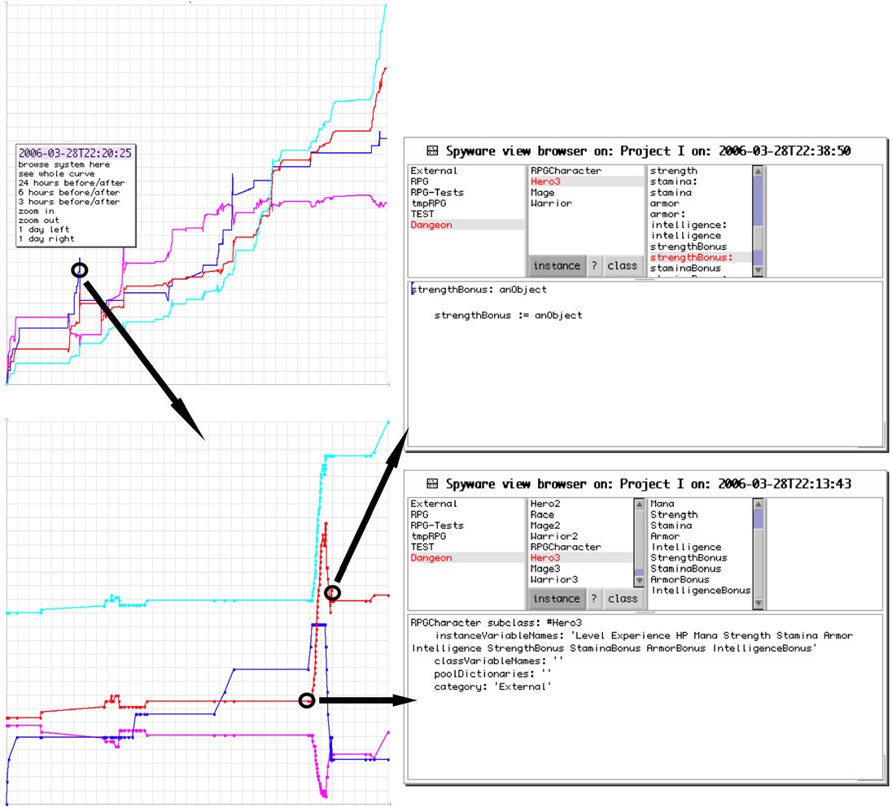

Fig. 2. SpyWare’s UI features interactive visualization, version browsing, and statistics (not shown). Project: Project I. Metrics: Number of classes (blue); Number of methods (red); Number of statements (cyan); Average non-accessor method size (magenta)

SpyWare associates these change operations to program entities up to the state- ment level. It is possible to track changes to a single statement. Entities are uniquely

identified independently from their name: a rename is a trivial operation. SpyWare can also generate the source code of the program it is monitoring at any point in time, by applying or reverting change operations. It also features basic support for interactive visualizations of the history.

Our future work includes the definition and detection of higher-order changes such as refactorings, or distinct features of the monitored program, out of the basic building blocks we already defined. SpyWare is currently single-user: we plan to make it multi-user soon.

# Change-Based Software Evolution

We believe our approach has the potential to address several problems in both reverse and forward engineering, as an IDE integration makes the dialogue between the two activities more natural.

**Facilitating program comprehension.** Processing finer-grained changes will allow us to detect and characterize changes with greater accuracy. Storing all the refactorings performed on the code will enable us to track specific entities for their entire lifetime, even after renames and moves. We also believe that it is possible to characterize changes as either bug fixes, refactorings or feature additions and that this information will allow to focus analysis on specific changes by contextualizing them.

Our model allows us to characterize or classify changes and entities in arbitrary ways (using properties or annotations). This facility can be used to ease understand- ing of the code as well. Contrary to classical versioning systems where branches are fixed and are set up before modification, our model permits the modification of properties of changes while reviewing them. Changes that need to be grouped can be tagged for an easier handling.

Recording the complete history of a system allows for fine-grained understanding of a dedicated piece of code by reviewing its introduction and modifications in context of surrounding modifications, e.g., it is useful to know whether a line is present from the beginning of a method or much later because of a bug fix.

**Facilitating program evolution.** First-class change objects can be broad- casted through a network to increase awareness and responsiveness to changes, thus providing developers insights of what other developers are doing. Such a system would tell them if their changes are conflicting with other people’s changes interac- tively. This will help avoiding long and painful merge phases.

Change-based operation coupled with entity-level tracking will ease refactoring, e.g., in our current model, the name of an entity is just a property: A rename does not affect identity.

**Merging reverse and forward engineering.** Higher-level languages and tools promote a faster and easier implementation of functionality, which translates into a higher change rate of the system. Hence some reverse engineering activities need to be done on a smaller scale, but with a higher frequency and accuracy, to keep track of what has been modified recently in the system before resuming work

on a part of it.

Change operations between two versions of the system can be used to generate an automatic and interactive change log to bring other developers up to speed on the changes a developer made.

# Preliminary Results

To validate our claims we need to gather some data supporting our hypotheses. Since no system has been recording information with that grain of detail before, we can not rely on pre-existing software repositories as data sources. Hence we had to devise a process to gather the information we needed and find some adequate test subjects.

Our prototype is currently monitoring itself, so it could be used as a case study, but we wished to have software developed externally to be as unbiased as possible in our first case study.

* 1. *Case Study Setup and Description*

Since the curriculum at our faculty includes several projects, we chose to use data generated by our students for this case study. During the course of their second semester, students had to program in Smalltalk a pair-project for a period of a week. Out of a class of 22 students, 11 pairs were formed. Each pair had to choose a topic out of these three:

* + - A virtual store in the vein of Amazon, where users can buy books, CDs, DVDs etc.
    - A geometry program where one can perform various mathematical functions on different elementary three-dimensional shapes, such as cubes, pyramids, etc.
    - A simple text-based role-playing game. The user plays a hero who must wander a dungeon in search of some treasures, while fighting monsters in a turn-based fashion. Due to the open-ended nature of this project, people choosing this project ended up having significantly more code and more complex designs.

The chosen topics were simple: the goal of the projects was to give students insights in object-oriented design and how key concepts of object-oriented program- ming such as composition, inheritance and polymorphism work and can be used in practice.

To gather data, we had programming environments tailored for student use. Their environment included the monitoring part of our prototype, which in its current incarnation periodically uploads new changes as files to an FTP server. It also included a notification that they were involved in such an experiment.

The results were as follows: out of the 11 projects, 9 contained suitable data and are presented here. The other two either chose to implement their project using another programming environment, or an older version of the environment we provided, in which the information sent to us had a slightly different format.

* 1. *Quantitative Data Analysis*

This section gives an overview of the kind of data we found in the projects, from a high-level perspective. In each of the tables, each project is denoted by a letter, from A to I.

|  |  |  |  |  |  |  |  |  |  |  |
| --- | --- | --- | --- | --- | --- | --- | --- | --- | --- | --- |
| **Project** | **Type** | **Start** | | **End** | | **Duration** | **Effort** | | **Changes** | **Changes per Hour** |
| **A** | Geometry | 2006/03/27  15:02 | - | 2006/04/03  20:06 | - | 7 d 5 h | 43.5 h | | 1923 | 44.2 |
| **B** | Store | 2006/03/27  11:27 | - | 2006/04/03  20:37 | - | 7 d 9 h | 11 | h | 305 | 27.7 |
| **C** | Store | 2006/03/27  13:06 | - | 2006/04/01  18:21 | - | 5 d 5 h | 25.5 h | | 800 | 31.4 |
| **D** | Store | 2006/03/27  11:28 | - | 2006/04/01  16:09 | - | 7 d 4.5 h | 22 | h | 609 | 27.7 |
| **E** | Store | 2006/03/27  11:30 | - | 2006/03/30  19:05 | - | 3 d 7.5 h | 15 | h | 388 | 25.9 |
| **F** | RPG | 2006/03/27  11:28 | - | 2006/04/04  12:04 | - | 8 d 0.5 h | 21 | h | 741 | 35.3 |
| **G** | Geometry | 2006/03/27  17:06 | - | 2006/04/03  23:17 | - | 7 d 6 h | 27.5 h | | 836 | 30.4 |
| **H** | Store | 2006/03/27  11:45 | - | 2006/04/03  22:45 | - | 7 d 11 h | 14 | h | 490 | 35.0 |
| **I** | RPG | 2006/03/27  11:29 | - | 2006/04/03  23:36 | - | 7 d 12 h | 48 | h | 1247 | 26.0 |

Table 2

Duration of each project (from first to last change recorded)

In Table 2 we see the time that the students spent in total on these projects, varying from slightly more than 10 hours to nearly 50 hours. Considering the relevant number of changes that these students applied to their systems (from 400 to 2000 high-level changes, implying an even higher number of low-level changes), we think this is a strong argument for a change-based approach: we measured the average number of CVS commits on a number of large open-source projects and noted that most of them had an average of only slightly more than 1 commit per working day, i.e., 8 hours. In short, the degree of change information loss with a versioning system like CVS is impressive. This is also reflected in the “change per hour” metric: it varies from 26 to 45 changes per hour. If students had saved once per hour – an optimistic figure according to the statistic above –, it would still be difficult to tell each change apart.

Table 3 shows the number of entities who were created during the course of the project. We also see in bold the number of entities remaining when the system was shipped to us for grading.

Table 4 gives a summary of the kind of changes which were performed on each system. From these two tables we see some trends in project stability: projects A, C, G, and – to some extent – I show a lot more removals of entities. All the other projects have more than 85% of added entities still present at the end of the project, with projects B and E being the most stable (with 89 and 91% respectively). According to Table 4, project B, E and F, the most stable ones, feature some events invoking good maintenance practices: classes being renamed and commented.

|  |  |  |  |  |  |  |  |  |  |
| --- | --- | --- | --- | --- | --- | --- | --- | --- | --- |
| **Entity Type** | **A** | **B** | **C** | **D** | **E** | **F** | **G** | **H** | **I** |
| **Packages** | **7**/7 | **2**/2 | **1**/1 | **2**/2 | **2**/2 | **2**/2 | **4**/4 | **2**/2 | **7**/7 |
| **Classes** | **19**/23 | **13**/14 | **11**/14 | **8**/9 | **13**/13 | **15**/17 | **16**/21 | **10**/12 | **28**/43 |
| **Instance Vari- ables** | **32**/80 | **12**/19 | **16**/29 | **14**/19 | **18**/20 | **42**/55 | **18**/29 | **24**/29 | **72**/107 |
| **Class Variables** | **0**/0 | **0**/0 | **0**/2 | **0**/0 | **0**/0 | **0**/0 | **12**/43 | **0**/0 | **1**/1 |
| **Methods** | **157**/331 | **98**/116 | **77**/144 | **129**/158 | **109**/121 | **205**/242 | **105**/212 | **114**/135 | **308**/405 |
| **Arguments** | **65**/65 | **21**/21 | **35**/35 | **86**/86 | **16**/16 | **81**/81 | **17**/17 | **32**/32 | **60**/60 |
| **Temporaries** | **209**/239 | **71**/72 | **54**/85 | **100**/118 | **73**/81 | **124**/134 | **31**/45 | **71**/82 | **142**/157 |
| **Persistence Ratio** | 69% | 89% | 62% | 86% | 91% | 88% | 54% | 87% | 79% |

Table 3

High-level indicators of project size: **final number of entities**/total number of entities

|  |  |  |  |  |  |  |  |  |  |
| --- | --- | --- | --- | --- | --- | --- | --- | --- | --- |
| **Change Type - Project** | **A** | **B** | **C** | **D** | **E** | **F** | **G** | **H** | **I** |
| **Class Added** | 22 | 14 | 14 | 9 | 12 | 15 | 21 | 12 | 48 |
| **Class Modified** | 65 | 17 | 34 | 13 | 6 | 24 | 57 | 15 | 27 |
| **Class Commented** | 0 | 12 | 0 | 0 | 1 | 0 | 0 | 0 | 0 |
| **Class Recatego- rized** | 0 | 0 | 5 | 0 | 0 | 0 | 0 | 0 | 11 |
| **Class Renamed** | 0 | 0 | 0 | 0 | 1 | 1 | 0 | 0 | 1 |
| **Class Removed** | 10 | 1 | 5 | 5 | 0 | 3 | 6 | 2 | 18 |
| **Attributes Added** | 82 | 19 | 29 | 19 | 20 | 61 | 30 | 29 | 137 |
| **Attributes Re- moved** | 50 | 7 | 13 | 5 | 2 | 19 | 15 | 5 | 54 |
| **Method Added** | 366 | 119 | 182 | 164 | 117 | 237 | 219 | 135 | 415 |
| **Method Modified** | 234 | 69 | 117 | 140 | 81 | 154 | 143 | 118 | 185 |
| **Method Recate- gorized** | 82 | 0 | 1 | 2 | 34 | 3 | 36 | 4 | 21 |
| **Method Removed** | 190 | 20 | 81 | 32 | 13 | 38 | 117 | 21 | 106 |

Table 4

High-level indicators of change type

On the other side of the spectrum, Projects C and I feature several classes being reorganized, e.g changing packages. This indicates a more important restructuring of the project.

* 1. *Qualitative Data*

Figure 3 shows the evolution of the nine projects, from March 27, 2006, to April 4, 2006. On the left we can easily spot and characterize session by their shapes. Contrast with the figure on the right, in which one point is plotted after each coding sessions: it is impossible to characterize the sessions from it. We see several types of sessions in this figure, each with a different visual pattern:

* + - Session S1 is *stair-shaped* : many methods are added in a short period of time, and almost none are removed. This indicates a certain focus and efficiency by the programmers during this session.

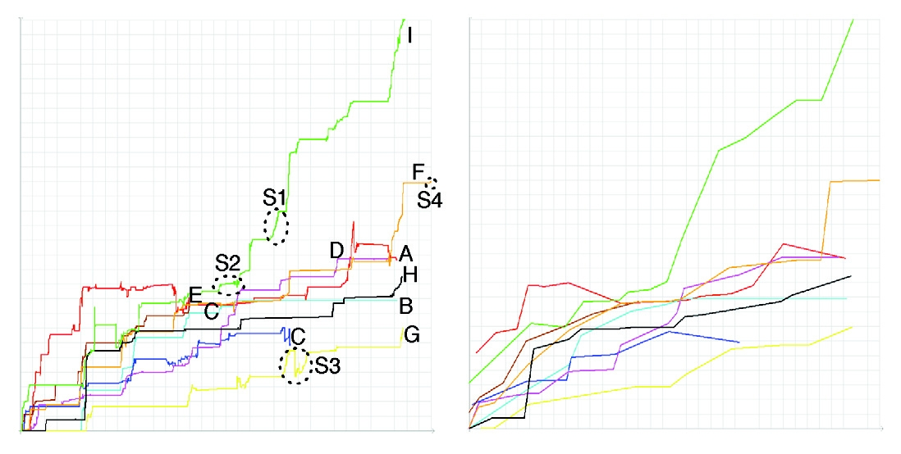

Fig. 3. Left: visualization of the number of methods of all projects. Right: simulation of the same metric after each coding session. Projects: A (red); B (cyan); C (blue); D (magenta); E (brown); F (orange); G (yellow); H (black); I (green).

I

F

S1 S4

S2 D A H

EC B

C G

S3

* Session such as session S2 are *stagnant* : The growth is slow, with some occasional removals of methods. This indicates a much more cautious approach, where the road to follow is not as clear as in stair-shaped sessions. If certain methods are modified several times during this session, this could be a bug-fixing session, involving several tries before finding the correct fix.
* Session S3 is a *roller-coaster* session. Session S3 and similar ones features a lot of removal of methods: this indicates either cleanups (such as at the end of the project, before delivering it) or redistribution of functionality: if the session ends with a sharp raise (as S3) it could indicate knowledge transfer from a deleted class to another, either by copy/paste and modify, or by code rewriting.
* Finally, sessions such as S4 can be thought as *focused bug-ﬁxing* sessions: after a certain time of evaluation, the programmer focuses on a problem and solves it in one swift session.

With this classification of programming sessions, we can qualify the evolution of each project:

Several projects are characterized by a large number of stairs-shaped sessions. Projects B, D, E and H have a large majority of such sessions, while projects F and G also have a fairly high number of them. Projects F and G also have a few “roller-coaster” shaped sessions where some reorganization occurred, but managed to stay rather focused until the end of the projects. Projects B, D, E and H are “virtual store” types of projects, which were easier to design and implement than geometry and role-playing projects: the domain was much more defined, and the projects were not as open-ended as the other ones. This explains the focus and efficiency of the students programming these.

Three projects behave differently though: project A (geometry), C (virtual store) and I (role-playing game). Project C has several “stagnant” sessions, in which the

implementation was not as direct as other projects. It also features a cleanup phase near the end. Project I has two “roller-coaster” sessions near the beginning, indi- cating alternative designs tentatives: one spike is very tall and thin, and the size of the system rises sharply afterwards. Other sessions are either stagnant or halfway between stagnant and stairs-shaped. In those periods the design and implemen- tation were harder to determine. Project A has the most atypic curves of all: it features an extended roller-coaster near the beginning, then a phase in which the system is rather stagnant, and yet another roller-coaster near the end of the project, ending with some cleanup. This project was characterized by a combination of good extension ideas (using a graphical user interface), and poor design choices (the main inheritance tree made model classes inherit from user interface classes).

To conclude this study, we comment on the right side of Figure 3. In it the same data curves are displayed as on the left side with the following exception: it is drawn as if data was collected at the end of each coding session, rather than after each change. In fact it mimics the kind of data we would obtain from a mainstream versioning system such as CVS. We can clearly see that we could not have done an in-depth analysis like the one we did with such a low data quality.

# Conclusion

Software evolution research is restrained by the loss of information which are not captured by most versioning systems. Evolution analysis tools are not used by developers because they are not integrated in an IDE and require time-consuming data retrieval and processing phases. They are not suited for smaller-scale, day-to- day tasks [2].

We presented an alternative approach to gather and process information for software evolution. We gather data from the IDE the developer is using rather than the versioning system. We model program change as first-class entities to be closer to the developer’s thought process. Changes can manipulate the model to bring it at any point in time in a very fine-grained way.

Our approach being incremental, fine-grained and integrated in an IDE, we consider it is suited for a daily use by developers. To validate our hypothesis, we are currently implementing a prototype named SpyWare.

The preliminary results we obtained gives us confidence in the usefulness of our approach, that we intend to develop further. We were able to both characterize the student projects at a high level, but also at a lower level, on a session-by-session basis by using visual patterns.

**Acknowledgments:** We gratefully acknowledge the financial support of the Swiss National Science foundation for the projects “COSE - Controlling Software Evolution” (SNF Project No. 200021-107584/1), and “NOREX - Network of Reengi- neering Expertise” (SNF SCOPES Project No. IB7320-110997), and the Hasler Foundation for the project “EvoSpaces - Multi-dimensional navigation spaces for software evolution” (Hasler Foundation Project No. MMI 1976). We thank Marco D’Ambros and Mircea Lungu for giving valuable feedback on drafts of this paper. We also thank the students at the University of Lugano who accepted being moni- tored while doing their projects.

# References

1. K. Beck. *Extreme Programming Explained: Embrace Change*. Addison Wesley, 2000.
2. S. Demeyer, F. Van Rysselberghe, T. Gˆırba, J. Ratzinger, , R. Marinescu, T. Mens, B. Du Bois,

D. Janssens, S. Ducasse, M. Lanza, M. Rieger, H. Gall, M. Wermelinger, and M. El-Ramly. The Lan- simulation: A Research and Teaching Example for Refactoring. In *Proceedings of IWPSE 2005 (8th International Workshop on Principles of Software Evolution)*, pages 123–131, Los Alamitos CA, 2005. IEEE Computer Society Press.

1. M. Fowler, K. Beck, J. Brant, W. Opdyke, and D. Roberts. *Refactoring: Improving the Design of Existing Code*. Addison Wesley, 1999.
2. H. Gall, K. Hajek, and M. Jazayeri. Detection of logical coupling based on product release history. In *Proceedings International Conference on Software Maintenance (ICSM ’98)*, pages 190–198, Los Alamitos CA, 1998. IEEE Computer Society Press.
3. H. Gall, M. Jazayeri, R. Kl¨osch, and G. Trausmuth. Software evolution observations based on product release history. In *Proceedings International Conference on Software Maintenance (ICSM’97)*, pages 160–166, Los Alamitos CA, 1997. IEEE Computer Society Press.
4. H. Gall, M. Jazayeri, and J. Krajewski. CVS release history data for detecting logical couplings. In *International Workshop on Principles of Software Evolution (IWPSE 2003)*, pages 13–23, Los Alamitos CA, 2003. IEEE Computer Society Press.
5. T. Gˆırba, S. Ducasse, and M. Lanza. Yesterday’s Weather: Guiding early reverse engineering efforts by summarizing the evolution of changes. In *Proceedings 20th IEEE International Conference on Software Maintenance (ICSM’04)*, pages 40–49, Los Alamitos CA, 2004. IEEE Computer Society Press.
6. T. Gˆırba, M. Lanza, and S. Ducasse. Characterizing the evolution of class hierarchies. In *Proceedings Ninth European Conference on Software Maintenance and Reengineering (CSMR’05)*, pages 2–11, Los Alamitos CA, 2005. IEEE Computer Society.
7. C. G¨org and P. Weissgerber. Detecting and visualizing refactorings from software archives. In *Proceedings of IWPC (13th International Workshop on Program Comprehension*, pages 205–214. IEEE CS Press, 2005.
8. D. Ingalls, T. Kaehler, J. Maloney, S. Wallace, and A. Kay. Back to the future: The story of Squeak, A practical Smalltalk written in itself. In *Proceedings OOPSLA ’97, ACM SIGPLAN Notices*, pages 318–326. ACM Press, Nov. 1997.
9. M. Lehman and L. Belady. *Program Evolution: Processes of Software Change*. London Academic Press, London, 1985.
10. E. Lippe and N. van Oosterom. Operation-based merging. In *SDE 5: Proceedings of the fifth ACM SIGSOFT symposium on Software development environments*, pages 78–87, New York, NY, USA, 1992. ACM Press.
11. T. Mens. A state-of-the-art survey on software merging. *IEEE Trans. Software Eng.*, 28(5):449–462, 2002.
12. R. Robbes and M. Lanza. Versioning systems for evolution research. In *Proceedings of IWPSE 2005 (8th International Workshop on Principles of Software Evolution)*, pages 155–164. IEEE Computer Society, 2005.
13. D. Roberts, J. Brant, R. E. Johnson, and B. Opdyke. An automated refactoring tool. In *Proceedings of ICAST ’96, Chicago, IL*, Apr. 1996.
14. Q. Tu and M. W. Godfrey. An integrated approach for studying architectural evolution. In *10th International Workshop on Program Comprehension (IWPC’02)*, pages 127–136. IEEE Computer Society Press, June 2002.