IWCIA 2001 Preliminary Version

A New 3D 12-Subiteration Thinning Algorithm Based on *P* -Simple Points

Christophe Lohou 1 and Gilles Bertrand 2

*Laboratoire A*2*SI,*

*E´cole Sup´erieure d’Ing´enieurs en E´lectrotechnique et E´lectronique (ESIEE), 2, bd Blaise Pascal, Cit´e Descartes, BP 99,*

*F-93162 Noisy-le-Grand Cedex, France*

**Abstract**

In this paper, we propose a new methodology based on *P* -simple points, in order to build a thinning algorithm. From an existent thinning algorithm *A*, we construct another thinning algorithm *A'*, such that *A'* deletes at least all the points removed by *A*, while preserving the same end points. In fact, we propose an algorithm which deletes at least the points removed by a recent 12-subiteration thinning algorithm proposed by Pala´gyi and Kuba [26].

# Introduction

Some graphical applications require to transform objects while preserving their topology [20][24]. That leads to the well-known notion of simple point: a point in a binary image is said to be *simple* if its deletion from the image “preserves the topology” [23] [16] [15] [28] [11] [1] [18] [13] [14] [9]. A process deleting simple points is called *a thinning algorithm*. During the thinning process, certain simple points are kept in order to preserve some geometrical properties of the object. Such points are called *end points*. We can define two different kinds of end points: curve end-points and surface end-points [26]. A thinning process which preserves curve end-points (resp. surface end-points) is called a *curve thinning algorithm* (resp. a *surface thinning algorithm*). The result obtained by a curve thinning algorithm (resp. a surface thinning algorithm) is called a *curve skeleton* (resp. a *surface skeleton*) [26][6].

A process deleting simple points in parallel may not preserve the topology. For example, a two-width ribbon may vanish because all its points are simple.

1 Email: [lohouc@esiee.fr](mailto:lohouc@esiee.fr)

2 Email: [bertrang@esiee.fr](mailto:bertrang@esiee.fr)

*This is a preliminary version. The final version will be published in Electronic Notes in Theoretical Computer Science*

*URL:* [www.elsevier.nl/locate/entcs](http://www.elsevier.nl/locate/entcs)

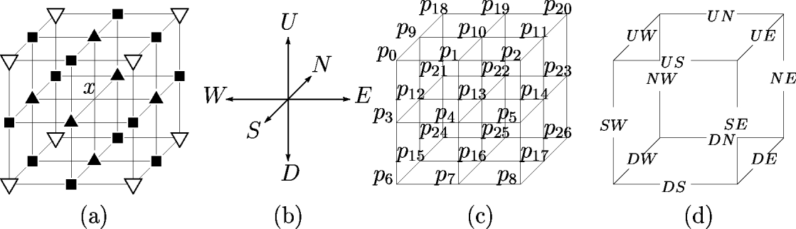

Fig. 1. (a) The 6-, 18-, and 26- neighbors of *x*, (b) the six major directions, (c) the used notations, (d) the 12 directions of deletion.

Therefore, a parallel thinning algorithm must use a “certain deletion strategy” in order to preserve the topology. For example, we may consider a deletion strategy based on subiterations, which consists in dividing a deletion iteration into several subiterations. These subiterations may be based on directions [30][10][24][26]or on subgrids [5][25]. Another example of deletion strategy consists in using an extended neighborhood; such a strategy may lead to fully parallel thinning algorithms [19][20][22].

One of the authors has proposed the notion of *P* -simple point [2]. A subset composed solely of *P* -simple points may be deleted in one time while preserving the topology. Furthermore, a *P* -simple point may be locally cha- racterized. In this paper, we introduce the notion of *Px*-simplicity. This permits us to propose a new thinning scheme based on the deletion of *Px*- simple points. This scheme needs neither a preliminary step of labelling nor the examination of an extended neighborhood, in the opposite of the already proposed thinning algorithms based on *P* -simple points.

Our purpose is to design a new 3D 12-subiteration thinning algorithm based on the deletion of *Px*-simple points. From the 12-subiteration thinning algorithm proposed by Pala´gyi and Kuba [26], we conceive a first thinning algorithm deleting *Px*-simple points. Then, we improve it twice, in such a way that it can delete at least all the points removed by the Pala´gyi and Kuba’s thinning algorithm, while preserving the same end points.

In fact, the approach adopted in this paper may be seen as a general methodology to build a thinning algorithm *A'* deleting *Px*-simple points, from an existent thinning algorithm *A*, while preserving the same end points. This methodology consists in proposing successive “refinements” of *P* , until to ob- tain a certain *P* such that at least all points deleted by *A* are *Px*-simple. This also implies that *A* preserves the topology.

# Basic notions

A point *x ∈ Z*3 is defined by (*x*1*, x*2*, x*3) with *xi ∈ Z*. We consider the three neighborhoods: *N*26(*x*)= *{x' ∈ Z*3; *M ax*[*|x*1 *− x' |, |x*2 *− x' |, |x*3 *− x' |*] *≤* 1*}*,

1 2 3

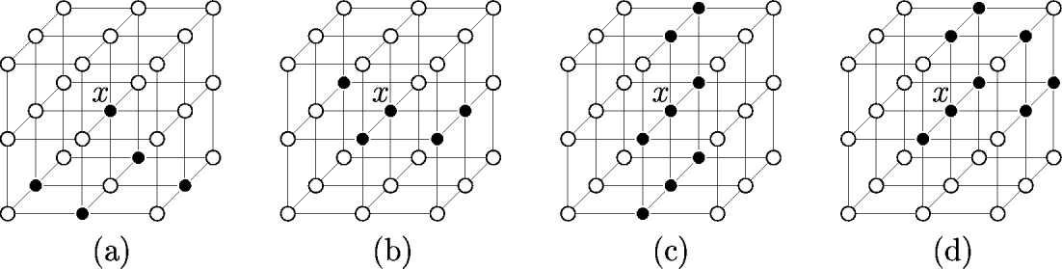

Fig. 2. Points belonging to *X* and *X* are respectively represented by black discs and white circles. Only the point *x* in (d) is 26-simple.

*N*6(*x*)= *{x' ∈ Z*3; *|x*1 *−x' |*+*|x*2 *−x' |*+*|x*3 *−x' |≤* 1*}*, and *N*18(*x*)= *{x' ∈ Z*3;

1 2 3

*|x*1*−x' |*+*|x*2*−x' |*+*|x*3*−x' |≤* 2*}∩N*26(*x*). We define *N∗*(*x*)= *Nn*(*x*)*\{x}*. We

1 2 3 *n*

call respectively 6*,* 18*,* 26*-neighbors of x* the points of *N∗*(*x*), *N∗* (*x*) *\ N∗*(*x*),

6 18 6

*N∗* (*x*)*\N∗* (*x*); these points are respectively represented in Fig. 1 (a) by black

26 18

triangles, black squares, and white triangles. The 6-neighbors of *x* determine

six major directions (Fig. 1 (b)): Up, Down, North, South, West, East; res- pectively denoted by *U* , *D*, *N* , *S*, *W* and *E*. Each point of *N∗* (*x*) may characterize one direction amongst the 26 that we can obtain from the 6 major ones, *e.g. SW* , *USW* ... Let *Dir* denote one of these 26 directions. The point in *N∗* (*x*) along the direction *Dir* is called the *Dir-neighbor of x* and is denoted by *Dir*(*x*). In the following, points in *N*26(*x*) are often denoted by *pi*; *i* = 0*,...,* 26 (Fig. 1 (c)); for example, *p*0 is the *USW* -neighbor of *p*13,

26

26

*i.e. p*0 = *USW* (*p*13). Let *X ⊆ Z*3. The points belonging to *X* (resp. *X*, the complement of *X* in *Z*3) are called *black points* (resp. *white points*).

Two points *x* and *y* are said to be *n-adjacent* if *y ∈ N∗*(*x*) (*n* = 6*,* 18*,* 26). An *n-path* is a sequence of points *x*0*,..., xk*, with *xi n*-adjacent to *xi−*1 for *i* = 1*,..., k*. If *x*0 = *xk*, the path is *closed*. Let *X ⊆ Z*3. Two points *x ∈ X* and *y ∈ X* are *n-connected* if they are linked by an *n*-path included in *X*. The equivalence classes relative to this relation are the *n-connected components* of

*n*

*X*. If *X* is finite, the infinite connected component of *X* is the *background*, the other connected components of *X* are the *cavities*. In order to have a correspondence between the topology of *X* and the one of *X*, we have to consider two differents kinds of adjacency for *X* and for *X* [15]: if we use an *n*-adjacency for *X*, we have to use another *n*-adjacency for *X*. In this paper, we only consider (*n, n*) = (26*,* 6). The presence of an *n*-hole in *X* is detected whenever there is a closed *n*-path in *X* that cannot be deformed, in *X*, into a single point (see [16], for further details). For example, a hollow ball has one cavity and no hole, a solid torus has one hole and no cavity, and a hollow torus has one cavity and two holes.

Let *X ⊆ Z*3. A point *x ∈ X* is said to be *n-simple* if its removal does not “change the topology” of the image, in the sense that there is a one to one correspondence between the components, the holes of *X* and *X* and the components, the holes of *X\{x}* and *X∪{x}* (see [16], for a precise definition).

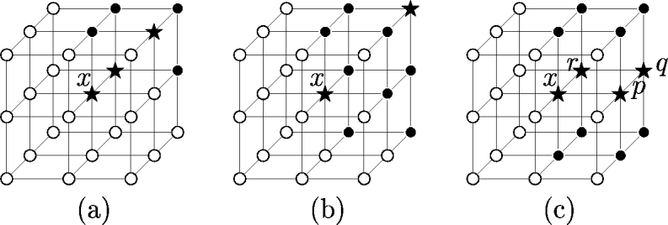

Fig. 3. Points belonging to *R*, *P* and *X* are respectively represented by black discs, black stars and white circles. Only the points *x* in (a) and (b) are *P* -simple.

The set composed of all *n*-connected components of *X* is denoted by *Cn*(*X*). The set of all *n*-connected components of *X* and *n*-adjacent to a point *x* is denoted by *Cx*(*X*). The cardinal number of *X* is denoted by #*X*. The *topological numbers* relative to *X* and *x* are the two numbers [1]: *T*6(*x, X*)=

*n*

#*Cx*[*N∗* (*x*) *∩ X*] and *T*26(*x, X*)= #*Cx* [*N∗* (*x*) *∩ X*]. These numbers lead to

6 18 26 26

a very concise characterization of 3D simple points [21]: *x ∈ X* is 26-simple

for *X* if and only if *T*26(*x, X*) = 1 and *T*6(*x, X*)= 1.

Some examples are given in Fig. 2. The topological numbers relative to *x* for *X* and its complement are: (*T*26(*x, X*)*, T*6(*x, X*)) = (1*,* 2)*,* (2*,* 1)*,* (1*,* 2)*,* (1*,* 1) for the configurations (a), (b), (c) and (d), respectively. Only the configuration in Fig. 2 (d) corresponds to a 26-simple point.

# *P* -simple points

Let us introduce the notions of *P* -simple point and *P* -simple set [2]. In the following, we consider a subset *X* of *Z*3, a subset *P* of *X*, and a point *x* of *P* .

**Definition 3.1** The point *x* is *P-simple* if for each subset *S* of *P \ {x}*, *x* is 26-simple for *X \ S*. Let *S*(*P* ) denote the set of all *P* -simple points. A subset *D* of *X* is *P-simple* if *D ⊆ S*(*P* ).

We have the property that any algorithm removing only *P* -simple subsets (*i.e.* subsets composed solely of *P* -simple points) is guaranteed to keep the topology unchanged [2].

We give a local characterization of a *P* -simple point [4](see also [3]):

**Proposition 3.2** *Let R denote the set X \ P. The point x is P-simple iff:*

 *T*26(*x, R*)= 1*,*

 *T*6(*x, X*)= 1*,*

*∀y ∈ N∗* (*x*) *∩ P, ∃z ∈ R such that z is* 26*-adjacent to x and to y,*

26



 *∀y ∈ N∗*(*x*) *∩ P, ∃z ∈ X and ∃t ∈ X such that {x, y, z, t} is a unit square.*

6

Some examples are given in Fig. 3: only the points *x* in (a) and (b) are

*P* -simple. Let us consider the subset *X* depicted in Fig. 3 (c). The subset *S* = *{p, q, r}* is a subset of *P* ; and *x* is non-simple for *X \ S*. Therefore by the Definition 3.1, the point *x* cannot be a *P* -simple point; or directly with the Proposition 3.2, the first *P* -simplicity condition is not verified because *T*26(*x, R*)= 2.

# *Px*-simple points

In the following, we consider a subset *X* of *Z*3, and a subset *P* of *X*. For each *x* of *Z*3, we consider a finite family of pairs of subsets of *Z*3 (*Bk*(*x*)*,Wk*(*x*)) with *k ∈* [1*, l*], such that *Bk*(*x*) *∩ Wk*(*x*)= *∅* and *x* belongs to *Bk*(*x*).

We say that *P* is “characterized” by such a family (*Bk,Wk*) if *P* = *{x ∈ Z*3; *∃k ∈* [1*, l*]such that *Bk*(*x*) *⊆ X* and *Wk*(*x*) *⊆ X}*. In fact, *P* corresponds to a Hit or Miss transform of *X* by (*Bk,Wk*) [29][12]. All subsets *P* considered in this paper are characterized by such a family.

A thinning algorithm using the notion of *P* -simple points must decide whether a point *x* is *P* -simple or not: in order to check the four conditions of the Proposition 3.2, it must check if the point *x* belongs to *P* , and furthermore it must check if the points *y* of *N∗* (*x*) belong to *P* (see the third and fourth *P* - simplicity conditions). Such an algorithm may operate according to different ways to characterize the points belonging to *P* and the points being *P* -simple:

26

* The first strategy consists in the repetition of two steps [2]. During the first step, the points belonging to *P* are labelled, through the access of *Bk*(*x*), and of *Wk*(*x*), for all points *x* of *Z*3; at most *l* pairs (*Bk*(*x*)*,Wk*(*x*)) have to be checked. During the second step, the four conditions of *P* -simplicity of the Proposition 3.2 are checked for all points of *P* : the checking of these four conditions may be possible by the previous labelling step.
* The second strategy consists in a single step of detection of *P* -simple points. During the *P* -simplicity check of each point *x* of *X*, it is allowed to access to *Bk*(*z*), and to *Wk*(*z*) for all *z ∈ N*26(*x*). Thus, this strategy usually requires the examination of a neighborhood larger than *N*26(*x*).
* In this paper, we propose another strategy which uses neither a preliminary step of labelling, nor an extended neighborhood. This strategy uses the notions of membership to *Px* and of *Px*-simplicity that we introduce now.
  1. *Px-simple points*

For each point *x* of *X*, we define a new subset *Px* of *Z*3, determined by *Px* =

*{y ∈ N*26(*x*); *∃k ∈* [1*, l*]such that *Bk*(*y*) *∩ N*26(*x*) *⊆ X* and *Wk*(*y*) *∩ N*26(*x*) *⊆ X}*. We have *Px ⊇ P ∩ N*26(*x*). We also define *Rx* = [*N*26(*x*) *∩ X*] *\ Px*, thus *Rx ⊆ R∩N*26(*x*) and *Px ∪Rx* = (*P ∪R*) *∩N*26(*x*). In fact, *Px* is constituted by the points *y* of *N*26(*x*) *∩ X* which “may belong” to *P* , by the only inspection of membership to *X* or to *X* of points belonging to [*Bk*(*y*) *∪ Wk*(*y*)] *∩ N*26(*x*).

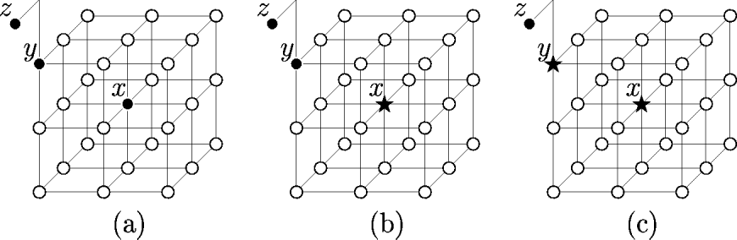

Fig. 4. Initial configuration (a). The point *x* is *P* -simple (b), is not *Px*-simple (c).

**Remark** For any *y* in *N*26(*x*) such that *Bk*(*y*) *∪ Wk*(*y*) *⊆ N*26(*x*) for each *k* in [1*, l*], then *y ∈ P* iff *y ∈ Px*. In the following, we assume that *P* is such that *Bk*(*x*) *∪ Wk*(*x*) *⊆ N*26(*x*), for any point *x* of *X* and for each *k* in [1*, l*]; therefore *x ∈ P* iff *x ∈ Px*.

This leads to the notion of a *Px*-simple point: a point *x* of *Px* is said to be *Px-simple* if *x* verifies the four conditions of *P* -simplicity of the Proposition 3.2, by replacing *P* by *Px*, and *R* by *Rx*.

We can prove that a *Px*-simple point is *P* -simple, with the help of topo- logical numbers, and under our assumption made in the previous remark. Therefore, an algorithm deleting *Px*-simple points is guaranteed to preserve the topology. In the following, we will propose a thinning algorithm deleting *Px*-simple points.

* 1. *Example*

In this section, we give an example that illustrates there exists points *x* which are *P* -simple but not *Px*-simple, for the same initial set *P* .

The 12-subiteration thinning algorithm proposed by Pala´gyi and Kuba deletes certain simple points whose neighbor according to a considered direc- tion, belongs to *X* (see section 5.2). So, we propose to consider the subset *P* such that *P* = *{x ∈ X*; the *US*-neighbor of *x* belongs to *X}* (see also section 6.1). For all *x* of *Z*3, we have *B*1(*x*)= *{x}*, *W* 1(*x*)= *{US*(*x*)*}*, and *l* = 1; we write *B*(*x*)= *B*1(*x*) and *W* (*x*)= *W* 1(*x*).

Let us consider the figure 1 (c). Let *x* denote *p*13. Let *U* be the set of points in *N*26(*x*) *∩ X* for which the *US*-neighbor belongs to *N*26(*x*), *i.e. U* = *{p*12,

*.. .*, *p*17, *p*21, *.. .*, *p*26*} ∩ X*. Let *V* = [*N*26(*p*13) *∩ X*] *\ U* , *i.e. V* = *{p*0, *.. .*, *p*11,

*p*18, *p*19, *p*20*}∩ X*. We have:

* + - For *y ∈ U* , *y ∈ Px* iff *B*(*y*) *∩N*26(*x*)(= *{y}*) is included in *X* (always verified for any *y ∈ U* ), and if *W* (*y*)*∩N*26(*x*)(= *{US*(*y*)*}*) is included in *X*; therefore for *y ∈ U* , we have *y ∈ Px* iff *US*(*y*) belongs to *X*.
    - For *y ∈ V* , *y ∈ Px* iff *B*(*y*) *∩N*26(*x*)(= *{y}*) is included in *X* (always verified for any *y ∈ V* ), and if *W* (*y*) *∩ N*26(*x*)(= *∅*) is included in *X* (always verified for any *y*); therefore *y ∈ Px* for any *y ∈ V* .

In summary, for each point *x* of *Z*3, *Px* = *{y ∈ U* ; *US*(*y*) *∈ X}∪ V* .



A position marked by a (resp. ) matches a black point (resp. a white point). At least one position marked by a or by a belongs to *X*. At least one position marked by a or by a belongs to *X*. Every position non marked matches either a black or a white point. Two positions marked by the two bicolored and match different points (one of them matches a black point and the other one matches a white one). A position marked by a matches a black point belonging to a considered set *P* .

Fig. 5. Notations used in the following of the paper.

Let us consider the configuration depicted in Fig. 4 (a). The points of *P* (resp. *Px*) are represented by a star in Fig. 4 (b) (resp. Fig. 4 (c)). In Fig. 4 (b), the point *x* belongs to *P* since *x* belongs to *X* and the *US*-neighbor of *x* belongs to *X*. The point *y* belongs to *R* since *z*(= *US*(*y*)) belongs to *X* and *W* (*y*) */⊆ X*. In this case, *x* is a *P* -simple point. In Fig. 4 (c), the point *x* belongs to *Px* since *x* belongs to *U* and the *US*-neighbor of *x* belongs to

*X*. The point *y* belongs to *Px* as *y* belongs to *V* . In this case, *x* is not a *Px*-simple point because the first and third *Px*-simplicity conditions are not verified: *T*26(*x, Rx*) = 0 and there is no point of *Rx* 26-adjacent to *x* and to *y*.

# Description of the used thinning algorithms

In this section, we recall the general scheme for 12-subiteration thinning al- gorithms and then we specify it more precisely for the algorithm proposed by Pala´gyi and Kuba [26] (denoted by pk), and partially for our algorithm deleting *Px*-simple points (denoted by lb).

* 1. *General scheme*

A thinning scheme consists in the repetition until stability of deletion ite- rations. In the case of 12-subiteration thinning algorithms, an iteration is divided into 12 subiterations, each of them successively corresponding to one of the 12 following directions: *US, NE, DW, SE, UW, DN, SW, UN, DE, N W, UE, DS* (see Fig. 1 (d)). Let *Dir* denotes such a direction. The stability is obtained when there is no more deletion during 12 successive subiterations. Such a thinning scheme can be described by *Xi* = *Xi−*1 *\ DEL*(*Xi−*1*, Dir*) for the *i*th deletion subiteration (*i >* 0), with *X*0 = *X*, and *DEL*(*Y, Dir*) being the set of points to be deleted from *Y* , according to the direction *Dir* corres- ponding to the *i*th subiteration. The stability is obtained when *Xk* = *Xk*+12.

* 1. *The Pal´agyi and Kuba’s thinning algorithm*

Pal´agyi and Kuba have proposed a 12-subiteration thinning algorithm, which can produce either curve skeletons or surface skeletons [26]. When it is im- portant to distinguish them, we write pk c (resp. pk s) to indicate the curve

thinning algorithm (resp. the surface thinning algorithm).

A set of 3 *×* 3 *×* 3 matching templates is given for each direction. For a given direction, a point is deletable by pk if at least one template in the set of templates matches it. The set of templates used by pk c (resp. pk s) along

the direction *Dir*, is denoted by *TDir* (resp. *T '*

*Dir*

) and is represented in Fig.

1. (resp. Fig. 7) for the direction *Dir* = *US*; the notations are depicted in

Fig. 5. The templates for the other directions can be obtained by appropriate rotations and/or reflections of these templates. Sometimes, we will write that

“*TDir* (resp. *T '*

*Dir*

) deletes a point” to mean pk c (resp. pk s) deletes this

point during a subiteration along the direction *Dir*.

We recall some definitions, used by Pal´agyi and Kuba [26], that we will use too. A black point *x* is a *curve end-point* if the set *N∗* (*x*) contains exactly one black point. A black point *x* is a *surface end-point* if the set *N*6(*x*) contains at least one opposite pair of white points. We note that end points are prevented to be deleted by the templates. The authors have precised that the configurations which can be deleted by pk s are precisely the ones which can be deleted by pk c, without these ones corresponding to a surface end-point.

26

According to the previous general thinning scheme (described in section 5.1), for the deletion subiteration corresponding to the direction *Dir* in pk c (resp. pk s), *DEL*(*Y, Dir*) is the set of points of *Y* such that at least one of

the templates of *TDir* (resp. *T '*

*Dir*

) matches them.

* 1. *Algorithm deleting Px-simple points*

A 6-subiteration thinning algorithm removing *P* -simple points, has already been proposed [2]. Now, we give a general scheme for 12-subiteration thinning algorithms deleting *Px*-simple points. It can be described by the scheme of section 5.1, with *DEL*(*Y, Dir*) = *S*(*Px*); *S*(*Px*) being the set of *Px*-simple points for *Y* which are not end points according to the wanted skeleton and according to the direction *Dir*. From this scheme, we will propose our algo- rithm by defining an appropriate *P* (sections 6 and 7), in the sense that we investigate *P* such that our algorithm deletes at least the points removed by pk. In the following, we write lb c (resp. lb s) to indicate our final algo- rithm which produces curve skeletons (resp. surface skeletons) by deletion of *Px*-simple points.

* 1. *Implementation*

A preliminary step to the use of pk or lb on real 3D binary images consists in producing all possible 67 108 864(= 226) configurations of the 3 *×* 3 *×* 3 neighborhood of a point *x* (*i.e. N∗* (*x*)) and to retain only either these ones verifying at least one of the thinning templates in the case of pk, or these ones which correspond to a *Px*-simple and non end point in the case of lb (once a satisfying set *P* has been found); that must be done for each deletion

26

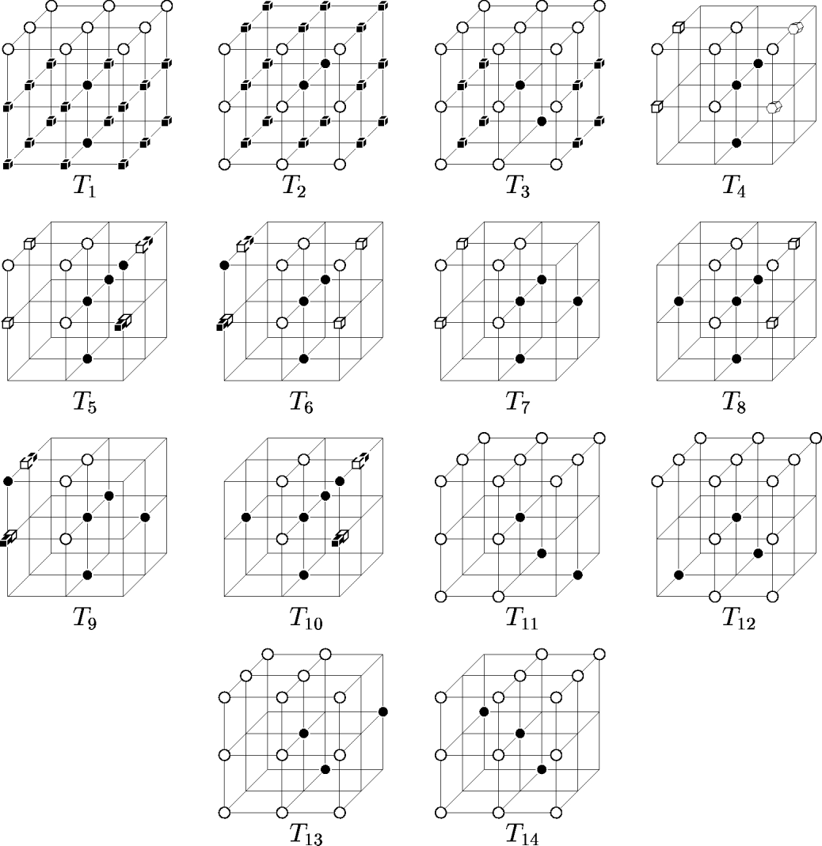

Fig. 6. The set of curve-thinning templates for the direction *US* (*TUS*).

direction and according to the wanted kind of skeleton. Then, we use a Binary Decision Diagram (or BDD) [8][7]to encode these deletable configurations. A BDD can be seen as a compressed graph which permits to know here whether a configuration, only described through the points of *X* and of *X*, is deletable or not [27]; this decision being done by a simple inspection of the neighborhood without any other computation.

In the case of pk, the use of the associated BDD avoids to check the matching of a configuration with the thinning templates. In the case of lb, for a considered configuration whose central point is *x*, the use of the associated BDD avoids to check whether the points in *N*26(*x*) belong to *Px* or not, to check the four *Px*-simplicity conditions on *x* to know whether *x* is *Px*-simple or not, and to check whether *x* is an end point or not. In summary, once BDDs are obtained, then the implementation is the same for the algorithms pk or lb, only the size of “storage” of the called BDDs is different.

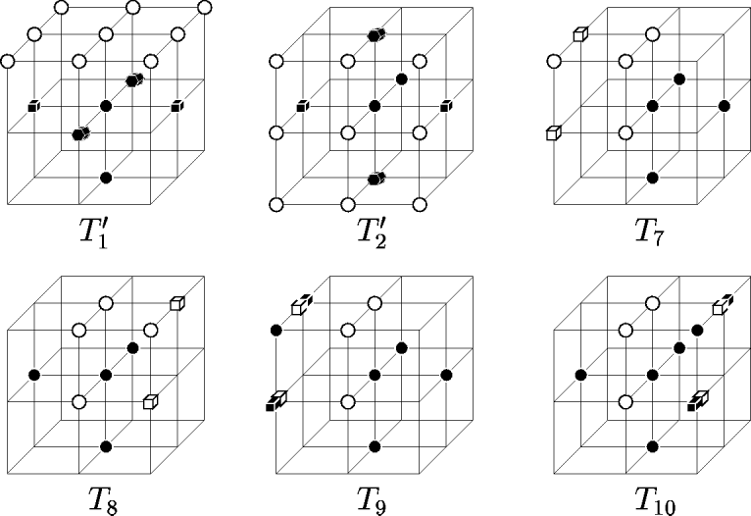

Fig. 7. The set of surface-thinning templates for the direction *US* (*T '* ).

*US*

# Our curve thinning algorithm (LBC)

In this section, we give the entire reasoning which leads us to propose three successive conditions of membership to a set *P* . The used methodology con- sists in proposing successive “refinements” of *P* , until to obtain a set *P* such that at least all points deleted by pk c are *Px*-simple. This is achieved with our third proposal of a set *P* . We note that the first proposal, detailed in section 6.1, is directly deduced from pk c. Our goal is not to obtain the “best” set *P* , but only to propose a new methodology to conceive thinning algorithms, deleting more points than another ones.

We highlight that in this study, we propose an algorithm deleting only *Px*-simple points, and by the very definition of such points, the topology is preserved - no additionnal proof is required, in contrary to the most of already proposed thinning algorithms.

We first deal with the direction *US* until a general comparison of our results. In the following, when we write “a point belongs to *Px*” then *x* is the point *p*13 for the considered configuration (see Fig. 1 (c)). We write “a configuration is *Px*-simple” to mean that the central point *x*(= *p*13) of this configuration is *Px*-simple. Let *y* be a point of a configuration, *y* belongs to

*{p*0*,..., p*26*}*, see Fig. 1 (c); we write “a point *y* verifies a template *T* ” to mean that the template *T* matches the configuration whose central point is *y*.

* 1. *First membership condition*

We observe that *TUS* deletes certain points of *X* whose *US*-neighbor belongs to *X* (see section 5.2 and templates in Fig. 6). We propose to consider *P*1 =

1

*{x ∈ X*; the *US*-neighbor of *x* belongs to *X}*, already studied in section 4.2. Among all 226 possible configurations, we obtain 923 551 ones corresponding to *Px*-simple and non curve end-points, for the direction *US*.

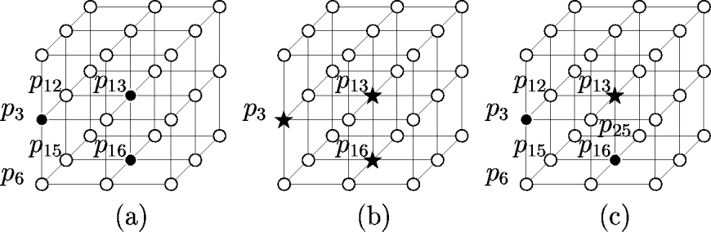

Fig. 8. This configuration (a) is not *Px*-simple (b), and is *Px*-simple (c).

1 2

Let us consider the configuration in Fig. 8 (a). The three points *p*3*, p*13 and *p*16 belong to *Px* (Fig. 8 (b)) because they belong to *X*, the *US*-neighbor of *p*13 and this one of *p*16 belong to *X*, and the *US*-neighbor of *p*3 may belong to *X*; in fact, *p*13 and *p*16 belong to *U* , and *p*3 belongs to *V* ; with the notations used in the section 4.2. The first and the third *Px*-simplicity conditions are not verified for the central point *p*13: with *Rx* = [*N*26(*x*)*∩X*]*\Px*, *T*26(*p*13*, Rx*)= 0,

1

1

1 1 1

and for example, for *p*16 of *N∗* (*p*13) *∩ Px* there is no point of *Rx* 26-adjacent

26 1 1

to *p*16 and to *p*13. Thus, the point *p*13 is not *Px*-simple. Nevertheless it is

1

matched by the template *T*1 of *TUS*. Therefore it should be deleted by our wanted algorithm.

Let us examine the behavior of the other points of this configuration with the templates *TUS* (see Fig. 8 (a)). The point *p*16 cannot be deleted, because the points *p*3 (= *USW* (*p*16)) belongs to *X* for *T*2; and *p*13 (= *U* (*p*16)) belongs to *X* for the other templates. The point *p*3 cannot be deleted because *p*6, *p*15 and *p*12 belong to *X*, *i.e.* the *D*-, *DN* -, *N* -neighbors of *p*3, and all the templates impose that at least such a point must belong to *X* in order to delete a central point. With these remarks, we propose a new set *P*2.

* 1. *Second membership condition*

Let *p*13 belong to *X*. Now, we observe the membership of the points *p*1(= *US*(*p*13)), *p*4(= *S*(*p*13)), and *p*10(= *U* (*p*13)), imposed by the templates of *TUS* when they may delete *p*13, see Fig. 9. Only the points of *X* whose *US*-neighbor belongs to *X*, may be deleted by *TUS*, then *p*1(= *US*(*p*13)) must belong to *X*. If *p*4 belongs to *X* and *p*10 belongs to *X* (see *M*1) then *p*13 may only verify *T*1 and *p*16(= *D*(*p*13)) must belong to *X*. If *p*4 belongs to *X* and *p*10 belongs to *X* (see *M*2) then *p*13 may only verify *T*2 and *p*22(= *N* (*p*13)) must belong to

*X*. If *p*4 and *p*10 belong to *X* (see *M*3) then a necessary condition imposed by the templates *TUS* to delete such a configuration is that at least the *D*-, or the *DN* -, or the *N* -neighbor of *p*13 (*i.e. p*16, *p*25 or *p*22) must belong to *X*; in fact, this is imposed by all the templates, not only when *p*4 and *p*10 belong to

*X*. If *p*4 and *p*10 belong to *X*, then the corresponding configurations are not deleted by the templates *TUS*; we do not require that our algorithm deletes such configurations too.

Finally, we propose *P*2 = *{x ∈ Z*3; *x* verifies at least one of the templates

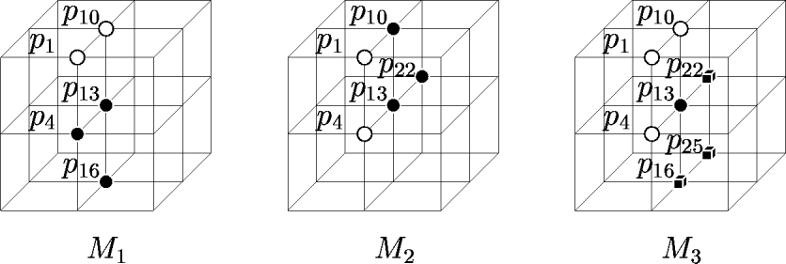

Fig. 9. A point belongs to *P*2 iff it verifies at least one of these templates.

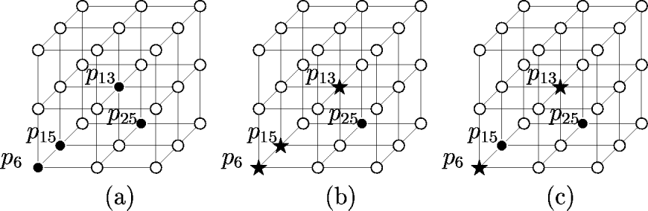

Fig. 10. This configuration (a) is not *Px*-simple (b), and is *Px*-simple (c).

2 3

in Fig. 9 *}*. We note that the non *Px*-simple configuration depicted in Fig.

1

8 (b) is *Px*-simple (Fig. 8 (c)). Indeed, *p*13 belongs to *Px*

as it verifies *M*3;

2 2

*p*3 belongs to *Rx*(= [*N*26(*x*) *∩ X*] *\ Px*) because it cannot verify neither *M*1

2 2

nor *M*2 nor *M*3 as the *D*-, the *DN* -, and the *N* -neighbors of *p*3 belong to *X*

(*i.e.* resp. *p*6, *p*15 and *p*12); *p*16 belongs to *Rx* because it cannot verify neither *M*2 as *p*25(= *N* (*p*16)) belongs to *X*, nor *M*1 nor *M*3 as *p*13(= *U* (*p*16)) belongs to *X*. We obtain 4 672 557 configurations which correspond to *Px*-simple and

2

2

non curve end-points, for the direction *US*.

Let us consider the configuration in Fig. 10 (a). The points *p*13, *p*6 and *p*15 belong to *Px* (see Fig. 10 (b)) because *p*6 may verify *M*1 or *M*3, *p*15 may verify *M*1, *p*13 verifies *M*3; and the point *p*25 belongs to *Rx* as *p*13(= *US*(*p*25)) belongs to *X*. The third condition of *Px*-simplicity is not verified: for *p*6 of *N∗* (*p*13) *∩ Px*, there is no point of *Rx* 26-adjacent to *p*6 and to *p*13. So, the

2

2

2

26 2 2

point *p*13 is not *Px*-simple. Nevertheless, it may be deleted by the template

2

*T*12 of *TUS*. Such a configuration should be deleted by our wanted algorithm. According to the templates *TUS*, the point *p*25 cannot be deleted as *p*13(=

*US*(*p*25)) belongs to *X*, the point *p*6 may be deleted at least by the template *T*2, but the point *p*15 cannot be deleted because *p*13 (= *UE*(*p*15)) belongs to *X* for *T*1, and *p*6 (= *S*(*p*15)) belongs to *X* for the other templates. We are going to propose a set *P*3, in such a way that the point *p*15 of the configuration in Fig. 10 (b) cannot belong to *Px*.

3

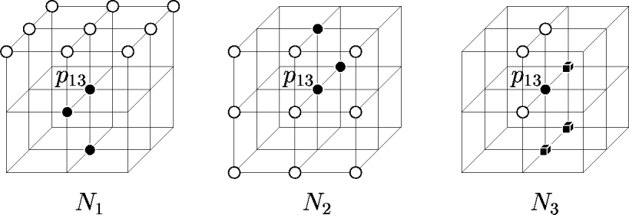

Fig. 11. A point belongs to *P*3 iff it verifies at least one of these templates.

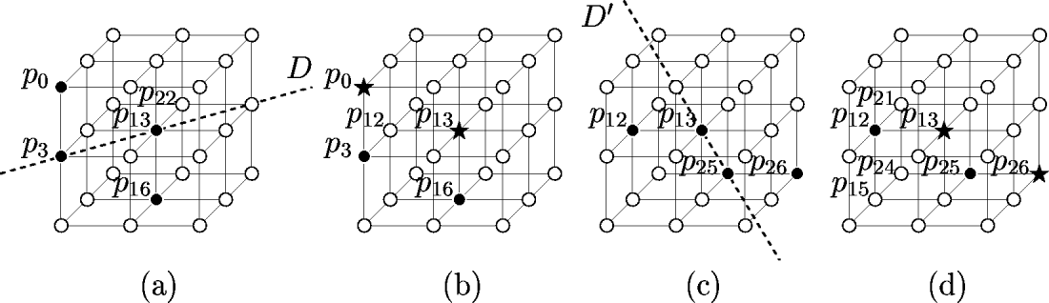

Fig. 12. This configuration (a) is not deleted by *TUS* and (b) is *Px*-simple, (c) shows

3

an isometry of (a), it is deleted by *TUS* and is *Px*-simple (d).

3

* 1. *Third membership condition*

In fact, in the non *Px*-simple configuration in Fig. 10 (b), the point *p*15 may verify *M*1, and *M*1 has been obtained from the template *T*1. But *p*15 does not verify *T*1 because the point *p*13(= *UE*(*p*15)) belongs to *X* in the configuration, but the *UE*-neighbor of the central point in *T*1 does not. So we add the points of *T*1 belonging to the background to the template *M*1, and obtain *N*1 (see Fig. 11). We do the same thing for *M*2 with *T*2 and obtain *N*2. We keep *M*3 and rename it *N*3.

2

So, we propose *P*3 = *{x ∈ Z*3; *x* verifies at least one of the templates in Fig. 11 *}*. We note that the non *Px*-simple configuration in Fig. 10 (b) is now *Px*-simple (see Fig. 10 (c)). Indeed, *p*6 belongs to *Px* as it may verify *N*3; *p*13

2

3 3

belongs to *Px* as it verifies *N*3; the point *p*25 belongs to *Rx*(= [*N*26(*x*)*∩X*]*\Px*)

3 3 3

as *p*13(= *US*(*p*25)) belongs to *X*; and the point *p*15 belongs to *Rx*

3

as *p*6(=

*S*(*p*15)) belongs to *X* for *N*2 and *N*3, and *p*13(= *UE*(*p*15)) belongs to *X* for *N*1. We obtain 2 803 838 configurations corresponding to *Px*-simple and non curve end-points, for the direction *US*. The 1 379 581 configurations deleted by *TUS*,

3

are also *Px*-simple. The fact that the configurations deletable by pk are *Px*-

3 3

simple (for each direction and therefore for the whole algorithm), guarantees

that the topology is preserved by pk (as pk deletes subsets of some *Px*-simple

3

points, see sections 3 and 4).

Let us consider the configuration in Fig. 12 (a). This configuration is

*Px*-simple (see Fig. 12 (b)). Indeed, *p*13 belongs to *Px*

as it verifies *N*3; *p*0

3 3

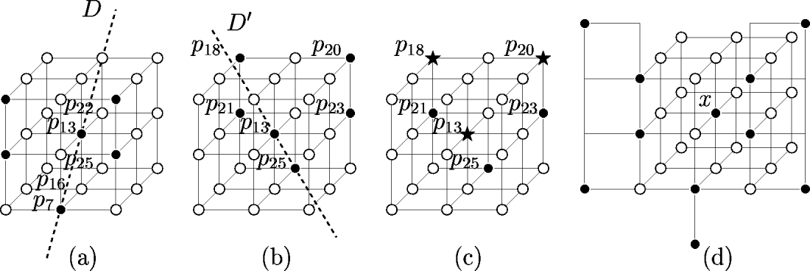

Fig. 13. (a) This configuration cannot be deleted by pk c whatever the deletion direction, and is not *Px*-simple, (b) shows an isometry of (a), it is *Px*-simple (c),

3 3

in (d) (obtained from (a)) no point is deleted by pk c nevertheless *x* is deleted by

lb c.

belongs to *Px* as it may verify *N*1 or *N*3; *p*3 belongs to *Rx* as *p*0(= *U* (*p*3))

3 3

belongs to *X* for *N*1 and *N*3, and *p*12(= *N* (*p*3)) belongs to *X* for *N*2; the

point *p*16 belongs to *Rx*

3

as *p*13(= *U* (*p*16)) belongs to *X* for *N*1 and *N*3 and

*p*3(= *USW* (*p*16)) belongs to *X* for *N*2. This configuration is not deleted by *TUS* (see Fig. 12 (a)) as *p*0(= *USW* (*p*13)) belongs to *X* for *T*1 *... T*4*, T*11 *... T*14; and *p*22(= *N* (*p*13)) belongs to *X* for *T*5 *... T*10. Figure 12 (c) shows an isometry of the configuration of Fig. 12 (a), obtained when the line *D* (through the points *p*3 and *p*13(= *NE*(*p*3))) along the direction *NE* in (a) is considered according to the direction *US* in (c) obtaining thus *D'* (through *p*25 and *p*13(= *US*(*p*25))). This configuration is deleted by *T*3 of *TUS*; or more directly, there exists a deletion direction *Dir* such that the configuration of Fig. 12 (a) is deleted by *T*3 of *TDir*. We note that this configuration is *Px*-simple (see Fig. 12 (d))

3

because *p*13 belongs to *Px* as it verifies *N*3; *p*26 belongs to *Px* as it may verify

3 3

*N*3; *p*25 belongs to *Rx* as *p*13(= *US*(*p*25)) belongs to *X*; and *p*12 belongs to *Rx*

3 3

as the *D*-, the *DN* -, and the *N* -neighbors of *p*12 (*i.e.* resp. *p*15, *p*24 and *p*21)

belong to *X*.

For a better comparison between pk c and lb c, we generate the configu- rations deleted by these algorithms for each direction: pk c deletes 11 268 606 configurations, *i.e.* there exists at least one direction such that a given config- uration among these ones is deleted for this direction by pk c; lb c deletes 19 327 098 configurations (70*.*6% better). The configuration depicted in Fig. 13 (a) cannot be deleted by pk c, whatever the deletion direction. The point *p*13 belongs to *Rx* as the *D*-, the *DN* -, and the *N* -neighbors of *p*13 (*i.e.* resp. *p*16, *p*25 and *p*22) belong to *X*, so it is not *Px*-simple. However, when the line *D* in (a) (through the points *p*7 and *p*13) is considered along the direction *US* in (b) obtaining thus *D'* (through the points *p*25 and *p*13), then the obtained configuration is *Px*-simple (Fig. 13 (c)). Indeed, the points *p*18 and *p*20 belong

3

3

3

to *Px* as they may verify *N*3; *p*13 belongs to *Px* as it verifies *N*3; *p*25 belongs

3 3

to *Rx* as *p*13(= *US*(*p*25)) belongs to *X*; *p*21 belongs to *Rx* as *p*18(= *U* (*p*21))

3

3

belongs to *X* for *N*1 and *N*3, and *p*13(= *SE*(*p*21)) belongs to *X* for *N*2; *p*23 be-

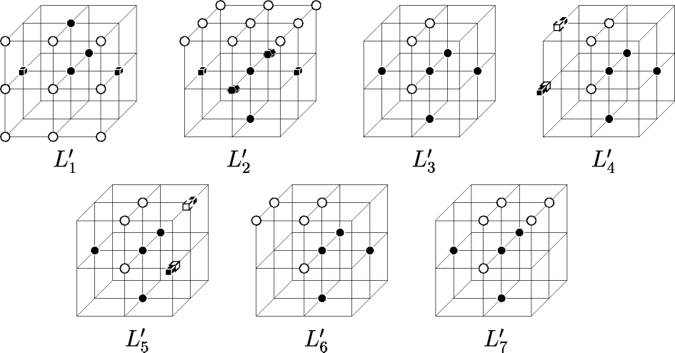

Fig. 14. Our surface thinning algorithm (lb s) deletes the points verifing at least one of these templates (for the direction *US*).

longs to *Rx* as *p*20(= *U* (*p*23)) belongs to *X* for *N*1 and *N*3, and *p*13(= *SW* (*p*23)) belongs to *X* for *N*2. Fig. 13 (d) shows an image built from the configuration in Fig. 13 (a) such that each point is either a non-simple point (except *x*) ora curve end-point, and no point may be deleted by pk c, nevertheless the point *x* may be deleted by lb c, according to the direction giving the isometry in Fig. 13 (b).

3

With this third set, we are going to obtain the configurations which cor- respond to *Px*-simple and non surface end-points, see section 7.

3

**Remark** We also could propose other conditions of membership in order to better respect symmetries, for example: modify (*DN* (*p*13) or *D*(*p*13) or *N* (*p*13)) *∈ X* in *M*3 from *P*2 by (*DN* (*p*13) or (*D*(*p*13) and *N* (*p*13))) *∈ X* to

propose *P '*; then add points in *X*, as in *P*3, to propose *P '*.

2 3

# Our surface thinning algorithm (LB S)

We only retain the configurations corresponding to *Px*-simple and non surface end-points from the ones deleted by lb c, with the surface end-point defi- nition proposed by Pala´gyi and Kuba, see section 5.2. We obtain 1 228 800 configurations which include the 1 155 072 configurations deleted by pk s, for the direction *US*.

3

Furthermore, on the opposite of lb c, we have succeeded to obtain few templates to describe these configurations (with the help of Binary Decision Diagram). The set of these templates is represented for the direction *US* in Fig. 14. A point which verifies at least one of them, will be deleted by lb s, for the direction *US*. Thus, the reader who wants to encode lb s needs neither the conditions of *P* -simplicity, nor the condition of membership to *P* , nor the condition of surface end-point. We can also see that the templates of *T '*

*US*

(Fig. 7) are strictly “included” in ours: for example, *T '* = *L'* , *T ' ⊆* [*L' ∪ L' ∪*

1 2 2 1 3

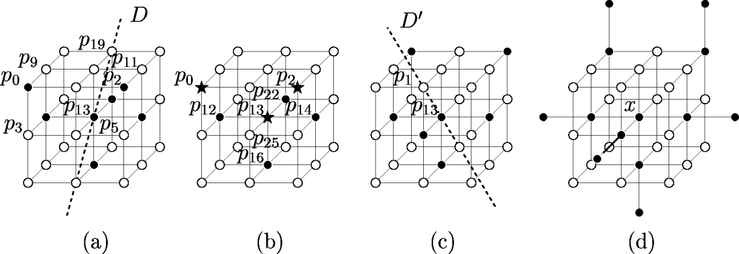

Fig. 15. (a) This configuration cannot be deleted by pk s whatever the deletion direction, and is *Px*-simple (b), (c) shows an isometry of (a), it is *Px*-simple (c),

3 3

in (d) (obtained from (c)) no point is deleted by pk s nevertheless *x* is deleted by

lb s.

*L' ∪ L' ∪ L' ∪ L'* ], *T*7 *⊆* [*L' ∪ L'* ], *T*8 *⊆* [*L' ∪ L'* ], *T*9 *⊆ L'* , *T*10 *⊆ L'* ; *Ti ⊆ L'*

4 5 6 7 4 6 5 7 4 5 *j*

(resp. *Ti* = *L'* ) means that configurations deleted by *Ti* are amongst (resp.

*j*

are the same than) these ones deleted by *L'* , or by a union of some *L'* . That

*j j*

confirms that we can delete at least the configurations deleted by pk s. We

can also verify that our templates prevent from deleting surface end-points. Let us consider the configuration in Fig. 15 (a). It is not deleted by *T '*

*US*

because *p*0(= *USW* (*p*13)) belongs to *X* for *T '*, *T '*

and *T*7; *p*2(= *USE*(*p*13))

1 2

belongs to *X* for *T*8; *p*3(= *SW* (*p*13)) and *p*9(= *UW* (*p*13)) belong to *X* for *T*9;

*p*5(= *SE*(*p*13)) and *p*11(= *UE*(*p*13)) belong to *X* for *T*10. However, it corre- sponds to a *Px*-simple and non surface end-point (see Fig. 15 (b)). Indeed, the points *p*0 and *p*2 belong to *Px* because they may verify *N*3; the point *p*13

3

3

belongs to *Px* as it verifies *N*3; *p*16 belongs to *Rx* as *p*13(= *U* (*p*16)) belongs

3 3

to *X* for *N*1 and *N*3, and *p*25(= *N* (*p*16))belongs to *X* for *N*2; *p*12 belongs to

*x* as *p*0(= *US*(*p*12)) belongs to *X* for *N*1, *N*2 and *N*3; *p*14 belongs to *Rx*

*R*

3

3

as *p*2(= *US*(*p*14)) belongs to *X* for *N*1, *N*2 and *N*3; *p*22 belongs to *Rx* as

3

*p*13(= *S*(*p*22)) belongs to *X* for *N*2 and *N*3, and *p*25(= *D*(*p*22)) belongs to *X* for *N*1. In fact, this configuration may be deleted by *L'* , one of our proposed templates in Fig. 14. However, this configuration is not deleted by pk s, whatever the deletion direction.

3

We have again generated all the configurations deleted by lb s, for each direction. pk s deletes 9 101 312 configurations; lb s deletes 9 986 048 con- figurations (9*.*7% better). Figure 15 (c) shows an isometry of the configura- tion of Fig. 15 (a), obtained when the line *D* (through the points *p*13 and *p*19(= *UN* (*p*13))) along the direction *UN* in (a) is considered according to the direction *US* in (c), obtaining thus *D'* (through *p*13 and *p*1(= *US*(*p*13))). This configuration is not deleted by pk s, as it is said above. Fig. 15 (d) shows an image built from the configuration in Fig. 15 (c) such that each point is either a non simple point (except *x*) or a surface end-point; and no point may be deleted by pk s; nevertheless the point *x* may be deleted by lb s. In

fact, Pal´agyi et Kuba have excluded the configuration in Fig. 15 (a) (see [26], p.207, Fig. 6). They adverted that if the set of templates *TUS* can delete it, then unwanted curve/surface segments may be created. Perhaps, this is not the case with our algorithm because it deletes more other points than pk.

# Other results

Amongst all subsets *P* , proposed in sections 6 and 7, the subset *P*2 permits to delete more points than the other proposals. Although it does not delete all configurations removed by pk, it can delete 23 814 994 *P*2-simple and non curve end-points, and 15 257 520 *P*2-simple and non surface end-points, for the 12 deletion directions. We recall that there are 25 985 118 simple and non curve end-points, and 16 252 928 simple and non surface end-points amongst the 67 108 864(= 226) possible 3 *×* 3 *×* 3 configurations. The skeletons of some images, obtained respectively by pk c, lb c, pk s and lb s, are shown in Fig. 16. We observe that:

* The geometrical appearance is almost the same between pk c and lb c, or between pk s and lb s.
* The number of deletion subiterations required by lb c is inferior to or equal to the one of pk c. The number of points deleted by lb c is inferior to or equal to the one of pk c. The resulting centering is not the same. We recall that it is possible that lb needs more subiterations to obtain a skeleton than pk needs (see Fig. 13 (d) and 15 (d)).
* On these examples, the number of deletion subiterations, the number of deleted points and the skeletons are the same for pk s and lb s.

# Conclusion

In the first part of this study, we have introduced the notion of *Px*-simplicity. Then, we have proposed a new thinning scheme based on the parallel deletion of *Px*-simple points which needs neither a preliminary of labelling nor the examination of an extended neighborhood. Thus, it permits us to compare with some other existent thinning algorithms conceived in such a way.

In the second part, we have proposed a new 12-subiteration thinning algo- rithm, based on the deletion of *Px*-simple points, producing curve or surface skeletons. As it deletes solely *Px*-simple points, this algorithm is guaranteed to preserve the topology. Furthermore, we have proposed some various sets *P* such that our final algorithm deletes at least all the points deleted by pk, while preserving the same end points; this also implies that pk is guaranteed to preserve the topology. Moreover, our surface thinning algorithm is “ex- pressed” in a set of templates. In fact, the used approach may be seen as a general methodology to conceive algorithms which enhance themselves: the basic idea is to adapt a condition of membership to a set *P* , from an existent

algorithm *A*. The condition is such that the final proposed algorithm deletes at least the points removed by *A*, while preserving the same end points. This also implies that *A* preserves the topology. We precise that if we define *P* as the subset constituted of points that *A* may delete from any object *X* and if this subset is a *P* -simple set then *A* is guaranteed to preserve the topology. This work has already been made in [4](see also [3]).

In another study [17], we succeeded in proposing a new 6-subiteration thinning algorithm for 3D binary images, which produces curve skeletons, and such that it deletes at least the points removed by two other 6-subiteration thinning algorithms. A future work will propose new fully parallel thinning algorithms for 2D and 3D binary images.

# References

1. Bertrand, G., *Simple points, topological numbers and geodesic numbers in cubic grids*, Pattern Recognition Letters **15** (1994), pp. 1003–1011.
2. Bertrand, G., *On P-simple points*, Compte Rendu Acad´emie des Sciences de Paris **t. 321** (1995), pp. 1077–1084.
3. Bertrand, G., *P-simple points: A solution for parallel thinning*, in: *5th DGCI*, 1995, pp. 233–242.
4. Bertrand, G., *Sufficient conditions for* 3*D parallel thinning algorithms*, in:

*Vision Geometry VIII*, SPIE **2573**, 1995, pp. 52–60.

1. Bertrand, G. and Z. Aktouf, *A three-dimensional thinning algorithm using subﬁelds*, in: *Vision Geometry III*, SPIE **2356**, 1994, pp. 113–124.
2. Borgefors, G., I. Nystr¨om and G. S. di Baja, *Skeletonizing volume objects. Part II: From surface to curve skeleton*, in: *SSPR’98*, LNCS **1451**, 1998, pp. 220–229.
3. Brace, K., R. Rudell and R. Bryant, *Efficient implementation of a bdd package*, in: *27th IEEE Design Automation Conference*, 1990, pp. 40–45.
4. Bryant, R., *Graph-based algorithms for boolean function manipulation*, IEEE Transactions on Computer **Vol. C-35** (1986), pp. 677–691.
5. Fourey, S. and R. Malgouyres, *A concise characterization of* 3*D simple points*, in: *9th DGCI*, LNCS **1953**, 2000, pp. 27–36.
6. Gong, W. and G. Bertrand, *A simple parallel* 3*D thinning algorithm*, in:

*International Conference on Pattern Recognition*, 1990, pp. 188–190.

1. Hall, R., *Connectivity preserving parallel operators in* 2*D and* 3*D images*, in:

*Vision Geometry*, SPIE **1832**, 1992, pp. 172–183.

1. Jonker, P., *Morphological operations on* 3*D and* 4*D images: From shape primitive detection to skeletonization*, in: *9th DGCI*, LNCS **1953**, 2000, pp. 371–391.
2. Kong, T., *On topology preservation in* 2*-D and* 3*-D thinning*, Int. Journal of Pattern Recognition and Artificial Intelligence **9** (1995), pp. 813–844.
3. Kong, T., *Topology-preserving deletion of* 1*’s from* 2*-,* 3*- and* 4*-dimensional binary images*, in: *7th DGCI*, LNCS **1347**, 1997, pp. 3–18.
4. Kong, T. and A. Rosenfeld, *Digital topology: introduction and survey*, Computer Vision, Graphics and Image Processing **48** (1989), pp. 357–393.
5. Kong, T. Y., *A digital fundamental group*, Computer and Graphics **13** (1989),

pp. 159–166.

1. Lohou, C. and G. Bertrand, *New* 6*-subiteration thinning algorithm for* 3*D images, based on the deletion of P-simple points*, in preparation.
2. Ma, C., *On topology preservation in* 3*D thinning*, Comp. Vision, Graphics, and Image Processing: Image Understanding **59** (1994), pp. 328–339.
3. Ma, C., *A* 3*D fully parallel thinning algorithm for generating medial faces*, Pattern Recognition Letters **16** (1995), pp. 83–87.
4. Ma, C. M. and M. Sonka, *A fully parallel* 3*D thinning algorithm and its applications*, Comp. Vision and Image Understanding **64** (1996), pp. 420–433.
5. Malandain, G. and G. Bertrand, *Fast characterization of* 3*D simple points*, in:

*IEEE International Conference on Pattern Recognition*, 1992, pp. 232–235.

1. Manzanera, A., T. M. Bernard, F. Prˆeteux and B. Longuet, *A uniﬁed mathematical framework for a compact and fully parallel n-D skeletonization procedure*, in: *Vision Geometry VIII*, SPIE **3811**, 1999, pp. 57–68.
2. Morgenthaler, D., *Three-dimensional simple points: Serial erosion, parallel thinning, and skeletonization*, Technical Report TR-1009, Computer Vision Laboratory, University of Maryland (1981).
3. Pala´gyi, K. and A. Kuba, *A* 3*D* 6*-subiteration thinning algorithm for extracting medial lines*, Pattern Recognition Letters **19** (1998), pp. 613–627.
4. Pala´gyi, K. and A. Kuba, *A hybrid thinning algorithm for* 3*D medical images*, Journal of Computing and Information Technology, CIT 6 (1998), pp. 149–164.
5. Pala´gyi, K. and A. Kuba, *A parallel* 3*D* 12*-subiteration thinning algorithm*, Graphical Models and Image Processing **61** (1999), pp. 199–221.
6. Robert, L. and G. Malandain, *Fast binary image processing using binary decision diagrams*, Technical Report n 3001, pp 1-24, INRIA (1996).
7. Saha, P., B. Chanda and D. Majumder, *Principles and algorithms for* 2*D and* 3*D shrinking*, Technical Report TR/KBCS/2/91, N.C.K.B.C.S. Library, Indian Statistical Institute, Calcutta, India (1991).
8. Serra, J., “Image Analysis and mathematical morphology,” Acad. Press, 1982.
9. Tsao, Y. and K. Fu, *A parallel thinning algorithm for* 3*D pictures*, Computer Graphics Image Processing **17** (1981), pp. 315–331.

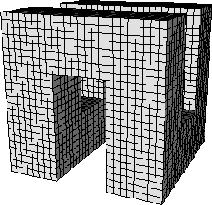 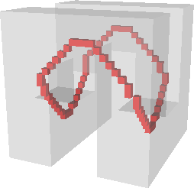 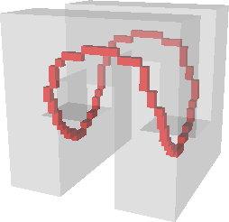 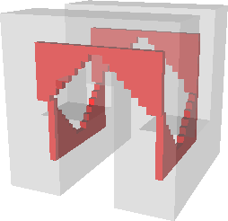 

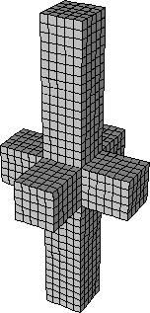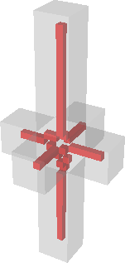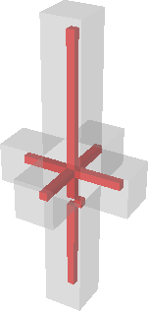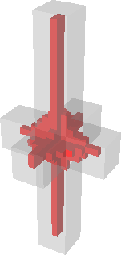Initial 21 *−* 8 120 19 *−* 8 106 11 *−* 7 850 11 *−* 7 850

Initial 60 *−* 1 494 25 *−* 1 492 27 *−* 1 362 27 *−* 1 362

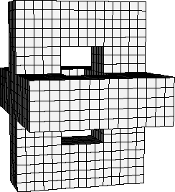 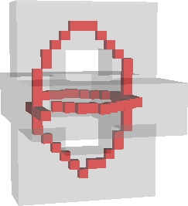 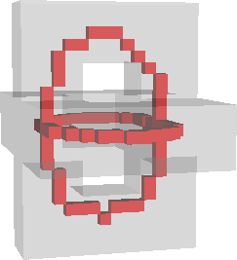  

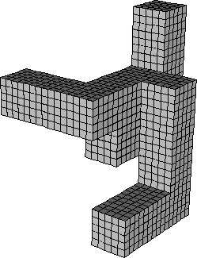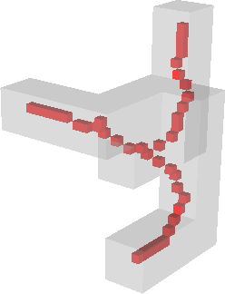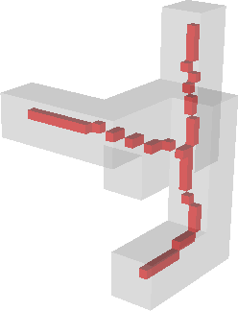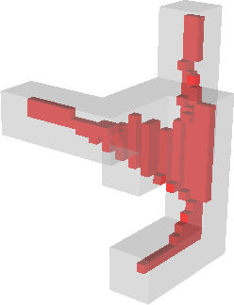Initial 49 *−* 2 282 16 *−* 2 274 9 *−* 2 100 9 *−* 2 100

Initial 51 *−* 2 008 21 *−* 2 003 20 *−* 1 863 20 *−* 1 863

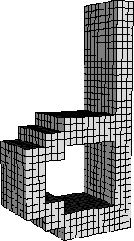 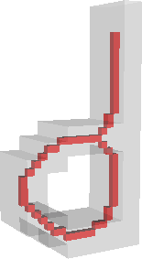  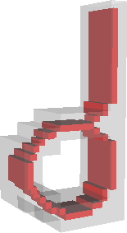 

Initial 12 *−* 2 023 12 *−* 2 023 12 *−* 1 725 12 *−* 1 725

Fig. 16. By row, respectively: an initial object, the curve skeletons for pk c and lb c, then the surface skeletons for pk s and lb s. Under each figure, are given the number of the last subiteration of deletion, and the number of deleted points.