

Electronic Notes in Theoretical Computer Science

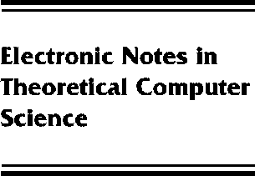[www.elsevier.com/locate/entcs](http://www.elsevier.com/locate/entcs)

A Non-Topological View of Dcpos as Convergence Spaces (Extended Abstract)

Reinhold Heckmann1

*AbsInt Angewandte Informatik GmbH, Stuhlsatzenhausweg 69, D-66123 Saarbru¨cken, England, code UK*

*{heckmann}@absint.com*

**Abstract**

Abstract The category TOP of topological spaces is not cartesian closed, but can be embedded into the cartesian closed category CONV of *convergence spaces.* “It is well-known that the category DCPO of dcpos and Scott continuous functions can be embedded into TOP, and so into CONV, by considering the Scott topology. We propose a different, ”*cotopological* embedding of DCPO into CONV, which, in contrast to the topological embedding, preserves products. If *X* is a cotopological dcpo, i.e. a dcpo with the cotopological CONV-structure, and *Y* is a topological space, then [*X → Y*] is again topological, and conversely, if *X* is a topological space, and *Y* a cotopological complete lattice, then [*X → Y*] is again a cotopological complete lattice. For a dcpo *D*, the topological and the cotopological convergence structures coincide if and only if *D* is a continuous dcpo. Moreover, cotopological dcpos still enjoy some of the properties which characterise continuous dcpos. For instance, all cotopological complete lattices are injective spaces (in CONV) w.r.t. topological subspace embeddings.

1 This paper was written while the author was research fellow in the Department of Computing at Imperial College of Science, Technology, and Medicine, London, UK.

1571-0661 *⃝*c Elsevier Ltd Open access under [CC BY-NC-ND license.](http://creativecommons.org/licenses/by-nc-nd/3.0/)

10.1016/S1571-0661(05)80045-3