 Electronic Notes in Theoretical Computer Science 194 (2008) 87–102 

[www.elsevier.com/locate/entcs](http://www.elsevier.com/locate/entcs)

A Process Model of Rho GTP-binding Proteins in the Context of Phagocytosis

Luca Cardelli 1*,*2

*Microsoft Research*

*7 JJ Thomson Avenue, CB3 0FB, Cambridge, UK*

Philippa Gardner 3

*Department of Computing Imperial College, London, UK*

Ozan Kahramanog˘ulları 4

*Department of Computing & Centre for Integrative Systems Biology*

*Imperial College, London, UK*

**Abstract**

At the early stages of the phagocytic signalling, Rho GTP-binding proteins play a key role. With the stimulus from the cell membrane and with the help from the regulators (GEF, GAP, Effector, GDI), these proteins serve as switches that interact with their environment in a complex manner. We present a generic process model for the Rho GTP-binding proteins, and compare it with a previous model that uses ordinary differential equations. We then extend the basic model to include the behaviour of the GDIs. We discuss the challenges this extension brings and directions of further research.

*Keywords:* phagocytosis, GTP-binding proteins, stochastic *π*-calculus, process modeling

1 We would like to thank Andrew Phillips for discussions on the SPiM language, Emmanuelle Caron for her comments and suggestions which helped to shape Section 4, and Jaroslav Stark for proof reading the paper and also suggesting improvements in the presentation. Cardelli acknowledges support of a visiting profes- sorship at Imperial College. Gardner acknowledges support of a Royal Academy of Engineering/Microsoft Research Cambridge Senior Fellowship. Kahramano˘gulları acknowledges support of the UK Biotechnology and Biological Sciences Research Council through the Centre for Integrative Systems Biology at Imperial College (grant BB/C519670/1).

2 Email: [luca@microsoft.com](mailto:luca@microsoft.com)

3 Email: [pg@doc.ic.ac.uk](mailto:pg@doc.ic.ac.uk)

4 Email: [ozank@doc.ic.ac.uk](mailto:ozank@doc.ic.ac.uk)

1571-0661 © 2008 Elsevier B.V. Open access under [CC BY-NC-ND license.](http://creativecommons.org/licenses/by-nc-nd/3.0/)

doi:10.1016/j.entcs.2007.12.007

# Introduction

Phagocytosis is a form of endocytosis by which a cell engulfs micro-organisms, large edible particles and cellular debris. Phagocytosis literally means ‘cell eating’. Single-celled organisms such as amoeba obtain food in this way. Phagocytosis also occurs in multi-celled organisms when, for example, macrophages and other white blood cells defend the body against invasions of harmful viruses, bacteria, cancerous body cells, and other threats to health [1]. A key project in the newly-formed Centre for Integrative Systems Biology at Imperial is to analyse the fundamental mechanisms for phagocytosis, using the expertise of biologists, computer scientists and mathematicians. Our part of the project is to use stochastic process algebras, such as the stochastic *π*-calculus (see, e.g., [18]), to provide a compositional and scalable notation for simulating phagocytosis.

In this first paper, we give a process calculus model of Rho GTP-binding pro- teins which play an important role also in phagocytosis. These proteins act on the membranes of cells as molecular switches in several subcellular activities, regulating a variety of cell functions such as actin organisation, cell shape and cell adhesion. We study Goryachev and Pokhilko’s paper [11] on an ordinary differential equation (ODE) analysis of the Rho GTP-binding protein cycle, first in isolation and then with their regulators GEF and GAP. Our process models provide a simple, compo- sitional description of the Rho GTP-binding protein cycle, where the structure of models naturally follows the structure of the biological models. Using the Stochastic Pi Machine (SPiM) [17,16] and the rates of interaction described in [11], we provide simulations which precisely mimic the results given using ODEs. Following [11], we also extend our model to include the effectors which interact with these proteins at the membrane. Again, our results remain consistent with the results obtained from the ODE analysis. Our results provide an essential starting point for our investigation of the behaviour of Rho GTP-binding proteins using process models.

We further extend our model to include the interactions of the GTP-binding proteins with another class of regulators called GDIs, which were not incuded in the ODE analysis of [11]. Our initial aim was to analyse two biological models described in the survey paper [7]. Instead, based on discussions with Caron, a biol- ogist at Imperial, we introduce a hybrid model which fits more closely with current knowledge. We extend our process model, again illustrating the compositional na- ture of our approach. The next step is to provide a systematic study of the rates, searching the biological literature and using SPiM to explore the parameter space leading to sensible behaviour. We begin this study, using SPiM to explore the effect of varying the quantity of the GDI protein on the behaviour of the protein cycle and the effectors. Ultimately, we require help from the biologists to fill the gaps in our current knowledge. Indeed, our ambitious goal is to create a research en- vironment where the biological experiments corroborate and provide data for our process-model simulations, and our simulations guide the biological experiments.

# Rho GTP-binding Proteins and their Role in Fc Receptor-mediated Phagocytosis

Phagocytosis is the process whereby cells engulf large particles, usually over 0*.*5*μm* in diameter, by a mechanism that is based on local rearrangement of the cytoskele- ton. Phagocytosis plays an essential role in host defence against invading pathogens, and in clearance of cell corpses generated by programmed cell death or apoptosis. Phagocytosis contributes to inflammation and the immune response [1].

Phagocytosis is a triggered process, often initiated by the interaction of particle- bound ligands (opsonins) with specific receptors on the cell membrane of ‘profes- sional’ phagocytic white blood cells such as macrophages, neutrophils and dendritic cells [5]. Among the variety of surface proteins dedicated to phagocytosis, Fc recep- tors (FcRs) and receptors for complement fragments (Cr’s) mediate the clearence of pathogens covered by the specific antibody or complement respectively [12].

* 1. *Fc Receptor-mediated Phagocytosis*

In the context of Fc receptor-mediated phagocytosis, the signalling cascade is trig- gered by antibodies, called immunoglobulin, e.g., IgG, which protect the organism by binding to the surface of infectious microorganisms to form a coat. In this sit- uation, the tail region of each antibody molecule, called the *Fc region*, is exposed on the exterior. This antibody coat is recognised by specific *Fc receptors* on the surface of the cell. Their binding induces the phagocytic cell to extend pseudopods and extend its tips to form a phagosome while proceeding with binding its ligands in a zipper like fashion around the internalised particle [10].

As a result of FcR-Fc interaction on the exterior surface of the cell membrane, a protein tyrosine kinase of the Src family is activated. Following this, Src phos- phorylates two tyrosine residues on the receptor’s signalling subunits located on the internal tail of the Fc receptor. These tyrosine residues belong to immunorecep- tor tyrosine-based activation motifs, or ITAMs. Another protein tyrosine kinase, Syk, is then recruited through its Src-homology 2 (SH2) domains by binding to the phosphorylated ITAMs. This results in autophosphorylation and activation of Syk. Among other tasks, activated Syk is responsible for the recruitment of the protein Vav [12], which then activates Rho GTP-binding protein Rac. In a parallel inde- pendent pathway, another Rho GTP-binding protein Cdc42 gets activated by an unknown protein [15]. Cdc42 and Rac then act at distinct stages to promote actin filament polymerisation and organisation at the site of particle ingestion: Cdc42 and Rac control actin filament polymerisation through proteins WASP (Wiskott-Aldrich Syndrome protein) and WAVE, respectively, that bind to and stimulate the activity of the Arp2/3 complex. Activation of Arp2/3 results in actin polymerisation and a network of actin filaments that extend the cytoskeleton around the internalised particle formed. While Rac is responsible for the branching structure of the actin polymerisation, Cdc42 causes the actin to polymerise in a linear structure [19].

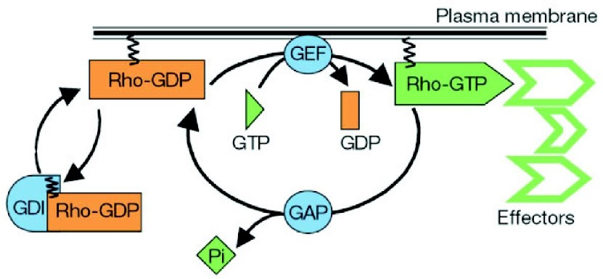

Fig. 1. Rho GTP-binding protein cycle. Adapted by permission from Macmillan Publishers Ltd: *Nature*

[9], copyright 2002.

* 1. *Rho GTP-binding Proteins in Fc Receptor-mediated Phagocytosis*

The proteins Cdc42 and Rac mentioned above belong to the Rho GTP-binding proteins. As in the context of phagocytosis, the family of Rho GTP-binding proteins serve as molecular switches in various subcellular activities, regulating a variety of cell functions, including actin organisation and cell shape, cell adhesion, cell motility, membrane trafficking and gene expression [5,3]. These proteins can be perceived as transmitting an incoming signal further to some effector in a molecular module by cycling between inactive and active states, depending on being GDP or GTP bound, respectively. As depicted in Figure 1, GDP/GTP cycling is regulated by guanine nucleotide exchange factors (GEFs) that promote the GDP dissociation and GTP-binding, whereas GTPase-activating proteins (GAPs) have the opposite effect and stimulate the hydrolysis of Rho GTP into Rho GDP. In the active GTP- bound state, Rho proteins interact with and activate downstream effectors, e.g., to control actin polymerisation in the context of Fc receptor mediated phagocytosis [13]. Although the role of GDIs (Guanine Nucleotide dissociation Inhibitors) is not totally clear, there is evidence that these proteins are responsible for multiple tasks in the regulation of Rho GTP-binding proteins, including the inhibition of the GTP hydrolysis into GDP (see Section 4).

* 1. *An ODE Model of Rho GTP-binding Proteins*

In [11], Goryachev and Pokhilko give a computational model of the Rho GTP- binding proteins by means of ordinary differential equations (ODE). The structure and the differential equations of their model are given in Figure 2, respectively. In Figure 2, R denotes the Rho GTP-binding protein, whereas RD and RT denote its GDP and GTP bound forms respectively. A and E denote GAP and GEF, respectively. Thus, RDE, for example, denotes the protein complex formed by RD and E. After an inspection of the ODEs given in [11], we found the typos depicted with red ink in Figure 2. However, these typos seem to be only in the presentation of [11], not in the actual model, as suggested by the results in this paper.

In this model, the authors study GTP-binding proteins in isolation, disregarding

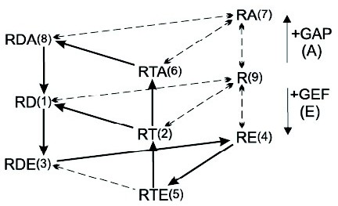 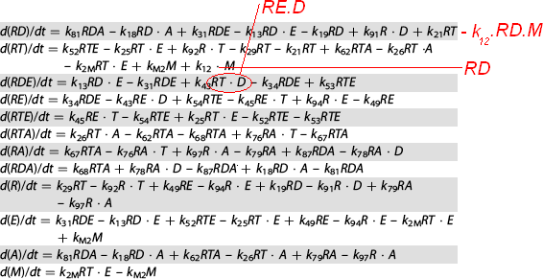

Fig. 2. The ODE model given in [11]. The diagram on the left depicts the chemical reactions underlying the ODEs on the right.

the GDIs. The model uses mainly the quantitative biochemical data on Cdc42p. This results in an explanation of the experimentally observed rapid turn over in Rho GTP-binding proteins by means of an ODE model. In the following, based on this ODE model, we will give a process calculus model which compositionally builds and extends the ODE model. We will provide a comparison of two models.

# A Process Calculus Model

We compositionally build a process model of Rho GTP-binding proteins by treating the components of the Rho GTP cycle as components of a stochastic *π*-calculus process (see, e.g., [18,2]). We first build a basic model, and then modularly extend it with regulators. At each stage, we provide simulations of our models and compare our results with the corresponding ODE model [11].

* 1. *Biological Processes as Computations*

In the stochastic *π*-calculus, the basic building blocks are processes. Each process has a precise description of what actions it can take. Once a biological system has been modeled using these basic components, the model can be stochastically simulated in order to predict the evolution of the system over time. In this paper, the simulations are performed using the Stochastic Pi Machine (SPiM) 5 [17] which serves as a platform for implementing stochastic *π*-calculus processes and for running machine simulations. We use the SPiM notation throughout this paper.

Processes are viewed as the choice between zero or more processes. A process with *n* choices is written as let P = do P1 or ... or Pn. If there is only one choice, we write let P = P1. A process can perform an input ?x(m);Q or output

!x(n);Q on a channel x or perform a delay, written as delay@r;Q, where r is a real number value denoting the rate of an exponential distribution and Q is the continuation process. Complementary input and output actions interact by means of hand shake operations on channels declared with the syntax new. The operator new x@r:t P creates a fresh channel x of rate r to be used in the process P where t is the type of the channel x which can be, e.g., chan(chan,chan) denoting that

5 <http://research.microsoft.com/~aphillip/spim/>

(*i*) 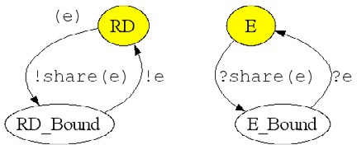 (*ii.*) 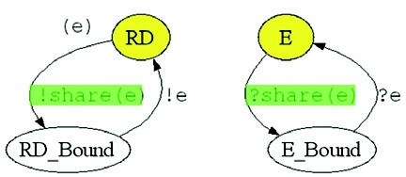

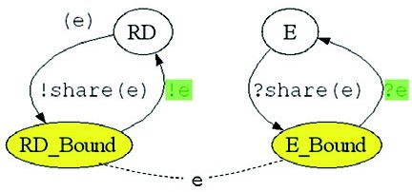(*iii.*) (*iv.*)

Fig. 3. Graphical representation of the evolution of the RD and E interaction model. Processes RD and E coexist (*i.*), and they can interact on channel share (*ii.*). When they interact, RD sends the private channel *e*, and E receives it. This way, they evolve to processes RD Bound and E Bound, respectively, which share the private channel *e*, resembling a covalent bond between two bio-chemical species (*iii.*). By interacting on channel *e*, they evolve back to the processes RD and E, respectively (*iv.*).

the channel can pass the names of two channels. When a process is prefixed with a declaration of a fresh channel, that channel remains private to the process and does not conflict with any other channel. A process can be the empty process, written (). Two process components P and Q can be combined using parallel composition P | Q. This constitutes the basic form of compositionality which allows to compose processes in order to gradually build bigger models.

We can model chemical reactions using processes [18]. Let us see this on the following example: consider the situation where the biological processes RD and E can interact to form RDE complex, which can return to the state where RD

*r*

and E coexist. We depict this as the reaction RD + E RDE *.* This reaction can

*r*

be read in Figure 2 as the arrow from

RD to

*'*

RDE together with the arrow for

GEF (E). Following the results in [11], we know that the left-to-right direction has the rate *r* = 0*.*0054 *μ*M*−*1*.*min*−*1, whereas the right-to-left direction has the rate *r'* = 0*.*136 min*−*1. This reaction is coded in SPiM as follows:

new share@0.0054:chan(chan)

let RD() = ( new [e@0.136:](mailto:e@0.136) chan() !share(e); RD_Bound(e) ) and RD_Bound(e:chan) = !e; RD()

let E() = ?share(e); E_Bound(e) and E_Bound(e:chan) = ?e; E()

The first line of the code states that there is a channel share which takes another channel as argument. The second and third line state that the process RD can interact on channel share and broadcast the private channel e, and then evolve to process RD_Bound, which can send a message on channel e and evolve to RD. The fourth line states that process E can receive a message on channel share, and then evolve to E_Bound which can receive a message on channel e and evolve to E.

Figure 3 shows a run of a cycle of this reaction in the style of the graphical representation of the SPiM language, presented in [16]. There, the system is repre- sented as two processes that interact over shared channels. Yellow marks indicate

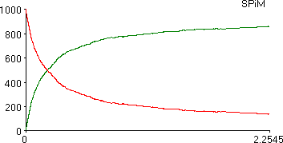 

Fig. 4. SPiM plots of a simulation of the process with the graphical representation shown in Figure 3. The *x*-axis is the time in minutes and *y*-axis is the number of processes. The simulation is started with 1000 RD and 1000 E.

the state of the system, and green marks indicate the active channel.

When we run a simulation by using the code above with 1000 RD and 1000 E initially (RD0 = 1000 and E0 = 1000), we get the plot in Figure 4, where red and green are used for RD and RD_Bound molecules, respectively. We can read from this plot the recovery time, i.e., the time necessary for the system to reach stable state, as approximately 2*.*1 mins. At the stable state, the RDE*/*RD0 ratio is 0*.*86.

* 1. *Rho GTP-binding Proteins without GEF and GAP*

At a first step towards compositionally building a model of Rho GTP-binding pro- teins, we first consider these proteins in isolation by disregarding the regulators GEF and GAP. This corresponds to the mid-layer of the graph on the left-hand side of Figure 2, which is also the left-most graph in Figure 5. Below, we encode this graph in the SPiM language by considering the possible reactions between the species as processes as shown on the left-hand-side of Figure 6.

In the graph in Figure 5, the reactions between the species RD and R, and R and RT are bi-directional. However, there are only reactions from RT to RD with no reaction on the opposite direction. This is because GTP molecules can hydrolyse to GDP molecules by the disassociation of a phosphate group, but re-association of the phosphate group to GDP is not possible. Similar to the model in [11], we do not include the interactions with the GTP and GDP molecules explicitly in the structure of the model, this information is reflected in the quantitative data, as factors of the rates of the reaction which involve these molecules and set with respect to the constant concentrations of these molecules as reported in the literature

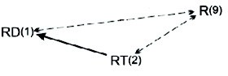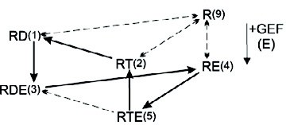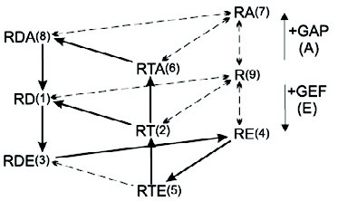*~i. ~ii.*

Fig. 5. A graphical representation of modular construction of the interactions of Rho GTP-binding proteins with respect to the ODE model in [11]. A basic model excluding the regulators GEF (E) and GAP (A) is extended first with GEF (*i.*) and then with GAP (*ii.*).

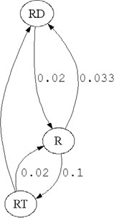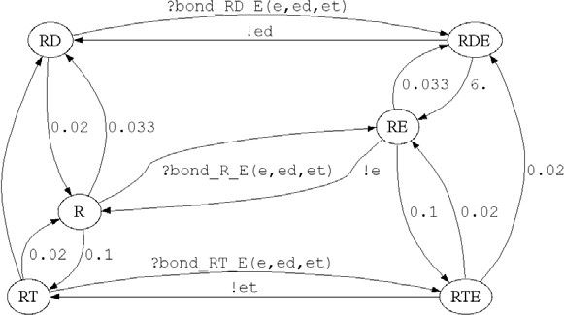*~i.*

*~ii.*

Fig. 9

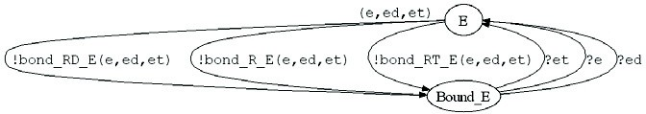

Fig. 6. Compositional construction of the process model for the Rho GTP-binding proteins with GEF and

without GAP with respect to *~i*

in Figure 5.

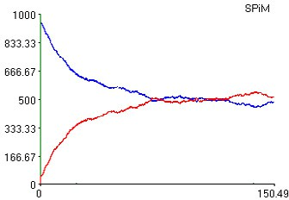 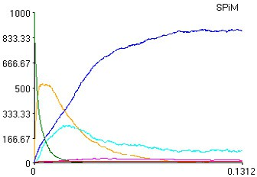 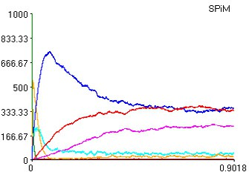 

Fig. 7. SPiM plots of some simulations. The *x*-axis is the time in minutes and *y*-axis is the number of processes. The legend on the right is for all the three plots.

(500*μM* for GTP and 50*μM* for GDP 6 ). The SPiM code of this model, including the quantitative data, is as follows:

val D = 50.0 val T = 500.0

let R() = do [delay@0.033*D;](mailto:delay@0.033) RD() or [delay@0.1*T;](mailto:delay@0.1) RT() and RD() = [delay@0.02;](mailto:delay@0.02) R()

and RT() = do [delay@0.02;](mailto:delay@0.02) R() or [delay@0.02;](mailto:delay@0.02) RD()

The first line above states that the values of D and T are set to 50.0 and 500.0 respectively. The second line states that process R can evolve to RD or RT with the rates 0.033*D and 0.1*T, respectively. The third and forth lines state that RD can evolve to R with rate 0.02 and RT can evolve to R or RD with both rates 0.02.

When we run a simulation using this code with 1000 R (R0 = 1000), we get

the left-most plot in Figure 7, where red, green and blue colours are used for RD, R and RT molecules, respectively. We can then read from this plot that the recovery time, i.e., the time necessary for the system to reach stable state, is approximately

6 *M* (Mol) is the chemical unit for the number of molecules per unit solution, known as the Avogadro’s number. 1*M* denotes approximately 6*.*02 *∗* 1023 molecules, determined by the number of atoms in 12*g* of carbon-12. *μM* denotes micromoles, i.e., 1*M ∗* 10*−*6.

90 mins. At the stable state, the RT*/*R0 ratio is 0*.*5.

* 1. *Rho GTP-binding Proteins with GEF and without GAP*

We extend the Rho GTP-binding protein process model, given in Subsection 3.2, to a process that also models GEF regulation. This corresponds to the middle diagram in Figure 5 and process model given in Figure 6. Here, we have two interacting processes, one for the Rho GTP-binding protein, which extends the process model given in the previous subsection, and one for GEF (the E process). The SPiM code of the model in Subsection 3.4 extends the code of this model, however that code can also be used for this model by taking the initial number of A (GAP in Figure 2) as 0. When we run a simulation using this code with 1000 R and 1000 E processes (R0 = 1000 and E0 = 1000), we get the middle plot in Figure 7, where red, green, blue, pink, yellow, and light blue colours are used for RD, R, RT, RDE, RE, and RTE molecules, respectively. We can then read from this plot that the recovery time, i.e., the time necessary for the system to reach stable state, is approximately 0*.*12 mins. At the stable state, the RT*/*R0 ratio is 0*.*87.

In order to compare our process model with the ODE model given in [11], we ran the SPiM simulations on a range of initial number of molecules, where R0 and E0 range between 10*−*2*μM* and 106*μM* . In these simulations, the rate values are given with the unit *μM−*1. Because of this, we encode 1*μM* of a species as 1 instance of the process in the model at the start of the simulation. For instance, when we start the simulation with E0 = 1000, this corresponds to 1000*μM* in the ODE model. In order to be able to run simulations for the situations where the initial concentration of species are too low for meaningful stochastic simulations or too high from the point of view of computational resources, we do a scaling by means of a factoring constant. This scaling can be seen to be performed on the underlying chemical reactions, that is, we divide the rates of the underlying binary chemical reactions and multiply the initial concentrations of the species with a factoring constant [20]. For instance, in order to run a simulation for the case where there are 10*−*2*μM* of R and 10*−*2*μM* of E, we scale the rate values by a factor of 104, which allows to give the initial values as 10*−*2 *∗* 104 = 102. For this purpose, we divide the rates of the interaction channels in the process model with our scaling factor, e.g., 104.

The outcome of our SPiM simulations, reflecting the RT*/*R0 ratio at the stable state, are depicted as the graph on the right-hand-side of Figure 8. In Figure 8, the graph on the left-hand-side is the outcome of the ODE simulations taken from [11]. In both graphs, the values are given in logarithms of the concentrations in the ODE model and the amount of present processes in the process model, at the start of the respective simulations. For instance, the point in the plot where E0 = 4 and R0 = 2 is the case where the simulation is started with 104 = 10000 E processes and 102 = 100 R processes. We observe that the outcome of our simulations is consistent with the outcome of the ODE simulations. In order to obtain this match between the different models, the quantitative data consisting of the initial concentrations and rate values of the reactions had to be carefully analysed and fine-tuned. This turned out to be a challenging task which required a non-trivial interpretation of

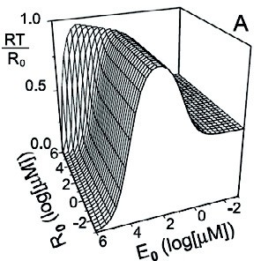 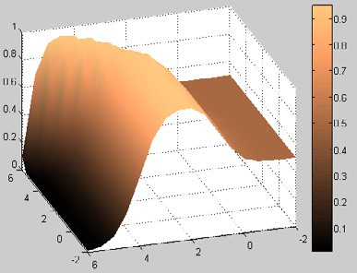

Fig. 8. Graphs displaying the RT*/*R0 ratio as the output of the ODE [11] and process simulations, respec- tively, for the models for Rho GTP-binding proteins with GEF and without GAP.

the data given in [11] in terms of processes.

* 1. *Rho GTP-binding Proteins with GEF and GAP*

We extend the model in Subsection 3.3 as in Figure 5 (*ii.*), and obtain process model for Rho GTP-binding proteins with GEF and GAP with the SPiM code given below. The graphical representation of this model is depicted in Figure 9 with three interacting processes: one for the Rho GTP-binding protein, which extends the model given in the previous subsection, one for GEF (E) and one for GAP (A).

directive sample 0.1 1000 directive graph

directive plot RD(); R(); RT(); RDE(e,ed,et); RE(e,ed,et); RTE(e,ed,et);

RDA(a,ad,at); RA(a,ad,at); RTA(a,ad,at)

val D = 50.0 val T = 500.0

new bond_RD_A@1.0:chan(chan,chan,chan) new bond_RD_E@0.0054:chan(chan,chan,chan) new bond_RT_A@1.0:chan(chan,chan,chan) new bond_RT_E@0.0075:chan(chan,chan,chan) new bond_R_A@1.0:chan(chan,chan,chan) new bond_R_E@0.43:chan(chan,chan,chan)

let R() = ( do [delay@0.033*D;](mailto:delay@0.033) RD() or [delay@0.1*T;](mailto:delay@0.1) RT() or ?bond_R_A(a,ad,at); RA(a,ad,at)

or ?bond_R_E(e,ed,et); RE(e,ed,et) )

and RA(a:chan,ad:chan,at:chan) =

do [delay@0.1*D;](mailto:delay@0.1) RDA(a,ad,at) or [delay@0.0085*T;](mailto:delay@0.0085) RTA(a,ad,at) or !a; R()

*ii.*

6 *~*

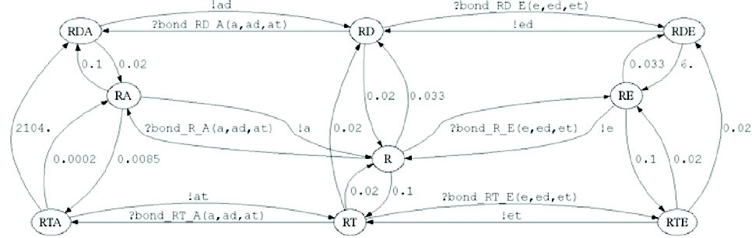Fig.

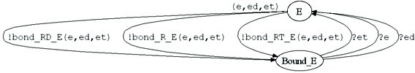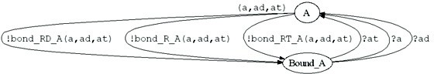

Fig. 9. Compositional construction of the process model for the Rho GTP-binding proteins with GEF and GAP with respect to *~ii* in Figure 5.

and RE(e:chan,ed:chan,et:chan) =

do [delay@0.033*D;](mailto:delay@0.033) RDE(e,ed,et) or [delay@0.1*T;](mailto:delay@0.1) RTE(e,ed,et) or !e; R()

and RT() = ( do [delay@0.02;](mailto:delay@0.02) R() or [delay@0.02;](mailto:delay@0.02) RD() or ?bond_RT_A(a,ad,at); RTA(a,ad,at)

or ?bond_RT_E(e,ed,et); RTE(e,ed,et) )

and RTA(a:chan,ad:chan,at:chan) =

do [delay@0.0002;](mailto:delay@0.0002) RA(a,ad,at) or [delay@2104.0;](mailto:delay@2104.0) RDA(a,ad,at) or !at; RT()

and RTE(e:chan,ed:chan,et:chan) =

do [delay@0.02;](mailto:delay@0.02) RDE(e,ed,et) or [delay@0.02;](mailto:delay@0.02) RE(e,ed,et) or !et; RT()

and RD() = ( do [delay@0.02;](mailto:delay@0.02) R() or ?bond_RD_A(a,ad,at); RDA(a,ad,at) or ?bond_RD_E(e,ed,et); RDE(e,ed,et) )

and RDA(a:chan,ad:chan,at:chan) = do [delay@0.02;](mailto:delay@0.02) RA(a,ad,at) or !ad; RD() and RDE(e:chan,ed:chan,et:chan) = do [delay@6.0;](mailto:delay@6.0) RE(e,ed,et) or !ed; RD() let A() = ( new a@500.0:chan new ad@500.0:chan new at@3.0:chan

do !bond_R_A(a,ad,at); Bound_A(a,ad,at)

or !bond_RT_A(a,ad,at); Bound_A(a,ad,at)

or !bond_RD_A(a,ad,at); Bound_A(a,ad,at) )

and Bound_A(a:chan,ad:chan,at:chan) = do ?a; A() or ?ad; A() or ?at; A() let E() = ( new e@1.074:chan new ed@0.136:chan new et@76.8:chan

do !bond_R_E(e,ed,et); Bound_E(e,ed,et) or !bond_RT_E(e,ed,et); Bound_E(e,ed,et)

or !bond_RD_E(e,ed,et); Bound_E(e,ed,et) )

and Bound_E(e:chan,ed:chan,et:chan) = do ?e; E() or ?ed; E() or ?et; E() run 1000 of R() run 10 of A() run 1000 of E()

When we run a simulation using this code with 1000 R, 10 A and 1000 E processes (R0 = 1000, A0 = 10 and E0 = 1000), we get the right-most plot in Figure 7. We can then read from this plot that the recovery time is approximately 0*.*5 mins. At the stable state, the RT*/*R0 ratio is 0*.*35.

In order to compare this model with the model in [11], we ran simulations on a range of initial number of molecules, where R0 is 1000 and E0 ranges between 10*−*1*μM* and 104*μM* , and A0 ranges between 10*−*2*μM* and 102*μM* . For some sim- ulations, we performed a scaling as described for the simulations in Subsection 3.3.

The outcome of our simulations are depicted as the graph on the right-hand- side of Figure 10, where the graph on the left-hand-side is the outcome of the ODE simulations taken from [11]. In both graphs, the values are given in logarithms of the concentrations in the ODE model and the amount of present species in the process model, at the beginning of the respective simulations. Again, the outcome of these simulations is consistent with the outcome of the ODE simulations.

# Extending the Model with Effectors and GDI

Besides the regulators GEF and GAP, the Rho GTP cycle depicted in Figure 1 is also affected by the interactions with the effectors and another regulator called GDI. The effectors of the Rho GTP-binding proteins, e.g., WASP (also in the context of phagocytosis), change their structural conformation and gain the ability to bind to other proteins while they are associated with the active GTP-bound Rho protein attached to the membrane. The GDIs (Guanine-nucleotide Dissociation Inhibitors) form a class of regulatory proteins for the Rho GTP cycle [6,7,8]. GDIs play two

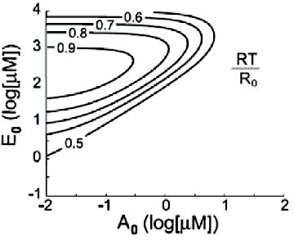 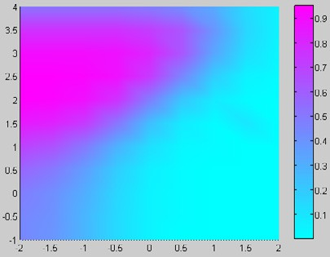

Fig. 10. Graphs displaying the RT*/*R0 ratio as the output of the ODE [11] and process simulations, respec- tively, for the models for Rho GTP-binding proteins with GEF and GAP.

roles: they down-regulate the Rho activity by preventing membrane association of these proteins, and they serve as shuttling mechanisms for the active GTP-bound and passive GDP-bound Rho proteins to and from membranes.

* 1. *Extending the Model with Effectors*

The biological function of the GTP-binding proteins is performed only by the active GTP-bound form that binds and activates a broad range of effector proteins. By disregarding the role played by the GDIs, [11] gives a model that extends the model in Subsection 3.4 with effectors. The model is obtained by extending the model of GTP-binding protein cycle with reactions that capture the behaviour of these proteins together with the effectors; a scaffold-effector complex forms a stable complex with GEF (E) at all times. The binding of E to the RT results in the formation of an activated tripartite complex, consisting of RT, E and the effector protein. In this model, M denotes this complex. Due to the lack of detailed data in the literature, the authors suggest that such a representation provides a sufficiently abstract model of the actual biological system. This results in the introduction of 3 reactions which sufficiently abstract away from the actual biological kinetics that would involve 54 more reaction rate constants. Thus, this simplified model extends the model depicted in Figure 2 with the reactions

r1 : RT + E *→* M r2 : M *→* RT + E r3 : RD + M *→* RT + M

where the rates of *r*1, *r*2, and *r*3 are estimated and set as 600 *μ*M*−*1*.*min*−*1, 18 min*−*1 and 0*.*6 *μ*M*−*1*.*min*−*1, respectively.

Using the reactions and rates given above, we extended the process model of Subsection 3.4, analogously. For a comparison with the model of [11], we ran sim- ulations on a range of initial number of molecules, where R0 is 1000 and E0 ranges between 10*−*1*μM* and 104*μM* and A0 ranges between 10*−*2*μM* and 103*μM* .

The outcome of our simulations are depicted as the graph on the right-hand- side of Figure 11, where the graph on the left-hand-side is the outcome of the ODE simulations taken from [11]. In both graphs, the values are given in logarithms of the concentrations in the ODE model and the amount of present species in the process model, at the beginning of the respective simulations. Again, the outcome of these simulations is consistent with the outcome of the ODE simulations.

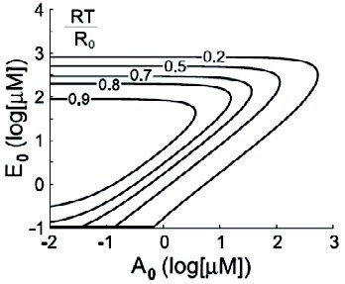 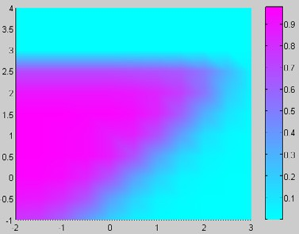

Fig. 11. Graphs displaying the RT*/*R0 ratio as the output of the ODE [11] and process simulations, respec- tively, for the models for Rho GTP-binding proteins with GEF, GAP and effectors.

* 1. *Extending the Model with GDIs*

GDIs were initially identified as down-regulators of GTP-binding proteins due to their ability to prevent the dissociation of GDP or GTP from the GTP-binding pro- teins [6]. However, this ability turns out to be a crucial mechanism with which GDIs serve as transport proteins, shuttling GTP-binding proteins between membranes. It is now believed that the complementary structures of GTP-binding proteins and GDIs is crucial in this transport mechanism [8]. When associated to the membrane, GTP-binding proteins are anchored to the membrane by lipid modification on their C-terminus. However, when GTP-binding proteins interact with GDIs, they estab- lish a bond such that C-terminal domain of GDI binds with the C-terminus and recognises switch 2 region of the GTP-binding protein, while N-terminal domain of the GDI binds to the switch 2 region of the GTP-binding protein and recognises its switch 1 region as well. This interaction results in a blocking mechanism that prevents the anchoring of the GTP-binding protein to the membrane. By interact- ing with and covering the switch 1 and switch 2 region of the GTP-binding protein, GDIs also inhibit the dissociation of the GDP or GTP [6]. We can thus summarise the function of the GDIs as inhibiting the disassociation of GDP, inhibiting GTP hydrolysis, and stimulating the shuttling of Rho GTP proteins such as Cdc42 and Rac to and from cellular membranes.

Along these lines, there are various models of the exact role of the GDI. We adopt a model which is hybrid between the two models given in Figure 12 [7], based on a discussion with Caron, a biologist at Imperial College. We describe this model by means of reactions r4*,...,* r7 given in Figure 13. During the interaction of the GTP-bound Rho protein with an effector, GTP hydrolysis facilitated by a GAP protein terminates the signal and allows the membrane extraction of the resulting GDP-bound Rho protein by binding to a GDI (reaction r4, 5 in Figure 12). A complex formed by GDP-bound Rho and GDI is then in the cytosol; a displacement factor or signal at the membrane localizes the complex proximal to a membrane compartment (reaction r5, 1 in Figure 12). At some membrane, GDI might extract the Rho protein from the membrane in its GTP-bound form to either terminate signal prematurely (reaction r6, 6 in Figure 12) or to redirect the Rho protein to a distinct membrane within the cell where GTP-bound Rho anchors to the cell membrane and GDI is released (reaction r7, 9 in Figure 12).

The reactions shown in Figure 13 are an abstraction of the interactions of GDIs

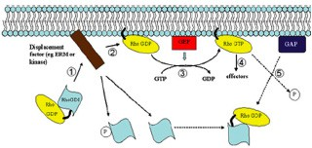 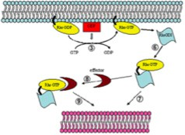

Fig. 12. Models for the regulation of Rho family GTP-binding proteins by RhoGDI molecules [7].

with the GTP-binding protein cycle in the actual biological system. It is possible to work with more complicated models: for example, those involving reactions for the association of different combinations of R, RD and RT with A and E together with

G. We do not have precise information about the rates of these reactions except

that they have been observed to have very low affinity. We therefore work with a model which abstracts away from these reactions.

We implemented the reactions above in the SPIM language in the same way as in Section 3. By using the quantitative data at hand on the concentration of the GDIs, we ran simulations. The outcome of 8 simulations, where G0 is set to 0, 10,

30, 60, 100, 300, 600 and 1000, are shown in Figure 14. In these simulations, the initial number of molecules for R0 and E0 are 1000 and the number of molecules for and A0 is 10. The rate of the reactions above are set to 1*.*0.

In [8,6], it is reported that GDIs are out numbered by GEF and GAP regulators. The molar amount of GDI is in excess of any single Rho protein, but roughly equal to the total levels of the RhoA, Rac1 and Cdc42 GTP-binding proteins in these cells.

r4 : RD + G *→* RDG r6 : RT + G *→* RTG

r5 : RDG *→* RD + G r7 : RTG *→* RT + G

Fig. 13. Reactions of a model that extends the GTP-binding protein cycle with GDI (G).



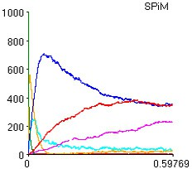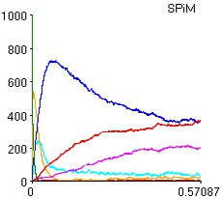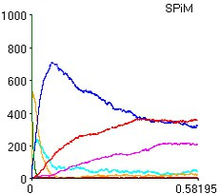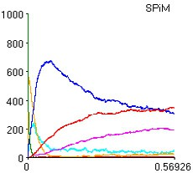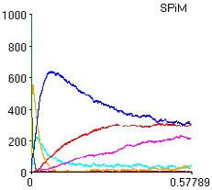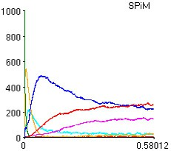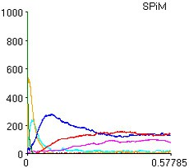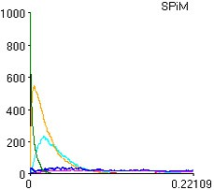

Fig. 14. SPiM plots of simulations with the model which extends GTP-binding protein cycle with GDI and effectors. The *x*-axis is the time in minutes and *y*-axis is the number of processes. The legend on the right is for all the the plots. In all the simulations, R0 and E0 are 1000; A0 is 10. From left to right, the G0 value is 0, 10, 30, 60, 100, 300, 600 and 1000.

In human neutrophils, RhoA, Rac1/Rac2 and Cdc42 are also equimolar with overall GDI levels, and exist largely as cytosolic GDI complexes. Our simulations capture this behaviour, because, for lower concentrations of GDIs, our model captures the inhibitory role of the GDIs while preserving the behaviour pattern of the model of Subsection 3.4. However, a more comprehensive analysis of the model above requires more accurate quantitative data in terms of rates of reactions, which is the topic of on-going work.

# Discussion

We have given a process model of the Rho GTP-binding protein cycle, and run simulations of our model using SPiM [17]. Our model closely follows Goryachev and Pokhilko’s paper [11], which provides an ODE analysis of the Rho GTP-binding protein cycle, both in isolation and with effectors. The use of our techniques to model and simulate biological systems, and the comparison with the ODE analysis is not new, see for example [14,4]. Our results do however provide an essential cali- bration between our process-algebra techniques and the ODE analysis for the basic model of the Rho GTP-binding protein cycle. With this initial calibration, we now have the freedom to exploit the compositionality of the process-algebra approach to study additional features—in this paper adding effectors in the cytosol—on top of our basic model. Although the ODE approach can also be extended, we believe the extension is less natural and ultimately will not scale to large biological systems.

We extend our basic model to capture also the effect of the GDIs in the Rho GTP-binding protein cycle. We expected to use the biological models described in a survey paper [7]. Instead, based on discussions with Caron, a biologist at Imperial, we introduce an abstract, hybrid model which better reflects the current knowledge. At the moment, we lack the quantitative data for the rates of the reactions for this model. We give an initial analysis of the behaviour of the protein cycle by setting the unknown rates as 1*.*0 and varying the quantity of GDIs. A thorough assessment of the usefulness of SPiM as a tool for systematically searching the parameter space for plausible rates is left for future research. We hope SPiM will eventually assist in the literature search and wet-lab experiments necessary to complete the missing quantitative data.

Rho GTP-binding proteins serve as molecular switches in various subcellular activities, including phagocytosis. Our long-term goal is to use the model of this paper as a generic model for these proteins which can be compositionally plugged into larger models. By gradually extending the model and moving between levels of abstractions, we hope to eventually deliver useful process models of phagocytosis. However, biological knowledge is in a state of constant flux, and is often incomplete. Our aim is to work closely with biologists at Imperial to overcome these challenges.

# References

1. Bruce Alberts, Alexander Johnson, Julian Lewis, Martin Raff, Keith Roberts, and Peter Walter.

*Molecular Biology of the Cell, Fourth Edition*. Garland Science, 2002.

1. Ralf Blossey, Luca Cardelli, and Andrew Phillips. A compositional approach to the stochastic dynamics of gene networks. *Transactions in Computational Systems Biology*, 3939:99–122, 2006.
2. Xose R. Bustelo, Vincent Sauzeau, and Inmaculada M. Berenjeno. Gtp-binding proteins of the rho/rac family: regulation, effectors and function in vivo. *BioEssays*, 29:356–370, 2007.
3. Luca Cardelli. On process rate semantics. *Theoretical Computer Science*, 2007. to appear.
4. Giovanni Chimini and Philippe Chavrier. Function of Rho family proteins in actin dynamics during phagocytosis and engulfment. *Nature Cell Biology*, 2:191–196, 2000.
5. C´eline DerMardirossian and Gary M. Bokoch. GDIs: central regulatory molecules in Rho GTPase activation. *TRENDS in Cell Biology*, 15(7):356–363, 2005.
6. Athanassios Dovas and John R. Couchman. RhoGDI: Multiple functions in the regulation of rho family gtpase activities. *Biochemistry Journal*, 390:1–9, 2005.
7. Estelle Dransart, Birgitta Olofsson, and Jacqueline Cherfils. RhoGDIs revisted: Novel roles in rho regulation. *Traffic*, 6:957–966, 2005.
8. Sandrine Etienne-Manneville and Alan Hall. Rho GTPases in cell biology. *Nature*, 420:629–635, 2002.
9. Erick Garcia-Garcia and Carlos Rosales. Signal transduction during fc receptor-mediated phagocytosis.

*Journal of Leukocyte Biology*, 72:1092–1108, 2002.

1. Andrew B. Goryachev and Alexandra V. Pokhilko. Computational model explains high activity and rapid cycling of rho gtpases within protein complexes. *PLOS Computational* *Biology*, 2:1511–1521, 2006. For the license terms of the figures adapted from this work, see [http://creativecommons.org/licenses/by/2.5/.](http://creativecommons.org/licenses/by/2.5/)
2. A.B. Hall, M. A. Gakidis, M Glogauer, J.L. Wilsbacher, S Gao, W. Swat, and J.S. Brugge. Requirements for vav guanine nucleotide exchange factors and rho gtpases in fc*γ*r- and complement-mediated phagocytosis. *Immunity*, 24:305–316, 2006.
3. Aron B. Jaffe and Alan Hall. Rho GTPases: Biochemistry and biology. *Annual Review of Cell and Developmental Biology*, 21:247–269, 2005.
4. P. Lecca and C. Priami. Cell cycle control in eukaryotes: A BioSpi model. In *Proc. Workshop on Concurrent Models in Molecular Biology (BioConcur’03)*, ENTCS. Elsevier, 2003.
5. J. C. Patel, A. Hall, and E. Caron. Vav regulates activation of rac but not cdc42 during Fc*γ*R-mediated phagocytosis. *Molecular Biology of the Cell*, 13:1215–1226, 2002.
6. A. Phillips, L. Cardelli, and G. Castagna. A graphical representation for biological processes in the stochastic pi-calculus. *Transactions in Computational Systems Biology*, 4230:123–152, 2006.
7. Andrew Phillips and Luca Cardelli. Efficient simulation of biological processes in the stochastic pi- calculus. submitted, 2007.
8. C. Priami, A. Regev, E. Shapiro, and W. Silverman. Application of a stochastic name-passing calculus to representation and simulation of molecular processes. *Information Processing Letters*, 80, 2001.
9. Joel A. Swanson and Adam D. Hoppe. Cdc42, Rac1, and Rac2 display distinct patterns of activation during phagocytosis. *Molecular Biology of the Cell*, 15(8):3509–3519, 2004.
10. O. Wolkenhauer, M. Ullah, W. Kolch, and Cho K.H. Modeling and simulation of intracellular dynamics: choosing an appropriate framework. *IEEE Trans. Nanobioscience*, 3:200–207, 2004.