 HOSTE D BY

Available online at [www.sciencedirect.com](http://www.sciencedirect.com/science/journal/2314808X)

**ScienceDirect**

journal homepage: [http://ees.elsevier.com/ejbas/default.asp](http://http//ees.elsevier.com/ejbas/default.asp)

**Full Length Article**

**A computational method for solving a class of singular boundary value problems arising in science and engineering**



***Pandy Pirabaharan*** ***a******,******\*******, R. David Chandrakumar*** ***b***

a *Department of Mathematics, Anna University, University College of Engineering, Dindigul 624 622,*

*Tamilnadu, India*

b *Department of Mathematics, Vickram College of Engineering, Sivaganga District, Tamilnadu, India*

A R T I C L E I N F O A B S T R A C T

*Article history:*

Received 31 December 2015 Received in revised form 18 September 2016

Accepted 19 September 2016

Available online 3 October 2016

*Keywords:*

Computational method Bernstein operational matrices Nonlinear differential equations

Singular boundary value problems

This note deals with a new computational method for solving a class of singular boundary value problems. The method is based upon Bernstein Polynomials. The properties of Bernstein Polynomials, together with Bernstein operational matrix for differentiation formula, are presented and utilized to reduce the given singular boundary value problems to the set of algebraic equations. The proposed method is applied to solve some test problems with the comparison between the computational solutions and the exact solutions. The results indicate that the proposed algorithm provides high reliability and good accuracy.

© 2016 Mansoura University. Production and hosting by Elsevier B.V. This is an open access article under the CC BY-NC-ND license (<http://creativecommons.org/licenses/by->

nc-nd/4.0/).

# Introduction

*y* 0  *a*1,

*y* 1  *b*

or

*y* 0  *a*2,

*y* 1  *b*

(2)

In this paper, we consider the class of singular boundary value problems (SBVPs) of the form

**

where *p**x* and *r* *x* are analytic in *x* 0, 1 and *a*1, *a*2, *b* and

** are finite constants. Problem (1) has singularity at the initial point *x*  0. We note that the main difficulty arises in the singularity of the equations at *x*  0.

*y* *x*  *y* *x*  *p**x* *y* *x*  *r* *x*, 0  *x*  1

*x*

with the boundary conditions

*and*

**  0 (1)

The numerical treatment of singular boundary value prob- lems has always been a difficult and challenging task due to the singular behavior that occurs at a point.

* *Corresponding author.*

*E-mail address:* [pandypirabaharan@gmail.com](mailto:pandypirabaharan@gmail.com) (P. Pirabaharan). <http://dx.doi.org/10.1016/j.ejbas.2016.09.004>

2314-808X/© 2016 Mansoura University. Production and hosting by Elsevier B.V. This is an open access article under the CC BY-NC-ND license ([http://creativecommons.org/licenses/by-nc-nd/4.0/).](http://creativecommons.org/licenses/by-nc-nd/4.0/))

In recent years, strenuous action and interest have been investigating singular boundary value problems (SBVPs) and a number of methods have been proposed. The singular bound- ary value problems arise frequently in many branches of applied mathematics, mechanics, nuclear physics, atomic theory and chemical sciences. Hence, the singular boundary value problems have attracted much attention and have been in- vestigated by many researchers. Kadalbajoo and Agarwal treated the homogeneous equation using Chebyshev polynomial and B-spline [1]. Kanth and Reddy solved a particular singular boundary value problem by applying higher order finite dif- ference method [2].The same authors investigated by using the cubic spline [3] method. Mohanty et al. [4] introduced accurate cubic spline method for solving the singular bound- ary value problems. Variational iteration method (VIM) was introduced by Wazwaz [5] for solving nonlinear singular bound- ary value problems.

The authors [6,7] elaborately discussed singular boundary value problems and solved by the methods based on repro- ducing kernel space. Galerkin and Collocation methods are presented for solving two-point boundary value problems by Mohsen and El-Gamel [8]. Secer and Kurulay [9] described the Sinc-Galerkin method for singular Dirichlet-type boundary value problems. Rashidinia et al. [10] proposed a reliable paramet- ric spline method.

The purpose of this note is to develop a reliable opera- tional matrix method for singular boundary value problems. The aim of the present paper is to apply Bernstein opera- tional matrix of differentiation to propose a reliable numerical technique for solving SBVPs.

With the advent of computer graphics, Bernstein polyno- mial restricted to the interval *x* 0, 1becomes important in the form of Bezier curves [11,12]. Bernstein polynomials have

that combines Neumann and integral condition for the wave equation. Bhattacharya et al. [25] implemented the algorithm for integro differential equations. Shen et al. [26] suggested a boundary knot method (BKM) to solve Helmholtz problems with boundary singularities. Lin et al. [27] used the efficient bound- ary knot method to obtain the solution of axisymmetric Helmholtz problems. Recently, Pirabaharan et al. [28] intro- duced a Bernstein operational matrix method for boundary value problems.

The objective of this paper is to give the computational method based on the Bernstein operational matrix for differ- entiation for the class of singular boundary value problems (SBVPs). The proposed algorithm converted to the given SBVP to the system of algebraic equations with unknown coeffi- cients and are solved easily by using mathematical tool like MATLAB.

The outline of the paper is as follows. In section 2, we review the basic properties of Bernstein polynomials and we develop the Bernstein operational matrix for derivative. Section 3 implemented and presented the methods of solution for the singular boundary value problems. In Section 4, some numeri- cal examples are presented to show the efficiency and the applicability of the suggested algorithm. Conclusion is given in Section 5.

# Properties of Bernstein polynomials [29]

The Bernstein basis polynomials of degree n are defined in the interval (0, 1) as [17,18]

many constructive properties such as the positivity, the con-

*bn* *x*   *n* *xi* 1  *x**n**i*,

*i*  0, 1, 2, , *n*

(3)

tinuity, recursive relation, symmetry and unity partition of the basis set over the interval. For this reason, Bernstein opera- tional matrix method is a new and rising area in applied mathematical research which has gained considerable atten- tion in dealing with differential equations. Optimal stability of the Bernstein basis was discussed by Farouki and Goodman [13]. Bhatta and Bhatti [14] have been used modified Bern-

*i*  *i* 

These Bernstein polynomials form a complete basis on the interval (0, 1). Using the recursive definition to generate these polynomials

*bn* *x*  1  *x**bn*1 *x*  *xbn*1 *x*, *i*  0, 1, 2, , *n*

*i*

stein polynomials for solving Korteweg-de Vries (KdV) equation.

*i i*1

Chakrabarti and Martha [15] described a method for Fredholm integral equations. Bhattacharya and Mandal [16] presented Bernstein polynomials method for Volterra integral equa- tions. Yousefi and Behroozifar [17] found the operational matrices of integration and product of B-polynomials. The same authors [18] introduced the Bernstein operational matrix method (BOMM) for solving the parabolic type partial differ-

where *bn*1 *x*  0 and *bn*1 *x*  0 .

Since the power basis forms a basis for the space of poly- nomials of degree less than or equal to *n*, any nth degree Bernstein polynomial can be expressed in terms of the power basis. This can be computed by using the binomial expansion,

1

*n*

one can illustrate that *bn* *x*  1*j*1  *n*  *n*  1 *xj*,*n*

ential equations (PDEs). Isik et al. [19] have demonstrated a new method to solve high order linear differential equations with initial and boundary conditions. Ordokhani et al. [20] intro-

*i* 

*j*1

*i*  0, 1, … , *n*

 *i*   *j*  *i* 

(4)

duced Bernstein polynomial for solving differential equations. Singh et al. [21] established the Bernstein operational matrix

By using the property, the dual basis is defined as follows:

of integration for solving differential equations. Doha et al.

[22,23] have implemented and proved new formulas about de-

1 1,

*bn* *x**dn* *x*  

*i*  *j*

*for i*, *j*  0, 1, 2, , *n*.

rivatives and integrals of Bernstein polynomials and solving high even-order differential equations by Bernstein polyno-

⇩ *i j*

0



0,

*i*  *j*

mial based method. Yousefi et al. [24] described the Ritz- Galerkin method for solving an initial boundary value problem

A function *f* *x*, square integrable in the interval [0, 1], may be written in terms of Bernstein basis [17,18].

Practically, only the first (*n* + 1) term Bernstein polynomi- als are considered.

*i*

(ii) Positivity property

Therefore, we can write

*bn* *x*  0,

for

*i*  0, 1, 2, , *n*.

*n*

 *i i*

*f* *x*  *c bn* *x*  *CTB**x*

(5)

*bn* *x*  0, if

*i*  0 or

*i*  *n*

*i*0

*i*

where the Bernstein coefficient vector *C* and the Bernstein vector *B**x* is Bernstein vector are given by

*CT*  *c*0, *c*1, , *cn* ,

*B**x*  *bn* *x*, *bn* *x*, , *bn* *x**T*, (6)

0 1 *n*

then

where *bn* *x* is the Bernstein polynomial of degree *n*.

* 1. ***The operational matrix of the derivative*** ***[29]***

*i*

The derivative of the vector *B*(*x*) can be written as

*dB**x*  *D*1*B**x*

*dx*

(8)

1

*ci*  

0

*f* *x**dn* *x**dx*,

*i*  0, 1, 2, , *n*.

where *D*1 is the operational matrix of derivative of

*n*  1  *n*  1 order and is specified in Ref. [17] as

Jutler [30] has derived explicit representations,

*D*1  *AVB*\* (9)

*i*

10  *n*

11  *n*  *n*  0

. . .



1*n*0  *n*  *n*  0 

  0



 .









 0  1 

.

.

*n*

 0  *n*  0 









*n*  *n*  *i* 



Here *A*   0

10   . . .

1*n**i*   





 .

 . .



 *i* 

 *i*   *n*  *i* 







 . . 

 

 0 . . . 0





10  *n*

 *n*

 



*n*1*n*1

*dn* *x* 

*j*

 ** *bn* *x*,

*j*  0, 1, 2, , *n*

0 0 0

1 0 0

. . . 0

. . . 0

1

1

*A* 

*A*1 

*k*0

*n*

*jk k*

  

2 

0 2 0

. . . 0

*A*1 

  

3 

for the dual basis functions, defined by the coefficients

*V*   

 . . . . . 

, *B*  . 

. 

1*j**i* min *j**k*

 *n*  *i*  1  *n*  *i*  *n*  *i*  1  *n*  *i*  

  

** *jk*   *n*  *n*

 2*i*  1

*n*  *j*

  *n*  *j* 

*n*  *k*   *n*  *k*

 . . . . . 

. 

*i*0

0 0 0 . . . *n*

*A*1 

 *j*  *k*

*k*

*n*1*n*

 *n* *n**n*1

for

*j*, *k*  0, 1, 2, , *n*.

(7)

where *A*1 is the *k*-th row of *A*1 for *k*  1, 2, , *n*.

The Bernstein polynomials are useful for practical compu- tations on account of its essential numerical stability [13]. One of the valuable property of Bernstein basis polynomials is that

Thus,

*d B**x*  *AVB*\**B**x*  *DB**x*. *dx*

(10)

they all disappear at boundaries of the interval, except the first and the last one, which are equal to one at *x*  0 and *x*  1 re- spectively. This gives greater flexibility which imposes boundary conditions at the end points of the interval [31]. Also, Bernstein polynomials have two most important properties:

(i) Unity partition property

Therefore, we have the operational matrix of differentia- tion as *D*  *AVB*\*.

* + 1. *Generalized Bernstein operational matrix of differentiation*

The generalized nth order operational matrix of differentia- tion can be expressed as

*n*

*bn* *x*  1,

*x* 0, 1,

*dn B**x*  

1 *n*

   

 *i*

*i*0

*dxn*

*D B x* , *n*

1, 2,

*B**x*  *bn* *x*, *bn* *x*, *bn* *x*, , *bn* *x**T*

First, we approximate function y(x) by Bernstein polynomial

0 1 2

*bn* *x*   *n* *xi* 1  *x**n**i*,

*n*

as

*i*  0, 1, 2, , *n*. *n*

 *i i*

*i*  *i* 

*y* *x*  *c bn* *x*  *CTB**x*

(13)

where *bn*1 *x*  0 and *bn*1 *x*  0 .

*i*0

*T*

1 *n*

where the vector *C*  *c* , , *c*  is an unknown vector and

For example, if *n*  2, we get

*B**x*  *b*2 *x*, *b*2 *x*, *b*2 *x*

0 1 2

*b*2 *x*   2 *x*0 1  *x*20  1  *x*2

0  0

 2

0 *n*

*B**x*  *bn* *x*, *bn* *x*, , *bn* *x**T* .

0 1

*n*

Using Eqs. (12) and (13), we have the residual R(x)

*Dy* *x*  *CTD*1*B**x* , *D*2*y* *x*  *CTD*2*B**x*.

By substituting these equations in Eq. (1), we obtain the following:

*R* *x*  1 *CTD*2*B**x*  1 *CTD*1*B**x*  1 *CTB**x**k*  *g* *x*. (14)

*b*2 *x*  

 *x*1 1  *x*21  2*x* 1  *x*

*p**x*

*q**x*

*r* *x*

1  1

Similarly, by substituting Eq. (13) in Eq. (2), it yields

*b*2 *x*   2 *x*2 1  *x*22  *x*2

2  2

*y* 0  *CTB*0  *a*1,

*y* 1  *CTB*1  *b*

or

 2 

*y* 0  *CTDB*0  *a*2,

*y* 1  *CTB*1  *b* (15)

Therefore, for

*n*  2,

1  *x*

*B**x*   2*x* 1  *x* .

 



 *x*2 

Similarly, we can define *B**x* for any value of *n*,

To find the solution *y* *x*, we first collocate Eq. (14) at *n*  1

suitable points

*xi*   1  cos *i*   1 , *i*  1, 2, , *n*  1.

*d B**x*  *D*1*B**x*. *dx*

 2   *n*  

Here, *D*1  *AVB*\*, *D*1 is the *n*  1  *n*  1 operational matrix where *A* is the *n*  1  *n*  1 matrix, *V* is the *n*  1  *n* matrix, *B*\* is *n*  *n*  1matrix.

For example, if *n*  2,

These equations jointly with Eq. (15) produce *n*  1 alge- braic equations which can be solved to find unidentified coefficients *ci*, *i*  0, 1, 2, , *n*. Consequently, the unknown func- tion *y* *x* given in Eq. (13) can be computed.

1 2 1 

0 0

1 1 1

Lemma 3.1. [32]. Suppose the function *f* : 0, 1  *R* is *m*  1

*A*  0 2 2  *V*  1 0 *A*1  0 0.5 1

times continuously differentiable *i*, *e*, *f* *Cm*1 0, 1, and

     

*Sm*  *Span* *B*0,*m*, *B*1,*m*, *B*2,*m*, , *Bm*,*m* . If *CTB* be the best approxi-

0 0 1 3*x*3

0 23*x*2

0 0 1

mation *f* out of *S*, then

 *A*1   1 1 1

− *T*   *k* , where *k*  max *f m*1 *x*.

*B*\* 

1 .

*f C B* 2 ,

2*m*  1



*A*1

 2 

0 0.5 12*x*3

*L* 0,1

*m*  1!

*x*0,1

1 2 1  0 0

Therefore, by using *D*1  *AVB*\*  0 2 2  1 0 1 1 1

Proof. It is known that set 1, *x*, *x*2, , *xm* is a basis for the polynomial space of degree *m* . Therefore, we define the function

    0 0.5 1

0 0 1  0 2

2 1 0 



*y* *x*  *f* 0  *xf*  0  *x*2 *f*  0   *xm f* *m* 0.

  2 0



2  .

1 2! *m*!

 0 1 2  Similarly, we can find *D*1 for any value of *n*. By equation *D*1  *AVB*\*, it is clear that

From the Taylor expansion, we have

*f* *x*  *y* *x*  *f* *m*1 ** 

*xm*1

*m*  1!

*dn B**x*

1 *n*

1 *x*

(16)

*dxn*

 *D*

 *B**x*, (11)

where *x* 0, 1 . Since *CTB* is the finest estimation of *f* out

where *n* N and the superscript in *D*1 denotes matrix powers.

Thus,

of *S*, *y*1

*Sm*

and from Eq. (16) we have

*D**n*  *D*1 *n*,

*n*  1, 2, 

(12)

*f*  *CTB* 2

  *f*  *y *2

1

 *f* *x*  *y* *x* 2 *dx*

*L*2 0,1

1 *L*2 0,1 

0

1

1

2  *xm*1  2

# Function approximation

  *f* *m*1 *x* 

0

*k* 1

 

*m*  1! *dx*

   *x*2*m*2*dx*

2

In this section, we solve singular boundary value problems of Eq. (1) with the boundary conditions of Eq. (2) by using Bernstein operational matrix method.

*m*  1! 0

  *k* .

*m*  1!2 2*m*  1

Then by taking square roots on both sides, the proof is complete.

|  |  |  |  |
| --- | --- | --- | --- |
| **Table 1 – Computed values and comparison to the exact solutions for Example 4.1.** | | | |
| x | Exact | BOM  *n*  2 | Absolute error |
| 0.1 | 0.9950 | 0.9954 | 0.0004 |
| 0.2 | 0.9801 | 0.9816 | 0.0015 |
| 0.3 | 0.9553 | 0.9586 | 0.0033 |
| 0.4 | 0.9211 | 0.9264 | 0.0053 |
| 0.5 | 0.8776 | 0.8851 | 0.0075 |
| 0.6 | 0.8253 | 0.8345 | 0.0092 |
| 0.7 | 0.7648 | 0.7747 | 0.0099 |
| 0.8 | 0.6967 | 0.7058 | 0.0091 |
| 0.9 | 0.6216 | 0.6276 | 0.0060 |
| 1 | 0.5403 | 0.5403 | 0 |

Note 3.1. The previous lemma demonstrates that the error vanishes as *m*  .

# Numerical examples

To exhibit the effectiveness and power of the Bernstein op- erational matrix method, we have tested several singular boundary value problems. These problems have been pre- ferred because they are commonly discussed in literature.

Example 4.1. Consider the linear singular two-point bound- ary value problem [33]

1 1

In Table 1, the values of the exact solution and the pro- posed algorithm solution with *n*  2 are listed for various values

*y* *x*  *y* *x*   cos *x*  sin *x x x*

with boundary conditions

(17)

of x. It also shows the absolute errors computed by using the proposed algorithm solution. This shows that the present ap- proach is not only more accurate but also it is used in easier way.

*y* 0  0,

*y* 1  cos1. (18)

Comparison between the curves of exact solutions and the Bernstein operational matrix (BOM) solutions in case of *n*  2

Eq. (17) has the exact solution of the boundary value problem and it is *y* *x*  cos *x* .

Applying the method developed in sections 2 and 3 for *n*  2, where n is the order of the Bernstein polynomial.

We have *y* *x*  *c b*2 *x*  *c b*2 *x*  *c b*2 *x*  *CTB**x*.

0 0

1 1

2 2

is shown in Fig. 1. From this figure, it can be noted that the results of the present technique are an excellent agreement with the exact solution, they are more applicable and effi- cient for solving singular boundary value problem.

Here we have *y* *x*  *CTB**x*, *y* *x*  *CTDB**x*, *y* *x*  *CTD*2*B**x*. Using these values in Eq. (17), we obtain the following:

Example 4.2. Next we consider the following singular BVP [34] as

*CTD*2*B**x*  1 *CTDB**x*   cos *x*  1 sin *x*. (19)

*y* *x*  2 *y* *x*  1  *x*2  *y* *x*  *x*4  2*x*2  7

(23)

*x x*

From Eq. (12), we have

*x*

with boundary conditions *y* 0  1,

*y* 1  0. (24)

 2

1 0 

 2 2 2 

*D*1   2 0



2  ,



*D*2   4



4 4  .

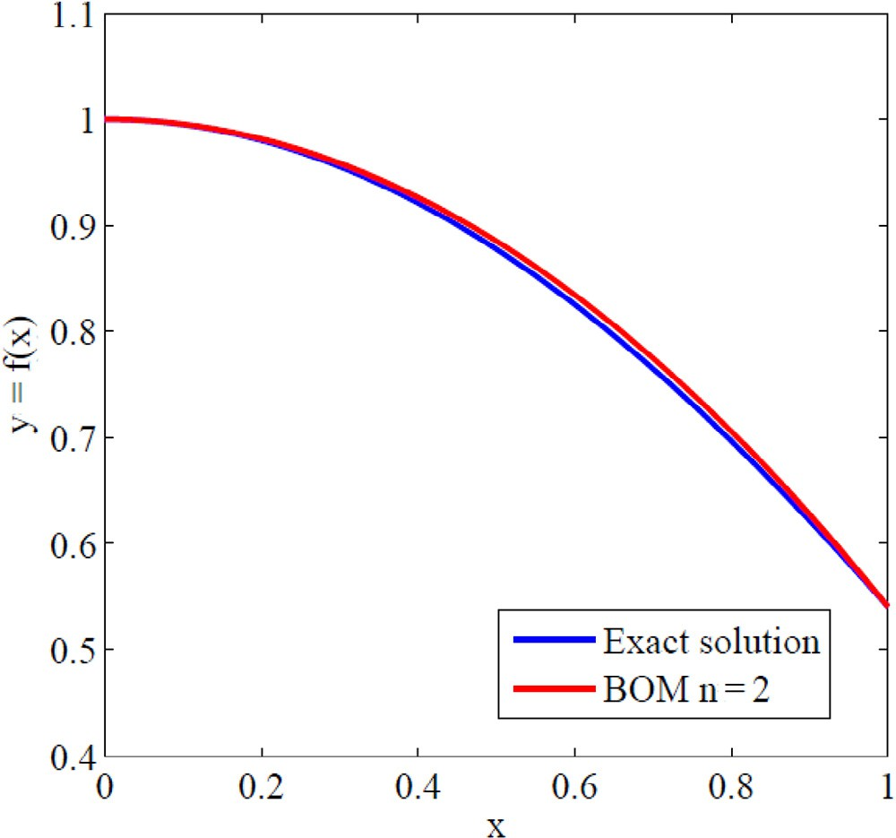

 0 1 2   2 2 2 

By collocating Eq. (19), choosing the suitable collocation point *x*1  1 , we obtain

2

2*c*0  4*c*1  2*c*2   2 *c*0  *c*2   1.8364. (20) Applying the boundary conditions from Eq. (18), we get

*y* 0  0

i.e.

*CTDB*0  0,

which implies

*c*0  *c*1

(21)

*y* 1  cos1

i.e.

*CTB*1  cos1,

which implies

*c*2  0.5403.

(22)

Substitute the values *c*0, *c*2 in Eq. (20), we obtain *c*0  1. Therefore, *c*0  1, *c*1  1, *c*2  0.54.

Consequently, we get

1  *x*2 

*y* *x*  1, 1, 0.54 2*x* 1  *x*  1  0.4597 *x*2



 2

 

 *x* 

**Fig. 1 – Comparison between exact and BOM solutions with**

***n***  **2 for Example 4.1.**

Eq. (23) has the exact solution of the boundary value problem and it is *y* *x*  1  *x*2 . As described in sections 2 and 3, Bernstein

Applying Eq. (15) in the boundary conditions (26), we obtain

operational matrix technique leads to the system of alge- braic equations, by solving them, the unknown coefficients of

3*c*0  3*c*1  0

(28)

the vector *C* calculated by using the following values

*c*3  1. (29)

*c*0  1,

*c*1  1,

*c*2  0.

Solving the Eqs. (27)–(29), we get

Thus, *y* *x*  1  *x*2 is the exact solution of the given in Example 4.2

*c*0  1.3167,

*c*1  1.3167,

*c*2  1.1850,

*c*3  1.

It is understandable that in Example 4.2, the proposed al- gorithm is speedily converged in to the true solution results. For a small value of *n*  2, the exact solution is reached. This proves the efficiency of the proposed BOM method.

The results obtained by BOM for *n*  2 are compared with

Consequently, we obtain

1  *x*3 

 2 

3*x* 1  *x*

*y* *x*  1.3167, 1.3167, 1.1850, 1 

3*x* 1  *x*

2

the exact solution, and B-Spline results given in Ref. [3] are listed in Table 2. The absolute errors among exact, BOM and B-Spline methods are calculated. E1 indicates the absolute errors between exact and BOM, whereas E2 indicates the absolute errors between exact and B-Spline methods. Table 2 shows that the proposed method has high accuracy and has better results than the B-Spline method for all points of x. It is also clear that the proposed algorithm attains the exact solution by using very few calculations.

Example 4.3. Consider the Bessel’s equation of order zero [35]

*y* *x*  1 *y* *x*  *y* *x*  0 (25)

*x*

with boundary conditions

 

 *x* 

3

 0.0784 *x*3  0.3951 *x*2  1.3161

The numerical results are presented in the Table 3.

The proposed algorithm is applied to the well known Bessel’s equation of order zero. The exact solution and BOM with *n*  3 solution are displayed in Table 3. The maximum absolute errors between BOM and exact solution for various choices of x are also shown in Table 3. It is clearly noted that the errors are very close to zero. This proves the efficiency of the proposed algorithm.

Example 4.4. Next we consider the following singular bound- ary value problem [35]

*y* *x*  2 *y* *x*  4*y* *x*  2 (30)

*y* 0  0,

*y* 1  1

(26) *x*

The exact solution is *y* *x*   *J*0 *x* .

*J*0 1

subject to the conditions

*y* 0  0,

*y* 1  5.5

(31)

By applying the method described in the sections 2 and 3 with *n*  3,

Eq. (25) converted to the following equation:

 13 *c*0    33 *c*1    9 *c*2   37 *c*3  0. (27)

       

8 8 8 8

which has the exact solution of the boundary value problem

*y* *x*  1  5sinh 2*x*

2 *x* sinh 2

This problem is solved by applying the method described in Sections 2 and 3.

Applying Bernstein operational matrices of derivatives with *n*  3 in Eq. (30) and using the boundary conditions, the unknown coefficient values

|  |  |  |  |  |  |
| --- | --- | --- | --- | --- | --- |
| **Table 2 – Errors of the present method compared with B-Spline results for the Example 4.2.** | | | | | |
| x | Exact | BOM  *n*  2  (E1) | B-Spline (E2) | Error by E1 | Error by E2 |
| 0 | 1.0000 | 1.0000 | 0.9990 | 0 | 0.001 |
| 0.1 | 0.9900 | 0.9900 | 0.9899 | 0 | 1E-04 |
| 0.2 | 0.9600 | 0.9600 | 0.9599 | 0 | 1E-04 |
| 0.3 | 0.9100 | 0.9100 | 0.9099 | 0 | 1E-04 |
| 0.4 | 0.8400 | 0.8400 | 0.8399 | 0 | 1E-04 |
| 0.5 | 0.7500 | 0.7500 | 0.7499 | 0 | 1E-04 |
| 0.6 | 0.6400 | 0.6400 | 0.6399 | 0 | 1E-04 |
| 0.7 | 0.5100 | 0.5100 | 0.5099 | 0 | 1E-04 |
| 0.8 | 0.3600 | 0.3600 | 0.3599 | 0 | 1E-04 |
| 0.9 | 0.1900 | 0.1900 | 0.1900 | 0 | 0 |
| 1 | 0 | 0 | 0 | 0 | 0 |

|  |  |  |  |
| --- | --- | --- | --- |
| **Table 3 – Computed values and comparison to the exact solutions for the Example 4.3.** | | | |
| x | Exact | BOM  *n*  3 | Absolute error |
| 0.1 | 1.3036 | 1.3128 | 0.0092 |
| 0.2 | 1.2939 | 1.3015 | 0.0076 |
| 0.3 | 1.2777 | 1.2833 | 0.0056 |
| 0.4 | 1.2552 | 1.2585 | 0.0033 |
| 0.5 | 1.2265 | 1.2277 | 0.0012 |
| 0.6 | 1.1919 | 1.1914 | 0.0005 |
| 0.7 | 1.1516 | 1.1500 | 0.0016 |
| 0.8 | 1.1060 | 1.1040 | 0.0020 |
| 0.9 | 1.0554 | 1.0538 | 0.0016 |
| 1 | 1 | 1 | 0 |

|  |  |  |  |
| --- | --- | --- | --- |
| **Table 4 – Computed values and comparison to the exact solutions for the Example 4.4.** | | | |
| x | Exact | BOM  *n*  3 | Absolute Error |
| 0.1 | 3.2756 | 3.3143 | 0.0387 |
| 0.2 | 3.3313 | 3.605 | 0.0292 |
| 0.3 | 3.4256 | 3.4438 | 0.0182 |
| 0.4 | 3.5608 | 3.5694 | 0.0086 |
| 0.5 | 3.7402 | 3.7425 | 0.0023 |
| 0.6 | 3.9682 | 3.9682 | 0 |
| 0.7 | 4.2503 | 4.2516 | 0.0013 |
| 0.8 | 4.5937 | 4.5979 | 0.0042 |
| 0.9 | 5.0067 | 5.0123 | 0.0056 |
| 1 | 5.5000 | 5.5000 | 0 |

*c*0  3.3, *c*1  3.3, *c*2  3.746

and

*c*4  5.5

are obtained.

Then we get *y* *x*  0.86 *x*3  1.34 *x*2  3.3. (32)

The numerical results are presented in the Table 4. Maximum absolute errors for this problem have been dis-

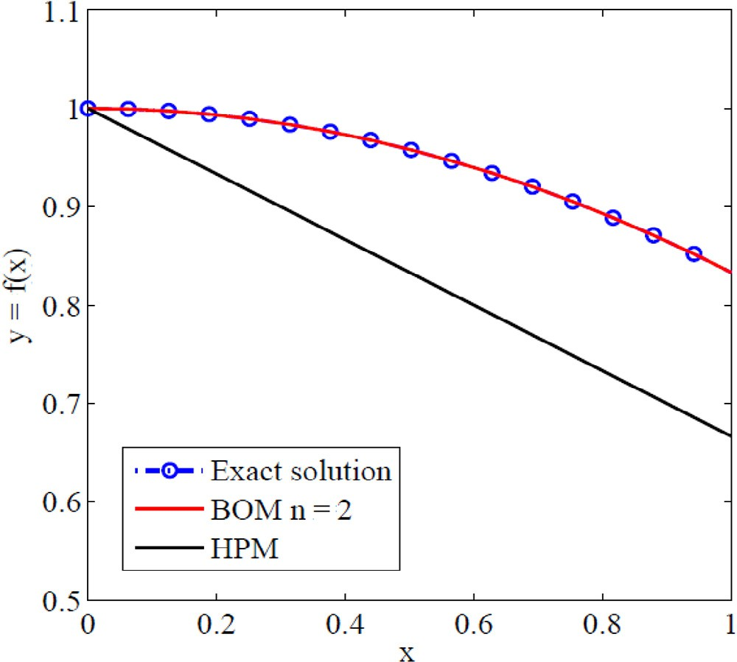**Fig. 3 – Comparison between the BOM, HPM, and exact solutions of Example 4.5.**

played for *n*  3 in Table 4, which shows the accuracy of proposed method. From the exhibited results for this example

in 4.4 show the advantage of this method.

Fig. 2 illustrates a comparison between the curves of exact solutions and the approximate solutions. It can be concluded

*y* 0  1,

*y* 0  0. (34)

from Fig. 2 that the Bernstein operational matrix method so- lutions converge rapidly to the exact solution.

For the case *r*  *n*  0, Eq. (33) has the exact solution of the

*y* *x*  1  *x*2

boundary value problem and it is 6 .

Example 4.5. Now, the general Lane-Emden type differential equation discussed by Rafiq et al. [36] is considered

*y*  2 *y*  *xryn*  0 0  *x*  1 (33)

*x*

with boundary conditions

As done before, the Lane-Emden type differential equa- tion is solved. Applying the boundary conditions of Eq. (34) in Eq. (33) and by following the same procedure given in Example

4.1 for the case corresponds to *n*  2.

Thus, Eq. (33) and Eq. (34) are transformed into a system of algebraic equations. Solving the system of algebraic equations,

*c*0  1, *c*1  1, *c*2  5 are obtained.

6

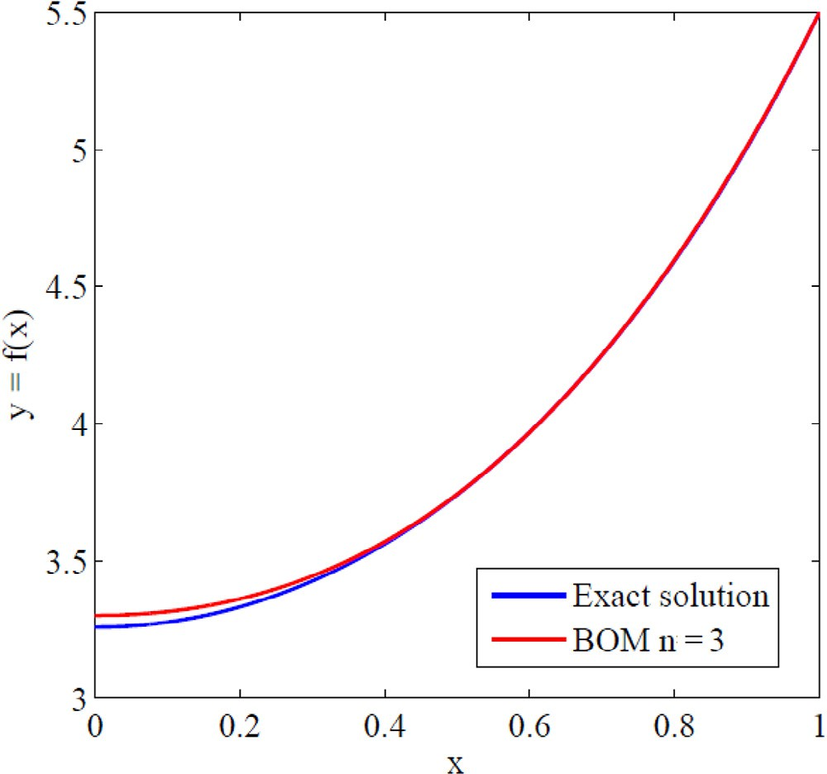1  *x*2  

Then, *y* *x*  1, 1, 5  2*x* 1  *x*  1  *x*2 is the exact solution.

 6   6

 *x*2 

The exact solution of y(x), the approximate solutions of BOM and Homotopy Perturbation Method (HPM) are plotted in Fig. 3, Comparison between the solution obtained by using the pro- posed algorithm, HPM used by Rafiq et al. [36] and the exact solution are exhibited. It is observed from Fig. 3 that the present solution converges rapidly to the exact solution for small size of operational matrix and it is more accurate than the solu- tion in Rafiq et al. [36]. The efficiency and power of the proposed algorithm are proved.

Example 4.6. Finally, consider the following initial value problem

1  8  2

*y* *x*  *x y* *x*   8  *x*2 

with boundary conditions

(35)

*y* 0  0,

*y* 1  0

(36)

**Fig. 2 – Comparison between exact and BOM solutions with**

***n***  **3 for Example 4.4.**

which has the exact solution 2 log  7  .

8  *x*

 2 

We solve problem Eq. (35) by applying the method de- scribed in Sections 2 and 3, using Bernstein operational matrices of derivatives with *n*  2 we have

*c*0  0.2663, *c*1  0.2663, *c*2  0 and get

*y* *x*  0.2663 *x*2  0.2663.

Results in Table 5 show the comparison between the exact solutions and the BOM solutions for various values of x and *n*  2 . The absolute errors are also given in Table 5. As seen from the table, it is evident that the overall errors are near to zero. This shows that the proposed approach is not only more accurate but also more simple and direct.

The curves of exact solutions and approximate solutions obtained by the proposed method for *n*  2 are shown in Fig. 4. In the figure, the exact and approximate solutions com- pletely coincide. It is clear from this figure that the proposed solutions converge rapidly to the exact solution.

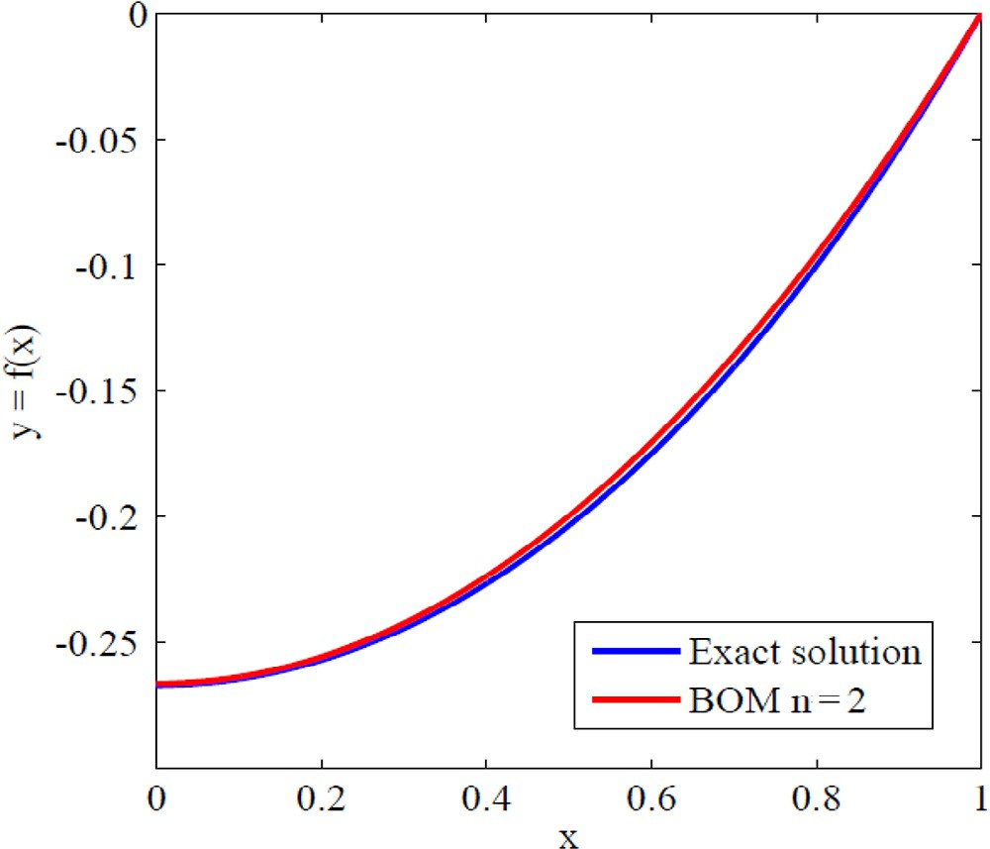

**Fig. 4 – Comparison between the results obtained from BOM and exact solution of Example 6.**

# Conclusion

In this work, a new spectral method is constructed for a nu- merical solution of the singular boundary value problems. Based on the Bernstein polynomials, the operational matrix derivatives are used together with the properties of Bern- stein polynomials to reduce the given singular boundary value problems to a system of algebraic equations and it simplifies the problem. The main advantage of the proposed algorithm is adding few terms of the Bernstein polynomials, and a good approximation of the exact solution of the problem is achieved. The accuracy of the proposed BOM method has been demon- strated by solving widely applicable singular boundary value test problems.

|  |  |  |  |
| --- | --- | --- | --- |
| **Table 5 – Computed values and comparison to the exact solutions for the Example 4.6.** | | | |
| x | Exact | BOM  *n*  2 | Absolute error |
| 0.1 | –0.2646 | –0.2636 | 0.0010 |
| 0.2 | –0.257 | –0.2556 | 0.0014 |
| 0.3 | –0.2444 | –0.2423 | 0.0021 |
| 0.4 | –0.2267 | –0.2237 | 0.0030 |
| 0.5 | –0.2036 | –0.1997 | 0.0039 |
| 0.6 | –0.175 | –0.1704 | 0.0046 |
| 0.7 | –0.1407 | –0.1358 | 0.0049 |
| 0.8 | –0.1003 | –0.0959 | 0.0044 |
| 0.9 | –0.0536 | –0.0506 | 0.0030 |
| 1 | 0 | 0 | 0 |

Moreover, the proposed technique provides a reliable method which requires less work compared to the traditional tech- niques such as B-spline and standard HPM. The approach has been tested on some existing problems from the literature. From the comparison of the results made with some exact solu- tions, it can be concluded that the proposed approach is effective and viable to broad range of nonlinear singular bound- ary value problems. The results show that BOM method values match very effectively with the exact solution with very few calculations. By comparing the results with other existing methods, it has been proved that the proposed method provides more realistic solutions that convey very rapid convergence toward the exact solution.

# Acknowledgment

The authors would like to thank the referee for his valuable comments and suggestions which improved the manuscript in its present form.

R E F E R E N C E S

1. [Kadalbajoo MK, Aggarwal VK. Numerical solution of singular](http://refhub.elsevier.com/S2314-808X(16)30060-4/sr0010) [boundary value problems via Chebyshev polynomial and](http://refhub.elsevier.com/S2314-808X(16)30060-4/sr0010)

[B-spline. Appl Math Comput 2005;160:851–63.](http://refhub.elsevier.com/S2314-808X(16)30060-4/sr0010)

1. [Kanth ASVR, Redd YN. Higher order finite difference method](http://refhub.elsevier.com/S2314-808X(16)30060-4/sr0015) [for a class of singular boundary value problems. Appl Math](http://refhub.elsevier.com/S2314-808X(16)30060-4/sr0015) [Comput 2004;155:249–58.](http://refhub.elsevier.com/S2314-808X(16)30060-4/sr0015)
2. [Kanth ASVR, Reddy YN. Cubic spline for a class of singular](http://refhub.elsevier.com/S2314-808X(16)30060-4/sr0020) [boundary value problems. Appl Math Comput 2005;170:733–](http://refhub.elsevier.com/S2314-808X(16)30060-4/sr0020) [40.](http://refhub.elsevier.com/S2314-808X(16)30060-4/sr0020)
3. [Mohanty RK, Sachder PL, Jha N. An O(h4) accurate cubic](http://refhub.elsevier.com/S2314-808X(16)30060-4/sr0025) [spline TAGE method for nonlinear singular two point](http://refhub.elsevier.com/S2314-808X(16)30060-4/sr0025) [boundary value problem. Appl Math Comput 2004;158:853–](http://refhub.elsevier.com/S2314-808X(16)30060-4/sr0025) [68.](http://refhub.elsevier.com/S2314-808X(16)30060-4/sr0025)
4. [Wazwaz AM. The variational iteration method for solving](http://refhub.elsevier.com/S2314-808X(16)30060-4/sr0030) [nonlinear singular boundary value problems arising in](http://refhub.elsevier.com/S2314-808X(16)30060-4/sr0030) [various physical models. Commun Nonlin Sci Num Simult](http://refhub.elsevier.com/S2314-808X(16)30060-4/sr0030) [2011;16:3881–6.](http://refhub.elsevier.com/S2314-808X(16)30060-4/sr0030)
5. [Geng FZ, Cui MG. Solving singular nonlinear second-order](http://refhub.elsevier.com/S2314-808X(16)30060-4/sr0035) [periodic boundary value problems in the reproducing kernel](http://refhub.elsevier.com/S2314-808X(16)30060-4/sr0035) [space. Appl Math Comput 2007;192:389–98.](http://refhub.elsevier.com/S2314-808X(16)30060-4/sr0035)
6. [Li ZY, Wang YL, Tan FG, Wan XH, Nie TF. The solution of a](http://refhub.elsevier.com/S2314-808X(16)30060-4/sr0040) [class of singularly perturbed two-point boundary value](http://refhub.elsevier.com/S2314-808X(16)30060-4/sr0040)

problems by the iterative reproducing kernel method. Abstr [Appl Anal 2012;1–7.](http://refhub.elsevier.com/S2314-808X(16)30060-4/sr0040)

1. [Mohsen A, El-Gamel M. On the Galerkin and collocation](http://refhub.elsevier.com/S2314-808X(16)30060-4/sr0045) [methods for two-point boundary value problems using sinc](http://refhub.elsevier.com/S2314-808X(16)30060-4/sr0045) [bases. Comput Math Appl 2008;6:930–41.](http://refhub.elsevier.com/S2314-808X(16)30060-4/sr0045)
2. [Secer A, Kurulay M. The sinc-Galerkin method and its](http://refhub.elsevier.com/S2314-808X(16)30060-4/sr0050) [applications on singular Dirichlet-type boundary value](http://refhub.elsevier.com/S2314-808X(16)30060-4/sr0050) [problems. Boundary Value Probl 2012;126:1–14.](http://refhub.elsevier.com/S2314-808X(16)30060-4/sr0050)
3. [Rashidinia J, Mahmoodi Z, Ghasemi M. Parametric spline](http://refhub.elsevier.com/S2314-808X(16)30060-4/sr0055) [method for a class of singular two-point boundary value](http://refhub.elsevier.com/S2314-808X(16)30060-4/sr0055) [problems. Appl Math Comput 2007;188:58–63.](http://refhub.elsevier.com/S2314-808X(16)30060-4/sr0055)
4. [Disibuyuk C, Oruc H. A generalization of rational Bernstein–](http://refhub.elsevier.com/S2314-808X(16)30060-4/sr0060) [Bezier curves. BIT 2007;47:313–23.](http://refhub.elsevier.com/S2314-808X(16)30060-4/sr0060)
5. [Farin G. Curves and surfaces for computer aided geometric](http://refhub.elsevier.com/S2314-808X(16)30060-4/sr0065) [design. Boston: Academic Press; 1996.](http://refhub.elsevier.com/S2314-808X(16)30060-4/sr0065)
6. [Farouki RT, Goodman TNT. On the optimal stability of the](http://refhub.elsevier.com/S2314-808X(16)30060-4/sr0070) [Bernstein basis. Math Comput 1996;64:1553–66.](http://refhub.elsevier.com/S2314-808X(16)30060-4/sr0070)
7. [Bhatta DD, Bhatti MI. Numerical solution of KdV equation](http://refhub.elsevier.com/S2314-808X(16)30060-4/sr0075) [using modified Bernstein polynomials. Appl Math Comput](http://refhub.elsevier.com/S2314-808X(16)30060-4/sr0075) [2006;174:1255–68.](http://refhub.elsevier.com/S2314-808X(16)30060-4/sr0075)
8. [Chakrabarti A, Martha SC. Approximate solutions of](http://refhub.elsevier.com/S2314-808X(16)30060-4/sr0080) [Fredholm integral equations of the second kind. Appl Math](http://refhub.elsevier.com/S2314-808X(16)30060-4/sr0080) [Comput 2009;211:459–66.](http://refhub.elsevier.com/S2314-808X(16)30060-4/sr0080)
9. [Bhattacharya S, Mandal BN. Use of Bernstein polynomials in](http://refhub.elsevier.com/S2314-808X(16)30060-4/sr0085) [numerical solutions of Volterra integral equations. Appl](http://refhub.elsevier.com/S2314-808X(16)30060-4/sr0085) [Math Sci 2008;36:1773–87.](http://refhub.elsevier.com/S2314-808X(16)30060-4/sr0085)
10. [Yousefi SA, Behroozifar M. Operational matrices of Bernstein](http://refhub.elsevier.com/S2314-808X(16)30060-4/sr0090) [polynomials and their applications. Int J Syst Sci 2010;6:709–](http://refhub.elsevier.com/S2314-808X(16)30060-4/sr0090) [16.](http://refhub.elsevier.com/S2314-808X(16)30060-4/sr0090)
11. [Yousefi SA, Behroozifar M, Dehghan M. The operational](http://refhub.elsevier.com/S2314-808X(16)30060-4/sr0095) [matrices of Bernstein polynomials for solving the parabolic](http://refhub.elsevier.com/S2314-808X(16)30060-4/sr0095) [equation subject to specification of the mass. J Comput Appl](http://refhub.elsevier.com/S2314-808X(16)30060-4/sr0095) [Math 2011;235:5272–83.](http://refhub.elsevier.com/S2314-808X(16)30060-4/sr0095)
12. [Isik OR, Sezer M, Guney Z. A rational approximation based](http://refhub.elsevier.com/S2314-808X(16)30060-4/sr0100) [on Bernstein polynomials for high order initial and](http://refhub.elsevier.com/S2314-808X(16)30060-4/sr0100) [boundary value problems. Appl Math Comput](http://refhub.elsevier.com/S2314-808X(16)30060-4/sr0100) [2011;217:9438–50.](http://refhub.elsevier.com/S2314-808X(16)30060-4/sr0100)
13. [Ordokhani Y, Davaeifar S. Approximate solutions of](http://refhub.elsevier.com/S2314-808X(16)30060-4/sr0105) [differential equations by using the Bernstein polynomials,](http://refhub.elsevier.com/S2314-808X(16)30060-4/sr0105) [International Scholarly Research Network ISRN Applied](http://refhub.elsevier.com/S2314-808X(16)30060-4/sr0105) [Mathematics. 2011: 1–15.](http://refhub.elsevier.com/S2314-808X(16)30060-4/sr0105)
14. [Singh AK, Singh VK, Singh OP. The Bernstein operational](http://refhub.elsevier.com/S2314-808X(16)30060-4/sr0110) [matrix of integration. Appl Math Sci 2009;3:2427–36.](http://refhub.elsevier.com/S2314-808X(16)30060-4/sr0110)
15. [Doha EH, Bhrawy AH, Saker MA. On the derivatives of](http://refhub.elsevier.com/S2314-808X(16)30060-4/sr0115) [Bernstein polynomials: an application for the solution of](http://refhub.elsevier.com/S2314-808X(16)30060-4/sr0115)

[high even-order differential equations. Boundary Value Probl](http://refhub.elsevier.com/S2314-808X(16)30060-4/sr0115) [2011;1–16.](http://refhub.elsevier.com/S2314-808X(16)30060-4/sr0115)

1. [Doha EH, Bhrawy AH, Saker MA. Integrals of Bernstein](http://refhub.elsevier.com/S2314-808X(16)30060-4/sr0120) [polynomials: an application for the solution of high even-](http://refhub.elsevier.com/S2314-808X(16)30060-4/sr0120) [order differential equations. Appl Math Lett 2011;24:559–65.](http://refhub.elsevier.com/S2314-808X(16)30060-4/sr0120)
2. [Yousefi SA, Barikbin Z, Dehghan M. Bernstein Ritz-Galerkin](http://refhub.elsevier.com/S2314-808X(16)30060-4/sr0125) [method for solving an initial boundary value problem that](http://refhub.elsevier.com/S2314-808X(16)30060-4/sr0125) [combines Neumann and integral condition for the wave](http://refhub.elsevier.com/S2314-808X(16)30060-4/sr0125) [equation. Numer Methods Partial Diff Eq 2010;26:1236–46.](http://refhub.elsevier.com/S2314-808X(16)30060-4/sr0125)
3. [Bhattacharya S, Mandal BN. Numerical solution of a singular](http://refhub.elsevier.com/S2314-808X(16)30060-4/sr0130) [integro-differential equation. Appl Math Comput](http://refhub.elsevier.com/S2314-808X(16)30060-4/sr0130) [2008;195:346–50.](http://refhub.elsevier.com/S2314-808X(16)30060-4/sr0130)
4. [Shen DJ, Lin J, Chen W. Boundary knot method solution of](http://refhub.elsevier.com/S2314-808X(16)30060-4/sr0135) [Helmholtz problems with boundary singularities. J Mar Sci](http://refhub.elsevier.com/S2314-808X(16)30060-4/sr0135) [Technol 2014;22:440–9.](http://refhub.elsevier.com/S2314-808X(16)30060-4/sr0135)
5. [Lin J, Chen W, Chen CS, Jiang XR. Fast boundary knot](http://refhub.elsevier.com/S2314-808X(16)30060-4/sr0140) [method for solving axisymmetric Helmholtz problems with](http://refhub.elsevier.com/S2314-808X(16)30060-4/sr0140) [high wave-number. CMES 2013;94:485–505.](http://refhub.elsevier.com/S2314-808X(16)30060-4/sr0140)
6. [Pirabaharan P, David Chandrakumar R, Hariharan G. An](http://refhub.elsevier.com/S2314-808X(16)30060-4/sr0145) [efficient Bernstein operational matrix based algorithm for a](http://refhub.elsevier.com/S2314-808X(16)30060-4/sr0145) [few boundary value problems. Int J Appl Eng Res](http://refhub.elsevier.com/S2314-808X(16)30060-4/sr0145) [2015;10:18691–708.](http://refhub.elsevier.com/S2314-808X(16)30060-4/sr0145)
7. [Saadatmandi A. Bernstein operational matrix of fractional](http://refhub.elsevier.com/S2314-808X(16)30060-4/sr0150) [derivatives and its applications. Appl Math Model](http://refhub.elsevier.com/S2314-808X(16)30060-4/sr0150) [2014;38:1365–72.](http://refhub.elsevier.com/S2314-808X(16)30060-4/sr0150)
8. [Juttler B. The dual basis functions for the Bernstein](http://refhub.elsevier.com/S2314-808X(16)30060-4/sr0155) [polynomials. Adv Comput Math 1998;8:345–52.](http://refhub.elsevier.com/S2314-808X(16)30060-4/sr0155)
9. [Bhatti MI, Bracken P. Solutions of differential equations in a](http://refhub.elsevier.com/S2314-808X(16)30060-4/sr0160) [Bernstein polynomial basis. J Comput Appl Math](http://refhub.elsevier.com/S2314-808X(16)30060-4/sr0160) [2007;205:272–80.](http://refhub.elsevier.com/S2314-808X(16)30060-4/sr0160)
10. [Alipour M, Rostamy D. Bernstein polynomials for solving](http://refhub.elsevier.com/S2314-808X(16)30060-4/sr0165) [Abel’s integral equation. J Math Comput Sci 2011;3:403–12.](http://refhub.elsevier.com/S2314-808X(16)30060-4/sr0165)
11. [Sami Bataineh A, Alomari AK, Hashim I. Approximate](http://refhub.elsevier.com/S2314-808X(16)30060-4/sr0170) [solutions of singular two-point BVP’s using Legendre](http://refhub.elsevier.com/S2314-808X(16)30060-4/sr0170) [operational matrix of differentiation. J Appl Math](http://refhub.elsevier.com/S2314-808X(16)30060-4/sr0170) [2013;Article ID 547502.](http://refhub.elsevier.com/S2314-808X(16)30060-4/sr0170)
12. [Usman M Mohjud-Din ST. Physicists Hermite wavelet](http://refhub.elsevier.com/S2314-808X(16)30060-4/sr0175) [method for singular differential equations. Int J Adv Appl](http://refhub.elsevier.com/S2314-808X(16)30060-4/sr0175) [Math Mech 2013;1:16–29.](http://refhub.elsevier.com/S2314-808X(16)30060-4/sr0175)
13. [Ravi Kanth A, Reddy Y. Cubic spline for a class of singular](http://refhub.elsevier.com/S2314-808X(16)30060-4/sr0180) [two-point boundary value problem. Appl Math Comput](http://refhub.elsevier.com/S2314-808X(16)30060-4/sr0180) [2005;170:733–40.](http://refhub.elsevier.com/S2314-808X(16)30060-4/sr0180)
14. [Rafiq A, Hussain S, Ahmed M. General homotopy method for](http://refhub.elsevier.com/S2314-808X(16)30060-4/sr0185) [Lane-Emden type differential equations. Int J Appl Math](http://refhub.elsevier.com/S2314-808X(16)30060-4/sr0185) [Mech 2009;5:75–83.](http://refhub.elsevier.com/S2314-808X(16)30060-4/sr0185)