[Expert Systems with Applications: X 1 (2019) 100003](https://doi.org/10.1016/j.eswax.2019.100003)

 

Contents lists available at [ScienceDirect](http://www.ScienceDirect.com/)

Expert Systems with Applications: X

journal homepage: [www.elsevier.com/locate/eswax](http://www.elsevier.com/locate/eswax)

A novel multi-module neural network system for imbalanced heartbeats classification

Jing Jiang, Huaifeng Zhang, Dechang Pi∗, Chenglong Dai

*College of Computer Science and Technology, Nanjing University of Aeronautics and Astronautics, Nanjing, China*

a r t i c l e i n f o a b s t r a c t

*Article history:*

Received 2 October 2018

Revised 13 March 2019

Accepted 14 March 2019

Available online 14 March 2019

*Keywords:*

Multi-module Heartbeats classification Imbalance problem

Convolutional neural network

In this paper, a novel multi-module neural network system named MMNNS is proposed to solve the im- balance problem in electrocardiogram (ECG) heartbeats classification. Four submodules are designed to construct the system: preprocessing, imbalance problem processing, feature extraction and classification. Imbalance problem processing module mainly introduces three methods: BLSM, CTFM and 2PT, which are proposed from three aspects of resampling, data feature and algorithm respectively. BLSM is used to synthesize virtual samples linearly around the minority samples. CTFM consists of DAE-based feature ex- traction part and QRS-based feature selection part, in which selected features and complete features are applied to determine the heartbeat class simultaneously. The processed data are fed into a convolutional neural network (CNN) by applying 2PT to train and fine-tune. MMNNS is trained on MIT-BIH Arrhyth- mia Database following AAMI standard, using intra-patient and inter-patient scheme, especially the latter which is strongly recommended. The comparisons with several state-of-the-art methods using standard criteria on three datasets demonstrate the superiority of MMNNS for improving detection of heartbeats and addressing imbalance in ECG heartbeats classification.

© 2019 The Authors. Published by Elsevier Ltd. This is an open access article under the CC BY-NC-ND license. (<http://creativecommons.org/licenses/by-nc-nd/4.0/>)

#### Introduction

Cardiovascular diseases (CVDs) are the leading cause of death globally. The number of people dying of CVD increases year by year, which resulted in 17.9 million deaths (32.1%) in 2015, up from 12.3 million (25.8%) in 1990 (Wang, Naghavi, Allen, Barber, & Bhutta, 2015). Cardiovascular diseases (CVDs) are disorders of the heart and blood vessels, including coronary heart disease, cere- brovascular disease, rheumatic heart disease and other conditions. Arrhythmia is one of the cardiovascular diseases during which the heart can beat too fast, too slowly or with an irregular rhythm. Generally speaking, arrhythmia can be mainly divided into two types. One is life-threatening ventricular fibrillation and tachycar- dia, requiring immediate treatment with a defibrillator. The other is the arrhythmia studied in this paper, being not immediately life- threatening but requiring further treatment.

Electrocardiogram (ECG) is a promising diagnostic tool for ex- amining cardiac tissues and structures. It reflects the electrical ac- tivity of the heart recorded by electrodes placed on the skin over a period of time and consists of different waveforms representing

∗ Corresponding author.

*E-mail address:* [nuaacs@126.com](mailto:nuaacs@126.com) (D. Pi).

the polarization or depolarization of the heart (Šarlija, Jurišic´, & Popovic´, 2017). ECG contains a large number of information on not only the structure of the heart but also the function of its electrical conduction system. Moreover, it also provides data for diagnosis of diseases, classification of heartbeat, etc.

ECG widely applied in the fields of related disease classifica- tion, heartbeat type detection, biometric identification and emo- tion recognition (Kaplan Berkaya et al., 2018). The study in this paper aims to classify heartbeats, which is an important step in diagnosing arrhythmia. Recommended by the Association for the Advancement of Medical Instrumentation (AAMI), non-life- threatening arrhythmia can be divided into five subclasses (Table 1 lists the detailed heartbeat types): normal (N), supraventricular (S/SVEB), ventricular (V/VEB), fusion (F) and unknown beats (Q). Each type of beats has a great difference in morphology, and each type contains several subclasses with different shape, which brings a great challenge for physicians to analyze manually. To compen- sate for visual errors and manual interpretations, researchers have begun to develop computer-aided diagnosis (CAD) systems to au- tomatically diagnose ECG.

With the emergence of CAD system in clinical medicine, the workload of cardiologists has been reduced, and the computational eﬃciency and accuracy of disease detection have been improved.

<https://doi.org/10.1016/j.eswax.2019.100003>

2590-1885/© 2019 The Authors. Published by Elsevier Ltd. This is an open access article under the CC BY-NC-ND license. (<http://creativecommons.org/licenses/by-nc-nd/4.0/>)

**Table 1**

ECG class description using AAMI standard.

AAMI heartbeat class MIT-BIH heartbeat type

Normal beats (N) Normal beat (N)

Left bundle branch block (L) Right bundle branch block (R) Atrial escape beat (e)

Nodal (junctional) escape beat (j) Supraventricular ectopic beats (S) Atrial premature contraction (A)

Aberrated atrial premature beat (a) Nodal (junctional) premature beat (J) Supraventricular premature beat (S)

Ventricular ectopic beats (V) Ventricular premature contraction (V)

Ventricular escape Beat (E)

Fusion beats (F) Fusion of ventricular and normal beat (F)

Unknown beats (Q) Paced beat (/)

Fusion of paced and normal beat (f) Unclassified beat (Q)

A CAD system automatically classifies heartbeats, which contains four steps of ECG signal preprocessing, heartbeat segmentation, feature extraction and learning/classification. Traditional methods first extract features from the original data, such as P-QRS-T com- plex features, statistical features, morphological features, wavelet features, etc. (Acharya et al., 2015; Khandoker, Palaniswami, & Kar-

heartbeats classification, which is called MMNNS. The main contri- butions of our proposed system are highlighted as follows:

* Four submodules are designed to construct the whole system, of which Imbalance Problem Processing Module, the core part, introduces three methods to eliminate the negative effect of imbalanced data distribution, named Borderline-SMOTE (BLSM), Context-Feature Module (CTFM) and Two-Phase Training (2PT). These methods are from the views of resampling, data feature and algorithm respectively. To the best of our knowledge, this is the first try to combine such three modules together to over- come imbalance problem.
* Denoising autoencoder (DAE) and convolutional neural network (CNN) are used to extract high-level features in turn from ECG signal automatically instead of manually extracting features, thus simplifying the feature extraction process and improving the accuracy of extracted features.
* MMNNS is trained on two data division schemes of intra- patient and inter-patient simultaneously, especially the latter which is more convincing but has not been adopted by most scholars. To validate the effectiveness of our model, extensive experiments are carried out on three datasets using seven clas- sification assessment metrics and two statistical measures. Be- sides, a large number of comparisons have been made between MMNNS and state-of-the-arts.

makar, 2009; Li, Rajagopalan, & Clifford, 2014; Yücelbas¸

et al.,

The rest of paper is organized as follows. In Section 2, a succinct

2017), and then feed them into conventional machine learning models, for instance, artificial neural networks, decision trees, sup- port vector machine, linear discriminant analysis, k nearest neigh- bor and Bayesian algorithm (Chui, Tsang, Chi, Ling, & Wu, 2016; De, O’Dwyer, & Reilly, 2004; Martis, Acharya, Prasad, Chua, & Lim, 2013; Pławiak, 2018; Raj & Ray, 2018) to realize heartbeats classi- fication. However, such features extracted manually may not accu- rately represent the optimal features in the signal and traditional machine learning methods can easily lead to overfitting (Acharya et al., 2017; Rahhal et al., 2016). Therefore, more accurate and ef- ficient feature extraction and classification methods are critical to the overall diagnosis of the system.

As the great success in image recognition, speech recogni- tion, natural language processing and other fields, deep learning model has been gradually applied to ECG analysis in recent years. Taking convolutional neural network (CNN) as an example, CNN integrates feature extraction and classification, classifying high- level features automatically learned by itself from original data. Li, Zhang, Zhang, and Wei (2017) feed the raw ECG signals directly into a 5-layer CNN for feature extraction and training. The idea of transfer learning is adopted in Isin and Ozdalili (2017) to take pre-trained AlexNet as a feature extractor, and the extracted fea- tures are then fed into a simple BP neural network to classify the heartbeats. Rahhal et al. (2016) uses active learning technology to improve the performance of the system. Zhai and Tin (2018) and Golrizkhatami and Acan (2018) process the input of the final clas- sifier respectively, the former transforms the beats into dual beat couple matrix as 2-D inputs of CNN, and the latter fuses the 2D- convolutional and handcrafted features extracted from each beat. The accuracy of deep learning model is shown higher than that of the traditional classifier combined with manual feature extraction. Although the aforementioned methods have achieved consider- able classification accuracy, the evaluation metric of accuracy is in- comprehensive when training data is skewed. Most of these papers fail to pay attention to the adverse effects of imbalance problem yet. As a result, solving the imbalance problem reasonably accord- ing to the characteristics of ECG data is the key to improve the

classification performance of the model.

To overcome the deficiencies mentioned above, this paper pro- posed a novel multi-module neural network system for imbalanced

background of denoised autoencoder and convolutional neural net- work is introduced. Detailed descriptions of the proposed method are demonstrated in Section 3. Section 4 presents the experimental configuration and reports the experimental results. Conclusion and future direction are drawn in Section 5.

#### Preliminaries

Denoising autoencoder and convolutional neural network, as two classical deep learning models, are adopted to extract high- level features from ECG heartbeats in this study. Detailed introduc- tions are made in this section.

* 1. *Denoising autoencoder*

Autoencoder is a neural network capable of learning effective features from input data in an unsupervised manner (Géron, 2017). It can reconstruct ECG data by extracting the most useful sparse high-level features. To make the autoencoder learn more useful features instead of simply copying the input data, we usually add some restrictions to the network and force the model to consider which parts of the input data need to be copied first. In this paper, a denoising autoencoder (DAE) is used to predict the original data by training corrupted data.

A corruption process *C(x*˜|*x)* is introduced in the model firstly

(see Fig. 1). Then the corrupted data is fed into the network. The network consists of two parts: one is the encoder represented by the function *h* = *f (x)*, which converts input into internal features;

the other is a decoder that generates reconfiguration, *r* = *g(h)*,

which converts internal features into output.

*h* = *f (x*˜*)* = *f (W*1*x*˜ + *b*1*)* (1)

*f (z)* = max*(*0*, z)* (2)

*r* = *g(h)* = *W*2*h* + *b*2 (3)

where *x*˜ is the copy of the input *x* after adding the Additive white Gaussian noise (AWGN). *W*1 and *W*2 are the weight matrices of en- coder and decoder respectively. Because the autoencoder built here

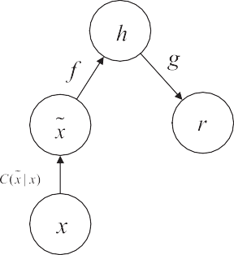of the receptive field, and *fn*r is the number of feature maps in the previous layer (layer *l* — 1). *sh* and *sw* are the vertical and horizon- tal strides respectively (Géron, 2017).

In this study, the input heartbeat data is one-dimensional vec- tors with one channel, so we modify the output of a neuron in a convolutional layer as Eq. (6).

*c j,k* = *σ*

µ*bk* +

*fw fn*r

Σ Σr

*v*=1 *k* =1

*x j*r *,k*r *wv,k,k*r ¶

with *j*r = *v* · *sw* + *fw* — 1 (6)

**Fig. 1.** DAE structure.

is neatly symmetrical, we tie the weights of the decoder layers to the weights of encoder layers, i.e. *W*1 = *WT* = *W* . This technique halves the number of weights, speeding up training and limiting the risk of overfitting. *b*1 and *b*2 are the bias vectors of input and output layers, respectively. Activation function ReLU is used in cod- ing layer to get nonlinearization of the input, while the decoding layer is a linear process and does not require the activation func- tion.

2

We usually adjust the hyperparameters by minimizing the cost function of Eq. (4), so that the DAE can well represent the input signal.

Pooling layer, also called subsampling layer, is aimed to sub- sample the input data in order to reduce computational load and the memory usage. Max pooling is used in this paper to pre- serve the most prominent features by offering the maximum out- put within a rectangular neighborhood (Ian Goodfellow, 2016).

The training of CNN is similar to that of traditional fully- connected neural network, which is usually trained through back propagation algorithm to minimize the loss function.

#### Multi-module neural network system

This section introduces the whole system structure, mainly in- cluding four modules: signal preprocessing, imbalance problem processing, feature extraction and classification. In the process of

*L(w, b , b )* = Σ  *r* — *x * 2

(4)

preprocessing, the original data is denoised and segmented into

1 2 2

*2.2. Convolutional neural network*

Convolutional neural networks (CNNs) refer to the neural networks that use convolution operations at least one layer of the network instead of general matrix multiplication, specifically for processing data with grid-like topology (Ian Goodfellow, 2016). It integrates feature extraction and classification together, different from the traditional classifier which needs to input pre-extracted features. A typical layer in a CNN consists of a convolutional layer and a pooling layer. Feature maps of previous layer are computed with several convolutions in parallel to generate a set of linear activation responses. Then, they passed through a nonlinear acti- vation function to generate a feature map for next layer. Finally, the pooling function is used to further adjust the output. CNNs are stacked with several typical layers, which can be used to extract high-level features.

Each unit in the convolutional layer is connected to a local re- ceptive field of the previous layer’s feature map by a set of weights called filters (convolution kernels) and each convolution kernel ob- tains a mapping of a class of features. Different feature maps use different filters, while all neurons in same feature map share same filters (Lecun, Bengio, & Hinton, 2015). The formula for the output of a neuron in a convolutional layer is

n

heartbeat segment of equal length. Imbalance problem processing is the main emphasis of the Algorithm. This part combines the characteristic of both ECG data and classification model, taking a series of measures to process the imbalanced data after segmenta- tion based on data level and algorithm level. Then, the processed imbalanced data are fed into the CNN model for feature extraction and classification.

The flow chart is described in Fig. 2.

* 1. *Preprocessing*

ECG recordings are usually contaminated by different types of noises and artifacts, which will affect the subsequent experiments and the final classification results. It is essential to adopt reason- able method to pre-process the original signal without losing use- ful information. Although the ECG signals obtained from public datasets do not contain as much noise as the ECG data obtained directly from the patient, there are still some noises in the sig- nal spectrum that overlap with useful information. Given that ECG signal is the raw data of almost all cardiac disease diagnosis and analysis, we should utilize a reasonable method to preprocess the original signal without losing useful information.

It is pointed out in Haritha, Ganesan, and Sumesh (2016) that the low-frequency noise, mainly coming from baseline wander, can

*ci, j,k*

*fh fw fn*r

= *σ bk* +

Σ

Σ

Σ

µ

*u* = 1 *v* = 1 *k*r = 1

*xi*r *, j*r *,k*r

· *wu,v,k,k*r ¶

# with

*i*r = *u*·*sh* + *fh* —1 *j*r = *v*·*sw* + *fw* —1

# (5)

be removed by median filter effectively. As in De et al. (2004), we use a 200 ms width median filter to remove P wave and QRS complex wave, then use a 600 ms width median filter to remove T wave, and afterwards subtract the filtered signal from the origi- nal signal to get the baseline correction signal. The 12-tap low-pass

where *ci, j,k* is the output of the neuron located in row *i* column *j* in feature map *k* of the convolutional layer (layer *l*). *xi*r *, j*r *,k*r is the output of the neuron located in layer *l* — 1, row *i*r , column *j*r , fea- ture map *k*r (or channel *k*r if the previous layer is the input layer).

*wu,v,k,k*r is the connection weight between any neuron in feature map *k* of the layer *l* and its input located at row *u*, column *v* (rel- ative to the neuron’s receptive field), and feature map *k*r.*bk* is the bias for feature map *k* (in layer *l*) and *σ* is the activation function

which produce non-linearity. *fh* and *fw* are the height and width

filter is used to remove high-frequency noise and power-line inter- ference.

Then Pan-Tompkins algorithm (Pan & Tompkins, 2007) is used to detect R-peak. The signal is segmented into pieces with the length of 300 sampling points by taking the first 130 samples and the last 170 points including R-peak as fiducial point. Subsequently, we apply Z-score normalization to eliminate the effects of offset and amplitude scaling and group the segmented pieces by cate- gories, after which is easy to facilitate the following operations.

**Algorithm:** BLSM(T, M, r, k, s).

**Input:** *T* -Training set

*M*-Minority examples set

*r, k*-Number of nearest neighbors

*s*-Number of synthetic examples that account for the number of original examples in the given class

**Output:** Synthetic minority samples set: *M*r

1. *D* = *Ф* //*D* is a set containing borderline samples
2. **for** all *mi* in *M* **do**
3. *Nmi* › *r* nearest neighbors of *mi* in *T*
4. *n* › the number of samples in *Nmi* and not in *M*
5. **if** *r/*2 ≤ *n < r* **then** //*mi* is a borderline sample
6. add *mi* to *D*
7. **end if**
8. **end for**
9. *M*r = *Ф* //*M*r is a set containing synthetic samples
10. **for** all *di* in *D* **do**
11. *Ndi* › *k* nearest neighbors of *di* in *M*
12. **for** *i* = 1 **to** *s* **do**
13. *m* › choose a random sample from *Ndi*
14. *d*r › *di* + *p* ∗ *(di* — *m)* //*p* is a random number in*(*0*,* 1*)*, *d*ris a synthetic sample

*i i*

1. add *d*r to *M*r

*i*

1. **end for**
2. **end for**
3. *M*r = *M*r ∪ *M* //*M*r is the union of minority samples and synthetic samples
4. **return** *M*r

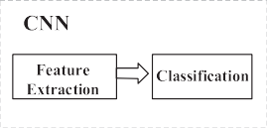

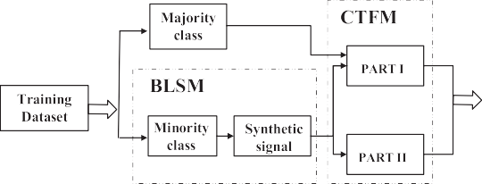

**Fig. 2.** Schematic overview of MMNNS.

* 1. *Imbalance problem processing*

Data imbalance refers to the phenomenon that the number of certain class in training set is overrepresented compared to other classes. The class with too many numbers is called majority class, while others are called minority class. Most real-world datasets are imbalanced. For example, the number of N-type heartbeats in MIT-BIH Arrhythmia Database is more than 8000 times that of Q-type and 100 times that of F-type. In medical diagnosis, the cost of erroneously misclassifying the minority (i.e. abnormal samples), which will delay the best treatment time, is much higher than that of majority classes (i.e. normal samples). In addition, most machine learning algorithms are designed under the assumption that the underlying training set is balanced. Such highly skewed distribution of training data will be prone to force the learning algorithm biased towards majority class. This not only limits the convergence during the training phase, but also affects the generalization of the model and the accuracy on testing set. As a result, the importance of minority class should not be neglected and it is the key to solve the imbalanced problem in this study.

Methods for solving class imbalance can be divided into three main categories (Buda, Maki, & Mazurowski, 2017; Guo, Li, Shang, Gu, Huang, & Gong, 2017).

Data level methods mainly change the distribution of train- ing data by oversampling or undersampling. The basic way of oversampling is to simply replicates the samples selected from minority class randomly, which is called random oversampling.

However, random oversampling is prone to cause overfitting. As a result, more advanced techniques are proposed, such as SMOTE, Cluster-based oversampling, DataBoost-IM, Class-aware sampling and other adjusted SMOTE strategies (Chawla, Bowyer, Hall, & Kegelmeyer, 2002; Guo & Viktor, 2004; Jo & Japkowicz, 2004; Maldonado, López, & Vairetti, 2019; Shen, Lin, & Huang, 2016). Undersampling, in contrast to oversampling, randomly removes samples from majority until the distribution gets balanced. More attention must be paid to avoid losing useful information in data selection when using undersampling.

Algorithm level methods overcome class imbalance by adjust- ing algorithm with training data distribution unchanged, includ- ing Thresholding, Cost-sensitive learning, Ensemble methods and One-class classification (Elkan, 2001; Lee & Cho, 2006; Sun, Kamel, Wong, & Wang, 2007; Zhou & Liu, 2006). Although Cost-sensitive learning can significantly improve the classification performance, they are only applicable to the cases where misclassification costs are known. Unfortunately, it is quite challenging and even impos- sible to determine the cost of misclassification in some particular domains (Wang et al., 2016). As for ensemble methods, requiring considerable time to train multiple classifiers, it is not practical when we use deep neural network as the base classifier. Thus new methods such as second order cone programing SVM (Maldonado & López, 2014) have been proposed.

Hybrid methods combine methods in data level and algorithm level, such as EasyEnsemble, BalanceCasecade, SMOTEBoost, Two- Phase Training, etc. (Chawla, Lazarevic, Hall, & Bowyer, 2003;

Havaei et al., 2017; Liu, Wu, & Zhou, 2009). Compared with data level or algorithm level methods only, it is shown that hybrid methods are more effective in imbalanced learning.

Besides, performance measures are essential for effectiveness evaluations and guidance of learning. As stated at the beginning of this section, accuracy, a commonly used metric, favors majority class and easily leads to misleading assessment. Metrics like preci- sion, specificity, sensitivity, G-mean, F-measure are introduced into imbalanced learning field. Some works even focus on novel eval- uation metrics, such as Adjusted F-measure (Maratea, Petrosino, & Manzo, 2014).

Neural networks and deep learning have gained lots of inter- ests recently, also facing the imbalance problem. In standard back propagation algorithm, weights are updated by minimizing over- all error, which are contributed mainly from majority class. Thus, we achieve biased classification results. To tackle this problem, two novel loss functions named MFE and MSFE are proposed in Wang et al. (2016). A stacked denoising autoencoder neural net- works algorithm based on cost-sensitive oversampling is designed in Zhang, Gao, Song, and Jiang (2016). Khan, Hayat, Bennamoun, Sohel, and Togneri (2018) present a cost sensitive deep neural network which can automatically learn robust feature representa- tions for both of the majority and minority classes. Raj, Magg, and Wermter (2016) integrate different methods into a novel approach using cost sensitive neural networks to improve the performance on imbalanced datasets.

We design a structure to deal with imbalanced training data combining both data and algorithm level. Above all, from data point of view, we apply Borderline-SMOTE (BLSM) algorithm to one-dimensional ECG time series data, and oversample minority samples by linear synthesis. Secondly, considering the features ex- tracted from skewed data are biased towards majority class, a novel context-feature module (CTFM) is introduced in this paper. CTFM integrates feature extraction and feature selection, feeding prominent feature of each heartbeat segmentation and the features in the larger region of its context to the classifier simultaneously. CTFM doubles the number of minority samples, and enhances both the accuracy of model recognition and reliability for feature extrac- tion. Finally, we adopt Two-Phase Training, referred to as 2PT. In the first training stage, the convolutional neural network (CNN) is trained with balanced data, and in second stage, the model is fine- tuned with original skewed data.

In order to make the test results closer to the real results and convenient to compare with other literature, we only balance the training samples and keeps the test samples as the original sam- ple distribution in this paper. Considering that the accuracy is only more convincing when the data distribution is relatively balanced, we also introduce other metrics to measure the eﬃcacy of the model. In the following chapters, we will give a detailed descrip- tion of these contents.

* + 1. *Borderline-SMOTE (BLSM)*

Given that deep learning models need large quantities of train- ing data, we balance our training data by oversampling the mi- nority class rather than undersampling the majority class. Also, to avoid overfitting caused by simple random oversampling, we choose BLSM algorithm to synthesize a series of linear interpola- tion samples.

Data augmentation can be regarded as expanding data by adding similar but different samples in the original training set (Zhang, Cisse, Dauphin, & Lopezpaz, 2018). On the basis of this definition, overcoming the imbalance problem in the number of training data can be regarded as local augmentation of minority class in training data. When realizing images classification, we usu- ally obtained augmented data with horizontal reflection, rotation and scaling. Inspired by this idea, we plan to add virtual samples

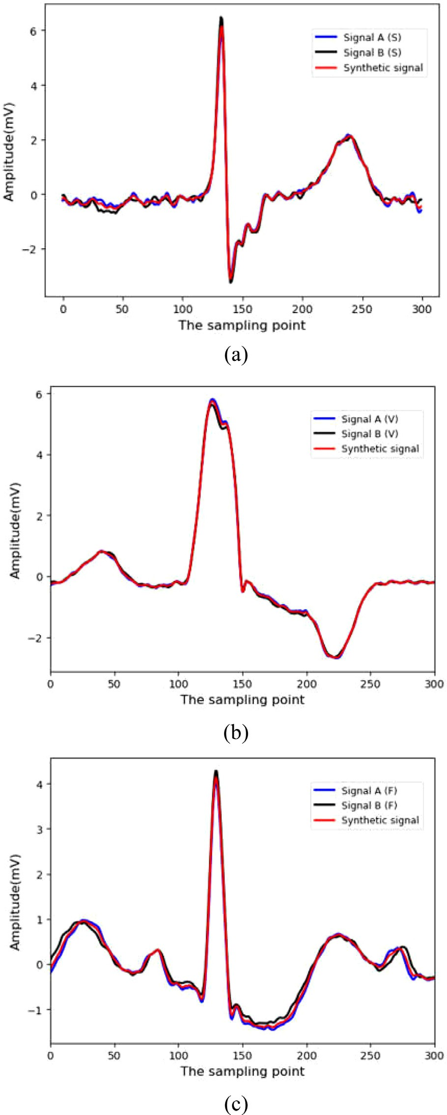

**Fig. 3.** Examples of synthetic signal (a) Example synthesized by same class S (b) Example synthesized by same class V (c) Example synthesized by same class F.

around the minority class. By learning a linear interpolation func- tion in the ‘blank area’ around it, distribution of minority class in training data set will be enlarged, and complexity of space with- out data coverage will be reduced. This linear modeling reduces the inadaptability of predicting data beyond training samples, and makes the final model more stable in predicting data between training data. It is exactly consistent with the main idea of SMOTE (Chawla et al., 2002), i.e., filling the ‘blank area’ between origi- nal samples by linearly synthesizing minority sample with its k

**Table 2**

The changing number of training set in two grouping schemes.

|  |  |  |  |  |  |  |
| --- | --- | --- | --- | --- | --- | --- |
| Data div. scheme | Method | N | S | V | F | Total |
| Intra-patient scheme | Original | 44,800 | 1345 | 3412 | 396 | 49,953 |
|  | BDSM | 44,800 | 22,740 | 23,102 | 22,173 | 112,815 |
|  | CTFM | 44,800 | 45,480 | 46,204 | 44,346 | 180,830 |
| Inter-patient scheme | Original | 45,492 | 865 | 3664 | 410 | 50,431 |
|  | BDSM | 45,492 | 23,265 | 23,024 | 22,410 | 114,191 |
|  | CTFM | 45,492 | 46,530 | 46,048 | 44,820 | 182,890 |

**Table 3**

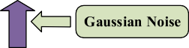

The details for CNN structure with input length N of 180.

|  |  |  |  |
| --- | --- | --- | --- |
| Layer name | No. of neurons | Kernel size for each feature map | Stride |
| Input Layer | 180 × 1 | – | – |
| Conv1 | 180 × 16 | 2 | 1 |
| MaxPool1 | 180 × 16 | 2 | 2 |
| Conv2 | 180 × 32 | 4 | 1 |
| MaxPool2 | 180 × 32 | 2 | 2 |
| Conv3 | 180 × 64 | 5 | 1 |
| MaxPool3 | 180 × 64 | 2 | 2 |
| Fully-Connected | 50 | – | – |





**Fig. 4.** CTFM DAE structure.

nearest neighbors in feature space instead of data space. This en- larges the decision region and reduces the pertinence of classifier learning.

SMOTE resamples the training data by synthesizing each mi- nority sample and its random selected neighbor. Since the num- ber of original samples in each class located at the boundaries is small, the newly synthetic samples are mainly distributed in the non-boundary regions. However, the samples near the borderline, also referred as dangerous samples, are more likely to be misclas- sified than those far away from borderline, and are of more signifi- cance to classification tasks. Therefore, BLSM, an improved version of SMOTE, only oversamples the minority examples near the bor- derline, which is more in line with our expectations.

In BLSM, minority class examples which are easily misclassi- fied will get more training. Minority examples on the borderline are first found, and then synthesized with their selected k near- est neighbors. BLSM algorithm is modified slightly and adapted to one-dimensional ECG time series data in this paper. The detailed process is shown as follows.

After oversampling with BLSM, the number of samples in mi- nority class has increased significantly. Assuming that the amount of original samples in minority class is *num* and the number of samples in borderline samples set *D* is *dnum*, then the number of

samples in *M*r reaches *(num* + *s* × *dnum)* in the end. In this algo-

rithm, the values of *s* and *m* are determined by the amounts of samples that we need to synthesize. The values of *s* in S, V, F class with two grouping schemes are (11, 14), (11, 11), (17, 40) respec-

tively, and the values of *m* are (30, 30), (50, 50), (60, 60). The value of *k* is set to 5 (Chawla et al., 2002; Han, Wang, & Mao, 2005). The synthetic ECG heartbeat patterns are shown in Fig. 3.

What needs to be stressed is that the number of samples varies greatly from one class to another. If a complete balance is achieved by BLSM, it may cause the boundary between different classes to become blurred, which makes it easier to misclassify. Therefore, we synthesize the minority class to make they reach only half of the number of majority class.

* + 1. *Context-feature module (CTFM)*

After finishing oversampling using BLSM, a Context-Feature Module (CTFM) is proposed in this section to expand the samples obtained previously. The number of samples in minority class can be increased from N to 2 N by CTFM and all classes will reach bal- ance then.

Compared with resampling methods in data level, few papers considered feature selection, which is known to select a subset of the original features. In classification problems, samples of differ- ent classes may overlap, which makes it diﬃcult for classifiers to identify the boundaries between classes. When the distribution of training data is skewed, minority samples can be easily regarded as noise because of the small number. However, if irrelevant features are removed, boundaries between classes will be less ambiguous to some extent. Li, Guo, Liu, Li, and Li (2016) focus on feature se- lection and then combine it with resampling and ensemble lean- ing into an adaptive multiple classifiers system, finally solving the imbalance problem. A novel feature learning method using partial least square analysis is proposed in Bae and Yoon (2015) to learn unbiased results from imbalanced datasets.

Feature extraction, as another way to deal with dimensionality, converts the original features into new feature set. When solving imbalance problem, extracted features are often biased to predict the majority class samples that lead to poor performance on classi- fication. Taking principal component analysis (PCA) as an example, (Braytee, Liu, & Kennedy, 2016) point out that PCA algorithm seeks the orthogonal feature extractors that maximize the total variance. As a result, the extracted features favor majority class because their number is larger than the minority class. Moreover, other feature extraction methods will encounter the same problem. Accordingly, improved feature extraction algorithms are proposed recently to adapt to imbalanced training data (Moepya, Akhoury, & Nelwa- mondo, 2015; Ng, Zeng, Zhang, Yeung, & Pedrycz, 2016).

Similarly, if we feed imbalanced data directly into DAE or CNN in this study, it is easy to mislead extractors to produce biased fea- tures. However, if we keep the ratio between majority and minor- ity classes not that high, which is 2:1 here, the bias will be greatly reduced.

In the present study, we construct a CTFM module consist- ing of two parts: DAE-based feature extraction part (PART I) and QRS-based feature selection part (PART II). In PART I, we choose DAE as our extractor to extract sparse high-level features from all the heartbeats obtained in Section 3.2.1. On the one hand, the

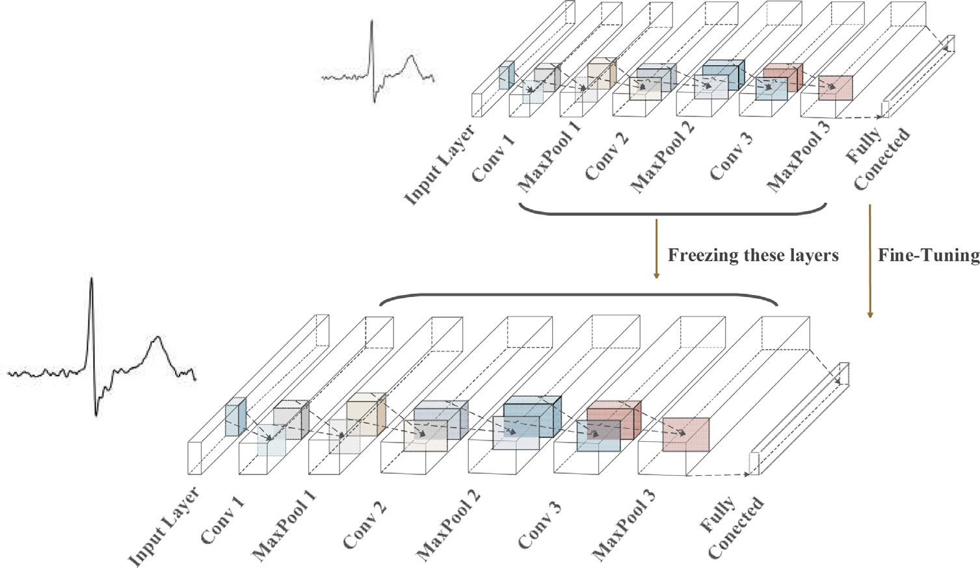

**Fig. 5.** The architecture of proposed CNN and training schematic diagram.

**Table 4**

The number of ECG beats used for training, validating and testing in the experiments.

Data div. scheme Training set Validation set Testing set Intra-patient 120,544 60,286 49,945

Inter-patient 121,927 60,963 49,467

**Table 5**

Confusion matrix of ECG heartbeat classification re- sults for testing set with the inter-patient scheme.

Ground truth Classification results

|  |  |  |  |  |  |
| --- | --- | --- | --- | --- | --- |
|  | N | S | V | F |  |
| N | 43,465 | 639 | 167 | 241 |  |
| S | 480 | 1173 | 134 | 35 |  |
| V | 163 | 25 | 2875 | 97 |  |
| F | 67 | 4 | 18 | 293 |  |

extracted features will not be heavily biased towards majority class, because the number of different classes is in a wide differ- ence. On the other hand, dimensionality of the samples is reduced by DAE to the same size of N as the other part. In PART II, we fo- cus on the selection of important features from minority samples obtained in the previous section, which can be regarded as adding another batch of samples in minority class. QRS complex, the most prominent part in a heartbeat, provides most significant informa- tion and reflects ventricular contraction (Šarlija et al., 2017). There- fore, the function of PART II is to intercept the feature area around QRS complex with the length of N from each heartbeat. The sam- ples obtained by CTFM through aforementioned two parts are the samples finally fed to the classifier.

The DAE in PART I is showed in Fig. 4. DAE corrupts the input by randomly dropping-out some input values of randomly selected samples to enhance the robustness of the autoencoder (Wang, Zeng, Ng, & Li, 2017). The hyperparameters are set as follows: the learning rate, coeﬃcient of Gauss noise is set at 0.001 and 0.01 respectively. Training is done in 1000 epochs with batch size of 200. The main purpose of this stage is to convert the original input signal into a shorter segment which can eﬃciently represent the original signal. Over-complete representation is more conducive to the subsequent operation, thus we only pre-train the DAE in a supervised manner. We do not need to reuse the

pre-trained lower layers to create a network for the practical task, and we train it using labeled data. When the loss function gets stable, the features represented by encoder at this time are regarded as the input of the next stage.

In addition, in order to ensure the input of classifier with the same length of N, testing samples should also pass through a same DAE structure.

So far, we have used two methods in data level to balance the training data, and the numbers of different heartbeat types on MIT-BIH Arrhythmia Database are shown in Table 2.

* + 1. *Two-phase training (2PT)*

Two-Phase Training (2PT), first proposed in Havaei et al. (2017), is a hybrid method of data and algorithm level to deal with class imbalance problem, which has been shown the eﬃcacy in Buda et al. (2017). In the first stage, we input the balanced data into CNN for training, then the neural network has the ability to distinguish different classes at the level of balanced data. In the second stage, we replace the input data with original unbalanced data, only fine-tuning output layer parameters while keeping those in previous layers unchanged. This way makes the final classifica- tion result more convincing.

* 1. *Feature extraction and classification*

CNN is commonly used for 2-D image classification. In this pa- per, we modify the traditional structure and design a CNN suit- able for processing 1-D ECG signal (Fig. 5). It consists of an input layer, three convolutional layers, three max-pooling layers, a fully- connected layer and an output layer. Each pooling layer follows the corresponding convolutional layer. The input layer, MaxPool1, Max- Pool2 are convolved through Eq. (5) with kernels size of 2, 4, 5 and strides of 1, 1, 1 respectively. The kernels size and strides for layers Conv1, Conv2, Conv3 are all set at 2 and outputs of each layer fol- lows Eq. (6) in Section 2.2. These layer in the model use full zero- padding to ensure input and output with the same size. Hence there will be no limitation on the number of convolutional layers that the network is able to contain. Finally, the extracted features are connected with 50 neurons in the fully-connected layer, and then a softmax function is used to classify the beats of N, S, V and

F. The parameters above are all obtained through brute force tech- nique. Table 3 gives the details of CNN.

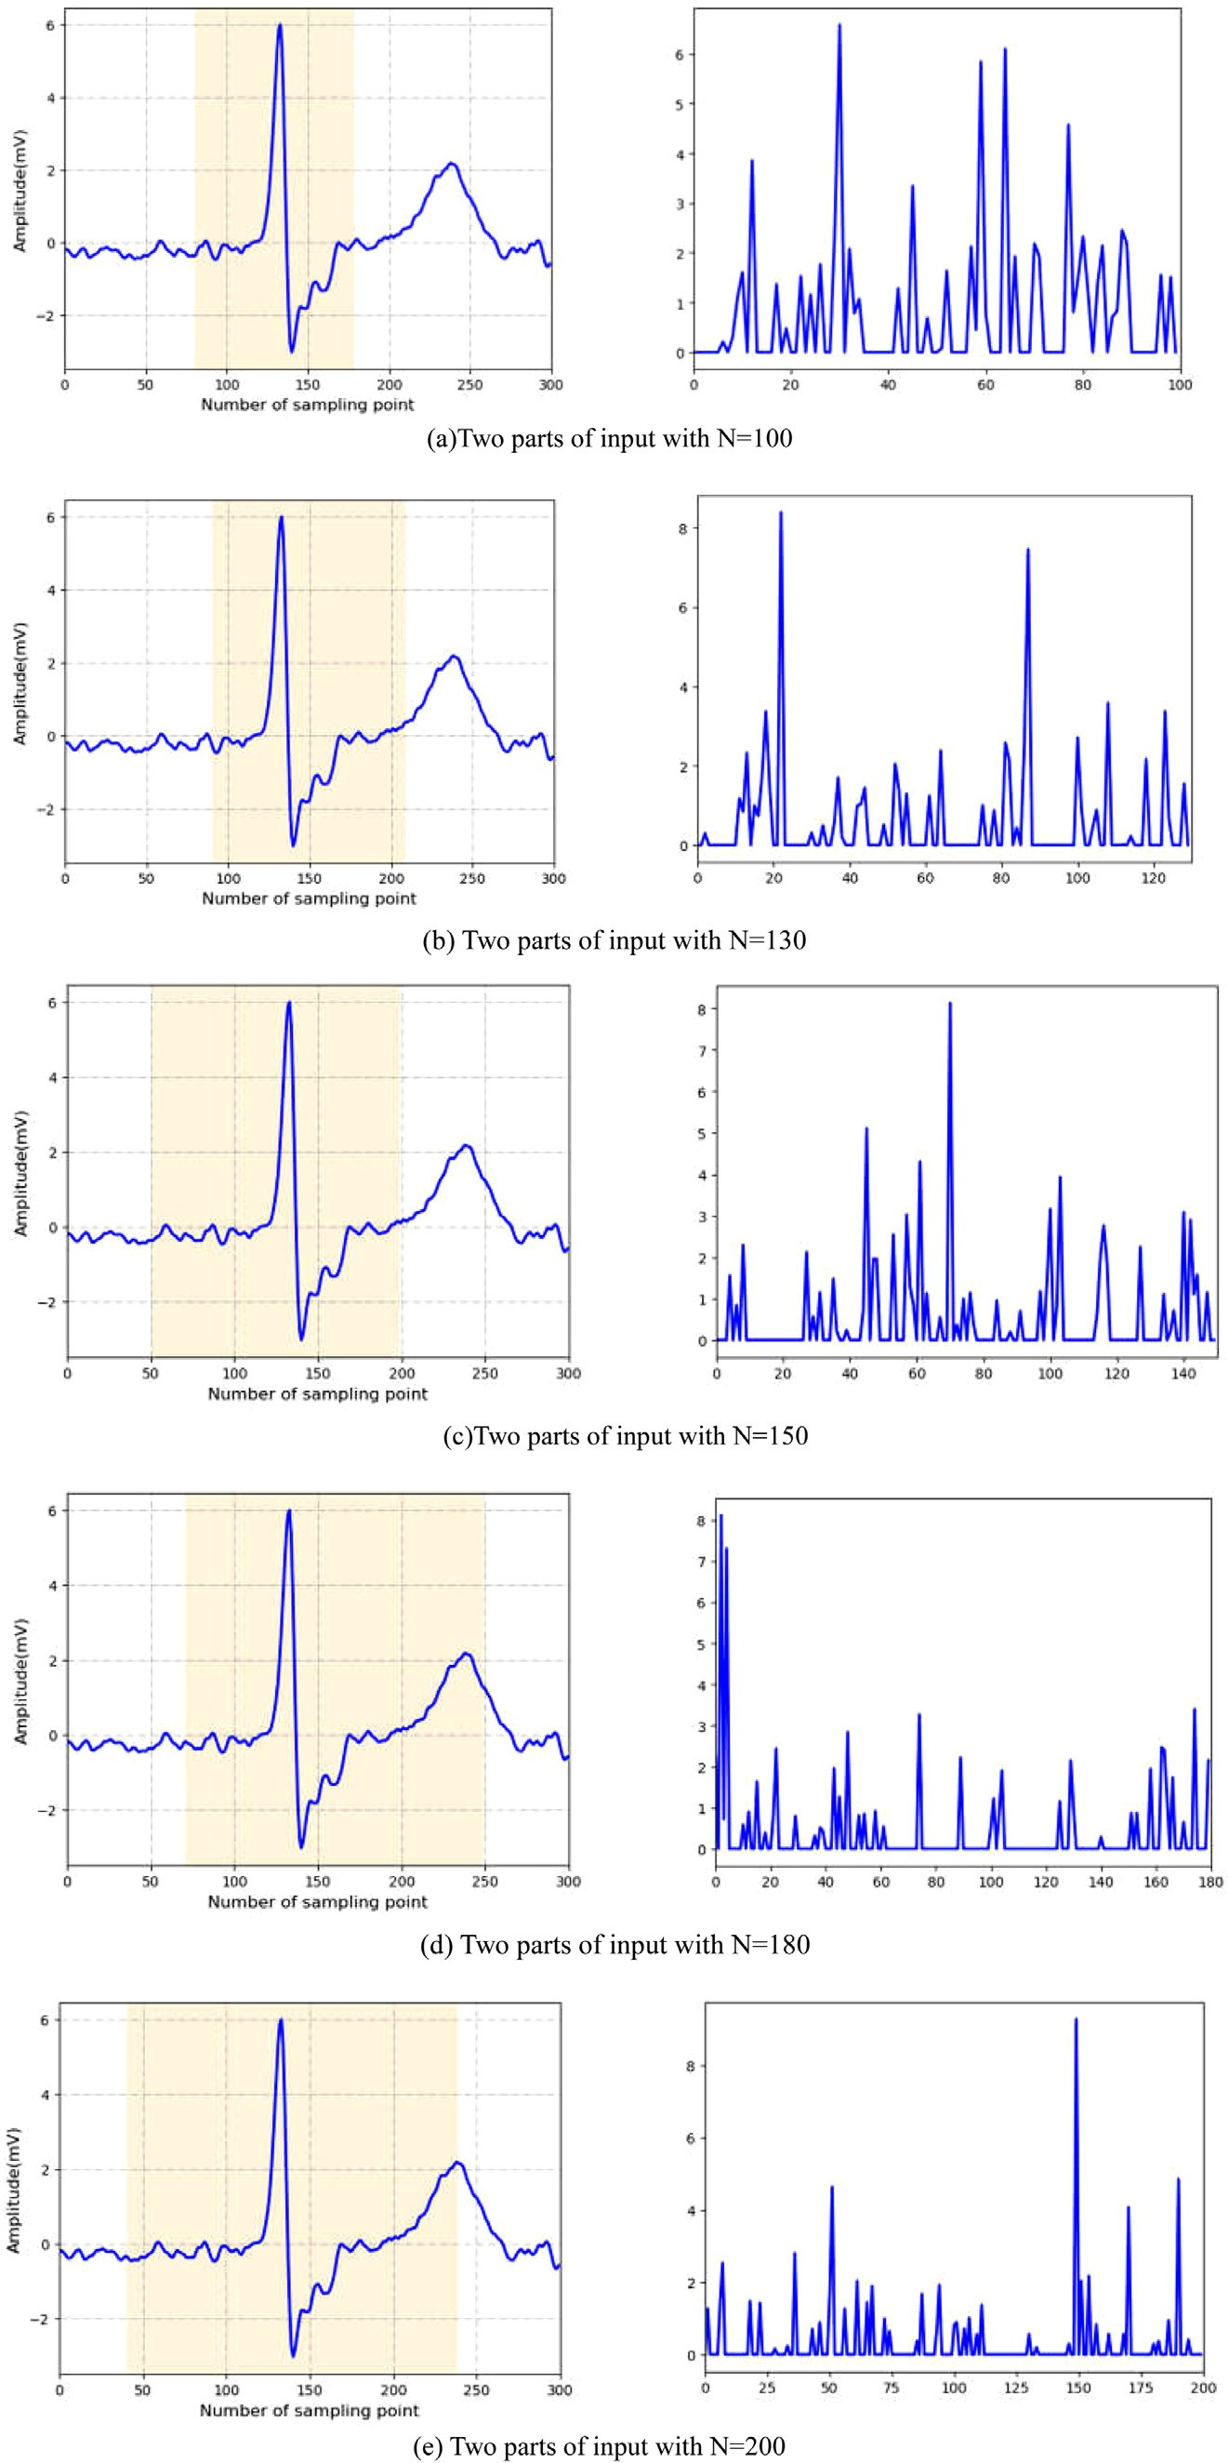

**Fig. 6.** Example of two parts of input in different length.

**Table 6**

Classification results in terms of SVEB and VEB using 22 testing records of MIT-BIH Arrhythmia Database with the inter-patient scheme.

|  |  |  |  |  |  |  |  |  |  |  |  |  |  |
| --- | --- | --- | --- | --- | --- | --- | --- | --- | --- | --- | --- | --- | --- |
| N Size | SVEB |  |  |  |  |  | VEB |  |  |  |  |  | MAUC |
|  | Acc Sen | Spe | Ppr | Fm | GM |  | Acc | Sen | Spe | Ppr | Fm | GM |  |
| 100 | 94.7 44.3 | 97.1 | 51.8 | 47.8 | 65.6 |  | 97.9 | 72.6 | 97.2 | 81.2 | 76.6 | 84.0 | 92.2 |
| 130 | 95.2 56.7 | 97.4 | **64.0** | 60.1 | 74.3 |  | 98.4 | 87.9 | 98.6 | 89.3 | 88.6 | 93.1 | 93.7 |
| 150 | 96.8 61.2 | **99.2** | **64.6** | 62.9 | 78.0 |  | **98.8** | 90.4 | **99.4** | 88.6 | 89.5 | **94.8** | **95.3** |
| 180 | **97.3 64.4** | **98.6** | 63.7 | **64.0** | **80.0** |  | **98.8** | **91.0** | **99.3** | **90.0** | **90.1** | **95.1** | **97.8** |
| 200 | **97.1 64.8** | 98.5 | 62.1 | **63.4** | **80.0** |  | **99.0** | **90.8** | 98.9 | **88.9** | **89.8** | **94.8** | 94.1 |

The values in the table multiply the original values by 100. Best two results are highlighted.

**Table 7**

With the intra-patient scheme, classification results in terms of SVEB and VEB obtained by different methods on the MIT-BIH.

|  |  |  |  |
| --- | --- | --- | --- |
| Method | Features | Classifier | Accuracy |
| Gutiérrez-Gnecchi et al. (2017) | Wavelet | PNN | 92.7 |
| Tang and Shu (2014) | WT | QNN | 92.8 |
| Martis et al. (2013) | Pan-Tompkin + PCA | NN+LS-SVM | 93.0 |
| Acharya et al. (2017) | 1D-CNN | Softmax | 94.0 |
| Li and Zhou (2016) | WPE+RR | Random Forest | 94.6 |
| Zadeh and Khazaee (2011) | CWT | SVM+GA | 97.2 |
| Li et al. (2017) | 1D-CNN | Softmax | 97.5 |
| Proposed1 | DAE+1D-CNN | Softmax | 98.4 |

Proposed1 are based on intra-patient scheme for SVEB and VEB detection.

**Table 8**

With the inter-patient scheme, classification results in terms of SVEB and VEB obtained by different methods on the MIT-BIH.

|  |  |  |  |  |  |  |  |  |  |  |  |  |
| --- | --- | --- | --- | --- | --- | --- | --- | --- | --- | --- | --- | --- |
|  |  | Acc | Sen | Spe | Ppr |  | Acc | Sen | Spe | Ppr | Accur | a |
| De et al. (2004) | 94.6 | 75.9 | / | 38.5 |  | 97.4 | 77.7 | / | 81.9 | 85.9 |  |
| Zhang et al. (2014) | 93.3 | 79.1 | 93.9 | 36.0 |  | 98.6 | 85.5 | 99.5 | 92.7 | 86.6 |  |
| Kiranyaz et al. (2016) | 96.4 | 64.6 | 98.6 | 62.1 |  | 98.6 | 95 | 98.1 | 89.5 | 96.6 |  |
| Jiang and Kong (2007) | 96.6 | 50.6 | 98.8 | 67.9 |  | 98.1 | 86.6 | 99.3 | 93.3 | 94.5 |  |
| Ince et al. (2009) | 96.1 | 62.1 | 98.5 | 56.7 |  | 97.6 | 83.4 | 98.1 | 87.4 | 93.6 |  |
|  | Proposed2 (MMNNS) | 97.3 | 64.4 | 98.6 | 63.7 |  | 98.8 | 91.0 | 99.3 | 90.0 | 96.6 |  |

Method SVEB VEB Overall cy

Proposed2 are based on inter-patient scheme for SVEB and VEB detection.

**Table 9**

Different strategies for addressing imbal- ance with CNN.

Algorithm Strategy PCNN Pure CNN

SMCNN SMOTE + CNN

BSCNN BLSM + CNN

BSDC BLSM + DAE-CNN

BSCP BLSM + CNN + 2PT MMNNS BLSM + CTFM + CNN + 2PT

Previous operations dealt with imbalanced data also greatly ex- panded the amount of training data, which causes pressure on the accelerated convergence of the model. We use the following tricks to speed up the training and solve vanishing/exploding gradients problems. Xavier Initialization (Glorot & Bengio, 2010) is exploited to initialize the connection weights. Leaky ReLU, a variant of the ReLU function is used as the activation function of convolutional layers and fully-connected layers to avoid dying ReLUs. Referring to Géron (2017), setting *α* = 0*.*2 in leaky ReLU results in better perfor- mance than *α* = 0*.*1 that we commonly use. These two tricks can significantly overcome the vanishing/exploding gradients problems at the beginning of training. We then use a faster optimizer named Adam Optimizer instead of the regular Gradient Descent Optimizer and we adopt Exponential Decay Learning Rate to optimize the

classification error with the base learning rate and learning rate decay rate set to 0.001 and 0.99 respectively.

In this paper, training of the algorithm is done in 800 epochs with a mini batch size of 200. Validation set is used to validate the model each 100 rounds of training. After training CNN with processed balanced data, the model is fine-tuned according to the method described in 3.2.3. The final performance of the testing set is measured by eight metrics defined below.

#### Experiments setup

* 1. *Datasets*
     1. *MIT-BIH arrhythmia database*

MIT-BIH arrhythmia database consists of 48 records slightly longer than 30 min of two-channel ECG recordings with digitiza- tion rate of 360 Hz. The signals of the two channels were recorded by placing the electrodes at different angles on the chest. The up- per signal is a modified limb lead II (MLII), and the lower signal is a modified lead V1, V2, or V5 (Moody & Mark, 2002). ECG data were collected from 47 subjects, including 25 men aged 32-89 and 22 women aged 23-89 (Records 201 and 202 are from the same male subject). More than 100,900 heart beats in the database have been annotated. Only one channel (channel MLII) for each record- ing is used for the classification task, excluding four records with poor quality (102,104,107,217).

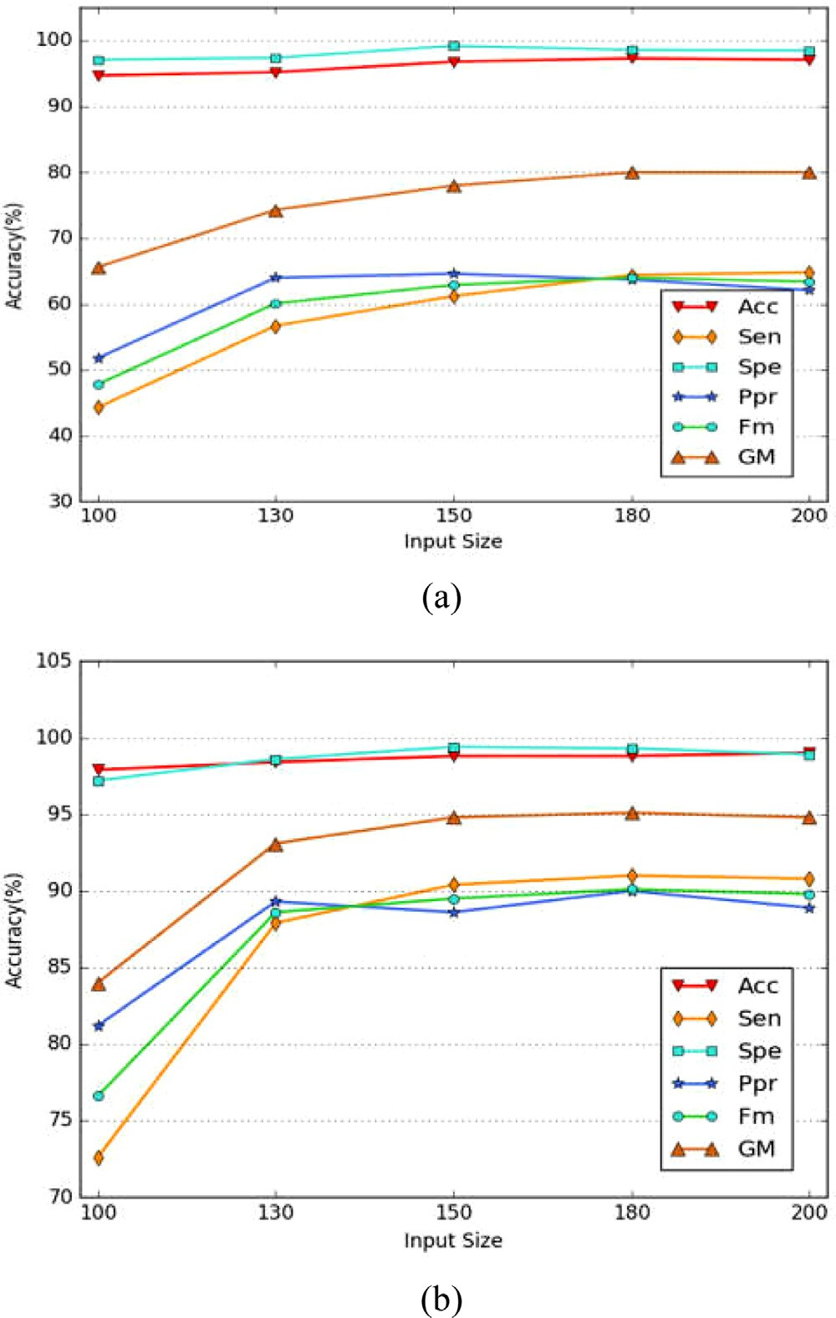

**Fig. 7.** Acc, Sen, Spe, Ppr, Fm and GM in different length of input for (a) SVEB and

(b) VEB.

the inter-patient scheme, we use DS1 as the training set and DS2 as the testing set. Processed training set is divided into training set and validation set in proportion of 2:1. The specific data partition is shown in the Table 4.

* + 1. *European ST-T database*

European ST-T database (Taddei et al., 1992) consists of 90 an- notated excerpts of ambulatory ECG recordings from 79 subjects. The subjects are 70 men aged 30 to 64, and 8 women aged 55 to

71. Each record lasts for two hours, and two signals contained are both sampled at 250 samples per second. Two cardiologists anno- tated each record beat by beat and for changes in ST segment and T-wave morphology, rhythm and signal quality.

* + 1. *MIT-BIH ST change database*

MIT-BIH ST change database (Goldberger et al., 2000) includes 28 ECG recordings with different lengths. The annotation files con- tain only beat labels; they do not include ST change annotations, as in the European ST-T Database.

Only one channel of both two datasets is selected to conduct the experiments. The heartbeats obtained from these two datasets are fed into the model which we have already trained before. Test results are used for further comparison and evaluation from differ- ent aspects.

* 1. *Evaluation metrics*

To evaluate the classification performance, seven classification assessment metrics and two statistical measures are adopted in this study. The first seven metrics are defined by four represen- tations of *TP*, *TN*, *FP*, *FN*, meaning true positive, true negative, false positive and false negative respectively.

1. Accuracy

Accuracy (*Acc*) is a standard performance measure for clas- sification, representing the proportion of test examples clas- sified correctly. In learning imbalanced data, it will lead to highly misleading assessment if we regard it as the only evaluation metric, since majority class is overrepresented.

*T P* + *T N*

### *Acc* =

*T P* + *T N* + *F P* + *F N*

(7)

MIT-BIH Arrhythmia Database is the main database used in

the experiment, including determining parameters of each mod- ules in the system, selecting the appropriate data grouping scheme, and training and testing the model. Recommended by ANSI/AAMI

1. Sensitivity

Sensitivity (*Sen*), also called Recall, measures the integrity of positive samples being correctly classified.

EC57:1998/(R) 2008 standard, we should classify all samples into five classes: N, S, V, F, Q. However, considering that the number of samples of Q is too small after removing 4 paced records, which is

*T P*

### *Sen* =

*T P* + *F N*

1. Specificity

(8)

only 12, we choose to realize classification on other 4 classes.

Two heartbeats grouping schemes are adopted on this database, called intra-patient and inter-patient. Intra-patient is a used by

Specificity (*Spe*) means the percentage of correctly classified negative tuples.

majority of scholars, in which training samples and testing set is randomly selected from all heartbeats. In this grouping method, heartbeats in training set and testing set are likely from the same

*T N*

### *Spe* =

*T N* + *F P*

1. Positive predictive rate

(9)

patient. This may easily lead to biased results due to the heart- beats from same patient have strong correlation and dependence. In the inter-patient scheme, all records are divided into two groups with similar number and similar proportions of each class. Heart- beats in DS1 are all from records: 101, 106, 108, 109, 112, 114, 115,

116, 118, 119, 122, 124, 201, 203, 205, 207, 208, 209, 215, 220, 223

and 230 .Heartbeats in DS2 are all from records: 100, 103, 105,

111, 113, 117, 121, 123, 200, 202, 210, 212, 213, 214, 219, 221, 222,

228, 231, 232, 233 and 234. The heartbeats of two groups will not come from the same subjects. In the intra-patient scheme, 49,953 heartbeats (N44800, S1345, V3412, F396) are selected from the to- tal heartbeats as the training set and the rest as the testing set. In

Positive predictive rate (*Ppr*), also called Precision, means the proportion of positive samples classified correctly, being sensitive to data distribution.

## *T P*

*P pr* = (10)

*T P* + *F P*

1. F-measure

F-measure (*Fm*) incorporates *Sen* and *Ppr* to express their tradeoff. Parameter *β* is used to adjust the relative impor- tance of recall *Sen* and *Ppr*, which is usually set to 1.

*(*1 + *β*2 *)* × *Sen* × *P pr*

*Fm* = *β*2 × *Sen* + *P pr* (11)

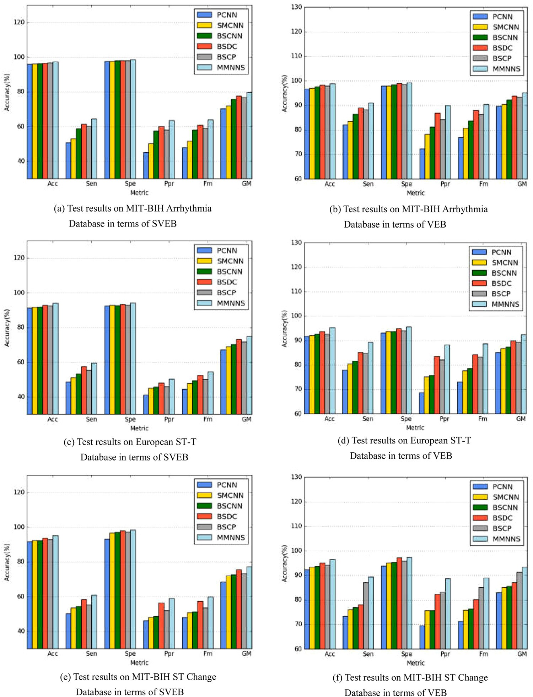

**Fig. 8.** Comparisons between six algorithms on SVEB and VEB.

1. G-mean

G-mean (*GM*) can evaluate the degree of inductive bias according to the positive accuracy and negative accuracy, which is widely used in imbalanced classification problems.

,

*T N*

*T P*

*GM* =

× (12)

*T N* + *F P T P* + *F N*

(8) Statistical measures

Wilcoxon signed-rank test (Wilcoxon, 1945) and sign test (Dixon & Mood, 1946) are two non-parametric tests adopted in this study to explore the differences between each two algorithms by calculating the p-value.

**5. Experiments and analysis**

(7) Multiclass AUC

Area under the receiver operating characteristic curve (AUC) is a sound measure of discrimination and has been widely used as an evaluation metric for classifiers, especially in im- balanced learning. We use a multi-class modification of ba- sic version of ROC. The multi-class AUC (*MAUC*) is calculated by taking the average of AUCs obtained independently for each class for the binary classification task of distinguishing a given class from all the other (Buda et al., 2017).

* 1. *Experiment 1: Determination of the input feature size*

To determine the suitable length of input features in the CTFM and the parameters of final classification model, we perform exper- iments on five different input lengths (*N* = 100, 130, 150, 180, 200) around QRS complex intercepted from the original heartbeat.

Fig. 6 takes S class as an example to show two parts of the input for different length. The colored region in the left subfig- ures are the selected features with N sampling points processed by

QRS-based feature selection part (PART II). Those in the right sub- figures are the features extracted from DAE-based extraction part (PART I).

Taking *N* = 180 as an example, Table 5 shows the confusion ma- trix of the classification results on the testing set in inter-patient scheme. Table 5 also indicates that the number of samples in N class is the largest, and the number of misclassified samples is the largest correspondingly. In N beats, 639 are misclassified into class S, 167 are misclassified into class V and 241 are misclassified into class F. In class S, V and F, the number of samples that are wrongly classified into N class is the largest relatively.

To compare the classification performances of five different in- put lengths comprehensively, we detect the SVEB and VEB classes according to AAMI standard. Table 6 highlights the best two results for each metric. The trends of each metric with different length in the detection of SVEB and VEB are plotted in Fig. 7. When detect- ing SVEB class, the values of Acc and Spe are generally higher than those of Sen, Ppr, Fm and GM which are consistent with the detec- tion on VEB. It’s easy to see that when input length is set to 180 and 200, the best detection results are achieved on SVEB and VEB. This may be explained that larger feature areas contribute more to determine the class of heartbeats.

For the SVEB class, the Acc, Spe, Ppr and Fm with input length N of 180 are all higher than those with *N* = 200. For the VEB class, the gross ACC was 99.0% with *N* = 200, a little higher than those with *N* = 180, which is 98.8%. However, the values of other five metrics are slightly lower than those with *N* = 180. It indicates that larger feature areas may not always achieve good performance, and the location of feature area also plays an important role. We also compare MAUC scores in different input length, and the results in Table 6 indicate that the highest score is achieved at *N* = 180. In a word, the input length of 180 sampling points is the respectively best. Hence, we use it as the final input in this paper.

* 1. *Experiment 2: Comparison with the state-of-the-arts on two data grouping schemes*

In this section, we conduct experiments on both intra-patient and inter-patient scheme. Intra-patient, as a popular grouping scheme, randomly selects the corresponding number of beats from all hearts as training set and testing set. It has achieved a high classification accuracy in early literature. As is shown in Table 7, compared with the manual feature extraction and traditional machine learning classifier by Martis, Acharya, Man- dana, Ray, and Chakraborty (2013), the classification accuracy of Acharya et al. (2017) and Li and Zhou (2016) using CNN has been significantly improved. The accuracy in this paper with intra- patient scheme is 98.4%, remaining top when compared with the related literature. It demonstrates that a series of methods pro- posed in this paper are reliable. However, since the heartbeats in testing set are likely from the same subject as the heartbeats in training set, strong correlation between the beats of the same sub- ject can easily lead to biased results. That means the final classifi- cation result seems to be high, but in fact there remains a devia- tion.

From Tables 7 and 8, we know that the accuracy of intra- pattern scheme is superior to that of inter-pattern scheme, which is consistent with the previous description. Nevertheless, when it comes to real-life situation, the inter-patient scheme clearly distin- guishing each object is more fair and persuasive. All the test beats used in the experiments in Table 8 with inter-patient scheme come from entirely new individuals that differ from the training data. Among them, De et al. (2004) and Zhang, Dong, Luo, Choi, and Wu (2014) adopted the same data grouping method as this paper, using beats of 22 records in DS2 as testing set to show the de- tection results on SVEB, VEB and the overall accuracy. Jiang and

Kong (2007); Kiranyaz, Ince, and Gabbouj (2016) and Ince, Ki- ranyaz, and Gabbouj (2009) used 24 new records relative to the training set as testing set data to verify the effectiveness of mod- els. As is seen from Table 8, the proposed method yields the best classification result regardless of the overall accuracy of the model or detection for SVEB and VEB separately.

* 1. *Experiment 3: Comparison with different strategies for addressing imbalance problem*

To show the eﬃcacy of MMNNS, we test the other two datasets on the basis of the previous experiments, and compared it with other five algorithms, including several classical methods dealing with imbalanced learning with CNN. The brief descriptions of the strategy for these algorithms are shown in Table 9.

The first algorithm named PCNN aims to feed the original im- balanced data directly into a pure CNN model without any process. Algorithm SMCNN and BSCNN preprocess the original data by over- sampling them using SMOTE and BLSM respectively. On the basis of BSCNN, the classifier CNN is replaced by a cascaded structure of DAE and CNN in algorithm BSDC, which feeds oversampled train- ing data to a DAE at first and then to a CNN. The fifth algorithm is BSCP, which integrates 2PT to BSCNN. Unlike BSCNN, which only fine-tunes the model using balanced training data after oversam- pling, BSCP introduces an extra fine-tuning phase using the origi- nal imbalanced data. The last one is our method: MMNNS.

For the purpose of comparison, we present the test results of each method on SVEB and VEB separately with respect to Acc, Sen, Spe, Ppr, Fm and GM, together with overall accuracy and MAUC score in Tables 10 –12. The variation trends of these metrics in dif- ferent algorithms on different datasets are shown in Fig. 8. As il- lustrated in the tables and figures, the performances in all metrics on MIT-BIH Arrhythmia Dataset are obviously better than those on other dataset. This is because our model is trained exactly on MIT- BIH Arrhythmia Dataset. However, no matter which dataset we test on, we can see that the five algorithms show significant improve- ments, compared with feeding imbalanced original data into CNN directly. The SMCNN and the BSCNN have similar effects, and the latter one is slightly better than the former one because it focuses on the borderline samples that are easier to be misclassified. Al- gorithm BSDC constructs a cascaded structure combining DAE and CNN, extracting high-level features of heartbeats sequentially. The accuracy of each metric is just a little lower than MMNNS while higher than others. On the basis of BSCNN, BSCP involves a fine- tuning phase using imbalanced data, which improves the final per- formance somewhat. The algorithm MMNNS achieves the highest overall accuracy and MAUC score, and the performances of the detection on SVEB and VEB are almost always better than other methods.

In the last step, Wilcoxon signed-rank test and sign test are

implemented over average accuracy, sensitivity, specificity, positive predictive rate, F-measure, G-mean and MAUC between each two algorithms. We consider MMNNS as the control method, and calcu- late the p-value to see if there are significant differences between such two algorithms. The smaller the p-value is, the more signif- icant the difference between the two algorithms is. As shown in Table 13, there remain significant differences between MMNNS and the other five algorithms, with p-value lower than 0.05. This makes it clear that the MMNNS significantly outperforms other methods.

#### 6. Conclusion and future work

The heartbeats of ECG signals in the existing datasets are usu- ally imbalanced among different classes, which brings great dif- ficulties in classifying them accurately. However, most scholars mainly pay attention to enhance the overall accuracy of the system

**Table 10**

Classification results on MIT-BIH arrhythmia database.

|  |  |  |  |  |  |  |  |  |  |  |  |  |  |  |  |
| --- | --- | --- | --- | --- | --- | --- | --- | --- | --- | --- | --- | --- | --- | --- | --- |
| Algorithm | SVEB |  |  |  |  |  |  | VEB |  |  |  |  |  | Overall Acc | MAUC |
|  | Acc | Sen | Spe | Ppr | Fm | GM |  | Acc | Sen | Spe | Ppr | Fm | GM |  |  |
| PCNN | 95.9 | 50.8 | 97.6 | 45.1 | 47.8 | 70.4 |  | 96.8 | 82.1 | 97.9 | 72.4 | 77.0 | 89.7 | 92.5 | 73.8 |
| SMCNN | 96.1 | 53.2 | 97.6 | 50.3 | 51.7 | 72.1 |  | 97.0 | 83.6 | 97.9 | 78.2 | 80.8 | 90.5 | 93.4 | 82.6 |
| BSCNN | 96.4 | 58.7 | 97.9 | 57.6 | 58.1 | 75.8 |  | 97.6 | 86.4 | 98.3 | 81.2 | 83.7 | 92.2 | 94.1 | 86.3 |
| BSDC | 96.5 | 61.6 | 97.9 | 60.1 | 60.8 | 77.7 |  | 98.2 | 88.9 | 99.0 | 86.9 | 87.9 | 93.8 | 95.7 | 92.1 |
| BSCP | 96.8 | 60.2 | 98.0 | 58.2 | 59.2 | 76.8 |  | 97.9 | 88.3 | 98.5 | 84.3 | 86.3 | 93.3 | 94.5 | 87.4 |
| MMNNS | 97.3 | 64.4 | 98.6 | 63.7 | 64.0 | 79.7 |  | 98.8 | 91.0 | 99.3 | 90.0 | 90.5 | 95.1 | 96.6 | 97.8 |

The values in the table multiply the original values by 100.

**Table 11**

Classification results on European ST-T database.

|  |  |  |  |  |  |  |  |  |  |  |  |  |  |  |  |
| --- | --- | --- | --- | --- | --- | --- | --- | --- | --- | --- | --- | --- | --- | --- | --- |
| Algorithm | SVEB |  |  |  |  |  |  | VEB |  |  |  |  |  | Overall Acc | MAUC |
|  | Acc | Sen | Spe | Ppr | Fm | GM |  | Acc | Sen | Spe | Ppr | Fm | GM |  |  |
| PCNN | 91.2 | 48.7 | 92.6 | 41.1 | 44.6 | 67.2 |  | 91.8 | 78.0 | 93.1 | 68.7 | 73.1 | 85.2 | 88.4 | 68.2 |
| SMCNN | 91.7 | 51.2 | 92.9 | 45.2 | 48.0 | 69.0 |  | 92.1 | 80.5 | 93.6 | 75.1 | 77.7 | 86.8 | 90.1 | 79.9 |
| BSCNN | 92.0 | 53.3 | 92.8 | 45.9 | 49.3 | 70.3 |  | 92.6 | 81.7 | 93.6 | 75.7 | 78.6 | 87.4 | 91.8 | 82.4 |
| BSDC | 92.9 | 57.6 | 93.3 | 48.2 | 52.5 | 73.3 |  | 93.6 | 85.1 | 94.8 | 83.6 | 84.3 | 89.8 | 93.1 | 88.3 |
| BSCP | 92.6 | 55.4 | 93.0 | 46.1 | 50.3 | 71.8 |  | 92.7 | 84.7 | 93.9 | 82.0 | 83.3 | 89.2 | 92.4 | 86.0 |
| MMNNS | 94.1 | 59.7 | 94.2 | 50.4 | 54.7 | 75.0 |  | 95.3 | 89.2 | 95.6 | 88.3 | 88.7 | 92.3 | 93.7 | 94.1 |

The values in the table multiply the original values by 100.

**Table 12**

Classification results on MIT-BIH ST change database.

|  |  |  |  |  |  |  |  |  |  |  |  |  |  |  |  |
| --- | --- | --- | --- | --- | --- | --- | --- | --- | --- | --- | --- | --- | --- | --- | --- |
| Algorithm | SVEB |  |  |  |  |  |  | VEB |  |  |  |  |  | Overall Acc | MAUC |
|  | Acc | Sen | Spe | Ppr | Fm | GM |  | Acc | Sen | Spe | Ppr | Fm | GM |  |  |
| PCNN | 91.8 | 50.3 | 93.2 | 46.3 | 48.2 | 68.5 |  | 92.3 | 73.4 | 93.8 | 69.6 | 71.4 | 83.0 | 90.2 | 71.5 |
| SMCNN | 92.3 | 53.6 | 96.8 | 48.2 | 50.8 | 72.0 |  | 93.4 | 76.1 | 95.2 | 75.7 | 75.9 | 85.1 | 91.4 | 81.2 |
| BSCNN | 92.4 | 54.3 | 97.1 | 48.7 | 51.3 | 72.6 |  | 93.6 | 76.9 | 95.3 | 75.8 | 76.3 | 85.6 | 91.9 | 81.4 |
| BSDC | 93.8 | 58.3 | 97.9 | 56.4 | 57.3 | 75.5 |  | 95.2 | 78.1 | 97.2 | 82.3 | 80.1 | 87.1 | 93.7 | 89.6 |
| BSCP | 93.0 | 55.2 | 97.3 | 52.1 | 53.6 | 73.3 |  | 94.1 | 87.0 | 95.9 | 83.2 | 85.1 | 91.3 | 92.8 | 85.3 |
| MMNNS | 95.2 | 60.8 | 98.4 | 59.1 | 59.9 | 77.3 |  | 96.5 | 89.4 | 97.4 | 88.6 | 89.0 | 93.3 | 94.3 | 93.2 |

The values in the table multiply the original values by 100.

**Table 13**

Wilcoxon signed-rank test and sign test of different algorithms (taking MMNNS as the control method).

classical methods for addressing imbalance problem. Finally, seven classification assessment metrics and two statistical measures are

used to evaluate the classification results. Our designed system

achieves an accuracy of 97.3%, a sensitivity, specificity and positive predictive rate of 64.4%, 98.6% and 63.7%, a F-measure of 64% and G-mean of 79.7% for the SVEB class. The VEB accuracy is 98.8%, sensitivity, specificity, positive predictive rate, F-measure and G-mean are 91.0%, 99.3%, 90.0%, 90.5%, 95.1% respectively. The overall accuracy and MAUC score are 96.6% and 0.978. Such results are superior over most state-of-the-arts. Specifically, MMNNS proposed in this paper not only provides a solution for heart-

|  |  |  |  |
| --- | --- | --- | --- |
| Algorithm | Wilcoxon signed-rank test p-value | Sign test p-value | Hypothesis (*α* = 0*.*05) |
| PCNN | 0.0003 | 0.0000 | Rejected for MMNNS |
| SMCNN | 0.0010 | 0.0002 | Rejected for MMNNS |
| BSCNN | 0.0047 | 0.0017 | Rejected for MMNNS |
| BSDC | 0.0287 | 0.0023 | Rejected for MMNNS |
| BSCP | 0.0046 | 0.0006 | Rejected for MMNNS |

losing sight of the fact that other metrics are also needed to con- sider at the same time to make it more reliable. In addition, even though some scholars have already taken some measures to bal- ance the original data, they only adopt simple oversampling meth- ods, not considering the specific characteristics of the ECG itself.

In this paper, we propose a novel multi-module neural net- work system named MMNNS for ECG heartbeats classification. We focus on the imbalance problem of heartbeats which is not well addressed before. A system consisting of four submodules is constructed, and a series of balancing measures which combine resampling, data feature, and algorithm together are taken on the original data. DAE and CNN are used as feature extractors of ECG heartbeats, from which the feature representations are fed into softmax regression. We then realize the classification on four classes of N, S, V and F according to AAMI standard. We train our model on MIT-BIH Arrhythmia Database using inter-patient scheme especially, and fine-tuning the model by 2PT algorithm. Then, we validate the model on other two datasets with five

beats classification, but also shows a way for other time series classification even image classification.

In the future works, other types of neural networks could be taken into account to enhance the classification performance. Be- sides, more attention should be paid to the structure and nature of minority classes to gain a better insight into the source of learn- ing diﬃculties. Furthermore, the approach proposed in this paper could be extended to solve the imbalance problem in other related fields. It is possible to evaluate this approach on more datasets and make more comprehensive comparisons with other approaches.

#### Credit Author Statement

Ph.D Jing Jiang is in charge of the whole section of the paper, and has completed the design of the algorithm, the implemen- tation of the algorithm, the writing and revising of the original draft. Ph.D Huaifeng Zhang is mainly responsible for the test of the algorithm, the validation of the algorithm and visualization

of experimental results. Ph.D Dechang Pi is responsible for the review and has provided the fund support. Ph.D Chenglong Dai is responsible for the review.

#### Acknowledgements

[The research work is supported by National Natural Science](http://dx.doi.org/10.13039/501100001809) [Foundation of China (](https://doi.org/10.13039/501100012226)U1[433116), the Fundamental Research Funds](https://doi.org/10.13039/501100012226) [for the Central Universities (](https://doi.org/10.13039/501100003405)NP20[17208), and the Foundation of Graduate Innovation Center in NUAA (](https://doi.org/10.13039/501100003405)kfjj20[181605).](https://doi.org/10.13039/501100003405)

#### References

[Acharya, U. R.](http://refhub.elsevier.com/S2590-1885(19)30003-4/sbref0001), [Fujita, H.](http://refhub.elsevier.com/S2590-1885(19)30003-4/sbref0001), [Sudarshan, V. K.](http://refhub.elsevier.com/S2590-1885(19)30003-4/sbref0001), [Sree, V. S.](http://refhub.elsevier.com/S2590-1885(19)30003-4/sbref0001), [Eugene, L. W. J.](http://refhub.elsevier.com/S2590-1885(19)30003-4/sbref0001), [&](http://refhub.elsevier.com/S2590-1885(19)30003-4/sbref0001) [Ghista, D. N. (2015). An integrated index for detection of sudden cardiac death using discrete wavelet transform and nonlinear features. *Knowledge-Based Sys- tems, 83*, 149–158.](http://refhub.elsevier.com/S2590-1885(19)30003-4/sbref0001)

[Acharya, U. R., Oh, S. L., Hagiwara, Y., Tan, J. H., Adam, M., & Gertych, A. (2017). A deep convolutional neural network model to classify heartbeats. *Computers in Biology & Medicine, 89*, 389–396.](http://refhub.elsevier.com/S2590-1885(19)30003-4/sbref0002)

[Bae, S. H., & Yoon, K. J. (2015). Polyp detection via imbalanced learning and discrim- inative feature learning. *IEEE Transactions on Medical Imaging, 34*, 2379–2393.](http://refhub.elsevier.com/S2590-1885(19)30003-4/sbref0003)

[Braytee, A., Liu, W., & Kennedy, P. (2016). A cost-sensitive learning strategy for fea- ture extraction from imbalanced data. In *International Conference on Neural In- formation Processing* (pp. 78–86). Kyoto, Japan.](http://refhub.elsevier.com/S2590-1885(19)30003-4/sbref0004)

[Buda, M., Maki, A., & Mazurowski, M. A. (2017). A systematic study of the class imbalance problem in convolutional neural networks. *Neural Networks, 106*, 249–259.](http://refhub.elsevier.com/S2590-1885(19)30003-4/sbref0005)

[Chawla, N. V., Bowyer, K. W., Hall, L. O., & Kegelmeyer, W. P. (2002). SMOTE: Syn- thetic minority over-sampling technique. *Journal of Artificial Intelligence Research, 16*, 321–357.](http://refhub.elsevier.com/S2590-1885(19)30003-4/sbref0006)

[Chawla, N. V., Lazarevic, A., Hall, L. O., & Bowyer, K. W. (2003). SMOTEBoost: Im- proving prediction of the minority class in boosting. In *European Conference on* *Principles and Practice of Knowledge Discovery in Databases* (pp. 107–119). Cav- tat-Dubrovnik, Croatia.](http://refhub.elsevier.com/S2590-1885(19)30003-4/sbref0007)

[Chui, K. T., Tsang, K. F., Chi, H. R., Ling, B. W. K., & Wu, C. K. (2016). An accurate ECG-based transportation safety drowsiness detection scheme. *IEEE Transactions on Industrial Informatics, 12*, 1438–1452.](http://refhub.elsevier.com/S2590-1885(19)30003-4/sbref0008)

[De, C. P., O’Dwyer, M., & Reilly, R. B. (2004). Automatic classification of heart- beats using ECG morphology and heartbeat interval features. *IEEE Transactions* *on Bio-medical Engineering, 51*, 1196–1206.](http://refhub.elsevier.com/S2590-1885(19)30003-4/sbref0009)

[Dixon, W. J., & Mood, A. M. (1946). The statistical sign test. *Publications of the Amer- ican Statistical Association, 41*, 557–566.](http://refhub.elsevier.com/S2590-1885(19)30003-4/sbref0054)

[Elkan, C. (2001). The foundations of cost-sensitive learning. In *Seventeenth Interna-* *tional Joint Conference on Artificial Intelligence* (pp. 973–978). Seattle, Washing- ton, USA.](http://refhub.elsevier.com/S2590-1885(19)30003-4/sbref0010)

[Géron, A. (2017). *Hands-on machine learning with Scikit-learn and Tensorflow O’Reilly*.](http://refhub.elsevier.com/S2590-1885(19)30003-4/sbref0011)

[Media.](http://refhub.elsevier.com/S2590-1885(19)30003-4/sbref0011)

[Glorot, X., & Bengio, Y. (2010). Understanding the diﬃculty of training deep feedfor- ward neural networks. *Journal of Machine Learning Research, 9*, 249–256.](http://refhub.elsevier.com/S2590-1885(19)30003-4/sbref0012)

[Goldberger, A. L.](http://refhub.elsevier.com/S2590-1885(19)30003-4/sbref0054a), [Amaral, L. A.](http://refhub.elsevier.com/S2590-1885(19)30003-4/sbref0054a), [Glass, L.](http://refhub.elsevier.com/S2590-1885(19)30003-4/sbref0054a), [Hausdorff, J. M.](http://refhub.elsevier.com/S2590-1885(19)30003-4/sbref0054a), [Ivanov, P. C.](http://refhub.elsevier.com/S2590-1885(19)30003-4/sbref0054a), [Mark, R. G.](http://refhub.elsevier.com/S2590-1885(19)30003-4/sbref0054a), [Mietus, J. E., Moody, G. B., & Peng, C. K. (2000). Circulation. *PhysioBank, Phys-* *ioToolkit, and PhysioNet: Components of a new research resource for complex phys-* *iologic signals, 101*, 215–220.](http://refhub.elsevier.com/S2590-1885(19)30003-4/sbref0054a)

[Goodfellow, Ian](http://refhub.elsevier.com/S2590-1885(19)30003-4/sbref0020), [B. , Y.](http://refhub.elsevier.com/S2590-1885(19)30003-4/sbref0020), [&](http://refhub.elsevier.com/S2590-1885(19)30003-4/sbref0020) [Courville, Aaron](http://refhub.elsevier.com/S2590-1885(19)30003-4/sbref0020) [(2016). *Deep Learning*. MIT Press](http://refhub.elsevier.com/S2590-1885(19)30003-4/sbref0020).

[Golrizkhatami, Z., & Acan, A. (2018). ECG classification using three-level fusion of different feature descriptors. *Expert Systems with Applications, 114*, 54–64.](http://refhub.elsevier.com/S2590-1885(19)30003-4/sbref0013)

[Guo, H., Li, Y., Shang, J., Gu, M., Huang, Y., & Gong, B. (2017). Learning from class-im- balanced data: Review of methods and applications. *Expert Systems with Appli-* *cations, 73*, 220–239.](http://refhub.elsevier.com/S2590-1885(19)30003-4/sbref0014)

[Guo, H., & Viktor, H. L. (2004). Learning from imbalanced data sets with boost- ing and data generation: The DataBoost-IM approach. *Acm Sigkdd Explorations* *Newsletter, 6*, 30–39.](http://refhub.elsevier.com/S2590-1885(19)30003-4/sbref0015)

[Gutiérrez-Gnecchi, J. A.](http://refhub.elsevier.com/S2590-1885(19)30003-4/sbref0016), [Morfin-Magaña, R.](http://refhub.elsevier.com/S2590-1885(19)30003-4/sbref0016), [Lorias-Espinoza, D.](http://refhub.elsevier.com/S2590-1885(19)30003-4/sbref0016), [Reyes-Archundia, E.](http://refhub.elsevier.com/S2590-1885(19)30003-4/sbref0016), [Méndez-Patiño, A., & Castañeda-Miranda, R. (2017). DSP-based arrhythmia clas- sification using wavelet transform and probabilistic neural network. *Biomedical Signal Processing & Control, 32*, 44–56.](http://refhub.elsevier.com/S2590-1885(19)30003-4/sbref0016)

[Han, H., Wang, W. Y., & Mao, B. H. (2005). Borderline-SMOTE: A new over-sam- pling method in imbalanced data sets learning. *Lecture Notes in Computer Sci- ence, 3644*, 878–887.](http://refhub.elsevier.com/S2590-1885(19)30003-4/sbref0017)

[Haritha, C., Ganesan, M., & Sumesh, E. P. (2016). A survey on modern trends in ECG noise removal techniques. In *International Conference on Circuit, Power and Com- puting Technologies* (pp. 1–7). Nagercoil, India.](http://refhub.elsevier.com/S2590-1885(19)30003-4/sbref0018)

[Havaei, M., Davy, A., Wardefarley, D., Biard, A., Courville, A., & Bengio, Y. et](http://refhub.elsevier.com/S2590-1885(19)30003-4/sbref0019) [al. (2017). Brain tumor segmentation with deep neural networks. *Medical Im- age Analysis, 35*, 18–31.](http://refhub.elsevier.com/S2590-1885(19)30003-4/sbref0019)

[Ince, T., Kiranyaz, S., & Gabbouj, M. (2009). A generic and robust system for auto- mated patient-specific classification of ECG signals. *IEEE Transactions on Biomed- ical Engineering, 56*, 1415–1426.](http://refhub.elsevier.com/S2590-1885(19)30003-4/sbref0021)

[Isin, A., & Ozdalili, S. (2017). Cardiac arrhythmia detection using deep learning. *Pro- cedia Computer Science, 120*, 268–275.](http://refhub.elsevier.com/S2590-1885(19)30003-4/sbref0022)

[Jiang, W., & Kong, S. G. (2007). Block-based neural networks for personalized ECG signal classification. *IEEE Transactions on Neural Networks, 18*, 1750–1761.](http://refhub.elsevier.com/S2590-1885(19)30003-4/sbref0023)

[Jo,](http://refhub.elsevier.com/S2590-1885(19)30003-4/sbref0024) [T., & Japkowicz, N. (2004). Class imbalances versus small disjuncts. *ACM SIGKDD Explorations Newsletter, 6*, 40–49.](http://refhub.elsevier.com/S2590-1885(19)30003-4/sbref0024)

[Kaplan](http://refhub.elsevier.com/S2590-1885(19)30003-4/sbref0025) [Berkaya, S., Uysal, A. K., Sora Gunal, E., Ergin, S., Gunal, S., & Gulme-](http://refhub.elsevier.com/S2590-1885(19)30003-4/sbref0025) [zoglu, M. B. (2018). A survey on ECG analysis. *Biomedical Signal Processing and Control, 43*, 216–235.](http://refhub.elsevier.com/S2590-1885(19)30003-4/sbref0025)

[Khan,](http://refhub.elsevier.com/S2590-1885(19)30003-4/sbref0026) [S. H., Hayat, M., Bennamoun, M., Sohel, F. A., & Togneri, R. (2018). Cost-sensi- tive learning of deep feature representations from imbalanced data. *IEEE Trans- actions on Neural Networks and Learning Systems, 29*, 3573–3587.](http://refhub.elsevier.com/S2590-1885(19)30003-4/sbref0026)

[Khandoker, A. H., Palaniswami, M., & Karmakar, C. K. (2009). Support vector ma- chines for automated recognition of obstructive sleep apnea syndrome from ECG recordings. *IEEE Transactions on Information Technology in Biomedicine, 13*, 37–48.](http://refhub.elsevier.com/S2590-1885(19)30003-4/sbref0027)

[Kiranyaz, S., Ince, T., & Gabbouj, M. (2016). Real-time patient-specific ECG classi- fication by 1-D convolutional neural networks. *IEEE Transactions on Biomedical Engineering, 63*, 664–675.](http://refhub.elsevier.com/S2590-1885(19)30003-4/sbref0028)

[Lecun, Y.](http://refhub.elsevier.com/S2590-1885(19)30003-4/sbref0029), [Bengio, Y.](http://refhub.elsevier.com/S2590-1885(19)30003-4/sbref0029), [&](http://refhub.elsevier.com/S2590-1885(19)30003-4/sbref0029) [Hinton, G.](http://refhub.elsevier.com/S2590-1885(19)30003-4/sbref0029) [(2015). Deep learning. *Nature, 521*, 436–444](http://refhub.elsevier.com/S2590-1885(19)30003-4/sbref0029).

[Lee,](http://refhub.elsevier.com/S2590-1885(19)30003-4/sbref0030) [H. J., & Cho, S. (2006). The novelty detection approach for different degrees of class imbalance. In *13th International Conference on Neural Information Processing* (pp. 21–30). Hongkong, China.](http://refhub.elsevier.com/S2590-1885(19)30003-4/sbref0030)

[Li,](http://refhub.elsevier.com/S2590-1885(19)30003-4/sbref0031) [D., Zhang, J., Zhang, Q., & Wei, X. (2017). Classification of ECG signals based on 1D convolution neural network. In *IEEE International Conference on E-Health Net- working, Applications and Services* (pp. 1–6). Dalian, China.](http://refhub.elsevier.com/S2590-1885(19)30003-4/sbref0031)

[Li,](http://refhub.elsevier.com/S2590-1885(19)30003-4/sbref0032) [Q., Rajagopalan, C., & Clifford, G. D. (2014). Ventricular fibrillation and tachycardia classification using a machine learning approach. *IEEE Transactions on Bio-medi- cal Engineering, 61*, 1607–1613.](http://refhub.elsevier.com/S2590-1885(19)30003-4/sbref0032)

[Li,](http://refhub.elsevier.com/S2590-1885(19)30003-4/sbref0033) [T., & Zhou, M. (2016). ECG classification using wavelet packet entropy and ran- dom forests. *Entropy, 18*, 285.](http://refhub.elsevier.com/S2590-1885(19)30003-4/sbref0033)

[Li,](http://refhub.elsevier.com/S2590-1885(19)30003-4/sbref0034) [Y., Guo, H., Liu, X., Li, Y., & Li, J. (2016). Adapted ensemble classification algo- rithm based on multiple classifier system and feature selection for classifying multi-class imbalanced data. *Knowledge-Based Systems, 94*, 88–104.](http://refhub.elsevier.com/S2590-1885(19)30003-4/sbref0034)

[Liu,](http://refhub.elsevier.com/S2590-1885(19)30003-4/sbref0035) [X. Y., Wu, J., & Zhou, Z. H. (2009). Exploratory undersampling for class-im- balance learning. *IEEE Transactions on Systems Man & Cybernetics Part B, 39*, 539–550.](http://refhub.elsevier.com/S2590-1885(19)30003-4/sbref0035)

[Maldonado,](http://refhub.elsevier.com/S2590-1885(19)30003-4/sbref0036) [S., & López, J. (2014). Imbalanced data classification using second-order cone programming support vector machines. *Pattern Recognition, 47*, 2070–2079.](http://refhub.elsevier.com/S2590-1885(19)30003-4/sbref0036)

[Maldonado,](http://refhub.elsevier.com/S2590-1885(19)30003-4/sbref0037) [S., López, J., & Vairetti, C. (2019). An alternative SMOTE oversampling strategy for high-dimensional datasets. *Applied Soft Computing, 76*, 380–389.](http://refhub.elsevier.com/S2590-1885(19)30003-4/sbref0037)

[Maratea, A., Petrosino, A., & Manzo, M. (2014). Adjusted F-measure and kernel scal- ing for imbalanced data learning. *Information Sciences, 257*, 331–341.](http://refhub.elsevier.com/S2590-1885(19)30003-4/sbref0038)

[Martis,](http://refhub.elsevier.com/S2590-1885(19)30003-4/sbref0039) [R. J., Acharya, U. R., Mandana, K. M., Ray, A. K., & Chakraborty, C. (2013). Cardiac decision making using higher order spectra. *Biomedical Signal Processing & Control, 8*, 193–203.](http://refhub.elsevier.com/S2590-1885(19)30003-4/sbref0039)

[Martis,](http://refhub.elsevier.com/S2590-1885(19)30003-4/sbref0040) [R. J., Acharya, U. R., Prasad, H., Chua, C. K., & Lim, C. M. (2013). Automated detection of atrial fibrillation using Bayesian paradigm. *Knowledge-Based Sys- tems, 54*, 269–275.](http://refhub.elsevier.com/S2590-1885(19)30003-4/sbref0040)

[Moepya, S. O., Akhoury, S. S., & Nelwamondo, F. V. (2015). Applying cost-sensi- tive classification for financial fraud detection under high class-imbalance. In *IEEE International Conference on Data Mining Workshop* (pp. 183–192). Shenzhen, China.](http://refhub.elsevier.com/S2590-1885(19)30003-4/sbref0041)

[Moody, G. B., & Mark, R. G. (2002). The impact of the MIT-BIH arrhythmia database.](http://refhub.elsevier.com/S2590-1885(19)30003-4/sbref0042)

[*IEEE Engineering in Medicine & Biology Magazine, 20*, 45–50.](http://refhub.elsevier.com/S2590-1885(19)30003-4/sbref0042)

[Ng,](http://refhub.elsevier.com/S2590-1885(19)30003-4/sbref0043) [W. W. Y., Zeng, G., Zhang, J., Yeung, D. S., & Pedrycz, W. (2016). Dual autoen- coders features for imbalance classification problem. *Pattern Recognition, 60*, 875–889.](http://refhub.elsevier.com/S2590-1885(19)30003-4/sbref0043)

[Pan, J., & Tompkins, W. J. (2007). A real-time QRS detection algorithm. *IEEE Transac- tions on Biomedical Engineering, 32*, 230–236.](http://refhub.elsevier.com/S2590-1885(19)30003-4/sbref0044)

[Pławiak, P. (2018). Novel methodology of cardiac health recognition based on ECG signals and evolutionary-neural system. *Expert Systems with Applications, 92*, 334–349.](http://refhub.elsevier.com/S2590-1885(19)30003-4/sbref0045)

[Rahhal, M. M. A., Bazi, Y., Alhichri, H., Alajlan, N., Melgani, F., & Yager, R. R. (2016). Deep learning approach for active classification of electrocardiogram signals. *In- formation Sciences, 345*, 340–354.](http://refhub.elsevier.com/S2590-1885(19)30003-4/sbref0046)

[Raj,](http://refhub.elsevier.com/S2590-1885(19)30003-4/sbref0047) [S., & Ray, K. C. (2018). Sparse representation of ECG signals for automated recognition of cardiac arrhythmias. *Expert Systems with Applications, 105*, 49–64.](http://refhub.elsevier.com/S2590-1885(19)30003-4/sbref0047) [Raj,](http://refhub.elsevier.com/S2590-1885(19)30003-4/sbref0048) [V., Magg, S., & Wermter, S. (2016). Towards effective classification of imbalanced data with convolutional neural networks. In *7th IAPR TC3 Workshop on Artificial*](http://refhub.elsevier.com/S2590-1885(19)30003-4/sbref0048)

[*Neural Networks in Pattern Recognition* (pp. 150–162). Ulm, Germany.](http://refhub.elsevier.com/S2590-1885(19)30003-4/sbref0048)

[Šarlija, M., Jurišic´, F., & Popovic´, S. (2017). A convolutional neural network based approach to QRS detection. In *International Symposium on Image and Signal Pro- cessing and Analysis* (pp. 121–125). Ljubljana, Slovenia.](http://refhub.elsevier.com/S2590-1885(19)30003-4/sbref0049)

[Shen,](http://refhub.elsevier.com/S2590-1885(19)30003-4/sbref0050) [L., Lin, Z., & Huang, Q. (2016). Relay backpropagation for effective learning of deep convolutional neural networks. In *European Conference on Computer Vision* (pp. 467–482). Amsterdam, The Netherlands.](http://refhub.elsevier.com/S2590-1885(19)30003-4/sbref0050)

[Sun,](http://refhub.elsevier.com/S2590-1885(19)30003-4/sbref0051) [Y., Kamel, M. S., Wong, A. K. C., & Wang, Y. (2007). Cost-sensitive boosting for classification of imbalanced data. *Pattern Recognition, 40*, 3358–3378.](http://refhub.elsevier.com/S2590-1885(19)30003-4/sbref0051)

[Taddei, A., Distante, G., Emdin, M., Pisani, P., Moody, G. B., & Zeelenberg, C. (1992). The European ST-T database: Standard for evaluating systems for the analysis of ST-T changes in ambulatory electrocardiography. *European Heart Journal, 13*, 1164–1172.](http://refhub.elsevier.com/S2590-1885(19)30003-4/sbref0052)

[Tang, X., & Shu, L. (2014). Classification of electrocardiogram signals with RS and quantum networks neural. *International Journal of Multimedia & Ubiquitous En- gineering, 9*, 363–372.](http://refhub.elsevier.com/S2590-1885(19)30003-4/sbref0053)

[Wang, H., Naghavi, M., Allen, C., Barber, R. M., & Bhutta, Z. A. (2015). Global, re- gional, and national age–sex specific all-cause and cause-specific mortality for 240 causes of death, 1990–2013: A systematic analysis for the Global Burden of Disease Study 2013. *The Lancet, 385*, 117–171.](http://refhub.elsevier.com/S2590-1885(19)30003-4/sbref0055)

[Wang, S., Liu, W., Wu, J., Cao, L., Meng, Q., & Kennedy, P. J. (2016). Training deep neural networks on imbalanced data sets. In *International Joint Conference on Neural Networks* (pp. 4368–4374). Vancouver, Canada.](http://refhub.elsevier.com/S2590-1885(19)30003-4/sbref0056)

[Wang, T., Zeng, G., Ng, W. W. Y., & Li, J. (2017). Dual denoising autoencoder features for imbalance classification problems. In *IEEE International Conference on Internet of Things* (pp. 312–317). Exeter, UK.](http://refhub.elsevier.com/S2590-1885(19)30003-4/sbref0057)

[Wilcoxon, F. (1945). Individual comparisons by ranking methods. *Biometrics Bulletin, 1*, 80–83.](http://refhub.elsevier.com/S2590-1885(19)30003-4/sbref0058)

[Yücelbas¸ , S¸ ., Yücelbas¸ , C., Tezel, G., Özs¸ en, S., Küççüktürk, S., & Yosunkaya, S¸ . (2017). Pre-determination of OSA degree using morphological features of the ECG sig- nal. *Expert Systems with Applications, 81*, 79–87.](http://refhub.elsevier.com/S2590-1885(19)30003-4/sbref0059)

[Zadeh, A. E., & Khazaee, A. (2011). High eﬃcient system for automatic classification of the electrocardiogram beats. *Annals of Biomedical Engineering, 39*, 996–1011.](http://refhub.elsevier.com/S2590-1885(19)30003-4/sbref0060)

[Zhai,](http://refhub.elsevier.com/S2590-1885(19)30003-4/sbref0061) [X., & Tin, C. (2018). Automated ECG classification using dual heartbeat cou- pling based on convolutional neural network. *IEEE Access, 6*, 27465–27492.](http://refhub.elsevier.com/S2590-1885(19)30003-4/sbref0061)

[Zhang,](http://refhub.elsevier.com/S2590-1885(19)30003-4/sbref0062) [C., Gao, W., Song, J., & Jiang, J. (2016). An imbalanced data classification al- gorithm of improved autoencoder neural network. In *Eighth International Con- ference on Advanced Computational Intelligence* (pp. 95–99). ChangMai, Thailand.](http://refhub.elsevier.com/S2590-1885(19)30003-4/sbref0062) [Zhang,](http://refhub.elsevier.com/S2590-1885(19)30003-4/sbref0063) [H., Cisse, M., Dauphin, Y. N., & Lopezpaz, D. (2018). mixup: Beyond empirical risk minimization. *International Conference on Learning Representations* Vancou-](http://refhub.elsevier.com/S2590-1885(19)30003-4/sbref0063)

[ver, Canada.](http://refhub.elsevier.com/S2590-1885(19)30003-4/sbref0063)

[Zhang,](http://refhub.elsevier.com/S2590-1885(19)30003-4/sbref0064) [Z., Dong, J., Luo, X., Choi, K. S., & Wu, X. (2014). Heartbeat classification using disease-specific feature selection. *Computers in Biology & Medicine, 46*, 79–89.](http://refhub.elsevier.com/S2590-1885(19)30003-4/sbref0064)

[Zhou,](http://refhub.elsevier.com/S2590-1885(19)30003-4/sbref0065) [Z. H., & Liu, X. Y. (2006). Training cost-sensitive neural networks with meth- ods addressing the class imbalance problem. *IEEE Transactions on Knowledge & Data Engineering, 18*, 63–77.](http://refhub.elsevier.com/S2590-1885(19)30003-4/sbref0065)