[Egyptian Informatics Journal 23 (2022) 121–131](https://doi.org/10.1016/j.eij.2022.09.001)

Contents lists available at [ScienceDirect](http://www.sciencedirect.com/science/journal/11108665)

Egyptian Informatics Journal

journal homepage: [www.sciencedirect.com](http://www.sciencedirect.com/)

[](http://crossmark.crossref.org/dialog/?doi=10.1016/j.eij.2022.09.001&domain=pdf)A speech separation system in video sequence using dilated inception network and U-Net

Ghada Dahy ⇑, Mohammed A.A. Refaey, Reda Alkhoribi, M. Shoman

*Faculty of Computers and AI, Cairo University, Egypt*

a r t i c l e i n f o

*Article history:*

Received 7 January 2022

Revised 15 May 2022

Accepted 4 September 2022

Available online 29 September 2022

*Keywords:*

Speech separation Surpassing Speech Noise Speech Analysis using STFT Cepstral Coefficients

Log Filterbank Energies and Spectral Subband Centroid

Audio-visual speech

a b s t r a c t

In this paper, an audio-visual model for separating a speech of the target speaker from a combination of other speakers’ speeches is proposed. It can be used in speech separation, automatic speech recognition systems (ASR) and also in creating single speaker speech databases. Speech separation is complicated problem using audio information only so visual and auditory signals are combined to complete the sep- aration process. The proposed model consists of four modules, two for audio signal, one for visual feature and the last one used to concatenate the features resulted from the previous three modules to generate the separated signals. Our proposed model improved Short-time objective intelligibility (STOI) with 11%, Perceptual Evaluation of Speech Quality (PESQ) with 24%, and Frequency-weighted Segmental SNR (fwSNRseg) with 16% compared with previous works. It also improved Csig’ which is the predicted rating of speech distortion with 13% and ’Covl’ which is the predicted rating of overall quality with 18% com- pared with previous audio-visual models.

© 2022 THE AUTHORS. Published by Elsevier BV on behalf of Faculty of Computers and Artificial Intel-

ligence, Cairo University. This is an open access article under the CC BY-NC-ND license ([http://creative-](http://creativecommons.org/licenses/by-nc-nd/4.0/)

[commons.org/licenses/by-nc-nd/4.0/](http://creativecommons.org/licenses/by-nc-nd/4.0/)).

1. Introduction

Voice data has an important role in our current days, and speech communication becomes more frequently method daily, as using software to send voice messages and controlling mobile phone setting and applications.

In real-world environments, speech occurs simultaneously with acoustic interference, as background noise. The interference usu- ally affects in speech perception, and results in performance degra- dation. Speech separation is being one of the essential problems in the field of audio processing, it is considered as the task of focusing on the sound of the target speaker in a noisy environment and mutating ‘‘silencing” speeches of other speakers and background

* Corresponding author at: Teaching Assistant, Faculty of Computers and Artificial Intelligence, Cairo University, Egypt.

*E-mail addresses:* [g.dahy@fci-cu.edu.eg](mailto:g.dahy@fci-cu.edu.eg) (G. Dahy), [m.refaey@fci-cu.edu.eg](mailto:m.refaey@fci-cu.edu.eg) (M.A.A. Refaey), [r.abdelwahab@fci-cu.edu.eg](mailto:r.abdelwahab@fci-cu.edu.eg) (R. Alkhoribi), [m.essmael@fci-cu.edu.](mailto:m.essmael@fci-cu.edu.eg) [eg](mailto:m.essmael@fci-cu.edu.eg) (M. Shoman).

Peer review under responsibility of Faculty of Computers and Information, Cairo University.

**Production and hosting by Elsevier**

noise. It is also considered the process of extracting all interfered speech sources in a given mixed speech signal.

With increasing speech technologies, as Apple Siri and Amazon Alexa, the speech separation problem has become more of an important and interest. Actually, speech separation is considered as a pre-processing phase that is used in many speech applications such as noise separation from speech signals, ASR and creation of speech databases. Actually, machines cannot recognize speech rel- atively well in noisy environments, there is a significant deteriora- tion in performance of recognition in crowding environment with sounds. Progress in the speech separation area relies heavily on the development of appropriate speech databases.

Human auditory system has the ability that enables them to distinguish sounds from complex mixture of signals through their experience but machines can’t distinguish between them that known as the ‘‘cocktail party effect” as human could understand a conversation partner in crowded environment with other speak- ers in background. Although a significant progress has been made on this problem, it is a widely regarded challenge. The main goal of this paper is to recover a better quality speech of a target speaker from a mixed background signals. We hope in the future having hearing aids and earbuds that able to remove audio sources that we don’t want to hear to them.

It is difficult to model the process of speech separation effec- tively because the time frequency characteristics of human’s sound

<https://doi.org/10.1016/j.eij.2022.09.001>

1110-8665/© 2022 THE AUTHORS. Published by Elsevier BV on behalf of Faculty of Computers and Artificial Intelligence, Cairo University. This is an open access article under the CC BY-NC-ND license (<http://creativecommons.org/licenses/by-nc-nd/4.0/>).

vary widely. In an acoustic environment like a cocktail party, it is difficult to follow one speaker in the presence of other speakers and background noises. Researchers have shown that the advan- tage of using visual streams beside audio signal as an assistant fac- tor to analyze mixed sounds in a noisy environment. As we have a limited resource, it is difficult to train the proposed model with datasets having millions of recorded videos so a subset samples were taken from TheOxford-BBC LRS2 Dataset.

Most Speech separation systems usually operate on the short time Fourier transform (STFT), researchers have tried to analyze speech in frequency domain so we used STFT components to ana- lyze input audio signals. There is a great attention in the past few years to enhance accuracy of speech separation systems by sug- gesting new network structure or using new loss function depend- ing resulted data from STFT.

In this paper, we introduced a new solution for speech separa- tion which achieved an interesting performance comparing against other old methods. The proposed solution combines visual and auditory signals to complete the process of separation. The selected visual features are used to guide in Isolating audio of the desired speaker and to improve the quality of separation pro- cess. Supporting model with other audio features beside visual fea- ture and STFT components as the Mel Frequency Cepstral Coefficients, Log Filterbank Energies and Spectral Subband Cen- troid can enhance the quality of the separated speech. It combines four modules, two to analyze audio signal, one to learn visual fea- ture and last module is used to concatenate the features resulted from the three previous modules to generate the separated signals. To complete the process of separation, we built a dataset consists of 15,625 samples splitted into 14,063 for training and 1562 for testing. U-net and inception network deep learning structure are used to support our proposed model to learn sound of target speaker.

The main contributions of this paper are building audio separa- tion model of two parallel speakers, using visual features as a guide in the separation process and analyzing audio signals in more level to enhance the performance of separated sounds.

The rest of this paper is organized as follows. We first review several related speech separation approaches in Section 2. Then, we elaborate our proposed model for sound separation in Section 3. In Section 4, we describe the experimental setup, report the exper- imental results, and discuss our findings. Finally, we conclude our work in Section 5.

1. Related works

There are many researchers who try to solve this problem using audio information only. Yannan et al. [1] demonstrated unsuper- vised co-channel speech separation. Their proposed DNN frame- work could well segregate speech from mixtures of two unseen speakers with different genders because the distance between speakers of the same gender is smaller than those between speak- ers of different genders. They used log power spectral an input fea- ture to DNN. They implemented the system under the MMSE criteria which minimize the mean squared error between the DNN outputs and the reference clean features of both female and male speakers. Their system achieved PESQ better than GMM (Gaussian mixture model).

There are some researchers have tried to separate sounds using reference audio of the target speaker. Quan Wang et al. [2] pre- sented a novel system that separates the voice of a target speaker from multi-speaker signals, by making use of a reference signal from the target speaker. They achieved this by training two sepa- rate neural networks. Their system consists of two separately

components, the speaker encoder and the VoiceFilter. The speaker encoder produced a speaker embedding from an audio sample of the target speaker. The second system is named VoiceFilter is developed for speech enhancement. Their network can generate a magnitude spectrogram of the target speaker; they directly add a noisy phase to the estimated magnitude and finally apply ISTFT to get the final result. Their network was trained to minimize the difference between the masked magnitude spectrogram and the target spectrogram. In the VoiceFilter, they need a clean reference utterance of each target to compute the speaker embedding so they generated their dataset from VCTK dataset. They randomly selected 99 speakers for training and 10 for testing. To evaluate the performance of their system, they used two metrics: the speech recognition word error and source to distortion ratio. The system reduced word error rate to 23.4 %. Using visual information from target speaker as expression from his/her face’s muscles is considered one of the best methods to improve the accuracy of speech separation.

Ariel Ephrat et al. [3] designed and trained a dilated convolution neural network model which takes an audio of the mixed sounds, with all detected faces of each frame in the video as an input, and splits the mixed sounds into sets of separated audios for all detected speakers. The model used visual Embedding features to improve the source separation quality and also to support their model in keeping track with all speakers in the video. Their model takes from the user marked face of the target speaker which he/she wants to separate as a guide in separation process. They introduced a new dataset which consists of thousands of hours vides recorded from web. To generate the training data, they mixed clean audios of two different speakers. Their proposed network was imple- mented by using TensorFlow. It has high SDR compared with other previous visual methods when trained in their data sets. They showed that their audio system is robust to separate voices of the same gender. They presented the importance of visual informa- tion in increasing the system accuracy even if it is small.

There are end-to-end learning methods for audio source separa- tion operates directly in the time domain and also may be used in frequency domain as Time Audio Separation Network (TAS-Net) [4,5], U-Net [6,7], Multi-Resolution Network [8] and WaveNet [9]. TAS-Net depends on taking the raw data from user and sepa- rates it to unmixed signal. There is a great attention in the current days to TAS-Net in sounds separation depends on audio or audio- visual information. U-Net contains two paths. First path is the con- traction path (also called the encoder) which is used to capture the context in the audio. The encoder is just a traditional stack of con- volutional and max pooling layers. The second path is the symmet- ric expanding path (also called the decoder). U-net focuses only on audio information to separate signals. It operates in time and fre- quency domain. Most researches related to U-net are in time domains and depend on separating songs from background noise as drums and guitar. There are researches in frequency domain which use U-net for speech enhancement and separating back- ground noise. Multi-Resolution network consists of two main parts encoder and decoder. Encoder consists of set of convolution layers and a set of filters applied to each layer after that the resulted fea- ture maps from each layer are concatenated to generate the input of the next layer after applying activation function on them. Deco- der uses the reversed operation of encoder to generate the final output. Most of researches uses multi- resolution network are in frequency domain but we can benefit from the filter sets idea in increasing the accuracy of the time domain signal by analyze the sound using different resolution. Inception Modules [10] are used in Convolutional Neural Networks to allow more efficient compu- tation and deeper Networks.

1. Audio-visual speech separation model

The proposed model introduced architecture for speech separa- tion when a list of speaker is available where the number of speak- ers in this paper is two. It is considered as audio visual model that separates speech relative to face embedding features of each speaker. It could achieve better performance even using limited size dataset.

The proposed model consists of four modules. It takes visual embedding features of the detected faces and mixed audios as inputs, and generates compressed complex spectrogram R(t,f), related to each speaker as shown in Fig. 1. The Complex spectro- gram of each speaker *M*(*t*,*f* ) is calculated relative to STFT compo- nents of mixed speech *Y*(*t*,*f* ) and clean speech of the target speaker *S*(*t*,*f* ) as in Eq. (1).

taken from speaker’s detected face in video’s frames, and the audio data is taken from mixed speech in the input video.

For the visual stream module, a pre-trained face recognition model is used to generate face embeddings per frame in the input video for each detected faces that called A Unified Embedding for Face Recognition and Clustering ‘FaceNet’ which is considered as a facial recognition system. It achieved high face recognition accu- racy in many benchmark face dataset as Youtube Face Labeled Faces in the Wild datasets. It is directly learns a mapping from face images to a compact Euclidean space where distances directly cor- respond to a measure of face similarity [15], then the proposed module learns a visual feature using the same idea of filters decomposition in inception network that enable us to analysis input by using multiple types of filters that are concatenated and forwarded to the next block or layer instead of using only one filter. The Inception block is designed in a way which needs less compu-

*M*(*t*,*f* )

## *R*

*S*(*t*,*f* )

=

*Y*

(*t*,*f* )

1 — *e*—0.1*M*

(1)

tational complexity and fewer parameters compared with using only one filter. This module consists of four inception block where each inception block consists of concatenation of three convolution neural networks (CNN) and MaxPooling2D.

Another Inception network with different number of filters is

(*t*,*f* ) = 10

1 + *e*—0.1*M*

(2)

used to train audio stream analysis module which takes Mel Fre-

where t and f are indexes of time and frequency respectively.

The proposed model completes the process of separation by implementing two modules for audio, one for visual streams and the fourth one for feature concatenation. The visual streams are

quency Cepstral Coefficients, Log Filterbank Energies and Spectral Subband Centroids of mixed sounds as an input.

STFT of the mixed signal is calculated to train short time speech frequency analysis module by using a similar U-net convolutional

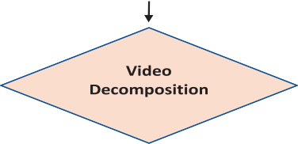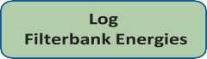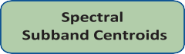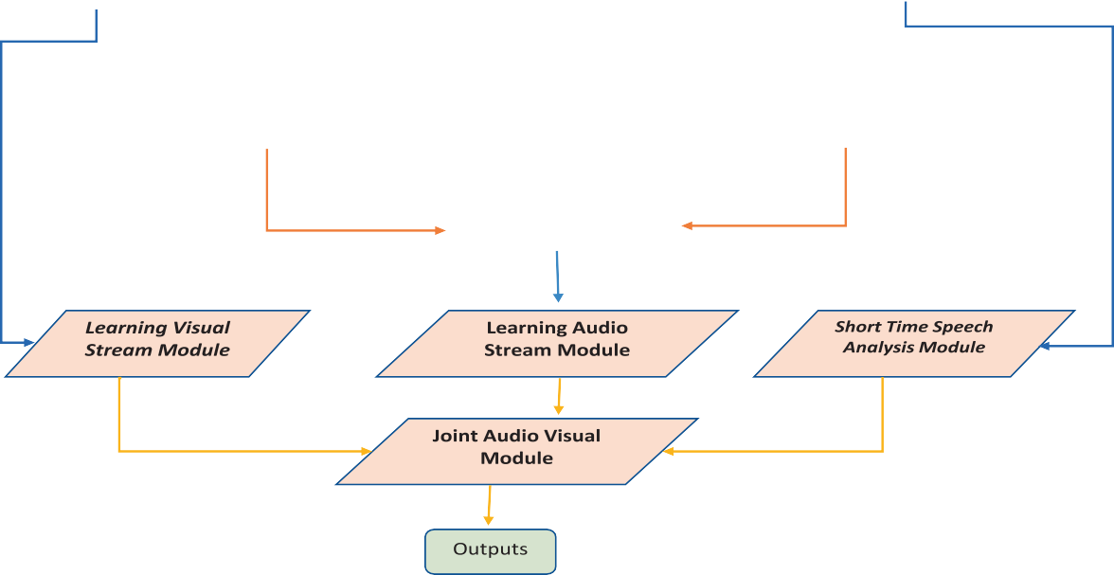

Fig. 1. Structure of the Proposed Model Which Consists of Four Modules to Isolate Speech of the Target Speakers.

NN. U-net was used for medical image segmentation and its struc- ture is very shallow and simple as it repeat blocks of CNNs,Relu and maxPooling for decoding and encoding path so it is very easy to implement. It achieved high segmentation performance on var- ious benchmarks and also it can work well with little amount of data. It has better performance in case of using it in speech separa- tion and enhancement.

The audio-visual architecture is created by combining the learned visual embeddings features and audio features, then this combination is processed by using a bidirectional long short- term memory ‘BLSTM’ and three dense layers. BLSTM able to anal- ysis input sequence from back to front and from front to back that enable the network to generate a context of the input where the network able to connect to past and future. The outputs of the net- work are complex spectrogram masks for all detected speaker in the video, then multiplied by the signal of the input audio and finally, they are converted back to waveforms to get an isolated speech of each detected speaker.

* 1. *Learning visual stream module*

This module is used to guide the overview model in the process of separation as the model would retrieve the voice of the target speaker based on the his/her face features.Firstly a pre- processing step is applied on the scanned images of the recoded videos to prepare the input of this module. In this step, a pre- trained FaceNet network takes detected faces from input image as input and output is a vector of 1792 values which represent the most important features crossponding to each face. In machine learning, this vector is called embedding feature vector then the proposed module takes as an input the concatenation of face embeddings features which are 75x1792Xnumber of speakers, as the number of frames in the input video is 75 frames, and FACENET network obtains 1792 face embeddings features for each frame.

The proposed module is trained by using inception block as it is built by different scales of convolution kernels, then contact in the end to fuse features of different scales. It depends on dilated Con- volutional Neural Networks to allow more efficient computation with different dilated factor in each block.

The dilated convolution is called convolution with a dilated fil- ter. It can expand the input by setting holes between its consecu- tive elements. It works as convolutions but using pixel skipping

to cover a large area from the input and discover relations between elements of the input easily. The classical CNN consumes too much computation resources but the dilated CNN could reduce the time of training by 12.09 % [11] and also it has better performance in image classification and segmentation.

Mainly in this module, we benefit from advantages of Incep- tions blocks and dilated convolution by constructing architecture that consists of four inception blocks where each inception block has different dilation factor. This module uses only four blocks because the updated version from FACENET is used for extracting input features of face and the process of increasing the dilation fac- tor would be harmful to small embedding features retrieved from FACENET [12].

Each block consists of concatenation of three dilated convolu- tion neural network and MaxPooling2D layers with size N1XM1, the first dilated CNN uses N filters with size N2XM2, second dilated CNN uses M filters with size N3XM3, third dilated CNN uses L fil- ters with size N4XM4, then the previous four layers are concate- nated, Batchnormaliztion and relu activation function are applied to the concatenated features as in Fig. 2. Max pooling is done as part of inception block to reduce over-fitting by providing an abstracted form of the representation. Each inception block has dif- ferent dilation rates to support exponential expansion in the con- text of the receptive field and this led to no loss of resolution.

Finally, a CNN layer with K filters is applied on features map resulted from Batchnormlization layer of the last inception block.

* 1. *Learning audio stream module*

To improve the process of speech separation, a concatenation of the Mel Frequency Cepstral Coefficients, Log Filterbank Energies and Spectral Subband Centroids of the input audio which are 302X65 as the number of Mel Frequency Cepstral Coefficients are 302X13, Log Filterbank Energies are 302X26 and Spectral Subband Centroids are 302X26. To analysis these features and argues the important of each one in separation process.

The proposed module takes the concatenation of these features as an input to six inception blocks with different dilation rate as the width of the input feature is 65 that means, if the number of inception blocks are increased than six, the last one will scan bor- ders all the time. Using dilated CNN in the process of analysis audio feature with different dilation factor in each inception block is con-

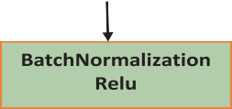

Fig. 2. Inception Block layers.



Fig. 3. Short Time Speech Analysis Module by using U-Net Network.

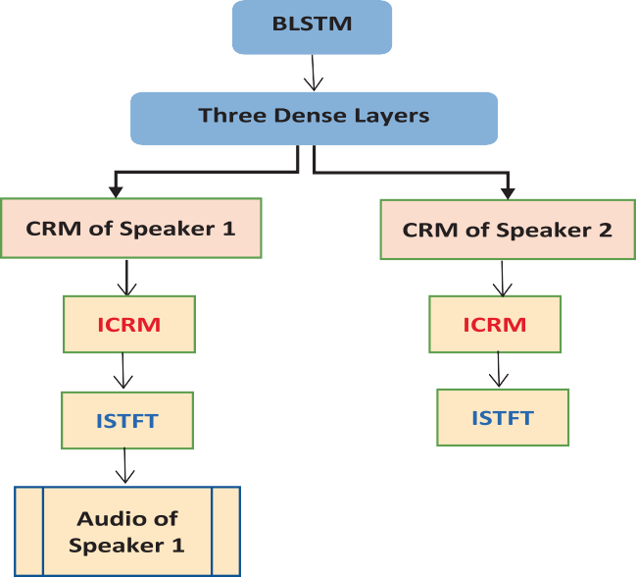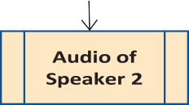

Fig. 4. A joint Audio-Visual Module.

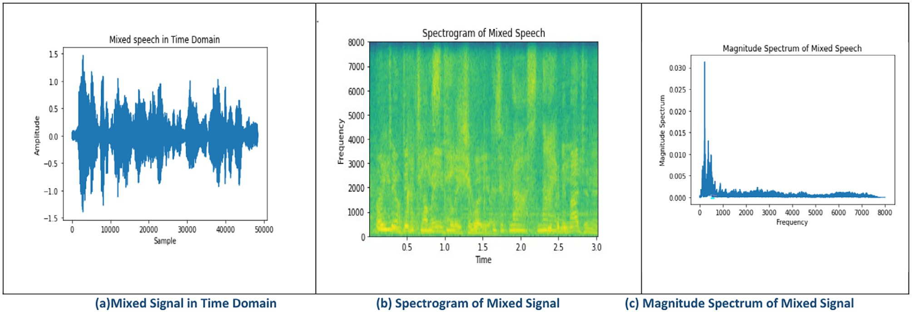

Fig. 5. Mixture speech of two speakers.

sidered an important process to resolution and context of the input.

Each block consists of concatenation of three dilated CNN and MaxPooling2D layers. The first dilated CNN uses N filters with size

Table 1

Filters of Inception Network.

|  |  |  |
| --- | --- | --- |
| Parameters | Learning Visual Stream Module | Learning Audio Stream Module |
| N | 50 | 25 |
| M | 50 | 50 |
| L | 100 | 100 |
| K | 256 | – |
| N1 × M1 | 3 × 1 | 3 × 3 |
| N2 × M2 | 1 × 1 | 1 × 1 |
| N3 × M3 | 3 × 1 | 3 × 3 |
| N4 × M4 | 5 × 1 | 5 × 5 |
| Dilation Rates | [1,2,4,7] | [1,2,4,8,16,32] |

Table 2

Filters of Unet Network.

|  |  |  |  |
| --- | --- | --- | --- |
| *Block* | *Layers[Filter Size = 5x5]* | *Input Size* | *Output Size* |
| *En_Block1* | CNN1 CNN2 | 304 × 256 × 2  304 × 256 × 64 | 304 × 256 × 64  304 × 256 × 64 |
| *En_Block2*  *En_Block3*  *En_Block4* | MaxPooling CNN1 CNN2  MaxPooling CNN1 CNN2  MaxPooling  CNN1 | 304 × 256 × 64  152 × 128 × 64  152 × 128 × 128  152 × 128 × 128  76 × 64 × 128  76 × 64 × 256  76 × 64 × 256  38 × 32 × 256 | 152 × 128 × 64  152 × 128 × 128  152 × 128 × 128  76 × 64 × 128  76 × 64 × 256  76 × 64 × 256  38 × 32 × 256  38 × 32 × 512 |
| *Con_Block* | CNN2  MaxPooling CNN | 38 × 32 × 512  38 × 32 × 512  19 × 16 × 512 | 38 × 32 × 512  19 × 16 × 512  19 × 16 × 1024 |
| *De_Block4*  *De_Block3* | UpSampling CNN1  CNN2  UpSampling | 19 × 16 × 1024  38 × 32 × 512  38 × 32 × 512  38 × 32 × 512 | 38 × 32 × 512  38 × 32 × 512  38 × 32 × 512  76 × 64 × 256 |
| *De_Block2*  *De_Block1* | CNN1 CNN2  UpSampling CNN1  CNN2  UpSampling CNN1  CNN2 | 76 × 64 × 256  76 × 64 × 256  76 × 64 × 256  152 × 128 × 128  152 × 128 × 128  152 × 128 × 128  304 × 256 × 64  304 × 256 × 64 | 76 × 64 × 256  76 × 64 × 256  152 × 128 × 128  152 × 128 × 128  152 × 128 × 128  304 × 256 × 64  304 × 256 × 64  304 × 256 × 64 |
| *Out_Block* | CNN | 304 × 256 × 64 | 304 × 256 × 2 |

N2XM2, second dilated CNN uses M filters with size N3XM3, third dilated CNN uses L filters with size N3XN4 and MaxPooling2D with size N1XM1, then the previous four layers are concatenated, Batch- normaliztion and Relu activation function are applied on the con- catenated features. The proposed module uses different kernel size of filters to analyze and track audio features in different scales.

* 1. *Short time speech analysis module*

In this module, audio data which is recoded in input video is analyzed and understood by using real and imaginary components of audio files after converting them to frequency domain.

The input of this module is a concatenation of real and imagi- nary components resulted from STFT which are 304X256x2. Fre- quency components are fed into U-Net to learn audio features. UNet is a convolutional neural network architecture that built by expanding with few changes in the CNN architecture, first used for biomedical image segmentation as has a great effect in o ana- lyzing and tracking features in different sizes and also it has a good performance in the speech separation. The U-net architecture is symmetric and consists of two major parts contracting path, Expansive Path, a convolution process between contracting and expansion paths named Con_Block and finally a convolution layer named Out_Block is applied after expansion path as shown in Fig. 3. The left part which is called contracting path consists of four processes named En_Block1, En_Block2, En_Block3 and En_Block4 respectively. Each process consists of two 2d convolutional and max pooling process which halves down size of input features. The right part which is called expansive path consists of four pro- cess named De_Block1, De_Block2, De_Block3, and De_Block1 respectively. It is going to upsized features of the previous process to its original size. The size of the input features is upsized, then the upsized features are concatenated with the corresponding fea- tures from the contracting path to generate a concatenated fea- tures which are taken as input to next layers in the same process which has two 2d convolutional layers, and finally the resulted image is prepared to be taken as input to start the next process.

* 1. *A joint audio-visual module*

Features concatenation is the method that has ability to trans- form the features in the separated columns into a single column of feature vector. It is necessary and essential process to generate new feature set that control the separation process. In this module, Learning Visual Stream, Learning Audio Stream and Short Time



Fig. 6. Validation Loss Ariel of Ephrat et al. [3].

Speech Analysis modules are concatenated by combining the fea- ture maps of the previous three modules, then BLSTM are applied on the concatenated features followed by three Dense layers.

Outputs of this module are compressed complex masks of speaker’s. All results of our experiments depend on CRM to sepa- rate audio segment of the target speaker. To retrieve the speech of the target speakers, firstly the predicted CRM resulted from model is decompressed by using equation (3), and then we calcu- late ICRM of decompressed CRM. The final speech of each speaker is computed by using ISTFT of ICRM as in Fig. 4.

( )= ( )

*D R*  1 log 10 — *R* 3

# 0.1 10 + *R*

where D is decompressed CRM resulted from model, *ICRM* is the inverse of decompressed, (R) is compressed CRM.

1. Experiments and results

In order to compare our results with the Audio-Visual model of the previous work, we implemented Ephrat et al. [3] Speech Sepa- ration model, we train and test it using the same dataset in our proposed model.

Table 3

We compare our speech separation results in case of training our proposed network using Experiment 1 and Experiment 2 with Cocktail party model [3], using the Short- time objective intelligibility (STOI), Perceptual Evaluation of Speech Quality (PESQ) and Frequency-weighted Segmental SNR (fwSNRseg) to compare the quality of models.

|  |  |  |  |
| --- | --- | --- | --- |
| Training/Testing | STOI | PESQ | fwSNRseg |
| *Ariel Ephrat* et al. [3] | 0.72 | 1.75 | 10.90 |
| *Experiment 1* | 0.77 | 1.85 | 11.95 |
| *Experiment 2* | 0.80 | 2.17 | 12.59 |

Table 4

Using ‘Csig’ which is the predicted rating of speech distortion and ’Covl’ which is the predicted rating of overall quality to compare the proposed with Cocktail part model [3].

Training/Testing Csig) Covl

Ariel Ephrat et al. [3] 3.17 2.40

Experiment 1 3.28 2.51

Experiment 2 3.58 2.83

To generate our dataset of two-speaker, 250 videos are taken from the BBC (LRS2) Dataset [13]. The BBC dataset consists of thou- sands of spoken sentences from BBC television. Each sentence is up



Fig. 7. Experiment 1 validation loss.

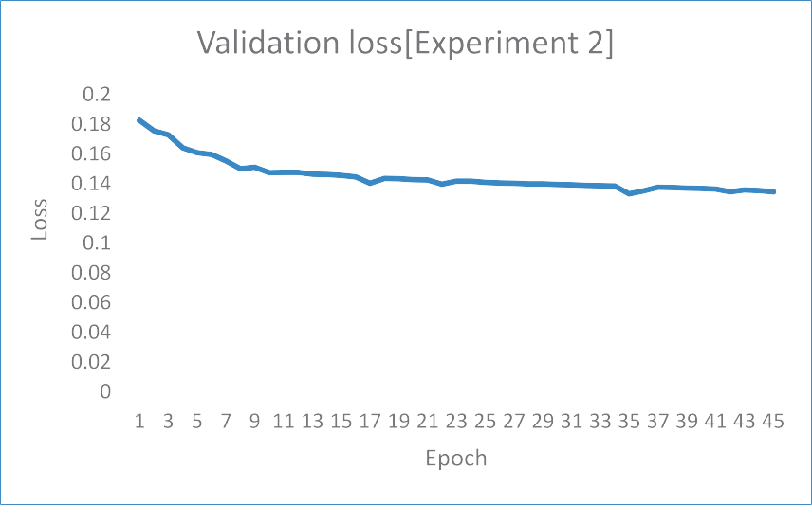

Fig. 8. Experiment 2 validation loss.

to 100 characters in length. The video segments have a length between 3 and 10 s. The dataset was built by combining clean speech of two speakers from different videos: combined speech = *Speaker*1 + *Speaker*2where *Speaker*1 and *Speaker*2 are clean speeches as in Fig. 5. The total generated samples in our data- sets are 15,625 samples splitted into 14,063 for training and 1562 for testing.

The proposed model takes visual embedding and audio features as inputs. OpenCV library is used to detect speaker’s face in the input video. OpenCV is the most popular library for computer vision. Originally written in C/C++, it now provides bindings for Python [14].

Audio files are resampled to 16 kHz, then STFT is computed of 3-second audio segments of the input video. Every time–frequency (TF) bin consists of real and imaginary parts of a complex number

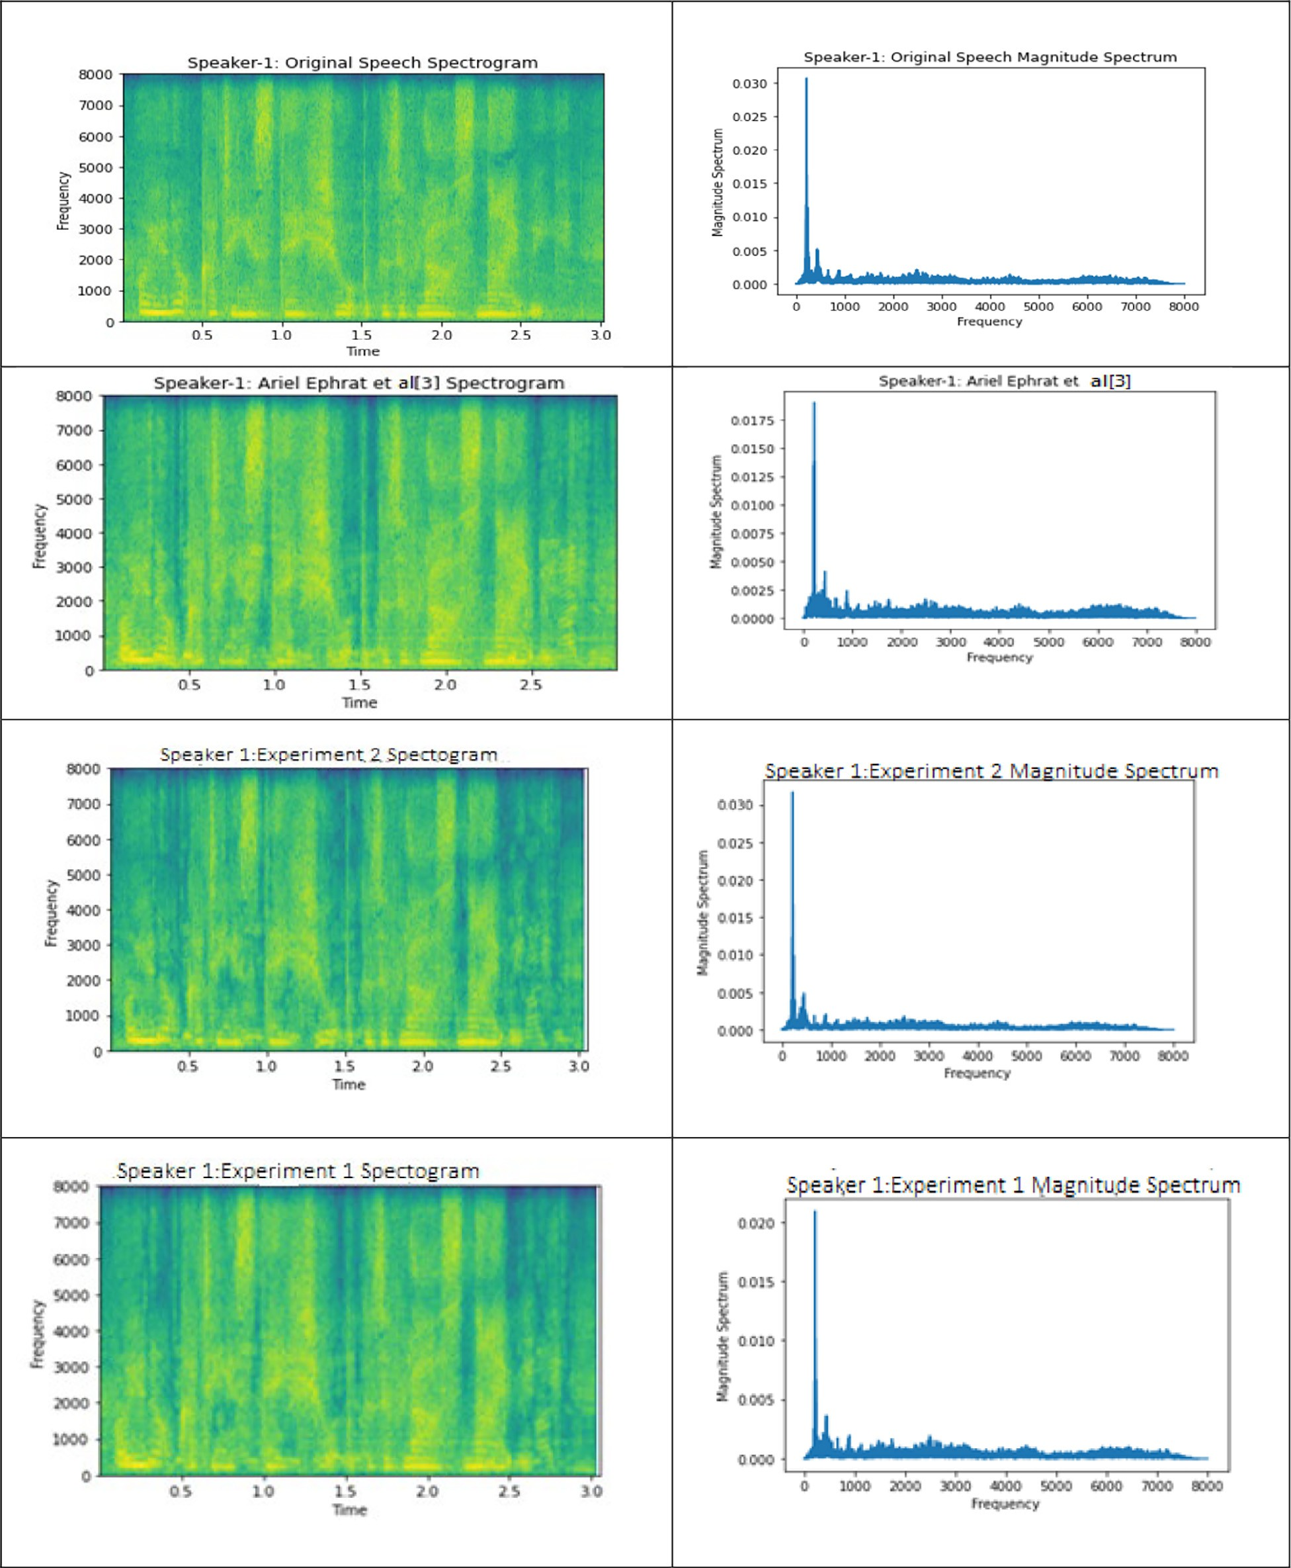

as they are used as an input to train our model. STFT is computed on input audio files using a Hann window of length 25 ms, hop length of 10 ms, and FFT size of 512.

We use python_speech_features [16] library to compute Mel Frequency Cepstral Coefficients, Log Filterbank Energies and Spec- tral Subband Centroids of 3-seconds input segments which are

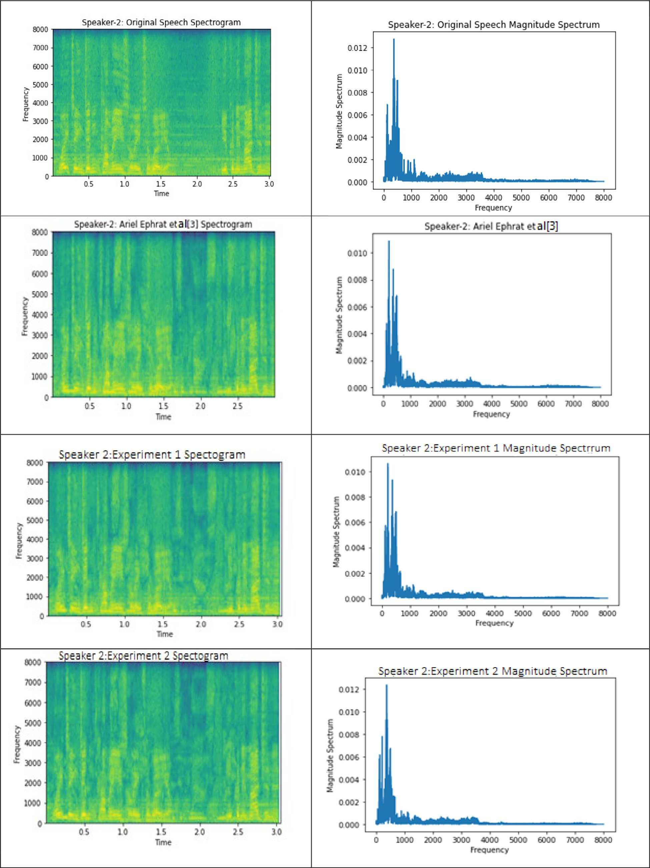

combined, then used as an input to our proposed model. We use the mean squared error (L) between compressed clean spectro- gram and the enhanced spectrogram to train our proposed model as in equation (4).

iment 1 as shown in Tables 3 and 4. The spectrogram and magni- tude spectrum of each speaker have best values compared to experiment 1 and Ariel Ephrat et al. [3] as in Figs. 9 and 10.

P*N* (*A*(*i*)— *P*(*i*) 2 — 0.1P*N* (*A*(*i*)— *P*(*j*))

*L*(*A*, *P*) = *i* ) *j*–*i*

*S*

# (4)

1. Conclusion

In this paper, we presented combined architecture between

where A is compressed clean spectrogram, P is the enhanced spec- trogram N is the number of speakers and S is the size of CRM.

We have two experiments which are implemented using Ten- sorFlow. To evaluate our experiments, we use as a helper Python Speech Enhancement Performance Measures (Quality and Intelligi- bility) project [17], predicted rating of speech distortion and over- all quality project [18].

* 1. *Experiment 1*

In this experiment, the proposed model takes visual streams of the target speaker and STFT components of mixed speech as input where the output is corresponding compressed CRM of target speaker. A combination between visual stream, speech frequency analysis and joint audio visual modules are used to build the over- all architecture.

Visual stream module uses combination of inception blocks where each inception block uses the concatenation of learnable parameters in Table 1 that consist of 50 filters with size 1X1 ‘‘where size means number of scanned neighbors information” to track and focus on pure embedding features, 50 filters with size 3x1, 100 filters with size 5x1” number of filters is doubled as the scanned area relative to neighbors increased from 3 to 5” to analysis the relation between neighbors features in different levels and finally maxpooling with size 3x1. Table 2 shows the UNet fil- ters relative to each layer in speech frequency analysis module where each block in encoder and decoder path consists of two con- volutions layers with the same number of filters and maxpool- ing2D with size 2x2 to halve input features.The joint audio-visual module consists of BLSTM with 400 neurons followed by three Dense layers with 600 neurons.

In this experiment, a batch size of six samples and Adam opti- mizer for 2343 batches with learning rate of 1X10—5 are used to complete the separation process. It is observed that experiment 1 has better validation loss compared to Ariel Ephrat et al. [3]. It has better Speech Enhancement Performance, predicted rating of speech distortion and overall quality compared to Ariel Ephrat et al. [3]. The spectrogram and magnitude spectrum of each speaker are better than Ariel Ephrat et al. [3].

* 1. *Experiment 2*

In this experiment, the proposed model takes Cepstral Coeffi- cients, Log Filterbank Energies and Spectral Subband Centroid as an input feature beside visual streams and STFT components. It is trained by using a concatenation of the audio stream analysis mod- ule beside three modules mentioned in experiment1.

In audio stream analysis module, each inception block consist of concatenation of 25 filters with size 1x1, then the number of filters is duplicated when the size of filter increased so the audio module uses 50 filters with size 3x3 and 100 filters with size 5x5. Every inception block in this module uses maxPooling with size 3x3 as in Table 1.

This experiment uses Adam optimizer with learning rate 1X10—5 and batch size equal two. It has better validation loss com- pared to previous work and experiment 1 as in Figs. 6–8. Speech Enhancement Performance predicted rating of speech distortion are considered best values compared to previous work and Exper-

voice and audio data for speech separation which has better per- formance comparing to pervious work. We generate a new dataset by using 250 videos from (LRS2) Dataset which contains visible speaker and clean speech. The proposed model used a deep neural network structure consists of u-net and inception networks to learn the separation process. Our proposed model consists of two modules for audio, one for visual streams and the fourth one for feature concatenation where the visual streams data of each speaker is taken from speaker’s detected faces, and the audio stream data is taken from mixture of speakers’ speech in the input audio. To evaluate its performance, we used python Speech Enhancement Performance Measures as Short-time objective intel- ligibility, Perceptual Evaluation of Speech Quality and Frequency- weighted Segmental SNR and predicted rating of speech distortion and the predicted rating of overall quality. The experiments illus- trated that our proposed model improved STOI with 11 %, PESQ with 24 %, and fwSNRseg with 16 % compared with previous works. It also improved Csig’ with 13 % and ’Covl’ with 18 % compared to other visual models. In our view, we will promise future directions include enhancing quality of target speaker’s speech by taking the resulted signal from this system as an input to speech enhanced system and we will take in our consideration removing any back- ground noises mixed with the speech of the target speaker.

Declaration of Competing Interest

The authors declare that they have no known competing finan- cial interests or personal relationships that could have appeared to influence the work reported in this paper.

References

1. Yannan Wang, Jun Du, Li-Rong Dai, Chin-Hui Lee, Unsupervised single-channel speech separation via deep neural network for different gender mixtures, in: *Proceeding in Asia-Pacific Signal and Information Processing Association Annual Summit and Conference (APSIPA),* Jeju, Korea, 13-15 December 2016.
2. Quan Wang, Hannah Muckenhirn, , Prashant Sridhar, Zelin Wu, John Hershey, Rif A. Saurous, Ron J. Weiss, Ye Jia, Ignacio Lopez Moreno, VoiceFilter: Targeted Voice Separation by Speaker-Conditioned Spectrogram Masking, *Proceeding in International Speech Communication Association INTERSPEECH,* Graz, Austria, 15- 19 September 2019.
3. Ariel Ephrat, Inbar Mosseri, Oran Lang, Tali Dekel, Kevin Wilson, Avinatan Hassidim, William T. Freeman, Michael Rubinstein*,* Looking to Listen at the Cocktail Party:A Speaker-Independent Audio-Visual Model for Speech Separation, *ACM Trans. Graph. Journal*, Vol:37, No: 4, PP: 112:1-112:11,2018.
4. [Luo Yi, Mesgarani N. Conv-TasNet: surpassing ideal time–frequency](http://refhub.elsevier.com/S1110-8665(22)00062-7/h0020) [magnitude masking for speech separation. IEEE/ACM Trans Audio Speech](http://refhub.elsevier.com/S1110-8665(22)00062-7/h0020) [Lang Process 2019;27(8):1256–66](http://refhub.elsevier.com/S1110-8665(22)00062-7/h0020).
5. Jian Wu, Yong Xu, Shi-Xiong Zhang, Lian-Wu Chen, Meng Yu, Lei Xie, Dong Yu, Time Domain Audio Visual Speech Separation, *Proceedings in the 20th Annual Conference of the International Speech Communication Association INTERSPEECH 2019*, Graz, Austria, 15-19 September. 2019.
6. Tomasz Grzywalski, Szymon Drgas, Application of recurrent U-net architecture to speech enhancement, *Proceeding in 2018 Signal Processing: Algorithms, Architectures, Arrangements, and Applications (SPA)*, Poznan, Poland,19-21 September 2018.
7. Daniel Stoller, Sebastian Ewert, Simon Dixon Wave-U-Net: a multi-scale neural network for end-to-end audio source separation, *Proceeding in the 19th International Society for Music Information Retrieval Conference (ISMIR 2018*), Paris, France 23-27 September 2018.
8. Emad M. Grais, Dominic Ward, Mark D. Plumbley, Raw multi-channel audio source separation using multi-resolution convolutional auto-encoders, *Proceeding in 2018 26th European Signal Processing Conference (EUSIPCO),* Rome, Italy, 3-7 September 2018.
9. Dario Rethage, Jordi Pons, Xavier Serra, A wavenet for speech denoising*, Proceedings in IEEE International Conference on Acoustics, Speech and Signal Processing*, Calgary, AB, Canada, April 15-20, 2018.
10. Christian Szeged, Wei Liu, Yangqing Jia, Pierre Sermanet, Scott Reed, Dragomir Anguelov, Dumitru Erhan, Vincent Vanhoucke, Andrew Rabinovich, Going deeper with convolutions, *Proceedings in 2015 IEEE Conference on Computer Vision and Pattern Recognition (CVPR),* Boston, MA, USA,7-12 June 2015.
11. [Lei X, Pan H, Huang X. A dilated CNN model for image classification. IEEE](http://refhub.elsevier.com/S1110-8665(22)00062-7/h0055) [Access 2019;7:124087–95](http://refhub.elsevier.com/S1110-8665(22)00062-7/h0055).
12. Ryuhei Hamaguchi, Aito Fujita, Keisuke Nemoto, Tomoyuki Imaizumi, Shuhei Hikosaka, Effective use of dilated convolutions for segmenting small object instances in remote sensing imagery, *Proceedings in 2018 IEEE Winter Conference on Applications of Computer Vision (WACV),* Lake Tahoe, NV, USA, 12-15 March 2018.
13. https://[www.robots.ox.ac.uk/~vgg/data/lip_reading/lrs2.html](http://www.robots.ox.ac.uk/~vgg/data/lip_reading/lrs2.html) last accessed:20/

2/2021.

1. Mastering Computer Vision with TensorFlow 2.x: Build advanced computer vision applications using machine learning and deep learning techniques book.
2. Florian Schroff, Dmitry Kalenichenko, James Philbin, FaceNet: A Unified Embedding for Face Recognition and Clustering, *Proceeding in E EE Conference on Computer Vision and Pattern Recognition (CVPR),* Boston, MA, USA, 7-12 June 2015.
3. https://github.com/jameslyons/python_speech_features library last accessed: 22/10/2021.
4. https://github.com/schmiph2/pysepm last accessed: 10/11/2021.
5. https://github.com/usimarit/semetrics/blob/master/README.md last accessed 10/11/2021.