[Egyptian Informatics Journal 24 (2023) 100390](https://doi.org/10.1016/j.eij.2023.100390)

Contents lists available at [ScienceDirect](http://www.sciencedirect.com/science/journal/11108665)

Egyptian Informatics Journal

journal homepage: [www.sciencedirect.com](https://www.sciencedirect.com/)

[](http://crossmark.crossref.org/dialog/?doi=10.1016/j.eij.2023.100390&domain=pdf)AI-Driven livestock identification and insurance management system

Munir Ahmad a, Sagheer Abbas a, Areej Fatima b, Taher M. Ghazal c,d, Meshal Alharbi e,

Muhammad Adnan Khan f,*, Nouh Sabri Elmitwally g,h

a *School of Computer Science, National College of Business Administration & Economics, Lahore 54000, Pakistan*

b *Department of Computer Science, Lahore Garrison University, Lahore 54000, Pakistan*

c *School of Information Technology, Skyline University College, University City Sharjah, Sharjah 1797, UAE*

d *Applied Science Research Center, Applied Science Private University, Amman 11931, Jordan*

e *Department of Computer Science, College of Computer Engineering and Sciences, Prince Sattam Bin Abdulaziz University, Alkharj 11942, Saudia Arabia*

f *Department of Software, Faculty of Artificial Intelligence and Software, Gahcon University, Seongnam 13120, Republic of Korea*

g *School of Computing and Digital Technology, Birmingham City University, Birmingham B4 7XG, UK*

h *Department of Computer Science, Faculty of Computers and Artificial Intelligence, Cairo University, Giza 12613, Egypt*

A R T I C L E I N F O

*Keywords:* Machine Learning Transfer Learning Deep Learning

Artificial Intelligence

A B S T R A C T

Cattle identification is pivotal for many reasons. Animal health management, traceability, bread classification, and verification of insurance claims are largely depended on the accurate identification of the animals. Conventionally, animals have been identified by various means such as ear tags, tattoos, rumen implants, and hot brands. Being non-scientific approaches, these controls can be easily circumvented. The emerging technologies of biometric identification are extensively applied for Human recognition via thumb impression, face features, or eye retina patterns. The application of biometric recognition technology has now moved towards animals. Cattle identification with the help of muzzle patterns has shown tremendous results. For precise identification, nature has awarded a unique Muzzle pattern that can be utilized as a primary biometric feature. Muzzle pattern image scanning for biometric identification has now been extensively applied for identification. Animal recognition via Muzzle pattern image for different applications has been proliferating gradually. One of those applications in- cludes the identification of fake insurance claims under livestock insurance. Fraudulent animal owners tend to lodge fake claims against livestock insurance with proxy animals. In this paper, we proposed the solution to avoid and/or discard fraudulent claims of livestock insurance by intelligently identifying the proxy animals. Data collection of animal muzzle patterns remained challenging. Key aspects of the proposed system include: (1) the Animal face will be detected through visual using YOLO v7 object detector. (2) After face detection, the same procedures will apply to detect muzzle point (3) the muzzle pattern is extracted and then stored in the database. The System has a mean average precision of 100% for the face and 99.43% for the nose/muzzle point of the animal. Once the animal is registered in the database, the identification process is initiated by extracting unique nose pattern features with ORB and/or SIFT. Then it is matched using the pattern matchers like BFMatcher and/ or FLANNMatcher for animal identification. The proposed model is more efficient and accurate as compared to concurrent approaches. The results extracted from this research study show 100% accurate identification.

# Introduction

Nature provided human beings with countless blessings and animals are one of those. They are beneficial in many ways as a source of nurtured food like meat, dairy products, and clothing such as woolen and leather [1].

To protect the Cattle effectively from multiple hazards, their

accurate identification is of utmost importance. Cattle identification can broadly be categorized into two types namely contact and non-contact methods [2]. Under the contact method, various techniques have been used manually to recognize animals such as hot iron branding, freeze branding, ear tags, rumen implants, tattoos, etc. [3]. Though conven- tional methods served the purpose to some extent but with a major pitfall of easy circumvention [4]. Contact methods inherent major

* Corresponding author.

*E-mail addresses:* [munir@ncbae.edu.pk](mailto:munir@ncbae.edu.pk) (M. Ahmad), [dr.sgaheer@ncbae.edu.pk](mailto:dr.sgaheer@ncbae.edu.pk) (S. Abbas), [areejfatima@lgu.edu.pk](mailto:areejfatima@lgu.edu.pk) (A. Fatima), [taher.ghazal@skylineuniversity.](mailto:taher.ghazal@skylineuniversity.ac.ae) [ac.ae](mailto:taher.ghazal@skylineuniversity.ac.ae) (T.M. Ghazal), [mg.alharbi@psau.edu.sa](mailto:mg.alharbi@psau.edu.sa) (M. Alharbi), [adnan@gachon.ac.kr](mailto:adnan@gachon.ac.kr) (M.A. Khan), [Nouh.elmitwally@bcu.ac.uk](mailto:Nouh.elmitwally@bcu.ac.uk) (N.S. Elmitwally).

<https://doi.org/10.1016/j.eij.2023.100390>

Received 29 March 2023; Received in revised form 12 May 2023; Accepted 10 July 2023

Available online 16 July 2023

1110-8665/© 2023 THE AUTHORS. Published by Elsevier BV on behalf of Faculty of Computers and Artificial Intelligence, Cairo University. This is an open access article under the CC BY-NC-ND license (<http://creativecommons.org/licenses/by-nc-nd/4.0/>).

drawback of Animal stress due to the painful procedure involved to mark identity. However, these are invasive for the cattle and non-cost- efficient as compared to other more effective processes [5]. Non- contact methods include AI-based technologies using biometric identi- fication and other machine learning models.

Cattle identification is equally important for Livestock Risk coverage. Insurers are highly concerned about the exact recognition of insurable animals; not only to provide adequate cover but also to establish a firm basis for subsequent verification. Cattle identification using conven- tional approaches remain a significant issue for livestock insurers and veterinarian for registration and health monitoring activities.

Manual processing of cattle identification is considered highly vulnerable to fake insurance claims that can’t be detected accurately [4].

During the last couple of decades, with the evolvement of AI tech- nologies such as machine learning / deep learning, human recognition using human biometrics features of the face, iris, fingerprint, etc. It has become quite easy to recognize human beings with greater accuracy [6]. The recognition using biometrics is not limited to humans anymore and now animal recognition has also become a vital segment of this emerging technology [7].

The cattle identification system could be used to fulfill a variety claims, animal traceability, registration, monitoring, and.

Animal Registration through a Biometric system, based on scientific techniques is widely used for Cattle identification and traceability [8]. A highly transparent process of cattle registration would mitigate the risk of manipulation, fraudulent verification, and cattle swapping. The Cattle Registration process comprises a standard framework-based system [9] for verification of bogus insurance claims of registered cattle. Not only for Insurance Claims verification, but it’s also equally important for the

implementation of animal safety policies [10].

Biometric identification of cattle provides fundamental information for numerous applications. One of the prominent applications is to manage fake livestock Insurance claims [11]. Farm owners who have insured their cattle, unfortunately, tend to make false claims because a non-technical layman who did not stay around the cattle so much, cannot easily recognize the cattle. Only those who stay for a longer period and are appropriately familiar with the cattle can identify which one had been insured. Hence, these fraudulent farm owners successfully deceive Insurers and obtain claim money for the cattle that were not even registered. To overcome this issue of bogus Insurance claims lodged by farm owners, an Automated Intelligent Cattle Identification and Insurance Claim Management System is proposed to overcome the most critical issue faced by the insurers which are fake claims. Just like human fingerprints, cattle muzzle print comprises two unique features recognized as ridge bifurcation and ridge termination which can be used to track accurate Identity by matching relevant information with pre- served datasets.

The input parameters of the proposed system comprise three layers namely Data Acquisition, Pre-processing, and Data Preparation. The Data Acquisition Layer represents the source from which the data is firstly pooled in the system. In this segment, two activities will have been performed namely collection of raw images of animals and then storing cluster datasets into the database management system. We also use a video dataset to enhance accuracy. The Number of frames in the video sequence impacts the identification results.

Pre-processing is an essential layer applied to extract image features and subsequent matching procedures for object recognition [12]. The prime objectives to be achieved in the pre-processing segment are to minimize though not eliminate the noises and other particles muzzle images. Next to data collection, data will be purified by applying certain processes. Major activities In Preprocessing segment include to Remove Blurry and noisy images, Cropping and Resizing of images. Data Prep- aration is the final stage of Data input for the biometric system of Cattle identification. Purified data received from preprocessing layer will finally tag in the Data preparation layer. Activities performed include

labeling/ notation of images and then splitting data into train and test data.

The proposed system will intelligently detect the face and muzzle point of the cattle, and identify/recognize the cattle using muzzle pat- terns in real-time.

The system will not only be helpful for the detection of false insur- ance claims but it can also be utilized on farms for monitoring the cattle, for their health, safety, and management. The traditional approaches to recognizing cattle except for the naked eye are tagging the animal using ear tags, and implanting microchips in the animal [13]. While micro- chips like NFC, RFID, etc. are better than ear tags, they can be expensive, and hurtful to the cattle as they will be needed to be implanted inside the cattle and there will be a need for an expert who can safely execute the said procedure, which can be expensive. On the other hand, using ear tags is not very efficient as these tags can be forged or switched from one animal to other pretty easily.

The proposed system offers wide range of potential applications, including the accurate and efficient tracking of individual cattle for breeding or medical purposes, as well as monitoring their behavior and movement within feedlots, and identifying lost or stolen animals. This novel approach has the potential to revolutionize cattle management and tracking, resulting in increased productivity and efficiency within the agricultural sector. By utilizing advanced computer vision tech- niques, the proposed system provides a rapid and precise method for identifying specific cattle based on their unique biometric characteris- tics, offering significant advantages over traditional identification methods.

Section 2 demonstrates the literature review. Section 3 explains the Research Methodology to intelligently identify cattle in real-time. It includes description of all the adopted tools and technologies for achievement of our research objectives. Section 4 elucidates the per- formance of proposed model and experimental results. Section 5 con- cludes the research work and recommend some new avenues for future researches.

# Literature review

During the last couple of decades, numerous research studies have been conducted on biometric features based on Animal identity [8]. The emergence of Precision Livestock Farming (PLF) played an important role in the fourth Industrial Revolution [14]. Owners of big cattle farms are induced to adopt new identification techniques because traditional methods are more expensive, cumbersome to implement, and sometimes inefficient to manage a larger number of animals. Moreover, Artificial Intelligence (AI) has made the task much easier to identify any cattle with greater accuracy, minimal effort, and shorter time [15]. Since ancient times, various techniques have been employed for accurate identifications of cattle. Conventional systems of cattle recognition include Hot or cold branding, ear tagging, ear tattoos, and ear notches [16]. Though these are comparatively cheaper the process is very paining for cattle which often causes severe health issues for the animals [16].

Alternatively, the Biometric system uses visual features to identify an individual animal. Biometric features may include iris patterns, muzzle images, and eye retina. These methods though introduce computerized systems but they also involve some critical challenges, such as accuracy based on extracted features and time required for process completion. Anders Herlin et al. [17] highlighted the usage of digital technologies such as GPS collars, E-tagging, and Chips used for RFID and its impli- cations for the management and monitoring of cattle farms.

The recent work in cattle face recognition has brought forth multiple techniques to recognize cattle faces. In earlier days of research on cattle biometrics features, Scale Invariant Feature Transform (SIFT) technique had been used to extract muzzle patterns features from image print [18]. The implanted RFID chips are also used for tracking and identification of cattle. However, it is challenging for large herds to implement RFID

effectively [4]. Researchers used texture fusion techniques for the extraction of muzzle features. Worapan Kusakunniran et al. [19] pro- posed a fusion of Transition Local Binary Pattern with Gabor feature. Convolution Neural Network was proposed for greater accuracy of image recognition. The CNN technology is applied on basis of system training instead of a hardcoded algorithm; resultantly a large number of images can be identified [20]. Kumar et al. [21] proposed cattle face

recognition approach using LBP and SURF feature extractors with Gaussian Pyramid [22] levels 1 through 4. This technique might not work properly with images in different lighting conditions. Also, they are using full face images of cattle which is not very efficient in recog- nizing cattle as mostly the cattle have similar facial features. Zin et al.

[23] proposed a method of cow detection using ear tags, they used you only look once (YOLO) [24] object detection to detect cow head in real-

**Table 1**

Related Work Comparison with Proposed Solution.

|  |  |  |  |  |  |
| --- | --- | --- | --- | --- | --- |
| Paper/Author | Title | Method Used | Accuracy | Limitation | Our Solution |
| Kumar, Santosh & | Face Recognition for Cattle | LBP and SURF Feature | 92.75% | The Data they have used is the | We are recognizing cattle by using |
| Singh, Sanjay. |  | Extraction along with |  | photos of cattle faces. The cattle | cattle biometrics that is their nose |
| (2015). |  | Gaussian Pyramid |  | have very similar faces and hence | pattern, as each animal has a unique |
|  |  | Smoothing. The Algorithms |  | should not be used for | nose pattern. |
|  |  | that are used are: |  | identification. |  |
|  |  | Principle Component |  |  |  |
|  |  | Analysis |  |  |  |
|  |  | Linear Discriminant Analysis |  |  |  |
|  |  | Independent Component |  |  |  |
|  |  | Analysis |  |  |  |
|  |  | ICA_LibSVM |  |  |  |
| Kumar, Singh | Automatic identification of | They extracted muzzle point | 96.74% with | They have used muzzle point | Considering the issue of animals |
| Sanjay. (2016). | cattle using muzzle point | texture features using: | Fuzzy-KNN | recognition and the system requires | running away, our system lets the |
|  | pattern: a hybrid feature | Haralick texture features |  | capturing muzzle point images of | laymen point the camera towards |
|  | extraction and | techniques |  | cattle which is not an easy thing to | the animal and it will automatically |
|  | classification paradigm | morphology based features, |  | do as animals tend to run away. | capture images, and not just muzzle |
|  |  | shape based features |  |  | point, but the animal, its face and |
|  |  | Histogram of Oriented |  |  | muzzle, which can be used for even |
|  |  | Gradient (HOG) |  |  | better recognition/identification of |
|  |  | Wavelet |  |  | the animal. |
|  |  | Colour features |  |  |  |
|  |  | Tamuras |  |  |  |
|  |  | Laws Texture Energy (LTE) |  |  |  |
|  |  | Local Binary Pattern texture |  |  |  |
|  |  | Fuzzy-Local Binary Pattern |  |  |  |
|  |  | The Algorithm they used for |  |  |  |
|  |  | classification: |  |  |  |
|  |  | KNN |  |  |  |
|  |  | Fuzzy KNN |  |  |  |
|  |  | Radial Basis Function |  |  |  |
|  |  | Decision Tree |  |  |  |
|  |  | Gaussian Mixture Model |  |  |  |
|  |  | Probabilistic Neural Network |  |  |  |
|  |  | MLP Classifier |  |  |  |
|  |  | Naïve Bayes Classifier |  |  |  |
| Kusakunniran | Biometric for Cattle | contrast limited adaptive | 95.13% | They have used watershed | This issue is also dealt with in our |
| et al., (2020) | Identification using Muzzle | histogram equalization |  | algorithm and estimated the | system as with our system all it is |
|  | Patterns | (CLAHE) technique to |  | position of the muzzle point at the | needed to keep the camera pointed |
|  |  | enhance muzzle image |  | center of the image which will not | at the animal and it will |
|  |  | extracted from cattle face. |  | be true in real-time and cannot | automatically capture images, and |
|  |  | Then BoHoG and LBP |  | always keep the animal have its | not just muzzle point, but the |
|  |  | histogram are used for |  | muzzle point in the center. | animal, its face and muzzle, which |
|  |  | recognition |  |  | can be used for even better |
|  |  |  |  |  | recognition/identification of the |
|  |  |  |  |  | animal. |
| Wang, Qin, Hou | Cattle Face Recognition | VGGNet Deep Convolutional | 70% | They are using face images and no | We are recognizing cattle by using |
| and Gong, | Method Based on | Neural Network. |  | animal biometrics are involved. | cattle biometrics that is their nose |
| (2020) | Parameter | Pre-trained and fine-tuned |  |  | pattern, as each animal has a unique |
|  | Transfer and Deep Learning | ImageNet |  |  | nose pattern. |
| Thi Thi Zin et al. | Cow Identification System | You Only Look Once (YOLO) | 96% Cow | They are using ear tags to recognize | Our system has 100% mAP for cattle |
| (2020) | Using Ear Tag Recognition | base cow Head detection. | Head | the cows, which is not an efficient | head/face detection, and our |
|  |  | Images Segmentation for Ear | Detection | approach as the tags can be forged | approach is based on animal |
|  |  | Tag recognition. | 84% Cow | and switched. | biometrics. |
|  |  |  | recognition |  |  |
| Yongliang Qiao | Automated Individual | CNN | 93.3% | Accuracy based on video frame | We use VOLOv7 model for object |
| et al.(2021) | Cattle Identification Using | BiLSTM. |  | length may not improve or even | detection which is the most efficient |
|  | Video Data: A Unified Deep | Inception-V3 CNN for visual |  | decrease after a certain frame length | in speed and accuracy. |
|  | Learning Architecture | feature extraction |  |  |  |
|  | Approach |  |  |  |  |
| Ali Shojaeipour | Automated Muzzle | YOLO-ResNet-50 | 99.11% | They have used a smaller dataset of | In the proposed model we use 8,020 |
|  | Detection and Biometric |  |  | 563 images. Further studies are | images which is reasonable sample |
|  | Identification via |  |  | required to verify the accuracy. | size for generic prediction. |
|  | Few-Shot Deep Transfer |  |  |  |  |
|  | Learning of Mixed Breed |  |  |  |  |
|  | Cattle. |  |  |  |  |

time, and from there, they recognize ear tags using image segmentation techniques. The problem with this technique is the ear tags that can be altered and forged. Hongyu Wang et al. [25] proposed a parametric transfer approach with VGGFace dataset and VGG-16 deep convolu- tional neural network. Pre-trained VGG-16 network is then fed with their cattle face dataset. Their dataset contains images of cattle faces, which again is not a very efficient way to recognize cattle, especially buffalos, as in low-lit environments, their facial features cannot be differentiated. Santosh Kumar et al. [26] proposed a system to recognize cattle in real-time. The proposed system recognizes cattle using the muzzle point or nose pattern of the cattle. It involves: (1) the cattle is captured through a video camera in real-time, (2) the frames are then cropped into nose/muzzle point images (3) which are then preprocessed further to remove any noise or blurry images and converted into gray- scale images, (4) then their features are extracted using appearance- based feature extractor algorithms, (5) which are then stored into the database. In their testing phase, they take the nose image as a query image and then extract features using FLLP extractor. At this point, the features are matched with the features in the database, where a threshold value is returned, which is compared with a predefined threshold value to determine the decision of cattle recognition. The problem with this method is that nose images are cropped from sur- veillance video frames. Santosh Kumar et al. [27] presented a compre- hensive review of cattle identification along with problems/drawbacks involve in various methods, they emphasized on development of a framework for cattle identification via muzzle point. Table 1 has the comparison of proposed solution with related work by other researchers.

# Research methodology

The proposed system to intelligently identify cattle in real-time or in still images or videos requires an image dataset of cattle to be trained so that it can detect the face/head and nose of cattle. The process of col- lecting image datasets for training and testing consists of the following steps, which include:

* Data Acquisition
* Data Preprocessing
* Data Augmentation
* Data Preparation
  1. *Data Acquisition*

Raw images of cattle were taken using different smartphones with different camera capabilities. The environments in which the images were taken were different too, to add diversity to image data. These include indoor, outdoor, sunny, and cloudy weather conditions. The cattle include domestic buffalos, cows, calves, and bulls. Taking pictures of these animals was the most difficult part of data acquisition as it required a lot of hard work and running after the animals. This struggle resulted in a lot of useless images, a few of which can be seen in Fig. 1. The difficulty in taking the pictures of cattle was that the animals would get scared the moment a person goes near to grab their picture, as it is required for the dataset that the images of cattle should be clear and have their head/face in it. Another problem that occurred was that, because some of the cattle were eating/grazing, their nose/muzzle point was covered in grass straws, hence taking such images would be of no use. Even though it was the priority to collect clear and concise images of cattle, a lot of useless images were still captured along with the required images. Images of animals including, cows, buffalos, bulls, and calves along with images other than these were collected, which included humans, dogs, sheep, horses, and donkeys, etc. A dataset of 300 animals from Shojaeipour, Ali et al. [28] was also added in the dataset which totaled in 5875 images, which were not much, as the dataset still required some cleansing.

* 1. *Data Preprocessing*

Once the data was collected, the images were then filtered out. Some irrelevant visuals which are considered noise in the data can be seen in Fig. 1*,* had to be deleted, some images needed cropping, and some

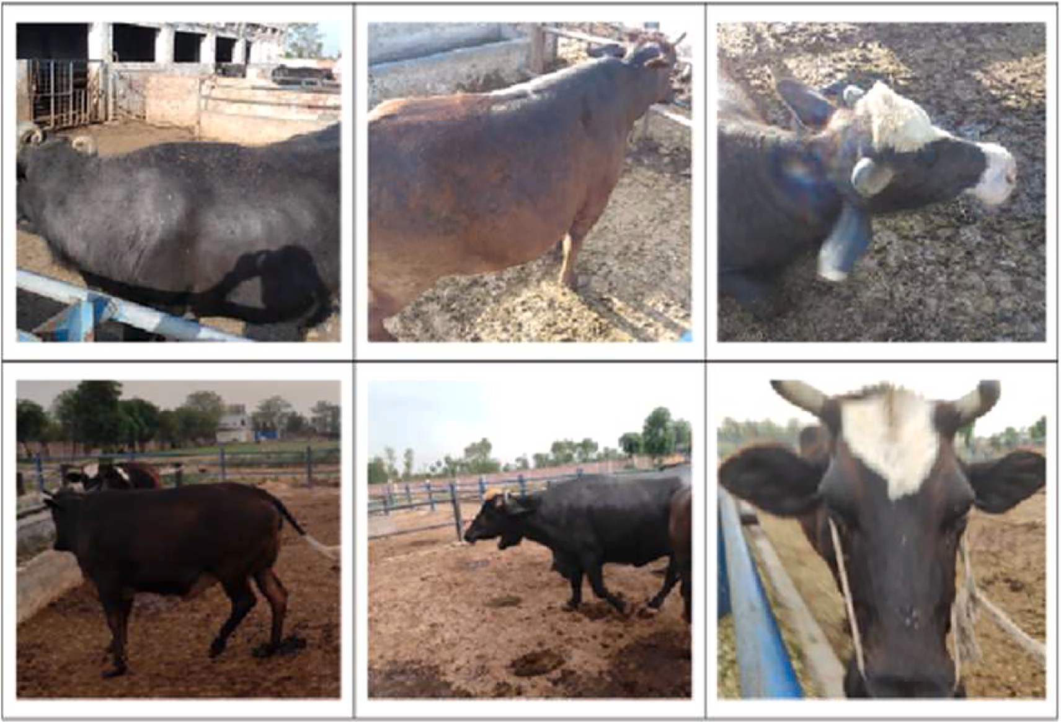

**Fig. 1.** Noise in Data.

images needed to be resized. This step was necessary to have images that are required to properly train the system.

* 1. *Data augmentation*

Data augmentation is a technique where, when required, more data is generated from existing data if the existing data is not enough. That is the case with our dataset and thus in order to increase the data set a bit, data augmentation was used. The augmentation steps include: hori- zontal flip, —10 degrees to 10 degrees rotation, crop, grayscale, hue,

brightness, exposure, noise and saturation. Doing this substantially

increased the amount of the dataset.

* 1. *Data Preparation*

Now when the data is preprocessed, and augmented the next step was to prepare it for training and testing. Our purpose is to detect the face/head, nose of cattle, dirty nose, and faces other than cows/buffalos. So, for detection in images, image data has to be annotated to be trained for object detection. A total of 9400 images were annotated using the open source image Labeling Tool [29]. Once annotated, it had to be split into training ~ 94%, validation ~ 5%, and testing 1 %, Fig. 2.

We have used five classes namely: Face, Nose, Nose-Dirty, and Not- cow, Table 2.

* Face:

The class represents cattle face. It is necessary to detect cattle face to locate muzzle point, and to make sure a cow or buffalo is present in the scene.

* Nose:

Detection of Nose/Muzzle Point is the ultimate objective to extract muzzle pattern for biometric identification of the cattle, thus Nose class.

* Nose-Dirty:

In case the muzzle point of the animal has something on it which can cause the muzzle pattern or the lower lip of the animal to not be visible, in that case, it would be useless to extract muzzle pattern and the identification process can be flawed, thus this class is necessary to avoid any dirty muzzle pattern to be captured, and the system will be able to alert about the dirty muzzle of the animal.

* Not-cow:

Some object detection models are likely to detect other animal faces

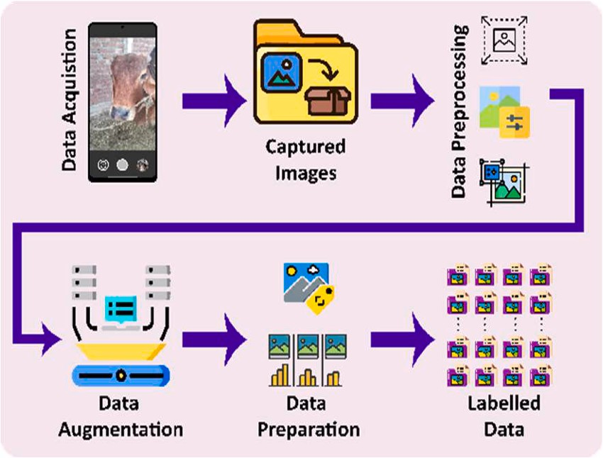

**Fig. 2.** Data Preparation.

**Table 2**

Data Distribution and Class Labels.

|  |  |  |  |  |  |  |
| --- | --- | --- | --- | --- | --- | --- |
| Class | Train Image | Label | Validation Image | Label | Test Image | Label |
| All | 8820 | 14,463 | 480 | 786 | 100 | 167 |
| Face | 8820 | 4945 | 480 | 269 | 100 | 56 |
| Nose | 8820 | 3342 | 480 | 181 | 100 | 39 |
| Nose-Dirty | 8820 | 2878 | 480 | 178 | 100 | 38 |
| Not-Cow | 8820 | 3298 | 480 | 158 | 100 | 34 |

as cow/buffalo faces, and in some case, they even detect human faces so Not-Cow class is used as shown in Table 2 to make sure the model un- derstands the difference, and to make sure the subject which is a Cow/ Buffalo is in the scene and its face is being captured to get its nose pattern.

Class label balance can be seen in the following analysis of training data, Fig. 3. Total annotated dataset comprises on 15,416 class labels representing all the four classes.

* 1. *Training*

Now that we have our dataset annotated and prepared as shown in Fig. 4, the dataset is now ready to be trained.

* 1. *Detecto*

We used a pre-trained Fast R-CNN ResNet-50 FPN model-based py- thon package Detecto [30]. It is a python package based on PyTorch and can be used for the training of object detection. However, it did not prove to be efficient for our problem even though above 80% accuracy was achieved Fig. 5 shows training loss. But when the model was tested it would detect the face with above 90% accuracy.

It seemed to mostly leave the nose part out, which would be a problem as our main goal is to detect the nose once the face was detected, Fig. 6. Detecto model does not properly predict the bounding box. The bounding box predicted by the model is way off the required subject which in our case is the cattle head/face, its nose, either dirty or not, and faces other than cattle, including humans.

* 1. *Yolov4*

We have also trained on yolov4 for object detection, which shows considerably good mAP and no overfitting, following Fig. 7 shows the training loss and mAP gain.

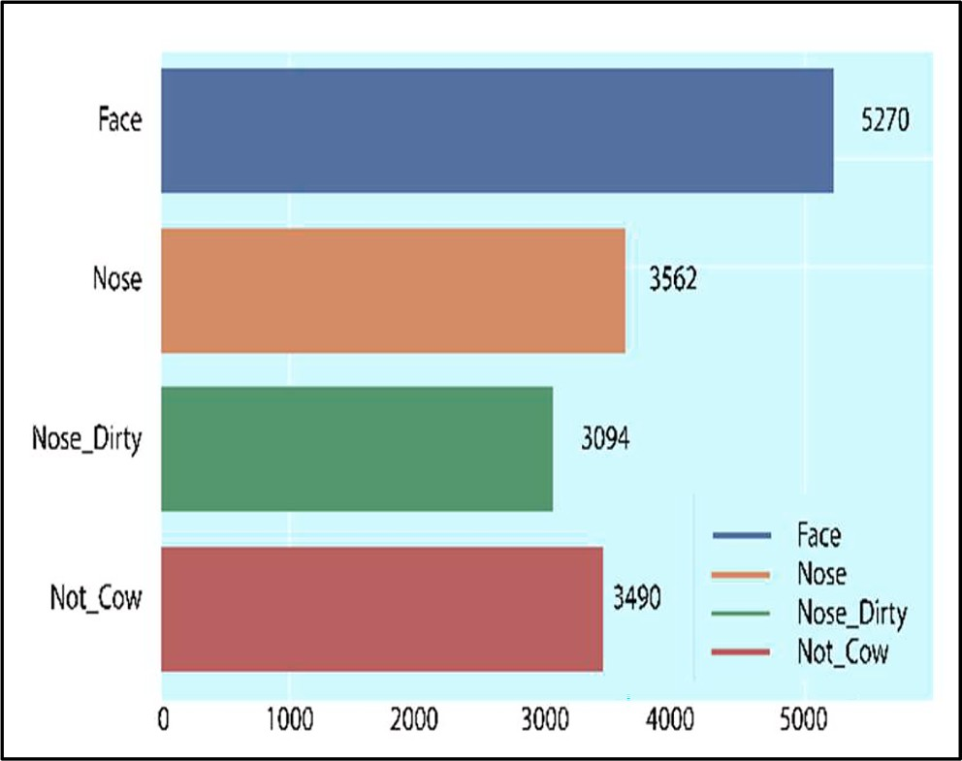

**Fig. 3.** Class Labels Analysis.

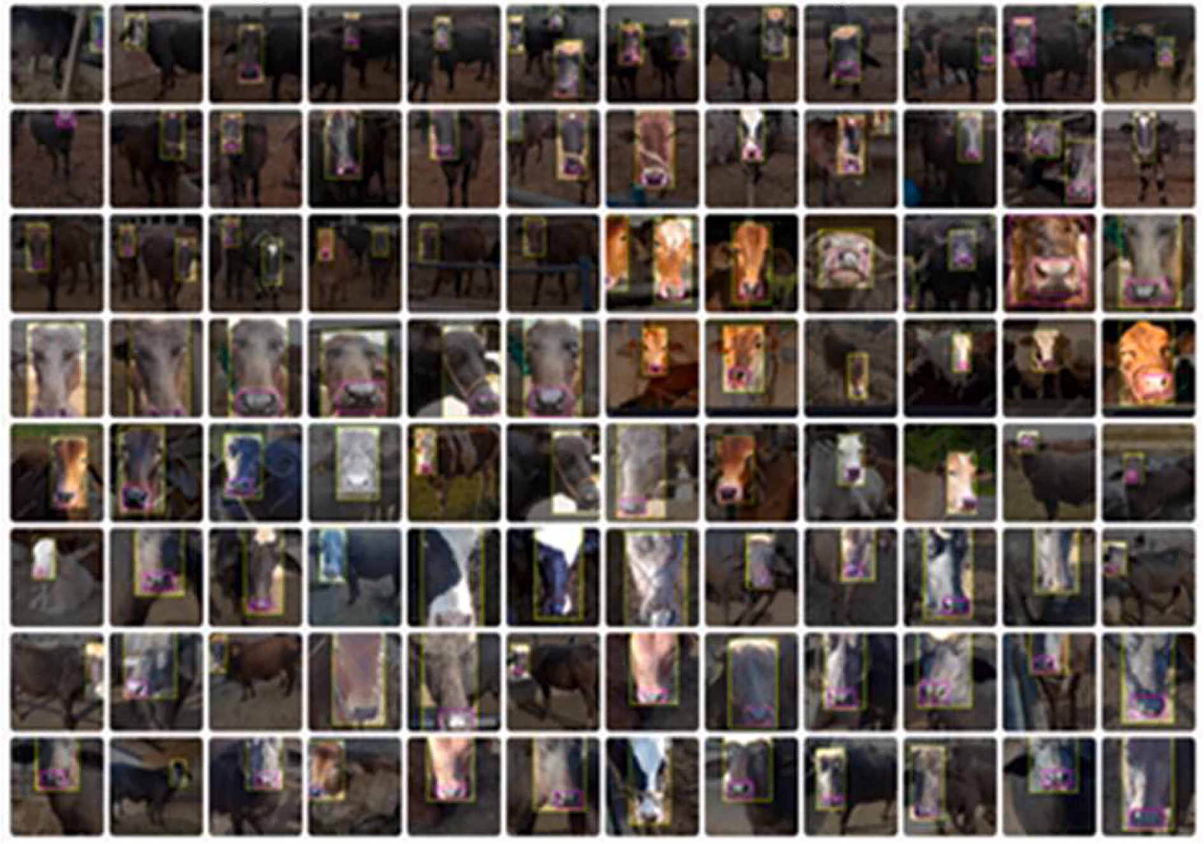

**Fig. 4.** A Sample from Annotated Data.

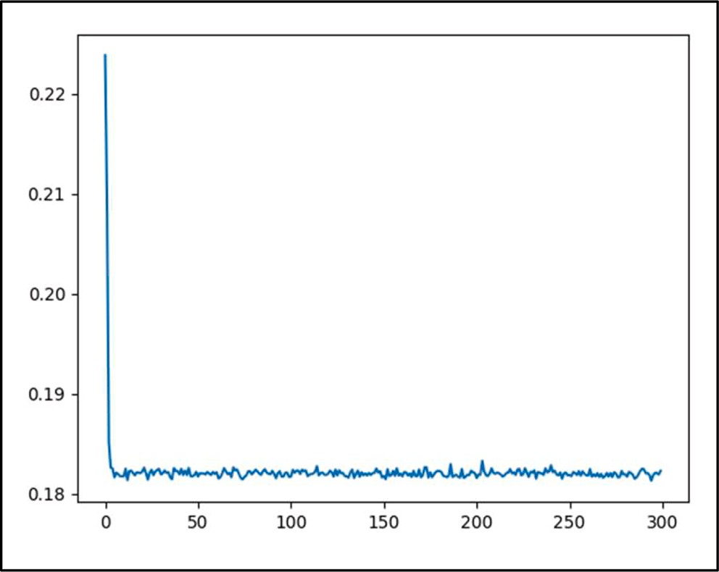

**Fig. 5.** Detecto Loss Curve.

Even though yolov4 showed promising results with mAP of 100% yet it was not considered final model for detection as its inference time was high.

* 1. *Yolov7 - network Architecture*

YOLOv7 presents the latest technology to support the multiple object tracking (MOT) framework [31]. Yolov7 performs extremely well when it comes to object detection. It detects objects more accurately and swiftly than the previous versions. In this architecture enhanced

cardinality of new features has been achieved by using collective convolution while the gradient-oriented routing does not change as shown in Fig. 8.

The process can increase learned features with the help of feature mapping, shuffling, and merging in a cardinality manner. Consequently, improve calculation and parameter usage**.** YOLOv7 is the most appro- priate object detector for the aggregate scaling approach. It can be applied to interlinked model architecture to compute modifications in the output width of the computational block. It is recommended to scale only depth in computational blocks. This approach can maintain the initial model design and structure properties. Re-parameterization techniques involve averaging a set of model weights to create a model that is more robust to the general patterns that it is trying to model. In research, there has been a recent focus on module-level re- parameterization where the piece of the network has its re- parameterization strategies. The YOLOv7 authors use gradient flow propagation paths to see which modules in the network should use re- parameterization strategies and which should not.

A state-of-the-art Yolov7 object detection model is the latest intro- duction to YOLO family. It has a few variants. Some of which we used for training our data are:

* Yolov7-tiny (training from scratch)
* Yolov7x or Yolox (training using transfer learning)
* Yolov7 (training from scratch)
  1. Yolov7-tiny

We performed training using transfer learning of pre-trained yolov7 tiny model and it can be seen in the following Fig. 9, the overall mAP achieved by yolov7-tiny on our dataset is 0.9946 or 99.46%. The loss curve is seen in the Fig. 10.

There is no overfitting of the model as can be seen in the figures

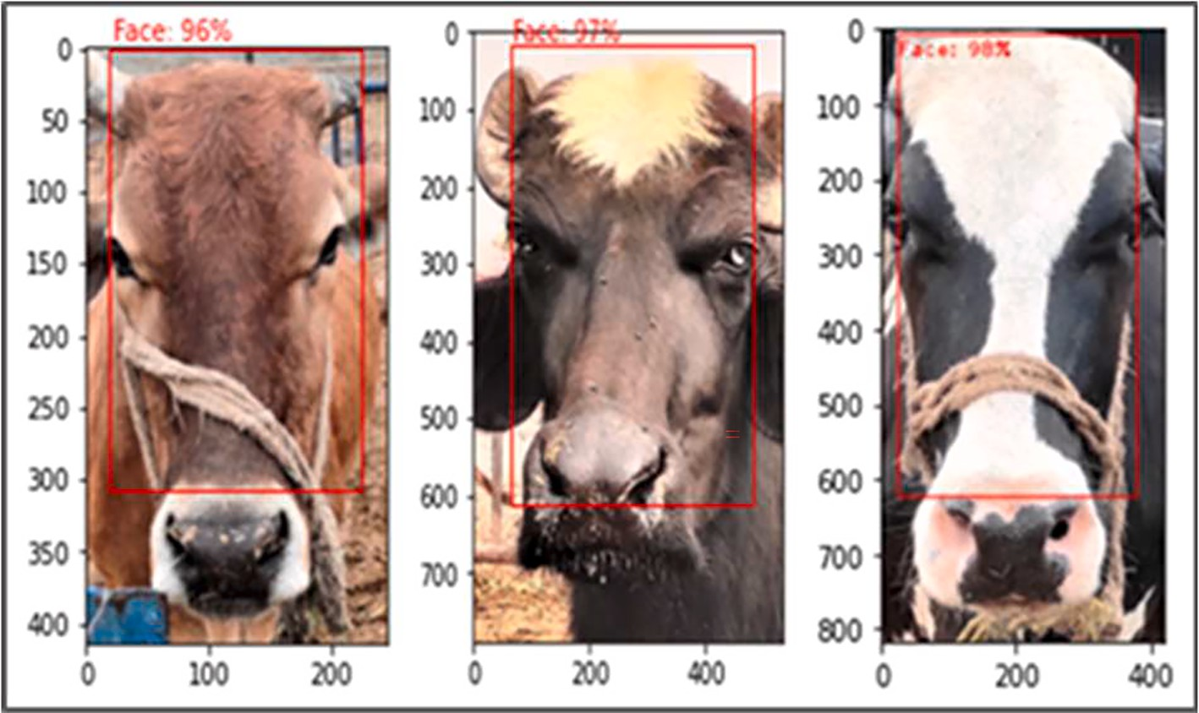

**Fig. 6.** Cattle Face Detection using Detecto.

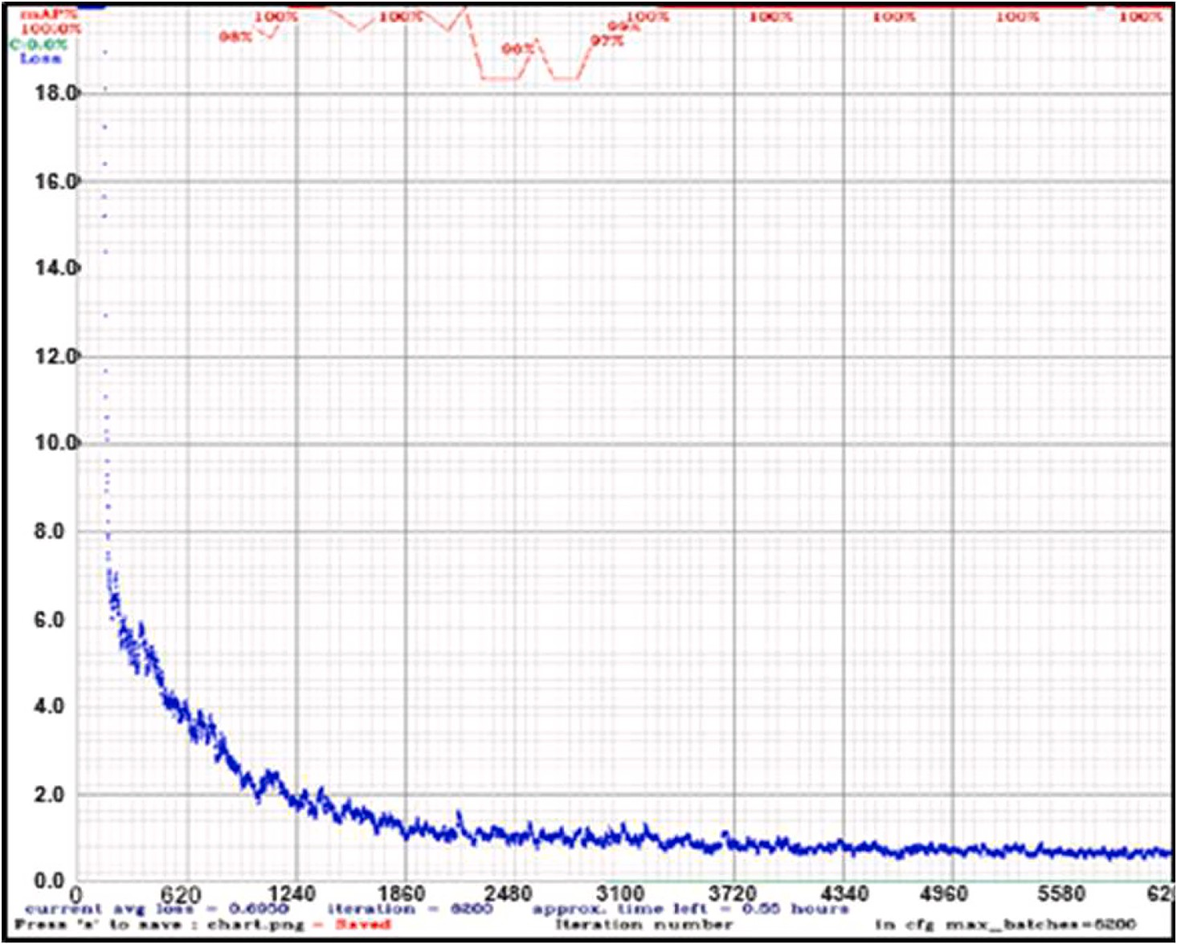

**Fig. 7.** Yolov4 mAP – Loss.

above and test results are present in Fig. 11.

* 1. Yolov7x

We also trained yolov7x model on our dataset and the training was done from scratch, following figures: Fig. 12 & Fig. 13 show the ach- ieved overall mAP and loss curve respectively. Yolov7x mAP is around 78% and the loss curve shows over fitting.

* 1. Yolov7

The Fig. 14 show how yolov7 model trained on our data and this yolo

variant was able achieved 83% mean average precision after being trained from scratch.

The YOLOv7 model is trained using a deep neural network that is specifically designed for object detection tasks. It comprises on three main segments: the backbone network, the neck network, and the detection head. The backbone network extracts high-level features from the input image, which are important in identifying objects. The neck network refines the extracted features and integrates data from different scales and resolutions, which improves the model’s accuracy. Ulti-

mately, the detection head produces the final predictions, generating

bounding box predictions and class probabilities for identified objects using the improved features. These components are optimized using

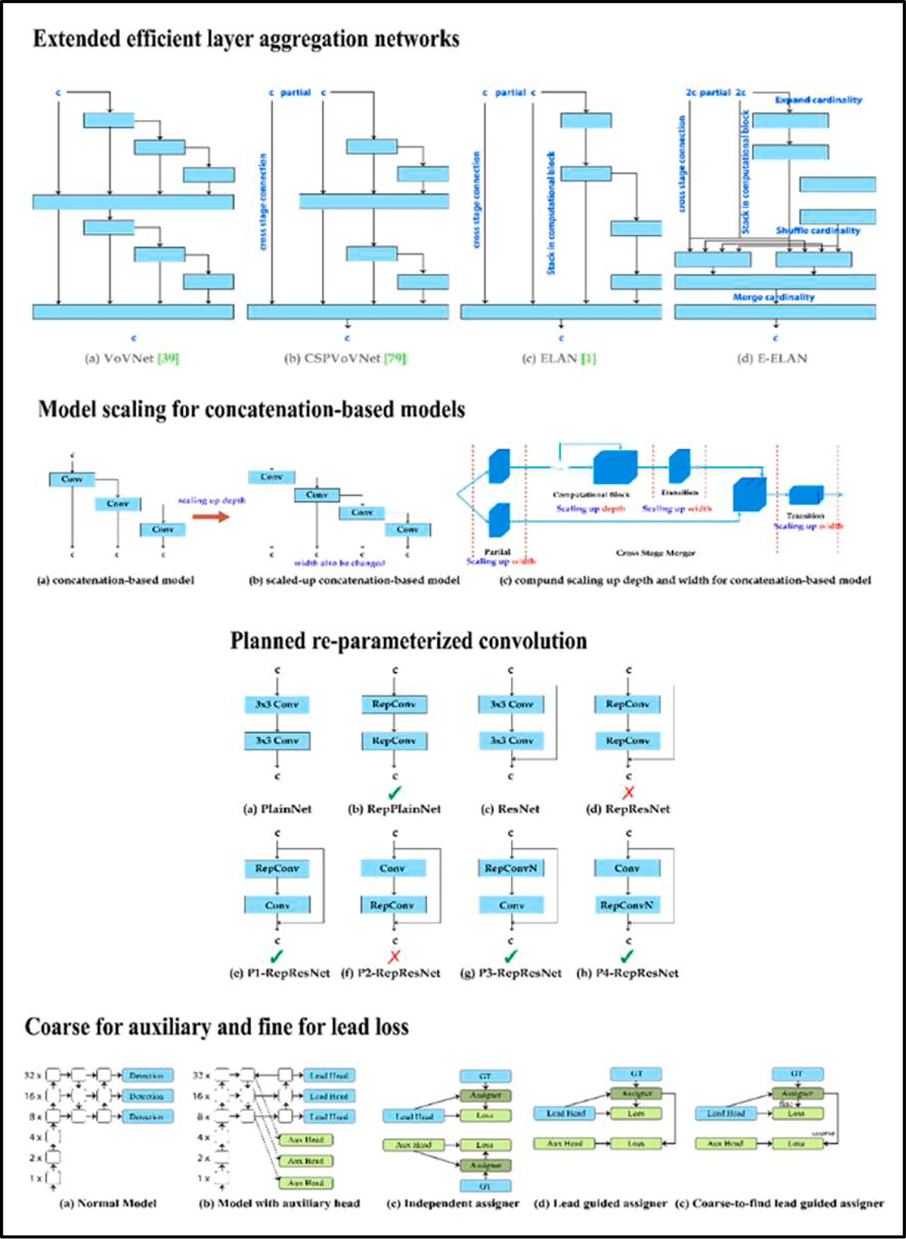

**Fig. 8.** Yolov7 Model Architecture.

cutting-edge methods and convolutional layers to ensure optimal per- formance in object detection.

Overfitting is visible in Fig. 15, loss curve of yolov7 shows slight overfitting of the model.

Once the training was completed Fig. 16, comparing results of all trained models Table 3 showed that yolov7-tiny model was best among

all these, other yolov7 models can also be fine-tuned to achieve better results. The final model which is yolov7-tiny, is deployed on the cloud. We trained several object detection models from YOLO object detection family and Detecto, Yolo family include Yolov4, Yolov7, Yolov7x, and Yolov7-tiny. The training was done on NVidia GTX 1050 Ti

4 GB GPU and Google Colab [32]. The training results were then

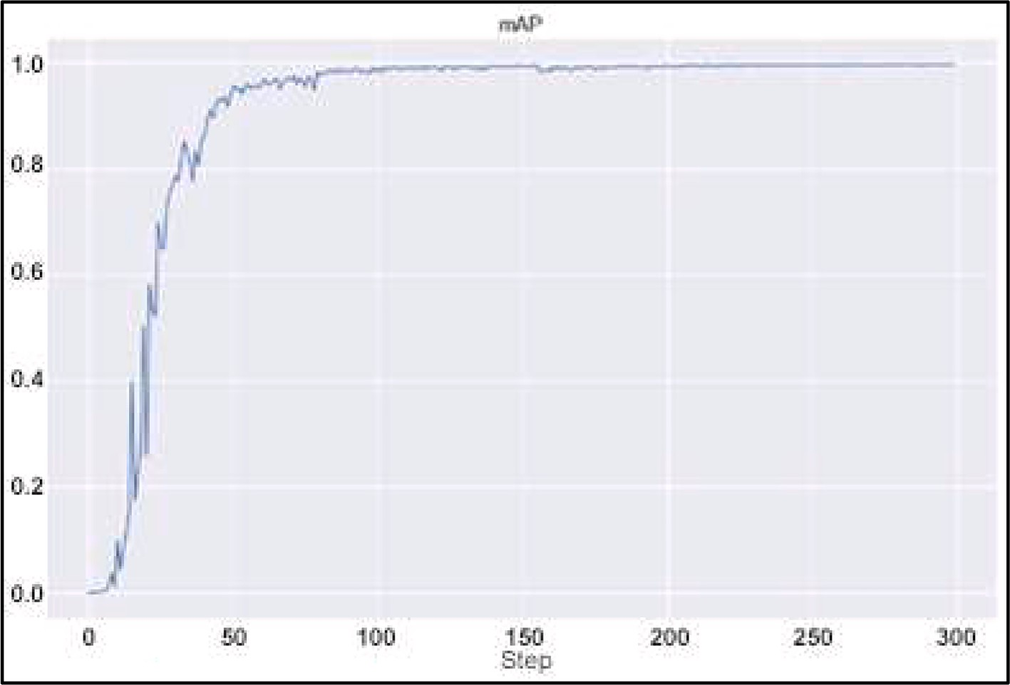

**Fig. 9.** YOLOv7-tiny mean Average Precision.

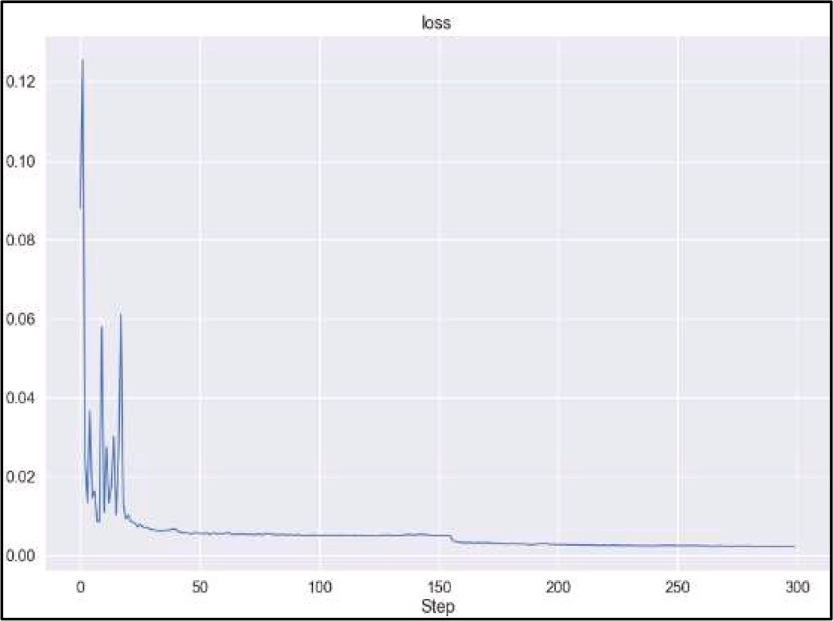

**Fig. 10.** YOLOv7-tiny Loss Curve.

compared and we found that yolov7 has better overall performance even though yolov4 had a mAP of 100% yet its inference time was highest among all of the models.

Table. 3 shows the comparison of different detection models that we used, without transformation to ONNX.

The yolov7 model is then transformed to ONNX (Open Neural Network Exchange) and is simplified which further improved inference time and the ONNX model has inference time of 0.04 s and that too on CPU (Intel(R) Xeon(R) Gold 5122 CPU @ 3.60 GHz 3.59 GHz).

Based on comparison results and multiple test runs, we decided to deploy yolov7-tiny object detection model on cloud as our default model for detecting earlier defined classes, then use them to extract muzzle pattern features, identify the animal, and finally decide whether the claim for livestock insurance was fraudulent or not based on identifi- cation results.

* 1. Confusion matrices

The individual class confusion matrices of yolov7-tiny model are

described as follows and these confusion matrices defines and summa- rizes the detection model performance [33]. These confusion matrices show performance of the model on training set, validation set, and test set.

* Face Class

Face class represents dataset of 4945 images for training, 269 for validation, and 56 test instances. Our model correctly classifies all im- ages as shown in Table 4. Predicted results are same as actual.

* Nose Class

Nose class distributed as 3342 images for training, 181images for validation, and 39 for testing. Table 5 shows 99% training accuracy because of 34 images have been wrongly classified. While validation and testing accuracy is also 99%.

* Nose-Dirty Class

Nose-Dirty class has been inserted to enhance model performance. 2878 images allocated for training while 178 images for validation, and

38 images were allocated for testing. Table 6 shows 99% accurate training because of 33 images have been wrongly classified. Validation and testing accuracy is 99% and 100% respectively.

* Not-Cow Class

Not-Cow class added to prevent object selection other than Cow. It consists of 3298 images for training while 158 images for validation. Table 7 shows 100% accuracy for training and validation, and 99% for testing.

* 1. Cattle Identification Process

In our proposed model, the cattle Identification process comprises two stages. First to register the animal Table 8 & Fig. 17 with specified details such as identity tag and muzzle point feature images and sec- ondly how the system will process pattern matching for subsequent recognition of the same Animal. These processes are elaborated as

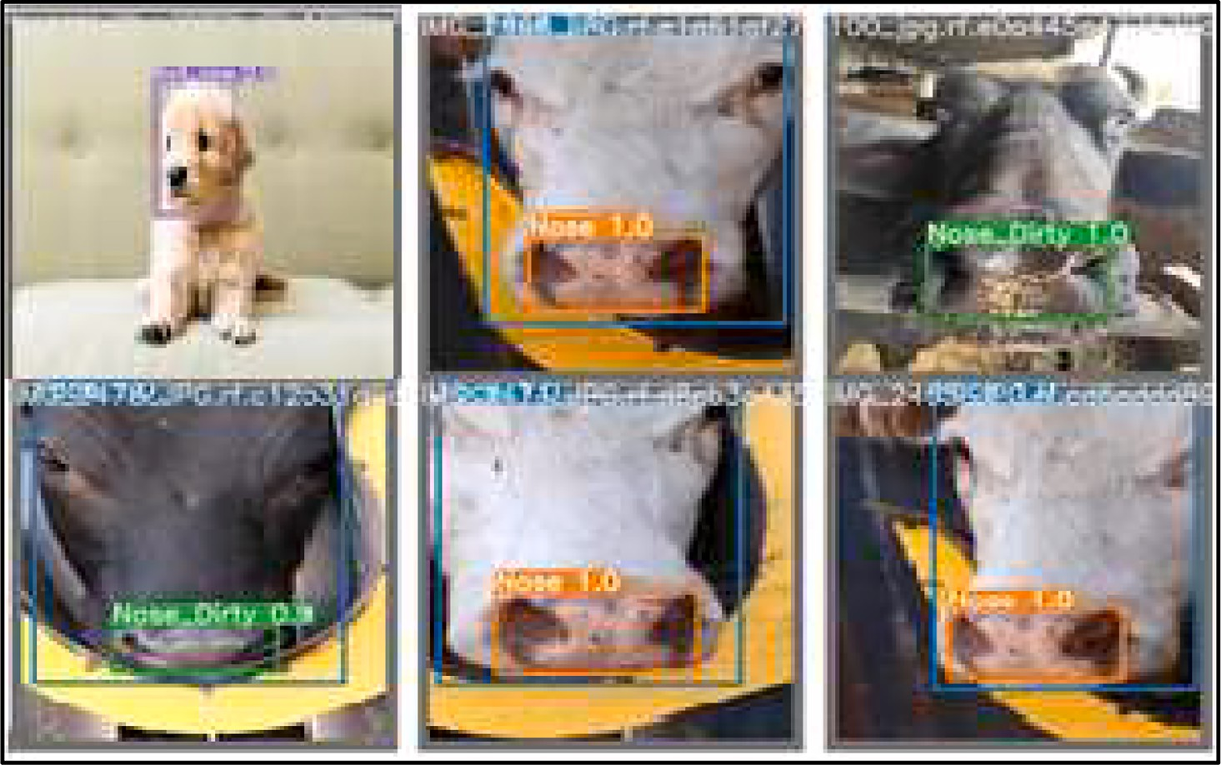

**Fig. 11.** Yolov7-tiny Predicting Bounding Boxes on Test Set.

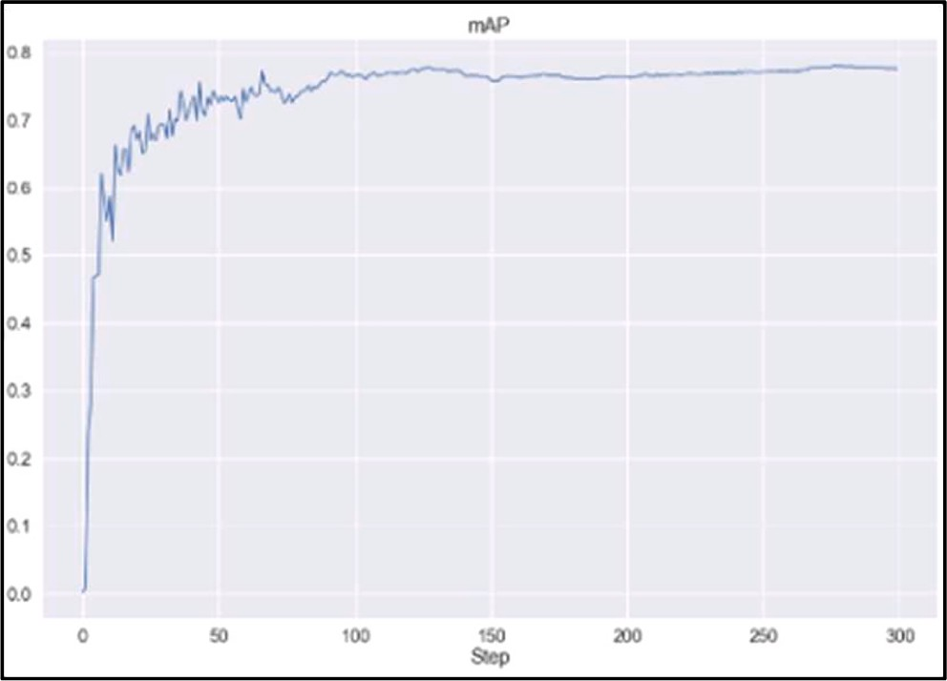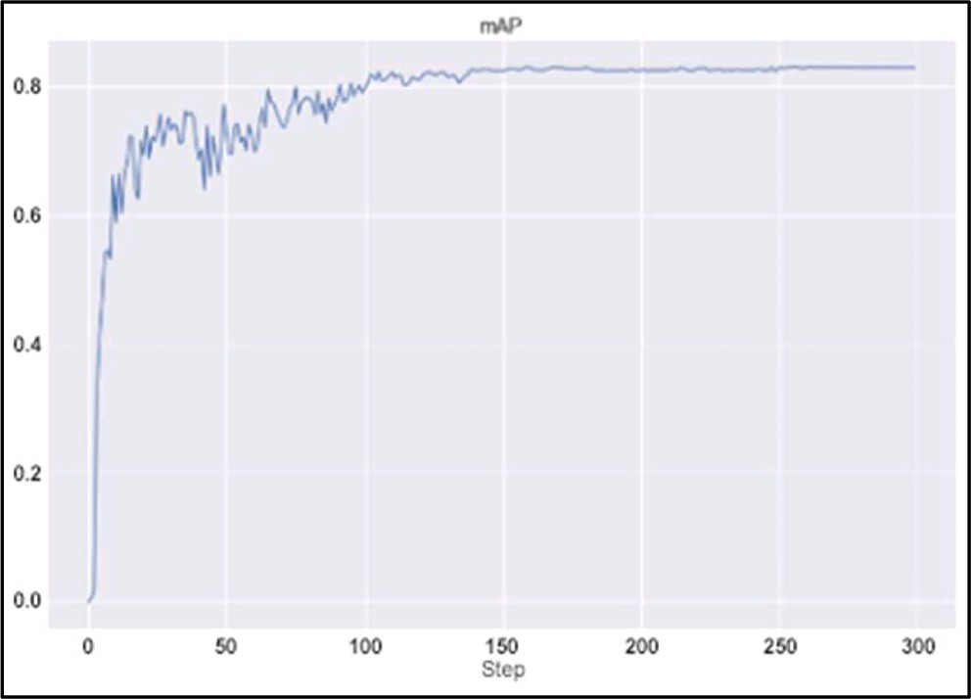

**Fig. 12.** Yolov7-x mean Average Precision. **Fig. 14.** Yolov7 mean Average Precision.

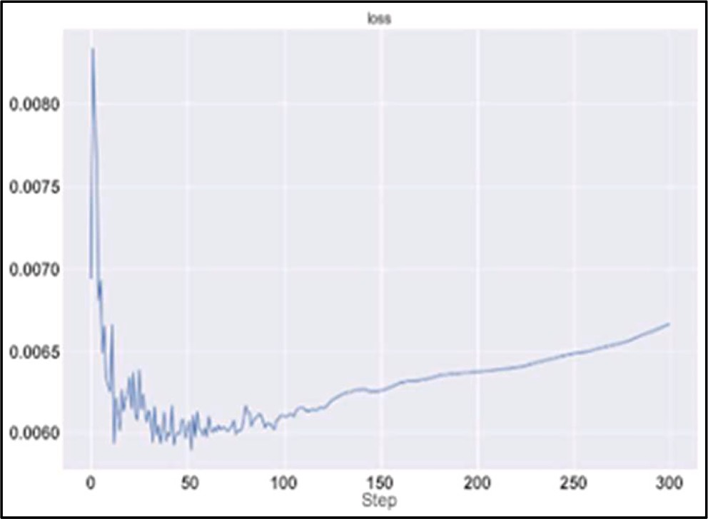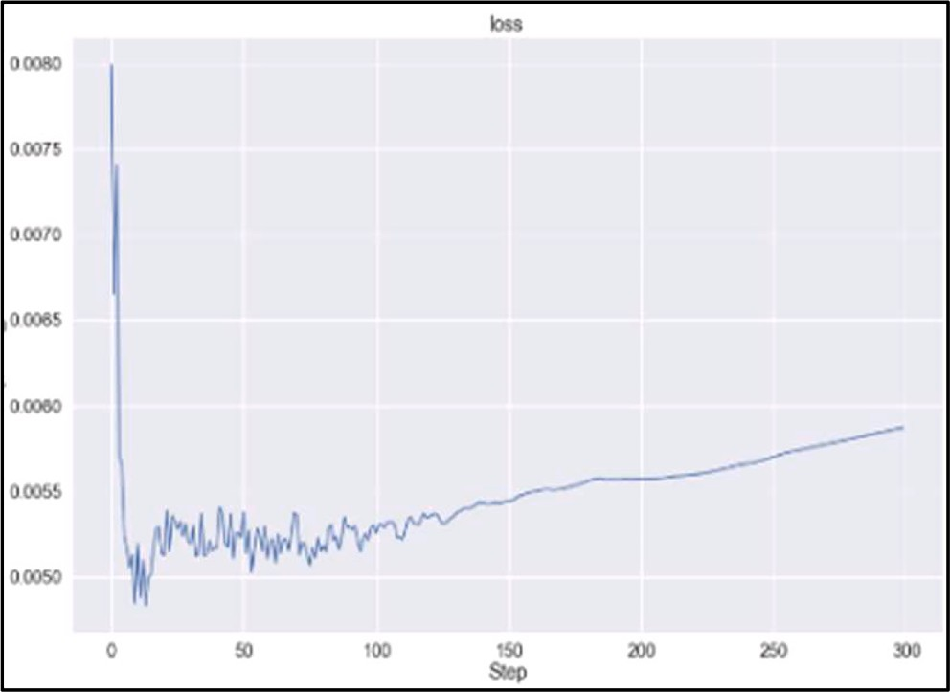

**Fig. 13.** Yolov7-x Loss Curve.

**Fig. 15.** Yolov7 Loss Curve.

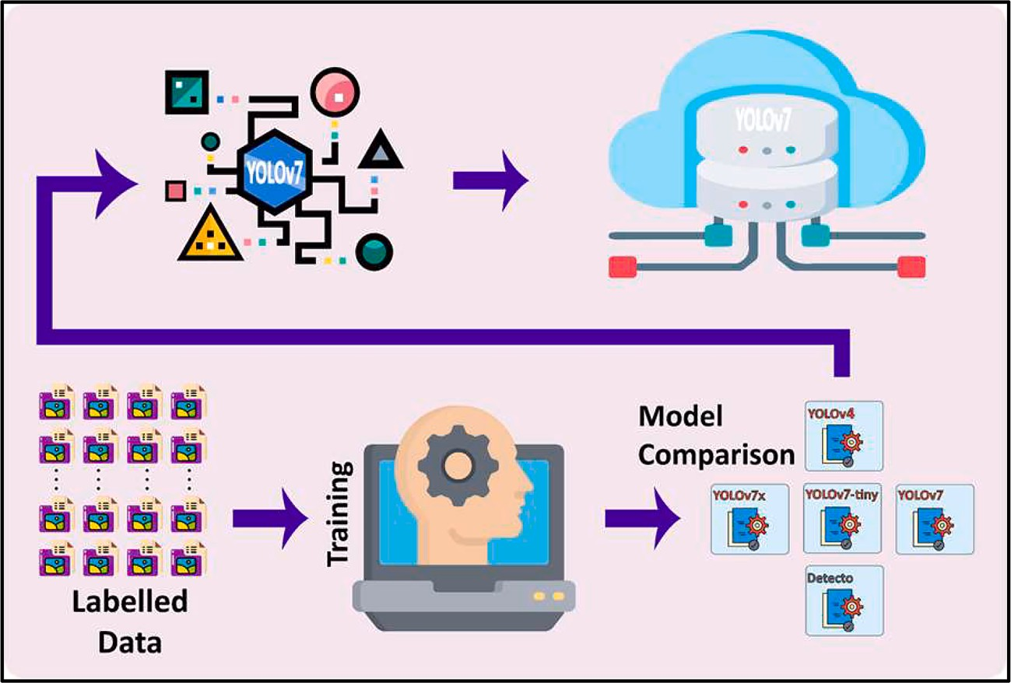

**Fig. 16.** Model Training and Comparison.

**Table 3**

Model Comparison.

|  |  |  |  |
| --- | --- | --- | --- |
| Models | mAP | Inference time | FPS |
| Yolov7 Tiny | 0.9946 | 0.06 s | 35 (On Average) |
| Yolov7x | 0.7833 | 0.18 s | 29 (On Average) |
| Yolov7 | 0.8347 | 0.21 s | 19 (On Average) |
| Yolov4 | 1.0 | 6.00 s | 4 (On Average) |
| Detecto | 0.94 | 4.24 s | 6 (On Average) |

follows:

* + 1. *Animal registration*

1. Insertion for Animal Registration Tag

Animal tagging is the First step of the Pseudocode statement. Unique Identification string to be created for each animal. The *Registration T*ag provides a referential key to be mapped with the visual for subsequent retrieval of identity information.

1. Video stream or Images

Animal image is an essential parameter to be entered into the data- base. The system will extract biometric features from the images*.* it can be either a frame from a video or a single image.

1. Tag Validation

Before starting up the animal registration process, the system vali- dates the tag. Duplicate, unspecified, and the substandard tag will be rejected*.*

**Table 4**

Confusion Matrix - Class = Face.

|  |  |  |  |  |  |  |  |  |
| --- | --- | --- | --- | --- | --- | --- | --- | --- |
| No. of Samples = 4945 (Train) | True (Train) |  | No. of Samples = 269 (Val) | True (Val) |  | No. of Samples = 56 (Test) | True (Test) |  |
| Predicted (Train) | TP = 4945  FN = 0 | FP = 0  TN = 0 | Predicted (Val) | TP = 269  FN = 0 | FP = 0  TN = 0 | Predicted (Test)  FN = 0 | TP = 56  TN = 0 | FP = 0 |

**Table 5**

Confusion Matrix - Class = Nose.

|  |  |  |  |  |  |  |  |  |
| --- | --- | --- | --- | --- | --- | --- | --- | --- |
| No. of Samples = 3342 (Train) | True (Train) |  | No. of Samples = 181 (Val) | True (Train) |  | No. of Samples = 39 (Test) | True (Test) |  |
| Predicted (Train) | TP = 3323  FN = 0 | FP = 19  TN = 0 | Predicted (Val) | TP = 180  FN = 0 | FP = 1  TN = 0 | Predicted (Test) | TP = 38  FN = 0 | FP = 1  TN = 0 |

**Table 6**

Confusion Matrix - Class = Nose-Dirty.

|  |  |  |  |  |  |  |  |  |
| --- | --- | --- | --- | --- | --- | --- | --- | --- |
| No. of Samples = 2878 (Train) | True (Train) |  | No. of Samples = 178 (Val) | True (Val) |  | No. of Samples = 38 (Test) | True (Test) |  |
| Predicted (Train) | TP = 2849  FN = 0 | FP = 29  TN = 0 | Predicted (Val) | TP = 177  FN = 0 | FP = 1  TN = 0 | Predicted (Test) | TP = 38  FN = 0 | FP = 0  TN = 0 |

**Table 7**

Confusion Matrix - Class = Not-Cow.

|  |  |  |  |  |  |  |  |  |
| --- | --- | --- | --- | --- | --- | --- | --- | --- |
| No. of Samples = 3298 (Train) | True (Train) |  | No. of Samples = 158 (Val) | True (Val) |  | No. of Samples = 34 (Test) | True (Test) |  |
| Predicted (Train) | TP = 3298  FN = 0 | FP = 0  TN = 0 | Predicted (Val) | TP = 158  FN = 0 | FP = 0  TN = 0 | Predicted (Test) | TP = 33  FN = 0 | FP = 0  TN = 1 |

**Table 8**

Algorithm for Animal Registration.

**Algorithm 1 (Animal Registration):**

**Input**:

TAG = Animal TAG;

stream = Video Stream of Animal / image of animal

**Output**:

image = Extracted muzzle point of Animal stored in database with TAG

**while** stream **do**:validate (TAG)

frame ← stream.frame frame ← frame.reshape

face ← Detect(frame, “Face”) nose ← Detect(face, “Nose”) nose ← ExtractFeature(nose)

image = WriteDB(nose, TAG)display (image)

**end**

1. Image reshapes as per defined standard parameters

Image resizing process perform after tag validation, Animal image to be optimized to make to compatible for feature extraction procedures.

1. Detect face area and mark as a face.

Animal face recognition is essential to detect face and then proceed to identify muzzle point. We use Yolov7 to perform face detection

swiftly and accurately*.*

1. Detect nose within face area and mark as a nose.

Next to marking the face area, system detect Nose on the animal’s face. The same procedure is applied as used for face detection*.*

1. Extract muzzle pattern from detect nose

At this stage, the system successfully detected the Nose area. Now extract the muzzle pattern as the required biometric identifier.

1. Update database with muzzle pattern and Tag ID.

Finally, extracted muzzle pattern mapped Tag ID of the same cattle and store the information in the designated database management sys- tem. Show cattle image after a successful registration.

* + 1. *Recognizing the animal*

Once the nose gets detected, the scale invariant feature transform algorithm (SIFT) is used to get key points and descriptors of muzzle point image, i.e., query image, and it also finds key points and descriptors of the images of nose/muzzle points of different animals stored, Table 9 & Fig. 18.

* + 1. *Scale-Invariant feature Transform (SIFT)*

It is commonly used to extract distinguishing features from photos, which enables accurate object detection and image matching. In order to

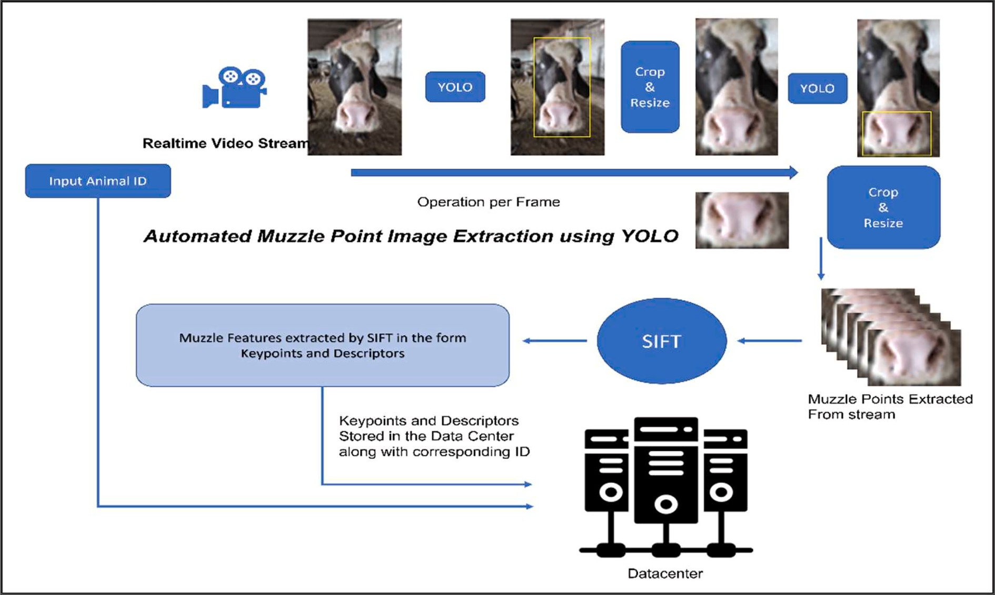

**Fig. 17.** Animal Registration Algorithm.

**Table 9**

Algorithm for Animal Recognition.

**Algorithm 2 (Animal Recognition):**

**Input**:

stream = Video Stream of Animal / image of animal

**Output**:

image, TAG = Recognized Animal with TAG

**while** stream **do**:

frame ← stream.frame frame ← frame.reshape

face ← Detect(frame, “Face”) nose ← Detect(face, “Nose”) nose ← ExtractFeature(nose)

image, TAG = Recognize(nose)display (image, TAG)

**end**

find key points—areas of the image that are unaffected by adjustments to scale, rotation, and illumination—SIFT examines image features.

1. Focus Localization

DoG pictures.

The programme employs additional criteria to precisely localise the critical points. This includes eliminating extrema or low contrast key points, as well as key-point localization triggered by rejecting files and edges. According to the equation, files and edges in the context of SIFT correspond to particular properties that must be disregarded during key- point localization:

|*D*(̂*x*)〈0.03 (2)

Furthermore, edges and unstable key points are rejected by analyzing the eigenvalues of the Hessian matrix H. Letting α be the larger eigenvalue and β be the smaller eigenvalue, the trace and deter- minant of H are calculated as:

*Tr*(*H*) = *Dxx* + *Dyy* = α + β (3)

*Det*(*H*) = *DxxDyy* — *Dxy*)2 = αβ (4)

Let r = α/β. So, α = rβ

To precisely locate the key points in the image, the SIFT algorithm’s key-point localization is used. It is performed by examining the image’s

*Tr* *H*2 )

*Det*(*H*) =

(α + β)2

αβ =

(*r*β + β)2

rβ2 =

(*r* + 1)2

*r* (5)

scale-space representation, which is created by applying a number of scale-space transformations. The image is scaled to several octaves, each of which is half the size of the preceding octave, in order to locate the potential feature sites. Within each octave, a scale-space pyramid is constructed by convolving the images with Gaussian blur filters. The blurred images are represented as:

*L*(*x*, *y*, *σ*) = *G*(*x*, *y*, *σ*)\**l*(*x*, *y*) (1)

Where x,y are the variable coordinates and σ is the “scale” param- eter, G(x,y,σ) is the Gaussian function, and I(x,y) is the original image.

Next, the adjacent blurred images inside each octave are subtracted to create the Difference of Gaussians (DoG) images. The local scale-space extrema, which correlate to possible key locations, are shown by the

The algorithm checks to see if the ratio r is smaller than 10 before

computing it as r=/. Key points are disregarded if this requirement is not met when the eigenvalues are almost equal, which denotes a flat region. The next step in the SIFT method is orientation assignment after each

key point’s scale, location, and orientation have been established. The algorithm now makes sure that the extracted characteristics are

rotation-invariant as well as scale-invariant. To achieve this invariance, an orientation is allocated to each key point.

Each key point is given an orientation by SIFT after it has examined the local image region around it. The algorithm computes gradient magnitudes and orientations of the image pixels within this region. The dominant orientation in the region is then identified, and the key point is assigned that orientation. This step ensures that the subsequent com- putations are rotationally invariant.

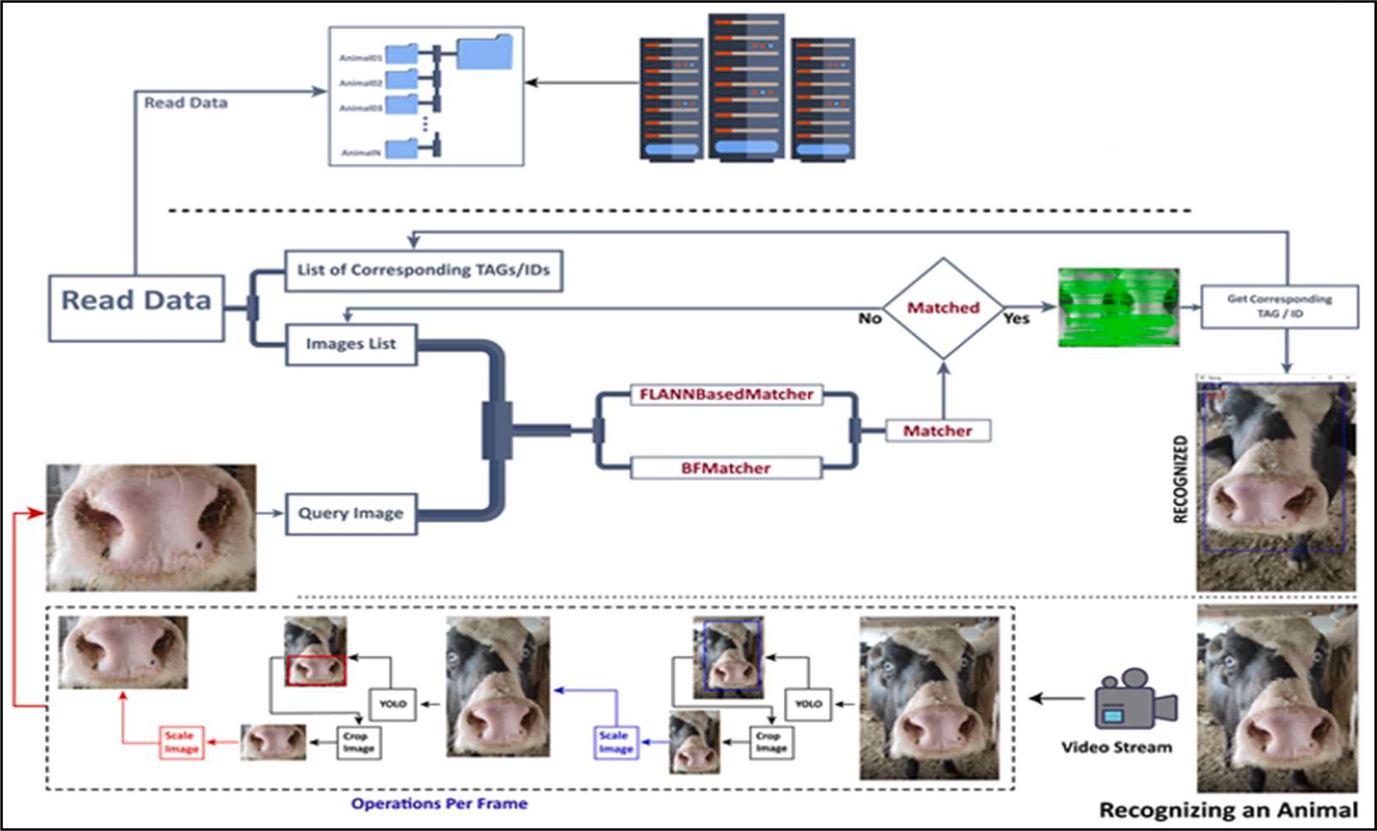

**Fig. 18.** Animal Recognition Algorithm.

1. Computational Cost

The scale-space pyramid construction, DoG computation, and eigenvalue analysis used in the SIFT algorithm’s key-point localization step add significant processing cost. However, this cost is required to

guarantee the reliability and exactness of the essential points that are discovered.

It is pertinent to remember that the computational cost of key-point localization is influenced by the size and complexity of the input image as well as the desired degree of scale-space representation. More octaves and scales are needed for huge photos, which increases computing cost. SIFT is now computationally practical for a variety of real-world ap- plications thanks to developments in technology and optimization approaches.

1. Orientation Assignment and Key-point Descriptor

The SIFT algorithm assigns an orientation to each key point after key- point localization, making each key point rotation invariant. The algo-

rithm’s ability to match important spots in various orientations is improved by this orientation assignment.

The SIFT algorithm then computes a descriptor for each key point after determining the scale, location, and orientation of each key point.

The key point’s immediate surroundings are captured by the descriptor, which results in a highly distinctive depiction that is resistant to varia-

tions in scale, rotation, and illumination.

A region surrounding each key point is specified, often in the form of a square or circular neighborhood, in order to calculate the key-point descriptor. A histogram of the gradient orientations is produced within each of the smaller sub regions or bins that make up this region. The gradient orientations reveal details about the boundaries and texture of the local image structure.

Each pixel within the sub regions has its gradient magnitudes and orientations calculated, and these values are weighted by a Gaussian function centered at the critical point. This weighting prioritizes the gradients nearer the focal point, obtaining the most pertinent local data. The weighted gradient magnitudes are then added together into orientation bins to create the histogram of gradient orientations. The key-point descriptor is formed from this histogram and is often displayed as a high-dimensional feature vector. The number of bins utilized in the orientation histogram and other factors set during the descriptor

computation determine how dimensional the descriptor is.

The resulting key-point descriptors are strong and distinctive, allowing for quick matching and scene identification. To determine which critical points in distinct photos match up best, they can be compared using a variety of distance measures, such as Euclidean dis- tance or cosine similarity.

1. FLANN Based Matcher

FLANN-based matcher or Brute Force matcher is then used to match the key points and descriptors of the query image with the images in the data, and if it matches with the image of the animal in the data, it will return the tag associated with that matched image in data, thus, recognizing/identifying the animal.

* 1. Video stream or Images

On the spot image/video capture to identify registered cattle.

* 1. Reshape as per defined standard parameters

Same procedures have been applied to the captured image as already performed during the registration process.

* 1. Match image with stored muzzle pattern and Tag ID.

Procedures are applied to detect the face and nose area to get the latest muzzle pattern. The system will look up the muzzle pattern with the stored information in the database. In case the pattern is matched, the system will get the concerned Tag ID.

* + 1. *Parameter settings*

A comprehensive account of the parameter settings employed throughout our methodology.

For YOLOv7, the following parameters were utilized: Input image size: 640x640.

Learning rate: 0.0001.

Batch size: 16.

Number of epochs: 300. Optimizer: Adam.

Loss function: Cross-entropy.

Regarding the SIFT algorithm, the following parameters were utilized:

Number of octaves: 4. Step size: 1.

Contrast threshold: 0.03 (Kept to default). Edge threshold: 10.

RANSAC threshold: 3.

For FLANN (Fast Library for Approximate Nearest Neighbors), the following parameters were used:

K: 7.

Tree type: K-D tree. Number of trees: 6.

Distance metric: Euclidean distance.

We recognize the importance of reporting all parameter configura- tions to ensure transparency and reproducibility of our methodology. By providing these details, we aim to enhance the comprehensiveness and accuracy of our paper.

# Results ad discussion

The best options and combinations of the strategies have been carefully evaluated for the proposed plan. The requirement for an automated and non-intrusive method to capture the muzzle point of the cattle served as the driving force for the choice of YOLOv7 as the object identification framework. Other conventional techniques, including personally photographing animals up close or employing restraints, can be time-consuming, labor-intensive, and possibly upsetting to the ani- mals. We were able to record the animals from a safe distance while minimizing disruption to their natural behavior by utilizing YOLOv7 to automate the procedure of finding the muzzle point.

Additionally, the difficulties with other well-known techniques like CNN, RCNN, RESNET, and VGG16 that did not deliver adequate out- comes in terms of muzzle pattern identification led to the choice to use Scale-Invariant Feature Transform (SIFT) for muzzle pattern feature extraction. For extracting distinguishing features from photos, particu- larly when there are variations in scale, rotation, and viewpoint, SIFT is a well-known and reliable technique. We deployed SIFT to the muzzle region in an effort to record distinctive patterns that could be used for precise animal identification and recognition.

Our system can detect face and muzzle point of cow/buffalo with mAP of 99%, not only that but this system has the capability to differ- entiate cows/buffalos from other cattle as well as humans. The inference time is also remarkable as we have used the state of the art yolov7 object detection model. As far as recognition is concerned, the feature match- ing algorithm FLANN is used for muzzle point pattern recognition. The system was able to recognize the animal with 100% accuracy. The testing was done by registering the animal in the system using an image and then tested with different images in different environments. Images of a total of 500 animals were used to evaluate recognition algorithm and it recognized all the animals with 100% accuracy beating the humans because at one point we were not able to recognize the animal

by just looking at the picture but the system successfully recognized the animal.

* 1. *Proposed model*

The Fig. 19 represents our proposed model for the purpose of tack- ling livestock insurance fraud by biometrically identifying cattle through their muzzle point patterns.

* 1. *Confusion Matrix*

In this research study, though our prime objective is to present a most efficient and effective model for cattle.

Identification it would be helpful for biometric identification of other Animals having muzzle pattern. Fig. 20 is the confusion matrix showing the performance of the system in identification of the animal.

Following is the Table 10, enlisting animals that have unique distinguishable features:

Our proposed model takes cattle images/videos in real-time and yolo object detection model extracts muzzle point in two steps, first is to extract the head/face of the animal in order to make sure that only cow, buffalo, bull, and/or a calf is present in the scene, next once the muzzle point is taken out, its features are extracted and stores in case of animal

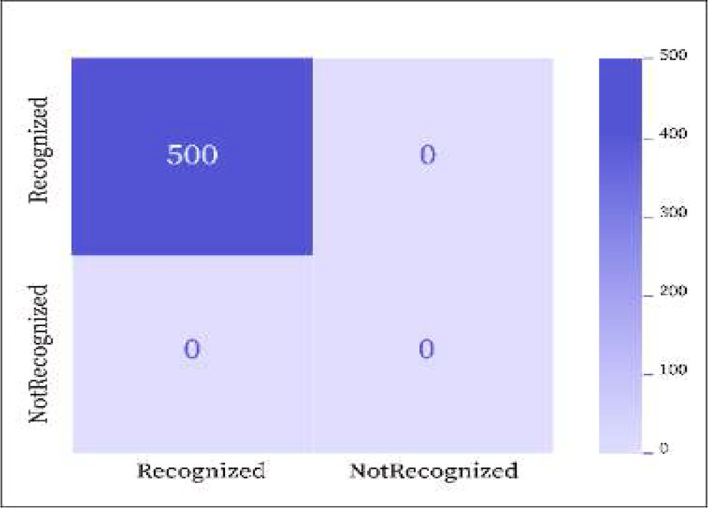

**Fig. 20.** Cattle Identification Confusion Matrix.

registration. In case of recognition, the extracted features are then transferred to the matcher algorithm which matches the muzzle point features with already stored muzzle features in database and in case of a

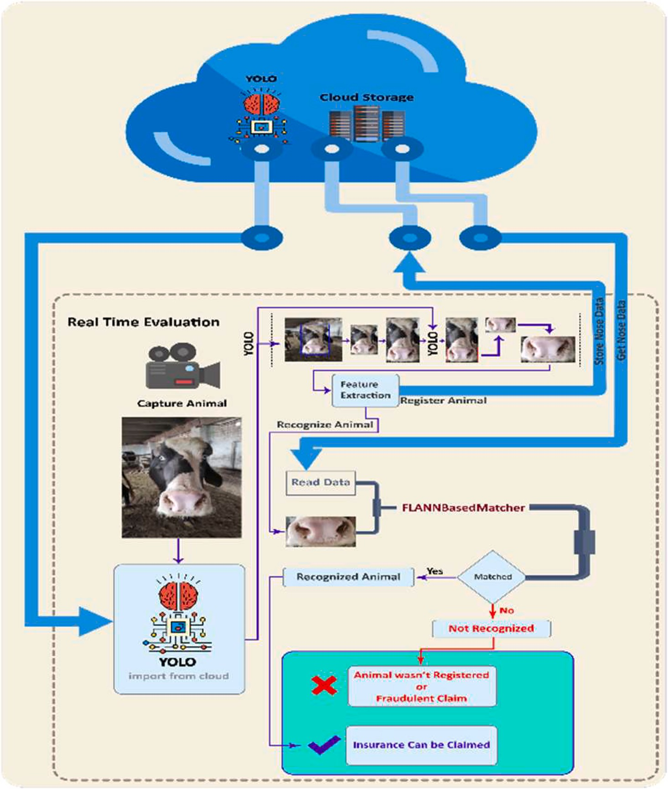

**Fig. 19.** Proposed Model.

**Table 10**

Animal Unique Features.

Sr. No Animal Unique Feature

1 Cows Muzzle/Nose Pattern

2 Bulls Muzzle/Nose Pattern

3 Calves Muzzle/Nose Pattern

4 Buffalos Muzzle/Nose Pattern

5 Horses Muzzle/Nose Pattern

6 Goats Muzzle/Nose Pattern

7 Sheep Muzzle/Nose Patter

8 Cats Nose Pattern

9 Dogs Nose Pattern

10 Lions Whisker Holes

hit, it returns the tag of the animal which can assure genuineness of the insurance claim, but if the matcher does not recognize, then that would mean that the animal was not registered in the system which subse- quently tells that the claim for livestock insurance was fraudulent.

The algorithms for cattle identification systems are compared in Table 11, along with the detection and identification accuracy rates. The first system uses the Fuzzy-KNN algorithm in combination with the Hybrid Feature Extraction and Classification approach to achieve an accuracy rate of 96.74% with a loss rate of 3.26%. However, as animals tend to flee, collecting muzzle point photographs of cattle for this technique can be difficult.

The second system achieves a 95.13% accuracy rate with a 4.87% loss rate using the BoHoG and LBP Histogram algorithms. However, they use the watershed approach to estimate the location of the muzzle point

in the image’s center, which might not be precise in real-time scenarios. With the help of the VGGNet-DCNN algorithm and the Cattle Face

Recognition Method, the third system achieves an identification accu- racy rate of 70.00%. The YOLO algorithm, which is used by the fourth system, has a detection accuracy rate of 96.00%. However, because they can be switched or faked, ear tags are not a reliable method for identi- fying cows.

The fifth system achieves a 93.30% identification accuracy rate with a 6.70% loss rate by utilizing a Unified Deep Learning Architecture method with BiLSTM and Inception-V3 CNN algorithms. However, after a certain frame length, the accuracy based on video frame length may not improve or even decline.

The sixth system uses YOLO and Few-Shot Deep Transfer Learning algorithms for Automated Muzzle Detection and Biometric Identifica- tion, achieving a 99.11% detection accuracy rate with a 0.99% loss rate. Our proposed algorithm, which uses YOLOV7 and Muzzle Pattern Feature Matching algorithms, achieved exceptional results. It achieved a detection accuracy rate of 99.50% with a 0.50% loss rate and a perfect identification accuracy rate of 100.00% with 0.00% loss rate. The pro- posed deep learning-based systems using YOLO algorithm demonstrated superior performance in terms of detection and identification accuracy

rates.

# Conclusion

Accurate identification of cattle is very critical and remains chal- lenging for veterinarian and livestock Insurer. They have been facing problems for registration and subsequent accurate recognition of regis- tered animals. Livestock insurance frauds not only entail financial losses to the insurers but they also limit the capacity of livestock Insurers to provide services to the potential clients.

In this paper, we introduced a unique approach based on Yolov7 techniques of object detection. It detects objects more accurately and swiftly than the previous versions. Our dataset includes 9400 images. Total annotated dataset comprises 15,416 class labels representing all the four classes face, nose, dirty nose and not cow. Then had to be split into training ~ 94%, validation ~ 5%, and testing 1%.

Images of a total of 500 animals were used to evaluate the recogni- tion algorithm and it recognized all the animals with 100% accuracy as we have kept the threshold of recognition by considering the sensitivity of the risk involved Animal is considered as recognized if the recognition algorithm matches at most 10 key points and descriptors. But this can be changed which can change the accuracy of animal identification.

The proposed model may be applied to resolve cattle identification current issues, and also lead to exploring other identification technolo- gies to protect livestock from serious diseases and avoid financial loss. Likewise, it may be helpful for Livestock Insurers to substantiate valid claims by accurate identification of the exactly insured animal. We are confident that this research work will provide a firm basis for future studies on the identification of other animals having muzzle patterns as listed in Table 10. The application of more advanced methodologies with an extended system for a huge dataset is highly recommended as a research area for future work. Researchers should focus on techniques to provide more accurate robust identification irrespective of the muzzle pattern quality.

Funding statement

This research program is partially funded by the United Insurance Company of Pakistan Ltd. in collaboration with United Software and

Technologies International (Pvt) Ltd. under Grant No.UICL-06–2022/ USTI-RND-006/11/2022.

# CRediT authorship contribution statement

**Munir Ahmad:** Resources, Formal analysis, Writing – original draft. **Sagheer Abbas:** Resources, Supervision. **Areej Fatima:** Resources, Writing – original draft. **Taher M. Ghazal:** Formal analysis, Writing –

original draft, Writing – review & editing. **Meshal Alharbi:** Writing –

original draft, Writing – review & editing. **Muhammad Adnan Khan:**

Formal analysis, Supervision. **Nouh Sabri Elmitwally:** .

# Declaration of Competing Interest

The authors declare that they have no known competing financial

**Table 11**

Comparing Proposed Model with Different Research Approaches.

|  |  |  |  |  |  |  |
| --- | --- | --- | --- | --- | --- | --- |
| Sr. No | Title | Algorithms | Detection Accuracy Rate (%) | Detection Loss Rate (%) | Identification Accuracy Rate (%) | Identification Loss Rate (%) |
| 1 | Hybrid Feature Extraction and Classification | Fuzzy-KNN | – | – | 96.74 | 3.26 |
| 2 | Biometric for Cattle Identification using Muzzle | BoHoG and LBP | – | – | 95.13 | 4.87 |
|  | Patterns | Histogram |  |  |  |  |
| 3 | Cattle Face Recognition Method Based on Parameter | VGGNet-DCNN | – | – | 70.00 | 30.00 |
|  | Transfer and Deep Learning |  |  |  |  |  |
| 4 | Cow Identification System Using Ear Tag Recognition | YOLO | 96.00 | 4.00 | – | – |
| 5 | Automated Individual Cattle Identification Using | BiLSTM. | – | – | 93.30 | 6.70 |
|  | Video Data: A Unified Deep Learning Architecture | Inception-V3 CNN |  |  |  |  |
|  | Approach |  |  |  |  |  |
| 6 | Automated Muzzle Detection and Biometric | YOLO & Few-Shot Deep | 99.11 | 0.99 | – | – |
|  | Identification | Transfer Learning |  |  |  |  |

interests or personal relationships that could have appeared to influence the work reported in this paper.

# References

1. [Awad AI, Hassaballah M. Bag-of-visual-words for cattle identification from muzzle](http://refhub.elsevier.com/S1110-8665(23)00046-4/h0005) [print images. Appl Sci 2019;9:4914](http://refhub.elsevier.com/S1110-8665(23)00046-4/h0005).
2. [Li G, Erickson GE, Xiong Y. Individual Beef Cattle Identification Using Muzzle](http://refhub.elsevier.com/S1110-8665(23)00046-4/h0010) [Images and Deep Learning Techniques. Animals 2022;12:1453](http://refhub.elsevier.com/S1110-8665(23)00046-4/h0010).
3. A.I. Awad A.E. Hassanien H.M.A. Zawbaa cattle identification approach using live captured muzzle print images. Adv. Secur. Inf. Commun. Networks First Int. Conf.

SecNet, Cairo, Egypt, Sept. 3–5, 2013 Proc. 2013 2013 143 152.

1. [Kumar S, Pandey A, Sai Ram Satwik K, Kumar S, Singh SK, Singh AK, et al. Deep](http://refhub.elsevier.com/S1110-8665(23)00046-4/h0020) [learning framework for recognition of cattle using muzzle point image pattern.](http://refhub.elsevier.com/S1110-8665(23)00046-4/h0020)

[Measurement 2018;116:1–17](http://refhub.elsevier.com/S1110-8665(23)00046-4/h0020).

1. [Tharwat A, Gaber T, Hassanien AE. Two biometric approaches for cattle](http://refhub.elsevier.com/S1110-8665(23)00046-4/h0025)

[identification based on features and classifiers fusion. Int J Image Min 2015;1:](http://refhub.elsevier.com/S1110-8665(23)00046-4/h0025) [342–65](http://refhub.elsevier.com/S1110-8665(23)00046-4/h0025).

1. [Ammour B, Boubchir L, Bouden T, Ramdani M. Face–iris multimodal biometric](http://refhub.elsevier.com/S1110-8665(23)00046-4/h0030)

[identification system. Electronics 2020;9:85](http://refhub.elsevier.com/S1110-8665(23)00046-4/h0030).

1. [Neethirajan S, Reimert I, Kemp B. Measuring farm animal emotions—Sensor-based](http://refhub.elsevier.com/S1110-8665(23)00046-4/h0035) [approaches. Sensors 2021;21:553](http://refhub.elsevier.com/S1110-8665(23)00046-4/h0035).
2. [Kumar S, Singh SK. Visual animal biometrics: survey. IET. Biometrics 2017;6(3):](http://refhub.elsevier.com/S1110-8665(23)00046-4/h0040) [139–56](http://refhub.elsevier.com/S1110-8665(23)00046-4/h0040).
3. [Kumar S, Singh SK, Abidi AI, Datta D, Sangaiah AK. Group sparse representation](http://refhub.elsevier.com/S1110-8665(23)00046-4/h0045)

[approach for recognition of cattle on muzzle point images. Int J Parallel Program](http://refhub.elsevier.com/S1110-8665(23)00046-4/h0045) [2018;46(5):812–37](http://refhub.elsevier.com/S1110-8665(23)00046-4/h0045).

1. [Kumar S, Singh SK, Singh AK. Muzzle point pattern based techniques for individual](http://refhub.elsevier.com/S1110-8665(23)00046-4/h0050)

[cattle identification. IET Image Process 2017;11(10):805–14](http://refhub.elsevier.com/S1110-8665(23)00046-4/h0050).

1. [Bello RW, Olubummo DA, Seiyaboh Z, Enuma OC, Talib AZ, Mohamed ASA. Cattle](http://refhub.elsevier.com/S1110-8665(23)00046-4/h0055) [identification: the history of nose prints approach in brief. IOP Conf Ser Earth](http://refhub.elsevier.com/S1110-8665(23)00046-4/h0055) [Environ Sci 2020;594(1):012026](http://refhub.elsevier.com/S1110-8665(23)00046-4/h0055).
2. [Kumar S, Singh SK. Automatic identification of cattle using muzzle point pattern: a](http://refhub.elsevier.com/S1110-8665(23)00046-4/h0060)

[hybrid feature extraction and classification paradigm. Multimed Tools Appl 2017;](http://refhub.elsevier.com/S1110-8665(23)00046-4/h0060) [76(24):26551–80](http://refhub.elsevier.com/S1110-8665(23)00046-4/h0060).

1. [Ruhil AP, Mohanty TK, Rao SVN, Lathwal SS, Subramanian VV, et al. Radio-](http://refhub.elsevier.com/S1110-8665(23)00046-4/h0065)

[frequency identification: A cost effective tool to improve livestock sector. Indian J](http://refhub.elsevier.com/S1110-8665(23)00046-4/h0065) [Anim Sci 2013;83:871–9](http://refhub.elsevier.com/S1110-8665(23)00046-4/h0065).

1. [García R, Aguilar J, Toro M, Pinto A, Rodríguez P. A systematic literature review](http://refhub.elsevier.com/S1110-8665(23)00046-4/h0070)

[on the use of machine learning in precision livestock farming. Comput Electron](http://refhub.elsevier.com/S1110-8665(23)00046-4/h0070) [Agric 2020;179](http://refhub.elsevier.com/S1110-8665(23)00046-4/h0070).

1. [Xu B, Wang W, Guo L, Chen G, Wang Y, Zhang W, et al. Evaluation of deep learning](http://refhub.elsevier.com/S1110-8665(23)00046-4/h0075) [for automatic multi-view face detection in cattle. Agriculture 2021;11(11):1062](http://refhub.elsevier.com/S1110-8665(23)00046-4/h0075).
2. [Awad AI. From classical methods to animal biometrics: A review on cattle](http://refhub.elsevier.com/S1110-8665(23)00046-4/h0080) [identification and tracking. Comput Electron Agric 2016;123:423–35](http://refhub.elsevier.com/S1110-8665(23)00046-4/h0080).
3. [Herlin A, Brunberg E, Hultgren J, Ho¨gberg N, Rydberg A, Skarin A. Animal welfare](http://refhub.elsevier.com/S1110-8665(23)00046-4/h0085)

[implications of digital tools for monitoring and management of cattle and sheep on](http://refhub.elsevier.com/S1110-8665(23)00046-4/h0085) [pasture. Animals 2021;11:829](http://refhub.elsevier.com/S1110-8665(23)00046-4/h0085).

1. [Ahmed S, Gaber T, Tharwat A, Hassanien AE, Sn´ael V. Muzzle-based cattle](http://refhub.elsevier.com/S1110-8665(23)00046-4/h0090)

[identification using speed up robust feature approach. 2015 Int. Conf Intell Netw](http://refhub.elsevier.com/S1110-8665(23)00046-4/h0090) [Collab Syst 2015:99–104](http://refhub.elsevier.com/S1110-8665(23)00046-4/h0090).

1. W. Kusakunniran A. Wiratsudakul U. Chuachan S. Kanchanapreechakorn T.

Imaromkul Automatic cattle identification based on fusion of texture features extracted from muzzle images. IEEE Int Conf. Ind. Technol. 2018 2018 1484 1489.

1. [Rudenko O, Megel Y, Bezsonov O, Rybalka A. Cattle breed identification and live](http://refhub.elsevier.com/S1110-8665(23)00046-4/h0100) [weight evaluation on the basis of machine learning and computer vision. CMIS](http://refhub.elsevier.com/S1110-8665(23)00046-4/h0100)

[2020;2608:939–54](http://refhub.elsevier.com/S1110-8665(23)00046-4/h0100).

1. Kumar S, Singh SK, Singh R, Singh AK. Animal biometrics: Techniques and applications. Anim Biometrics Tech Appl 2018:1–243. [https://doi.org/10.1007/](https://doi.org/10.1007/978-981-10-7956-6) [978-981-10-7956-6](https://doi.org/10.1007/978-981-10-7956-6).
2. [Adelson EH, Anderson CH, Bergen JR, Burt PJ, Ogden JM. Pyramid methods in](http://refhub.elsevier.com/S1110-8665(23)00046-4/h0110) [image processing. RCA Eng 1984;29:33–41](http://refhub.elsevier.com/S1110-8665(23)00046-4/h0110).
3. [Zin TT, Misawa S, Pwint MZ, Thant S, Seint PT, Sumi K, et al. IEEE 2nd Glob. Conf](http://refhub.elsevier.com/S1110-8665(23)00046-4/h0115)

[Life Sci Technol 2020;2020:65–6](http://refhub.elsevier.com/S1110-8665(23)00046-4/h0115).

1. [Bochkovskiy A, Wang C-Y, Liao H-Y-M. Yolov4: Optimal speed and accuracy of](http://refhub.elsevier.com/S1110-8665(23)00046-4/h0120) [object detection. ArXiv Prepr ArXiv200410934 2020](http://refhub.elsevier.com/S1110-8665(23)00046-4/h0120).
2. [Wang H, Qin J, Hou Q, Gong S. Cattle face recognition method based on parameter](http://refhub.elsevier.com/S1110-8665(23)00046-4/h0125) [transfer and deep learning. J Phys Conf Ser 2020;1453:12054](http://refhub.elsevier.com/S1110-8665(23)00046-4/h0125).
3. [Kumar S, Singh SK, Singh RS, Singh AK, Tiwari S. Real-time recognition of cattle](http://refhub.elsevier.com/S1110-8665(23)00046-4/h0130) [using animal biometrics. J Real-Time Image Process 2017;13(3):505–26](http://refhub.elsevier.com/S1110-8665(23)00046-4/h0130).
4. [Kumar S, Singh SK. Cattle recognition: A new frontier in visual animal biometrics](http://refhub.elsevier.com/S1110-8665(23)00046-4/h0135)

[research. Proc Natl Acad Sci India Sect A Phys Sci 2020;90(4):689–708](http://refhub.elsevier.com/S1110-8665(23)00046-4/h0135).

1. [Shojaeipour A, Falzon G, Kwan P, Hadavi N, Cowley FC, Paul D. Automated muzzle](http://refhub.elsevier.com/S1110-8665(23)00046-4/h0140) [detection and biometric identification via few-shot deep transfer learning of mixed](http://refhub.elsevier.com/S1110-8665(23)00046-4/h0140) [breed cattle. Agronomy 2021;11:2365](http://refhub.elsevier.com/S1110-8665(23)00046-4/h0140).
2. Tzutalin. labelImg. Https://GithubCom/ 2018.
3. Bi A. Detecto 2019.
4. [Yang F, Zhang X, Liu B. Video object tracking based on YOLOv7 and. DeepSORT](http://refhub.elsevier.com/S1110-8665(23)00046-4/h0155) [2022;14:2015–8](http://refhub.elsevier.com/S1110-8665(23)00046-4/h0155).
5. Google. Google Colab. Https://ColabResearchGoogleCom/ n.d.
6. Bowes D, Hall T, Gray D. Comparing the performance of fault prediction models which report multiple performance measures: Recomputing the confusion matrix.

ACM Int Conf Proceeding Ser 2012:109–18. [https://doi.org/10.1145/](https://doi.org/10.1145/2365324.2365338) [2365324.2365338](https://doi.org/10.1145/2365324.2365338).