

Electronic Notes in Theoretical Computer Science

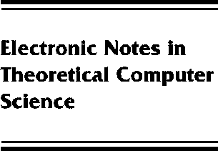[www.elsevier.com/locate/entcs](http://www.elsevier.com/locate/entcs)

Abstract Interpretation Based Verification of Logic Programs

Giorgio Levi

**Abstract**

The talk is an overview of our results on the application of abstract interpretation concepts to various problems related to the verification of logic programs. These include the systematic design of semantics modeling various proof methods and the characterization of assertions as abstract domains.

1571-0661 *⃝*c Elsevier Ltd Open access under [CC BY-NC-ND license.](http://creativecommons.org/licenses/by-nc-nd/3.0/)

10.1016/S1571-0661(05)80052-0