[Egyptian Informatics Journal 23 (2022) 73–82](https://doi.org/10.1016/j.eij.2021.06.002)

Contents lists available at [ScienceDirect](http://www.sciencedirect.com/science/journal/11108665)

Egyptian Informatics Journal

journal homepage: [www.sciencedirect.com](http://www.sciencedirect.com/)

[](http://crossmark.crossref.org/dialog/?doi=10.1016/j.eij.2021.06.002&domain=pdf)AgroSupportAnalytics: A Cloud-based Complaints Management and Decision Support System for Sustainable Farming in Egypt

Kamran Munir a,⇑, Mubeen Ghafoor a, Mohamed Khafagy b, Hisham Ihshaish a

a *Computer Science Research Centre (CSRC), Department of Computer Science and Creative Technologies, University of the West of England (UWE), Bristol, United Kingdom*

b *Faculty of Computers and Information, Fayoum University (FU), Egypt*

a r t i c l e i n f o

*Article history:*

Received 10 February 2021

Revised 24 May 2021

Accepted 12 June 2021

Available online 30 June 2021

*Keywords:*

AgriTech Sustainable Farming

Decision Support Systems Big Data

Analytics

a b s t r a c t

Sustainable Farming requires up-to-date advice on crop diseases, patterns, and adequate prevention actions to face developing circumstances. Currently, in developing countries like Egypt, farmers’ access to such information is extremely limited due to the agriculture support being either not available, incon- sistent, or unreliable. The presented Cloud-based Complaints Management and Decision Support System for Sustainable Farming in Egypt, named as AgroSupportAnalytics, aims to resolve the problem of both the lack of support and advice for farmers, and the inconsistencies in doing so by current manual approach provided by agricultural experts. Key contribution is the development of an automated com- plaint management and decision support strategy, on the basis of extensive research on requirement analysis tailored for Egypt. The solution is grounded on the application of knowledge discovery and anal- ysis on agricultural data and farmers’ complaints, deployed on a Cloud platform, to provide farming stakeholders in Egypt with timely and suitable support. This paper presents the overall system architec- tural framework along with the information and storage services, which have been based on the require- ments specifications phases of the project along with the historical data sets of past 10 year of farmers complaints and enquiries in Egypt.

© 2022 THE AUTHORS. Published by Elsevier B.V. on behalf of Faculty of Computers and Information,

Cairo University. This is an open access article under the CC BY-NC-ND license ([http://creativecommons.](http://creativecommons.org/licenses/by-nc-nd/4.0/)

[org/licenses/by-nc-nd/4.0/](http://creativecommons.org/licenses/by-nc-nd/4.0/)).

1. Introduction

Cultivating soil, producing crops, and preparation and distribu- tion of the resulting products is a practice that dates back thou- sands of years, and since has been playing a vital role in contributing to the global economy. In many developing countries, agriculture is a major source for income and employment in rural communities which constitute 45% of the world’s population. Around 26.7% of the world population secure their livelihoods from agriculture [1]. Yet, despite its historical impact on food security, employment and socioeconomic development and stability, the sector still faces structural weaknesses and challenges. These include, but not limited to, pests, vulnerability to climate change,

* Corresponding author.

Peer review under responsibility of Faculty of Computers and Information, Cairo University.

**Production and hosting by Elsevier**

inadequate farming practices and uninformed decision making related to planning, support and protection. The lack of effective support for farmers to adopt good agricultural practices and pre- vention methods are yet another factors that hinder both the pro- ductivity and food security in large scale rural communities [2]. Farmers need up-to-date advice on crops’ diseases, crop patterns and adequate prevention actions to face developing circumstances. Currently, farmers’ access to such information is limited due to current support system being inconsistent, unreliable and often not timely – hence delivered advice can become irrelevant.

Over the last two decades, advancements in the agricultural industry has been made through the application of data analytic tools and decision support systems (DSS), with noticeable impact in irrigation management, precision agriculture and optimal farm- ing [3]. Though these systems are very useful in offering structured analysis and information to the farmers in a step by step manner, difficulty in usage due to their sophisticated nature, especially for farmers with low literacy in developing countries is often times a challenge. Several systems exist, including related informal forums [4], social networks [5], and interactive voice response systems [6] where peers and experts interact with each other and exchange suggestions and opinions on issues raised by farmers. Govern-

<https://doi.org/10.1016/j.eij.2021.06.002>

1110-8665/© 2022 THE AUTHORS. Published by Elsevier B.V. on behalf of Faculty of Computers and Information, Cairo University. This is an open access article under the CC BY-NC-ND license (<http://creativecommons.org/licenses/by-nc-nd/4.0/>).

ments have also tried to handle enquiries and concerns raised by farmers via establishing agri-centres at rural hubs where experts provide suggestions on farmers’ complaints and enquiries by tele- phony [7]. Whilst this approach seems to facilitate reasonable results, nonetheless, due to the high user demand, it is practically not feasible to provide effective response to extremely large num- bers of phone calls, and does not offer a structured way to keep track, and use, of the historic record of enquiries made, resolved and otherwise. Moreover, providing adequate responses for farm- ers’ queries is difficult for domain experts as comprehensive infor- mation regarding the context of the problem (corp, area, historic information, etc.) and underlying issues may not be adequately communicated through conventional phone calls. For a sustainable farming practice, the development of an automated query/com- plaint management system is still an open problem. Mohit Jain et al. [8] proposed a conversational agent for resolving farmer queries by using IBM Watson Speech-based system and Google Translator. However, there is still a high demand for efficient query/complaint management system to enhance the usability and acceptability aspects for farmers with limited literacy while keeping the system highly scalable, available around-the-clock and have manageable overheads.

This study aims to resolve the problem of support and advice for farmers in place of the current manual system, deployed in Egypt, by presenting a framework for Complaint Management and Deci- sion Support System for Sustainable Farming (AgroSupportAnalyt- ics). It is based on the application of knowledge discovery and analytics on agricultural data and farmers’ complaints, deployed on a Cloud platform. The automated system is to provide adequate and timely advice for farmers upon their enquires/ complaints, and also to foresee near future development of circumstances by the experts. Consequently, enabling agricultural experts to broadcast early warning signals of threats, mainly pests and disease, and the needed prevention actions to be undertaken by farmers. The system can be deployed to serve villages around farming fields in Egypt and will aim at improving welfare and development in rural parts of the country, and open opportunities for further research and development in the field.

The rest of the paper is structured as follows: In Section 2, a lit- erature review of decision support and expert systems in agricul- ture is presented. Section 3 describes the system requirements and applications constraints. Section 4 presents the system archi- tecture with an illustration of the services/features offered by AgroSupportAnalytics system. In Section 5, we present the software application architecture. The N-tiered architectural representation of the proposed system is described in Section 6. Section 7 offers the subsystem layering and component-level functionalities details. Section 8, presents the Applications of the AgroSupportAnalytics system along with a brief case study of farmer query and complaint response that serves as a demonstra- tive proof of system. Section 9 concludes the paper.

* 1. *Existing farmer complaint processing approach*

Agriculture in Egypt absorbs over 30% workforce and provides livelihood to more than 50% of rural population, but contributes only 11% to national GDP in 2019 [9]. This is mainly because each year a large portion of crops are wasted due to pests and diseases and also due to obsolete farming practices. It is believed, therefore, that timely farmers’ complaint resolution and access to informa- tion and expertise advice is vital to achieve sustainable and quality agriculture production. The existing farmers’ complaint manage- ment process follows a conventional query (complaint) submission approach where farmers deliver, usually manually, their complaints and needs for support to their respective ‘agricultural associations’ distributed across Egypt. These, being in Arabic text,

are received and then submitted to one of the national ‘centers’ distributed over the country to offer support for farmers in their villages. Several agricultural experts working at these centers sub- sequently process farmers’ enquiries, either instantly or by con- sulting the Agricultural Research Center (ARC) via an interface designed for the purpose. A recommendation is usually provided. Most of the times, however, a ‘no known solution’ is delivered ‘ usually via phone calls. The portal provided by ARC offers access to a database of complaint-support pairs, which can sometimes features issues of inconsistency, redundancy, lack of structure, or missing value. The flow of the existing manual querying system is shown as Fig. 1. Even with a swift ‘‘round” of consultancy pro- vided by the system, response from experts can get significantly delayed, mainly due to a large number of sent queries (in the order of tens of thousands). Consequently, farmers, get an answer when it is too late for them to act. Similarly, the support provided by experts deals only with farmers’ instant complaints, lacking near future perspective on developing circumstances, and thus advice.

1. Related literature review

For nearly two decades, decision support systems (DSS) and data analytics have become efficient tools for providing precision agriculture and farming. Recently, Big data technologies are being widely adapted in agriculture domain mainly because the agricul- ture related data sets (including real time) are becoming extremely large and complex that it is becoming difficult to process them using on–hand data management tools and/or traditional data pro- cessing applications. CropSyst [10] is a DSS developed into a suite of programs, including a crop simulator, a weather forecast gener- ator, GIS (Geographic Information System) modeler program, and a watershed utility program. CropSyst aims to simulate and optimize

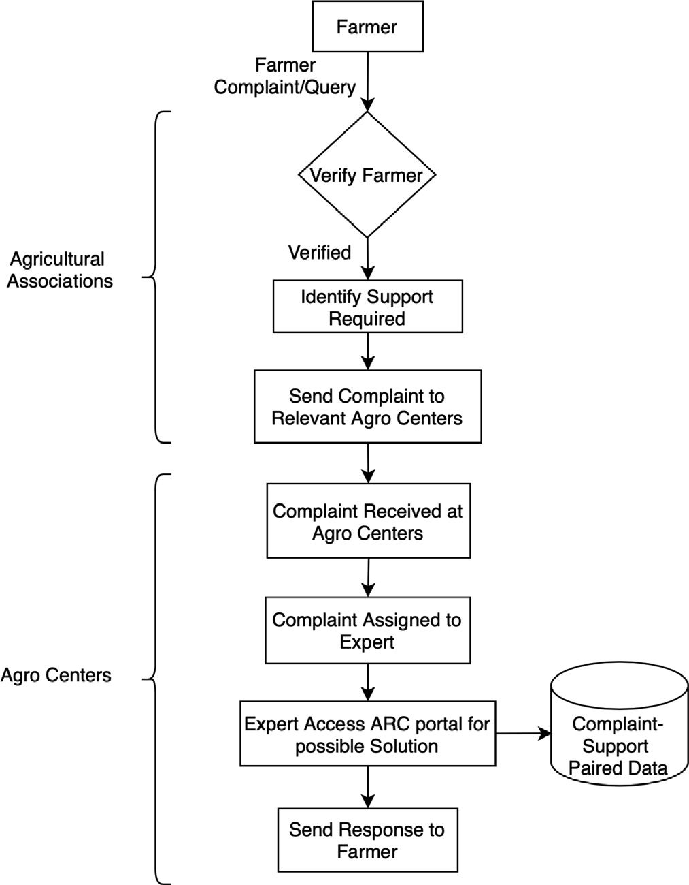

Fig. 1. Existing complaint/query resolution mechanism.

features like the soil water budget, soil–plant nitrogen budget, crop canopy and root growth, and yield. The AquaCrop [11] model eval- uates the production of maize crop under semi-arid climate condi- tions. García-Vila and Fereres later combined an economic model with the AquaCrop simulator to optimized farm-level irrigation [12]. Paredes et al. analysed and predicted the impact of irrigation management strategies against yield and economic returns of maize crop [13]. In [14], an inferential framework is used to exam- ine the soil moisture based on environmental weather conditions such as moisture, precipitation, temperature and canopy coverage variation. Giusti and MarsiliLibelli [15] introduced an inference based fuzzy DSS to optimally find irrigation actions based on the crop and site characteristics and conserving the water usage.

Perini and Susi [16] discussed the design and development aspects of a pest management DSS that can be used by the mem- bers of advisory services including pest experts and technicians. Xu et al.[17] introduced an agricultural ecosystem management systems to extracts, manage and analyze data regarding terrain, land utilization and planting. Kurlavicˇius et al. [18] introduced a DSS for sustainable agriculture to predict the optimal crops grown and animals kept in particular regions, The system also predicts the resources required to carry out these activities under the varying environmental conditions.

Antonopoulou et al. introduced a Web-based DSS to let farmers find the appropriate crops based on their regional and environ- mental conditions and also provide the best cultivation strategies and periods [19]. In [20] a DSS for Farm Management Information Systems(FMIS) is proposed using cloud and external web services. Kaloxylos et al. later, proposed implementation of a cloud-based FMIS for managing a greenhouse [21]. Fountas et al. [22], Tayyebi et al. [23] and Tan [24] proposed perspectives of cloud computing as the key drivers in future development of FMIS and precision agriculture. Big data mining can facilitate the extraction of useful information from complex, variable, and large volume of the data- set [25], therefore can improve a DSS’s accuracy in various fields. The Millennium Project [26,27]; for example, has identified many interesting challenges related to clean water, sustainable develop- ments, climate changes, population and resources etc. This project has advocated the use of big geospatial data to save energy with eco-routing, i.e., avoiding congestion, stopping at red lights, turn- ing points, and identifying elevation changes. Furthermore, a fuel consumption minimising technique has been proposed to achieve best travel time with reduced travel distance.

Recently, an unprecedented growth of Data Force Analytics enabled utilisation of big data technologies and digital sensors to manage data efficiently. Adopting such an approach in the field of agriculture can bring many benefits to support decisions. Never- theless, data analytics still faces many challenges of handling extensive data and diverse data sets like semi-structured, unstruc- tured, and streaming data. Therefore, in such Data Force Analytics developments there will be a strong need to effectively utilise datasets to facilitate users in finding their needs efficiently and effectively e.g. a qualitative study in [28] points out a co-evolving tool to understand such needs/skills.

Recently, organisations have started to use the concept of Self- Service Analytics to encourage professionals or workers to perform queries with IT support and generate reports independently [29]. The framework proposed in [29] provides matrix called the gover- nance of Self-Service Analytics (GOSSA), which uses the power of business intelligence (BI) tools and platform to support IT- enabled analytic content development to help experts find the best solutions and get the decision rapidly.

The geodatabase contains a visual analysis of tabular data to achieve the primary utilisation of practising BI system and GISs in data analytics [30]. The Puerto de la Luz is a SmartPort [30]

solution, enabling real-time monitoring and collection of sensor data in a seaport infrastructure. It is a web-based GIS application, which uses an open-source big data architecture to achieve its functionality. The system is deployed on the Puerto de La Luz sea- port and applied to data from two system sensors.

The Spatial Decision Support System (SDSS) is an extension of DSS application [31], which supports an improvement in decision-making compared to non-spatial data. In particular, SDSS in agriculture has a positive impact on improving decision making [32]. SDSS benefited from the greater public availability of spatial data and the more flexible software, which enables its integration/- modelling into the geographic information system [33]. In addi- tion, an open-source SDSS project known as MicroLEIS DSS [34] aids agriculture soil protection and land sustainability. It comprises valuable tools and techniques for decision-making in a wide range of agro-ecological schemes. This system builds on statistics, data- bases, neural networks, expert systems, Web technology, and GIS applications.

The SDSS for agricultural land management [35], helps in deci- sion making for the land management of food crops. It also aids in testing, validating and sensitivity checking of the decision models. The study revealed that SDSS is developed on Compromise Pro- gramming modules to produce spatial information integrated with fuzzy set and analytic hierarchy(AHP). SDSS utilises input informa- tion in operation, for instance, information from field experts and its applications.

Whilst noticeable progress has been made in digital support systems, nonetheless, most of the proposed DSS have been put for- ward to handle aspects related to precision agriculture, irrigation management and optimal farming. Additionally, not much, if at all, have been proposed around facilitating support for farmers in terms of addressing their enquiries, questions and complaints, and optimising the whole process efficiently, besides providing insights to the beneficiaries from the vast amount of historic data, and recorded experience. The aim of this study, therefore, is to design and develop a system by considering the unique require- ments of the farmers into accessing information whilst enhancing the overall sysetm’s usability and acceptability. That is, the pro- posed DSS enables farmers to access information and experts’ advice; for example, information regarding the choice of seeds to sow, optimal harvesting times, knowing how to treat and combat plant diseases and pests, weather/calamity based forecasting and advisory etc.

1. System requirements and constraints

The purpose of AgroSupportAnalytics is to manage farmers enquiries and complaints, while replacing the current manual sys- tem, which would additionally result in an overall reduction of the costs of running the system. The system will need comply with agricultural standards, and maintain high quality expert response by ensuring access to timely information, elaborate estimation, record-keeping and knowledge extraction using data mining (to help in decision making) tools. The derived functional and non- functional requirements are detailed as follows:

* 1. *Functional requirements*

Following are the key functional requirements that are consid- ered in designing the architecture of this project:

* + - Development of a web application that allows farmers to input their queries and complaints in free text supported by a fixed set of pre-defined questions, which are then resolved by agri- culture experts.
    - Storage of all queries and complaints and their solutions in a centralised data storage hosting observations, support and ana- lytics toolkits.
    - Analyses of the queries and complaints through data analytics techniques, for matching optimisation and pattern detection.
    - Enabling an automated support response based on semantic similarity approximation to preexisting complaints within the historical complaint’s datasets.
  1. *Non-functional requirements*

Following are the non-functional requirements that are consid- ered in designing the architecture of this project:

* + - Usability: an important factor in determining whether the farmer uses and relies on the new system, widely. Usability in agriculture is complex, particularly due to farmers’ lack of awareness and experience in dealing with digital processes. That is, the system should be easy to use, with suitable features to overcome the potential impediment of digital gap.
    - Performance: The system to allow domain experts to search complaints, identify the complaint words from the text, associ- ate them with the attributes of agricultural objects and label them together. In this way, system lets a human expert do required analysis as the software system would do; such that, results of the system against human analysis can be comparable.
    - Support-ability: The architecture should support cross- platform.
    - Security: To have the ability to prevent unauthorised access and continue to provide service to legitimate users.
    - Fault tolerance: The system should be resilient to failures and should restore in case of partial service disruption being it sev- ere or not, hence allowing shorter service recovery times.
    - Maintenance and sustainability at lower cost: The system should be sustainable at low cost and have the ability to incor- porate changes effectively.
    - Scalability: To be scalable in terms of user capacity, i.e. if the number of users/clients grows then system resources can be added to deal with regards to the increased user demand.
  1. *Project constraints*

There are some key project constraints that have a significant bearing on the architecture. They are:

1. The existing legacy complaints database should be accessed to retrieve all the historical complaints information to assist in answering the new query of the farmer. The AgroSupportAna- lytics need to support the data formats of the legacy complaint data.
2. The functionality of AgroSupportAnalytics system should be available to the farmer, expert, and administration from remote sites with internet connection.
3. All remote accesses are subject to user identification and pass- word control.
4. The AgroSupportAnalytics will be implemented as a client–ser- ver system. The client-side can be accessed using an internet browser, and the server-side will be deployed on a Cloud.
5. System architecture

The three primary services/features of AgroSupportAnalytics system performs are:

* Effective farmers’ access, registration and complaint raising.
* Expert support and predictive insights (provisions and prevention).
* Reporting services, scalability and sustainability.

The system is designed using a client–server architecture, where the client-side is responsible for all user interactions with the system. Clients interact with the server through web- services. The Server applications are deployed on server machines along with a storage for managing data sets. Apart from these ser- vices, the AgroSupportAnalytics system also provides user registra- tion and login functionality. A user can interact with the online AgroSupportAnalytics Central Server from the client machine through a web browser. The AgroSupportAnalytics Central Server handles input connections (requests) from clients as well as it hosts user registration and login services. In order to execute user requests the AgroSupportAnalytics Central Server is connected to more back-end services; i) Farmer Complaint service, ii) Historical Search service, iii) Analytics Apps. The overall working of the cli- ent/server system is illustrated in Fig. 2.

1. Software application architecture

Software applications of AgroSupportAnalytics have been designed on the configuration and plugin-based mechanism. This mechanism facilitates support for new workflow management sys- tems and algorithms without altering the core of the system. Since the scope of the project is broad and complex; the overall project requirements can be divided into different applications with vary- ing degrees of independence between the applications. Each appli- cation is further divided such that the application logic and business logic can be executed across servers. Moreover, the sys- tem under consideration requires faster network communications, high reliability, and excellent performance.

In order to fulfil these design requirements, the n-tier architec- ture, or multi-layered software architecture is employed where each of the layers corresponds to a different level of abstraction [36]. The N-tier or multi-layered approach is particularly suitable for developing web-scale and cloud-hosted applications very quickly and relatively risk-free [37,38]. N-tier application architec- ture provides a model by which developers can create flexible and reusable applications. By segregating an application into tiers, developers acquire the option of maintaining, modifying, or adding a specific layer, instead of reworking the entire application. In prac- tice, the tiered architecture greatly simplifies the management of the software infrastructure [39].

In this project, the layered architecture followed is ’closed’, meaning a request should go through all layers from top to bottom [40]. Since architecture is broken up into multiple layers, the changes that need to be made should be more comfortable and less extensive than having to tackle the entire architecture. The layered architecture for designing the system enables self-independence between layers [41]. In a given layer, software components that belong to a similar level are organised horizontally, where the components may depend on the processing of each other, and this also makes relevant components to stays in a single compatible layer. This allows for a clean separation between types of compo- nents and also helps gather similar programming code together in one location. By isolating the layers, they become independent from one another.

In the layered architecture, although the components from one layer can interact with the components of another layer, but they do not directly depend on other layer’s components [42]. Tradi- tional enterprise systems use RDBMS while the NoSQL system is widely adopted due to its excellent performance and high avail- ability for large sets of distributed data. Thus if, for example, we want to change the database from SQL (RDBMS) to NoSQL (such

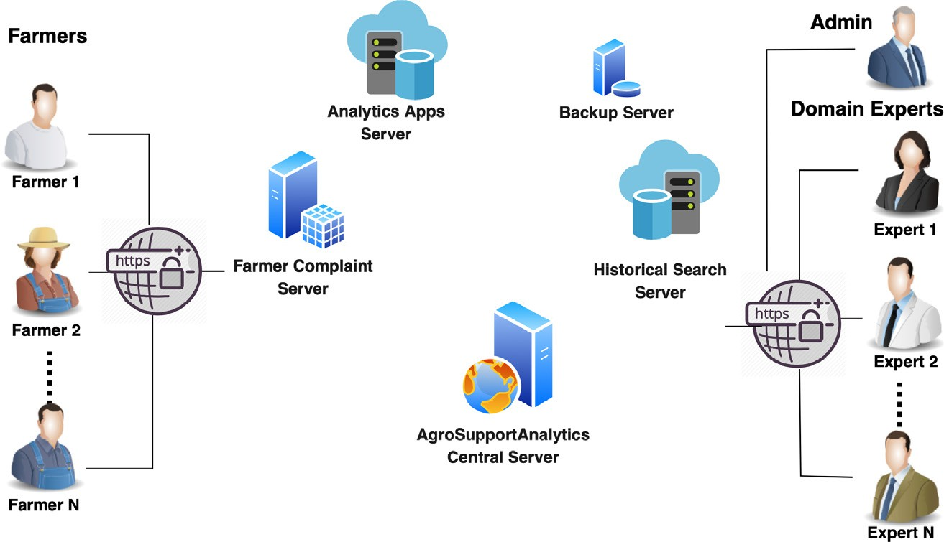

Fig. 2. Overall client/server illustration of AgroSupportAnalytics design.

as Hadoop), this will cause a significant impact on the database layer, but that won’t impact any other layers. The adapted layered architectural pattern reduces the communication overhead caused by network traffic to provide faster network communications and efficient system performance. The component-based layered archi- tecture also makes the testing process simple and convenient as individual components from each layer can be tested separately.

1. Architectural representation

This section describes the logical view of AgroSupportAnalytics architecture. The individual plug-in or components are organised in n-tiered layered architecture patterns where the components are arranged in horizontal layers. The AgroSupportAnalytics is designed into four key layers as shown in Fig. 3, i.e.:

i Applications;

1. Information and Analysis Services;
2. Data Integration and Storage; and
3. Data Sets and Pre-Processing.

I Application layer: This is the top most layer or tier present in the system. This tier provides presentation services; in simple terms, it is a layer that end users can access directly through a graphical user interface (GUI). This tier can be accessed through from various supported client devices e.g. desktop or mobile device. For the content to the displayed to the user, the relevant web-pages should be fetched by the web browser or other presentation component which is running in the client device. To present the content, it is essential for this tier to interact with the other preceding tiers.

1. Information and Analysis Services layer: In this second tier, business logic of the applications runs. Business logic here is the set of rules that are required for running the application as per the laid down guidelines. In simple words, this layer con- trols an application’s functionality by performing detailed pro- cessing. The components of this tier run on a back-end servers. This tier has the objective of providing a quick response time to the end-user and plays a vital role by acting as a glue that binds the user application together by allowing the func- tions present in different tiers to communicate with each other and display the outputs to the end-user through the web brow- ser.This Information and Analysis Services layer also contains Persistency Service. Here, persistency service provides a mech-

anism for accessing the system data as per user requirements. The core data in the project include: (1) farmer compliant data- sets that are collected from various agricultural departments;

(2) new user complaints; and (3) online weather datasets. Pro- viding direct access to these datasets is not ideal because a user who is maybe preparing to carry out an analysis may need to select the part of a dataset based on specific characteristics. Fil- tering giga-bytes of data at run-time is not a trivial task unless it is methodology indexed beforehand for analysis purposes. The persistency services carry out the necessary functions of importing, indexing, and storage of the datasets. This layer pro- vides enhanced scalability and performance to the data and storage tier.

1. Data Integration and Storage layer: This is the third tier of the proposed architecture from the top and is majorly responsible for the storage, maintenance, and retrieval of application data. The application data is stored in a database and file server. Moreover, this layer supports data access logic and provides the necessary steps to ensure that only the data is exposed without providing any access to the data storage and retrieval mechanisms. This layer maintains data independent from the application server and the business logic. The data tier does this by providing an API to the System and Analysis Services layer. The provision of this API ensures complete transparency to the data operations, which are done in this tier without affect- ing the System and Analysis Services layer. For example, updates or upgrades to the components in this tier do not affect the System and Analysis Services layer.
2. Data Sets and Pre-Processing layer: It is mainly concerned with the raw historical agriculture data and corresponding semanti- cally structured processed data. This dataset is required to find the similarity between the current farmer’s complaint and the available historical agriculture data to provide a suitable solu- tion to the farmer. Data pre-processing is important for bringing the raw historical complaint/response textual data into a form on which its similarity match can be effectively performed with the farmer’s new complaint/query. Data pre-processing include operations, such as, tokeniation, stop words removal, normal- ization, stemming, lemmatization, and part of speech (POS) tagging.
3. Architecture overview and subsystem

Fig. 3 also shows the component level details of individual lay- ers. Moreover, the mutual interaction among layers and their

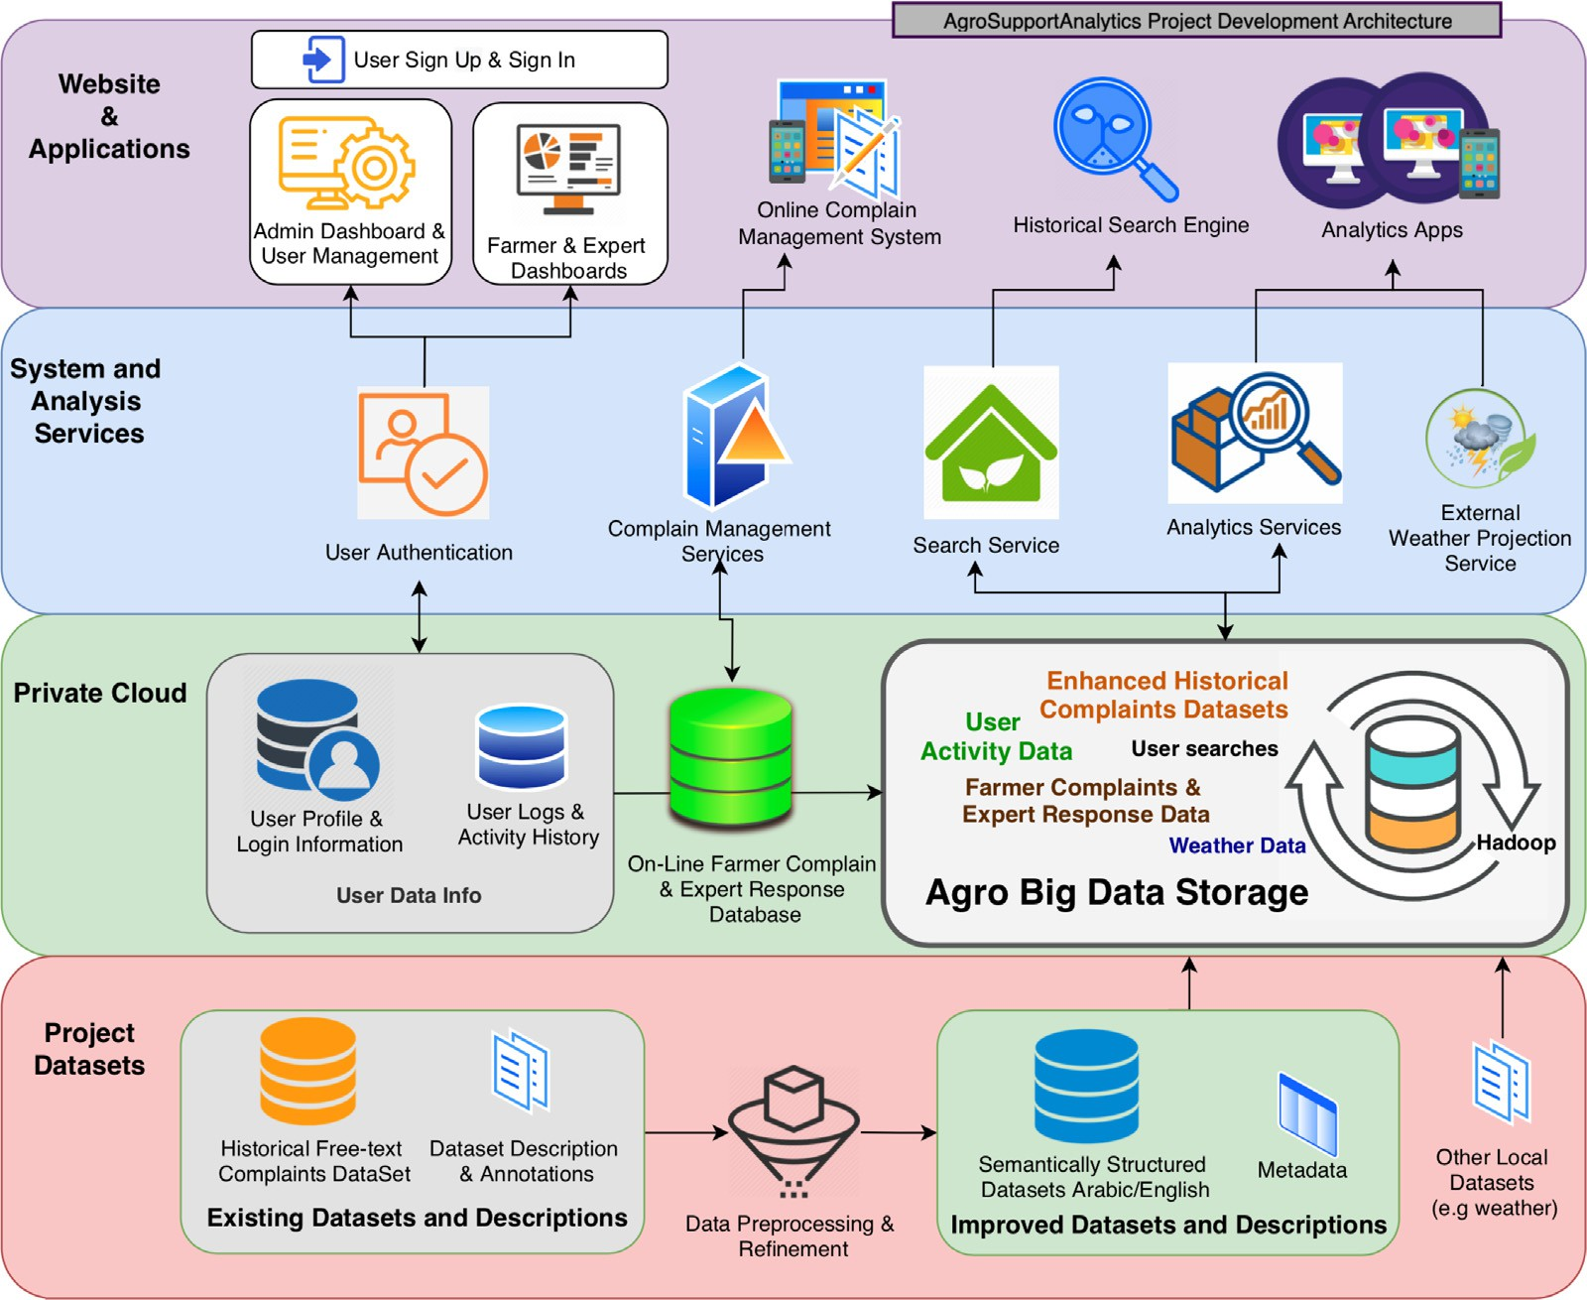

Fig. 3. AgroSupportAnalytics architecture with and underlying components and interactions.

underlying components is also presented. A brief discussion of each layer and their components is provided in the following sections.

* 1. *Data sets and pre-processing*

In order to develop an automated farmer recommendation sys- tem, a tool is designed that can extract knowledge from historic complaint-solution datasets and provide most suitable recommen- dations (or suggestions) to farmers regarding their new complaints by analysing similar complaints in the historical complaints data- set. Following are the key sub-components and techniques to be used to perform this task:

I Data Acquisition and Pre-processing of Historical Data: In order to develop an automated tool for farmer recommendation, there was a need to possess a Question/Answer (QA) Dataset of farmer complaints along with experts (specialists) responses for each question (or complaint). Regarding this, a dataset of historical complaint records has been acquired from the Egypt’s agriculture centers. This dataset includes the historical records of the textual complaints made by Farmers and the responses provided by the Experts. However, this is Free-text QA Data in somewhat slang Arabic language and it cannot be used in the existing form directly for answering new farmer complaints. A pre-processing and Data Refinement step is imperative to con- vert this Free-text slang data into Semantically Structured Data- set for further analysis. Moreover, the architecture will allow aggregating weather data into the system, for likely integration with the services focused on predictions, provisions and pre- vention advices.

1. English Translation of Complaints/Responses: As mentioned, the dataset acquired from the Egypt’s agriculture centers contains farmer’s historical complaint and responses pro- vided by the Experts in textual formats. This dataset is sig- nificant because it contains questions/answers (QA) from diverse agricultural scenarios that contain data for different crop types, soil natures, environment, conditions, pest and diseases, farming and administrative practices. Moreover, the datasets are available in a textual format that very clo- sely resembles the natural form of expression or communi- cation and can be interpreted by natural language processing models. Thirdly, it contains loads of real-world (real scenario) records that are collected over a large period of time by the Egypt’s agriculture centers. These features make the dataset unique and it is not only important for answering new complaints of Egyptian Farmers, but farmers and agricultural centers from other parts of the world can also greatly benefit from the overall system developed as an outcome of this project. In today’s world of big data ana- lytics, the significance of such datasets is of paramount importance. In order to take full advantage of the dataset, the possibility of translation of the Free-text QA Data in slang Arabic language to semantically structured Dataset in the English language has been explored. This ability is not only giving an option to the Egyptians farmers/experts to query dataset in another language, but also opens available dataset for farmers/ agricultural centers across the world to get benefit.
2. Feature Extraction and Historical Complaint Mapping: Once the QA Dataset are pre-processed, the next step is to build a semantic model from the available textual documents to

extract the most insightful features, that can be further used for the textual data analysis and similarity mapping. The datasets and the extracted features in this layer are made part of the Agro Big Data storage hosted on the Cloud and are used by Search and Analytics Services.

* 1. *Data integration and storage*

This consists of a back-end database service comprising of var- ious types of data sets, files, and the database management system that manages and provides access to the project data. The datasets are made accessible to the Information and Analysis Services layer by hosting them on the Cloud.

The second major functionality considered in AgroSupportAna- lytics is a Farmer Complaint Registration and Expert Response sys- tem. This system involves the development of interfaces for the online complain management, which can be remotely accessed to queries. These complaints can be reviewed by experts to provide feedback or suggestions using Expert web-forms. In order to store farmer complaints and associated experts’ responses, a new On- Line Farmer Complain and Expert Response dataset storage is established to contain richer data as compare to the available his- torical complaints data acquired from the Egyptian agricultural departments. Based on this data, extended analysis and predictions could be made possible that goes beyond the natural language- based textual processing.

Other datasets comprise User Profile and Login Info that includes the profile and login information of the users and user logs and activity history that contains the activities and logs of the Users. The layer also includes Agro Big Data Storage that con- tains the Historical Complain Dataset, the Online Farmer Complain and Expert Response Dataset. Search and Analytics Services in the Service layer interacts with this dataset in order to extract infor- mation from it.

* 1. *Information and analysis services layer components*

The Information and Analysis Services layer contains back-end software components and provides authentication, persistency, and information services. The authentication is a RESTful web ser- vice that operates on top of the User Data Info dataset in the pri- vate cloud and authenticates the users. Depending on the authentication result, user access type, and privileges, the user is given access to the modules in the application layer.

The Complaint Management Services interfaces between the Online Complain Management application and the Online Farmer Complain and Expert Response dataset can provide functionalities such as (a) crawl the datasets; (b) make a model based on the structure of dataset; and(c) store both data sets and outcomes, data dictionaries including possible parameters’ values, such that these are query-able by other tools and services, and (d) store and index the image files associated with data sets.

The Search Service provides a mechanism to directly query datasets from the Agro Big Data Storage for querying, indexing, and searching based on Historical Search Engine as well as Farmer Complain and Expert Response Data. The Analytic and External Weather Projections services will act as information services and provide an interface between Analytic apps and the Agro Big Data Storage. Based on the Analytic apps information request, these ser- vices can query the Agro Big Data Storage dataset and then can apply data-mining, visualization, and machine learning algorithms on the data and then return the information to the Analytic apps.

* 1. *Applications layer components*

This layer contains user-friendly front-end interfaces designed for farmers and experts to remotely access the web components containing static as well as dynamic content. The front-end content is rendered by the web browser. These components include the User Sign In and Sign Up module, Farmer and Expert Dashboards, and Online Complain Management System. User Sign-In and Sign-Up components are available to authenticate the valid system users. After Sign In, Users can view Dashboards that contains their previous activity and up-coming notifications. In the Online Com- plain Management System, Farmer can submit their new com- plaint along with the textual, audio, and imagery data. The complaints are reviewed by the Experts, and they provide feedback or suggestions using Expert interface. These webforms are sup- ported both in Arabic and English texts. This layer also includes Historical Search Engine and Analytics Apps. Using the Historical Search Engine component, users can query the Search Services, which in turn calls the Agro Big Data Storage to find the closest response from Historical Complain Datasets. The Analytics Apps can include analysis and predictions on the existing and/or exter- nal data sources to identify and explore patterns of ‘cause effect relationships’. .

1. Applications of the AgroSupportAnalytics system

This section describes Agro Big Data Information Retrieval ser- vice and one selected case study (due to space limitations) of farmer query and complaint response that served as one of the var- ious demonstrative proof of the system. The snapshot of the AgroSupportAnalytics system is shown as Fig. 4.

* 1. *Agro Big Data information retrieval through the querying services*

In order to access or retrieve information, a method was required to search and query the data from the Agro Big Data stor- age. This retrieval method facilitates querying the historical com- plaint data set, analytic algorithms and other services that require data from the Agro Big Data storage. This is achieved by developing a Data Querying Interface; for example, searching and browsing the datasets for farmers and other users, viewing data dictionary, etc. The following subsection illustrates the design and implementation of the proposed Querying Service.

* + 1. *The Querying Service*

The Querying Service is designed as a web service to be invoked over HTTPS to interact with the Agro Big Data storage, as shown in Fig. 5. This service-oriented approach provides the option to expose the server-side functionality to the client application. It enables a transparent (seamless) and easy setup for providing desired functionality to users as well as external services within an authenticated session. The implementation of Querying Service starts with user verification that utilises the identity retrieval method provided by the AgroSupportAnalytics gateway. This fea- ture not only secures the system by authenticating all the incom- ing requests but is also useful for maintaining logs of user activities. After user authentication, Querying Service initiates a query-building phase. The implementation of the query-building involves i) parsing of parameters provided by the user, ii) selection of appropriate data sets.

* 1. *Agro-experts responses against farmers queries or complaints*

In this section, we describe the design of user interfaces for the agro-experts responses against farmer queries and complaints sys-

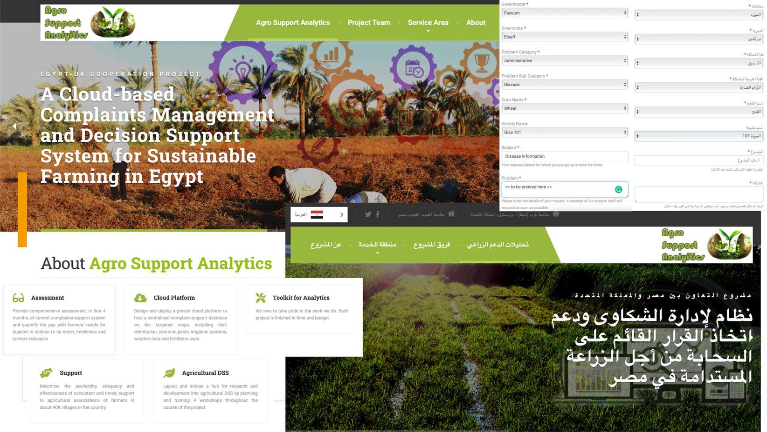

Fig. 4. A snapshot of the AgroSupportAnalytics system.

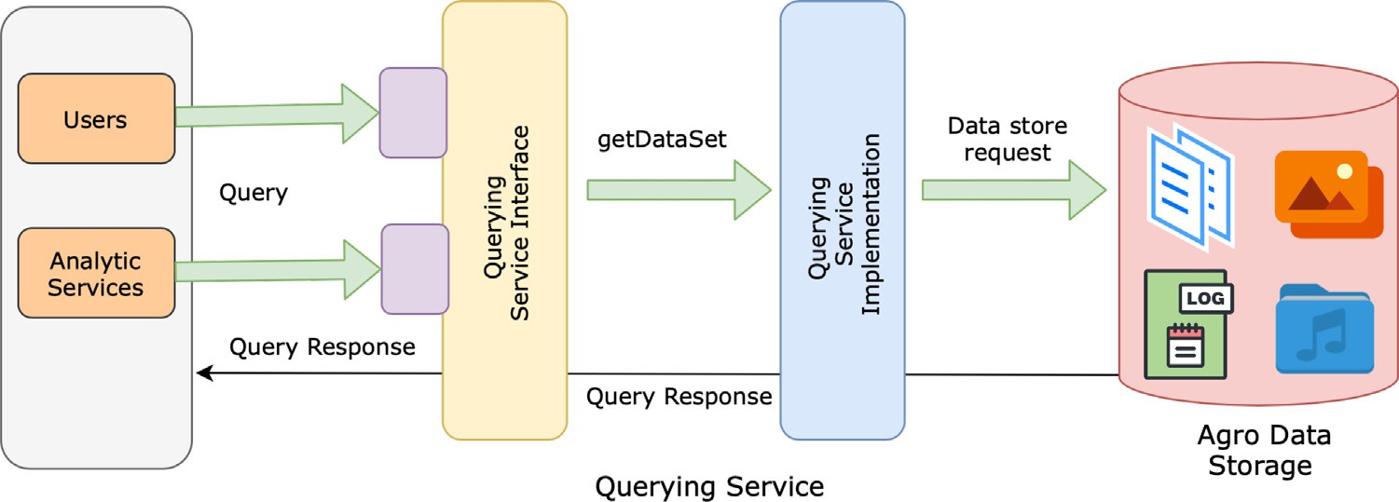

Fig. 5. User and analytic services interaction with the agro data storage.

tem. It contains three major components: the farmer interface, the agro-expert interface and the administrator interface.

* + 1. *Farmer (process flow) interface*

To interact with the query and complaint management compo- nent farmer needs to register with system if he is a new user or he can enter his login credentials to see the query and complaint man- agement page. The system sends an automated email to the farm- ers email upon his registration. After registration/login, farmer can see a dashboard, where they can see list of all previous queries or complaints that are submitted. For each query or complaint, a sta- tus parameter is available with three possible values, i.e., ‘unre- solved’, ’in-process’, or ‘resolved’. When a new query or complaint is submitted, its status is set as ‘unresolved’ by the sys- tem. This status can later be changed as ‘resolved’ by the agro- expert or by the farmer upon the resolution. Whenever the status is changed, the system sends an automated email to the farmer’s email regarding the change in the query or complaint status.

In order to raise a new query or complaint, the farmer presses a ‘‘New Query or Complaint” button and a new form appears where the farmer enters the title of the query or complaint along with a detailed description in free text. Farmers can also relate their query or complaint with several filters available on the webpage. For

example, farmers can add information regarding his area or region and can associate their query or complaint with one of the cate- gories such as profitable crops for a region, irrigation, harvesting procedures and timings, management issues, pest issues, plant dis- eases, weather/calamity-based issues, etc., as shown in Fig. 4. Farmers also have the option to relate their query with a crop and attach images or audio files related to the issue they are facing. The additional information that the farmer provides will help the supervisor/admin later to assign (mark) them to the appropriate (relevant) agro-expert. After the successful submission, the farm- ers’ dashboard appears with the status of the new query or com- plaint marked as ‘unresolved’. Farmers have the option to click on a query or complaint to view its details and responses made by agro-experts and he can make multiple top-ups on a query or complaint before it gets ‘resolved’.

* + 1. *Supervisor/Administrator (process flow) interface*

Supervisor controls the overall system and has the option to create, edit and delete the argo-experts. The supervisor can create new argo-experts by adding their credentials and registration/ login information in the system. Upon registration system sends an automated email to the agro-expert.

Supervisor can view a list of all farmers and the queries or com- plaints submitted by them. When a new farmer registers with the system, supervisor receives an automated email. The new queries or complaints can be filtered by selecting the ‘unresolved’ status. Supervisor can read the new query or complaint and based on the content, assigns it to one of the agro-experts with relevant expertise. Upon assignment, the status of the query or complaint is automatically changed to ‘in process’ by the system and an email is also sent to agro-expert, notifying them that a new query or complaint has been assigned. Supervisor can see the list of all argo-experts and can also see the list of queries or complaints assigned to each argo-expert. Moreover, supervisor can monitor the performance of every argo-expert based on the number of queries or complaints resolved by them.

* + 1. *Agro-expert (process flow) interface*

The Agro-experts can access the system by initially entering the login credentials. After login, agro-expert can see their dashboard, with a list of all queries or complaints assigned to them. The new queries or complaints can be filtered by clicking the ‘unresolved’ status. Agro-expert can click the query or complaint to study its content and view the provided images/audio files and then can submit the response by adding a solution or a comment or a ques- tion to ask farmer to elaborate the problem further. Based on the response, agro-expert can change the status of the query or com- plaint to ‘resolved’ or can leave it as ‘in process’. Agro-experts receive a system generated automated email for each query or complaint assigned to them or when status of a query or complaint is changed. Agro-experts can also visualize their performance based on the number of queries or complaints they resolved.

1. Discussion and conclusions

Agriculture in developing countries contributes a big portion to national GDP, but there is a lack of effective support for farmers to adopt suitable agricultural practices through technology advance- ments. Farmers usually require timely advice and suggestions on crop patterns, diseases and prevention actions to tackle emerging situations. However, the development of a reliable, scalable, real- time responsive system that is available 24/7 and fulfills the infor- mation requirements and support of farmers is still an open issue, especially in large agricultural countries like Egypt.

The agri-culture sector’s data can be historical as well as pro- cesses related. Processing and analysing these massive amounts of data is challenging and involves a number of critical decisions such as selection of data storage depending on the nature and modalities of data involved. The large amounts of data being col- lected in the agriculture sector is expected to have an impact not only on smart farming but will also improve the decision-making capabilities of the farmers and government. The future of agricul- ture undoubtedly seems to lie in embarking on big data technolo- gies and smart farming. Moreover, integration of concepts like Data Force Analytics and by providing a series of training to the system users, the whole process can be speed up overtime. Consequently, farmers will be able to directly interact with such systems for their queries without interacting with human resources.

To make a progress towards few of these challenges, the archi- tecture of AgroSupportAnalytics has been developed. This has enabled building a support system that facilitates the provision of timely advice and relevant predictions to farmers. This, opera- tional currently, will ensure a reduction and mitigation of signifi- cant negative effects of many serious challenges and threats facing the farming community and hence the agriculture sector in Egypt. The support provided will be more consistent, timely, reliable, and at easy reach, not only for ‘research centres’ but also

for the ’agricultural associations,’ with minimal training and resources needed.

The developed architecture of AgroSupportAnalytics has been designed on the basis of the following non-functional requirements.

*Scalability* ‘ The AgroSupportAnalytics has several separated components in the architecture that allows easy scalability by upgrading one or more of those individual components. As an example, if the number of farmers/users/clients grows that may require splitting the Web Service by adding new capacity to deal with the client demand which means more Web Servers on the Information and Analysis Services Layer.

*Resilience and Redundancy* ‘ The architecture of AgroSupportAn- alytics is resilient as the critical components can be split in tiers that are clustered and geographically split to ensure failover, hence a more resilient system.

*Maintenance flexibility* – As with the case of scalability, having distinct tiers allows pin pointed maintenance actions that do not produce collateral unwanted effects. This means that maintenance scheduling has fewer dependencies from 3rd party components.

*Developer Friendly Environment* ‘ Having the several coding lay- ers split by distinct tiers allows developers to focus on their indi- vidual task without having to share resources or bear in mind collateral potential impacts in each other’s tasks/domains. This is the type of architecture that also empowers frameworks and pro- gramming cultures like that of Agile development methodologies. The prototype system is being operational currently and under- going a process of outreach campaign to ensure sufficient stake- holder awareness of the services and capabilities it provides. A few snapshots of the AgroSupportAnalytics system is shown as Fig. 4. A transition stage is expected to follow in the near future whereby both farmers and agricultural experts will be using the system for their usual query-response activities. That is, besides the efficiency and effectiveness in dealing with farmers’ enquiries, the presented system can provide a sustainable and near real-time advice to the large sector of farmers in Egypt, that is besides vitally needed insights and projections of future events, relevant to their decision and action making. Currently, the AgroSupportAnalytics system doesn’t directly cater for IoT integration and analytics,

which can also be an interesting future direction.

Acknowledgement

This work has been supported by a Newton Institutional Links grant, ID 347762518, under the Newton-Mosharafa Fund ID 30812 partnership. The grant is funded by the UK Department for Business, Energy and Industrial Strategy and Science and Tech- nology Development Fund (STDF) and delivered by the British Council. For further information, please visit [*www.newtonfund.ac.*](http://www.newtonfund.ac/) *uk*.

Declaration of Competing Interest

The authors declare that they have no known competing finan- cial interests or personal relationships that could have appeared to influence the work reported in this paper.

References

1. Agriculture G. Agriculture at a Crossroads, URL: https:// [www.globalagriculture.org/report-topics/](http://www.globalagriculture.org/report-topics/) industrial-agriculture-and-small- scale-farming.html, accessed: August 17, 2020; 2018.
2. Ngo VM, Le-Khac N-A, Kechadi M-T. Data warehouse and decision support on integrated crop big data. arXiv preprint arXiv:2003.04470.
3. [Bacco M, Barsocchi P, Ferro E, Gotta A, Ruggeri M. The digitisation of](http://refhub.elsevier.com/S1110-8665(21)00043-8/h0015) [agriculture: a survey of research activities on smart farming. Array](http://refhub.elsevier.com/S1110-8665(21)00043-8/h0015) [2019;3:100009](http://refhub.elsevier.com/S1110-8665(21)00043-8/h0015).
4. [Patel N, Chittamuru D, Jain A, Dave P, Parikh TS. Avaaj otalo: a field study of an](http://refhub.elsevier.com/S1110-8665(21)00043-8/h0020) [interactive voice forum for small farmers in rural india. In: Proceedings of the](http://refhub.elsevier.com/S1110-8665(21)00043-8/h0020) [SIGCHI conference on human factors in computing systems. p. 733–42](http://refhub.elsevier.com/S1110-8665(21)00043-8/h0020).
5. [Medhi-Thies I, Ferreira P, Gupta N, O’Neill J, Cutrell E. KrishiPustak: a social](http://refhub.elsevier.com/S1110-8665(21)00043-8/h0025) [networking system for low-literate farmers. In: Proceedings of the 18th ACM](http://refhub.elsevier.com/S1110-8665(21)00043-8/h0025) [conference on computer supported cooperative work & social computing. p.](http://refhub.elsevier.com/S1110-8665(21)00043-8/h0025) [1670–81](http://refhub.elsevier.com/S1110-8665(21)00043-8/h0025).
6. [Riaz W, Durrani H, Shahid S, Raza AA. Ict intervention for agriculture](http://refhub.elsevier.com/S1110-8665(21)00043-8/h0030) [development: Designing an ivr system for farmers in pakistan. In:](http://refhub.elsevier.com/S1110-8665(21)00043-8/h0030) [Proceedings of the ninth international conference on information and](http://refhub.elsevier.com/S1110-8665(21)00043-8/h0030) [communication technologies and development. p. 1–5](http://refhub.elsevier.com/S1110-8665(21)00043-8/h0030).
7. KCC. Ministry of Agriculture Govt of India, Kisan Call Centre. URL: https://dackkms.gov.in/account/Login.aspx, accessed: August 07, 2020; 2004..
8. Jain M, Kumar P, Bhansali I, Liao QV, Truong K, Patel S. FarmChat: A Conversational Agent to Answer Farmer Queries, Proceedings of the ACM on Interactive, Mobile, Wearable Ubiquit Technol 2018;2(4):1–22.
9. Plecher H. Egypt: Distribution of gross domestic product (GDP) across economic sectors from 2009 to 2019. URL: [https://www.statista.com/](http://www.statista.com/) statistics/377309/, accessed: August 07, 2020; 2020.
10. [Stöckle CO, Donatelli M, Nelson R. CropSyst, a cropping systems simulation](http://refhub.elsevier.com/S1110-8665(21)00043-8/h0050) [model. Eur J Agron 2003;18(3–4):289–307](http://refhub.elsevier.com/S1110-8665(21)00043-8/h0050).
11. [Abedinpour M, Sarangi A, Rajput T, Singh M, Pathak H, Ahmad T. Performance](http://refhub.elsevier.com/S1110-8665(21)00043-8/h0055) [evaluation of AquaCrop model for maize crop in a semi-arid environment.](http://refhub.elsevier.com/S1110-8665(21)00043-8/h0055) [Agric Water Manage 2012;110:55–66](http://refhub.elsevier.com/S1110-8665(21)00043-8/h0055).
12. [García-Vila M, Fereres E. Combining the simulation crop model AquaCrop with](http://refhub.elsevier.com/S1110-8665(21)00043-8/h0060) [an economic model for the optimization of irrigation management at farm](http://refhub.elsevier.com/S1110-8665(21)00043-8/h0060) [level. Eur J Agron 2012;36(1):21–31](http://refhub.elsevier.com/S1110-8665(21)00043-8/h0060).
13. [Paredes P, Rodrigues G, Alves I, Pereira L. Partitioning evapotranspiration, yield](http://refhub.elsevier.com/S1110-8665(21)00043-8/h0065) [prediction and economic returns of maize under various irrigation](http://refhub.elsevier.com/S1110-8665(21)00043-8/h0065) [management strategies. Agric Water Manage 2014;135:27–39](http://refhub.elsevier.com/S1110-8665(21)00043-8/h0065).
14. [Ghosh S, Bell DM, Clark JS, Gelfand AE, Flikkema PG. Process modeling for soil](http://refhub.elsevier.com/S1110-8665(21)00043-8/h0070) [moisture using sensor network data. Statist Methodol 2014;17:99–112](http://refhub.elsevier.com/S1110-8665(21)00043-8/h0070).
15. [Giusti E, Marsili-Libelli S. A Fuzzy Decision Support System for irrigation and](http://refhub.elsevier.com/S1110-8665(21)00043-8/h0075) [water conservation in agriculture. Environ Model Softw 2015;63:73–86](http://refhub.elsevier.com/S1110-8665(21)00043-8/h0075).
16. [Perini A, Susi A. Developing a decision support system for integrated](http://refhub.elsevier.com/S1110-8665(21)00043-8/h0080) [production in agriculture. Environ Model Softw 2004;19(9):821–9](http://refhub.elsevier.com/S1110-8665(21)00043-8/h0080).
17. [Xu L, Liang N, Gao Q. An integrated approach for agricultural ecosystem](http://refhub.elsevier.com/S1110-8665(21)00043-8/h0085) [management. IEEE Trans Syst Man Cybern Part C (Appl Rev) 2008;38](http://refhub.elsevier.com/S1110-8665(21)00043-8/h0085) [(4):590–9](http://refhub.elsevier.com/S1110-8665(21)00043-8/h0085).
18. [Kurlavicˇius A. Sustainable agricultural development: Knowledge-based](http://refhub.elsevier.com/S1110-8665(21)00043-8/h0090) [decision support. Technol Econ Develop Econ 2009;15(2):294–309](http://refhub.elsevier.com/S1110-8665(21)00043-8/h0090).
19. [Antonopoulou E, Karetsos S, Maliappis M, Sideridis A. Web and mobile](http://refhub.elsevier.com/S1110-8665(21)00043-8/h0095) [technologies in a prototype DSS for major field crops. Comput Electron Agric](http://refhub.elsevier.com/S1110-8665(21)00043-8/h0095) [2010;70(2):292–301](http://refhub.elsevier.com/S1110-8665(21)00043-8/h0095).
20. [Kaloxylos A, Eigenmann R, Teye F, Politopoulou Z, Wolfert S, Shrank C,](http://refhub.elsevier.com/S1110-8665(21)00043-8/h0100) [Dillinger M, Lampropoulou I, Antoniou E, Pesonen L, et al. Farm management](http://refhub.elsevier.com/S1110-8665(21)00043-8/h0100) [systems and the Future Internet era. Comput Electron Agric 2012;89:130–44](http://refhub.elsevier.com/S1110-8665(21)00043-8/h0100).
21. [Kaloxylos A, Groumas A, Sarris V, Katsikas L, Magdalinos P, Antoniou E,](http://refhub.elsevier.com/S1110-8665(21)00043-8/h0105) [Politopoulou Z, Wolfert S, Brewster C, Eigenmann R, et al. A cloud-based Farm](http://refhub.elsevier.com/S1110-8665(21)00043-8/h0105) [Management System: architecture and implementation. Comput Electron](http://refhub.elsevier.com/S1110-8665(21)00043-8/h0105) [Agric 2014;100:168–79](http://refhub.elsevier.com/S1110-8665(21)00043-8/h0105).
22. [Fountas S, Carli G,](http://refhub.elsevier.com/S1110-8665(21)00043-8/h0110) Sørensen [CG, Tsiropoulos Z, Cavalaris C, Vatsanidou A,](http://refhub.elsevier.com/S1110-8665(21)00043-8/h0110) [Liakos B, Canavari M, Wiebensohn J, Tisserye B. Farm management](http://refhub.elsevier.com/S1110-8665(21)00043-8/h0110) [information systems: Current situation and future perspectives. Comput](http://refhub.elsevier.com/S1110-8665(21)00043-8/h0110) [Electron Agric 2015;115:40–50](http://refhub.elsevier.com/S1110-8665(21)00043-8/h0110).
23. [Tayyebi A, Meehan TD, Dischler J, Radloff G, Ferris M, Gratton C. SmartScape: A](http://refhub.elsevier.com/S1110-8665(21)00043-8/h0115) [web-based decision support system for assessing the tradeoffs among](http://refhub.elsevier.com/S1110-8665(21)00043-8/h0115)

[multiple ecosystem services under crop-change scenarios. Comput Electron](http://refhub.elsevier.com/S1110-8665(21)00043-8/h0115) [Agric 2016;121:108–21](http://refhub.elsevier.com/S1110-8665(21)00043-8/h0115).

1. [Tan L. Cloud-based decision support and automation for precision agriculture](http://refhub.elsevier.com/S1110-8665(21)00043-8/h0120) [in orchards. IFAC-PapersOnLine 2016;49(16):330–5](http://refhub.elsevier.com/S1110-8665(21)00043-8/h0120).
2. [Fan W, Bifet A. Mining big data: Current status, and forecast to the future. ACM](http://refhub.elsevier.com/S1110-8665(21)00043-8/h0125) [SIGKDD Explorat Newslett 2014;16:1–5](http://refhub.elsevier.com/S1110-8665(21)00043-8/h0125).
3. Eagle N, Greene K. Reality Mining: Using Big Data to Engineer a Better World. MIT Press, ISBN 9780262027687; 2014.
4. [Mayer-Schönberger V, Cukier K. Big data: a revolution that will transform how](http://refhub.elsevier.com/S1110-8665(21)00043-8/h0135) [we live, work, and think, 2013](http://refhub.elsevier.com/S1110-8665(21)00043-8/h0135).
5. Convertino G, Echenique A. Self-service data preparation and analysis by business users: new needs, skills, and tools, 2017. doi: [https://doi.org/10.1145/](https://doi.org/10.1145/3027063.3053359) [3027063.3053359](https://doi.org/10.1145/3027063.3053359).
6. Passlick J, Guhr N, Lebek B, Breitner MH. Encouraging the use of self-service business intelligence – an examination of employee-related influencing factors. J Decis Syst 2020;29(1):1–26. ISSN 1246-0125, doi: 10.1080/ 12460125.2020.1739884, URL: 10.1080/12460125.2020.1739884.
7. Fernández P, Santana JM, Ortega S, Trujillo A, Suárez JP, Santana JA, et al. Web- based GIS through a big data open source computer architecture for real time monitoring sensors of a seaport, the rise of big spatial data. Springer International Publishing. p. 41–53, ISBN 978-3-319-45123-7.
8. Keenan P. Changes in DSS disciplines in the Web of Science. J Decis Syst 2016;25(sup1):542–9, ISSN 1246-0125, doi: 10.1080/12460125.2016.

1187408, URL:https://doi.org/10.1080/12460125.2016.1187408.

1. Rossiter DG. A theoretical framework for land evaluation. Geoderma 1996;72 (3–4):165–90. ISSN 0016-7061.
2. Keenan PB, Jankowski P. Spatial decision support systems: three decades on, decision support systems 2019;116:64–76, ISSN 0167-9236, doi: 10.1016/j. dss.2018.10.010.
3. De la Rosa D, Mayol F, Diaz-Pereira E, Fernandez M, de la Rosa D. A land evaluation decision support system (MicroLEIS DSS) for agricultural soil protection: With special reference to the Mediterranean region. Environ Model Softw 2004;19(10):929–42, ISSN 1364-8152, doi: 10.1016/j.

envsoft.2003.10.006.

1. Arif S, Suriamihardja D, Baja S, Zubair H. A spatial decision support system for agricultural land management in Maros Region, Indonesia. Int J Inf Eng Appl 5 (7).
2. Liu L, özsu MT, editors. Multi-Tier Architecture. Springer, US; Boston, MA; 2009. p. 1862–5, ISBN 978-0-387-39940-9, doi: 10.1007/978-0-387-39940-

9652.

1. Fowler M. Patterns of enterprise application architecture. Addison-Wesley Longman Publishing Co., Inc, USA, ISBN 0321127420; 2002..
2. Grozev N, Buyya R. Multi-cloud provisioning and load distribution for three- tier applications. ACM Trans Auton Adapt Syst 9(3), ISSN 1556-4665, doi: 10.1145/2662112.
3. Lin L, Yang W, Lin J. A layer-based method for rapid software development. Comput Math Appl 2012;64(5):1364–75, ISSN 0898-1221, doi: 10.1016/

j.camwa.2012.03.082, advanced Technologies in Computer, Consumer and Control.

1. Richards M. Software architecture patterns. O’Reilly Media Inc, ISBN 9781491925409; 2015.
2. Aarsten A, Brugali D. Patterns for three-tier client/server applications.
3. Buschmann F, Meunier R, Rohnert H, Sommerlad P, Stal M. Pattern-oriented software architecture - Volume 1: A system of patterns, Wiley Publishing, ISBN 0471958697; 1996.