Available online at [www.sciencedirect.com](http://www.sciencedirect.com/)

[Electronic Notes in Theoretical Computer Science 343 (2019) 89–101](https://doi.org/10.1016/j.entcs.2019.04.012)

[www.elsevier.com/locate/entcs](http://www.elsevier.com/locate/entcs)

An Augmented Reality Prototype for supporting IoT-based Educational Activities for Energy-efficient School Buildings

Georgios Mylonas, Christos Triantafyllis, Dimitrios Amaxilatis1

*Computer Technology Institute and Press “Diophantus” Research Unit 1*

*Patras, 26504, Greece*

**Abstract**

The use of Augmented Reality (AR) technologies is currently being investigated in numerous and diverse application domains. In this work, we discuss the ways in which we are integrating AR into educational in-class activities for the GAIA project, aiming to enhance existing tools that target behavioral changes towards energy efficiency in schools. We combine real-time IoT data from a sensing infrastructure inside a fleet of school buildings with AR software running on tablets and smartphones, as companions to a set of educational lab activities aimed at promoting energy awareness in a STEM context. We also utilize this software as a means to ease access to IoT data and simplify device maintenance. We report on the design and current status of our implementation, describing functionality in the context of our target applications, while also relaying our experiences from the use of such technologies in this application domain.

*Keywords:* Augmented reality, IoT, energy efficiency, education, school buildings, lab activity, STEM.

# Introduction

Augmented reality (AR) has been around since at least the 1990s, but it has only recently started to become more mainstream in terms of broad market availability. Augmented reality as a field, backed by initiatives from large IT companies such as Google, Microsoft and Apple, is steadily maturing and becoming more affordable to use in multiple use-cases. Apart from dedicated hardware devices, smartphones and tablets are becoming the main enablers of AR technologies. This proliferation of AR-enabled devices and software tools has led to the creation of numerous prototype applications in multiple application domains, in order to test in practice what we can do with these technologies. In the case of the educational sector, it is one of the

1 Email: [mylonasg@cti.gr](mailto:mylonasg@cti.gr)

<https://doi.org/10.1016/j.entcs.2019.04.012>

1571-0661/© 2019 The Author(s). Published by Elsevier B.V.

This is an open access article under the CC BY license (<http://creativecommons.org/licenses/by/4.0/>).

domains where AR is expected to make an impact in the coming years. AR is often used in education as a means to complement an existing educational activity, mostly by providing additional information in an interactive manner. Recent studies [11] suggest, in some cases, a positive effect in students’ learning performance and overall engagement in educational activities, when using AR during class.

At the same time, in the educational domain there is a growing interest in insert- ing sustainability awareness and energy-related aspects to the science parts of the curriculum. Raising awareness among young people and changing their habits con- cerning energy usage is considered key in achieving a sustainable energy behavior. The EU specifically considers environmental education one of the most prominent instruments to influence human behavior towards sustainability [9], while educa- tional buildings constitute 17% of the EU non-residential building stock (in *m*2) [8]. It is thus reasonable to state that the educational community is one of the impor- tant sectors in our society that could have a sizeable impact in energy consumption reduction, granted we succeed in teaching sustainability principles and responsible consumption behaviors. Another important aspect to note is that such behavioral changes in many cases could lead to energy savings as significant as more brute force approaches, e.g., using more energy-efficient devices.

Having this in mind, a key objective of energy efficiency initiatives in schools is making students aware that energy consumption is influenced by the sum of individual behaviors. In this context, we believe that IoT technologies can support such initiatives with immediate feedback regarding the impact of our actions and automating the implementation of energy-savings policies. The availability of actual measurements of environmental parameters, such as energy consumption, indoor and outdoor luminosity, temperature, noise, and so on, could allow the realization of a number of diverse education-related applications and scenarios: teachers can use collected data and analytics during class to explain basic phenomena related to the parameters monitored. Green Awareness In Action GAIA [2], a Horizon2020 EC-funded project, is developing an IoT platform that combines sensing, web-based tools and gamification elements, in order to address the educational community. Its aim is to increase awareness about energy consumption and sustainability, based on real-world sensor data produced by the school buildings where students and teachers live and work, while also leading towards behavior change in terms of energy efficiency. The project is continuously expanding its software lineup, in order to make a stronger case for energy efficiency, while utilizing a number of current technologies.

In this work, we discuss the rationale behind using augmented reality to com- plement an in-class lab activity for the GAIA project. This activity utilizes IoT devices and real-time data from sensors, aiming to help students gain a deeper un- derstanding of some concepts related to energy consumption and efficiency inside their own school building. The augmented reality part provides an additional visual companion to these activities. Apart from the lab-specific part, it is also used as a way to directly inspect sensor data inside classrooms at any point in time, greatly simplifying the access to such data, while helping in device maintenance as well.

Our first implementation is built on top of Unity3D, targeting Apple’s devices, i.e., iPads and iPhones. Our first experiences, discussed here, show that the approach works reasonably well in practice. We aim to use this software in the near future in a more systematic manner inside classrooms during actual lectures of several schools’ curriculum in order to further examine its application in real-world settings.

Regarding the structure of this work, in Section 2 we provide a brief discussion on related work, while in Section 3 we present the rational behind the use-case we chose and our design. Section 4 provides some details regarding the current state of our implementation and we conclude in Section 5.

# Related Work

Augmented reality is a rapidly expanding field these days, as showcased by the in- terest coming from companies like Google, Microsoft and Apple. Google released one of the first mass-market AR devices, the Google Glass, while Microsoft has rev- olutionized the area with HoloLens. Apart from hardware-specific implementations, Apple has released ARKit, which is a framework used to develop augmented real- ity apps for its ecosystem. Google’s ARCore is the respective implementation for Android in this aspect. Regarding the education field, Microsoft’s mixed reality ini- tiative and HoloLens in particular have a stated interest in educational applications. There have also been implemented some first prototype applications regarding en- ergy efficiency in buildings utilizing HoloLens. We believe that our solution could, in the future, potentially be used over HoloLens for an improved end-user experi- ence; however, it currently utilizes that are far more pervasive today, such as tablets and smartphones.

With respect to energy efficiency and sustainability, a significant number of research projects and activities focus on the energy efficiency domain. BuildUp [1] is a European portal presenting in a systematic manner the current state-of-the-art in research on energy-efficient buildings. Our work sees energy awareness through the prism of behavioral change towards more sustainable practices in school buildings. There are also a number of past projects, like SEACS [5], which produced material related to sustainability and STEM that tie educational content to the Internet of Things. However, few attempts are made to tie together real-world IoT data with a curriculum aiming for long-term behavioral change, like in the case of GAIA.

The combination of AR and energy efficiency has so far been applied mostly in the context of building inspection and energy consumption modeling. The INSITER H2020 project [4] aims to utilize AR for self-inspection inside buildings, partially focusing on energy performance, specifically of prefabricated components. How- ever, although it uses sensors and related hardware, it has a very specific focus on monitoring and does not investigate any educational or behavioral change-related aspects. Another work that demonstrates the interest in providing intuitive UIs for building-related aspects is [10]. It focuses on aspects of automating the modeling of a building’s infrastructure and operation, based on augmented reality technologies, while also discussing end user-related aspects of interfacing.

As early as 2014 [14], there were initial attempts to combine lab activities inside classrooms with some first available hardware systems for AR, in some cases with similarities to the work discussed here. [15] reviews recent and current trends in the integration of AR inside classrooms in a STEM-specific context, while [19] is another similar attempt to review the current situation with respect to AR. [11] reviews recent trends on a more general context (i.e., not STEM-specific), noting that there are reported benefits to using AR in classrooms but there also downsides, together with technical complexities and usability issues in currently available plat- forms. [20] is a recent example of work discussing the utilization of AR/VR to foster engagement. [18] is a similar example examining the combination of AR with the flipped learning approach, reporting on positive changes in students’ performance and learning motivation. All of these works seem to agree that augmented reality has its place in education, due to findings such as improved academic performance and greater student engagement. However, there is still no wide consensus on the best practices for introducing augmented reality into the classroom, as it is still much an open research question.

Regarding our own previous work, [17] provides an overview of the GAIA educa- tional lab kit and its activities, while [12] provides some insights to the cloud-based part of the GAIA software ecosystem. In [13], we utilized Google Earth to visualize sensor data inside a 3D building representation, following some similar principles to the work presented here. Our work here aims to combine real-world IoT data with AR, in order to promote sustainability awareness, while helping students understand energy consumption aspects inside buildings in a STEM context.

# Using AR in the context of the GAIA project

GAIA, as mentioned previously, utilizes an infrastructure of IoT devices deployed inside several school buildings, which continuously monitor environmental param- eters and energy consumption providing feedback in real-time. Examples of the deployed devices can be seen in Fig. 1. A number of in-class activities utilize the data from these devices, such as the GAIA educational lab kit [17]. In short, the kit aims to teach students about basic energy consumption aspects using a hands- on approach, in which they get to use IoT components and electronics. Based on guides provided by the project, the students examine data from their school build- ing and go through the peculiarities of consuming energy, how the building behaves in the various classrooms in terms of environmental parameters, and more. The kit includes already assembled devices and commercial IoT sensors and actuators to al- low students complete classes and lab tutorials regarding energy and sustainability, as well as provides guidelines for implementing crowdsensing quests (also related to the gamification component of GAIA). In such quests, students create a map of specific parameters, e.g., energy, insulation, in their own school building. It also serves as an additional means of interacting with the project and further increasing end-user engagement.

The lab kit activities have been tested by primary, junior high school and high

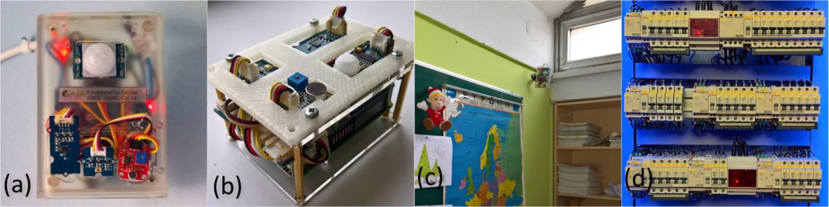

Fig. 1. Sample photos of the device lineup inside GAIAs schools: a) an Arduino-based IoT node for classrooms, b) a Raspberry Pi-based node for classrooms, c) an IoT node inside a classroom, d) power meters installed on electricity distribution panels.

school students so far, with positive reception from both the students and teachers, as discussed in [17]. Regarding the overall organization of the activities and the provided material, the consortium has prepared a series of lab activities, covering aspects of energy consumption and efficiency inside school buildings. The thematic list covered is the following:

* “Energy consumption in our school”.
* “Lighting inside school buildings”.
* “Heating inside school buildings”.
* “Temperature, Humidity and Thermal Comfort”.
* “Devices and Energy efficiency”.
* “Energy Inspectors - The energy footprint of our building”.

As an example, in the Temperature, Humidity and Thermal Comfort activity, students are given a short introduction to the aims of the activity, as well as in- structions on how to draw “circuits” for the lab using conductive ink, on top of a printed floorplan of their school. They are then instructed to assemble a small electronic circuit using 2-color LEDs, buttons and an LCD screen, and place the components over a predefined set of classrooms in the floor map. After assembling the circuit, the students power up Raspberry Pis, and start looking into the Python code. They execute a series of available Python scripts that connect to GAIAs cloud infrastructure to fetch real-time data. They then go through a series of “exercises”, where they see the temperature and humidity inside their classrooms, which are visualized on the LEDs of the circuit (e.g., red for temperatures above 25 degrees) and the LCD screen.

Since previous results suggest that AR can produce a positive effect in students’ learning performance and overall engagement, we expect that the integration of AR capabilities to the workflow of the lab activities could also enhance the lab kit aspects. With respect to adding such AR functionality to GAIA activities, the aim was to act both as a companion to these simple lab kit activities, and also to simplify monitoring and maintenance of IoT devices, as we explain in the following paragraphs. Moreover, our intention was to not overshadow the hands-on parts of the activities but, instead, support them; by adding AR visual elements we hope to clarify some parts of the activities workflow. The AR aspects could also

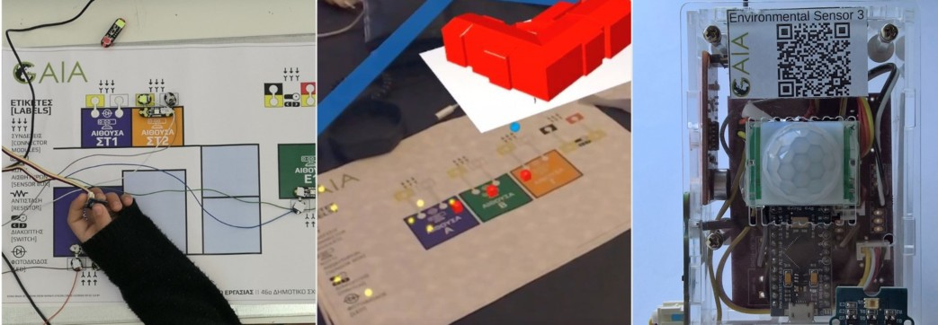

Fig. 2. Sample photos from the educational lab kit and AR tool in practice: a) an assembled GAIA “circuit” over the floormap of a primary school, b) an AR overlay of the 3D model of a school building, c) an IoT device inside a classroom.

guarantee that certain parts of information related to energy are available to the students regardless of potential failures, e.g., due to poorly implemented electrical connections in the lab circuits, etc.

It is important to note here that the functionality presented in this work is a means to showcase a prototype version of the envisioned system. As such, the im- plementation is in a preliminary stage; we wanted to show mainly the opportunities in combining the different elements discussed in this work. Future revisions of the system will offer a more rich set of functionality, tested in a more systematic man- ner, i.e., for long time periods, as well as closer to the real-world daily settings of educational environments.

* 1. *Companion to the lab kit activities*

Since the lab kit activities are implemented over hardware that allows for limited visualization opportunities, the AR tool aims to provide additional options, to both offer further details and present them in an engaging manner. We added a 3D building overlay to the activity, in order to “breathe” life into the 2D floor map used as a “board” to implement “circuits” to display real-time sensor data. This offers additional possibilities in visualizing sensor data or highlighting areas of interest or activity. Moreover, this is complemented with dynamic charts displayed in 3D over the real-world surfaces used in each classroom. Such graphs present information in much better granularity than the ones presented with the lab kit components, and also allow for instant visualization as a back-stop solution in case there are issues with the actual “circuits” assembled by the students.

We use QR tags as “anchors” regarding the actual placement of the AR overlays, since we already use prefabricated paper surfaces for the activities, or floormaps printouts. This helps us to place the overlays both from a technol- ogy/implementation standpoint, as well as to organize the overall activity in a more sensible manner. Regarding the 3D building models, we have used Sketchup to pro- duce the 3D model files, which are then imported by the software and displayed on the screen of the tablet/smartphone of the end-users.

For the lab activities, we use QR tags to determine the exact placement for the

visualization of the information. This could help also to utilize “empty” spaces in the physical space where students perform the educational activities, as “displays” for activity-specific information. For example, on the board used for the activity if there is a white rectangle (could be an A4 sheet of paper on top of a dark background), we can use this space to show some measurements there in 2D form and not e.g., as

, 3D bars depicting energy consumption. Another direction we will be looking into in the near future is the manipulation of the current visualization by moving certain objects or by obscuring a certain part of the surface dedicated to the activity to indicate a change of visualization mode. As an example, we could have 3 modes of visualization for energy, temperature and humidity; by hiding 2 of these options and pointing with the camera to the third one, we can change the mode and draw a 2D green arrow over the respective choice to indicate the current visualization mode.

We can also utilize AR to simplify the completion of the lab activities, since, as mentioned previously, the activities are aimed at students of various age ranges and educational backgrounds. We can assume that in a number of cases such characteristics will contribute to a longer than expected time of completion, that, as a result, could end up in a subpar educational experience. Moreover, we aimed at making the activities as easy to complete in an independent manner, i.e., ideally without requiring the presence and supervision/support by a representative from the project or with a detailed knowledge of the inner workings of the system. In this case, AR can provide the functionality to have a visual guide for the parts of the circuit, e.g., in our case, display squares around the points which we want to connect using conductive ink during the lab activities, or the most important parts of the circuit printed on paper. Figures 4 and 5 showcase some aspects of the app mentioned above, over a sample floormap.

Furthermore, as there is a limited number of interfacing options, we can utilize AR to allow for some form of “diagnostics” mode, checking the correct function of some part of the circuitry, or whether network communication with a specific cloud service is available, and so on. This is a part that is ignored more often than not, however, it is important to have in mind, since many times there is limited time available in schools to invest in educational activities like the ones mentioned in this work. Since each minute is valuable, it is important to have a quick way of “debugging” and point to a number of causes for the activity not going as planned.

* 1. *Data viewer and maintenance tool*

The second role of the GAIA AR tool is to allow for functionality related to other GAIA activities, such as monitoring environmental parameters in real-time and ease device maintenance. On the one hand, the IoT devices installed inside classrooms do not have any kind of visual feedback on them besides a couple of LEDs showing that the device is powered on and that they have an active network link to the building network gateway. Teachers or students thus are required to enter the Web portal of the project to see real-time readings, which may require several steps: first login, then select the school, then a specific classroom and, finally, the sensor.

Instead of this procedure that has several steps, we can insert AR to the overall workflow and simplify it enough for anybody to use, i.e., apart from technical staff, teachers and students can use it as well. In similar fashion to the activities described above, we use QR tags to enable the integration of AR visualization in this specific use-case. By simply pointing to the device with a phone or tablet, the application recognizes the specific IoT device and utilizes AR to display relevant data in a visually interesting manner. Figure 7 shows an indicative example of the use of a smartphone in front of an IoT device installed inside a classroom.

Furthermore, it also simplifies maintenance: the AR tool acts as a “manual” overlaying info about a specific device, e.g. indicating sensor-specific placement on the device. In other words, we can have an AR legend indicating what components are present on each device and where, e.g., the thermistor is bottom right, and so on. Again, the AR visualization is based on where a specific QR tag is located. It should be noted that not all devices inside school buildings for the GAIA project infrastructure have an identical set of sensor components. This is due to the fact that device deployment has been performed in different phases, at which a certain component was not available or replacement with another similar component was decided for better performance, etc. In addition, for devices in the classroom we can display simple information such as device name, location in the school building, whether a network connection is available to the Internet, what was the last time the device was connected to the network if not, or the last measurement taken by a specific sensor in this device. Figure 6 shows an in-app screenshot in front of an IoT device, after having detected it correctly and highlighting its components.

The above features can greatly simplify monitoring and maintenance of the infrastructure. This way, on the one hand, educators have a tool to make on-site inspections themselves and take measures to correct or identify the cause of any malfunction of the infrastructure equipment. On the other hand, technicians of the GAIA project could save time and effort by avoiding unnecessary on-site visits to inspect the devices’ operation, or know beforehand exactly where a potential malfunction could take place.

# System Implementation - Discussion

Moving on to details regarding our implementation, we have based our tool around Unity3D’s [6] AR libraries, while C# is the programming language used in Unity. We are targeting tablets and smartphones, since basically every other type of AR- enabled device is practically non-existent in classrooms today. The tool is currently implemented and tested over iOS devices, without directly using Apple’s ARKit but rather the abstractions provided by Unity. This manner of implementation al- lows potentially for future compatibility with Android and Windows devices. We also utilize ZXing [7] for QR code scanning, an open-source, multi-format 1D/2D barcode image processing library implemented in Java, with ports to other lan- guages. Both technologies are very popular within the AR developer community today. Overall, the source code for our implementation is available through GAIA’s

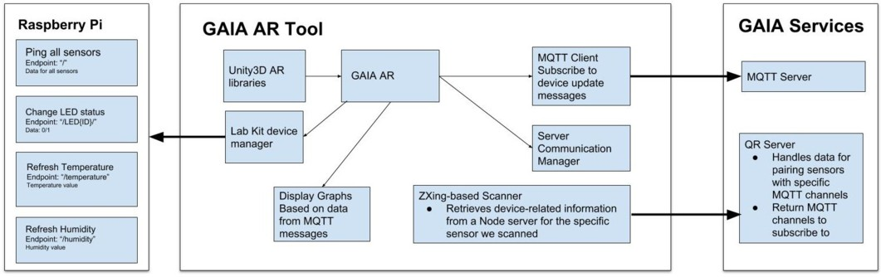

Fig. 3. The overall architecture of the GAIA AR tool.

project repository [3].

Fig. 3 presents an overview of the current architecture of the system. As men- tioned above, we use Unity3D and Zing libraries for AR and QR code scanning respectively. For development purposes, we have used an iPad Pro 10.5 and iPhone SE, 7 and X devices, running iOS 11. The application utilizes the devices’ main camera to get a view of the real-world; QR tags are placed on GAIA devices and the floormaps used in the lab kit activities, in order to provide context to the applica- tion and help it to locate areas of interest. The ZXing-based scanner recognizes e.g., which one is the IoT device we are pointing to with our phone, or which is the class- room in which the user is at. The node server communicates with the GAIA cloud services to get info about specific devices and sensors based on the ID returned by the scanner, using MQTT channels. MQTT [16] follows a publish/subscribe logic, where brokers/servers offer “channels” to broadcast messages about a specific topic; e.g., the temperature values inside a specific classroom in a school building are such a channel in GAIA. If the device knows the channel to subscribe to and has the respective credentials, it starts getting updates on new sensor values in real-time. Using such data, the application can overlay in AR any kind of information available on top of the lab kit surface or an IoT device placed on the walls of a classroom.

The application can communicate with both the GAIA cloud services, in order to retrieve data regarding the energy consumption of a school building and envi- ronmental sensor values, but it can also communicate directly with the Raspberry Pi devices used for the lab kit activities (which must be in the same WiFi net- work in order to establish a connection). Direct communication with such devices allows for options such as directly manipulating sensor values (e.g., change light sensor input), as well as control over visualization capabilities of the IoT device (e.g., change the status of an LED or display a message on an LCD screen). Such direct communication is also handled via MQTT.

We now briefly discuss the overall process in terms of time required to scan a QR tag, recognize an IoT component, contact a cloud service and then return relevant data. Regarding the time it takes in total for the app to recognize correctly a QR code, e.g., when pointing a smartphone to recognize an IoT device installed inside a classroom, our numbers indicate that with an iPad Pro on average it takes 0*.*9 seconds. The data retrieved by the QR code is then used to contact a cloud service

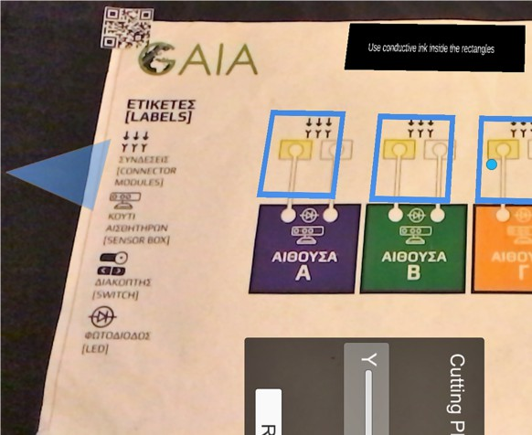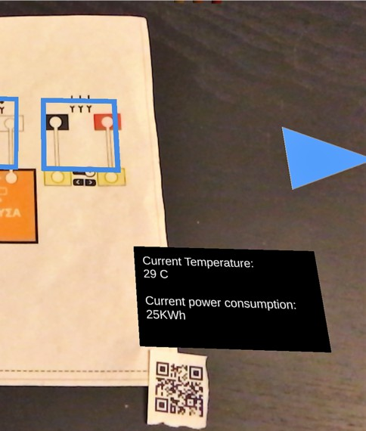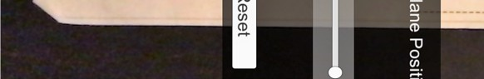

Fig. 4. Aspects of the AR app acting as a companion to the lab kit activities: a printed floormap of a school building is used during a lab kit exercise. The parts of the floormap that need to be filled with conductive ink are outlined in blue squares, while a legend giving some simple instructions is also utilized. Arrows on the left and right of the screen are used to navigate between different parts of the exercise.

and subscribe to an MQTT broker to receive information regarding the specific IoT device or sensor in question. On average, this part of the workflow takes 0*.*74 seconds before receiving an update containing the last sensor values produced by this device. Thus, in overall terms of recognizing an IoT device, contacting the respective service and then produce a result, the app requires approximately 1.5 to 2 seconds. This could be characterized as very reasonable in terms of interactivity, also having in mind that subsequent updates on sensor values are published by the cloud part and received by the app automatically (i.e., with negligible delay).

In practice, in terms of distance of the device from the tag, QR tag scanning performs well when done between 0*.*5 to 1 meter away from the QR tag/device. Empirically, we have about 80% success rate in recognizing the device correctly, within these constrictions, and given that there is adequate light to illuminate the area of the classroom. In general, good lighting is required for the system to function properly for AR as well, since otherwise the application misinterprets real-world surfaces or, in some cases, can recognize the same QR tag twice and interpret it as 2 separate tags (which can lead to issues with real-world surface recognition). We have also chosen to have the application’s camera view autofocus itself; the user only points the device at the lab kit area or the IoT device. This strategy works reasonably well in the context of the current implementation. We plan to work in the next iterations of the system’s implementation to handle such nuances in a more consistent manner.

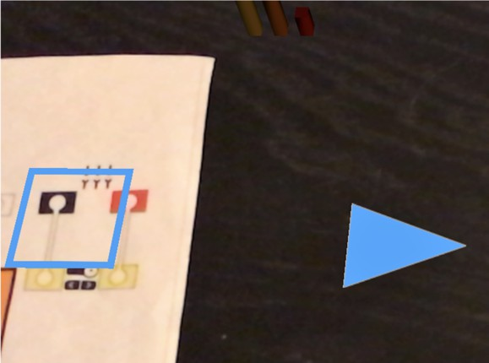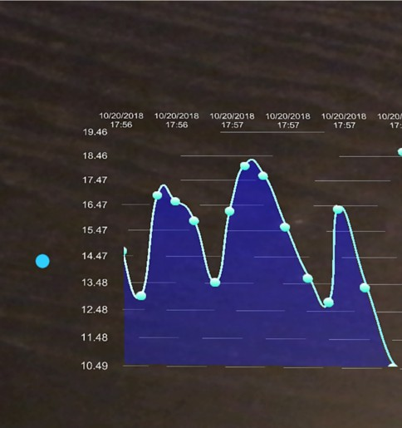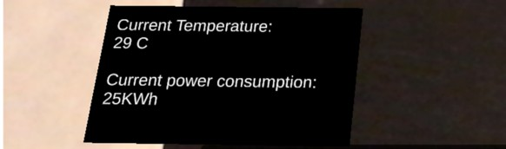

Fig. 5. Aspects of the AR app acting as a companion to the lab kit activities: in this picture, if we move the tablet used to the right of the floormap, a graph depicting some sensor readings is also displayed.

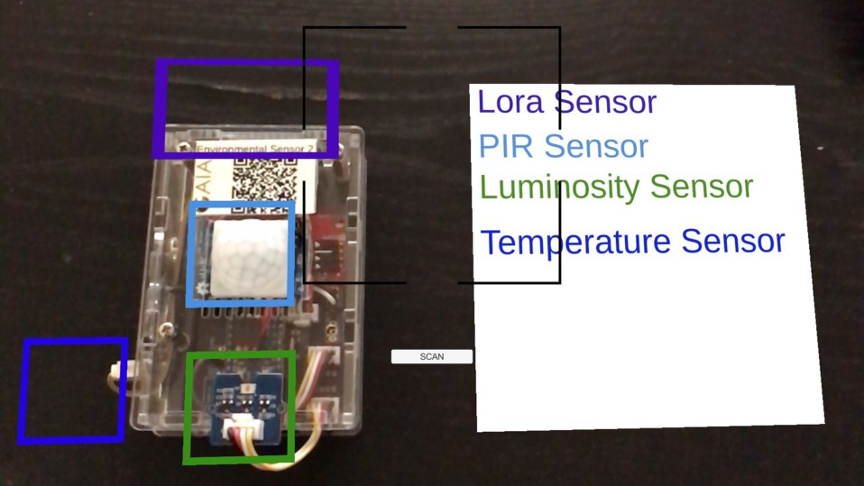

Fig. 6. A view of the AR app acting as a data viewer and maintenance tool. The placement of sensors on this specific device is known beforehand; the sensors are highlighted by colored squares, while a legend is displayed in order to identify each sensor type.

# Conclusions - Future work

In this work, we presented a system that uses augmented reality to support an educational in-class activity, which is part of the GAIA project ecosystem aiming for energy efficiency in school buildings. It aims to allow for additional affordances while conducting educational activities with IoT devices in-class, and at the same time serve as a monitoring and maintenance tool for a sensor infrastructure. The first results so far are promising, with the current implementation offering some



Fig. 7. Third-person view photos of using the AR tool in practice.

basic functionality in a reliable manner. However, since is the first iteration of the software, we expect to make numerous changes and additions to provide a more usable and useful system. Our main aim here was to discuss the aspects of combining real-world IoT data with AR in a educational setting.

In this sense, we have discussed a number of “affordances” where we think an AR tool can add value to the content presented in the classroom. We also think that since smartphones and tablets are more or less omnipresent these days, together with the fact that in most school buildings that we have visited WiFi networking is available, this is a very good base to work on in order to provide an inexpensive and useful addition to a STEM educational activity. Our work on such activities, which revolve around energy efficiency, seems to be a good match for AR integration.

Regarding our future work, we plan to continue on further developing this sys- tem, and evaluate its use inside the classroom during actual educational activities in the near future. We believe that this is a good showcase of the multiple poten- tial uses of IoT-produced data inside school buildings, utilizing technology already available inside schools (i.e., tablets and smartphones). We also believe that intro- ducing end-user interfaces like the ones described here is a way to engage students to educational activities; we should not underestimate the power of the “wow factor”, especially in the primary and secondary school context.

# Acknowledgment

This work was supported by the European Commission and the EASME, under the H2020-EE-2015-2-RIA call and contract number 696029. This document reflects only the authors view and the EC and EASME are not responsible for any use that may be made of the information it contains.

# References

1. *European Web Portal for energy efficiency in buildings*, [http://www.buildup.eu](http://www.buildup.eu/), (accessed on August 31, 2018).
2. *GAIA project*, [http://gaia-project.eu](http://gaia-project.eu/), (accessed on August 31, 2018).
3. *GAIA project repository*, <https://github.com/GAIA-project>, (accessed on August 31, 2018).
4. *INSITERh2020 project, intuitive self-inspection techniques using augmented reality for construction,* *refurbishment and maintenance of energy-efficient buildings made of prefabricated components*, [https:](https://www.insiter-project.eu/)

[//www.insiter-project.eu/](https://www.insiter-project.eu/), (accessed on August 31, 2018).

1. *Tackling the energy challenge together toolkit a toolkit for communities, local authorities, and schools on how to raise awareness or build capacity on sustainable energy issuesy*, [http://en.seacs.eu](http://en.seacs.eu/), (accessed on August 31, 2018).
2. *Unity for Mobile AR*, <https://unity.com/solutions/mobile-ar>, (accessed on August 31, 2018).
3. *ZXing barcode scanning library for Java, Android Unity for Mobile AR*, [https://github.com/zxing/](https://github.com/zxing/zxing) [zxing](https://github.com/zxing/zxing), (accessed on August 31, 2018).
4. *Energy usage of buildings*, Technical report, Statistical Office of the European Union (Eurostat) (2011), data extracted from [http://epp.eurostat.ec.europa.eu.](http://epp.eurostat.ec.europa.eu/)
5. *Key data on education in europe 2012*, Technical report, Education, Audiovisual and Culture Executive Agency (EACEA P9 Eurydice, EUROSTAT) (2012), iSBN 978-92-9201-242-7.
6. Aftab, M., S. C.-K. Chau and M. Khonji, *Enabling self-aware smart buildings by augmented reality*, in: *Proceedings of the Ninth International Conference on Future Energy Systems*, e-Energy ’18 (2018),

pp. 261–265.

URL <http://doi.acm.org/10.1145/3208903.3208943>

1. Akayr, M. and G. Akayr, *Advantages and challenges associated with augmented reality for education: A systematic review of the literature*, Educational Research Review **20** (2017), pp. 1 – 11.

URL <http://www.sciencedirect.com/science/article/pii/S1747938X16300616>

1. Amaxilatis, D., O. Akrivopoulos, G. Mylonas and I. Chatzigiannakis, *An iot-based solution for monitoring a fleet of educational buildings focusing on energy efficiency*, Sensors **17** (2017), p. 2296.

URL <http://dx.doi.org/10.3390/s17102296>

1. Antoniou, A., I. Chatzigiannakis, A. Kinalis, G. Mylonas, S. Nikoletseas and A. Papageorgiou, *A peer-to-peer environment for monitoring multiple wireless sensor networks*, in: *Proceedings of the 2Nd ACM Workshop on Performance Monitoring and Measurement of Heterogeneous Wireless and Wired Networks*, PM2HW2N ’07 (2007), pp. 132–135.

URL <http://doi.acm.org/10.1145/1298275.1298305>

1. Chang, S.-C. and G.-J. Hwang, *Impacts of an augmented reality-based flipped learning guiding approach on students scientific project performance and perceptions*, Computers and Education **125** (2018),

pp. 226 – 239.

URL <http://www.sciencedirect.com/science/article/pii/S0360131518301507>

1. Ibanez, M.-B. and C. Delgado-Kloos, *Augmented reality for stem learning: A systematic review*, Computers and Education **123** (2018), pp. 109 – 123.

URL <http://www.sciencedirect.com/science/article/pii/S0360131518301027>

1. MQTT: Message Queuing Telemetry Transport, [http://mqtt.org/.](http://mqtt.org/)
2. Mylonas, G., D. Amaxilatis, L. Pocero, I. Markelis, J. Hofstaetter and P. Koulouris, *Using an educational* *iot lab kit and gamification for energy awareness in european schools*, in: *Proceedings of the Conference on Creativity and Making in Education*, FabLearn Europe’18 (2018), pp. 30–36.

URL <http://doi.acm.org/10.1145/3213818.3213823>

1. Restivo, T., F. Chouzal, J. Rodrigues, P. Menezes and J. B. Lopes, *Augmented reality to improve stem motivation*, in: *2014 IEEE Global Engineering Education Conference (EDUCON)*, 2014, pp. 803–806.
2. Saltan, F. and . Arslan, *The use of augmented reality in formal education: A scoping review*, Eurasia Journal of Mathematics, Science and Technology Education **13** (2017), pp. 503–520.

URL <http://dx.doi.org/10.12973/eurasia.2017.00628a>

1. Vretos, N., P. Daras, S. Asteriadis, E. Hortal, E. Ghaleb, E. Spyrou, H. C. Leligou, P. Karkazis,

P. Trakadas and K. Assimakopoulos, *Exploiting sensing devices availability in ar/vr deployments to foster engagement*, Virtual Reality (2018).

URL <https://doi.org/10.1007/s10055-018-0357-0>