Journal Pre-proofs

Article

An Integrated Analysis on the Synergistic Reduction of Carbon and Pollution Emissions from China’s Iron and Steel Industry

Quanyin Tan, Fei Liu, Jinhui Li

PII: S2095-8099(23)00461-7

DOI: <https://doi.org/10.1016/j.eng.2023.09.018>

Reference: ENG 1396

To appear in: *Engineering*

Received Date: 3 January 2023

Revised Date: 6 September 2023

Accepted Date: 7 September 2023

Please cite this article as: Q. Tan, F. Liu, J. Li, An Integrated Analysis on the Synergistic Reduction of Carbon and Pollution Emissions from China’s Iron and Steel Industry, *Engineering* (2023), doi: [https://doi.org/10.1016/](https://doi.org/10.1016/j.eng.2023.09.018) [j.eng.2023.09.018](https://doi.org/10.1016/j.eng.2023.09.018)

This is a PDF file of an article that has undergone enhancements after acceptance, such as the addition of a cover page and metadata, and formatting for readability, but it is not yet the definitive version of record. This version will undergo additional copyediting, typesetting and review before it is published in its final form, but we are providing this version to give early visibility of the article. Please note that, during the production process, errors may be discovered which could affect the content, and all legal disclaimers that apply to the journal pertain.

© 2023 THE AUTHORS. Published by Elsevier LTD on behalf of Chinese Academy of Engineering and Higher Education Press Limited Company

Research

Pollution Control—Article

An Integrated Analysis on the Synergistic Reduction of Carbon and Pollution Emissions from China’s Iron and Steel Industry

Quanyin Tan, Fei Liu, Jinhui Li *

*State Key Joint Laboratory of Environment Simulation and Pollution Control, School of Environment, Tsinghua University, Beijing 100084, China*

* Corresponding author.

*E-mail address:* [jinhui@tsinghua.edu.cn](mailto:jinhui@tsinghua.edu.cn) (J. Li)

# ARTICLE INFO

*Article history:*

Received 3 January 2023

Revised 6 September 2023

Accepted 7 September 2023 Available online xxxx

**Highlights**

* Examines the synergistic reduction of both carbon and pollution emissions.
* Explore the low-carbon and low pollution pathway in the iron and steel industry.
* Feedstock composition and technological structure are critical to the synergy.
* Benefit in pollution emission reduction is 4.0- to 5.6- fold of carbon emission reduction.

**Abstract:** Decarbonization and decontamination of the iron and steel industry (ISI), which contributes up to 15% to anthropogenic CO2 emissions (or carbon emissions) and significant proportions of air and water pollutant emissions in China, are challenged by the huge demand for steel. Carbon and pollutants often share common emission sources, indicating that emission reduction could be achieved synergistically. Here, we explored the inherent potential of measures to adjust feedstock composition and technological structure and to control the size of the ISI to achieve carbon emission reduction (CER) and pollution emission reduction (PER). We investigated five typical pollutants in this study, namely, petroleum hydrocarbon pollutants and chemical oxygen demand in wastewater, particulate matter, SO2, and NO*x* in off gases, and examined synergies between CER and PER by employing cross elasticity for the period between 2022 and 2035. The results suggest that a reduction of 8.7%–11.7% in carbon emissions and 20%–31% in pollution emissions (except for particulate matter emissions) could be achieved by 2025 under a high steel scrap ratio (SSR) scenario. Here, the SSR and electric arc furnace (EAF) ratio serve critical roles in enhancing synergies between CER and PER (which vary with the type of pollutant). However, subject to a limited volume of steel scrap, a focused increase in the EAF ratio with neglection of the available supply of steel scrap to EAF facilities would lead to an increase carbon and pollution emissions. Although CER can be achieved through SSR and EAF ratio optimization, only when the crude steel production growth rate remains below 2.2% can these optimization measures maintain the emissions in 2030 at a similar level to that in 2021. Therefore, the synergistic effects between PER and CER should be considered when formulating a development route for the ISI in the future.

**Keywords:** Iron and steel industry; Carbon and pollution emissions; Synergistic reduction; Technological structure; Steel scrap; Cross-elasticity

# 1. Introduction

Climate change, biodiversity loss, and pollution are three interconnected planetary crises that humanity faces [1]. Currently, approximately 140 countries have committed to carbon neutrality and endeavor to meet carbon neutrality targets under the Paris Agreement [2]. Meanwhile, the international community is negotiating to establish an autonomous body dedicated to pollution prevention and control as one of its core functions [3]. Effective decarbonization and pollution prevention and control of the industrial sector are key factors for achieving climate targets and a clean planet [1,4]. As one of the largest industrial emitters, the iron and steel industry (ISI) accounts for approximately 25% of direct greenhouse gas (GHG) emissions [5] from industrial sectors and approximately 7% of the global anthropogenic CO2 emissions [6–8]. The ISI can be the most essential sector of a nation’s industrial economic infrastructure [9], and its continuous long-term growth can pose a serious challenge to achieving global emission targets. In particular, the ISI has contributed up to 15% to the Chinese anthropogenic CO2 emissions (or carbon emission) [10,11] and 16.5%, 22.3%, and 14.5% to China’s SO2, NO*x*, and particulate matter (PM) emissions in 2020, respectively [12].

To address climate change, the Chinese government has made commitments in 2020 and released schedule and relevant targets in 2021. [13]. To reach these goals while simultaneously improving environmental quality, the Chinese government put forward a development concept in 2020 to reduce both overall pollution and carbon emissions [14]. Subsequently, in 2022, China released a national implementation plan for the synergistic reduction of carbon and pollution emissions to enhance the multi-objective governance of the environment. The realization of these goals has put enormous pressure on the ISI to reduce emissions.

In recent decades, many studies have focused on eliminating bottlenecks in both technologies and equipment for smelting [15,16], waste heat utilization [17,18], ultra-low emissions [19], and carbon capture and storage [20], leading to significant reductions in energy consumption and emission levels in the ISI. Concurrently, an increasing number of studies have explored and assessed low-carbon development paths in the ISI [21]. Assessment of the carbon emission-reduction potential of energy- saving technologies at the plant level [22] provides basic data that can then be extended to a comprehensive evaluation of the whole industry [23,24]. Some studies have determined the correlations among environmental regulation, carbon emission intensity (CEI), and economic growth [25,26]. Some studies have focused on the construction of high-resolution emission inventories for the ISI to better asses and monitor the total emissions of the industry [20,27–29]. Wang et al. [21] and Ren et al. [5] simulated pathways toward carbon neutrality for China’s ISI, based on a systematic review of various low-carbon technologies. However, most studies attempted to achieve an overall optimization of the ISI based on the single-sided focus on carbon emissions. Such studies have highlighted the need to evaluate synergies between carbon emission reduction (CER) and pollution emission reduction (PER) to support the creation of an integrated development path with multiple governance objectives. The cross-elasticity method derived from economic studies [30] has been increasingly applied in quantitative analyses of the co-benefits of CER measures in the transport sector [31–33] and in different regions [34,35].

In this work, we quantify the potentials of synergistic benefits between CER and PER under various low-carbon development paths for the ISI. Based on a thorough review of China’s actions to promote the high-quality development of the ISI [36–38], we summarize five categories of requirements proposed in national and sectoral plans and identify end-of- pipe measures. The significance and degree of synergies between different types of measures were assessed via tests of between-subjects effects and the cross-elasticity index. We further constructed pathways for the period between 2021 and 2035 based on industrial development goals, technological structure, technology level, and Chinese and global historical

practices. Differences and trends in synergies in different contexts were further analyzed for paths that are consistent with policy goals. We find that the benefit of PER was 4.0- to 5.6-fold that of CER, except for reductions in PM emissions, which were 1.1–2.3 times of CER. Coordination between measures is critical to enable the industry to move toward synergistic reductions in both carbon and pollution emissions.

# Methods

* 1. *Estimation of potential carbon and pollution emissions in various pathways*
     1. **Formulas.** To estimate the potential carbon and pollution emissions of the ISI in different pathways for the period between 2021 and 2035, we first predicted the production of crude steel. The crude steel production (CSP) under an inertia growth pathway was predicted by employing the autoregressive integrated moving average model, while the production under the policy-control pathway remained unchanged at 1 Gt as declared in policies. The mean value of these two pathways was selected as the moderate pathway. Steel scrap is an important raw material for CSP and includes self-produced scrap (*S*a), processing scrap (*S*b), and depreciated scrap (*S*c) [39], and its overall generation (*S*sc) was estimated by summing up the generations of these three individual types of scrap, as shown in Eq. (1).

𝑆sc = ∑ 𝑆𝑚

𝑚 = a,b,c

(1)

Self-produced scrap refers to slag steel, intermediate ladle-casting residue, cut-offs, trimmings, or rejects produced by steel mills. The yield of self-produced scrap depends on the technological level of the steel mill. The yield ratio has decreased to 5% in recent years, with slight fluctuations. Therefore, we adopted the average value of 4.9% for the last ten decades in China’s ISI as the yield ratio (*y*a) for the period between 2022 and 2035. Processing scrap refers to scrap generated by the equipment manufacturing industry during the mechanical processing of steel, and the yield ratio (*y*b) is also approximately 5%. Depreciated scrap is generated by the scrapping of various products when their service life ends. Its generation is predicted via the social steel accumulation method for countries with stable steel production and via the steel product life cycle method for developing countries that still experience growth in steel production. Since China is in the transition between these two modes, with a rapid growth in production in the last decade, and expected to experience strict control in the future, we adopted the mean value of these two methods.

We used one ton of crude steel as the functional unit, and the system boundary was set from mineral mining to crude steel. The product of each process was calculated by a coefficient equivalent to crude steel. Subsequently, carbon and pollution emissions originating from CSP activities were estimated by multiplying production data for each process by the corresponding emission factors (Eqs. (2) and (3)). Apart from the generation of wastewater, off-gas, and solid waste (SW), the final discharge of typical pollutants such as petroleum hydrocarbon pollutants (PHPs) and chemical oxygen demand (COD) in wastewater, and PM, SO2, and NO*x* in off gases, was estimated based on corresponding generation factors and removal rates of end-of-pipe treatment technologies in the manual (see Data sources). We selected pollutants for which data were available for all processes of CSP.

*Ei*   *Fi*, *j*  *Pj*

*j*

(2)

where *Ei*

denotes carbon emissions when *i* = 1, generation of wastewater when *i* = 2, off-gas when *i* = 3, SW when *i* = 4,

discharges of PHPs and COD in wastewater when *i* = 5 and 6, PM when *i* = 7, SO2 when *i* = 8, and NO*x* when *i* = 9.

*Fi*, *j*

refers to the emission factors of carbon and/or pollution from process *j* (as presented in Table S1 in Appendix A). *Pj*

refers

to the volume of product outputs from process *j*. The emission factor for the typical pollutants (*i* = 5, 6, 7, 8, and 9) was determined using Eq. (3):

𝐹𝑖,𝑗 = 𝐺𝑖,𝑗 × (1 ― 𝑅𝑖,𝑗) (𝑖 = 5,6,7,8, and 9) (3)

where

*Gi* , *j*

denotes the yield ratio of pollutants from process *j*, and *Ri* , *j*

refers to the respective removal rate.

* + 1. **Data sources.** The average value of carbon emission factors (Table S1 in Appendix A) summarized in the China Products Carbon Footprint Factors Database were extracted and adopted in Eq. (2) [40,41]. Adoption of an average value helps minimize the uncertainty of the results because carbon emission data sources can include large uncertainties [42]. The pollution emission factors (Table S2) were directly extracted from or calculated according to the generation intensity and relevant removal rate provided in the manual of accounting methods and coefficients of the generation of and emissions for

industrial sources in China, which was issued by the Ministry of Ecology and Environment of China based on investigations on both key emission and non-key emission enterprises [43]. Details about the carbon emission accounting methods and pollution emission factors investigation can be found in the notes to the Tables S1 and S2.

* 1. *Synergy analysis of various scenarios*

To quantify the synergistic linkage between CER (ΔCE) and PER (ΔPE), the synergy index (𝐸CE(𝑡)) based on the cross-

PE

elasticity of emission reductions in the year *t* was defined as in Eq. (4):

𝐸CE(𝑡) = ( ΔCE(𝑡) )/( ΔPE(𝑡) ) = (CE(𝑡 ― 1) ― CE(𝑡))/(PE(𝑡 ― 1) ― PE(𝑡))

(4)

PE CE(𝑡 ― 1)

PE(𝑡 ― 1)

CE(𝑡 ― 1)

PE(𝑡 ― 1)

where CE(*t*) denotes the carbon emissions in year *t* and PE(*t*) refers to a specific category of pollution and/or emissions in

year *t*. 𝐸ce(𝑡)

pe

indicates that the measures in the analyzed scenario could lead to CO2

and pollution emission changes with the

same trend, i.e., emissions decrease or increase simultaneously. When both emissions decrease and

𝐸CE(𝑡)

is higher than 1,

the reduction in carbon emissions is more rapid than the reduction in pollution emissions, and vice versa. However, if the value is negative, there is no synergistic reduction with respect to the two types of emissions.

PE

* 1. *Identification of co-beneficial measures and establishment of scenarios*

We compiled a detailed explanation of measures that may achieve a synergistic reduction in carbon and pollution emissions by identifying and summarizing five synergetic measures based on policies. The measures and targets are presented in Table S3 in Appendix A. At present, most of the policies and plans have targets for the end of the Fourteenth Five-Year period, namely, the year 2025. Approaches for scenario analysis are introduced below. Feedstock composition is to be structurally adjusted such that the total volume of steel scrap consumed increases to more than 300 Mt by 2025, from the volume of 226 Mt in 2021. Given that the steel scrap ratio (SSR) is a generally used indicator for the industry, it is proposed in the specific plan for the steel scrap sector that it should reach 30% by 2025; we thus adopted this as the standard SSR scenario. Then, a controlled SSR scenario (with a fixed SSR of 21.9% in 2021), a moderate SSR scenario (with a target of 25%), and two optimistic SSR scenarios (with targets of 35% and 40%) were established. We chose these scenarios given that the SSR is unlikely to increase indefinitely; for example, the second largest CSP region—the European Union—has maintained an SSR of approximately 55% for most of the last decade. Likewise, the SSR of other Asian countries such as Republic of Korea and Russia are currently at approximately 40% [44]. We thus assumed that the SSR will maintain the same growth trend after 2025 and eventually reach a ceiling of 50%.

Policies propose adjustments to the technological structure by increasing the electric arc furnace (EAF) ratio so that it exceeds 15%, up from the 10.7% in 2021. Similarly, four additional development scenarios were established based on this target, with a fixed ratio of 10.7%, a moderate ratio of 12.5%, and two optimistic ratios of 17.5% and 20.0%. During the 14th Five-Year Plan period, China is pushing the transformation of ultra-low emissions for off-gas pollution control facilities of iron and steel enterprises to advance technology on pollutant emissions; moreover, for SW management, the “zero-waste city” strategy is being implemented in prefecture-level cities, in which the reduction of SW at sources is an important task. However, none of the relevant policies have proposed targets on generation/emission factors. As presented in Table S3 in Appendix A, China has set a quantitative target (reduction by more than 10%) for reducing the water resource consumption intensity during the 14th Five-Year Plan period. Therefore, we assumed the impact of technological advancement based on the requirement of reducing the water consumption intensity, in which a reduction of 10% by 2025 should be achieved as moderate expectation. The scenarios for CSP were established as described in the section on production prediction. A summary of the design of the scenarios is presented in Table S4 in Appendix A. No target requirements for the SSR of EAF have been imposed in policies. The scenarios were thus established based on an SSR ratio of 68.14% in 2021, and the SSR for blast furnace (BF)–basic oxygen furnace (BOF) was calculated using Eq. (5):

𝑟b =

𝑟t × 𝑝t ― 𝑟e × 𝑝e

𝑝b

𝑟t × (𝑝e + 𝑝b) ― 𝑟e × 𝑝e

= 𝑝b

(5)

where

𝑟t,

𝑟e, and

𝑟b

refer to the SSR of the ISI, the EAF approach, and the BF–BOF approach, respectively; similarly,

𝑝t,

𝑝e, and

𝑝b

refer to the CSP of the ISI, and the EAF, and BF–BOF approaches, respectively.

# Results

* 1. *Carbon and pollution emissions*

According to the historical production of crude steel in China and the production-weighted intensities of carbon and typical pollutant emissions, the future production of crude steel and the relevant annual emissions of carbon and pollutants are predicted (Fig. 1(a) and Fig. S1 in Appendix A). Analysis of between-subject effects (Table S5 in Appendix A) indicated that the increase in industry size (CSP) was the most critical factor in increasing carbon emissions and those of water and air pollutants from the ISI. In 2030, for example, when CSP is strictly controlled in accordance with policy requirements, total carbon emissions would be (1.81 ± 0.20) Gt in the controlled scenario (Sc; maintenance of CSP at 1 Gt). This result is comparable to the 1.7 Gt estimated by Pan et al. [45] under a low carbon pathway and is expected to be 13.68%–17.08% of China’s peak carbon emissions as predicted by existing studies [46]. However, when CSP increases at its historical growth rate (as-usual scenario (Sa)), namely, from 1.04 Gt in 2021 to 1.53 Gt in 2030, carbon emissions would reach (2.78 ± 0.30) Gt, which is 1.53 times the projected emissions in 2021 and 21.07%–26.17% of China’s projected carbon emissions in 2030. The carbon emissions in 2035 could be as high as (3.17 ± 0.35) Gt if CSP continues to grow. The corresponding emissions in 2030 and 2035 were estimated to be (2.30 ± 0.25) and (2.50 ± 0.28) Gt, respectively, if CSP increases by only 50% of the inertial growth rate (moderate scenario (Sm)).

Although CER can be achieved through SSR and EAF ratio optimization, only when the CSP growth rate remains below 2.2% will the corresponding optimization measures be able to maintain carbon emissions of the industry in 2030 at a level similar to that in 2021. In this case, the SSR and EAF ratio, and the SSR of EAF, would be 50.0%, 14.8%, and 84.0%, respectively.

The industrial wastewater generation from CSP was estimated to reach (8.87 × 109 ± 1.54 × 109) and (13.57 × 109 ±

2.35 × 109) m3 in 2030 under the Sc and Sa scenarios, respectively. Accordingly, emission of PHPs would be (1.43 ± 0.56) and (2.19 ± 1.08) kt, and emissions of COD would be (599.7 ± 235.5) and (917.3 ± 360.2) kt, respectively, among which COD emissions amount to 2.4% ± 0.9% and 3.6% ± 1.4% of China’s statistical COD emissions in 2021 [47]. The generation

of off gases in both scenarios could be up to (9.98 × 109 ± 1.63 × 109) and (15.1 × 109 ± 2.31 × 109) m3, respectively, and be accompanied by PM, SO2, and NO*x* emissions of (231.2 ± 46.5) and (345.1 ± 63.2) kt, (386.7 ± 152.0) and (591.5 ± 232.5) kt, and (185.1 ± 72.8) and (283.2 ± 111.3) kt, respectively. SW slags mainly include dust removal ash and slag from

BF, converters and EAF, as well as residues from steel scrap pretreatment, amounting to (360.3 ± 24.9) and (551.1 ± 38.1)

Mt, respectively.

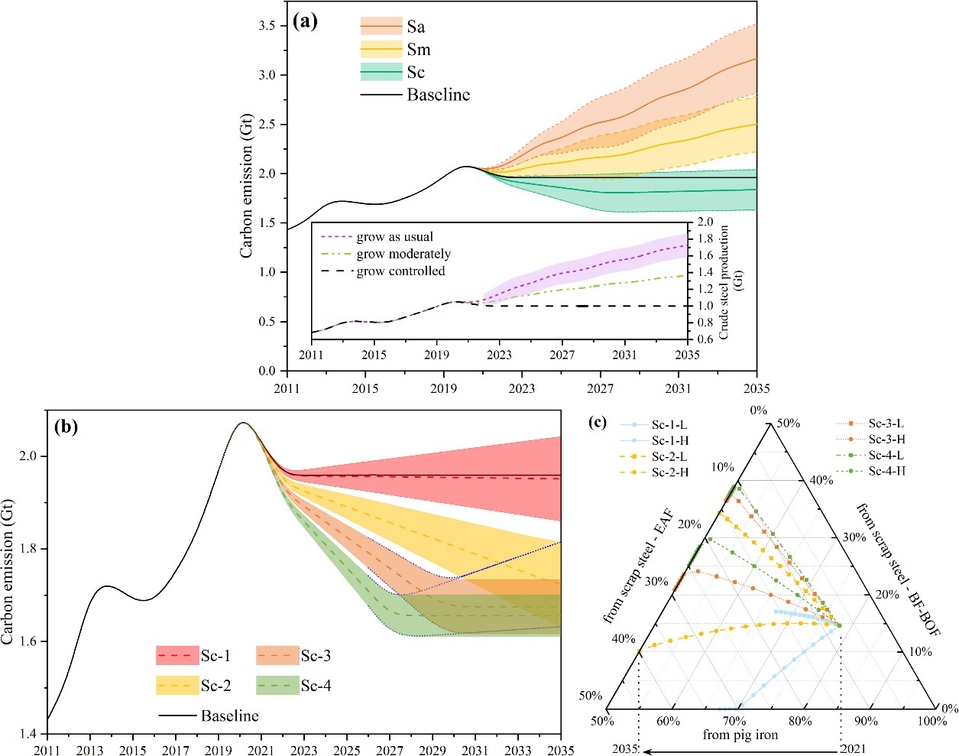

**Fig. 1.** (a) Carbon emissions of the ISI with CSP increase at different growth rates, (b) carbon emissions, and (c) technological and feedstock composition of crude steel under different SSRs in the Sc scenario. L indicates adoption of a low growth in the EAF ratio (ratio of crude steel by EAF to all crude steels), while H indicates adoption of a high growth in the EAF ratio.

The results demonstrated that when CSP is strictly controlled, the growth in the SSR will determine the reduction rate of sectoral carbon emissions (Figs. 1(b) and (c)). As indicated in Fig. 1(c) and Table S4, the four different pathways of the Sc scenario mainly differed in the growth rates of the SSR. In particular, the SSR in 2025 was estimated to increase from scenarios Sc-1–Sc-4 in the order 25%, 30%, 35%, and 40%, respectively. Considering the impact of the EAF ratio on carbon and pollution emissions, the maximum or minimum values of the EAF ratio were set as the upper and lower bounds for the corresponding pathways. The results indicate that the carbon emission volume will decrease with an increase in the SSR in the predicted time interval (2022–2035), while changes in pollutant emissions will vary. For example, the carbon emissions in 2025 would be (1.96 ± 0.03) Gt in scenario Sc-1, with an SSR of 25%, and the average emission volume would be slightly lower than that of the baseline scenario. For the same year, when the SSR increases to 35% (scenario Sc-3) and 40% (scenario Sc-4), carbon emissions would be (1.83 ± 0.03) and (1.76 ± 0.03) Gt, respectively, so that a reduction of 5.6%–8.2% and 8.7%–11.7% could be achieved compared to the baseline. For these two scenarios, the SSR is expected to reach the ceiling set at 50% in 2030 and 2028, respectively. The relevant carbon emissions were estimated to be 85.5% and 84.5% of those in the baseline scenario of the same year. Thereafter, carbon emissions will be mainly influenced by the technological structure—the ratio of crude steel by EAF/BOF to all crude steels, and by the scrap flow—the SSR of EAF. These two factors would lead to a similar fluctuation of 2.76%–3.50% in carbon emissions.

Following a similar trend to that of carbon emissions, pollution generation and emissions were estimated to decrease gradually with an increasing SSR. As presented in Fig. S1, in 2025, when the SSR increases from 25% in scenario Sc-1 to

40% in scenario Sc-4, the volume of wastewater generated will decrease from 10.96 × 109 to 8.79 × 109 m3, while the amount of COD emissions, with treated wastewater, will decrease from 893 to 715 kt. Meanwhile, the volume of off gases generated in scenario Sc-4 will be reduced by 18% from 119 × 1012 m3 in scenario Sc-1, while the emissions of SO2 and NO*x* in scenario Sc-4 will be reduced by 20%, from the volumes of 576 and 276 kt, respectively, in scenario Sc-1. However,

emissions of PM were estimated to have the opposite trend, with an 8% increase. This is attributed to the fact that PM is mainly generated in the steel scrap pretreatment process, and PM emissions will significantly increase with a growing SSR. SW generation would be reduced from 385 Mt in scenario Sc-1 to 356 Mt in scenario Sc-4.

* 1. *Synergy of PER and CER*

Based on the preceding analysis of various Sc scenarios, CER is achieved through CSP control and SSR adjustment. The synergies between reductions in carbon and pollution emissions of the ISI under different development paths are presented in Fig. 2. Based on Figs. 2(a)–(c) and Fig. S2 in Appendix A, the CER rate would range between 0.38% and 6.23% if both the SSR and the EAF ratio increased. Moreover, although PHPs and COD in wastewater and SO2 and NO*x* in off gases are generated in and discharged from different processes, their reduction rates were estimated to be fairly similar, with median values of 5.33%, 5.43%, 5.44%, and 5.44%, respectively. However, the reduction rate of PM was estimated to be significantly lower than that of the four aforementioned pollutants, with a median value of 2.40%. The reduction rates of wastewater, off gases, and SW generation were 0.99%–9.00%, 0.87%–8.44%, and 0.35%–5.55%, respectively. Detailed rates of CER and PER under other development paths are presented in Fig. S1.

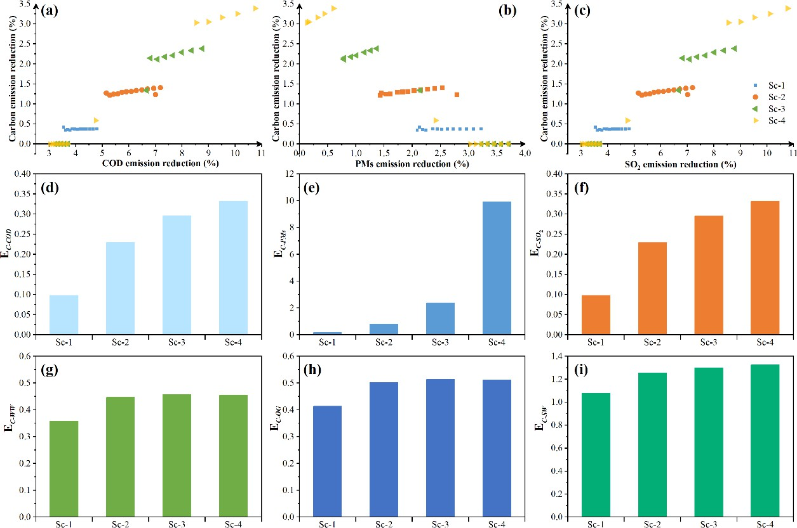

**Fig. 2.** Distribution of CER and PER: (a) COD, (b) PM, and (c) SO2, under the four scenarios. Synergistic reduction degrees of carbon emissions to pollution emissions in 2025 for: (d) COD, (e) PM, (f) SO2, (g) wastewater, (h) off gases (OG), and (i) SW.

We further determined variations in the degree of synergistic reductions with different pollutants and under different scenarios (Figs. 2(d)–(i) and Fig. S3 in Appendix A). In scenario Sc-2, for example, the coefficients of PHP and COD were approximately the same, ranging from 0.18–0.25, because their generation procedures are consistent and allow for similar reduction rates. This indicates that enhancing steel scrap utilization and optimizing its allocation in converter and EAF facilities can not only reduce carbon emissions, but also produce more drastic emission reduction effects for PHPs and COD. These emission reduction benefits can be 4.0–5.6 times those for carbon emissions. There were similar synergistic reduction benefits for SO2 and NO*x* emissions. However, differing from these four pollutants, the coefficient of PM was estimated to gradually reduce from 0.88 in 2022 to 0.44 in 2035, indicating that the synergy between CER and PM emission reduction is more consistent than that for the reduction of emissions for the other four pollutants (COD, PM, SO2, and NO*x*), when the industry follows the scenarios. However, the reduction rate in PM emissions was estimated to be still higher than that of carbon emissions, and a higher synergistic reduction can be achieved with technological advances in pollution control.

The impacts of the SSR growth rate on the synergistic benefits of CER and PER were further explored for the year 2025 (Figs. 2(d)–(i) and Fig. S3). The results show that all coefficients increased, but with varying intensity. Among them, the

coefficient of carbon/particulate matter (C-PM) increased from 0.17 to 9.92—more significantly than the others. The results indicate that scenario Sc-3 could be the best pathway among all four options to achieve high synergies in reducing carbon and pollution emissions. The changes in the coefficients for the same pollutant also suggested that, with the same SSR, an increase in the EAF ratio would further strengthen the benefits of PER. In particular, the PHP coefficient was estimated to decline from 0.234 to 0.102, while the SO2 coefficient was estimated to decline from 0.229 to 0.100. This shows a larger reduction in PHP and SO2 emissions than in PM emissions, whose coefficient was estimated to decline from 0.811 to 0.472.

* 1. *Impacts of raw material composition and technological structure*

When many countries are striving to reduce the CEI of the ISI, the total supply of steel scrap in international trade may be insufficient to sustain the expected growth in CSP. Therefore, it is essential to further regulate the flow of steel scrap/waste to enable the sector to move into a decarbonizing direction. As indicated by the blue dotted line in Fig. 1(b), a continuous increase in the EAF ratio at an SSR maintained at 50% would lead to a reduction in the SSR of the BF–BOF approach to ensure that EAF facilities are supplied with sufficient scrap feedstock. However, such a re-allocation would increase both industrial carbon and pollutant emissions.

The results indicate that when the EAF ratio continuously increases, as in scenario Sc-3 (to 43.25% in 2035), the total carbon emissions would increase to 1.82 Gt, an increase of 81 Mt as compared to a constant EAF ratio. This increase would be as high as 113 Mt in scenario Sc-4, primarily because the molten iron produced in the BF–BOF approach provides some of the heat for the melting of the steel scrap fed into the converter, which achieves energy savings and CER to some extent. Therefore, given that the iron ore-based BF–BOF approach remains essential, optimizing the allocation of steel scrap to the converter and EAF is important to ensure a sustainable reduction in the industry’s carbon emissions. In general, the SSR of the BF–BOF approach is approximately 20% [48] due to limitations in residual heat available in the molten iron and the content of alloying elements in the steel scrap. At present, enterprises are working to increase the SSR to 30% [49], or even 35% [50,51], by increasing the molten iron temperature, preheating the steel scrap, and adding coke powder to the converter. Although these practices can increase heat consumption to a certain extent as compared with the conventional BOF steelmaking process, utilization of residual heat in molten iron contributes to overall energy savings.

The results shown in Fig. 3 indicate that for carbon emissions, the BF ironmaking process (P3) accounted for up to 58.1% of the industry’s overall carbon emissions, even when the SSR reaches 50%. In contrast, the share of mineral processing (P1) and raw material preparation (P2) processes were small, at 1.3% and 3.9%, respectively. The sum of these three processes, which are all directly related to the production of pig iron, was 63.3%. This further demonstrates the significance of the utilization of steel scrap to reduce carbon emissions. The next highest carbon emission processes were steel scrap pretreatment (P4) and steelmaking (P5), accounting for 23.9% and 12.9% of total emissions, respectively. For the latter, the percentages of carbon emissions originating from primary pig iron smelting in a converter and steel scrap smelting were 1.5% and 1.0% respectively, while the percentage of carbon emissions from primary pig iron smelting and steel scrap smelting in an EAF was 1.7% and 8.7%, respectively.

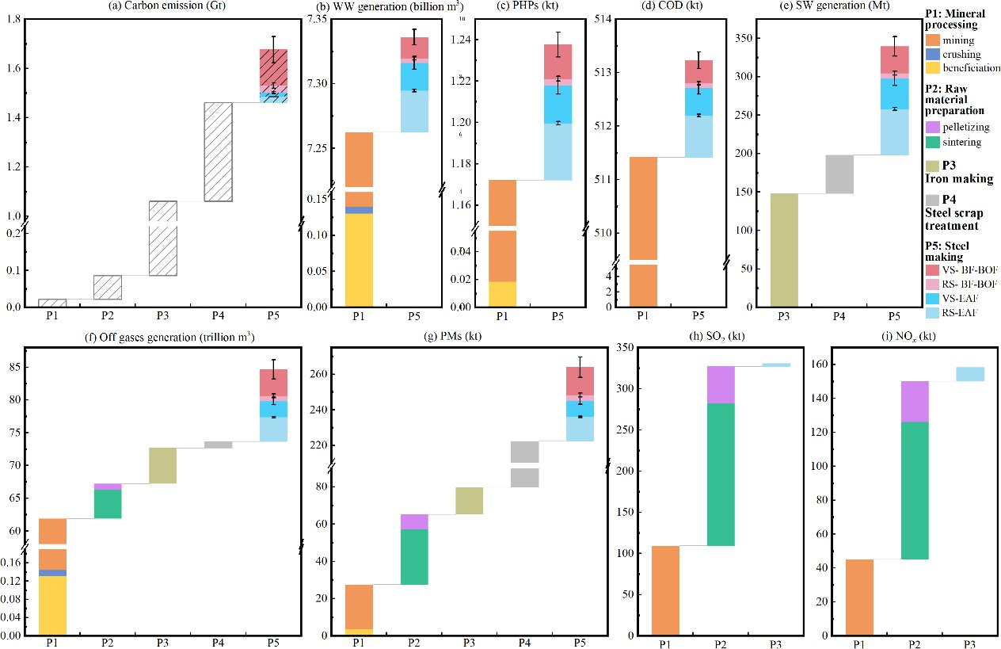

**Fig. 3.** Carbon and pollutant emissions from CSP processes in scenario Sc-3 in 2035: (a) carbon emissions, (b) wastewater generation, (c) PHP emissions, (d) COD emissions, (e) SW generation, (f) off-gas generation, (g) PM emissions, (h) SO2 emissions, and (i) NO*x* emissions. WW: wastewater; VS: virgin steel, refers to crude steel originating from raw minerals; RS: recycled steel, refers to crude steel originating from steel scrap.

The vast majority of industrial wastewater and pollutants within—PHPs and COD—are generated in the mineral processing process (P1), mainly during mining and mineral flotation procedures. The proportions of wastewater and COD generated in P1 exceeded 99% of their total generation from all five processes. For PHPs, this percentage of P1 was slightly lower, 94.7%, while the rest is generated during steelmaking. Off gases and the PM therein are generated in all processes. Off gases are mainly generated during mineral processing, accounting for 73.1% of the total volume, followed by steelmaking at 13.0%. PM is mainly generated in the steel scrap pretreatment process, with a percentage of 53.9%, followed by raw material preparation, with a percentage of 14.2%. The processes by which SO2 and NO*x* are generated are very similar, including mineral processing, raw material preparation, and ironmaking. The generation of SO2 in these processes was 33.1%, 65.8%, and 1.2% respectively, while that of NO*x* was 28.4%, 66.5%, and 5.1%, respectively. The results show that SW is generated mainly in iron making, steel scrap pretreatment, and steel making, in which the iron and steel making generate the highest proportions, 43.6% and 41.7%, respectively. The remaining proportion is generated in steel scrap pretreatment. It is worth noting that we did not include tailings because their generation is closely related to the grade of the ore, which varies greatly with ore type. For example, the generation of tailings from iron production using the most commonly used iron ore concentrate, magnetite concentrate, with a total ferric content of 60% (the lowest grade concentrate, C60), is theoretically more than 1.4 times the amount generated when using the best grade concentrate—C68 (total ferric content of 68%).

* 1. *Impact of CSP and the gap between steel scrap supply and demand*

An increase in CSP will exacerbate the gap between the demand and supply of steel scrap because a reduction in the CEI increases the demand for steel scrap. As presented in Fig. 4, the BF–BOF approach greatly dominates the industry's carbon and pollutant emissions in terms of production technology. In the case of scenario Sc, in which CSP is maintained at 1.0 Gt, the BF–BOF approach accounted for 78.3% of total carbon emissions by the ISI in the projection for 2030. Compared to the BF–BOF approach, the EAF approach is key to reducing carbon emissions in the ISI in many countries as it can consume and utilize a higher percentage of waste and steel scrap and has only a CEI of approximately 30%–50% of that of the BF– BOF approach [52,53]. With respect to pollution generation and emissions, the BF-BOF approach accounted for 96.5%, 91.8%, and 81.0% of the industrial wastewater, off-gas, and solid-waste generation of the ISI, respectively; among the corresponding pollutants, the highest percentage of BF–BOF-approach emissions were observed for COD, accounting for

96.9% of the total emissions of the industry. The percentages of all pollutants exceeded 95.0%, except for PM, which accounted for 64.8%.

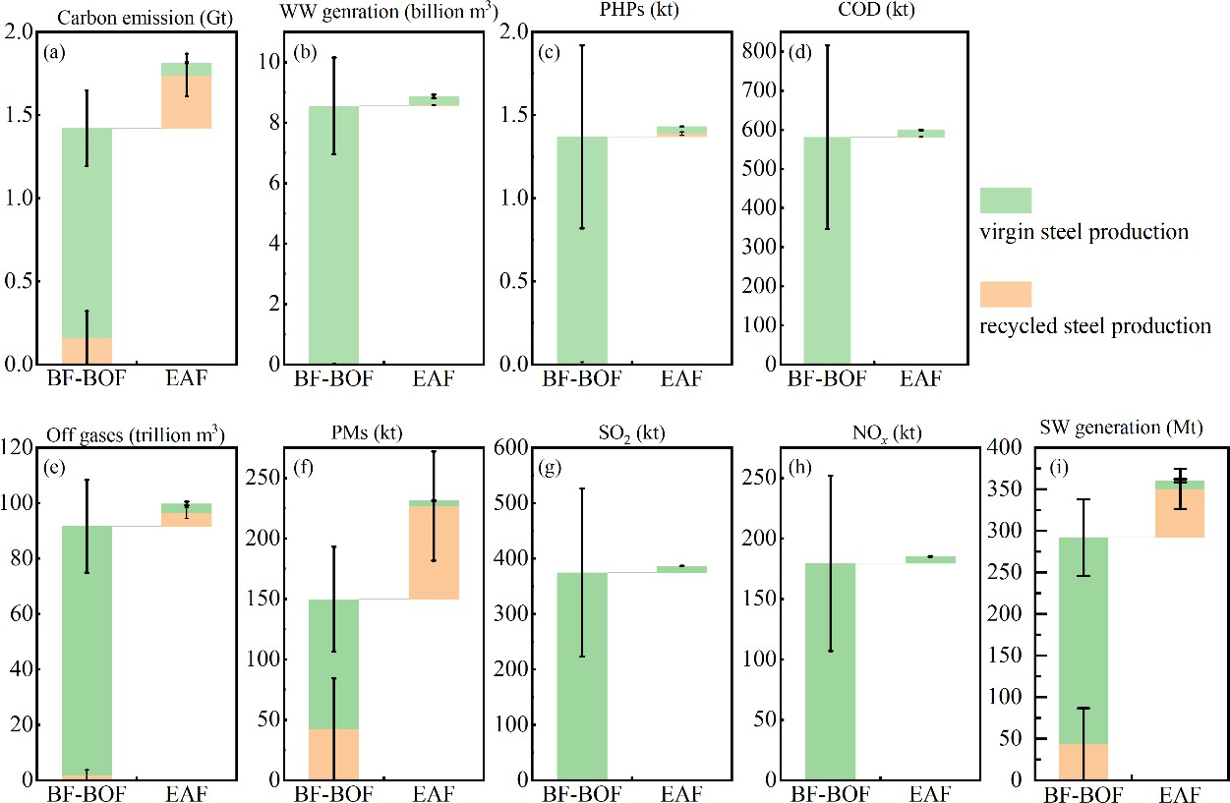

**Fig. 4.** Distribution of carbon and pollution emissions in different technological approaches: (a) carbon emissions, (b) wastewater generation, (c) PHP emissions, (d) COD emissions, (e) off gases, (f) PM emissions, (g) SO2, (h) NO*x*, and (i) SW generation.

CSP also significantly influences the supply and demand balance of steel scrap. As shown in Fig. 4, under different CSP growth scenarios, depreciated scrap, with 61.9%–80.5%, accounted for the dominant portion of steel scrap feedstock, followed by self-produced scrap and processing scrap, which accounted for 9.8%–18.8% and 9.7%–19.3%, respectively. Since self-produced and processing scrap are generated during crude steel production and steel product processing, respectively, their total amount is directly affected by changes in CSP in the same year. Depreciated scrap, on the other hand, originates from obsolescence of the steel from its social stock after consumption. Therefore, unlike the other two types of scrap, changes in the generation of depreciated scrap have a significant lag time. Most of the depreciated scrap originates from steel consumption in the early 21st century, and the continued growth in consumption during this period has increased the sources of depreciated scrap, which resulted in a continued increase in the SSR. In the Sc scenarios, the amount of depreciated scrap will grow to 238.2 and 336.6 Mt in 2025 and 2030, respectively. In the Sa scenario, the increase in production and consumption of crude steel will also lead to a continuous increase in the amount of depreciated scrap and total scrap resources; the total volume of steel scrap will reach 371.3 Mt in 2025 and 510.5 Mt in 2030, within which the amounts of depreciated steel scrap will be 252.8 and 367.5 Mt, respectively. These values are slightly higher than those predicted for the total volume of steel scrap by Zhang et al. [54], which is approximately 330 Mt in 2025 and 420 Mt in 2030. This difference is mainly due to the fact that Zhang et al. [54] adopted a decreased CSP (880 Mt until 2030), which results in a lower amount of self-produced scrap originating from the production process. By 2035, total steel scrap will reach 592.8 Mt and depreciated scrap 431.7 Mt.

As the Chinese ISI raises the SSR and the EAF ratio, the demand for steel scrap increases accordingly. The change in the supply and demand gap for steel scrap was evaluated by examining the total demand for steel scrap for both BF–BOF and EAF approaches and the steel scrap potential under the different scenarios (Fig. 5). In the baseline scenario in which CSP and the SSR remain constant, the steel scrap potential will exceed the industry’s demand from 2020 onward, and the amount of surplus steel scrap will gradually increase. The surplus will be 112.6 Mt by 2025 and increase to 211.05 Mt by 2030. However, when the SSR gradually rises, the amount of surplus steel scrap will gradually shrink and a shortage will develop. In the low-SSR-growth scenario, in which the SSR is 25% in 2025 (Sc-1), the amount of surplus steel scrap will be 81.66 Mt in 2025. The surplus will narrow to 25.17 Mt if the SSR in 2025 rises to 30% (Sc-2). A steel scrap deficit would develop if the SSR growth continues to increase. In scenarios Sc-3 and Sc-4, in which the target SSR is 35% and 40% in 2025,

respectively, the deficit will further increase to 18.3 and 69.9 Mt, respectively, for the same year. In the Sa scenario, the simultaneous growth in CSP and SSR would exacerbate the steel scrap shortage, which could reach 136.2 Mt in 2025.

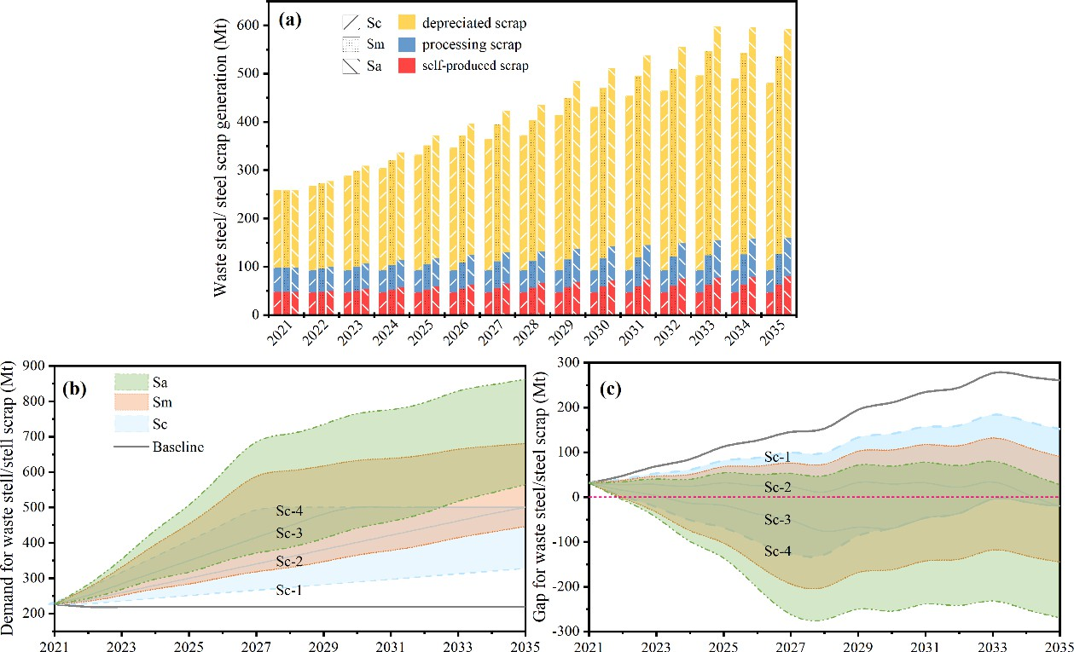

**Fig. 5.** (a) Composition of waste steel/steel scrap generation in China; (b) demand for, and (c) gap between, waste steel and steel scrap in China, under different scenarios.

# Discussion

* 1. *Reinforcement of structural adjustment in feedstock composition*

To meet its carbon peak and carbon neutrality commitments, China is strongly pushing to reduce the CEI in many industries. For the ISI, measures include increasing the utilization of steel scrap, raising the capacity and production of EAF facilities, or limiting the growth of CSP. Restructuring the composition of raw materials will significantly increase the industry's demand for steel scrap. Self-produced and processing scrap together account for 61.9%–80.5% of domestic steel scrap [55], while the remained is depreciated scrap collected after the steel stock in products, equipment, and constructions reaches its end of life.

Although China's crude steel consumption has grown rapidly in the last decade, it will take 20–25 years before that steel can be recycled, making it difficult to support a continued CSP growth in the future. To achieve greater carbon and PERs, on the one hand, scrap collection needs to be enhanced from the current collection rate of 24% [56], while on the other hand, suppliers abroad and domestic importers are still having a wait-and-see attitude towards China’s steel scrap standard released in 2020. In 2021, the import volume of recycled iron/steel materials was only 552.8 kt [56]. Further clarification of the specific implementation requirements of the standard is needed to promote the import of recycled iron/steel materials and alleviate the gap. For other developing countries with increased urbanization and industrialization, the dual pressures of a growing demand for steel products and the control of carbon emissions present an even greater challenge to steel waste/scrap collection and import policies and enforcement.

* 1. *Optimization of technological structure to achieve emission reduction*

China’s action plan for achieving the carbon peak in the ISI proposes simultaneous adjustments to the SSR and EAF ratio. However, the energy consumption intensity of the BF-BOF approach will significantly decrease if the SSR increases. This intensity is comparable to the EAF approach at an SSR of approximately 40% in the BOF–BF approach [57,58]. The results suggest that, subject to a limited volume of steel scrap, an obsessive increase in the EAF ratio while neglecting the available supply of steel scrap to EAF facilities will lead to increases in both carbon and pollution emissions. Therefore, during policy implementation, the long-term supply potential of steel scrap needs to be systematically considered at the regional level,

combined with the allocation of scrap in converters and EAF facilities to optimize implementation of structural technological measures to achieve emission reduction. Moreover, requirements for the composition of feedstock for different types of facilities should be proposed so that emission reduction effects can be achieved more efficiently. We focused on steel production and pollution control in terms of emission reductions by technological advances without insights into the role of energy greening, which a limitation of this study. However, there have been other, more specialized studies on reductions in energy system emissions. We further did not consider the impact of technologies that are not ready for use from a technical and commercial perspective, such as hydrogen-technologies. Thus, we may have overestimated future carbon and pollution emissions, which is another limitation of this study.

* 1. *Controlling the scale of industrial production*

The results suggest that limiting the volume of CSP plays a fundamental role in reducing carbon and pollution emissions of the ISI. Measures of raw material composition and technological structural adjustment have complementary roles if the limiting targets are to be achieved. At an annual CSP growth rate of approximately 2%, the carbon emissions in 2030 will only be comparable to those in 2021 through the extensive use of steel scrap and EAF facilities. Moreover, CSP growth will also cause a continuous increase in the emission of various pollutants such as PHPs, PM, and SO2. While China issued a legal obligation in 2021 to tightly control CSP, the actual production of that year still exceeded the control target by 35 Mt. The production also reached 0.81 Gt in the first three quarters of 2022, which is 81% of the annual control target and still too high. Therefore, stricter enforcement is essential to control CSP. This can also obviate the new demand for steel scrap, especially for countries and regions with low urbanization rates that do not have enough historical stock to provide the needed volume of depreciated steel scrap.

* 1. *Synergistic reduction of emissions to achieve multiple environmental benefits*

The results illustrate variability in the synergy between CER and PER via various low-carbon emission measures due to differences in CEI and pollution emission intensity (PEI) in various processes. PM emissions, in particular, may change contrarily to those of the other four pollutants (COD, PM, SO2, and NO*x*). On the one hand, in terms of carbon emission and PER, it is necessary to optimize the development path of the industry in an integrated manner with multiple objectives due to differences in environmental capacity in different regions.

On the other hand, ore types and steel scrap sources are diverse. Heavy metals and harmful compounds contained in ores or added during steel production, as well as the pollutants attached during steel scrap collection, can significantly change the industry's pollution emissions, especially those of contaminants of high concern. For example, waste iron drums that contain solvents, paints, and lacquers, should be disposed of as hazardous waste but are increasingly recycled in furnaces of the ISI to take advantage of the high temperature and completely decompose organic pollutants. However, common environmental protection facilities for waste gases and waste water are inadequate for the control of volatile organic pollutants such as benzene, toluene, or formaldehyde and hazardous residual liquids generated in the storage and pretreatment stages. Heavy metals such as cadmium, chromium, and vanadium are used to enhance the function of steel products. The content of heavy metals in SW may also change with higher SSRs, thus posing challenges to the management of SW. Studies on pollutant analysis have rarely paid attention to high-risk heavy metals and compounds or to the corresponding hazardous wastes. Investigations on their content in ores and steel wastes and their transport and fate during processing are required to identify priorities in different regions and achieve synergistic goals toward climate mitigation, clean water, a blue sky, and unpolluted land.

China’s experience with promoting the synergistic reduction of carbon and pollution emissions has broad implications for other developing countries, such as India, Brazil, or South Africa, which have high carbon emissions while suffering from severe health impacts from various types of pollution [59]. The urbanization rate is expected to further increase for these countries [60], while the per capita consumption of iron and steel is still at a relatively low level [44,61]. This leads to an increasing consumption demand. For similar countries with a growing consumption, the prevention of an excessive growth in CSP is key to controlling total carbon and pollutant emissions. Furthermore, it is essential to identify key sources that can enhance the supply of scrap, specifically if the SSR is to be increased. Restructuring of facilities to EAF production in large proportions is a rational path only if an adequate supply with steel scrap is secured.

The ISI is a major contributor to both carbon and pollution emissions [6], specifically in the air. China’s measures toward synergistic reductions in various emissions may provide feasible optimization pathways for other developing countries in the near future. Such reference pathways may assist those countries to better cope with the coordination of reduction approaches

via raw material composition control, technological structural adjustment, technological advances, and production-scale limitations to transition to a low-carbon and low-emission development model.

* 1. *Uncertainty analysis*

An uncertainty analysis was conducted by employing the Monte Carlo framework to verify the reliability of carbon and pollution emission estimations. Random values were generated according to the ranges of the CSP, SSR, EAF ratio, and emission factors of pollutants in each scenario. A total of 10 000 simulations were run to assess the ranges of uncertainty. The results suggested that the estimations are stable (Fig. S4 in Appendix A), with a slightly larger uncertainty range for CO2 emissions in the Sa scenario, ±0.84 for 2SD (standard deviation), than in the other scenarios (±0.52 for both Sc and Sm scenarios), and similar results for pollution emissions among the scenarios. The COD in the Sa-H scenario had the largest uncertainty range among all the estimated pollution emissions with a 2SD of ±578.17, followed by SO2, SW generation, and PM with 2SD values of ±374.57, ±193.77, and ±188.03, respectively. This is primarily due to the influence of key model inputs for emission estimation, which included activity level data, namely, CSP and correlation coefficients (SSR, EAF ratio, and PEI). The results show that the SSR had the largest impact among the correlation coefficients on carbon emissions in the Sa-H scenario, with a contribution of 68.13%. On the other hand, the PEI was the most influential parameter on SO2 and SW generation with a contribution of 88.66% and 87.04%, respectively. In addition, the use of stable emission factor values may increase uncertainty due to the heterogeneity of technologies, raw materials, operations, and other conditions of production facilities. We assumed that a 5% change in carbon emission factors for each production step resulted in a 0.06%–2.86% change in model-estimated carbon emissions.

# Acknowledgments

This study is supported by the National Key Research and Development Program of China (2019YFC1904800) and the National Natural Science Foundation of China (72274105). The authors also thank Mr. Chufan Wang, from Tsinghua University for his contribution in investigations.

# Compliance with ethics guidelines

Quanyin Tan, Fei Liu, and Jinhui Li declare that they have no conflict of interest or financial conflicts to disclose.

# Appendix A. Supplementary data

Supplementary data to this article can be found online at

**References**

1. United Nations Environment Programme (UNEP). Making Peace with Nature: a scientific blueprint to tackle the climate, biodiversity and pollution emergencies. Nairobi: United Nations Environment Programme; 2021. p. 166.
2. Wallach O. Race to net zero: carbon neutral goals by country [Internet]. Vancouver: Visual Capitalist; 2021 Jun 8 [cited 2022 Oct 1]. Available from: [https://www.visualcapitalist.com/sp/race-to-net-zero-carbon-neutral-goals-by-country/.](https://www.visualcapitalist.com/sp/race-to-net-zero-carbon-neutral-goals-by-country/)
3. United Nations Environment Programme (UNEP). Science-policy panel to contribute further to the sound management of chemicals and waste and to prevent pollution [UNEP/EA.5/RES.8] [Internet]. Gigiri: United Nations Environment Programme; 2022 Nov 04 [cited 2022 Jun 30]. Available from: [https://wedocs.unep.org/20.500.11822/39719.](https://wedocs.unep.org/20.500.11822/39719)
4. Rogelj J, den Elzen M, Hohne N, Fransen T, Fekete H, Winkler H, et al. Paris agreement

climate proposals need a boost to keep warming well below 2 ℃. Nature 2016;534(7609):631–9.

1. Ren L, Zhou S, Peng T, Ou X. A review of CO2 emissions reduction technologies and low-carbon development in the iron and steel industry focusing on China. Renew Sustain Energy Rev 2021;143:110846.
2. Ritchie H, Roser M, Rosado P. CO2 and greenhouse gas emissions [Internet]. Oxford: Our World in Data; 2017 May [cited 2022 Jun 30]. Available from: [https://ourworldindata.org/co2-and-other-greenhouse-gas-emissions.](https://ourworldindata.org/co2-and-other-greenhouse-gas-emissions)
3. Yoro KO, Daramola MO. Chapter 1-CO2 emission sources, greenhouse gases, and the global warming effect. In: Rahimpour MR, Farsi M, Makarem MA, editors. Advances in carbon capture. Cambridge: Woodhead Publishing; 2020. p. 3–28.
4. Çiftçi B. Potential game changers for the future of steelmaking. Brussels: World Steel Association; 2017.
5. Kumar D, Kumar D. Chapter 1-introduction. In: Kumar D, Kumar D, editors. Management of coking coal resources. Amsterdam: Elsevier; 2016. p. 1–8.
6. Energy Transitions Commission, Rocky Mountain Institute. China 2050: a fully developed rich zero-carbon economy. London: Energy Transitions Commission, Rocky Mountain Institute; 2019.
7. World Steel Association (WSA). 2019 steel statistical yearbook. Brussels: World Steel Association; 2020.
8. National Bureau of Statistics of China, Ministry of Ecology and Environment of China. 2021 China statistical yearbook on environment. Beijing: National Bureau of Statistics; 2022. Chinese.
9. Central Committee of the Communist Party of China, the State Council of the People’s Republic of China. Working guidance for carbon dioxide peaking and carbon neutrality in full and faithful implementation of the new development philosophy [Internet]. Beijing: Central Committee of the Communist Party of China; 2021 Sep 22 [cited 2023 Jun 19]. Available from: <https://www.gov.cn/zhengce/2021-10/24/content_5644613.htm>. Chinese.
10. Xinhua News Agency. The central economic work conference was held in Beijing [Internet]. Beijing: China Xinhua News; 2020 Dec 18 [cited 2022 Oct 30]. Available from: [http://www.xinhuanet.com/politics/leaders/2020-12/18/c_1126879325.htm.](http://www.xinhuanet.com/politics/leaders/2020-12/18/c_1126879325.htm) Chinese.
11. International Energy Agency (IEA). Energy technology perspectives 2016: towards sustainable urban energy systems. Paris: International Energy Agency; 2016.
12. Wang X, Hao L, Analysis of modern ironmaking technology and low-carbon development direction, Chin Metal 2021;31(05):1–5,18. Chinese.
13. Li Z, Xu Y, Yi W, Huang Y, Liu X, Li X. Evaluation, selection and application of low- carbon technology in iron and steel enterprises. Res Environ Sci 2022;35(6):1538–46. Chinese.
14. Jouhara H, Khordehgah N, Almahmoud S, Delpech B, Chauhan A, Tassou SA. Waste heat recovery technologies and applications. Therm Sci Eng Prog 2018;6:268–89.
15. Zhu T, Wang X, Yu Y, Li C, Yao Q, Li Y. Multi-process and multi-pollutant control technology for ultra-low emissions in the iron and steel industry. J Environ Sci 2022;123:83– 95.
16. Bo X, Jia M, Xue X, Tang L, Mi Z, Wang S, et al. Effect of strengthened standards on Chinese ironmaking and steelmaking emissions. Nat Sustain 2021;4:811–20.
17. Wang X, Yu B, An R, Sun F, Xu S. An integrated analysis of China’s iron and steel industry towards carbon neutrality. Appl Energy 2022;322:119453.
18. Wang X, Zhang Q, Xu L, Tong Y, Jia Xp, Tian H. Water-energy-carbon nexus assessment of China’s iron and steel industry: case study from plant level. J Clean Prod 2020;253:119910.
19. Long W, Wang S, Lu C, Xue R, Liang T, Jiang N, et al. Quantitative assessment of energy conservation potential and environmental benefits of an iron and steel plant in China. J Clean Prod 2020;273:123163.
20. Zhao X, Ma X, Chen B, Shang Y, Song M. Challenges toward carbon neutrality in China: strategies and countermeasures. Resour Conserv Recycl 2022;176:105959.
21. Wu R, Lin B. Environmental regulation and its influence on energy-environmental performance: evidence on the Porter Hypothesis from China’s iron and steel industry. Resour Conserv Recycl 2022;176:105954.
22. Yu B, Li X, Qiao Y, Shi L. Low-carbon transition of iron and steel industry in China: carbon intensity, economic growth and policy intervention. J Environ Sci (China) 2015;281:37–47.
23. Gao Y, Zhang L, Huang A, Kou WH, Bo X, Cai B, et al. Unveiling the spatial and sectoral characteristics of a high-resolution emission inventory of CO2 and air pollutants in China. Sci Total Environ 2022;847:157623.
24. Zhong H, Zhao Y, Muntean M, Zhang L, Zhang J. A high-resolution regional emission inventory of atmospheric mercury and its comparison with multi-scale inventories: a case study of Jiangsu, China. Atmos Chem Phys 2016;16:15119–34.
25. Hua H, Jiang S, Sheng H, Zhang Y, Liu X, Zhang L, et al. A high spatial-temporal resolution emission inventory of multi-type air pollutants for Wuxi city. J Clean Prod 2019;229:278–88.
26. Acutt MZ, Dodgson JS. Cross-elasticities of demand for travel. Transp Policy 1995;2(4):271–7.
27. Zeng QH, He LY. Study on the synergistic effect of air pollution prevention and carbon emission reduction in the context of “dual carbon”: evidence from China’s transport sector. Energy Policy 2023;173:113370.
28. Alimujiang A, Jiang P. Synergy and co-benefits of reducing CO2 and air pollutant emissions by promoting electric vehicles—a case of Shanghai. Energy Sustain Dev 2020;55:181–9.
29. Jiao J, Huang Y, Liao C. Co-benefits of reducing CO2 and air pollutant emissions in the urban transport sector: a case of Guangzhou. Energy Sustain Dev 2020;59:131–43.
30. Chen J, Cheng S, Song M, Wang J. Interregional differences of coal carbon dioxide emissions in China. Energy Policy 2016;96:1–13.
31. Wu K, Liu X, Dai H, Zhang S, Zhou Z, Ma T, et al. Mutual effects of CO2 emission reduction and air pollution control policies in Beijing-Tianjin-Hebei region. Front Environ Sci 2022;10:1006142.
32. Ministry of Industry and Information Technology of China, Ministry of Science and Technology of China, Ministry of Natural Resources of China. The “14th five-year” plan for the development of raw material industry. Beijing: The State Council of the People’s Republic of China; 2021. Chinese.
33. Ministry of Industry and Information Technology of China, National Development and Reform Commission of China, Ministry of Ecology and Environment of China. Implementation plan for peaking carbon dioxide emissions in industry sector. Beijing: The State Council of the People’s Republic of China; 2022. Chinese.
34. Ministry of Industry and Information Technology of China, National Development and Reform Commission of China, Ministry of Ecology and Environment of China. Guideline on promoting the high-quality development of the iron and steel industry. Beijing: The State Council of the People’s Republic of China; 2022. Chinese.
35. Wang M, Tian Y, Liang Y, Zhou R, Luo Y, Li X. Forecast scrap generation and emission reduction of China’s steel industry. In: Xu J, Ahmed SE, Cooke FL, Duca G, editors. Proceedings of the 13th International Conference on Management Science and Engineering Management (ICMSEM 2019); 2019 Aug 5–8; Ontario, Canada. Berlin: Springer International Publishing; 2020. p. 283–92.
36. China City Greenhouse Gas Working Group. China products carbon footprint factors database. Beijing: China City Greenhouse Gas Working Group; 2022.
37. Cai BF, Liang S, Zhou J, Wang JN, Cao LB, Qu S, et al. China high resolution emission database (CHRED) with point emission sources, gridded emission data, and supplementary socioeconomic data. Resour Conserv Recycl 2018;129:232–9.
38. He K, Mi Z, Zhang J, Li J, Coffman DM. The polarizing trend of regional CO2 emissions in China and its implications. Environ Sci Technol 2023;57(11):4406–14.
39. Ministry of Ecology and Environment of China. Manual of accounting method and coefficient of generation and emission for industrial source. Beijing: The State Council of the People’s Republic of China; 2021. Chinese.
40. Bureau of International Recycling. World steel recycling in figures. 12th edition. Brussels: Bureau of International Recycling; 2021. p. 40.
41. Pan C, Wang B, Hou X, Gu Y, Xing Y, Liu Y, et al. Carbon peak path of the Chinese iron and steel industry based on the LMDI−STIRPAT model. Chin J Eng 2023;45(06):1034– 44.
42. Project Team on the Strategy and Pathway for Peaking Carbon Emissions and Carbon Neutrality. Analysis of a peaked carbon emission pathway in China toward carbon neutrality. Engineering 2021;7(12):1673–7.
43. Ministry of Ecology and Environment of China. Annual report of China ecology and environment statistics 2021. Beijing: The State Council of the People’s Republic of China; 2023. p. 66. Chinese.
44. Liu L, Zhang D, Ren T, Hu Z, Zhou W, Chen H. Process practice of increasing converter scrap ratio by using hot scrap. Shanxi Metal 2022;28(6):97–9. Chinese.
45. Wimmer G. Greening converter steelmaking [Internet]. London: Metals Magazine; 2020 Jan 01 [cited 2023 Sep 14]. Available from: <https://magazine.primetals.com/2020/01/01/greening-converter-steelmaking/>.
46. Fang W, Yang N, You X, Wu L. Research on high efficiency low consumption high scrap ratio converter. Steelmaking 2020;36(6):8–13. Chinese.
47. Feng T, Hao H, Chen J, Wei J. Application practice of improving scrap ratio in converter smelting. Metall Info Rev 2019;25(3):40–2.
48. Steel Manufacturers Association. Steelmaking emissions report 2022. Report. Washington: Steel Manufacturers Association; 2022.
49. Li F, Chu M, Tang J, Liu Z, Zhou Y. Environmental performance analysis of coal gasification-shaft furnace-electric furnace process and BF-BOF process based on life cycle assessment. J Iron Steel Res Int 2020;32(7):577–83.
50. Zhang Q, Tian S, Shen J. Roadmap and timetable for achieving carbon peak and carbon neutrality of China’s iron and steel industry. Iron & Steel 2023;1–14. Chinese.
51. Editorial Board of China Steel Yearbook. China steel yearbook 2021. Beijing: China Iron and Steel Association; 2021. Chinese.
52. China National Resources Recycling Association. Report on the development of recycling industry in China. Beijing: China National Resources Recycling Association; 2022. Chinese.
53. He K. Research on energy saving and efficiency increasing potential of energy regulation and process optimization in metallurgical system [dissertation]. Beijing: University of Science and Technology Beijing; 2019. p. 133. Chinese.
54. Dai Y, Wang W. Converter’s energy consumption and raising of scrap return ratio. J Northeast Univ 1994;15(4):384–9. Chinese.
55. United Nations Environment Programme (UNEP). Earth observation for monitoring pollution [Internet]. Genève: United Nations Environment Programme; undated [cited 2022 Oct 30]. Available from: [https://wesr.unepgrid.ch/?project=MX-JOJ-8ME-I4T-G9M-](https://wesr.unepgrid.ch/?project=MX-JOJ-8ME-I4T-G9M-I9E&language=en) [I9E&language=en.](https://wesr.unepgrid.ch/?project=MX-JOJ-8ME-I4T-G9M-I9E&language=en)
56. Wahba Tadros SN, Wellenstein A, Das MB, Palmarini N, D’Aoust OS, Singh G, et al. Demographic trends and urbanization (English). Washington: World Bank Group; 2021.
57. World Steel Association. World steel in figures 2022: apparent steel use per capita 2017 to 2021 [Internet]. Genève: United Nations Environment Programme; undated [cited 2022 Oct 30]. Available from: [https://worldsteel.org/steel-topics/statistics/world-steel-in-](https://worldsteel.org/steel-topics/statistics/world-steel-in-figures-2022/#apparent-steel-use-per-capita-2017-to-2021) [figures-2022/#apparent-steel-use-per-capita-2017-to-2021.](https://worldsteel.org/steel-topics/statistics/world-steel-in-figures-2022/#apparent-steel-use-per-capita-2017-to-2021)

**Declaration of interests**

☒ The authors declare that they have no known competing financial interests or personal relationships that could have appeared to influence the work reported in this paper.



* The authors declare the following financial interests/personal relationships which may be considered as potential competing interests: